Integrated Performance Assessment Units for Chinese, High School Course 4

Contents

Unit 1: Global Families
Unit 2: Global Organizations
Unit 3: Global Village and Global Governance
Unit 4: Global Environment: Issues and Solutions
Appendix A – Unit 1 Materials
Appendix B – Unit 2 Materials
Appendix C – Unit 3 Materials
Appendix D – Unit 4 Materials

Integrated Performance Assessment Unit
for Chinese, High School Course 4
Back to Contents

Unit 1 Overview
Unit 1 Title/Topic  Enduring Understandings  Essential Questions  Unit 1 Proficiency Levels  Unit 1 Duration | Unit 1 Performance Indicators  Unit 1 IPA  Unit 1 Sample Lesson Plan 1  Unit 1 Sample Lesson Plan 2  Unit 1 Sample Lesson Plan 3  Unit 1 Sample Lesson Plan 4 | Unit 1 Summary of Suggested  Lexical Content, Functional  Chunks, and Support  Structures  Unit 1 Instructional Strategies  Unit 1 Materials (Appendix A)

Unit Title/Topic: Global Families

Enduring Understandings:
Families from different countries/continents are different in many ways.
The backgrounds we come from affect our value system and our way of viewing the world.
Culture defines aspects of who we are.

Essential Questions:
What are the similarities and differences among these cultures?
How do these similarities and differences affect the way in which people live and think?
How do these similarities and differences shape people’s value system and influence the communication between people from different backgrounds?

Proficiency Levels Targeted:
Interpretive Listening: Intermediate Low
Interpretive Reading: Intermediate Low
Interpersonal: Intermediate Low
Presentational Speaking: Intermediate Low
Presentational Writing: Intermediate Low

Teachers may help determine expectations of learner proficiency growth by observing what learners can do and then providing experiences designed to help learners “level up” in their performances over time. When determining if targeted levels above are appropriate for a given group of learners, teachers may wish to reference the sample rubrics linked to here for guidance describing what learners can do at each sublevel and for each mode:
https://ed.sc.gov/instruction/standards-learning/world-languages/support-documents-and-resources/00-all-high-school-rubrics-for-modern-languages/

Duration:
9 Weeks (31 hours)

Performance Indicators
for Unit 1 from the
South Carolina College and Career-Ready Standard for World Language Proficiency 2019
Back to Unit 1 Grid

Note to the Educator on Performance Indicators:

Purpose and Adaptability
The selection of Performance Indicators to follow help frame the teaching and learning for the unit, and educators implementing this unit may wish to add to this sample selection, or in some cases narrow this selection, depending on the proficiency goals of a group of learners. Indicators are broader performance goals (written in the form of Can-Do Statements) that can help guide learning for a unit of study. These goals can help teachers and learners track learner performance over time, providing insight into learner proficiency growth based on sustained performance in the Modes of Communication. They are measurable goals that come directly from the South Carolina College- and Career-Ready Standard for World Language Proficiency 2019 and are aligned to ACTFL proficiency levels.

Selection and Extension
This selection is based on the sample targets for the unit (see Unit Overview) that will assist learners in moving toward targeted proficiency goals as they approach the completion of the course.

Note that some of the Performance Indicators selected for the unit may go beyond the sample proficiency targets for the unit which are based on averages that could be attainable for most learners in the program type by completion of the unit. Educators and students should remember that learners progress in language proficiency at different rates, and some learners will, for example, be able to go beyond the targets used in this sample unit, and possibly any adapted unit that an educator could create. In light of this variance, learners should take part in setting their own goals so that they can attain the highest levels of proficiency possible.

Aligning Lesson Goals to These Broader Goals
Specific, measurable lesson-level goals (also written as Can-Do Statements) can be created by the teacher in alignment with Performance Indicators to guide teaching and learning for lessons. The writers of this sample unit included sample lesson-level Can-Do Statement goals that can be found with the sample lesson plans in this unit.

Interpretive Reading/Listening | Interpersonal | Presentational Speaking/Writing | Intercultural Communication: Investigate | Intercultural Communication: Interact
Intermediate Low  I can identify the topic and related information from simple sentences in short informational texts. (p. 34)  I can identify the topic and related information from simple sentences in short fictional texts. (p. 34)  I can identify the main idea in short conversations. (p. 34)  Intermediate Mid  I can understand the main idea and key information in short straightforward informational texts. (p. 34)  I can understand the main idea and key information in short straightforward fictional texts. (p. 34)  I can identify the main idea and key information in short straightforward conversations. (p. 34) | Intermediate Low  I can request and provide information in conversations on familiar topics by creating simple sentences and asking appropriate follow-up questions. (p. 39)  I can interact with others to meet my basic needs in familiar situations by creating simple sentences and asking appropriate follow-up questions. (p. 39)  I can express, ask about, and react with some details to preferences, feelings, or opinions on familiar topics, by creating simple sentences and asking appropriate follow-up questions. (p. 39)  Intermediate Mid  I can exchange information in conversations on familiar topics and some researched topics, creating sentences and series of sentences and asking a variety of follow-up questions. (p. 39)  I can interact with others to meet my needs in a variety of familiar situations, creating sentences and series of sentences and asking a variety of follow-up questions. (p. 39)  I can exchange preferences, feelings, or opinions and provide basic advice on a variety of familiar topics, creating sentences and series of sentences and asking a variety of follow-up questions. (p. 39) | Intermediate Low  I can present personal information about my life, activities and events, using simple sentences. (p. 46)  I can express my preferences on familiar and everyday topics of interest and explain why I feel that way, using simple sentences. (p. 46)  I can present on familiar and everyday topics, using simple sentences. (p. 46)  Intermediate Mid  I can tell a story about my life, activities, events and other social experiences, using sentences and series of connected sentences. (p. 46)  I can state my viewpoint about familiar topics and give some reasons to support it, using sentences and series of connected sentences. (p. 46)  I can give straightforward presentations on a variety of familiar topics and some concrete topics I have researched, using sentences and series of connected sentences. (p. 46) | Intermediate  Products: In my own and other cultures I can compare products related to everyday life and personal interests or studies. (p. 53)  Practices: In my own and other cultures I can compare practices related to everyday life and personal interests or studies. (p. 53) | Intermediate  Language: I can converse with peers from the target culture in familiar situations at school, work, or play, and show interest in basic cultural similarities and differences. (p. 53)  Behavior: I can recognize that significant differences in behaviors exist among cultures, use appropriate learned behaviors and avoid major social blunders. (p. 53)

Integrated Performance Assessment
for Unit 1
Back to Unit 1 Grid
Scenario/Context:
The International Festival will be held at your school. Many of your friends will be presenting cultures and traditions from different countries. Your job to assist this will be creating a pamphlet including but not limited to the following information. e.g. clothes, foods, songs, music, etc. in your work so your friends can prepare their presentation.

Interpretive Task (reading/listening):
Students will investigate other countries’ traditions/cultures with guidance from their teacher. They will use multiple texts selected by the teacher (here, “text” refers to Mandarin Chinese that students will interpret either by reading or listening). Students will select a format for recording their understandings from the text(s): e.g. Venn Diagram; Graphic Organizer; bullet points; Q & A; etc.

Sample texts that teachers may draw from for this task:

各国文化习俗及禁忌
https://wenku.baidu.com/view/1c8fefa0a6c30c2258019e36.html?re=view
文化多样性及差异
http://zhongxue.hujiang.com/tiku/p2037802/
各国风俗礼仪
http://archive.wenming.cn/lyxx/2010-04/29/content_19652545.htm
有趣的民族文化
https://www.zhihu.com/question/55731796

10 of the most interesting customs around the world
https://matadornetwork.com/read/10-interesting-customs-around-world/
20 Fascinating Cultural Traditions Around the World
https://www.daytranslations.com/blog/20-traditions-around-the-world/
各国禁忌欧洲篇
https://www.youtube.com/watch?v=dFq3zaY5xGU
12个意想不到的世界各地用餐礼仪
https://www.youtube.com/watch?v=GgrbI6zmv7E
世界各国小常识: World Trivia
https://www.youtube.com/watch?v=9wGWnviztJA
世界各国民族服饰
https://www.youtube.com/watch?v=pKl2rN4NbUI

Intermediate Low Interpretive Rubric:
https://ed.sc.gov/instruction/standards-learning/world-languages/support-documents-and-resources/04-intermediate-low-interpretive-communication-rubric/

Intermediate Mid Interpretive Rubric:
https://ed.sc.gov/instruction/standards-learning/world-languages/support-documents-and-resources/05-intermediate-mid-interpretive-communication-rubric/

Interpersonal Task:
Interview a friend from your class about the cultures/traditions of the background he/she comes from or he/she knows about. Remember to request clarification when in doubt.

Link to graphic organizer in Appendix A
Link to Venn Diagram in Appendix A

Intermediate Low Interpersonal Rubric:
https://ed.sc.gov/instruction/standards-learning/world-languages/support-documents-and-resources/11-intermediate-low-interpersonal-communication-rubric/

Intermediate Mid Interpersonal Rubric:
https://ed.sc.gov/instruction/standards-learning/world-languages/support-documents-and-resources/12-intermediate-mid-interpersonal-communication-rubric/

Presentational Task (speaking/writing):
Present to your friend who is going to present at the International Festival about what you have learned about the traditions/cultures so she/he can start preparing for the presentation.

Complete the pamphlet with the information that you have learned about with matching pictures. You only need to choose one country. Include information about the taboos that you have learned about in your pamphlet, so your friend will not present something that is offensive to other people.

Intermediate Low Presentational Rubric:
https://ed.sc.gov/instruction/standards-learning/world-languages/support-documents-and-resources/18-intermediate-low-presentational-communication-rubric/

Intermediate Mid Presentational Rubric:
https://ed.sc.gov/instruction/standards-learning/world-languages/support-documents-and-resources/19-intermediate-mid-presentational-communication-rubric/

Unit 1
Sample Lesson Plan 1 (50 minutes)
Continents and Countries
Back to Unit 1 Grid

Sample Lesson Plan 1 (50 minutes): Continents and Countries

Where this lesson occurs within the unit:
This lesson should be at the beginning phase of the unit.

Context for this lesson:
Have a talk/discussion with students about continents and countries to trigger the prior knowledge before this lesson.

Expected duration:
50 minutes lesson can be repeated 2-3 times to make sure students grasp key vocabulary.

Learning Targets (specific, measurable goals for students for this lesson):

Interpretive Listening: I can identify countries’ names while listening (only) to the video. Interpretive Reading: I can identify countries’ names while reading the material.
Interpersonal Speaking & Listening: I can identify the names of the countries and talk about them with my partner.
Presentational Speaking: I can use basic sentence structures to introduce countries.
Presentational Writing: I can write about the country names heard from the audio in simple sentences.

Suggested Lexical Content, Functional Chunks, and Language Structures:
中国 英国 美国 加拿大 日本 韩国 巴西 西班牙 意大利 墨西哥 瑞士 法国 丹麦 泰国 希腊 法国 土耳其
● 在这个视频里， 提到了美国。。。
● 我在这个视频里听到了法国。。。
● 文章里提到了英国。。。
● 我看到了日本。。。
Sample Materials:
中华传统文化 第4期】世界各国奇葩新年习俗：不许笑必须哭 甚至还要在墓地过新年

其他国家不准做的事
世界上各个国家和民族的文化习俗大致是相同的。 [多元文化_中学题库-沪江中学学科网]

文明观博：世界各国的主要风俗礼仪有哪些

世界各国有哪些有趣的民族文化？

Interesting customs and traditions from around the world

20 Fascinating Cultural Traditions Around the World
MTC文化快递 08各国禁忌欧洲篇

12个意想不到的世界各地用餐礼仪

世界各国小常识: World Trivia

服饰世界各国民族服饰

Sequence during lesson | Teacher and Student Actions in Lesson
1st in lesson sequence  Interpretive Listening  (10 min) | Teacher: only play the audio to students while muting the video part.  Students: actively listen to the audio circle the countries heard from the audio.
2nd in lesson sequence  Interpretive Reading  (10 min) | Teacher: give students’ list of resources and have students pick two resources to read and copy the names and they can identify.  Students: pick two websites (guided by teacher in making this decision) and read through to copy the countries they can identify.
3rd in lesson sequence  Interpersonal Speaking & Listening  (10 min) | Teacher: pair students; have them listen to the audio from YouTube and talk about the names they can identify.  Students: work in pairs and listen to the audio from YouTube; exchange the names heard with the partner.
4th in lesson sequence  Presentational Speaking  (10 min) | Teacher: pair students up; instruct students to present to each other about the countries heard about.  Students: work with your partner to present to each other about the countries heard about.
5th in lesson sequence  Presentational Writing  (10 min) | Teacher: instruct students to write down the countries’ names in target language in simple sentence structures.  Students: use the sample sentence structures to write about countries heard from the audio.  Also, students can list countries read from the websites.

Unit 1
Sample Lesson Plan 2
(50 minutes) Cultures and Traditions
Back to Unit 1 Grid

Sample Lesson Plan 2 (50 minutes): Cultures and Traditions

Where this lesson occurs within the unit:
This lesson should be in the middle of the unit after students are very familiar with the continents and countries. Also, key vocabulary should be taught already.
Context for this lesson:
Students may explore cultures and traditions in English before this lesson to get familiar with the topic.

Expected duration:
50 minutes lesson; can be repeated a few days with different activities to strengthen proficiency.

Learning Targets (specific, measurable goals for students for this lesson):

Interpretive Listening: I can identify cultural traditions and taboos from the audio.
Interpretive Reading: I can identify the information regarding cultures, traditions, and taboos from the Reading resources.
Interpersonal Speaking and Listening: I can communicate with people of different cultures, traditions or taboos of different countries: asking questions about the topic; asking questions to clarify and talk about the topic.
Presentational Speaking: I can present what I have learned about cultures, traditions and taboos of different countries to people.
Presentational Writing: I can gather my findings and write them into some informational text: flyer, brochure, PowerPoint, or any format through any media that I choose.

Suggested Lexical Content, Functional Chunks, and Language Structures:
basic markers for traditions and taboos:
会…
不能…
Specific vocabulary depends on specific country
Specific information will be different for each country, but students can look for “ 能， 不能， 会， 可以， 不可以， 经常， 往往 ” as a sign to tell traditions or taboos.

Use the following sentence starters to communicate:
● 在——————国， 人们可以/会/能。。。
● 在——————国， 人们不可以/不能。。。
● 我没听懂/听清楚
● 你能再说一遍么？
● 是——————————么？

Student may use the following starters for the presentation:
● 在————国， 人们经常。。。
● 在————国， 人们往往。。。
● 在————国， 人们不可以/不能。。。

Sample Materials:
MTC文化快递 08各国禁忌欧洲篇

12个意想不到的世界各地用餐礼仪

世界各国小常识: World Trivia

世界各国民族服饰

【中华传统文化 第4期】世界各国奇葩新年习俗：不许笑必须哭 甚至还要在墓地过新年

其他国家不准做的事

Sequence during lesson | Teacher and Student Actions in Lesson
1st in lesson sequence  Interpretive Listening (10 min) | Teacher: Play only the audio from the YouTube file and instruct students to choose from the list of traditions.  Students: listen to the audio file and choose from the list of traditions/taboos.
2nd in lesson sequence  Interpretive Reading  (10 min) | Teacher: pair students up and assign each pair 2 reading assignments; then have them take notes on the reading regarding cultures.  Students: work with a partner to finish reading assignments and take notes.
3rd in lesson sequence  Interpersonal Speaking and Listening  (10 min) | Teacher: pair each student with a partner (different from the reading partner) and have students talk about the reading notes and then add to their notes.  Students: talk to your partner about your findings. Remember to ask questions to clarify information.
4th in lesson sequence  Presentational Speaking  (10 min) | Teacher: give each student an opportunity to present their findings. Each student should present a different country.  Students: pick a country and present your findings to your peers.
5th in lesson sequence  Presentational Writing  (10 min) | Teacher: allow each student to choose the format and media to present their findings in writing.  Students: choose your format and media to present your findings in writing.

Unit 1
Sample Lesson Plan 3 (50 minutes)
Cultures and Traditions (focus: taboos)
Back to Unit 1 Grid

Sample Lesson Plan 3 (50 minutes):

Where this lesson occurs within the unit:
This lesson should be in the middle of the unit after students are very familiar with the continents and countries. Also, key vocabulary should be taught already.

Context for this lesson:
Students may explore cultures and traditions in English before this lesson to get familiar with the topic.

Expected duration:
50 minutes lesson; can be repeated a few days with different activities to strengthen proficiency

Learning Targets (specific, measurable goals for students for this lesson):

Interpretive Listening: I can identify cultural traditions (focus: taboos) from the audio.
Interpretive Reading: I can identify the information regarding taboos from the reading resources.
Interpersonal Speaking and Listening: I can communicate with people of different taboos of different countries: asking questions about the topic; asking questions to clarify and talk about the topic.
Presentational Speaking: I can present what I have learned about taboos of different countries to people.
Presentational Writing: I can gather my findings and write them into some informational text: flyer, brochure, PowerPoint, or any format through any media that I choose.

Suggested Lexical Content, Functional Chunks, and Language Structures:
basic markers for traditions and taboos: 会； 不能。
Specific vocabulary depends on specific country
Specific information will be different for each country, but students can look for “ 能， 不能， 会， 可以， 不可以， 经常， 往往 ” as a sign to tell tradition or taboos.

Use the following sentence starters to communicate:
● 在——————国， 人们可以/会/能。。。
● 在——————国， 人们不可以/不能。。。
● 我没听懂/听清楚
● 你能再说一遍么？
● 是——————————么？

Student may use the following starters for the presentation:
● 在————国， 人们经常。。。
● 在————国， 人们往往。。。
● 在————国， 人们不可以/不能。。。

Sample Materials:

MTC文化快递08各国禁忌欧洲篇

12个意想不到的世界各地用餐礼仪

世界各国小常识: World Trivia

世界各国民族服饰

【中华传统文化 第4期】世界各国奇葩新年习俗：不许笑必须哭 甚至还要在墓地过新年

其他国家不准做的事

Sequence during lesson | Teacher and Student Actions in Lesson
1st in lesson sequence  Interpretive Listening  (10 min) | Teacher: Play only the audio from the YouTube file and instruct students to choose from the list of taboos.  Students: listen to the audio file and choose from the list of traditions/taboos.
2nd in lesson sequence  Interpretive Reading  (10 min) | Teacher: pair students up and assign each pair 2 reading assignments; then have them take notes on the reading regarding taboos.  Students: work with a partner to finish reading assignments and take notes.
3rd in lesson sequence  Interpersonal Speaking and Listening  (10 min) | Teacher: pair each student with a partner (different from the reading partner) and have students talk about the reading notes and then add to their notes.  Students: talk to your partner about your findings. Remember to ask questions to clarify information.
4th in lesson sequence  Presentational Speaking  (10 min) | Teacher: give each student an opportunity to present their findings. Each student should present a different country.  Students: pick a country and present your findings to your peers.
5th in lesson sequence  Presentational Writing  (10 min) | Teacher: allow each student to choose the format and media to present their findings in writing.  Students: choose your format and media to present your findings in writing.

Unit 1
Sample Lesson Plan 4 (50 minutes)
Compare and Contrast
Back to Unit 1 Grid

Sample Lesson Plan 4

Where this lesson occurs within the unit:
This lesson should happen after students are very familiar with the cultures and traditions so to compare and contrast.

Context for this lesson:
Students may explore cultures and traditions in English before this lesson to get familiar with the topic.

Expected duration:
50 minutes lesson; can be repeated a few days with different activities to strengthen proficiency.

Learning Targets (specific, measurable goals for students for this lesson):

Interpretive Listening: I can identify the similarities and differences between the cultures of different countries through listening to my classmates’ presentations.
Interpretive Reading: I can identify the similarities and differences between the cultures of different countries through reading my classmates’ findings.
Interpersonal Speaking and Listening: I can talk about the similarities and differences between the cultures of different countries with my classmates and ask clarifying questions.
Presentational Speaking: I can present orally my findings on the similarities and differences between the cultures of different countries.
Presentational Writing: I can present in writing my findings on the similarities and differences between the cultures of different countries.

Suggested Lexical Content, Functional Chunks, and Language Structures:

Notes can be taken in English or the language that students prefer.
____国和___国有很多相同之处， 比如： 1.。。2.。。。
—__国和____国的不同之处在于 1.。。。 2.。。。
你是说。。。么？
你能重复一遍么？

Sample Materials:
Student presentations can be used as a resource.
Specific content varies.
MTC文化快递08各国禁忌欧洲篇

12个意想不到的世界各地用餐礼仪

世界各国小常识: World Trivia

世界各国民族服饰

【中华传统文化 第4期】世界各国奇葩新年习俗：不许笑必须哭 甚至还要在墓地过新年

其他国家不准做的事

Sequence during lesson | Teacher and Student Actions in Lesson
1st in lesson sequence  Interpretive Listening  (10 min) | Teacher: give each student an opportunity to present their findings and have the rest of the students listen and take notes on the similarities and differences between the cultures of different countries.  Students: listen to your classmate’s presentation and take notes on the similarities and differences between the cultures of different countries.
2nd in lesson sequence  Interpretive Reading  (10 min) | Teacher: assign students in small groups and have them read each other’s findings. Let them take notes on the similarities and differences between the cultures of different countries.  Students: Read your group members’ findings and take notes on the similarities and differences between the cultures of different countries.
3rd in lesson sequence  Interpersonal Speaking and Listening  (10 min) | Teacher: assign students in small groups (different from reading groups) and have them talk about the similarities and differences between the cultures of different countries gathered from reading each other’s findings. Remind them to ask clarifying questions.  Students: Talk to your group members about the similarities and differences between the cultures of different countries gathered from reading each other’s findings. Ask clarifying questions if needed.
4th in lesson sequence  Presentational Speaking  (10 min) | Teacher: give each student an opportunity to present their findings orally on the similarities and differences between the cultures of different countries.  Students: Present your findings orally on the similarities and differences between the cultures of different countries.
5th in lesson sequence  Presentational Writing  (10 min) | Teacher: give each student an opportunity to present their findings in writing through a format chosen by the student (e.g. poster, PPT, brochure, …) on the similarities and differences between the cultures of different countries.  Students: Present your findings in writing through a format chosen by yourself (e.g. poster, PPT, brochure, …) on the similarities and differences between the cultures of different countries.

Summary of Suggested Lexical Content, Functional Chunks,
and Support Structures for Unit 1 (Global Families)
Back to Unit 1 Grid  Summary of Suggested Lexical Content  Productive:  What are the similarities and differences among the cultures of countries on different continents? Name 3-5.  How does where we live influence our values?  In what ways do families differ on different continents and in different countries?  Receptive:  What are the continents and oceans? Which continents are occupied?  What are the countries (name 3-5) in the 3 biggest continents? What are the names of the oceans surrounding the continents?  What are the traditions/cultures in the named countries? Name 3-5. | Back to Unit 1 Grid  Summary of Suggested Support Structures  我来自_______________.  ____________(国家）在_______________ (洲）。  _____________(节日）在 ______________(日期）。  ____________和_____________的相同点有____________.  ____________和_____________的不同点有____________.  在——————过， 人们可以/会/能。。。  在——————国， 人们不可以/不能。。。  我没听懂/听清楚  你能再说一遍么？  是——————————么？  在————国， 人们经常。。。  在————国， 人们往往。。。  在————国， 人们不可以/不能。。。  在————国， 人们经常。。。  在————国， 人们往往。。。  在————国， 人们不可以/不能。。。  在——————过， 人们可以/会/能。。。  在——————国， 人们不可以/不能。。。  我没听懂/听清楚  你能再说一遍么？  是______么？

Summary of Sample Instructional Strategies
for Unit 1
Back to Unit 1 Grid

Sentence starters: 我来自_______________.

____________ (国家）在_______________ (洲）。

_____________ (节日）在 ______________(日期）。

____________和_____________的相同点有____________.

____________和_____________的不同点有____________.

Tiered questioning:

亚洲有哪些国家？ 请举三-五个例子。
每个国家有什么风俗和习惯？ 举例子说明。
各个国家在风俗和习惯上有什么不同和相同之处？
这些相同之处和不同之处是如何影响人们的思维方式和生活方式的？ 价值观是如何被影响的？

Link to pictorial chart in Appendix A

Link to Intermediate Low Interpersonal rubric
Links to Intermediate Mid Interpersonal & Intermediate High Interpersonal rubrics

Integrated Performance Assessment Unit
for Chinese, High School Course 4
Back to Contents
Unit 2 Overview
Unit 2 Title/Topic  Enduring Understandings  Essential Questions  Unit 2 Proficiency Levels  Unit 2 Duration | Unit 2 Performance Indicators  Unit 2 IPA  Unit 2 Sample Lesson Plan 1  Unit 2 Sample Lesson Plan 2  Unit 2 Sample Lesson Plan 3  Unit 2 Sample Lesson Plan 4 | Unit 2 Summary of Suggested  Lexical Content, Functional  Chunks, and Support  Structures  Unit 2 Instructional Strategies  Unit 2 Materials (Appendix B)

Unit Title/Topic: Global Organizations

Enduring Understandings:
There are many different world organizations, and they function differently.
The functions of these world organizations play important roles toward reaching common worldwide goals.

Essential Questions:
What are the major organizations in the world? What are their functions?
What is the structure of each organization and the major positions under each organization?
How did each organization come into the present formality? Timeline? History?
What are the similarities and differences among these organizations?
How do these organizations help with reaching the common goals of the world?

Proficiency Levels Targeted:
Interpretive Listening: Intermediate Low
Interpretive Reading: Intermediate Low-Mid
Interpersonal: Intermediate Low
Presentational Speaking: Intermediate Low
Presentational Writing: Intermediate Low-Mid

Teachers may help determine expectations of learner proficiency growth by observing what learners can do and then providing experiences designed to help learners “level up” in their performances over time. When determining if targeted levels above are appropriate for a given group of learners, teachers may wish to reference the sample rubrics linked to here for guidance describing what learners can do at each sublevel and for each mode:
https://ed.sc.gov/instruction/standards-learning/world-languages/support-documents-and-resources/00-all-high-school-rubrics-for-modern-languages/

Duration:
9 Weeks (31 hours)

Performance Indicators
for Unit 2 from the
South Carolina College and Career-Ready Standard for World Language Proficiency 2019
Back to Unit 2 Grid

Note to the Educator on Performance Indicators:

Purpose and Adaptability
The selection of Performance Indicators to follow help frame the teaching and learning for the unit, and educators implementing this unit may wish to add to this sample selection, or in some cases narrow this selection, depending on the proficiency goals of a group of learners. Indicators are broader performance goals (written in the form of Can-Do Statements) that can help guide learning for a unit of study. These goals can help teachers and learners track learner performance over time, providing insight into learner proficiency growth based on sustained performance in the Modes of Communication. They are measurable goals that come directly from the South Carolina College- and Career-Ready Standard for World Language Proficiency 2019 and are aligned to ACTFL proficiency levels.

Selection and Extension
This selection is based on the sample targets for the unit (see Unit Overview) that will assist learners in moving toward targeted proficiency goals as they approach the completion of the course.

Note that some of the Performance Indicators selected for the unit may go beyond the sample proficiency targets for the unit which are based on averages that could be attainable for most learners in the program type by completion of the unit. Educators and students should remember that learners progress in language proficiency at different rates, and some learners will, for example, be able to go beyond the targets used in this sample unit, and possibly any adapted unit that an educator could create. In light of this variance, learners should take part in setting their own goals so that they can attain the highest levels of proficiency possible.

Aligning Lesson Goals to These Broader Goals
Specific, measurable lesson-level goals (also written as Can-Do Statements) can be created by the teacher in alignment with Performance Indicators to guide teaching and learning for lessons. The writers of this sample unit included sample lesson-level Can-Do Statement goals that can be found with the sample lesson plans in this unit.

Interpretive Reading/Listening | Interpersonal | Presentational Speaking/Writing | Intercultural Communication: Investigate | Intercultural Communication: Interact
Intermediate Low  I can identify the topic and related information from simple sentences in short informational texts. (p. 34)  I can identify the topic and related information from simple sentences in short fictional texts. (p. 34)  I can identify the main idea in short conversations. (p. 34)  Intermediate Mid  I can understand the main idea and key information in short straightforward informational texts. (p. 34)  I can understand the main idea and key information in short straightforward fictional texts. (p. 34)  I can identify the main idea and key information in short straightforward conversations. (p. 34) | Intermediate Low  I can request and provide information in conversations on familiar topics by creating simple sentences and asking appropriate follow-up questions. (p. 39)  I can interact with others to meet my basic needs in familiar situations by creating simple sentences and asking appropriate follow-up questions. (p. 39)  I can express, ask about, and react with some details to preferences, feelings, or opinions on familiar topics, by creating simple sentences and asking appropriate follow-up questions. (p. 39)  Intermediate Mid  I can exchange information in conversations on familiar topics and some researched topics, creating sentences and series of sentences and asking a variety of follow-up questions. (p. 39)  I can interact with others to meet my needs in a variety of familiar situations, creating sentences and series of sentences and asking a variety of follow-up questions. (p. 39)  I can exchange preferences, feelings, or opinions and provide basic advice on a variety of familiar topics, creating sentences and series of sentences and asking a variety of follow-up questions. (p. 39) | Intermediate Low  I can present personal information about my life, activities and events, using simple sentences. (p. 46)  I can express my preferences on familiar and everyday topics of interest and explain why I feel that way, using simple sentences. (p. 46)  I can present on familiar and everyday topics, using simple sentences. (p. 46)  Intermediate Mid  I can tell a story about my life, activities, events and other social experiences, using sentences and series of connected sentences. (p. 46)  I can state my viewpoint about familiar topics and give some reasons to support it, using sentences and series of connected sentences. (p. 46)  I can give straightforward presentations on a variety of familiar topics and some concrete topics I have researched, using sentences and series of connected sentences. (p. 46) | Intermediate  Products: In my own and other cultures I can compare products related to everyday life and personal interests or studies. (p. 53)  Practices: In my own and other cultures I can compare practices related to everyday life and personal interests or studies. (p. 53) | Intermediate  Language: I can converse with peers from the target culture in familiar situations at school, work, or play, and show interest in basic cultural similarities and differences. (p. 53)  Behavior: I can recognize that significant differences in behaviors exist among cultures, use appropriate learned behaviors and avoid major social blunders. (p. 53)

Integrated Performance Assessment
for Unit 2
Back to Unit 2 Grid
Scenario/Context:
Your friends did a wonderful job at the international festival, and now he/she has been asked to participate on Model UN to introduce different world organizations. Again, you are asked to help with the research about this and provide assistance to your friend.

Interpretive Task (reading/listening):
Students will learn about world organizations through exploring the websites listed or watching/listening to the videos listed.

Students: Choose your own way to record the information that you have learned: e.g. Venn Diagram; Graphic Organizer; bullet points; Q & A; ...etc.

联合国简介https://www.un.org/chinese/aboutun/uninbrief/institutions.shtml (in Chinese)
联合国概览https://www.un.org/zh/about-un/ (in Chinese)
联合国教科文组织https://zh.unesco.org/
世界银行https://www.shihang.org/
世界知识产权组织https://www.wipo.int/portal/zh/index.html
联合国简介https://www.un.org/chinese/aboutun/brief.htm

Intermediate Low Interpretive Rubric:
https://ed.sc.gov/instruction/standards-learning/world-languages/support-documents-and-resources/04-intermediate-low-interpretive-communication-rubric/

Intermediate Mid Interpretive Rubric:
https://ed.sc.gov/instruction/standards-learning/world-languages/support-documents-and-resources/05-intermediate-mid-interpretive-communication-rubric/

Interpersonal Task:
In pairs, have a conversation about your research on the world organization. Remember to ask and answer questions, clarifying the information when in doubt. Find out as much new information as you can from your partner, and be sure to share your own research in as much detail as possible, answering your partner’s questions.

Intermediate Low Interpersonal Rubric:
https://ed.sc.gov/instruction/standards-learning/world-languages/support-documents-and-resources/11-intermediate-low-interpersonal-communication-rubric/

Intermediate Mid Interpersonal Rubric:
https://ed.sc.gov/instruction/standards-learning/world-languages/support-documents-and-resources/12-intermediate-mid-interpersonal-communication-rubric/

Presentational Task (speaking/writing):
Present to your friend who is going to present at the Model UN about what you have learned on different organizations so she/he can start preparing for the presentation.

Complete your research product through a PPT; poster; flyer; etc. so your friend can use it as a resource for his/her presentation on Model UN.

Intermediate Low Presentational Rubric:
https://ed.sc.gov/instruction/standards-learning/world-languages/support-documents-and-resources/18-intermediate-low-presentational-communication-rubric/

Intermediate Mid Presentational Rubric:
https://ed.sc.gov/instruction/standards-learning/world-languages/support-documents-and-resources/19-intermediate-mid-presentational-communication-rubric/

Unit 2
Sample Lesson Plan 1
(50 minutes) the UN and Its Organizations
Back to Unit 2 Grid

Sample Lesson Plan 1 (50 minutes): UN and Its Organizations

Where this lesson occurs within the unit:
This lesson should be at the beginning phase of the unit.

Context for this lesson:
Have a talk/discussion with students about the UN and its organizations to trigger their prior knowledge before this lesson.

Expected duration:
50 minutes lesson can be repeated 2-3 times to make sure students grasp key vocabulary.

Learning Targets (specific, measurable goals for students for this lesson):

Interpretive Listening: I can identify specific information regarding each UN organization through listening.
Interpretive Reading: I can identify specific information regarding each UN organization through reading.
Interpersonal Speaking & Listening: I can talk about the information that I know about the UN with other people and ask questions to solve my problems.
Presentational Speaking: I can present my findings about the UN and its different organizations.
Presentational Writing: I can present my findings about the UN and its different organizations in different formats of writing.

Suggested Lexical Content, Functional Chunks, and Language Structures:
联合国 、常委会、理事国、教科文组织、世界卫生组织、世界气象组织、世界银行 、世界知识产权组织、成立于、主要作用/工作

Sample Materials:
联合国简介https://www.un.org/chinese/aboutun/uninbrief/institutions.shtml (in Chinese)
联合国概览https://www.un.org/zh/about-un/ (in Chinese)
联合国教科文组织https://zh.unesco.org/
世界银行https://www.shihang.org/
世界知识产权组织https://www.wipo.int/portal/zh/index.html
联合国简介https://www.un.org/chinese/aboutun/brief.htm
Sequence during lesson | Teacher and Student Actions in Lesson
1st in lesson sequence  Interpretive Listening  (10 min) | Teacher: read aloud information about the UN and have students write down important notes using a graphic organizer.  Students: listen to the teacher read aloud about the UN and finish the graphic organizer (in English).
2nd in lesson sequence  Interpretive  Reading  (10 min) | Teacher: assign websites for students to finish their graphic organizer regarding each UN organization.  Students: read through all the resources and finish the graphic organizer.
3rd in lesson sequence  Interpersonal Speaking & Listening  (10 min) | Teacher: pair up students; have students talk about their findings using the graphic organizers. Remind them to ask clarifying questions.  Students: pair up with another student and talk about your findings using the graphic organizers. Remember to ask clarifying questions.
4th in lesson sequence  Presentational Speaking  (10 min) | Teacher: give each student an opportunity to share with other students what they have learned about the UN using the graphic organizer.  Students: present to the class your findings about the UN using the graphic organizer.
5th in lesson sequence  Presentational Writing  (10 min) | Teacher: have students pick their own format of writing (flyer, PPT, brochure…) to present their findings about the UN and its different organizations.  Students: choose your own format of format of writing (flyer, PPT, brochure…) to present their findings about the UN and its different organizations.

Unit 2
Sample Lesson Plan 2
(50 minutes) Similarities and Differences among the UN’s Organizations
Back to Unit 2 Grid
Back to Unit 2 Grid

Sample Lesson Plan 2 (50 minutes): Similarities and Differences among the UN’s Organizations

Where this lesson occurs within the unit:
This lesson should be in the middle of the unit after students are very familiar with the vocabulary related to the UN and its organizations.

Context for this lesson:
Have a talk/discussion with students about the UN and its organizations to trigger their prior knowledge before this lesson.

Expected duration:
50 minutes lesson can be repeated 2-3 times to make sure students grasp key vocabulary and sentence structures.

Learning Targets (specific, measurable goals for students for this lesson):

Interpretive Listening: I can identify the similarities and differences among different organizations under the UN.
Interpretive Reading: I can identify specific information regarding each UN organization through reading.
Interpersonal Speaking & Listening: I can talk about my findings regarding the similarities and differences among different organizations under the UN with other people and ask clarifying questions.
Presentational Speaking: I can present my findings regarding the similarities and differences among different organizations under the UN.
Presentational Writing: I can present my findings in writing regarding the similarities and differences among different organizations under the UN.

Suggested Lexical Content, Functional Chunks, and Language Structures:
常委会、理事国、教科文组织、世界卫生组织、世界气象组织、世界银行 、世界知识产权组织、成立于
主要作用/工作
__和__的相同之处 在于。。。

__和__的不同之处 在于。。。
他们都。。。
他们都不。。。

Sample Materials:
联合国简介https://www.un.org/chinese/aboutun/uninbrief/institutions.shtml (in Chinese)
联合国概览https://www.un.org/zh/about-un/ (in Chinese)
联合国教科文组织https://zh.unesco.org/
世界银行https://www.shihang.org/
世界知识产权组织https://www.wipo.int/portal/zh/index.html
联合国简介https://www.un.org/chinese/aboutun/brief.htm
Sequence during lesson | Teacher and Student Actions in Lesson
1st in lesson sequence  Interpretive Listening  (10 min) | Teacher: read aloud the information about the UN and its organizations and have students write down the similarities and differences among different organizations under the UN. Students can write notes in English.  Students: Listen to your teacher read aloud the information about the UN and its organizations and write down the similarities and differences among different organizations under the UN. Students can write notes in English.
2nd in lesson sequence  Interpretive Reading  (10 min) | Teacher: give students the choices of reading and have them decide on which 2 organizations that they want to compare. Let students use Venn diagrams to record the findings in Chinese.  Students: choose your 2 organizations to compare and use Venn diagrams to record your findings in Chinese.
3rd in lesson sequence  Interpersonal Speaking & Listening  (10 min) | Teacher: have students pair up with another student and talk about the similarities and differences among different organizations under the UN. Remind them to ask clarifying questions.  Students: work with your partner and talk about your findings regarding the similarities and differences among different organizations under the UN. Remember to ask clarifying questions.
4th in lesson sequence  Presentational Speaking  (10 min) | Teacher: give each student an opportunity to present their findings orally regarding the similarities and differences among different organizations under the UN.  Students: present to the whole class your findings regarding the similarities and differences among different organizations under the UN.
5th in lesson sequence  Presentational Writing  (10 min) | Teacher: give each student an opportunity to present their findings in writing regarding the similarities and differences among different organizations under the UN. Students can choose their own format of writing: flyer, PPT, brochure, ...  Students: present your findings regarding the similarities and differences among different organizations under the UN. Choose your own format of writing: flyer, PPT, brochure, ...

Unit 2
Sample Lesson Plan 3
(50 minutes) Functions of the UN and Its Organizations
Back to Unit 2 Grid
Back to Unit 2 Grid

Sample Lesson Plan 3 (50 minutes): Functions of the UN and Its Organizations

Where this lesson occurs within the unit:
This lesson should be in the middle of the unit after students are very familiar with the vocabulary related to the UN and its organizations.

Context for this lesson:
Have a talk/discussion with students about the UN and its organizations to trigger their prior knowledge before this lesson.

Expected duration:
50 minutes lesson can be repeated 2-3 times to make sure students grasp key vocabulary and sentence structures.

Learning Targets (specific, measurable goals for students for this lesson):

Interpretive Listening: I can identify the major information, e.g. functions, history, events...; regarding the different organizations under the UN through listening to the introduction.
Interpretive Reading: I can identify the major information, e.g. functions, history, events...; regarding the different organizations under the UN through reading the introduction.
Interpersonal Speaking & Listening: I can identify important information e.g. functions, history, events...; regarding the different organizations under the UN through listening to my partner talking about it and ask clarifying questions.
Presentational Speaking: I can present my findings regarding important information e.g. functions, history, events...; regarding the different organizations under the UN.
Presentational Writing: I can present my findings regarding important information e.g. functions, history, events...; regarding the different organizations under the UN in a written format, e.g. poster, flyer, PPT, brochure, ….

Suggested Lexical Content, Functional Chunks, and Language Structures:
__ 成立于___.；___的主要工作是______.；____的目标是___.
教科文组织、世界卫生组织、世界气象组织、世界银行 、世界知识产权组织
For clarifying questions:
你是说___么？
你能再说一遍么？
我没听清楚， 是___么 ？

For presentation:
今天我要讲的联合国机构是___.

Sample Material:
联合国简介https://www.un.org/chinese/aboutun/uninbrief/institutions.shtml (in Chinese)
联合国概览https://www.un.org/zh/about-un/ (in Chinese)
联合国教科文组织https://zh.unesco.org/
世界银行https://www.shihang.org/
世界知识产权组织https://www.wipo.int/portal/zh/index.html
联合国简介https://www.un.org/chinese/aboutun/brief.htm
世界卫生组织https://www.who.int/zh/home
Sequence during lesson | Teacher and Student Actions in Lesson
1st in lesson sequence  Interpretive Listening  (10 min) | Teacher: read the introduction of each organization to the class and have students take notes on the important information that they hear. This can be done in either English or Chinese per students’ choice.  Students: listen to the teacher read about the organization and take notes on the important information. It is your own choice to do this in either English or Chinese.
2nd in lesson sequence  Interpretive Reading  (10 min) | Teacher: assign students websites to read about the organizations under the UN to locate major information, e.g. functions, history, events ...; then have students organize their findings using graphic organizers.  Students: read through the websites to locate major information, e.g. functions, history, events ...; regarding the different organizations under the UN and then use graphic organizers to organize your findings.
3rd in lesson sequence  Interpersonal Speaking & Listening  (10 min) | Teacher: pair up students and have them talk to each other about their findings of important information e.g. functions, history, events ...; regarding the different organizations under the UN. Remind them to ask clarifying questions.  Students: pair up with a partner and talk to each other about your findings of important information e.g. functions, history, events ...; regarding the different organizations under the UN. Remember to ask clarifying questions.
4th in lesson sequence  Presentational Speaking  (10 min) | Teacher: give each student an opportunity to present their findings orally regarding important information e.g. functions, history, events...; regarding the different organizations under the UN.  Students: Present your findings orally regarding important information e.g. functions, history, events...; regarding the different organizations under the UN.
5th in lesson sequence  Presentational Writing  (10 min) | Teacher: assign each student the work to finish a written presentation to present their findings regarding important information e.g. functions, history, event ...; regarding the different organizations under the UN in a written format, e.g. poster, flyer, PPT, brochure.  Students: work to finish a written presentation to present your findings regarding important information e.g. functions, history, events ...; regarding the different

Unit 2
Sample Lesson Plan 4
(50 minutes) Common and Different Goals of the UN’s Organizations
Back to Unit 2 Grid
Back to Unit 2 Grid

Sample Lesson Plan 4 (50 minutes): Common and Different Goals of the UN’s Organizations

Where this lesson occurs within the unit:
This lesson should be taught towards the end of the unit after students are very familiar with the vocabulary related to the UN and its organizations.

Context for this lesson:
Have a talk/discussion with students about the common and different goals of the UN and its organizations to trigger their prior knowledge before this lesson.

Expected duration:
50 minutes lesson can be repeated 2-3 times to make sure students grasp key vocabulary and sentence structures.

Learning Targets (specific, measurable goals for students for this lesson):

Interpretive Listening: I can identify the information I need for my project through watching related videos (this is in English, but students are encouraged to translate the information into Chinese.)
Interpretive Reading: I can identify information I need for my project through reading materials in Chinese and take notes in Chinese.
Interpersonal Speaking & Listening: I can talk about my findings regarding my research on the common and different goals of the UN’s organizations with other people and clarify information when needed.
Presentational Speaking: I can prepare a draft of my future oral presentation on the common and different goals of the UN’s organizations and present it to my peers.
Presentational Writing: I can draft my findings regarding the common and different goals of the UN’s organizations in a written format, e.g. poster, flyer, PPT, brochure, ….

Suggested Lexical Content, Functional Chunks, and Language Structures:
__ 成立于___.；___的主要工作是______.； ____的目标是___.
教科文组织、世界卫生组织、世界气象组织、世界银行、世界知识产权组织
For clarifying questions:

你是说___么？

你能再说一遍么？

我没听清楚， 是___么 ？

For presentation:
今天我要讲的主题是___.
Sample Materials:
联合国简介https://www.un.org/chinese/aboutun/uninbrief/institutions.shtml (in Chinese)
联合国概览https://www.un.org/zh/about-un/ (in Chinese)
联合国教科文组织https://zh.unesco.org/
世界银行https://www.shihang.org/
世界知识产权组织https://www.wipo.int/portal/zh/index.html
联合国简介https://www.un.org/chinese/aboutun/brief.htm
联合国营养问题行动十年https://www.un.org/nutrition/zh
联合国日常议题 https://www.un.org/zh/sections/issues-depth/youth-0/index.html
联合国纪事https://www.un.org/zh/chronicle
UN Web TVhttp://webtv.un.org/search?term=%22%E6%B0%94%E5%80%99%E5%8F%98%E5%8C%96%22&sort=date
重新定位联合国发展系统https://www.un.org/sustainabledevelopment/zh/repositioning-the-un-development-system/
联合国日常议题 https://www.un.org/zh/sections/issues-depth/aids/index.html
气候变化https://www.un.org/zh/climatechange/
可持续发展https://www.un.org/sustainabledevelopment/zh/repositioning-the-un-development-system/
现场直播https://www.un.org/zh (try the live show)
Sequence during lesson | Teacher and Student Actions in Lesson
1st in lesson sequence  Interpretive Listening  (10 min) | Teacher: give students resources to choose their interested ones to do the research. They can take notes in English and translate the notes to Chinese due to limited resources in Chinese.  Students: Choose your favorite topic to do your research and take notes. Notes can be in English but are needed to be translated into Chinese.
2nd in lesson sequence  Interpretive Reading  (10 min) | Teacher: assign students different resources related to their project and have them take notes for the project.  Notes can be about but not limited to functions of different organizations, similarities and differences among agencies, goals of each organization, ….  Students: read through the resources related to your project and take notes for your project.
3rd in lesson sequence  Interpersonal Speaking  (10 min) | Teacher: pair up students and have them talk about their findings regarding their research on the UN and its organizations with other people and clarify information when needed.  Students: work with a partner to talk about their findings regarding their research on the UN and its organizations with other people and clarify information when needed.  Take notes to enrich your own findings.
4th in lesson sequence  Presentational Speaking  (10 min) | Teacher: give students enough time to draft their presentation on the UN and its organizations. This should be short and just an outline.  Students: work on your own and draft your presentation on the UN and its organizations. This should be short and just an outline.
5th in lesson sequence  Presentational Writing  (10 min) | Teacher: give students time to design and outline their presentation in writing.  Students: work on your own to design and outline your presentation in writing. It doesn’t need to be long and include all information.

Summary of Suggested Lexical Content, Functional Chunks, and
Support Structures for Unit 2 (Global Organizations)
Back to Unit 2 Grid  Summary of Suggested Lexical Content  Productive:  Differences and similarities among these organizations.  Receptive:  World organizations and their functions;  Organizational structures and positions;  History of each organization; | Back to Unit 2 Grid  Summary of Suggested Support Structures  联合国成立于。。。  联合国有——个常委会  联合国有——个理事国  ————的主要作用/工作是  __和__的相同之处 在于。。。  __和__的不同之处 在于。。。  他们都。。。  他们都不。。。  __和__的相同之处 在于。。。  __和__的不同之处 在于。。。  他们都。。。  他们都不。。。  __的主要工作是______.  ____的目标是___.  你是说___么？  你能再说一遍么？  我没听清楚， 是___么 ？  今天我要讲的联合国机构是___.

Summary of Sample Instructional Strategies
for Unit 2
Back to Unit 2 Grid

Sentence starters:

- 联合国成立于。。。
- 联合国有——个常委会
- 联合国有——个理事国
- ————的主要作用/工作是

- __和__的相同之处 在于。。。

- __和__的不同之处 在于。。。

- 他们都。。。
- 他们都不。。。

- __和__的相同之处 在于。。。

- __和__的不同之处 在于。。。

- 他们都。。。
- 他们都不。。。

- __的主要工作是______.
- ____的目标是___.

- 你是说___么？

- 你能再说一遍么？

- 我没听清楚， 是___么 ？

Tiered questioning:

联合国有哪些组织？
这些组织成立于什么时间？ 出于什么原因？ 有什么宗旨？
这些组织有什么相同之处？ 不同之处？
这些组织有共同的工作目标么？ 如果有是什么？
你如何看待联合国的组织？ 有什么建议可以帮助他们提高工作？

Graphic Organizer

Venn Diagram

Pictorial input charts:

unit2pic: Students and teacher will work together using the target language to add to this chart.

Integrated Performance Assessment Unit
for Chinese, High School Course 4
Back to Contents

Unit 3 Overview
Unit 3 Title/Topic  Enduring Understandings  Essential Questions  Unit 3 Proficiency Levels  Unit 3 Duration | Unit 3 Performance Indicators  Unit 3 IPA  Unit 3 Sample Lesson Plan 1  Unit 3 Sample Lesson Plan 2  Unit 3 Sample Lesson Plan 3  Unit 3 Sample Lesson Plan 4 | Unit 3 Summary of Suggested  Lexical Content, Functional  Chunks, and Support  Structures  Unit 3 Instructional Strategies  Unit 3 Materials (Appendix C)

Unit Title/Topic: Global Village & Global Governance

Enduring Understandings:
Globalization tendencies can be both visible (e.g., food, social media, etc.) and invisible (e.g., mentality, lifestyle, etc.).
Globalization has both advantages and disadvantages.
UN specialized agencies are playing important roles in promoting and administrating globalization.

Essential Questions:
What makes people feel like they are living in a global village?
What are the visible and invisible globalization tendencies?
What are the advantages and disadvantages of globalization?
What is the role of UN agencies in promoting and administrating globalization?

Proficiency Levels Targeted:
Interpretive Listening: Intermediate Low
Interpretive Reading: Intermediate Mid
Interpersonal: Intermediate Low
Presentational Speaking: Intermediate Low
Presentational Writing: Intermediate Low-Mid

Teachers may help determine expectations of learner proficiency growth by observing what learners can do and then providing experiences designed to help learners “level up” in their performances over time. When determining if targeted levels above are appropriate for a given group of learners, teachers may wish to reference the sample rubrics linked to here for guidance describing what learners can do at each sublevel and for each mode:
https://ed.sc.gov/instruction/standards-learning/world-languages/support-documents-and-resources/00-all-high-school-rubrics-for-modern-languages/

Duration:
9 Weeks (31 hours)

Performance Indicators
for Unit 3 from the
South Carolina College and Career-Ready Standard for World Language Proficiency 2019
Back to Unit 3 Grid

Note to the Educator on Performance Indicators:

Purpose and Adaptability
The selection of Performance Indicators to follow help frame the teaching and learning for the unit, and educators implementing this unit may wish to add to this sample selection, or in some cases narrow this selection, depending on the proficiency goals of a group of learners. Indicators are broader performance goals (written in the form of Can-Do Statements) that can help guide learning for a unit of study. These goals can help teachers and learners track learner performance over time, providing insight into learner proficiency growth based on sustained performance in the Modes of Communication. They are measurable goals that come directly from the South Carolina College- and Career-Ready Standard for World Language Proficiency 2019 and are aligned to ACTFL proficiency levels.

Selection and Extension
This selection is based on the sample targets for the unit (see Unit Overview) that will assist learners in moving toward targeted proficiency goals as they approach the completion of the course.

Note that some of the Performance Indicators selected for the unit may go beyond the sample proficiency targets for the unit which are based on averages that could be attainable for most learners in the program type by completion of the unit. Educators and students should remember that learners progress in language proficiency at different rates, and some learners will, for example, be able to go beyond the targets used in this sample unit, and possibly any adapted unit that an educator could create. In light of this variance, learners should take part in setting their own goals so that they can attain the highest levels of proficiency possible.

Aligning Lesson Goals to These Broader Goals
Specific, measurable lesson-level goals (also written as Can-Do Statements) can be created by the teacher in alignment with Performance Indicators to guide teaching and learning for lessons. The writers of this sample unit included sample lesson-level Can-Do Statement goals that can be found with the sample lesson plans in this unit.

Interpretive Reading/Listening | Interpersonal | Presentational Speaking/Writing | Intercultural Communication: Investigate | Intercultural Communication: Interact
Intermediate Mid  I can understand the main idea and key information in short straightforward informational texts. (p. 34)  I can understand the main idea and key information in short straightforward fictional texts. (p. 34)  I can identify the main idea and key information in short straightforward conversations. (p. 34)  Intermediate High  I can usually follow the main message in various time frames in straightforward, and sometimes descriptive, paragraph-length informational texts. (p. 34)  I can usually follow the main story and actions expressed in various time frames in paragraph-length fictional texts. (p. 34)  I can usually understand the main idea and flow of events expressed in various time frames in conversations and discussions. (p. 34) | Intermediate Mid  I can exchange information in conversations on familiar topics and some researched topics, creating sentences and series of sentences and asking a variety of follow-up questions. (p. 39)  I can interact with others to meet my needs in a variety of familiar situations, creating sentences and series of sentences and asking a variety of follow-up questions. (p. 39)  I can exchange preferences, feelings, or opinions and provide basic advice on a variety of familiar topics, creating sentences and series of sentences and asking a variety of follow-up questions. (p. 39)  Intermediate High  I can exchange information in conversations and some discussions on a variety of familiar and some concrete topics that I have researched, using connected sentences that may combine to form paragraphs and asking a variety of questions, often across various time frames. (p. 39)  I can interact with others to meet my needs in a variety of situations, sometimes involving a complication, using connected sentences that may combine to form paragraphs and asking a variety of questions, often across various time frames. (p. 39)  I can explain preferences, opinions, and emotions and provide advice on a variety of familiar and some concrete topics that I have researched, using connected sentences that may combine to form paragraphs and asking a variety of questions, often across various time frames. (p. 39) | Intermediate Mid  I can tell a story about my life, activities, events and other social experiences, using sentences and series of connected sentences. (p. 46)  I can state my viewpoint about familiar topics and give some reasons to support it, using sentences and series of connected sentences. (p. 46)  I can give straightforward presentations on a variety of familiar topics and some concrete topics I have researched, using sentences and series of connected sentences. (p. 46)  Intermediate High  I can tell stories about school and community events and personal experiences, using a few short paragraphs, often across various time frames. (p. 46)  I can state my viewpoint on familiar or researched topics and provide reasons to support it, using a few short paragraphs, often across various time frames. (p. 46)  I can give detailed presentations on a variety of familiar topics and some concrete topics I have researched, using a few short paragraphs, often across various time frames. (p. 46) | Intermediate  Products: In my own and other cultures I can compare products related to everyday life and personal interests or studies. (p. 53)  Practices: In my own and other cultures I can compare practices related to everyday life and personal interests or studies. (p. 53)  Advanced  Products: In my own and other cultures I can explain how a variety of products of public and personal interest are related to perspectives. (p. 77)  Practices: In my own and other cultures I can explain how a variety of practices within familiar and social situations are related to perspectives. (p. 77) | Intermediate  Language: I can converse with peers from the target culture in familiar situations at school, work, or play, and show interest in basic cultural similarities and differences. (p. 53)  Behavior: I can recognize that significant differences in behaviors exist among cultures, use appropriate learned behaviors and avoid major social blunders. (p. 53)  Advanced  Language: I can converse comfortably with others from the target culture in familiar and some unfamiliar situations and show some understanding of cultural differences. (p. 77)  Behavior: I can demonstrate awareness of subtle differences among cultural behaviors and adjust my behavior accordingly in familiar and some unfamiliar situations. (p. 77)

Integrated Performance Assessment
for Unit 3
Back to Unit 3 Grid
Scenario/Context:
Your class will host a hallway exhibition on globalization and global village. When preparing the exhibition, you will need to
(1) Talk about both visible and invisible global tendencies;
(2) Talk about both advantages and disadvantages of globalization.
(3) select one of the 17 UN specialized agencies (different from the ones learned in Unit 2) and learn more about them.
You will share your findings with your classmates and ask and answer questions. In the end, you will need to present your findings and thoughts globalization to your classmates.

Interpretive Task (reading/listening):
By exploring the globalization tendencies, UN website, and watching related video clips, you will find out more about the topic of global village, globalization tendency, and the roles of UN agencies in promoting and administrating globalization. You will use a graphic organizer to record your understandings from the text, identifying main ideas and as many supporting details as possible.

Instructions for this task may be provided in the target language; however, since the learners are being assessed on their ability to perform the task (not interpret the instructions), teachers should ensure that all learners who engage with the IPA understand the instructions.

Intermediate Low Interpretive Rubric:
https://ed.sc.gov/instruction/standards-learning/world-languages/support-documents-and-resources/04-intermediate-low-interpretive-communication-rubric/

Intermediate Mid Interpretive Rubric:
https://ed.sc.gov/instruction/standards-learning/world-languages/support-documents-and-resources/05-intermediate-mid-interpretive-communication-rubric/

Interpersonal Task:
In groups of 2 or 3, share your findings (globalization tendency, UN agencies, background, history, timelines, functions) with each other. You should be able to answer possible questions raised by your audience and ask your classmates questions about their topics. Remember to clarify information/ask for clarification when needed.

Instructions for this task may be provided in the target language; however, since the learners are being assessed on their ability to perform the task (not interpret the instructions), teachers should ensure that all learners who engage with the IPA understand the instructions.

Intermediate Low Interpersonal Rubric:
https://ed.sc.gov/instruction/standards-learning/world-languages/support-documents-and-resources/11-intermediate-low-interpersonal-communication-rubric/

Intermediate Mid Interpersonal Rubric:
https://ed.sc.gov/instruction/standards-learning/world-languages/support-documents-and-resources/12-intermediate-mid-interpersonal-communication-rubric/

Presentational Task (speaking/writing):
Present to your classmates your findings (learned from visiting websites, watching YouTube videos and interpersonal discussions) using PPT; poster; flyer; ...etc. Your presentation needs to cover both visible and invisible globalization tendencies, globalization advantages and disadvantages, and the role of UN agencies in promoting and administrating globalization and turning the world into a global village.

Instructions for this task may be provided in the target language; however, since the learners are being assessed on their ability to perform the task (not interpret the instructions), teachers should ensure that all learners who engage with the IPA understand the instructions.

Intermediate Low Presentational Rubric:
https://ed.sc.gov/instruction/standards-learning/world-languages/support-documents-and-resources/18-intermediate-low-presentational-communication-rubric/

Intermediate Mid Presentational Rubric:
https://ed.sc.gov/instruction/standards-learning/world-languages/support-documents-and-resources/19-intermediate-mid-presentational-communication-rubric/

Unit 3
Sample Lesson Plan 1
(50 minutes) Global Village: Visible globalization tendencies
Back to Unit 3 Grid

Sample Lesson Plan 1 (50 minutes): Visible globalization tendencies (50 minutes)
This sample learning plan includes some of the learning experiences that could assist students in moving toward the unit outcomes.

Where this lesson occurs within the unit:
This lesson should be at the beginning phase of the unit.

Context for this lesson:
Have a talk/discussion with students about how the world has become a global village and the function of United Nations and its specialized agencies to trigger the prior knowledge before this lesson.

Expected duration:
50-minute lesson can be repeated 2-3 times to make sure students grasp key vocabulary.

Learning Targets (specific, measurable goals for students for this lesson):

Interpretive Listening: I can identify visible globalization tendencies while listening (only) to the video.
Interpretive Reading: I can identify the terms for globalization and some visible globalization tendencies while reading/listening the material.
Interpersonal Speaking & Listening: I can identify the terms for globalization and some visible globalization tendencies and talk about them with my partner.
Presentational Speaking: I can use basic sentence structures to introduce globalization and some visible globalization tendencies.
Presentational Writing: I can write about globalization and some visible globalization tendencies heard from the audio in simple sentences.

Suggested Lexical Content, Functional Chunks, and Language Structures:

Key terms (visible globalization tendencies):
全球化、地球村、全球性品牌、商品、耐克、可口可乐、苹果、谷歌、好莱坞、电影、互联网、生活方式、跨国、企业、越来越

Some example questions:
- 视频里给出的全球化的定义是什么。
- 在这个视频里， 你听到了那些和全球化相关的名词。。。
- 根据文章，什么是全球化？
- 文章里提到了全球化哪些几个方面。。。
- IMF认为全球化包括哪些基本方面？
- 学术界一般将全球化分为哪几个方面？
- 请列举一些你身边看得见的全球化的例子。

Use the following sentence starters to communicate:
- 什么是…?
- 为什么会…？
- 请举一些你身边的…的例子。
- 我没听懂/听清楚。
- 你能再说一遍么？
- ...是什么意思？

Student may use the following starters for the presentation:
- 全球化指的是…
- 全球化的原因是…
- 我们身边全球化的例子有…
- ...都是全球化的例子。

Sample Materials:
Listening: 全球化https://www.youtube.com/watch?v=NAGknVDKKUE
Reading: 什么是全球化？ (with sample questions)

Sequence during lesson | Teacher and Student Actions in Lesson
1st in lesson sequence  Interpretive Listening  (10 min) | Teacher: only play the audio to students while muting the video part.  Students: actively listen to the audio and circle the visible globalization tendencies (globalization examples in their lives) heard from the audio.
2nd in lesson sequence  Interpretive Reading  (10 min) | Teacher: give students’ list of resources (e.g., newspaper articles, short passages, websites, etc.) and have students pick two resources to read and then copy the visible globalization tendencies they can identify.  Students: pick two resources and read through and copy the visible globalization tendencies they can identify.
3rd in lesson sequence  Interpersonal Speaking & Listening  (10 min) | Teacher: pair students up and have them listen to the audio from YouTube and talk about the globalization-related terms they can identify.  Students: work in pairs and listen to the audio from YouTube; exchange info regarding the visible globalization tendencies with your partner.
4th in lesson sequence  Presentational Speaking  (10 min) | Teacher: pair students up; instruct students to present to each other about the visible globalization tendencies.  Students: work in pairs and present to your partner visible globalization tendencies in your daily life.
5th in lesson sequence  Presentational Writing  (10 min) | Teacher: instruct students to write down the visible globalization tendencies in target language using simple sentence structures.  Students: use the sample sentence structures to write about visible globalization tendencies they have learned so far.  Also, students can list visible globalization tendencies read from the websites.

Unit 3
Sample Lesson Plan 2 (50 minutes)
Globalization: invisible tendencies
Back to Unit 3 Grid
Back to Unit 3 Grid

Sample Lesson Plan 2 (50 minutes): Invisible globalization tendencies (50 minutes)
This sample learning plan includes some of the learning experiences that could assist students in moving toward the unit outcomes.

Where this lesson occurs within the unit:
This lesson should be in the middle of the unit after students are very familiar with the globalization and visible globalization tendencies. Also, key vocabulary should be taught already.

Context for this lesson:
Students may explore invisible globalization tendencies in English before this lesson to get familiar with the topic.

Expected duration:
50 minutes lesson; can be repeated 2-3 times with different activities to strengthen proficiency.

Learning Targets (specific, measurable goals for students for this lesson):
Interpretive Listening: I can identify invisible globalization tendencies from the audio.
Interpretive Reading: I can identify the information regarding the cultural, political and economic aspects of globalization from the reading resources.
Interpersonal Speaking and Listening: I can communicate with my partners/groupmates regarding invisible globalization tendencies and asking questions about the topic; asking questions to clarify and talk about the topic.
Presentational Speaking: I can present what I have learned about the cultural, political and economic aspects of globalization to people.
Presentational Writing: I can gather my findings and write them into some informational text: flyer, brochure, PowerPoint, or any format through any media that I choose.

Suggested Lexical Content, Functional Chunks, and Language Structures:
Key terms (invisible globalization tendencies):
不可见趋势、经济、文化、政治、层面、趋势、各国、国际贸易、国际分工、投资、相互依存、一体化、流行、交流、通讯、交通

Suggested basic markers for invisible globalization tendencies:
- 虽然…却…
- 尽管…但是…

Use the following sentence starters to communicate
- 看不见的国际化趋势有哪些？
- 请举一些…的例子。
- 我没听懂/听清楚
- 你能再说一遍么？
- ...是什么意思？

Student may use the following starters for the presentation:
- 在经济层面，各国越来越…
- 在文化层面，各国越来越…
- 在政治层面，各国越来越…
- 各国越来越…

Sample Materials:
Listening: 全球化对文化的影响
https://www.youtube.com/watch?v=CnJyX-PyYIg
Reading: 经济全球化
https://baike.baidu.com/item/%E7%BB%8F%E6%B5%8E%E5%85%A8%E7%90%83%E5%8C%96
Sequence during lesson | Teacher and Student Actions in Lesson
1st in lesson sequence  Interpretive Listening  (10 min) | Teacher: only play the audio to students while muting the video part.  Students: actively listen to the audio circle the invisible globalization tendencies heard from the audio.
2nd in lesson sequence  Interpretive Reading  (10 min) | Teacher: give students’ list of resources (e.g., newspaper articles, short passages, websites, etc.) and have students pick two resources to read and copy the invisible globalization tendencies they can identify.  Students: pick two resources and read through and copy the invisible globalization tendencies they can identify.
3rd in lesson sequence  Interpersonal Speaking & Listening  (10 min) | Teacher: pair students; have them listen to the audio from YouTube and talk about the invisible globalization tendencies they can identify.  Students: work in pairs and listen to the audio from YouTube; exchange the invisible globalization tendencies heard with the partner.
4th in lesson sequence  Presentational Speaking  (10 min) | Teacher: pair students up; instruct students to present to each other about the invisible globalization tendencies they have learned.  Students: work with your partner and present to each other about the invisible globalization tendencies you have learned.
5th in lesson sequence  Presentational Writing  (10 min) | Teacher: instruct students to write down the invisible globalization tendencies in target language in simple sentence structures.  Students: use the sample sentence structures to write about invisible globalization tendencies heard from the audio.  Also, students can list invisible globalization tendencies read from the websites.

Sample Lesson Plan 3
Pros & cons of globalization (50 minutes)
Back to Unit 3 Grid
Where this lesson occurs within the unit:
This lesson should be in the middle of the unit after students are very familiar with the globalization and both visible and invisible globalization tendencies. Also, key vocabulary should be taught already.

Context for this lesson:
Students may explore the pros and cons of globalization in English before this lesson to get familiar with the topic.

Expected duration:
50 minutes lesson; can be repeated a few days with different activities to strengthen proficiency

Learning Targets (specific, measurable goals for students for this lesson):

Interpretive Listening: I can identify pros and cons of globalization from the audio.
Interpretive Reading: I can identify the information regarding the pros and cons of globalization from the reading resources.
Interpersonal Speaking and Listening: I can communicate with people about the pros and cons of globalization: asking questions about the topic; asking questions to clarify and talk about the topic.
Presentational Speaking: I can present what I have learned about the pros and cons of globalization to people.
Presentational Writing: I can gather my findings and write them into some informational text: flyer, brochure, PowerPoint, or any format through any media that I choose.

Suggested Lexical Content, Functional Chunks, and Language Structures:
利弊、有利有弊、利大于弊、弊大于利、支持者、反对者、认为、贫富差距、人才流失、垄断、文化冲突、创新、融合、理解

Suggested basic markers for the pros and cons of globalization:
- 有利有弊
- 一方面…另一方面…

Use the following sentence starters to communicate:
- 你怎么看…？
- 你觉得全球化是利大于弊还是弊大于利？
- 我没听懂/听清楚。
- 你能再说一遍么？

Student may use the following starters for the presentation:
- 全球化有利有弊/利大于弊/弊大于利
- 其利在于…
- 其弊在于…
- 全球化的支持者认为…
- 全球化的反对者认为…

Sample Materials:
Reading: 全球化的利弊 https://feng.ifeng.com/c/7jTmYKX0788
Audio & video
全球化对文化的影响https://www.youtube.com/watch?v=CnJyX-PyYIg
全球经济问题：贫富差距https://www.youtube.com/watch?v=Y5qawmzwWcY
反全球化「公平贸易」避免剥削环境永续https://www.youtube.com/watch?v=ig1ngkCMPyo

Sequence during lesson | Teacher and Student Actions in Lesson
1st in lesson sequence  Interpretive Listening  (10 min) | Teacher: Play only the audio from the YouTube file and instruct students to choose from the list of pros and cons of globalization.  Students: listen to the audio file and choose from the list of pros and cons of globalization.
2nd in lesson sequence  Interpretive Reading  (10 min) | Teacher: pair students up and assign each pair 2 reading assignments; then have them take notes on the reading regarding pros and cons of globalization.  Students: work with your partner to finish reading assignments and take notes.
3rd in lesson sequence  Interpersonal Speaking and Listening  (10 min) | Teacher: pair each student with a partner (different from the reading partner) and have students talk about the reading notes and then add to their notes.  Students: talk to your partner about your findings. Remember to ask questions to clarify information.
4th in lesson sequence  Presentational Speaking  (10 min) | Teacher: give each student an opportunity to present his/her findings. Each student should present a different pros and cons of globalization.  Students: pick a pros and cons of globalization and present your findings to your peers.
5th in lesson sequence  Presentational Writing  (10 min) | Teacher: allow each student to choose the format and media to present their findings in writing.  Students: choose your format and media to present your findings in writing.

Sample Lesson Plan 4:
Global Governance (50 minutes)
Back to Unit 3 Grid

Where this lesson occurs within the unit:
This lesson should happen after students are very familiar with the visible and invisible globalization tendencies, the pros and cons of globalization, UN, and UN agencies (Unit 2) so they are able to talk and discuss global governance (the role of UN and other international organizations in administrating and promoting globalization) in general.

Context for this lesson:
Students may explore global governance (the role of UN and other international organizations in administrating and promoting globalization) in English before this lesson to get familiar with the topic.

Expected duration:
50 minutes lesson; can be repeated a few days with different activities to strengthen proficiency.

Learning Targets (specific, measurable goals for students for this lesson):
Interpretive Listening: I can identify the functions and focuses of different international organizations in promoting and administrating globalization through listening to my classmates’ presentations.
Interpretive Reading: I can identify the functions and focuses of different international organizations in promoting and administrating globalization through reading my classmates’ findings.
Interpersonal Speaking and Listening: I can talk about the functions and focus of different international organizations in promoting and administrating globalization with my classmates and ask clarifying questions.
Presentational Speaking: I can present orally my findings on the functions and focuses of different international organizations in promoting and administrating globalization.
Presentational Writing: I can present in writing my findings on the functions and focuses of different international organizations in promoting and administrating globalization.

Suggested Lexical Content, Functional Chunks, and Language Structures:
全球治理、联合国、国际组织、一体化、G7集团、经合组织、欧盟、世界、成员国、达沃斯论坛、创建于、致力于、有利于、职责、推动、促进、管理、协调
Notes can be taken in English or the language that students prefer.

Suggested basic markers for global governance:
- 不但…而且
- 首先…其次…最后
- 第一…第二…第三

Use the following sentence starters to communicate:
- 你知道…(组织）吗？
- …（组织）有哪些主要职责?
- …（组织）有哪些成员国？
- 我没听懂/听清楚。
- 你能再说一遍么？

Student may use the following starters for the presentation:
- ... 创建于…
- ... (组织）的成员国有…
- …致力于推动…
- …有利于促进…

Sample Materials:
Example reading materials: 全球化和治理 https://www.un.org/chinese/aboutun/prinorgs/ga/millennium/sg/report/ch2.htm
Example audios & videos：
经合组织改进全球农业拖拉机安全标准https://www.youtube.com/watch?v=f5aCKBK_luU
世界经济论坛 － 塑造更美好的未来https://www.youtube.com/watch?v=QlFxPmsqFjw
世界银行免费数据库https://www.youtube.com/watch?v=2mzKe2BhKsU

Student presentations can also be used as a resource.
Sequence during lesson | Teacher and Student Actions in Lesson
1st in lesson sequence  Interpretive Listening  (10 min) | Teacher: give each student an opportunity to present their findings and have the rest of the students listen and take notes on the roles and functions of different international organizations in promoting and administrating globalization.  Students: listen to your classmate’s presentation and take notes on the roles and functions of different international organizations in promoting and administrating globalization.
2nd in lesson sequence  Interpretive Reading  (10 min) | Teacher: assign students in small groups and have them read each other’s findings. Let them take notes on the roles and functions of different international organizations in promoting and administrating globalization.  Students: Read your group members’ findings and take notes on the roles and functions of different international organizations in promoting and administrating globalization.
3rd in lesson sequence  Interpersonal Speaking and Listening  (10 min) | Teacher: assign students in small groups (different from reading groups) and have them talk about the roles and functions of different international organizations in promoting and administrating globalization gathered from reading each other’s findings. Remind them to ask clarifying questions.  Students: Talk to your group members about the roles and functions of different international organizations in promoting and administrating globalization gathered from reading each other’s findings. Ask clarifying questions if needed.
4th in lesson sequence  Presentational Speaking  (10 min) | Teacher: Give each student an opportunity to present their findings orally on the roles and functions of different international organizations in promoting and administrating globalization.  Students: Present your findings orally on the roles and functions of different international organizations in promoting and administrating globalization.
5th in lesson sequence  Presentational Writing  (10 min) | Teacher: Give each student an opportunity to present their findings in writing through a format chosen by the student (e.g. poster, PPT, brochure, …) on the roles and functions of different international organizations in promoting and administrating globalization.  Students: Present your findings in writing through a format chosen by yourself (e.g. poster, PPT, brochure, …) on the roles and functions of different international organizations in promoting and administrating globalization.

Summary of Suggested Lexical Content, Functional Chunks, and
Support Structures for Unit 3 (Global Village & Global Governance)
Back to Unit 3 Grid  Summary of Suggested Lexical Content  Productive:  Globalization tendencies;  Pros and cons of globalization;  Roles of UN and other international organizations in global governance.  Receptive:  Globalization;  Functions and history of international organizations involved in global governance. | Back to Unit 3 Grid  Summary of Suggested Support Structures  Part I. Suggested key vocabulary for this unit.  Globalization and visible globalization tendencies:  全球化、地球村、全球性品牌、商品、耐克、可口可乐、苹果、谷歌、好莱坞、电影、互联网、生活方式、跨国、企业、越来越  Invisible globalization tendencies:  不可见趋势、经济、文化、政治、层面、趋势、各国、国际贸易、国际分工、投资、相互依存、一体化、流行、交流、通讯、交通  Pros & cons of globalization:  利弊、有利有弊、利大于弊、弊大于利、支持者、反对者、认为、贫富差距、人才流失、垄断、文化冲突、创新、融合、理解  Global governance:  全球治理、联合国、国际组织、一体化、G7集团、经合组织、欧盟、世界、成员国、达沃斯论坛、创建于、致力于、有利于、职责、推动、促进、管理、协调  Part II. Suggested presentation starters: Global Environmental Issues:  Globalization and visible globalization tendencies:  - 全球化指的是…  - 全球化指的是…  - 全球化的原因是…  - 我们身边全球化的例子有…  - ...都是全球化的例子。  Invisible globalization tendencies:  - 在经济层面，各国越来越…  - 在文化层面，各国越来越…  - 在政治层面，各国越来越…  - 各国越来越…  Pros & cons of globalization:  - 全球化有利有弊。其利在于… ；其弊在于…  - 全球化有利有弊/利大于弊/弊大于利  - 其利在于…  - 其弊在于…  - 全球化的支持者认为…  - 全球化的反对者认为…  - 有利有弊  - 一方面…另一方面…  Global governance:  - …（组织）有哪些主要职责?  - …（组织）有哪些成员国？  - . 创建于…  - ... (组织）的成员国有…  - …致力于推动…  - …有利于促进…  Basic markers for class discussion and presentation in this unit.  - 虽然…却…  - 尽管…但是…  - 有利有弊  - 一方面…另一方面…  - 不但…而且  - 首先…其次…最后  - 第一…第二…第三

Summary of Sample Instructional Strategies
for Unit 3
Back to Unit 3 Grid

Sentence starters:
- 请举一些…的例子。
- ...是什么意思？
- 你怎么看…？
- 你觉得…是…还是…？
- 你知道…(组织）吗？
- …（组织）有哪些主要职责?
- …（组织）有哪些成员国？
- 我没听懂/听清楚
- 你能再说一遍么？

Tiered questioning:
- 什么是全球化？
- 有哪些身边的全球化的例子？
- 有哪些看不见的全球化例子？
- 全球化有哪些利弊？
- 联合国/某国际组织在促进全球化中发挥了哪些作用？
- 联合国/某国际组织在全球化治理中发挥了哪些作用？

Integrated Performance Assessment Unit
for Chinese, High School Course 4
Back to Contents

Unit 4 Overview
Unit 4 Title/Topic  Enduring Understandings  Essential Questions  Unit 4 Proficiency Levels  Unit 4 Duration | Unit 4 Performance Indicators  Unit 4 IPA  Unit 4 Sample Lesson Plan 1  Unit 4 Sample Lesson Plan 2  Unit 4 Sample Lesson Plan 3  Unit 4 Sample Lesson Plan 4 | Unit 4 Summary of Suggested  Lexical Content, Functional  Chunks, and Support  Structures  Unit 4 Instructional Strategies  Unit 4 Materials (Appendix D)

Unit Title/Topic: Global Environment: Issues & Solutions

Enduring Understandings:
While becoming a global village, we are also facing many global environmental issues (e.g., global warming, deforestation, etc.)
As future global citizens, we need to understand the causes of these environmental issues and discuss how to solve them.
International organizations (such as UN, UN agencies, EU) may play important roles in solving the environmental issues facing human kind.

Essential Questions:
What are the global environmental issues we are facing?
What are the causes?
How to solve these environmental issues?
What is your solution?
What are your classmates’ solutions?

Proficiency Levels Targeted:
Interpretive Listening: Intermediate Low
Interpretive Reading: Intermediate Mid
Interpersonal: Intermediate Low
Presentational Speaking: Intermediate Low
Presentational Writing: Intermediate Mid

Teachers may help determine expectations of learner proficiency growth by observing what learners can do and then providing experiences designed to help learners “level up” in their performances over time. When determining if targeted levels above are appropriate for a given group of learners, teachers may wish to reference the sample rubrics linked to here for guidance describing what learners can do at each sublevel and for each mode:
https://ed.sc.gov/instruction/standards-learning/world-languages/support-documents-and-resources/00-all-high-school-rubrics-for-modern-languages/

Duration:
9 Weeks (31 hours)

Performance Indicators
for Unit 4 from the
South Carolina College and Career-Ready Standard for World Language Proficiency 2019
Back to Unit 4 Grid

Note to the Educator on Performance Indicators:

Purpose and Adaptability
The selection of Performance Indicators to follow help frame the teaching and learning for the unit, and educators implementing this unit may wish to add to this sample selection, or in some cases narrow this selection, depending on the proficiency goals of a group of learners. Indicators are broader performance goals (written in the form of Can-Do Statements) that can help guide learning for a unit of study. These goals can help teachers and learners track learner performance over time, providing insight into learner proficiency growth based on sustained performance in the Modes of Communication. They are measurable goals that come directly from the South Carolina College- and Career-Ready Standard for World Language Proficiency 2019 and are aligned to ACTFL proficiency levels.

Selection and Extension
This selection is based on the sample targets for the unit (see Unit Overview) that will assist learners in moving toward targeted proficiency goals as they approach the completion of the course.

Note that some of the Performance Indicators selected for the unit may go beyond the sample proficiency targets for the unit which are based on averages that could be attainable for most learners in the program type by completion of the unit. Educators and students should remember that learners progress in language proficiency at different rates, and some learners will, for example, be able to go beyond the targets used in this sample unit, and possibly any adapted unit that an educator could create. In light of this variance, learners should take part in setting their own goals so that they can attain the highest levels of proficiency possible.

Aligning Lesson Goals to These Broader Goals
Specific, measurable lesson-level goals (also written as Can-Do Statements) can be created by the teacher in alignment with Performance Indicators to guide teaching and learning for lessons. The writers of this sample unit included sample lesson-level Can-Do Statement goals that can be found with the sample lesson plans in this unit.

Interpretive Reading/Listening | Interpersonal | Presentational Speaking/Writing | Intercultural Communication: Investigate | Intercultural Communication: Interact
Intermediate Mid  I can understand the main idea and key information in short straightforward informational texts. (p. 34)  I can understand the main idea and key information in short straightforward fictional texts. (p. 34)  I can identify the main idea and key information in short straightforward conversations. (p. 34)  Intermediate High  I can usually follow the main message in various time frames in straightforward, and sometimes descriptive, paragraph-length informational texts. (p. 34)  I can usually follow the main story and actions expressed in various time frames in paragraph-length fictional texts. (p. 34)  I can usually understand the main idea and flow of events expressed in various time frames in conversations and discussions. (p. 34) | Intermediate Mid  I can exchange information in conversations on familiar topics and some researched topics, creating sentences and series of sentences and asking a variety of follow-up questions. (p. 39)  I can interact with others to meet my needs in a variety of familiar situations, creating sentences and series of sentences and asking a variety of follow-up questions. (p. 39)  I can exchange preferences, feelings, or opinions and provide basic advice on a variety of familiar topics, creating sentences and series of sentences and asking a variety of follow-up questions. (p. 39)  Intermediate High  I can exchange information in conversations and some discussions on a variety of familiar and some concrete topics that I have researched, using connected sentences that may combine to form paragraphs and asking a variety of questions, often across various time frames. (p. 39)  I can interact with others to meet my needs in a variety of situations, sometimes involving a complication, using connected sentences that may combine to form paragraphs and asking a variety of questions, often across various time frames. (p. 39)  I can explain preferences, opinions, and emotions and provide advice on a variety of familiar and some concrete topics that I have researched, using connected sentences that may combine to form paragraphs and asking a variety of questions, often across various time frames. (p. 39) | Intermediate Mid  I can tell a story about my life, activities, events and other social experiences, using sentences and series of connected sentences. (p. 46)  I can state my viewpoint about familiar topics and give some reasons to support it, using sentences and series of connected sentences. (p. 46)  I can give straightforward presentations on a variety of familiar topics and some concrete topics I have researched, using sentences and series of connected sentences. (p. 46)  Intermediate High  I can tell stories about school and community events and personal experiences, using a few short paragraphs, often across various time frames. (p. 46)  I can state my viewpoint on familiar or researched topics and provide reasons to support it, using a few short paragraphs, often across various time frames. (p. 46)  I can give detailed presentations on a variety of familiar topics and some concrete topics I have researched, using a few short paragraphs, often across various time frames. (p. 46) | Intermediate  Products: In my own and other cultures I can compare products related to everyday life and personal interests or studies. (p. 53)  Practices: In my own and other cultures I can compare practices related to everyday life and personal interests or studies. (p. 53)  Advanced  Products: In my own and other cultures I can explain how a variety of products of public and personal interest are related to perspectives. (p. 77)  Practices: In my own and other cultures I can explain how a variety of practices within familiar and social situations are related to perspectives. (p. 77) | Intermediate  Language: I can converse with peers from the target culture in familiar situations at school, work, or play, and show interest in basic cultural similarities and differences. (p. 53)  Behavior: I can recognize that significant differences in behaviors exist among cultures, use appropriate learned behaviors and avoid major social blunders. (p. 53)  Advanced  Language: I can converse comfortably with others from the target culture in familiar and some unfamiliar situations and show some understanding of cultural differences. (p. 77)  Behavior: I can demonstrate awareness of subtle differences among cultural behaviors and adjust my behavior accordingly in familiar and some unfamiliar situations. (p. 77)

Integrated Performance Assessment
for Unit 4
Back to Unit 4 Grid

Scenario/Context:
Your school is preparing a multilingual project for the “environmental awareness week” and your class will be in charge of the Chinese version. Through exploring different websites and group discussions, you will find out more about the global environmental issues facing mankind as a whole, the causes of these issues and how can the global society cope with these issues. You need to present to the class your findings and your solutions.

Interpretive Task (reading/listening):
Using text selections guided by your teacher (“text” here refers to Mandarin Chinese that will be interpreted by reading or listening), you need to identify 2-3 major global environmental issues, their causes, and solutions scientists have proposed. You also need to find out the roles of international organizations (such as UN, UN agencies) may play in solving the global environmental issues.

Task – Comprehension Questions:
1. Who is the audience?
2. In your words, describe two problems mentioned in the infographic.
3. In your words, describe two solutions mentioned in the infographic.
4. Why is it a good idea to brush your teeth after dinner?
5. Why are salad plates better than dinner plates?
6. Why is it a good idea to have breakfast foods that you can eat on the run?

Note to the educator:
This task can be completed with the sample text in Appendix D. If the teacher chooses to use a different text, some of the comprehension questions will need to be changed to appropriately accompany the text selected.

Intermediate Low Interpretive Rubric:
https://ed.sc.gov/instruction/standards-learning/world-languages/support-documents-and-resources/04-intermediate-low-interpretive-communication-rubric/

Intermediate Mid Interpretive Rubric:
https://ed.sc.gov/instruction/standards-learning/world-languages/support-documents-and-resources/05-intermediate-mid-interpretive-communication-rubric/

Interpersonal Task:
In groups of 2 or 3, share and compare your findings (2-3 major global environmental issues, their causes, and solutions scientists have proposed) with each other. You should be able to answer possible questions raised by your audience. You may also invite your group mates to propose creative solutions to the environmental issues you identified. Remember to clarify information/ask for clarification when needed.

Instructions:
Prepare a questionnaire that you will use to interview 4-5 of your classmates. Your task is to find out information regarding the following:
• Their normal eating habits.
• The effect of their daily routine on their eating.
• Ways in which they could improve their eating.
• How their eating habits compare to yours.

Intermediate Low Interpersonal Rubric:
https://ed.sc.gov/instruction/standards-learning/world-languages/support-documents-and-resources/11-intermediate-low-interpersonal-communication-rubric/

Intermediate Mid Interpersonal Rubric:
https://ed.sc.gov/instruction/standards-learning/world-languages/support-documents-and-resources/12-intermediate-mid-interpersonal-communication-rubric/

Presentational Task (speaking/writing):
Present to your classmates your findings (learned from exploring websites, watching YouTube videos and interpersonal discussion) using PPT; poster; flyer; etc.
Your presentation needs to cover
- 2-3 major global environmental issues, their causes, and solutions scientists have proposed;
- your new/creative solutions or solutions you collected from your classmates.
- the roles of global organizations in solving or mitigating these environmental issues.

Instructions:
Create a visual (charts, infographic, etc.) that you will use to share the following information:
• Overview of the findings from your questionnaire.
• How you compare with the general findings.
• A list of problems identified and potential solutions.

Intermediate Low Presentational Rubric:
https://ed.sc.gov/instruction/standards-learning/world-languages/support-documents-and-resources/18-intermediate-low-presentational-communication-rubric/

Intermediate Mid Presentational Rubric:
https://ed.sc.gov/instruction/standards-learning/world-languages/support-documents-and-resources/19-intermediate-mid-presentational-communication-rubric/

Sample Lesson Plan 1:
Global Environmental Issues (50 minutes)
Back to Unit 4 Grid

Where this lesson occurs within the unit:
This lesson should be at the beginning phase of Unit 4.

Context for this lesson:
Have a talk/discussion with students about the pros and cons of globalization and environmental issues facing human being to trigger the prior knowledge before this lesson.

Expected duration:
50-minute lesson can be repeated 2-3 times to make sure students grasp key vocabulary.

Learning Targets (specific, measurable goals for students for this lesson):

Interpretive Listening: I can identify global environmental issues while listening (only) to the video.
Interpretive Reading: I can identify the terms for global environmental issues while reading/listening the material.
Interpersonal Speaking & Listening: I can identify the terms for global environmental issues and talk about them with my partner.
Presentational Speaking: I can use basic sentence structures to talk about global environmental issues.
Presentational Writing: I can write about global environmental issues heard from the audio in simple sentences.

Suggested Lexical Content, Functional Chunks, and Language Structures:

Suggested key terms:
面临、严重、环境问题、全球变暖、臭氧层空洞、生物灭绝、荒漠化、酸雨、污染、塑料、环保、二氧化碳、资源、短缺、垃圾

Suggested basic markers for global environmental issues:
- …的同时，也…
- 既...也…

Use the following sentence starters to communicate:
- 世界面临哪些严重的环境问题？
- … (某个环境问题）指的是什么？
- 我没听懂/听清楚。
- 你能再说一遍么？
- ...是什么意思？

Student may use the following starters for the presentation:
- 全球性环境问题指的是…
- 全球面临的以下严重的环境问题：
- 我们身边环境污染的例子有…
- ...都是环境污染的例子。

Sample Materials:
Reading:
当今地球面临的十大环境问题 http://www.malaysiaeconomy.net/world_economy/world_lands/know_our_globe/2017-07-12/45765.html

Supplementary reading materials:
21世纪初世界面临的主要环境问题+相关图片http://www.kepu.net.cn/gb/earth/environment/globe/200205280269.html
芬兰的环境保护https://finland.fi/zh/shenghuoyushehui/fenlandehuanjingbaohu/
“中国环境问题二、三十年内难以解决” https://www.bbc.com/zhongwen/simp/china/2013/07/130710_china_environment_south_north
《2018/19前沿报告》: 全球新兴的环境问题
https://www.unenvironment.org/zh-hans/resources/201819qianyanbaogao-quanqiuxinxingdehuanjingwenti

Video:
世界环境日：打击塑料污染https://www.youtube.com/watch?v=PdEB41fUdkM
世界环境日：打击空气污染https://www.youtube.com/watch?v=IyvevtXoRzc
Sequence during lesson | Teacher and Student Actions in Lesson
1st in lesson sequence  Interpretive Listening  (10 min) | Teacher: only play the audio to students while muting the video part.  Students: actively listen to the audio and circle the major global environmental issues heard from the audio.
2nd in lesson sequence  Interpretive Reading  (10 min) | Teacher: give students’ list of resources (e.g., newspaper articles, short passages, websites, etc.) and have students pick two resources to read and copy the major global environmental issues they can identify.  Students: pick two resources and read through and copy the major global environmental issues they can identify.
3rd in lesson sequence  Interpersonal Speaking  (10 min) | Teacher: pair students up; have them listen to the audio from YouTube and talk about the major global environmental issues they can identify.  Students: work in pairs and listen to the audio from YouTube and exchange info regarding major global environmental issues with the partner.
4th in lesson sequence  Presentational Speaking  (10 min) | Teacher: pair students up; instruct students to present to each other about major global environmental issues.  Students: work with your partner to present to each other about major global environmental issues.
5th in lesson sequence  Presentational Writing  (10 min) | Teacher: instruct students to write down major global environmental issues in target language using simple sentence structures.  Students: use the sample sentence structures to write about major global environmental issues heard from the audio.  Also, students can list major global environmental issues collected from the websites.

Sample Lesson Plan 2:
Causes of Major Global Environmental Issues (50 minutes)
Back to Unit 4 Grid

Where this lesson occurs within the unit:
This lesson should be in the middle of the unit after students are very familiar with the some major global environmental issues. Also, key vocabulary should be taught already.

Context for this lesson:
Students may explore causes of major global environmental issues in English before this lesson to get familiar with the topic.

Expected duration:
50 minutes lesson; can be repeated 2-3 times with different activities to strengthen proficiency.

Learning Targets (specific, measurable goals for students for this lesson):
Interpretive Listening: I can identify causes of global environmental issues from the audio.
Interpretive Reading: I can identify the causes of global environmental issues from the reading resources.
Interpersonal Speaking and Listening: I can communicate with my partners/groupmates regarding causes of global environmental issues and asking questions about the topic; asking audience questions or answer clarifying questions.
Presentational Speaking: I can present what I have learned about the causes of global environmental issues to my classmates.
Presentational Writing: I can gather my findings and write them into some informational text: flyer, brochure, PowerPoint, or any format through any media that I choose.

Suggested Lexical Content, Functional Chunks, and Language Structures:
Key terms:
全球性的、困扰、原因、排放、二氧化碳、砍伐、森林、水土流失、氟利昂、二氧化硫、烧荒、污水、污染、塑料、有毒、降解、雾霾、疾病

Suggested basic markers for causes of global environmental issues:
- 不但…而且…

Use the following sentence starters to communicate
- …(某环境问题）的主要原因...
- …造成了…(某环境原因）的主要原因是什么？
- 你知道哪些全球性的环境问题？
- 我没听懂/听清楚
- 你能再说一遍么？
- ...是什么意思？

Student may use the following starters for the presentation:
- …(某环境问题）是当前一个全球性的环境问题。
- 造成…(某环境问题）的主要原因包括…
- 当前…(某环境问题）越来越严重。

Sample Materials:
Reading:
当今地球面临的十大环境问题: http://www.malaysiaeconomy.net/world_economy/world_lands/know_our_globe/2017-07-12/45765.html
大气污染成因： https://zhuanlan.zhihu.com/p/68026376
地球的环境污染 （no audio）https://www.youtube.com/watch?v=EwlWo4450EA
海洋污染 – 为保护海洋尽一份力量 (no audio) （1：57）https://www.youtube.com/watch?v=qM0EQkkUnGE

Video:
全球环境议题https://www.youtube.com/watch?v=kOz1QlbdYEs
塑料海洋危害地球https://www.youtube.com/watch?v=iqCQ04_pngI
全球暖化、气候变迁到底怎回事？https://www.youtube.com/watch?v=wJ0jCuERsD8
Sequence during lesson | Teacher and Student Actions in Lesson
1st in lesson sequence  Interpretive Listening  (10 min) | Teacher: only play the audio to students while muting the video part.  Students: actively listen to the audio circle the causes of major global environmental issues heard from the audio.
2nd in lesson sequence  Interpretive Reading  (10 min) | Teacher: give students’ list of resources (e.g., newspaper articles, short passages, websites, etc.) and have students pick two resources to read and copy the causes of major global environmental issues they can identify.  Students: pick two resources and read through and copy the causes of major global environmental issues they can identify.
3rd in lesson sequence  Interpersonal Speaking  (10 min) | Teacher: pair students; have them listen to the audio from YouTube and talk about the causes of major global environmental issues they can identify.  Students: work in pairs and listen to the audio from YouTube; exchange causes of major global environmental issues heard with your partner.
4th in lesson sequence  Presentational Speaking  (10 min) | Teacher: pair students up; instruct students to present to each other about the causes of major global environmental issues.  Students: work with your partner and present to each other about the causes of major global environmental issues you have learned.
5th in lesson sequence  Presentational Writing  (10 min) | Teacher: instruct students to write down the causes of major global environmental issues in target language using simple sentence structures.  Students: use the sample sentence structures to write about the causes of major global environmental issues you have learned.  Also, students can list the causes of major global environmental issues read from the websites.

Sample Lesson Plan 3:
Current Solutions to Global Environmental Issues (50 minutes)
Back to Unit 4 Grid

Where this lesson occurs within the unit:
This lesson should be in the middle of the unit after students are very familiar with major global environmental issues the world is facing and the causes of the environmental issues. Also, key vocabulary should be taught already.

Context for this lesson:
Students may explore the status quo of environmental protection and solutions proposed in fighting global environmental issues in English before this lesson to get familiar with the topic.

Expected duration:
50 minutes lesson; can be repeated a few days with different activities to strengthen proficiency

Learning Targets (specific, measurable goals for students for this lesson):

Interpretive Listening: I can identify solutions to global environmental issues from the audio.
Interpretive Reading: I can identify the information regarding solutions to global environmental issues from the reading resources.
Interpersonal Speaking and Listening: I can communicate with people about the solutions to global environmental issues; asking questions about the topic; asking questions to clarify and talk about the topic.
Presentational Speaking: I can present what I have learned about current solutions to global environmental issues.
Presentational Writing: I can gather my findings and write them into some informational text: flyer, brochure, PowerPoint, or any format through any media that I choose.

Suggested Lexical Content, Functional Chunks, and Language Structures:
退耕还林、碳中和、温室气体排放、植树造林、国际公约、国际社会、新技术、塑料、禁塑令、可循环、可降解、可再生、禁止、治理、解决、应对、措施、努力、成效

Suggested basic markers for status quo of environmental protection:
- 为了…

Use the following sentence starters to communicate:
- 为了应对…(某个环境问题），国际社会做了哪些努力？
- 为了治理…(某个环境问题），现在有哪些应对措施？
- 怎么样解决…(某个环境问题）？
- 你怎么看…？
- 你觉得现在解决…（某个环境问题）的措施有效吗？
- 你认为国际社会治理…(某个环境问题）成功吗？
- 我没听懂/听清楚。
- 你能再说一遍么？

Student may use the following starters for the presentation:
- 为了应对…(某个环境问题），国际社会现有的应对措施包括：
- 为了应对…(某个环境问题）， 国际社会做了以下努力：
- 国际社会为了治理…(某个环境问题），采取了以下应对措施：
- 现有…(某个环境问题）的应对措施存在以下问题:

Sample Materials:
Reading:
应对环境污染 https://www.un.org/zh/un60/60ways/envir.shtml
Audio & video：
为保护我们的海洋尽一份力量 (Chinese caption) https://www.youtube.com/watch?v=TMrBViAsMRk （1:36）
多数消费者支持 “无塑料袋” 计划 但收效存挑战https://www.youtube.com/watch?v=kq0TRZcltQs （1:42）
马善高：整合力量 共同应对气候环境挑战https://www.youtube.com/watch?v=GUuzsWExNVw 1:07）
晨光聚焦：气候变化如何影响我国 政府又如何应对？ https://www.youtube.com/watch?v=tdfjZdmcqeQ （8:30）
Sequence during lesson | Teacher and Student Actions in Lesson
1st in lesson sequence  Interpretive Listening  (10 min) | Teacher: Play only the audio from the YouTube file and instruct students to choose from the list of current solutions to the major global environmental issues facing human being.  Students: listen to the audio file and choose from the list of current solutions to the major global environmental issues facing human being.
2nd in lesson sequence  Interpretive Reading  (10 min) | Teacher: pair students up and assign each pair 2 reading assignments; then have them take notes on the reading regarding current solutions to the major global environmental issues facing human being.  Students: work with your partner to finish reading assignments and take notes.
3rd in lesson sequence  Interpersonal Speaking  (10 min) | Teacher: pair each student with a partner (different from the reading partner) and have students talk about the reading notes and then add to their notes.  Students: talk to your partner about your findings. Remember to ask questions to clarify information.
4th in lesson sequence  Presentational Speaking  (10 min) | Teacher: give each student an opportunity to present his/her findings. Each student should present a different current solution to the major global environmental issues facing human being.  Students: pick a current solution to the major global environmental issues facing human being and present your findings to your peers.
5th in lesson sequence  Presentational Writing  (10 min) | Teacher: allow each student to choose the format and media to present their findings in writing.  Students: choose your format and media to present your findings in writing.

Sample Lesson Plan 4:
Solution to Global Environmental Issues: My suggestions (50 minutes)
This sample learning plan includes some of the learning experiences that could assist students in moving toward the unit outcomes.
Back to Unit 4 Grid

Where this lesson occurs within the unit:
This lesson should happen after students are very familiar with major global environmental issues, their causes and current solutions, so they are able to propose and discuss their own solutions to solve one or two major environmental issues facing human being. This lesson can be fun and creative. Students are encouraged to brainstorm different (and creative) solutions and discuss the pros and cons of the suggestions they propose.

Context for this lesson:
Students may explore creative ideas in solving major global environmental issues and in protecting the planet in English before this lesson to get familiar with the topic.

Expected duration:
50 minutes lesson; can be repeated a few days with different activities to strengthen proficiency.

Learning Targets (specific, measurable goals for students for this lesson):
Interpretive Listening: I can identify solutions proposed in solving one or two particular environmental issues by listening to my classmates’ presentations.
Interpretive Reading: I can identify the pros and cons of different solutions proposed in solving major environmental issues by reading my classmates’ findings.
Interpersonal Speaking and Listening: I can talk about the pros and cons of different solutions proposed in solving major environmental issues with my classmates and ask clarifying questions.
Presentational Speaking: I can present orally my solutions to one or two particular environmental issues facing the world to my classmates.
Presentational Writing: I can present in writing my solutions to one or two particular environmental issues facing the world.

Suggested Lexical Content, Functional Chunks, and Language Structures:
（The key vocabulary for this lesson may vary depending on specific environment-protecting suggestions students propose. The following terms are just some example for your reference. Notes can be taken in English or the language that students prefer. ）
非政府组织、环保协会、民间、高中生联合国、高中生市长、环保积分、熄灯、绿色出行、生态、监督、携手、更有效、可降解、可回收、循环使用

Use the following sentence starters to communicate:
- 为了应对…（某环境问题），你有哪些好的建议？
- 你觉得怎样才能更好地解决…(某环境问题）。
- 你对解决…(某环境问题）有什么看法？
- 我没听懂/听清楚。
- 你能再说一遍么？

Student may use the following starters for the presentation:
- 为了更好地解决… (某环境问题），我建议…
- 我认为要创造性地解决…(某环境问题），我们可以…
- 在应对…(某环境问题）时，我们可以…
- 下面是一些我个人对解决…(某环境问题）的建议

Sample Materials:
reading materials:
美国环保协会大事记http://www.cet.net.cn/plus/list.php?tid=2
3 creative ways to fix fashion's waste problem |Amit Kalra（in English 9:47）https://www.youtube.com/watch?v=yeVU2Ff4ffc&t=108s

Example audios & videos：
封城禁足 碳排放骤减 大自然給人类啥警示？（7:11）https://www.youtube.com/watch?v=-qMJu_VHqFM
环保教育 (bilingual caption 3:21) https://www.youtube.com/watch?v=w6vKAznM2w4

Sequence during lesson | Teacher and Student Actions in Lesson
1st in lesson sequence  Interpretive Listening  (10 min) | Teacher: give each student an opportunity to present his/her suggestions on solving one or two particular global environmental issues and have the rest of the class listen and take notes.  Students: listen to your classmate’s presentation and take notes.
2nd in lesson sequence  Interpretive Reading  (10 min) | Teacher: assign students in small groups and have them read each other’s suggestions. Let them take notes while reading.  Students: Read your group members’ environment-saving suggestions and take notes.
3rd in lesson sequence  Interpersonal Speaking  (10 min) | Teacher: assign students in small groups (different from reading groups) and have them talk about their classmates’ suggestions on solving one or two particular global environmental issues. Remind them to ask clarifying questions.  Students: Talk to your group members about creative environment-saving suggestions gathered from your classmates. Ask clarifying questions if needed.
4th in lesson sequence  Presentational Speaking  (10 min) | Teacher: Give each student an opportunity to present his/her suggestions orally on how to creatively solving one or two particular global environmental issues. These suggestions should be different from current solutions.  Students: Present your suggestions orally on how to creatively solving one or two particular global environmental issues.
5th in lesson sequence  Presentational Writing  (10 min) | Teacher: Give each student an opportunity to present in writing suggestions on how to creatively solve one or two major global environment issues through a format chosen by the student (e.g. poster, PPT, brochure, …).  Students: Present your suggestions on how to creatively solve one or two major global environment issues in writing through a format chosen by yourself (e.g. poster, PPT, brochure, …)

Summary of Suggested Lexical Content, Functional Chunks,
and Support Structures for Unit 4 (Global Village & Global Governance)
Back to Unit 4 Grid  Summary of Suggested Lexical Content  Productive:  - Pros and cons of different solutions to global environmental issues.  - My suggestions on solving one or two particular global environmental issues facing the world.  Receptive:  - Major environmental issues facing the world  - Causes of major global environmental issues.  - Current solutions to major global environmental issues. | Back to Unit 4 Grid  Summary of Suggested Support Structures  Part I. Suggested key vocabulary for this unit.  Global Environmental Issues:  面临、严重、环境问题、全球变暖、臭氧层空洞、生物灭绝、荒漠化、酸雨、污染、塑料、环保、二氧化碳、资源、短缺、垃圾  Causes of Major Global Environmental Issues:  全球性的、困扰、原因、排放、二氧化碳、砍伐、森林、水土流失、氟利昂、二氧化硫、烧荒、污水、污染、塑料、有毒、降解、雾霾、疾病  Current Solutions to Global Environmental Issues:  退耕还林、碳中和、温室气体排放、植树造林、国际公约、国际社会、新技术、塑料、禁塑令、可循环、可降解、可再生、禁止、治理、解决、应对、措施、努力、成效  Solution to Global Environmental Issues: My Suggestions:  非政府组织、环保协会、民间、高中生联合国、高中生市长、环保积分、熄灯、不开车、生态、监督、携手、更有效、可降解、可回收、循环使用  Part II. Suggested presentation starters:  Global Environmental Issues:  - 全球性环境问题指的是…  - 全球面临的以下严重的环境问题：  - 我们身边环境污染的例子有…  - ...都是环境污染的例子。  Causes of Major Global Environmental Issues:  - …(某环境问题）是当前一个全球性的环境问题。  - 造成…(某环境问题）的主要原因包括…  - 当前…(某环境问题）越来越严重。  Current Solutions to Global Environmental Issues:  - 为了应对…(某个环境问题），国际社会现有的应对措施包括：  - 为了应对…(某个环境问题）， 国际社会做了以下努力：  - 国际社会为了治理…(某个环境问题），采取了以下应对措施：  - 现有…(某个环境问题）的应对措施存在以下问题:  Solution to Global Environmental Issues: My Suggestions:  - 为了更好地解决…(某环境问题），我建议…  - 我认为要创造性地解决…(某环境问题），我们可以…  - 在应对…(某环境问题）时，我们可以…  - 下面是一些我个人对解决…(某环境问题）的建议  Basic markers for class discussion and presentation in this unit.  - …的同时，也…  - 既...也…  - 不但…而且…  - 为了

Sample Instructional Strategies
for Unit 4
Back to Unit 4 Grid

Sentence starters:
Global Environmental Issues:
- 世界面临哪些严重的环境问题？
- …(某个环境问题）指的是什么？
- 我没听懂/听清楚。
- 你能再说一遍么？
- ...是什么意思？
Causes of Major Global Environmental Issues:
- …(某环境问题）的主要原因...
- …造成了…(某环境原因）的主要原因是什么？
- 你知道哪些全球性的环境问题？
Current Solutions to Global Environmental Issues:
- 为了应对…(某个环境问题），国际社会做了哪些努力？
- 为了治理…(某个环境问题），现在有哪些应对措施？
- 怎么样解决…(某个环境问题）？
Solution to Global Environmental Issues: My Suggestions:
- 为了应对…（某环境问题），你有哪些好的建议？
- 你觉得怎样才能更好地解决…(某环境问题）。
- 你对解决…(某环境问题）有什么看法？

Tiered questioning:
- 世界面临哪些严重的环境问题？
- 造成这些环境问题的主要原因是什么？
- 为了应对这些环境问题，国际社会做出了那些努力？
- 要更好地解决这个/些环境问题，你有哪些建议？

Appendix A
Unit 1 Materials
Back to Contents
Graphic Organizer
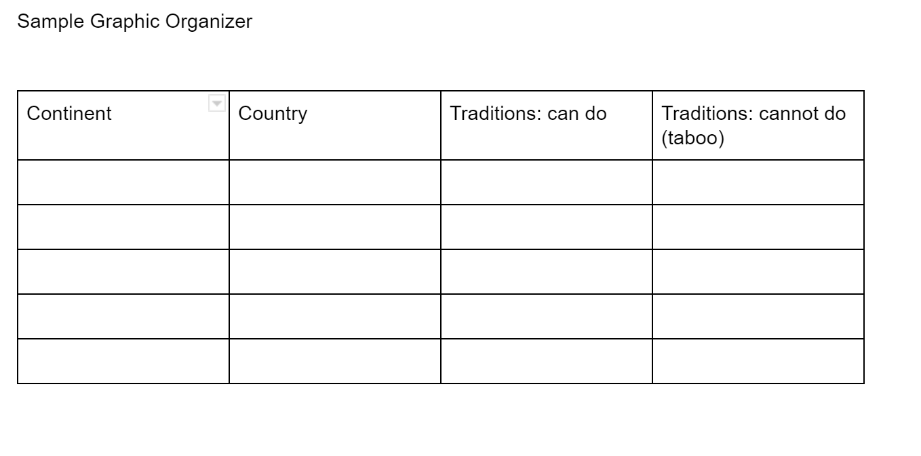
Sample Graphic Organizer

Venn Diagram
2-Circle
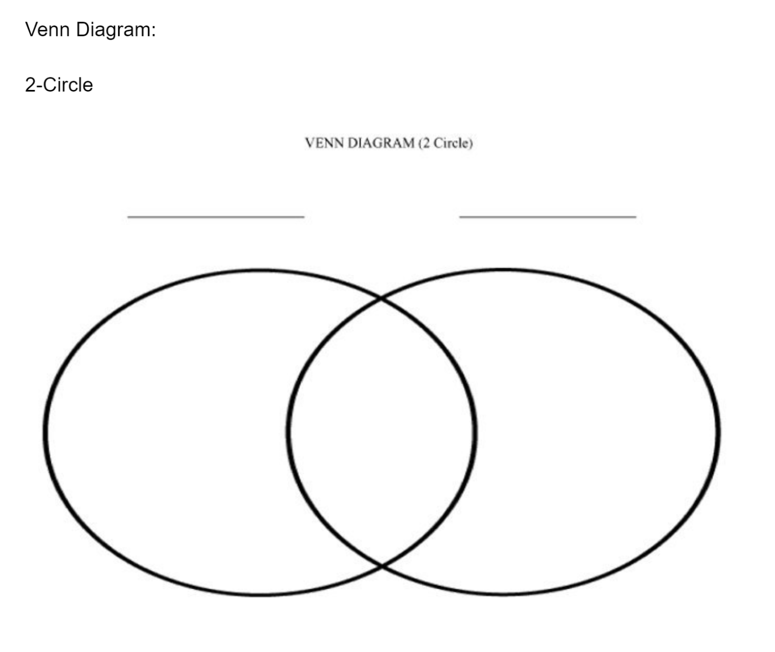

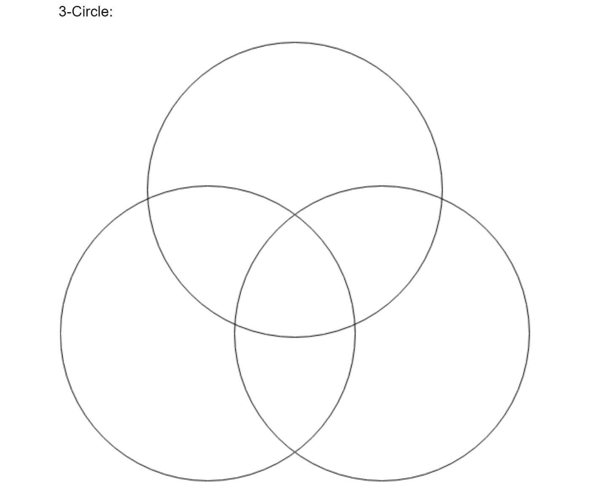
3 Circle
Pictorial Chart

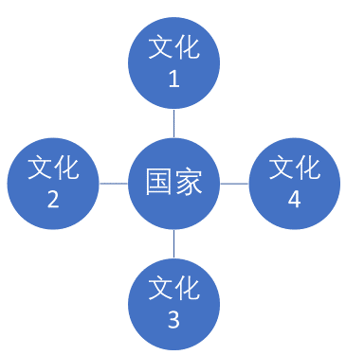
This is just an example. Please edit to fit your lesson.
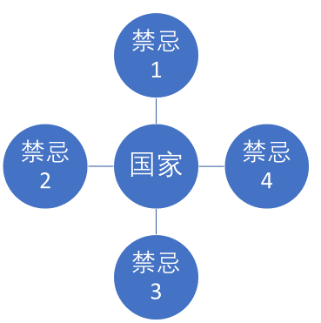

Appendix B
Unit 2 Materials
Back to Contents

Unit 2 (Global Organizations) resources:

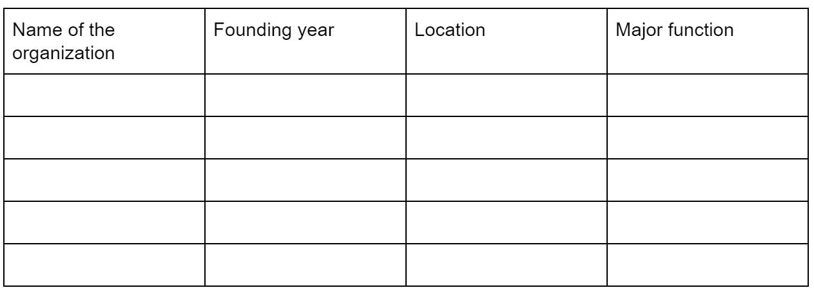
This work can be completed in English as a note-taking source
Venn Diagram
2-circle

3-Circle

Pictorial Chart: this is just an example. Please edit to fit your lesson.
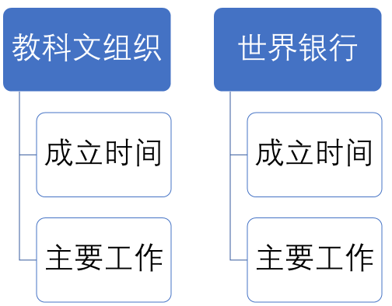
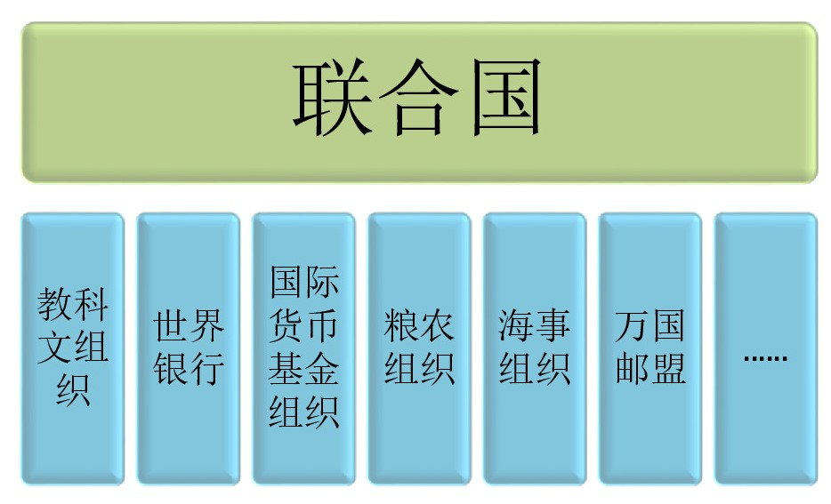

Appendix C
Unit 3 Materials
Back to Contents
Suggested reading materials:

- 联合国与各联合国机构 （英中文）
https://www.un.org/en/sections/about-un/funds-programmes-specialized-agencies-and-others/
- (UN Funds, Programmes, Specialized Agencies and Others)

https://www.un.org/zh/sections/about-un/funds-programmes-specialized-agencies-and-others/index.html (UN Funds, Programmes, Specialized Agencies and Others) (in Chinese)

- 地球村 https://www.itsfun.com.tw/%E5%9C%B0%E7%90%83%E6%9D%91/wiki-1078045

- 全球化与卫生(陈冯富珍博士在联合国大会上的讲话） https://www.who.int/dg/speeches/2008/20081024/zh/

- 什么是全球化
https://zh.wikipedia.org/zh-cn/%E5%85%A8%E7%90%83%E5%8C%96

- 经济全球化
https://baike.baidu.com/item/%E7%BB%8F%E6%B5%8E%E5%85%A8%E7%90%83%E5%8C%96

- 全球化的利弊
https://feng.ifeng.com/c/7jTmYKX0788
- 全球化和治理 https://www.un.org/chinese/aboutun/prinorgs/ga/millennium/sg/report/ch2.htm

Suggested video & audio materials:

1. 全球化的意义
https://www.youtube.com/watch?v=0OC7GKpuSp4

2.全球化的优缺点
https://www.youtube.com/watch?v=_Rok76Zn1-E

- 全球化
https://www.youtube.com/watch?v=NAGknVDKKUE

- 全球化对文化的影响
https://www.youtube.com/watch?v=CnJyX-PyYIg

- 全球经济问题：贫富差距
https://www.youtube.com/watch?v=Y5qawmzwWcY

6. 反全球化「公平贸易」 避免剥削环境永续 https://www.youtube.com/watch?v=ig1ngkCMPyo

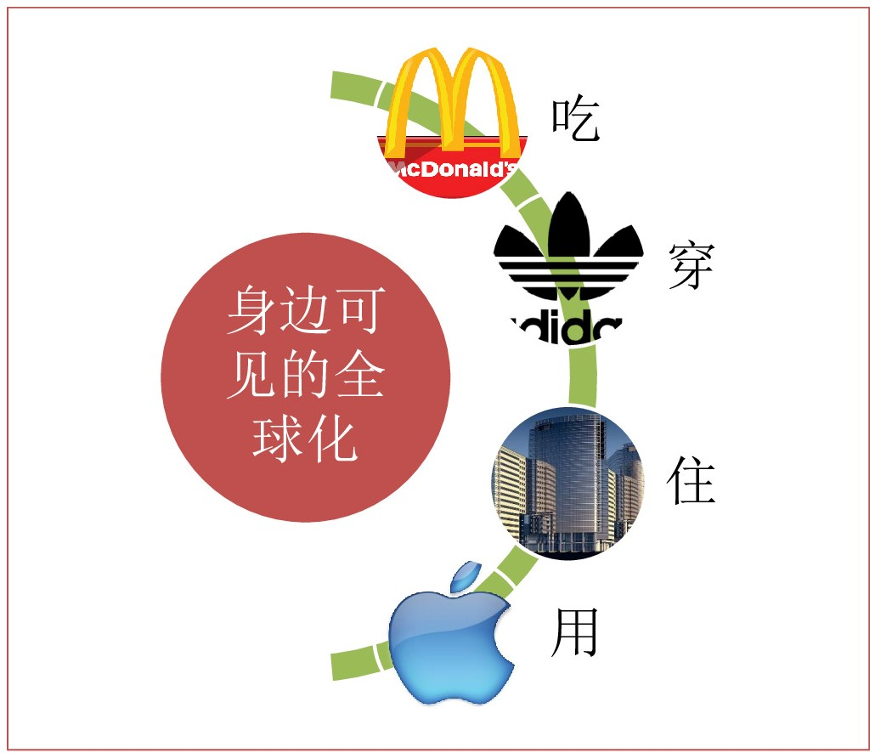

全球化的利弊

国际组织对全球化的推动

Unit 3 Example Reading Material 1
What is globalization?

什么是全球化？(老师可根据需要删减、简化或部分使用示例中的网络材料，下同。）

Recommended material: : https://zh.wikipedia.org/zh-cn/%E5%85%A8%E7%90%83%E5%8C%96

Sample questions
问题：
1.根据上述文章，什么是全球化？
2.IMF认为全球化包括哪些基本方面？
3.学术界一般将全球化分为哪几个方面？
4.请列举几个你身边的全球化的例子。

Appendix D
Unit 4 Materials
Back to Contents

Reading:
- 当今地球面临的十大环境问题
http://www.malaysiaeconomy.net/world_economy/world_lands/know_our_globe/2017-07-12/45765.html

- 21世纪初世界面临的主要环境问题+相关图片
http://www.kepu.net.cn/gb/earth/environment/globe/200205280269.html

- 芬兰的环境保护
https://finland.fi/zh/shenghuoyushehui/fenlandehuanjingbaohu/

- “中国环境问题二、三十年内难以解决”
https://www.bbc.com/zhongwen/simp/china/2013/07/130710_china_environment_south_north

- 《2018/19前沿报告》: 全球新兴的环境问题
https://www.unenvironment.org/zh-hans/resources/201819qianyanbaogao-quanqiuxinxingdehuanjingwenti

- 美国环保协会大事记
http://www.cet.net.cn/plus/list.php?tid=2

- 大气污染成因：
https://zhuanlan.zhihu.com/p/68026376
- 应对环境污染
https://www.un.org/zh/un60/60ways/envir.shtml

Audio & Video:
- 世界环境日：打击塑料污染
https://www.youtube.com/watch?v=PdEB41fUdkM

- 世界环境日：打击空气污染
https://www.youtube.com/watch?v=IyvevtXoRzc

- 全球暖化、气候变迁到底怎回事？
https://www.youtube.com/watch?v=wJ0jCuERsD8
- 地球的环境污染 （no audio）
https://www.youtube.com/watch?v=EwlWo4450EA

- 海洋污染 – 为保护海洋尽一份力量 (no audio) （1：57）
https://www.youtube.com/watch?v=qM0EQkkUnGE

- 全球环境议题
https://www.youtube.com/watch?v=kOz1QlbdYEs

- 塑料海洋危害地球
https://www.youtube.com/watch?v=iqCQ04_pngI

- 为保护我们的海洋尽一份力量 (Chinese caption)
https://www.youtube.com/watch?v=TMrBViAsMRk （1:36）

- 多数消费者支持“无塑料袋”计划 但收效存挑战
https://www.youtube.com/watch?v=kq0TRZcltQs （1:42）

- 马善高：整合力量 共同应对气候环境挑战 ）
https://www.youtube.com/watch?v=GUuzsWExNVw （1:07)

- 晨光聚焦：气候变化如何影响我国 政府又如何应对？
https://www.youtube.com/watch?v=tdfjZdmcqeQ （8:30）

- 3 creative ways to fix fashion's waste problem | Amit Kalra
https://www.youtube.com/watch?v=yeVU2Ff4ffc&t=108s （in English 9:47）

- 封城禁足 碳排放骤减 大自然給人类啥警示？
https://www.youtube.com/watch?v=-qMJu_VHqFM （7:11）

- 环保教育 (bilingual caption 3:21)
https://www.youtube.com/watch?v=w6vKAznM2w4


环保倡议书(1)
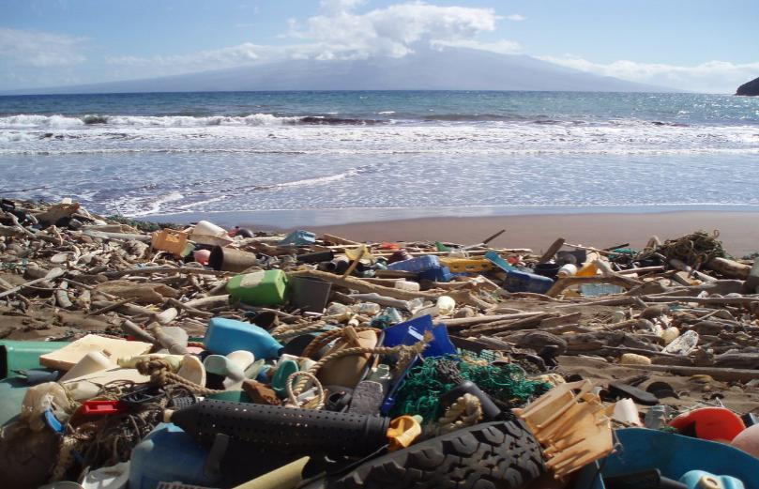  A |   B
  C |   D

环保倡议书(2)
调查表
小组成员
污染名称
污染形成的原因
环保倡议书 | 我们应该…… | 我们不应该……

