USHC Unit 8 America in Transition 2020
Appendix G: Great Depression Effects Primary Sources adapted from New Visions for Public Schools

Great Depression Effects Primary Sources
Document A  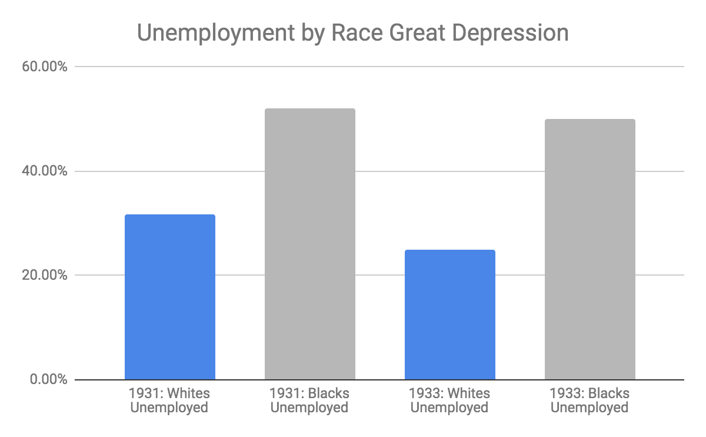  Unemployment Rate: The unemployment rate is the percentage of the labor force that is willing and able to work, does not currently have a job, and is actively looking for employment. The labor force consists of people ages 16 and over who are employed or actively seeking work. | Document B  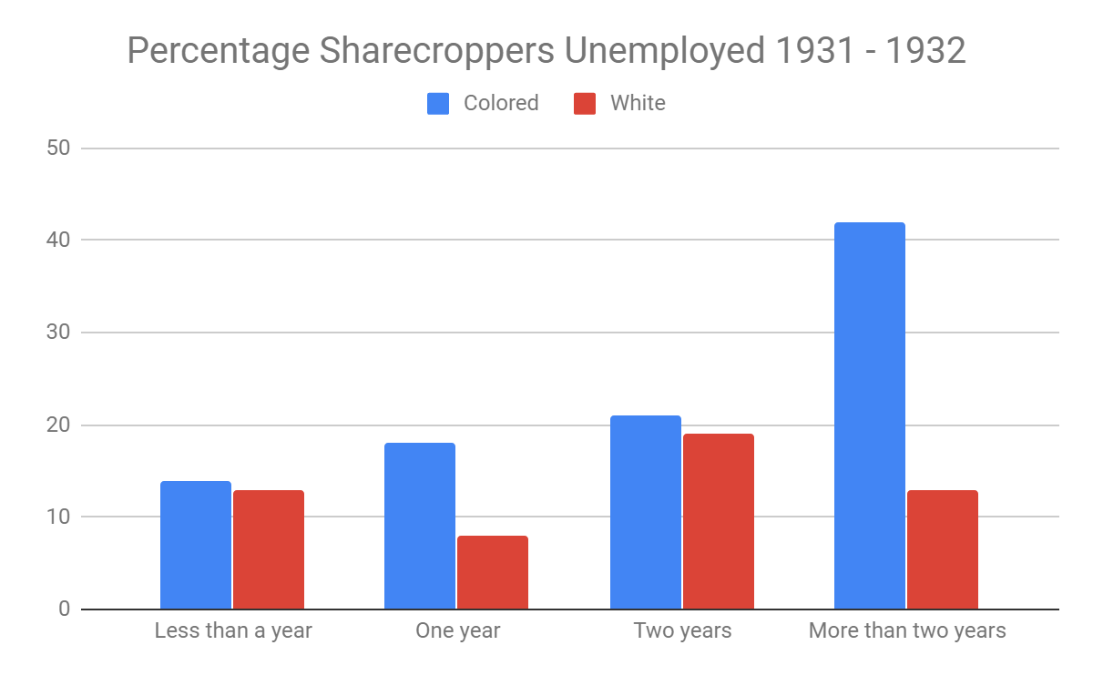  Sharecroppers: Sharecroppers were amongst the poorest of farmers, they rented land from a larger land owner to farm. During the Great Depression, many sharecroppers lost their land. According to much of the data collected, race played a factor in whether or not farmers were unemployed.
Document C  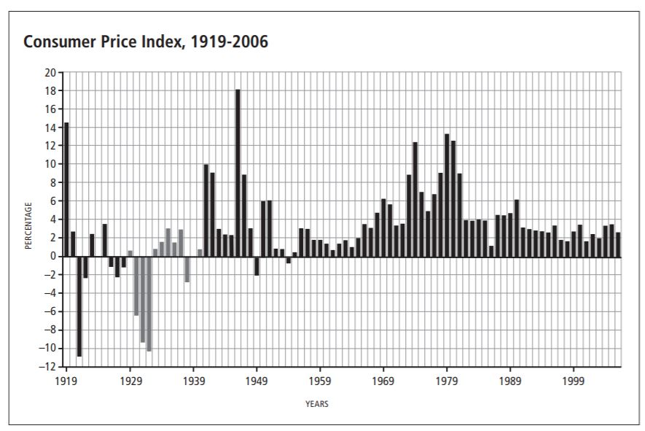  Great Depression  Consumer Price Index: A measure of the average change over time in the prices paid by consumers for a market basket of consumer goods and services. It indicates the cost of living for a typical consumer. Negative CPI suggests that there is a steady decrease in the prices of goods and services, which suggests that unemployed Americans can’t buy any goods and services at any price. | Document D  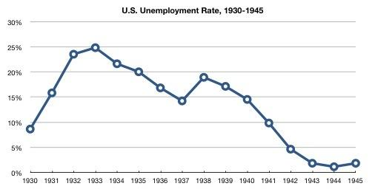  Unemployment Rate: The unemployment rate is the percentage of the labor force that is willing and able to work, does not currently have a job, and is actively looking for employment. The labor force consists of people ages 16 and over who are employed or actively seeking work.
Document E  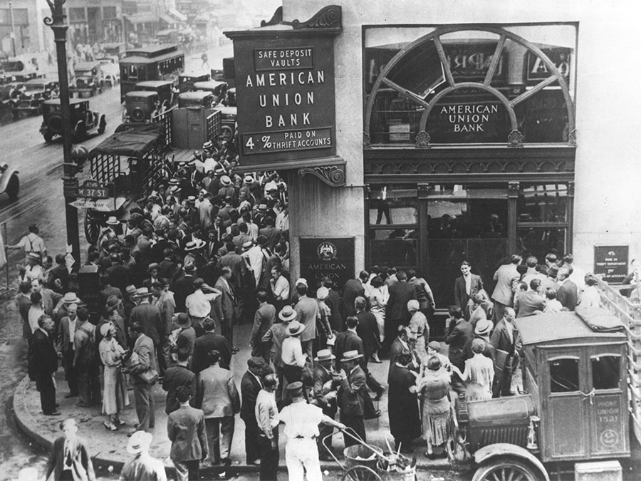 | Document F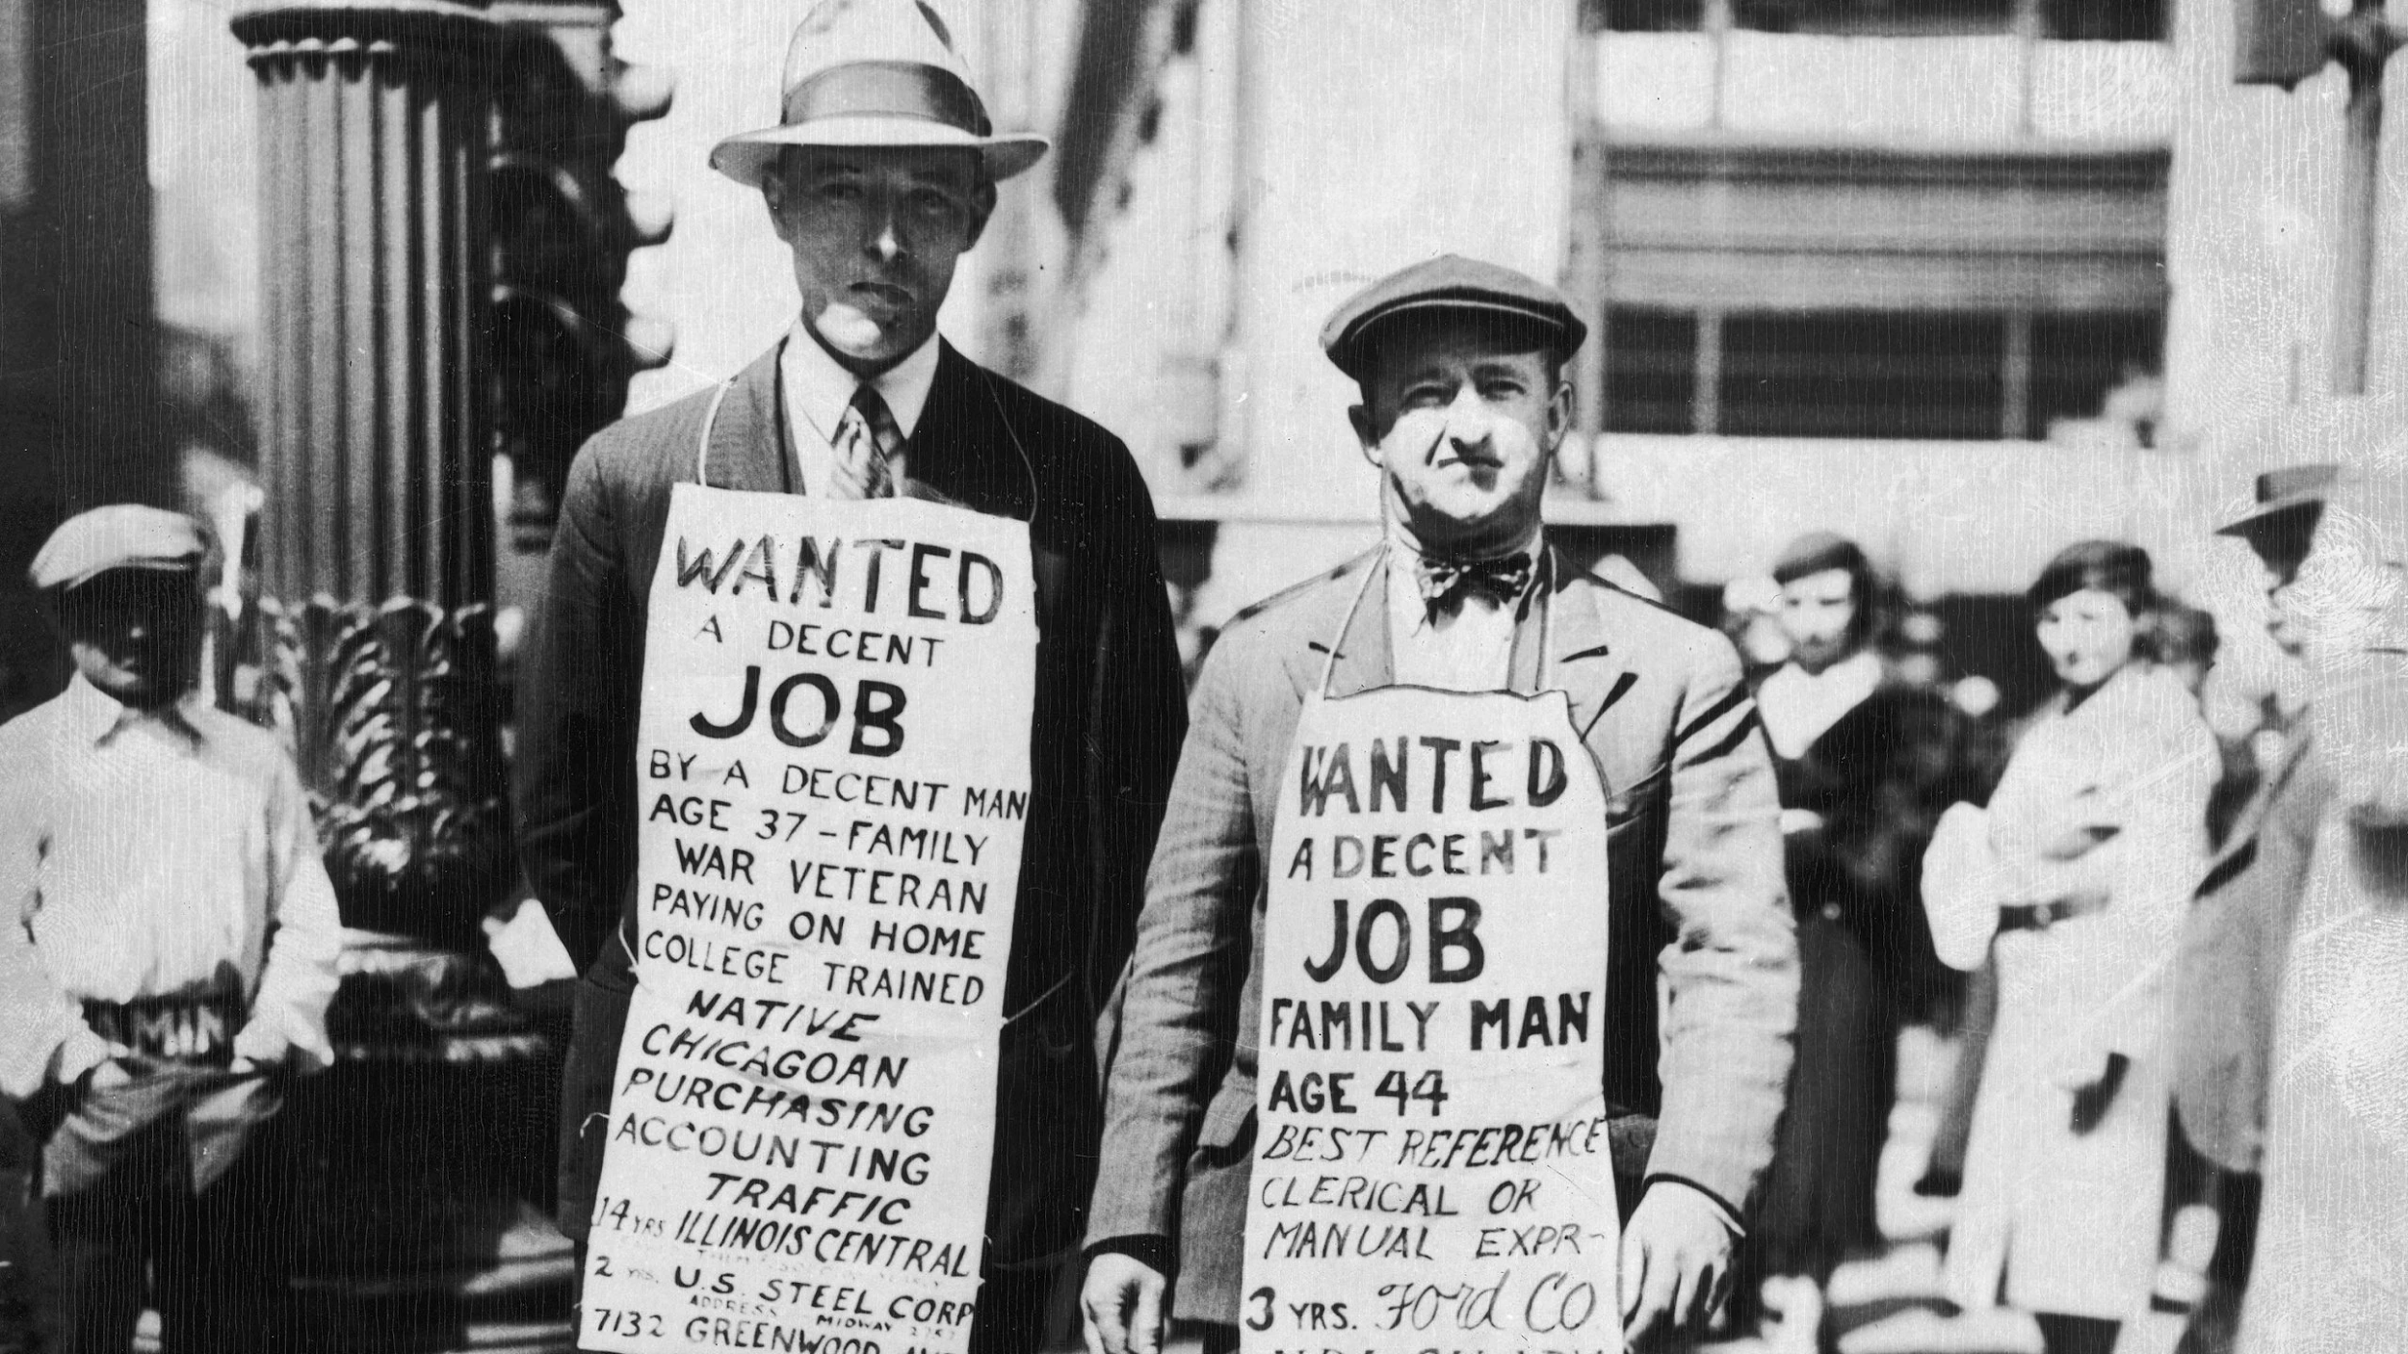
Document G  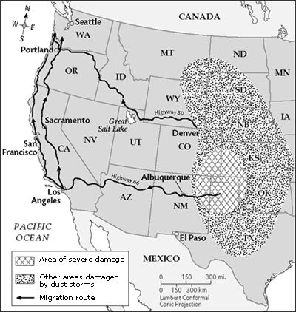 | Document H  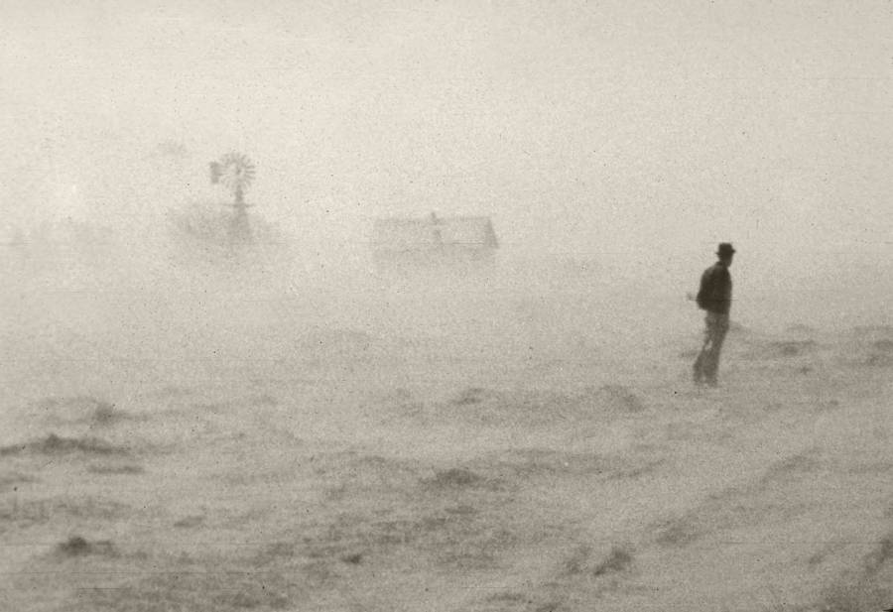  A dust storm rages at an unspecified location, circa 1930s.  United States Department of Agriculture via Wikimedia Commons
Document I  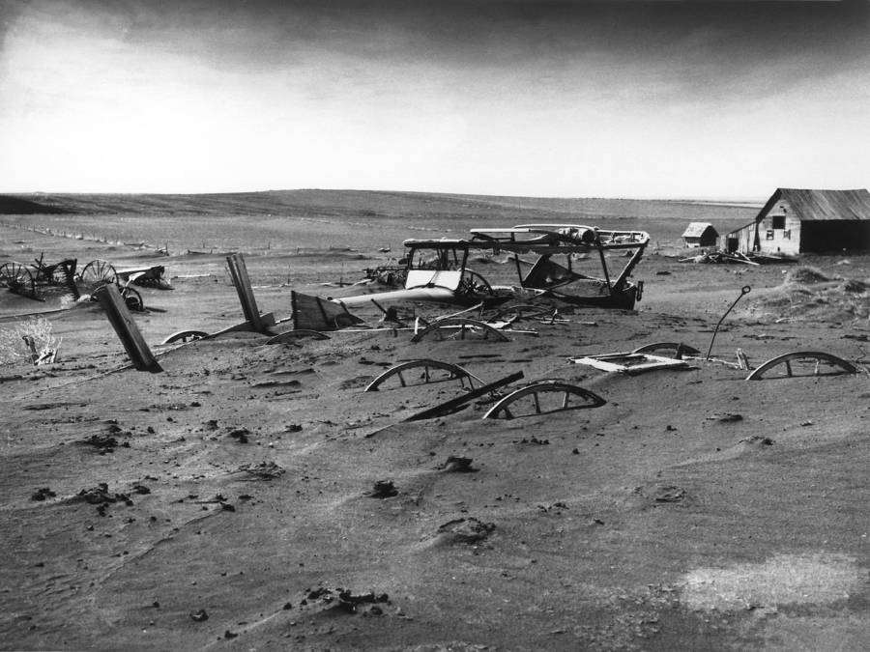  Farm machinery buried by a dust storm near a barn lot in Dallas, South Dakota, May 1936.  United States Department of Agriculture via Wikimedia Commons | Document J  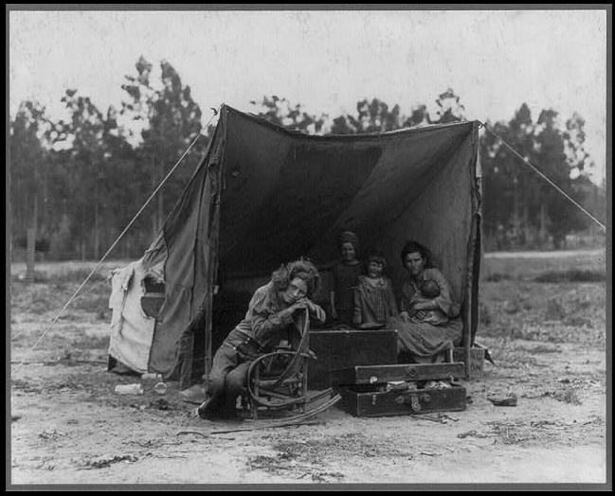  Caption: Agricultural worker's family. Seven hungry children. Mother aged thirty-two. Father is native Californian. Taken in: Nipomo, California  Photographer: Dorothea Lange  Date: February or March 1936  Original Image: Library of Congress

