South Carolina Department of Education
South Carolina College- and Career-Ready Standards for Mathematics
7th Grade Support Document

Office of Standards and Learning
July 2020 - DRAFT



The mathematics support documents have been created by teachers for teachers. This is a working document. Based on feedback from classroom application, revisions will continue. During 2019-2020, a team of teachers from 31 districts developed units of instruction. These units are not intended to be a pacing guide. The strategies in the units are not all-inclusive for specific content instruction. Tasks within the units of instruction are not presented in a particular order, but are numbered for ease of reference.
Mathematical Process Standards: The South Carolina College- and Career-Ready (SCCCR) Mathematical Process Standards demonstrate the ways in which students develop conceptual understanding of mathematical content and apply mathematical skills. As a result, the SCCCR Mathematical Process Standards should be integrated within the SCCCR Content Standards for Mathematics for each grade level and course. Since the process standards drive the pedagogical component of teaching and serve as the means by which students should demonstrate understanding of the content standards, the process standards must be incorporated as an integral part of overall student expectations when assessing content understanding.

- Make sense of problems and persevere in solving them.  - Relate a problem to prior knowledge.  - Recognize there may be multiple entry points to a problem and more than one path to a solution.  - Analyze what is given, what is not given, what is being asked, and what strategies are needed, and make an initial attempt to solve a problem.  - Evaluate the success of an approach to solve a problem and refine it if necessary. | - Use a variety of mathematical tools effectively and strategically.  - Select and use appropriate tools when solving a mathematical problem.  - Use technological tools and other external mathematical resources to explore and deepen understanding of concepts.
- Reason both contextually and abstractly.  - Make sense of quantities and their relationships in mathematical and real-world situations.  - Describe a given situation using multiple mathematical representations.  - Translate among multiple mathematical representations and compare the meanings each representation conveys about the situation.  - Connect the meaning of mathematical operations to the context of a given situation. | - Communicate mathematically and approach mathematical situations with precision.  - Express numerical answers with the degree of precision appropriate for the context of a situation.  - Represent numbers in an appropriate form according to the context of the situation.  - Use appropriate and precise mathematical language.  - Use appropriate units, scales, and labels.
- Use critical thinking skills to justify mathematical reasoning and critique the reasoning of others.  - Construct and justify a solution to a problem.  - Compare and discuss the validity of various reasoning strategies.  - Make conjectures and explore their validity.  - Reflect on and provide thoughtful responses to the reasoning of others. | - Identify and utilize structure and patterns.  - Recognize complex mathematical objects as being composed of more than one simple object.  - Recognize mathematical repetition in order to make generalizations.  - Look for structures to interpret meaning and develop solution strategies.
- Connect mathematical ideas and real-world situations through modeling.
- Identify relevant quantities and develop a model to describe their relationships.
- Interpret mathematical models in the context of the situation.
- Make assumptions and estimates to simplify complicated situations.
- Evaluate the reasonableness of a model and refine if necessary.

Unit 1 | Unit 2 | Unit 3 | Unit 4 | Unit 5 | Unit 6 | Unit 7
Rational Numbers | Expressions and Equations | Ratios and Proportions | Geometry | Algebraic Geometry | Statistics | Probability
Standards | Standards | Standards | Standards | Standards | Standards | Standards
7.NS.1  7.NS.2  7.NS.3 | 7.EEI.1  7.EEI.2  7.EEI.3  7.EEI.4  7.EEI.5  7.NS.4  7.NS.5 | 7.RP.1  7.RP.2  7.RP.3  7.EEI.4  7.GM.1 | 7.GM.1  7.GM.2  7.GM.3 | 7.GM.4  7.GM.5  7.GM.6  7.EEI.4b | 7.DSP.1  7.DSP.2  7.DSP.3  7.DSP.4 | 7.DSP.5  7.DSP.6  7.DSP.7  7.DSP.8

Unit 1  Rational Numbers | Unit 2  Expressions and Equations | Unit 3  Ratios and Proportions
Content Standards With Clarifying Notes  New Academic Vocabulary  Prior Knowledge  Subsequent Knowledge  Relationship Among Standards  Potential Instructional Strategies  Resource Links  Task 1: Underwater Treasure: Investigating Integers through Elevation and Sea-Level  Task 2: Ethan and Annie’s Money Madness  Task 3: Dining Out Decimals: Operations with Decimals through Menus and Bills  Task 4: Baking Brownies: Exploring Operations With Fractions | Content Standards With Clarifying Notes  New Academic Vocabulary  Prior Knowledge  Subsequent Knowledge  Relationship Among Standards  Potential Instructional Strategies  Resource Links  Task 1: Ordered Chaos: Using the Order of Operations  Task 2: Movie Money: Comparing Similar Expressions  Task 3: Journey through Multi-Step Equations  Task 4: Sports Equipment Set  Task 5: Money Wise (Ordering Fractions) | Content Standards With Clarifying Notes  New Academic Vocabulary  Prior Knowledge  Subsequent Knowledge  Relationship Among Standards  Potential Instructional Strategies  Resource Links  Task 1: Unit Rates, Proportional Relationships & Complex Fractions  Task 2: Shirt Sale Proportions  Task 3: Talking Turkey and Taxes: Percentages  Task 4: The Car of Your Dreams: Summative Project for Percentages  Task 5: Similar Shapes

Unit 4  Geometry | Unit 5  Algebraic Geometry | Unit 6  Statistics
Content Standards With Clarifying Notes  New Academic Vocabulary  Prior Knowledge  Subsequent Knowledge  Relationship Among Standards  Potential Instructional Strategies  Resource Links  Task 1: Mona Lisa Math  Task 2: Constructing Triangles and Quadrilaterals  Task 3: Cross-Sections | Content Standards With Clarifying Notes  New Academic Vocabulary  Prior Knowledge  Subsequent Knowledge  Relationship Among Standards  Potential Instructional Strategies  Resource Links  Task 1: Toilet Paper Tube Design  Task 2: Surface Area and Volume | Content Standards With Clarifying Notes  New Academic Vocabulary  Prior Knowledge  Subsequent Knowledge  Relationship Among Standards  Potential Instructional Strategies  Resource Links  Task 1: Making Sense of Data Box-Plot Football

Unit 7
Probability
Content Standards With Clarifying Notes  New Academic Vocabulary  Prior Knowledge  Subsequent Knowledge  Relationship Among Standards  Potential Instructional Strategies  Resource Links  Task 1: Is the game fair or unfair? | References

Unit 1 Content Standards with Clarifying Notes
Open bullets indicate clarifying notes.
Return to Table of Contents
7.NS.1 Extend prior knowledge of operations with positive rational numbers to add and to subtract all rational numbers and represent the sum or difference on a number line.
a. Understand that the additive inverse of a number is its opposite and their sum is equal to zero.
b. Understand that the sum of two rational numbers (p + q) represents a distance from p on the number line equal to |q| where the direction is indicated by the sign of q.
c. Translate between the subtraction of rational numbers and addition using the additive inverse, p − q = p + (−q).
d. Demonstrate that the distance between two rational numbers on the number line is the absolute value of their difference.
e. Apply mathematical properties (e.g., commutative, associative, distributive, or the properties of identity and inverse elements) to add and subtract rational numbers.
  - Understand, apply, and explain the additive inverse
  - Model addition and subtraction of rational numbers, including integers, decimals, and fractions using visual models
7.NS.2 Extend prior knowledge of operations with positive rational numbers to multiply and to divide all rational numbers.
a. Understand that the multiplicative inverse of a number is its reciprocal and their product is equal to one.
b. Understand sign rules for multiplying rational numbers.
c. Understand sign rules for dividing rational numbers and that a quotient of integers (with a non-zero divisor) is a rational number.
d. Apply mathematical properties (e.g., commutative, associative, distributive, or the properties of identity and inverse elements) to multiply and divide rational numbers.
e. Understand that some rational numbers can be written as integers and all rational numbers can be written as fractions or decimal numbers that terminate or repeat.
  - Understand, apply, and explain the multiplicative inverse
  - Model multiplication and division of rational numbers, including integers, decimals, and fractions using visual models
  - Explain why division by zero is undefined
7.NS.3 Apply the concepts of all four operations with rational numbers to solve real-world and mathematical problems.
  - Model and solve real-world problems using numbers and operations
  - Explain the solution to a real-world problem in the context of the problem
  - Interpret the reasonableness of solutions in the context of the problem

Unit 1 New Academic Vocabulary for This Unit
Return to Table of Contents
- Integer
- Positive
- Negative
- Additive inverse
- Zero pairs
- Multiplicative inverse
- Terminating decimal
- Repeating decimal

Unit 1 Prior Knowledge Required for this Unit
Return to Table of Contents
- Fluent with operations of positive rational numbers (4.NSBT.4, 5.NSBT.5, 5.NSF.1, 5.NSF.4, 6.NS.1, 6.NS.2, 6.NS.3)
- Understand and perform operations using absolute value (6.NS.7)
- Fluent understanding of mathematical properties (e.g., commutative associative, distributive, or the properties of identity and inverse elements)(3.ATO.5, 4.NSBT.6, 5.NSBT.6, 6.EEI.3, 6.EEI.4)
- Fluent with the Order of Operations with positive rational numbers (3.ATO.8, 4.ATO.3, 5.ATO.1, 6.EEI.1, 6.EEI.2)

Unit 1 Subsequent Knowledge Related to this Unit
Return to Table of Contents
This unit will lead to mastery of the Order of Operations involving the fraction bar as a grouping symbol with integers in Grade 7. These standards will also guide students when solving expressions, equations, and inequalities with rational coefficients. The introduction of terminating and repeating decimals will extend to an understanding of 7.NS.5 involving the translation among multiple representations of rational numbers excluding a repeating decimal to a fraction. In Grade 8, students will continue to solve linear equations and inequalities with rational numbers; mastery of these skills will lay a strong foundation for success in high school math courses. In Grade 8, students will extend their knowledge to multiple representations of rational and irrational numbers.

Unit 1 Relationship Among Standards in this Unit
Return to Table of Contents
Standards in this unit are all necessary to develop computational skills necessary for work with rational numbers.

Unit 1 Potential Instructional Strategies
Return to Table of Contents
- Visual models
  - Two color counters
  - Addition and Subtraction
  - Heaps and Holes: Explain to your students that +1 is like a pile (or heap) of sand on a level beach. A hole of equivalent size dug into the beach represents -1. This model explains positives as a surplus and negatives as a deficit. (See page 9)
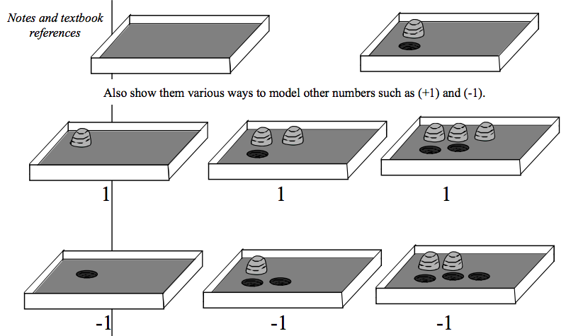
Source: NC Grade 7 Classroom Strategies (pages 10-12)
  - Multiplication
  - Number line (horizontal and vertical)
- Tracking Text: This strategy is used to process a word problem. The process entails underlining essential information needed to solve the given problem, including the labels as well as circling important math terms and renaming them with known vocabulary to assist in understanding what process to follow when solving for the answer.

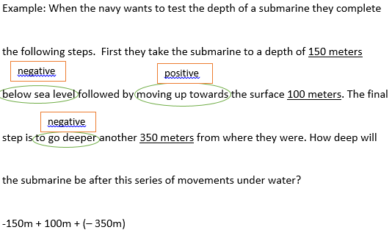

Unit 1 Resources
Return to Table of Contents
Elementary and Middle School Mathematics: Teaching Developmentally, Eighth Edition (older editions can be used as well) By John A. Van de Walle, Karen S. Karp, and Jennifer M. Bay-Williams
ISBN-10: 0132612267; ISBN-13: 9780132612265

7.NS.1 - 7.NS.3 - This Jeopardy game provides students with a computational review of operations with rational numbers. 7th Grade Numbers and Operations Jeopardy

Course/Grade: 7th  Unit: 1 | Task Title: Task 1 Underwater Treasure: Investigating Integers through Elevation and Sea-Level  Return to Table of Contents
State Standards Addressed | 7.NS.1 Extend prior knowledge of operations with positive rational numbers to add and subtract all rational numbers and represent the sum or difference on the number line.  7.NS.1a Understand that the additive inverse of a number is its opposite and their sum is equal to zero.  7.NS.1b Understand that the sum of two rational numbers (p + q) represents a distance from p on the number line equal to |q| where the direction is indicated by the sign of q.  7.NS.1c Translate between the subtraction of rational numbers and addition using the additive inverse, p − q = p + (−q).  7.NS.1d Demonstrate that the distance between two rational numbers on the number line is the absolute value of their difference.  7.NS.3 Apply the concepts of all four operations with rational numbers to solve real-world and mathematical problems.
Mathematical Process Standards Addressed | 1a. Relate a problem to prior knowledge.  1d. Evaluate the success of an approach to solve a problem and refine it if necessary.  2a. Make sense of quantities and their relationships in mathematical and real-world situations.  6b. Represent numbers in an appropriate form according to the context of the situation.  6d. Use appropriate units, scales, and labels.  7c. Look for structures to interpret meaning and develop solution strategies.
Materials and Resources | Pictures of different elevations  Legos (optional)  clay (optional)  graph or blank paper  positive and negative counters  teacher model  number line
Task Description | Teacher note: Start by giving students a brief overview of sea-level and elevation. Reference real-world elevation differences, such as the bottom of a nearby lake compared to a bridge, or various mountains and valleys. Show students this image:  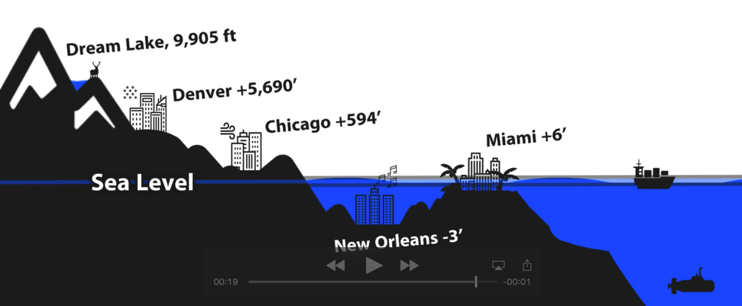  Explain that elevation can be positive or negative, depending on whether it is above or below sea-level. For example, New Orleans is three feet below sea level, which gives it an elevation of -3 feet.  Using the picture, have students answer the following questions:  - What is the difference in elevation between Chicago and New Orleans?  - Death Valley has an elevation of -282 feet. Is it above or below sea-level? How do you know?  - In Chicago, Monica dives 8 feet into a pool. She says that she was at an elevation of -8 feet. Do you agree with Monica? Why or why not?  Teacher note: Either in pairs or small groups, have students create a city that is partially underwater or flooded (such as Atlantis). If students have access to technology, encourage them to research cities that are underwater or flooded. In their creation, there must be three features that have a positive elevation (buildings, farms, trees, etc.) and three features that have a negative elevation (sunken ships, sunken buildings, treasure chest, valley, etc.). One feature above water and one feature below water must be the exact same distance from sea-level. Students may draw the city on paper, or use clay/other art materials to model the city. Students MUST designate where the sea level is located, and label the elevation of each feature (this is a great opportunity to explain scale modeling).  Once students have finished their models, provide them with the following tasks.  - A treasure chest is found at the lowest elevation. Indicate where this treasure chest is located.  - You bring the treasure chest up to the top of the water. How many feet has the treasure chest traveled?  - Should this value be positive or negative? Why?  - Captain Sparrow is located the highest point above water. He comes down to meet you at sea level.  - How far downward has Captain Sparrow traveled?  - If Captain Sparrow dove ten feet underwater, what was his total distance traveled downward?  - Draw a number line and plot all six features. What are some of your observations?  - Glacier melt causes the sea level to rise five feet. How does this affect the elevation of the city (specifically the objects underwater and above water)?  Questions for class discussion:  - How could you explain absolute value using your diagram?  - Explain to students that absolute value is the distance from any object to sea-level, or zero. This is why the absolute value will never be negative.  - Students should have some prior knowledge of absolute value.  - Additive inverse is when two numbers add together to make zero, also called a “zero-pair.” Create a different real-world example that demonstrates additive inverse.  - List all of the elevations that were featured on your model. How many different numbers can you create by adding and subtracting these integers?
Equitable Access | Students will work together in collaborative groups of two/four. This will ensure that all students are actively engaged and can voice their thoughts and hear the ideas of others. You may use the Kagan grouping* or any grouping strategy that provides student-centeredness.  *This is a strategy where they are seated in groups of four, heterogeneous preferably, where each person has a number 1-4. 1&2 will be shoulder partners while 3&4 likewise. They will do a pair-share then a table-share to elaborate on their answers.  Refer to local events/structures to help students understand the concept of sea-level and flooding, such as the Columbia Flood, Lake Murray, Lake Hartwell, etc.  Scaffolding measures could include providing students with a picture of different elevations and having them label the elevations, or having students draw their different features on a number line vertically rather than a sea-level drawing.
Mathematical Vocabulary | elevation  integer  positive  negative  additive inverse  absolute value  distance  sea-level  zero-pair
Student Reflection | You may use this structure for students reflection:  - What was the main idea you learned today?  - What is something you are struggling with or have questions about?  - How could the idea from today’s lesson/class be used in real life? (Mathematical Mindsets: Jo Boaler)  - How could you create another example (non-elevation) using positive and negative integers?

Course/Grade: 7th  Unit: 1 | Task Title: Task 2 Ethan and Annie’s Money Madness  Return to Table of Contents
State Standards Addressed | 7.NS.2 Extend prior knowledge of operations with positive rational numbers to multiply and to divide all rational numbers.  7.NS.2b. Understand sign rules for multiplying rational numbers.  7.NS.2c. Understand sign rules for dividing rational numbers and that a quotient of integers (with a non-zero divisor) is a rational number.  7.NS.2d. Apply mathematical properties (e.g., commutative, associative, distributive, or the properties of identity and inverse elements) to multiply and divide rational numbers.  7.NS.3 Apply the concepts of all four operations with rational numbers to solve real-world and mathematical problems.
Mathematical Process Standards Addressed | 1b. Recognize there may be multiple entry points to a problem and more than one path to a solution.  2d. Connect the meaning of mathematical operations to the context of a given situation.  3c. Make conjectures and explore their validity.  6b. Represent numbers in an appropriate form according to the context of the situation.  7c. Look for structures to interpret meaning and develop solution strategies.
Materials and Resources | Optional extension: Multiplying Negatives  Paper, pencil
Task Description | Teacher note: begin by leading a class discussion about “double negatives.” For example, “I can’t not cheer at a football game!” Have students come up with creative double negatives. This could be done as a discussion, in an independent journal, with partners, on a whiteboard, or via technology. Encourage students to think about double negatives in the context of money, weather, or other numeric scenarios. This will ease the transition to the first activity. Students should try to list as many examples as possible. Take 1-2 minutes to explore the silly sentences as a class.  Part I  Teacher note: this activity intends to explore multiplying and dividing positives and negatives. The idea in this section is that students will view multiplying positives and negatives in sentence form prior to numerical form. Have students work in partners.  Identify whether money is gained or lost by Annie and Ethan.  (SCDE, 2019)  Teacher note: lead a class discussion on how you can decide whether money was gained or lost.  Based on your answer, create a rule that helps you decide whether money is gained or lost.  Class Discussion: Come up with three examples of losses or gains for Annie and Ethan. Does your rule work? Why or why not? Talk to a partner.  Teacher note: Introduce the sign rules for multiplying with negatives. Explain how multiplication is one thing modifying another, so when a negative modifies a negative, it becomes positive. Show students how Annie and Ethan’s gains/losses represent multiplying negatives and positives. Then, ask students to complete the next table.  (SCDE, 2019)  Draw a number line to represent each of Annie and Ethan’s gains and losses. Be sure to start each gain or loss at zero.  Did your rule for gains and losses work? If not, how could you adapt it?  If Ethan has 2 water bills for $100, how much will he lose?  What if Ethan has 100 water bills for $2 each? Are these the same or different? Why?  Teacher note: this is intended to introduce the idea that the order of multiplication terms does not affect the answer.  Part II  Teacher note: lead a class discussion to help students realize rules for division. Have students complete the following table and use as a guide for discussion. It is important students understand that $10÷-2$ and $-10÷2$ are the same thing, therefore their sign rules are the same.  (SCDE, 2019)
  Problem | Gained or lost?
  Annie loses four $5 bills.
  Ethan gets two water bills for $100 each.
  Someone takes away Ethan’s two water bills of $100.
  Annie pays $30 per hour for two hours.
  Problem | Gain or Loss | Answer
  Annie has 4*5
  Ethan has 2*-100
  Ethan has -2*-100
  Annie has -30*2
  Equation | Phrase | Answer
  $$10÷2$$ | 10 split into 2
  $$10÷-2$$ | 10 split into -2
  $$-10÷2$$ | -10 split into 2
  $$-10÷-2$$ | -10 split into -2
Equitable Access | Students will work together in collaborative groups of two/four to offer equitable access. By operating with money, all students have an entry point because of common understanding and prior knowledge. These discussions should offer all students high-level content and encourage students to think deeply about mathematics.
Mathematical Vocabulary | integer  positive  negative  multiplicative inverse  mathematical properties  absolute value
Student Reflection | - What are five ways to represent a negative number in the real world?  - What are five ways to represent a positive number in the real world?  - How did you come up with a rule to decide gains and losses?  - Yali says a negative multiplied by a negative becomes more negative, but Keyandre says a negative multiplied by a negative makes a positive. Who is correct and why?

Course/Grade: 7th  Unit: 1 | Task Title: Task 3 Dining Out Decimals: Operations with Decimals through Menus and Bills  Return to Table of Contents
State Standards Addressed | 7.NS.1 Extend prior knowledge of operations with positive rational numbers to add and subtract all rational numbers and represent the sum or difference on the number line.  7.NS.1e. Apply mathematical properties (e.g., commutative, associative, distributive, or the properties of identity and inverse elements) to add and subtract rational numbers.  7.NS.2 Extend prior knowledge of operations with positive rational numbers to multiply and to divide all rational numbers.  7.NS.2d. Apply mathematical properties (e.g., commutative, associative, distributive, or the properties of identity and inverse elements) to multiply and divide rational numbers.  7.NS.2e. Understand that some rational numbers can be written as integers and all rational numbers can be written as fractions or decimal numbers that terminate or repeat.  7.NS.3 Apply the concepts of all four operations with rational numbers to solve real-world and mathematical problems.
Mathematical Process Standards Addressed | 1a. Relate a problem to prior knowledge.  2d. Connect the meaning of mathematical operations to the context of a given situation.  4c. Make assumptions and estimates to simplify complicated situations.  7b. Recognize mathematical repetition in order to make generalizations.
Materials and Resources | Paper or technology device  crayons/markers/colored pencils  fake money (optional)
Task Description | Part I  Teacher’s note: the focus of part I is that students are exploring how to add and subtract decimals. Do not provide direct instruction before beginning this task.  Students will design a menu that contains at least five items on it. Each item’s cost must have a value to the hundredths place, ex. Hamburger $1.97 or Coca-Cola $1.57. Students may work individually or in pairs. Students should leave some space at the bottom of the page for further operations.  (Teacher note: Have art supplies on hand for students to decorate their menus)  Here is an example menu:  (SCDE, 2019)  Have students create a bill that adds up three items on the menu. Make sure they put the total at the bottom. Students should answer the following questions.  - How did you add up the three items?  Teacher note: Students may find the total a variety of ways, but they should not use a calculator yet. Students could draw coins and dollar bills, round up and subtract, round down and add, etc. Encourage students who are struggling to draw a picture or imagine that they themselves were going to a restaurant. If possible, provide students with fake money to assist. If students are struggling with three items, adjust it to two items. Do not show students a procedure for adding decimals yet.  - What did you notice about how they added up?  Teacher note: The key focus here is that students are able to add hundredths and tenths, tenths and get to ones, and so on. If using fake money, you can show students how ten pennies make a dime.  - Explain how to add money together. You may draw a picture if you like, in addition to your description.  Teacher note: students should be able to verbally describe how they add money together. Be sure that they understand that ten hundredths make a tenth. The goal is that this information will transfer when decimals are further out, such as thousandths or ten-thousandths.  - You receive a discount of $2.15. What is the new total?  Teacher note: at this stage, some students may benefit by “taking apart” $2.15 into $0.05 + $0.10 +$2.00. They can then see that they could simply subtract each piece. However, allow space for students to struggle with this problem. If the answer is incorrect, ask them are they sure they took off tenths (dimes), hundredths (pennies), and dollars (ones). Make sure students understand the connection between the money and the decimal places.  - How did you take off the money? What did you have to do?  Teacher note: students should be able to elaborate on how to subtract money. Draw a connection between how to subtract decimals.  - The manager says instead of your $2.15 discount, you can have a coupon for 20% off. Which one should you take? Why?  Teacher note: at this point, students should not have much understanding of how to subtract a percentage. However, they should be able to reach the conclusion that 20% is $0.20 for every dollar and make a reasonable estimation. If this question overextends your students, use it as a challenge question for early finishers.  Part II  Teacher note: part II is intended to extend information from part I to help with addition and division. Using fake money is very helpful in this scenario, as students can see how to split it evenly. Students should see that if there aren’t enough of a certain denomination to go around (ex., dollar bills), then they will have to split it into smaller amounts.  Using the provided bill, answer the following questions. Students should draw a picture if it is helpful to them.  (SCDE, 2019)  - What is the total cost of the meal?  Teacher note: this relies on information and skills from part I. Allow students to add however they see fit.  - Four friends are going to split the total cost. How much does each person need to pay?  Teacher note: fake money may be especially useful during this section. Pay attention to the order in which students split the money. Most likely, students will work from the whole dollar down to the penny, much like you would work in a long division problem. This particular problem will provide a challenge, because there will be a remainder of one penny. Lead students in a discussion of how it doesn’t make sense to split the one penny, but if you could, how would you do it? This leads to the next question.  - Is it possible for each person to pay the exact same amount, down to the penny? Why or why not?  - Kicky the Chicken is on the street handing out gift cards for $3.33 each to celebrate the restaurant’s third year. How many gift cards would you need to pay the bill completely?  Teacher note: most students will add up $3.33 several times. Keep an eye out for responses that divide the total by $3.33 to get an exact number, and discuss if it is logical to have a decimal portion of a gift card.  - What would be leftover on the gift cards?  - For every dollar you spend on fast food, your waiter makes $1.7892. How much money did your waiter make after this meal?  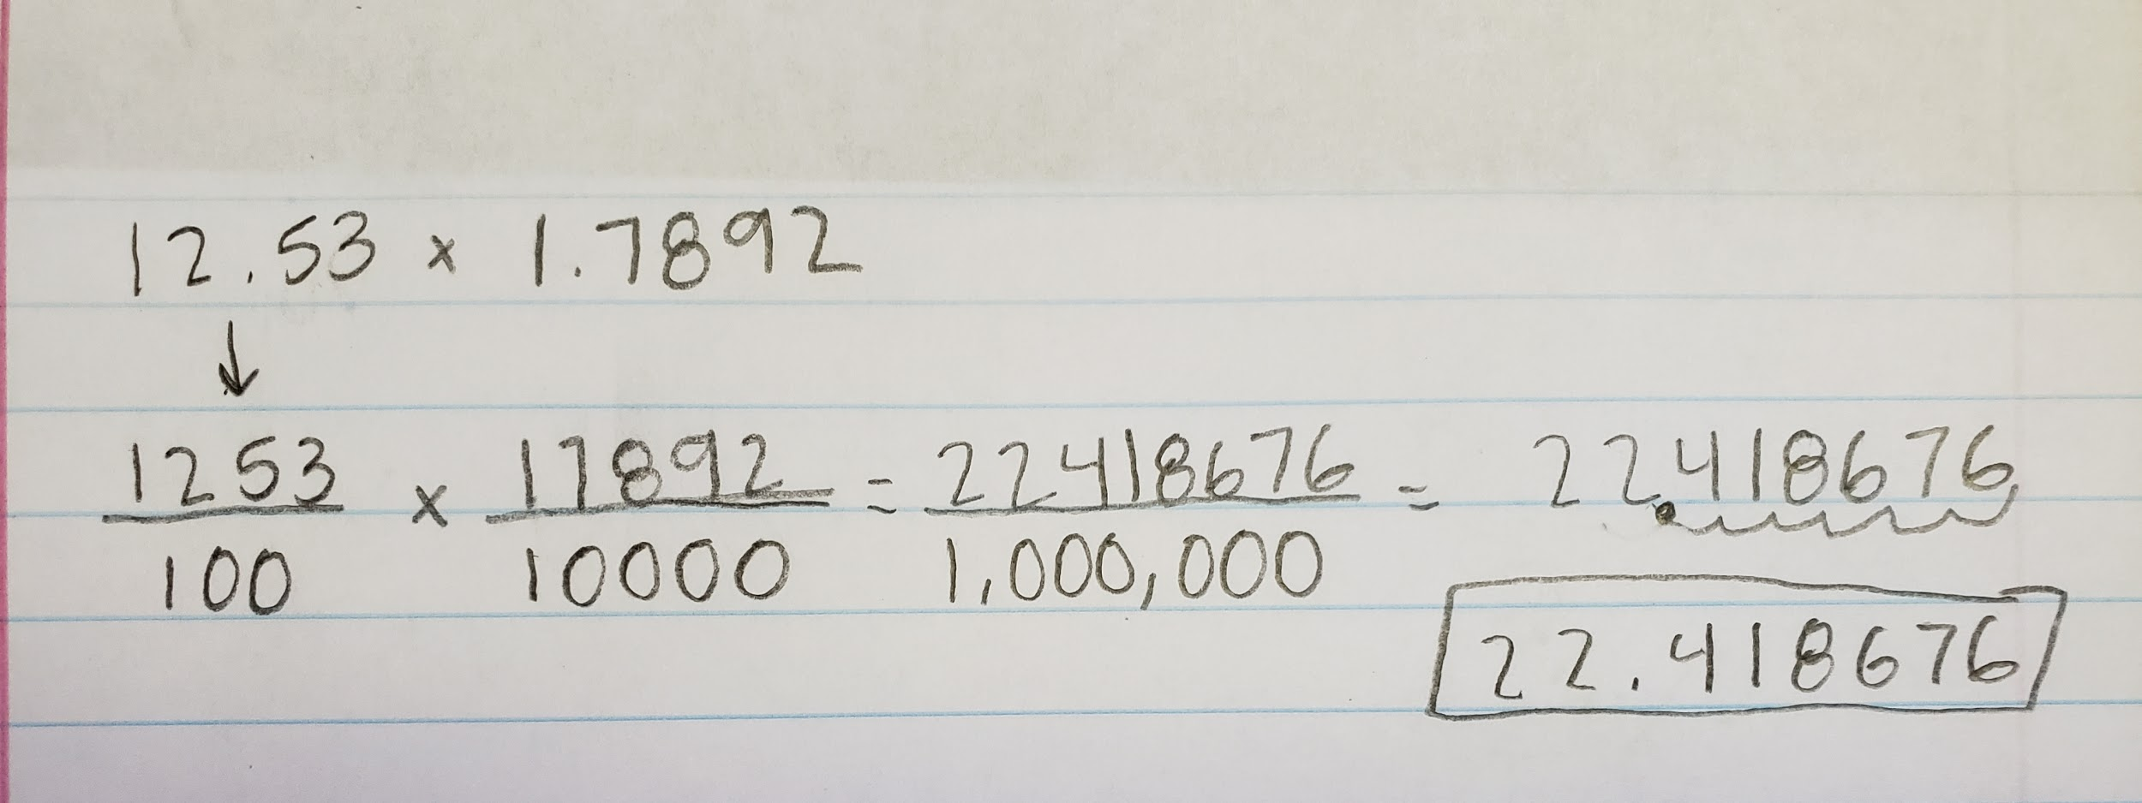  Teacher note: this is likely going to be the most challenging question. Students will be required to multiply two decimals together. This is an opportunity to teach decimal multiplication. One way to show decimal multiplication without just teaching “multiply and move the decimal place” is to show students how to multiply the fractional equivalent and let them create a rule.  (SCDE, 2019)  The example demonstrates how to show students the reasoning behind moving the decimal place when multiplying. After this, ask students to come up with a rule about how to multiply decimals.  Teacher: Explain how to operate with decimals, being sure to address addition and subtraction problems that go out to the hundredths place.  Answer the following.  Teacher note: The goal here is to demonstrate patterns of repeating and terminating decimals.  - Three people need to split a $10 bill. How much money should they each pay?  - What pattern do you see when you try to split the $10?  - How can you recognize when this pattern will show up? Does it always show up, or only in some division problems?  Teacher note: elaborate on repeating and terminating decimals.  Extension: Students should research the base ten system to look for:  - How did the decimal system come about?  - What is the decimal system used for?  - How does the decimal system relate to fractions?  Students could also create a decimal addition or subtraction problem to challenge other students.  A quick reference on the base ten system: Base 10
  Item | Price
  Hamburger | $1.97
  Coca-Cola | $1.57
  Salad | $3.23
  Ice Cream | $1.78
  Smoothie | $3.98
  Kicky Chicken’s Diner
  Bill
  Item | Price
  Hamburger | $1.97
  Coca-Cola | $1.57
  Salad | $3.23
  Ice Cream | $1.78
  Smoothie | $3.98
  Total
Equitable Access | Because of the finance basis behind these problems, all students will be able to interact with the content. Using fake money provides an opportunity for students to have a physical aspect and manipulate the comment. The material allows students to think deeply about mathematics, particularly when students are asked to come up with a rule for multiplying decimals.
Mathematical Vocabulary | repeating decimals  terminating decimals  discount  percentage
Student Reflection | - Describe the processes for adding, subtracting, multiplying, and dividing decimals.  - What is the easiest operation to do with decimals? Why?  - What is the hardest operation to do with decimals? Why?

Course/Grade:7th  Unit: 1 | Task Title: Task 4 Baking Brownies: Exploring Operations With Fractions  Return to Table of Contents
State Standards Addressed | 7.N.S.2a. Understand that the multiplicative inverse of a number is its reciprocal and their product is equal to one. 7.N.S.2c. Understand sign rules for dividing rational numbers and that a quotient of integers (with a non-zero divisor) is a rational number.  7.N.S.2d. Apply mathematical properties (e.g., commutative, associative, distributive, or the properties of identity and inverse elements) to multiply and divide rational numbers.  7.N.S.2e. Understand that some rational numbers can be written as integers and all rational numbers can be written as fractions or decimal numbers that terminate or repeat
Mathematical Process Standards Addressed | 1c. Analyze what is given, what is not given, what is being asked, and what strategies are needed, and make an initial attempt to solve a problem.  2a. Make sense of quantities and their relationships in mathematical and real-world situations.  3a. Construct and justify a solution to a problem.  4d. Evaluate the reasonableness of a model and refine if necessary.  6c. Use appropriate and precise mathematical language.  7a. Recognize complex mathematical objects as being composed of more than one simple object.
Materials and Resources | Brownie Pan (optional)  Question sheet  Journal or paper for answering questions  Crayons  Subtracting Fractions  Multiplying Fractions
Task Description | Teacher note: It is important to address misconceptions during this task. It may take two class periods.  Engage by providing students with a piece of paper (graph or printer paper, ideally), and asking them to split it up into as many different size rectangles as possible. This demonstrates the idea that one whole can be split into many different fractions that can still add up to one whole.  Part I - Subtracting and Multiplying Fractions, Multiplicative Inverse  Teacher’s note: the focus here is for students to fluently work with fractions and be able to add and subtract them in a real-world context. Drawing pictures is highly encouraged during this activity. Students should work individually for a few minutes, then allow students to help each other.  Jasmine and Da’Veon are making brownies in rectangular pans. Damyen wants ½ of the pan, David wants ¼ of the pan, Brianna wants ⅛ of the pan, and Leroy wants whatever is left over.  - Draw a picture that represents how Jasmine and Da’Veon will split up the brownies.  - How could you calculate Leroy’s portion? List as many ways as you could think of.  Teacher note: Be sure to encourage multiple ways of arriving at Leroy’s portion.  Discuss: How much of the pan will Leroy get? How do you know?  - How much is left in the pan if only David takes his piece?  - Camryn asks David for ⅓ of his brownie. How much of the original brownie pan will Camryn get?  Jasmine makes 3 trays of brownies. Hasan says he wants ⅓ of the brownies that Jasmine has made. How many pans of brownies does Hasan want?  Teacher note: explain that this is called multiplicative inverse (1/3 *3 = 1) Review how to multiply and subtract fractions. A possible extension is to add more students or split up the existing brownie pieces.  Part II - Adding and Dividing Fractions  Teacher note: this section is going to be more frustrating for students than part I. Allow students to work with partners. Encourage students to draw cakes. Students who are struggling may benefit from cutting the cake into slices to solve part one. Questions to prompt may include, “How many slices do you think are in each cake?” or “What kinds of things do the French Club, the Spanish Club, and the Dance Team have in common?” Students will need to understand that the cakes have to be split into 24ths, so ask focusing questions to lead them to that understanding.  Austin and Nataleigh are making cakes for the different clubs at school. The French Club wants ⅓ of a cake, the Spanish Club wants ⅝ of a cake, and the Dance Team wants $1\frac{1}{4}$ of a cake.  - How many whole cakes do Austin and Nataleigh need to make? Why?  - What will be leftover?  - Each cake has 24 slices. How many slices does each club get?  - The Spanish Club has 6 members. What fraction of the cake does each member get, assuming they split it equally?  - Draw a picture of the cakes, showing how much cake each group gets.  Teacher note: Review how to add and divide fractions after the task or in the middle depending on the level of difficulty with your students. A possible extension would be to add more clubs with different fractions of cake.  Task adapted from: Marcus. (2018, November 9). 'Café Fractions' - A Rich Task in Mathematics for Years 5 to 7. Retrieved from https://calculate.org.au/2018/07/26/cafe-fractions-a-rich-task-in-mathematics-for-years-3-to-4/
Equitable Access | Starting by drawing a picture allows students to visually represent the problem in multiple ways. Encouraging students to work together and teaching them to work together allows for equitable access for students that may typically view math as an individualistic study.
Mathematical Vocabulary | fractions  decimals  multiplicative inverse
Student Reflection | Students will explain in a journal reflection:  - How did you calculate the size of each brownie?  - Can you cut the original brownie pan into other portions? What would that look like?  - How did they determine the portions?  - If Jasmine and Da’Veon had to cater to a party twice the size of the number of students, how would you assign the portions?  - Make a question that is like what you were provided, but more difficult. Use your favorite bakery treat or pizza!

Unit 2 Content Standards with Clarifying Notes
Open bullets indicate clarifying notes.
Return to Table of Contents
7.EEI.1 Apply mathematical properties (e.g., commutative, associative, distributive) to simplify and to factor linear algebraic expressions with rational coefficients.
- Use properties to simplify and factor algebraic expressions, including those with rational coefficients
- Use the greatest common factor to factor algebraic expressions
- Foundational formulas (e.g., perimeter, area) should be used to extend knowledge of algebraic expressions
7.EEI.2 Recognize that algebraic expressions may have a variety of equivalent forms and determine an appropriate form for a given real-world situation.
- Describe real-world situations and determine the appropriate form of an algebraic expression (e.g., 2(x+4) or 2x+8)
7.EEI.3 Extend previous understanding of Order of Operations to solve multi-step real-world and mathematical problems involving rational numbers. Include fraction bars as a grouping symbol.
  - Understand that the fraction bar implies parentheses for grouping the numerator
  - Order of Operations should include multiplication and division of rational numbers, including integers, decimals, and fractions
7.EEI.4 Apply the concepts of linear equations and inequalities in one variable to real-world and mathematical situations.
a. Write and fluently solve linear equations of the form ax + b = c and a(x + b) = c where a, b, and c are rational numbers.
b. Write and solve multi-step linear equations that include the use of the distributive property and combining like terms. Exclude equations that contain variables on both sides.
c. Write and solve two-step linear inequalities. Graph the solution set on a number line and interpret its meaning.
d. Identify and justify the steps for solving multi-step linear equations and two-step linear inequalities.
- Understand the difference between an equation and an expression
- Equations must remain balanced
- Use Order of Operations in the reverse order to isolate the variable
7.EEI.5 Understand and apply the laws of exponents (i.e., product rule, quotient rule, power to a power, product to a power, quotient to a power, zero power property) to simplify numerical expressions that include whole-number exponents.
- Understand that a number raised to a power of zero results in a value of 1, not 0
- Derive the laws of exponents (i.e., product rule, quotient rule, power to a power, product to a power, quotient to a power, zero power property) before applying the laws in numerical expressions
7.NS.4 Understand and apply the concepts of comparing and ordering to rational numbers.
a. Interpret statements using less than (<), greater than (>), less than or equal to (≤), greater than or equal to (≥), and equal to (=) as relative locations on the number line.
b. Use concepts of equality and inequality to write and explain real-world and mathematical situations.
  - Understand that a closed circle represents the rational number and an open circle will not represent the rational number when graphing an inequality
  - Understand the symbol for “not equal to” (≠).
  - Focus on real-world situations including vocabulary for less than or equal to (≤) and greater than or equal to (≥)
7.NS.5 Extend prior knowledge to translate among multiple representations of rational numbers (fractions, decimal numbers, and percentages). Exclude the conversion of repeating decimal numbers to fractions.
- Recognize that$\frac{1}{3}=0.\overline{3} and \frac{2}{3}=0.\overline{66}$.

Unit 2 New Academic Vocabulary for This Unit
Return to Table of Contents
- Product Rule
- Quotient Rule
- Power to a Power
- Product to a Power
- Quotient to a Power
- Zero Power Property
- Greater than or Equal to
- Less than or Equal to
- Coefficient
- Terms
- Expression
- Constant
- Variable

Unit 2 Prior Knowledge Required for this Unit
Return to Table of Contents
- Evaluate numerical expressions involving grouping symbols (5.ATO.1)
- Write and evaluate numerical and algebraic expressions with whole number exponents and positive rational numbers (6.EEI.1, 6.EEI.2)
- Apply mathematical properties to generate and justify equivalent expressions (6.EEI.3, 6.EEI.4)
- Calculate the greatest common factor of two numbers less than or equal to 100 (6.NS.4)

Unit 2 Subsequent Knowledge Related to this Unit
Return to Table of Contents
In Grade 8, students will extend knowledge of the Laws of Exponents to include numerical expressions with integer exponents. In high school courses, students will apply the Laws of Exponents with rational exponents and algebraic expressions. Additionally in Grade 8, students will solve multi-step equations with variables on both sides of the equal sign. Grade 7 students will use their complete understanding of the Order of Operations and their properties to lay a foundation for functions in Grade 8.

Unit 2 Relationship Among Standards in this Unit
Return to Table of Contents
Standards in this unit are all necessary to develop the computational skills needed for work within the real number system including solving multi-step linear equations and inequalities and simplifying expressions which include the use of whole-number exponents.

Unit 2 Potential Instructional Strategies
Return to Table of Contents
- Algebra Tiles
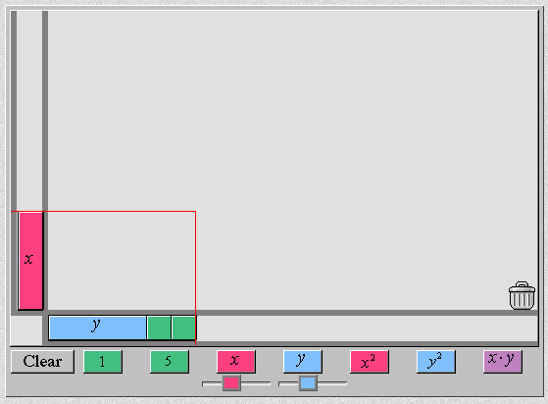 Source: National Library of Virtual Manipulatives
(Need Java)

- Algebra Balance Scales
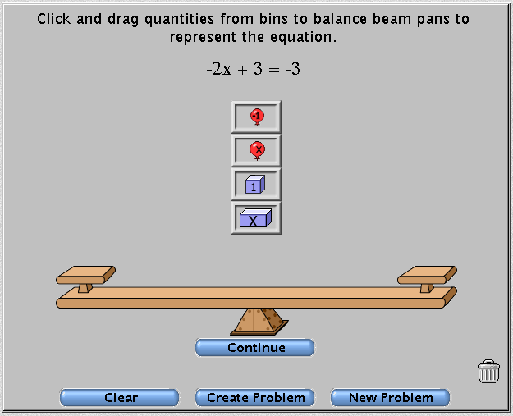 Source: National Library of Virtual Manipulatives
(Need Java)

Unit 2 Resources
Return to Table of Contents
Solving multi-step equations: this website allows the students to solve multi step equations using algebra tiles. (NCTM membership required for access)

7.EEI.2 – Pan Balance Expressions (NCTM membership required for access)

7.EEI.4 - This website provides a Jeopardy review game for students to practice the skills involved in solving multi-step equations and simplifying expressions. Solving Multi-Step Equations

7.EEI.5 - This website demonstrates how to derive the laws of exponents. Use this website as a guide for lesson planning. Laws of Exponents

7.EEI.5 - Applying Properties of Exponents - lesson

Course/Grade: 7th  Unit: 2 | Task Title: Task 1 Ordered Chaos: Using the Order of Operations  Return to Table of Contents
State Standards Addressed | 7.EEI.3 Extend previous understanding of Order of Operations to solve multi-step real-world and mathematical problems involving rational numbers. Include fraction bars as a grouping symbol.
Mathematical Process Standards Addressed | 1a. Relate a problem to prior knowledge.  3a. Construct and justify a solution to a problem.  3b. Compare and discuss the validity of various reasoning strategies.  3d. Reflect on and provide thoughtful responses to the reasoning of others.  4. Connect mathematical ideas and real-world situations through modeling.  5. Use a variety of mathematical tools effectively and strategically.  6. Communicate mathematically and approach mathematical situations with precision.  6c. Use appropriate and precise mathematical language.
Materials and Resources | pencil  sheet of paper  display (projector, chart paper, white board, etc.)
Task Description | Part 1  Students will need a pencil and a sheet of paper. Students should come up with as many ways to get to 24 as possible, using any number 0-9 and a variety of operations. For example, 4*5+4=24 or 6*5-6=24. (It may be beneficial to set a timer for anywhere from 3-10 minutes).  Have a class discussion about the different problems, and how the order of operations plays a role in solving different equations. Discuss how not using the correct order in completing a task can result in vastly different results.  In a discussion of the order of operations, use the order as follows: grouping, exponents/roots, multiplication/division, and addition/subtraction.  Teacher note: Make sure you discuss all grouping symbols.  Part 2  Students should answer the following questions:  Timmy and Cal sit down to work on their math assignments. The first math problem is 50-8*3+(4-1). Timmy gets an answer of 29. Cal gets an answer of 129.  - Who is correct? How do you know?  - How would the answer change if the parentheses were removed?  - Change the parentheses in the original problem so that you get Cal’s answer.  - Experiment with changing the parentheses to see how many different answers you can get.  - Katie has a different problem, $3×\frac{24-3}{7}$. She says the answer is 9, Alivia says the answer is 9.85. Who is correct? How could you prove it?  Extension: write your own multi-step problems. How many different answers can you come up with? To make it extra challenging, add in fraction bars. What is the one correct answer? Swap with a partner to see if they can figure out your problem. (Note: this is similar to the reflection activity)
Equitable Access | All students have the opportunity to come up with different equations to get to 24. They will be able to collaborate with each other on a variety of ways to create a problem. We are encouraging student expansion of learning from a variety of levels.
Mathematical Vocabulary | operations  parentheses  brackets
Student Reflection | - Students will write in their journal how many ways they can come up with finding an answer for 54 using only 0-9, and discuss how they came up with those ways.  - Create an equation using grouping symbols and swap with your elbow partner. How many answers can you come up with for that equation? Which one is the correct one?  - Why is order important?

Course/Grade: 7th.  Unit: 2 | Task Title: Task 2 Movie Money: Comparing Similar Expressions  Return to Table of Contents
State Standards Addressed | 7.EEI.1 Apply mathematical properties (e.g., commutative, associative, distributive) to simplify and to factor linear algebraic expressions with rational coefficients.  7.EEI.2 Recognize that algebraic expressions may have a variety of equivalent forms and determine an appropriate form for a given real-world situation.
Mathematical Process Standards Addressed | 1c. Analyze what is given, what is not given, what is being asked, and what strategies are needed, and make an initial attempt to solve a problem.  2c. Translate among multiple mathematical representations and compare the meanings each representation conveys about the situation.  3a. Construct and justify a solution to a problem.  4a. Identify relevant quantities and develop a model to describe their relationships.
Materials and Resources | Paper, index cards, task on piece of paper
Task Description | Warm-Up  How many different ways can you write the expression 2x+30?  *Teacher Note: Use this as an opportunity to remind students that like terms can be separated and combined to make different expressions that are equivalent. One answer may be 3x-x+2(15), or x+x+30, etc. Allow students up to five minutes to work individually, and then have students share with partners or table groups.  **Teacher note: It may be fun to make it a competition, “How many different expressions can you create?”  Movie Experience:  **For the extension, it may be useful to have students work on chart paper in teams.  Brandon, Chloe, and Jasmine went to the movies and all three of them purchased a medium popcorn and drink. They paid $10 to get into the movies, $7 for the medium popcorn and $5 for the drink.  - Chloe’s mom gave Chloe a $50 bill. Chloe wants to pay for herself and all of her friends, including their popcorn and drinks. Is this possible?  Class Discussion: How does Chloe’s $50 compare to the amount of money needed to pay for herself and her friends?  - With Chloe’s $50 bill, how much money do they still owe?  - How much did they spend on their total movie experience?  - Write or draw a way to represent the amount of money the three of them spent at the concession stand in total.  Class Discussion: Allow two or three students to use chart paper or the white board to show their thinking.  - Let n represent the number of people going to the movies that buy a medium popcorn and a drink. 10n+7n+5n is one expression to represent the total amount of money they spend. Where did those numbers come from?  - What are the different expressions that could represent the total amount of money spent?  - How much money did they spend all together at the concession stand?  - What information did you use to solve this?  Teacher note: Explain the concept of expressions and show multiple ways to write expressions. Include words such as “factor” and “distribute.”  Equivalent Expressions:  Complete the table with equivalent expressions to the beginning problem.  This can be used as homework if you run low on time.  (SCDE, 2019)  Extension: If students complete work on chart paper, place on the wall and have a gallery walk the next day. Have students discuss whether answers were correct, what questions or extensions they have, and how they could solve the task differently.
  Example  x = 2 | 2( x - 5)  (2*2)- (2*5)  4 -10  -6 | 2x - 10  2(2) -10  4 -10  -6 | 2x -5-5  2(2)-5-5  4 -10  -6
  x = 5 | 2(x-15)
  y = -2 | 5(3y- 4y)
  x = 4 | 8-2x
  y =-5 | 5y + 20
Equitable Access | Students will work with their elbow partner and discuss collaboratively and discuss their findings and come to a consensus on the best way to solve or set up the problems.  Manipulatives provide opportunities for students to engage with content in different ways.  Students have different ways to represent the cost of going to the movies. All members of the group adds value in deciding the best way to solve the problem.
Mathematical Vocabulary | expression  equation  equivalent  distribute  factor  like terms  unlike terms
Student Reflection | Reflection writing:  - How did you create your expressions? What information was important?  - Explain how you filled in the table. Did you have a pattern or method for writing equivalent expressions?  - What was the most confusing part for you? Why was it confusing?

Course/Grade:7th grade  Unit: 2 | Task Title: Task 3 Journey through Multi-Step Equations  Return to Table of Contents
State Standards Addressed | 7.EEI.4 Apply the concepts of linear equations and inequalities in one variable to real world and mathematical situations. Write and solve multi-step linear equations that include the use of the distributive property and combining like terms. Exclude equations that contain variables on both sides.
Mathematical Process Standards Addressed | 1a. Relate a problem to prior knowledge.  3a. Construct and justify a solution to a problem.  3d. Reflect on and provide thoughtful responses to the reasoning of others.
Materials and Resources | Task 1: A New ‘Egg’ - venture  8 plastic Easter eggs per group  8 multi-step equations per group (cut apart equations from worksheet – You may use a work book or website such as Mathx that has free worksheets.)  Task 2: Equation Walk  Posters created in Task 1  Sticky Notes
Task Description | Prep: Before students arrive, prepare a set of 8 Easter eggs for each group. Each Easter egg in the group set will contain a different multi-step equation.  Task 1 –- A New ‘Egg’-venture  - Divide students into 8 groups.  - Give each group a set of eggs with equations already in the egg (see materials and resources).  - Students then choose one egg and solve the problem individually. Ask students to jot down their thinking while solving (students will be working the same problem).  - Once students have solved the problem, students should work as a group to discuss strategies, provide justification for how they solved the problem, and find any discrepancies with their work.  - Once a solution has been agreed upon the group will display work and answer on a poster or chart paper.  - The group will repeat #3-5 to complete all 8 equations (if time allows).  - Posters will be displayed and then the class will do an equation walk as task 2.  Prep: Before students arrive, all posters created in Task 1 should be displayed. They should be at a height that is accessible for students to read. Each group will be given enough sticky notes to leave a comment on each poster.  Task 2: Equation Walk  - Display group posters around the room.  - Student should form same groups from Task 1 and walk around the room and hallway on the equation walk.  - Students should solve the problem, and read the justifications and the problem computations and tell if they agree or disagree and why. They will write their response on a sticky note and leave it on each poster.  - Students may ask clarifying questions and point out discrepancies.  Whole Class Discuss:  - What did you notice as you walked around?  - What were some similarities and differences between your work and others?  - Is there anything you would change about the work you did?
Equitable Access | Students will collaboratively discuss the justifications of their peers and hear the ideas of others.  Students will independently practice multi-step linear equations during the scavenger hunt. Teacher should be available to assist struggling students with prompting questions such as:  - How did you start?  - Should you distribute or collect like terms before solving? What makes you think this?  - Have you thought about how the equation is built (order of operations)?  - How would you un-build something? Now use what you know about un-building to solve the equation.  - Don’t forget your rational number rules and using them to solve.
Mathematical Vocabulary | equations  variables  balanced
Student Reflection | Students will complete a journal to reflect on these three activities.  - What did you find most difficult about these tasks?  - Which one was your favorite and why?  - What is the most challenging part of solving multi-step equations?  - What are you still struggling with when it comes to solving multi-step equations?

Course/Grade: 7th  Unit: 2 | Task Title: Task 4 Balancing Equations  Return to Table of Contents
State Standards Addressed | 7.EEI.4 Apply the concepts of linear equations and inequalities in one variable to real-world and mathematical situations.  7.EEI.4a. Write and fluently solve linear equations of the form ax + b = c and a(x + b) = c where a, b, and c are rational numbers.
Mathematical Process Standards Addressed | 1b. Recognize there may be multiple entry points to a problem and more than one path to a solution.  3b. Compare and discuss the validity of various reasoning strategies.  5b. Use technological tools and other external mathematical resources to explore and deepen understanding of concepts.  6b. Represent numbers in an appropriate form according to the context of the situation.
Materials and Resources | Balance trays  blocks of same size and weight
Task Description | Class Demo: Start by adding the same amount of blocks to each side of the balance beam. If you don’t have a balance beam, you can use the NCTM Pan Balance. You can also have students access this on their devices.  Remove one block or number from one side.  Class Discussion: If you wanted to keep the trays balanced, what do you need to do to the other side? Can you make up a rule on how to keep things balanced?  Teacher: explain that an equation is like a balance – it shows that two expressions are equal to each other, almost like they have the “same weight.” Provide students with the equation 4x+5=25.  - Imagine that each side is part of a balance tray. What would you have to do to the other side if you removed an item, added, divided, or multiplied one side by a number?  - Teacher: guide students through solving the equation, reminding them that the goal is to “isolate” the variable, or x.  - Tyler has four video games and $20. This means he had $200 in total. How much does a video game cost? How do you know? (Teacher: allow students to solve this problem in different ways. Some may want to use the Pan Balance website.  - Carly says Tyler’s video game purchases can be represented by 4v+20 = 200. Shay says Tyler’s video game equation should be v+v+v+v = 200-20. Who is right, or are they both right? Why?  - Abigail says Tyler’s video game purchases could look like 4(v+5) = 200. Is she right? Why or why not? (Teacher: this is an opportunity to approach the idea of the distributive property. Have students solve the equation first by dividing by 4, and then allow them to distribute the 4 to both sides).
Equitable Access | Manipulatives provide students a chance to play with balancing equations and incorporating their intuition about the concept of balancing. Questions 5 and 6 address multiple representations of the problem. Engaging conversations with group members about problems 5 and 6 helps students have a different perspective and understanding on how to work and solve equations.
Mathematical Vocabulary | equation  balance
Student Reflection | - Abigail says to solve an equation, you have to “undo” it. What does she mean?  - Is 3(v+5) the same as 3v+5? Why or why not?  - Shay says the opposite of multiplication is division. Do you agree? Why or why not?

Course/Grade:7th  Unit: 2 | Task Title: Task 5 Money Wise (Ordering Fractions)  Return to Table of Contents
State Standards Addressed | 7.NS.4 Understand and apply the concepts of comparing and ordering to rational numbers.  7.NS.4a. Interpret statements using less than (<), greater than (>), less than or equal to (≤), greater than or equal to (≥), and equal to (=) as relative locations on the number line.  7.NS.4b. Use concepts of equality and inequality to write and explain real-world and mathematical situations.  7.NS.5 Extend prior knowledge to translate among multiple representations of rational numbers (fractions, decimal numbers, and percentages). Exclude the conversion of repeating decimal numbers to fractions.
Mathematical Process Standards Addressed | 1a. Relate a problem to prior knowledge  2d. Connect the meaning of mathematical operations to the context of a given situation.  3a. Construct and justify a solution to the problem.  4a. Connect mathematical ideas and real-world situations through modeling.  4b. Interpret mathematical models in the context of the situation.  5b. Use technological tools and other external mathematical resources to explore and deepen the understanding of concepts.  6a. Express numerical answers with a degree of precision appropriate for the context of the situation.
Materials and Resources | paper  fraction tiles/blocks/strips  (If fraction strips are unavailable, have students cut and color their own using a printable or have students use an online fraction bar tool)
Task Description | Students will work together in pairs using fraction tiles/blocks. The goal here is for students to be able to organize fractions and understand the relationships between numerators and denominators. They should also be able to use statements such as less than (<), greater than (>), less than or equal to (≤), greater than or equal to (≥), and equal to (=) to compare fractions.  Task 1  - Both students should organize fraction tiles from smallest to largest, and then compare their responses. For example, 1/12, 1/10, ⅛. They will record each size using the < or > symbols. For example: 1/12 < 1/10 < ⅛.  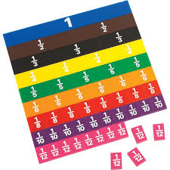  - Students should create their own fractions by using various combinations of fractions tiles (note: the online tool found in the resources box would work well for this section). They should compare one to the other and practice ordering from least to greatest, creating equal (equivalent) fractions, and adding different fractions together. They should record their observations.  - Answer the following questions.  - José says that ½ and 2/4 are the same sizes. Is he correct? Why or why not?  - Anna observes that $\frac{3}{5}$ and $\frac{6}{10}$ are the same, and that ⅓ and $\frac{5}{15}$ are also the same. What other fraction pairs can you find that are the same?  - What rule could you create for fractions that are the same size?  Class Discussion:  1. What did you discover as you were combining fractions?  2. What is the relationship between the size of the fraction and the size of the denominator?  3. How does a fraction change if you make the numerator bigger? What about if you make the denominator bigger? Why do you think this happens?  Task 2  - Given your monthly income is $3000 and your bills are as follows:  - Electric/heat- 1/10 of your income  - Cell Phone - $150  - Internet- 1/12 of your income  - Grocery- $90  - Car payment- ⅜ of your income  - Insurance-10% of your income  - Savings - whatever is leftover  - Calculate the cost for each bill. What is left for your savings?  - Order the bills in ascending order.  - Imagine you were promoted the following month and your monthly income became $4500. How much are your new bills? How will your savings be affected?  - Use fraction bars, draw a picture, or draw a pie chart to show your new allotments/spending.  - Fill in the following chart.  (SCDE, 2019)  Class Discussion:  1. How did you calculate the fractional portions?  2. Was this method different than how you calculated percent?  Task 3:  Six students are given 10 seconds to run on the track. Use dice (or an interactive dice) to come up with each of their times. Let the first roll represent the whole number of meters, and the second and third roll represents the fraction of a meter that they ran. Complete the table below. The first one has been done for you.  (SCDE, 2019)  - Which of your students came in first place? How do you know?  - Which of your students came in last place?  - Is there a different way you can show the distance that each person ran?  - Fill in the blanks with these symbols: $≤ ≥ < > = ≠$  Student #1 ___________ Student #2  Student #3 ___________ Student #4  Student #5 ___________ Student #6  - Did any of your students have equal running times? Did you expect them to? Why or why not?
  Decimal | Percent | Fraction
  0.25
   |  | 2/5
   | 50%
  0.48
   | Roll 1 | Roll 2 | Roll 3 | Distance
  Student #1 | 6 | 2 | 5 | $6\frac{2}{5}$meters
  Student #2
  Student #3
  Student #4
  Student #5
  Student #6
Equitable Access | Students will work together in collaborative groups of two/four. With their elbow partner, they will both create fractions and compare and contrast their problems. They will work out each other's problems and discuss their findings, helping students have a different perspective and understanding. Students should then discuss all the problems with the whole group and decide what they agree with and why.  Students are able to explore with fraction bars, offering multiple entry points to their learning. Students will model the understanding of exploration with fraction bars in creating new problems for their partner to work.
Mathematical Vocabulary | inequality  greater than  less than  ascending  descending  equivalent fractions
Student Reflection | - What did you learn about ordering fractions?  - What is something you are struggling with or still have questions about?  - How could you use ordering fractions in real life?

Unit 3 Content Standards with Clarifying Notes
Open bullets indicate clarifying notes.
Return to Table of Contents
7.RP.1 Compute unit rates, including those involving complex fractions, with like or different units.
- Realize a complex fraction indicates a fraction within a fraction (e.g., $\frac{\frac{1}{2}}{\frac{1}{4}}$)
7.RP.2 Identify and model proportional relationships given multiple representations, including tables, graphs, equations, diagrams, verbal descriptions, and real-world situations.
a. Determine when two quantities are in a proportional relationship.
b. Recognize or compute the constant of proportionality.
c. Understand that the constant of proportionality is the unit rate.
d. Use equations to model proportional relationships.
e. Investigate the graph of a proportional relationship and explain the meaning of specific points (e.g., origin, unit rate) in the context of the situation.
- Distinguish between linear and proportional relationships.
- Understand that proportional relationships are linear and include the origin in the solution set.
7.RP.3 Solve real-world and mathematical problems involving ratios and percentages using proportional reasoning (e.g., multi-step dimensional analysis, percent increase/decrease, tax).
- Include sales tax, tip, markup/discount, simple interest, depreciation, commission, percent error
- Solve for all values in a simple interest problem
- Calculate the percent increase/decrease by $\frac{\left|New-Original\right|}{Original} = \frac{Part of Percent}{100}$
7.EEI.4 Apply the concepts of linear equations and inequalities in one variable to real-world and mathematical situations.
a. Write and fluently solve linear equations of the form $ax + b = c$ and $a(x + b) = c$ where $a, b, and c$ are rational numbers.
b. Write and solve multi-step linear equations that include the use of the distributive property and combining like terms. Exclude equations that contain variables on both sides.
c. Write and solve two-step linear inequalities. Graph the solution set on a number line and interpret its meaning.
d. Identify and justify the steps for solving multi-step linear equations and two-step linear inequalities.
- Include equations and inequalities with rational number coefficients, constants, and solutions.
- Justify steps and solutions using multiple means (e.g., substitution, properties, definitions)
7.GM.1 Determine the scale factor and translate between scale models and actual measurements (e.g., lengths, area) of real-world objects and geometric figures using proportional reasoning.
Include examples for scaling up and scaling down (e.g., a scale model of an eye would be scaling up, a map would be an example of scaling down).

Unit 3 New Academic Vocabulary for This Unit
Return to Table of Contents
- Proportion
- Proportional relationships
- Complex fraction
- Constant of proportionality
- Like Terms
- Linear inequalities
- Scale factor
- Scale model

Unit 3 Prior Knowledge Required for this Unit
Return to Table of Contents
- Ratios, rates, and unit rates (6.RP.1, 6.RP.2, 6.RP.3, 6.EEI.9)
- Expressions, equations, and inequalities (6.EEI.2b, 6.EEI.3, 6.EEI.4, 6.EEI.5, 6.EEI.7, 6.EEI.8, 6.EEI.9)
- Translations among rational numbers (6.NS.9)
- Scale factor of geometric shapes (6.GM.1)

Unit 3 Subsequent Knowledge Related to this Unit
Return to Table of Contents
In Grade 6, students determine the basic meaning ratios and unit rates, leading to complex ratios and rates in Grade 7. Subsequently, in Grade 8, students will apply unit rates to functions leading to an understanding of constant rate of change and slope. In high school mathematics courses, students will extend the knowledge of constant rate of change to include rate of change and average rate of change.
In Grade 6, students solved problems involving one-step dimensional analysis. In Grade 7 and beyond, multi-step dimensional analysis is taught, used, and applied beyond mathematics courses (e.g., chemistry, physics). In Grade 6, students begin to translate among representations of rational numbers with limited denominators (2, 3, 4, 5, 8, 10, and 100), which is extended to all denominators in Grade 7. In Grade 8, students will extend their knowledge of translations among rational numbers to include the conversion of repeating decimal numbers to fractions.

In Grade 6, students created and solved one-step equations and inequalities. In Grade 7, students create and solve multi-step linear equations and inequalities, utilizing the distributive property and combining like terms. Students extend knowledge of determining a solution set in Grade 6 to graph and interpret solutions to multi-step linear inequalities in Grade 7. In Grade 8, students solve linear equations and inequalities to include variables on both sides and systems of equations. In high school courses, students will create, solve, and graph linear and nonlinear equations and inequalities in two variables. Additionally, students will apply knowledge and understanding of solving equations to solve literal equations for an indicated value.

In Grade 7, scale factor and scale model are introduced using proportional reasoning which leads to, in Grade 8, an understanding of the relationship between dilations and attributes of geometric figures. In high school, dilations will be extended to include negative scale factors, which represent reflections of enlargements and reductions.

Unit 3 Relationship Among Standards in this Unit
Return to Table of Contents
Standards in this unit are all necessary to develop an understanding of proportional relationships and model those relationships using multiple representations.

Unit 3 Potential Instructional Strategies
Return to Table of Contents
- Real-world problems such as comparing better buys, using sales flyers or websites to compare unit rates or percent discounts

Unit 3 Resources
Return to Table of Contents
7.GM.1 - This activity allows students to practice working with scale factors. Scale Factor (NCTM membership required for access)

7.EE1.4 - This game allows students an opportunity to graph simple linear inequalities. Shooting Inequalities (Requires Adobe Flash Player)

7.EE1.4 - This game helps students understand the meaning of inequalities. Inequality Wars (Requires Adobe Flash Player)

7.RP.2 - This game allows an opportunity to solve proportions. Solving Proportions (Requires Adobe Flash Player)

7.EE1.4 - This game allows students to practice recognizing like terms. Like Term Invaders (Requires Adobe Flash Player)

7.RP.2 - This activity checks for an understanding of constant of proportionality. Mathopolis

7.RP.1 - This Jeopardy games gives students an opportunity to practice finding unit rates and make comparisons for the best price. Unit Rate and Price Comparison

Course/Grade: 7th  Unit: 3 | Task Title: Task 1 Unit Rates, Proportional Relationships & Complex Fractions  Return to Table of Contents
State Standards Addressed | 7.RP.1 Compute unit rates, including those involving complex fractions with like or different units.
Mathematical Process Standards Addressed | 1c. Analyze what is given, what is not given, what is being asked, and what strategies are needed, and make an initial attempt to solve a problem.  2a. Make sense of quantities and their relationships in mathematical and real-world situations.  3. Use critical thinking skills to justify mathematical reasoning and critique the reasoning of others.  3a. Construct and justify a solution to a problem.  3d. Reflect on and provide thoughtful responses to the reasoning of others.  4. Connect mathematical ideas and real-world situations through modeling.  4a. Identify relevant quantities and develop a model to describe their relationships.  6. Communicate mathematically and approach mathematical situations with precision.  6a. Express numerical answers with a degree of precision appropriate for the context of a situation.  6c. Use appropriate and precise mathematical language.  7. Identify and utilize structure and patterns.
Materials and Resources | Graph paper
Task Description | PART 1  Class Discussion: What is a best buy? How does this matter when we’re shopping for something? (Teacher note: Introduce the concept of unit rates and determining the cost per shirt, cost per ounce, etc. and how you would use that to determine which item is going to be the best purchase).  Student Work: Fernando is comparing prices to order shirts for his club. The prices are as follows. Each box contains 5 shirts.  (SCDE, 2019)  *Teachers may want to change company names to local stores for relevance.  - Which company is the best deal? Why?  - What is the cost per shirt for each company? Complete the table.  (SCDE, 2019)  - How did you find the cost per shirt? What information did you use?  - Which company seems to have the best deal?  - Does this deal change if you buy a lot of shirts? Using graph paper or chart paper, prove your thinking.  - One box contains five shirts. Original Prints charges $40 per box. Carolina Custom charges $6 per shirt. Which is the better deal? How do you know? Explain your thinking.  Class Discussion: What did you have to think about when comparing Original Prints and Carolina Custom? Why does it matter if the price listed is per box or per shirt?  Teacher: Provide ten or so examples of unit rates, and have a class discussion where students notice and wonder about unit rates. Afterward, explain the concept of the unit rate as one item per another item. It’s important that students understand that the denominator will always be one, and they will have to manipulate the unit rate so that it is set up correctly.  - John’s car travels 2 miles in five minutes. How many miles per hour is he going? (Or, what is the unit rate?)  - Alyssa’s car travels ½ a mile in ⅓ minute. How far does she travel per minute? (Or, what is the unit rate?)  PART 2  Students will create a table comparing a variety of items and the unit rates using sales papers or online prices from stores in your area. Students will compare 3 different items from three different stores – they should compare one item across three stores. For example, the cost per lb. of bananas at Publix, Food Lion, and BI-LO. Students could choose different stores using the internet, if you have devices.  Teacher note: the goal here is that students are looking at unit rates in real life and trying to find which store has the best deal, based on the unit rate. One strategy may be looking at different food items and finding the cost per ounce from different stores. Students could set up a table like below:  (SCDE, 2019)  Teacher note: You may want to walk students through an example before letting them proceed individually. Guide students through understanding that the units must all be the same.  - Which store seems to have the best deals? Why?  - Based on the information you now have on saving; how can you use this information to benefit your family?  - What suggestions could you offer to someone the next time they are shopping?  - Pepsi costs $2 per bottle at Lowe’s, but $0.09 per ounce at Lidl. What makes these unit rates difficult to compare? (Teacher note: students should be able to identify that they need to know how many ounces are in the bottle. Key idea: it’s impossible to compare unit rates without the same units!)  Extension: Have students choose the store with the best deals and make an advertisement that compares their unit rate prices to the other stores.
   | Cost | Amount
  Shirts Inc. | $100 | 20 boxes
  Custom Designs | $30 | 4 shirts
  Tees Inkorporated | $25 | 1 box
  Made to Order | $80 | 10 shirts
  Cost per shirt
  Shirts Inc.
  Custom Designs
  Tees Inkorporated
  Made to Order
  Item | Store #1 Unit Rate | Store #2 Unit Rate | Store #3 Unit Rate
Equitable Access | Students will work together in collaborative groups of two/four after they have individually attempted the question and are at the productive struggle stage. Engaging conversations with group members helps students have a different perspective and understanding. Students will be encouraged to ask questions for clarity of tasks.
Mathematical Vocabulary | x-axis y- axis  unit rate convert  proportional complex  fractions ratios
Student Reflection | - How are unit rates used in real life?  - Why might a store be able to charge higher unit rates for things like individually bagged chips, or refrigerated sodas?  - Provide three examples of unit rates.

Course/Grade: 7th  Unit: 3 | Task Title: Task 2 Hat Sale Proportions  Return to Table of Contents
State Standards Addressed | 7.RP.2 Identify and model proportional relationships given multiple representations, including tables, graphs, equations, diagrams, verbal descriptions, and real-world situations.  7.RP.2a. Determine when two quantities are in a proportional relationship.  7.RP.2b. Recognize or compute the constant of proportionality.  7.RP.2c. Understand that the constant of proportionality is the unit rate.  7.RP.2d. Use equations to model proportional relationships.  7.RP.2e. Investigate the graph of a proportional relationship and explain the meaning of specific points (e.g., origin, unit rate) in the context of the situation.  7.EEI.4 Apply the concepts of linear equations and inequalities in one variable to real-world and mathematical situations.  7.EEI.4a. Write and fluently solve linear equations of the form 𝑎𝑥 + 𝑏 = 𝑐 and (𝑥 + 𝑏) = 𝑐 where 𝑎, 𝑏, 𝑎𝑛𝑑 𝑐 are rational numbers.  7.EEI.4b. Write and solve multi-step linear equations that include the use of the distributive property and combining like terms. Exclude equations that contain variables on both sides.  7.GM.1 Determine the scale factor and translate between scale models and actual measurements (e.g., lengths, area) of real-world objects and geometric figures using proportional reasoning.
Mathematical Process Standards Addressed | 1. Make sense of problems and persevere in solving them.  1a. Relate a problem to prior knowledge.  1b. Recognize there may be multiple entry points to a problem and more than one path to a solution.  1c. Analyze what is given, what is not given, what is being asked, and what strategies are needed, and  make an initial attempt to solve a problem  2b. Describe a given situation using multiple mathematical representations.  3c. Make conjectures and explore their validity.  4a. Identify relevant quantities and develop a model to describe their relationships.  6d. Use appropriate units, scales, and labels.
Materials and Resources | graph paper  blocks
Task Description | 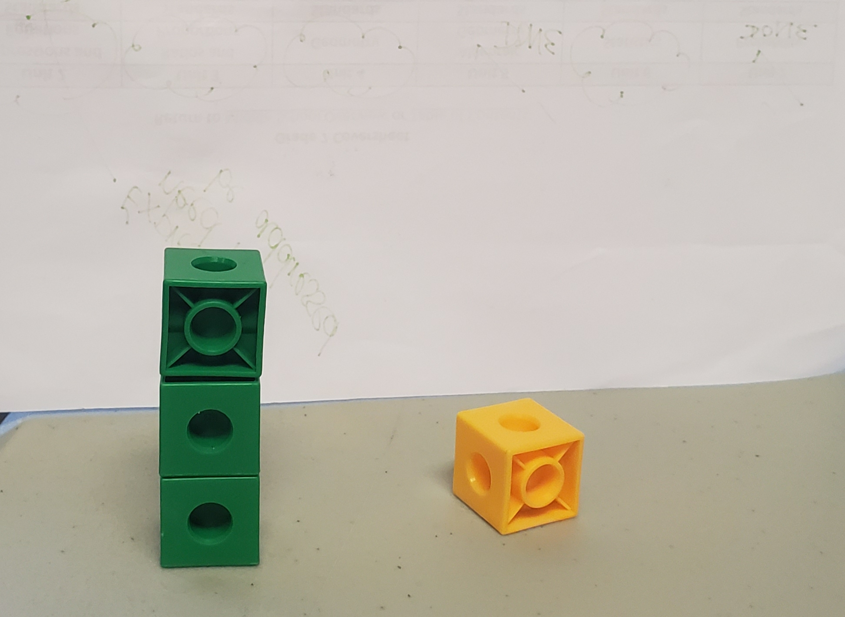 (SCDE, 2019)  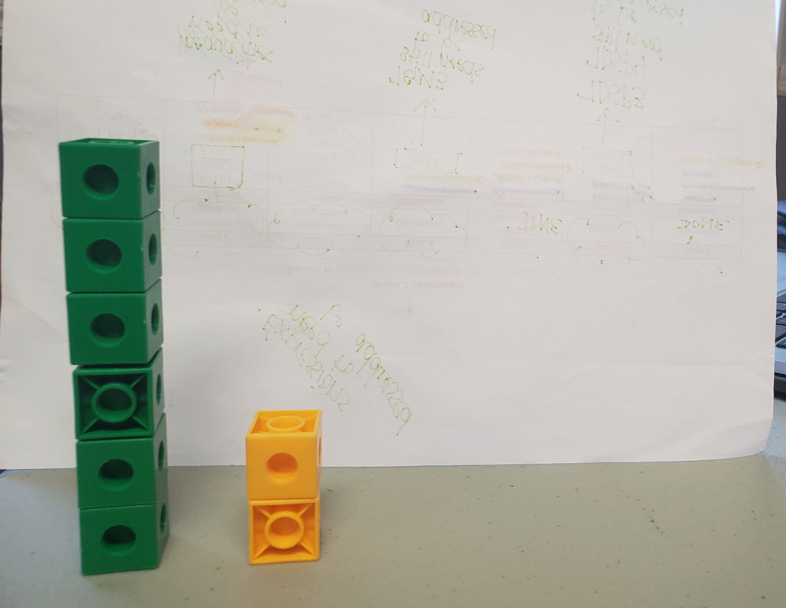 (SCDE, 2019)  Task 1  Teacher: Start by demonstrating the idea of proportionality/scale with blocks. For example, stack one block on one side and three on the other. Continue this pattern. Using chart paper or white board, make a table (and you may want to have students do this also) to keep track of how many blocks are on each side.  Using the table, encourage students to observe a pattern. Provide them with blocks and let them make their own patterns. If you don’t have access to a class set, use graph paper and let them color in the squares.  Pair-Share Activity: Partner 1 should make/draw a proportional model (students will understand this as a pattern, make sure to connect their existing vocabulary to the term “proportional”), and a non-proportional model, and ask Partner 2 which one is proportional. Have partner 2 jot down their thoughts and explain why it’s proportional. Then switch roles. Share out in a whole class setting. The teacher should list the words and phrases students use to describe “proportional” on the board.  Teacher note: during the pair-share activity, walk around the room and ask students probing questions, such as, “Could you make a pattern where the output is smaller? What would you be multiplying by?” and work in words like “scale,” “inverse proportionality” and “constant of proportionality” in conversations with students.  Ask students to identify what the input is being multiplied by to get the output. Explain this as the constant of proportionality (k) and scale factor. Use this opportunity to explore fractional constants of proportionality (including examples where the numerator is not 1).  The key understanding is that students know how to determine the constant of proportionality through a variety of methods.  Teacher demo: At this point in the activity, the teacher should add 2 cubes to the tower, and then began building using the same pattern of 1:3. While building, ask students questions like, “What happened to my rule?”, “Why does it no longer apply?,” “Does the rule change, and if so, what does it change to?” and “Is the relationship still proportional?” The idea here is that students understand a proportional relationship must have an output of zero for an input of zero.  Task 2  Jayne and Maysen each sell hats. Jayne charges $10 for 2 hats, $25 for 5 hats, and $50 for 10 hats. Maysen charges $10 for 4 hats, $30 for 5 hats, and $70 for 6 hats.  - Which person do you think offers the fairer prices? Why?  - How much does Jayne charge for 1 hat? How do you know?  - Why would it be hard to figure out how much Maysen charges for 1 hat?  - Fill in the table below to represent Jayne’s hat sales.  (SCDE, 2019)  - Graph Jayne’s hat profits below. Be sure to label the axes and title it.  Teacher note: You may want to graph the first two points as a class, if your students are unfamiliar with graphing.  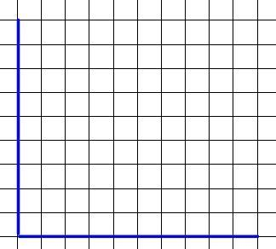  (SCDE, 2019)  - What do you notice about your graph? List as many things as possible.  - What could be a rule to figure out how much money Jayne made (y), for any number of hats (x)?  - David says that if Jayne’s hat sales go up by one, her profit should go up by $1, too. What would you tell David?  Teacher note: If two quantities increase by the same amount, that does not necessarily mean they are proportional.
  Tower 1 (input) | Tower 2 (output) | What is the pattern?
  1 | 3 | Tower 1 is multiplied by ____.
  2 | 6 | Tower 1 is multiplied by ____.
  3 | 9 | Tower 1 is multiplied by ____.
  Input (# hats sold by Jayne) | Output ($ received)
  0
  1
   | $10
  3
  4
Equitable Access | Options for multiple representations of proportional understanding, authentic problem-solving, students will be able to share and discuss with their elbow partner after they have been productively struggling and then with their table for more insights. The hands-on aspect where students are interacting with the graph sheets allows students to visualize the mathematics.
Mathematical Vocabulary | proportional graph  input output  x-axis y-axis  scale constant of proportionality
Student Reflection | For proportional relationships, what would you expect each of the following to look like?  - Table:  - Graph:  - Equation:  How can you tell if something is proportional? List as many ways as possible.  If proportion relationship looks like________, then non-proportional relationship looks like______.

Course/Grade: 7th  Unit: 3 | Task Title: Task 3 Talking Turkey and Taxes: Percentages  Return to Table of Contents
State Standards Addressed | 7.RP.3 Solve real-world and mathematical problems involving ratios and percentages using proportional reasoning (e.g., multi-step dimensional analysis, percent increase/decrease, tax).
Mathematical Process Standards Addressed | 1c. Analyze what is given, what is not given, what is being asked, and what strategies are needed, and make an initial attempt to solve a problem.  2a. Make sense of quantities and their relationships in mathematical and real-world situations.  3d. Reflect on and provide thoughtful responses to the reasoning of others.  6b. Represent numbers in an appropriate form according to the context of the situation.  6c. Use appropriate and precise mathematical language.  6d. Use appropriate units, scales, and labels.  7c. Look for structures to interpret meaning and develop solution strategies.
Materials and Resources | student device  chart paper/printer paper  markers/colored pencils/crayons
Task Description | Task 1  Introduce this problem prior to explaining tax or percentage. Students should be able to translate between percents, decimals, and fractions. Students may work in pairs to answer the first several questions.  Teacher note: students may benefit from using fake money as a visualization. You can also use prices from a sales advertisement or restaurant to make this more relatable for your students, or use the sample menu below.  (SCDE, 2019)  Brittany is buying a Thanksgiving dinner for her family. The total comes out to $25.00.  Teacher note: Explain to students that they will pay tax on every item bought. This may be a good opportunity to research South Carolina sales tax or any additional taxes for your county, as well as any tax exemptions your items may be eligible for.  - Brittany has to pay tax on the meal she bought. The South Carolina sales tax is $0.06 for every dollar. How much tax does Brittany have to pay in total?  - What is the new total amount Brittany has to pay?  - What was Brittany’s tax as a percentage? What about as a fraction?  Teacher note: for question 3, ask guiding questions such as “What is a percent?,” “How could you set up a fraction using this sales tax?” to lead students towards converting between fractions, percents, and decimals. Avoid quick methods such as moving the decimal points.  At this point, the teacher should lead students through finding percentage as multiplying a decimal by a total (so, 0.06 * 25).  - Brittany’s new total is $_________.  - Brittany decides she wants to add another pie onto her order. What is her new total? Don’t forget tax!  - Using your answer from #4 and #5, Brittany’s total bill went from $______ (old amount) to $________ (new amount).  - How much did Brittany’s bill go up?  - Can you find the percent that Brittany’s bill rose?  Teacher may need to lead students in finding an equation to show how to find percent change. $\frac{new-old}{old}=percent change.$ Some students may be able to come to a solution on their own in question 8.  - Brittany has a coupon where she can receive 20% off if she spends over $30. Did she reach $30?  - Is it cheaper for Brittany to keep the second pie and use the coupon, or should she get rid of the second pie and not use the coupon? Why?  Task 2  Provide students with printer paper or chart paper, as well as markers.  Students: make a new Thanksgiving menu using the items from Task 1. Remember you must pay a 6% tax, and you have a 20% off coupon if you spend more than $30. You would like to keep your total under $50. Create your menu on a sheet of paper.  When students have created their menu, complete a gallery walk. Have students use sticky notes to provide affirmations and ask questions.  Extension: Percentages web quest  Students should be directed to the above link, which will direct them to a web quest. In this activity, students will be allotted $500 to buy gifts for four friends using various websites such as Walmart, Target, etc.
  Item | Price
  Roasted Turkey | $12.00
  Dressing | $4.00
  Cornbread | $4.00
  Pumpkin Pie | $5.00
  TOTAL | $25.00
Equitable Access | Students will be given time to work individually before pairing/sharing thoughts, providing equitable access through collaboration and helping students have a different perspective and understanding. Using money provides authentic content that all students may access.
Mathematical Vocabulary | tax  sales rate (sales tax)  percent increase  percent decrease  deal  discount  profit
Student Reflection | - What did you learn while completing this task?  - During this task at what point were you most challenged?  - Did this challenge hinder you from completing the task?  - How will this new information help you in the future when you go shopping?

Course/Grade: 7th  Unit: 3 | Task Title: Task 4 The Car of Your Dreams: Summative Project for Percentages  Return to Table of Contents
State Standards Addressed | 7.RP.3 Solve real-world and mathematical problems involving ratios and percentages using proportional reasoning (e.g., multi-step dimensional analysis, percent increase/decrease, tax, Simple interest, Compound interest, Commission, Depreciation).
Mathematical Process Standards Addressed | 1a. Relate a problem to prior knowledge.  1b. Recognize there may be multiple entry points to a problem and more than one path to a solution.  2a. Make sense of quantities and their relationships in mathematical and real-world situations.  4. Connect mathematical ideas and real-world situations through modeling.  5b. Use technological tools and other external mathematical resources to explore and deepen understanding of concepts.  6c. Use appropriate and precise mathematical language.  6d. Use appropriate units, scales, and labels.
Materials and Resources | tablet  internet access  SC Vehicle Sales Tax  SCDMV  Geico  State Farm  Progressive  Auto Loan Calculator  Fuel Economy  Kelley Blue Book  Car Depreciation
Task Description | Teacher Note: You can review the concepts of the unit and begin talking about the project and what is to be expected of the students. You could consider talking to the bank, car dealership and have them talk to the students about what is required in purchasing a car if you do this, have students come up with questions they would like to know. Students having a dialogue with them will allow them to deepen their understanding of the process of purchasing a vehicle. Have students brainstorm what they think they need to do to purchase a car. Ask if the car they are thinking about would be beneficial why or why not?  Congratulations! You are about to buy the car of your dreams.  Make a presentation that describes your dream car and how you purchased it. You can present your information in the form of a brochure or a PowerPoint.  Scaffolding note: For some students, it may be better to make a presentation that has these questions already in it to guide students through this process.  The presentation should include the following:  - Type/make of car  - Total cost  - Loan/monthly payments (including down price and interest rate-simple or compound interest)  - Dealership  - Tax percentage added  - Sales commission made by the salesman  - Gas mileage – students can research their distance from home to the high school or other places they would frequent, and estimate the gas needed for a week, month, or year. They can then use gas prices and mileage to estimate how much they would spend.  - The car’s expected value in ten years  - Percent depreciation – use the depreciation value from the calculator tool to calculate the percent depreciation  - Any extra features purchased and cost  Students should reflect on how much money they would need per month to afford the car and how many hours that would take to work at a minimum wage.  (Note: This is a culminating project and can be worked on throughout the content being taught. You can introduce the project so the students know what they need to know and focus on.)
Equitable Access | All students will have equal access because everyone has a car they are interested in and can find out how much it costs. Students will discuss with their elbow partner or a group member why they made the decision they have about the vehicle they chose allowing students hear different perspective and create understanding. This task gives them real life exposure to the process of purchasing and maintaining a vehicle.
Mathematical Vocabulary | sales tax markup  simple interest depreciation  commission percent  percent error compound interest
Student Reflection | - Could you afford your car?  - Do you think it’s a good buy?  - What challenges do you see in the future when it comes to buying a car?  - Do you see the connections to what you are doing in class to real life? Please state.  - If your car depreciated by 30% of the original price in the fourth year, what would be the value of your care? Would it make sense to keep it or trade it in? Would trading in your car be a good decision? Why or why not?
Course/Grade:7th grade  Unit: 3 | Task Title: Task 5 Similar Shapes  Return to Table of Contents
State Standards Addressed | 7.GM.1: Determine the scale factor and translate between scale models and actual measurements of real-world objects and geometric figures.
Mathematical Process Standards Addressed | 1a. Relate a problem to prior knowledge.  2a. Make sense of quantities and their relationships in mathematical and real-world situations.  3d. Reflect on and provide thoughtful responses to the reasoning of others.
Materials and Resources | Student Direction Sheet – Similar Shapes (one per group)
Task Description | PART 1  Provide each student a piece of graph paper and a ruler, have them put their name on it, and ask them to draw a simple shape on it (no bigger than a 4x4 grid square). Collect all papers once this is complete.  Lead students through the following conversation (feel free to jot notes on chart paper or white board):  - What do you think the point of a blueprint is?  - How might contractors (explain what a contractor is) use blueprints to make a real building?  - What do you think a scale factor is?  - Explain that scale factors are very important for reading blueprints and maps, as well as making models because it helps people understand how big or small an item is supposed to be.  - What might happen if a contractor’s scale factor was too small or too big?  - Explain that to use scale factors, you take a model and multiply it by the scale factor to determine the real size. Alternately, you can take the original item and divide it by the scale factor to determine the model size.  Randomly return the graph papers to the students. Provide them with a simple scale factor such as 2, 3, or 4, and have them recreate the drawing. Remind students that they can use rulers. You may have to demonstrate this to students. Have students return papers back to the original owner and check work. Show students how to count the grid squares and how to use a ruler to check work.  PART 2  - Students will each receive a copy of the image below with the 2 rectangles. They will be asked to fill in the boxes so that one rectangle is a scale drawing of the other. Each of the digits 0-9 can only be used one time.  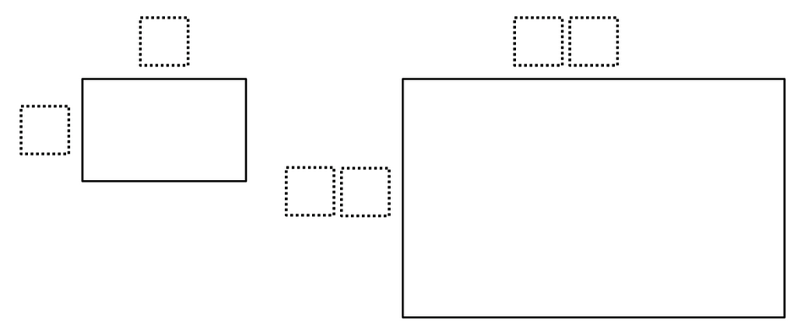  - Students will then find the area of each rectangle and determine how they compare. They should be able to justify their answer with mathematical calculations and then display thinking using a model, picture, or other representation of choice.  - Teacher instructs one member of each group to add their scale factor and change in area to the class table provided at the front of the room (example pictured below).  Discussion:  - What patterns do you notice?  - What answer was most common?  - How does the scale factor affect the change in area?  - What do you think “similar figures” means?  Teacher note: discuss the concept of similar figures and be sure to draw the connection between scale factor sides and how the area scale factor is the side scale factor squared.  - Students will find as many additional dimensions (given the same guidelines) as possible.
  Group | Dimensions | Scale Factor | Change in Area
  Ex. 1 | 2 x 3 and 4 x 6 | 2 | 6 to 24
Equitable Access | All students should be able to have one example, while some groups may be able to come up with many possible answers.  All students should have background knowledge on how to find the area of rectangles.  Extension Options:  1. Groups could swap rectangles and identify the scale factor used to create rectangles and justify using mathematical language and thinking giving students different perspectives from which to create.  2. The students could also do the same activity with triangles and then compare how the area would be affected.
Mathematical Vocabulary | Scale  Ratios  Proportions  Rectangles  Area  Dimensions
Student Reflection | Group answer display  What did you struggle with today? Why do you think you had difficulty with it?  What do you need clarification on concerning similar rectangles?  What did you do well today? Why do you think you were able to do it well?  What questions do you still have?

Unit 3 Task 5 Resource: Student Handout
Return to Table of Contents
Similar Shapes

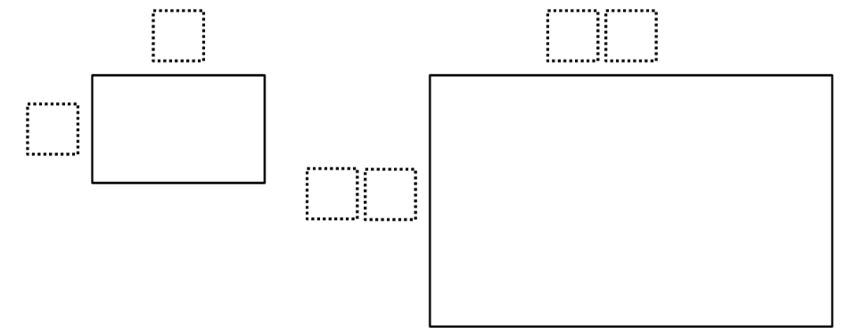

- The two rectangles above are similar. Using the digits 0 – 9, at most one time each, fill in the boxes so that one rectangle is a scaled drawing of the other.

- How does the area of the two rectangles compare? Justify your answer with mathematical evidence and display thinking using a model, picture, or other representation of your choice.

- Using the similar rectangles above and directions from #1, come up with as many possible combinations for the dimensions of both rectangles. (work space below)

Saha, P. (n.d.). Similar Shapes. Retrieved June 24, 2019, from https://www.openmiddle.com/similar-shapes/

Unit 4 Content Standards with Clarifying Notes
Open bullets indicate clarifying notes.
Return to Table of Contents
7.GM.1 Determine the scale factor and translate between scale models and actual measurements (e.g., lengths, area) of real-world objects and geometric figures using proportional reasoning.
- Include examples for scaling up and scaling down (e.g., a scale model of an eye would be scaling up, a map would be an example of scaling down).
- Make the distinction between a scale factor and scale. Scale factors are always expressed in the same units. (1cm to 50 cm) Scale is used when working with maps, drawings, or photographs and many times are expressed in two different units (1 inch = 10 miles).
7.GM.2 Construct triangles and special quadrilaterals using a variety of tools (e.g., freehand, ruler and protractor, technology).
a. Construct triangles given all measurements of either angles or sides.
b. Decide if the measurements determine a unique triangle, more than one triangle, or no triangle.
c. Construct special quadrilaterals (i.e., kite, trapezoid, isosceles trapezoid, rhombus, parallelogram, rectangle) given specific parameters about angles or sides.
- Two-dimensional figures that are constructed by freehand need not be drawn to scale. However, all measurements should be labeled.
- Not all combinations of side measurements or angle measurements produce triangles.
- The conditions for unique triangles are such that the dimensions will not satisfy another (unless they are congruent).
- Some combinations of measurements will produce more than one triangle (For example, there are an infinite number of triangles that contain three ${60}^{∘}$angles. Additionally, a triangle with side lengths 3 and 4 could have a third side that measures greater than 1 but less than 7.)
- The lengths of any two sides of a triangle will have a sum greater than the third (Triangle Inequality Theorem).
- Categorize triangles by the lengths of their sides (isosceles, equilateral, and scalene) as well as by the measure of their angles (right, obtuse, and acute).
7.GM.3 Describe two-dimensional cross-sections of three-dimensional figures, specifically right rectangular prisms and right rectangular pyramids.
- Include horizontal, vertical, and diagonal cross-sections.
- Predict the two-dimensional figures that result from slicing a 3-D figure such as a right-rectangular prism or pyramid. (perpendicular cuts and parallel cuts)

Unit 4 New Academic Vocabulary for This Unit
Return to Table of Contents
- Scale drawings
- Scale factor
- Cross-section
- Freehand
- Diagonal
- Equiangular
- Interior Angles

Unit 4 Prior Knowledge Required for this Unit
Return to Table of Contents
- Identify and describe two-dimensional shapes (K.G.2)
- Identify triangles, quadrilaterals, hexagons, and cubes. Recognize and draw shapes having specified attributes, such as a given number of angles or a given number of equal faces (2.G.1)
- Understand that shapes in different categories (e.g., rhombus, rectangle, square, and other 4-sided shapes) may share attributes (e.g., 4-sided figures) and the shared attributes can define a larger category (e.g., quadrilateral). Recognize rhombuses, rectangles, and squares as examples of quadrilaterals, and draw examples of quadrilaterals that do not belong to any of these subcategories (3.G.1)
- Identify a three-dimensional shape (i.e., right rectangular prism, right triangular prism, pyramid) based on a given two-dimensional net and explain the relationship between the shape and the net (3.G.4)
- Recognize right triangles as a category, and identify right triangles. (4.G.3)

Unit 4 Subsequent Knowledge Related to this Unit
Return to Table of Contents
Constructions facilitate an understanding of geometry. Providing opportunities for students to construct angles, triangles, and quadrilaterals will allow students to discover the side and angle conditions that will form triangles. Students should be able to use this knowledge to determine if certain side lengths or angles can form a triangle and justify their conclusions with both sketches and reasoning. This leads directly into preparation for proofs in geometry. In high school mathematics courses, students will use their understanding of triangles’ attributes to recognize similar and congruent triangles. Students will also draw conclusions about the perimeters, areas, and volumes of similar figures based on the scale factor that exists between them. Also in high school, students will extend their knowledge of cross sections to explain Cavalieri’s Principle.

Unit 4 Relationship Among Standards in this Unit
Return to Table of Contents
Standards in this unit will establish an understanding of relationships that exist among the attributes of triangles, quadrilaterals, and three-dimensional figures (e.g. prisms and pyramids). They also help develop 3-D visualization skills.

Unit 4 Potential Instructional Strategies
Return to Table of Contents
- Dynamic Geometric Software (e.g. Geometer’s Sketchpad or GeoGebra)
- Compass and Straightedge construction
- Geometric Solids and Nets

Unit 4 Resources
Return to Table of Contents
7.GM.1 - This YummyMath activity has students use proportional reasoning to discuss and theorize about the size of various television screens. Glowing Rectangles

7.GM.3 - This site defines a cross-section and also has an interactive activity which allows you to slice and see the cross-sections of 3D figures. Cross Section Flyer

Course/Grade: 7th Grade  Unit: 4 | Task Title: Task 1 Mona Lisa Math  Return to Table of Contents
State Standards Addressed | 7.GM.1 Determine the scale factor and translate between scale models and actual measurements (e.g., lengths, area) of real-world objects and geometric figures using proportional reasoning.
Mathematical Process Standards Addressed | 2a. Make sense of quantities and their relationships in mathematical and real-world situations.  2d. Connect the meaning of mathematical operations to the context of a given situation.  4c. Make assumptions and estimates to simplify complicated situations.  6d. Use appropriate units, scales, and labels.  7c. Look for structures to interpret meaning and develop solution strategies.
Materials and Resources | A projected picture of the Mona Lisa  It may be beneficial to have papers that actually measure these sizes, for students who are hands-on learners. A life-size picture of the Mona Lisa would be the most beneficial.
Task Description | Teacher note: this activity should be used after previous instruction on scale factor. Students can work in groups or pairs for this activity.  Provide students with two sets of two paper rectangles, one set should have dimensions that are scaled (ex., 2”x4” and 6”x12”) and the other set should not be scaled. It may be beneficial to label each rectangle A, B, C, or D. Allow students to explore these sets of rectangles and list their notices and wonders. Ideally, this should lead to a discussion of scale factors.  Oscar wants to sketch a picture of the Mona Lisa from his recent visit to the Louvre. The Mona Lisa’s original size is 21 inches by 30 inches.  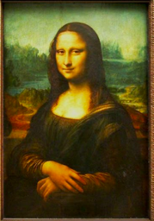  ↑  30 in  ↓  ←21 in→  Oscar has two sheets of paper. One measures 7 inches by 10 inches, and the other measures 8 inches by 11 inches. (Not drawn to scale).  (SCDE, 2019)  7 in  10 in  8 in  11 in  - Which sheet of paper would be better for Oscar to use to draw the Mona Lisa? Why?  Teacher note: students should observe that the 7*11 paper is better because it's scaled down from the original, so there will be no leftover space.  - Oscar’s friend Allison makes a drawing. It measures 3 inches by 5 inches. Allison, a talented artist, can’t figure out why her drawing doesn’t quite look like the Mona Lisa. What do you think happened?  Teacher note: the student should observe that Allison’s drawing will be off because it is not to scale from the original.  - Oscar decides to turn a printout of the Mona Lisa into a keychain. The keychain has a scale factor of $\frac{1}{10}$from the original. Would you expect the keychain to be bigger or smaller than the original painting? Why?  - Based on your answer to #3, what can you expect from all scale factors that are fractions?  Teacher note: lead a discussion about fractional and decimal scale factors that are between 0 and 1. Be sure students do not confuse this with negative scale factors.  - The Mona Lisa is displayed as a banner on the side of a museum. In the original painting, her smile measures about two inches. On the poster, it measures 18 inches.  - What is the scale factor?  - If her hair is ten inches long in the picture, how long would you expect it to be on the poster? Why?  Optional extension: Students should research a piece of artwork and draw it to scale.
Equitable Access | By making the first few questions intuition-based with multiple responses, all students are able to access the content from the beginning. Engaging conversations, whole group and small group, helps students have a different perspective and create understanding. Real-world context is incorporated so that students can authentically engage with the problem.
Mathematical Vocabulary | scale  scale factor  fraction
Student Reflection | - What sort of things need to be considered when scaling an object up or down?  - Where are scale models used in real life? Give as many examples as you can.  - Explain the difference between a scale factor, like 1 cm to 50 cm, and scale, like 2 ft. to 1 inch.

Course/Grade:7th grade  Unit: 4 | Task Title: Task 2 Constructing Triangles and Quadrilaterals  Return to Table of Contents
State Standards Addressed | 7.GM.2: Construct triangles and special quadrilaterals using a variety of tools (e.g., freehand, ruler and protractor, technology).
Mathematical Process Standards Addressed | 1b. Recognize there may be multiple entry points to a problem and more than one path to a solution.  3a. Construct and justify a solution to a problem.  5a. Select and use appropriate tools when solving a mathematical problem.
Materials and Resources | 6 Sheets of Poster Paper  Post-It Notes (2 different colors)  Protractors  Compass  Rulers  Math Is Fun: Constructions
Task Description | Teacher note: This is an exploratory activity, please use after instruction about the shapes mentioned in step 1. This will take at least one 50 minute class period. You will likely need to teach students on how to use and read protractors and compasses.  The goal for students during this activity is to understand how to construct triangles and special quadrilaterals. Students should be able to use a protractor, ruler, and a compass. Lastly, they should recognize what the identity of a shape is, and how the angles, side lengths, or orientation could affect that.  Teacher Instructions  - Write the name of one of the following shapes on the top of a sheet of poster. There will be a total of 6 posters, 1 for each shape. Place the 6 posters around the room (either on the wall or on tables/desks). You should put a protractor, compass, and ruler with each poster.  - Triangle  - Kite  - Trapezoid  - Rhombus  - Parallelogram  - Rectangle  - On each poster, provide one or two reasonable parameters about each shape. For example, “one angle must measure 45 degrees,” or “a side must be 5 inches long.”  - Divide students into 6 groups. (Teacher note: mix the ability of the students)  - Give each group an assigned poster to start. They will have approximately 10 minutes to construct that shape using parameters about angles or sides. Teacher: please circulate the room to ensure everyone is constructing correctly. Students may use Math Is Fun: Constructions as a resource.  - Students will rotate to the next station on the gallery walk and construct the next shape. Teacher: please remind students that they are constructing the shape, not just drawing it.  - Students should return to their original station after rotating all the way through.  Discussion:  1. Did your shape look different than the ones on the paper? Why or why not?  2. Does the size and orientation of a shape change its identity? Why or why not?  3. What recommendations could you make so that all the shapes look the same?  4. Would it be possible to construct a parallelogram if one angle was 180 degrees? Why or why not?
Equitable Access | Students will be grouped heterogeneously so struggling students will have support from their group. Engaging conversations with group members allows students hear different perspectives from which to create understanding. The teacher will circulate and help students/groups as needed.
Mathematical Vocabulary | Angle Measures  Side lengths  Triangle  Quadrilaterals  Kite  Trapezoid  Rhombus  Parallelogram  Rectangle
Student Reflection | Have students answer the following questions independently. They can do this as an exit ticket, submit online or in a math journal.  1. Which shape do you think is easier to construct and why?  2. What did you struggle with today? Why do you think you had difficulty with it?  3. What questions do you still have?

Course/Grade:7th  Unit: 4 | Task Title: Task 3 Cross-Sections  Return to Table of Contents
State Standards Addressed | 7.GM.3 Describe two-dimensional cross-sections of three-dimensional figures, specifically right rectangular prisms and right rectangular pyramids.
Mathematical Process Standards Addressed | 1. Make sense of problems and persevere in solving them.  1a. Relate a problem to prior knowledge.  1b. Recognize there may be multiple entry points to a problem and more than one path to a solution.  1c. Analyze what is given, what is not given, what is being asked, and what strategies are needed, and make an initial attempt to solve a problem.  3. Use critical thinking skills to justify mathematical reasoning and critique the reasoning of others.  3d. Reflect on and provide thoughtful responses to the reasoning of others.  4. Connect mathematical ideas and real-world situations through modeling.  4b. Interpret mathematical models in the context of the situation.  5a. Select and use appropriate tools when solving a mathematical problem.  5b. Use technological tools and other external mathematical resources to explore and deepen understanding of concepts.  6. Communicate mathematically and approach mathematical situations with precision.  6c. Use appropriate and precise mathematical language.  6d. Use appropriate units, scales, and labels.  7a. Recognize complex mathematical objects as being composed of more than one simple object.
Materials and Resources | Tablet or computer, projector  Video: 3D Shapes into 2D Objects  Slicing Solids  Play-doh or clay  String  Math Is Fun: Cross Sections
Task Description | Teacher note: this activity will take at least two days.  Introduction: Show students the 3D Shapes into 2D Objects (teacher note: watch the video first to look for talking points)  1. Pause the video at 31 seconds. Ask students, “What shape is the onion?”  2. Pause the video at 32 seconds. Ask students, “When it’s being sliced, what shape is being created?”  3. Watch the remainder of the video.  4. Ask students, “What do you think a cross section is?” Explain the idea that a cross section shows what 2d shape a section of a 3d object makes.  5. Ask students, “Would the 2d shape change based on the orientation of the figure? What if you had cut a cube of cheese at an angle?”  5. Access the website Slicing Solids. Show students how the cross section changes based on the angle that the plane intersects the 3d figure.  Task 1  Students should form a cube using their clay.  - Try to form the following shapes by slicing the cube with the string: square, equilateral triangle, a rectangle that is not a square, a non-equilateral triangle, pentagon, hexagon, octagon, a parallelogram that is not a rectangle, circle.  - A couple of the shapes on the list in Problem 1 are impossible to make by slicing a cube. Explain what makes them impossible.  - Find a way to slice a tetrahedron to make a square cross section. How did you do it?  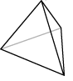  - What cross sections can you get from each of these figures?  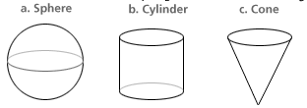  Note: the objective of this is for students to see the visual aspect of math and form concrete conclusions.  Task 2 (Optional Extension) Slicing Solids  - Students will be directed to go to the above site. They should answer questions 11.1, 11.2, and 11.3.  (SCDE, 2019)  Students should answer the following questions.  - What do you notice from the cross-section of a prism taken from different heights vertically or horizontally? Justify your response or responses.  - What do you notice from the cross-section of a pyramid taken from different heights vertically or horizontally? Justify your response or responses.  Resource: Math Is Fun: Cross Sections
   | Original Solid (pyramid/prism) | Name of Shape or shapes Derived | Did you make a cut horizontally, vertically or at an angle?
  11.1 |  | --------------- | ---------------
  11.2
  11.4
Equitable Access | Students access through devices, work with shoulder partner to compare findings. Visual aspect of cutting solids, either physically or digitally, allows all students to access the material. Engaging conversations with group members helps students hear different perspectives and create understanding.
Mathematical Vocabulary | Cross-section  Prisms  Pyramids  Solids  3-Dimension  2-Dimension  Surfaces
Student Reflection | - What is a cross-section?  - How are cross-sections formed?  - How can you use the concept of a cross-section to solve a problem in real life?

Unit 5 Content Standards with Clarifying Notes
Open bullets indicate clarifying notes.
Return to Table of Contents
7.GM.4 Investigate the concept of circles.
a. Demonstrate an understanding of the proportional relationships between diameter, radius, and circumference of a circle.
b. Understand that the constant of proportionality between the circumference and diameter is equivalent to $π$.
c. Explore the relationship between circumference and area using a visual model.
d. Use the formulas for circumference and area of circles appropriately to solve real-world and mathematical problems.
- Understand that pi is derived from the ratio of the circumference of a circle and its diameter.
- Recognize that $πd$and $2πr$are equivalent expressions that can be used to find circumference.
- Recognize 3.14 and $\frac{22}{7}$as acceptable approximations for pi.
- Recognize 2$π$ as an exact value and 6.28 as an approximate answer.
7.GM.5 Write equations to solve problems involving the relationships between angles formed by two intersecting lines, including supplementary, complementary, vertical, and adjacent.
- Recognize that two angles whose sum is ${90}^{∘}$are complementary angles
- Recognize that two angles whose sum is ${180}^{∘}$are supplementary angles.
- Recognize that vertical angles are congruent to one another.
- Recognize that two pairs of vertical angles are formed when two lines intersect one another.
- Recognize that two angles are defined as adjacent if they share a vertex and a side.
- Recognize that two angles that are supplementary and adjacent form a linear pair.
7.GM.6 Apply the concepts of two- and three-dimensional figures to real-world and mathematical situations.
a. Understand that the concept of area is applied to two-dimensional figures such as triangles, quadrilaterals, and polygons.
b. Understand that the concepts of volume and surface area are applied to three dimensional figures such as cubes, right rectangular prisms, and right triangular prisms.
c. Decompose cubes, right rectangular prisms, and right triangular prisms into rectangles and triangles to derive the formulas for volume and surface area.
d. Use the formulas for area, volume, and surface area appropriately.
- Recognize that surface area covers a three-dimensional shape while volume fills the three-dimensional shape.
- Recognize that surface area is the sum of the areas of the bases and lateral surfaces of a three-dimensional figure.
- Recognize that the volume of cubes, right rectangular prisms, and right triangular prisms is equivalent to the area of the base multiplied by the height ($V=Bh, where B is the area of the base)$.
- Recognize that surface area is labeled with square units and volume is labeled with cubic units.
- Recognize that a length is measured in linear units if finding an unknown length.
7.EEI.4 Apply the concepts of linear equations and inequalities in one variable to real-world and mathematical situations.
a. Write and fluently solve linear equations of the form $ax+b=c$ and $a\left(x+b\right)=c$ where $a$, $b$, and $c$ are rational numbers.
b. Write and solve multi-step linear equations that include the use of the distributive property and combining like terms. Exclude equations that contain variables on both sides.
c. Write and solve two-step linear inequalities. Graph the solution set on a number line and interpret its meaning.
d. Identify and justify the steps for solving multi-step linear equations and two-step linear inequalities.
- Write and use equations to solve problems involving circumference, area, surface area, volume, and angle relationships.

Unit 5 New Academic Vocabulary for This Unit
Return to Table of Contents
- Diameter
- Radius
- Circumference
- Supplementary Angles
- Complementary Angles
- Vertical Angles
- Adjacent Angles
- Linear Pair
- Congruent angles
- Pi ($π$)

Unit 5 Prior Knowledge Required for this Unit
Return to Table of Contents
- Solve 2-step equations (7.EEI.4)
- Understand the constant of proportionality (7.RP.2)
- Understand how to use formulas to find area, surface area, volume (4.MDA.3, 5.MDA.3, 6.GM.2, 6.GM.4)

Unit 5 Subsequent Knowledge Related to this Unit
Return to Table of Contents
In high school mathematics classes, students will use their knowledge of angle measures to prove theorems about two- and three-dimensional figures and extend their knowledge of circles to determine the lengths of arcs and the area of sectors within a circle. Students will also use a three-dimensional figure’s apothem and perimeter to determine its area. Also in high school, students will apply Cavalieri’s Principle to prove the volumes of figures possessing the same height and cross-sectional areas are equivalent.

Unit 5 Relationship Among Standards in this Unit
Return to Table of Contents
Standards in this unit will establish an understanding of relationships that exist among the concepts of two- and three- dimensional figures.

Unit 5 Potential Instructional Strategies
Return to Table of Contents
- Real-world Connections - use circular items and have students measure the circumference and the diameter to help students visualize the ratio between circumference and diameter which is pi.
- Dynamic Geometric Software – use software/applications to explore angle relationships formed by intersecting lines.
  - Geometer’s Sketchpad
  - GeoGebra

Unit 5 Resources
Return to Table of Contents
7.GM.4 - This activity allows you to investigate how the area and circumference of a circle compare to its radius and diameter. Circle Tool (NCTM membership required for access) (Requires Adobe Flash Player)

7. GM. 4 - This is a video that introduces the parts of a circle. What Is a Circle?

7.GM.4 - Performance Task for calculating area of a circle. Eight Circles

Course/Grade:7th grade  Unit: 5 | Task Title: Task 1 Toilet Paper Tube Design  Return to Table of Contents
State Standards Addressed | 7.GM.4 Investigate the concept of circles.
Mathematical Process Standards Addressed | 1b. Recognize there may be multiple entry points to a problem and more than one path to a solution.  1c. Analyze what is given, what is not given, what is being asked, and what strategies are needed, and make an initial attempt to solve a problem.  2d. Connect the meaning of mathematical operations to the context of a given situation.  3a. Construct and justify a solution to a problem.  5a. Select and use appropriate tools when solving a mathematical problem.  6b. Represent numbers in an appropriate form according to the context of the situation.
Materials and Resources | Empty Toilet paper tube – one per group  Ruler - one per group  String to measure or flexible tape measure one per group  Calculator one per group  Compass  Part 1 Task Card for each group  Part 2 Task Card for each group
Task Description | Teacher note: This task is in two parts, plus an optional extension. Each part has a task card. Review the term “circumference” with the students before starting the activity.  Part 1  - Divide students into groups of 3-4 each  - Give each group Part 1 Task Card and related materials (empty toilet paper tube, string to measure, ruler, calculator)  - When groups have completed task 1 – teacher should check, discuss, and allow for revisions if needed  Discussion:  1. What did you discover through the process of comparing the distance around the tube, and the height of the tube?  2. Does the height of the tube affect the circumference of the tube? What about the other way around? Why or why not?  3. Using a calculator, divide the circumference of the circle by the diameter. What number did you get? (Teacher: explain pi as the ratio of the diameter to the circumference).  4. How can this ratio help you find the circumference of a circle with just a straight ruler?  Part 2  - Give each group the Part 2 Task Card. Students will be asked to find how much cardboard would be needed to create a lid to cover both the top and bottom of the tube.  - Ask students to construct the lids on graph paper using a compass. Find the area of each circle using the formula$πr^{2}=A$.  Teacher Note: In each part students must explain and justify all thinking and clearly display it.  Discussion  1. Why do you think the area of a circle involves “squaring” the radius?  2. How could you find the area using the diameter of a circle? What about the circumference?  Part 3 – Optional Extension  Have students cut open the toilet paper roll to find the surface area of the lateral side.  Discussion:  1. What do you think may be the relationship between the circumference and the surface area of the toilet paper roll?  2. Can you come up with a formula that will give you the surface area of the entire cylinder, including the top and bottom that you made in part 2?
Equitable Access | All students can explore the concept using the manipulatives. Engaging conversations with group members allows students to hear different perspectives and create understanding.
Mathematical Vocabulary | cylinder  tube  height of cylinder  circumference  area
Student Reflection | Students will demonstrate their understanding through their answer display, group oral conversation, and written justification.  Journal Questions:  1. Why might they use a cylinder for a tissue roll instead of a different shape?  2. Why is pi useful in operating with circles?  3. Explain the difference between circumference and area.

Unit 5 Task 1 Resource: Task Card Part 1
Return to Table of Contents
Toilet Paper Tube Activity
Part 1

Clare wonders if the height of the toilet paper tube or the distance around the tube (circumference) is greater. Using the material provided (or others if you can think of any), explain how she could find this out. Then think, discuss, and explain how this could be done with only a straight ruler. Be sure to use words, mathematics, and pictures if needed to create your answer. Be sure to justify and explain each step clearly so Clare can read and follow your directions to solve the problem.

Open Up Resources and Illustrative Mathematics. (n.d.). Lesson 3: Exploring Circumference. Retrieved June 26, 2019, from https://im.openupresources.org/7/students/3/3.html

Unit 5 Task 1 Resource: Task Card Part 2
Return to Table of Contents
Toilet Paper Tube Activity
Part 2

Now Clare needs to create a lid to perfectly cover the top and bottom of the tube to create a storage container. Determine what information she needs and then explain (words, math, and/or pictures) how she could find how much cardboard it would take to cover the top and bottom.

Open Up Resources and Illustrative Mathematics. (n.d.). Lesson 3: Exploring Circumference. Retrieved June 26, 2019, from https://im.openupresources.org/7/students/3/3.html

Course/Grade:7th grade  Unit: 5 | Task Title: Task 2 Surface Area and Volume  Return to Table of Contents
State Standards Addressed | 7.GM.6 – Apply the concepts of two and three-dimensional figures to real-world and mathematical situations.
Mathematical Process Standards Addressed | 1b. Recognize there may be multiple entry points to a problem and more than one path to a solution.  3a. Construct and justify a solution to a problem.  4d. Evaluate the reasonableness of a model and refine if necessary.  5a. Select and use appropriate tools when solving a mathematical problem.  6c. Use appropriate and precise mathematical language.  7c. Look for structures to interpret meaning and develop solution strategies.
Materials and Resources | Maximizing Rectangular Prism Surface Area Task Card – one per student
Task Description | Specific Learning Outcomes: create a rectangular prism with the greatest surface area using digits 1-9, without repeating any digits.  The student should be able to understand surface area and the formula behind it.  - Create groups of 3-4 students  - Each student will be given the Maximizing Rectangular Prism Surface Area Task Card (with the following diagram on the task card). Teacher note: it may be beneficial to laminate the cards or put them in page protectors and allow students to use Expo markers).  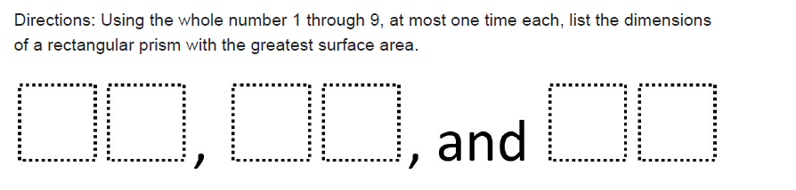  Each group member should write their own justification (silently), then come back together as a group and create ONE unified justification piece to add to their answer display.  *Teacher questions for prompting student when necessary:  -Could you draw a diagram to help you?  -Could you label that diagram to help place the numbers you need?  -Discuss with your group how you find the surface area of a rectangle.  -Could you use a trial and error method or guess and check method to start your thinking?  -Which three digits do you think won’t be included in the dimensions? Why?  - Gallery Walk: groups will display answers and then each group will do a gallery walk – (walking around the room to view and “critique” others work). Teacher should provide sticky notes to students to ask clarifying questions.
Equitable Access | Engaging conversations with group members allows students to hear different perspectives and create understanding.  See task description:  *suggestions to help struggling students get started thinking  *questions for scaffolding.  *two options to differentiate instruction for early finishers  Extension: Early Finishers  Option 1 – Using the same squares and numbers 1-9, what is the rectangle dimensions for the smallest surface area?  Option 2 – Are there any number combinations that would give you the same surface area?  Option 3 - Students could create their own “guidelines” for creating rectangular prisms with certain surface areas, limiting digits used or any set of criteria.
Mathematical Vocabulary | surface area  rectangular prism  dimensions
Student Reflection | Students will demonstrate their understanding through their answer display, group oral conversation, and written justification.

Unit 5 Task 2 Resource: Maximizing Rectangles Task Card
Return to Table of Contents

- As a group use the box below to show all work and thinking.
- Each group member will then write their own justification (silently), then come back together as a group and create ONE unified justification piece to add to their answer display.
- Create a group display for your answers, thinking, and group justification.
WORK SPACE:

Maximizing Rectangular Prism Surface Area | Open Middle®. (n.d.). Retrieved June 24, 2019, from https://www.openmiddle.com/maximizing-rectangular-prism-surface-area/

Unit 6 Content Standards with Clarifying Notes
Open bullets indicate clarifying notes.
Return to Table of Contents
7.DSP.1* Investigate concepts of random sampling.
a. Understand that a sample is a subset of a population and both possess the same characteristics.
b. Differentiate between random and nonrandom sampling.
c. Understand that generalizations from a sample are valid only if the sample is representative of the population.
d. Understand that random sampling is used to gather a representative sample and supports valid inferences about the population.
- Recognize that a random sample is an unbiased representation of a group.
- Recognize that a random sample must be used in conjunction with the population to make valid inferences.
7.DSP.2* Draw inferences about a population by collecting multiple random samples of the same size to investigate variability in estimates of the characteristic of interest.
- Important to make sure that the sample sizes of the population are the same.
- Issues of variation in the samples should be addressed through investigations of multiple subsets.
7.DSP.3 Visually compare the centers, spreads, and overlap of two displays of data (i.e., dot plots, histograms, box plots) that are graphed on the same scale and draw inferences about this data.
- Understand that alternate data sources should be used beyond sports data.
- Make inferences about multiple displays of data of the same type of data representation with the same scale (e.g., visually comparing the box plot of company A salaries to the box plot of company B salaries).
7.DSP.4* Compare the numerical measures of center (mean, median, mode) and variability (range, interquartile range, mean absolute deviation) from two random samples to draw inferences about the populations.
  - Use the comparisons of data to draw inferences about populations.

Unit 6 New Academic Vocabulary for This Unit
Return to Table of Contents
- Subset
- Sample
- Random sample
- Non-random sample
- Inference
- Measures of central tendency
- Bias
- Population
- Spread

Unit 6 Prior Knowledge Required for this Unit
Return to Table of Contents
- Calculating center and spread (6.DS.2)
- Creation of dot plots, histograms, and boxplots (6.DS. 4)
- Analyze a single data display 6.DS.5

Unit 6 Subsequent Knowledge Related to this Unit
Return to Table of Contents
The work students have done from Grade 6 and Grade 7 utilizing univariate data will prepare them for statistics with the use of bivariate data in Grade 8. The plotting of points in Grade 6 will allow the students to work very closely with the most common form of bivariate data, scatter plots. In Grade 8, students will also use their graphing skills to locate the best line of fit for a data set. Working with the best line of fit ties in directly with finding the slope and intercept of a line in Grade 8. In high school math courses, students will begin to identify linear, quadratic, and exponential relationships among data values. Also, in high school math courses, students will determine the regression equations for linear, quadratic, and exponential relationships.

Unit 6 Relationship Among Standards in this Unit
Return to Table of Contents
The standards in this unit require students to use previous skills to draw inferences about one population from a random sampling of that population. They will extend these skills to draw informal inferences about two populations.

Unit 6 Potential Instructional Strategies
Return to Table of Contents
- Real-world Connections – Allow students to use real-world examples from social studies and science of random samples to make predictions about population. Additionally, have students represent the data and analyze shape, center, and spread to draw conclusions about population.
- Technology - Students can use technology to create data displays. These sites require Java.
  - Box Plot Tool
  - Histogram Tool
  - National Library of Virtual Manipulatives

Unit 6 Resources
Return to Table of Contents
7.DSP.1, 7.DSP.2 - This activity, from NCTM’s Illuminations, engages students as they collect data from classmates and use the data to answer statistical questions regarding their class. About Our Class (NCTM membership required for access)

7.DSP.3 - This site provides sample problems to use as examples in class that provide dot plots and box plots and allows them to compare the centers and spreads of two sets of data. Comparing Populations - What are center, shape and spread?

Course/Grade:7th  Unit: 6 | Task Title: Task 1 Making Sense of Data Box-Plot Football  Return to Table of Contents
State Standards Addressed | 7.DSP.3 Visually compare the centers, spreads, and overlap of two displays of data (i.e., dot plots, histograms, box plots) that are graphed on the same scale and draw inferences about this data.  7.DSP.4* Compare the numerical measures of center (mean, median, mode) and variability (range, interquartile range, mean absolute deviation) from two random samples to draw inferences about the populations.
Mathematical Process Standards Addressed | 1d. Evaluate the success of an approach to solve a problem and refine it if necessary.  2a. Make sense of quantities and their relationships in mathematical and real-world situations.  3c. Make conjectures and explore their validity.  3d. Reflect on and provide thoughtful responses to the reasoning of others.  5b. Use technological tools and other external mathematical resources to explore and deepen understanding of concepts.
Materials and Resources | Student devices (if possible)  display (chart paper/white board)
Task Description | Teacher note: This is not an introductory activity. Please make sure students are familiar with the five number summary prior to this activity.  If students have access to the internet, have them access Desmos Box Plot Generator.  Students should create as many different box plots as possible, and look for patterns regarding the width, points, lines (representing Q1, median, and Q3).  Jaylen (A) and Jake (B) are comparing their rushing yards (the yards that a player carries a football) during a football season. They make a boxplot of each list.  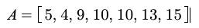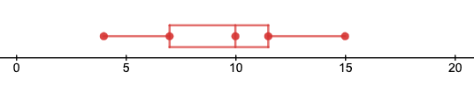(SCDE, 2019)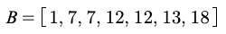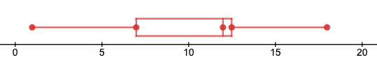(SCDE, 2019)  Teacher note: This activity could work as whole group, small group stations, or partners.  List as many things that you notice and wonder about these two boxplots. Also, write the five number summary and find the variation for both boxplots. (If completing in groups or whole group, list on chart paper or white board)  - Who do you think is better at rushing? Why?  - Who do you think is the more consistent rusher?  - How does the range of the boxplot influence what you think about each player?  - Find the mean for each set of data. Should Jake and Jaylen compare their means to see who is best? If not, what should they compare?  - What is the median for each box plot? What do you think this means for the players?  - The coach decides to use Jaylen (graph A) for the next ball game. How many yards should he expect Jaylen to rush?  - What kind of extra data would make Jake (graph B) look like a more reliable player?  Class Discussion: What does everyone see in the two graphs? What do you know about the two players? What do you need to know about the two graphs to compare them?  - Compare the modes for each player. Does it matter that Jake has two modes? Why or why not?  - The size of the box is called the interquartile range. What does Jake’s interquartile range tell you?
Equitable Access | The football perspective allows students to engage at an authentic level.  By allowing students to make observations about the boxplots prior to performing any formal mathematics, students at all levels can explore the concepts.
Mathematical Vocabulary | mean  mode  median  range  quartiles  random sampling
Student Reflection | - When is it better to use the median instead of the mode?  - What does the range tell you about a set of data?  - What does the interquartile range tell you about a set of data?  - If you were a coach, besides the data, what else would help you determine which player should play?

Unit 7 Content Standards with Clarifying Notes
Open bullets indicate clarifying notes.
Return to Table of Contents
7.DSP.5 Investigate the concept of probability of chance events.
a. Determine probabilities of simple events.
b. Understand that probability measures likelihood of a chance event occurring.
c. Understand that the probability of a chance event is a number between 0 and 1.
d. Understand that a probability closer to 1 indicates a likely chance event.
e. Understand that a probability close to $\frac{1}{2}$ indicates that a chance event is neither likely nor unlikely.
f. Understand that a probability closer to 0 indicates an unlikely chance event.
- Write the probability of an event as the ratio of possible outcomes to the total number of outcomes ($\frac{possible outcomes}{total number of outcomes}$).
7.DSP.6* Investigate the relationship between theoretical and experimental probabilities for simple events.
a. Determine approximate outcomes using theoretical probability.
b. Perform experiments that model theoretical probability.
c. Compare theoretical and experimental probabilities.
- Recognize the relationship between experimental and theoretical probability. Students need to see that experimental probability proves theoretical probability.
- Use experimental probability $\left(\frac{number of times an event occurs}{total number of trials}\right)$to perform experiments that can be compared to theoretical probability $\left(\frac{number of ways an event can occur}{total number of outcomes}\right)$.
- Find probabilities for simple events using methods such as organized lists and tables.
7.DSP.7* Apply the concepts of theoretical and experimental probabilities for simple events.
a. Differentiate between uniform and non-uniform probability models (distributions).
b. Develop both uniform and non-uniform probability models.
c. Perform experiments to test the validity of probability models.
- Understand that a uniform probability model is an example of a model where all events are equally likely (e.g., a standard deck of 52 cards has four suits, each suit is equally likely to be drawn from the deck of cards).
- Understand that a non-uniform probability model is an example of a model where all events are not equally likely (e.g., a spinner that does not have equal distribution or sector sizes).
7.DSP.8* Extend the concepts of simple events to investigate compound events.
a. Understand that the probability of a compound event is between 0 and 1.
b. Identify the outcomes in a sample space using organized lists, tables, and tree diagrams.
c. Determine probabilities of compound events using organized lists, tables, and tree diagrams.
d. Design and use simulations to collect data and determine probabilities.
e. Compare theoretical and experimental probabilities for compound events.
- Understand that compound events represent two or more events happening at the once.
- Find the probability of a compound event by adding the probability of the events ($P(A, B) = P(A)∙P(B)$).
- Explain that the fraction of outcomes in probability of a compound event is similar to the probability of a simple event.
- Represent probability outcomes as fractions, decimals, or percents.

Unit 7 New Academic Vocabulary for This Unit
Return to Table of Contents
- Probability
- Theoretical Probability
- Experimental Probability
- Chance
- Likelihood
- Uniform, non-uniform probability models
- Simple events
- Compound events
- Certain
- Impossible
- Sample Space
- Simulation
- Equally Likely
- Equivalent

Unit 7 Prior Knowledge Required for this Unit
Return to Table of Contents
- Write a ratio (6.RP.1)
- Multiplication of fractions (5.NSF.5, 5.NSF.6)
- Addition of fractions (5.NSF.1)

Unit 7 Subsequent Knowledge Related to this Unit
Return to Table of Contents
In high school math courses, students will apply their knowledge of probability to determine the likelihood of an object being located in an indicated area of a geometric figure. Students will also extend their understanding of probability to include conditional probability.

Unit 7 Relationship Among Standards in this Unit
Return to Table of Contents
Standards in this unit will establish an understanding of relationships that exist among theoretical, experimental, simple, and compound probabilities.

Unit 7 Potential Instructional Strategies
Return to Table of Contents
- Real-world Connections
  - Conduct an experiment using a Styrofoam cup by tossing the cup and recording how it lands.
    - How many trials were conducted?
    - How many times did the cup land right side up?
    - How many times did the cup land upside down?
    - How many times did the cup land on its side?
    - Determine the probability for each result.
  - Conduct an experiment using a coin and a spinner and record results in a table. (Compound Event)(Students could determine the probability of rolling a certain number, let’s say 2, and a certain color (if using a color wheel) or the same number on a number wheel)
    - Have students conduct at least 20 trials
    - How many times did you land on the number 2 and the color red?
    - How many times did you not land on the number 2 and not get the color red?
    - Determine the probability for the compound event with both desired outcome and with non-desired outcomes. Together the sum of those probabilities should equal 1.
- Technology – Technology can be used to simulate the act of using coins, spinners, and fair number cubes to determine experimental probability.
  - Marble Mania (Requires Adobe Flash Player)
  - NCTM’s Random Drawing Tool

Unit 7 Resources
Return to Table of Contents
7.DSP.5, 7.DSP.6, 7.DSP.7, 7.DSP.8 - This site provides a lesson plan for activity stations allowing students to express their understanding of theoretical, experimental, simple, and compound probabilities. Probability Review Stations

7.DSP.5, 7.DSP.6, 7.DSP.7, 7.DSP.8 - This site provides several lesson plan and activities that will allow students an opportunity to express their understanding of theoretical, experimental, simple, and compound probabilities. Statistics and Probability

7.DSP.5, 7.DSP.6, 7.DSP.7 - This site allows students to watch and listen to an explanation of different ways to express probability set to hip-hop music. This video focuses on the basics of odds and probability and expressing probabilities as decimals, percents, and fractions. Probability: Tell the Future

Course/Grade:7th grade  Unit: 7 | Task Title: Task 1 Is the game fair or unfair?  Return to Table of Contents
State Standards Addressed | 7.DSP.5 Investigate the concept of probability of chance events.  7.DSP.6* Investigate the relationship between theoretical and experimental probabilities for simple events.  7.DSP.7* Apply the concepts of theoretical and experimental probabilities for simple events.
Mathematical Process Standards Addressed | 1b. Recognize there may be multiple entry points to a problem and more than one path to a solution.  3a. Construct and justify a solution to a problem.  4d. Evaluate the reasonableness of a model and refine it if necessary.
Materials and Resources | Activity Procedures – one per group (word document)  Game Instructions – one game per four man group with materials listed on document for game (die, spinner, standard deck of cards, bag of marbles) (word document)  **If physical items for the games are not available, there are several websites that provide virtual spinners, die, etc. For example, Google Dice or NCTM’s Adjustable Spinner.
Task Description | Students should be able to understand basic principles of probability and chance, investigate theoretical probabilities, and practice with experimental probabilities.  - Divide students into groups of four (no more than 8 groups) – each group should create pairs to play the game  - Give each group a copy of the activity procedures and game instructions with materials specific for that game (see Unit 7 Task 1 Resources)  - Students will play games that are based on simple events and simple probability. They should each keep score of the game. Students will be challenged to use their knowledge of probability and chance to determine if the game is fair or unfair.  - Students should be encouraged to use mathematical thinking and language to create justification and support for their decision of fair or unfair. Students can use any method they choose to represent their answer/ justification (i.e.: Flipgrid video, picture, writing in words, etc.)  - Extending the activity: If the game is fair, students will then discuss how they could use their game and make it unfair. If the game is unfair, students will discuss how they could use their game and make it fair.  - Class Discussion Questions:  - How do you know your game is fair or unfair?  - Would you have the same answer if you played another 25 rounds?  - If you started completely over would your results (fair or unfair) be the same?  - Have you compared your results with the other pair in your group?
Equitable Access | All students will be involved in a group. Each student will be responsible for playing the game and keeping score. Each student will also be responsible for writing down their individual thoughts, discuss with partner, and then group to create one thought as a group about the fairness of their game.
Mathematical Vocabulary | probability  chance  fair  unfair  equal chance  unequal chance
Student Reflection | Students will submit score, written individual thoughts, and group written response.

Unit 7 Task 1 Resource: Activity Procedures
Return to Table of Contents
Activity Procedures
Part I: Play Game
- Partner up within your group and choose who will be player 1 and player 2
- Create a score sheet – two columns to tally score of game
- Read the instructions for the game you are given
- Play 50 rounds and be sure to keep a tally of points to see who wins the game
Part II: Fair or Unfair
Answer the question: Is this game fair? Why or why not?
- Individually: Think and write your own thoughts
- Partner: Discuss your thoughts with your partner.
- Group: Discuss your thoughts with your group and create one representation (your choice) to display your answer and justification. Be sure to support your answer mathematically and with math vocabulary
Part III: Change the Game
- If the game is fair, how could you make it unfair?
- If the game is unfair, how could you make it fair?

(SCDE, 2019)

Unit 7 Task 1 Resource: Games Instructions
Return to Table of Contents
Give students the instructions only not the teacher notes – do not tell students if the game is fair or unfair. This is something the group will decide and justify during the activity

Unfair Games
- Roll a die one-time for each turn. Player 1 wins a point only a number greater than 4 is rolled, otherwise; player 2 wins a point. (Teacher note: one die per two students)

- Spin the spinner one-time for each turn. Player 1 wins a point only if red or blue is spun, otherwise; player 2 wins a point. Play 50 rounds and be sure to keep a tally of points to see who wins the game. (Teacher note: one spinner per two students -- modify based on spinner you have available – spinner should be divided into 6 equal parts – 6 different colors)

- Choose one card for each turn, replace card each time and shuffle deck. Player 1 wins a point only if any card with a multiple of 4 is drawn, otherwise; player 2 wins a point. Play 50 rounds and be sure to keep a tally of points to see who wins the game. (Teacher note: one deck of standard playing cards per two students, Jack = 11, Queen = 12, King = 13, Ace = 1)

- Select one marble out of the bag for each turn, replace marble each time and shake bag. Player 1 wins a point only if a blue, purple, or yellow marble is selected. Play 50 rounds and be sure to keep a tally of points to see who wins the game. (Teacher note: a bag of marbles per two students - includes 20 marbles: 12 red, 2 blue, 3 yellow, 3 purple)

Fair Games:
- Roll a die one-time for each turn. Player 1 wins a point only if an even number is rolled, otherwise; player 2 wins a point. (Teacher note: one die per two students)

- Spin the spinner one-time for each turn. Player 1 wins a point only if blue, red, or green is spun, otherwise; player 2 wins a point. (Teacher note: one spinner per two students -- modify based on spinner you have available – spinner should be divided into 6 equal parts – 6 different colors)

- Choose one card for each turn, replace card each time and shuffle deck. Player 1 wins a point only if a spade or club is drawn, otherwise; player 2 wins a point. (Teacher note: one deck of standard playing cards per two students)

- Selected one marble out of the bag for each turn, replace marble each time and shake bag. Player 1 wins a point if a blue or yellow marble is selected. (Teacher note: a bag of marbles per two students - includes 20 marbles: 8 red, 6 blue, 4 yellow, 2 purple)
(SCDE,2019)

References
Return to Table of Contents
South Carolina Department of Education. (2015). South Carolina College- and Career-Ready Standards for Mathematics. Retrieved from https://ed.sc.gov/instruction/standards-learning/mathematics/standards/scccr-standards-for-mathematics-final-print-on-one-side/

Unit 1, Task 1
Persico, A. (2017, March 2). How to Teach Kids to Understand Elevation Above and Below Sea Level. Retrieved from https://mashupmath.com/blog/2017/3/2/how-to-teach-kids-to-understand-elevation-above-and-below-sea-level

Unit 1, Task 2
Multiplying Negatives. (n.d.). Retrieved from https://www.mathsisfun.com/multiplying-negatives.html

Unit 1, Task 3
(n.d.). Retrieved from http://www.amathsdictionaryforkids.com/qr/b/base10system.html#:~:text=our%20everyday%20number%20system%20is,a%20decimal%20point%20to%20separate

Unit 1, Task 4
Marcus. (2018, November 9). 'Café Fractions' - A Rich Task in Mathematics for Years 3 to 4. Retrieved from https://calculate.org.au/2018/07/26/cafe-fractions-a-rich-task-in-mathematics-for-years-3-to-4/

Multiplying Fractions. (n.d.). Retrieved from https://www.mathsisfun.com/fractions_multiplication.html

Subtracting Fractions. (n.d.). Retrieved from https://www.mathsisfun.com/fractions_subtraction.html

Unit 2, Task 5
(n.d.). Fraction Tiles with Work Tray, 5 sets - Bulk Pricing. Retrieved from https://www.didax.com/fraction-tiles-with-work-tray-5-sets-vp.html

Unit 3, Task 1
Lemily, C. (2014, January 1). Perfect Cubes Activity.pdf. Retrieved from https://betterlesson.com/lesson/resource/2599382/perfect-cubes-activity-pdf

Unit 3, Task 3
Task - Percentages WebQuest. (n.d.). Retrieved from https://sites.google.com/a/temple.edu/percentages-webquest/task

Unit 3, Task 5
Saha, P. (n.d.). Similar Shapes. Retrieved June 24, 2019, from https://www.openmiddle.com/similar-shapes/

Unit 4, Task 1
(2019, August 13). Mona Lisa. Retrieved from https://en.wikipedia.org/wiki/Mona_Lisa

Unit 4, Task 2
(n.d.). Retrieved from https://www.mathsisfun.com/geometry/constructions.html

Unit 4, Task 3
Open Up Resources and Illustrative Mathematics. (n.d.). Lesson 11: Slicing Solids. Retrieved from https://im.openupresources.org/7/students/7/11.html

(n.d.). Retrieved from https://www.mathsisfun.com/geometry/cross-sections.html

(n.d.). Retrieved from https://www.youtube.com/watch?v=Hwt0xhsIeAQ

Unit 5, Task 1
Open Up Resources and Illustrative Mathematics. (n.d.). Lesson 3: Exploring Circumference. Retrieved June 26, 2019, from https://im.openupresources.org/7/students/3/3.html

Unit 5, Task 2
Maximizing Rectangular Prism Surface Area | Open Middle®. (n.d.). Retrieved June 24, 2019, from https://www.openmiddle.com/maximizing-rectangular-prism-surface-area/

Graphs Created Using:
- Desmos Graphing Calculator. Desmos, Inc. Available from https://www.desmos.com/calculator

- TI Connect CE Software for Windows. Texas Instruments, Inc. Available from https://education.ti.com/en/software/details/en/13312F7CEC074A2DAFD7EE5646129839/swticonnectcesoftwareforwindows

- GraphFree. (n.d.). Retrieved June 23, 2018, from http://www.graphfree.com/

