Integrated Performance Assessment Units for French, High School Course 3

Contents

Unit 1: My Childhood
Unit 2: Travel
Unit 3: My Future
Unit 4: My Health
References
Appendix A – Unit 1 Materials
Appendix B – Unit 2 Materials
Appendix C – Unit 3 Materials
Appendix D – Unit 4 Materials

Integrated Performance Assessment Unit
for French, High School Course 3
Back to Contents

Unit 1 Overview
Unit 1 Title/Topic  Unit 1 Enduring Understandings  Unit1EssentialQuestions  Unit 1 Proficiency Levels  Unit 1 Duration | Unit 1 Performance Indicators  Unit 1 IPA  Unit 1 Sample Lesson Plan 1  Unit 1 Sample Lesson Plan 2  Unit 1 Sample Lesson Plan 3  Unit 1 Sample Lesson Plan 4 | Unit 1 Summary of Suggested  Lexical Content, Functional  Chunks, and Support  Structures  Unit 1 Instructional Strategies  Unit 1 Materials (Appendix A)
Unit Title/Topic: My Childhood

Enduring Understandings:
Childhood experiences vary from culture to culture.
Our childhood experiences can impact our beliefs and values.

Essential Questions:
How is my childhood similar or different from those in the French-speaking world?
How does my culture affect my childhood?
How does where I grew up impact my opportunities and obligations?

Proficiency Levels Targeted:
Interpretive Listening: Novice High
Interpretive Reading: Intermediate Low
Interpersonal: Novice High
Presentational Speaking: Novice High
Presentational Writing: Novice High

Teachers may help determine expectations of learner proficiency growth by observing what learners can do and then providing experiences designed to help learners “level up” in their performances over time. When determining if targeted levels above are appropriate for a given group of learners, teachers may wish to reference the sample rubrics linked to here for guidance describing what learners can do at each sublevel and for each mode:
https://ed.sc.gov/instruction/standards-learning/world-languages/support-documents-and-resources/00-all-high-school-rubrics-for-modern-languages/

Duration: 4 weeks on a 90 minute block and 7-8 weeks for a yearlong class.

Performance Indicators
for Unit 1 from the
South Carolina College and Career-Ready Standard for World Language Proficiency 2019
Back to Unit 1 Grid

Note to the Educator on Performance Indicators:

Purpose and Adaptability
The selection of Performance Indicators to follow help frame the teaching and learning for the unit, and educators implementing this unit may wish to add to this sample selection, or in some cases narrow this selection, depending on the proficiency goals of a group of learners. Indicators are broader performance goals (written in the form of Can-Do Statements) that can help guide learning for a unit of study. These goals can help teachers and learners track learner performance over time, providing insight into learner proficiency growth based on sustained performance in the Modes of Communication. They are measurable goals that come directly from the South Carolina College- and Career-Ready Standard for World Language Proficiency 2019 and are aligned to ACTFL proficiency levels.

Selection and Extension
This selection is based on the sample targets for the unit (see Unit Overview) that will assist learners in moving toward targeted proficiency goals as they approach the completion of the course.

Note that some of the Performance Indicators selected for the unit may go beyond the sample proficiency targets for the unit which are based on averages that could be attainable for most learners in the program type by completion of the unit. Educators and students should remember that learners progress in language proficiency at different rates, and some learners will, for example, be able to go beyond the targets used in this sample unit, and possibly any adapted unit that an educator could create. In light of this variance, learners should take part in setting their own goals so that they can attain the highest levels of proficiency possible.

Aligning Lesson Goals to These Broader Goals
Specific, measurable lesson-level goals (also written as Can-Do Statements) can be created by the teacher in alignment with Performance Indicators to guide teaching and learning for lessons. The writers of this sample unit included sample lesson-level Can-Do Statement goals that can be found with the sample lesson plans in this unit.

Interpretive Reading/Listening | Interpersonal | Presentational Speaking/Writing | Intercultural Communication: Investigate | Intercultural Communication: Interact
Novice High  I can identify the topic and some isolated facts from simple sentences in informational texts. (p. 15)  I can identify the topic and some isolated elements from simple sentences in short fictional texts. (p. 15)  I can understand familiar questions and statements from simple sentences in conversations. (p. 15)  Intermediate Low  I can identify the topic and related information from simple sentences in short informational texts. (p. 34)  I can identify the topic and related information from simple sentences in short fictional texts. (p. 34)  I can identify the main idea in short conversations. (p. 34)  Intermediate Mid  I can understand the main idea and key information in short straightforward informational texts. (p. 34)  I can understand the main idea and key information in short straightforward fictional texts. (p. 34)  I can identify the main idea and key information in short straightforward conversations. (p. 34) | Novice Mid  I can request and provide information by asking and answering a few simple questions on very familiar and everyday topics, using a mixture of practiced or memorized words, phrases, and simple sentences. (p. 19)  I can express basic needs related to familiar and everyday activities, using a mixture of practiced or memorized words, phrases, and questions. (p. 19)  I can express my own preferences or feelings and react to those of others, using a mixture of practiced or memorized words, phrases, and questions. (p. 19)  Novice High  I can request and provide information by asking and answering practiced and some original questions on familiar and everyday topics, using simple sentences most of the time. (p. 19)  I can interact with others to meet my basic needs related to routine everyday activities, using simple sentences and questions most of the time. (p. 19)  I can express, ask about, and react to preferences, feelings, or opinions on familiar topics, using simple sentences most of the time and asking questions to keep the conversation on topic. (p. 19) | Novice High  I can present personal information about my life and activities, using simple sentences most of the time. (p. 25)  I can express my preferences on familiar and everyday topics of interest, using simple sentences most of the time. (p. 25)  I can present on familiar and everyday topics, using simple sentences most of the time. (p. 25)  Intermediate Low  I can present personal information about my life, activities and events, using simple sentences. (p. 46)  I can express my preferences on familiar and everyday topics of interest and explain why I feel that way, using simple sentences. (p. 46)  I can present on familiar and everyday topics, using simple sentences. (p. 46) | Novice  Products: In my own and other cultures I can identify some typical products related to familiar everyday life. (p. 31)  Practices: In my own and other cultures I can identify some typical practices related to familiar everyday life. (p. 31)  Intermediate  Products: In my own and other cultures I can compare products related to everyday life and personal interests or studies. (p. 53)  Practices: In my own and other cultures I can compare practices related to everyday life and personal interests or studies. (p. 53) | Novice  Language: I can communicate with others from the target culture in familiar everyday situations, using memorized language and showing basic cultural awareness. (p. 31)  Behavior: I can use appropriate rehearsed behaviors and recognize some obviously inappropriate behaviors in familiar everyday situations. (p. 31)  Intermediate  Language: I can converse with peers from the target culture in familiar situations at school, work, or play, and show interest in basic cultural similarities and differences. (p. 53)  Behavior: I can recognize that significant differences in behaviors exist among cultures, use appropriate learned behaviors and avoid major social blunders. (p. 53)

Integrated Performance Assessment
for Unit 1
Back to Unit 1 Grid

Scenario/Context:
An exchange student from (insert French-speaking country/city) is staying with your family for a week. Your French teacher has asked you to find out all about this exchange student, including experiences the student has likely had growing up in (insert French-speaking country/city).

Interpretive Task (reading):
Investigate to find out what it can be like growing up in (insert French-speaking country/city). Read about some people’s memories and experiences growing up, and demonstrate your understanding by responding to the questions provided based on the text.

Sample text and questions in Appendix A: French people discussing what they did when they were children

Novice High Interpretive Rubric:
https://ed.sc.gov/instruction/standards-learning/world-languages/support-documents-and-resources/03-novice-high-interpretive-communication-rubric/

Intermediate Low Interpretive Rubric:
https://ed.sc.gov/instruction/standards-learning/world-languages/support-documents-and-resources/04-intermediate-low-interpretive-communication-rubric/

Interpersonal Task:
To help you find out how the experiences you read about compare with the childhood experiences of people in your class, interview a classmate and find out as much as you can about what this classmate did or liked to do as a child. You can also discuss what you learned about in the interpretive task.

Novice High Interpersonal Rubric:
https://ed.sc.gov/instruction/standards-learning/world-languages/support-documents-and-resources/10-novice-high-interpersonal-communication-rubric/

Presentational Task (speaking/writing):
You want to leave a comment on the survey page about your childhood and typical childhood experiences of Americans. Write a comment and include something about your partner as well.

Novice High Presentational Rubric:
https://ed.sc.gov/instruction/standards-learning/world-languages/support-documents-and-resources/17-novice-high-presentational-communication-rubric/

Unit 1
Sample Lesson Plan 1
Back to Unit 1 Grid

Where this lesson occurs within the unit:
First lesson of unit.

Context for this lesson:
In this lesson, students will watch a few short interviews of PSG soccer players talking about what they liked at school as children. They will then reminisce on childhood activities and will discuss what they liked to do and what they used to do as children.

Expected duration:
1 90 minute class period

Learning targets: (IL) I can identify key information about someone’s childhood. (IPS) I can ask and answer questions and give my opinion about what I liked as a child. (IPS) I can request and provide information by asking and answering practiced and some original questions about my childhood. (PS) I can present personal information about childhood activities.

Suggested lexical content, functions and language structures: Imparfait, class subjects, unit 1 vocabulary.
Suggested materials: PSG player interviews, #Unit1Vocab

Sequence during lesson | Teacher and Student Actions
1 | 1) (Interpretive listening) Start with video of interview with PSG. (At 1:56, the interviewer asks for funny memories. You can continue on or stop here)  PSG player interviews  2) (Interpersonal speaking) Ask questions in French about the video as you show it. Follow up with students for their opinions. Tu aimais l'école? Pourquoi/pourquoi pas? Qu’est-ce que tu aimais ? Qu’est-ce que les joueurs aimaient ? Have students talk with their partner about what they liked/didn’t like in school.
2 | Vocabulary: Teacher shows childhood activities pictures and asks questions about what students used to do when they were children. Teacher then divides the class in ½ and gives one ½ pictures of the vocabulary and the other ½ the words. Have them work together to match them.  #Unit1Vocab
3 | Interpersonal communication: Have students ask their partners what they did using the vocabulary notes. Ask students to dig deeper to get more information. Example: tu jouais au basket? Avec qui? Quand? Tu avais quel âge?
4 | Presentational speaking: Wrap up the lesson by having students share what their partners used to do as children.

Unit 1
Sample Lesson Plan 2
Back to Unit 1 Grid

Where this lesson occurs within the unit:
2nd lesson of unit

Context for this lesson:
During this lesson, students will read about Kylian Mbappe’s childhood and will complete an interpretive reading activity. The article gives the students the opportunity to see the imparfait in context. The students will learn how to form the imparfait with teacher guidance.

Expected duration:
Type number of days and/or hours with any brief explanation necessary.

Learning targets: I can identify key information about someone’s childhood, I can understand the main idea and information in short straightforward informational texts.

Suggested lexical content, functions and language structures: Childhood vocabulary, imparfait
Suggested materials: Student devices, interactive whiteboard, Sample interpretive and grammar: Kylian Mbappe's childhood, Sample quizlet set: Imparfait stems

Sequence during lesson | Teacher and Student Actions in Lesson
1 | Begin the lesson with a recap of vocabulary from the previous day.
2 | 1) Ask students in French to describe themselves as children. Comment étais-tu? Sage? Ask students if they know who Kylian Mbappe is. Tell students that they will be reading about Kylian Mbappe’s childhood. Unit4InterpretationEcrite  2) (Interpretive reading) Give them the interpretive reading assignment to complete. You can go over the comprehension questions with students prior to their doing the “focus on for” activities to find the imparfait.
3 | 1) Go over imparfait stems and check for understanding.  2) Do a quizlet live for practice matching verb stems to verbs. Sample quizlet set: Imparfait stems

Unit 1
Sample Lesson Plan 3
Back to Unit 1 Grid

Where this lesson occurs within the unit:
3rd lesson of the unit

Context for this lesson:
During this lesson students will interview classmates about their childhood and will then do a presentational writing activity about their partner’s childhood and will then present what they learn to the class.

Expected duration:
1 90 minute class period

Learning targets: I can ask and answer questions about my and others’ childhoods (IPS), I can talk about childhood experiences. (PS)

Suggested lexical content, functions and language structures: Imparfait, childhood activities
Suggested materials: Sample Interpersonal Speaking, Presentational Writing

Sequence during lesson | Teacher and Student Actions in Lesson
1 | 1) Begin class with a review of material from the previous day.  2) Interpersonal Speaking and Presentational Writing: Have students complete the interpersonal communication activity and presentational writing.  Sample Interpersonal Speaking, Presentational Writing
2 | Presentational Speaking: Have students present what they have in common with their partners.
3 | Finish class with a “Four Corners” activity. Use statements from the students’ presentations to have students show what they have in common. Corners could be 1) Did often 2) Did sometimes 3) Did rarely 4) Never. You can use this time to ask students questions in their corners. Example: Si tu ne jouais pas au golf, à quoi est-ce que tu jouais ? Est-ce que tu aimais jouer au golf ?

Unit 1
Sample Lesson Plan 4
Back to Unit 1 Grid

Where this lesson occurs within the unit:
Midway through the unit.

Context for this lesson:
Students will look at slides showing “30 things” that French children did in their youth. They will compare the similarities and differences to American children. They will create “Instragram pictures” showing things that they remember doing as children.

Expected duration:
1-2 class 90 minute class periods.

Learning targets: I can present about my childhood experiences using simple sentences and familiar grammatical structures (PS, PW), I can compare my childhood activities with those of Francophone children (cultures), I can recognize differences in childhood behaviors and experiences of French and American children (cultures).

Suggested lexical content, functions and language structures: Childhood vocabulary, imparfait
Suggested materials: Student devices, interactive whiteboard or projector, #Unit1Buzzfeedslides

Sequence during lesson | Teacher and Student Actions in Lesson
1 | Ask students to think back to what they used to do when they were children. What habits did they have? What silly things did they do?
2 | Show students the Buzzfeed “30 choses qu’on aimait faire quand on était petit.” You can use the link below to see the full 30 or an abbreviated version with selected childhood activities below.  You could do this whole class or individually. Ask them if they did any of these things as children.  #Unit1Buzzfeedslides
3 | Have students work with their partner to come up with 5-10 things they liked to do as children. The students can create “Instagram pictures” for what they liked to do as American kids. Students can take turns presenting their slides or they could be compiled into a class childhood memories slide show.

Summary of Suggested Lexical Content, Functional Chunks,
Structures for Unit 1
Back to Unit 1 Grid

Summary of Suggested Lexical Content:
Sentiments
1) J’étais triste…
2) J’étais content (e)…
3) J’étais obéissant (e)…
4) J’étais sage…
5) J’étais un petit ange/une petite ange…
6) J’étais un petit diable/une petite…
Childhood activities:
regarder des dessins animés
jouer aux jeux-vidéo
jouer à la poupée
jouer au ballon
faire de la balançoire
collectionner des pièces
jouer aux petites voitures
faire des châteaux de sable
grimper aux arbres
sauter à la corde
jouer à la marelle
jouer aux dames
jouer aux billes
jouer à cache-cache
faire des farces
faire des bêtises

à ce moment-là
alors que
finalement
heureusement
pendant que
quand/lorsque

tous les jours
tous les étés
chaque jour

Imparfait formation, stems and endings
School subjects

Summary of Sample Instructional Strategies
for Unit 1
Back to Unit 1 Grid

Sentence starters:
Quand j'étais petit (e), j’aimais…
Il était une fois,
Dans les années...

Tiered questioning:
Est-ce que tu jouais au golf quand tu étais petit?
Qu’est-ce que tu aimais faire quand tu étais petit?

Interactive read-alouds:

https://www.youtube.com/watch?v=lVJKHYUZ0yI

https://www.lasourisquiraconte.com/lecteur/75-1-2-3-soleil

Anchor charts: Post a chart comparing imparfait and passé compose and key words to trigger the use of each.

Pictorial input charts: Create a diamond chart with places where the students spent time as children. Ie at the beach, at the park, at school. Fill in the chart together with students with activities students did as children.

Integrated Performance Assessment Unit
for French, High School Course 3
Back to Contents

Unit 2 Overview
Unit 2 Title/Topic  Unit 2 Enduring Understandings  Unit 2 Essential Questions  Unit 2 Proficiency Levels  Unit 2 Duration | Unit 2 Performance Indicators  Unit 2 IPA  Unit 2 Sample Lesson Plan 1  Unit 2 Sample Lesson Plan 2  Unit 2 Sample Lesson Plan 3  Unit 2 Sample Lesson Plan 4 | Unit 2 Summary of Suggested  Lexical Content, Functional  Chunks, and Support  Structures  Unit 2 Instructional Strategies  Unit 2 Materials (Appendix B)
Unit Title/Topic: Travel

Enduring Understandings:
Travel habits and norms can vary from culture to culture.
Modes of transportation can differ based on the needs of community.
Travel experiences can have a lasting impact on a person’s life.

Essential Questions:
How does travel change my life?
How do I interact appropriately in situations encountered in travel?
How do I travel in my community or in the target community?
What differences in transportation, lodging, tourist attractions exist between my country and the target country?
How do personal interests impact travel decisions?

Proficiency Levels Targeted:
Interpretive Listening: Novice High
Interpretive Reading: Intermediate Low-Mid
Interpersonal: Novice High
Presentational Speaking: Novice High
Presentational Writing: Novice High-Intermediate Low

Teachers may help determine expectations of learner proficiency growth by observing what learners can do and then providing experiences designed to help learners “level up” in their performances over time. When determining if targeted levels above are appropriate for a given group of learners, teachers may wish to reference the sample rubrics linked to here for guidance describing what learners can do at each sublevel and for each mode:
https://ed.sc.gov/instruction/standards-learning/world-languages/support-documents-and-resources/00-all-high-school-rubrics-for-modern-languages/

Duration: 4 weeks on a 90 minute block and 7-8 weeks for a yearlong class.

Performance Indicators
for Unit 2 from the
South Carolina College and Career-Ready Standard for World Language Proficiency 2019
Back to Unit 2 Grid

Note to the Educator on Performance Indicators:

Purpose and Adaptability
The selection of Performance Indicators to follow help frame the teaching and learning for the unit, and educators implementing this unit may wish to add to this sample selection, or in some cases narrow this selection, depending on the proficiency goals of a group of learners. Indicators are broader performance goals (written in the form of Can-Do Statements) that can help guide learning for a unit of study. These goals can help teachers and learners track learner performance over time, providing insight into learner proficiency growth based on sustained performance in the Modes of Communication. They are measurable goals that come directly from the South Carolina College- and Career-Ready Standard for World Language Proficiency 2019 and are aligned to ACTFL proficiency levels.

Selection and Extension
This selection is based on the sample targets for the unit (see Unit Overview) that will assist learners in moving toward targeted proficiency goals as they approach the completion of the course.

Note that some of the Performance Indicators selected for the unit may go beyond the sample proficiency targets for the unit which are based on averages that could be attainable for most learners in the program type by completion of the unit. Educators and students should remember that learners progress in language proficiency at different rates, and some learners will, for example, be able to go beyond the targets used in this sample unit, and possibly any adapted unit that an educator could create. In light of this variance, learners should take part in setting their own goals so that they can attain the highest levels of proficiency possible.

Aligning Lesson Goals to These Broader Goals
Specific, measurable lesson-level goals (also written as Can-Do Statements) can be created by the teacher in alignment with Performance Indicators to guide teaching and learning for lessons. The writers of this sample unit included sample lesson-level Can-Do Statement goals that can be found with the sample lesson plans in this unit.

Interpretive Reading/Listening | Interpersonal | Presentational Speaking/Writing | Intercultural Communication: Investigate | Intercultural Communication: Interact
Novice High  I can identify the topic and some isolated facts from simple sentences in informational texts. (p. 15)  I can identify the topic and some isolated elements from simple sentences in short fictional texts. (p. 15)  I can understand familiar questions and statements from simple sentences in conversations. (p. 15)  Intermediate Low  I can identify the topic and related information from simple sentences in short informational texts. (p. 34)  I can identify the topic and related information from simple sentences in short fictional texts. (p. 34)  I can identify the main idea in short conversations. (p. 34)  Intermediate Mid  I can understand the main idea and key information in short straightforward informational texts. (p. 34)  I can understand the main idea and key information in short straightforward fictional texts. (p. 34)  I can identify the main idea and key information in short straightforward conversations. (p. 34)  Intermediate High  I can usually follow the main message in various time frames in straightforward, and sometimes descriptive, paragraph-length informational texts. (p. 34)  I can usually follow the main story and actions expressed in various time frames in paragraph-length fictional texts. (p. 34)  I can usually understand the main idea and flow of events expressed in various time frames in conversations and discussions. (p. 34) | Novice High  I can request and provide information by asking and answering practiced and some original questions on familiar and everyday topics, using simple sentences most of the time. (p. 19)  I can interact with others to meet my basic needs related to routine everyday activities, using simple sentences and questions most of the time. (p. 19)  I can express, ask about, and react to preferences, feelings, or opinions on familiar topics, using simple sentences most of the time and asking questions to keep the conversation on topic. (p. 19)  Intermediate Low  I can request and provide information in conversations on familiar topics by creating simple sentences and asking appropriate follow-up questions. (p. 39)  I can interact with others to meet my basic needs in familiar situations by creating simple sentences and asking appropriate follow-up questions. (p. 39)  I can express, ask about, and react with some details to preferences, feelings, or opinions on familiar topics, by creating simple sentences and asking appropriate follow-up questions. (p. 39) | Intermediate Low  I can present personal information about my life, activities and events, using simple sentences. (p. 46)  I can express my preferences on familiar and everyday topics of interest and explain why I feel that way, using simple sentences. (p. 46)  I can present on familiar and everyday topics, using simple sentences. (p. 46) | Novice  Products: In my own and other cultures I can identify some typical products related to familiar everyday life. (p. 31)  Practices: In my own and other cultures I can identify some typical practices related to familiar everyday life. (p. 31)  Intermediate  Products: In my own and other cultures I can compare products related to everyday life and personal interests or studies. (p. 53)  Practices: In my own and other cultures I can compare practices related to everyday life and personal interests or studies. (p. 53) | Novice  Language: I can communicate with others from the target culture in familiar everyday situations, using memorized language and showing basic cultural awareness. (p. 31)  Behavior: I can use appropriate rehearsed behaviors and recognize some obviously inappropriate behaviors in familiar everyday situations. (p. 31)  Intermediate  Language: I can converse with peers from the target culture in familiar situations at school, work, or play, and show interest in basic cultural similarities and differences. (p. 53)  Behavior: I can recognize that significant differences in behaviors exist among cultures, use appropriate learned behaviors and avoid major social blunders. (p. 53)

Integrated Performance Assessment
for Unit 2
Back to Unit 2 Grid

Scenario/Context:
You and your classmates have an opportunity to travel to one of the locations we have studied. However, you want to make the best decision and convince your classmates to all travel together.

Interpretive Task (reading/listening):
Students will read descriptions of popular Francophone destinations.

Sample text and questions: Descriptions of popular francophone travel destinations

Novice High Interpretive Rubric:
https://ed.sc.gov/instruction/standards-learning/world-languages/support-documents-and-resources/03-novice-high-interpretive-communication-rubric/

Intermediate Low Interpretive Rubric:
https://ed.sc.gov/instruction/standards-learning/world-languages/support-documents-and-resources/04-intermediate-low-interpretive-communication-rubric/

Intermediate Mid Interpretive Rubric:
https://ed.sc.gov/instruction/standards-learning/world-languages/support-documents-and-resources/05-intermediate-mid-interpretive-communication-rubric/

Interpersonal Task:
In this unit, you have digitally visited several Francophone cities/countries. You will choose the city you would most like to visit, then discuss with a partner/small group where you would like to go and why. You should discuss the following: describe the city, tell what attractions and activities are available, and propose activities they could do. You should also talk about other factors such as weather/climate of that area, geographical features, and things to keep in mind (advice for people traveling to that area)
Novice High Interpersonal Rubric:
https://ed.sc.gov/instruction/standards-learning/world-languages/support-documents-and-resources/10-novice-high-interpersonal-communication-rubric/

Presentational Task (speaking/writing):
Students will write a travel blog/record a travel vlog as if they have just visited the target language city of their choice. They should tell what they did, where they went, what they saw/ate/experienced. Students should also include some information for people who are considering a trip to that locale, such as what to bring or any issues to be aware of.
Novice High Presentational Rubric:
https://ed.sc.gov/instruction/standards-learning/world-languages/support-documents-and-resources/17-novice-high-presentational-communication-rubric/

Intermediate Low Presentational Rubric:
https://ed.sc.gov/instruction/standards-learning/world-languages/support-documents-and-resources/18-intermediate-low-presentational-communication-rubric/

Unit 2
Sample Lesson Plan 1
Back to Unit 2 Grid

Where this lesson occurs within the unit:
First lesson of the unit

Context for this lesson:
This unit reviews several concepts of prior knowledge which can now be used in the context of travel

Expected duration:
1 90-minute class period

Learning targets: I can tell my travel preferences and explain why, I can understand travel preferences, I can tell my travel preferences and explain why, I can write/speak about past, present, and future vacations, I can understand what others say/write about vacation experiences.

- Suggested lexical content, functions and language structures:
- un pays (francophone)
- une ville
- la France
- le Canada, le Québec
- l’Afrique, l’Haïti, le Sénégal, la Côte d’Ivoire
- l’Europe, la Suisse, la Belgique
- adjectives describing locations, such as urbain, rural, moderne, ancient, accueillant, bruyant, etc.
les activités:
- faire une promenade
- prendre des photos
- faire un tour
- visiter…
( may include any other prior vocabulary used for places and activities)
- Pourquoi est-ce que tu préfères ____?
- Qu’est-ce que tu aimes faire (à la plage, en ville, aux montagnes, etc)
Vocabulary generated by students such as activities, weather phrases
- Pourquoi est-ce que tu préfères ____?
- Qu’est-ce que tu aimes faire (à la plage, en ville, aux montagnes, etc)
Vocabulary generated by students such as activities, weather phrases
Vocabulary will depend on what verbs are often used in your classroom, but could include:
- aller
- visiter / rendre visite à
- voyager
- prendre
- faire
Suggested materials: Class-created chart on review of prior knowledge of vacation vocabulary, photos to use for Four Corners activity, some sample target language Tweets or other statements for interpretive practice/modeling how to write Tweets
Sequence during lesson | Teacher and Student Actions in Lesson
1 | Warm-up: Review prior knowledge of vacation destinations, Francophone countries, and activities one does on vacation.
2 | Four Corners – interpersonal activity (Students choose their preference from 2-4 options on the board, move to the appropriate area in the classroom and then speak to ask others why/justify their opinion, also brainstorm vocabulary)
3 | Review – present and past tense of common travel verbs. How are they formed?
4 | Interpretive Task – read target language tweets about traveling and decide if it’s talking about a past, present or future vacation.
5 | Presentational: Write your own Tweets about vacations past/present/future. If time allows, students could share their tweets with a partner and have the partner decide which time frames are being discussed.

Unit 2
Sample Lesson Plan 2
Back to Unit 2 Grid

Where this lesson occurs within the unit:
Near the beginning of the unit (when you feel that students are comfortable using passé composé and imparfait to talk about a past trip)

Context for this lesson:
Students will discuss familiar travel memories (their own trips) before focusing on unfamiliar Francophone locations

Expected duration:
1 90-minute class period

Learning targets: I can understand what others say/write about vacation experiences, I can ask and answer questions about travel experiences, I can write about travel experiences and preferences.

- Suggested lexical content, functions and language structures:
Il / elle forms of verbs to explain préférences (Il/elle préfère, il/elle pense, il/elle voudrait, etc)

Question words and different ways to phrase
Pourquoi est-ce que tu préfères / Tu préfères ____ pourquoi
Est-ce que versus qu’est-ce que questions
Quel / quelle
N’est-ce pas?

- Qu’est-ce que tu aimes faire / Qu’est-ce que tu fais en vacances?
-Qu’est-ce qu’on peut faire (at a certain location)?
Questions about the past : qu’est-ce que tu as fait/vu? Où es-tu allé?

Words for infographics:
Pourcent / pourcentage
La majorite / la plupart
Une moitié
Suggested materials: Travel blogs and infographics depending on the level/interests of students
Sequence during lesson | Teacher and Student Actions in Lesson
1 | Interpretive Task : read some blurbs about traveling and classify aspects of travel as positive/negative, active/calm, other categories of trips
2 | Interpersonal – interview classmates about a favorite vacation and why they enjoyed it  Teacher should review some question structures and how to work in a variety of types of questions before beginning. Students should get as many responses as possible (talking to 3-5 classmates would be ideal).
3 | Presentational - Create an infographic about travel preferences based on what you learned  (Googling “infographie” + a location or “le tourisme” or “les voyages” should provide examples that you could show.  If student talks to 5 classmates, they could create an infographic that uses percents or fractions, so they may use  - pourcent  - la majorité  - # sur # (1 sur 3)  if they talk to less classmates, they could draw a picture of each person they talked to and sum up their experiences and preferences  - ____ dit << … >>  Il / elle préfère
4 | If time allows, students could share their infographic with a partner or post findings on a class discussion board.

Unit 2
Sample Lesson Plan 3
Back to Unit 2 Grid

Where this lesson occurs within the unit:
Mid-unit after reviewing past tense and infinitive structures such as “on peut” and “il faut” that students can use to give advice on what to do when traveling.

Context for this lesson:
Students should already be able to tell what they did on a vacation as well as explain what can be done in a location. They will complete digital visits to Francophone destinations. Make sure that ½ the class does one city while the other ½ does another city so they can have partner discussions.

Expected duration:
1 90-minute class period in a yearlong class

Learning targets: I can understand information about a travel destination, I can write about travel experiences, I can ask and answer questions about travel destinations, I can write about travel destinations.

Suggested lexical content, functions and language structures:
Functional chunks are included in the passport sheet in the appendix (phrases in the passé compose, such as “J’ai vu,” etc)
Vocabulary will depend on digital visit and may be specific to the destination each student researches in addition to reviewed vocabulary such as past tense of travel verbs.

Infinitive structures such as :
On peut
Il faut
On doit

Conditional phrasing such as:
J’aimerais
Je voudrais
Si je voyageais à _____, je … (si clauses)
Si j’avais ___ Euros, je …
Si j’avais ___ jours, j’irais …

Common imperatives or infinitive structures for giving advice, such as:
Visitez
Allez
Achetez
Apportez
Voyez
Mangez

Suggested materials: Digital visits in the appendix, passport sheet #Unit2Lesson3materials
Sequence during lesson | Teacher and Student Actions in Lesson
1 | Students complete a digital visit to a Francophone city. They do their research in French learning about what is offered and what that destination is like.  ½ of the class should do one city and the other ½ can do another.
2 | For the presentational piece, they will fill in a passport sheet with information on what they saw, did, ate, etc. on their digital visit.
3 | Interpersonal - Students will discuss with a partner (who visited the other city what they did, what the city is like, etc.
4 | Option for another presentational activity - have students post questions and comments on a discussion forum with what they still want to know or didn’t get to share in their conversation about the city

Unit 2
Sample Lesson Plan 4
Back to Unit 2 Grid

Where this lesson occurs within the unit:
Tell where in the unit this lesson should occur (for example, “first lesson of the unit, near the beginning of the unit, in the middle of the unit, near the end of the unit”) and any brief explanation necessary.

Context for this lesson:
After doing lesson 3 (could be the next day or after a couple days of other things). The format is the same but different cities.

Expected duration:
1 90-minute class period in a year-long class.

Learning targets: I can understand information about a travel destination, I can write about travel experiences, I can ask and answer questions about travel destinations, I can write about travel destinations.

Suggested lexical content, functions and language structures:
Same as prior lesson (can also be found on passport sheet)
Suggested materials: Digital visits and passport sheet (included in Appendix B)
Sequence during lesson | Teacher and Student Actions in Lesson
1 | Students complete a digital visit to a Francophone city They do their research in French learning about what is offered and what that destination is like.  ½ of the class should do one city and the other ½ can do another.
2 | For the presentational piece, they will fill in a passport sheet with information on what they saw, did, ate, etc. on their digital visit
3 | Interpersonal - Students will discuss with a partner (who visited the other city what they did, what the city is like, etc.
4 | Option for another interpersonal activity: Students could play a dice game (each number on the dice corresponds to a question about their preferences and opinions of the city they’ve visited and the city they discussed with their partner.)

Summary of Suggested Lexical Content, Functional Chunks,
and Support Structures for Unit 2
Back to Unit 2 Grid

Lesson 1

- un pays (francophone)
- une ville
- la France
- le Canada, le Québec
- l’Afrique, l’Haïti, le Sénégal, la Côte d’Ivoire
- l’Europe, la Suisse, la Belgique
- urbain, rural, moderne, ancien
les activités:
- faire une promenade
- prendre des photos
- faire un tour
- visiter…
( may include any other prior vocabulary used for places and activities)

Summary of Sample Instructional Strategies
for Unit 2
Back to Unit 2 Grid

Sentence starters:
- Quand je suis allé(e) en/au/ à …
- On peut …
- Il faut …
- Une fois, j’ai/je suis …
Tiered questioning:
- Est-ce que tu es jamais allé … ? Si non, est-ce que tu voudrais y aller ?
- Quelle ville est-ce que tu préfères ? Pourquoi ? Qu’est-ce qu’on peut y faire ?

Interactive read-alouds:
https://www.getepic.com/app/read/46202 (Les Vacances on Epic Books - sign up is free for teachers)

https://www.getepic.com/app/read/46198 (Le Camping, Epic Books)

Anchor charts: Teacher could create an anchor chart with irregular past participles and illustrations (vu and a pair of eyes; lu and a book), etc, to help students more easily discuss past trips.

Pictorial input charts: Students and teacher could create a labelled map of the Francophone world, adding new city/country names when the class has “visited” more locations.

Integrated Performance Assessment Unit
for French, High School Course 3
Back to Contents

Unit 3 Overview
Unit 3 Title/Topic  Unit 3 Enduring Understandings  Unit 3 Essential Questions  Unit 3 Proficiency Levels  Unit 3 Duration | Unit 3 Performance Indicators  Unit 3 IPA  Unit 3 Sample Lesson Plan 1  Unit 3 Sample Lesson Plan 2  Unit 3 Sample Lesson Plan 3  Unit 3 Sample Lesson Plan 4 | Unit 3 Summary of Suggested  Lexical Content, Functional  Chunks, and Support  Structures  Unit 3 Instructional Strategies  Unit 3 Materials (Appendix C)
Unit Title/Topic: My Future

Enduring Understandings:
Culture can affect how people plan for the future.
Learning and understanding another language and culture can increase professional and personal opportunities.

Essential Questions:
What professions are needed in communities?
How can I prepare for my work future?
How do people in other cultures prepare to enter the working world?
Which professions interest me?
In which professions would I utilize my language skills?
What are my personal plans for the future?

Proficiency Levels Targeted:
Interpretive Listening: Novice High
Interpretive Reading: Intermediate Mid
Interpersonal: Novice High
Presentational Speaking: Novice High
Presentational Writing: Novice High-Intermediate Low

Teachers may help determine expectations of learner proficiency growth by observing what learners can do and then providing experiences designed to help learners “level up” in their performances over time. When determining if targeted levels above are appropriate for a given group of learners, teachers may wish to reference the sample rubrics linked to here for guidance describing what learners can do at each sublevel and for each mode:
https://ed.sc.gov/instruction/standards-learning/world-languages/support-documents-and-resources/00-all-high-school-rubrics-for-modern-languages/

Duration: 4 weeks on a 90 minute block and 7-8 weeks for a yearlong class.

Performance Indicators
for Unit 3 from the
South Carolina College and Career-Ready Standard for World Language Proficiency 2019
Back to Unit 3 Grid

Note to the Educator on Performance Indicators:

Purpose and Adaptability
The selection of Performance Indicators to follow help frame the teaching and learning for the unit, and educators implementing this unit may wish to add to this sample selection, or in some cases narrow this selection, depending on the proficiency goals of a group of learners. Indicators are broader performance goals (written in the form of Can-Do Statements) that can help guide learning for a unit of study. These goals can help teachers and learners track learner performance over time, providing insight into learner proficiency growth based on sustained performance in the Modes of Communication. They are measurable goals that come directly from the South Carolina College- and Career-Ready Standard for World Language Proficiency 2019 and are aligned to ACTFL proficiency levels.

Selection and Extension
This selection is based on the sample targets for the unit (see Unit Overview) that will assist learners in moving toward targeted proficiency goals as they approach the completion of the course.

Note that some of the Performance Indicators selected for the unit may go beyond the sample proficiency targets for the unit which are based on averages that could be attainable for most learners in the program type by completion of the unit. Educators and students should remember that learners progress in language proficiency at different rates, and some learners will, for example, be able to go beyond the targets used in this sample unit, and possibly any adapted unit that an educator could create. In light of this variance, learners should take part in setting their own goals so that they can attain the highest levels of proficiency possible.

Aligning Lesson Goals to These Broader Goals
Specific, measurable lesson-level goals (also written as Can-Do Statements) can be created by the teacher in alignment with Performance Indicators to guide teaching and learning for lessons. The writers of this sample unit included sample lesson-level Can-Do Statement goals that can be found with the sample lesson plans in this unit.

Interpretive Reading/Listening | Interpersonal | Presentational Speaking/Writing | Intercultural Communication: Investigate | Intercultural Communication: Interact
Intermediate Low  I can identify the topic and related information from simple sentences in short informational texts. (p. 34)  I can identify the topic and related information from simple sentences in short fictional texts. (p. 34)  I can identify the main idea in short conversations. (p. 34)  Intermediate Mid  I can understand the main idea and key information in short straightforward informational texts. (p. 34)  I can understand the main idea and key information in short straightforward fictional texts. (p. 34)  I can identify the main idea and key information in short straightforward conversations. (p. 34)  Intermediate High  I can usually follow the main message in various time frames in straightforward, and sometimes descriptive, paragraph-length informational texts. (p. 34)  I can usually follow the main story and actions expressed in various time frames in paragraph-length fictional texts. (p. 34)  I can usually understand the main idea and flow of events expressed in various time frames in conversations and discussions. (p. 34) | Intermediate Low  I can request and provide information in conversations on familiar topics by creating simple sentences and asking appropriate follow-up questions. (p. 39)  I can interact with others to meet my basic needs in familiar situations by creating simple sentences and asking appropriate follow-up questions. (p. 39)  I can express, ask about, and react with some details to preferences, feelings, or opinions on familiar topics, by creating simple sentences and asking appropriate follow-up questions. (p. 39) | Intermediate Mid  I can tell a story about my life, activities, events and other social experiences, using sentences and series of connected sentences. (p. 46)  I can state my viewpoint about familiar topics and give some reasons to support it, using sentences and series of connected sentences. (p. 46)  I can give straightforward presentations on a variety of familiar topics and some concrete topics I have researched, using sentences and series of connected sentences. (p. 46) | Novice  Products: In my own and other cultures I can identify some typical products related to familiar everyday life. (p. 31)  Practices: In my own and other cultures I can identify some typical practices related to familiar everyday life. (p. 31)  Intermediate  Products: In my own and other cultures I can compare products related to everyday life and personal interests or studies. (p. 53)  Practices: In my own and other cultures I can compare practices related to everyday life and personal interests or studies. (p. 53) | Novice  Language: I can communicate with others from the target culture in familiar everyday situations, using memorized language and showing basic cultural awareness. (p. 31)  Behavior: I can use appropriate rehearsed behaviors and recognize some obviously inappropriate behaviors in familiar everyday situations. (p. 31)  Intermediate  Language: I can converse with peers from the target culture in familiar situations at school, work, or play, and show interest in basic cultural similarities and differences. (p. 53)  Behavior: I can recognize that significant differences in behaviors exist among cultures, use appropriate learned behaviors and avoid major social blunders. (p. 53)

Integrated Performance Assessment
for Unit 3
Back to Unit 3 Grid

Scenario/Context:
You have learned that several French companies are hiring in the area. You want to be able to present information about your goals to see if you might work for them.

Interpretive Task (reading/listening):

Students will read and listen to conversations and texts about students and their personal/professional goals and answer comprehension questions.

Sample text and questions: future goals

Novice High Interpretive Rubric:
https://ed.sc.gov/instruction/standards-learning/world-languages/support-documents-and-resources/03-novice-high-interpretive-communication-rubric/

Intermediate Low Interpretive Rubric:
https://ed.sc.gov/instruction/standards-learning/world-languages/support-documents-and-resources/04-intermediate-low-interpretive-communication-rubric/

Intermediate Mid Interpretive Rubric:
https://ed.sc.gov/instruction/standards-learning/world-languages/support-documents-and-resources/05-intermediate-mid-interpretive-communication-rubric/

Interpersonal Task:
Students will create a vision board for their future goals (personal and professional) – this should have pictures but not captions. After creating their vision board collage, students will discuss with partners or small groups, asking questions about one another’s goals.

Novice High Interpersonal Rubric:
https://ed.sc.gov/instruction/standards-learning/world-languages/support-documents-and-resources/10-novice-high-interpersonal-communication-rubric/

Presentational Task (speaking/writing):
Students will choose one of their goals to focus on and create a recorded presentation on Flipgrid, narrated PowerPoint or other type of recording. In this presentation/recording, they will discuss how this goal relates to their prior experience, interests and skills, what they hope to accomplish and how they will do it.
Novice High Presentational Rubric:
https://ed.sc.gov/instruction/standards-learning/world-languages/support-documents-and-resources/17-novice-high-presentational-communication-rubric/

Intermediate Low Presentational Rubric:
https://ed.sc.gov/instruction/standards-learning/world-languages/support-documents-and-resources/18-intermediate-low-presentational-communication-rubric/

Unit 3
Sample Lesson Plan 1
Back to Unit 3 Grid

Where this lesson occurs within the unit:
Beginning of unit

Context for this lesson:
Students will review prior knowledge and vocabulary that they’ll use to talk about their ideal future (such as futur proche).

Expected duration:
1 90-minute class period in a year-long class

Learning targets: I can identify the time frame being discussed, I can write about my past, present, and future experiences, I can ask and answer questions about past and future experiences, I can agree and disagree with others, I can understand what people say/write about future goals.

Suggested lexical content, functions and language structures:
The futur proche and futur simple equivalents of phrases to talk about their futures:
Je vais être = Je serai
Je vais avoir = J’aurai
Je vais faire = Je ferai
Je vais aller = J’irai
Je vais devenir = Je deviendrai
and some examples of regular verbs (travailler, étudier, épouser, voyager, etc)

Questions with
- est-ce que
- qu’est-ce que

Suggested materials: Interpretive blog posts in Unit 3 materials
Sequence during lesson | Teacher and Student Actions in Lesson
1 | Teacher - present 6 Tweets or statements in a variety of time frames (present, futur proche, passé composé / imparfait) and have students identify the time frame of each phrase.
2 | Teacher - set up three anchor charts labeled “hier” “aujourd’hui” et “demain” - give out post-it notes and have students post their own “tweets” about what they are doing or did (one note on each poster)  Teacher could share examples and point out any errors or good use of vocabulary.
3 | Teacher - hand out one die to each group and a list of questions and prompts - Students should practice asking and answering questions (majority will be futur proche)
4 | Teacher - introduce the futur simple equivalent of futur proche phrases. Class could create a chart to be used as they become comfortable with these forms.
5 | Students will read blog entries about people and their future goals and answer interpretive questions. They could also demonstrate comprehension by drawing a storyboard of what they understood.

Unit 3
Sample Lesson Plan 2
Back to Unit 3 Grid

Where this lesson occurs within the unit:
Near the beginning of the unit

Context for this lesson:
This does not require students to have mastered futur simple. To talk about jobs, they will need a lot of present tense to explain what that profession does, as well as some infinitive structures to tell what someone has to do to get that job. For example, they’ll use structures like “Il faut.”

Expected duration:
1 90-minute block in a year-long class

Learning targets: I can talk about what different jobs entail. I can explain my preferences about careers and ask others about theirs. I can agree and disagree with others’ opinions.

Suggested lexical content, functions and language structures:
Futur simple structures, both regular and irregular such as
Je serai
Je ferai
J’irai
J’aurai
J’étudierai
Je travaillerai

Some vocabulary about jobs, goals, and opinions such as
Un métier
Une carrière
Une profession
Un travail
Un objectif
Un rêve

Students could also use phrases/functional chunks such as
Je me vois … / Je ne me vois pas …
Je le trouve ______
Ce n’est pas mon truc
C’est mon rêve
Suggested materials: Video clips explaining different jobs, interpretive activity in appendix

Sequence during lesson | Teacher and Student Actions in Lesson
1 | Teacher will review prior knowledge of professions with students. Teacher could use Quizlet Live/Kahoot/Quizizz or a flipchart/PowerPoint.
2 | Students will complete interpretive activity using videos explaining different jobs.  (worksheet will be in appendix)
3 | In small groups, students will discuss the careers they saw. They may use a speaking checklist to guide their discussions.
4 | After students have discussed these careers, they should write about their favorite and least favorite career they learned about that day on a discussion board or on posters in the classroom. They may also agree/disagree or ask follow-ups. This could also be done as a class discussion or in groups (perhaps after changing groups from previous arrangements).

Unit 3
Sample Lesson Plan 3
Back to Unit 3 Grid

Where this lesson occurs within the unit:
Mid-unit

Context for this lesson:
Students will need to be familiar with futur simple as well as other vocabulary for the future such as jobs, things they might own, adjectives for how they might be, and other vocabulary related to family and personal goals.

Expected duration:
1 90-minute class period in a year-long class

Learning targets: I can talk about what my classmates and I will do in the future. I can give opinions about various future activities.

Suggested lexical content, functions and language structures:
Futur simple structures such as “J’aurai,” “je serai,” “j’irai,” “j’habiterai"
Professions
Vocabulary related to family goals (les enfants, un animal domestique, une maison, un appartement)

Suggested materials: Interpretive video for comprehension, MASH worksheet and instruction sheet, discussion board online or posters with post-its for student responses (in appendix)
Sequence during lesson | Teacher and Student Actions in Lesson
1 | Interpretive task: Students will watch/listen to these French speakers talk about the future (of the planet, their own future, etc). They can do different types of comprehension activities, such as matching a picture to a prediction, identifying different futur simple verbs used, classifying predictions by what the subject is (environment, professions, family, health, etc). Link to youtube video
2 | As an introduction to the MASH game they will play, teacher will lead students in a review of interrogative words (qu’est-ce que, est-ce que, qui, quel/quelle, où, combien, etc) and the formation of questions (qu’est-ce que tu + verb; est-ce que tu + verb) Students will play MASH game with a partner. Example: Link to Youtube Mash video The creator of this video made all of her choices based on her favorite fictional characters and locations, not on her actual future goals)  First, they will interview their partner on preferences. For each category (future home, job, spouse, number of kids, what pet they will have, etc) the student will give 1-2 preferences. Their partner will fill in the other 2 possibilities for each category. After filling out the MASH chart, students will play the game, determining each student’s future.
3 | After narrowing choices down to one per category, each student will write a short report about their partner’s future (one sentence per category) using the futur simple.
4 | On a discussion board (or post-its stuck to posters) students will share something about their future and react to others’ statements about their future. This could also be done in groups or as a whole class, where each student shares something and other people react.

Unit 3
Sample Lesson Plan 4
Back to Unit 3 Grid

Where this lesson occurs within the unit:
Tell where in the unit this lesson should occur (for example, “first lesson of the unit, near the beginning of the unit, in the middle of the unit, near the end of the unit”) and any brief explanation necessary.

Context for this lesson:
Near the end of the unit as a culminating/review activity

Expected duration:
1 90-minute class period in a year-long class

Learning targets: I can understand perspectives on the future. I can understand others’ goals and plans. I can express my preferences on the future.

Suggested lexical content, functions and language structures:
Vocabulary from “Je Veux Etre Vieux”
les rides
manquer
vivre, vécu
survivre, survécu

Vocabulary from « Run Run »
Ralentis (ralentir)
viser
sacrifier
“Métro, boulot, dodo”
Il y aurait, je serais (some conditional phrasing)
se laisser aller
Suggested materials: Francophone songs “Run Run” by Indila and “Je Veux Etre Vieux” by Slimane (teacher should display lyrics as well, which can be done from YouTube, lyrics Web sites, or just from Googling them) ; Interpretive activities are given in the appendix
Sequence during lesson | Teacher and Student Actions in Lesson
1 | Teacher will review with students some of the vocabulary from this unit, such as adjectives for how they want to be when they grow up, things they might want to have. Teacher may use Quizlet Live/Kahoot/Gimkit or a flipchart/PowerPoint.
2 | Students will complete an interpretive activity on two Francophone songs with different attitudes towards goals and the future. (add interpretive worksheets to appendix).
3 | In small groups, students will play Roulez et Répondez, a speaking game with dice. One student will roll. That student should answer the question that corresponds to the number they rolled. Another student could read the question and other students in the group could agree or disagree to make it more participatory for all.
4 | For a presentational exit ticket, students could draft a quick response of which song they liked more and which song lined up best with their future goals. They may also want to add something to their vision boards that they have begun, if the songs gave them any ideas for things they want to do in the future.

Summary of Suggested Lexical Content, Functional Chunks,
and Support Structures for Unit 3
Back to Unit 3 Grid

Functional chunks/Sentence starters:
Quand je serai grand(e)…
Je voudrais…
J’aimerais …

Summary of Sample Instructional Strategies
for Unit 3
Back to Unit 3 Grid

Sentence starters:
Quand je serai grand(e)/adulte …
Dans 5 ans, …
Dans 10 ans, …
Je voudrais …

Tiered questioning:
Est-ce que tu voudrais (te marier / aller à l’université/ travailler à ___ ) ?
Qu’est-ce que tu voudrais faire plus tard ?
Si tu avais 25 ans, qu’est-ce que tu ferais ? (or Quand tu as 25 ans, qu’est-ce que tu feras ?)

Interactive read-alouds:
https://www.getepic.com/app/read/44057 (Un Canard à New York)

Anchor charts: Teacher could create an anchor chart with phrases in the futur proche and their equivalent in futur simple.

For example, the chart could show correspondence between “J’irai” and “Je vais aller,” “J’aurai” and “Je vais avoir,” and several other irregular verbs in the futur simple.

Pictorial input charts: When students are gathering vocabulary about their own ideal future, students can add onto a pictorial chart with adjectives for what they want to be like, jobs they might want to have, things they want to own, places they might like to live, etc.

This would allow students to focus on the vocabulary they need to communicate their own goals but would give them support to understand interpretive readings, listening clips, and discussions with classmates without having to necessarily memorize vocabulary that doesn’t apply to them.

Integrated Performance Assessment Unit
for French, High School Course 3
Back to Contents

Unit 4 Overview
Unit 4 Title/Topic  Unit 4 Enduring Understandings  Unit 4 Essential Questions  Unit 4 Proficiency Levels  Unit 4 Duration | Unit 4 Performance Indicators  Unit 4 IPA  Unit 4 Sample Lesson Plan 1  Unit 4 Sample Lesson Plan 2  Unit 4 Sample Lesson Plan 3  Unit 4 Sample Lesson Plan 4 | Unit 4 Summary of Suggested  Lexical Content, Functional  Chunks, and Support  Structures  Unit 4 Instructional Strategies  Unit 4 Materials (Appendix D)
Unit Title/Topic: My Health

Enduring Understandings:
Health habits vary from culture to culture.
People in different parts of the world may face different health issues.
People in different parts of the world and from different cultures may approach health concerns in a variety of ways.

Essential Questions:
How do we live a healthy lifestyle?
How do others view a healthy lifestyle?
How do healthy eating customs differ from culture to culture?
What health issues do Francophone countries face?

Proficiency Levels Targeted:
Interpretive Listening: Novice High
Interpretive Reading: Intermediate Mid
Interpersonal: Novice High
Presentational Speaking: Novice High
Presentational Writing: Novice High-Intermediate Low

Teachers may help determine expectations of learner proficiency growth by observing what learners can do and then providing experiences designed to help learners “level up” in their performances over time. When determining if targeted levels above are appropriate for a given group of learners, teachers may wish to reference the sample rubrics linked to here for guidance describing what learners can do at each sublevel and for each mode:
https://ed.sc.gov/instruction/standards-learning/world-languages/support-documents-and-resources/00-all-high-school-rubrics-for-modern-languages/

Duration: 4 weeks on a 90 minute block and 7-8 weeks for a year-long class.

Performance Indicators
for Unit 4 from the
South Carolina College and Career-Ready Standard for World Language Proficiency 2019
Back to Unit 4 Grid

Note to the Educator on Performance Indicators:

Purpose and Adaptability
The selection of Performance Indicators to follow help frame the teaching and learning for the unit, and educators implementing this unit may wish to add to this sample selection, or in some cases narrow this selection, depending on the proficiency goals of a group of learners. Indicators are broader performance goals (written in the form of Can-Do Statements) that can help guide learning for a unit of study. These goals can help teachers and learners track learner performance over time, providing insight into learner proficiency growth based on sustained performance in the Modes of Communication. They are measurable goals that come directly from the South Carolina College- and Career-Ready Standard for World Language Proficiency 2019 and are aligned to ACTFL proficiency levels.

Selection and Extension
This selection is based on the sample targets for the unit (see Unit Overview) that will assist learners in moving toward targeted proficiency goals as they approach the completion of the course.

Note that some of the Performance Indicators selected for the unit may go beyond the sample proficiency targets for the unit which are based on averages that could be attainable for most learners in the program type by completion of the unit. Educators and students should remember that learners progress in language proficiency at different rates, and some learners will, for example, be able to go beyond the targets used in this sample unit, and possibly any adapted unit that an educator could create. In light of this variance, learners should take part in setting their own goals so that they can attain the highest levels of proficiency possible.

Aligning Lesson Goals to These Broader Goals
Specific, measurable lesson-level goals (also written as Can-Do Statements) can be created by the teacher in alignment with Performance Indicators to guide teaching and learning for lessons. The writers of this sample unit included sample lesson-level Can-Do Statement goals that can be found with the sample lesson plans in this unit.

Interpretive Reading/Listening | Interpersonal | Presentational Speaking/Writing | Intercultural Communication: Investigate | Intercultural Communication: Interact
Intermediate Low  I can identify the topic and related information from simple sentences in short informational texts. (p. 34)  I can identify the topic and related information from simple sentences in short fictional texts. (p. 34)  I can identify the main idea in short conversations. (p. 34)  Intermediate Mid  I can understand the main idea and key information in short straightforward informational texts. (p. 34)  I can understand the main idea and key information in short straightforward fictional texts. (p. 34)  I can identify the main idea and key information in short straightforward conversations. (p. 34)  Intermediate High  I can usually follow the main message in various time frames in straightforward, and sometimes descriptive, paragraph-length informational texts. (p. 34)  I can usually follow the main story and actions expressed in various time frames in paragraph-length fictional texts. (p. 34)  I can usually understand the main idea and flow of events expressed in various time frames in conversations and discussions. (p. 34) | Intermediate Low  I can request and provide information in conversations on familiar topics by creating simple sentences and asking appropriate follow-up questions. (p. 39)  I can interact with others to meet my basic needs in familiar situations by creating simple sentences and asking appropriate follow-up questions. (p. 39)  I can express, ask about, and react with some details to preferences, feelings, or opinions on familiar topics, by creating simple sentences and asking appropriate follow-up questions. (p. 39) | Intermediate Mid  I can tell a story about my life, activities, events and other social experiences, using sentences and series of connected sentences. (p. 46)  I can state my viewpoint about familiar topics and give some reasons to support it, using sentences and series of connected sentences. (p. 46)  I can give straightforward presentations on a variety of familiar topics and some concrete topics I have researched, using sentences and series of connected sentences. (p. 46) | Novice  Products: In my own and other cultures I can identify some typical products related to familiar everyday life. (p. 31)  Practices: In my own and other cultures I can identify some typical practices related to familiar everyday life. (p. 31)  Intermediate  Products: In my own and other cultures I can compare products related to everyday life and personal interests or studies. (p. 53)  Practices: In my own and other cultures I can compare practices related to everyday life and personal interests or studies. (p. 53) | Novice  Language: I can communicate with others from the target culture in familiar everyday situations, using memorized language and showing basic cultural awareness. (p. 31)  Behavior: I can use appropriate rehearsed behaviors and recognize some obviously inappropriate behaviors in familiar everyday situations. (p. 31)  Intermediate  Language: I can converse with peers from the target culture in familiar situations at school, work, or play, and show interest in basic cultural similarities and differences. (p. 53)  Behavior: I can recognize that significant differences in behaviors exist among cultures, use appropriate learned behaviors and avoid major social blunders. (p. 53)

Integrated Performance Assessment
for Unit 4
Back to Unit 4 Grid

Scenario/Context:
A French exchange student is staying with you this school year. He does not speak very much English, is very stressed, and is having difficulty adjusting. He has asked for your advice.

Interpretive Task (reading/listening):
Interpretive Reading: You find an article online with advice on how to manage stress. Read the article and answer the questions that follow.
Interpretive Listening: You also search YouTube for advice and find a video with interviews of teenagers about their stress and how they manage it.

Sample text and questions: Adolescents and how to manage stress

Novice High Interpretive Rubric:
https://ed.sc.gov/instruction/standards-learning/world-languages/support-documents-and-resources/03-novice-high-interpretive-communication-rubric/

Intermediate Low Interpretive Rubric:
https://ed.sc.gov/instruction/standards-learning/world-languages/support-documents-and-resources/04-intermediate-low-interpretive-communication-rubric/

Intermediate Mid Interpretive Rubric:
https://ed.sc.gov/instruction/standards-learning/world-languages/support-documents-and-resources/05-intermediate-mid-interpretive-communication-rubric/

Interpersonal Task:

You read the article, watched the youtube video and now you decide to go to your French friend to seek advice on what parts of the article are best to share with your French exchange student. Decide together how best to help your exchange student.

Novice High Interpersonal Rubric:
https://ed.sc.gov/instruction/standards-learning/world-languages/support-documents-and-resources/10-novice-high-interpersonal-communication-rubric/

Presentational Task (speaking/writing):
You will now present your ideas and advice to your exchange student in written or spoken form. You will also present your ideas to the counseling department so that they may use it to help other exchange students.

Novice High Presentational Rubric:
https://ed.sc.gov/instruction/standards-learning/world-languages/support-documents-and-resources/17-novice-high-presentational-communication-rubric/

Intermediate Low Presentational Rubric:
https://ed.sc.gov/instruction/standards-learning/world-languages/support-documents-and-resources/18-intermediate-low-presentational-communication-rubric/

Unit 4
Sample Lesson Plan 1
Back to Unit 4 Grid

Where this lesson occurs within the unit:
This lesson will be the first lesson of the unit.

Context for this lesson:
This lesson will be the introductory lesson to the My Health unit. The lesson will enable students to make comparisons between American and Francophone teen health.

Expected duration:
90 minute class period

Learning targets: IM (reading): I can understand the main idea and information in an infographic about the health of young people in Quebec, IM (reading): I can understand the main idea and information in an infographic about the health of young people in Quebec, NH: I can express, ask about and react to preferences, feelings, or opinions on healthy habits using simple sentences most of the time and asking questions to keep the conversation on topic, Intermediate(practices): I can compare healthy habits between the US and Francophone countries.

Suggested lexical content, functions and language structures:

Suggested materials: infographic, projector/smart board, student devices, chart paper or interactive whiteboard, Sample Infographic Sante des jeunes quebecois,
Sample interpretive reading and questions: Health habits of Quebecois youth
Sample Interpersonal Communication questions

Sequence during lesson | Teacher and Student Actions in Lesson
1 | Begin lesson with an infographic Sample Infographic Sante des jeunes quebecois about Quebecois youth. Begin with guiding questions in English or French depending on your preference.  → What is this?  → For whom was this written?  → Who was interviewed? What kind of information do you see?  → What categories are presented?
2 | Interpretive Reading: Have students complete the “Interpretive reading” document using the infographic. After students complete the interpretive reading, follow up with questions about the infographic .  Sample interpretive reading and questions: Health habits of Quebecois youth
3 | Interpersonal: Have students complete the interpersonal activity with a partner.  Sample Interpersonal Communication questions
4 | Presentational Speaking: Finish the lesson with students presenting their partner’s responses to the questions and making a chart. (This will allow for comparisons between the Quebecois youth responses and those of the students in the class).

Unit 4
Sample Lesson Plan 2
Back to Unit 4 Grid

Where this lesson occurs within the unit:
2nd lesson of the unit, near the beginning.

Context for this lesson:
During this lesson, students will be learning to discuss healthy eating habits. They will begin with a set of Interpretive Listening activities and finish with an Interpersonal Communication activity.

Expected duration:
Type number of days and/or hours with any brief explanation necessary.

Learning targets: NH (listening): I can identify the topic and some isolated facts from simple sentences in informational texts about healthy habits, NH: I can tell and describe healthy habits, NH (listening): I can identify the topic and some isolated facts from simple sentences in an informational video about healthy habits., NH: I can ask for other’s opinions and give my own opinion on health habits.

Suggested lexical content, functions and language structures:

Suggested materials: Sample Unit 4 Vocabulary, Sample Interpretive Listening and Interpersonal Communication, device for watching video
headphones

Sequence during lesson | Teacher and Student Actions in Lesson
1 | Begin the lesson with a review of what healthy habits were discussed in the previous class.  Sample Unit 4 Vocabulary
2 | Interpretive Listening: Have students watch the video “comment rester jeune” while completing the grid with health recommendations.  Sample Unit 4 Vocabulary  Sample Interpretive Listening and Interpersonal Communication
3 | Have students complete the true/false comprehension activity that follows. The teacher should go over student responses and ask questions about what students learned from the video.
4 | Interpersonal Speaking: Have students work with a different partner from yesterday to complete the interpersonal speaking activity. Encourage students to “dig deeper” to learn about their partners. The teacher may want to model how to ask a variety of questions to get more information.  When students have finished, they can share some of what they have learned from the video.

Unit 4
Sample Lesson Plan 3
Back to Unit 4 Grid

Where this lesson occurs within the unit:
Beginning to mid.

Context for this lesson:
Students will do an interpretive reading that illustrates a variety of ways to give advice. Students will then be presented with the subjunctive in the “tu” form.

Expected duration:
2 90 minute class periods

Learning targets: NH: I can express, ask about and react to preferences, feelings, or opinions on physical activity, using simple sentences most of the time and asking questions to keep the conversation on topic, IM (reading): I can understand the main idea and information in short straightforward informational texts, IM: I can use context clues and prior knowledge to identify ways to give advice about being physically active, NH: I can give advice on being healthy using the subjunctive in familiar, rehearsed ways.
Suggested materials: Sample Interpretive Reading and Grammar: Ways of giving commands including subjunctive, Sample Notes on how to give advice/introduction to subjunctive, Sample Presentational Writing: Giving advice to a friend with juvenile arthritis

Sequence during lesson | Teacher and Student Actions in Lesson
1 | Begin the lesson by asking students what types of physical activities they do. Ask a variety of questions about why they do different activities/what they enjoy/which are more difficult. Ask students if they have ever been hurt and how that impacted their ability to participate in physical activity and how it impacted their health.
2 | Ask students if they have heard of arthritis and if they have heard of young people having arthritis.  Have them complete the interpretive reading activity.  When you get to section 3, you will want to see if they can identify different ways to give advice-commands, si clauses, etc. In Section 4, they will match advice to problems. This is where the subjunctive is introduced.  Sample Interpretive Reading and Grammar: Ways of giving commands including subjunctive
3 | Ask students what they notice about the way advice is given in section 4. Have them pick out the expressions used and what they have in common. You can use the document here to review ways to give advice and to fill in tu forms of the subjunctive that will help them give advice about healthy habits.  Sample Notes on how to give advice/introduction to subjunctive
4 | Presentational Writing: Finish the lesson with the presentational writing assignment. They can use the article to help give their friend advice.  Sample Presentational Writing: Giving advice to a friend with juvenile arthritis

Unit 4
Sample Lesson Plan 4
Back to Unit 4 Grid

Where this lesson occurs within the unit:
Mid-end of unit

Context for this lesson:
During this lesson, students will work in groups to annotate an infographic about a health issue. They will then present what they have learned to their classmates. They will also do online research to compare French and American health habits and concerns.

Expected duration:
2-3 90 minute class periods

Learning targets: I can ask and answer unrehearsed questions about an infographic using prior knowledge, NH: I can exchange ideas and information about an infographic with classmates, NH: I can present on familiar and every day topics, using simple sentences most of the time.

Suggested lexical content, functions and language structures: Health unit vocabulary, subjunctive

Suggested materials: Sample Infographic Analysis: Analyzing infographics about health habits

Sequence during lesson | Teacher and Student Actions in Lesson
1 | The teacher will begin the lesson by going over what students have learned from past infographics. What kinds of information do we learn? The teacher can then use the infographic from lesson 1 to demonstrate how to annotate the infographic.  Sample Infographic Analysis: Analyzing infographics about health habits
2 | Interpersonal: Assign students in groups of 4 an infographic. (If your class is larger, you could assign two groups the same infographic or find another health topic infographic). Students will work together to discuss the infographic, and will then to do research on their topic. They could work on this part for homework to save class time.
3 | Give students some class time to work with their group on their google slide presentations. Encourage all discussion and interaction to be in French.
4 | Presentational: Have groups present their topic and check to make sure students have the important vocabulary and ideas given by classmates.

Summary of Suggested Lexical Content, Functional Chunks,
and Support Structures for Unit 4
Back to Unit 4 Grid

Sample Unit 4 Vocabulary
La bonne santé
La mauvaise santé
La santé physique
Le stress
L’alimentation
L’activité physique
Le sommeil
Les bonnes habitudes
1) avoir un régime équilibré
2) être en bonne santé
3) faire des abdominaux (m.)
4) faire de l’exercice (m.)
5) faire de la musculation
6) faire des pompes (f.)
7) faire un régime
8) faire du yoga
9) manger léger
10) se nourrir
11) prendre des vitamines (f.)
12) se relaxer/se reposer
13) acheter les produits (m.) bio (logiques)

Les mauvaises habitudes
1) consommer trop de matières grasses
2) fumer
3) se priver de sommeil
4) sauter des repas (m.)
Les Parties du Corps
le bras
le cerveau
la cheville
le cœur
le corps
le cou
le doigt
le dos
l’épaule (f.)
l’estomac (m.)
le front
le genou
la jambe
la joue
la lèvre
la main
le muscle
l’œil (m.)
l’orteil/le doigt de pied
l’os
le pied
le poignet
le poumon
le sourcil
le visage
Les maladies
avoir la grippe
avoir de la fièvre
se blesser
se brûler
se casser
éternuer
se fouler
être fatigué(e)
être malade
prendre la température
tousser
le dentiste
le médecin
Asking/Telling How You Are:
Ça n’a pas l’air d’aller
Qu’est-ce que tu as?
Qu’est-ce qu’il y a?
Tu as l’air...
Tu as mauvaise mine.
Tu n’as pas bonne mine...
J’ai mal dormi. .
Je me sens mal.
Je ne me sens pas bien.
Non, je ne suis pas en forme.
To describe symptoms and give advice:
J’ai le nez qui coule.
J’ai mal au cœur.
J’ai mal aux... à la.../à l’...
Je me suis coupé...
Il est important que tu désinfectes. . .

Summary of Sample Instructional Strategies
for Unit 4
Back to Unit 4 Grid

Sentence starters:
Il faut que
Il est important que
Il vaut mieux que
Il est nécessaire que
Pour être en bonne santé, il faut...

Tiered questioning: Est-ce que tu as de bonnes habitudes ? Quelles sont tes bonnes habitudes ? Qu’est-ce qu’il faut que tu manges pour être en bonne santé ?

Interactive read-alouds:

https://www.lumni.fr/video/le-lion-malade-et-le-loup#containerType=program&containerSlug=manimo

Anchor charts: subjunctive conjugation chart.

Pictorial input charts: food pyramid.

Appendix A
Unit 1 Materials
Back to Contents
Back to Unit 1 Grid

Unit 1 IPA

Nostalgie...quel est votre plus beau souvenir d’enfance ?

laurel27
Il y a 111 mois
De mon côté je n'ai pas un souvenir en particulier, mais je sais que les plus beaux souvenirs que j'ai sont des moments passés en famille avec mes parents, ma soeur, et ma grand-mère maternelle, qui était un peu une deuxième mère pour moi. Et vous, avez-vous un souvenir qui vous ait particulièrement marqué ?

doramary
Il y a 109 mois
J'ai de très bons souvenirs des vacances dans la ferme de mes grands-parents. Pour une petite parisienne qui vivait avec son frère et ses parents dans 20 m2, c'était le paradis sur terre ! L'espace, les animaux, la tranquillité...
0Top

chatslili13
Il y a 109 mois
C'est un ensemble : j'ai été heureuse avec mes parents et ma sœur : le plus beau souvenir, c'est peut-être, le jour que nous sommes rentrés dans notre maison pas tout à fait achevée ! C'était le soir de mes 21 ans. Nous quittions notre HLM !
0Top

INDOS
Il y a 110 mois
Tous mes noël c’était super et à chaque fois qu’on allait en vacances mon père nous déposait au bord de la mer avant d’aller au camping

fifnette
Il y a 110 mois
Quand j'étais petite dans mon pays, les gosses du village passaient leurs journées à aider le "curé “, on allait chercher des fleurs pour décorer l'église et ça tous les jours, j'adorais ça ! et quand j'en parle je sens encore le parfum de toutes ces fleurs dans l'église ! c'est un très bon souvenir, ici en France je n'ai jamais vu ni été dans une église ou on met des fleurs fraiches tous les jours ....
lilasdemer
Il y a 111 mois
Les moments que j'ai passé avec mes frères et ma sœur. Nous nous déguisions, on chantait, on s'amusait vraiment bien
0Top

vieuxchien
Il y a 111 mois
J'ai plein de beaux souvenirs d'enfance, mais je crois que les Noëls qui nous réunissaient tous autour de nos grands-parents avec nos cousins germains resteront toujours dans ma mémoire. On ne croulait pas sous les cadeaux à l'époque, mais qu'est-ce qu'on était heureux de se revoir et de préparer cette fête !
0Top

fabyv
Il y a 111 mois
Des souvenirs de nos vacances à la mer...nous qui partions que très rarement...Des souvenirs de la mousse au chocolat que faisait ma mère, j’attendais à côté avec plaisir à l'idée de lécher la cuillère ! Bonne journée

laureho
Il y a 111 mois
moi mon meilleur souvenir c'est ma meilleure amie et ses sœurs, on jouait ensemble, que de bons souvenirs ...
0Top

https://fr.toluna.com/opinions/698598/Nostagie-quel-est-votre-plus-beau-souvenir-d%27enfance

Interpretation Ecrite: Version 1
- Les Mots Clés: Identify the phrases below from the passage (they are in order).

- A memory _______________________________________
- Time spent with family _______________________________________
- Vacation _______________________________________
- I was happy _______________________________________
- Every Christmas _______________________________________
- We used to go _______________________________________
- When I was little _______________________________________
- Every day _______________________________________
- I used to wait _______________________________________
- My best friend _______________________________________

- Drawing Meaning from Context. Do your best to figure out the meaning of the following words and phrases based on context clues. All phrases are underlined in the text.

- Les plus beaux souvenirs _______________________________________
- Une petite parisienne qui vivait _______________________________________
- C’était le paradis sur terre _______________________________________
- Au bord de la mer _______________________________________
- Le jour que nous sommes rentres _______________________________________
- on s’amusait _______________________________________
- nous nous déguisions _______________________________________
- nous partions _______________________________________
- j’ai plein de souvenirs _______________________________________

III. Main ideas and important details. Respond to the questions below about the text in English.
1. What type of document is this?
_____________________________________________________________________
2. What are Laurel’s best memories?
_____________________________________________________________________
3. Where did Doramay like going as a child and why?
____________________________________________________________________
4. What was Chatslili’s best memory and why?
_____________________________________________________________________
5. What did Fifnette enjoy doing?
________________________________________________________________________
6. With whom did Vieuxchien enjoy spending time?
________________________________________________________________________
7. What memory did Fabyv have of her grandmother? Why do you think this was such a memorable experience?
______________________________________________________________________
IV. Cultural beliefs and values. What cultural products, practices or perspectives can you identify in the text?
________________________________________________________________________
________________________________________________________________________
________________________________________________________________________
________________________________________________________________________
________________________________________________________________________

Interpretation Ecrite-Version 2
Questions -Répondez aux questions suivantes.
- Les souvenirs sont des moments du…
  - passé b. présent c. futur
- Laurel pose une question. Qu’est-ce que tu répondrais à sa question ?
_________________________________________________________________________
- Comment est-ce que les vacances chez les grands-parents de Doramary étaient différentes de sa vie quotidienne ?
_________________________________________________________________________
- Chatslili dit « Nous quittions notre HLM. » Qu’est-ce que c’est qu’une HLM et pourquoi est-ce que ce serait un bon souvenir pour Chatslili ?
________________________________________________________________________
- Quel est un synonyme de « Au bord de la mer ? »
  - à la campagne b. à la plage c. à la montagne
- « Fifnette », aimait-elle décorer l’église ? Citez l’expression qui montre si elle l’aimait ou ne l’aimait pas.___________________________________________________________
- Qui a parlé des fêtes ? ____________________________________________________
- Qui a des souvenirs de cuisine ? _____________________________________________
- Qui ne parle pas de sa famille ? _______________________________
- Quels sont tes meilleurs souvenirs ? Avec quelle personne est-ce que tu as le plus en commun ?
________________________________________________________________________
________________________________________________________________________
________________________________________________________________________
________________________________________________________________________

Unit 1 Vocabulaire-Mon Enfance
Vocabulaire-Mon Enfance
A. Jeux/Activités.
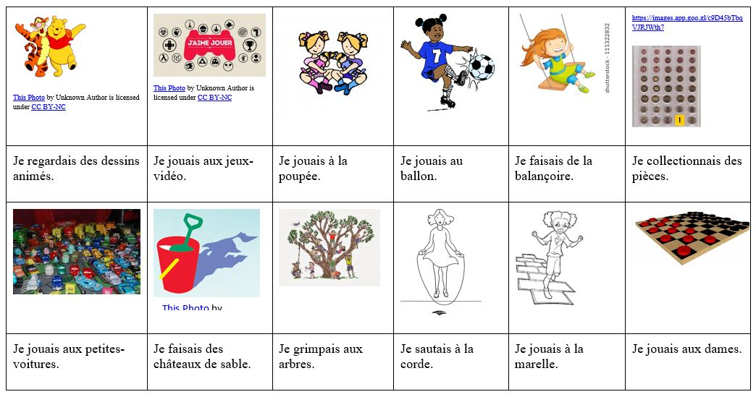
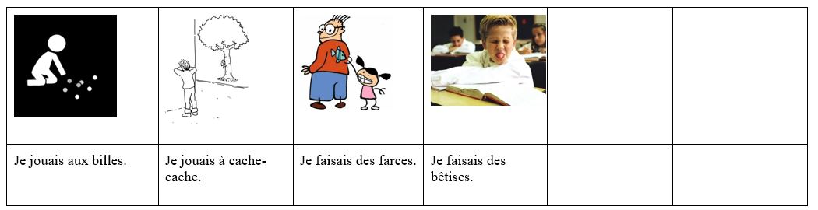
B. Expressions à utiliser :
1) Quand j’étais petit…
2) Quand j’avais …ans…
3) Quand j’étais plus jeune…
C. Sentiments
1) J’étais triste…
2) J’étais content (e)…
3) J’étais obéissant (e)…
4) J’étais sage…
5) J’étais un petit ange/une petite ange…
6) J’étais un petit diable/une petite…

Francais 3 Mon Enfance
Unit 4 Interprétation Ecrite-Kylian Mbappe
Answer the questions below as you read an excerpt article about Kylian Mbappe’s childhood.
- Supporting Details. Answer the following questions about the article.
- Who was Kylian’s childhood friend? _______________________________________________________
- Who was Kylian’s soccer coach for several years? ____________________________________________
- What did Kylian’s life revolve around as a child?
_____________________________________________
_____________________________________________
_____________________________________________
- Where was his favorite place to go? ___________________________________________
- Where did he go every day as a child? _________________________________________

III. Vocabulaire. Now that you’ve read the article, find the underlined verbs and what you think they mean.
1. La vie de Kylian tournait autour de trois grands axes
______________________________________
2. On jouait sur un terrain en sable______________________________
3. Quand il était encore petit__________________________________
4. Il habitait en face du stade__________________________________
5. Il pouvait alors voir le stade_________________________________
6. il y allait tous les jours_____________________________________
7. Quand il avait 5 ou 6 ans ___________________________________
8. Nous étions au centre de loisirs_______________________________
IV. Read the short paragraph from the point of view of one of Kylian’s teammates. Find the underlined verbs and tell what you think they mean.
1. Quand j'étais jeune ______________________________________________________
2. je ne savais pas ce que c'était d'être en professionnel, jouer en équipe de France _________________________________________________
3. On ne connaissait pas tout ça avec Kylian ______________________________________________________
4. on jouait dans la même équipe ______________________________________________________
5. on prenait du plaisir ______________________________________________________

V. Focus on form. Using the above, answer the questions below.
What is the ending of the verb when the subject is je? ____________________
What is the ending of the verb when the subject is il/elle/on? ____________________
What is the ending of the verb when the subject is nous? ________________________
IV. L’imparfait. Can you determine the endings for all subjects?
Je ___________ Nous ___________
Tu ___________ Vous ___________
Il/Elle/On ___________ Ils/Elles ___________

V. Below are other descriptions or statements about Kylian from the article. Can you figure out the infinitive and stem of the underlined verb using what you have learned about the imparfait?
1) Il lisait et étudiait la musique.
2) Il allait chez ses amis.
3) Il ne faisait pas de bêtises.
4) Kylian voulait jouer au foot.
5) Les profs disaient que Kylian avait des capacités intellectuelles au dessus de la moyenne.

VI. Fill in the chart below with the infinitives of the verbs. Most you have seen in the text or the above activities.
All-
Av-
Et-
Aim-
Choisiss-
Connaiss-
Dev-
Deven-
Dis-
Etudi-
Fais-
Finiss-
Jou-
Lis-
Pren-
Sav-
Tomb-
Ven-
Voul-
To determine the stem of most verbs in the imparfait:

Article 1
http://www.leparisien.fr/sports/football/sur-les-traces-de-kylian-mbappe-a-bondy-la-ville-de-son-enfance-17-10-2018-7920855.php

Vu du stade
« Il a inscrit des milliers de buts ici ! »
Le stade Léo-Lagrange, théâtre des premiers dribbles de Kylian Mbappé. LP/Jean-Baptiste Quentin
« Nous avons joué ensemble dans les mêmes équipes à l'AS Bondy de 5 à 15 ans, explique Rayan Yanga, son ami d'enfance. Son père Wilfrid nous a également coachés pendant plusieurs années. La vie de Kylian tournait autour de trois grands axes : sa maison, l'école et le foot. Le stade Léo-Lagrange était son endroit préféré, celui qu'il fréquentait le plus. On jouait sur un terrain en sable devenu depuis un terrain synthétique. Kylian a inscrit des milliers de buts ici ! Quand il était encore petit, il habitait en face du stade Léo-Lagrange. Il pouvait alors voir le stade depuis sa fenêtre et il y allait tous les jours. Pendant les vacances, il venait s'entraîner avec son père alors que pendant ce temps nous étions au centre de loisirs. »

Vu de son collège privé
« Sa ténacité m'a bluffée »
Le champion du monde a fréquenté le collège privé de l’Assomption avant de partir à Clairefontaine. LP/V.T.
Nicole Lefebvre a connu Kylian Mbappé lorsqu'il était « une petite grenouille ». Enseignante de français au collège privé de « L'Assomption de Bondy », elle a été sa professeur principale en 6e puis en 5e, quand il avait 11 et 12 ans. Elle se souvient d'un enfant « chétif », « blagueur » et « très bon élève ». « II n'était pas comme les autres, il avait une rapidité mentale extraordinaire, souligne-t-elle. C'était un leader en classe, il tirait les autres vers le haut et détestait l'injustice. Il a du mal à exprimer ses sentiments également. Mais, il est déterminé, ce qu'il veut faire, il va le faire. Déjà très jeune, sa ténacité m'a bluffé. »

Article 2
http://www.madeinfoot.com/infos/article-france-ikone-raconte-son-enfance-avec-kylian-mbappe-284783.html

France - Ikoné raconte son enfance avec Kylian Mbappé
Publié le 05/09/2019 à 18:54 | Julien Castanheira
Nouveau venu chez les Bleus, Jonathan Ikoné a côtoyé Kylian Mbappé à Bondy, qu?il a quitté à l'âge de 12 ans pour le PSG. Le Lillois ne retrouvera tout de suite pas le Parisien, actuellement blessé, mais espère rejouer prochainement avec lui.
"Quand j'étais jeune, je ne savais pas ce que c'était d'être en professionnel, jouer en équipe de France. On ne connaissait pas tout ça avec Kylian, on jouait dans la même équipe, on prenait du plaisir. Ce qui nous arrive aujourd'hui, je suis vraiment heureux, et lui aussi je pense. On y pense maintenant à jouer ensemble" explique Ikoné avant de raconter une petite anecdote de son CM2 avec Mbappé. "On jouait ensemble en club, mais à l'école, les professeurs nous interdisaient d'être dans la même équipe ! J'espère rejouer avec lui et reprendre ce plaisir."

Unit 1-Buzzfeed slide show “30 choses”
A pd

Unit 1_Communication Interpersonelle/Presentation Ecrite

Francais 3 Mon Enfance

I. Communication Interpersonnelle. Ask your partner the following questions about when s/he was little (about 5 or 6 years old). Write down his/her answers in French.

1. Où est-ce que tu habitais ? ____________________________________________________________________________
2. Avec qui est-ce que tu habitais ? ______________________________________________________________________
3. Combien de sœurs et de frères est-ce que tu avais ? _____________________________________________________
4. Tu étais comment ? ______________________________________________________________________________
5. Ou est-ce que tu allais à l’école ? ___________________________________________________________________
6. Est-ce que tu aimais l’école ? Pourquoi ou pourquoi pas ? ________________________________________________
7. Est-ce que tes parents travaillaient ? __________________________________________________________________
8. Où est-ce que tu allais après l’école ? _________________________________________________________________
9. Est-ce que tu jouais au foot ? Tu jouais à quels sports ? ____________________________________________________
10. Est-ce que tes parents faisaient du sport ? ______________________________________________________________

II. Présentation. Fill in the Venn diagram with at least 10 sentences comparing your early childhood with your partner’s.
Notes:
1. When your sentence starts with “Je,” your verbs should end with –ais. (Ex. Je dansais, regardais, jouais etc.)
2. When your sentence starts with “Nous,” your verbs should end with –ions. (Ex. Nous dansions, nous regardions, nous jouions etc.)

III. Using the venn diagram, write a paragraph describing the differences and similarities between your childhood and your partner’s.
______________________________________________________________________________
______________________________________________________________________________________________________________________________________________________________________________________________________________________________________________________________________________________________________________________________________________________________________________________________________________________________________________________________________________________________________________________________________________________________________________________________________________________________________________________________________________________________________________________________

Appendix B
Unit 2 Materials
Back to Contents
Back to Unit 2 Grid

Unit 2 IPA

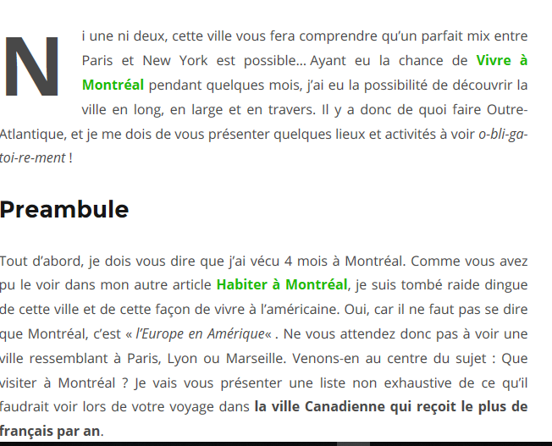
- Montréal est populaire parce que c’est une combinaison de cultures … a) africaine et français b) française et américaine c) africaine et américaine
- L’auteur a ________ à Montréal. A) habité b) visité c)
- Montréal est très similaire aux villes en France. A) vrai B) faux
- La dernière phrase indique que Montréal __________ beaucoup de citoyens français. A) donne B) accueille C) chasse D) quitte

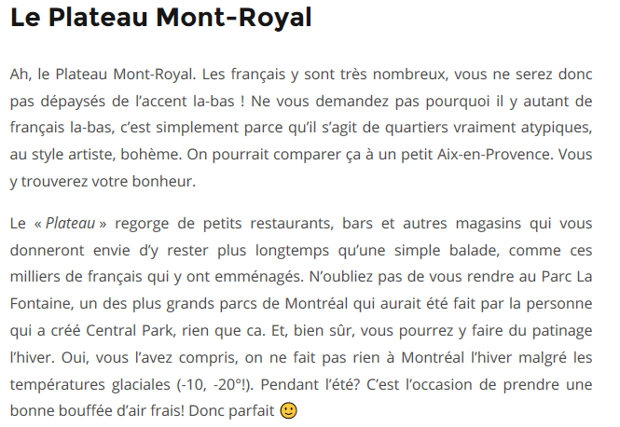
- Un citoyen de France a) va avoir beaucoup de difficulté avec les accents au Plateau Mont Royal b) va comprendre les accents facilement c) va penser que l’accent n’est pas mignon
- Le climat de Montréal est a) très froid en hiver b) très froid pendant toute l’année c) trop chaud pour les touristes
- L’auteur ne mentionne pas … a) les options pour dîner b) faire une promenade dans la nature c) les sports qu’on joue au Canada d) faire du shopping

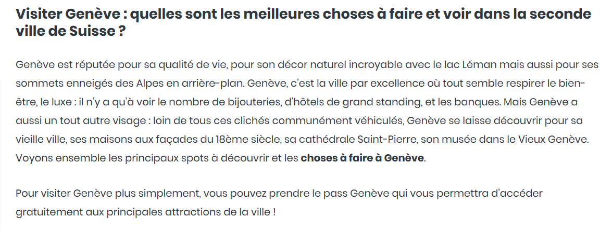
https://generationvoyage.fr/visiter-geneve-faire-voir/
8. Une attraction importante à Genève est … a) la plage b) les montagnes c) le chocolat d) le climat
9. Il y a une qualité de… a) richesse b) tristesse c) sport d) pauvreté
10. On peut voir des attractions … a) anciennes b) dangereuses c) ennuyeuses d) sportives
11. « Accéder gratuitement » veut dire … a) qu’il faut payer b) qu’on ne paie pas c) que c’est cher d) que c’est dangereux
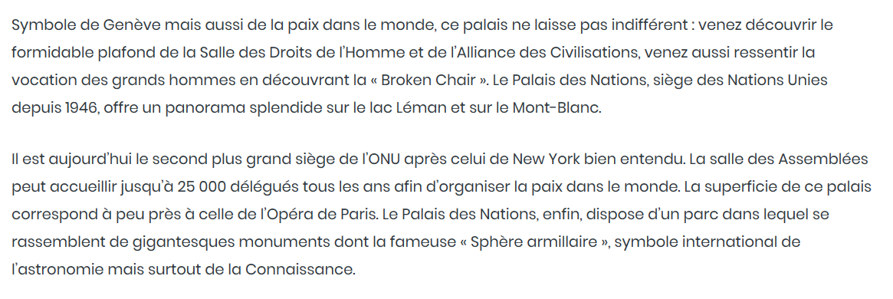
12. On peut voir ______ à Genève. a) des animaux b) la politique c) les jeux Olympiques d) la violence
13. « Broken Chair » et Le Palais des Nations sont a) des activités populaires b) les jeux suisses c) les monuments célèbres d) des lois en Suisse
14. Les attractions mentionnés dans ces deux paragraphes sont populaires pour les personnes a) sportives b) paresseuses c) intellectuelles d) riches

Unit 2, Lesson 1 Materials

Sample of Tweets/statements to be used for warm-up reviewing time frames

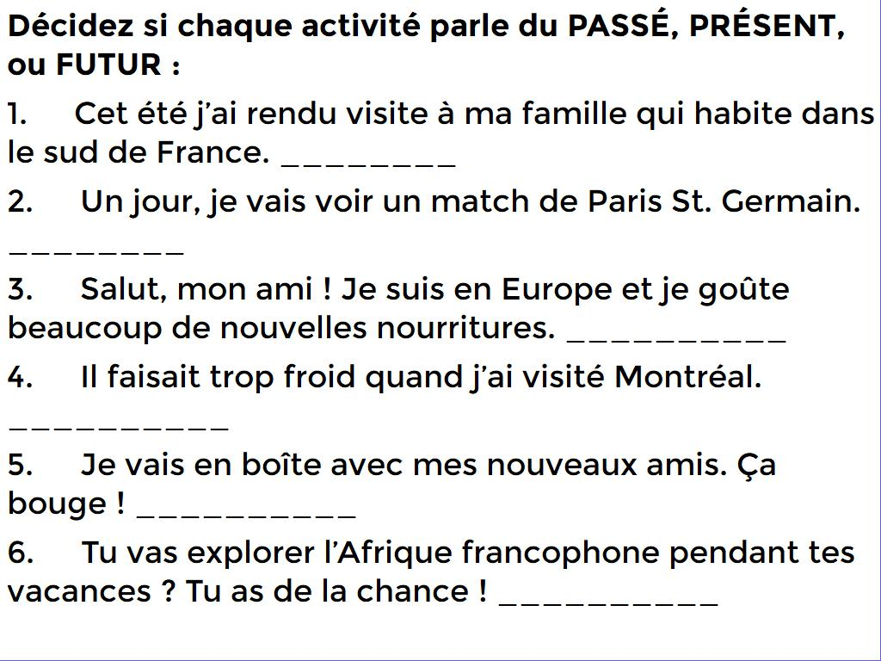
Unit 2, Lesson 2 Materials

Some sample blog/journal blurbs about travel – teacher-created.

1 : Cet été, j’ai fait un voyage à New York. Je suis allée en avion. Ma mère et moi, nous allons souvent à New York parce que c’est notre ville préférée aux Etats-Unis. Pendant ce voyage, nous sommes allées à un concert. Nous avons aussi vu une pièce à Broadway. Les billets coûtent très chers, mais c’est New York. Nous avons beaucoup marché parce que les taxis et les Ubers sont chers aussi. J’ai acheté beaucoup de choses que je ne peux pas acheter en Caroline du Sud, mais j’ai dépensé trop d’argent et j’ai été un peu pauvre après le voyage.
2 : En août, je suis allée en Californie. Il a fait très beau avec beaucoup de soleil. Je me suis perdue une fois parce que je ne suis pas bonne avec les directions. Je n’avais pas eu le temps de faire du shopping, donc j’ai été un peu fâché et triste. J’ai assisté à un festival. Je trouve que les restaurants sont bizarres en Californie. J’ai diné dans un restaurant mexicain—mais ils n’ont pas eu de salsa ! C’est quelque chose que je ne comprends pas ! De toute façon, j’aime toujours mon temps en Californie parce que j’aime la diversité de personnes, de magasins, et d’activités.

Unit 2, Lesson 3 Materials
Digital Visit #1 : Genève, Suisse

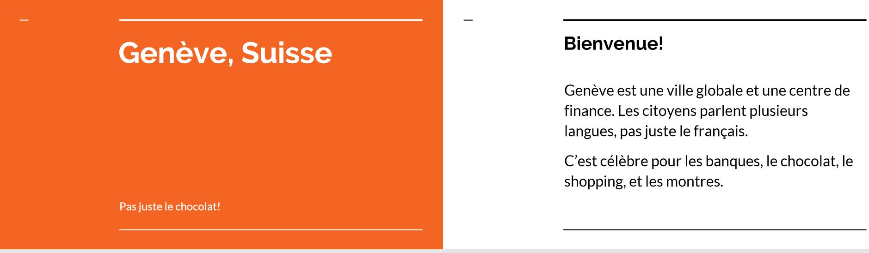

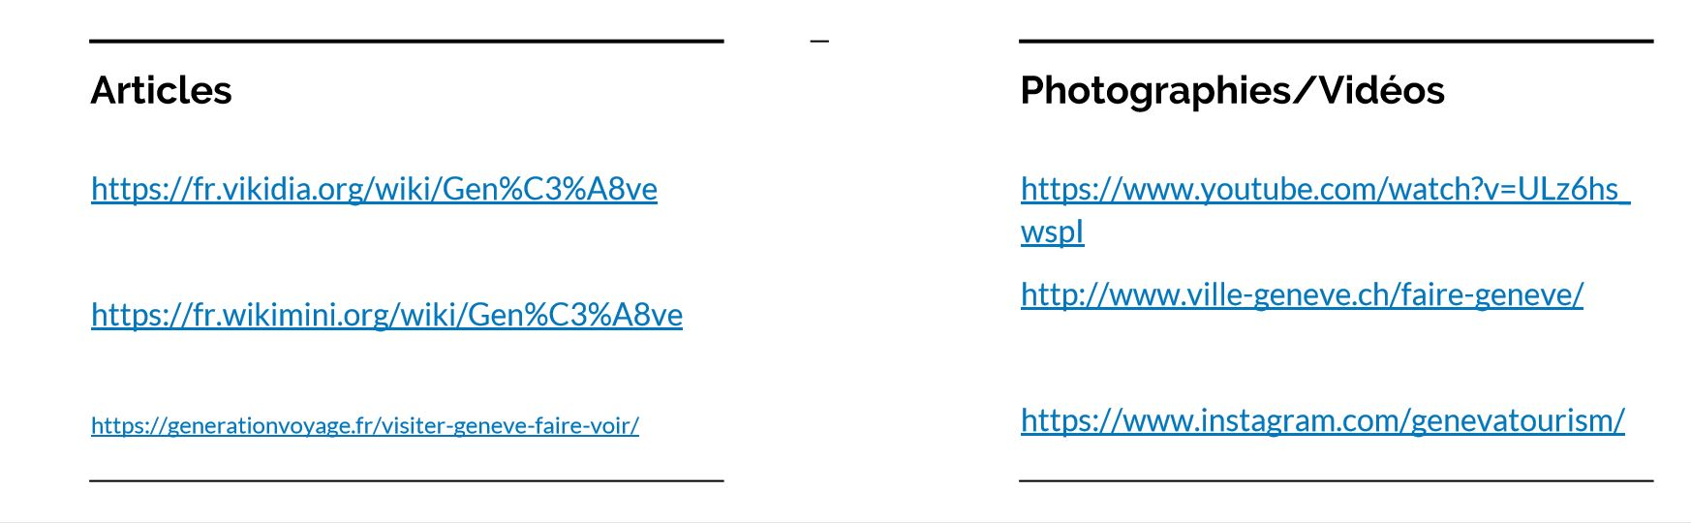

Digital Visit #2 : La Nouvelle Orléans

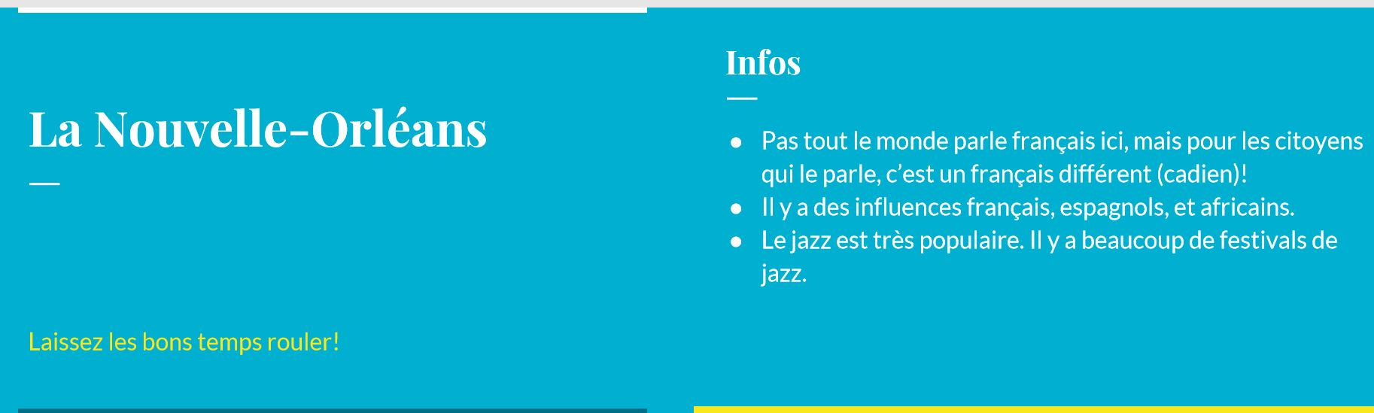

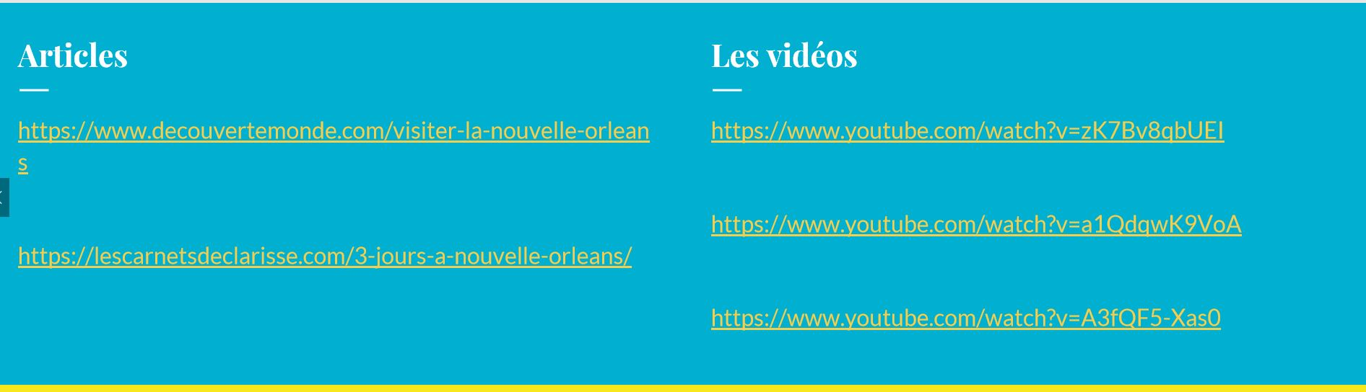

Passport Sheet :

Salut! Aujourd’hui, je me trouve à ___________________, dans le pays de __________________ sur le continent d’__________________.
Une description de ma ville: __________________________________________________________________________________________
__________________________________________________________________________________________
__________________________________________________________________________________________
Quel temps fait-il ici (normalement)? ________________________________________________________.
J’ai apporté pour mon voyage _________________________________________________________________________________________
_________________________________________________________________________________________.
Aujourd’hui, je ____________________________________________________________________________________________________________________________________________________________________________________
_________________________________________________________________________________________.
Ici, on peut manger _________________________________________________________________________________________.
J’ai vu _________________________________________________________________________________________
_________________________________________________________________________________________.
Les citoyens __________________________________________________________________________________________
__________________________________________________________________________________________
Mes conseils pour les autres visiteurs: __________________________________________________________________________________________
__________________________________________________________________________________________
Demain, je veux _________________________________________________________________________________________
_________________________________________________________________________________________.
Je t’invite! __________________________________________________________________________________________
__________________________________________________________________________________________
Unit 2, Lesson 4 Materials

Digital Visit #3 : Montréal



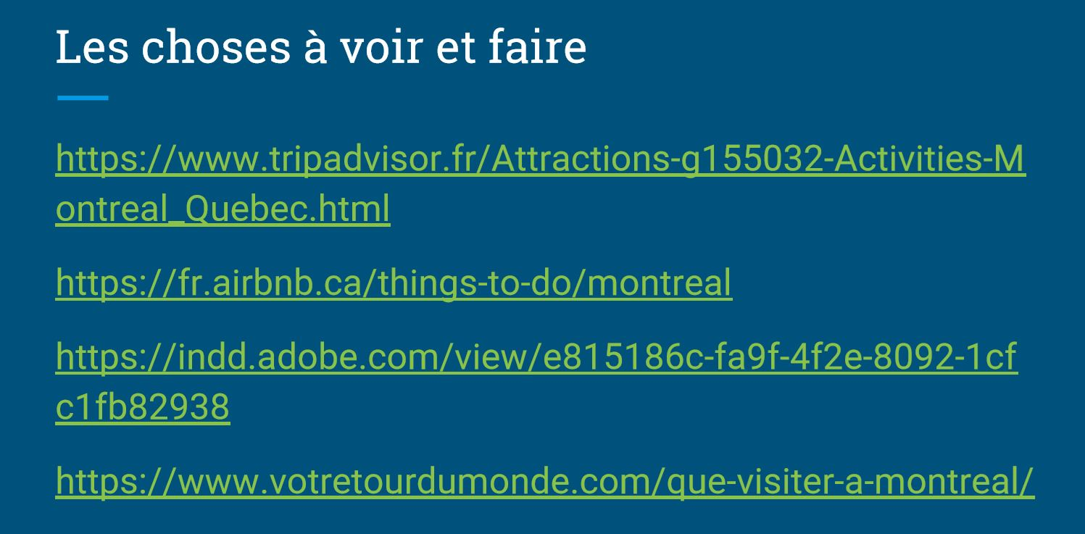

Digital Visit #4 : Marrakech, Maroc



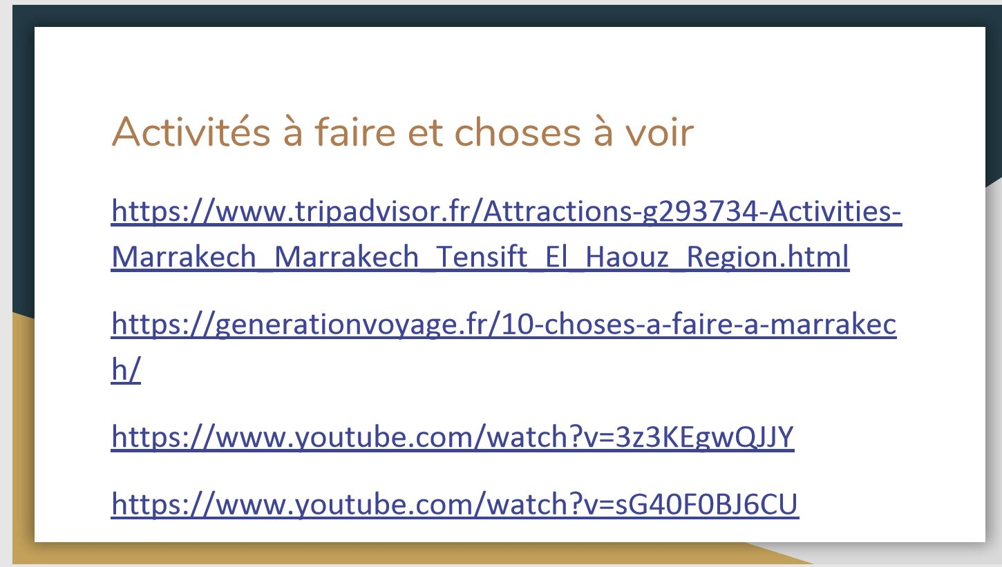

Appendix C
Unit 3 Materials
Back to Contents
Back to Unit 3 Grid

Unit 3 IPA

 Jean-Francois Dufour-Poirier, Âme bienveillante (2014-présent)
A répondu le 21 nov. 2018 · L'auteur a 1,4 k réponses et 630 k vues de réponse

J’aimerais être une bonne personne, devenir plus sage, moins polarisé, je voudrais être plus heureux.
Simplement vivre, avoir plus de temps pour moi.
En fait, j’attends depuis trop longtemps l’événement qui va changer ma vie pour le mieux. Je vais avoir 38 ans en décembre.
Je ne pense pas que 2019 sera très différent de 2018. Je peux me tromper, mais si je veux du changement pour 2019, l’objectif que je devrais choisir est celui d’agir et de provoquer l’événement que j’attends depuis si longtemps.
Il faudrait que j’apprenne à avoir plus confiance en moi… j’ai besoin de plus de temps pour moi et les gens que j’aime, de passé des moments de qualité.
En 2019, j’ai l’intention de vivre, c’est suffisant je crois.
https://fr.quora.com/Quels-sont-vos-objectifs-2019
Utilisez le passage écrit par Jean-François pour répondre aux questions 1 à 7.
- Jean-François discute … a) les objectifs personnels b) les objectifs professionnels c) les objectifs de santé d) sa famille
- Un de ses objectifs principaux est … a) être riche b) le bonheur c) obtenir un diplôme d) se marier
- Il parle de ses objectifs pour … a) sa jeunesse b) sa famille c) la nouvelle année d) son métier
- Il pense qu’il doit a) continuer à attendre pour les bonnes choses b) être plus proactif c) continuer comme normal d) trouver un meilleur travail
- Quelle phrase peut être sa devise pour 2019 ? a) « Je crois en moi ! » b) « Travaillez plus ! » c) Acceptez les autres ! d) « Faites plus d’effort ! »
- Il veut … a) travailler plus b) voyager plus c) passer plus de temps avec sa famille et les personnes qu’il aime d) faire plus de shopping
- Quelle image représente ses objectifs ?

A.😀 B. 🤑 C. 😷

Ghislaine, 31 ans, employée
« Moi je suis employée dans l’administration alors j’ai des heures fixes : 9h – midi trente et 13h30 – 17h00. On travaille 35 heures par semaine et pas le samedi. C’est un peu long l’après-midi mais quelquefois on a beaucoup de travail, alors ça passe vite. Sinon, quand on a rien à faire je discute avec mes copines. On discute du film de la veille, de quelqu’un d’autre, de nos maris… J’ai pas d’enfant donc je n’ai pas besoin de faire la cuisine le soir, mon mari se débrouille, moi je n’ai jamais faim le soir, une soupe ça me suffit. On dort mieux quand on n’a pas trop mangé le soir. A midi je déjeune à la cantine du bureau, c’est un self-service, on prend ce qu’on veut. Moi j’aime bien les fruits alors je prends souvent des fruits. Le soir je ne regarde pas la télé parce que je n’aime pas la télé, il n’y a que des bêtises. Je prends un bouquin plutôt, j’adore lire. »
Lisez le passage de Ghislaine pour répondre aux questions 8 à 14.
https://www.french.hku.hk/portraits-du-quotidien
- En France, on travaille ________ qu’aux Etats-Unis en général. A) plus B) moins C) autant
- Quand Ghislaine est ennuyée, elle … a) joue aux jeux vidéo b) mange dans le bureau c) parle avec ses amis d) regarde Netflix sur son portable
- Est-ce que Ghislaine est un parent ? a) OUI b) NON c) Elle ne mentionne pas.
- Je n’ai pas besoin est un synonyme pour a) Je veux b) Je ne vais pas c) Je ne dois pas d) Je ne peux pas
- Pour le dîner, elle mange a) beaucoup b) un peu c) quelquefois d) rien
- Pour les loisirs, elle préfère les a) films b) émissions de télé c) livres d) jeux Internet
- Un bouquin est probablement un type de a) musique b) sport c) personne d) livre

Ecoutez le clip suivant pour répondre aux questions.

https://enseigner.tv5monde.com/fiches-pedagogiques-fle/projets-1616

- « Qu’est-ce que tu feras » est une autre façon pour poser la question … a) « qu’est-ce que tu vas être ? »
b) qu’est-ce que tu vas faire ? » c) « qu’est-ce que tu vas avoir » ? d) « qu’est-ce que tu veux faire ? »
16. Un pédopsychiatre travaille avec a) les bâtiments b) les films c) les enfants d) l’argent
17. « Je serai » est similaire à quelle autre phrase ? a) je vais faire b) je vais être c) je vais avoir d) je vais acheter
18. Les ados ne mentionne pas quel sujet ? a) le travail b) les voyages c) l’environnement d) le mariage
19. Tous les quatre ados voudraient se marier plus tard. a) vrai b) faux c) pas certain
20) Au moins un étudiant voudrait habiter dans un autre pays. a) vrai b) faux c) pas certain

Unit 3, Lesson 1 Materials :

Interpretive Blog posts

Dembele Jean-Marc, Développeur
A répondu le 20 nov. 2018 · L'auteur a 187 réponses et 116 k vues de réponse
- Devenir riche
- Parvenir à lire un livre par semaine
- Tomber par hasard, sur un malentendu, sur une nana qui ne soit ni psychotique ni fade
- Entraîner ma mémoire pour retenir tout ce que je lis, vois, entends
- Faire beaucoup plus de projets annexes
- Arrêter de fumer (pouah elle est bonne celle-là)

- Pour devenir riche, Dembele doit … a) parler avec les amis b) travailler plus c) aller au gymnase d) trouver une copine
- Lire un livre par (chaque) semaine est a) un objectif professionnel b) un objectif de famille c) un objectif personnel d) un objectif de santé (health)
- Arrêter de fumer des cigarettes est a) un objectif professionnel b) un objectif de famille c) un objectif personnel d) un objectif de santé (health)


Enzo Paredes
A répondu le 24 nov. 2018
Mes objectifs sont:
- Travailler et pouvoir acheter ce que je veux. Maintenant, je veux un PS3. J'ai travaillé beaucoup cette année-ci mais je n'ai pas assez d'argent.
- Passer tous les examens que j'aurai l’année prochaine.
- Me faire plus d’amis et un couple.
- Améliorer les langues étrangères que j'ai appris et pouvoir apprendre des autres langues qui m'intéressent.

- Enzo est probablement a) un étudiant b) un professionnel c) un parent
- Il NE voudrait PAS a) plus d’argent b) plus de copains/copines c) plus de stress
- Il va probablement … a) voyager b) aller à la gym c) faire du camping d) étudier chinois ou italien
- Il ne mentionne pas a) un objectif professionnel b) un objectif personnel c) un objectif de santé
- Now, find 5 words that you weren’t familiar with and look them up on WordReference or another resource -- could you use them to talk about your own goals ?

Sample Tweets (teacher-created) to review time frames:

1. @presqueparisienne : Ce matin, j’ai goûté les fruits de mer les plus fabuleuses du monde !
2. @mmekah : Je suis super excitée pour ce voyage en train ! C’est la première fois que je vais monter le train !
3. @10sur10dance : Ma copine et moi ont gagné des billets d’avion et nous irons à Montréal cet hiver ! Quelle chance !
4. @lalalauzanne : Tiens ! Je me trouve à Montréal, une ville romantique –mais je suis toute seule
5. @seraphine1 : Je suis vraiment jalouse ! Tout le monde sur mon timeline a passé de merveilleuses vacances et moi je suis restée chez moi comme une vraie pantouflarde !

Sample Questions for a Dice Game
Round 1:
- Est-ce que tu veux avoir des enfants? Pourquoi?
- Est-ce que tu préfères une grande maison ou une petite maison?
- Est-ce que tu veux aller à l’université?
- Qu’est-ce que tu veux faire quand tu as fini avec le lycée __________?
- Est-ce que tu veux un animal domestique?
- Est-ce que tu voudrais voyager beaucoup?

Round 2: Agree or disagree with each statement
- C’est important d’être riche.
- Il faut avoir des enfants.
- Le travail est très important.
- Voyager, c’est amusant!
- “Métro, boulot, dodo” est ennuyeux.
- L’école a beaucoup de stress.

Round 3: Complétez les phrases:
- J’aimerais
- Je peux
- Je ne veux pas
- Il faut
- Je voudrais
- Je sais

Unit 3, Lesson 2 Materials :
Interpretive Activity on Professions

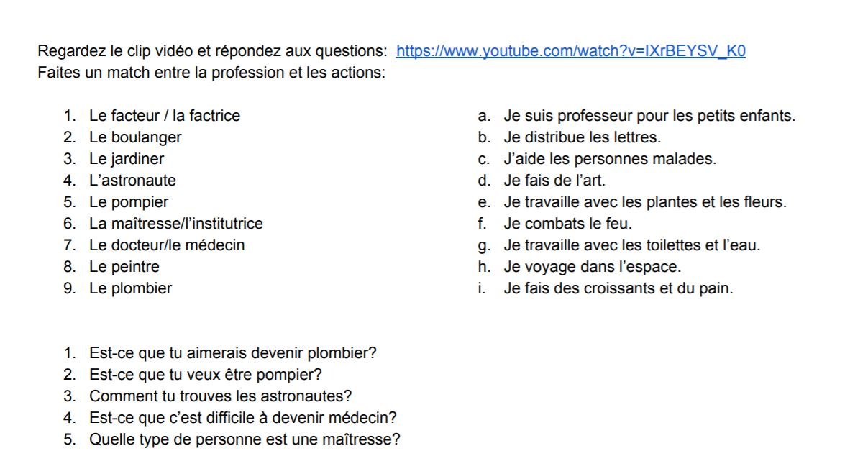

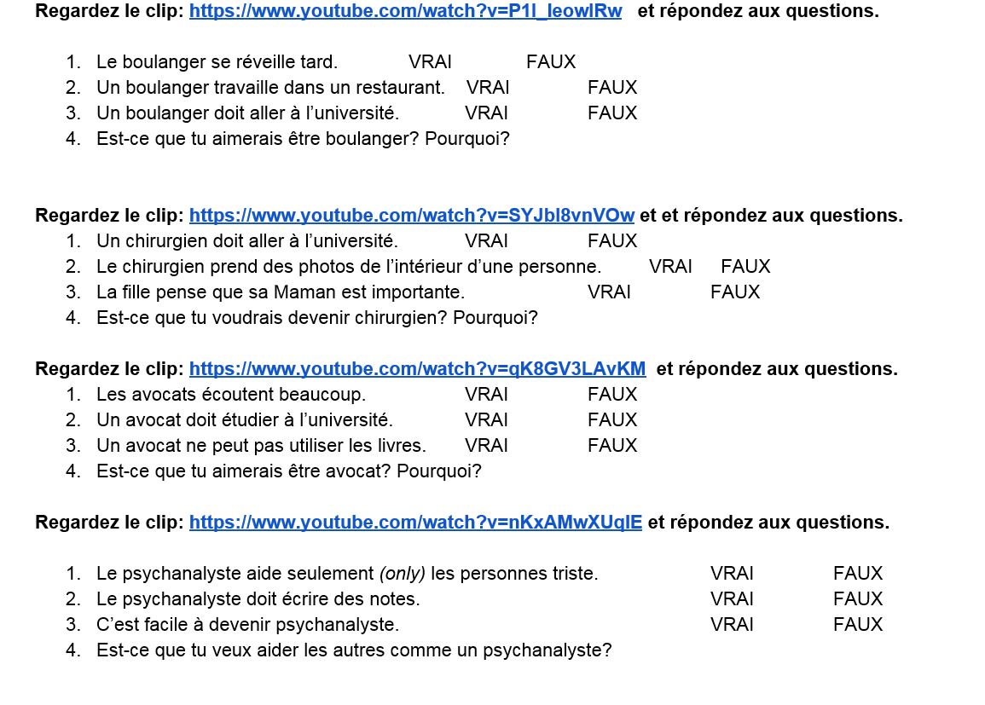

Speaking Checklist (LOTO) for Discussing Professions

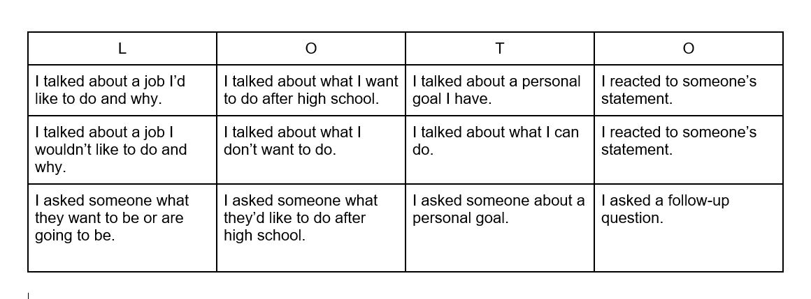

Unit 3, Lesson 3 Materials:
MASH Table to Be Filled Out by Students
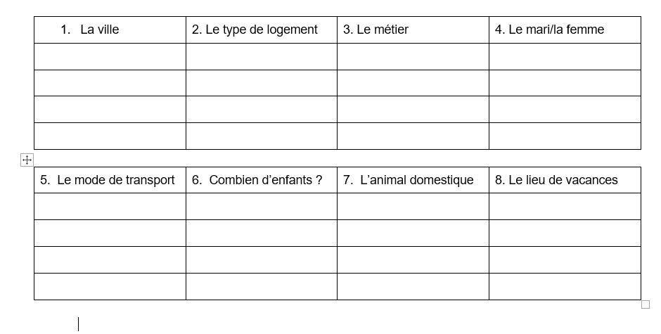

Unit 3, Lesson 4 Materials

Interpretive Activity for “Run Run” by Indila

Lisez cette partie de la chanson « Run Run » qui est interprétée par Indila (Pre-listening)
« Mais à ce lundi, mardi
Métro, boulot, dodo
C'est toute ta vie »
« Trop déterminé, tu vises the jackpot
Prêt à sacrifier tout pour ton job
- Est-ce qu’Indila a une attitude positive ou négative vers le travail ? Justifiez votre réponse avec des exemples.
- « Métro, boulot, dodo » est une phrase en français qui représente la vie professionnelle – le métro (le train), le boulot (le travail), et le dodo = dormir
Est-ce que tu voudrais vivre la vie dans la mode « métro, boulot, dodo » ? Pourquoi ?
Écoutez en regardant les sous-titres en français. Répondez aux questions : (while listening/reading)
- Quel vocabulaire est-ce qu’Indila utilise au sujet de travail ?
- À ton opinion, est-ce qu’Indila veut être riche et réussie?
- Quels conseils est-ce qu’Indila donne aux personnes qui écoutent la chanson ?
Regardez encore et répondez *option : on peut la regarder avec les sous-titres en anglais aussi pour mieux comprendre les nuances)
- Quelle est sa prédiction pour les personnes qui travaillent beaucoup ?
- Quelle est ta prédiction pour les personnes qui travaillent beaucoup ?
- Quel vocabulaire est-ce qu’Indila utilise pour parler de la vie professionnelle ?
- Qu’est-ce qu’Indila voudrait faire au lieu de travailler tout le temps ?
- Est-ce que tu es d’accord avec le message d’Indila ? Pourquoi ?
- Est-ce que tu connais une personne comme les personnes qu’elle décrit ? Qui ?

Interpretive Activity for “Je Veux Etre Vieux” by Slimane

PRE-LISTENING – répondez aux questions avant d’écouter la chanson.

- Slimane dit qu’il veut être vieux. Est-ce que tu veux être vieux aussi ? Pourquoi ?
- Qui est un exemple d’une vieille personne ?

En regardant les paroles en français, décidez si Slimane mentionne ou ne mentionne pas chaque sujet. Répondez avec OUI ou NON.

- L’apparence d’une vieille personne
- La famille
- Les problèmes de santé
- Les objectifs professionnels
- L’argent
- Discuter avec amis

Après avoir écouté et lu les paroles en français et en anglais, répondez aux questions avec des phrases complètes.
- Est-ce que tu veux vivre longtemps ? A quel âge ?
- Qu’est-ce que tu veux faire quand tu es vieux/vieille ?
- Est-ce que tu voudrais avoir des enfants et des petits enfants ?
- Qu’est-ce qu’il faut faire quand on est vieux/vieille ?

Appendix D
Unit 4 Materials
Back to Contents
Back to Unit 4 Grid

Unit 4 IPA

Français 3 Ma Santé
Interprétation Ecrite : « Ados : comment prendre soin de son corps pour gérer le stress ? » http://goo.gl/rqB3rB

Partie A. Votre enfant est angoissé ? Le magazine Okapi lui explique ce qu’est le stress et comment le contrôler avec des conseils à suivre toute l’année scolaire. Extraits.

Ferme les yeux
En cas de grosse panique, fais appel à ton imagination. Dans le bus ou devant ta feuille d'examen, ferme les yeux et pense à un endroit calme, que tu aimes bien. Respire à fond, déconnecte-toi du moment stressant. Une fois calmé(e), il ne reste plus qu'à ouvrir les yeux et à foncer.

Détends tes muscles
Tu connais la réflexologie chinoise ? Cette tradition relie chaque organe à un point sur la paume des mains, la voûte plantaire ou les oreilles. Pour éviter de te masser les pieds en classe, trace avec le bout de ton pouce des petits ronds dans le sens inverse des aiguilles d'une montre sur le milieu de ta paume. C'est sûr, tes tensions seront évacuées !

Partie B. Calme tes nerfs
Rien ne vaut une recette de grand-mère pour bien se calmer les nerfs. Pour mieux dormir, bois une tasse de tisane au tilleul ou à la camomille. Pas très sexy mais vraiment relaxant ! Autre technique : un lait chaud au miel avant de se coucher. Attention, on devient vite accro…

Soigne ton estomac
Certains aliments ont de véritables vertus calmantes. Pendant les pics de stress, on perd beaucoup de magnésium, un micronutriment que l'on peut récupérer en mangeant du chocolat noir et des graines (noix, noisettes, amandes). Il y a pire comme régime antistress !

Fais du sport
Pour se vider la tête, rien de tel qu'une petite séance de sport. En plus de libérer l'esprit, l'effort physique produit des molécules spéciales, appelées endorphines, qui provoquent une sensation de bien-être. Les muscles se détendent, le corps se relaxe et on trouve plus facilement le sommeil.

Essaye le yoga
Le but du yoga est d'étirer son corps pour libérer ses tensions. Ferme la porte de ta chambre avant de commencer les exercices : c'est un peu ridicule mais ça marche !

Posture du lion : mets-toi debout, les bras le long du corps, les jambes serrées. Prends une grande inspiration et contracte tous tes muscles : serre les poings, monte les épaules vers les oreilles.

Bloque quelques instants la position. En expirant, étire les bras vers le sol, ouvre grand la bouche et les yeux, tire la langue et lâche un “aaaaahhhh” du fond de la gorge, comme un lion qui rugit.

Torsion vertébrale : assis(e) en tailleur, monte tes bras à l'horizontale en inspirant. En expirant, tourne ton buste vers la droite jusqu'à ce que tes bras soient perpendiculaires au bassin.

Pour bien t'étirer, tu peux poser une main derrière ton dos, et l'autre sur ton genou. Reste dans cette position quelques instants, respire bien, puis relève tes bras à l'horizontale pour tourner vers l'autre côté. Refais trois ou quatre fois chaque posture et tu seras super relax.

Inspire… Respire !
La meilleure amie de la relaxation ? La respiration. L'exercice est simple mais il y a quelques règles à respecter. Inspire par le nez en comptant jusqu'à 5 puis expire par la bouche pendant une dizaine de secondes. Le mieux : lever la langue vers le palais pour reproduire le sifflement d'un ballon qui se dégonfle.
Tu peux aussi tester la “respiration abdominale”. Lorsque tu inspires, pousse sur tes abdos pour gonfler le ventre. En expirant, laisse ton ventre se détendre. Pas facile à faire mais super efficace !
- Main ideas and important details. Respond to the questions below about the text in English.
- What’s the purpose of the article ?
_________________________________________________________________
- For whom is it intended?
_________________________________________________________________
- What are the “7 Conseils” to follow?
- ______________________________________________________________
- _____________________________________________________________
- ______________________________________________________________
- ______________________________________________________________
- ______________________________________________________________
- ______________________________________________________________
- ______________________________________________________________

- Les Mots Clés: Identify the phrases below from the passage (they are in order and by section).

- Advice (A) ________________________________________
- All school year (A) ________________________________________
- Close your eyes (A) ________________________________________
- Breathe deeply (A) ________________________________________
- Calm your nerves (B) ________________________________________
- To sleep better (B) ________________________________________
- A workout/gym class (B) ________________________________________
- Your body relaxes (B) ________________________________________

- Drawing Meaning from Context. Do your best to figure out the meaning of the following words and phrases based on context clues. All phrases are underlined in the text.
- Votre enfant est angoissé ? _______________________________________
- Pense à un endroit calme _______________________________________
- Respire à fond ________________________________________
- Sur la paume ________________________________________
- Aliments ________________________________________
- Se vider la tête ________________________________________
- Se détendent ________________________________________
- D’étirer ________________________________________
- Inspiration ________________________________________
- Abdos _______________________________________

- Cultural beliefs and values. What cultural products, practices or perspectives can you identify in the text?
_____________________________________________________________________
_____________________________________________________________________
_____________________________________________________________________
_____________________________________________________________________
_____________________________________________________________________
Interprétation Écrite: Version 2
Répondez aux questions suivantes.
- A qui est destiné cet article ?
- Quelles sont les recommandations de l’auteur pour minimiser le stress ?
- ____________________________________________________________________
- ____________________________________________________________________
- ____________________________________________________________________
- ____________________________________________________________________
- ____________________________________________________________________
- ____________________________________________________________________
- ____________________________________________________________________
- Quels conseils est-ce que tu as déjà suivi ?
________________________________________________________________________
________________________________________________________________________
________________________________________________________________________
________________________________________________________________________
- Est-ce que ce sont des conseils qu’un magazine américain donnerait ? Pourquoi ou pourquoi pas ?
________________________________________________________________________
________________________________________________________________________
________________________________________________________________________
________________________________________________________________________
_____________________________________________________________________

Interprétation Orale: Version 1 (https://www.youtube.com/watch?v=pKtYIPhYAbQ)

- List 5 words (in English) that help you know the purpose of the video.
- _______________________________
- _______________________________
- _______________________________
- _______________________________
- _______________________________

- What were two reasons given for the students being stressed?
_______________________________________________________________
_______________________________________________________________

- What were two ways that students managed their stress?
_______________________________________________________________

Interprétation Orale: Listening Version 2

Regardez la vidéo et répondez aux questions en français.

https://www.youtube.com/watch?v=pKtYIPhYAbQ

- Quelles raisons est-ce que les adolescents donnent pour expliquer leur stress ?
- Qu’est-ce qu’ils font pour « équilibrer leur stress ? »
- Est-ce que tu as déjà eu une expérience similaire ?

Unit 4: Interpretation Ecrite

Français 3 Ma Santé

Interprétation Ecrite- « Santé physique et habitudes de vie chez les jeunes du secondaire au Québec en 2016-2017 »
http://www.stat.gouv.qc.ca/statistiques/infographies/eqsjs2018-sante-jeunes-dec1805.pdf
Activités Interpretive. Faites les activités suivantes en utilisant l’infographie.
- Vrai/Faux. Est-ce que les phrases suivantes sont vraies (V) ou fausses (F) ? List words from the infographic that help you know the answer.

_______ 1. The majority of Quebecois girls drink the recommended number of milk servings daily. _______________________________________________
_______ 2. Many Quebecois youth drink sodas regularly.
________________________________________________________________
_______ 3. Quebecois youth would be more likely to drink juice than soda.
________________________________________________________________
_______ 4. More students have tried electronic cigarettes than alcohol.
________________________________________________________________

_______ 5. More boys are satisfied with their appearance than girls.
________________________________________________________________

_______ 6. More girls participate in sports than boys.
________________________________________________________________

_______ 7. The majority of Quebecois youth do not sleep enough during the school week.
________________________________________________________________
_______ 8. Quebecois youth eat fast food several times per week.
________________________________________________________________
- Trouvez les mots suivants ou les phrases suivantes dans le texte.

- Daily ______________________________________
- Consume ______________________________________
- Fruity drinks ______________________________________
- Once per day or more ______________________________________
- Unhealthy food ______________________________________
- At least once ______________________________________
- Active ______________________________________
- Sleep ______________________________________
- During the school week ______________________________________

- Supporting Details. Answer the questions below based on the infographic.
- List the good health habits mentioned in the infographic.
___________________________________________________
___________________________________________________
___________________________________________________
___________________________________________________
___________________________________________________
___________________________________________________

- List the “bad” health habits mentioned in the infographic.
___________________________________________________
___________________________________________________
___________________________________________________
___________________________________________________
___________________________________________________
___________________________________________________

- Which habits do Quebecois youth seem to struggle with the most? Why do you think that is?
- Where do you see the greatest difference between boys and girls? Why do you think that may be?

Unit 4-Communication interpersonnelle
Français 3 Ma Santé
Communication Interpersonnelle. Posez les questions suivantes à votre partenaire et prenez des notes.
- Est-ce que tu consommes le nombre recommandé de portions de lait chaque jour ?
- Combien de fruits et légumes est-ce que tu consommes chaque jour ?
- Combien de fois par semaine est-ce que tu bois des boissons gazeuses ?
- Combien de fois par semaine est-ce que tu manges de la « malbouffe ? »
- Est-ce que tu fais du sport/de l’activité physique souvent ? Combien de fois par semaine ?
Est-ce que tu dors la durée recommandée d’heures par nuit ? Combien d’heures par nuit est-ce que tu dors d’habitude ?

Français 3 Ma Santé
Unit 4 : Interprétation Orale « Comment rester jeune et en bonne santé »
https://www.youtube.com/watch?v=9D3rb7CBFBQ&list=PL4uGw3JnqUNxLNwS_p8kH8Cs5tjiyynjy&index=18&t=0s

- Regardez la vidéo et remplissez ce schéma pour découvrir les recommandations pour rester jeune et en bonne santé. (Prenez vos notes en français.)

 | La recommendation | Des détails/suggestions plus spécifiques
#1
#2
#3
#4
#5
#6
#7
#8
#9

B. Vrai ou Faux ? Selon les conseils de la vidéo, dites si les phrases suivantes sont « V » Vrai ou « F » Faux. Justifiez votre réponse avec des exemples de la vidéo.

______ 1. Pour combattre le stress, il est bien de se relaxer. ____________________________________________________________________________
______ 2. Il faut dormir plus pour être en bonne santé. ____________________________________________________________________________
______ 3. Il ne faut pas sortir de la maison. ____________________________________________________________________________
______ 4. Il faut bouger tout le temps. ____________________________________________________________________________
______ 5. Il est bien de boire de l’eau. ____________________________________________________________________________
______ 6. Il faut manger beaucoup de bonbons. ____________________________________________________________________________
______ 7. Il ne faut pas manger trop de sucre. ____________________________________________________________________________
______ 8. Il est bien de manger des fruits et légumes. ____________________________________________________________________________

C. Communication interpersonnelle. Interviewez votre partenaire pour savoir s’il/elle suit les recommandations de la vidéo. Ecrivez ses réponses.

 | Sujet | Réponses (avec des détails)
#1 | Le stress  Exemple: Est-ce que tu es souvent stressé ?  Pourquoi/Pourquoi pas ?  Qu’est-ce que tu fais pour te relaxer ?
#2 | Le sommeil  Exemple : Est-ce que tu dors bien ? Assez ?  Combien d’heures par nuit ?
#3 | Le temps passé hors de la maison  Exemple : Est-ce que tu sors souvent ?  Qu’est-ce que tu fais quand tu sors ?
#4 | Le sport/L’exercice  Exemple: Qu’est-ce que tu fais comme sport ?
#5 | L’hydratation  Exemple : Qu’est-ce que tu bois ?  Est-ce que tu bois beaucoup d’eau ?
#6 | Les antioxydants  Exemple: Est-ce que tu manges des fruits, etc. ?
#7 | Le sucre  Exemple : Est-ce que tu manges beaucoup de sucre ?  Pourquoi/pourquoi pas ?

Français 3 Ma Santé
Interprétation Écrite « Rester actif ou active »
https://teens.aboutkidshealth.ca/fr/Article?contentid=2624&language=French
Vous allez lire un extrait d’un article à propos des jeunes canadiens qui sont atteints de AIJ (l'arthrite idiopathique juvénile). Il y a plusieurs conseils donnés aux jeunes pour rester actifs/actives. Faites les exercices suivants pour montrer votre compréhension des conseils donnés.

I. Supporting details. Answer the following questions as you read the article.
1. What will help youth with juvenile arthritis a lot? ______________________________________________________________________________
2. Are sports recommended?
______________________________________________________________________________
3. Why are sports important for young people?
______________________________________________________________________________
4. Are youth with juvenile arthritis always able to participate the same as they did before?
______________________________________________________________________________
5. What sport is recommended to be the easiest for youth with juvenile arthritis?
______________________________________________________________________________

II. Les recommandations pour les jeunes. Go back through the article and find the recommendations given and give the meaning.
1. Il est très important que tu fasses de l’activité physique.
______________________________________________________________________________
2. Rester actif ou active est bon pour ta santé globale.
______________________________________________________________________________
3. Demande à ton médecin s’il y a des restrictions quant aux activités que tu peux faire.
______________________________________________________________________________
4. Si tu trouves difficile de pratiquer certains sports, essaie de choisir des sports qui sont doux pour tes articulations, comme la natation.
______________________________________________________________________________
5. Si tu faisais de la compétition avant et que tu n’es plus capable de pratiquer ton sport à ce niveau, tu pourrais peut-être penser à le pratiquer seulement comme loisir.
______________________________________________________________________________
6. Fais au moins 30 minutes d’activité physique, au moins cinq jours par semaine.
______________________________________________________________________________
8. Trouve une activité que tu AIMES et invite tes ami(e)s à la faire avec toi! Tu la pratiqueras plus assidûment si tu t’amuses.
______________________________________________________________________________
9. Commence lentement et travaille ton endurance.
______________________________________________________________________________

10. ARRÊTE immédiatement si tu ressens une douleur à la poitrine, des étourdissements, un essoufflement intense ou des nausées.
______________________________________________________________________________
11. Le plus important – AMUSE-TOI!
______________________________________________________________________________
III. Focus on form. What were the different ways that the author of the article gave advice?

IV. Des conseils. You read the article above and want to give your friend advice about how to be active with juvenile arthritis. Match the problems with the solutions.
____1. J’ai mal quand je joue au foot. A. Il faut que tu fasses de la natation !
____2. Je reste au lit tous les jours. B. Il est important que tu sois actif 30 minutes par jour.
____3. Je ne sais pas comment commencer. C. Il faut que tu commences lentement.
____4. J’ai très mal tout le temps. Je ne sais pas si D. Il vaut mieux que tu parles avec ton médecin.
je peux faire du sport.
____5. Je joue au basket mais je le déteste. E. Il est nécessaire que tu trouves une activité que tu aimes.
____6. Quand je fais du sport, j’ai très, très mal. F. Il faut que tu arrêtes immédiatement.
____7. Je fais du sport le lundi seulement. G. Il faut que tu prennes le temps d’être actif 5 fois par semaine.
____8. Je ne fais pas de sport et je ne dors pas bien. H. Il est important que tu dormes bien alors il faut que tu sois actif.

--Now that you have done the above activity, what do you notice about the way the advice is
given? What structures are used?
Rester actif ou active
Par le personnel de l'hôpital SickKids Dans les derniers modules, tu as appris sur la physiothérapie et les différents exercices qui peuvent t’aider à gérer les symptômes de ton AIJ et à garder tes articulations en santé. Pour contrôler ton AIJ, il est très important que tu fasses de l’activité physique. Faire ces exercices tous les jours t’aidera beaucoup!
Rester actif ou active est bon pour ta santé globale, que tu sois atteint(e) d’AIJ ou non. L’activité physique permet de garder un cœur en santé (santé cardiovasculaire) et de maintenir un poids équilibré. De plus, cela peut t’aider à maîtriser la douleur, à améliorer ton sommeil et à te sentir mieux et de meilleure humeur.
Sports et loisirs
Si tu es comme la plupart des jeunes atteints d’AIJ, il ne devrait pas y avoir de restriction quant aux sports et aux loisirs que tu peux pratiquer, sauf si tu as des lésions graves aux articulations ou si tu as des problèmes au cou. Demande à ton médecin s’il y a des restrictions quant aux activités que tu peux faire.
Les sports et les loisirs sont une partie importante de la vie pour beaucoup de jeunes. Pourquoi? Principalement parce qu’ils te permettent de t’amuser! De plus, la pratique d’un sport contribue à une vie saine et active, mais ne remplace PAS les exercices thérapeutiques qui pourraient t’être prescrits. Si tu trouves difficile de pratiquer certains sports, essaie de choisir des sports qui sont doux pour tes articulations, comme la natation. Tu peux demander d’autres suggestions à ton médecin ou à ton ou ta physiothérapeute.
Tu t’es peut-être rendu compte que depuis que tu as reçu ton diagnostic d’arthrite, tu ne peux plus pratiquer des sports de la même façon. Cela peut être très frustrant et décevant. Si tu faisais de la compétition avant et que tu n’es plus capable de pratiquer ton sport à ce niveau, tu pourrais peut-être penser à le pratiquer seulement comme loisir. Si tu tiens à faire de la compétition, tu peux peut-être essayer d’en faire dans un autre sport. Par exemple, la natation peut être un sport très compétitif qui est plus facile pour tes articulations que les autres sports.
Parle à ton équipe de soins de santé des activités qui sont importantes pour toi. Les membres de ton équipe de soins pourront t’apprendre comment continuer à faire les activités que tu aimes ou à modifier tes activités, lorsque c’est préférable.

Conseils pour rester actif ou active
- Fais au moins 30 minutes d’activité physique, au moins cinq jours par semaine.
- Trouve une activité que tu AIMES et invite tes ami(e)s à la faire avec toi! Tu la pratiqueras plus assidûment si tu t’amuses.
- Choisis tes activités de façon réaliste.
- Commence lentement et travaille ton endurance.
- Demande des conseils à ton ou ta physiothérapeute ou à ton médecin.
- Rappelle-toi que l’exercice ne devrait pas te causer de douleur aux articulations.
- ARRÊTE immédiatement si tu ressens une douleur à la poitrine, des étourdissements, un essoufflement intense ou des nausées.
- Le plus important – AMUSE-TOI!
Pour d’autres conseils, consulte le Guide d'activité physique canadien pour les jeunes.
Quels sont tes objectifs pour rester actif ou active? Est-ce que ce sont des objectifs SMART? Rappelle-toi que les objectifs S.M.A.R.T. sont :
- Stratégiques
- Mesurables
- Atteignables
- Réalistes
- Limités dans le temps – ils peuvent être atteints dans un délai réaliste.

Français 3 Ma Sante
Comment donner des conseils
# 1 : L’impératif “Commands”
# 2: Le conditionnel du verbe « Devoir »
# 3 : « Advice expression » + Infinitif
A. Il faut + infinitif exemple : Il faut manger des fruits et légumes.
B. Il est nécessaire de exemple : Il est nécessaire de manger des fruits et légumes.
C. Il est important de exemple : Il est important d’être actif 5 fois par semaine.
# 4 : Le Subjonctif
Il faut que tu…
Il ne faut pas que tu…
Il est important que tu…
Il vaut mieux que tu…
Il est nécessaire que tu…
Verbes importants au subjonctif :
1) aller 7) prendre
2) avoir 8) finir
3) être 9) manger
4) faire 10) commencer
5) boire 11) choisir
6) dormir

Français 3 Ma Santė
Présentation Écrite. Votre ami est atteint de l’AIJ. Écrivez un email (minimum 100 mots) ou vous lui donnez des conseils pour rester actif. Il faut expliquer vos conseils.

Exemple : Pierre, il faut que tu fasses du sport parce qu’il est nécessaire d’être actif.

Utilisez les expressions suivantes :

Il faut que…
Il est important que…
Il est nécessaire que…
Il vaut mieux que…

tu fasses…
tu ailles…
tu joues…
tu aies…
tu sois…
tu trouves…
tu choisisses…
tu commences…
tu arrêtes…
tu restes…

Unit 4 Infographic Analysis
Français 3 La Santé des français et des américains

- Lisez l’infographie et annotez-la selon ces directions:
- Encerclez les parties importantes.
- Surlignez les mots de vocabulaire important.
- Mettez un point d’interrogation si vous ne connaissez pas le mot de vocabulaire.
- Mettez une *si vous établissez un lien.
B. Informations importantes. Dans votre groupe, complétez la grille suivante.

Idée principale | Vocabulaire

C. Discutez l’infographie avec votre groupe. Voici des locutions pour guider votre conversation.
- Je pense qu’il est important …
- Je trouve que ___, ___ et ____ sont des mots clés dans la partie qui s’appelle…
- Je ne comprends pas le mot __________.
- Je ne comprends pas pourquoi….
- J'étais surpris(e) de découvrir/lire/apprendre que…
- Comme nous, les Français…
- Cette infographie a indiqué que….et dans l’article que j'ai lu (la vidéo que j’ai regardé) a constaté.

D. Faites un peu de recherche en français pour comparer les américains et les français et remplissez cette grille.
Note: Posez une question en français sur Google pour découvrir des infos sur les américains. Ex. “Quel est le taux du diabète aux Etats-Unis?”

URL | Ce que j’ai appris (dans mes propres mots)

E. Discutez ce que vous avez appris avec les autres membres de votre groupe et remplissez le schéma pour comparer les Français et les Américains. Ecrivez au moins dix phrases (utilisez vos propres mots) en français. Vous écrirez les informations que vous avez trouvées et celles des autres membres de votre groupe.
Les américains/aux Etats-Unis | Les français/En France
Dans les deux pays

F. Présentation. Travaillez avec votre groupe pour préparer une présentation Google dans laquelle vous comparez les Français et les Américains en ce qui concerne l’aspect de la santé que vous avez recherché. Chaque membre du groupe sera responsable des Slides qui correspond aux détails qu’il/elle va présenter. Vos Slides auront des photos/images et des légendes de 2-3 mots, mais aucune phrase.
G. Ecoutez les présentations et remplissez la grille avec des détails sur la santé des Français et des Américains. Posez des questions à vos camarades si vous n’avez pas compris (ou avez oublié) ce qu’ils ont dit.
Ce que j’ai appris/Vocabulaire
Le stress
Le sommeil
L’alimentation
Les infections/le systeme immunitaire
Les boissons
L’activité physique

Links to infographics for teacher:
Le stress | http://jaimelelundi.com/2014/10/infographie-trucs-alleger-stress/
Le sommeil | https://www.quechoisir.org/actualite-sommeil-infographie-vous-vos-problemes-de-sommeil-et-vos-solutions-n2625/
L’alimentation | https://www.assurance-prevention.fr/infographie-equilibre-alimentaire
Les infections/le systeme immunitaire | https://www.grippe65plus.fr/histoires/système-immunitaire-8-conseils-santé-pour-le-renforcer
Les boissons | https://www.groupe-uneo.fr/blog/infographie-sucre-cache-boissons/
L’activité physique | https://flevert3oeso.wordpress.com/unite-3-2/presentation/
Adapted from « Madame Shepard. » http://madameshepard.com/?p=1428

References
Back to Contents

Unit 1 References

bookboxinc. (2011, June 25). Le petit pianiste: Apprendre le Français avec sous-titres - Histoire pour enfants “BookBox.com.” Retrieved March 1, 2020, from https://www.youtube.com/watch?v=lVJKHYUZ0yI
Castanheira, J. (2019, September 5). France - Ikoné raconte son enfance avec Kylian Mbappé Retrieved January 4, 2020, from http://www.madeinfoot.com/infos/article-france-ikone-raconte-son-enfance-avec-kylian-mbappe-284783.html
Michonneau, P. (2014, December 22). 30 choses qu'on aimait tous faire quand on était petits. Retrieved April 12, 2020, from https://www.buzzfeed.com/fr/bullo/choses-quon-a-tous-faites-quand-on-etait-petits-121cn
Miserazzi, J. T. (n.d.). 1, 2, 3, Soleil ! - La souris qui raconte. Retrieved April 12, 2020, from https://www.lasourisquiraconte.com/lecteur/75-1-2-3-soleil
Nostagie...quel est votre plus beau souvenir d’enfance? (n.d.). Retrieved April 12, 2020, from https://fr.toluna.com/opinions/698598/Nostagie-quel-est-votre-plus-beau-souvenir-d%27enfance
Tassel, V. F. G. E. A. D. (2018, October 17). Sur les traces de Kylian Mbappé à Bondy, la ville de son enfance. Retrieved February 10, 2020, from http://www.leparisien.fr/sports/football/sur-les-traces-de-kylian-mbappe-a-bondy-la-ville-de-son-enfance-17-10-2018-7920855.php
YouTube. (2018, April 14). Retrieved February 1, 2020, from https://www.youtube.com/watch?v=G-pLf7TbK9Q&feature=youtu.be

Unit 2 References
Back to Contents

Bouchet, A. (2020, April 15). Les 13 choses incontournables à faire à Genève. Retrieved May 13, 2020, from https://generationvoyage.fr/visiter-geneve-faire-voir/

Dufresne Rhéa, & Orbie. (2014). Les vacances [Editions de l'Isatis, Epic Books]. Retrieved from https://www.getepic.com/book/51330424/les-vacances
Ledu Stéphanie. (2012). Le camping [Editions Milan, Epic Books]. Retrieved from https://www.getepic.com/app/read/46198

Portraits du quotidien. (n.d.). Retrieved May 4, 2020, from https://www.french.hku.hk/portraits-du-quotidien
Que visiter à Montréal ? Itinéraire des immanquables! (2019, November 22). Retrieved May 4, 2020, from https://www.votretourdumonde.com/que-visiter-a-montreal/

Unit 3 References
Back to Contents

(2019, June 3). Retrieved May 4, 2020, from http://enseigner.tv5monde.com/fle/projets-1616

Dufour-Poirier, J.-F., Paredes, E., & Jean-Marc, D. (2018, November 21). Quels sont vos objectifs 2019? Retrieved March 5, 2020, from https://fr.quora.com/Quels-sont-vos-objectifs-2019

Futur predictions video. (n.d.). Retrieved May 13, 2020, from https://www.youtube.com/watch?v=AeVV5ZSxRV8

Kaldor, C. (2006). Un canard à New York [Epic Books]. Retrieved from https://www.getepic.com/app/read/44057
Mash in French. (n.d.). Retrieved May 13, 2020, from https://www.youtube.com/watch?v=xnjkrKG7DXM

Monde des Titounis. (2013, March 22). Apprendre les métiers en français [Video]. YouTube. https://www.youtube.com/watch?v=IXrBEYSV_K0.
Sedraïa, A. (2014). Run Run. [Recorded by Indila]. On Mini World [CD]. Paris, France: Capitol Music France.
Slimane. (2018). Je veux être vieux. On Solune [CD]. Paris, France: Mercury/Universal.
Supamonks. (2010, September 10). LES METIERS (JOBS) : ep1. Le Boulanger (Baker) [Video]. YouTube. https://www.youtube.com/watch?v=P1I_leowIRw.
Supamonks. (2014, February 22). LES METIERS (JOBS) : ep2. La Chirurgienne (Surgeon) [Video]. YouTube. https://www.youtube.com/watch?v=SYJbI8vnVOw.
Supamonks. (2014, May 20). LES METIERS (JOBS) : ep4. La Psychanalyste (Psychanalyst) [Video]. YouTube. https://www.youtube.com/watch?v=nKxAMwXUqlE.
Supamonks. (2014, February 22). LES METIERS (JOBS) : ep3. L’avocat (Lawyer) [Video]. YouTube. https://www.youtube.com/watch?v=qK8GV3LAvKM&list=PLLA7zXwbXEXTVwe4t_iqo6sFpJhU8ppGd&index=3.

Unit 4 References
Back to Contents

admin. (2019, November 21). Infographie : quand le sucre se cache dans les boissons. Retrieved April 1, 2020, from https://www.groupe-uneo.fr/blog/infographie-sucre-cache-boissons/

AboutKidsHealth Teens Site. (2017, January 31). Retrieved April 12, 2020, from https://teens.aboutkidshealth.ca/fr/Article?contentid=2624&language=French

Équilibrer son alimentation : les bonnes recettes (infographie). (2020, March 24). Retrieved April 1, 2020, from https://www.assurance-prevention.fr/infographie-equilibre-alimentaire
France TV. (n.d.). Le lion malade et le loup. Retrieved April 1, 2020, from https://www.lumni.fr/video/le-lion-malade-et-le-loup#containerType=program&containerSlug=manimo
Guilhem, A. (2014, August 20). Ados : comment prendre soin de son corps pour gérer le stress ? Retrieved April 12, 2020, from https://www.vosquestionsdeparents.fr/dossier/1346/rentree-au-college-sans-stress-pour-les-ados/page/3
Infographie : des astuces pour alléger le stress au travail. (2014, October 31). Retrieved April 1, 2020, from http://jaimelelundi.com/2014/10/infographie-trucs-alleger-stress/
Institut de la Statistique du Quebec. (n.d.). Enquête québécoise sur la santé des jeunes du secondaire 2016-2017 . Retrieved April 12, 2020, from https://www.stat.gouv.qc.ca/statistiques/sante/enfants-ados/alimentation/sante-jeunes-secondaire-2016-2017-t3.pdf
Laureen Ah-Soon. (2013, December 18). Le stress chez les adolescents. Retrieved March 20, 2020, from https://www.youtube.com/watch?v=pKtYIPhYAbQ
M. (2018, May 25). Ma Bonne Résolution: A Unit on Health for Intermediate French Students. Retrieved April 1, 2020, from http://madameshepard.com/?p=1428
PRÉSENTATION. (2017, September 9). Retrieved April 1, 2020, from https://flevert3oeso.wordpress.com/unite-3-2/presentation/
Système immunitaire : 8 conseils santé pour le renforcer. (n.d.). Retrieved April 1, 2020, from https://www.grippe65plus.fr/histoires/syst%C3%A8me-immunitaire-8-conseils-sant%C3%A9-pour-le-renforcer
Vie Saine. (2019, August 1). COMMENT RESTER JEUNE ET EN BONNE SANTE AU QUOTIDIEN [Vie Saine]. Retrieved December 4, 2020, from https://www.youtube.com/watch?v=9D3rb7CBFBQ&list=PL4uGw3JnqUNxLNwS_p8kH8Cs5tjiyynjy&index=18&t=0s

