Grade 3 Unit 6 Economy
Unit Overview
Regional differences in the physical environment shape how people use the land where they live to make money. The value of a resource changes based on accessibility over space and time. People change their practices to meet the demands of the environment or to overcome the limits placed on them by the environment. International systems of transportation and communication allow us to move goods from one region to another, creating more jobs in the process, and increasing accessibility to those goods and resources.

The unit sequence follows a progression to scaffold student thinking. Guiding questions are provided to help students answer the Overarching Inquiry Question. The suggested inquiry activities may take multiple class sessions, or could span an entire year. Do not feel that each lesson sequence should be completed in one class period.
Overarching Inquiry Question
How do geographic characteristics influence the economy of countries and regions around the world?
All units are created to support the Overarching Inquiry Question. Inquiry-Based Learning supports the Profile of the South Carolina Graduate where students use skills to explore their inquiries related to the content as indicated in the standards instead of the teacher merely providing the information.
Theme
Human Systems: Students will study human activities and characteristics across Earth. Economic systems, political systems, and migration and settlement patterns are explored.
Skills Emphasis at a Glance
Study the conditions and connections between how historical and contemporary groups of people made a living.
People change their practices to meet the demands of the environment or to overcome the limits placed on them by the environment. Students can model and explore the aspects that make cultures unique over time and across locations.
Use maps to inquire about how geographic location contributes to the development of the economy. Create a geographic representation using information gathered.
Information about the economy can be represented in many different ways- graphs, maps, charts, etc. Showing how these are distributed across a world region can show connections between location and economic characteristics.
Standard(s)
3.4.2.HS Investigate the economic and land use characteristics of places and regions around the world.
Purpose: This indicator prompts students to inquire about how geography influences economic activities around the world. Economic livelihoods may be expressed by agriculture (subsistence, commercial), industry, and services.
3.4.3.AG Research and create a geographic representation of a contemporary or historic group of people to communicate findings about their cultural characteristics and livelihoods
Purpose: This indicator prompts students to inquire about different ways to represent the distribution of various cultural characteristics, like belief systems, clothing, food, and shelter, and the varied ways in which people make a living in different world regions.
I Can Statement(s)
- I can explain how an economy works.
- I can investigate the economic characteristics of places and regions around the world.
- I can investigate the land use of places and regions around the world.
- I can create a geographic representation for a contemporary or historic group of people to communicate information about their economic characteristics.
Unit Sequence of Teacher Instructional Practices and Actions Students will Take to answer the Overarching Inquiry Question | Instructional Guidance and Resources  Instructional Guidance and resources listed below are offered as suggestions for educators to assist students in reaching the goals of the proposed sequence.
Explain the goal of the unit study to students.  For the sixth unit, students will create a geographic representation of a group of people located in the country/region they chose to research throughout the year. See Instructional Guidance and Resources for related tasks. | Teacher will set the purpose for learning. Students will use one country or region to study this year and apply the learned geography skills to a project that is formatted in the teacher or students’ choice. As you begin to plan this unit, select a model country to use that students may not select for their own project. Use this country in your examples throughout the unit as you discuss the I Can Statements and skills.  For example, the teacher could model applying these skills with The United States. The teacher could choose to have students present their findings in different ways (small groups, partners, with students from other countries/regions on their continent, whole group, virtually) for the end of the unit.
Guide a conversation with students to discuss how people make money in their local area (what kind of jobs, etc.); Encourage students to think about why their communities may have certain kinds of jobs and how regions might determine different types of jobs. | Unit 5 and unit 6 focus on standard 4, but they are separated to allow deeper exploration and inquiry into culture and economy separately.  There is no prior knowledge for the information taught within this unit. However, students will be able to make connections to prior learning in previous units, such as how location affects human decision making and development of culture.  Possible teacher questions:  - What natural resources exist in our area? What jobs can people do with those resources?  - Would people who live in the mountains/by the beach/in the middle of the state need the same jobs?
I can explain how an economy works.
Students may have loose understandings of goods and services and how those interactions define an economy. Ask students to consider how they acquire the resources they both need and want (new shoes, games, vacations, food).  Students will discuss jobs their families have or jobs they would want.  Students will watch the BrainPopJr video on Goods and Services. Students will make a T chart to list examples of goods and services.  Have students create a product (collage, flipbook, group poster, etc.) to show a visual and a written statement explaining their new understanding of economy. Students should use academic vocabulary in their explanations. | The goal is for students to understand that an economy is a system of interactions that rely on the exchange of goods and services. Some global economies use currency and others use bartering. Because this concept is complex, it is suggested you make concrete connections and make this as tangible as possible. For example, when students trade food items at lunch (“You can have my fruit rollup if you give me your KitKat bar.”), they are exchanging goods.  Pull in connections to any classroom economy systems you may use (tickets, class jobs), an allowance students may make, or experiences with their caregivers’ employment.  Teacher can ask students:  - How do you get the items you need?  - Who buys them? How do they buy them?  - What does the store then do with your money?  - Do you order from Amazon? How do you and the company benefit from a purchase?  Academic vocabulary to consider:  - producer  - consumer  - good  - service  - barter  - currency  - exchange  - GDP (how much money a country makes per year)  Teacher could do a read aloud of a fiction book to help students connect to the concept of economy. Suggestions for read-alouds:  - Alexander Who Used to be Rich Last Sunday by Judith Viorst (1987)  - Beatrice’s Goat by Page McBrier (2004)  - Whatever Happened to Penny Candy (2010)
I can investigate the economic characteristics of places and regions around the world.
Students will complete the Beaver Fur Trade activity from PBS to learn about how economy functioned before money.  Students will work with the teacher to learn about the three types of jobs in an economy- service, agriculture, and industry. Students will create a list of local jobs that would fit under each type.  Students will look at maps of countries’ Gross Domestic Product around the world in an Esri Geoinquires - Wealth of nations map lesson to analyze how different countries make money. Students will complete a 3, 2, 1 table after viewing the countries: 3 countries that make most of their money from agriculture, 2 countries that make the least amount of their money from services, and 1 thing that students are wondering about after looking at the map.  Students will work with the teacher to hear a read aloud of “Mama is a Miner.” Each student will create a page for a class book that uses one letter for a job (example: Peter is a Painter). Students will illustrate the job and explain what kind of job the person does (service, agriculture, or industry). | Teacher could utilize resources from previous standards to illustrate the trade economy between the Native American tribes in South Carolina and how the geographic region impacted the resources available to each. (i.e. pottery, seashells, archaeological finds in midden mounds)  Teacher can use the entire ESRI Geoinquiry Lesson - Wealth of Nations about economies around the world (layers for each type of economy).  When looking at the countries’ GDP, it is important for students to notice not only how countries make their money, but also how they do not make their money. For example, if a country only makes a small percentage of their GDP from agriculture, it might mean that the country does not have a lot of land that is rich for farming.  Read aloud: “Mama is a Miner” by George Ella Lyon (1994)  Teacher could allow students to explore the economy of specific countries, using Britannica School Elementary (link from SCDiscus requiring the user to create a free account, example: Brazil) or the “Explore” series of books on Epic (pictured below, example: Explore Nigeria).  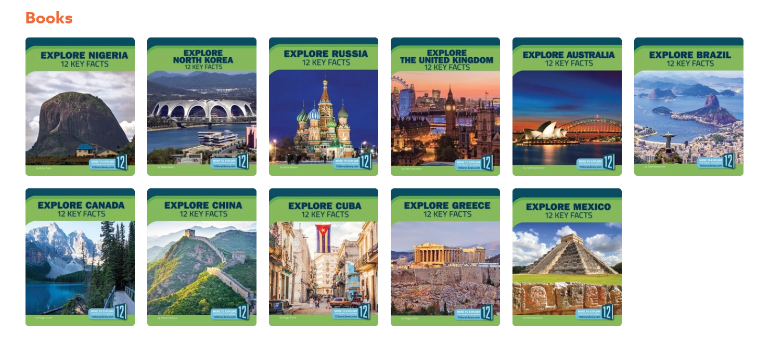
I can investigate the land use of places and regions around the world.
Students will watch “Economic and Land Use Resources: Welcome to the Neighborhood - Crash Course.”  Students will revisit the chart of local jobs that they created and discuss if those jobs use the land or not, and if they do, how they use it.  Students will work with the teacher to explore the land use of countries around the world (suggested sites: CIA World Factbook, Food and Agriculture Organization of the United Nations, Our World in Data). Based on their observations, students can generate a question that could be answered by the information presented. Students can use the Snowball Fight instructional strategy to answer their peers’ questions. | Teacher will use Welcome to the Neighborhood - Crash Course video to provide students with an overview of economics and land use.  Teacher will model the chart of local jobs that were previously created and allow students to discuss if the jobs use the land and how they use the land.  Teacher could reread “Mama is a Miner,” this time focusing on how they used the land to help students make connections.  Suggested sites with information about land use around the world:  - Food and Agriculture Organization of the United Nations: interactive land use graphics; can change dates, countries, etc. (FAOSTAT)  - CIA World Factbook: land use of countries listed alphabetically (Field Listing :: Land use — The World Factbook)  - Website about land use- has some great graphics and information (Land Use)  See here for instructional support on Snowball Fight strategy: Play Snowball Fight to Break the Ice or Review Lessons
I can explain how the distribution of Earth’s resources impacts the economies of various regions around the world.
Students will review Earth’s natural resources by watching the BrainPopJr Natural Resources video. Students can complete a sorting activity on BrainPopJr or cut/paste activity on paper.  Students will engage in a discussion of possible ways land is used in the United States.  Students will explore and analyze a map of Earth’s resources in the United States of America. (Possible map: Esri Geoinquiries - Natural resources and regions)  Students will view Mapping Africa's Natural Resources and analyze how the distribution of natural resources in Africa impacts the economy of that continent. Students will select one region or country to write an analysis sentence on a sticky note. | Teacher can review natural resources as needed before looking at land use around the world. (Science Standards- 3.E.4A.3 Obtain and communicate information to exemplify how humans obtain, use, and protect renewable and nonrenewable Earth resources.)  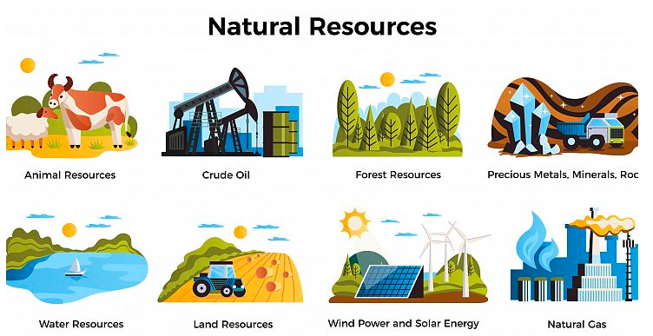  Alternatively, for the natural resources sorting activity, the teacher could list resources verbally and have students stand up if it is a natural resource, and sit down if it is not.  Teacher can use the entire lesson from Esri Geoinquiries - Natural Resources And Regions.  Teacher could use the Mapping Africa's Natural Resources as an assessment. Possible teacher questions:  - What would happen if people around the world stopped buying diamonds? Would that have a big or small effect on the economy? (Or petroleum, gold, etc.)  - What would happen if the fishing industry was not doing well? Would it have a big or small effect on the economy?  - Which three resources are the most prevalent on the continent of Africa? Are they similar to or different from the resources you saw in the United States?  - Are most of the resources contained in only one country? What does that tell you about the geography of the land? (Think beyond lines on a political map.)  Possible sentence starter for sticky notes on map of Africa: (Name the continent or region) has (Name the natural resource(s). It/They impact(s)the economy in its region by _______________. It/They may also impact(s) other parts of the world by ________________________.
I can create a geographic representation for a contemporary or historic group of people to communicate information about their economic characteristics.
Students will create a geographic representation of a group of people located in the country/region they chose to research throughout the year. See Instructional Guidance and Resources for related tasks. | Tasks for Unit 6 for the yearlong study:  - Describe the economic characteristics  - Explain how the country/region uses the land that surrounds/surrounded them.  - Create geographic representation of the economy of the country/region.  After learning about the economy of other countries, as well as the United States, students could use the five themes of Social Studies to research and create a geographic representation.  Five Themes are:  Geography - The location of land and its resources  Culture - Aspects of daily life  Economics - System for exchanging goods and services that are wanted and/or needed  History- The story of events from the past  Government - System for making decisions
Resources
For suggested content, see the Grade 3 World Geography Alignment Guide.

Mapping Resources:

CIA World Factbook

Food and Agriculture Organization of the United Nations

Our World in Data

Esri Geoinquiry about Natural Resources And Regions.
Esri Geoinquiry about Economies Around the World

Literature Resources:
US News and World Report book list
Teaching Economics with Children’s Literature
Best Economics Books for Kids
How Do Natural Resources Affect The Economy? - Article

