

South Carolina Mathematical Competencies for Middle and High School
February 19, 2026

Ellen E. Weaver
State Superintendent of Education

Contents
Contents 2
Introduction 4
Standard 1: Foundational Knowledge 5
Classroom Teachers understand the theoretical evidence-based instructional strategies of mathematics and mathematical proficiency. 5
Indicator 1.1 5
Indicator 1.2 8
Indicator 1.3 15
Standard 2: Standards, Curriculum, and Instruction 17
Indicator 2.1 17
Indicator 2.2 18
Indicator 2.3 18
Indicator 2.4 19
Indicator 2.5 19
Indicator 2.6 20
Indicator 2.7 20
Indicator 2.8 21
Indicator 2.9 22
Standard 3 Assessment, Evaluation, and Progress Monitoring 23
Indicator 3.1 23
Indicator 3.2 23
Indicator 3.3 24
Indicator 3.4 24
Standard 4: Mathematical Perspectives 26
Indicator 4.1 26
Indicator 4.2 27
Indicator 4.3 27
Indicator 4.4 27
Indicator 4.5 28
Indicator 4.6 28
Standard 5: Mathematical Environment 29
Indicator 5.1 29
Indicator 5.2 29
Standard 6: Professional Learning, Professional Reflection, and Collaboration 31
Indicator 6.1 31
Indicator 6.2 31
Indicator 6.3 31
Indicator 6.4 32
Glossary 33
References 70

Introduction
The future mathematical success of our nation's children is largely dependent on the teachers of mathematics they encounter from prekindergarten to Grade 12 (PreK-12). According to Tatto and Senk (2011), “If the quality of education for every child is to be improved, the education of teachers needs to be taken seriously” (p. 134). Those involved in preparing teachers of mathematics must ensure that all their candidates have the knowledge, skills, and dispositions to provide all students access to meaningful experiences with mathematics.
The South Carolina middle and high school Math Teacher Competencies exist to define what teachers should know and be able to do in order to ensure that all students have the knowledge and skills to solve problems using critically important skills for college and career readiness. The competencies are aligned with instruction and intervention methods grounded in the Standards for Preparing Teachers of Mathematics. They address the implementation of evidence-based classroom instruction, interventions, and progress monitoring for all students with specific consideration to meet the needs of students with math difficulties, including those with dyscalculia. The competencies focus on the five components of mathematical proficiency (conceptual understanding, procedural fluency, strategic competence, adaptive reasoning, and productive disposition, four types of assessment (screening, progress monitoring, diagnostic, summative), core instruction for all students (Tier 1), targeted interventions for students in need of supplemental support (Tier 2) and intensive interventions for students substantially below grade level in mathematics (Tier 3).

Standard 1: Foundational Knowledge

Classroom Teachers understand the theoretical evidence-based instructional strategies of mathematics and mathematical proficiency.

Indicator 1.1
Understand the major theories that help students achieve math proficiency.
Competencies:
The teacher will be able to…
- Identify the five interrelated strands that, together, constitute mathematical proficiency.
  - Mathematical proficiency encompasses conceptual understanding, procedural fluency, strategic competence, adaptive reasoning, and productive disposition. Students need adaptive reasoning to think logically and justify one’s own thinking; strategic competence to formulate, represent and solve mathematical problems; productive disposition to see math as sensible and useful; procedural fluency to carry out mathematical procedures flexibly, accurately, efficiently, and appropriately; and conceptual understanding to comprehend concepts, operations, and relations in mathematics. Teachers must foster both the procedural and conceptual aspects of math learning; conceptual understanding establishes the foundation, and is necessary, for developing procedural fluency (National Research Council, 2001).
- Provide students with multiple representations, such as, the Lesh Translation Model or the Concrete Representational Abstract (CRA) method.
  - Students should be encouraged to move between and within various representations including concrete materials, pictures, real-world context, verbal descriptions, and written symbols so that students develop a deeper understanding of mathematical ideas.
  - Students should have the opportunity to learn and develop a deeper understanding of math by exposing students to multiple representations and allowing them to transition from the use of physical objects to the use of pictorial drawings, and to the final stage of numbers and symbols to solve problems.
- Demonstrate an understanding of evidence-based instructional strategies.
  - To help students achieve math proficiency, skills need to be decomposed into a series of actionable steps, and this can be done for concepts taught in a whole group setting or in small groups. It is particularly helpful in small groups as it enables the teacher to hone in on students who are in need within a larger concept. In addition, teachers use a focused, coherent progression of math learning; develop conceptual understanding, procedural fluency, and problem-solving skills at the same time; use explicit instruction along with multiple approaches to meet the needs of students; focus on proficiency with whole numbers, fractions, geometry, and measurement; and use formative assessment on a regular basis to assess student learning (National Mathematics Advisory Panel, 2008).
  - To help students experiencing difficulty with math proficiency, teachers use explicit instruction; teach clear and concise math language; use concrete, pictorial, and visual representations; use number lines for learning concepts and procedures; provide deliberate instruction on solving word problems; and allot time to practice math fluency (Fuchs et al., 2021).
- Provide explicit instructional practices that support conceptual understanding, procedural fluency, and problem-solving skills (National Research Council, 2001).
  - Math proficiency is a blend of concepts: understanding concepts, operations, and relations; procedures: using procedures flexibly, accurately, and efficiently; and strategies: formulating, representing, and solving problems (National Research Council, 2001).
- Use deliberate word problem instructions.
  - Students benefit from explicit instruction surrounding word problems, as they require skills including reading and understanding the narrative and its vocabulary, identifying the most relevant information, interpreting visuals, and identifying appropriate procedures for solving a given problem (Virginia Department of Education, 2020).

Table 1: Dos and Don’ts for Teaching Problem Solving
🚫 DON’T tie key words to operations. | 👍 DO have an attack strategy. | 👍 DO teach word-problem schema.
Source: Virginia Department of Education
- Don’t tie key words to operations. When key words are tied to operations, students play seek and find with word problems; students look for a key word and then use the operation signaled by the key word without thinking conceptually about what the problem is asking. Emphasis should be placed on thinking and reasoning rather than key words.
- Do have an attack strategy. An attack strategy serves as a tool that students can use to structure their thinking before and during the solving of a word problem.
Table 2: Problem Solving Attack Strategies
Understand  Plan  Solve  Check (adapted from Pólya, 2009) | Find the problem  Organize information using a diagram  Plan to solve the problem  Solve the problem (Jitenra and Star, 2012)
Search the word problem  Translate the words into an equation or picture  Answer the problem  Review the solution (Gagnon and Maccini, 2001) | Read: for understanding  Paraphrase: your own words  Visualize: a picture or diagram  Hypothesize: a plan to solve the problem  Estimate: predict the answer  Compute: do the arithmetic  (Montague, 2008)
Source: Virginia Department of Education
- Do teach word-problem schemas. Teach students to understand word problems according to their structure: additive, multiplicative, combined.
Table 3: Math Word Problem Schema Types
Additive | - Total: Involves adding or combining two or more distinct sets (each set representing a part that are put together to form a total.  - Difference: Involves comparing and finding the difference between two sets.  - Change: Involves finding the increase or decrease in the quantity of the same set (i.e., there is one set and something happens to that set).
Multiplicative | - Equal Groups: Involves multiplying or dividing groups where there is an equal number in each group.  - Comparison: Involves multiplying a set a given number of times.  - Ratios/Proportions: Involves finding the relationship between two numbers.
Combined | - As students advance in school, they will encounter new kinds of mathematical problems with new underlying structure, or schema. They will also encounter multi-step mathematics problems. For example, students might encounter a multiplicative and an additive schema in one problem.
Source: Iris Center

Indicator 1.2
Possess a solid and flexible knowledge of relevant mathematical concepts and procedures from middle and secondary level curriculum, including how prerequisite mathematical concepts connect to subsequent learning.
Competencies:
The middle school teacher will be able to…
- Make connections and build on the relationship of ratios and proportional reasoning.
  - Understand a ratio as a distinct entity representing a relationship different from the quantities it compares; recognize the difference between proportional and nonproportional situations; experience problem situations involving more than one variable with both direct and inverse variation; and know and use a variety of strategies to solve problems involving ratios and proportions (Conference Board of the Mathematical Sciences, 2012).
  - Understand the content that precedes ratios and proportions (multiplicative comparisons and fractions) and content that follows ratios and proportions (linear functions) (Association of Mathematics Teacher Educators, 2017).
  - Engage students by employing a range of reasoning strategies, including rates and scaling, ratio tables, tape or strip diagrams, double number line diagrams, and equations (proportions) (Ercole, Frantz, & Ashline, 2011; Olson, Olson, & Slovin, 2015).
- Exhibit a deep understanding of the number system.
  - Understand and explain methods of calculating products and quotients of fractions, by using area models, tape diagrams, and double number lines (Conference Board of the Mathematical Sciences, 2012).
  - Use properties of operations to explain operations with rational numbers, including negative integers. (Conference Board of the Mathematical Sciences, 2012).
  - Examine the concepts of greatest common factor and least common multiple (Conference Board of the Mathematical Sciences, 2012).
  - Use a standard algorithm to change a fraction to a decimal and how decimals that eventually repeat can be expressed as fractions (Conference Board of the Mathematical Sciences, 2012).
  - Explain why irrational numbers are needed and how the number system expands from rational to real numbers (Conference Board of the Mathematical Sciences, 2012).
- Demonstrate a deep understanding of algebraic thinking, noticing the central role of generalization and the use of variables to represent numbers.
  - Convey an awareness that symbols such as equal signs, inequality symbols, and square-root symbols can be confusing for students and connect these symbols to their meanings to prepare students for algebra (Association of Mathematics Teacher Educators, 2017).
  - Exhibit strong conceptual and procedural understandings of linear equations, linear functions, and slope of a line. (Association of Mathematics Teacher Educators, 2017).
  - Understand that functions describe a relationship or situation in which one quantity determines another so that learners understand the meaning of function and use appropriate notations and representations (Association of Mathematics Teacher Educators, 2017).
  - Understand how mathematical representations such as graphs, tables, and equations support and influence algebraic and functional thinking (Association of Mathematics Teacher Educators, 2017).
  - Utilize strategies to integrate representations into instruction in ways that support students so that they can move flexibly among representations and connect each representation to the given context/situation (Association of Mathematics Teacher Educators, 2017).
- Connect geometry to measurement and algebra to bridge the content while understanding that geometry itself is relevant and important in the middle school grades (Sinclair, Pimm, Skelin, 2012).
  - Obtain strategies for connecting geometry to ratios, proportions, and algebraic thinking for scale drawing and transformations (Association of Mathematics Teacher Educators, 2017).
  - Explain why the Pythagorean Theorem is true (Association of Mathematics Teacher Educators, 2017).
  - Apply the Pythagorean Theorem by selecting high quality tasks in which students explain and use the Pythagorean Theorem (Association of Mathematics Teacher Educators, 2017).
  - Apply measurement to authentic and relevant contexts (Association of Mathematics Teacher Educators, 2017).
  - Develop an understanding of area formulas and examine how area and volume change between similar shapes (Conference Board of the Mathematical Sciences, 2012).
- Engage students in statistical thinking and data-analysis processes beyond computation of values, calculation of statistical measures, and rote creation of data displays (Association of Mathematics Teacher Educators, 2017).
  - Understand various ways to summarize, describe, and compare distributions of numerical data in terms of shape, center, and spread (Conference Board of the Mathematical Sciences, 2012).
  - Calculate theoretical and experimental probabilities of simple and compound events and understand why their values may differ for a given event in a particular experimental situation (Conference Board of the Mathematical Sciences, 2012).
  - Develop an understanding of statistical variability and its sources, the role of randomness in statistical inference (Conference Board of the Mathematical Sciences, 2012).
  - Explore relationships between two variables by studying patterns in bivariate data (Conference Board of the Mathematical Sciences, 2012).
The high school teacher will be able to…
- Demonstrate and apply understandings of major mathematics concepts, procedures, knowledge, and applications within and among mathematical domains of Numbers; Algebra and Functions; Calculus; Statistics and Probability; and Geometry, Trigonometry, and Measurement. (National Council of Teachers of Mathematics, 2020)
- Demonstrate and apply understanding of major mathematics concepts, procedures, knowledge, and applications of numbers including flexibly applying procedures, using real and rational numbers in contexts, developing solution strategies, and evaluating the correctness of conclusions. (National Council of Teachers of Mathematics, 2020)
  - Be able to move fluidly between multiple representations of numbers and understand how concrete materials and technology can assist in the development of conceptual knowledge.
  - Use tools from sketching through using modeling technology to explore how these representations can enhance and broaden their understanding.
  - Engage with properties of number systems and explore the differences in the properties of rational numbers and real numbers
- Demonstrate and apply understanding of major mathematics concepts, procedures, knowledge, and applications of algebra and functions including how mathematics can be used systematically to represent patterns and relationships including proportional reasoning, to analyze change, and to model everyday events and problems of life and society. (National Council of Teachers of Mathematics, 2020)
  - Essential Concepts in Algebra (National Council of Teachers of Mathematics, 2018)
    - Expressions can be rewritten in equivalent forms by using algebraic properties, including properties of addition, multiplication, and exponentiation, to make different characteristics or features visible.
    - The structure of an equation or inequality can be purposefully analyzed to better understand context and relationships and to determine efficient strategies to find, justify, and interpret solutions.
    - Expressions, equations, and inequalities can be used to analyze and make predictions, both within mathematics and as mathematics is applied in different contexts—in particular, contexts that arise in relation to linear, quadratic, exponential, logarithmic, and trigonometric situations.
  - Essential Concepts in Functions (National Council of Teachers of Mathematics, 2018)
    - Functions can be described by using a variety of representations: mapping diagrams, function notation (e.g., f (x) = x²), recursive definitions, tables, and graphs.
    - Families of functions have distinguishing attributes (structure) common to all members that are identifiable in the various representations such as key features of the graphs, including zeros, intercepts, and, when relevant, rate of change, and maximum/minimum values, and that can also be associated with and interpreted in terms of the equivalent symbolic representations.
    - Functions can describe a wide variety of real situations and can help students understand the processes of making and changing assumptions, assigning variables, and finding solutions to contextual problems.
- Demonstrate and apply understandings of major mathematics concepts, procedures, knowledge, and applications of calculus including the mathematical study of the calculation of instantaneous rates of change and the summation of infinitely many small factors to determine some whole. (National Council of Teachers of Mathematics, 2020)
  - Conceptual understanding and procedural fluency, supported by appropriate technology and varied representational tools, including concrete models, should be included along with the following concepts:
    - Limits, continuity, rates of change, the Fundamental Theorem of Calculus, and the meanings and techniques of differentiation and integration
    - Parametric, polar, and vector functions
    - Sequences and series
    - Multivariate functions
    - Applications of function, geometry, and trigonometry concepts to solve problems involving calculus
- Demonstrate and apply understandings of statistical thinking and the major concepts, procedures, knowledge, and applications of statistics and probability, including how statistical problem solving and decision making depend on understanding, explaining, and quantifying the variability in a set of data to make decisions. They understand the role of randomization and chance in determining the probability of events. (National Council of Teachers of Mathematics, 2020)
  - Essential Concepts in Quantitative Literacy
    - Apply statistical reasoning with contextual data to evaluate risks or conclusions.
  - Essential Concepts in Visualizing and Summarizing Data (National Council of Teachers of Mathematics, 2020)
    - Analyze contexts to identify appropriate data types and distributions with attention to describing the context to compare two or more subgroups with respect to a variable.
    - Use Data-analysis techniques and representations to develop models of contextual situations.
  - Essential Concepts in Statistical Inference (National Council of Teachers of Mathematics, 2020)
    - Understand that the scope and validity of statistical inferences are dependent on the role of randomization in the study design, including the differences in randomly selecting samples and randomly assigning subjects to experimental treatment groups.
    - Understand the impact of bias, such as sampling, response, or nonresponse bias, yielding results that are not representative of the population of interest.
  - Essential Concepts in Probability (National Council of Teachers of Mathematics, 2020)
    - Demonstrate that two events are independent if the occurrence of one event does not affect the probability of the other event.
    - Demonstrate and apply conditional probabilities that can be computed from data organized in contingency tables.
- Demonstrate and apply understandings of major mathematics concepts, procedures, knowledge, and applications of geometry including using visual representations for numerical functions and relations, data and statistics, and networks, to provide a lens for solving problems in the physical world. (National Council of Teachers of Mathematics, 2020)
  - Essential Concepts in Measurement
    - Calculating or approximating measurements, including areas and volumes, should support an understanding of measurement and the objects being acted on.
    - Applying proportional relationships allows for the generation and comparison of measures, including length, area, or volume, between a known object and similar objects.
  - Essential Concepts in Transformations
    - Applying geometric transformations to figures provides opportunities for describing the attributes of the figures preserved by the transformation and for describing symmetries by examining when a figure can be mapped onto itself.
    - Transformations in geometry serve as a connection with algebra, both through the concept of functions and through the analysis of graphs of functions as geometric figures.
  - Essential Concepts in Geometric Arguments, Reasoning, and Proof
    - Proofs of theorems can sometimes be made with transformations, coordinates, or algebra; all approaches can be useful, and in some cases, one may provide a more accessible or understandable argument than another.
  - Essential Concepts in Solving Applied Problems and Modeling in Geometry
    - Recognizing congruence, similarity, symmetry, measurement opportunities, and other geometric ideas, including right triangle trigonometry in real-world contexts, provides a means of building understanding of these concepts and is a powerful tool for solving problems related to the physical world in which we live.

Indicator 1.3
Understand the role of scientific research, comprehensive data, progress monitoring, and professional judgement in ensuring the numeracy development and achievement for all students.

Competencies:
The teacher will be able to…
- Use a Multi-Tiered System of Supports (MTSS) process to provide responsive teaching and targeted, explicit instruction for all students’ numeracy development using high-quality instruction and intervention, comprehensive data, progress monitoring, and professional judgement.

Standard 2: Standards, Curriculum, and Instruction
Teachers use instructional approaches, materials, and integrated, comprehensive, and systematic-based curriculum to support student learning in mathematics.

Indicator 2.1
Demonstrate an understanding of evidence-based instructional approaches and strategies to develop mathematical knowledge and build numeracy.
Competencies:
The teacher will be able to…
- Use the South Carolina College- and Career-Ready Mathematics Standards to provide explicit instruction for Data, Probability, and Statistical Reasoning; Measurement, Geometry, and Spatial Reasoning; Numerical Reasoning; and Patterns, Algebra, and Functional Reasoning.
- Embed the Mathematical Process Standards into daily lessons to ensure students develop conceptual understanding of mathematical content and apply mathematical skills.
- Use the components for mathematical proficiency to organize daily classroom schedules, routines, and structures.
- Provide explicit, systematic, and scaffolded instruction through modeling, practice, and supports.
  - Model clear explanations and planned examples of correct and incorrect responding on well-sequenced tasks.
  - Practice builds understanding, while guided practice builds accuracy and independent practice builds fluency.
  - Engage students through the use of well-planned questions, frequent student responding, and specific feedback that is both affirmative and corrective.
- Implement activities that promote reasoning and problem solving.
- Use and connect mathematical representations to deepen understanding of mathematics and procedures and as tools for problem solving.
- Facilitate meaningful mathematical discourse.
- Build procedural fluency from conceptual understanding.

Indicator 2.2
Implement and use high quality instructional materials (HQIM) to provide effective Tier 1 instruction
Competencies:
The teacher will be able to…
- Align materials with the 2025 South Carolina College- and Career-Ready Mathematical Standards.
- Adapt materials to meet the needs of diverse learners.
- Use materials to collect and analyze data to inform instruction.
- Demonstrate pedagogical knowledge which includes the understanding of how students learn, using various teaching strategies, and employing assessment techniques to monitor progress.
- Exhibit a strong foundation in mathematical content to interpret and adapt materials appropriately.
- Ensure vertical alignment in order to bridge content gaps and ensure a smooth transition and coherent learning experience for all students.

Indicator 2.3
Demonstrate an understanding of MTSS, including the types of instruction that should occur in Tier 1, Tier 2, and Tier 3, to support the needs of all learners, including students with disabilities, multilingual learners (MLs), and immigrant students.
Competencies:
The teacher will be able to…
- Provide evidence-based core instruction for all students (Tier 1), targeted interventions for students in need of supplemental support (Tier 2) and intensive interventions for students substantially below grade level in mathematics (Tier 3).
- Teach using whole group, small group, and individual student instruction.
- Use evidence-based tools to monitor the effectiveness of core instruction and interventions in procedural fluency, conceptual understanding, and problem solving.
- Adapt and accommodate instructional approaches and materials to meet the language proficiency needs of all learners.
- Use data to individualize instruction for students with disabilities to the areas of the student’s specific need.
- Ensure access to the general education curriculum that addresses grade level academic standards for students with disabilities, using universal design for learning as well as individualized accommodations and modifications listed in the Individual Education Plan (IEP).
- Gather formative and summative diagnostic data for students with disabilities to inform IEP goals, align and adjust instruction to student needs, and monitor progress toward IEP goals, as described in the IEP.

Indicator 2.4
Demonstrate an understanding of the strands of mathematical proficiency.
Competencies:
The teacher will be able to…
- Comprehend mathematical concepts, operations, and relations.
- Carry out procedures flexibly, accurately, efficiently, and appropriately.
- Formulate, represent, and solve mathematical problems.
- Use logical thought, reflection, explanation, and justification.
- Use a belief in diligence and efficacy to see mathematics as sensible, useful, and worthwhile.

Indicator 2.5
Demonstrate an understanding of varied instructional approaches and strategies to develop critical thinkers to reason both abstractly and quantitatively.
Competencies:
The teacher will be able to…
- Construct arguments using multiple representations (objects, drawings, diagrams, and actions).
- Recognize and explain bias and errors in an argument.
- Listen to and read the arguments of others to critique whether they make sense and ask questions for clarification.
- Use reasoning to make and explore the truth of conjectures.

Indicator 2.6
Demonstrate an understanding of mathematical representation and communication.
Competencies:
The teacher will be able to…
- Model how to use available and relevant tools that are helpful to explore, model, and deepen understanding of mathematical concepts.
- Use precise mathematical language to model, explain, and justify valid solutions.
- Encourage students to use math drawings or other visual supports to explain and justify reasoning.
- Engage students in constructive dialogue through writing, speaking, and listening.

Indicator 2.7
Demonstrate an understanding of varied instructional approaches and strategies to make sense of problems and persevere in solving them strategically.
Competencies:
The teacher will be able to…
- Explicitly teach students to use multiple entry points for problem solving.
- Teach students to use an estimation strategy to check for reasonable solutions to problems.
- Utilize tasks and activities that require a high level of cognitive demand.
- Encourage students to use varied approaches and strategies to make sense of problems.

Indicator 2.8
Multilingual learners and immigrant students must have opportunities to learn the target language, and teachers must differentiate and accommodate instruction to make content accessible and comprehensible for students to access grade-level content standards.
Competencies:
The teacher will be able to…
- Use knowledge of the WIDA English Language Development Standards Framework, 2020 Edition to support the needs of multilingual learner and immigrant students in all classrooms.
- Integrate blended content and language instruction.
- Use student proficiency levels to guide language needs and growth.
- Differentiate and incorporate listening, speaking, reading, and writing throughout the instruction.
- Know and understand how to support multilingual learners and immigrant students in learning to read English.
- Incorporate accommodated materials for multilingual learners and immigrant students throughout content units and lesson plans that support and provide access to the core content.
- Provide explicit, systematic, and scaffolded instruction through modeling, practice, and supports.
  - Model clear explanations and planned examples of correct and incorrect responding on well-sequenced tasks.
  - Know that practice builds understanding, while guided practice builds accuracy and independent practice builds fluency.
  - Support engaging students through the use of well-planned questions, frequent student responding, and feedback that is both affirmative and corrective.
- No matter the proficiency level, encourage students to represent their thinking and understanding of grade-level content standards (using their native language, translanguaging, writing, drawing, sentence frames, etc.).
- Design instruction incorporating multiple language modes (reading, writing, listening, speaking, and interaction).
- Utilize academic and background knowledge from students’ first language to support student learning in the target language.
- Scaffold both interpretive and expressive academic language.
- Use native languages to leverage success in the target language and encourage parallel growth in both languages.
- Use many and various texts.
- Incorporate appropriate strategies and accommodations to help students acquire proficiency in English by following Individualized Language Acquisition Plans (ILAPs) and collaborating with multilingual learner specialists/teachers to meet the language needs of students.
- Know and respect students, their backgrounds, their experiences, and their interests to develop a relevant curriculum.
- Include representations of all students.
- Understand and use best practices that support multilingual learners and immigrant students (lesson preparation, building background, comprehensible input, strategies, meaningful interaction, practice and application, lesson delivery, review and assessment).

Indicator 2.9
Demonstrate an understanding of providing instructional support through technology.

Competencies:
The teacher will be able to…
- Enhance instruction, scaffold learning, and determine the effectiveness of instruction by using technology to meet the individual needs of students.
- Determine best practices during synchronous and asynchronous learning.

Standard 3 Assessment, Evaluation, and Progress Monitoring
Teachers use a range of ongoing formal and informal assessment tools and practices to plan, progress monitor, and evaluate student learning in mathematics instruction.

Indicator 3.1
Understand types of assessment and their purposes, strengths, and limitations.
Competencies:
The teacher will be able to…
- Demonstrate an understanding of formal and informal assessments.
- Describe the strengths and limitations of assessment types and their appropriate uses (e.g., formative assessments vs statewide summative assessments).
- Identify the basic technical adequacy of assessments (e.g., reliability, validity, fairness).
- Demonstrate an understanding of intended score use and interpretation (e.g., norm- vs criterion-referenced).

Indicator 3.2
Select/develop and administer assessments for specific purposes.
Competencies:
The teacher will be able to…
- Administer assessments (classroom, school-based, state) using consistent, fair, and impartial procedures.
- Select or develop formative assessment tools such as rubrics, observations, surveys, anecdotal notes, specific skill/strategy to monitor student progress and to guide instructional decision making.
- Systematically monitor students’ progress using screening, diagnostic, progress monitoring, and summative assessments.
- Develop and implement a variety of appropriate assessments that include the use of authentic and dynamic assessment data points during lessons, at the end of lessons, and at the end of units.

Indicator 3.3
Demonstrate an understanding of student performance on screening, progress monitoring, diagnostic, and summative assessment tools.
Competencies:
The teacher will be able to…
- Use various types of assessments (screening, progress monitoring, diagnostic, summative) for their intended purposes.
- Collaborate and co-create standards-based learning goals with students using assessment data to promote student self-reflection.
- Interpret and use assessment data to analyze individual, group, and classroom performance and progress to inform instruction.
- Use the MTSS process to analyze multiple sources of data to make instructional decisions for whole group, small group, and individual student learning goals.
- Use multiple sources of data to respond to students’ needs by developing relevant next steps for teaching.
- Collaborate with other educational professionals to modify instruction and to plan and evaluate interventions based on assessment data.
- Use assessment data to reflect on teaching as well as student learning, where appropriate.

Indicator 3.4
Demonstrate an understanding of assessment results to communicate and explain implications to all stakeholders (administrators, parents, teachers, community) to advocate for effective mathematical practices.
Competencies:
The teacher will be able to…
- Provide substantive and dynamic feedback to students, families, and vested others.
- Communicate regularly with and provide feedback to students and families on overall performance, progress toward the SCCCR Standards.
- Explain district and state assessments, proficiency standards, and/or student benchmarks to all stakeholders.
- Collect samples of student work, photographs, anecdotal records, assessments, etc., to provide a history of student growth.
- Interpret patterns in students’ data.
- Set goals across content areas and mathematical improvement initiatives to enhance instruction.

Standard 4: Mathematical Perspectives
Teachers design and facilitate mathematical learning experiences practices that promote reasoning, collaboration, and respect for diverse perspectives.

Indicator 4.1
Foster mathematical discourse in the classroom to instill concepts, skills, and thought processes necessary for student’s long-term mathematical success.
Competencies:
The teacher will be able to…
- Create a safe and supportive learning environment where students feel comfortable sharing their ideas, reasoning, and approaches to problem-solving. This is done through establishing clear classroom discussion norms, fostering a sense of belonging and acceptance, and modeling respectful dialogue.
- Encourage students to listen actively, build on each other’s ideas, and use open-ended questions to prompt deeper thinking. Students should be able to respond to their peers’ ideas, agree or disagree with them, and explain their reasoning.
- Design tasks and activities that promote discourse. Students should justify answers, explore multiple strategies, share ideas in pairs or groups, and make connections to different mathematical ideas.

Indicator 4.2
Collaborate with instructional leaders to develop mathematics instruction that is responsive to all students.
Competencies:
The teacher will be able to…
- Embed perspectives of those with individual differences within instruction.
- Provide differentiated instruction and instructional materials, including traditional print, digital, and online resources that provide multiple perspectives.
- Teach students how respecting individual differences strengthens a numerate society, making it more productive and more adaptable to change.

Indicator 4.3
Demonstrate an understanding of how individual differences influence mathematical development.
Competencies:
The teacher will be able to…
- Engage in professional learning on how personal beliefs impact mathematical development.
- Apply knowledge of students’ backgrounds and incorporate this knowledge into the curriculum and/or instruction.
- Recognize the ways in which personal beliefs interact with mathematical development.

Indicator 4.4
Demonstrate an understanding of how issues within and outside of mathematics teachers’ immediate classrooms influence their students.
Competencies:
The teacher will be able to…
- Recognize the multiple influences of background and environment on student learning.

Indicator 4.5
Demonstrate an understanding of contextual influences on numeracy and mathematical development (e.g. community, home, socioeconomic status, language, parent/guardian education level).
Competencies:
The teacher will be able to…

- Design communication systems and offer parent/guardian workshops so parents are aware of how they can support their child.
- Identify the unique perspectives of individuals from urban, suburban, rural, and other communities through mathematics, academic, and student experiences.

Indicator 4.6
Demonstrate an understanding that multilingual learners have a wide variety of educational and personal experiences as well as language differences.
Competencies:
The teacher will be able to…
- Create an environment that values the assets that each student brings to the community.
- Differentiate and accommodate instruction to meet the needs of multilingual learners.
- Emphasize characteristics of multilingual learners that may influence their success in school.

Indicator 4.7
Demonstrate an understanding of the wide range of abilities that students have within a classroom, which include those who receive services from special education.
Competencies:
The teacher will be able to…
- Differentiate instruction to meet the needs of all students.
- Use multiple sources of information to develop a comprehensive understanding of students’ strengths and needs.
- Teach cognitive and metacognitive strategies to support learning and independence.

Standard 5: Mathematical Environment
Teachers create a mathematical environment that fosters mathematics by providing space for differentiated instructional practices, integrating foundational knowledge, and using appropriate instructional practices and materials to support mathematicians.

Indicator 5.1
Demonstrate an understanding of optimizing physical space for independent and group instruction and practice.
Competencies:
The teacher will be able to…
- Use a variety of classroom configurations (i.e., whole class, small group, and individual) to differentiate instruction.

Indicator 5.2
Recognize the importance of an emotionally safe environment.
Competencies:
The teacher will be able to…
- Promote an environment that encourages risk-taking and includes choice, relevant to student interest.
- Include opportunities for community building (i.e., morning meetings, share time, calendar math, collaboration).
- Provide frequent opportunities for students to share and talk with each other about their learning as they relate to other content areas.
- Organize content so that it is personally meaningful, relevant and intellectually engaging to all students.
- Develop learning experiences where curiosity and exploration are valued.
- Reinforce and reward effort.
- Plan and provide learning environments that address all domains of child development: social, emotional, language, cognitive, and physical.
- Create an environment with hands-on manipulatives that are clearly labeled and easily accessible for students to obtain and use independently as needed.

Standard 6: Professional Learning, Professional Reflection, and Collaboration
Teachers improve their knowledge and practice through a recursive process of professional learning and reflecting.

Indicator 6.1
Develop an understanding of the importance of pursuing professional learning and knowledge by engaging in opportunities to learn from research, colleagues, and students.
Competencies:
The teacher will be able to…
- Apply learning from professional inquiry and research.

Indicator 6.2
Demonstrate an understanding that collaborating with educators is important to professional growth.
Competencies:
The teacher will be able to…
- Participate and collaborate with educators within Professional Learning Communities (PLCs).
- Participate in Professional Learning Opportunities (PLOs) (e.g. conferences, classroom observations, webinars, book studies)
- Collaborate with instructional leaders and colleagues in PLCs to deconstruct SCCCR Mathematics Standards to determine curriculum adjustments and modifications needed to support student achievement.
- Collaborate with instructional leaders and colleagues in PLCs to create daily lesson plans and long-range curriculum plans.

Indicator 6.3
Demonstrate an understanding of the importance of reflecting on the effectiveness of instructional practices and assessments.
Competencies:
The teacher will be able to…
- Reflect on student progress towards learning goals and expectations to make instructional decisions.
- Collaborate with other teachers and support personnel to respond to students’ specific needs, based on data.
- Demonstrate effective use of technology as an instructional practice for improving student learning.
- Use SCCCR Mathematics Standards and formative assessments to make informed decisions on evidence-based instructional approaches and strategies for instruction.

Indicator 6.4
Demonstrate an understanding of displaying professionalism when interacting with all stakeholders.
Competencies:
The teacher will be able to…
- Demonstrate professionalism on technology and social media platforms.
- Work collaboratively with families, colleagues, and community members to support students’ mathematical growth.
- Identify personal attitudes toward family involvement.
- Acquire knowledge of why families may or may not participate in school activities.
- Recognize that engagement may look different for each family.
- Develop strategies to involve families in a way that is comfortable and accessible for them to be involved.
- Design communication systems and offer workshops so that families are aware of how they can support their student(s) as a mathematician.
- Ensure the communication system includes translation and interpretation services as needed.
- Invite families into the classroom to share their expertise.

Glossary
A
Abstract Reasoning A cognitive skill that involves identifying patterns and relationships in symbolic or non-verbal data sets to solve problems; the ability to understand and apply formulas in different situations.
Academic Indicators Educational targets that students are expected to learn by the end of the current grade level.
Academic Language The specialized language, both oral and written, of academic settings that facilitates communication and thinking about disciplinary content.
Academic Standard Educational targets that students are expected to master by the end of their academic career.
Accessible Supports that include both embedded (digitally provided) and non-embedded (non-digitally or locally provided), universal features that are available to all students as they access instructional or assessment content, and accommodations that are generally available for students for whom there is documentation on an Individualized Education Program (IEP) or Section 504 accommodation plan. Approaches to these supports may vary depending on state or assessment consortium contexts as well as nature of assessments - be they content assessments, English Language Proficiency (ELP) assessments, or alternate assessments. Learn more here: SC Accessibility Support Document
Accommodations Changes in procedures or materials that ensure access to instructional and assessment content and generate valid assessment results for students who need them. Learn more here: Accommodations Digital Handbook
Accuracy Degree to which a measurement, calculation, or estimate conforms to the true value or standard.
Addend A number or quantity that is added to another number or quantity to form a sum.
Addition One of the four mathematical operations of arithmetic. Addition is the process of combining two or more numbers together to find their total, also known as the “sum,” and is represented by the plus sign (+) symbol.
Additive Schema A structured framework used to categorize and solve word problems involving addition and subtraction, typically including three main types: “combine” (part-part-whole), “compare,” and “change” problems, where each type represents a distinct relationship between quantities that can be solved using addition or subtraction operations depending on the missing information.
- Combine problem: John has 5 apples, and Mary has 3 apples. How many apples do they have altogether?
- Compare problem: Sarah is 10 years old, and her brother is 12 years old. How many years older is her brother than Sarah?
- Change problem: A store had 20 toys, and then they sold 5 toys. How many toys do they have left?
Adaptive Reasoning The capacity for logical thought, reflection, explanation, and justification.
Algebra A branch of mathematics that uses variables (represented by letters) to represent unknown numbers, allowing for the manipulation of expressions and solving equations to find the values of those variables.
Algebraic Thinking The ability to analyze and generalize patterns, relationships, and how things change, while focusing on processes and operations rather than numbers and computations.
Analyze Examine methodically and in detail the constitution or structure of information for the purposes of explanation and interpretation.
Angle A figure formed by two rays (lines with a single endpoint) that share a common endpoint, called the vertex. The two rays are considered the sides of the angle. Angles are measured in degrees and depending on their measure, angles can be classified as acute (less than 90 degrees), obtuse (greater than 90 degrees but less than 180 degrees), right angles (exactly 90 degrees), or straight angles (exactly 180 degrees).
Area The amount of space enclosed within a two-dimensional shape, typically measured in square units, essentially representing how many square units would fit inside the shape; it is a measure of the surface covered by a flat figure.
Area Model A rectangular diagram used to visualize and solve multiplication and division problems. The factors (numbers being multiplied) or the quotient and divisor determine the length and width of the rectangle, and the product or quotient represents the area.
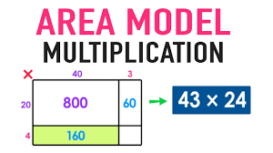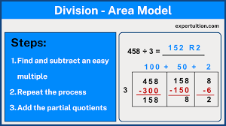

Arithmetic The fundamental branch of mathematics that studies numbers, their properties, relationships, and the basic operations performed on them. It also covers advanced concepts like fractions, decimals, and percentages, focusing on the properties and manipulations of numbers.
Asynchronous Learning Asynchronous instruction is the idea that students learn similar material at different times and locations. The term is often associated with online learning where students complete assignments or activities at their own pace and at their own chosen time. This approach is particularly useful when students are spread across different time zones or may have limited access to technology.
Attribute A specific characteristic or feature of a geometric object, like its shape, size, number of sides, or angles, which allows you to classify and distinguish it from other objects; essentially, it's a defining property used to describe an object mathematically. The components(i.e., points, lines, and angles) are the building blocks that determine the shape’s attributes. For example, a triangle’s components (three points and three lines) lead to its defining attributes of three sides and three angles.
B
Background Knowledge connections between the content material and experiences of the student.
Bar Graph A visual representation of data using rectangular bars or columns where the length or height of each bar corresponds to a specific value or category. It's a way to compare different categories or values at a glance.
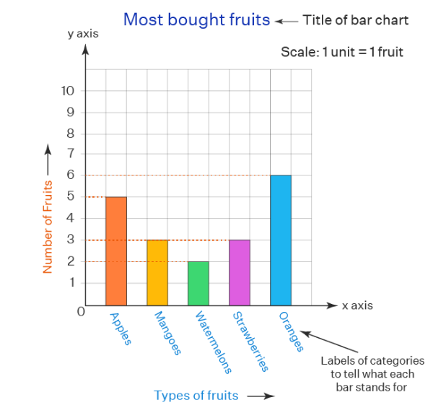
Base Ten A number system that uses the digits 0-9 to represent numbers and assigns a value to each digit based on its position in the number. It is also known as the decimal system or place value number system.

Benchmark The standard or reference point based on which things can be measured, assessed, or compared.
Benchmark Assessment A typical or expected performance level in a given skill (e.g. mathematics) that serves as a general indicator of a student’s overall progress.
Best Practices Digital Handbook Best practices are intended to support multilingual learners (MLs) in all classes, no matter their proficiency level. These strategies are expected to be used by all teachers within lessons, assignments, and assessments to support MLs and all learners. Best practices are strategies that educators can quickly implement within daily instruction, activities, and classroom assessments. Learn more here: Best Practices Digital Handbook
Bivariate Data Data that involves two variables. These variables are often quantitative, meaning they are measured numerically, and can be plotted on a graph to visualize their relationship. For example, one variable might be the amount of time a student studies, and the other variable could be their test score.
Example: Studying the relationship between hours studied per week and test scores.
Box Plot A statistical diagram that visually displays the distribution of data, particularly the five-number summary: minimum, first quartile, median, third quartile, and maximum. It helps to identify the central tendency, spread, and potential outliers within a dataset.
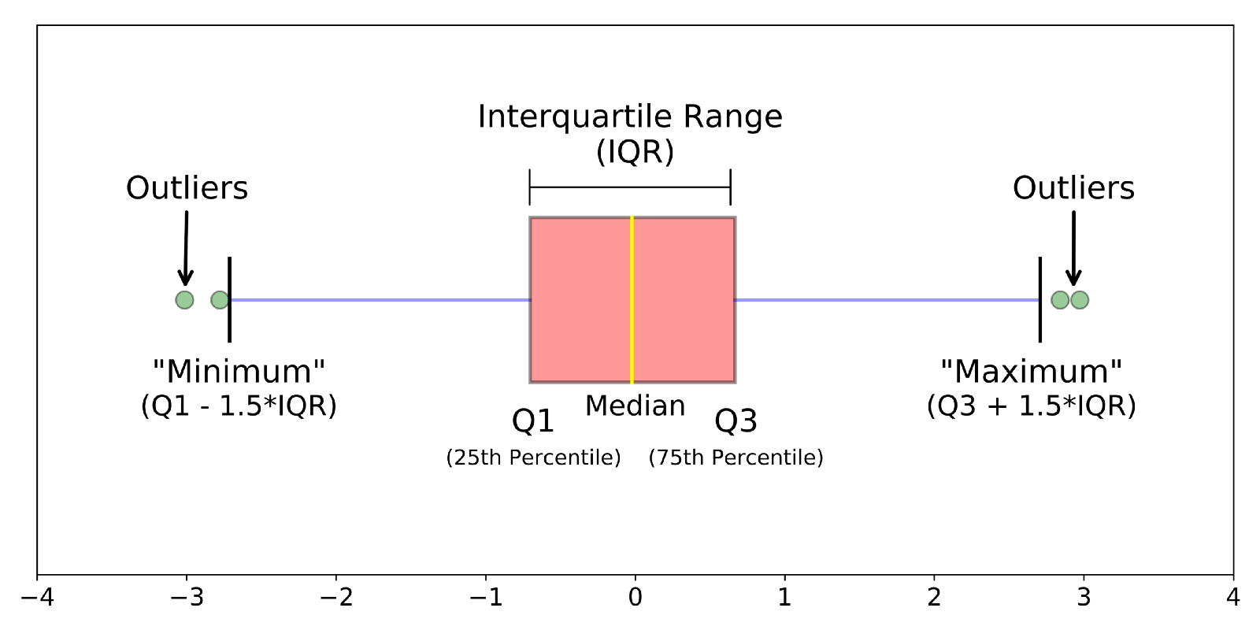
C
Center (of a dataset) A representative value that describes the typical or average value within the data. The most common measures of center are the mean, median, and mode.
Cognitive Strategies Ways to strategically approach academic tasks to gain and use information effectively.
Coherent Progression The idea that math concepts are connected and build on each other across grades and within grade levels. This progression helps students understand math as a whole and apply their knowledge to new situations.
Comparing (problem types) Specifically focuses on finding the difference between two given values, while other types like “joining” or “separating” problems deal with combining or subtracting quantities in a single set. Comparing problems is an additive schema. Different variations of comparing problems include difference unknown, quantity unknown, and referent unknown.
- Difference unknown: Mark collected 8 rocks. Jen collected three rocks. How many more rocks did Mark collect than Jen? 8 - 3 = x or 3 + x = 8
- Quantity unknown: There are eight rocks. Mark found 5 rocks and Jen found the other rocks. How many rocks did Jen find? 8 - 5 = x or 5 + x = 8
- Referent unknown: Mark has three more rocks than Jen. Mark has 8 rocks. How many rocks does Jen have? 8 - 3 = x or x + 3 = 8
Compound Event The combination of two or more simple events, with two or more outcomes.
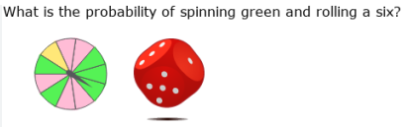
P(G) Probability of rolling a green is 5/11
P(6) Probability of rolling a 6 is ⅙
The probability of rolling a green and rolling a 6 = 5/11 x 1/6 = 5/66 = 0.076
Comprehensive Data A complete set of data that covers all necessary aspects of a given subject, ensuring no critical information is missing and providing a thorough understanding of the topic at hand; essentially, it means all relevant data points are included, making it a fully inclusive data set.
Compute To calculate or determine a value.
Conceptual Understanding The comprehension of mathematical concepts, operations, and relations. Includes the ability to understand the “why” behind mathematical concepts and procedures, rather than just memorizing rules and formulas. The ability to see the big picture and how different mathematical ideas connect, enabling students to apply their knowledge flexibly and solve problems.

Concrete Modeling each mathematical concept with concrete materials (e.g. red and yellow chips, cubes, base ten blocks, pattern blocks, etc.). The “seeing” stage uses representations of the objects to model problems. Students must have access and be encouraged to use manipulatives. This provides flexibility to represent multiple learning progressions.
Concise Math Language Using the Tier 2 and Tier 3 language of mathematics. For example, when working with fractions, both teacher and students should use terms such as “numerator” and “denominator” rather than “top” and “bottom” number.
Concrete Representational Abstract (CRA) A teaching approach that helps students develop a strong understanding of concepts by progressing from concrete, hands-on experiences, to visual representations, and finally to abstract symbolic notation. This method is not necessarily linear, and students can move between these stages as needed.
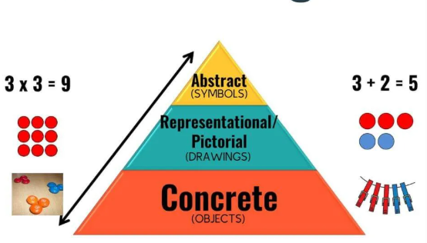
Content Area An organized body of knowledge, such as mathematics, history, science, or literature.
Coordinate Plane A two-dimensional surface created by the intersection of two perpendicular number lines, called the x-axis (horizontal) and the y-axis (vertical), where the point of intersection is called the origin, allowing for the precise location of points using ordered pairs (x, y).
Coordinate System A system that uses a set of numbers (called coordinates) to uniquely identify the position of a point in a defined space, typically by referencing its distance from one or more perpendicular axes, allowing for precise location and description.
Core Instruction (Tier I) Daily whole classroom instruction where all students receive an evidence-based core mathematics program that is explicit and systematic. It is sometimes referred to as Universal instruction.
Corrective Feedback Information provided to a student that identifies a specific error in their mathematical solution, explains why it's incorrect, and guides them on how to correct it, essentially highlighting the gap between their current understanding and the correct mathematical process to achieve the desired answer; it aims to improve learning by directly addressing mistakes and providing targeted strategies for improvement.
Criterion-Referenced Assessment An assessment designed to measure performance against a set of clearly defined criteria. Such assessments are used to identify student strengths and weaknesses with regard to specified knowledge and skills (which are the goals or standard of the instruction). Synonyms include standard-based or - referenced, objective-referenced, content-referenced, domain-referenced, or universe-referenced.
Critical Thinking Forms of learning, thought, and analysis that go beyond the memorization and recall of information and facts. In common usage, critical thinking is an umbrella term that may be applied to many different forms of learning acquisitions or to a wide variety of thought processes. In its most basic expression, critical thinking occurs when students are analyzing, evaluating, interpreting, or synthesizing information and applying creative thought to form an argument, solve a problem or reach a conclusion.
D
Data A collection of information gathered by observation, questioning or measurement. Data is often organized in graphs or charts for analysis and may include facts, numbers or measurements.
Data Displays Visual representations, typically using graphs, charts, or plots, which helps to organize and interpret information by presenting it in a clear and accessible way, allowing for easier analysis of patterns and trends within the data set; common data displays include bar graphs, line graphs, histograms, pie charts, scatter plots, box plots, and stem-and-leaf plots, each with its own specific use depending on the type of data being presented.
Data Probability The likelihood or chance that a specific data point or outcome will occur within a given dataset. Students should be able to represent simple events, determine the likelihood of an event occurring, identify an event as impossible, equally likely, or certain, connect benchmark values, to connect the values of 0 to impossible and 1 to certain and equally likely to ½, and represent the likelihood of a simple event occurring in the form of a fraction.
Decimal Often used to mean a number that uses a decimal point followed by digits that show a value smaller than one. Frequently used to separate the whole number part from the fractional part.
Deconstructing Standards Examining the language of a standard to determine its intent, identify implementation strategies, and establish success criteria.
Diagnostic Assessment A pre-test or pre-assessment that evaluates a student’s knowledge, skills, strengths, and weaknesses before instruction. They are designed to provide a more precise and detailed picture of the full range of a child’s knowledge and skill so that instruction can be more precisely planned.

Difference The result of subtracting one number from another.
Differentiated Instruction An approach whereby teachers adjust their curriculum and instruction to maximize the learning of all students (e.g., typical learners, multilingual learners, struggling students, students with learning disabilities, gifted and talented students); not a single strategy but rather a framework that teachers can use to implement a variety of evidence-based strategies.
District Assessments A district-wide assessment is one that is administered to an entire grade(s) at a district level to measure the achievement of students.
Division One of the four mathematical operations of arithmetic. Division is the process of splitting a quantity into multiple equal parts. Parts of a division problem include the dividend (the number being divided), divisor (the number you are dividing by), quotient (the result of the division), and remainder (when applicable, the amount left over after dividing). Various signs can be used to indicate division, such as ÷, ∕, ⟌. Division is the inverse of multiplication; and therefore, is also repeated subtraction.
Double Number Line Diagram A visual tool used to represent and compare equivalent ratios. It consists of two parallel number lines, one for each quantity in the ratio, with the tick marks aligned to show corresponding values. Each tick mark represents a specific unit of measurement for the corresponding quantity.
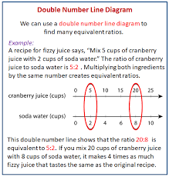
Dynamic Assessment An active teaching process that entails a pretest, teach, and retest model that locates a student's ability to learn new skills. It is a process that blends teaching and assessing into one activity as it works to observe a student’s cognitive function and changes in learning.
Dynamic Feedback A feedback approach that is responsive, adaptable, and continuously adjusts to a student’s individual needs and process in real-time.
Dyscalculia A specific learning disability with an impairment in mathematics, which can affect calculations, problem solving, or both. It impacts all sorts of numerical tasks, and it is inborn, meaning you are born with it. Although there is not yet a generally accepted definition of dyscalculia, the DSM-5 mentions difficulties with number sense, memorization of basic math facts, and accurate and fluent calculation. An estimated 4-7% of students have dyscalculia, so a teacher can expect to have one or two students with this per class.
E
Edges The line segments where two faces of a solid meet. Edges on a two-dimensional shape connect two vertices.
Engagement The behavioral, cognitive, and emotional activities and processes of learning that enable individuals to gain pleasure, knowledge, and self-realization from learning interactions. In a math classroom, engagement looks like active participation, curiosity, and a positive attitude toward learning. Students are actively engaged when they are listening attentively, asking and answering questions, working collaboratively, and seeing the relevance of math to their lives.
Equal Two quantities or expressions that have the same value and represented by the “=” sign.
Equal Sign Denotes that two expressions have the same value; avoid the common misconception of the equal sign as merely an indication that the answer comes next.
Equation A mathematical statement that shows two mathematical expressions are equal. For instance, 3x + 5 = 14 is an equation.
Equivalent Fractions Fractions that have different numerators and denominators but are equal to the same value. For example, 2/4 and 3/6 are equivalent fractions, because they both are equal to the ½.
Estimate An approximate calculation or educated guess of a value that is close enough to be useful but not exact. Often used in mental math and rounding numbers. Estimates are useful when precise measurements or tools are unavailable, or when accuracy is not critical.
Evidence Based Instructional Strategies teaching methods and practices that have been proven effective through research and data, meaning they have been shown to consistently improve student learning outcomes in math, allowing teachers to make informed decisions based on reliable evidence rather than personal preference or intuition; key elements often include explicit instruction, visual representations, concrete-representational-abstract sequencing, and targeted practice with problem-solving strategies. Below are a few evidence-based strategies:
- Cognitive task analysis - teaching students how to think about how to problem solve
- Jigsaw method - individual and group learning to solve a problem
- Outlining and summarizing learning materials by the teacher
- Classroom discussions
- Response to intervention
- Feedback
- Direct instruction
Experimental Probability A probability that is determined on the basis of a series of experiments. A random experiment is done and is repeated many times to determine their likelihood, and each repetition is known as a trial. The experiment is conducted to find the chance of an event to occur or not to occur. It can be tossing a coin, rolling a die, or rotating a spinner. In mathematical terms, the probability of an event is equal to the number of times an event occurred ÷ the total number of trials. For instance, you flip a coin 30 times and record whether you get a head or a tail. The experimental probability of obtaining a head is calculated as a fraction of the number of recorded heads and the total number of tosses. P(head) = Number of heads recorded ÷ 30 tosses.
Example: The number of cookies made by Patrick per day this week is given as 4, 7, 6, 9, 5, 9, 5.
Based on this data, what is the reasonable estimate of the probability that Patrick will make less than 6 cookies the next day?
P(< 6 cookies) = 3/7 = 0.428 = 42%
Explicit Instruction Teaching children in a systematic and sequential manner. Explicit instruction is step-by-step, and the actions of the teacher are clear, specific, direct, and related to the learning objective. It often follows the “I do. We do. You do” model. Explicit instruction provided time for lots of practice and cumulative review with the goal of teaching mastery. Explicit instruction is not strictly whole group instruction and can occur in small group instruction.
Expression A sentence with a minimum of two numbers or variables and at least one operation. An expression does not have an equal sign.
F
Faces The flat surfaces in both two-dimensional and three-dimensional shapes.
Formal Assessment Cumulative assessment used to measure what a student has learned. It includes standardized testing, screenings, and diagnostic evaluation.
Formative Assessment Student assessments used during instruction to provide the information needed to effectively direct and target teaching and learning as it occurs.
Fraction A number that represents a part of a whole or the division of one number by another. Fractions are written as a/b, where a is the numerator and b is the denominator. The denominator b ≠ 0 and represents the number of equal parts the whole has been divided into, and the numerator indicates how many parts are included.
Function A relationship where each input (from a set called the domain) is associated with exactly one output (from a set called the codomain).
Examples:
- f(x) = 2x + 3 is a function because for every value of x you input, you get exactly one value of f(x) as output.
- The set of ordered pairs {(1, 2), (2, 4), (3, 6)} represents a function because each x value (1, 2, 3) maps to a unique y value (2, 4, 6).
Functional Reasoning The ability to analyze and understand the relationship between two variables, considering how changes in one variable affect the other.
G
General Education Curriculum A sequence of instruction or program of study that is aligned with grade-level content standards and is provided to all students.
Geometry The branch of mathematics that deals with the measurement, properties, and relationships of points, lines, angles, surfaces, and solids.
Graphs Pictorial representations or diagrams that represent data or values in an organized manner.
Greatest Common Factor The largest number that is a factor (a number that divides into evenly) of two or more numbers. For example, 6 is the greatest common factor of 18 and 24.
Guided Practice An instructional technique where a teacher actively works alongside students to solve problems, providing support and feedback as they practice a new skill, allowing them to gradually take on more responsibility while minimizing the risk of developing incorrect habits by immediately addressing misconceptions.

Greater Than A number or variable is larger than another and uses the symbol >
For example, 10 > 6 is read as 10 is greater than 6.
H
High Quality Instructional Materials (HQIM) Educational resources that are aligned with academic standards, content-rich, and engaging, while also being readily accessible and designed to meet the diverse needs of students. They should also be evidence-based, provide a full suite of teacher and student materials, and reflect best practices in instruction. Examples of HQIM include:
- Curriculum materials (e.g., textbooks, units lesson plans) aligned to state standards.
- Supplemental materials (e.g., videos, interactive activities, online resources) that enhance learning.
- Assessment tools (e.g., quizzes, tests, performance tasks) to monitor student progress and provide feedback.
- Teacher resources (e.g., professional development materials, guidance on differentiation) to support effective instruction.
Histogram A graphical representation of data where data is grouped into continuous number ranges and each range corresponds to a vertical bar.
- The horizontal axis displays the number range.
- The vertical axis (frequency) represents the amount of data that is present in each range.
- There are no spaces between the bars to show continuity within the ranges each bar denotes.
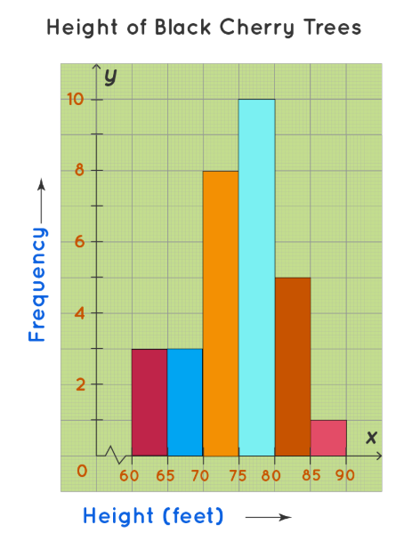
I
Imaginary Number A real number multiplied by the imaginary unit i, where i is defined as the square root of -1 ( i2 = -1).
Independent Practice When students apply math concepts and skills without direct teacher guidance.
Individualized Education Plan (IEP) A document that is unique to each individual school age student (3 years to 21 years old) with a disability and requires specialized instruction and/or services. The plan is developed, reviewed, and revised annually by a team in accordance with Title 42 U.S.C. Section 1414(d).
Individualized Language Acquisition Plan (ILAP) The student plan that states the multilingual language program (MLP) services, classroom accommodations, and testing accommodations an eligible multilingual student will receive.
Inequality Symbol Shows a relation between two expressions that are not equal. The following symbols are used to show an inequality to compare values or expressions: <, >, ≤, ≥, and ≠. These symbols indicate whether one value is less than, greater than, less than or equal to, greater than or equal to, or not equal to another.
Informal Assessment An ongoing assessment that includes student’s work samples, quizzes, teacher anecdotal notes/records, observations, and audio/video recordings.
Instructional Approaches The ways in which the content is taught to help students reach the learning goal. Different instructional approaches or methods serve different purposes and may look different in different grades and content areas.
Intensive Interventions (Tier 3) Designed for the smaller number of students who need more than targeted (Tier 2) instruction. Intensive instruction should occur in small groups of approximately three or four students. Intervention may include looking at time, intensity, frequency, and group size in order to meet each student’s needs. The focus of instruction is usually on foundational skills that need strengthening. Progress monitoring occurs every 7-10 days.
Interquartile Range (IQR) The difference in the values of the first quartile and the third quartile, Q1 and Q3.
The following steps are used to find interquartile range:
- Arrange data from least to greatest.
- Find the median (middle value).
- Identify the first quartile (Q1) - the median of the lower half of data.
- Identify the third quartile (Q3) - the median of the upper half of data.
- Calculate the IQR by subtracting Q1 from Q3.
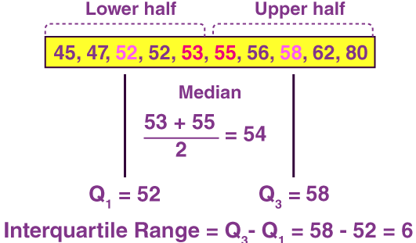
Inverse Variation A type of proportionality where one quantity decreases while the other increases or vice versa. This implies that the magnitude or the absolute value of one quantity decreases if the other quantity increases such that their product will always remain the same. This product is also known as the constant of proportionality. For example, if the speed of a car increases, the time taken to reach the destination decreases.
Irrational Number Any real number that cannot be written as a fraction. An irrational number cannot be expressed as a ratio of two integers–where p/q and q≠0. If a number cannot be written this way, it’s not a rational number. One clue that a number is irrational is if it never ends or never repeats when written as a decimal.
Common irrational numbers:
- Decimals that do not repeat and continue indefinitely are the most common irrational numbers. They never end and cannot be written as a fraction without rounding. For this reason, they are considered to be irrational, not rational.
- Square and cube roots that are not perfect squares or cubes are classified as irrational. You can enter the square root of the numbers 2, 13, or 18 into a calculator, but the answer you get will not be rational.
- Pi, or π, is probably the most famous irrational number that’s known for its never-ending decimal places. We estimate it to be around 22/7, but the exact number for Pi can never be a rational number.
- Euler’s number is another famous irrational number that starts with 2.71828182845….and so on. It is often used in the complex math concept of logarithms.
- The Golden Ratio φ is a famous ratio that approximately equals 1.618 (except it keeps going on and on). It is also known by the names Golden Mean, Divine Proportion, and Golden section.
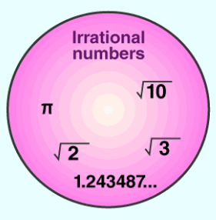
J
K
L
Lesh Translation Model An instructional approach to teaching mathematics that emphasizes the importance of students connecting different representations of mathematical concepts. This model encourages students to move between and within various representations, including concrete materials, pictures, real-world contexts, verbal descriptions, and written symbols. By doing so, students develop a deeper understanding of mathematical ideas and improve their ability to translate between different modes of representation.
Example: When teaching the concept of fractions the teacher might….
- Concrete Representation: Use fraction circles or bars to visually represent different fractions.
- Pictorial Representation: Draw diagrams of these fraction circles or bars.
- Real-world Context: Discuss how fractions are used in everyday life, such as when sharing a pizza or measuring ingredients in a recipe.
- Verbal Representation: Explain fractions in words, such as "one-half" or "two-thirds".
- Symbolic Representation: Use the numerical symbols to represent fractions, such as 1/2 or 2/3.
Lesson Plan The most detailed standards-based plan that a teacher will develop. It outlines the purpose and activities of what will be done on a specific day or across several days. Unit plans help to turn year-long plans into daily plans. Standard-based daily lesson plans are composed of objectives and activities that are based on the unit plans.
Less Than A number or variable is smaller than another and uses the symbol <
Example: 6 > 10 is read as 6 is less than 10.
Linear Equation An equation that makes a straight line when it is plotted. Often written in the form y = mx + b where m is the slope and b is the y-intercept.
Linear Function A mathematical function that graphs as a straight line. It's often represented by the formula y = mx + b, where m is the slope and b is the y-intercept. In essence, it's a function where the independent variable appears only to the first power and is combined with constants using only addition and subtraction.
Line Graph a graphical representation of information that changes over a period of time. It is a chart made by joining points using line segments.
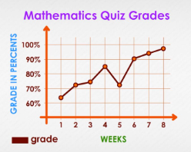
M
Math Fluency The ability to solve basic math problems quickly and accurately. Fluency builds on a foundation of conceptual understanding, strategic reasoning, and problem-solving to achieve automaticity. Fact fluency is the ability to quickly recall basic math facts, such as addition, subtraction, multiplication, and division. Students who are fluent can recall facts from their long-term memory without conscious effort. Procedural fluency is the ability to apply procedures efficiently, flexibly, and accurately. Students who are procedurally fluent can choose a method to solve a problem, explain their approach, and produce accurate answers.
Mathematical Discourse The verbal, visual, and written communication that takes place in a math classroom. Some strategies for cultivating and modeling mathematical discourse include sentence stems, practice providing feedback to peers (I agree with Kelly because…, I disagree with Susan because…, I like the way you…), modeling effective questioning strategies.
Mathematical Process Standards Demonstrate the ways in which students develop conceptual understanding of mathematical content and apply mathematical skills. The Mathematical Process Standards have grade-band specific insights that provide more information and clarity about how to provide these learning experiences within each grade band.
These standards include:
- Problem Solving: Make sense of problems and persevere in solving them strategically.
- Representation & Communication: Explain ideas using precise and contextually appropriate mathematical language, tools, and models.
- Connections: Demonstrate a deep and flexible conceptual understanding of mathematical ideas, operations, and relations while making real-world connections.
- Analyze & Justify Use critical thinking skills to reason both abstractly and quantitatively.
- Structure & Patterns Identify and apply regularity in repeated reasoning to make generalizations.
Mathematical Proficiency The ability to learn mathematics successfully. Mathematical proficiency is made up of the five strands listed below and are interdependent and are developed and strengthened together. Students who are proficient in one strand should also be proficient in the other four strands.
- Conceptual Understanding
- Procedural Fluency
- Strategic Competence
- Adaptive Reasoning
- Productive Disposition
Mathematical Representations The process of using mathematical tools, such as equations, graphs, and models, to describe and analyze mathematical ideas, physical phenomena, or relationships.
Mean The "average" of a set of numbers, calculated by adding up all the numbers in the set and then dividing by the total number of numbers in the set.
Mean Absolute Deviation (MAD) The average of the absolute differences between each data point and the mean of the data set. Essentially, it's a measure of how spread out the data values are from their average.
Example: The following shows the number of oranges that grew in Nancy’s orange tree each season.
Season | Number of Oranges
Winter | 5
Summer | 17
Spring | 24
Fall | 10
Step 1: Calculate the mean: (5 + 17 + 24 + 10) / 4 = 14 or 56 ÷ 4 = 14
Step 2: Calculate the difference between each data point:
Data-Point | Absolute Difference from the mean
5 | |5 - 14| = 9
17 | |17 - 14| = 3
24 | |24 - 14| = 10
10 | |10 - 14| = 4
Step 3: Adding the absolute difference together: 9 + 3 + 10 + 4 = 26
Step 4: Dividing the sum of absolute difference and the number of data points: 26 ÷ 4 = 6.5
MAD = 6.5
Metacognitive Strategies Techniques to help students develop an awareness of their thinking processes as they learn. These techniques help students focus with greater intention, reflect on their existing knowledge versus information they still need to learn, recognize errors in their thinking, and develop practices for effective learning.
Measurement A process of defining physical items using numbers. Measurement is often considered a branch of mathematics that includes a wide range of knowledge including conversion, units, measuring length, mass, time, etc. It is associated with other branches of mathematics such as geometry, trigonometry, and algebra.
Model The “I Do” step in gradual release where the teacher explicitly provides clear step-by-step explanation and planned examples.
Modifications Adaptations that change what students learn and are used with students who require more support or adjustments than accommodations can provide. Whereas accommodations level the playing field, modifications change the playing field. Unlike accommodations, modifications:
- do change the expectations for learning, and
- do reduce the requirements of the task.
Multi-Digit Computation The process of performing calculations with numbers that have more than one digit, such as adding, subtracting, multiplying, or dividing numbers like 23, 125, or 567, where each number consists of multiple digits in different place values (ones, tens, hundreds, etc.) ; essentially, any arithmetic operation involving numbers with multiple digits.
Multiplicative Comparison Compares two quantities by stating how many times larger or smaller one quantity is compared to the other. It essentially involves expressing one quantity as a multiple of the other. For example, if one person has 10 apples and another person has 5 apples, a multiplicative comparison could be: "The first person has twice as many apples as the second person" (10 is 2 times 5).
Multiply A mathematical operation that indicates how many times a number is added to itself to find the product. For example, “5 multiplied by 3” is the same as adding 5 to itself three times: 5 + 5 + 5 = 15. It is signified by the multiplication signs (x) or (*). Multiplication can also be seen as 3x, which is 3 times the value of x.
Multi-step When two or more steps are required to solve a mathematical problem.
Multi-Tiered System of Supports (MTSS) An evidence-based model of schooling that uses data-based problem solving to integrate academic and behavioral instruction and intervention. The integrated academic and behavioral supports are delivered to students at varying intensities by means of multiple tiers based on student need. Need-driven decision making seeks to ensure that district resources reach the appropriate students at their schools at the appropriate levels to accelerate the performance of all students to fulfill the profile of the South Carolina Graduate. Learn more here: South Carolina Multi-Tiered System of Supports (MTSS) Framework and Guidance Document
Multilingual Language Program (MLP) South Carolina’s English Language Development (ELD) program. Learn more here: SCDE Title III Multilingual Learner and Immigrant Student Program Guiding Principles
Multiple Interpretations The concept that a single idea or symbol can be understood in more than one way depending on the context.
Multiplication One of the four mathematical operations of arithmetic. Multiplication is where a number is added to itself a specified number of times, resulting in a “product”; to calculate the total when combining equal groups of items and can be described as the repeated addition of a number a certain number of times. Multiplication is represented by the symbol “x” or “*”. Multiplication can also be seen as 3x, which is 3 times the value of x.
Multiplicative (Schema) A structured framework used to categorize and solve word problems involving multiplication and division, typically including three main types: “equal groups,” “comparison,” and “ratios/proportions” problems, where each type represents a distinct relationship between quantities that can be solved using multiplication or division operations depending on the missing information.
- Equal Groups: involves multiplying or dividing groups where there is an equal number in each group.

Tara has 6 bags of oranges. There are 4 oranges in each bag. How many oranges does Tara have?

Matthew has 20 comic books. His bookshelf has 5 shelves. He wants to put an equal number of comic books on each shelf. How many comic books will he put on each shelf?
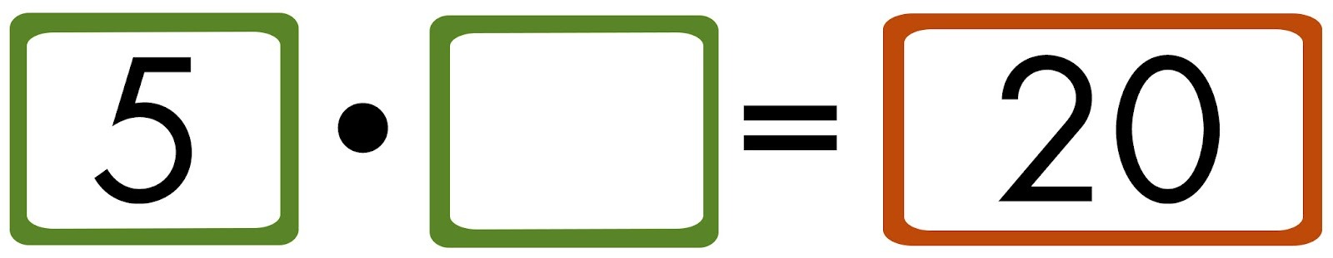
- Comparison: involves multiplying a set a given number of times.

Mai has 6 pieces of candy. Kayla has 2 times as many pieces of candy. How many pieces of candy does Kayla have?

Pedro has 7 video games. Brian has 21 video games. How many times as many video games does Brian have than Pedro?


- Ratios/Proportions: involves finding the relationship between two numbers.
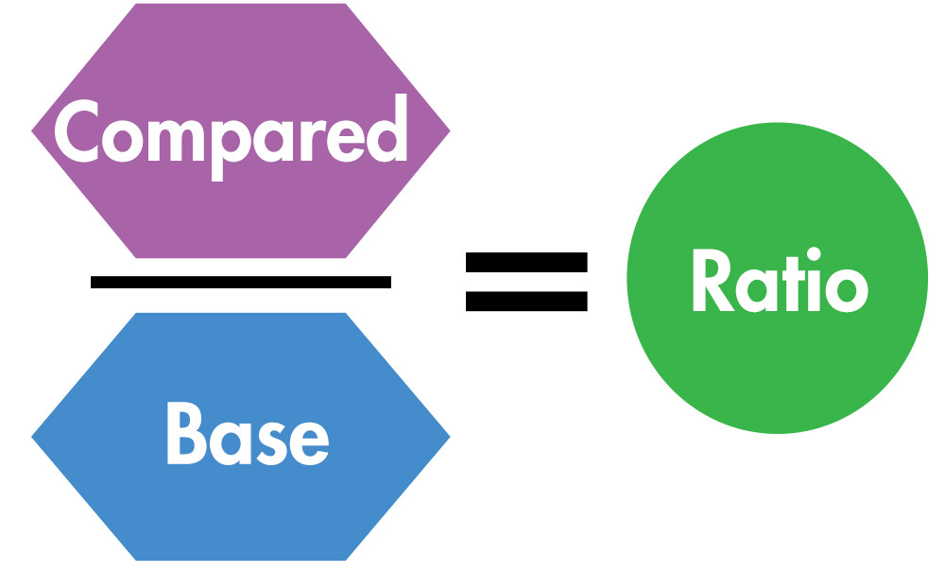
On Saturday, Nikki worked in the hot sun for 10 hours, helping to clean up and revitalize the neighborhood park. To prevent dehydration, she took a 5-minute water break every hour. What proportion of time did Nikki spend working compared to taking breaks?
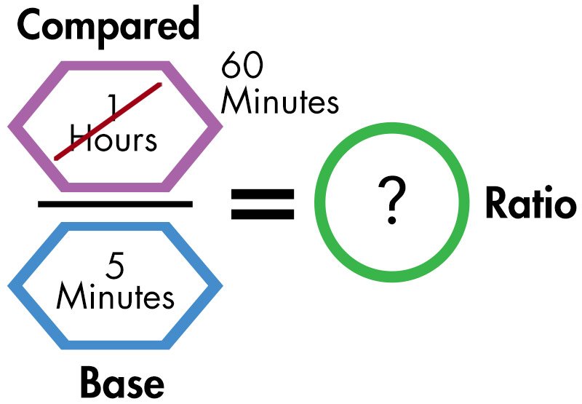
Multiple Entry Points Open-ended math tasks, such as “low floor, high ceiling” that allow for flexibility in strategy and the accommodation of different learning styles.
Multiple Representations The use of different ways show the same mathematical concept (i.e., manipulatives, drawings, graphs, tables, equations) in order to help students develop a deeper understanding of math concepts, connect concrete and abstract ideas, and develop more flexible problem-solving strategies.
N
Narrative To make meaning in order to arrive at the correct conclusion. Teaching narrative in mathematics is to check for understanding.
- What is the problem about? (i.e., the context)
- What am I trying to find out? (i.e., the question)
- What important information is given? (i.e., key information)
Negative Integers Numbers that have a value less than zero. They do not include fractions or decimals. For example, -7 and -10 are negative integers.
Nonproportional Relationship The ratio between corresponding values is not constant, and its graph does not pass through the origin (0, 0). A common way to express a non-proportional linear relationship is in the form y = mx + b, where b is not equal to zero.
Norm-Referenced Assessment A standardized assessment tool that compares a student’s test scores to the average score of a representative group.
Notation A system of symbols and conventions used to represent mathematical concepts, operations, and quantities in a concise and precise way. It provides a standardized language for communicating mathematical ideas.
Number Lines A visual representation of numbers arranged in order on a straight line, where the numbers are evenly spaced
Number System A system of writing to express numbers. It is the mathematical notation for representing numbers of a given set by using digits or other symbols in a consistent manner. It provides a unique representation of every number and represents the arithmetic and algebraic structure of the figures.
Numeracy The ability to understand and work with numbers. This includes how math is used in the real world, being able to use numbers to make reasonable decisions, and analyzing outcomes to determine reasonableness.
Numeracy Development The progressive acquisition of skills and understanding related to using numbers and mathematical concepts in real-world situations, encompassing abilities like counting, basic operations (addition, subtraction, multiplication, division), interpreting data, reasoning mathematically, and applying these skills to solve problems across various contexts; essentially, it's the process of becoming proficient in using math in everyday life.
Numerical Reasoning The ability to use mathematical skills to analyze and interpret numerical data to make decisions.
O
Observations The process of gathering, recording, and reflecting on information about children’s progress. Quality observations communicate each child’s individuality and context; because every child has strengths, interests, and experiences connected to their unique home and community contexts, it makes sense that observations and other assessments should provide a comprehensive view of who each child is, what they know, and what they can do.
Operations To calculate a value using numbers and a math operator (+, -, x, ÷, =). The symbol of the math operator has predefined rules to be applied to the given operands or numbers.
Origin The point where the x-axis and y-axis intersect on a coordinate plane, typically represented by the coordinates (0, 0), serving as the starting point for measuring distances and determining the position of other points on the graph; essentially, it's the "beginning" point on a coordinate system. Connections could be made to the number line, where 0 is the origin. Number lines are the one-dimensional precursor to coordinate grids/planes.
P
Parallel Two lines that are always the same distance apart and never intersect, no matter how far they are extended in either direction; essentially, they run alongside each other without ever touching.
Part-Whole Relations The concept where a fraction represents a specific "part" of a whole, with the denominator indicating the total number of equal parts in the whole and the numerator showing how many of those parts are being considered; essentially, it describes how a fraction is a portion of a larger unit divided into equal pieces.
Pattern A sequence or arrangement of numbers, shapes, or objects that repeats according to a specific, predictable rule. Students learn to identify patterns to predict future elements in a series, such as completing a numerical sequence; students recognize patterns as a fundamental skill for solving mathematical problems, particularly in algebra and data analysis; students use patterns to provide the framework for understanding more complex mathematical concepts, including functions and relationships.
Perpendicular Two lines that intersect to form a 90-degree angle.
Problem Solving Skills The ability to analyze, understand, and find solutions to mathematical problems by applying mathematical concepts, principles, and strategies in a logical and systematic manner, often involving critical thinking, reasoning, and the capacity to adapt knowledge to novel situations.
Procedural Fluency The skill in carrying out procedures flexibly, accurately, efficiently, and appropriately.
Product The result of two or more numbers when multiplied together.
Productive Disposition The habitual inclination to see mathematics as sensible, useful, and worthwhile, coupled with a belief of diligence and one’s own efficacy.
Professional Judgment The application of professional knowledge, professional experience, and ethical standards in context with understanding, analysis, and reflection. Educators exercise professional judgment to make intentional, informed decisions about appropriate practice in specific circumstances.
Professional Learning Community (PLC) A group in which educators commit to ongoing learning experiences with a deliberate intent to transform teaching and learning at their school or within their district.
Professional Learning Opportunity (PLO) Conferences, workshops, and seminars are examples of PLOs. Such opportunities allow you to step outside your daily routine, engage with others in your field, and explore new ideas and perspectives. Other benefits include learning and exploring the latest trends, research, and best practices in your field to improve your job performance.
Professionalism The conduct, aims, or qualities that characterize or mark a profession or a professional person.
Proficiency Thorough competence derived from training and practice.
Progress Monitoring A systematic process of regularly assessing a student's performance on specific math skills over time, using brief, standardized assessments to track their growth and identify areas where they might need additional support or intervention, allowing for timely adjustments to instruction based on their progress.
Progress Monitoring Assessment Administered frequently throughout instruction to determine whether students are making adequate progress and to determine whether instruction needs to be adjusted.
Properties of Operations Rules or laws that describe how mathematical operations like addition, subtraction, multiplication, and division work with numbers and other mathematical objects. These properties help simplify calculations, understand relationships between numbers, and solve equations.
Key Properties of Operations
- Commutative Property: Applies to addition and multiplication. It states that changing the order of the numbers in an operation does not change the result.
  - a + b = b + a or 6 + 3 = 3 + 6
  - a x b = b x a or 4 x 9 = 9 x 4
- Associative Property: Applies to addition and multiplication. It states that changing the grouping of numbers in an operation does not change the result.
  - (a + b) + c = a + (b + c) or (7 + 3) + 4 = 7 + (3 + 4)
  - (a x b) x c = a x (b x c) or (5 x 2) x 6 = 5 x (2 x 6)
- Distributive Property: Relates to multiplication and addition or subtraction. It allows you to distribute a number across the terms inside a set of parentheses.
  - a(b + c) = ab + ac or 7(5 + 8) = 7 x 5 + 7 x 8
- Identity Property: Applies to addition, multiplication, subtraction, and division, but is specifically known as additive inverse and multiplicative inverse. States when any number is combined with an identity either 0 or 1, the end result will be the number itself.
  - a + 0 = a or 3 + 0 = 3
  - a x 1 = a or 12 x 1 = 12
  - a - 0 = a or 7 - 0 = 7
  - a ÷ 1 = a or 24 ÷ 1 = 24
- Inverse Property: States when a number is added with its additive inverse, the sum of the two numbers will be zero. When a number is multiplied by its multiplicative inverse, the product will be one.
  - The additive inverse of 5 is -5, because 5 + (-5) = 0
  - The multiplicative inverse of 5 is ⅕, because 5 x (⅕) = 1
- Closure Property: States that when a set of numbers is closed under an arithmetic operation, performing the operation on any two numbers in the set always results in a number belonging to the same set of numbers. For example, if you add any two integers, the result is also an integer.
  - 2 + 3 = 5
Proportion An equation stating that two ratios are equal. For example, 1/2 = 2/4 and can be written as a:b = c:d or a/b = c/d.
Proportional Reasoning The ability to understand and solve problems involving proportional relationships, where two quantities change in a predictable, consistent way. This means that the ratio between the two quantities remains constant. Mathematically, it's about recognizing and applying relationships between ratios, fractions, and rates.
Proportional Relationship A connection between two quantities where their ratio always remains the same, meaning if one quantity increases or decreases the other does so at a constant rate. Fractions can represent proportional relationships when they express equivalent ratios.
Pythagorean Theorem Defines the relationship between the sides of a right triangle; states that the sum of the squares of the two shorter sides (legs) is equal to the square of the longest side (hypotenuse). This is represented by the formula a² + b² = c², where 'a' and 'b' are the lengths of the legs and 'c' is the length of the hypotenuse.
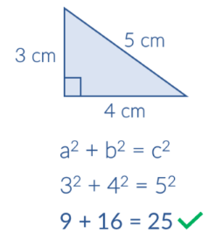
Q
Quantitative Reasoning The ability to analyze and interpret real-world data using basic mathematical skills like arithmetic, algebra, and statistics, to draw meaningful conclusions within a specific context, often involving practical applications beyond just solving mathematical equations.
Quotient The result when dividing one number by another number.
R
Randomness The property where the outcome of an event is unpredictable, lacking a discernible pattern, and where each outcome has a chance of occurring, but the exact result is unknown until the event takes place. This concept is crucial for many statistical methods, particularly in creating random samples and understanding probability distributions.
Range a measure of statistical variability that represents the difference between the highest and lowest values in a dataset. It provides a simple and easy-to-calculate measure of the spread of data.
Rate A comparison of two numbers with different quantities or units of measurement; for example, “miles per hour” or “cost per item” where the key feature is that the units being compared are not the same. If two rates are equivalent, then they are proportional.
Rational Number Any number that can be expressed as a fraction, where both the numerator and denominator are integers, and the denominator is not zero.
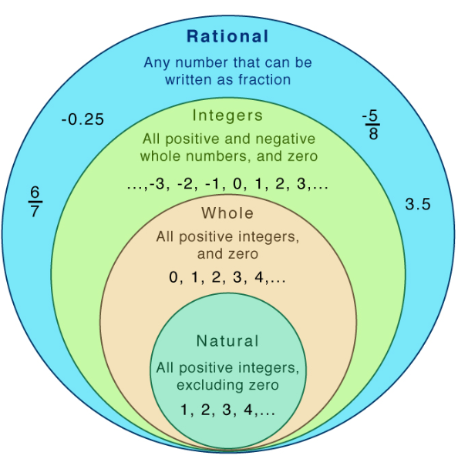
Ratios The comparison of two quantities of the same kind, or the relationship of one similar quantity to another. Ratios can be written in three different ways using ratio symbols or words, while keeping the same meaning. That is, ratios can be written by placing a fraction bar, the word "to", or the ratio symbol '' : '' between the two values being compared.
Ratio Table A structured list of equivalent (equal value) ratios that helps us understand the relationship between the ratios and the numbers; essentially showing how different values are proportionally related.
Real Numbers Any number that can be represented on the number line. This includes all rational numbers, like fractions and decimals, and all irrational numbers, like pi or the square root of 2. It is any number that is not an imaginary number.
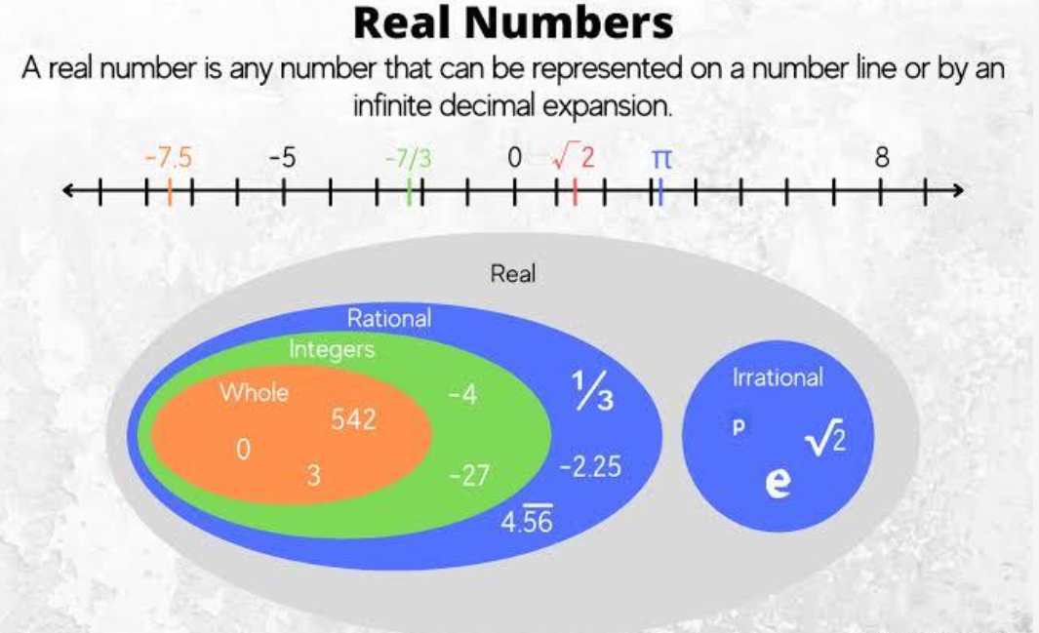
Reasonable Solutions To verify an answer makes sense or is correct by either using estimation or substituting the answer in the original problem. “Reasonableness” is a way of describing how realistic an answer may be.
Rectangular Prism A three-dimensional shape with six rectangular faces, where each pair of opposite faces are parallel and congruent, and all angles at the vertices are right angles (90 degrees); essentially, a solid shape with all sides being rectangles, having three distinct dimensions: length, width, and height.
Reliability The extent to which a measurement instrument yields consistent, stable, and uniform results over repeated observations or measurements under the same conditions each time.
Repeating Decimal Decimals in which a digit or a group of digits after the decimal point repeats indefinitely and at regular intervals.
Representations Very general relationships that express similarities (or equivalences) between mathematical objects or structures.
Rubric An established, ordered set of criteria for judging student performance/products; it includes performance descriptors of student work at various levels of achievement. Rubrics are sometimes referred to as a scoring guide or scoring criteria.
S
Scaffolded Instruction A teaching method that provides temporary support to help students learn new concepts and develop skills.
Scale Drawing A representation of an object where all dimensions are proportionally changed, either enlarged or reduced, by a specific scale factor. This means the drawing maintains the same shape as the original object but not necessarily the same size.
Example:
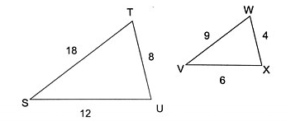
Scaling Changing the size of something so that it is proportional to the actual size of the object.
Scatterplot A graph of plotted points that show the relationship between two sets of data. In the example below, each dot represents one person's weight versus their height.
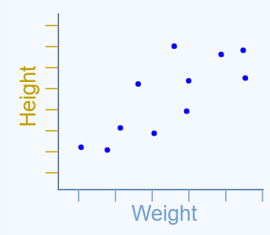
Scientifically Based Research Studies that use rigorous methodologies to investigate how people learn and understand mathematical concepts, aiming to inform effective teaching practices by providing evidence on what strategies and approaches are most impactful for different learners and situations; essentially, it's the study of how the human brain processes math and the best ways to facilitate that learning process based on empirical data.
Screening Assessment An informal inventory that provides the teacher with a beginning indication of the student’s preparation for grade level instruction. It is a “first alert” that a child may need extra help to make adequate progress in mathematics during the year.
Shape (of a distribution) Describes the overall pattern or form of how data values are distributed. It's often visualized using histograms, box plots, or stem-and-leaf plots. Key aspects of shape include symmetry, skewness, and modality.
Sides Line segments that form part of the boundary of a two-dimensional shape (polygons). For example, a triangle has three sides, and a square has four sides. Where two sides meet, they create a vertex (corner).
Similar Shape Two geometric shapes are considered mathematically similar if they have the same shape, meaning their corresponding angles are congruent (equal in measure) and the ratios of their corresponding sides are proportional (equal to a scale factor). Essentially, one can be obtained from the other by a series of transformations, including resizing (enlargement or reduction), rotation, reflection, and translation, while maintaining the same shape.
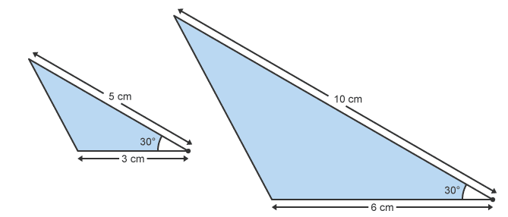
Simple Event An event that consists of a single outcome from a sample space.
Example: If you roll a six-sided die, the event “rolling a 3” is a simple event because it’s a single outcome from the sample space of {1, 2, 3, 4, 5, 6}
Slope of a Line A number that describes the steepness and direction of the line. It's also known as the rise over run, which is the change in the y-coordinate divided by the change in the x-coordinate.
South Carolina College- and Career-Ready (SCCCR) Mathematics Standards A document that outlines math learning standards in South Carolina. Standards are vertically and progressively articulated in grade appropriate learning goal statements called indicators.
The standards document is divided into four major strands: Data, Probability, and Statistical Reasoning (DPSR); Measurement, Geometry, and Spatial Reasoning (MGSR); Numerical Reasoning (NR); and Patterns, Algebra, and Functional Reasoning (PAFR). Neither the order of the strands nor the indicators within each strand are intended to prescribe an instructional sequence. The standards are similar in grades K-8, as they are the learning expectations for the culmination of a student’s school career. The indicators are developmentally specific as they outline what students are expected to learn in one grade year. The grade-level indicators set the end-of-year learning expectations, not instructional sequence. In most cases, the indicators progress from kindergarten through the completion of Geometry, Algebra 1, and Algebra 2 in high school. According to the South Carolina Educational Accountability Act of 1998, the purpose of academic standards is to provide the basis for the development of local curricula and statewide assessments Learn more here: 2025 South Carolina College and Career Ready Mathematics Standards
Spatial Location The precise position of a point or object within a defined coordinate system.
Spatial Reasoning A fundamental component of numeracy and is critical to early mathematics learning. It is a cognitive process that involves:
- constructing mental images of shapes and objects,
- thinking about how objects look from different angles, how they fit together, and how they relate to each other in space,
- and using information to problem solve.
Spatial Reasoning The cognitive ability to mentally visualize, manipulate, and transform objects and their relationships in space, enabling understanding of shapes, positions, and movement in both two and three dimensions; involves a range of specific skills such as mental rotation, symmetry, and composition/decomposition of shapes.
Spatial Relationships In mathematics, refers to how objects are positioned relative to one another in space, often using geometric concepts like coordinates, distance, angle, and topological relationships (such as “inside,” “outside,” “above,” “below”) to define their relative positions and orientations.
Spread The variability or dispersion of data within a dataset. It describes how widely the data values are scattered from the mean or median. Measures of spread help quantify the range and distribution of values within a dataset.
Square Root A value, that when multiplied by itself, equals the original number. For example, the square root of 9 is 3 because 3 * 3 = 9. The symbol for square root is a radical sign (√).
Square Root Symbol A mathematical symbol, denoted by '√' and represents the inverse operation of squaring a number.
Stakeholders Anyone who is invested in the welfare and success of a school and its students, including administrators, teachers, staff members, students, parents, families, community members, local business leaders, and elected officials such as school board members, city councilors, and state representatives.
Standard Algorithm The set of steps used to complete a mathematical process. Includes the traditional algorithm, partial products, and partial quotient.
Standards for Preparing Teachers of Mathematics A set of comprehensive standards describing a national vision for the initial preparation of all teachers Pre-K–12 who teach mathematics. The standards are intended to: guide the improvement of individual teacher preparation programs; inform the accreditation process of such programs; influence policies related to preparation of teachers of mathematics; and promote national dialogue and action related to preparation of teachers of mathematics.
State Assessments Developed and administered according to each state’s standards. See more here: SCDE Information for All Assessment Programs
Statistics The branch of mathematics that deals with the study of collecting, analyzing, interpreting, presenting, and organizing data into a mathematical form.
Statistical Inference The process of analyzing the result and making conclusions from data subject to random variation. It is also called inferential statistics. Hypothesis testing and confidence intervals are the applications of the statistical inference.
Statistical Measures The numerical values or indicators that summarize and describe different characteristics of a data set; also known as descriptive statistics. These measures provide a concise picture of the data making it easier to understand and interpret.
Key Statistical Measures:
- Central Tendency - the average or typical value with a data set; most commonly used central tendency measures are the mean, median, and mode.
- Variability - provide insights into the spread, or dispersion, of data points; help determine the extent to which data values deviate or differ from the central tendency measures; common variability measures include variance and standard deviation.
- Distribution - describe how data is spread out across the entire range of values; help identify if data follows a specific pattern, such as normal distribution or skewed distribution; histograms and box plots are graphical tools used to visualize the distribution of data.
- Correlation - assess the strength and direction of the relationship between two variables; by analyzing correlation coefficients, we can determine if variables are positively related, negatively related, or not related at all.
- Probability - help us understand the likelihood of different outcomes occurring; these measures are often used in statistics to make predictions and estimates based on past data patterns.
Statistical Reasoning The basic understanding and application of statistical concepts, including collecting, organizing, analyzing, and interpreting data using fundamental tools like measures of central tendency (mean, median, mode), variability (range, standard deviation), data visualization (graphs, charts), and basic probability to draw reasonable conclusions from data sets.
Statistical Thinking Using statistics and probability to analyze data, identify patterns, and draw conclusions while acknowledging uncertainty and variability. It's a way of understanding the world through data, emphasizing the need for data production, the importance of variability, and the ability to measure and model it.
Statistical Variability A measure of how widely values in a dataset differ from each other and from the mean. It quantifies the extent to which data points are clustered together or scattered. Common measures of variability include range, interquartile range (IQR), variance, and standard deviation.
Stem-and-Leaf Plot A special table where each data value is split into a "stem" (the first digit or digits) and a "leaf" (usually the last digit). See example:
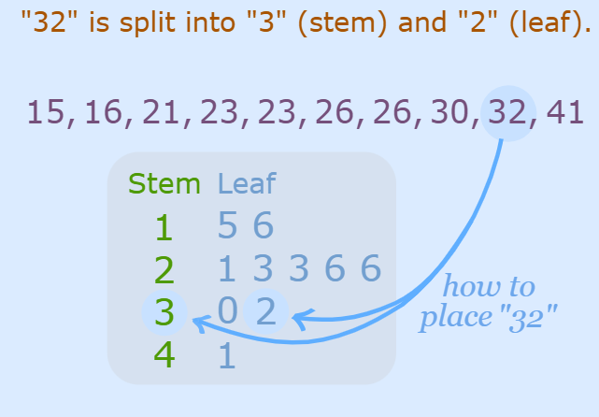
Strategic Competence The ability to formulate, represent, and solve mathematical problems.
Substantive Feedback Specific feedback that helps someone improve their work and/or celebrate a specific feature in their work. It can also expand on someone’s work.
Summative Assessment An evaluation administered to measure student learning outcomes, typically at the end of a unit or chapter. Often used to evaluate whether a student has mastered the content, skill, or standard.
Surveys A method of collecting data from a sample of individuals to gather information about a specific topic or group.
Synchronous Learning Synchronous instruction is the idea that students learn material at the same time. Examples of synchronous instruction might include lectures, discussion or collaborative activities. When applied to remote learning, students must be online at the same time.
Synthesize The process of taking new information and organizing it with existing knowledge to construct new meaning. In a math lesson, synthesis is a time for students to apply new learning to a larger understanding.
Systematic Instruction A plan of instruction (scope and sequence) that takes students through an explicit sequence of learning activities. Lessons build on previously taught information, building from easier to more difficult tasks, and breaking down harder skills into smaller parts.
T
Tables A way to organize data for information into rows and columns. It’s a visual representation of data that helps to display patterns and relationships. Tables are commonly used to represent mathematical functions, values, or relationships between different variables.
Tape (Strip) Diagram A visual representation of mathematical problems using rectangular bars divided into segments. These segments represent parts of a whole, fractions, or quantities in a ratio, aiding in understanding and solving problems.
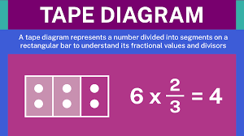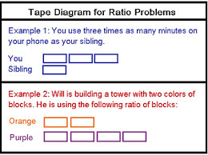
Targeted Instruction (Tier 2) Small groups of 3-7 students who are struggling with Tier 1 instruction. Students receive additional instruction based on core (Tier1), and often includes reteaching, differentiated instruction, and more opportunities to practice. At a minimum, progress monitoring occurs every 10-14 days to measure students’ progress.
Target Language The target language (TL) is the one learned and which learners aim to master.
Technical Adequacy (of Assessments) Scores or information generated from an instrument that is “technically adequate” can reliably and accurately predict performance or behavior for any given population of interest. In other words, the instrument should be standardized for the population it will be used on, reliable, and accurate in its identification of children who are and who are not a risk.
Theoretical Probability The number of favorable outcomes divided by the total number of possible outcomes.
Example:
The letters of the word “MATHEMATICS” are placed in a bag. What is the probability of drawing the letter “T” from the bag?
Solution: The total number of letters = 11
There are two T’s placed in the bag, therefore the number of favorable outcomes = 2
P (T) Probability of drawing “T” = 2 / 11 =0.182
Answer: The probability of drawing the letter “T” is 0.182
Three-Dimensional Figure A solid geometric shape that possesses three distinct dimensions: length, width, and height, allowing it to occupy space and have volume. Common 3D shapes are cube, cone, cylinder, rectangular prism (cuboid), and sphere.
Tier 1 Vocabulary Common, every day, basic words that are often learned through conversation and do not have explicit instruction. These can be concepts or words across all parts of speech (e.g., nouns, verbs, adjectives, etc.).
Tier 2 Vocabulary These are words that are frequently used in academic contexts but may have multiple meanings, requiring explicit instruction and attention.
Tier 3 Vocabulary These words are subject-specific terms and are generally used in only one context and have one meaning. Specialized terms that are specific to a particular mathematical concept or field, like "quadratic equation," "derivative," "hypotenuse," or "factor," which are not commonly used outside of the mathematical context and need to be explicitly taught when learning that specific topic.
Transformation A process that manipulates a polygon or other two-dimensional object on a plane or coordinate system.
- Translation - sliding a shape without changing its orientation

- Rotation - turning a shape around a fixed point


- Reflection - flipping a shape across a line
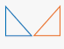
Two-Dimensional Figure A flat figure that only has two measurable dimensions: length and width, meaning it exists on a plane with no depth or thickness; examples include circles, squares, triangles, and rectangles. Also known as a plane figure.
U
Unit A single, standard quantity used to measure something, like an inch for length, a kilogram for weight, or a second for time; essentially, it's the basic building block of a measurement, representing "one" of that quantity.
Unit Rate A rate where the denominator is always 1, meaning it expresses how much of one quantity there is per unit of another quantity; essentially, it tells you the rate "per one" of something, like miles per hour or price per pound.
Universal Design for Learning Teachers design their lessons with all their learners in mind from the beginning, rather than designing a lesson and then planning adjustments for students with specific needs.
V
Validity (Test Validity) The extent to which a test or assessment measure matches its stated purpose.
Variable A symbol, usually a letter, that represents an unknown number or value in an equation or expression, allowing for calculations where the value can change depending on the situation; essentially, it acts as a placeholder for a number that is not yet known or could vary within a problem.
Variability The basic concept of how spread out or different the values within a data set are, often measured by simple methods like calculating the range (the difference between the highest and lowest values).
Variance A measurement of how far each number in a data set is from the mean (average), and thus from every other number in the set. Variance is a statistical measurement of the spread between numbers in a data set. It measures how far each number in the set is from the mean (average), and thus from every other number in the set. Variance is often depicted by this symbol: σ².
Vertical Alignment The process of ensuring that curriculum and instruction are aligned across different grade levels, ensuring a smooth transition and coherent learning experience for students. It focuses on how content and skills taught in one grade level build upon what is taught in previous grades, creating a foundational structure for learning.
Visual Representations Often referred to as a schematic representation or schematic diagram—is an accurate depiction of a given problem’s mathematical quantities and relationships. The purpose of this visual is to reflect a student’s understanding of the problem and to help the student correctly solve it.
Vocabulary A collection of known words that are important for understanding math concepts and solving problems.
Volume The amount of space a three-dimensional object occupies, measured in cubic units, essentially describing how much space is inside a solid shape like a box or a cylinder; it is calculated by multiplying the length, width, and height of the object together.
W
WIDA English Language Development (ELD) Standards Framework, 2020 Edition A document that provides a foundation for curriculum, instruction and assessment for multilingual learners in kindergarten through grade 12. The ELD Standards Framework is centered on fostering the assets, contributions, and potential of multilingual learners. The framework serves as a resource for planning and implementing language instruction and assessment for multilingual learners as they learn academic content See more here: WIDA English Language Development Standards Framework, 2020 Edition Kindergarten - Grade 12
Whole Numbers All positive integers beginning at zero and stretching to infinity. All whole numbers, except for zero, are also called counting numbers or natural numbers. Decimals, fractions, and negative numbers are not whole numbers.
Word Problems A mathematical problem that uses words to describe a real-world situation, instead of just numbers and symbols. The goal of a word problem is to use mathematical operations on the numerical data in the problem to answer the questions sed.
Word Problem Schemas A framework or structure that represents the underlying pattern and key elements of a specific type of word problem, allowing individuals to recognize and solve similar problems by identifying the relevant information and applying appropriate mathematical operations based on the problem's structure, rather than just the wording. Two types of schemas are additive and multiplicative.
X
Y
Z

References
Association of Mathematics Teacher Educators (AMTE). Standards for Preparing Teachers of Mathematics. Raleigh, N.C.: Association of Mathematics Teacher Educators, 2017.

Conference Board of the Mathematical Sciences (CBMS). (2012). The Mathematical Education of Teachers II. Providence, RI, and Washington, DC: American Mathematical Society and Mathematical Association of America.

Ercole, L. K., Frantz, M., & Ashline, G. (2011). Multiple ways to solve proportions. Mathematics Teaching in the Middle School, 16(8), 482-490.

Fuchs L.S., Newman-Gonchar R., Schumacher R., Dougherty B., Bucka N., Karp K. S., Woodward J., Clarke B., Jordan N. C., Gersten R., Jayanthi M., Morgan S. (2021). Assisting Students Struggling with Mathematics: Intervention in the Elementary Grades. Institute of Education Sciences.

Gagnon, J. C. & Maccini, P. (2001). Preparing Students with Disabilities for Algebra. Teaching Exceptional Children, 34, 8-15.

Jitendra, A. K., & Star, J. R. (2012). An exploratory study contrasting high- and low-achieving students' percent word problem solving. Learning and Individual Differences, 22, 151-158.

Montague, M. (2008). Self-Regulation Strategies to Improve Mathematical Problem Solving for Students with Learning Disabilities. Learning Disabilities Quarterly, 31, 37-44.

National Mathematics Advisory Panel (NMAP). Foundations for Success: The Final Report of the National Mathematics Advisory Panel. Washing, D.C.: U.S. Department of Education, 2008.

National Research Council. Adding It Up: Helping Children Learn Mathematics. Jeremy Kilpatrick, Jane Swafford, and Bradford Findell, eds., Mathematics Learning Study Committee, Center for Education, Division of Behavioral and Social Sciences and Education. Washington, D.C.: National Academy Press, 2001.

Olson, T. A., Olson, M., & Slovin, H. (2015). Putting essential understanding of ratios and proportions into practice in Grades 6-8 (H. Slovin, Ed.). In B. J. Dougherty (Series Ed.), Putting essential understanding into practice series. Reston, VA: National Council of Teachers of Mathematics.

Pólya, G. (1945). How to solve it. New York: Ishi Press.

Sinclair, N., Pimm, D., & Skelin, M. (2012). Developing essential understanding of geometry for teaching mathematics in Grades 6-8. In R. M. Zbiek (Series Ed.), Essential understanding series. Reston, VA: National Council of Teachers of Mathematics.

South Carolina College and Career Ready Mathematics Standards.

South Carolina Multi-Tiered System of Supports (MTSS) Framework and Guidance Document.

Vanderbilt University IRIS Center at Peabody College (Word problem structures).

Virginia Department of Education Evidence-Based Specially Designed Instruction in Mathematics.

WIDA University of Wisconsin-Madison: WIDA English Language Development Standards Framework, 2020 Edition.

