Request for Proposals (RFP)
Application Package
(Pages 54–56 revised June 16, 2023)

Stronger Connections Subgrant Program
Discretionary Subgrant 2023–25
Assistance Listing 84.424F

The Stronger Connections Subgrant Program is a subgrant program funded by the Bipartisan Safer Communities Act (BSCA), authorized by Title IV, Part A of the Elementary and Secondary Education Act (ESEA) as amended by the Every Student Succeeds Act (ESSA), and administered by the South Carolina Department of Education.

Deadline for Receipt of Applications: August 10, 2023, at 11:59 p.m.

Technical Assistance for Applicants: June 8, 2023

Email Notice of Intent to apply deadline: June 22, 2023

For questions about the Stronger Connections Subgrant Program, contact:
Kimberly Smith, Education Associate, Student Intervention Services
803-734-8113; strongerconnections@ed.sc.gov

Issued by:
South Carolina Department of Education (SCDE)
Office of Student Intervention Services
1429 Senate Street, Suite 803
Columbia, SC 29201

TABLE OF CONTENTS
PART I: General Information 1
A. Introduction and Purpose 1
B. Eligible Applicants 1
C. Competitive Priorities 2
D. Timeline of Subgranting Process 2
E. Technical Assistance Session for Applicants 2
F. Statutory, Federal Regulations, and Other Requirements 2
G. Authorized Activities 7
H. Unauthorized Activities 7
I. Program Accountability and Monitoring 8
J. Fiscal Operations 10
K. Supplement, Not Supplant 11
L. Review and Selection Process 11
M. Appeals Process 12

PART II: Application Overview, Content, and Instructions 13
A. Application Overview 13
B. Application Narrative Format 14
C. Online Application Submission 14
D. Project Abstract 14
E. Proposal Narrative Content 14
1. Needs Assessment 15
2. Goals and Objectives 15
3. Strategies and Activities 16
4. Management and Sustainability 17
5. Evaluation and Dissemination 18
F. Competitive Priority Points 18
G. Application Budget 18
H. Appendices 20
I. Deadline and Submission Procedures 22
J. Screenshots of Online Application Submission Forms 23

Appendix A: Definitions of Terms Used 30
Appendix B: Selection Criteria and Reviewers’ Scoring Rubric 31
Appendix C: SCDE Forms 41
Certification Signature Page 41
Assurances and Terms and Conditions for Federal Subawards 42
Instructions for GEPA Statement of Compliance 46
Request for Taxpayer Identification Number and Certification 47
Budget Forecast and Narrative Format Guidance 48
Non-Public (Private) School Consultation Form 49
Sample Timeline of Activities Template 50
Goals, Objectives, and Outcomes Worksheet 51
Grant Design Chart 52
Action Plan Form 53
List of Eligible LEAs 54

PART I: General Information

- Introduction and Purpose

On June 25, 2022, President Joseph R. Biden signed into law the Bipartisan Safer Communities Act (BSCA). Through this legislation, the US Congress authorized $1 billion in formula funding under Title IV, Part A of the Elementary and Secondary Education Act of 1965 (ESEA) to state educational agencies (SEAs) to provide students with safer and healthier learning environments. Under the BSCA Stronger Connections grant program, the South Carolina Department of Education (SCDE) received $15,353,308 and must award 95 percent of these funds competitively to high-need local educational agencies (LEAs) to fund activities allowable under section 4108 of the ESEA.

The purpose of the Stronger Connections subgrant program, as stated in the frequently asked questions, is to provide students with safer and healthier learning environments and fund only activities allowable under section 4108 of the ESEA. These funds must be used to develop, implement, and evaluate comprehensive programs within high need LEAs.

Approximately $14,500,000 will be available for new subgrants in this competition. The SCDE anticipates awarding approximately 40 subgrants, with the minimum of $50,000 and the maximum award being $350,000. Award amounts will be determined based on the quality of applications received and total funding requested. Final budgets may be negotiated based on demonstrated needs. All subgrant awards are contingent upon total allocations to the SCDE by the US Department of Education (USED).

The maximum subgrant period is two years and is subject to the availability of federal funds and projects meeting all Stronger Connections program requirements. The first budget period is September 1, 2023, through June 30, 2024.

Official subaward documents will be processed annually as continuation of funding is not automatic. In determining continuation funding, the SCDE will consider the subgrantee’s evidence of a project’s effectiveness in achieving objectives, timely submission and quality of all required reports (including the interim and annual progress reports), and rationale for budget expenditures. Submission of a continuation application may also be required in subsequent years.

The subgrantee may obligate funds upon receipt of the grant award notice. However, no funds will be disbursed until after September 1, 2023. Subgrant payments are made on a cost-reimbursement basis so applicants should have at least three months of operating funds at their disposal to implement the program to compensate for any delays in receiving reimbursement payments.

- Eligible Applicants

Eligible applicants are South Carolina LEAs (school districts) that demonstrate a high need, as identified by 1) a high percentage of students living in poverty (40 percent or higher) and 2) either a high rate of bullying/harassment, a high rate of chronic absenteeism, or a high rate of exclusionary discipline. See page 54 for a list of LEAs that are eligible to apply.

- Competitive Priorities

To receive priority points, applicants must describe a comprehensive plan to address bullying and harassment incidents. Points will be awarded based on a clear plan to revise, update, and outline additional interventions as a part of a South Carolina’s Muli-Tiered System of Supports (SCMTSS). In addition, the applicant must clearly describe how students, families, and community voices will be included in developing the comprehensive plan. LEAs must describe a plan to disseminate this information to all stakeholders. Applicants must upload the 2–4-page comprehensive plan as a separate PDF in the Application Attachments section of the online application (see pages 18 and 27).

Up to ten priority points will be awarded for this priority. Applicants are not eligible for competitive points unless their application earns an average score of 70 points or higher.

- Timeline of Subgranting Process

Date | Activity/Action
June 8, 2023 | Pre-application technical assistance session
August 10, 2023 | Deadline for receipt of application
September 2023 | Notification of awards
September 1, 2023 | Funding period begins; projects can begin
January 30, 2024 | First interim report due to the SCDE
June 30, 2024 | First budget period ends
July 31, 2024 | First programmatic report due to the SCDE

- Technical Assistance Session for Applicants

The Office of Student Intervention Services will offer a pre-application technical assistance session via Adobe Connect on June 8, 2023, 10:00 am from 12:00 pm. No password is required to join the session. Participants should enter their full names when logging in to the session. Participants will be able to log in 15 minutes prior to the start of the session to test their equipment’s audio settings and to download/print handouts. While participation is not mandatory in order to submit an application, it is highly recommended.

- Statutory, Federal Regulations, and Other Requirements

ESEA Sec.4108
The Stronger Connections subgrant is to provide students with safer and healthier learning environments. Funds must be used to develop, implement, and evaluate comprehensive programs within high-need LEAs through activities allowable under section 4108 of the ESEA:

- SEC. 4108. [20 U.S.C. 7118] ACTIVITIES TO SUPPORT SAFE AND HEALTHY STUDENTS.
Subject to section 4106(f), each local educational agency, or consortium of such agencies, that receives an allocation under section 4105(a) shall use a portion of such funds to develop, implement, and evaluate comprehensive programs and activities that—
- are coordinated with other schools and community-based services and programs;
- foster safe, healthy, supportive, and drug-free environments that support student academic achievement;
- promote the involvement of parents in the activity or program;
- may be conducted in partnership with an institution of higher education, business, nonprofit organization, community-based organization, or other public or private entity with a demonstrated record of success in implementing activities described in this section; and
- may include, among other programs and activities—
- drug and violence prevention activities and programs that are evidence-based (to the extent the State, in consultation with local educational agencies in the State, determines that such evidence is reasonably available) including—
- programs to educate students against the use of alcohol, tobacco, marijuana, smokeless tobacco products, and electronic cigarettes; and
- professional development and training for school and specialized instructional support personnel and interested community members in prevention, education, early identification, intervention mentoring, recovery support services and, where appropriate, rehabilitation referral, as related to drug and violence prevention;
- in accordance with sections 4001 and 4111—
- school-based mental health services, including early identification of mental health symptoms, drug use, and violence, and appropriate referrals to direct individual or group counseling services, which may be provided by school-based mental health services providers; and
- school-based mental health services partnership programs that—
- are conducted in partnership with a public or private mental health entity or health care entity; and
- provide comprehensive school-based mental health services and supports and staff development for school and community personnel working in the school that are—
(aa) based on trauma-informed practices that are evidence-based (to the extent the state, in consultation with LEAs in the state, determines that such evidence is reasonably available);
(bb) coordinated (where appropriate) with early intervening services provided under the Individuals with Disabilities Education Act (20 U.S.C. 1400 et seq.); and
(cc) provided by qualified mental and behavioral health professionals who are certified or licensed by the state involved and practicing within their area of expertise;
- programs or activities that—
- integrate health and safety practices into school or athletic programs;
- support a healthy, active lifestyle, including nutritional education and regular, structured physical education activities and programs, that may address chronic disease management with instruction led by school nurses, nurse practitioners, or other appropriate specialists or professionals to help maintain the well-being of students;
- help prevent bullying and harassment;
- improve instructional practices for developing relationship-building skills, such as effective communication, and improve safety through the recognition and prevention of coercion, violence, or abuse, including teen and dating violence, stalking, domestic abuse, and sexual violence and harassment;
- provide mentoring and school counseling to all students, including children who are at risk of academic failure, dropping out of school, involvement in criminal or delinquent activities, or drug use and abuse;
- establish or improve school dropout and reentry programs; or
- establish learning environments and enhance students’ effective learning skills that are essential for school readiness and academic success, such as by providing integrated systems of student and family supports;
- high-quality training for school personnel, including specialized instructional support personnel, related to—
- suicide prevention;
- effective and trauma informed practices in classroom management;
- crisis management and conflict resolution techniques;
- human trafficking (defined, for purposes of this subparagraph, as an act or practice described in paragraph (9) or (10) of section 103 of the Trafficking
- Victims Protection Act of 2000 (22 U.S.C. 7102));
- school-based violence prevention strategies;
- drug abuse prevention, including educating children facing substance abuse at home; and
- bullying and harassment prevention;
- in accordance with sections 4001 and 4111, child sexual abuse awareness and prevention programs or activities, such as programs or activities designed to provide—
    - age-appropriate and developmentally-appropriate instruction for students in child sexual abuse awareness and prevention, including how to recognize child sexual abuse and how to safely report child sexual abuse; and
    - information to parents and guardians of students about child sexual abuse awareness and prevention, including how to recognize child sexual abuse and how to discuss child sexual abuse with a child;
- designing and implementing a locally-tailored plan to reduce exclusionary discipline practices in elementary and secondary schools that—
    - is consistent with best practices;
    - includes strategies that are evidence-based (to the extent the State, in consultation with local educational agencies in the State, determines that such evidence is reasonably available); and
    - is aligned with the long-term goal of prison reduction through opportunities, mentoring, intervention, support, and other education services, referred to as a ‘‘youth PROMISE plan’’; or
- implementation of schoolwide positive behavioral interventions and supports, including through coordination with similar activities carried out under the Individuals with Disabilities Education Act (20 U.S.C. 1400 et seq.), in order to improve academic outcomes and school conditions for student learning;

- designating a site resource coordinator at a school or local educational agency to provide a variety of services, such as—
    - establishing partnerships within the community to provide resources and support for schools;
    - ensuring that all service and community partners are aligned with the academic expectations of a community school in order to improve student success; and
    - strengthening relationships between schools and communities; or
    - strengthening relationships between schools and communities; or

- pay for success initiatives aligned with the purposes of this section.

GEPA Statement
To comply with Section 427 of the General Education Provisions Act (GEPA), each application must contain an appropriate GEPA statement of compliance. See instructions on page 46.

Applicable Federal Regulations
Applicants should review the following federal regulations, accessible at the electronic Code of Federal Regulations (e-CFR) Web site, that are applicable to the Stronger Connections subgrant. Applicants are reminded that, if funded, their programs must comply with these regulations.
- 2 CFR Part 25—Universal Identifier and System of Award Management
- 2 CFR Part 170—Reporting Subaward and Executive Compensation Information
- 2 CFR Part 175—Award Term for Trafficking in Persons. The grant condition specified in 2 CFR 175.15(b) is incorporated into this subgrant with Paragraphs a.2.ii.B and b.2. ii. revised as follows:
“a.2.ii.B. Imputed to you or the subrecipient using the standards and due process for imputing the conduct of an individual to an organization that are provided in 34 CFR part 85.”
“b.2. ii. Imputed to the subrecipient using the standards and due process for imputing the conduct of an individual to an organization that are provided in 34 CFR part 85.”
Under this condition, the SCDE may terminate the subgrant without penalty for any violation of these provisions by a subgrantee or its employees.
- 2 CFR Part 180—OMB Guidelines to Agencies on Governmentwide Debarment and Suspension (Nonprocurement), as adopted at 2 CFR Part 3485
- 2 CFR Part 200—Uniform Administrative Requirements, Cost Principles, and Audit Requirements for Federal Awards (Note: 2 CFR Part 200.211(b)(1)) requires that a subgrant recipient’s name match the name associated with its unique entity identifier (UEI) as defined at 2 CFR Part 25.315)
- 34 CFR Part 76—State-Administered Programs
- 34 CFR Part 77—Definitions that Apply to Department Regulations
- 34 CFR Part 81—General Education Provisions Act Enforcement
- 34 CFR Part 82—New Restrictions on Lobbying

Universal Identifier and System of Award Management—2 CFR Part 25
All subgrant applicants must obtain a unique entity identifier (UEI) by registering in the federal System for Award Management (SAM). The applicant must be registered in SAM prior to submitting their application, maintain their SAM registration throughout the application and award process, and include a valid UEI in the online application.

To register in SAM, you will need to create a Login.gov account (see Help). Registration can take time so begin your login.gov and SAM registrations well in advance of the application deadline. If you do not receive confirmation that your SAM registration is complete, contact SAM.gov. For assistance, see the Federal Service Desk.

Note: an applicant organization must be registered in the SAM prior to submitting an application, must maintain the SAM registration throughout the application and award process, and must include a valid UEI in their application. The SCDE will not make a subaward of federal funds to an applicant until the applicant has complied with the requirements described in 2 CFR 25 to provide a valid UEI and maintain an active SAM registration with current information.

Reporting Subaward and Executive Compensation Information—2 CFR Part 170
The Federal Funding Accountability and Transparency Act (FFATA) of 2006 (Public Law 109–282), as amended by Section 6202 of Public Law 110–252, requires primary grantees of federal grants and cooperative agreements to report information on subgrantee obligations and executive compensation. FFATA promotes open government by enhancing the federal government’s accountability for its stewardship of public resources. This is accomplished by making government information, particularly information on federal spending, accessible to the general public.

Primary grantees, like the SCDE, are required to report actions that obligate $25,000 or more in federal grant funds to first-tier subgrantees. This information must be reported in the governmentwide FFATA Subaward Reporting System (FSRS). In order to access FSRS a current SAM registration is required. A primary grantee and first-tier subgrantees must also report total compensation for each of its five most-highly compensated executives. Every primary and first-tier subgrantee must register in SAM and obtain a UEI prior to being eligible to receive a grant or subgrant award. Additional information will be provided to subgrant recipients upon award.

Applicants should also review the Assurances and Terms and Conditions for Federal Subawards on pages 42–45 to ensure that, if awarded a subgrant, they are capable of full compliance, especially with all the referenced federal regulations and state laws, in order to enter into an agreement with the SCDE for this program. For example, in compliance with 2 CFR Part 200.112, applicants must disclose in writing any potential conflict of interest to the SCDE in accordance with the U.S. Department of Education’s conflict of interest policy. A signed Certification Signature Page (page 41) is required with the grant application and legally binds the applicant to the agency’s Assurances and Terms and Conditions.

- Authorized Activities

Funds may be used to:
- Implement school-based violence prevention programs, including training in character development, mental wellness, trauma-informed practices, conflict resolution, crisis management, and conflict resolution.
- Activities designed to support positive relationships, resilience, self-control, empathy, persistence, executive functioning skills, character development, and mental wellness.
- Implement plans to prevent and address bullying and harassment that include integrating anti-bullying practices or programs into schools that enhance learning and help prevent bullying and harassment; (2) Improving practices for developing relationship-building skills and the prevention of harassment violence; and (3) Promoting self-advocacy, conflict resolution, stress management, problem solving, and other areas that build social skills, and mental and behavioral health. (4) Providing ongoing, job-embedded, professional learning opportunities related to bullying and harassment prevention.
- Professional development and training for available school staff and interested community members in violence prevention, character development, education, early identification, and supporting and responding to student needs.
- Professional development and training for available school staff in trauma identification and trauma-informed care, linguistically responsive practices, intervention, mentoring, recovery support services and, where appropriate, rehabilitation referral.
- Providing professional development outlined in South Carolina’s Muli-Tiered System of Supports (SCMTSS).
- Improving practices for developing relationship-building skills, such as effective communication, executive functioning skills, and improving safety through the recognition and prevention of coercion, violence, or abuse, stalking, including teen and dating violence, domestic abuse, sexual violence, and harassment.
- Increase mental health services for students who experience substance use, violence, or harassment, may need individualized interventions.
- Support Preschool aged students who are served by the LEA through a range of allowable activities that support healthy growth and development.
- Support, promote or expand physical fitness and recreational activities.
- Develop early detection and screening methods to identify students who may be at risk of those in need of additional supports.

See pages 2–5 for activities to support safe and healthy students described in ESEA, Sec. 4108.

- Unauthorized Activities

Funds must not be used to
- Provide anyone with a dangerous weapon or training in the use of a dangerous weapon.
- Purchase firearms or to train teachers to use firearms.
- Pay for construction, renovation, or repair of any school facility.
- Cover purchases that do not directly support the approved work plan.
In addition, funds may not be transferred out or awarded to another authorized program.

- Program Accountability and Monitoring
The SCDE is responsible for monitoring the Stronger Connections subgrant program implementation to provide students with safer and healthier learning environments in accordance with the following program accountability requirements:
- Each subrecipient receiving funds through this RFP meets the eligibility requirements for the subgrant described herein, and the applicant has provided all required assurances that it will comply with all program implementation and reporting requirements established through this RFP.
- Each subrecipient receiving funds through this RFP appropriately uses these funds as described in this application package.
- Each subrecipient implements activities funded through this application within the timeline in which the funds provided are to be used.

In compliance with 2 CFR Part 200.205, the SCDE will conduct a pre-award risk assessment of potential subgrantees before a subgrant award is issued. Because only South Carolina LEAs are eligible to apply for this subaward, the SCDE will use results of the most recent risk assessment of LEAs, the annual risk assessment required under §200.332, conducted in early 2023, as the applicant pre-award risk assessment for this competition. The SCDE’s Office of Auditing Services reserves the right to conduct a further evaluation of the applicant’s financial system, internal controls, and policies and procedures.

Applicants awarded subgrant funds must satisfy periodic reporting and accountability requirements throughout the term of the subgrant. These requirements address: (1) program accountability; (2) performance reporting; (3) annual budget; (4) monitoring; (5) program evaluation; and (6) technical assistance.

    - Program Accountability
Each subgrantee is responsible for carrying out its responsibilities in accordance with the Stronger Connections subgrant program; all applicable statutes, regulations, and programmatic guidance; and its approved subgrant application and work plan. Subgrantees are also required to submit periodic reports to the SCDE to report on the use of subgrant funds and the progress of subgrant activities.

    - Performance Reporting
Performance reporting requirements include those for both programmatic reporting and fiscal reporting. The subgrantee is responsible for ensuring that all required performance reports are accurate, complete, and submitted on time.

Programmatic Reporting Requirements
Annual performance reports must be submitted to the SCDE no later than July 31 each year. Progress toward achieving subgrant goals and objectives will be monitored through the annual performance report process.

The following is required of all subgrant recipients, and these requirements are to be reported in the annual progress report in the period the activity occurred: End of year Program Evaluation by July 31 each year.

Fiscal Reporting Requirements
All expenditure reports must be submitted through the SCDE’s grants accounting processing system (GAPS). GAPS training will be provided to subgrantees during the subgrantee award meeting. Submission of expenditure reports will be accepted monthly but is required at least quarterly throughout the subgrant award period (see the following table).

Reporting Period | Report Due Date
September 1–September 30, 2023 | November 15, 2023
October 1–December 31 | February 15
January 1–March 31 | May 15
April 1–June 30 | August 15
July 1–September 30 | November 15

Subgrantees must submit a final fiscal report to the SCDE that covers the duration of the subaward.

    - Project Budget
A project budget of projected expenditures to be funded by the subgrant must be submitted with the application. Approved budgets must be uploaded into GAPS by subgrantees after the receipt of the subgrant award notification and prior to submitting any reimbursement requests. Any changes to project budget must be submitted to the SCDE no later than July 1 for each subsequent year of the subgrant.

    - Monitoring
The SCDE will monitor subgrantees by reviewing and approving the progress reports and annual performance reports. All information in monitoring reports is subject to verification.

The SCDE may conduct programmatic and financial monitoring site visits. Subgrantees must agree to site visits conducted by SCDE or federal program representatives. The purpose of site visits is to validate information provided in fiscal and program reports and to gather more detailed information on implementation efforts and challenges from interviews and observations for monitoring and evaluation purposes. The OSIS office will provide desktop monitoring for all funded programs.

The SCDE may require additional information from the subgrantee, verify information with the authorizing agency, or require the submission of additional documentation including, but not limited to, invoices, receipts, and personnel time and effort reports. Prior to a site visit, the subgrantee may be required to submit additional relevant information that will allow the SCDE to conduct a useful, efficient, and effective visit. The SCDE may require electronic submission of documents instead of a paper-copy submission.

SCDE staff will verify the contents of documentation submitted. Subgrantee may be asked to revise reports when
- non-allowable expenses are found;
- reports are confusing or difficult to understand; or
- there are unexplained discrepancies between the proposed use of subgrant funds, as provided in the annual budget, and actual expenditures found in the submitted documentation.

    - Program Evaluation
Subgrantee Project Monitoring and Evaluation
Subgrantees are required to conduct ongoing monitoring and evaluation to ensure project goals are achieved. While hiring an external monitoring and evaluation contractor is not required, it is also not prohibited. Progress toward meeting project goals is to be reported through the annual progress review process.

A final project evaluation report is to be completed before the end of the subgrant period. The final evaluation report must address project success toward each goal stated in the application. If a subgrantee fails to conduct the final project evaluation report before the end of the subgrant period, or if any of the performance requirements in section I.2 are not completed, the SCDE may consider the subgrantee a high risk and elect to discontinue funding or disqualify the subgrantee from future funding opportunities.

SCDE External Review
The SCDE is required to contract for an external evaluation of the Stronger Connections subgrant. The USED or its representatives may conduct evaluation of the Stronger Connections subgrant program as well. Subgrantees are required to comply with any request by the USED or its evaluation subcontractor, or the SCDE and its evaluation subcontractor, including, but not limited to, requests for information, site visits, interviews, completing surveys, or participating in data collections.

- Technical Assistance to Subgrantees
Subgrantees are required to participate in all technical assistance that the SCDE may conduct for the Stronger Connections subgrant. Delivery of such technical assistance may include in-person meetings, webinars and conference calls.

- Fiscal Operations

Subgrantees must use subgrant funds for allowable subgrant expenditures during the subgrant period. Stronger Connections subgrant funds are disbursed on a reimbursement basis. The SCDE will de-obligate any unspent funds remaining at the end of the subgrant period for reallocation to other subgrantees. Indirect costs are allowed. An LEA must use its restricted indirect cost rate.

Allowable Costs
Subgrant funds must be used in accordance with ESEA section 4108 (see pages 2–5) and must be used to:
- Design and implement high quality, comprehensive emergency operating plans and emergency drills
- Support safety and violence prevention program
- Integrated support services for students
- Professional development and trainings
- Implement anti-bullying and harassment plans
- Hire staff (e.g.) school-based mental health professional, behavior specialist, social worker, school counselors, school psychologists, post-secondary education transition coaches, student support coordinators, student success coaches, and school resource officer)
- Used for equipment such as surveillance cameras, and metal detectors (not exceeding $5,000)
- Contract with external service-providers
- Stipends for educator training and professional development.

Unallowable Costs
Subgrantees may not use Stronger Connections subgrant funds for any costs that provide for any unauthorized activities described in Section H (see page 7).

- Supplement, Not Supplant

Stronger Connections subgrant funds must supplement, not supplant, existing services and may not be used to supplant federal, state, local, or non-federal funds. Projects may not use subgrant funds to pay for existing levels of services funded from any other sources.

- Review and Selection Process

Only those applications received by August 10, 2023, at 11:59 p.m. and deemed complete will be forwarded for review and funding consideration. All required materials including forms and appendices must be submitted for the application to be considered complete and eligible for review. OSIS program staff will conduct an initial review of applications for completeness and compliance with the RFP instructions. No incomplete applications will be forwarded to reviewers or considered for funding.

Three reviewers from diverse backgrounds without a vested interest in any applicant being funded will evaluate each application based on the quality of the proposed activities and the capability of the applicant to implement the proposed project. The review team will be comprised of experienced grant readers from various professions and entities, including the SCDE.

Reviewers will use the scoring rubric on pages 31–40 to read and score each application independently. After the three reviewers have individually rated each application, the scores will be averaged. An application can earn up to 110 points for an average score. Applications that fail to earn an average score of 80 or higher will not be eligible for funding.

Competitive priority points will be assigned to eligible applications earning an average score of at least 70 points or higher as rated by the reviewers. Priority points will be assigned by an impartial designee, added to the application’s average total score, and awarded only once per application. A maximum of 10 competitive priority points may be awarded for applications that meet the specific competitive priority as defined on page 2.

Applications will be rank ordered by averaged scores. Subject to the SCDE’s final approval and the availability of federal funds, subgrant awards will be made starting with applications that earned an average score of 80 points or higher. If funds remain following these awards, the SCDE will consider funding remaining applications that earned an average score within the adequate/meets range until all funds are allocated.

Prior to making awards, the OSIS will use the results of the SCDE’s annual risk assessment of LEAs conducted in early 2023 as the pre-award risk assessment for this competition. Based upon the results of this assessment, special conditions may be applied to the award that may include, but are not limited to, requirements for more frequent programmatic or financial reporting, increased monitoring of subgrant activities, and the provision of additional technical assistance. The SCDE reserves the right to interview applicants recommended for funding, request additional documentation, and make a site visit as appropriate to ensure compliance with federal requirements.

The SCDE reserves the right to negotiate final budgets and to disqualify costs associated with any line items that are unallowable, unallocable, unreasonable, or inconsistent with the program’s goals or the proposed project’s activities and strategies.

Continuation awards are contingent upon the subgrantee’s meeting all reporting requirements and demonstrating substantial progress toward meeting project objectives and use of all funds requested in the previous subaward period. The SCDE will review the subgrantee’s prior year’s audit, year-end reports, thoroughness and timeliness in submitting reports and annual budgets, and the availability of funds before awarding any continuation subgrants.

Subawards are not final until an SCDE subgrant award notice is fully executed. Notification of funding will be sent in September 2023 to the authorized official listed on the Certification Signature Page. After the notification of awards, copies of the reviewers’ comments and score sheets will be sent to the contact person identified in the online application.

- Appeals Process

An applicant who has submitted a proposal that the SCDE does not fund has 30 calendar days after receiving notification that the proposal is not funded to request a review of the process. Scores may not be appealed; the SCDE will not rescore applications. An unfunded applicant may inquire as to whether or not the application process was followed. The request for review must be directed to the State Superintendent of Education and must state the reasons for the request. The SCDE will conduct a hearing in accordance with the provisions of 34 CFR Part 76.401.

PART II: Application Overview, Content, and Instructions

Read all guidelines and criteria carefully before preparing your application. Adhere to font, format, page limit, and organizational requirements. Only applications that include all sections and appendices and fully adhere to these guidelines will be reviewed and considered for funding. Incomplete applications will not be reviewed.

Application Overview

Applicants are encouraged to prepare all of the following elements of the application before beginning the online submission process. Do not wait until the last minute to submit an application. Use the following overview as a checklist to ensure that the application is complete with items labeled accordingly and presented in the order outlined below. Verify that all narrative components and appendices are included prior to uploading attachments.

The Stronger Connections subgrant online application is organized into the following sections (also see the screenshots on pages 24-29):
- Online Forms
- Applicant Information
- Contact Information
  - Superintendent Information
  - Project Director Information
  - Financial Director Information
- Funding Information
- Budget Summary
- Proposal Attachments
- Project Abstract
- Proposal Narrative
  - Needs Assessment
  - Goals and Objectives
  - Activities and Strategies
  - Management and Sustainability
  - Evaluation
- Comprehensive Plan to Address Bullying and Harassment (for Competitive Priority, if applicable)
- Budget Narrative
- Appendices
  - Certification Signature Page (located in this RFP)
  - GEPA Statement (see page 46 for guidance)
  - Request for Tax Identification Number and Certification (W-9)
  - Private School Consultation Form
  - Timeline of Activities (see page 50)
  - Project Director and Key Staff Members Résumés
  - Memorandums of Agreement from Collaborative Partners (if applicable)
  - Letters of Commitment (if applicable)

Application Narrative Format

Length of Narrative: | Maximum of 12 pages excluding abstract, competitive priority, timelines and budget
Required Font/Size: | Times New Roman 12.
Margins: | 1” on all sides.
Page Numbers: | Numbers on all pages on the bottom right
Spacing: | Double space the narrative
Final File Format: | PDF document.

Each section must be clearly identified. Sections may not be combined. Reviewers will not consider information requested in one section that is provided in another section. Incomplete proposals will not be considered.

Online Application Submission

Proposals must be submitted using the online application form. The online submission is organized into two sections—Online Forms and Proposal Attachments. Screenshots of the online forms are provided later in this guidance (pages 23–29).

Use the following instructions to compile and complete all proposal attachments prior to submitting your application. Verify that all components of the narrative and appendices are included prior to uploading attachments. Follow the directions in each section for saving the documents and refer to the screenshot on page 27 for upload locations.

Project Abstract

In one page, concisely describe the proposed projected, the target population to be served with the proposed project, the documented need for the project as revealed by the district’s needs assessment, the goals and objectives of the proposed project, and the amount of funding requested. The program abstract will not be scored and will not count towards the overall page limit.

When completed, save the abstract as a single PDF document to be uploaded as an attachment in the online application (see page 27).

Proposal Narrative Content

Use the following directions to write the proposal narrative and organize it into sections following the sequence presented below. Do not combine sections. Required components must be located in their designated sections in order to be scored.

When complete, save the entire narrative as a single PDF document to be uploaded into the online application where indicated in the proposal attachments section.

Needs Assessment (maximum 25 points)
The needs assessment is a key element of a proposal that makes a clear, concise, and well-supported statement of the need or problem to be addressed. This section presents the case for the project, and how implementing a comprehensive plan that incorporates evidence-based strategies will meet each student’s physical, and mental well-being needs; create safe, supportive, and healthy school environments; and increase access to interventions and services.

Applicant must:
- Provide a clear description of the needs and how the proposed project will address them.
- Explain how the identified needs will impact students, educators, and communities served. Include supporting data (ex. student demographic data, school demographic data, chronic absenteeism, bullying and harassment, school, campus, student and family survey results, grade retention, dropout rates, graduation rates, test scores, and disciplinary data) to effectively demonstrate the needs and explain the findings.
- Describe needs related to school safety, integrated student support and meaningful family engagement opportunities.
- Describe how families, educators, and local community members were involved in the development of the project being proposed. Include the frequency of meetings, data collected (i.e., surveys, interviews, focus groups) and a description of ongoing advisory meetings and activities that includes all stakeholders.

Goals and Objectives (maximum 25 points)
The applicant must provide a narrative that includes clear and full statements of what they propose to accomplish with the project. The narrative should have a goal that is aligned to the overall program priorities. A goal is a statement that explains the purpose of the project. The proposed Stronger Connections project goal must be aligned to providing a safe and healthy learning environment.

Objectives are statements that define the results the applicant expects to achieve through the proposed project. They explain the methods the applicant will use to achieve the goal(s). Objectives break the goal down into smaller parts that provide specific, measurable actions by which the goal can be accomplished. They refer to specific activities in a proposal and must be specific, measurable, achievable, relevant, and time-specific (i.e., SMART). A well-written objective will always answer the following question: Who is going to do what, when, and to what extent?

The applicant’s narrative must include objectives that are aligned to the project’s goal and to the following overall Stronger Connections program priorities:
- Implement comprehensive, evidence-based strategies that create safe, healthy, and supportive environments; and increase access to interventions and services.
- Engage students, families, educators, staff, and community organizations in the selection and implementation of strategies and interventions to create safe, inclusive, and supportive learning environments.
- Design and implement policies and practices that are responsive to underserved students, protect student rights, and demonstrate respect for student dignity and potential.

Objectives should be clearly measurable and describe who is to be affected by the proposed project, what changes will occur within the target population, and the expected outcomes for students by the end of the subgrant period.

The Goals, Objectives, and Outcomes Worksheet located on page 51 of this application packet may be used to develop the goals, objectives, and outcomes. The Grant Design Chart located on page 52 of this application packet may be used to develop the operational plan for the proposed project or program. Both the Grant Design Chart and the Goals, Objectives, and Outcomes Worksheet are for planning purposes only, and should not be submitted with the application.

Strategies and Activities (maximum 30 points)
Strategies are considered those tasks that support school safety assessments, such as improving safety plans, increasing access to integrated student supports, implementing South Carolina’s Muli-Tiered System of Supports (SCMTSS), and improving meaningful family engagement opportunities. In addition, strategies and activities must aim to foster safe, healthy, supportive, drug free environments and support students’ academic achievement.

Both strategies and activities must relate to the line item costs in the budget narrative for the proposed project. Any activities that require funding must be described in the strategies and activities section and must be explained in the budget narrative or the item(s) will not be funded. If a strategy or activity does not “equate to a dollar sign,” it is not a true strategy or activity.

Strategies and activities must be aligned to activities under section 4108 of ESEA (see pages 2–6). All activities must be evidence-based interventions and aligned to the stated program goals and the identified needs.

ESEA section 8101(21) defines the term “evidence-based” as activity, strategy, or intervention that demonstrates a statistically significant effect on improving student outcomes or other relevant outcomes based on the following tiered evidence listed below:
- Strong evidence from at least one well-designed and well-implemented experimental study (“tier 1”);
- Moderate evidence from at least one well-designed and well-implemented quasi-experimental study (“tier 2”);
- Promising evidence from at least one well-designed and well-implemented correlational study with statistical controls for selection bias (“tier 3”); or
- Demonstrating a rationale based on high-quality research findings or positive evaluation that such activity, strategy, or intervention is likely to improve student outcomes or other relevant outcomes and includes ongoing efforts to examine the effects of such activity, strategy, or intervention (“tier 4”)
Additional information regarding evidence-based strategies is available at
- Using Evidence to Strengthen Education Investments
- What Works Clearinghouse
- Evidence-Based Practice Resource Center
- StopBullying.gov
- Student Engagement and Attendance Technical Assistance Center (SEAC)
- Center on PBIS Positive Behavioral Interventions & Supports
- Readiness and Emergency Management for Schools Technical Assistance Center

Outline the project strategies and activities and explain how they relate to the goals and objectives. Applicants should address the following items:

- Describe how the proposed strategies and activities will implement a comprehensive approach to safe and healthy, and supportive learning environments that enhance students’ learning and academic success and address school-based violence.
- Identify any school-based prevention programs coordinated and aligned with evidence-based community violence prevention strategies that will be implemented.
- Describe how the proposed strategies and activities will address the personal development and academic growth of students. The description should include the identified interventions that support positive relationships, resilience, self-control, empathy, persistence, and student well-being.
- Describe the specific professional development opportunities associated with the selected activities.
- Describe how the proposed strategies and activities will meet the needs of students with disabilities and support their safety, health, learning and success.

A timeline of activities must be uploaded as a part of the appendices (see page 21). Use the template on page 50 to develop the timeline of activities. The timeline should describe when each program activity begins and ends, how each activity relates to a specific objective, and who is responsible for overseeing the activity. Timelines should include activities through June 30, 2025.

Management and Sustainability (maximum 10 points)
Describe the LEA’s capacity and resources (human, fiscal, operational, external partnerships, etc.) that will support the implementation of evidence-based programs, strategies, and activities throughout the project term. In the appendix (see page 22), include résumés, vitae, or a paragraph summary for each staff member, and an organizational chart.

The sustainability section must address what the applicant will do to ensure that the project will maintain its activities beyond the term of the subgrant. The applicant must include a reasonable plan for sustaining their project that identifies actions the LEA will take to continue activities after subgrant funding ends. Collaboration with a broad range of partners, professionals, and agencies will help develop and maintain a shared vision for the Stronger Connections Subgrant Program. Applicant should include sufficient resources (human, fiscal, operational, external partnerships, etc.) that support the implementation and sustainability of the evidence-based programs and/or activities implemented through this subgrant. The applicant should closely examine the extent of community involvement and support when developing their sustainability plan.

Evaluation and Dissemination (maximum 10 points)
Provide a clear description of how the goals, objectives, and desired outcomes will be monitored and evaluated. The evaluation plan should clearly identify what data will be collected, when and by whom, and the frequency of monitoring for implementation effectiveness. Evaluation data should include chronic absenteeism data, bullying and harassment data, exclusionary discipline data, and the total number of students, staff, community served, etc. The outcome of the evidence-based activities, programs, and practices should have a direct impact on the students, staff, and community. Identify the specific data to be used to determine the impact on students. Indicate how the information and results will be disseminated to all interested parties.

Competitive Priority Points (Up to 10 points; optional)

An applicant seeking competitive priority points must provide a comprehensive plan to address bullying and harassment incidents (see page 2). In addition, the applicant must clearly describe how students, families, and community voices will be included in developing the comprehensive plan. An applicant must describe a plan to disseminate this information to all stakeholders. Points will be awarded based on a clear plan to revise, update, and outline additional interventions consistent with South Carolina’s Muli-Tiered System of Supports (SCMTSS). Up to ten priority points will be awarded for this item.

Application Budget (0 points)

While the budget is assigned 0 points, the budget is a critical component of the entire application. No application with an incomplete budget will be funded.

The application budget consists of two parts: the Budget Summary and the Budget Narrative. All proposed expenditures for the subgrant funding period must be itemized in the Budget Summary and detailed in the Budget Narrative. Budget items not explained in the application narrative (see pages 14–18) will not be funded.

- The Budget Summary is the financial overview of the subgrant and must include all proposed expenditures for the project. Each line item of the Budget Summary must correspond to the line items of the Budget Narrative (discussed below). Provide the budget details for the first budget period of the project (September 1, 2023—June 30, 2024) in the online application Budget Summary section (see screenshot on page 27).
- The Budget Narrative must provide clear evidence that the budget is appropriate and justified based on the needs assessment. Use an Excel spreadsheet to provide a detailed Budget Narrative for the full project period (through June 30, 2025). A budget template is available; see page 48. Structure the Budget Narrative line-item categories to parallel the line-item categories of the Budget Summary. Include all formulas used to calculate each line-item expense. This narrative must demonstrate that all expenditures are allowable, reasonable, and allocable; are adequate to support the activities of the project; and directly connect to the goals and objectives in the application/proposal narrative. Review 2 CFR Part 200 Subpart E Cost Principles, specifically §§ 200.403–200.405, for additional information on the allowability, reasonableness, and allocability of costs for federal grant awards. The General Provisions for Selected Items of Cost are listed in 2 CFR §§ 200.420–200.475. The Stronger Connections Subgrant program places more restrictive limitations on selected items of cost than those described in the regulations (see pages 2–6). When finalized, save the Budget Narrative as an Excel file be uploaded into the online application where indicated.

Ensure that the totals in the Budget Summary equal the totals in the Budget Narrative.

The following describes the line items that should be budgeted in each category.

Salaries/Stipends (100)
This category includes pay for salaries for staff members and substitutes and stipends for teachers. The total percentage of time charged to the subgrant and to non-grant funds cannot exceed 100 percent of the total time worked by any staff member.

Employee Benefits (200)
FICA, workers’ compensation, health insurance, and other employee benefits costs should be included here. These costs will represent a percentage of the total in Salaries/Stipends (100).

Purchased Services (300)
Expenses such as consultant fees, travel/transportation costs, telephone costs, and other purchased services will be included here. This includes amounts paid for personal services rendered by personnel who are not on the payroll and for other specialized services purchased by the organization. While a product may or may not result from the transaction, the primary reason for the purchase is the service provided. Note: Salaries for direct teachers and project staff should be recorded in Salaries/Stipends (100) and not in this section.

For a subgrantee to pay a vendor with federal funds, a contract must be in place. At a minimum, the contract should include the scope of services, the duration of the contract, and the method and amount of payment; the contract must be executed by both parties. Consulting/service contracts must be procured in accordance with procurement regulations in 2 CFR Part 200 (see § 200.317 to § 200.326 and Appendix II). LEA applicants should also review South Carolina Procurement Law.

In compliance with 2 CFR Part 180.300, subgrantees must ensure that they do not enter into a contract with any vendor that is debarred, suspended, or ineligible (i.e., excluded) for participation in federal programs by
- checking the Exclusions at the federal SAM Web site (review the Quick Start Guide for Advanced Search-Exclusions prior to conducting searches.);
- collecting a certification from the vendor and attaching it to the contract; or
- adding a clause or condition to the contract that indicates the vendor is eligible.

Supplies and Materials (400)
Include the amounts paid for material items of an expendable nature. It is recommended that applicants group items into categories to avoid listing every item; however, make sure that such expenditures are aligned with relevant project characteristics (objectives, number of participants, frequency of activity, etc.). Allow for maintenance, repair, and replacement costs over the subgrant life cycle of the proposed project for any equipment that totals $5,000 and below.

Capital Outlay/Equipment (500)
Equipment and supplies totaling more than $5,000 per unit are not allowable (see part I, section H). Itemize furniture, fixtures and equipment that total $5,000 and below per unit under Supplies and Materials. Applicants are reminded that equipment purchased with federal funds must be managed in compliance with 2 CFR Part 200 Subpart D § 200.313 (and § 200.439 as applicable). See part I, section F for more information on applicable federal regulations.

Other Objects (600)
This category includes expenditures such as postage, liability insurance fees, and copyright fees that do not neatly fit into the other categories.

Indirect Costs (700)
To charge indirect costs to a subgrant, a subgrantee must have an approved indirect cost rate agreement. The LEA’s restricted indirect cost rate must be used for this subgrant.

The SCDE reserves the right to disqualify, disallow, and negotiate costs associated with any line item proposed in the budget. If any line item cost is determined to be excessive, given the nature and scope of the entire project or of a particular activity, the SCDE can request the applicant reduce the cost of the line item or ask the applicant to assume a portion of the cost before the budget is approved and funds are awarded.

Funds will be disbursed on a reimbursement basis upon the receipt of expenditure reports with all supporting documentation from the subgrantees. Subgrantees may not obligate funds prior to the receipt of a grant award notice. No expenditures incurred prior to September 1, 2023, will be reimbursed. Applicants should have at their disposal at least three months of sustainable funds to implement the program prior to SCDE reimbursement. Subgrantees are not permitted to pick up their reimbursements from the SCDE office.

Appendices

Follow the instructions below for developing the required appendix items. Scan the items into a single PDF document to be uploaded into the online application as indicated on page 27.

- Certification Signature Page
Print the Certification Signature Page (see page 41) and obtain the appropriate signatures. This form includes the certification of the SCDE’s Assurances and Terms and Conditions for Federal Subawards and any applicable program-related conditions conveyed in this RFP. Those documents are not required to be included in the applicant’s proposal submission. However, retain the copy included in this RFP for your records and ensure that the signatories and partner organizations have copies of each document.

By signing the Certification Signature Page, the signatories assure that they will comply with all the assurance and terms and conditions for the project/program. All signatories must understand that they are signing a document that is legally binding in the event a subgrant is awarded. Applications that do not include the signed Certification Signature Page will not be reviewed or considered for funding.

- GEPA Statement
Pursuant to section F of this RFP, Statutory Requirements, all applicants for Stronger Connections subgrant program funds are required to provide a GEPA Statement. Follow the instructions included on the attached GEPA Notice to All Applicants and create a GEPA Statement for the proposed Stronger Connections project. When finalized, save the GEPA Statement to be scanned with all other appendices and uploaded as one PDF document into the online application in the appendices section.

- Request for Taxpayer Identification Number and Certification (W-9)
Complete the W-9 Request for Taxpayer Identification Number and Certification form (sample located on page 47) for the primary applicant organization for inclusion in the application attachments.

- Non-Public (Private) School Consultation Form
Pursuant to section F of this RFP, Statutory Requirements all applicants for Stronger Connections subgrant program funds are required to provide evidence that they have held meaningful consultation with officials of private schools, in the geographic area to be served, on key issues that are relevant to the equitable participation of eligible private school teachers and other education personnel in Stronger Connections project activities. Print and complete the attached Non-Public (Private) School Consultation Form (page 49) and obtain the appropriate signatures. When finalized, save the Non-Public (Private) School Consultation Form to be to be included in the application attachments.

- Timeline of Activities
Include a Timeline of Activities that includes each benchmark activity (including evaluation and management components), when each project activity begins and ends, how each activity relates to a particular objective, and who is responsible for overseeing the activity. A template for this timeline is included on page 50. The Timeline of Activities may be single-spaced.

- Project Director and Key Personnel Resumes
Include a résumé or vita for the project director. For other key personnel to be involved in the program, include a paragraph summary.

- Memorandums of Agreement (if applicable)
Include a copy of all memorandums of agreement (MOAs) for the proposed Stronger Connections project. The MOA must articulate the role, scope of services, in-kind contributions, and funding to be provided by each collaborative partner. The authorized officials of each partnering organization must sign an MOA regarding the proposed partnership(s). Applicants and partners are urged to develop one clear, specific MOA when possible.

- Letters of Support (if applicable)
Applicants may include a letter of support from each partner organization. The letter of support must indicate the specific support to be provided by the partner organization, including the financial commitment with the amount and services to be provided for all in-kind donations.

Deadline and Submission Procedures

- Applicants should email a notice of intent to apply by June 22, 2023, to Kimberly Smith in the Office of Student Intervention Services at strongerconnections@ed.sc.gov. In the email, include the primary applicant’s name; the contact person’s name, address, phone number, and email address; and the names of the schools you propose to serve and the organizations that comprise the partnership (if applicable). A notice of intent is not required but will help the SCDE prepare for the application submission and review process.
- Applications must be submitted online using the online application form prior to the deadline on August 10, 2023. Do not wait until the last day to submit your application. The online application will date and time stamp your application and process it after it is fully uploaded. Upload speeds vary due to several factors including application size and the speed of your internet connection.
- If you see, from review of the confirmation email, that your application submission was not complete, you will need to successfully resubmit the online application form before 11:59:59 p.m. Eastern Time on August 10, 2023.
- Note: while the application form will be active and open until 11:59:59 p.m. Eastern Time on August 10, 2023, technical assistance is not available for submitting an application after 5:00 p.m. on the day of the deadline, August 10, 2023. No SCDE staff will be available to help with a submission between 5:01 p.m. and 11:59:59. For this reason, we strongly recommend that you do not wait until the last day to submit your application.
- Only applications that adhere to all of the guidelines and directions set forth in this RFP will be reviewed and considered for funding.
- No hard copy applications will be accepted. Applications delivered by hand, postal mail, email, or fax will not be accepted.
- Applications must originate from the applicant. Applications that are plagiarized from the internet, other grants, or other resources will not be considered for funding.
- Do not attach or submit any additional materials other than what is specifically required. Any additional materials will be disposed of without review.
- Applications will not be returned. Keep a copy of the entire application for your records.

Screenshots of Online Application Submission Forms

The following screenshots are for informational purposes only and are provided to assist applicants in compiling all items needed to complete the online submission. Complete the attachments for the online application as directed in the preceding instructions. The SCDE encourages applicants to prepare all parts of the application before beginning the online submission process.

Make sure all information submitted is accurate, including formal or official names such as the school district, and that spelling is correct. Do not use abbreviations or acronyms. All fields marked with a red asterisk are required; you will not be able to proceed to the next screen of the application without entering all required information.

If necessary, you may save your progress in the online application and return to the form later. Click on the “Save and Resume Later” link to save your progress. You will be prompted to create a password to securely save your form. You will be given the option of copying and saving the link to the partially completed form or entering an email address to have the link emailed to you. Be sure to enter the email address correctly as SCDE personnel cannot access the hyperlink or the incomplete application. Use the link to access the application from any computer within thirty days to complete the online submission. Without the link and password or after thirty days, the data previously entered cannot be retrieved, and you will have to begin a new application.

A saved application is not a submitted application. You must follow all of the steps described on pages 24–29 to complete the submission process.
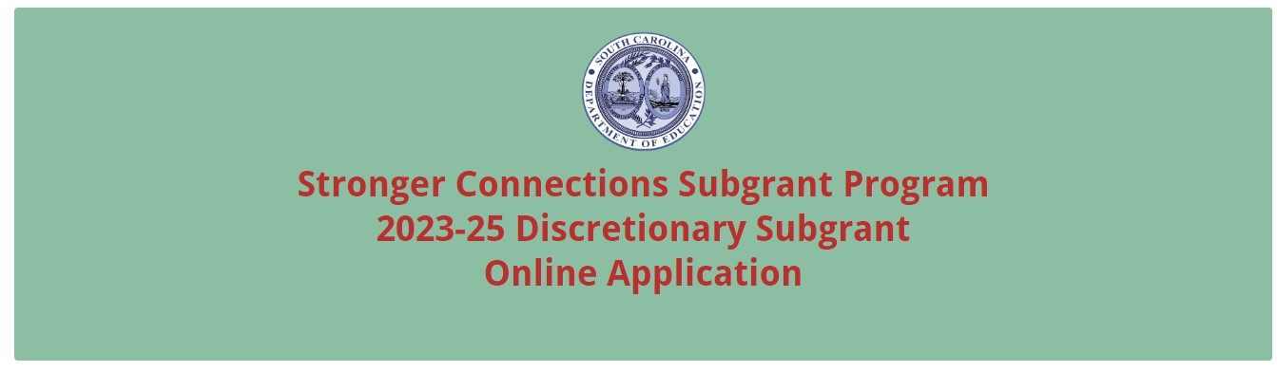
Enter the official name of the primary applicant organization. If a school is the primary applicant, also enter the name of the school district. The names as entered must match the registered name in SAM. Enter the applicant organization’s physical address with the 10-digit ZIP Code (ZIP+4 Code), 12-character UEI, and TIN (tax identification number).
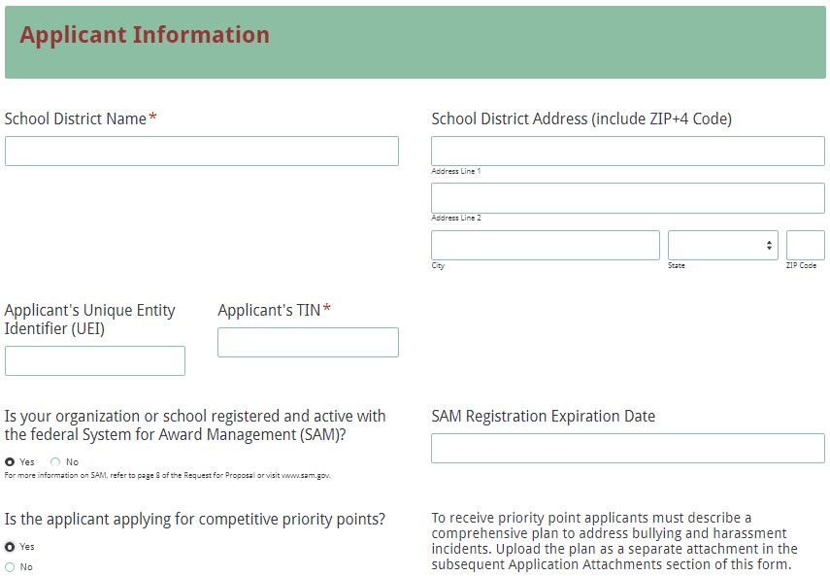

Indicate whether or not the applicant is registered and active with SAM. If the applicant does not have a SAM registration, the following message will be displayed. Refer to the information on page 6 for information on registering in SAM or updating a registration to comply with 2 CFR Part 25. If selecting “YES” to indicate an active SAM registration, enter the date that the applicant’s current SAM registration expires. Indicate if the applicant is applying for competitive priority points.
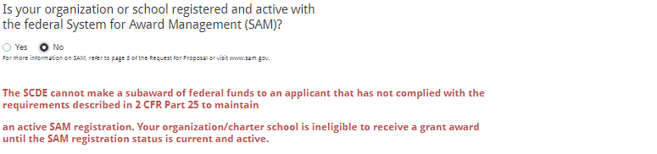

Enter the contact information for the Authorized Official or Superintendent. This is the person that has the authority to enter into legally binding contractual agreements on behalf of the school district. The name, as entered, must match the authorized official’s name on the Certification Signature Page.
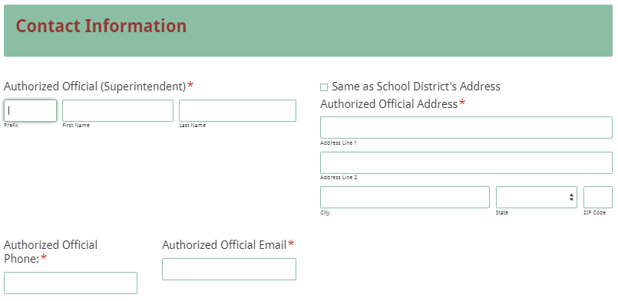

Enter the contact information for the Project Director. This is the person to be contacted in all matters relating to this application. If the Project Director’s address is the same as the school district’s address, click “Same as School District’s Address” and fields will automatically populate. Note: the application submission confirmation email will be sent only to the Project Director’s email address. You must re-enter the email address to validate that it is entered correctly. Enter the contact information for the school district’s Financial Director.
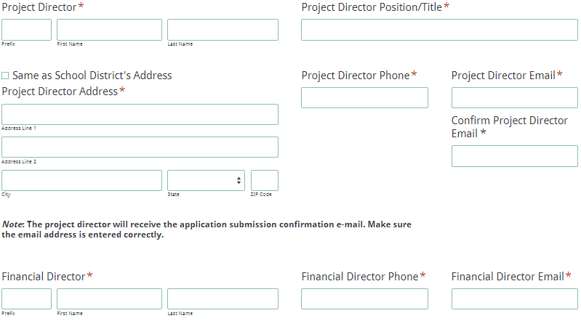

All amounts in the Funding Information and Budget Summary sections should be entered using whole dollars (no cents). Fill in all fields and enter 0 (zero) for line items that are not applicable.
In the Funding Information section, enter the total estimated project cost for all phases of the project over the 22-month period of operation. Enter the total amount of funding being requested for the first budget period of the project (September 1, 2023, through June 30, 2024).
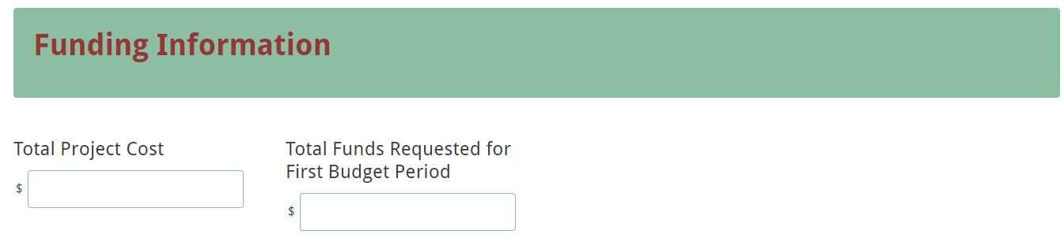

In the budget summary section, enter the line item totals for subgrant funds requested for the first budget period. The Total Direct Costs field will automatically calculate. Enter the Indirect Costs, the Total Costs field will automatically calculate. The Total Costs amount in the Grant Funds Requested column must match the Total Amount Requested for Year One under the Funding Information section.
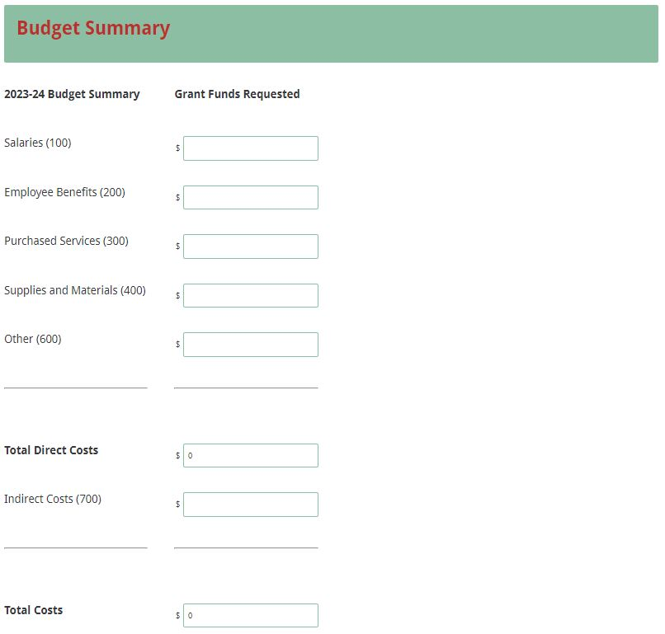
Prepare each of the proposal attachments (i.e., the Project Abstract, Proposal Narrative, Comprehensive Plan to Address Bullying/Harassment (if applicable), Budget Narrative, and the Appendices) following the preceding instructions in this RFP. Ensure that each attachment is saved in the proper format as either a PDF or Excel document. Pay close attention to attachments that must be scanned together into a single document. The online application will only allow one document to be uploaded for each attachment.

Upload the attachments where indicated in the following screenshot. All attachments are required; you will not be able to submit the application without uploading all five documents.
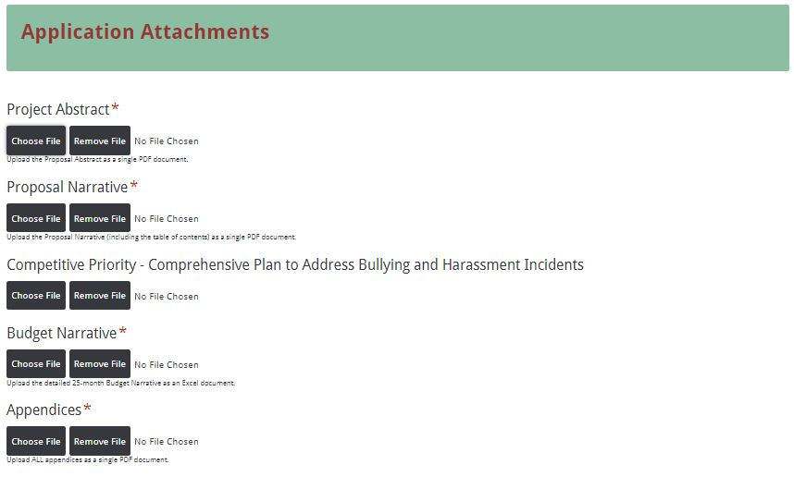

Thoroughly review the summary on the Data Review and Confirmation Page to verify that the information has been entered correctly in the online application prior to submitting. You will not be able to access the completed application form after it has been submitted. If any of the entries are incorrect, click on the "Previous" button at the bottom of each screen to return to the appropriate section(s) and reenter the correct information.
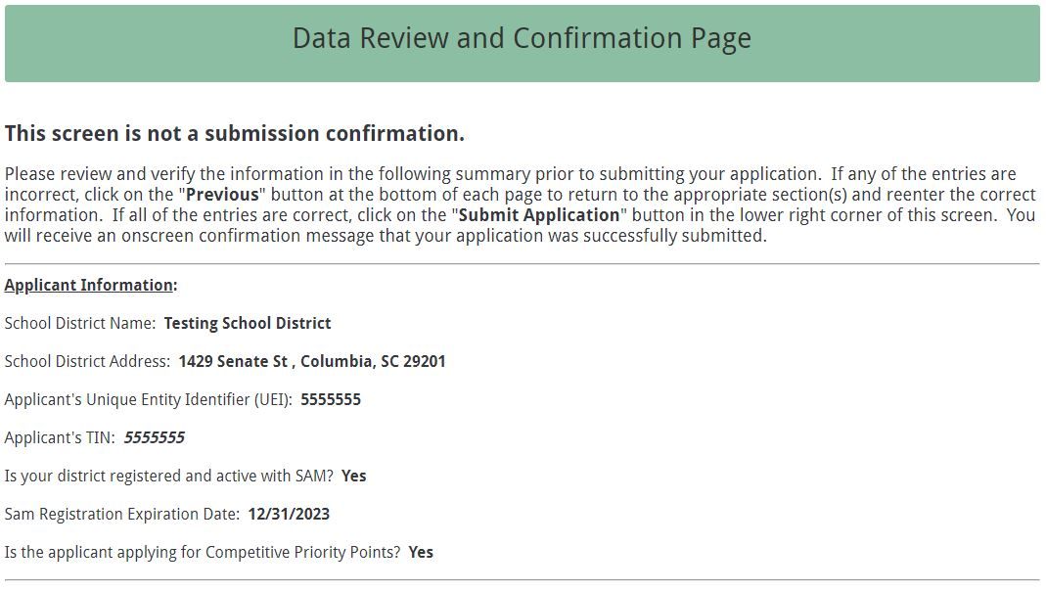
If all of the entries are correct, click on the “Submit Application” button in the lower right corner of this screen to complete the submission process.
Once the application is submitted, the following message will be displayed on the screen, and a submission confirmation will be sent to the e-mail address provided for the contact person in the online application.
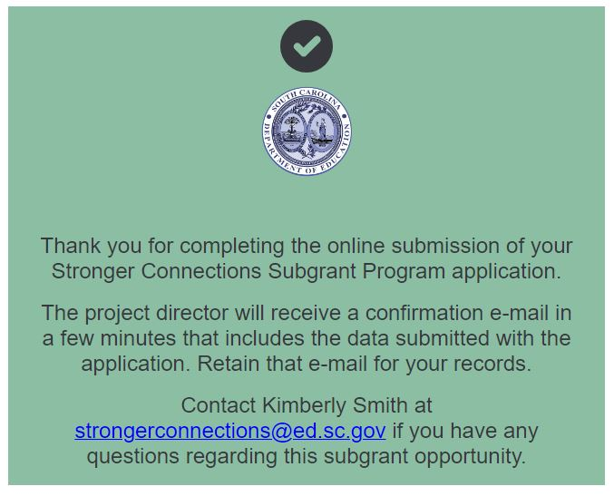
The following confirmation message will be sent to the email address provided for the contact person.
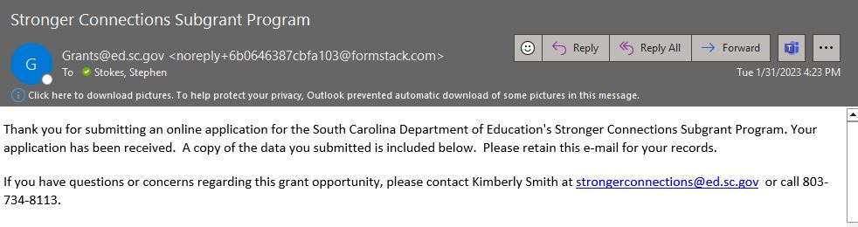

If the contact person does not receive a confirmation e-mail, then the application did not successfully upload. You must go back and resubmit the entire online form, including all attachments, in order for your application to be considered for funding. Only the most recently submitted application will be reviewed.

An e-mail confirmation that the application was successfully submitted does not account for the quality of the uploaded documents or the completeness of the online form. The confirmation e-mail only notifies you that the online application has been submitted. Applicants are responsible for ensuring that the information entered in the online form, including all attachments, is accurate and complete in order for the application to be reviewed and considered for funding.

Appendix A: Definitions of Terms Used

Bullying and Harassment—Bullying is unwanted, aggressive behavior among school aged children that involves a real or perceived power imbalance. The behavior is repeated, or has the potential to be repeated, over time. Both kids who are bullied and who bully others may have serious, lasting problems. See the following for more information: https://www.stopbullying.gov/bullying/what-is-bullying.

Chronic Absenteeism—Any student in grade K-12 who misses 50 percent or more of the instructional day for any reason for 10 percent (or more) of the enrollment period. All types of absences contribute to chronic absenteeism: excused absences, unexcused absences, and suspensions. A student is absent if he or she is not physically on school grounds and is not participating in instruction or instruction-related activities at an approved off-grounds location for the school day.

Cognizant Agency—The entity responsible for negotiating indirect cost rate proposals with applicant organizations. The SCDE serves as the cognizant agency for all LEAs/public school districts in South Carolina.

Collaborative Partner—An organization that provides routine, regular, and ongoing services to the project as outlined in a signed memorandum of agreement (e.g., the regular use of facilities and equipment, mentors/tutors). A collaborative partner plays a critical role in sustaining the project as subgrant funds decrease.

De-obligation—The downward adjustment of the obligations recorded in a grant award document. It is caused by factors such as (1) termination of part of the project, (2) reduction in material prices, (3) cost savings, or (4) correction of recorded amounts.

Exclusionary Discipline—Any type of school disciplinary action that removes or excludes a student from his or her usual educational setting.

Memorandum of Agreement (MOA)—A document signed by the authorized representative(s) of each collaborative partner that clearly specifies the role, services, contributions, expertise, and funding for each partner.

South Carolina’s Muli-Tiered System of Supports (SCMTSS).—A South Carolina-specific framework that helps educators provide academic and behavioral strategies for students with various needs.

School Climate—The quality and character of school life. School climate is based on patterns of students’, parents’ and school personnel’s experience of school life and reflects norms, goals, values, interpersonal relationships, teaching and learning practices, and organizational structures.

Appendix B: Selection Criteria and Reviewers’ Scoring Rubric

Selection Criteria
A total of 110 points (including all available competitive priority points) is available to applications that meet the maximum score for each selection criteria. While the budget is assigned zero (0) points, the budget remains a critical component of the entire application. An application with an incomplete budget will not be funded.

The point values for each section of the application are as follows:

Narrative Sections | Points Available
Needs Assessment | 25
Goals and Objectives | 25
Strategies and Activities | 30
Management and Sustainability | 10
Evaluation and Dissemination | 10
Budget (Summary and Narrative) | 0
SUBTOTAL | 100
Competitive Priorities (bonus points available) | 10
TOTAL | 110

Reviewers will score each section of the application narrative using the following rubric, which summarizes the required elements of the application narrative and the point ranges assigned to each section.

The scoring system is used to indicate how well an application meets the funding criteria for the project.
Scoring Rubric
Program Abstract—The applicant must, in one page, concisely describe the proposed project, the target population to be served, the documented need for the project as revealed by the district’s needs assessment, the goals and objectives of the proposed project, and the amount of funding requested.
The applicant provides a one-page narrative that concisely describes all of the following items:  - the proposed projected,  - the target population to be served,  - the documented need for the project as revealed by the district’s needs assessment,  - the goals and objectives of the proposed project, and  - the amount of funding requested. | Acceptable | Adequate/Meets—0 points  Applicant provides a narrative that fully addresses all required items.
 | Not Acceptable | Inadequate—0 points  Applicant provides a narrative that does not adequately addresses all required items.
Reviewer’s Comments

  - Needs Assessment—The applicant must
- provide a clear description of the needs and how the proposed project will address them,
- explain how the identified needs will impact students, educators, and communities served and include supporting data (ex. student demographic data, school demographic data, chronic absenteeism, bullying and harassment, school, campus, student and family survey results, grade retention, dropout rates, graduation rates, test scores, and disciplinary data) to effectively demonstrate the needs and explain the findings,
- describe needs related to school safety, integrated student support, South Carolina’s Muli-Tiered System of Supports (SCMTSS), and meaningful family engagement opportunities, and,
- describe how families, educators, and local community members were involved in the development of the project being proposed, and include the frequency of meetings, data collected (i.e., surveys, interviews, focus groups), and a description of ongoing advisory meetings and activities that include all stakeholders.
The applicant provides a narrative that addresses all of the following:  - Provides a clear description of the needs and how the proposed project will address them.  - Explains how the identified needs will impact students, educators, and communities served and includes supporting data to effectively demonstrate the needs and explain the findings.  - Describes needs related to school safety, integrated student support, and family engagement according to South Carolina’s Muli-Tiered System of Supports (SCMTSS).  - Describes how families, educators, and local community members were involved in the development of the project being proposed, and includes the frequency of meetings, data collected and a description of ongoing advisory meetings and activities that includes all stakeholders. |  | Acceptable | Fully Meets—20–25 points  Applicant provides a narrative that fully addresses all required items.
 |  | Acceptable | Adequate/Meets—14–19 points  Applicant provides a narrative that moderately addresses all required items.
 |  | Not Acceptable | Limited/Approaches—6–13 points  Applicant provides a narrative that is limited or unclear in addressing all required items.
 |  | Not Acceptable | Inadequate—0–5 points  Applicant provides a narrative that does not adequately address all required items.
Reviewer’s Comments
- Goals and Objectives— The applicant must provide a narrative that includes clear and full statements of what they propose to accomplish with the project. The narrative should have a goal that is aligned to the overall program priorities. The goal must be aligned to providing a safe and healthy learning environment.
The applicant’s narrative must include objectives that are aligned to the project’s goal and to the following overall Stronger Connections program priorities:
  - Implement comprehensive, evidence-based strategies that meet each student’s well-being needs; create positive and supportive school environments; and increase access to interventions and services.
  - Engage students, families, educators, staff, and community organizations in the selection and implementation of strategies and interventions to create safe, supportive, and healthy learning environments.
  - Design and implement policies and practices that serve underserved students and demonstrate respect for others.
Objectives should be clearly measurable and describe who is to be affected by the proposed project, what changes will occur within the target population, and the expected outcomes for students by the end of the subgrant period.
The applicant provides a narrative that presents clear and full statements of what they propose to accomplish with the project that includes the following:  - A goal that is aligned to providing a safe, supportive, inclusive, and healthy learning environment.  - Objectives that are aligned to the project’s goal and to the Stronger Connections program priorities:  - Implement comprehensive, evidence-based strategies that promote each student’s well-being needs; create safe and healthy and supportive school environments; and increase access to interventions and services.  - Engage students, families, educators, staff, and community organizations in the selection and implementation of strategies and interventions to create safe and healthy learning environments.  - Design and implement policies and practices that protect student rights, are responsive to underserved students, and demonstrate respect for student dignity and potential.  - Objectives that are clearly measurable and describe  - who is to be affected by the proposed project,  - what changes will occur within the target population, and  - the expected outcomes for students by the end of the subgrant period. |  | Acceptable |  | Fully Meets—20–25 points  Applicant provides a narrative that fully describes all required items.
Adequate/Meets—–14–19 points
Applicant provides a narrative that moderately describes all required items.
 |  | Not Acceptable |  | Limited/Approaches—6–13 points  Applicant provides a narrative that is limited or unclear in describing all required items.
Inadequate—0–5 points
Applicant provides a narrative that does not adequately describe the required items.
Reviewer’s Comments
3. Strategies and Activities: The applicant must outline the project strategies and activities and explain how they relate to the goals and objectives. Applicants should address the following:
- Describe how the proposed strategies and activities will implement a comprehensive approach to safe, supportive, and healthy learning environments that enhance students’ learning and academic success and address school-based violence.
- Identify any school-based prevention programs coordinated and aligned with evidence-based community violence prevention strategies that will be implemented.
- Describe how the proposed strategies and activities will address the health, safety, and academic growth of students. The description should include the identified interventions that support positive relationships, resilience, self-control, empathy, persistence and the student’s overall well-being.
- Describe the specific professional development opportunities associated with the selected activities.
- Describe how the proposed strategies and activities will meet the needs of students with disabilities and support their safety, health, learning and success.
The applicant must include a timeline of activities in the appendices that describes when each program activity begins and ends, how each activity relates to a specific objective, and who is responsible for overseeing the activity, and must include activities through June 30, 2025.
The applicant provides a narrative that addresses the following:  - outlines the project strategies and activities and explain how they relate to the goals and objectives;  - describes how the proposed strategies and activities will implement a comprehensive approach to safe, supportive, and healthy learning environments that enhance students’ learning and academic success and address school-based violence;  - identifies any school-based prevention programs coordinated and aligned with evidence-based community violence prevention strategies that will be implemented;  - describes how the proposed strategies and activities will address the personal development and academic growth of students. This description includes the identified interventions that support positive relationships, resilience, self-control, empathy, persistence, and well-being;  - describes specific professional development opportunities associated with the selected activities; and  - describes how the proposed strategies and activities will meet the needs of students with disabilities and support their safety, health, learning and success.  The applicant includes a timeline of activities in the appendices that describes  - when each program activity begins and ends,  - how each activity relates to a specific objective,  - who is responsible for overseeing the activity, and  includes activities through June 30, 2025. | Acceptable |  |  |  | Fully Meets—24–30 points  Applicant provides a narrative that fully details all required items.
Adequate/Meets—16–23 points
Applicant provides a narrative that moderately details all required items.
 | Not Acceptable |  |  |  | Limited/Approaches—8–15 points  Applicant provides a narrative that is limited or unclear in detailing all required items.
Inadequate—0–7 points
Applicant provides a narrative that does not adequately detail all the required items.
Reviewer’s Comments

- Management and Sustainability: The applicant must describe the LEA’s capacity and resources (human, fiscal, operational, external partnerships, etc.) that will support the implementation of evidence-based programs, strategies, and/or activities implemented throughout the project term.
The applicant must include résumés, vitae, or a paragraph summary for each staff member, and an organizational chart in the appendices.
To address sustainability, the applicant must
- address what they will do to ensure that the project will maintain its activities beyond the term of the subgrant,
- include a reasonable plan for sustaining their program that identifies actions the LEA will take to continue activities after subgrant funding ends,
- include sufficient resources (human, fiscal, operational, external partnerships, etc.) that support the implementation and sustainability of the evidence-based programs and/or activities implemented through this subgrant.
The applicant provides a narrative that  - describes the LEA’s capacity and resources (human, fiscal, operational, external partnerships, etc.) that will support the implementation of evidence-based programs, strategies, and or activities implemented throughout the project term;  - addresses what the applicant will do to ensure that the project will maintain its activities beyond the term of the subgrant;  - includes a reasonable plan for sustaining their project that identifies actions the LEA will take to continue activities after subgrant funding ends;  - includes sufficient resources (human, fiscal, operational, external partnerships, etc.) that support the implementation and sustainability of the evidence-based programs and/or activities implemented through this subgrant.  The applicant includes résumés, vitae, or a paragraph summary for each staff member, and an organizational chart in the appendices. |  | Acceptable | Fully Meets—9–10 points  Applicant provides a narrative that fully states and details all required items.
 |  | Acceptable | Adequate/Meets—7–8 points  Applicant provides a narrative that moderately states and details all required items.
 |  | Not Acceptable | Limited/Approaches—2–6 points  Applicant provides a narrative that is limited or unclear in stating and detailing all required items.
 |  | Not Acceptable | Inadequate—0–1 point  Applicant provides a narrative that does not adequately state and/or detail all required items.
Reviewer’s Comments
5. Evaluation and Dissemination: The applicant must provide a clear description of how the goal(s), objectives, and desired outcomes will be monitored and evaluated. The evaluation plan should clearly identify what data will be collected, when and by whom, and the frequency of monitoring for implementation effectiveness. Evaluation data should include chronic absenteeism data, bullying and harassment data, exclusionary discipline data, and the total number of students, staff, community served, etc. The outcome of the evidence-based activities, programs, and practices should have a direct impact on the students, staff, and community. The applicant must identify the specific data to be used to determine the impact on students and indicate how the information and results will be disseminated to all interested parties.
The applicant provides a narrative that  - provides a clear description of how the goals, objectives, and desired outcomes will be monitored and evaluated;  - clearly identifies what data will be collected, when and by whom, and the frequency of monitoring for implementation effectiveness;  - includes as evaluation data chronic absenteeism data, bullying and harassment data, exclusionary discipline data, and the total number of students, staff, community served, etc.  - indicates that the outcome of the evidence-based activities, programs, and practices should have a direct impact on the students, staff and community;  - identifies the specific data to be used to determine the impact on students; and  - indicates how the information and results will be disseminated to all interested parties. | Acceptable |  |  | Fully Meets—9–10 points  Applicant provides a narrative that fully describes all required items.
Adequate/Meets—7–8 points
Applicant provides a narrative that moderately describes all required items.
 | Not Acceptable |  |  | Limited/Approaches—2–6 points  Applicant provides a narrative that is limited or unclear in describing all required items.
Inadequate—0–1 point
Applicant provides a narrative that does not adequately describe the required items.
Reviewer’s Comments
Budget Narrative: The applicant provides a budget narrative that provides clear evidence that the expenditures are appropriate, justified, reasonable, and adequate to complete the project and includes the formulas used to calculate the cost for each line item.
The applicant provides a thorough and detailed budget narrative that  - provides clear evidence that the expenditures are appropriate, justified, reasonable, and adequate to complete the project; and  - includes the formulas used to calculate the cost for each line item. | Acceptable |  |  | Adequate/Meets—0 points  Applicant provides a budget narrative that provides all required items.
 | Not Acceptable |  |  | Inadequate—0 points  Applicant provides a budget narrative that did not provide all required items.
Reviewer’s Comments

Appendix C: SCDE Forms

Certification Signature Page
(This form must be signed by the individual from each proposed district, school, or organization who holds the title listed below.)

Certification
I hereby certify that, to the best of my knowledge, the information and data contained in this application are true and correct. The applicant’s governing body has duly authorized this application and documentation, and the applicant will comply with the Program Specific Assurances (if applicable) and the SCDE Assurances and Terms and Conditions if the subgrant is awarded. The applicant is registered and current (active) on the federal System for Award Management (SAM).

Authorized Official (superintendent of school district)
Name:
Position: | Email:
Telephone: | Fax:

Signature of Authorized Official: | Typed name of Authorized Official:
Date Signed:
Signature of Financial Official: | Typed Name of Financial Official:
Date Signed:
Signature of Project Director: | Typed Name of Project Director:
Date Signed:

Please complete, print, and obtain signatures prior to submission. Include the signed, scanned form in the required appendices as indicated on pages 20–21.

Assurances and Terms and Conditions for Federal Subawards

Assurances
I certify that this applicant
- Has the legal authority to apply for federal assistance and the institutional, managerial, and financial capability (including funds sufficient to pay the nonstate share of project costs) to ensure proper planning, management, and completion of the project described in this application.
- Will give the South Carolina Department of Education (SCDE) access to and the right to examine all records, books, papers, or documents related to this award and will establish a proper accounting system in accordance with generally accepted accounting principles (GAAP) or agency directives.
- Has an accounting system with sufficient internal controls, a clear audit trail, and written cost-allocation procedures as necessary. The financial management systems are capable of distinguishing expenditures that are attributable to this grant from those that are not attributable to this grant. This system is able to identify costs by programmatic year and by budget line item and to differentiate among direct, indirect, and administrative costs. In addition, the applicant will maintain adequate supporting documents for the expenditures (federal and nonfederal) and in-kind contributions, if any, that it makes under this grant. Costs are shown in books or records (e.g., disbursements ledger, journal, payroll register) and are supported by a source document such as a receipt, travel voucher, invoice, bill, or in-kind voucher.
- Will also comply with the Office of Management and Budget 2 CFR Part 200 Subpart E-Cost Principles related to the allowability, reasonableness, and allocability of costs consistent with the approved budget and also by maintaining required support for salaries and wages. Required support includes certifications and/or personnel activity records depending upon the amount of time spent on cost objectives.
- Will approve all expenditures, document receipt of goods and services, and record payments on the applicant’s accounting records prior to submission of reimbursement claims to the SCDE for costs related to this grant.
- Will initiate and complete work within the applicable time frame after receipt of approval by the SCDE.
- Will not discriminate against any employee or applicant for employment because of race, color, religion, age, sex, national origin, or disability and comply with Title VI of the Civil Rights Act of 1964, Section 504 of the Rehabilitation Act of 1973, Title IX of the Education Amendments of 1972, the Age Discrimination Act of 1975, and Titles I, II, and III of the Americans with Disabilities Act of 1990 (ADA). The grantee will take affirmative action to ensure that applicants for employment and the employees during the period of their employment are treated without regard to their race, color, religion, age, sex, national origin, or disability.
- Has no policy that prevents, or otherwise denies, participation in constitutionally protected prayer in public schools as set forth in the Guidance on Constitutionally Protected Prayer in Public Education (20 U.S.C. § 7904).
- Will comply with the Family Educational Rights and Privacy Act. (20 U.S.C. §1232g; 34 CFR Part 99).
- Will comply with the Ethics, Government Accountability, and Campaign Reform Act (S.C. Code Ann. § 2-17-10 et seq. and § 8-13-100 et seq. (Supp. 2022)).
- Will comply with the South Carolina Drug Free Workplace Act (S.C. Code Ann. § 44-107-10 et seq. (Supp. 2022) if the amount of this award is $50,000 or more and the federal Drug Free Workplace Act of 1988 (41 USC 702).
- Will provide information to the SCDE, as requested, regarding the reporting requirements of the Federal Funding Accountability and Transparency Act (FFATA), which requires the SCDE to file a FFATA subaward report by the end of the month following the month in which it awards any subgrant equal to or greater than $25,000.
- Will comply with 2 CFR Part 25 and register and receive a unique entity identifier, fulfill the requirement for the System for Award Management, maintain the currency of the registration throughout the full grant term, and allow access by the granting agency to ensure compliance.
- Will comply with 2 CFR Part 200.112 and disclose in writing any potential conflict of interest to the SCDE.
- Will comply with 2 CFR Part 200.113 and disclose in writing to the SCDE all violations of federal criminal law involving fraud, bribery, or gratuity violations potentially affecting the federal award.
- Will comply with conditions under Executive Order 13513 “Federal Leadership on Reducing Text Messaging While Driving” (October 1, 2009) by refraining from text messaging while driving during official grant business. Relatedly, the applicant will refrain from emailing while driving during official grant business.

Terms and Conditions

- Completeness of Proposal. All proposals should be complete and carefully worded and must contain all of the information requested by the South Carolina Department of Education (SCDE). If you do not believe a section applies to your proposal, please indicate that fact.
- Non-awards/Termination. The SCDE reserves the right to reject any and all applications and to refuse to grant monies under this solicitation. If the SCDE rejects an application, the applicant has a right to request a hearing, as provided by 2 CFR Part 200.341 and 34 CFR Part 76.401, if it alleges the SCDE’s actions violate a state or federal statute or regulation by (1) disapproving of or failing to approve the application or project, in whole or in part, or (2) failing to provide funds in amounts in accordance with the requirements of statutes and regulations.
After it has been awarded, the SCDE may terminate a grant by giving the grantee written notice of termination. In the event of a termination after award, the SCDE shall reimburse the grantee for allowable expenses incurred up to the notification of termination. In addition, this grant may be terminated by the SCDE if the grantee fails to perform as promised in its proposal. Federal grants will be terminated in accordance with 2 CFR Part 200.339 and 200.340.
In the event that this grant is terminated, the grantee shall have a right to a hearing as set forth in 34 CFR Part 76.783. The grantee must notify the SCDE of its request for a hearing within 30 days of receiving written notice of the termination. If a hearing is requested, the SCDE will conduct the hearing in accordance with the procedures outlined in 34 CFR Part 76.401(d)(2)–(7).
- Reduction in Budgets and Negotiations. The SCDE reserves the right to negotiate budgets with applicants. The SCDE may, at its sole discretion, determine that a proposed budget is excessive and may negotiate a lower budget with the applicant. The applicant may at that time negotiate or withdraw its proposal. In addition, the SCDE may desire to fund a project but not at the level proposed. In that case, the SCDE shall notify the applicant of the amount that can be funded, and the applicant and the SCDE shall negotiate a modification to the proposal to accommodate the lower budget. All final decisions are that of the SCDE.
- Amendments to Grants. Amendments are permitted generally for budgets, grant end date, and management upon the mutual agreement of the parties involved and will become effective when specified in writing and signed by both parties. However, amendments to scope of work that significantly alter the original application proposal may trigger partial or full termination consistent with 2 CFR Part 200.339 and 200.340.
- Use of Grant Funds. Funds awarded are to be expended only for purposes and activities covered by the approved project plan and approved budget and budget narrative.
- Submission of Expenditure Reports. Claims for reimbursement must be made at least quarterly and consistent with calendar quarters (e.g., an expenditure report claim for costs for January 1 through March 30 must be filed by May 15).
- Obligation of Grant Funds. Grant funds may not be obligated prior to the effective date or subsequent to the end or termination date of the grant period. No obligations are allowed after the end of the grant period. The final request for expenditure report claims must be submitted no later than forty-five (45) days after the end of the grant period unless the scope of work for the grant states a shorter reporting period.
- Deobligation of Funds. After a final expenditure report claim has been submitted to the SCDE, the grantee will go through the official deobligation process with the SCDE.
- Documentation. The grantee must provide for accurate and timely recording of receipts and expenditures. The grantee’s accounting system should distinguish receipts and expenditures attributable to each grant. The grantee must review the memo regarding “Guidelines for Retaining Documentation to Support Expenditure Claims.”
- Travel Costs. Travel costs, if allowed under this solicitation, must not exceed limits noted in the United States General Services Administration (GSA) per diem rates for lodging, except in the case of conference lodging required for program-required training. In the case that conference-related lodging exceeds the GSA per diem rate, the grantee shall follow their entity’s written procedure for obtaining prior approval to exceed a GSA rate for a conference hotel. Meals and incidentals are limited by the state budget proviso, currently not to exceed $35 per day for in-state travel and $50 for out-of-state travel (see page 81 of the State of South Carolina Statewide Disbursement Regulations). Mileage reimbursement must follow the current Office of Comptroller General instructions, which is consistent with the published IRS rates.
- Honoraria. Amounts paid in honoraria, if allowed under this grant, must be consistent with SCDE policies. Applicants should check with the program office before budgeting for honoraria.
- Reports. The grantee shall submit, as required or instructed by the awarding program office, all reports (programmatic, financial, or evaluation) within the specified period or date and in the prescribed format. An expenditure claim report must be filed by August 15 for all expenditures incurred by June 30 in order to comply with the generally accepted accounting principles (GAAP) and the production of the State's Comprehensive Annual Financial Report.
- Copyright. The grantee is free to copyright any books, publications, or other copyrightable materials developed in the course of this grant. However, the SCDE reserves a royalty-free, nonexclusive, and irrevocable license to reproduce, publish, or otherwise use, and to authorize others to use, the copyrighted work developed under this grant.
- Certification Regarding Lobbying, Suspension, and Debarment. By submitting an application, the applicant certifies, to the best of its knowledge and belief, that the
- Applicant and/or any of its principals, subgrantees, or subcontractors
  - Have not paid or will not pay to any person any federally appropriated funds for the purpose of influencing or attempting to influence an officer or employee of any agency, a Member of
- Congress, an officer or employee of Congress, or any employee of a Member of Congress in connection with making any federal grant and the extension continuation, renewal, amendment, or modification of any federal grant, as defined at 34 CFR Part 82.105 and 82.110. If any funds other than federally appropriated funds have been paid or will be paid to any person for influencing or attempting to influence an officer or employee of any agency, a Member of Congress, an officer or employee of Congress, or any employee of a Member of Congress in connection with this federal grant, the undersigned shall complete and submit Standard Form LLL, “Disclosure of Lobbying Activities,” in accordance with its instructions.
  - Are not presently debarred, suspended, proposed for debarment, or declared ineligible for the award of contracts by any state or federal agency as stated at 2 CFR Part 180 or 2 CFR Part 3485.
  - Have not, within a three-year period preceding this application, been convicted of or had a civil judgment rendered against them for commission of fraud or a criminal offense in connection with obtaining, attempting to obtain, or performing a public (federal, state, or local) contract or subcontract; violated federal or state antitrust statutes relating to the submission of offers; or committed embezzlement, theft, forgery, bribery, falsification or destruction of records, making false statements, tax evasion, or receiving stolen property.
  - Are not presently indicted for, or otherwise criminally or civilly charged by a governmental entity with, commission of any of the offenses enumerated above.
- Applicant has not, within a three-year period preceding this application, had one or more contracts terminated for default by any public (federal, state, or local) entity.
- Audits.
- Entities expending $750,000 or more in federal awards:
Entities that expend $750,000 or more in federal awards during the fiscal year are required to have an audit performed in accordance with the provisions of 2 CFR Part 200.501, et seq. Except for the provisions for biennial audits provided in 2 CFR Part 200.504 (a) and (b), audits must be performed annually as stated at 2 CFR Part 200.504. A grantee that passes through funds to subrecipients has the responsibility of ensuring that federal awards are used for authorized purposes in compliance with federal program laws, federal and state regulations, and grant agreements. The director of the OMB, who will review this amount every two years, has the option of revising the threshold upward.
- Entities expending less than $750,000 in federal awards:
Entities that expend less than $750,000 in a fiscal year in federal awards are exempt from the audit requirements in 2 CFR Part 200.504. However, such entities are not exempt from other federal requirements (including those to maintain records) concerning federal awards provided to the entity. The entity’s records must be available for review or audit by the SCDE and appropriate officials of federal agencies, pass-through entities, and the General Accounting Office (GAO).
- Records. The grantee shall retain federal grant records, including financial records and supporting documentation, for a minimum of six (6) years after the end date of the grant when the final expenditure report claim for reimbursement and all final reports have been submitted, unless informed otherwise or in the case of litigation.
- Electronic Signature Agreement. I agree that my electronic signature is the legally binding equivalent to my handwritten signature.

Instructions for GEPA Statement of Compliance
The purpose of this enclosure is to inform you about the following provision in the United States Department of Education's General Education Provisions Act (GEPA) that applies to applicants for new grant awards under Department programs. This provision is Section 427 of GEPA, enacted as part of the Improving America's Schools Act of 1994 (Public Law (P.L.) 103-382).

To Whom Does This Provision Apply?

Section 427 of GEPA affects applicants for new grant awards under this program. ALL APPLICANTS FOR NEW AWARDS MUST INCLUDE INFORMATION IN THEIR APPLICATIONS TO ADDRESS THIS NEW PROVISION IN ORDER TO RECEIVE FUNDING UNDER THIS PROGRAM.

What Does This Provision Require?
Section 427 requires each applicant for funds (other than an individual person) to include in its application a description of the steps the applicant proposes to take to ensure equitable access to, and participation in, its federally assisted program for students, teachers, and other program beneficiaries with special needs. This provision allows applicants discretion in developing the required description. The statute highlights six types of barriers that can impede equitable access or participation: gender, race, national origin, color, disability, or age. Based on local circumstances, you should determine whether these or other barriers may prevent your students, teachers, etc. from such access or participation in the federally funded project or activity. The description in your application of steps to be taken to overcome these barriers need not be lengthy; you may provide a clear and succinct description of how you plan to address those barriers that are applicable to your circumstances. In addition, the information may be provided in a single narrative, or, if appropriate, may be discussed in connection with related topics in the application.

Section 427 is not intended to duplicate the requirements of civil rights statutes, but rather to ensure that, in designing their projects, applicants for federal funds address equity concerns that may affect the ability of certain potential beneficiaries to fully participate in the project and to achieve to high standards. Consistent with program requirements and its approved application, an applicant may use the federal funds awarded to it to eliminate barriers it identifies.

What are Examples of How an Applicant Might Satisfy the Requirement of This Provision?
The following examples may help illustrate how an applicant may comply with Section 427.
- An applicant that proposes to carry out an adult literacy project serving, among others, adults with limited English proficiency might describe in its application how it intends to distribute a brochure about the proposed project to such potential participants in their native language.
- An applicant that proposes to develop instructional materials for classroom use might describe how it will make the materials available on audio tape or in braille for students who are blind.
- An applicant that proposes to carry out a model science program for secondary students and is concerned that girls may be less likely than boys to enroll in the course, might indicate how it intends to conduct "outreach" efforts to girls to encourage their enrollment.
- An applicant that proposes a project to increase school safety might describe the special efforts it will take to address concern of lesbian, gay, bisexual, and transgender students, and efforts to reach out to and involve the families of LGBT students.
We recognize that many applicants may already be implementing effective steps to ensure equal access and participation in their grant programs, and we appreciate your cooperation in responding to the requirements of this provision.
Estimated Burden Statement for GEPA Requirements
According to the Paperwork Reduction Act of 1995, no persons are required to respond to a collection of information unless such collection displays a valid OMB control number. Public reporting burden for this collection of information is estimated to average 1.5 hours per response, including time for reviewing instructions, searching existing data sources, gathering and maintaining the data needed, and completing and reviewing the collection of information. The obligation to respond to this collection is required to obtain or retain benefit (Public Law 103-382. Send comments regarding the burden estimate or any other aspect of this collection of information, including suggestions for reducing this burden, to the U.S. Department of Education, 400 Maryland Ave., SW, Washington, DC 20210-4537 or email ICDocketMgr@ed.gov and reference the OMB Control Number 1894-0005.

Request for Taxpayer Identification Number and Certification
Go to the IRS Web site for an easy-to-complete version of this form.
(To be completed by fiscal agent)
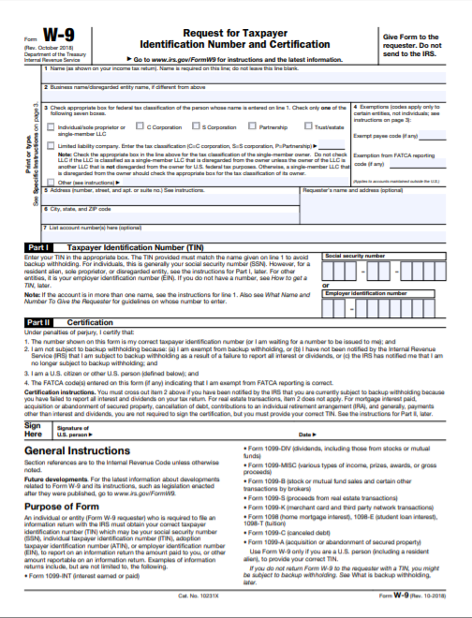

Budget Forecast and Narrative Format Guidance

Use the Excel budget file that accompanies this funding opportunity announcement to develop the Budget Forecast and Narrative (accessible here). Applicants should insert rows in the budget spreadsheet as needed to clarify information.
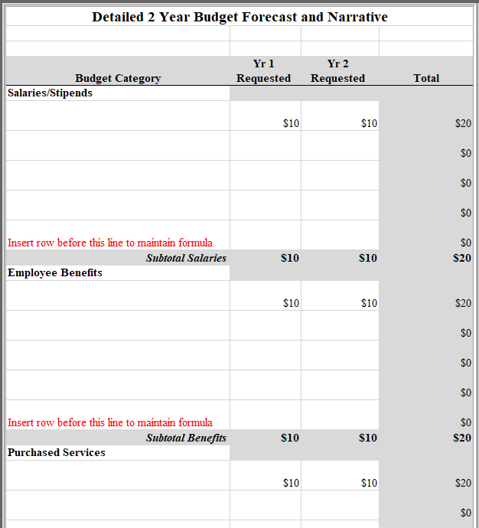

Non-Public (Private) School Consultation Form

The Elementary and Secondary Education Act (ESEA), as reauthorized by the Every Student Succeeds Act (ESSA) of 2015, requires that public school districts receiving financial assistance under the Stronger Connections, authorized under Title IV, Part A of the Elementary and Secondary Education Act of 1965 (ESEA), provide equitable services to eligible non-public school students (ESEA §§ 8501–8506(b)(1)(B)).

To comply, public school districts are required to engage in timely and meaningful consultation with appropriate private school officials about the provision of program services to non-public school students. This consultation must occur during the design and development of the proposed project before any decision is made that impacts the opportunities for participation of non-public school students throughout the design, development, implementation, and assessment of the program services. The quality of the consultative process will likely have an effect on the quality of services to non-public school students. (Authority: ESEA § 8501(c)).

Please complete the following related to the involvement of eligible non-public school students in Stronger Connections subgrant activities.

There are no non-public schools located within the attendance boundaries of the school(s) proposed to be served by this project. (Signature below is required.)

There are non-public schools located within the attendance boundaries of the school(s) proposed to be served by this project (listed below). These non-public schools were consulted (methods listed below) prior to the development of the Stronger Connections application.
Non-Public school(s) within the attendance boundaries of the school(s) proposed to be served by this project:
Name of Non-Public School | Name and Title of Person Contacted | Date of Contact | Method of Contact (e.g., in person, phone, email, other) | To receive services?  (Yes or No*)
*If no, please provide a brief explanation.

Signature of Applicant’s Authorized Representative | Date

Signature of Non-Public School Representative | Date

Sample Timeline of Activities Template

Start Date–End Date | Activity to achieve Objective | Related Objective and Goal | Evidence that Proves Activity has been Completed OR Data to be Collected from Activity | Persons/Agency Responsible

Stronger Connections Subgrant

Goals, Objectives, and Outcomes Worksheet

Goal _____:

Objective _____:

Directions
1. Identify a result you expect to achieve through this program.
2. Describe what you will do to achieve this result.
3. What data will you collect to prove that you have achieved this result?
4. Are there target benchmarks for progress toward achieving this result over time?
5. Combine the information from Steps 1-4 into one sentence. (This combined statement is a performance measure)
6. How long will it take to achieve this result?
7. What baseline data will you need to have to measure achievement of this result?

Grant Design Chart
Goal:
Objectives | Tasks/Activities | Begin/End  Dates | Personnel | Outcomes |  |  | Evaluation | Budget
 |  |  |  | Short | Mid | Long | Evaluation | Budget
A. | A-1:
 | A-2:
 | A-3:
B. | B-1:
 | B-2:
 | B-3:
C: | C-1:
 | C-2:
 | C-3:
D: | D-1:
 | D-2:
 | D-3:

Action Plan Form
Objective:
(Each Objective requires an Action Plan Form)
Strategy | Activity | Result/Measurable Outcome | Timeline | Responsible Agency/Personnel | Budget Needed for Activity

List of Eligible LEAs

Eligible applicants are South Carolina LEAs (school districts) that demonstrate a high need as identified by
    - a high percentage of students living in poverty (40 percent or higher) and
    - either
      - a high rate of bullying/harassment (> .5 percent),
      - a high rate of chronic absenteeism (> 20 percent), or
      - a high rate of exclusionary discipline (>11 percent).

The SCDE used 2021–22 School Report data and 2021–22 Chronic Absenteeism Data to determine that the following LEAs are eligible.

Eligible SC LEAs (School Districts)
Abbeville County School District
Aiken County Public School District
Allendale County Schools
Anderson School District One
Anderson School District Two
Anderson School District 3
Anderson School District Five
Bamberg County School District
Barnwell County Consolidated School District
Barnwell School District 45
Beaufort County School District
Berkeley County School District
Calhoun County Public Schools
Charleston County School District
Cherokee County School District
Chester County School District
Chesterfield County School District
Clarendon County School District
Colleton County School District
Beaufort County School District
Darlington County School District
Dillon School District Three
Dillon School District Four
Dorchester School District Two
Edgefield County School District
Fairfield County School District
Florence Public School District One
Florence County School District 2
Florence County School District 3
Florence County School District Five
Georgetown County School District
The School District of Greenville County
Greenwood School District 50
Ware Shoals School District 51 (Greenwood 51)
Greenwood County School District 52
Hampton County School District
Horry County Schools
Kershaw County Schools
Jasper County School District
Lancaster County School District
Laurens County School District 55
Laurens County School District 56
Lee County School District
Lexington County School District One
Lexington County School District Two
Lexington County School District Three
Lexington School District Four
School District Five of Lexington and Richland Counties (Lexington/Richland 5)
Marion County School District (Marion 10)
Marlboro County School District
McCormick County School District
School District of Newberry County
School District of Oconee County
Orangeburg County School District
School District of Pickens County
Richland County School District One
Richland School District Two
SC Public Charter School District
Spartanburg School District One
Spartanburg School District 2
Spartanburg School District Three
Spartanburg School District Four
Spartanburg School District Five
Spartanburg School District Six
Spartanburg School District 7
Sumter School District
Union County Schools
Williamsburg County School District
York School District 1
Rock Hill School District Three (York 3)

