Request for Proposals (RFP)
Application Package
(Pre-application TA session date revised April 12, 2018)

Public Charter Schools Program—Planning and Implementation 2018–19 Competitive Subgrant – Round Two

The Public Charter Schools Program Planning and Implementation Grant is a subgrant program funded by the United States Department of Education, authorized by the Elementary and Secondary Education Act of 1965, as amended by the No Child Left Behind Act of 2001, and administered by the South Carolina Department of Education.

Deadline for Receipt of Applications: May 15, 2018, 5:00 p.m.

Technical Assistance for Applicants: April 27, 2018, 2:00 p.m.

For questions, contact:
Fredrica M. Brailsford, Education Associate
803-734-0526, charterschoolgrant@ed.sc.gov

Issued by:
South Carolina Department of Education
Office of School Transformation
Charter Schools Program Office
1429 Senate Street, Suite 603E
Columbia, SC 29201

TABLE OF CONTENTS

PART I: General Information 1
A. Introduction and Purpose 1
B. Eligible Applicants 2
C. Competitive Priorities 4
D. Timeline of Subgranting Process 4
E. Technical Assistance Sessions for Applicants 5
F. Statutory, Federal Regulations, and State-Level Program Requirements 5
G. Applicable Federal Regulations 6
H. State-Level Program Requirements 8
I. Authorized Activities 9
J. Unauthorized Activities 9
K. Program Accountability and Monitoring 10
L. Fiscal Operations 14
M. Supplement, Not Supplant 15
N. Peer Review and Selection Process 15
O. Appeals Process 16
PART II: Application Overview, Content, and Instructions 17
A. Application Overview 17
B. Proposal Narrative Format 18
C. Online Application Submission 18
D. Project Abstract 18
E. Proposal Narrative Content 19
1. Section 1: The School and Its Stakeholders (Maximum of 42 points available) 19
2. Section 2: Financial Sustainability (Maximum of 28 points available) 20
3. Section 3: Governance and Management Plan (Maximum of 30 points available) 20
F. Application Budget 21
G. Appendices 24
H. Deadline and Submission Procedures 27
I. Screenshots of Online Application Submission Forms 28
Appendix A: Definitions of Terms Used 34
Appendix B: Selection Criteria and Reviewers’ Scoring Rubric 36
Appendix C: Required SCDE Forms 46
Certification Signature Page 46
Assurances and Terms and Conditions for Federal Subawards 47
Program Specific Assurances 51
Instructions for GEPA Statement of Compliance 52
Request for Taxpayer Identification Number and Certification 53
SCDE Pre-Award Audit Questionnaire for Non-LEAs 54
Timeline of Activities/Workplan Chart 59

PART I: General Information

Introduction and Purpose

The South Carolina Charter Schools Act (S.C. Code Ann. § 59-40-10 et seq. (Supp. 2017) provides the mechanism for the design and operation of charter schools for the purposes of improving student learning; increasing learning opportunities for students; encouraging the use of a variety of productive teaching methods; establishing new forms of accountability; creating new professional development opportunities for teachers; assisting South Carolina in reaching academic excellence; and creating new, innovative, and more flexible ways of educating children within the public school system with the goal of closing achievement gaps between low-performing student groups and high-performing student groups. As public schools, charter schools are nonreligious, non-home-based, nonprofit, and nondiscriminatory.

In 2015, the South Carolina Department of Education (SCDE) received a Public Charter Schools Program (CSP) grant from the United States Department of Education (USED) to support the initial planning, program design, and implementation of new charter schools. The purpose of the CSP (Title V, Part B, Subpart 1 of the Elementary and Secondary Education Act (ESEA)), as stated in the federal authorizing statute and non-regulatory guidance, is to increase the national understanding of the charter school model by (1) expanding the number of high-quality charter schools available to students across the nation by providing financial assistance for the planning, program design, and initial implementation of charter schools, and (2) by evaluating the effects of charter schools, including their effects on students, student academic achievement, staff and parents.

Contingent upon the receipt of funds from the USED, the SCDE will administer a Planning and Implementation (P&I) subgrant program to expand the number of high-quality charter schools available to students across the state. For charter schools opening during the 2018–19 school year, this is a multi-year project with a combined performance period of 36 months (24 months for implementation-only subgrants). Approved P&I subawards will have an effective start date of May 1, 2018.

Approximately $10 million will be available for new P&I subgrants to schools during 36-month project term. Funds will be distributed to subgrantees via reimbursement in three phases with the maximum allowable performance period for:
- Planning (12 months). This funding period is May 1, 2018, through April 30, 2019, for initial costs associated with planning and project design. Subgrantees may be granted additional months for Planning with a maximum allowed time of 18 months; however, the additional months for Planning will proportionally decrease the available time period for Implementation which cannot exceed 24 months.
- Implementation Phase 1 (12 months). The funding period is May 1, 2019, through April 30, 2020. For charter schools receiving an implementation-only subgrant, the funding period for Implementation Year One is May 1, 2018, through April 30, 2019.
- Implementation Phase 2 (up to 12 months). The funding period is May 1, 2020, through April 30, 2021. This time will be decreased proportionally for charter schools that opt to use additional months of the subgrant period for planning (see first bullet above). For charter schools receiving an implementation-only subgrant, this funding period is May 1, 2019, through April 30, 2020.

Official subgrant award documents will be processed annually for each phase as the continuation of subgrant funding is not guaranteed. In determining continuation funding, the SCDE will consider the subgrantee’s evidence of project’s effectiveness in achieving objectives, timely submission and quality of all required reports and data (including the Project Performance Accountability and Reporting Requirements, CSP benchmark reports, and Annual Progress Reports), and rationale for budget expenditures. No subgrantee will be authorized to move to the next funding phase without an official continuation award from the SCDE.

Applicants may apply as a targeted applicant or as a typical applicant (see appendix A, Definitions of Terms Used). A targeted applicant must define “at-risk” in accordance with State Board of Education (SBE) Regulation 43-274.1 and be able to prove direct services to at-risk students, or demonstrate that it is an Alternative Education Campus (AEC charter school with an explicit mission to serve an enrolled student population as defined in S.C. Code Ann. § 59-40-111). A typical applicant is a charter school that does not meet the eligibility criteria for a targeted applicant.

The following information is provided for budget projection purposes:
 | Targeted Applicant | Typical Applicant
Funding Phase | Maximum Amount* | Maximum Amount*
Planning Phase | $268,223 | $248,223
Implementation Phase 1 | $293,222 | $268,222
Implementation Phase 2 | $238,645 | $181,875
Maximum if funded for all phases | $800,090 | $698,320
*Annual awards are contingent upon continued funding to the SCDE by the USED.

To be considered for funding, subgrant applications must demonstrate compliance with the South Carolina Charter Schools Act. Information about the Charter Schools Act will be provided in the technical assistance session.15

The subgrantee may obligate funds upon receipt of the grant award notice. However, no funds will be disbursed until after the approved subgrant award notification is signed and executed and the revised detailed budget is approved. Subgrant payments are made on a cost-reimbursement basis so applicants should have at least three months of operating funds at their disposal to implement the program to compensate for any delays in receiving reimbursement payments.

Eligible Applicants

A new charter school that has received approval from its chartering sponsor (authorizer) to open in the 2018–19 school year and beyond may submit a subgrant application for this funding round (see Appendix A. Definition of Terms Used).

A new charter school that has not yet received an approval/denial determination from its sponsor (authorizer) may also submit a subgrant application. However, to receive subgrant funds, the charter school must be officially approved by a sponsor (authorizer). Funds will not be awarded until the approval is confirmed.

A charter school which meets the federal definition of a charter school and in the first year of operation may apply for an implementation-only subgrant for up to 24 months.

According to Title V, Part B, Subpart 1, Section 5210(3) of the ESEA, an eligible applicant is any charter developer group that has applied to an authorized public chartering authority to operate a charter school and has provided adequate and timely notice to that authority and provided a copy of the proposal (part 1 only) to said authority. However, to receive CSP funds, a charter school must meet the following definition from Section 5210(1):

The term “charter school” means a public school that

- in accordance with a specific state statute authorizing the granting of charters to schools, is exempt from significant state or local rules that inhibit the flexible operation and management of public schools, but not from any rules relating to the requirements in paragraphs one through twelve of this definition;
- is created by a developer as a public school, or is adapted by a developer from an existing public school, and is operated under public supervision and direction;
- operates in pursuit of a specific set of educational objectives determined by the school's developer and agreed to by the authorized public chartering agency;
- provides a program of elementary or secondary education, or both;
- is nonsectarian in its programs, admissions policies, employment practices, and all other operations, and is not affiliated with a sectarian school or religious institution;
- does not charge tuition;
- complies with the Age Discrimination Act of 1975, Title VI of the Civil Rights Act of 1964, Title IX of the Education Amendments of 1972, section 504 of the Rehabilitation Act of 1973, and part B of the Individuals with Disabilities Education Act;
- is a school to which parents choose to send their children, and that admits students on the basis of a lottery, if more students apply for admission than can be accommodated;
- agrees to comply with the same federal and state audit requirements as do other elementary schools and secondary schools in the state, unless such requirements are specifically waived for the purpose of this program;
- meets all applicable federal, state, and local health and safety requirements;
- operates in accordance with state law; and
- has a written performance contract with the authorized public chartering agency in the state that includes a description of how student performance will be measured in charter schools pursuant to state assessments that are required of other schools and pursuant to any other assessments mutually agreeable to the authorized public chartering agency and the charter school.

Employees of the SCDE are not eligible to apply for this subgrant; therefore, eligible charter developer groups must not include current SCDE employees.

In accordance with federal regulations, a previous subgrantee is ineligible to receive more than one planning and implementation subgrant.

Competitive Priorities

A maximum of 15 additional points is available for typical applicants and a maximum of 20 additional points is available for targeted applications that meet the criteria for competitive priorities. A typical application can qualify for any or all of the first three priorities, and a targeted applicant can qualify for any or all four priority categories.

Competitive Priority #1: District without any charter schools (5 points)
To be eligible for this priority, the applicant must be the first charter school to open in the school district or be the only charter school in the district at the time of application. The proposed charter school must be located within a district that currently does not have any authorized or operating charter schools.

Competitive Priority #2: Low-performing schools (5 points)
To be eligible for this priority, the applicant must propose to establish a charter school that is physically located within the attendance zone of one of the state’s lowest-performing schools and propose to serve the same grade levels. The school would serve as a viable option for students who currently attend, or would otherwise attend, the state’s lowest-performing schools.

Competitive Priority #3: Closing achievement gaps (5 points)
To be eligible for this priority, the applicant must propose to address closing achievement gaps (i.e., gender, race/ethnicity, poverty, or ability levels). Targeted achievement gaps must be based on the needs of students projected to attend the charter school.

Competitive Priority #4: At-risk students (5 points for targeted applicants only)
To be eligible for this priority, the applicant must propose to serve at-risk students (as defined by SBE Regulation 43-274.1) or the charter school must be an AEC as described on page 2.

Applicants must identify which competitive priority is being sought in the Project Abstract, complete the competitive priorities section of the online application, and clearly provide evidence in the proposal narrative that the proposed project meets and fulfills the priority in order for a determination to be made that competitive priority points are justified. A statement that competitive priority points are being sought is not sufficient evidence for additional points to be awarded. Applicants must clearly meet the specified criteria for each priority to earn additional points for each category. Applicants are not eligible for competitive priority points unless their application earns an average score of 80 points or higher on the initial review.

Timeline of Subgranting Process

Date | Activity/Action
April 20, 2018 | Pre-application technical assistance session
May 15, 2018 | Deadline for receipt of applications (by 5:00 p.m.)
June 2018 | Notification of awards
June 2018 | Post-award technical assistance session
May 1, 2018 | Funding period begins
September 15, 2018 | Deadline for evidence of school’s progress towards opening on time (Benchmark #1)
January 15, 2019 | Deadline for evidence that school will open as planned/agreed upon (Benchmark #2)
March 15, 2019 | For P& I subgrantees, deadline for evidence that school is ready to move from Planning Phase to Implementation Phase 1 (Benchmark #3)
March 15, 2019 | For implementation-only subgrantees, deadline for evidence that school is ready to move from Implementation Phase 1 to Implementation Phase 2 (Benchmark #1)
March 15, 2020 | For P& I subgrantees, deadline for evidence that school is ready to move from Implementation Phase 1 to Implementation Phase 2 (Benchmark #4)
April 30, 2020 | Project period ends for implementation-only subgrantees
May 15, 2020 | CSP P&I final programmatic project report due to the SCDE
April 30, 2021 | Project period ends for P&I subgrantees
August 15, 2021 | Final project expenditure claims submitted to the SCDE

Technical Assistance Sessions for Applicants

The Office of School Transformation will offer a pre-application technical assistance session on April 27, 2018, from 2:00 p.m. until 4:00 p.m. To participate, go to Adobe Connect. No password is required to join the session. Participants should enter their full names when logging in to the session. Participants will be able to log in 30 minutes prior to the start of the session to test their equipment’s settings and to download/print handouts. While participation is not mandatory in order to submit an application, it is highly recommended.

Statutory, Federal Regulations, and State-Level Program Requirements

Charter schools must provide evidence of improved student academic achievement for all groups of students described in Section 1111(b)(2)(C)(v) of the ESEA. Sponsors (authorizers) must use increases in student academic achievement for all groups of students described in Section 1111(b)(2)(C)(v) of the ESEA as the most important factor when determining to renew or revoke a school’s charter. Each sponsor (authorizer) and charter school must enter into a contractual agreement stating that student performance of all students described in Section 1111(b)(2)(C)(v) of the ESEA is the most important factor when determining to renew or revoke a school’s charter.

Planning phase: To receive a CSP P&I subgrant, an applicant must be officially approved by a sponsor (authorizer).

Each subgrantee is responsible for understanding and adhering to program guidelines to remain eligible for continuation funding. Each application must

- describe how the funds will be used, including a description of how such funds will be used in conjunction with funds from other federal programs administered by the USED;
- contain an assurance that the eligible applicant will annually provide the USED and the SCDE such information as may be required to determine if the charter school is making satisfactory progress toward achieving its stated objectives;
- contain an assurance that the eligible applicant will cooperate with the USED and the SCDE in evaluating the proposed program;
- contain a description of how the sponsor (authorizer) for the proposed charter school will comply with sections 613(a)(5) and 613(e)(1)(B) of the Individuals with Disabilities Education Act (IDEA), the Age Discrimination Act of 1975 (42 U.S.C. 6101, et seq.), title VI of the Civil Rights Act of 1964 (42 U.S.C. 2000d, et seq.), title IX of the Education Amendments of 1972 (20 U.S.C. 1681, et seq.), and section 504 of the Rehabilitation Act of 1973 (29 U.S.C. 794) in the operation of the charter school; and
- contain an appropriate General Education Provisions Act (GEPA) statement to comply with Section 427 of GEPA as described on page 52.

Subgrantees must have an annual independent audit conducted by a qualified auditing or accounting firm and must file the audit annually to the Federal Audit Clearinghouse in accordance with 2 CFR Part 200.512(d). A copy of the annual audit must also be provided to the SCDE and the charter school’s sponsor (authorizer).

If an applicant believes that it is necessary to waive federal statutory or regulatory provisions or state or local rules generally applicable to public schools for the successful operation of their charter school, a request and justification for any waiver must be submitted as part of the application. The applicant must identify the specific section of federal law for which they are requesting a waiver.

Note: Applicants should take particular care when or if contracting with a for-profit third party for the operation and administration of the school. Such contracts must be procured in accordance with procurement regulations in 2 CFR Part 200 (see §§ 200.317–200.326 and Appendix II). In these cases, the subgrantee’s board of directors should be independent of the contractor, and the contract should be considered “arms-length” and be able to be terminated with minimal penalties to the charter school.

Applicable Federal Regulations

Applicants should review the following federal regulations, accessible at the electronic Code of Federal Regulations (e-CFR) website, which are applicable to the Charter Schools Program. Applicants are reminded that, if funded, their programs must comply with these regulations.
  - 2 CFR Part 25—Universal Identifier and System for Award Management
  - 2 CFR Part 170—Reporting Subaward and Executive Compensation Information
  - 2 CFR Part 175—Award Term for Trafficking in Persons
  - 2 CFR Part 180—OMB Guidelines to Agencies on Governmentwide Debarment and Suspension (Nonprocurement) as adopted at 2 CFR Part 3485
  - 2 CFR Part 200—Uniform Administrative Requirements, Cost Principles, and Audit Requirements for Federal Awards as adopted at 2 CFR Part 3474 (Note: 2 CFR Part 200.210(a)(1)) requires that a subgrant recipient’s name match their registered name in the Data Universal Numbering System (DUNS))
  - 34 CFR Part 75—Direct Grants Programs
  - 34 CFR Part 77—Definitions that Apply to Department Regulations
  - 34 CFR Part 79—Intergovernmental Review of Department of Education Programs and Activities
- 34 CFR Part 81—General Education Provisions Act Enforcement
- 34 CFR Part 82—New Restrictions on Lobbying
- 34 CFR Part 84—Governmentwide Requirements for Drug-Free Workplace (Financial Assistance Grants)
- 34 CFR Part 86—Drug and Alcohol Abuse Prevention
- 34 CFR Part 97—Protection of Human Subjects
- 34 CFR Part 98—Student Rights in Research, Experimental Programs, and Testing
- 34 CFR Part 99—Family Educational Rights and Privacy.

The regulations for 2 CFR Part 200, 2 CFR Part 180, and 34 CFR Parts 75 and 77–99 are accessible at the Education Department General Administrative Regulations (EDGAR)Web page.

Additional information on select government wide regulations is presented below:

Universal Identifier and System for Award Management—2 CFR Part 25
Effective October 1, 2010, all grant applicants must obtain a Dun and Bradstreet (D&B) DUNS number as a universal identifier for federal financial assistance. Active grant recipients and their direct subrecipients of a subgrant award also must obtain a DUNS number. Visit the D&B website to request a DUNS number.

The grant applicant must also register its DUNS number in the System for Award Management (SAM). To register in SAM you will need the entity’s DUNS number, Taxpayer Identification Number (TIN), taxpayer name (as it appears on the last tax return), and ten-digit ZIP Code (ZIP+4); you must also submit an original, signed notarized letter identifying the authorized Entity Administrator for the applicant entity associated with the DUNS number before a new SAM.gov registration will be activated. Visit the SAM update Web site for more information on new registrations. If you do not receive confirmation that your SAM registration is complete, contact SAM.gov. Additional information can be found on the USED’s SAM.gov tip sheet.

In accordance with 2 CFR Part 25, applicant organizations must be registered in SAM prior to submitting an application, maintain their SAM registration throughout the application and award process, and include a valid DUNS number in their application. The SCDE cannot make a subaward of federal funds to an applicant until the applicant has complied with the requirements described above.

Reporting Subaward and Executive Compensation Information—2 CFR Part 170
The Federal Funding Accountability and Transparency Act (FFATA) of 2006 (Public Law 109–282), as amended by section 6202 of Public Law 110–252, requires primary grantees of federal grants and cooperative agreements to report information on subgrantee obligations and executive compensation. FFATA promotes open government by enhancing the federal government’s accountability for its stewardship of public resources. This is accomplished by making government information, particularly information on federal spending, accessible to the general public.

Primary grantees, like the SCDE, are required to report actions that obligate $25,000 or more in federal grant funds to first-tier subgrantees. This information must be reported in the governmentwide FFATA Subaward Reporting System (FSRS). In order to access FSRS a current SAM registration is required. A primary grantee and first-tier subgrantees must also report total compensation for each of its five most-highly compensated executives. Every primary and first-tier subgrantee must obtain a DUNS number prior to being eligible to receive a grant or subgrant award. Additional information will be provided to subgrant recipients upon award.

State-Level Program Requirements

Each applicant must furnish to the SCDE a fidelity bond listed in favor of the SCDE before subgrant funds will be released. The fidelity bond must be issued in the amount equal to the total of the annual subgrant award, list the SCDE as a loss payee, and include standard employee dishonesty bond coverage that covers all employees responsible for the receipt or disbursement of subgrant finances. Costs associated with the fidelity bond should be included in the planning subgrant budget. A copy of the Certificate of Insurance must be submitted to the Charter Schools Program office within 30 days of receipt of the official grant award notification from the SCDE. The fidelity bond is required for all phases of the subgrant.

In addition, charter schools are required to secure Director/Officers liability insurance and list the SCDE as a loss payee during Implementation Phase 1 and Phase 2 and present a copy of the certificate of insurance to the SCDE within 60 days of notice of approved budget.

The subgrantee is required to comply with any monitoring requests by the SCDE or its assignees, including, but not limited to, requests for information, site visits, interviews, completing surveys, or participating in data collections.

Applicants should review the Assurances and Terms and Conditions for Federal Subawards (see pages 47–50) and the program specific assurances (see page 51) to ensure that, if awarded a subgrant, they are capable of full compliance, especially with all the referenced federal regulations and state laws in order to enter into an agreement with the SCDE for this program. For example, in compliance with 2 CFR Part 200.112, applicants must disclose in writing any potential conflict of interest to the SCDE in accordance with the USED’s conflict of interest policy. A signed Certification Signature Page (see page 46) is required with the subgrant application and legally binds the applicant to the agency’s Assurances and Terms and Conditions.

Authorized Activities

Subgrant funds may be used to support the following activities:

Planning (post-award) and design of the educational program, which may include
- refinement of the desired educational results and of the methods for measuring progress toward achieving those results;
- development and implementation of plans and systems to increase student academic proficiency rates, close achievement gaps, and increase high school graduation rates; and
- professional development of board, teachers, and other staff who will work in the charter school.

Initial implementation of the charter school, which may include
- informing the community about the school;
- acquiring necessary equipment and educational materials and supplies;
- acquiring or developing curriculum materials; and
- other initial operational costs, upon prior approval from the SCDE, that cannot be met from state or local sources.

Examples of authorized activities include procurement of recruitment materials; recruitment of staff, board of trustees, and students; and limited services for contracting of legal, audit, and financial services.

Unauthorized Activities

The P&I subgrant is a non-construction grant. Unauthorized activities include
  - acquisition, renovation, or enhancement of a facility;
  - acquisition of any vehicle;
  - construction and any related construction activities, such as architectural renderings and engineering activities;
  - recurring operational expenses to include administrative and programmatic activities such as utilities, teacher and administrator salaries, and transportation of students;
  - indirect costs; and
  - expenditures that are not “allowable, allocable, or reasonable” as defined in the non-regulatory guidance handbook (updated January 2014).

Program Accountability and Monitoring

The SCDE is responsible for monitoring the CSP P&I subgrant in accordance with the following program accountability requirements:
- Each applicant receiving funding through this RFP meets the eligibility requirements for the subgrant described herein, and the applicant has provided all required assurances that it will comply with all program implementation and reporting requirements established through this RFP.
- Each applicant receiving funding through this RFP appropriately uses these funds as described in this application package.
- Each applicant implements activities funded through this application within the timeline in which the funds provided are to be used.

In compliance with 2 CFR Part 200.331, the SCDE will conduct a pre-award risk assessment of potential subgrantees before a subgrant award is issued. As part of the grant application requirements, all CSP P&I applicants are required to complete the Pre-Award Audit Questionnaire for non-LEAs (see pages 54–58). As part of this process, applicants may be subjected to an evaluation of their financial system, internal controls, and policies and procedures by the SCDE’s Office of Auditing Services.

Applicants awarded subgrant funds must satisfy periodic reporting and accountability requirements throughout the term of the subgrant. Such subgrantees may be required to submit quarterly and annual progress reports to the SCDE. These requirements address: (1) program accountability; (2) performance reporting; (3) annual budget; (4) monitoring; (5) program evaluation; and (6) technical assistance.

- Program Accountability
Each subgrantee is responsible for carrying out its responsibilities in accordance with ESEA, Title V, Part B, Subpart 1; all applicable statutes, regulations, and programmatic guidance; and the approved subgrant application and workplan. Subgrantees are also required to submit periodic reports to the SCDE to report on the use of subgrant funds and the progress of subgrant activities.

- Performance Reporting
Performance reporting requirements include those for both programmatic reporting and fiscal reporting. The subgrantee is responsible for ensuring that all required performance reports are accurate, complete, and submitted on time.

Programmatic Reporting Requirements
A subgrantee must work with its sponsor (authorizer) to provide benchmark information and submit required reports and documents. The SCDE Charter Schools Program will provide details on this process to subgrantees and their sponsors (authorizers), and additional information may be requested as needed.

If the submitted reports fail to comply with requested information, the allocation of funds for the next phase will be delayed until reports are complete and deemed satisfactory. Failure to submit any or all required reports and documentation can result in the charter school being deemed ineligible for future funding opportunities.

Table 2: Minimum Benchmarks for CSP Funds and Deadlines for Deliverables
Benchmark #1 | Deadline
Evidence that the school is making progress towards opening on time:  - Implementation of marketing plan for diverse groups;  - Progress toward satisfying conditions placed on the charter by the sponsor (authorizer) (i.e., contingencies are being resolved);  - Initiation of seeking and hiring educational staff;  - Office established to answer public inquiries;  - School policies in the process of being drafted and adopted;  - Verified contact with the SCDE’s Office of School Facilities and potential sites identified;  - Verification of application submitted to Internal Revenue Service (IRS) for nonprofit status designation;  - Fidelity Bonding Insurance coverage in place;  - Compliance with fiscal and programmatic reporting requirements; and  - Other evidence as may be required by the SCDE. | September 15, 2018
Benchmark #2 | Deadline
Evidence that the school will open as planned and agreed upon by the applicant and the sponsor (authorizer):  - Facility secured with proof of occupancy by charter school;  - Planning committee members have completed Governance/Board training;  - Administrator under contract;  - Few staff openings remain and those hired meet state certification requirements;  - Enrollment nearly completed and, if necessary, lottery planned or completed;  - Subgrant funds at least half expended; and  - Other evidence as may be required by the SCDE. | January 15, 2019
Benchmark #3 | Deadline
Evidence that the school is ready to move from the Planning Phase to Implementation Phase 1:  - Revised implementation detailed budget worksheet submitted for approval;  - School data sheet;  - Complete Annual Program Performance report;  - School Inventory list;  - Submit Retention letter to maintain CSP P&I inventory;  - List of negotiated services with the local district ;  - Governing board documentation (i.e., board roster, terms, representation category);  - Proof of nonprofit status from IRS;  - Annual report on the planning phase;  - 85 percent of subgrant funds expended; and  - Other evidence as may be required by the SCDE. | March 15, 2019
Benchmark #4 | Deadline
Evidence that the school is ready to move from Implementation Phase 1 to Implementation Phase 2:  - Copy of the Charter School Annual Report submitted to the local sponsor (authorizer) per the Charter Schools Act of 1996;  - Revised and submitted detailed budget worksheet for approval;  - Updated school data sheet;  - Complete Annual Program Performance report for SCDE CSP Office;  - Inventory of assets purchased with Implementation funds;  - Submit Retention letter to maintain CSP P&I inventory;  - Updated governing board documentation; and  - Programmatic report on the first phase of Implementation (grant-funded activities). | March 15, 2020

The templates for all required reports are located on the SCDE website on the Charter School Program Planning and Implementation grant page.

Annual performance reports must be submitted to the SCDE no later than June 30th of each year. The template for this report is on the SCDE’s Charter Schools Program Planning and Implementation webpage. Progress toward achieving subgrant goals and objectives will be monitored through the annual performance report process.

At the end of the Planning, Implementation 1, and Implementation 2 funding phases, subgrantees are required to submit (no later than 30 days from the close of the subgrant cycle) a final subgrant report to the Charter Schools Program Office that details major programmatic accomplishments, a summary of expenditures, an inventory list with tag numbers, all requests to retain property for the charter school, and highlights of subgrant activities.

Subgrantees must annually submit the Charter School Annual Report to its sponsor by December 31st. The SCDE CSP Office will verify the report has been submitted by the deadline. The Annual Report template is on the SCDE’s Charter Schools Program webpage

Fiscal Reporting Requirements
All expenditure reports must be submitted through the SCDE’s grants accounting processing system (GAPS). GAPS training will be provided to subgrantees. All expenditure reports must be submitted monthly by the 15th of the following month throughout the project period. Expenditure claims must be accompanied by a Grant Activity Report that is submitted to the Charter Schools Program office only. Subgrantees are responsible for ensuring that reports are accurate, complete, and submitted on time. Subgrantees must submit a final fiscal report to the SCDE that covers the duration of the subgrant award.

3. Annual Budget
An annual budget of projected expenditures to be funded by the subgrant must be submitted during the grant award notification (GAN) signing process. Approved budgets must be uploaded into GAPS by subgrantees following grant award notification and prior to submitting any reimbursement payment requests. Training on uploading budgets will be provided to subgrantees. The annual budget must be submitted to the SCDE no later than June 30th for each subsequent year of the subgrant.

4. Monitoring
The SCDE will monitor subgrantees by reviewing and approving the progress reports and annual performance reports. All information in monitoring reports is subject to verification.

The SCDE will conduct programmatic and financial monitoring site visits. Subgrantees must agree to site visits conducted by the SCDE or state or federal program representatives. The purpose of site visits is to validate information provided in fiscal and program reports and to gather more detailed information on implementation efforts and challenges from interviews and observations for monitoring and evaluation purposes.

The SCDE may require additional information from the subgrantee, verify information with the sponsoring (authorizing) agency, or require the submission of additional documentation including, but not limited to, invoices, receipts, contractual services, and personnel time and effort reports. Prior to a site visit, the subgrantee may be required to submit additional relevant information that will allow the SCDE to conduct a useful, efficient, and effective visit. The subgrantee is required to provide all information requested during a monitoring or site visit in a timely manner. The SCDE may require the electronic submission of documents instead of a paper-copy submission.

SCDE staff will verify the contents of documentation submitted. Subgrantees may be asked to revise reports when
- non-allowable expenses are found;
- reports are confusing or difficult to understand; or
- there are unexplained discrepancies between the proposed use of subgrant funds, as provided in the annual budget, and actual expenditures found in the submitted documentation.

5. Program Evaluation
Subgrant Recipient Project Monitoring and Evaluation
Subgrantees are required to conduct ongoing monitoring and evaluation to ensure project goals are achieved. While hiring an external monitoring and evaluation contractor is not required, it is also not prohibited. Progress toward meeting project goals is to be reported through the annual progress review process.

A final project evaluation report is to be completed before the end of the subgrant period. The final evaluation report must address project success toward each goal stated in the application. If a subgrantee fails to conduct the final project evaluation report before the end of the subgrant period, or if any of the performance requirements in section I.2 are not completed, the SCDE may consider the subgrantee a high risk and elect to discontinue funding or disqualify the subgrantee from future funding opportunities.

SCDE External Review
The SCDE is required to contract for an external evaluation of the CSP grant. The USED or its representatives may conduct an evaluation of the CSP P&I subgrant as well. Subgrantees are required to comply with any request by the USED or its evaluation subcontractor, or the SCDE and its evaluation subcontractor, including, but not limited to, requests for information, site visits, interviews, completing surveys, or participating in data collections.

6. Technical Assistance to Subgrantees
Subgrantees are required to participate in all technical assistance that the SCDE may conduct for the CSP P&I subgrant. Delivery of such technical assistance may include webinars and conference calls.

Fiscal Operations

Subgrantees must use CSP P&I funds only for allowable expenditures during the subgrant period as defined in the approved budget and workplan. Subgrant funds are disbursed on a reimbursement basis. The SCDE will deobligate any unspent funds remaining at the end of the subgrant period for reallocation to other subgrantees.

Matching or in-kind funds are not required; however, matching and in-kind funds are an indicator of potential long-term sustainability of a charter school.

Allowable Costs
An eligible applicant receiving a grant or subgrant under this subpart may use the grant or subgrant funds only for —
(A) post-award planning and design of the educational program, which may include —
(i) refinement of the desired educational results and of the methods for measuring progress toward achieving those results; and
(ii) professional development of teachers and other staff who will work in the charter school; and
(B) initial implementation of the charter school, which may include—
(i) informing the community about the school;
(ii) acquiring necessary equipment and educational materials and supplies;
(iii) acquiring or developing curriculum materials; and
(iv) other initial operational costs that cannot be met from State or local sources.
Unallowable Costs
A subgrantee may not use subgrant funds for the acquisition, renovation, or enhancement of a facility; the acquisition of any vehicle; construction and any related construction activities, such as architectural renderings and engineering activities; administrative and programmatic activities, including teaching, administrating, and transporting of students; and utilities, indirect costs, or expenditures that are not allowable, allocable or reasonable as defined in the non-regulatory guidance handbook (updated January 2014).

Supplement, Not Supplant

CSP P&I subgrant funds must supplement, not supplant, existing services and may not be used to supplant federal, state, local, or non-federal funds. Programs may not use subgrant funds to pay for existing levels of services funded from any other sources.

Peer Review and Selection Process

Only those subgrant applications that are received by the deadline and deemed complete will be forwarded for review and funding consideration. All required materials including forms and appendices must be submitted for the application to be considered complete and eligible for review. The SCDE Charter Schools Program office staff will conduct an initial review of applications for completeness and compliance with the RFP instructions. No incomplete applications will be forwarded to the reviewers or considered for funding.

Three peer reviewers from diverse backgrounds without a vested interest in any application being funded will evaluate each application to assess the quality of the proposed activities and the capability of the applicant to implement the proposed project. The peer review team will be selected to reflect a balance of backgrounds, experience, race, and ethnicities.

Reviewers will use the scoring rubric on pages 37–45 to read and score each application independently. After the three reviewers have individually rated each application, the scores will be averaged. An application can earn up to 100 points for an average score. Applications that fail to earn an average score in the adequate/meets range or higher as rated by the reviewers will not be eligible for funding.

Competitive priority points will be assigned to eligible applications earning an average score in the adequate/meets range or higher as rated by the reviewers. Priority points will be assigned by an impartial designee, added to the application’s averaged score, and awarded only once per application. A maximum of 20 competitive priority points may be awarded for targeted applicants and a maximum of 15 points for typical applicants that meet the specific competitive priorities as defined on page 4.

Applications will be rank-ordered by final scores. Subject to the SCDE’s final approval, the availability of federal funds, geographic equity, and the inclusion of priority programming, subgrant awards will be made starting with applications that earned an average score of 80 points or higher.

Prior to making awards, the SCDE’s Office of Auditing Services will conduct a pre-award risk assessment (see page 10). Based upon the results of this assessment, special conditions may be applied to the award that may include, but are not limited to, requirements for more frequent programmatic or financial reporting, increased monitoring of subgrant activities, and the provision of additional technical assistance. The SCDE reserves the right to interview applicants recommended for funding, request additional documentation, and make a site visit as appropriate to ensure compliance with federal and state requirements.

The SCDE reserves the right to negotiate final budgets and to disqualify costs associated with any line items that are unallowable, unallocable, unreasonable, or inconsistent with the program’s goals or the proposed project’s activities and strategies.

Continuation awards are contingent upon the subgrantee’s meeting all reporting requirements and demonstrating substantial progress toward meeting project objectives and use of all funds requested in the previous subgrant award period. The SCDE will review the subgrantee’s prior year’s audit, year-end reports, thoroughness and timeliness in submitting reports and annual budget, and the availability of funds before awarding any continuation subgrants.

Subgrant awards are not final until an SCDE subgrant award notice is fully executed. Notification of funding will be sent in June 2018 to the authorized official listed on the Certification Signature Page. After the notification of awards, copies of the reviewers’ comments and score sheets will be available upon request.

Appeals Process

An applicant who has submitted a proposal that the SCDE does not fund has 30 calendar days after receiving notification that the proposal is not funded to request a review of the process. Scores may not be appealed. An unfunded applicant may inquire as to whether or not the application process was followed. The request for review must be directed to the State Superintendent of Education and must state the reasons for the request. The SCDE will conduct a hearing in accordance with the provisions of 34 CFR Part 76.401.

PART II: Application Overview, Content, and Instructions

Read all guidelines and criteria carefully before preparing your application. Adhere to font, format, page limit, and organizational requirements. Only applications that include all sections and appendices and fully adhere to these guidelines will be reviewed and considered for funding. Incomplete applications will not be reviewed.

Application Overview

Applicants are encouraged to prepare all items for the application before beginning the online submission process. Do not wait until the last minute to submit an application. Use the following overview as a checklist to ensure that the application is complete with items labeled accordingly and presented in the order outlined below. The 2018–19 CSP P&I Round Two subgrant online application is organized into the following sections (see screenshots on pages 28–33):

- Online Form
- Applicant Information
- Project Director Contact Information
- Competitive Priorities
- Funding Information
- Budget Summary
- Proposal Attachments
- Project Abstract
- Proposal Narrative
- Section 1: The School and Its Stakeholders
- Section 2: Financial Sustainability
- Section 3: Governance and Management Plan
- Budget Narrative
- Appendices
  - Certification Signature Page
  - GEPA Statement
  - Request for Tax Identification Number and Certification (W-9)
  - Copy of Dun and Bradstreet Universal Numbering System (DUNS) Assignment
  - Copy of SAM Registration
  - Timeline of Activities/Workplan
  - Organizational Chart
  - Résumé(s)/Credentials of Project Director
  - Letter from Sponsor (Authorizer)/School District
  - Notification to Sponsor (Authorizer)/School District of Intent to Apply for Subgrant
  - Proof of Nonprofit Status from IRS or South Carolina Secretary of State
  - Summary List of Community Supporters (including parents)
  - Letter of Support from Each Partner Organization
  - Waiver Request (if applicable)
- Pre-Award Audit Questionnaire

Proposal Narrative Format

Length of Narrative: | Maximum of 35 pages. The page limit excludes the table of contents, required application forms, Project Abstract, Budget Narrative, and required appendices listed above.
Required Font/Size: | Times New Roman/11 or Arial/11.
Margins: | 1” on all sides.
Page Numbers: | Insert bottom right. Required forms do not require page numbers.
Spacing: | Double-spaced. Tables or charts may be single-spaced.
Final File Format: | PDF document for all files except three-year budget, which should be an Excel document.

Each section must be clearly identified using the headings provided in the instructions below. Sections may not be combined. Reviewers will not consider information requested in one section that is provided in another section.

Online Application Submission

Proposals must be submitted using the online application form. The online submission is organized into two sections—Online Forms and Proposal Attachments.

Enter the charter school’s nine-digit DUNS number and the Taxpayer Identification Number (TIN) in the application form. Do not enter the authorizer’s (sponsor’s) DUNS number. The name used by recipients of federal funding must match their registered name in DUNS. Applicants should contact their organization’s finance office if they need assistance with these items (see pages 7–8 for more information). Provide documentation of the primary applicant’s (not the sponsor’s or authorizer’s) DUNS number in the appendices (see page 25).

Use the following instructions to compile and complete all proposal attachments prior to submitting your application. Verify that all narrative components and appendices are included prior to uploading attachments. Follow the directions in each section for saving the documents and refer to the screenshot on page 31 for upload locations.

Project Abstract

Provide a double-spaced, one-page abstract of the project that includes the project background, mission, intended audience, curriculum type, amount requested, and any special features of the proposed school’s operation. Also, indicate in the abstract any categories for which you are seeking competitive priority points.

When completed, save this page as a single PDF document to be uploaded as an attachment in the online application.

Proposal Narrative Content

Use the following directions to write the proposal narrative and organize it into sections following the sequence presented below. Include a table of contents as the first page of the narrative (not included in the page limit). Each section must be clearly identified and sections may not be combined. Required components must be located in their designated sections in order to be properly scored. The narrative should be clearly and concisely written and describe the need for all elements of the planned program.

When complete, save the entire narrative as a single PDF document to be uploaded into the online application where indicated in the proposal attachments section (see page 31).

Section 1: The School and Its Stakeholders (Maximum of 42 points available)

- Mission of the Charter School and Relationship with Sponsor (Authorizer). State the mission of the new charter school and indicate any special features of the school’s operation or educational approach. Describe the type of curriculum to be implemented. Describe the relationship between the charter school and its sponsor (authorizer) (see Appendix A. Definitions of Terms Used).

Note: In the required attachments, applicants must provide a copy of the approval letter from the sponsor (authorizer). An applicant that does not have an approval letter at the time of application should state such and include a letter from their prospective sponsor (authorizer) in the required attachments that states that the sponsor (authorizer) has received an application on behalf of the charter school group that is pending review. Also in the required attachments, applicants must include a copy of their notification to their sponsor (authorizer) of their intent to apply for this CSP subgrant (in compliance with Section 5203(d)(3)) and proof of their nonprofit status (see page 26).

- Need for the Charter School. Include a clear statement of need for a charter school in the designated school district or location/region with specific details to support the need (such as student test performance, demographics, local school performance). Describe the target population to be served, including the grade levels and ages of students to be served. Include a detailed description of current opportunities available to the target population and the need for additional student learning opportunities. State the anticipated benefits to students from the new charter school.

- Support for the Charter School. Clearly describe the degree of support for the charter school from individuals and partner organizations within the community, including parents.

Note: A letter of support from each partner organization and a summary list, with signatures, of all community supporters, including parents, must be included in the application package (see instructions in section G. Appendices on page 27).

- Involvement in the Charter School. Explain how individuals (parents) and partner organizations within the community will continue to be involved with the school and how these stakeholders will be involved in designing and implementing the charter school. Address innovative methods targeted to engage parents and community members in school planning and governance. Describe the plan to inform students, parents, and the community about the charter school and describe how students will be given an equal opportunity to attend the school.

Section 2: Financial Sustainability (Maximum of 28 points available)

- Include a clear and thoughtful plan for financial viability of the charter school beyond the subgrant-funding period. Provide evidence of a long-term, sound business plan based on an awareness of current funding for public schools. The plan must demonstrate that the applicant intends to maintain effective internal controls and fiscal management practices and show a reasonable promise of sustainability beyond the scope of this CSP subgrant.

- Include contingency plans to deal with unanticipated budget reductions due to shortfalls in federal, state, and/or local revenue and a description of any public/private partnerships, including additional grant or funding opportunities. If applicable, include a description of how the subgrant funds will be used in conjunction with funds from other federal programs administered by the USED.

- Justify the proposed three-year budget. The narrative should address how the applicant arrived at the selected items to be purchased, how the items directly correlate to the school’s educational plan, how the cost per item was calculated, and how budget items will supplement, not supplant, other revenue sources available to the charter school.

Section 3: Governance and Management Plan (Maximum of 30 points available)

- Clearly and explicitly convey the plan to manage the charter school and the subgrant. Describe the school’s founders. Describe the school’s governance plans. Describe the board’s plans for school management and leadership, including plans to enter into a management or other comprehensive service agreement/contract, if applicable.

- Thoroughly describe the project director’s responsibilities and duties in managing the subgrant to accomplish the charter school’s objectives. Include an organizational chart indicating the chain of command and lines of direct report, school committees, and advisory groups and the qualifications and credentials for the project director in the required attachments. If the project director is already identified, provide their résumé.

- Explain how the charter school’s planning initiative and the resulting charter school will be managed. Include an assurance with timeframe and lead contact that the subgrantee will provide all requested information to the USED and the SCDE as required to determine if the charter school is making satisfactory progress toward achieving its objectives. In the required attachments, provide a projected timeline/workplan of proposed major subgrant activities (e.g., community meetings, professional development activities, lottery if the school is oversubscribed, opening of charter school, election of governing board) and indicate the person(s) responsible for oversight and completion of each activity. A sample timeline/workplan format is included on page 59.

- Describe how the sponsor (authorizer) for the charter school will comply with sections 613(a)(5) and 613(e)(1)(B) of the Individuals with Disabilities Education Act (IDEA), the Age Discrimination Act of 1975 (42 U.S.C. 6101, et seq.), title VI of the Civil Rights Act of 1964 (42 U.S.C. 2000d, et seq.), title IX of the Education Amendments of 1972 (20 U.S.C. 1681, et seq.), and section 504 of the Rehabilitation Act of 1973 (29 U.S.C. 794) (see page 7) in the operation of the charter school. Demonstrate an understanding of and the capacity to comply with the South Carolina Charter Schools Act, including strong board governance and stakeholder engagement.

Application Budget

The budget must provide clear evidence that proposed expenditures are appropriate, justified, reasonable, and adequate to support proposed allowable activities to complete the project. The application budget must include legitimate and reasonable costs for achieving the objectives of the charter school. Even though the budget is assigned zero (0) points, the budget remains a critical component of the entire application. No application with an incomplete budget will be funded.

While in-kind/match is not required, the applicant may choose to indicate estimates for any firm in-kind commitments to support stated plans for sustainability.

An applicant should designate up to $4,500 in funding during the Planning phase to support development of leadership capacity through a leadership training program approved by the SCDE. During the Planning phase, subgrantees will receive training in the identified leadership program. In subsequent years, subgrant funds will be used to continue training in the identified program. Information about the leadership training program will be provided to subgrantees.

The application budget must only propose Authorized Activities (page 9) and Allowable Costs (page 14) as outlined previously and as further outlined below:

Charter schools may use CSP subgrant funds only for post-award planning and design of the educational program, and initial implementation of a charter school. Planning activities may include refinement of the desired educational results and the methods for measuring progress toward achieving those results and professional development of teachers and other staff who will work in the charter school. Initial implementation activities may include: (a) informing the community about the school; (b) acquiring necessary equipment and educational materials and supplies; (c) acquiring or developing curriculum materials; and (d) other initial operational costs that cannot be met from State or local sources. As a general matter, these costs may include, but are not necessarily limited to, the following:

  - Costs associated with creating and implementing office functions, such as accounting systems, attendance and registration systems, and human resources policies;
  - Costs associated with the installation of computers, data systems, networks, and telephones;
  - Personnel expenses incurred either before or after the school’s opening, provided that these expenses are associated with initial implementation activities (i.e., as opposed to ongoing operations), such as program and curriculum development and integration, and teacher and staff recruiting. (Note: If personnel split their time between ongoing operational activities and initial implementation activities, only that portion of the time associated with initial implementation of the charter school is allowable as an initial operational cost. The charter school must maintain accurate time and effort records to document the amount of time each employee works on tasks related to the initial implementation of the charter school.); and
  - Rental or occupancy costs for the school facility for a reasonable period of time in preparation for the school’s opening.

All of the expenses described in a–d are allowable under the CSP only to the extent that they are related to the initial implementation of the charter school and cannot be met from state or local sources. Planning and implementation subgrants generally may be awarded for a period of up to three years, with no more than 18 months used for planning and program design, and no more than two years used for initial implementation of the charter school.

In addition, 2 CFR Part 200 establishes principles for determining allowable costs for federal subgrants to non-profit entities. As a general matter, costs must be reasonable, necessary, and allocable to meet the objectives of the subgrant.

The application budget has two parts: the Budget Summary and the Budget Narrative. All proposed expenditures for the subgrant funding period must be itemized in the Budget Summary and detailed in the Budget Narrative. Budget items not explained in the proposal narrative will not be funded.

- The Budget Summary is the financial overview of the subgrant plan and must include all proposed expenditures for the project. Each line item of the Budget Summary must correspond to the line items of the Budget Narrative (discussed below). Provide a Budget Summary for the first year of the award in the online application Budget Summary section (see screenshots on page 30–31).

- The Budget Narrative must provide clear evidence that the budget is appropriate and justified based on the needs assessment. Use the CSP P&I Budget Narrative template to provide a detailed three-year Budget Narrative. Include separate budgets for the Planning, Implementation 1, and Implementation 2 phases. Structure the Budget Narrative line-item categories to parallel the line-item categories of the Budget Summary. Include all formulas used to calculate each line-item expense. This narrative must demonstrate that all expenditures are allowable, reasonable, and allocable; are adequate to support the activities of the project; and directly connect to the goals and objectives in the proposal narrative. When finalized, save the Budget Narrative as an Excel file to be uploaded into the online application as the Budget Narrative attachment.

Review 2 CFR Part 200 Subpart E Cost Principles, specifically §§ 200.403–200.405, for additional information on the allowability, reasonableness, and allocability of costs for federal grant awards. The General Provisions for Selected Items of Cost are listed in §§ 200.420–200.475.

Ensure that the totals in the Budget Summary equal the totals in the Budget Narrative.

Because sustainability of the proposed project is of paramount importance, an applicant should indicate any matching and/or in-kind funding as a clear sign of sustainability plans and potential. In addition, demonstrate the use of supplemental funds available to schools and districts (such as Title I). Although matching funds are not required and give no “competitive edge” to any application, all in-kind contributions from partners (such as the use of community recreational areas, staff, supplies, etc.) should be included.

The following describes the services/items that should be budgeted to each category:

Purchased Services (300)
Expenses such as consultant fees, contractual services, travel, and other purchased services will be included here. This includes amounts paid for personal services rendered by personnel who are not on the payroll and for other specialized services purchased by the organization. While a product may or may not result from the transaction, the primary reason for the purchase is the service provided. Note: Salaries for direct teachers and project staff should be recorded in Salaries/Stipends (100) and not in this section.

For a subgrantee to pay a vendor with federal funds, a contract must be in place. At a minimum, the contract should include the scope of services, the duration of the contract, and the method and amount of payment; the contract must be executed by both parties. Consulting/service contracts must be procured in accordance with procurement regulations in 2 CFR Part 200 (see §§ 200.317–200.326 and Appendix II). Charter School applicants should also review the South Carolina Procurement Law.

In compliance with 2 CFR Part 180.300, subgrantees must ensure that they do not enter into a contract with any vendor that is debarred, suspended, or ineligible for participation in federal programs by either
- checking the exclusions list at the federal SAM Web site (Applicants are encouraged to review the user guides for exclusions provided via the “Help” page prior to conducting searches.);
- collecting a certification from the vendor and attaching it to the contract; or
- adding a clause or condition to the contract that indicates the vendor is eligible.

Supplies and Materials (400)
Include the amounts paid for material items of an expendable nature. It is recommended that applicants group items into categories to avoid listing every item; however, make sure that such expenditures are aligned with relevant project characteristics (objectives, number of participants, frequency of activity, etc.). Allow for maintenance, repair, and replacement costs over the three years of the proposed program for any equipment that totals $5,000 and below.

Capital Outlay/Equipment (500)
Equipment and supplies totaling more than $5,000 per unit are allowable. Itemize furniture, fixtures, and equipment that total $5,000 and below per unit under Supplies and Materials (400). Applicants are reminded that equipment purchased with federal funds must be managed in compliance with 2 CFR Part 200 Subpart D § 200.313 (and
§ 200.439 as applicable). See part I, section F for more information on applicable federal regulations.

Other (600)
This category includes allowable expenditures that do not neatly fit into the other categories above, such as a fidelity bond or liability insurance fees. Note that only expenditures such as a fidelity bond and liability insurance fees incurred by the subgrantee as a result of receiving this award may be submitted for reimbursement. These costs are related directly to the start-up of the school and are not re-occurring in nature.

Indirect Costs (700)
Indirect costs are not allowed.

The SCDE reserves the right to disqualify, disallow, and negotiate costs associated with any line item proposed in the budget. If any line item cost is determined to be excessive, given the nature and scope of the entire project or of a particular activity, the SCDE can request the applicant reduce the cost of the line item or ask the applicant to assume a portion of the cost before the budget is approved and funds are awarded.

Funds will be disbursed on a reimbursement basis upon the receipt of expenditure reports with all supporting documentation from the subgrantees. Subgrantees may not obligate funds prior to the receipt of a grant award notice. No expenditures incurred prior to May 1, 2018, will be reimbursed. Applicants should have at their disposal at least three months of sustainable funds to implement the program prior to SCDE reimbursement. Subgrantees are not permitted to pick up their reimbursements from the SCDE office. Applicants are encouraged to set up direct deposit to receive all applicable funds from the CSP P&I subgrant. Applicants must receive approval from the SCDE before including other initial operational costs that cannot be met from state or local sources in their project budget.

Appendices

Items 1–14 of the appendices must be scanned into a single PDF document to be uploaded into the online application where indicated. Item 15 must be saved as a separate PDF document and uploaded where indicated in the screenshot on page 31.

- Certification Signature Page

Print the Certification Signature Page (page 46) and obtain the appropriate signatures. Note: This form includes certification of the SCDE’s Assurances and Terms and Conditions for Federal Subawards and the program specific assurances conveyed in this RFP. Those documents are not required to be included in the online application submission. However, retain the copy included in this RFP for your records and ensure that each signatory reviews each document prior to signing.

By signing the Certification Signature Page, the signatories assure that they will comply with all the assurance and terms and conditions for the project/program. All signatories must understand that they are signing a document that is legally binding in the event a subgrant is awarded. Applications that do not include the signed Certification Signature Page will not be reviewed or considered for funding.

- General Education Provisions Act (GEPA) Statement

Pursuant to section F of this RFP, Statutory Requirements, all applicants are required to provide a GEPA Statement. Follow the instructions included in the GEPA Notice to All Applicants (page 52) to create a GEPA statement for the proposed charter school project.

- Request for Taxpayer Identification Number and Certification (W-9)

Complete the W-9 Request for Taxpayer Identification Number and Certification form (sample located on page 53) for authorized official only. Include the charter school’s Employer Identification Number (EIN).

- Copy of Dun and Bradstreet Universal Numbering System (DUNS) Assignment

Provide documentation of the primary applicant’s (not the sponsor’s or authorizer’s) DUNS number. In compliance with the federal acquisitions rule (FAR) § 52.204-7, all recipients of federal grant funds are required to have a DUNS number (see pages 7–8 for more information).

- Copy of Registration with SAM

Provide documentation of the primary applicant’s registration and current status at SAM.gov. This registration is required of all CSP P&I applicants.

- Timeline of Activities/Workplan

Use the sample timeline/workplan format provided on page 59 to include a projected timeline of proposed major subgrant activities and indicate the person(s) responsible for oversight and completion of each activity.

- Organizational Chart

Provide an organizational chart that clearly indicates the chain of command of the charter school, including lines of direct report and roles of the school committees and advisory groups.

- Résumé(s)/Credentials of Project Director (Limited to 2 pages)

Include a résumé or a detailed description of credentials for the project director. Limit this attachment to two pages.

- Letter from Sponsor (authorizer)/School District

Provide a copy of the approval letter from the sponsor (authorizer). An applicant that has not received an approval letter should submit a letter from the prospective sponsor (authorizer) that indicates that the sponsor (authorizer) has received an application on behalf of the charter school group that is pending review.

- Notification to Sponsor (authorizer)/School District of Intent to Apply

Provide a copy of the notification sent to the sponsor (authorizer) indicating the applicant’s intent to apply for this CSP subgrant. In compliance with ESEA, Part B Section 5203(d)(3), the applicant must provide its sponsor (authorizer) with timely notice that they intend to apply for a subgrant and also provide a copy of their subgrant application to the sponsor (authorizer).

- Proof of Nonprofit Status from IRS or South Carolina Secretary of State

Include proof of nonprofit status. Consistent with 34 CFR Part 75.51, an applicant may show that it is a nonprofit organization by providing the following:
- documentation that shows that the IRS currently recognizes the applicant as an organization to which contributions are tax deductible under section 501(c)(3) of the Internal Revenue Code,
- statement from a state taxing body or State Attorney General certifying that the applicant is a nonprofit organization operating within the state, or
- certified copy of the applicant’s certificate of incorporation or similar document if it clearly establishes the nonprofit status of the applicant.

At the time of application, the applicant must at least include proof of nonprofit status from the South Carolina Secretary of State but may also include any other appropriate documentation.

- Summary List of Community Supporters (including parents)

Include a summary list of community supporters, including parents, to indicate the support of key individuals. To document support, a certified letter from a notary indicating sufficient signatures are on file for the charter school group will be acceptable.

- Letter of Support from Each Partner Organization

Provide a letter of support from each partner organization. The letter of support must indicate the specific support to be provided by the partner organization, including the financial commitment with the amount and services to be provided for all in-kind donations.

- Waiver Request (if applicable)

If seeking to waive federal statutory or regulatory provisions or state or local rules generally applicable to public schools, include a waiver request specifying the section of law, regulation, or rule to be waived; explain the reason for the request; and provide a justification for the waiver.

- Pre-Award Audit Questionnaire for Non-LEAs

Complete the SCDE Pre-Award Audit Questionnaire for Non-LEAs (see pages 54–58). Scan the completed questionnaire as a separate document from appendix items 1–14. Do not submit the supporting documents with the online application. The SCDE’s Office of Auditing Services will review this questionnaire as part of the pre-award risk assessment and may conduct a further evaluation of the applicant’s financial system, internal controls, and policies and procedures.

Deadline and Submission Procedures

- Applications must be submitted online no later than 5:00 p.m., May 15, 2018. Applications cannot be submitted after this deadline as the online form will automatically close.
- Only complete applications that adhere to these guidelines and include all required documentation as attachments will be reviewed and considered for funding.
- Hard-copy applications will not be accepted. Applications delivered by hand, mail, fax, or e-mail will not be accepted.
- Applications must originate from the applicant. Applications that are plagiarized from the Internet, other grant applications, or resources will not be considered for funding.
- Do not attach or submit any additional materials other than what is specifically required. Any additional materials will be disposed of without review.
- Applications will not be returned. Keep a complete copy of the entire application for your records.

Screenshots of Online Application Submission Forms

The following screenshots are for informational purposes only and are provided to assist applicants in compiling all items needed to complete the online submission. Complete the attachments for the online application as directed in the preceding instructions.

The SCDE encourages applicants to prepare all elements of the application prior to beginning the online submission process. Make sure all information submitted is accurate, including formal or official names such as the applicant organization’s name, and that spelling is correct. Do not use abbreviations or acronyms. All fields marked with a red asterisk are required; you will not be able to proceed to the next screen of the application without entering all required information.

If necessary, you may save your progress in the online application and return to the form later. Click on the “Save and Resume Later” link to save your progress. You will be prompted to create a password to securely save your form. You will be given the option of copying and saving the link to the partially completed form or entering an e-mail address to have the link e-mailed to you. Be sure to enter the e-mail address correctly as SCDE personnel cannot access the link or the partially completed application. Using this link, you can access the application from any computer within thirty days to complete the online submission. Without the link or after thirty days, the data previously entered cannot be retrieved, and you will have to begin a new application. A saved application is not a submitted application. You must follow all of the steps described on pages 31–33 to complete the submission process.

Enter the official name of the applicant organization. The name as entered must match the registered DUNS name. The DUNS number and TIN are required fields; an applicant will not be able to proceed to the next screen of the application without entering this information. Indicate whether or not the applicant is registered and active with SAM. This is a required field.
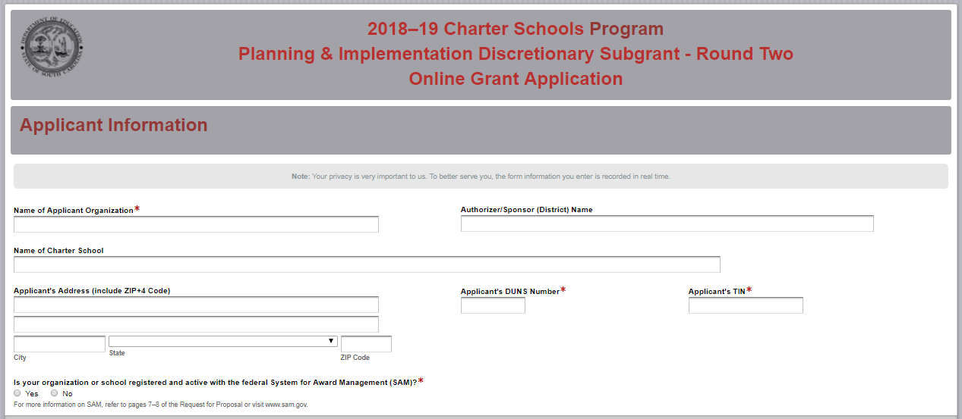
If the applicant selects “No” to indicate that they are not currently registered with SAM or that their status is inactive, the following message will be displayed. Refer to pages 7–8 or visit SAM.gov for more information.
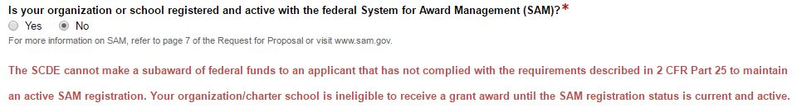

If the applicant is currently registered with SAM, enter the date your current SAM registration expires. Select whether the organization is applying for a Planning and Implementation or an Implementation Only subgrant. Also indicate if the organization is a targeted applicant or typical applicant (see definitions on page 2 and in appendix A. Definitions of Terms Used on page 34).
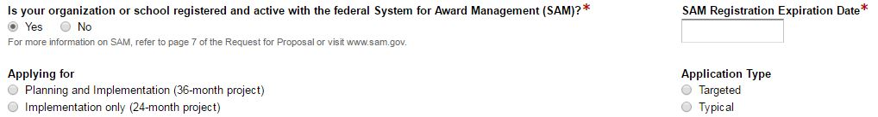

Enter the project director’s information. Select “Same as Applicant’s Address” if the project director’s mailing address is the same as the information entered on the first screen; the fields will automatically populate. If the address is different, enter the appropriate information. The project director’s e-mail is a required field and must be re-entered. The confirmation of a successful online application submission will be sent only to this e-mail address.
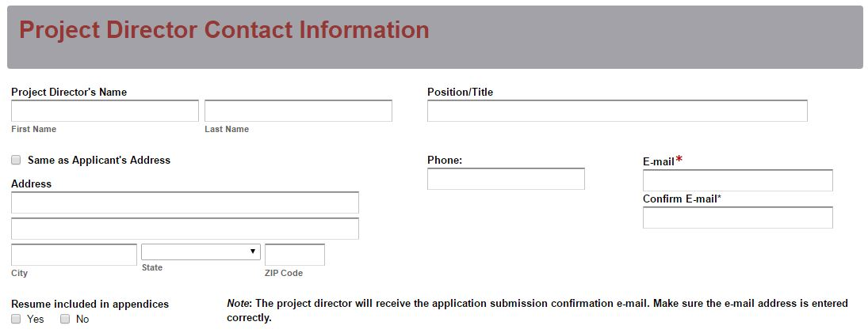

Select all competitive priority categories for which bonus points are sought and indicate the page number(s) in the proposal narrative where evidence can be found to support eligibility for each criteria. The fields for Competitive Priority 4 will only be displayed for targeted applicants.
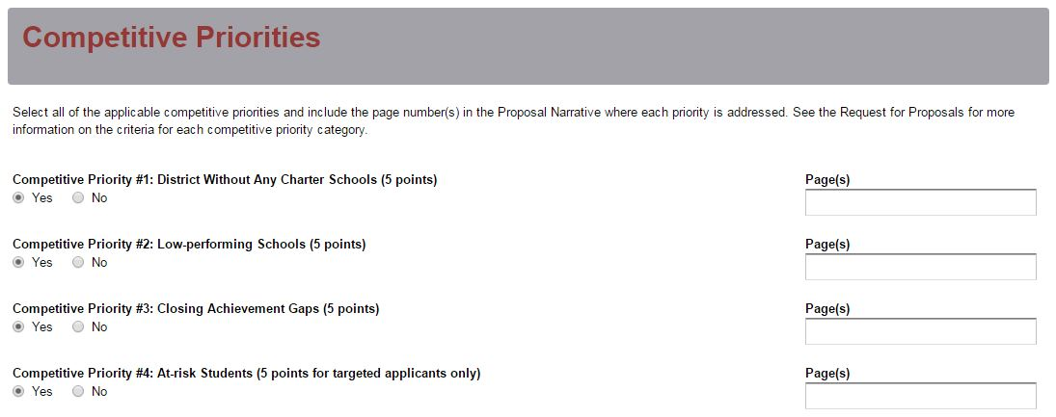

All amounts in the Funding Information and Budget Summary sections should be entered using whole dollars (no cents). Fill in all fields and enter zero (0) for line items that are not applicable. Enter the total estimated cost for all phases of the project. Enter the total amount of funding being requested for the first year of the project and the total in-kind or matching funds for the first year. Select the beginning and ending dates for phase one of the project.
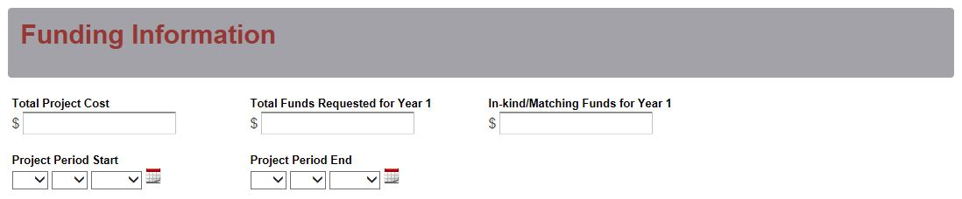

Enter the line item totals for funds requested for phase one. The Total Costs field will automatically calculate. This amount must match the total funds requested for year one above.
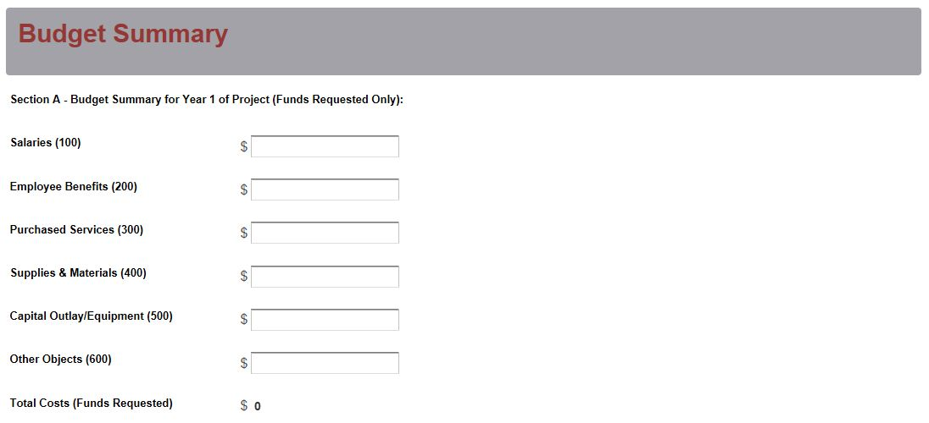
Enter the line item totals for the projected in-kind or matching funds for year one. The Total Costs field will automatically calculate. This amount must match the total in-kind/matching funds for year one under the Funding Information section.
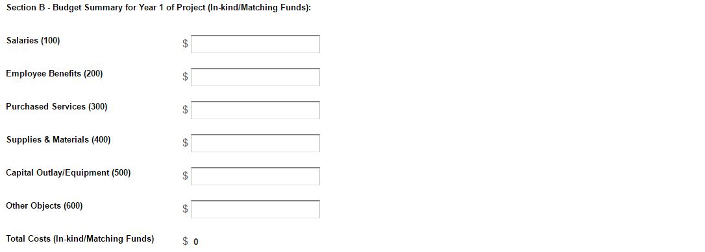

Prepare each of the proposal attachments (i.e., Project Abstract, Proposal Narrative, Budget Narrative, Appendices, and Pre-Award Audit Questionnaire) following the preceding instructions in this RFP. Ensure that each attachment is saved in the proper format as either a PDF or Excel document. Pay close attention to attachments that must be scanned together into a single document. The online application will only allow one document to be uploaded for each attachment. Upload the attachments where indicated in the following screenshot. All attachments are required; you will not be able to submit the application without uploading all five documents.
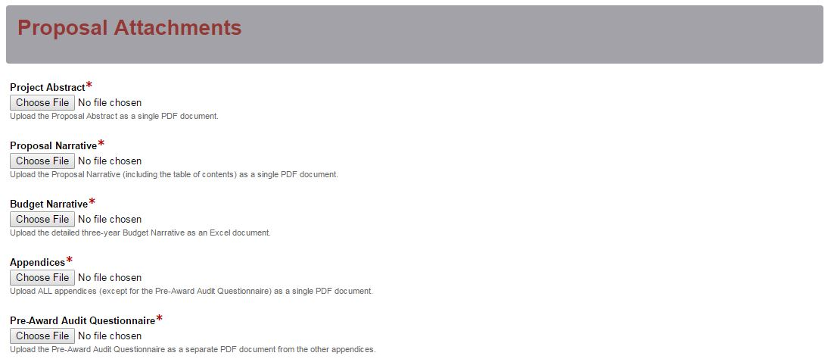

Thoroughly review the summary on the Data Review and Confirmation Page to verify that the information has been entered correctly in the online application prior to submitting. You will not be able to access the completed application form after it has been submitted. If any entries are incorrect, click on the "Previous" button at the bottom left corner of each screen to return to the appropriate section(s) and reenter the correct information. Then click on the “Next” button in the lower right corner of each screen to return to the Data Review and Confirmation Page. Note: This page is not a confirmation of the submission of an application.
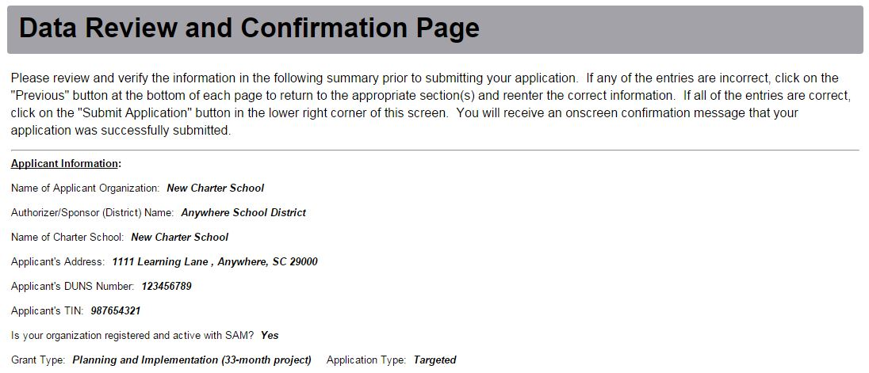

If all of the entries are correct, click on the "Submit Application" button in the lower right corner of this screen to complete the submission process.

Once the application is submitted, the following message will be displayed on the screen, and a submission confirmation will be sent to the e-mail address provided for the project director in the online application.
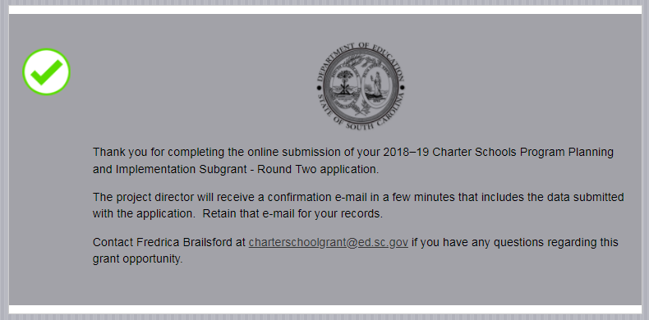

The following confirmation message will be sent to the e-mail address provided for the project director. If the project director does not receive a confirmation e-mail, then the application did not successfully transmit. You must go back and resubmit the entire online form, including all attachments, in order for your application to be considered for funding. Only the most recently submitted application will be reviewed.

An e-mail confirmation that the subgrant application was successfully submitted does not account for the quality of the uploaded documents or the completeness of the online form. The confirmation e-mail only notifies you that the online application has been submitted and received. Applicants are responsible for ensuring that the information entered in the online form, including all attachments, is accurate and complete in order for the application to be reviewed and considered for funding.

Appendix A: Definitions of Terms Used

An approved charter constitutes an agreement, the terms of which represent a contract between the charter school and the charter school sponsor (authorizer).

The authorizer, also known as the sponsor, is the South Carolina Public Charter School District (SCPCSD) Board of Trustees, the local school board of trustees in which the charter school is located, or, as provided by law, a public institution of higher education (IHE) as defined in Section 59-103–5, or an independent IHE as defined in Section 59-113-50, from which the charter school requested its charter and which granted approval for the charter school’s existence. Only those public or independent IHEs that register with the SCDE may serve as charter school authorizers (sponsors), and the SCDE shall maintain a directory of those institutions. The sponsor (authorizer) of a charter school is the charter school’s local education agency (LEA), and a charter school is a school within that LEA. The sponsor (authorizer) retains responsibility for special education and shall ensure that students enrolled in its charter schools are served in a manner consistent with LEA obligations under applicable federal, state, and local law.

The authorized financial official is the duly authorized representative of the charter committee who maintains the finances, signs financial documents, and affirms the committee’s commitment to carry out the tasks proposed for the amount requested. This person provides oversight and guidance on financial matters related to the subgrant. The authorized financial official for this project must not have a financial interest in any contract that will or may be awarded pursuant to this project.

The authorized official is the duly authorized representative of the charter committee who signs all subgrant documents submitted to the SCDE and certifies the application, assurances, and terms and conditions. The authorized official for this project must not have a financial interest in any contract that will or may be awarded pursuant to this project.

Available funds are determined by the CSP subgrant amount awarded to the SCDE, the number and types of subgrantees in each funding phase, and state performance on CSP benchmarks.

A benchmark is a standard that must be met to move to the next phase of subgrant funding. Examples of benchmarks include, but are not limited to, the following: (1) a report of major subgrant activities completed from the previous subgrant phase, (2) a revised budget for the next subgrant phase, (3) an approved charter, or (4) a schedule for obtaining a facility.

A charter school is a public, nonreligious, non-home-based, nonprofit corporation forming a school that operates with a public school district, the SCPCSD, or a registered IHE, but is accountable to the school board of trustees, or in the case of technical colleges, the area commission of the sponsor (authorizer) that grants its charter.

A high-quality charter school is a charter school that will show evidence of strong academic results for the past three years (or over the life of the school, if the school has been open for fewer than three years), based on the following factors:
(1) Increased student academic achievement and attainment (including, if applicable and available, high school graduation rates and college and other postsecondary education enrollment rates) for all students, including, as applicable, educationally disadvantaged students served by the charter school;
(2) Either—
(i) Demonstrated success in closing historic achievement gaps for the subgroups of students described in Section 1111(b)(2)(C)(v)(II) of the ESEA; or
(ii) No significant achievement gaps between any of the subgroups of students described in Section 1111(b)(2)(C)(v)(II) of the ESEA (20 U.S.C. 6311) at the charter school and significant gains in student academic achievement for all populations of students served by the charter school;
(3) Results (including, if applicable and available, performance on statewide tests, annual student attendance and retention rates, high school graduation rates, college and other postsecondary education attendance rates, and college and other postsecondary education persistence rates) for low-income and other educationally disadvantaged students served by the charter school that are above the average academic achievement results for such students in the state;
(4) Results on a performance framework established by the state or authorized public chartering agency for the purpose of evaluating charter school quality; and
(5) No significant compliance issues, particularly in the areas of student safety, financial management, and equitable treatment of students.

A secondary school is defined as any public school that contains grades no lower than seventh and no higher than twelfth (S.C. Code Ann. § 59-1-150).

A targeted applicant is a secondary charter school that targets at-risk students as defined in accordance with SBE Regulation 43-274.1 or is an Alternative Education Campus (AEC charter school with an explicit mission to serve an enrolled student population as defined in S.C. Code Ann. § 59-40-111).

A typical applicant is a charter school that does not meet the eligibility criteria for a targeted applicant.

Appendix B: Selection Criteria and Reviewers’ Scoring Rubric

Selection Criteria

Narrative Sections | Points Available
Section 1: The School and Its Stakeholders | 42
Section 2: Financial Sustainability | 28
Section 3: Governance and Management Plan | 30
Budget Summary and Narrative | 0
SUBTOTAL | 100
Competitive Priorities (Maximum bonus points available) | up to 20
TOTAL | 120

Appendix B: Reviewer’s Scoring Rubric
Project Abstract: The applicant must provide a double-spaced, one-page abstract of the project that includes project background, mission, intended audience, curriculum type, amount requested, any special features of the proposed school’s operation, and indicates any categories for which the applicant is seeking competitive priority points.
The application provides a detailed, one-page abstract that includes all of the following items:  - project background,  - mission,  - intended audience,  - curriculum type,  - amount of funds requested,  - special features of the proposed school’s operation, and  - the categories for which the applicant is seeking competitive priority points. |  |  | Acceptable |  |  | Adequate/Meets—0 points  Applicant provides a narrative that fully addresses all required items.
 |  |  | Not Acceptable |  |  | Inadequate—0 points  Applicant provides a narrative that does not adequately addresses all required items.
Reviewer’s Comments
1.a. School and Its Stakeholders—Mission of the Charter School and Relationship with Sponsor (authorizer): Applicant must state the mission of the new charter school, indicate any special features of the school’s operation or educational approach, describe the type of curriculum to be implemented, and describe the relationship between the school and its sponsor (authorizer).

In the required attachments, the applicant must provide a copy of the approval letter from the sponsor (authorizer), a copy of the notification sent to the sponsor (authorizer) indicating the applicant’s intent to apply for this CSP subgrant, and also provide proof of the applicant’s nonprofit status. Applicants that do not have an approval letter from their sponsor (authorizer) at the time of application should state such and include a letter from the prospective sponsor (authorizer) in the required attachments that states that the sponsor (authorizer) has received an application on behalf of the charter school group that is pending review.
Applicant provides a narrative that fully addresses all of the following items and the attachments include the required items:  - states the mission of the new charter school;  - indicates any special features of the school’s operation or educational approach;  - describes the type of curriculum to be implemented;  - describes the relationship between its sponsor (authorizer) and the charter school; and  - if applicable, states that the applicant does not have an approval letter from their sponsor (authorizer) at the time of application and includes a letter from the prospective sponsor (authorizer) in the required attachments that states that the sponsor (authorizer) has received an application on behalf of the charter school group that is pending review. |  |  | Acceptable |  |  | Fully Meets—8–10 points  Applicant provides a narrative that fully addresses all required items.
Adequate/Meets—6–7 points
Applicant provides a narrative that moderately addresses all required items.
 |  |  | Not Acceptable |  |  | Limited/Approaches—3–5 points  Applicant provides a narrative that is limited or unclear in addressing all required items.
Inadequate—0–2 points
Applicant provides a narrative that does not adequately address all required items.
Reviewer’s Comments
1.b. School and Its Stakeholders—Need for the Charter School: The applicant must include a clear statement of the need for a charter school in the designated district or location/region with specific supporting details (such as student test performance, demographics, local school performance); describe the target population to be served, including the grade levels and ages of students to be served; include a detailed description of the current opportunities available to the target population and the need for additional student learning opportunities; and state the anticipated benefits to students from the new charter school.
The applicant provides a narrative that addresses all of the following:  - clearly states the need for the charter school in the designated district or location/region with specific supporting details (such as student test performance, demographics, local school performance);  - describes the target population to be served including grade levels and ages of students to be served;  - describes in detail the current opportunities available to the target population;  - indicates the need for additional student learning opportunities; and  - states the anticipated benefits to students from the new charter school. |  |  | Acceptable |  |  | Fully Meets—8–10 points  Applicant provides a narrative that fully addresses all required items.
Adequate/Meets—6–7 points
Applicant provides a narrative that moderately addresses all required items.
 |  |  | Not Acceptable |  |  | Limited/Approaches—3–5 points  Applicant provides a narrative that is limited or unclear in addressing all required items.
Inadequate—0–2 points
Applicant provides a narrative that does not adequately address all required items.
Reviewer’s Comments
1.c. School and Its Stakeholders—Support for the Charter School: The applicant must clearly describe the degree of support for the charter school by individuals (parents) and partner organizations within the community and provide a letter of support from each partner organization and a summary list with signatures of all community supporters, including parents, in the required attachments.
The applicant provides a narrative that addresses the following narrative item and the attachments include the required items:  - describes the degree of support for the charter school and continuing involvement by individuals and partner organizations within the community; and  The attachments  - include a letter of support from each partner organization in the attachments; and  - include a summary list with signatures of community supporters, including parents, in the attachments. |  | Acceptable |  |  | Fully Meets—8–10 points  Applicant provides a narrative that fully addresses all required items.
Adequate/Meets—5–7 points
Applicant provides a narrative that moderately addresses all required items.
 |  | Not Acceptable |  |  | Limited/Approaches—2–4 points  Applicant provides a narrative that is limited or unclear in addressing all required items.
Inadequate—0–1 point(s)
Applicant provides a narrative that does not adequately address the required items.
Reviewer’s Comments
1.d. School and Its Stakeholders—Involvement in the Charter School: The applicant must explain how they will continue to involve individuals (parents) and partner organizations within the community; explain how these stakeholders will be involved in designing and implementing the new charter school; address innovative methods targeted to engage parents and community members in school planning and governance; describe the plan to inform students, parents, and the community about the charter school; and describe how students will be given an equal opportunity to attend the school.
The applicant provides a narrative that addresses all of the following:  - explains how they will continue to involve individuals and partner organizations within the community;  - explains how these stakeholders will be involved in designing and implementing the new school;  - addresses innovative methods targeted to parents and community members in school planning and governance;  - describes plans to inform students and parents and the community about the new school; and  - describes how students will be given an equal opportunity to attend the school. |  | Acceptable |  |  | Fully Meets—10–12 points  Applicant provides a narrative that fully addresses all required items.
Adequate/Meets—6–9 points
Applicant provides a narrative that moderately addresses all required items.
 |  | Not Applicable |  |  | Limited/Approaches—3–5 points  Applicant provides a narrative that is limited or unclear in addressing all required items.
Inadequate—0–2 points
Applicant provides a narrative that does not adequately address all required items.
Reviewer’s Comments
2.a. Financial Sustainability: The applicant must provide a clear and thoughtful plan for the financial viability of the charter school that includes evidence of a long-term, sound business plan based on an awareness of current funding for public schools, demonstrates the intent to maintain effective internal controls and fiscal management practices, and shows a reasonable promise of sustainability beyond the scope of the CSP subgrant.
The applicant provides a narrative that presents a clear and thoughtful plan for the financial viability of the charter school that includes all of the following:  - evidence of a long-term, sound business plan based on an awareness of current funding for public schools;  - the intent to maintain effective internal controls and fiscal management practices; and  - a reasonable promise of sustainability beyond the scope of the CSP subgrant. |  | Acceptable |  |  | Fully Meets—7–10 points  Applicant provides a narrative that fully addresses all required items.
Adequate/Meets—5–6 points
Applicant provides a narrative that moderately addresses all required items.
 |  | Not Acceptable |  |  | Limited/Approaches—3–4 points  Applicant provides a narrative that is limited or unclear in addressing all required items.
Inadequate—0–2 points
Applicant provides a narrative that does not adequately address all required items.
Reviewer’s Comments
2.b. Financial Sustainability: The applicant must include contingency plans to deal with unanticipated budget reductions due to shortfalls in federal, state, and/or local revenue; describe any public/private partnerships, including additional grant or funding opportunities; and, if applicable, describe how subgrant funds will be used in conjunction with funds from other federal programs administered by the USED.
The applicant provides a narrative that addresses all of the following:  - includes contingency plans to deal with unanticipated budget reductions due to shortfalls in federal, state, and/or local revenue;  - describes any public/private partnerships, including additional grant or funding opportunities; and  - if applicable, describes how subgrant funds will be used in conjunction with funds from other federal programs administered by the USED. |  | Acceptable |  |  | Fully Meets—6–8 points  Applicant provides a narrative that fully addresses all required items.
Adequate/Meets—4–5 points
Applicant provides a narrative that moderately addresses all required items.
 |  | Not Acceptable |  |  | Limited/Approaches—2–3 points  Applicant provides a narrative that is limited or unclear in addressing all required items.
Inadequate—0–1 point(s)
Applicant provides a narrative that does not adequately address all required items.
Reviewer’s Comments
2.c. Financial Sustainability: The applicant must justify the proposed three-year budget and address how they arrived at the selected items to be purchased, how the items directly correlate to the school’s educational plan, how the cost per item was calculated, and how the budget items will supplement, not supplant, other revenue sources available to the charter school.
The applicant provides a narrative to justify the proposed three-year budget that addresses all of the following:  - how they arrived at the selected items to be purchased;  - how the items directly correlate to the school’s educational plan;  - how the cost per item was calculated; and  - how budget items will supplement, not supplant, other revenue sources available to the charter school. |  | Acceptable |  |  | Fully Meets—8–10 points  Applicant provides a detailed narrative to justify the proposed three-year budget that fully addresses all required items.
Adequate/Meets—6–7 points
Applicant provides a detailed narrative to justify the proposed three-year budget that moderately addresses all required items.
 |  | Not Acceptable |  |  | Limited/Approaches—4–5 points  Applicant provides a detailed narrative to justify the proposed three-year budget that is limited or unclear in addressing all required items.
Inadequate—0–3 points
Applicant provides a detailed narrative to justify the proposed three-year budget that does not adequately address all required items.
Reviewer’s Comments
3.a. Governance & Management Plan: The applicant must convey clearly and explicitly a plan to manage the charter school and the subgrant and describe the school’s founders, the school’s governance plans, and the board’s plan for school management and leadership, including, if applicable, plans to enter into a management or other comprehensive service agreement/contract.
The applicant provides a narrative that addresses all of the following:  - conveys a clear and explicit plan to manage the charter school and the subgrant;  - describes the school’s founders;  - describes the school’s governance plans;  - describes the board’s plans for school management and leadership; and  - if applicable, includes plans to enter into a management or other comprehensive service agreement/contract. |  | Acceptable |  |  | Fully Meets—7–8 points  Applicant provides a narrative that fully addresses all required items.
Adequate/Meets—5–6 points
Applicant provides a narrative that moderately addresses all required items.
 |  | Not Acceptable |  |  | Limited/Approaches—3–4 points  Applicant provides a narrative that is limited or unclear in addressing all required items.
Inadequate—0–2 points
Applicant provides a narrative that does not adequately address all required items.
Reviewer’s Comments
3.b. Governance & Management Plan: The applicant must thoroughly describe the project director’s responsibilities and duties in managing the subgrant to accomplish the charter school’s objectives and include, in the required attachments, an organizational chart indicating the chain of command and lines of direct report and roles of the school committees and advisory groups. The attachments must also include either the qualifications and credentials for the project director position or, if the project director is already identified, their résumé.
The applicant provides a narrative that addresses the following narrative item and the attachments include the required items:  - describes the project director’s responsibilities and duties in managing the subgrant to achieve the charter school’s objectives;  - includes, as an attachment, an organizational chart indicating the chain of command and lines of direct report and the roles of the school committees and advisory groups; and  - includes, as an attachment, either the qualifications and credentials for the project director position or the identified project director’s résumé. | Acceptable |  |  | Fully Meets—6–7 points  Applicant provides a narrative that fully addresses all required items.
Adequate/Meets—4–5 points
Applicant provides a narrative that moderately addresses all required items.
 | Not Acceptable |  |  | Limited/Approaches—2–3 points  Applicant provides a narrative that is limited or unclear in addressing all required items.
Inadequate—0–1 point(s)
Applicant provides a narrative that does not adequately address all required items.
Reviewer’s Comments
3.c. Governance & Management Plan: The applicant must explain how the charter school’s planning initiative and the resulting charter school will be managed and include an assurance, with a timeframe and a lead contact, that the subgrantee will provide annual information to the USED and the SCDE as required to determine if the charter school is making satisfactory progress toward achieving its objectives. As a required attachment, the applicant must provide a projected timeline/work plan of proposed major subgrant activities (e.g., community meetings, professional development activities, lottery if the school is oversubscribed, opening of charter school, election of governing board) and indicate the person(s) responsible for oversight and completion of each activity.
The applicant provides a narrative that addresses all of the following narrative items and the attachments include the required item:  - explains how the charter school’s planning initiative and the resulting charter school will be managed;  - includes an assurance, with a timeframe and a lead contact, that the subgrantee will provide annual information to the USED and the SCDE as required to determine if the charter school is making satisfactory progress toward achieving its objectives; and  - includes, as an attachment, a projected timeline/workplan of proposed major subgrant activities (e.g., community meetings, professional development activities, lottery if the school is oversubscribed, opening of charter school, election of governing board) and indicates the person(s) responsible for oversight and completion of each activity. | Acceptable |  |  | Fully Meets—7–8 points  Applicant provides a narrative that fully addresses all required narrative items and the attachments include the required item.
Adequate/Meets—5–6 points
Applicant provides a narrative that moderately addresses all required narrative items and the attachments include the required item.
 | Not Acceptable |  |  | Limited/Approaches—3–4 points  Applicant provides a narrative that is limited or unclear in addressing all required narrative items and the attachments include the required item.
Inadequate—0–2 points
Applicant provides a narrative that does not adequately address all required narrative items or the attachments do not include the required item.
Reviewer’s Comments
3.d. Governance & Management Plan: The applicant must describe how the sponsor (authorizer) for the charter school will comply with sections 613(a)(5) and 613 (e)(1)(B) of the IDEA, the Age Discrimination Act of 1975 (42 U.S.C. 6101, et seq.), title VI of the Civil Rights Act of 1964 (42 U.S.C. 2000d, et seq.), title IX of the Education Amendments of 1972 (20 U.S.C.16891, et seq.), and section 504 of the Rehabilitation Act of 1973 (29 U.S.C. 794) in the operation of the charter school and demonstrate an understanding of and the capacity to comply with the South Carolina Charter School Act, including strong board governance and stakeholder engagement.
The applicant provides a narrative that addresses all of the following:  - describes how the sponsor (authorizer) for the charter school will comply with sections 613(a)(5) and 613(e)(1)(B) of the IDEA, the Age Discrimination Act of 1975, title VI of the Civil Rights Act of 1964 , title IX of the Education Amendments of 1972, and section 504 of the Rehabilitation Act of 1973 in the operation of the charter school;  - demonstrates an understanding of and the capacity to comply with the South Carolina Charter School Act; and  - includes evidence of strong board governance and stakeholder engagement. | Acceptable |  |  | Fully Meets—6–7 points  Applicant provides a narrative that fully addresses all required items.
Adequate/Meets—4–5 points
Applicant provides a narrative that moderately addresses all required items.
 | Not Acceptable |  |  | Limited/Approaches—2–3 points  Applicant provides a narrative that is limited or unclear in addressing all required items.
Inadequate—0–1 point(s)
Applicant provides a narrative that does not adequately address all required items.
Reviewer’s Comments
Budget Narrative: The applicant must provide a Budget Narrative that calculates correctly, includes all formulas used to calculate line-item expenses, and provides clear evidence that the proposed expenditures are appropriate, justified, reasonable, and adequate to support the proposed allowable activities to complete the project.
The applicant provides a thorough and detailed budget narrative that  - calculates correctly;  - includes all formulas used to calculate line-item expenses; and  - provides clear evidence that the proposed expenditures are appropriate, justified, reasonable, and adequate to support the proposed allowable activities to complete the project. | Acceptable |  |  | Adequate/Meets—0 points  Applicant provides a budget narrative that provides all required items.
 | Not Acceptable |  |  | Inadequate—0 points  Applicant provides a budget narrative that did not provide all required items.
Reviewer’s Comments

Appendix C: Required SCDE Forms

Certification Signature Page

Certification
I hereby certify that, to the best of my knowledge, the information and data contained in this application are true and correct. The applicant’s governing body has duly authorized this application and documentation, and the applicant will comply with the Program Specific Assurances and the SCDE Assurances and Terms and Conditions for Federal Subawards if the subgrant is awarded. The applicant is registered and current (active) on the federal System for Award Management (SAM).

Charter schools must provide evidence of improved student academic achievement for all groups of students described in Section 1111(b)(2)(C)(v) of the ESEA. Authorizers (sponsors) must use increases in student academic achievement for all groups of students described in Section 1111(b)(2)(C)(v) of the ESEA as the most important factor when determining to renew or revoke a school’s charter. Each sponsor (authorizer) and charter school must enter a contractual agreement stating that student performance of all students described in Section 1111(b)(2)(C)(v) of the ESEA is the most important factor when determining to renew or revoke a school’s charter.

Authorized Official Representative (duly authorized representative of charter committee)
Name:
Position: | E-mail:
Telephone: | Fax:

Signature of Authorized Official Representative: | Date:

Authorized Financial Official
Name:
Position: | E-mail:
Telephone: | Fax:

Signature of Authorized Financial Official: | Date:

Please complete, print, and obtain signatures prior to submission. Include the signed, scanned form in the Required Appendices as indicated on page 25.

Assurances and Terms and Conditions for Federal Subawards

Assurances

- Has the legal authority to apply for federal assistance and the institutional, managerial, and financial capability (including funds sufficient to pay the nonstate share of project costs) to ensure proper planning, management, and completion of the project described in this application.
- Will give the South Carolina Department of Education (SCDE) access to and the right to examine all records, books, papers, or documents related to this award and will establish a proper accounting system in accordance with generally accepted accounting principles (GAAP) or agency directives.
- Has an accounting system with sufficient internal controls, a clear audit trail, and written cost-allocation procedures as necessary. The financial management systems are capable of distinguishing expenditures that are attributable to this grant from those that are not attributable to this grant. This system is able to identify costs by programmatic year and by budget line item and to differentiate among direct, indirect, and administrative costs. In addition, the applicant will maintain adequate supporting documents for the expenditures (federal and nonfederal) and in-kind contributions, if any, that it makes under this grant. Costs are shown in books or records (e.g., disbursements ledger, journal, payroll register) and are supported by a source document such as a receipt, travel voucher, invoice, bill, or in-kind voucher.
- Will also comply with the Office of Management and Budget 2 CFR Part 200 Subpart E-Cost Principles related to the allowability, reasonableness, and allocability of costs consistent with the approved budget and also by maintaining required support for salaries and wages. Required support includes certifications and/or personnel activity records depending upon the amount of time spent on cost objectives.
- Will approve all expenditures, document receipt of goods and services, and record payments on the applicant’s accounting records prior to submission of reimbursement claims to the SCDE for costs related to this grant.
- Will initiate and complete work within the applicable time frame after receipt of approval by the SCDE.
- Will not discriminate against any employee or applicant for employment because of race, color, religion, age, sex, national origin, or disability and comply with Title VI of the Civil Rights Act of 1964, Section 504 of the Rehabilitation Act of 1973, Title IX of the Education Amendments of 1972, the Age Discrimination Act of 1975, and Titles I, II, and III of the Americans with Disabilities Act of 1990 (ADA). The grantee will take affirmative action to ensure that applicants for employment and the employees during the period of their employment are treated without regard to their race, color, religion, age, sex, national origin, or disability.
- Has no policy that prevents, or otherwise denies, participation in constitutionally protected prayer in public schools as set forth in the Guidance on Constitutionally Protected Prayer in Public Education (20 U.S.C. § 7904).
- Will comply with the Family Educational Rights and Privacy Act. (20 U.S.C. §1232g; 34 CFR Part 99).
- Will comply with the Ethics, Government Accountability, and Campaign Reform Act (S.C. Code Ann. § 2-17-10 et seq. and § 8-13-100 et seq. (Supp. 2017)).
- Will comply with the South Carolina Drug Free Workplace Act (S.C. Code Ann. § 44-107-10 et seq. (Supp. 2017) if the amount of this award is $50,000 or more and the federal Drug Free Workplace Act of 1988 (41 USC 702).
- Will provide information to the SCDE, as requested, regarding the reporting requirements of the Federal Funding Accountability and Transparency Act (FFATA), which requires the SCDE to file a FFATA subaward report by the end of the month following the month in which it awards any subgrant equal to or greater than $25,000.
- Will comply with 2 CFR Part 25 and register and receive a unique entity identifier, fulfill the requirement for the System for Award Management, maintain the currency of the registration throughout the full grant term, and allow access by the granting agency to ensure compliance.
- Will comply with 2 CFR Part 200.112 and disclose in writing any potential conflict of interest to the SCDE.
- Will comply with 2 CFR Part 200.113 and disclose in writing to the SCDE all violations of federal criminal law involving fraud, bribery, or gratuity violations potentially affecting the federal award.
- Will comply with conditions under Executive Order 13513 “Federal Leadership on Reducing Text Messaging While Driving” (October 1, 2009) by refraining from text messaging while driving during official grant business.

Terms and Conditions

- Completeness of Proposal. All proposals should be complete and carefully worded and must contain all of the information requested by the South Carolina Department of Education (SCDE). If you do not believe a section applies to your proposal, please indicate that fact.
- Non-awards/Termination. The SCDE reserves the right to reject any and all applications and to refuse to grant monies under this solicitation. If the SCDE rejects an application, the applicant has a right to request a hearing, as provided by 2 CFR Part 200.341 and 34 CFR Part 76.401, if it alleges the SCDE’s actions violate a state or federal statute or regulation by (1) disapproving of or failing to approve the application or project, in whole or in part, or (2) failing to provide funds in amounts in accordance with the requirements of statutes and regulations.
After it has been awarded, the SCDE may terminate a grant by giving the grantee written notice of termination. In the event of a termination after award, the SCDE shall reimburse the grantee for allowable expenses incurred up to the notification of termination. In addition, this grant may be terminated by the SCDE if the grantee fails to perform as promised in its proposal. Federal grants will be terminated in accordance with 2 CFR Part 200.339 and 200.340.
In the event that this grant is terminated, the grantee shall have a right to a hearing as set forth in 34 CFR Part 76.783. The grantee must notify the SCDE of its request for a hearing within 30 days of receiving written notice of the termination. If a hearing is requested, the SCDE will conduct the hearing in accordance with the procedures outlined in 34 CFR Part 76.401(d)(2)–(7).
- Reduction in Budgets and Negotiations. The SCDE reserves the right to negotiate budgets with applicants. The SCDE may, at its sole discretion, determine that a proposed budget is excessive and may negotiate a lower budget with the applicant. The applicant may at that time negotiate or withdraw its proposal. In addition, the SCDE may desire to fund a project but not at the level proposed. In that case, the SCDE shall notify the applicant of the amount that can be funded, and the applicant and the SCDE shall negotiate a modification to the proposal to accommodate the lower budget. All final decisions are that of the SCDE.
- Amendments to Grants. Amendments are permitted generally for budgets, grant end date, and management upon the mutual agreement of the parties involved and will become effective when specified in writing and signed by both parties. However, amendments to scope of work that significantly alter the original application proposal may trigger partial or full termination consistent with 2 CFR Part 200.339 and 200.340.
- Use of Grant Funds. Funds awarded are to be expended only for purposes and activities covered by the approved project plan and approved budget and budget narrative.
- Submission of Expenditure Reports. Claims for reimbursement must be made at least quarterly and consistent with calendar quarters (e.g., an expenditure report claim for costs for January 1 through March 30 must be filed by May 15).
- Obligation of Grant Funds. Grant funds may not be obligated prior to the effective date or subsequent to the end or termination date of the grant period. No obligations are allowed after the end of the grant period. The final request for expenditure report claims must be submitted no later than thirty (30) days after the end of the grant period.
- Deobligation of Funds. After a final expenditure report claim has been submitted to the SCDE, the grantee will go through the official deobligation process with the SCDE.
- Documentation. The grantee must provide for accurate and timely recording of receipts and expenditures. The grantee’s accounting system should distinguish receipts and expenditures attributable to each grant. The grantee must review the memo regarding “Guidelines for Retaining Documentation to Support Expenditure Claims.”
- Travel Costs. Travel costs, if allowed under this solicitation, must not exceed limits noted in the United States General Services Administration regulations for lodging. Meals and incidentals are limited by the state budget proviso, currently not to exceed $25 per day for in-state travel and $32 for out-of-state travel (see page 91 of the State of South Carolina Statewide Disbursement Regulations). Mileage reimbursement must follow the current Office of Comptroller General instructions, which is consistent with the published IRS rates.
- Honoraria. Amounts paid in honoraria, if allowed under this grant, must be consistent with SCDE policies. Applicants should check with the program office before budgeting for honoraria.
- Reports. The grantee shall submit, as required or instructed by the awarding program office, all reports (programmatic, financial, or evaluation) within the specified period or date and in the prescribed format. An expenditure claim report must be filed by August 15 for all expenditures incurred by June 30 in order to comply with the generally accepted accounting principles (GAAP) and the production of the State's Comprehensive Annual Financial Report.
- Copyright. The grantee is free to copyright any books, publications, or other copyrightable materials developed in the course of this grant. However, the SCDE reserves a royalty-free, nonexclusive, and irrevocable license to reproduce, publish, or otherwise use, and to authorize others to use, the copyrighted work developed under this grant.
- Certification Regarding Lobbying, Suspension, and Debarment. By submitting an application, the applicant certifies, to the best of its knowledge and belief, that the
- Applicant and/or any of its principals, subgrantees, or subcontractors
  - Have not paid or will not pay to any person any federally appropriated funds for the purpose of influencing or attempting to influence an officer or employee of any agency, a Member of Congress, an officer or employee of Congress, or any employee of a Member of Congress in connection with making any federal grant and the extension continuation, renewal, amendment, or modification of any federal grant, as defined at 34 CFR Part 82.105 and 82.110. If any funds other than federally appropriated funds have been paid or will be paid to any person for influencing or attempting to influence an officer or employee of any agency, a Member of Congress, an officer or employee of Congress, or any employee of a Member of Congress in connection with this federal grant, the undersigned shall complete and submit Standard Form LLL, “Disclosure of Lobbying Activities,” in accordance with its instructions.
  - Are not presently debarred, suspended, proposed for debarment, or declared ineligible for the award of contracts by any state or federal agency as stated at 2 CFR Part 180 or 2 CFR Part 3485.
  - Have not, within a three-year period preceding this application, been convicted of or had a civil judgment rendered against them for commission of fraud or a criminal offense in connection with obtaining, attempting to obtain, or performing a public (federal, state, or local) contract or subcontract; violated federal or state antitrust statutes relating to the submission of offers; or committed embezzlement, theft, forgery, bribery, falsification or destruction of records, making false statements, tax evasion, or receiving stolen property.
  - Are not presently indicted for, or otherwise criminally or civilly charged by a governmental entity with, commission of any of the offenses enumerated above.
- Applicant has not, within a three-year period preceding this application, had one or more contracts terminated for default by any public (federal, state, or local) entity.
- Audits.
- Entities expending $750,000 or more in federal awards:
Entities that expend $750,000 or more in federal awards during the fiscal year are required to have an audit performed in accordance with the provisions of 2 CFR Part 200.501, et seq. Except for the provisions for biennial audits provided in 2 CFR Part 200.504 (a) and (b), audits must be performed annually as stated at 2 CFR Part 200.504. A grantee that passes through funds to subrecipients has the responsibility of ensuring that federal awards are used for authorized purposes in compliance with federal program laws, federal and state regulations, and grant agreements. The director of the OMB, who will review this amount every two years, has the option of revising the threshold upward.
- Entities expending less than $750,000 in federal awards:
Entities that expend less than $750,000 in a fiscal year in federal awards are exempt from the audit requirements in 2 CFR Part 200.504. However, such entities are not exempt from other federal requirements (including those to maintain records) concerning federal awards provided to the entity. The entity’s records must be available for review or audit by the SCDE and appropriate officials of federal agencies, pass-through entities, and the General Accounting Office (GAO).
- Records. The grantee shall retain federal grant records, including financial records and supporting documentation, for a minimum of six (6) years after the end date of the grant when the final expenditure report claim for reimbursement and all final reports have been submitted, unless informed otherwise or in the case of litigation.
- Electronic Signature Agreement. I agree that my electronic signature is the legally binding equivalent to my handwritten signature.

Program Specific Assurances
For informational purposes only
The applicant agrees to abide by the SCDE Program Specific Assurances by signing and submitting the Certification Signature Page.

The applicant ensures that it will

- Use the Planning and Implementation subgrant to plan and implement a charter school that aligns with the intent of the SC Charter School Act.
- Comply with the US Department of Education (USED) Assurance 3B which indicates that charter schools must provide evidence of improved student academic achievement for all groups of students described in Section 1111(b)(2)(C)(v) of the Elementary and Secondary Education Act (ESEA). Authorizers (sponsors) must use increases in student academic achievement for all groups of students described in Section 1111(b)(2)(C)(v) of the ESEA as the most important factor when determining to renew or revoke a school’s charter. Each sponsor (authorizer) and charter school must enter into a contractual agreement stating that student performance of all students described in Section 1111(b)(2)(C)(v) of the ESEA is the most important factor when determining whether to renew or revoke a school’s charter.
- Comply with the non-regulatory guidance handbook (updated January 2014), regarding expenditures being allocable, allowable, and reasonable as determined by the USED.
- Comply with 2 CFR § 200.439 when purchasing equipment or disposing of equipment purchased with Planning and Implementation funds.
- Comply with all guidelines for meeting stated benchmarks in a time-sensitive manner.

OMB Control No. 1894-0005 (Exp. 04/30/2020)

Instructions for GEPA Statement of Compliance

The purpose of this enclosure is to inform you about a new provision in the Department of Education's General Education Provisions Act (GEPA) that applies to applicants for new grant awards under Department programs. This provision is Section 427 of GEPA, enacted as part of the Improving America's Schools Act of 1994 (Public Law (P.L.) 103-382).

To Whom Does This Provision Apply?
Section 427 of GEPA affects applicants for new grant awards under this program. All applicants for new awards must include information in their applications to address this new provision in order to receive funding under this program.

What Does This Provision Require?
Section 427 requires each applicant for funds (other than an individual person) to include in its application a description of the steps the applicant proposes to take to ensure equitable access to, and participation in, its federally assisted program for students, teachers, and other program beneficiaries with special needs. This provision allows applicants discretion in developing the required description. The statute highlights six types of barriers that can impede equitable access or participation: gender, race, national origin, color, disability, or age. Based on local circumstances, you should determine whether these or other barriers may prevent your students, teachers, etc. from such access or participation in the federally funded project or activity. The description in your application of steps to be taken to overcome these barriers need not be lengthy; you may provide a clear and succinct description of how you plan to address those barriers that are applicable to your circumstances. In addition, the information may be provided in a single narrative, or, if appropriate, may be discussed in connection with related topics in the application.

Section 427 is not intended to duplicate the requirements of civil rights statutes, but rather to ensure that, in designing their projects, applicants for federal funds address equity concerns that may affect the ability of certain potential beneficiaries to fully participate in the project and to achieve to high standards. Consistent with program requirements and its approved application, an applicant may use the federal funds awarded to it to eliminate barriers it identifies.

What are Examples of How an Applicant Might Satisfy the Requirement of This Provision?
The following examples may help illustrate how an applicant may comply with Section 427.
- An applicant that proposes to carry out an adult literacy project serving, among others, adults with limited English proficiency might describe in its application how it intends to distribute a brochure about the proposed project to such potential participants in their native language.
- An applicant that proposes to develop instructional materials for classroom use might describe how it will make the materials available on audio tape or in Braille for students who are blind.
- An applicant that proposes to carry out a model science program for secondary students and is concerned that girls may be less likely than boys to enroll in the course might indicate how it intends to conduct "outreach" efforts to girls to encourage their enrollment.
- An applicant that proposes a project to increase school safety might describe the special efforts it will take to address concern of lesbian, gay, bisexual, and transgender students, and efforts to reach out to and involve the families of LGBT students.

We recognize that many applicants may already be implementing effective steps to ensure equity of access and participation in their grant programs, and we appreciate your cooperation in responding to the requirements of this provision.
Estimated Burden Statement for GEPA Requirements
According to the Paperwork Reduction Act of 1995, no persons are required to respond to a collection of information unless such collection displays a valid OMB control number. Public reporting burden for this collection of information is estimated to average 1.5 hours per response, including time for reviewing instructions, searching existing data sources, gathering and maintaining the data needed, and completing and reviewing the collection of information. The obligation to respond to this collection is required to obtain or retain benefit (Public Law 103-382. Send comments regarding the burden estimate or any other aspect of this collection of information, including suggestions for reducing this burden, to the U.S. Department of Education, 400 Maryland Ave., SW, Washington, DC 20210-4537 or email ICDocketMgr@ed.gov and reference the OMB Control Number 1894-0005.

Request for Taxpayer Identification Number and Certification
Visit the IRS website for an easy-to-complete version of this form
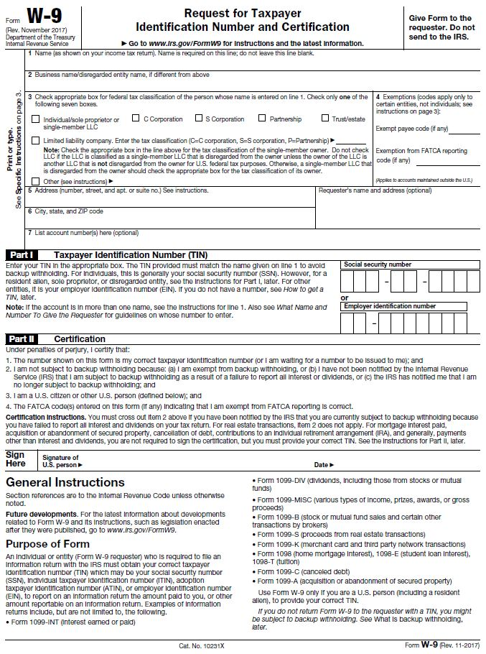

SCDE Pre-Award Audit Questionnaire for Non-LEAs
Visit the SCDE’s Office of Auditing Services website to access the Pre-Award Audit Questionnaire for Non-LEAs.
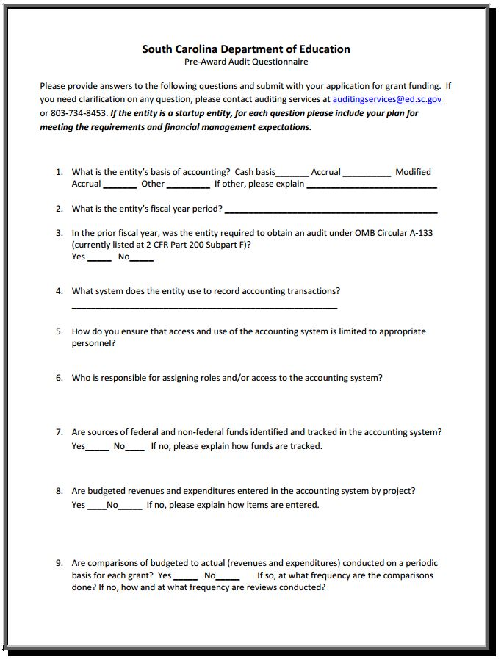
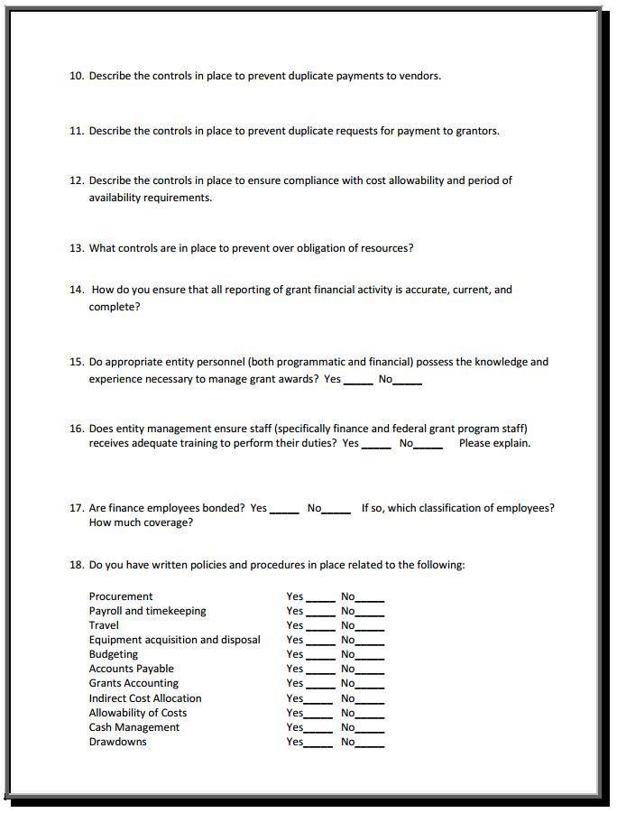
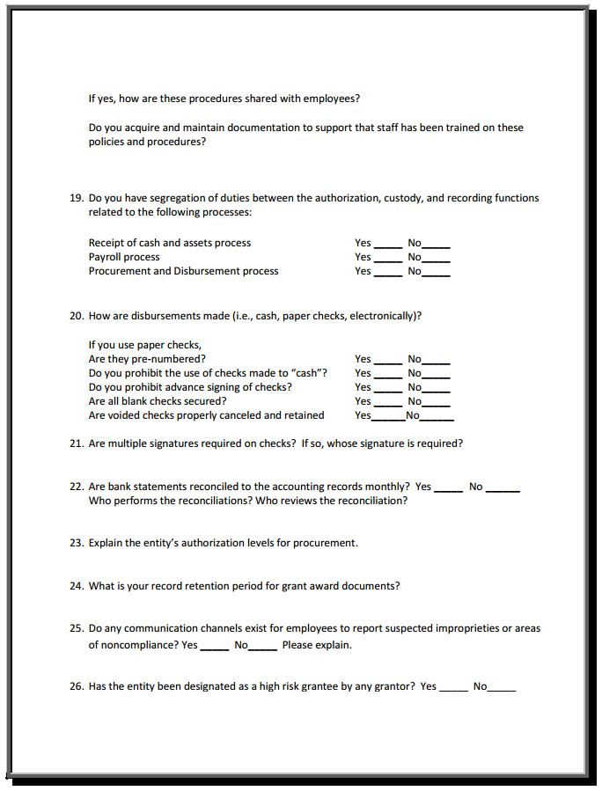
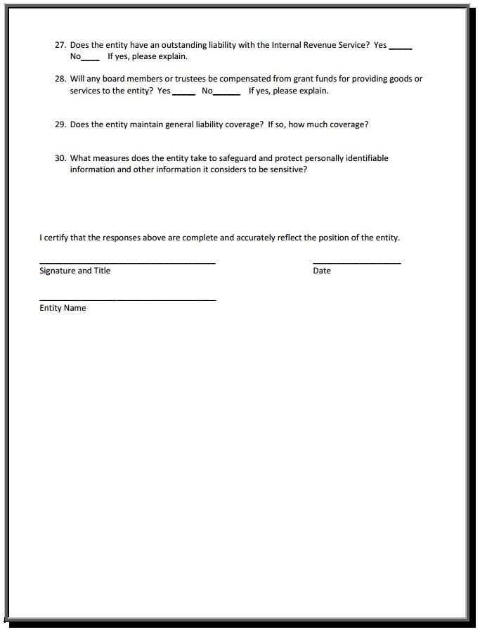
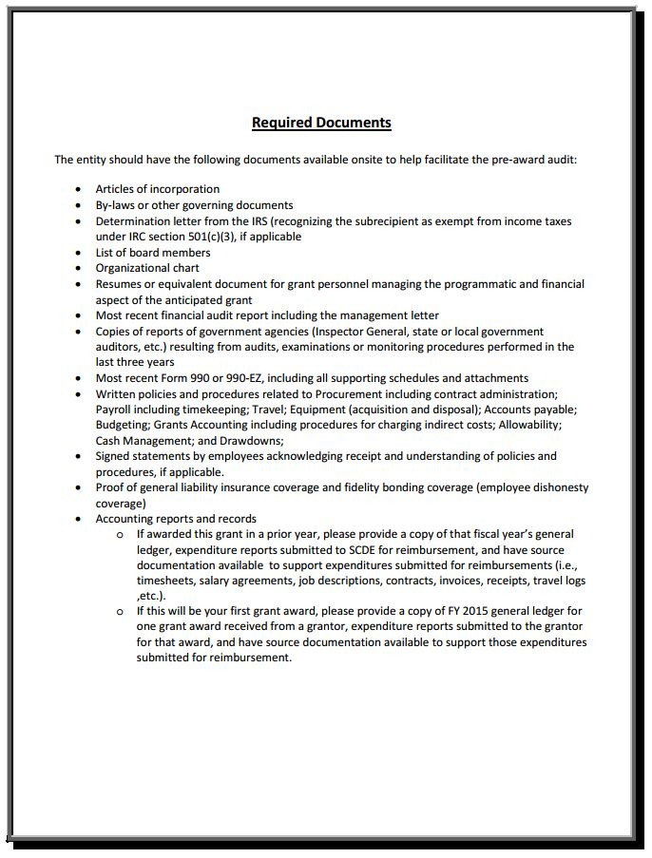

Timeline of Activities/Workplan Chart

Project Goal: To open and operate a high-quality charter school

Planning vs. Implementation: Subgrantees have, at a minimum, 9 months for Planning with a maximum of 18 months. Implementation Phase 1 charter schools will have 12 months and Implementation Phase 2 charter schools may have from 3 to 12 months depending on the remaining time; 24 months is the maximum period of time for the Implementation phase. Subgrant awards may range from 33 months to a maximum total of 36 months. Implementation Phase 1 begins when the doors open to students. Please indicate the Planning and Implementation periods below:

Planning: _________________________________________

Implementation: ________________________________________

Anticipated Date of Charter School Opening: _________________________________________

Activity | Budget Item | Amount of Funds (must align to Object Codes) | Timeline | Budget Justification
Complete the table below based on the proposed plan (tab to add rows).

