Request for Proposals (RFP)
Application Package

National School Lunch Program Equipment Assistance Subgrant
2018–20 Competitive Subgrant

The Fiscal Year 2018 National School Lunch Program Equipment Assistance Subgrant
is funded by the U.S. Department of Agriculture, authorized by
the Fiscal Year 2018 Agriculture Appropriations Act, and administered by
the South Carolina Department of Education.
CFDA 10.579 (Child Nutrition Discretionary Grants Limited Availability)

Deadline for Receipt of Applications: December 14, 2018, at 5:00 p.m.

Technical Assistance Webinar for Applicants: November 14, 2018

For National School Lunch Program Equipment Assistance and RFP questions, contact:
Heather B. Snelgrove, Education Associate
803-734-0699, hsnelgrove@ed.sc.gov

Issued by:
South Carolina Department of Education
Office of Health and Nutrition
1429 Senate Street, Suite 701-A
Columbia, SC 29201

TABLE OF CONTENTS

PART I: General Information 1
A. Introduction and Purpose 1
B. Eligible Applicants 1
C. Timeline of Subgranting Process 2
D. Technical Assistance Session for Applicants 2
E. Statutory and Other Requirements 2
F. Authorized Activities 5
G. Unauthorized Activities 6
H. Program Accountability and Monitoring 6
I. Fiscal Operations 9
J. Supplement, Not Supplant 10
K. Review and Selection Process 10
L. Appeals Process 11

PART II: Application Overview, Content, and Instructions 12
A. Application Overview 12
B. Application Narrative Format 12
C. Online Application 13
D. Application Narrative Content 13
1. Needs Statement 13
2. Focus Area(s) 14
3. Management and Sustainability 14
E. Budget 15
F. Appendices 15
G. Deadline and Submission Procedures 16
H. Screenshots of Online Application Submission Forms 16

Appendix A: Definitions of Terms Used 23

Appendix B: Selection Criteria and Reviewers’ Scoring Rubric 24

Appendix C: Required SCDE Forms 28
Certification Signature Page 28
Assurances and Terms and Conditions for U.S. Department of Agriculture Subawards 29
Equipment Specifications Form 33
Pre-Award Audit Questionnaire for LEAs and State Agencies 34
Monthly Performance Report Sample 38

Appendix D: Optional Forms and Information 40
Timeline of Activities Template—NSLP Equipment Assistance Grant Program 40
Schools and SFAs that Received Prior NSLP Equipment Subgrant Awards 41

PART I: General Information

Introduction and Purpose

The U.S. Department of Agriculture (USDA) has allocated $526,963 from the Fiscal Year (FY) 2018 Agriculture Appropriations Act to South Carolina for the National School Lunch Program (NSLP) Equipment Assistance Subgrants to School Food Authorities (SFA). The South Carolina Department of Education (SCDE) will award equipment assistance subgrants through a competitive process to eligible SFAs that participate in the NSLP.

The purpose of this program is to enable SFAs to purchase equipment to serve healthier meals that meet the updated meal patterns with an emphasis on more fruits and vegetables in school meals, including items purchased locally; improved food safety; and expanded access. This year, these funds will allow SFAs to purchase equipment needed to serve healthier school meals, improve food safety, improve energy efficiency, and expand access to school meals. Therefore, applicants must address all four focus areas for this funding round. The focus areas are detailed in section F Authorized Activities (see page 5).

Priority will be given to equipment requests from eligible high-need schools (i.e., schools in underserved areas, schools with limited access to other resources, and schools with aging food service equipment) in which at least 50 percent of the enrolled students are eligible for free or reduced-price meals (district-wide percentages will not be used).

Approximately $526,963 will be available for new subgrants. The SCDE anticipates awarding between 20 to 40 subgrants with award amounts per school ranging from $15,000 to $25,000. No subgrant will be awarded for more than $25,000; the balance for equipment costs exceeding this limit will be the responsibility of the SFA. Final award amounts will be determined based on the quality of applications received and total funding requested by all approved applicants. All subgrant awards are contingent upon total allocations to the SCDE by the USDA.

All equipment must be purchased and installed and funds expended by June 30, 2020.

Eligible Applicants

An SFA may apply for a subgrant on behalf of its schools that
- currently participate in the NSLP;
- did not receive equipment assistance under the American Recovery and Reinvestment Act of 2009 and the FY 2010, FY 2013, FY 2014 (rounds one or two), FY 2015, FY 2016, and FY 2017 Agriculture Appropriations Acts (see pages 41–46 for a list of ineligible schools); and
- have an enrollment of 50 percent or more of students eligible for free or reduced-price meals. For schools that participate in the Community Eligibility Provision (CEP), the school’s individual CEP claiming rate (the school’s Identified Student Percentage (ISP) multiplied by the 1.6 USDA adjustment factor) will be used in place of the traditional free or reduced-price eligibility rate. CEP schools must use their individual ISP for the calculation versus a district-wide or group ISP that may be used for reimbursement claims.

To request funding for more than one school, an SFA must submit a separate application for each school.

Timeline of Subgranting Process

Date | Activity/Action
November 14, 2018 | Pre-application technical assistance webinar
December 14, 2018 | Deadline for receipt of applications
March 2019 | Notification of awards; equipment purchases may begin
March 31, 2020 | Deadline for SFAs to obligate funds
June 30, 2020 | Equipment must be installed and all funds expended
August 15, 2020 | Final reports due to the SCDE

Technical Assistance Session for Applicants

The Office of Health and Nutrition will offer a pre-application technical assistance session via Adobe Connect on November 14, 2018, from 10:00 a.m. until 12:00 p.m. No password is required to join the session. Participants should enter their full names when logging in to the session. Participants will be able to log in 30 minutes prior to the start of the session to test their equipment’s audio and video settings and to download/print handouts. While participation is not mandatory in order to submit an application, it is highly recommended.

Statutory and Other Requirements

The school food service director/supervisor is responsible for assessing and determining the equipment needs of each school. The school food service director/supervisor should include other district personnel (i.e., procurement officer, maintenance director, and finance authority) in the decision-making process as needed.

In compliance with 2 CFR Part 200.317–326, SFAs are required to follow all federal, state, and local procurement laws when purchasing equipment with subgrant funds to ensure an open and free competitive procurement for the expenditure of federal funds. The vendor, broker, manufacturer, contactor, distributor, etc. of a product cannot have input into the development of product specifications or procurement specifications and/or advance review of the completed procurement documents or the Requests for Proposals/Contracts as such activities would compromise open and free competition.

All equipment procured using subgrant funds must be necessary, reasonable, and allocable. The SFA must ensure that equipment can be procured, delivered, and installed within the subgrant period. Wherever practical, SFAs should use the State Contract for Commercial Equipment.

Funds must be tracked and reported separately from other child nutrition funds. Warranty and service agreements should be monitored throughout the life of the equipment. SFAs must ensure that vendors are not on the federal suspension or disbarment list by checking the entity exclusion records at the System for Award Management (SAM).

Applicants must propose projects that adhere to the following requirements for the NSLP Equipment Assistance grant from statute, federal guidance, and the state.

Applicable Federal Regulations
Applicants should review the following federal regulations, accessible at the electronic Code of Federal Regulations (e-CFR) web site, which are applicable to the NSLP. Applicants are reminded that, if funded, their projects must comply with these regulations.
- 2 CFR Part 25—Universal Identifier and System for Award Management
- 2 CFR Part 170—Reporting Subaward and Executive Compensation Information
- 2 CFR Part 175—Award Term for Trafficking in Persons
- 2 CFR Part 180—OMB Guidelines to Agencies on Governmentwide Debarment and Suspension (Nonprocurement), as adopted at 2 CFR Part 417
- 2 CFR Part 200—Uniform Administrative Requirements, Cost Principles, and Audit Requirements for Federal Awards
- 2 CFR Part 400—USDA Implementing regulations Uniform Administrative Requirements, Cost Principles, and Audit Requirements for Federal Awards
- 2 CFR Part 415—USDA General Program Administrative Regulations
- 2 CFR Part 416—USDA General Program Administrative Regulations for Grants and Cooperative Agreements to State and Local Governments
- 2 CFR Part 417—USDA Nonprocurement Debarment and Suspension
- 2 CFR Part 418—USDA New Restrictions on Lobbying
- 2 CFR Part 421—Requirements for Drug Free Workplace (Financial Assistance)
- 7 CFR Part 3—Debt Management
- 41 U.S.C. Section 22—Interest of Member of Congress
- Duncan Hunter National Defense Authorization Act of FY 2009 (P.L. 110-417)
- Sections 745 and 746 of the Consolidated Appropriations Act, 2017 (P.L. 115-31)
- Federal Funding Accountability and Transparency Act (FFATA), September 26, 2006

USDA Nondiscrimination Statement
In accordance with federal civil rights law and USDA civil rights regulations and policies (7 CFR Part 15), the USDA, its agencies, offices, employees, and institutions participating in or administering USDA programs are prohibited from discriminating based on race, color, national origin, sex, disability, age, or reprisal or retaliation for prior civil rights activity in any program or activity conducted or funded by USDA.

Persons with disabilities who require alternative means of communication for program information (e.g. Braille, large print, audiotape, American Sign Language), should contact the agency (state or local) where they applied for benefits. Individuals who are deaf, hard of hearing, or have speech disabilities may contact the USDA through the Federal Relay Service at 800-877-8339. Additionally, program information may be made available in languages other than English.

To file a program complaint of discrimination, complete the USDA Program Discrimination Complaint Form, (AD-3027) found online at USDA Office of Assistant Secretary for Civil Rights, and at any USDA office, or write a letter addressed to the USDA and provide in the letter all of the information requested in the form. To request a copy of the complaint form, call 866-632-9992. Submit your completed form or letter to the USDA by:

(1) mail: U.S. Department of Agriculture
Office of the Assistant Secretary for Civil Rights
1400 Independence Avenue, SW
Washington, D.C. 20250-9410;
(2) fax: 202-690-7442; or
(3) email: program.intake@usda.gov.

This institution is an equal opportunity provider.

Additional information on select governmentwide regulations is presented below:

Universal Identifier and System of Award Management—2 CFR Part 25
Note: SFAs must work with the school district’s finance office to obtain the DUNS number and ensure the school district is current and active in SAM.

School districts must have a Dun and Bradstreet (D&B) Data Universal Numbering System (DUNS) number as a universal identifier for federal financial assistance. Active grant recipients and their direct subrecipients of a subgrant award also must obtain a DUNS number. Visit the D&B DUNS Web site to request a DUNS number.

The subgrant applicant must also be registered in the federal SAM prior to submitting an application, maintain their SAM registration throughout the application and award process, and include a valid DUNS number in the online application. To register in SAM, you will need your entity’s DUNS number and your entity’s Tax ID Number (TIN) and taxpayer name (as it appears on your last tax return), and ten-digit ZIP Code (ZIP+4). You must also submit an original, signed notarized letter identifying the authorized Entity Administrator for the applicant entity associated with the DUNS number before a new SAM.gov registration will be activated. Visit the SAM update Web site for more information on new registrations. Once registered, if you do not receive confirmation that your SAM registration is complete, please contact SAM.gov. See the USDA’s Food and Nutrition Service guidance page for more information.

Reporting Subaward and Executive Compensation Information—2 CFR Part 170
The Federal Funding Accountability and Transparency Act (FFATA) of 2006 (P. L. 109–282), as amended by Section 6202 of P. L. 110–252, requires primary grantees of federal grants and cooperative agreements to report information on subgrantee obligations and executive compensation. The FFATA promotes open government by enhancing the federal government’s accountability for its stewardship of public resources. This is accomplished by making government information, particularly information on federal spending, accessible to the general public.

Primary grantees, like the SCDE, are required to report actions that obligate $25,000 or more in federal grant funds to first-tier subgrantees. This information must be reported in the governmentwide FFATA Subaward Reporting System (FSRS). To access FSRS, a current SAM registration is required. A primary grantee and first-tier subgrantees must also report total compensation for each of its five most-highly compensated executives. Every primary and first-tier subgrantee must obtain a DUNS number prior to being eligible to receive a grant or subgrant award. Additional information will be provided to subgrantees upon award.

Applicants should also review the Assurances and Terms and Conditions for USDA Subawards (on pages 29–32) to ensure that, if awarded a subgrant, applicants are capable of full compliance, especially with all of the referenced federal regulations and state laws, in order to enter into an agreement with the SCDE for this program. A signed Certification Signature Page (see page 28) is required with the subgrant application and legally binds the applicant to the agency’s assurance and terms and conditions.

Authorized Activities

Equipment requests may include new equipment, renovation of equipment, or replacement of equipment only.

To make the most effective use of the subgrant funds, the applicant must address the following four key focus areas:

- Food Quality: Equipment that improves the quality of school nutrition meals in ways that support the new nutritional standards (e.g., purchasing an equipment alternative to a deep fryer).
- Food Safety: Equipment that improves the safety of food served in the school nutrition programs (e.g., cold/hot holding equipment, dishwashing equipment, refrigeration, milk coolers, freezers, blast chillers).
- Energy Efficiency: Equipment that improves the overall energy efficiency of the school nutrition operations (e.g., purchase of an energy-efficient, walk-in freezer replacing an outdated, energy-demanding freezer).
- Expand Participation: Equipment that supports improved and/or expanded participation in a school nutrition program such as the NSLP and/or School Breakfast Program (e.g., equipment to better use cafeteria space).

Applicants are encouraged to apply the following best practices to assist their efforts in upgrading food service equipment to serve healthier meals.

- School officials and local policymakers should work collaboratively with parents, teachers, students, and funders to identify and implement strategies for meeting equipment, infrastructure, and training needs.
- Nonprofit and for-profit organizations that have an interest in improving children’s health, education, school infrastructure, and community wellness should provide assistance to schools in acquiring the necessary equipment.

Unauthorized Activities

Subgrant funds must not be used to purchase non-commercial equipment or to purchase commercial equipment that is not conducive to the existing kitchen/cafeteria infrastructure. Subgrant funds may not be used for administrative costs. Subgrant funds must not be co-mingled with other program funds.

Program Accountability and Monitoring

The SCDE is responsible for monitoring NSLP Equipment Assistance Subgrant implementation in accordance with the following program accountability requirements.

- Each subrecipient receiving funds through this RFP meets the eligibility requirements for the subgrant described herein, and the applicant has provided all required assurances that it will comply with all program implementation and reporting requirements established through this RFP.
- Each subrecipient receiving funds through this RFP appropriately uses these funds as described in this application package.
- Each subrecipient implements activities funded through this application within the timeline in which the funds provided are to be used.

To fulfill its monitoring responsibilities, the SCDE requires subgrantees to submit appropriate fiscal and program documentation following guidance provided by the SCDE program office. In addition, representatives of the state or federal government may conduct site visits to a selected representative sample of subgrantees. The purpose of these visits is to validate information submitted by applicants and to gather additional information from interviews and observations for monitoring and evaluation purposes.

In compliance with 2 CFR Part 200.205, the SCDE will conduct a pre-award risk assessment of potential subgrantees before an award is issued. As a part of this process, each applicant should complete the pre-award audit questionnaire (example included on pages 34–37) to submit with their application as described on pages 16. The SCDE’s Office of Auditing Services will evaluate this questionnaire and may conduct a further evaluation of the applicant’s financial system, internal controls, and policies and procedures. Visit the Office of Auditing Services to access the review process and procedures.

Based upon the results of this assessment, special conditions may be applied to the award that may include, but are not limited to, requirements for more frequent programmatic or financial reporting, increased monitoring of subgrant activities, and the provision of additional technical assistance. The SCDE reserves the right to interview applicants recommended for funding, request additional documentation, and visit proposed sites that are not school facilities to ensure compliance with federal requirements.

Applicants awarded subgrant funds must satisfy reporting and accountability requirements throughout the term of the subgrant. These requirements address (1) program accountability; (2) performance reporting; (3) annual budget; (4) monitoring; (5) program evaluation; and (6) technical assistance.

1. Program Accountability
Each subgrantee is responsible for carrying out its responsibilities in accordance with the USDA’s NSLP Equipment Assistance Grants program requirements; all applicable statutes, regulations, and programmatic guidance; and its subgrant award, approved subgrant application, and work plan. Subgrantees are also required to submit periodic reports to the SCDE to report on the use of subgrant funds and the progress of proposed subgrant activities.

After a subgrantee receives and returns a signed subgrant notification award, the subgrantee can order and install the approved equipment. After the equipment is deemed operational, the subgrantee will submit the required documentation for reimbursement. Only the actual costs of approved equipment will be reimbursed, not to exceed the total NSLP Equipment Assistance Subgrant award. If the costs exceed the total subgrant amount awarded for equipment, the subgrantee is obligated to cover the difference.

2. Performance Reporting
Performance reporting requirements include those for both programmatic reporting and fiscal reporting. The subgrantee is responsible for ensuring that all required reports are accurate, complete, and submitted on time.

Programmatic Reporting Requirements
Monthly performance reports must be submitted to the SCDE to report progress on equipment purchase and installation. The monthly progress report must be submitted to the Office of Health and Nutrition by the 10th of each month. See pages 38–39 for a sample Monthly Performance Report.

Annual performance reports must be submitted to the SCDE no later than June 30 each year. Progress toward achieving subgrant goals and objectives will be monitored through the annual performance report process.

The following is required of all subgrantees, and these requirements are to be reported in the annual progress report in the period the activity occurred:
- Progress made in obligating at the SFA level,
- Accomplishments and challenges in expenditures both obligated and actual purchase,
- The impact of the equipment purchased on the school’s food service operations,
- Reasons for any unliquidated funds,
- Potential return of equipment,
- Each piece of equipment acquired with subgrant funds is listed with and the school site where installed and put into use, and
- The focus area(s) identified for each piece of equipment acquired with subgrant funds and how the functionality and use at the school aligns with the primary focus area and any additional focus area(s) identified in the approved application.

Fiscal Reporting Requirements
All expenditure reports must be submitted through the SCDE’s grants accounting processing system (GAPS). GAPS training will be provided to subgrantees during the subgrantee award meeting. Submission of expenditure reports will be accepted monthly but is required at least quarterly throughout the subgrant performance period. Subgrantees must submit a final fiscal report to the SCDE that covers the entire subgrant period.

Subgrantees must upload their approved budgets into the SCDE’s grants accounting processing system (GAPS) following receipt of their subgrant award notifications and prior to submitting any reimbursement requests. SFAs must submit the purchase order, invoice, and proof of payment before the SCDE’s Office of Health and Nutrition will release funds for reimbursement of equipment purchases.

3. Annual Budget
An annual project budget of projected expenditures to be funded by the subgrant must be submitted with the application. Approved budgets must be uploaded into GAPS by subgrantees after the receipt of the subgrant award notification and prior to submitting any reimbursement requests.

4. Monitoring
The SCDE will monitor subgrantees by reviewing and approving the monthly and annual performance reports. All information in monitoring reports is subject to verification.

The SCDE may conduct programmatic and financial monitoring site visits. Subgrantees must agree to site visits conducted by the SCDE or federal program representatives. The purpose of site visits is to validate information provided in fiscal and program reports and to gather more detailed information on implementation efforts and challenges from interviews and observations for monitoring and evaluation purposes.

The SCDE may require that the SFA provides documentation that the requested equipment can be competitively procured in the required timeframe and that the infrastructure—electricity, drainage, voltage, fire safety and building code compliance, width of doorway, etc.—is conducive for the immediate installation and operation of the equipment. Prior to a site visit, the subgrantee may be required to submit additional relevant information that will allow the SCDE to conduct a useful, efficient, and effective visit. The SCDE may require electronic submission of documents instead of a paper-copy submission.

The SCDE reserves the right to make post-installation site visits to schools to ensure that any equipment acquired with subgrant funds is installed and in working order in the school site for which it is requested in the application.

SCDE staff will verify the contents of documentation submitted. A subgrantee may be asked to revise reports when
- non-allowable expenses are found;
- reports are confusing or difficult to understand; or
- there are unexplained discrepancies between the proposed use of subgrant funds, as provided in the budget, and actual expenditures found in the submitted documentation.

5. Program Evaluation
Subgrantee Project Monitoring and Evaluation
Subgrantees are required to conduct ongoing monitoring and evaluation to ensure procurement and equipment goals are achieved. Progress toward meeting procurement and equipment goals are to be reported through the monthly performance reporting process.

A final equipment evaluation report is to be completed before the end of the subgrant period. The final evaluation report must address success toward all four focus areas as stated in the application. If a subgrantee fails to conduct the final evaluation report before the end of the subgrant period, or if any of the performance requirements in section H.2 are not completed, the SCDE may consider the subgrantee a high-risk and elect to discontinue funding or disqualify funding or disqualify the subgrantee from future funding opportunities.

6. Technical Assistance to Subgrantees
Subgrantees are required to participate in any technical assistance that the SCDE may conduct for the NSLP Equipment Assistance subgrant. Delivery of such technical assistance may include in-person meetings, webinars, and conference calls.

Fiscal Operations

Subgrantees must use subgrant funds for allowable expenditures during the subgrant period. NSLP Equipment Assistance subgrant funds are disbursed on a reimbursement basis. The SCDE will de-obligate any unspent funds remaining at the end of the subgrant period for reallocation to other subgrantees.

Allowable Costs
Subgrant funds must be used in accordance with statutory and regulatory requirements to acquire new equipment, renovate equipment, or replace equipment only.

Unallowable Costs
Subgrantees may not use NSLP Equipment Assistance subgrant funds for any unauthorized activities that are described in section G (see page 6).

Supplement, Not Supplant

All NSLP Equipment Assistance subgrant funds must supplement, not supplant, existing services and may not be used to supplant federal, state, local, or other non-federal funds. Programs may not use subgrant funds to pay for existing levels of services funded from any other sources. NSLP Equipment Assistance subgrant funds may not be used for new construction or purchases that do not directly support the approved work plan. If current expenditures are being paid from state or local public funds, the applicant may not propose to replace those funds with subgrant funds.

Review and Selection Process

Only those subgrant applications that are received by the deadline and deemed complete will be forwarded for review and funding consideration. All required materials including forms and appendices must be submitted for the application to be considered complete and eligible for review. The Office of Health and Nutrition staff will conduct an initial review of applications for completeness and compliance with the RFP instructions. No incomplete applications will be forwarded to the selected reviewers or considered for funding.

Three reviewers from diverse backgrounds without a vested interest in any applicant being funded will evaluate each application based on the quality of the proposed activities, the capability of the applicant to implement the proposed project, and criteria established by the USDA as reflected in the scoring rubric. The review team will be comprised of experienced grant readers from various professions and entities, including the SCDE.

Reviewers will use the scoring rubric on pages 24–27 to read and score each application independently. After the three reviewers have individually rated the application, the scores will be averaged. An application can earn up to a maximum of 100 points for an average score. Applications that fail to earn an average score in the adequate/meets range or higher will not be eligible for funding.

Applications will be rank-ordered by averaged scores. Subject to the SCDE’s final approval and the availability of federal funds, subgrant awards will be made starting with applications that earned an average score of 80 points or higher to serve schools that have not previously received an NSLP Equipment Assistance subgrant. If funds remain following these awards, the SCDE will consider funding the remaining eligible applications that earned a final score within the adequate/meets range until all funds are allocated.

Prior to making awards, the SCDE’s Office of Auditing Services will conduct a pre-award risk assessment. Based upon the results of this assessment, special conditions may be applied to the award that may include, but are not limited to, requirements for more frequent programmatic or financial reporting, increased monitoring of subgrant activities, and the provision of additional technical assistance. The SCDE reserves the right to interview applicants recommended for funding, request additional documentation, and visit proposed sites that are not school facilities to ensure compliance with federal requirements.

The SCDE reserves the right to negotiate final budgets and to disqualify costs associated with line items that are unallowable, unreasonable, or inconsistent with the program’s goals or the proposed project’s activities and strategies.

Subgrant awards are not final until a SCDE subgrant award notice is fully executed. Notification of funding will be sent in March 2019 to the authorized official listed on the Certification Signature Page. After the notification of awards, copies of the reviewers’ comments and score sheets will be available upon request.

Appeals Process

An applicant who has submitted an application that the SCDE does not fund has 30 calendar days after receiving notification that the application is not funded to request a review of the process. Scores may not be appealed; the SCDE will not rescore applications. An unfunded applicant may inquire as to whether or not the application process was followed. The request for review must be directed to the State Superintendent of Education and must state the reasons for the request. The SCDE will conduct a hearing in accordance with the provisions of 7 CFR Part 210.

PART II: Application Overview, Content, and Instructions

Read all guidelines and criteria carefully before preparing your application. Adhere to font, format, page limit, and organizational requirements. Only applications that include all sections and appendices and fully adhere to these guidelines will be reviewed and considered for funding. Incomplete applications will not be reviewed.

Application Overview

Applicants are encouraged to prepare all of the following elements of the application before beginning the online submission process. Do not wait until the last minute to submit an application. Use the following overview as a checklist to ensure that the application is complete with items labeled accordingly and presented in the order outlined below. Verify that all narrative components and appendices are included prior to uploading attachments. The 2018–20 NSLP Equipment Assistance online application is organized into the following sections:

- Online Form Sections
- School Food Authority Information
- Contact Information
  - Superintendent Information
  - Principal Information
  - SFA Finance Director Information
  - School Food Service Director/Supervisor Information
  - Facilities Director Information (if applicable)
- Equipment Information
- Summary of Funds Requested
- Proposal Attachments
- Application Narrative
  - Needs Statement
  - Goals and Focus Area(s)
  - Management and Sustainability
- Appendices
  - Signature Certification Page
  - Equipment Specifications Form
- Pre-Award Audit Questionnaire

Application Narrative Format

Length of Narrative: | Maximum of 4 pages, not including the table of contents and the Timeline of Activities.
Required Font/Font Size: | Times New Roman/12.
Margins: | 1” on all sides.
Page Numbers: | Place page numbers at bottom of page, right margin.
Spacing: | Double-space narrative. Tables and charts may be single-spaced.
Final File Format: | PDF document.

Each section must be clearly identified. Sections may not be combined. Reviewers will not consider information requested in one section that is provided in another section. Incomplete applications will not be considered.

Online Application

Applications must be submitted using the online application form. The online submission is organized into two sections—Online Forms and Proposal Attachments.

Provide the primary applicant’s nine-digit DUNS number and Taxpayer Identification Number (TIN) in the application form. Applicants should contact their school district’s finance office if they need assistance with these items. (See page 4 for more information.)

Use the following instructions to compile and complete all proposal attachments prior to submitting your application. Verify that all components of the narrative and appendices are included prior to uploading attachments. Follow the directions in each section for saving the documents and refer to the screenshot on page 21 for upload locations.

Application Narrative Content

Use the following directions to write the application narrative and organize it into sections following the sequence presented below. Include a table of contents as the first page of the narrative (not included in the page limit). Do not combine sections. Required components must be located in their designated sections in order to be scored.

When complete, save the narrative as a single PDF document to be uploaded into the online application where indicated in the proposal attachments section.

- Needs Statement (maximum of 40 points available)
- Discuss what type of equipment is needed and why. Indicate whether each item is new, a replacement, or a renovated piece of equipment.
- Identify the school food service director/supervisor who assessed and then determined the equipment needs of the school to be served through this project.
- List others (i.e., parents, teachers, students, and funders) who were involved in identifying and implementing strategies for meeting equipment, infrastructure, and training needs.
- List any nonprofit and for-profit organizations that have an interest in children’s health, education, school infrastructure, and community wellness that will provide assistance to the school in acquiring necessary equipment.

- Focus Area(s) (maximum of 40 points available)
For each piece of equipment proposed, explain how the equipment will support efforts to achieve all four Focus Areas. Focus areas are presented on page 5 and examples are provided below.

For example, this equipment supports efforts to achieve the following:

Focus Area 1—Food Quality: Equipment that improves the quality of school nutrition meals in ways that support the new nutritional standards:
- provides fresh fruit and/or vegetables at lunch and/or breakfast,
  - replaces outdated/worn equipment,
  - enables scratch cooking,
  - increases the variety of entrée choices, and
  - increases ability to prepare foods in a healthy manner such as steaming, baking, or grilling.

Focus Area 2—Food Safety: Equipment that improves the safety of food served in the school nutrition programs:
  - decreases cross-contamination risks,
  - improves sanitation,
  - maintains proper temperature, and
  - replaces outdated/worn equipment.

Focus Area 3—Energy Efficiency: Equipment that improves the overall energy efficiency of the school nutrition operations:
  - increases storage and decreases frequency of deliveries, and
  - replaces outdated/worn equipment.

Focus Area 4—Expand Participation: Equipment that supports improved and/or expanded participation in a school nutrition program such as the NSLP or School Breakfast Program:
  - enables preparation and service of additional meals,
  - increases the variety of entrée choices,
  - adds additional points of service,
  - provides meals to more sites,
  - replaces outdated/worn equipment, and
  - implements strategies for adopting smarter lunchrooms (appeals to student population, promotes healthier choices, enables faster/additional lunch lines, etc.).

- Management and Sustainability (maximum of 20 points available)
Provide the name of the person responsible for administering and managing the proposed equipment acquisition(s) and include the person’s job title and function. Include the Timeline of Activities for equipment acquisition, installation, and initial use. A Timeline of Activities template is provided on page 40.

Discuss how the equipment to be acquired through this project will be sustained beyond the subgrant period, including any warranty and service agreements. Identify who will be responsible for monitoring warranty and service agreements throughout the life of the equipment.

Budget

Although the budget is not scored, it remains a critical component of the entire application. No application with an incomplete budget will be funded.

The overall application budget should be reflected in the Summary of Funds Requested section of the online application (see the screenshot on page 20). This summary is the financial overview of the project. Each line item of this summary indicates the equipment item(s) for which funds are being requested and the total amount of funding for that school.

Applicants must also provide cost information for each piece of requested equipment in the online application form (see the screenshot on page 20) and, as part of the required appendices for this application, complete and submit an Equipment Specifications Form for each piece requested (see the screenshot on page 33). Ensure that all costs provided are correct and consistent and that the sum of the costs on the Equipment Specifications Forms equals the total on the Summary of Funds Requested section of the online application.

Appendices

Scan the completed Certification Signature Page and the Equipment Specifications Form(s) into a single PDF document to be uploaded into the online application where indicated. The completed Pre-Award Audit Questionnaire must be saved as a separate PDF document and uploaded where indicated in the screenshot on page 21.

    - Certification Signature Page
Print the Certification Signature Page (see page 28) and obtain the appropriate signatures. This form includes the certification of the SCDE’s Assurances and Terms and Conditions for USDA Subawards. The Assurances and Terms and Conditions is not required to be included in the application submission. However, retain the copy included in this RFP for your records and ensure that each signatory has a copy of each document.

By signing the Certification Signature Page, the signatories assure that they will comply with all the assurances and terms and conditions for the project. All signatories must understand that they are signing a document that is legally binding in the event a subgrant is awarded. Applications that do not include the signed Certification Signature Page will not be reviewed.

- Equipment Specifications Form
Complete an Equipment Specifications Form for each individual piece of equipment to be acquired with subgrant funds. See the screenshot of the form on page 33.

- Pre-Award Audit Questionnaire
Complete the SCDE Pre-Award Audit Questionnaire for LEAs and State Agencies (see page 34). Scan and upload the completed questionnaire as a separate document from the other appendix items. Do not submit the supporting documents with the application. The SCDE’s Office of Auditing Services will review this questionnaire as part of the pre-award risk assessment and may conduct a further evaluation of the applicant’s financial system, internal controls, and policies and procedures.

Deadline and Submission Procedures

- Applications must be submitted online before 5:00 p.m. on December 14, 2018. Applications received after this deadline will not be considered.
- Only applications that adhere to all of the guidelines and directions set forth in this RFP will be reviewed and considered for funding.
- No hard copy applications will be accepted. Applications delivered by hand, postal mail, email, or fax will not be accepted.
- Applications must originate from the applicant. Applications that are plagiarized from the Internet, other grants, or other resources will not be considered for funding.
- Subgrants are not transferrable.
- Do not attach or submit any additional materials other than what is specifically required. Any additional materials will be disposed of without review.
- Applications will not be returned. Keep a copy of the entire application for your records.

Screenshots of Online Application Submission Forms

The following screenshots are for informational purposes only and are provided to assist applicants in compiling all items needed to complete the online submission. Complete the attachments for the online application as directed in the preceding instructions. The SCDE encourages applicants to prepare all parts of the application before beginning the online submission process.

Make sure all information submitted is accurate, including formal or official names such as the school district, and that spelling is correct. Do not use abbreviations or acronyms. All fields marked with a red asterisk are required; you will not be able to proceed to the next screen of the application without entering all required information.

If necessary, you may save your progress in the online application and return to the form later. Click on the “Save and Resume Later” link to save your progress. You will be prompted to create a password to securely save your form. You will be given the option of copying and saving the link to the partially completed form or entering an email address to have the link emailed to you. Be sure to enter the email address correctly as SCDE personnel cannot access the link or the incomplete application. Use the link to access the application from any computer within thirty days to complete the online submission. Without the link and password or after thirty days, the data previously entered cannot be retrieved, and you will have to begin a new application. A saved application is not a submitted application. You must follow all of the steps described on pages 21–22 to complete the submission process.
Enter the official name of the SFA applying. The name as enter must match the registered DUNS name. Enter the SFA’s physical address with the 10-digit ZIP code (ZIP+4), DUNS number, and TIN. Indicate whether or not the SFA is registered and active with the SAM.
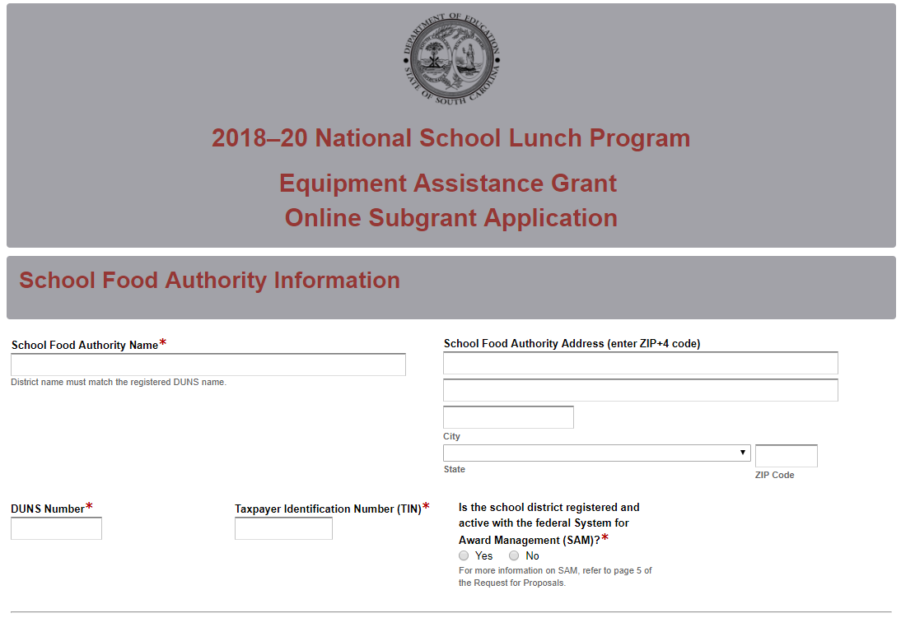
If the SFA does not have an active SAM registration, the following message will be displayed. The SFA should refer to the information on page 4 or visit SAM.gov for more information on how to update the status of their SAM registration.
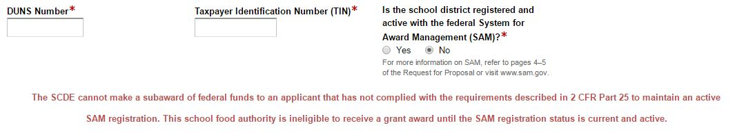
If the SFA selects “Yes” to indicate that their SAM registration is active, enter the date the current SAM registration expires.

The fields for the school’s information will be displayed. Enter the school’s name and physical address. Indicate if the school has never received NSLP Equipment Assistance funds or received funding under ARRA or the FY 2009, 2010, 2013, 2014, 2015, 2016, or 2017 Agriculture Appropriations Act.

If the SFA plans to request funding for more than one school, the SFA must complete a separate online application for each additional school.
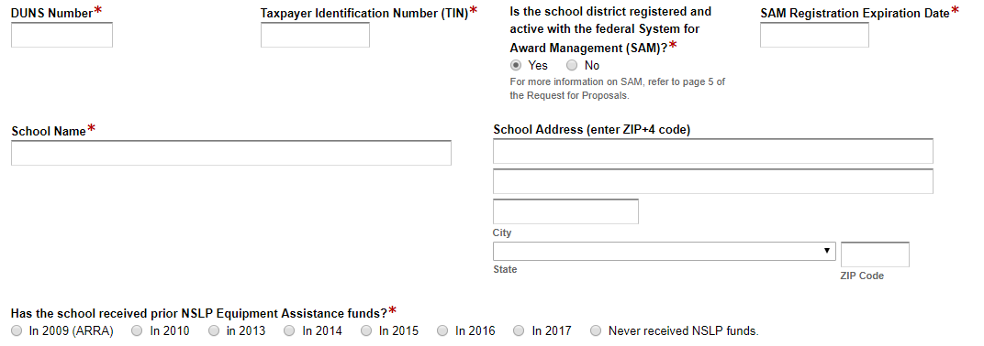
For schools that received ARRA 2009, FY 2010, 2013, 2014, 2015, 2016, or 2017 funding, the following message will be displayed. Those schools are ineligible to receive additional funding. Select another school to be served.
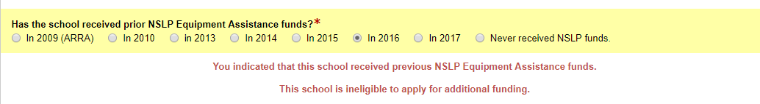
For schools that have not received prior NSLP Equipment Assistance funding or received a 2009 ARRA subgrant, enter the percentage of students at those schools who are eligible for free or reduced-price meals and if the school participates in CEP. From the dropdown box, select the number of equipment items (up to five) being requested for the school.
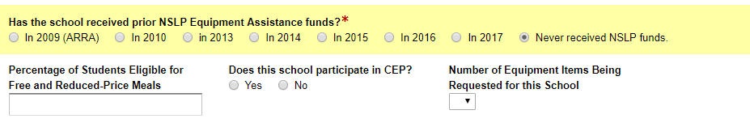
Enter the contact information for the superintendent, principal, and finance director. The names for all contacts entered in the online application must match the names as shown on the Certification Signature Page.
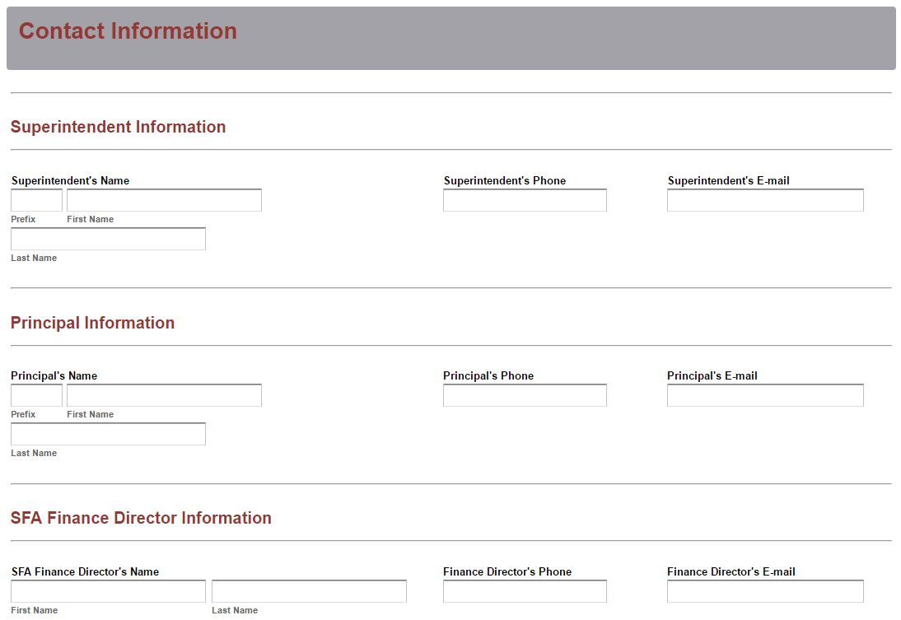
Enter the contact information for the school food service director/supervisor. The school food service director/supervisor’s email is a required field. The confirmation of a successful online application submission will be sent only to this email address. Reenter the email address to confirm that it is correct.
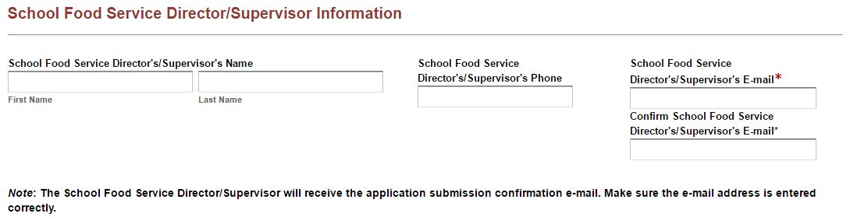
If applicable, enter the contact information for the facilities director.
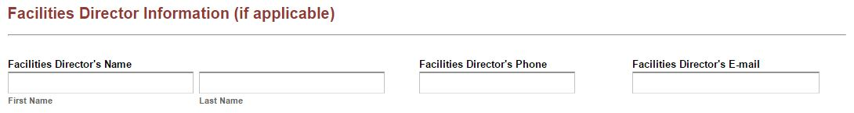
Separate screens will be displayed based on the number of equipment items being requested as selected on screen 1 of the online application. Enter a detailed description and estimated cost (including installation) of each equipment item. Indicate if the equipment purchase is new or is a replacement or renovation of existing equipment.
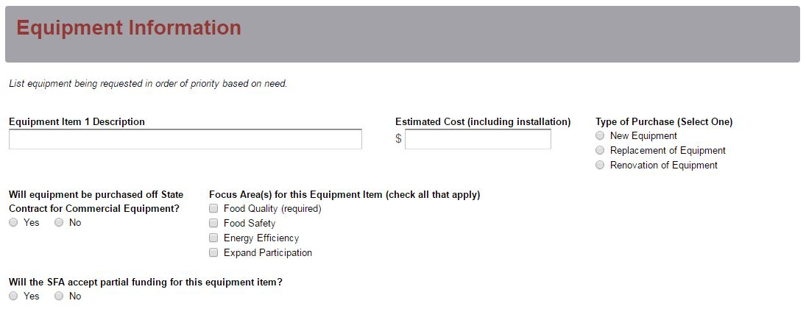
Indicate if the purchase will be made using the State Contract for Commercial Equipment. Check all of the focus areas that apply to the purchase of this specific equipment item (Note: see the requirements for this funding round). Indicate whether or not the SFA will accept partial funding for each equipment item included in the application.
If the type of purchase is to replace or renovate existing equipment, indicate the age of each item. If the SFA will accept partial funding for the equipment, indicate the minimum amount of funding that will be accepted for this item.
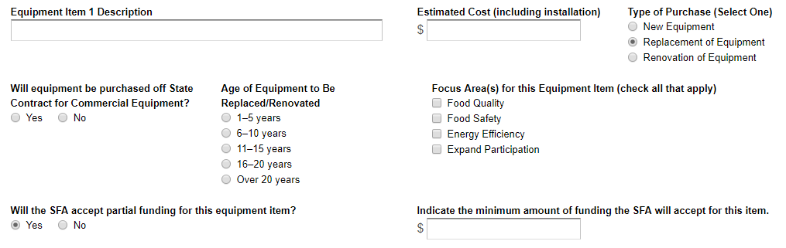
In the Summary of Funds Requested section, click on the box to autofill the equipment descriptions from the previous screen or manually enter the description for each equipment item.
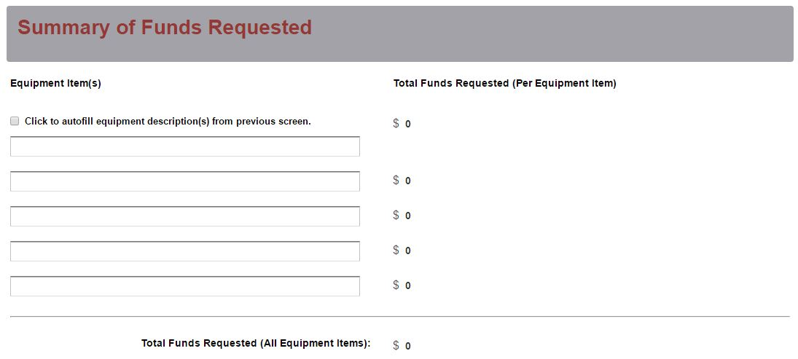
The Total Funds Requested (Per Equipment Item) fields will automatically populate from the estimated costs entered on the previous screen. The Total Funds Requested (All Equipment Items) field will automatically calculate the grand total of the funds being requested.

Prepare each of the proposal attachments (i.e., Application Narrative, Appendices, and Pre-Award Audit Questionnaire) following the preceding instructions in the RFP. Pay close attention to attachments that must be scanned together into a single document. The online application will only allow one document to be uploaded for each attachment. Upload the attachments where indicated in the following screenshot. All attachments are required; you will not be able to submit the application without uploading all three documents.
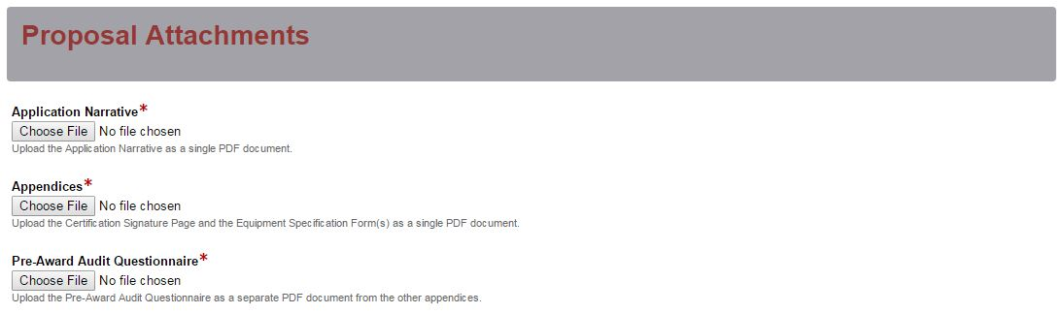
Thoroughly review the summary on the Data Review and Confirmation Page to verify that the information has been entered correctly in the online application prior to submitting. You will not be able to access the completed application form after it has been submitted. If any of the entries are incorrect, click on the "Previous" button at the bottom of each page to return to the appropriate section(s) and reenter the correct information.
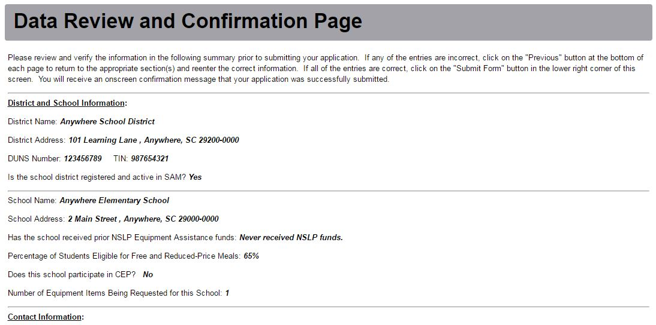
If all of the entries are correct, click on the “Submit Application” button in the lower right corner of this screen to complete the submission process.
Once the application is submitted, the following message will display on screen.

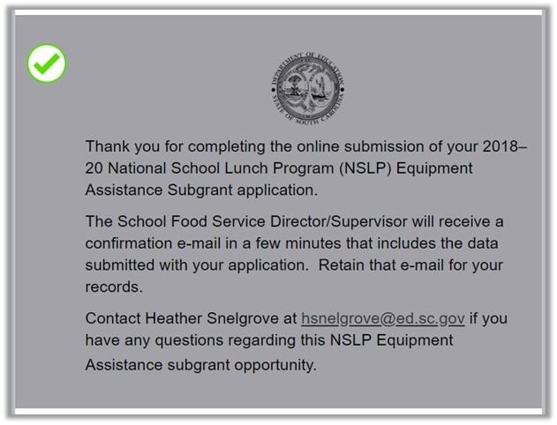
A submission confirmation will be sent to the email address provided for the school food service director/supervisor.

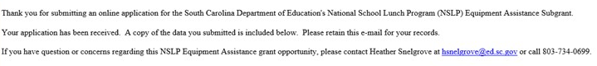
If the school food service director/supervisor does not receive a confirmation email, then the application did not successfully upload. You must go back and resubmit the entire online form, including all attachments, in order for your application to be considered for funding.

An email confirmation that the grant application was successfully submitted does not account for the quality of the uploaded documents or the completeness of the online form. The confirmation email only notifies you that the online application has been submitted. Applicants are responsible for ensuring that the information entered in the online form, including all attachments, is accurate and complete in order for the application to be reviewed and considered for funding.

Appendix A: Definitions of Terms Used

Deobligation—The downward adjustment of the obligations recorded in a subgrant award document. It is caused by factors such as (1) termination of part of the project,
(2) reduction in material prices, (3) cost savings, or (4) correction of recorded
amounts.

Equipment—Articles of nonexpendable, tangible personal property having a useful life of more than one year and a per-unit acquisition cost which equals or exceeds the lesser of the capitalization level established by the non-federal entity for financial statement purposes, or $5,000 (see 2 CFR Part 200.33). However, for FY 2018 Equipment Assistance Subgrants, Congress has specified that the threshold for the purchase of equipment cannot be lower than $1,000.

Appendix B: Selection Criteria and Reviewers’ Scoring Rubric

Selection Criteria

Each application will be scored based on the criteria and points outlined in the table below.

Narrative Sections | Points Available
Needs Statement | 40
Goal and Focus Area(s) | 40
Management and Sustainability | 20
TOTAL | 100

Appendix B: Scoring Rubric
1. Needs Statement: The applicant must discuss what type of equipment is needed and why and indicate whether each item is new, a replacement, or a renovated piece of equipment. The applicant must identify the school food service director/supervisor who assessed and then determined the equipment needs of the school to be served through this project; list others (i.e., parents, teachers, students, and funders) who were involved in identifying and implementing strategies for meeting equipment, infrastructure, and training needs; and list any nonprofit and for-profit organizations that have an interest in children’s health, education, school infrastructure, and community wellness that will provide assistance to the school in acquiring necessary equipment.
Applicant must provide a narrative that:  - Discusses what type of equipment is needed and why;  - Indicates whether each item is new, a replacement, or a renovated piece of equipment:  - Identifies the school food service director/supervisor who assessed and then determined the equipment needs of the school to be served through this project;  - Lists others (i.e., parents, teachers, students, and funders) who were involved in identifying and implementing strategies for meeting equipment, infrastructure, and training needs.  - Lists any nonprofit and for-profit organizations that have an interest in children’s health, education, school infrastructure, and community wellness that will provide assistance to the school in acquiring necessary equipment. | Acceptable | Fully Meets—31–40 points  Applicant provides a narrative that fully addresses all required items
 | Acceptable | Adequate/Meets—21–30 points  Applicant provides a narrative that moderately addresses all required items
 | Not Acceptable | Limited/Approaches—11–20 points  Applicant provides a narrative that is limited or unclear in addressing all required items
 | Not Acceptable | Inadequate—0–10 points  Applicant provides a narrative that does not adequately address all required items.
Reviewer’s Comments

2. Focus Areas: The applicant must explain how each piece of equipment proposed will support efforts to achieve all four of the Focus Areas:
- Focus Area 1—Food Quality: Equipment that improves the quality of school nutrition meals in ways that support the new nutritional standards;
- Focus Area 2—Food Safety: Equipment that improves the safety of food served in the school nutrition programs;
- Focus Area 3—Energy Efficiency: Equipment that improves the overall energy efficiency of the school nutrition operations; and
- Focus Area 4—Expand Participation: Equipment that supports improved and/or expanded participation in a school nutrition program such as the NSLP or School Breakfast Program.
Applicant must provide a narrative that explains how each piece of equipment will support efforts to achieve all four of the Focus Areas:  - Focus Area 1—Food Quality: Equipment that improves the quality of school nutrition meals in ways that support the new nutritional standards;  - Focus Area 2—Food Safety: Equipment that improves the safety of food served in the school nutrition programs;  - Focus Area 3—Energy Efficiency: Equipment that improves the overall energy efficiency of the school nutrition operations; and  - Focus Area 4—Expand Participation: Equipment that supports improved and/or expanded participation in a school nutrition program such as the NSLP or School Breakfast Program. | Acceptable | Fully Meets—31–40 points  Applicant provides a narrative that fully explains all required items
 | Acceptable | Adequate/Meets—21–30 points  Applicant provides a narrative that moderately explains all required items
 | Not Acceptable | Limited/Approaches—11–20 points  Applicant provides a narrative that is limited or unclear in explaining all required items
 | Not Acceptable | Inadequate—0–10 points  Applicant provides a narrative that does not adequately explain all required items.
Reviewer’s Comments

3. Management and Sustainability: The applicant must provide the name of the person responsible for administering and managing the proposed equipment acquisition(s); include the person’s job title and function; and include the Timeline of Activities for equipment acquisition, installation, and initial use. Also, the applicant must discuss how the equipment to be acquired through this project will be sustained beyond the subgrant period, including any warranty and service agreements, and identify who will be responsible for monitoring warranty and service agreements throughout the life of the equipment.
Applicant must provide a narrative that addresses all four of the following:  - identifies the person responsible for administering and managing the equipment acquisition(s), including their job title and function;  - includes the Timeline of Activities for equipment acquisition, installation, and initial use;  - discusses how equipment will be sustained beyond the subgrant period, including any warranty and service agreements; and  - identifies the person responsible for monitoring warranty and service agreements throughout the life of the equipment. | Acceptable | Fully Meets—16–20 points  Applicant provides a narrative that fully addresses all required items
 | Acceptable | Adequate/Meets—11–15 points  Applicant provides a narrative that moderately addresses all required items
 | Not Acceptable | Limited/Approaches—6–10 points  Applicant provides a narrative that is limited or unclear in addressing all required items
 | Not Acceptable | Inadequate—0–5 points  Applicant provides a narrative that does not adequately address all required items.
Reviewer’s Comments

Appendix C: Required SCDE Forms

Certification Signature Page
(This form must be signed by the individual from each proposed district, school, or organization who holds the title listed below.)

Certification
I hereby certify that, to the best of my knowledge, the information and data contained in this application are true and correct. The applicant’s governing body has duly authorized this application and documentation, and the applicant will comply with the SCDE Assurances and Terms and Conditions for USDA Subawards if the subgrant is awarded. The applicant is registered and current (active) on the federal System for Award Management (SAM).

Superintendent
Name:
Telephone: | Email:
Signature: |  | Date Signed:

Principal
Name:
Telephone: | Email:
Signature: |  | Date Signed:

SFA Finance Director
Name:
Telephone: | Email:
Signature: |  | Date Signed:

School Food Service Director/Supervisor
Name:
Telephone: | Email:
Signature: |  | Date Signed:

Facilities Director (if applicable)
Name:
Telephone: | Email:
Signature: |  | Date Signed:
Please complete, print, and obtain signatures prior to submission. Include the signed, scanned form in the Required Appendices as indicated on page 15.

Assurances and Terms and Conditions for U.S. Department of Agriculture Subawards

For informational purposes only
The applicant certifies to abide by the SCDE Assurances and Terms and Conditions by signing and submitting the Certification Signature Page.

Assurances

I certify that this applicant
- Has the legal authority to apply for federal assistance and the institutional, managerial, and financial capability (including funds sufficient to pay the nonstate share of project costs) to ensure proper planning, management, and completion of the project described in this application.
- Will give the South Carolina Department of Education (SCDE) access to and the right to examine all records, books, papers, or documents related to this award and will establish a proper accounting system in accordance with generally accepted accounting principles (GAAP) or agency directives.
- Has an accounting system with sufficient internal controls, a clear audit trail, and written cost-allocation procedures as necessary. The financial management systems are capable of distinguishing expenditures that are attributable to this grant from those that are not attributable to this grant. This system is able to identify costs by programmatic year and by budget line item and to differentiate among direct, indirect, and administrative costs. In addition, the applicant will maintain adequate supporting documents for the expenditures (federal and nonfederal) and in-kind contributions, if any, that it makes under this grant. Costs are shown in books or records (e.g., disbursements ledger, journal, payroll register) and are supported by a source document such as a receipt, travel voucher, invoice, bill, or in-kind voucher.
- Will also comply with the Office of Management and Budget 2 CFR Part 200 Subpart E-Cost Principles related to the allowability, reasonableness and allocability of costs consistent with the approved budget and also by maintaining required support for salaries and wages. Required support includes certifications and/or personnel activity records depending upon the amount of time spent on cost objectives.
- Will approve all expenditures, document receipt of goods and services, and record payments on the applicant’s accounting records prior to submission of reimbursement claims to the SCDE for costs related to this grant.
- Will initiate and complete work within the applicable time frame after receipt of approval by the SCDE.
- Will not discriminate against any employee or applicant for employment because of race, color, religion, age, sex, national origin, or disability and comply with Title VI of the Civil Rights Act of 1964, Section 504 of the Rehabilitation Act of 1973, Title IX of the Education Amendments of 1972, the Age Discrimination Act of 1975, and Titles I, II, and III of the Americans with Disabilities Act of 1990 (ADA). The grantee will take affirmative action to ensure that applicants for employment and the employees during the period of their employment are treated without regard to their race, color, religion, age, sex, national origin, or disability.
- Has no policy that prevents, or otherwise denies participation in, constitutionally protected prayer in public schools as set forth in the Guidance on Constitutionally Protected Prayer in Public Education (20 U.S.C. § 7904).
- Will comply with the Family Educational Rights and Privacy Act. (20 U.S.C. §1232g; 34 CFR Part 99).
- Will comply with the Ethics, Government Accountability, and Campaign Reform Act (S.C. Code Ann. § 2-17-10 et seq. and § 8-13-100 et seq. (Supp. 2017)).
- Will comply with the South Carolina Drug Free Workplace Act (S.C. Code Ann. § 44-107-10 et seq. (Supp. 2017) if the amount of this award is $50,000 or more, the federal Drug Free Workplace Act of 1988 (41 USC 702), and the U.S. Department of Agriculture Requirements for Drug-Free Workplace (2 CFR 421).
- Will provide information to the SCDE, as requested, regarding the reporting requirements of the Federal Funding Accountability and Transparency Act (FFATA), which requires the SCDE to file a FFATA sub-award report by the end of the month following the month in which it awards any subgrant equal to or greater than $25,000.
- Will comply with 2 CFR Part 25 and register and receive a unique entity identifier , fulfill the requirement for the System for Award Management, maintain the currency of the registration throughout the full grant term, and allow access by the granting agency to ensure compliance.
- Will comply with 2 CFR Part 200.112 and 400.2 and disclose in writing any potential conflict of interest to the SCDE.
- Will comply with 2 CFR Part 200.113 and disclose in writing to the SCDE all violations of federal criminal law involving fraud, bribery, or gratuity violations potentially affecting the federal award.
- Will comply with conditions under Executive Order 13513 “Federal Leadership on Reducing Text Messaging While Driving” (October 1, 2009), by refraining from texting messaging while driving during official grant business.

Terms and Conditions

- Completeness of Proposal. All proposals should be complete and carefully worded and must contain all of the information requested by the South Carolina Department of Education (SCDE). If you do not believe a section applies to your proposal, please indicate that fact.
- Non-awards/Termination. The SCDE reserves the right to reject any and all applications and to refuse to grant monies under this solicitation. If the SCDE rejects an application, the applicant has a right to request a hearing, as provided by the SCDE Hearing Procedures, if it alleges the SCDE’s actions violate a state or federal statute or regulation by (1) disapproving of or failing to approve the application or project, in whole or in part, or (2) failing to provide funds in amounts in accordance with the requirements of statutes and regulations.
After it has been awarded, the SCDE may terminate a grant by giving the grantee written notice of termination. In the event of a termination after award, the SCDE shall reimburse the grantee for allowable expenses incurred up to the notification of termination. In addition, this grant may be terminated by the SCDE if the grantee fails to perform as promised in its proposal.
In the event that this grant is terminated, the grantee shall have a right to a hearing as set forth in the SCDE Hearing Procedures. The grantee must notify the SCDE of its request for a hearing within 30 days of receiving written notice of the termination. If a hearing is requested, the SCDE will conduct the hearing in accordance with the SCDE Hearing Procedures.
- Reduction in Budgets and Negotiations. The SCDE reserves the right to negotiate budgets with applicants. The SCDE may, at its sole discretion, determine that a proposed budget is excessive and may negotiate a lower budget with the applicant. The applicant may at that time negotiate or withdraw its proposal. In addition, the SCDE may desire to fund a project but not at the level proposed. In that case, the SCDE shall notify the applicant of the amount that can be funded, and the applicant and the SCDE shall negotiate a modification to the proposal to accommodate the lower budget. All final decisions are that of the SCDE.
- Amendments to Grants. Amendments are permitted generally for budgets, grant end date, and management upon the mutual agreement of the parties involved and will become effective when specified in writing and signed by both parties. However, amendments to scope of work that significantly alter the original application proposal may trigger partial or full termination.
- Use of Grant Funds. Funds awarded are to be expended only for purposes and activities covered by the approved project plan and approved budget and budget narrative.
- Submission of Expenditure Reports. Claims for reimbursement must be made at least quarterly and consistent with calendar quarters (e.g., an expenditure report claim for costs for January 1 through March 30 must be filed by May 15).
- Obligation of Grant Funds. Grant funds may not be obligated prior to the effective date or subsequent to the end or termination date of the grant period. No obligations are allowed after the end of the grant period. The final request for expenditure report claims must be submitted no later than thirty (30) days after the end of the grant period.
- De-obligation of Funds. After a final expenditure report claim has been submitted to the SCDE, the grantee will go through the official de-obligation process with the SCDE.
- Documentation. The grantee must provide for accurate and timely recording of receipts and expenditures. The grantee’s accounting system should distinguish receipts and expenditures attributable to each grant. The grantee must review the memo regarding “Guidelines for Retaining Documentation to Support Expenditure Claims.”
- Travel Costs. Travel costs, if allowed under this solicitation, must not exceed limits noted in the United States General Services Administration regulations for lodging. Meals and incidentals are limited by the state budget proviso, currently not to exceed $25 per day for in-state travel and $32 for out-of-state travel (see page 91 of the State of South Carolina Statewide Disbursement Regulations. Mileage reimbursement must follow the current Office of Comptroller General instructions, which is consistent with the published IRS rates.
- Honoraria. Amounts paid in honoraria, if allowed under this grant, must be consistent with SCDE policies. Applicants should check with the program office before budgeting for honoraria.
- Reports. The grantee shall submit, as required or instructed by the awarding program office, all reports (programmatic, financial, or evaluation) within the specified period or date and in the prescribed format. An expenditure claim report must be filed by August 15 for all expenditures incurred by June 30 in order to comply with the generally accepted accounting principles (GAAP) and the production of the State's Comprehensive Annual Financial Report.
- Copyright. The grantee is free to copyright any books, publications, or other copyrightable materials developed in the course of this grant. However, the SCDE reserves a royalty-free, nonexclusive, and irrevocable license to reproduce, publish, or otherwise use, and to authorize others to use, the copyrighted work developed under this grant.
- Certification Regarding Lobbying, Suspension, and Debarment. By submitting an application, the applicant certifies, to the best of its knowledge and belief, that the
- Applicant and/or any of its principals, subgrantees, or subcontractors
  - Have not paid or will not pay to any person any federally appropriated funds for the purpose of influencing or attempting to influence an officer or employee of any agency, a Member of Congress, an officer or employee of Congress, or any employee of a Member of Congress in connection with making any federal grant and the extension continuation, renewal, amendment, or modification of any federal grant as stated at 2 CFR Part 418 and 34 CFR Part 82. If any funds other than federally appropriated funds have been paid or will be paid to any person for influencing or attempting to influence an officer or employee of any agency, a Member of Congress, an officer or employee of Congress, or any employee of a Member of Congress in connection with this federal grant, the undersigned shall complete and submit Standard Form LLL, “Disclosure of Lobbying Activities,” in accordance with its instructions.
  - Are not presently debarred, suspended, proposed for debarment, or declared ineligible for the award of contracts by any state or federal agency as stated at 2 CFR Part 417.
  - Have not, within a three-year period preceding this application, been convicted of or had a civil judgment rendered against them for commission of fraud or a criminal offense in connection with obtaining, attempting to obtain, or performing a public (federal, state, or local) contract or subcontract; violated federal or state antitrust statutes relating to the submission of offers; or committed embezzlement, theft, forgery, bribery, falsification or destruction of records, making false statements, tax evasion, or receiving stolen property.
  - Are not presently indicted for, or otherwise criminally or civilly charged by a governmental entity with, commission of any of the offenses enumerated above.
- Applicant has not, within a three-year period preceding this application, had one or more contracts terminated for default by any public (federal, state, or local) entity.
- Audits.
- Entities expending $750,000 or more in federal awards:
Entities that expend $750,000 or more in federal awards during the fiscal year are required to have an audit performed in accordance with the provisions of 2 CFR Part 200.501, et seq. Except for the provisions for biennial audits provided in 2 CFR Part 200.504 (a) and (b), audits must be performed annually as stated at 2 CFR Part 200.504. A grantee that passes through funds to subrecipients has the responsibility of ensuring that federal awards are used for authorized purposes in compliance with federal program laws, federal and state regulations, and grant agreements. The director of the OMB, who will review this amount every two years, has the option of revising the threshold upward.
- Entities expending less than $750,000 in federal awards:
Entities that expend less than $750,000 in a fiscal year in federal awards are exempt from the audit requirements in 2 CFR Part 200.504. However, such entities are not exempt from other federal requirements (including those to maintain records) concerning federal awards provided to the entity. The entity’s records must be available for review or audit by the SCDE and appropriate officials of federal agencies, pass-through entities, and the General Accounting Office (GAO).
- Records. The grantee shall retain federal grant records, including financial records and supporting documentation, for a minimum of six (6) years after the end date of the grant when the final expenditure report claim for reimbursement and all final reports have been submitted, unless informed otherwise or in the case of litigation.
- Electronic Signature Agreement. I agree that my electronic signature is the legally binding equivalent to my handwritten signature.

Equipment Specifications Form

To access this form, go to the NSLP Equipment Assistance Grant Opportunity Web page. Follow the instructions on page 15.

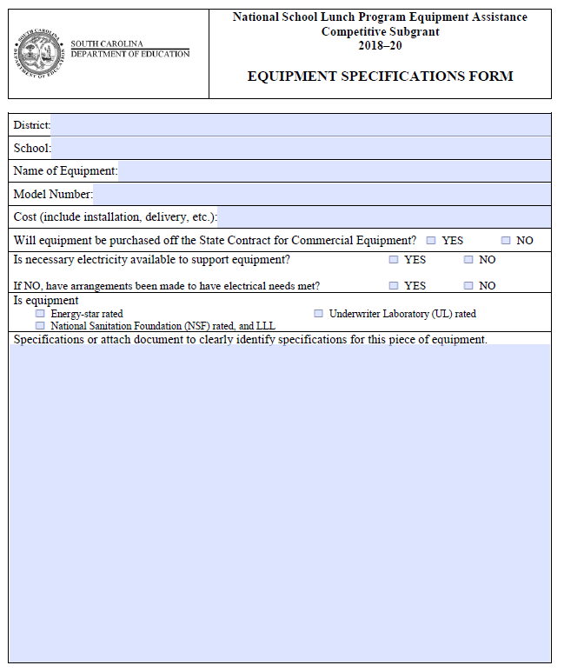

Pre-Award Audit Questionnaire for LEAs and State Agencies
Download and complete the Pre-Award Audit Questionnaire.
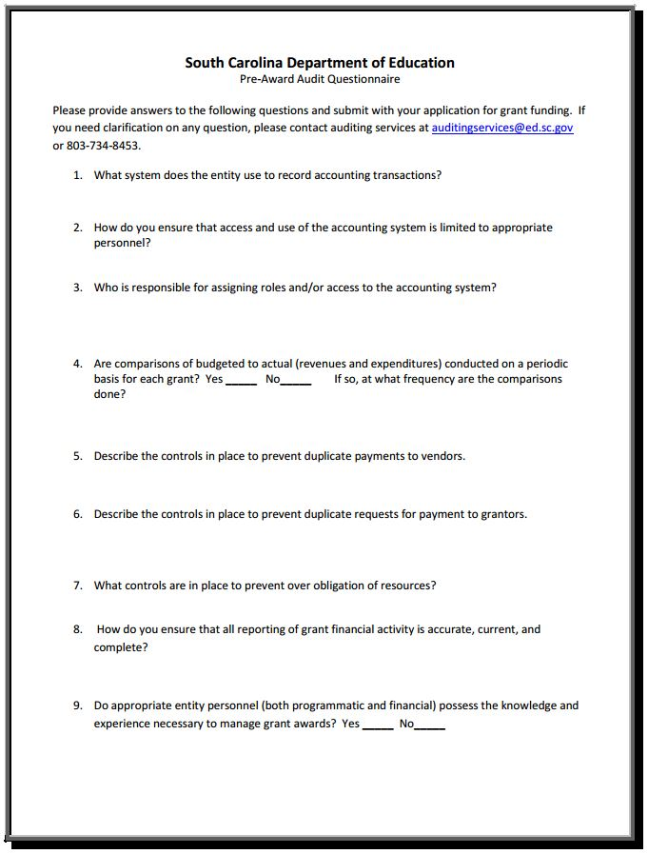
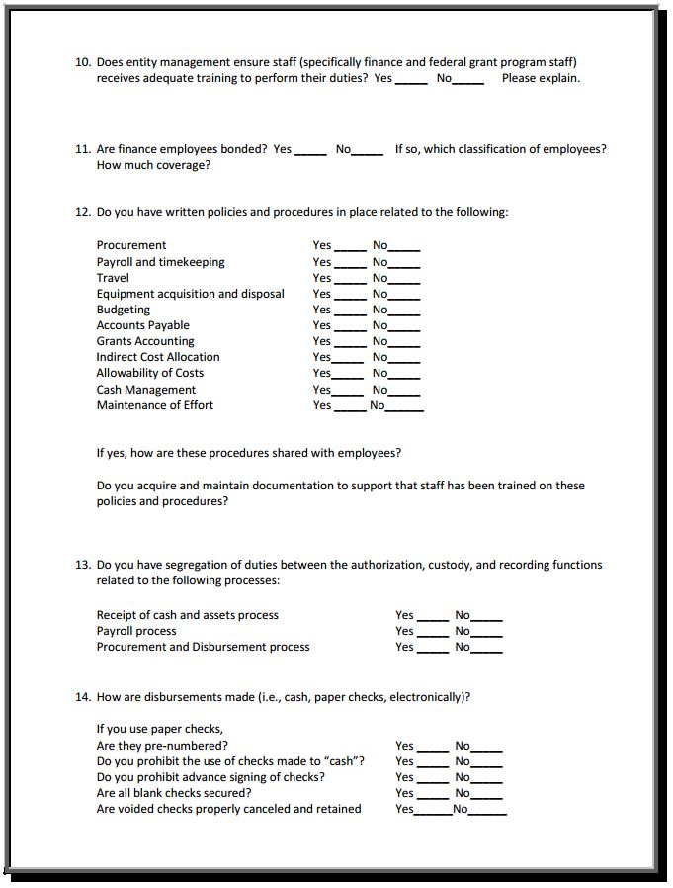
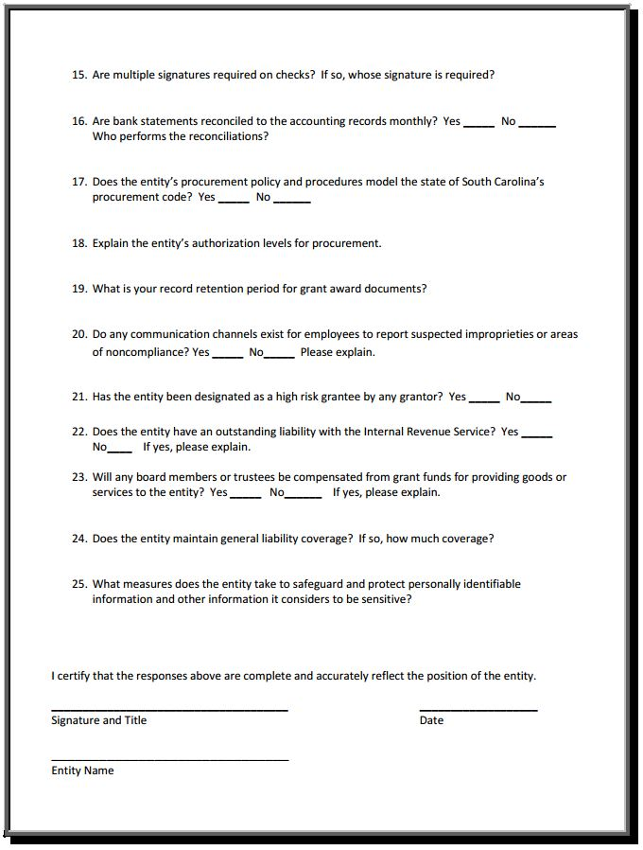
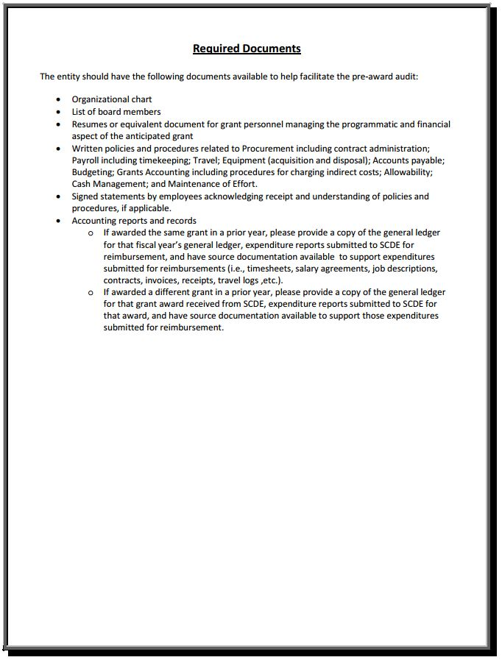

2018–20 National School Lunch Program Equipment Assistance Subgrant

Monthly Performance Report

Sample Only
District: ____________________________________________ Report Completed by: ________________________________________
Equipment Purchased | School Site Where Installed | Indicate Focus Area | Describe how the functionality and use support the focus areas
- Food Quality
- Food Safety
- Energy Efficiency
- Expand Participation
- Food Quality
- Food Safety
- Energy Efficiency
- Expand Participation
- Food Quality
- Food Safety
- Energy Efficiency
- Expand Participation

Accomplishments and challenges in expenditure activities | Impact of purchased equipment on the school food service operation | Reason(s) for any unliquidated funds

Procurement  - Purchase Order Submitted  - Delivery Scheduled  - Other: _____________________________________________________________ | Date: _________________________________  Date: _________________________________  Date: _________________________________
Installation  - Equipment Received  - Equipment Installed  - Other: _____________________________________________________________ | Date: _________________________________  Date: _________________________________  Date: _________________________________
Payment  - Partial Payment Made  - Full Payment Made  - Other: _____________________________________________________________ | Date: _________________________________  Date: _________________________________  Date: _________________________________
Reimbursement  - Reimbursement submitted to SCDE, Office of Health and Nutrition  - Reimbursement received  - Other: _____________________________________________________________ | Date: _________________________________  Date: _________________________________  Date: _________________________________

Appendix D: Optional Forms and Information

Timeline of Activities Template—NSLP Equipment Assistance Subgrant Program

Name of Applicant: _______________________________________________

For each equipment item requested, provide details regarding acquisition, installation, and initial use. Add rows as needed. Insert completed timeline as directed on page 14 of this RFP.

Start Date–End Date | Activity to Acquire, Install, or Initially Use Equipment | Related Focus Area | Evidence that Proves Activity Has Been Completed | Persons/Agency Responsible

Schools and SFAs that Received Prior NSLP Equipment Subgrant Awards
The following schools are not eligible to receive equipment funds under this competition.

 | SFA | School(s) | Prior Subgrant Received
 | Abbeville | Abbeville High  Westwood Elementary  Calhoun Elementary  Cherokee Trail Elementary | FY 2009 ARRA  FY 2009 ARRA  FY 2010 NSLP Equipment  FY 2010 NSLP Equipment
 | Aiken | Gloverville Elementary  Jackson Middle  Ridge-Spring Monetta High  Schofield Middle  Leavelle McCampbell Middle  Silver Bluff High  Midland Valley High School  Wagener Salley High School | FY 2009 ARRA  FY 2009 ARRA  FY 2009 ARRA  FY 2009 ARRA  FY 2014 NSLP Equipment  FY 2010 NSLP Equipment  FY 2016 NSLP Equipment  FY 2016 NSLP Equipment
 | Allendale | Allendale Elementary  Allendale Fairfax Middle  Allendale Fairfax High | FY 2009 ARRA  FY 2015 NSLP Equipment  FY 2014 NSLP Equipment
 | Anderson 1 | West Pelzer Elementary | FY 2009 ARRA
 | Anderson 2 | Honea Path Elementary  Marshall Primary | FY 2009 ARRA  FY 2010 NSLP Equipment
 | Anderson 3 | Iva Elementary  Crescent High | FY 2009 ARRA  FY 2010 NSLP Equipment
 | Anderson 4 | LaFrance Elementary  Pendleton Elementary  Pendleton High  Riverside Middle | FY 2009 ARRA  FY 2010 NSLP Equipment  FY 2014 NSLP Equipment  FY 2014 NSLP Equipment
 | Anderson 5 | Nevitt Forest Elementary  Calhoun Academy  New Prospect Elementary  Varennes Academy  Westside High  Whitehall Elementary School  South Fant School of Early | FY 2009 ARRA  FY 2014 NSLP Equipment  FY 2015 NSLP Equipment  FY 2014 NSLP Equipment  FY 2014 NSLP Equipment  FY 2016 NSLP Equipment  FY 2017 NSLP Equipment
 | Bamberg 1 | Bamberg-Ehrhardt Middle  Bamberg-Ehrhardt High  Richard Carroll Elementary | FY 2009 ARRA  FY 2009 ARRA  FY 2010 NSLP Equipment
 | Bamberg 2 | Denmark-Olar Elementary  Denmark-Olar Middle  Denmark-Olar High School | FY 2009 ARRA  FY 2009 ARRA  FY 2017 NSLP Equipment
 | Barnwell 19 | Blackville-Hilda High  Kelly-Edwards Elementary  Macedonia Elementary | FY 2009 ARRA  FY 2009 ARRA  FY 2009 ARRA
 | Barnwell 29 | Kelly Edwards Elementary  Williston Elko Middle | FY 2014 NSLP Equipment  FY 2010 NSLP Equipment
 | Barnwell 45 | Barnwell Primary  Barnwell Elementary  Barnwell High  Guinyard-Butler Middle | FY 2009 ARRA  FY 2014 NSLP Equipment  FY 2010 NSLP Equipment  FY 2014 NSLP Equipment
 | Beaufort | Whale Branch Elementary  Whale Branch Middle | FY 2009 ARRA  FY 2009 ARRA
 | Berkeley | St. Stephen Elementary  Sangaree Elementary /  Intermediate | FY 2009 ARRA  FY 2009 ARRA  FY 2009 ARRA
 | Calhoun | Calhoun County High  St Matthews K–8 | FY 2009 ARRA  FY 2010 NSLP Equipment
 | Charleston | Mary Ford Elementary  Memminger Elementary  C.C. Blaney Elementary  Jane Edwards Elementary  A. C. Corcoran Elementary  Angel Oak Elementary  Baptist Hill Middle-High  E. B. Ellington Elementary  Frierson Elementary  W. B. Goodwin Elementary  Hunley Park Elementary | FY 2009 ARRA  FY 2009 ARRA  FY 2010 NSLP Equipment  FY 2010 NSLP Equipment  FY 2016 NSLP Equipment  FY 2016 NSLP Equipment  FY 2016 NSLP Equipment  FY 2016 NSLP Equipment  FY 2016 NSLP Equipment  FY 2016 NSLP Equipment  FY 2016 NSLP Equipment
 | Cherokee | Ewing Middle  Blacksburg Middle  Gaffney Middle  Luther Vaughn Elementary  Alma Elementary  BD Lee Elementary  Draytonville Elementary  Mary Bramlett Elementary | FY 2009 ARRA  FY 2014 NSLP Equipment  FY 2015 NSLP Equipment  FY 2014 NSLP Equipment  FY 2017 NSLP Equipment  FY 2017 NSLP Equipment  FY 2017 NSLP Equipment  FY 2017 NSLP Equipment
 | Chester | Chester Park Complex Elem.  Chester Middle  Chester High  Great Falls Complex  Great Falls Elementary  Lewisville Elementary | FY 2009 ARRA  FY 2014 NSLP Equipment  FY 2015 NSLP Equipment  FY 2015 NSLP Equipment  FY 2015 NSLP Equipment  FY 2015 NSLP Equipment
 | Chesterfield | Cheraw Primary  Ruby Elementary  Palmetto Learning  Cheraw Intermediate  Jefferson Elementary  Plainview Elementary | FY 2009 ARRA  FY 2009 ARRA  FY 2009 ARRA  FY 2014 NSLP Equipment  FY 2014 NSLP Equipment  FY 2010 NSLP Equipment
 | Clarendon 1 | Scotts Branch High  Scotts Branch Middle  St. Paul Elementary | FY 2009 ARRA  FY 2009 ARRA  FY 2009 ARRA
 | Clarendon 2 | Manning Elementary  Manning Primary  Manning Junior High Manning High | FY 2014 NSLP Equipment  FY 2009 ARRA  FY 2009 ARRA  FY 2009 ARRA
 | Clarendon 3 | East Clarendon Middle/High  Walker Gamble Elementary | FY 2009 ARRA  FY 2009 ARRA
 | Colleton | Forest Hills Elementary  Black Street Early Childhood  Center  Colleton County Middle | FY 2009 ARRA  FY 2015 NSLP Equipment  FY 2016 NSLP Equipment
 | Darlington | Rosenwald Elementary  Thornwell Elementary  Cain Elementary  Darlington Middle  Pate Elementary  Spaulding Middle/Elementary  West Hartsville Elementary  Hartsville High  Hartsville Middle  North Hartsville Elementary | FY 2009 ARRA  FY 2009 ARRA  FY 2014 NSLP Equipment  FY 2015 NSLP Equipment  FY 2014 NSLP Equipment  FY 2014 NSLP Equipment  FY 2015 NSLP Equipment  FY 2016 NSLP Equipment  FY 2016 NSLP Equipment  FY 2016 NSLP Equipment
 | Dillon 1 | Lake View High | FY 2009 ARRA
 | Dillon 2 | Stewart Heights Elementary | FY 2009 ARRA
 | Dillon 3 | Latta Middle  Latta High | FY 2009 ARRA  FY 2009 ARRA
 | Dorchester 2 | Windsor Hill Elementary  Summerville Elementary | FY 2009 ARRA  FY 2014 NSLP Equipment
 | Dorchester 4 | Harleyville-Ridgeville  Elementary  St. George Middle  Williams Memorial  Elementary  Clay Hill Middle  Woodland High | FY 2009 ARRA  FY 2009 ARRA  FY 2009 ARRA  FY 2010 NSLP Equipment  FY 2014 NSLP Equipment
 | Edgefield | Douglas Elementary  JET Middle  Johnston Elementary  Strom Thurmond High  W.E. Parker Elementary | FY 2009 ARRA  FY 2009 ARRA  FY 2009 ARRA  FY 2010 NSLP Equipment  FY 2014 NSLP Equipment
 | Florence 1 | Delmae Elementary  Williams Middle  Wilson High  South Florence High | FY 2009 ARRA  FY 2009 ARRA  FY 2009 ARRA  FY 2014 NSLP Equipment
 | Florence 2 | Hannah-Pamplico High  Hannah-Pamplico  Elementary/Middle | FY 2009 ARRA  FY 2014 NSLP Equipment
 | Florence 3 | Lake City High  Truluck Middle | FY 2009 ARRA  FY 2009 ARRA
 | Florence 4 | Timmonsville High | FY 2014 NSLP Equipment
 | Florence 5 | Johnsonville Elementary  Johnsonville Middle Johnsonville High | FY 2009 ARRA  FY 2009 ARRA  FY 2010 NSLP Equipment
 | Georgetown | Andrews Elementary  Georgetown High  Kensington Elementary  McDonald Elementary  Pleasant Hill Elementary  Sampit Elementary  Plantersville Elementary  Brown’s Ferry Elementary  Andrews Elementary  Georgetown Middle  Maryville Elementary  Rosemary Middle | FY 2009 ARRA  FY 2010 NSLP Equipment  FY 2015 NSLP Equipment  FY 2014 NSLP Equipment  FY 2014 NSLP Equipment  FY 2015 NSLP Equipment  FY 2016 NSLP Equipment  FY 2016 NSLP Equipment  FY 2017 NSLP Equipment  FY 2017 NSLP Equipment  FY 2017 NSLP Equipment  FY 2017 NSLP Equipment
 | Greenville | Hollis Academy | FY 2010 NSLP Equipment
 | Greenwood 51 | Ware Shoals Primary  Ware Shoals  Middle/Elementary  Ware Shoals High | FY 2009 ARRA  FY 2014 NSLP Equipment  FY 2010 NSLP Equipment
 | Greenwood 52 | Ninety-Six Primary | FY 2009 ARRA
 | Hampton 1 | Hampton Elementary  Ben Hazel Primary  Brunson Elementary  Fennell Elementary  Wade Hampton High  Varnville Elementary | FY 2009 ARRA  FY 2010 NSLP Equipment  FY 2010 NSLP Equipment  FY 2014 NSLP Equipment  FY 2010 NSLP Equipment  FY 2016 NSLP Equipment
 | Hampton 2 | Estill Elementary  Estill Middle  Estill High | FY 2009 ARRA  FY 2009 ARRA  FY 2009 ARRA
 | Horry | Horry County Alternative  School  Socastee Elementary  Conway Middle  Conway High  Whittemore Park Middle  South Conway Elementary  Waccamaw Elementary | FY 2009 ARRA  FY 2009 ARRA  FY 2010 NSLP Equipment  FY 2010 NSLP Equipment  FY 2016 NSLP Equipment  FY 2017 NSLP Equipment  FY 2017 NSLP Equipment
 | Jasper | Ridgeland Elementary | FY 2009 ARRA
 | Kershaw | Bethune Elementary  Mt. Pisgah Elementary  North Central High | FY 2009 ARRA  FY 2009 ARRA  FY 2009 ARRA
 | Lancaster | Clinton Elementary  North Elementary  South Elementary  Andrew Jackson Middle  Heath Springs Elementary  Lancaster High  A.R. Rucker Middle | FY 2009 ARRA  FY 2009 ARRA  FY 2009 ARRA  FY 2015 NSLP Equipment  FY 2014 NSLP Equipment  FY 2014 NSLP Equipment  FY 2017 NSLP Equipment
 | Laurens 55 | Laurens Elementary  Laurens Middle  E. B. Morse | FY 2009 ARRA  FY 2009 ARRA  FY 2010 NSLP Equipment
 | Laurens 56 | Eastside Elementary  Joanna Woodson Elementary  Bell Street Middle | FY 2009 ARRA  FY 2009 ARRA  FY 2014 NSLP Equipment
 | Lee | Bishopville Primary  Lower Lee Elementary  Mount Pleasant School  West Lee Elementary  Lee Central Middle  Lee Central High | FY 2009 ARRA  FY 2009 ARRA  FY 2009 ARRA  FY 2009 ARRA  FY 2015 NSLP Equipment  FY 2010 NSLP Equipment
 | Lexington 1 | Pelion Elementary  Pelion Middle  Gilbert Primary  Gilbert Elementary  Saxe Gotha Elementary  Pelion High  Red Bank Elementary | FY 2009 ARRA  FY 2009 ARRA  FY 2014 NSLP Equipment  FY 2016 NSLP Equipment  FY 2016 NSLP Equipment  FY 2017 NSLP Equipment  FY 2017 NSLP Equipment
 | Lexington 2 | Taylor Elementary  Northside Middle  Pineview Elementary  Saluda River Elementary  Springdale Elementary  Wood Elementary – Congaree  Wood Early Childhood Ctr  Airport High School  Brookland Cayce High  Pair Education Center | FY 2009 ARRA  FY 2015 NSLP Equipment  FY 2014 NSLP Equipment  FY 2010 NSLP Equipment  FY 2014 NSLP Equipment  FY 2016 NSLP Equipment  FY 2017 NSLP Equipment  FY 2017 NSLP Equipment  FY 2017 NSLP Equipment
 | Lexington 3 | Batesburg Leesville Primary  Batesburg Leesville High | FY 2009 ARRA  FY 2009 ARRA
 | Lexington 4 | Sandhills Middle | FY 2009 ARRA
 | Lexington/ Richland 5 | Harbison West Elementary  Seven Oaks Elementary  Dutch Fork Elementary  H.E. Corley Elementary  Irmo High  Leaphart Elementary  Nursery Road Elementary  Irmo Middle | FY 2009 ARRA  FY 2009 ARRA  FY 2014 NSLP Equipment  FY 2010 NSLP Equipment  FY 2015 NSLP Equipment  FY 2014 NSLP Equipment  FY 2014 NSLP Equipment  FY 2016 NSLP Equipment
 | Marion | Marion High  Mullins High  Palmetto Middle  Britton’s Neck Elementary | FY 2009 ARRA  FY 2009 ARRA  FY 2009 ARRA  FY 2009 ARRA
 | Marlboro | Bennettsville Middle  Wallace Elementary/Middle | FY 2009 ARRA  FY 2009 ARRA
 | McCormick | McCormick High | FY 2009 ARRA
 | Newberry | Newberry Middle  Newberry High  Reuben Elementary  Boundary Street Elementary  Pomaria Garmany Elementary  Prosperity-Rikard Elementary  Whitmire Community  Gallman Elementary  Newberry Elementary | FY 2009 ARRA  FY 2009 ARRA  FY 2009 ARRA  FY 2015 NSLP Equipment  FY 2014 NSLP Equipment  FY 2014 NSLP Equipment  FY 2010 NSLP Equipment  FY 2017 NSLP Equipment  FY 2017 NSLP Equipment
 | Oconee | Orchard Park Elementary  Tamassee Salem Middle/High  James M. Brown Elementary  Seneca Middle | FY 2009 ARRA  FY 2009 ARRA  FY 2014 NSLP Equipment  FY 2010 NSLP Equipment
 | Orangeburg 3 | Holly Hills Roberts Middle  St. James-Gaillard Elementary  Vance Providence Elementary | FY 2009 ARRA  FY 2009 ARRA  FY 2009 ARRA
 | Orangeburg 4 | Edisto Primary  Hunter Kinard Tyler School | FY 2014 NSLP Equipment  FY 2016 NSLP Equipment
 | Orangeburg 5 | Brookdale Elementary  Marshall Elementary  Mellichamp Elementary  Rivelon Elementary Whitaker Elementary  Wilkinson High  William J. Clark Middle | FY 2009 ARRA  FY 2009 ARRA  FY 2009 ARRA  FY 2009 ARRA  FY 2014 NSLP Equipment  FY 2010 NSLP Equipment  FY 2014 NSLP Equipment
 | Pickens | A. R. Lewis Elementary  McKissick Elementary  Liberty Elementary  Pickens Elementary  Simpson Alternative  Education Center  West End Elementary  East End Elementary | FY 2009 ARRA  FY 2009 ARRA  FY 2015 NSLP Equipment  FY 2014 NSLP Equipment  FY 2010 NSLP Equipment  FY 2014 NSLP Equipment  FY 2017 NSLP Equipment
 | Richland 1 | A. J. Lewis Greenview Elem  Bradley Elementary  E. E. Taylor Elementary  Forest Heights Elementary  J. P. Thomas Elementary  W. A. Perry Middle  Burton-Pack Elementary  Dreher High  Pendergrass Fairwold School  W. S. Sandel Elementary  AC Moore Elementary  Carver Lyon Elementary  Satchel Ford Elementary | FY 2009 ARRA  FY 2009 ARRA  FY 2009 ARRA  FY 2009 ARRA  FY 2009 ARRA  FY 2009 ARRA  FY 2014 NSLP Equipment  FY 2015 NSLP Equipment  FY 2015 NSLP Equipment  FY 2015 NSLP Equipment  FY 2017 NSLP Equipment  FY 2017 NSLP Equipment  FY 2017 NSLP Equipment
 | Richland 2 | Conder Elementary  Bridge Creek Elementary  North Springs Elementary  Rice Creek Elementary | FY 2009 ARRA  FY 2015 NSLP Equipment  FY 2016 NSLP Equipment  FY 2016 NSLP Equipment
 | Saluda | Saluda Elementary  Hollywood Elementary  Saluda Educational Complex  Saluda Primary  Killian Elementary | FY 2009 ARRA  FY 2014 NSLP Equipment  FY 2014 NSLP Equipment  FY 2010 NSLP Equipment  FY 2017 NSLP Equipment
 | Spartanburg 1 | Inman Elementary  New Prospect Elementary  Inman Intermediate  O. P. Earle Elementary  Holly Springs-Motlow Elem  Mabry Middle | FY 2009 ARRA  FY 2009 ARRA  FY 2014 NSLP Equipment  FY 2014 NSLP Equipment  FY 2017 NSLP Equipment  FY 2017 NSLP Equipment
 | Spartanburg 2 | Chesnee Middle  Cooley-Springs-Fingerville  Elementary  Hendrix Elementary  Mayo Elementary  Boiling Springs Intermediate | FY 2009 ARRA  FY 2009 ARRA  FY 2009 ARRA  FY 2010 NSLP Equipment  FY 2017 NSLP Equipment
 | Spartanburg 3 | Broome High  Cowpens Middle  Cannons Elementary  Clifdale Elementary  Cowpens Elementary  Pacolet Middle | FY 2009 ARRA  FY 2009 ARRA  FY 2014 NSLP Equipment  FY 2010 NSLP Equipment  FY 2014 NSLP Equipment  FY 2014 NSLP Equipment
 | Spartanburg 4 | Woodruff Primary  Woodruff Elementary  Woodruff Middle  Woodruff High | FY 2009 ARRA  FY 2010 NSLP Equipment  FY 2014 NSLP Equipment  FY 2010 NSLP Equipment
 | Spartanburg 5 | Duncan Elementary  Welford Elementary  Beech Springs Intermediate  D.R. Hill Middle | FY 2009 ARRA  FY 2009 ARRA  FY 2010 NSLP Equipment  FY 2014 NSLP Equipment
 | Spartanburg 6 | Arcadia Elementary  Lone Oak Elementary  Jesse Bobo Elementary | FY 2009 ARRA  FY 2009 ARRA  FY 2014 NSLP Equipment
 | Spartanburg 7 | Houston Elementary  Whitlock Junior High  Chapman Elementary  Cleveland Academy of  Leadership  E. P. Todd Elementary  Mary H. Wright  Spartanburg High | FY 2009 ARRA  FY 2009 ARRA  FY 2014 NSLP Equipment  FY 2014 NSLP Equipment  FY 2010 NSLP Equipment  FY 2014 NSLP Equipment  FY 2010 NSLP Equipment
 | Sumter | High Hills Elementary  Manchester Elementary  Wilder Elementary  Willow Drive Elementary  Crestwood High  Pocalla Springs Elementary | FY 2009 ARRA  FY 2009 ARRA  FY 2009 ARRA  FY 2009 ARRA  FY 2015 NSLP Equipment  FY 2014 NSLP Equipment
 | Union | Foster Park Elementary  Union County High  Buffalo Elementary  Monarch Elementary | FY 2009 ARRA  FY 2009 ARRA  FY 2010 NSLP Equipment  FY 2014 NSLP Equipment
 | Williamsburg | Greeleyville Elementary  Hemingway High  St. Mark Elementary  Anderson Primary  Kenneth Gardener Elementary  Kingstree Middle  C. Murray High  Hemingway Elementary | FY 2009 ARRA  FY 2009 ARRA  FY 2009 ARRA  FY 2014 NSLP Equipment  FY 2015 NSLP Equipment  FY 2015 NSLP Equipment  FY 2017 NSLP Equipment  FY 2017 NSLP Equipment
 | York 1 | Harold C. Johnson Middle  Cotton Belt Elementary  Hickory Grove Sharon  Elementary  Hunter Street Elementary | FY 2009 ARRA  FY 2015 NSLP Equipment  FY 2015 NSLP Equipment  FY 2015 NSLP Equipment
 | York 1  (cont.) | Jefferson Elementary  York Intermediate  York Middle  York One Academy  York Comprehensive High | FY 2015 NSLP Equipment  FY 2014 NSLP Equipment  FY 2015 NSLP Equipment  FY 2015 NSLP Equipment  FY 2017 NSLP Equipment
 | York 3 | Northside Elementary  Castle Heights Middle  Ebenezer Elementary | FY 2009 ARRA  2017 NSLP Equipment  2017 NSLP Equipment
 | Other SFAs/Schools |  | Prior Subgrant Received
 | Billie Hardee Home for Boys |  | FY 2009 ARRA
 | Calhoun Falls Charter School |  | FY 2010 NSLP Equipment
 | Camp Sand Hills |  | FY 2010 NSLP Equipment
 | Capers Preparatory Christian Academy |  | FY 2009 ARRA
 | Carolina Children’s Home |  | FY 2009 ARRA
 | Chabad Academy |  | FY 2014 NSLP Equipment
 | Ellen Hines Smith Girls Home |  | FY 2010 NSLP Equipment
 | Epworth Children’s Home |  | FY 2014 NSLP Equipment  FY 2016 NSLP Equipment
 | Fair Play Camp |  | FY 2010 NSLP Equipment
 | Felton Laboratory |  | FY 2009 ARRA
 | Florence Crittenton Program of SC |  | FY 2016 NSLP Equipment
 | Helping Hands Clemson |  | FY 2010 NSLP Equipment
 | John De La Howe |  | FY 2010 NSLP Equipment
 | Lead Academy |  | FY 2010 NSLP Equipment
 | Legacy Charter |  | FY 2014 NSLP Equipment
 | New Foundations |  | FY 2009 ARRA
SC Department of Corrections |  |  | FY 2009 ARRA
SC Public Charter |  |  | FY 2009 ARRA
SC School for Deaf and Blind |  |  | FY 2009 ARRA
SC Youth Advocate Program |  |  | FY 2009 ARRA
St. Anthony Padua |  |  | FY 2010 NSLP Equipment
Tamassee DAR |  |  | FY 2009 ARRA
Wil Lou Gray Opportunity School |  |  | FY 2009 ARRA
Wilderness Way |  |  | FY 2010 NSLP Equipment
Windwood Farm |  |  | FY 2009 ARRA
Youth Academy |  |  | FY 2009 ARRA

