
State of South Carolina

DEPARTMENT OF EDUCATION
Molly M. Spearman
State Superintendent of Education

Request for Proposals (RFP)
Application Package

McKinney-Vento Homeless Assistance Act
Education for Homeless Children and Youths
2022–25 Discretionary Subgrant

The Education for Homeless Children and Youths Program is a subgrant funded by the United States Department of Education, authorized by the McKinney-Vento Homeless Assistance Act, Title VII, Subtitle B (42 U.S.C. 11431 et seq.), as amended by the Every Student Succeeds Act (ESSA), and administered by the South Carolina Department of Education.
.
Revised July 7, 2022

Deadline for Receipt of Applications:
August 15, 2022, at 4:30 p.m.

Technical Assistance Webinar for Applicants:
June 30, 2022, at 2:00 p.m.

For questions about the Education for Homeless Children and Youths Program, contact:
Birley Wright, McKinney-Vento State Coordinator
bwright@ed.sc.gov

Issued by:
South Carolina Department of Education
Office of Federal and State Accountability
1429 Senate Street, Suite 501-B
Columbia, SC 29201

TABLE OF CONTENTS
PART I: General Information 2
A. Introduction and Purpose 2
B. Eligible Applicants 3
C. Timeline of Subgranting Process 3
D. Technical Assistance Sessions for Applicants 3
E. Statutory, Federal Regulations, and State-Level Requirements 3
F. Authorized Activities 7
G. Unauthorized Activities 8
H. Program Accountability and Monitoring 9
I. Fiscal Operations 12
J. Supplement, Not Supplant 12
K. Review and Selection Process 13
L. Appeals Process 14

PART II: Application Overview, Content, and Instructions 15
A. Application Overview 15
B. Online Application Submission 15
1. Needs Assessment 16
2. McKinney-Vento Education Project Administration 18
3. Internal Collaboration 18
4. Cross-District Collaboration 19
5. Community Collaboration 19
6. State-Level Collaboration 20
7. Project Evaluation 20
8. Timeline of Objectives, Activities & Measurable Outcomes 21
9. Budget Summary and Narrative 22
C. Appendices 25
D. Deadline and Submission Procedures 26
E. Screenshots of Online Application Submission Forms 27

Appendix A: Definitions of Terms Used 36

Appendix B: Selection Criteria and Reviewers’ Scoring Rubric 37
Selection Criteria 37
Scoring Rubric 38

Appendix C: Required SCDE Forms 49
Certification Signature Page 49
Assurances and Terms and Conditions for Federal Subawards 50
Program-Specific Assurances 54
Pre-Award Audit Questionnaire 57
Instructions for GEPA Statement of Compliance 58
Timeline of Objectives, Activities, and Measurable Outcomes Template 59
Budget Narrative Template 60

PART I: General Information

Introduction and Purpose

The McKinney-Vento Homeless Assistance Act (42 USC § 11431 et seq.) ensures educational rights and protections for children and youths experiencing homelessness. The McKinney-Vento Education for Homeless Children and Youths Program (McKinney-Vento) is designed to address the problems that homeless children and youths have faced in enrolling, attending, and succeeding in school. Under this program, the South Carolina Department of Education (SCDE) must ensure that each homeless child and youth has equal access to the same free, appropriate public education, including a public preschool education, as other children and youths.

Homeless children and youths should have access to educational and other services that they need to enable them to meet the same challenging state student academic achievement standards to which all students are held. In addition, homeless students may not be separated from the mainstream school environment based on their housing status. State and local educational agencies (LEAs) are required to review and undertake steps to revise laws, regulations, practices, or policies that may act as a barrier to the identification, enrollment, attendance, or success in school of homeless children and youths. McKinney-Vento also requires that LEAs designate an appropriate staff person as the LEA McKinney-Vento Liaison who is able to carry out the duties described in the Act.

The U.S. Department of Education (USED) allocates federal funds for McKinney-Vento on a formula basis to the SCDE for state-level activities to coordinate, manage, and monitor all LEA McKinney-Vento programs and the competitive McKinney-Vento subgrant process.

The SCDE will award McKinney-Vento competitive subgrants to LEAs to improve the identification, enrollment, attendance, and success in school of homeless children and youths. McKinney-Vento funds can be used to provide activities for and services to homeless children and youths, including preschool-aged homeless children, that enable them to enroll in, attend, and succeed in school or preschool programs.

Approximately $1,500,000 will be available for new subgrants in the three-year funding period. Because McKinney-Vento funding is limited, applicants will be eligible to apply for subgrants based on the LEA’s reported count of homeless students in the 2020–21 180-day unduplicated count in PowerSchool. The following tiers should be used as a guideline for requesting funds.

Tier | Number of Homeless Students | Base Funding Levels
1 | 20–49 | $40,000
2 | 50–150 | $60,000
3 | 151–250 | $75,000
4 | 251–500 | $85,000
5 | 501–750 | $90,000
6 | More than 750 | $125,000
Competitive subgrants will be awarded to LEAs that have developed programs that go above and beyond the requirements of the law and document effective collaboration with service providers to ensure that homeless children and youths receive needed services. Award amounts will be determined based on demonstrated need for assistance, the quality of applications received, and total funding requested. Final budgets may be negotiated based on demonstrated needs.

The subgrant period is for a three year cycle. The grant budget period is July 1, 2022, through June 30, 2025.

The subgrantee may obligate funds upon receipt of the grant award notice. Subgrant payments are made on a cost-reimbursement basis. Therefore, applicants should have at least three months of operating funds at their disposal to implement the program to compensate for any delays in receiving reimbursement payments.

Eligible Applicants

All South Carolina public LEAs are eligible to apply.

Timeline of Subgranting Process

Date | Activity/Action
June 30, 2022 | Pre-application Online technical assistance webinar for applicants
August 15,2022 | Deadline for receipt of application
September 2022 | Notification of awards
September 2022 | Post award technical assistance session
July 1, 2022 | Funding period begins; projects can begin
June 30, 2025 | Project period ends.
November 15, 2025 | Final Expenditure Report due

Technical Assistance Sessions for Applicants

The Office of Federal and State Accountability (OFSA) will offer a pre-application technical assistance webinar via Adobe Connect on June 30, 2022 at 2:00 p.m. No password is required to join the session. Participants should enter their full names when logging in to the session. Participants will be able to log in 30 minutes prior to the start of the session to test their equipment’s audio settings and to download/print handouts. While participation is not mandatory in order to submit an application, it is highly recommended.

Statutory, Federal Regulations, and State-Level Requirements

Applicants must propose projects that adhere to the following McKinney-Vento program requirements from statute, federal guidance, and the state.

Statutory Requirements
Application Contents⎯A subgrant application proposing a McKinney-Vento project must include all the following:
- an assessment of the educational and related needs of homeless children and youths in the area served by such agency (which may be undertaken as part of a needs assessments for other disadvantaged groups);
- a description of the services and programs for which assistance is sought to address the educational and related needs identified in the assessment that the LEA would provide;
- an assurance that the LEA meets the maintenance-of-effort requirement;
- an assurance that the LEA would use subgrant funds in compliance with section
§ 11432(g)(3)–(7) of the McKinney-Vento Act;
- a description of policies and procedures that the LEA would undertake to ensure that its activities would not isolate or stigmatize homeless children and youths;
- an assurance that the LEA will collect and promptly provide data requested by the state coordinator pursuant to paragraphs (1) and (3) of § 11432(f);
- an assurance that the LEA will meet the requirements of § 11432(g)(3); and
- a statement that the LEA will comply with all of the Program-Specific Assurances (see pages 54-56.

Civil Rights and General Education Provisions Act (GEPA) Statement⎯Section 504 of the Rehabilitation Act obligates applicants to ensure that their proposed McKinney-Vento projects are accessible to persons with disabilities, and Title VI of the Civil Rights Act of 1964 obligates applicants to ensure non-discrimination against students based on race, color, sex, and national origin. To comply with Section 427 of the General Education Provisions Act (GEPA), each subgrant application must contain an appropriate GEPA statement of compliance as described on page 58 of this application package.

Collaboration with Other Local and State Agencies⎯Projects are required to collaborate with other local and state agencies that serve homeless children and youths. The McKinney-Vento program is intended to combine the resources and expertise from a variety of educational programs and services to meet the needs of children, youth, and families who are experiencing homelessness. Title I programs are a required partner under Title I of the ESEA, Section 1112 (20 U.S.C. § 6312). Title I staff (and other LEA program staff) and the McKinney-Vento liaison must mutually aid each other to identify and address specific needs of homeless students within the LEA. Additionally, LEAs must set-aside Title I Part A funds to directly address needs exacerbated by or due to housing status. Such set-asides must be an actual dollar amount; in-kind contributions do not qualify. The set-asides must be clearly identifiable as provided specifically for the LEA’s homeless students in addition to other services the students may receive through Title I programs. Other education programs that must be involved as a part of the education of homeless students due to federal and state law and regulations include, but are not limited to, special education, transportation, vocational education, and the National School Lunch and Breakfast Program.

Maintenance of Effort⎯LEAs are responsible for maintaining effort and for documenting Maintenance of Effort (MOE). The McKinney-Vento Act requires that LEAs assure that their combined fiscal effort per student, or the aggregate expenditures of that LEA and the state with respect to the provision of free public education by such agency for the fiscal year preceding the fiscal year for which the determination is made, was not less than 90 percent of such combined fiscal effort or aggregate expenditures for the second fiscal year preceding the fiscal year for which the determination is made (§ 11433(b)(3) of the McKinney-Vento Act).

Note: The McKinney-Vento Non-Regulatory Guidance states that, unlike other programs authorized by the ESEA, the McKinney-Vento Act does not include provisions allowing the SCDE to reduce the amount of a subgrant in the event an LEA fails to meet fiscal effort requirements. Thus, if an LEA fails to meet this requirement, the LEA cannot receive its subgrant funds during the grant period of availability until the next funding period for which it demonstrates maintenance of fiscal effort, according to the SCDE’s procedures.

Prohibition Against Segregating Homeless Students⎯To the maximum extent practical, services shall be provided through programs and mechanisms that integrate children and youth experiencing homelessness with their housed peers. Activities undertaken must not isolate or stigmatize homeless children and youths.

Services to Homeless Children and Youths⎯Services may be provided through programs on school grounds or at other facilities (e.g., shelters and nonprofit community social service centers). Where services are provided through programs on school grounds, such services also may be made available to children or youth who are determined by the LEA to be at risk of failing or dropping out of school, except that priority for such services shall be given to homeless children and homeless youths.

Applicable Federal Regulations
Applicants should review the following federal regulations, accessible at the electronic Code of Federal Regulations (e-CFR) Web site, which are applicable to the McKinney-Vento subgrant program. Applicants are reminded that, if funded, their programs must comply with these regulations.
- McKinney-Vento Homeless Assistance Act, Subtitle VII-B (42 U.S.C. § 11431 et seq.)
- 2 CFR Part 25—Universal Identifier and System of Award Management
- 2 CFR Part 170—Reporting Subaward and Executive Compensation Information
- 2 CFR Part 175—Award Term for Trafficking in Persons
- 2 CFR Part 180—OMB Guidelines to Agencies on Governmentwide Debarment and Suspension (Nonprocurement), as adopted at 2 CFR Part 3485
- 2 CFR Part 200—Uniform Administrative Requirements, Cost Principles, and Audit Requirements for Federal Awards, as adopted in 2 CFR 3474 (Note: 2 CFR Part 200.210(a)(1)) requires that a grant recipient’s name match their registered name in the Data Universal Numbering System (DUNS), for their DUNS number.)
- 34 CFR Part 75—Direct Grant Programs
- 34 CFR Part 76—State-Administered Programs (except for 76.650–76.662—Participation of Students Enrolled in Private Schools)
- 34 CFR Part 77—Definitions that Apply to Department Regulations
- 34 CFR Part 81—General Education Provisions Act Enforcement
- 34 CFR Part 82—New Restrictions on Lobbying
- 34 CFR Part 84—Governmentwide Requirements for Drug-Free Workplace (Financial Assistance Grants)
- 34 CFR Part 86—Drug and Alcohol Prevention
- 34 CFR Part 99—Family Educational Rights and Privacy.
- 34 CFR Part 200—Title I—Improving the Academic Achievement of the Disadvantaged, as applicable
- Conditions under Executive Order 13513 “Federal Leadership on Reducing Text Messaging While Driving” (October 1, 2009) by refraining from text messaging while driving during official grant business. Relatedly, the applicant will refrain from emailing while driving during official grant business.

Additional information on select federal governmentwide regulations is presented below:

Universal Identifier and System of Award Management—2 CFR Part 25
The LEA must be registered in the federal System for Award Management (SAM) prior to submitting an application and maintain their SAM registration throughout the application and award process to comply with 2 CFR Part 25. All LEAs with an active SAM registration have a unique entity identifier (UEI). The application must include the UEI in the online subgrant application. Contact your finance office for assistance with your UEI. For more information on the transition from DUNS to UEI visit SAM.gov. Please note that the SCDE will not make a subaward of federal funds to an applicant until the applicant has complied with the requirements described in 2 CFR 25 to provide a valid unique entity identifier and maintain an active SAM registration with current information.

Reporting Subaward and Executive Compensation Information—2 CFR Part 170
The Federal Funding Accountability and Transparency Act (FFATA) of 2006 (Public Law 109–282), as amended by Section 6202 of Public Law 110–252, requires primary grantees of federal grants and cooperative agreements to report information on subgrantee obligations and executive compensation. FFATA promotes open government by enhancing the federal government’s accountability for its stewardship of public resources. This is accomplished by making government information, particularly information on federal spending, accessible to the general public.

Primary grantees, like the SCDE, are required to report actions that obligate $25,000 or more in federal grant funds to first-tier subgrantees. This information must be reported in the governmentwide FFATA Subaward Reporting System (FSRS). In order to access FSRS a current SAM registration is required. A primary grantee and first-tier subgrantees must also report total compensation for each of its five most-highly compensated executives. Every primary and first-tier subgrantee must obtain a DUNS number prior to being eligible to receive a grant or subgrant award. Additional information will be provided to subgrant recipients upon award.

Applicants should also review the Assurances and Terms and Conditions for Federal Subawards (on pages 50–53) and the Program-Specific Assurances (on pages 54–56) to ensure that, if awarded a subgrant, they are capable of full compliance with all federal regulations and state laws, in order to enter into an agreement with the SCDE for this program. For example, in compliance with 2 CFR Part 200.112, applicants must disclose in writing any potential conflict of interest to the SCDE in accordance with the USED’s conflict of interest policy. A signed Certification Signature Page (see page 49) is required with the grant application and legally binds the applicant to the agency’s Assurances and Terms and Conditions and all Program-Specific Assurances.

State-Level McKinney-Vento Program Requirements
- All LEAs must use PowerSchool to submit data for the federal CSPR.
- Upon identification as homeless, the liaison or designated person must enter the student’s homeless status in PowerSchool by identifying the primary nighttime residence at the time of identification.
- The LEA must also indicate if the student is an unaccompanied homeless youth.
- In addition, subgrantees must report outcome-based data for evaluation purposes, including measures for academic performance.
- Each subgrantee is required to designate a person to be responsible for submitting all program data by deadlines set by the SCDE. However, the project coordinator is ultimately responsible for all elements and the timely submission of all reports.

Authorized Activities

LEAs must use McKinney-Vento subgrant funds to assist homeless children and youths with enrolling, attending, and succeeding in school. Funds may be used for the following specific activities, as outlined in § 11433(d), are authorized for this program.
- The provision of tutoring, supplemental instruction, and enriched educational services that are linked to the achievement of the same challenging state academic standards as the state establishes for other children and youths.
- The provision of expedited evaluations of the strengths and needs of homeless children and youths, including needs and eligibility for programs and services (such as educational programs for gifted and talented students, children with disabilities, and English learners, services provided under Title I of the Elementary and Secondary Education Act of 1965 or similar state or local programs, programs in career and technical education, and school nutrition programs).
- Professional development and other activities for educators and specialized instructional support personnel that are designed to heighten the understanding and sensitivity of such personnel to the needs of homeless children and youths, the rights of such children and youths under this part, and the specific educational needs of runaway and homeless youths.
- The provision of referral services to homeless children and youths for medical, dental, mental, and other health services.
- The provision of assistance to defray the excess cost of transportation for students under § 11432(g)(4)(A), not otherwise provided through federal, state, or local funding, where necessary to enable students to attend the school selected under § 11432(g)(3). This cost cannot exceed 20 percent of the total award amount.
- The provision of developmentally appropriate early childhood education programs, not otherwise provided through federal, state, or local funding, for preschool-aged homeless children.
- The provision of services and assistance to attract, engage, and retain homeless children and youths, particularly homeless children and youths who are not enrolled in school, in public school programs and services provided to nonhomeless children and youths.
- The provision for homeless children and youths of before- and after-school, mentoring, and summer programs in which a teacher or other qualified individual provides tutoring, homework assistance, and supervision of educational activities.
- If necessary, the payment of fees and other costs associated with tracking, obtaining, and transferring records necessary to enroll homeless children and youths in school, including birth certificates, immunization or other required health records, academic records, guardianship records, and evaluations for special programs or services.
- The provision of education and training to the parents and guardians of homeless children and youths about the rights of, and resources available to, such children and youths, and other activities designed to increase the meaningful involvement of parents and guardians of homeless children or youths in the education of such children or youths.
- The development of coordination between schools and agencies providing services to homeless children and youths, as described in § 11432(g)(5).
- The provision of specialized instructional support services (including violence prevention counseling) and referrals for such services.
- Activities to address the particular needs of homeless children and youths that may arise from domestic violence and parental mental health or substance abuse problems.
- The adaptation of space and purchase of supplies for any nonschool facilities made available under subsection (a)(2) to provide services under this subsection.
- The provision of school supplies, including those supplies to be distributed at shelters or temporary housing facilities, or other appropriate locations.
- The provision of other extraordinary or emergency assistance needed to enable homeless children and youths to attend school and participate fully in school activities.

All uses of subgrant funds, including meeting or conference travel expenses, must be detailed in the budget narrative.

Unauthorized Activities

McKinney-Vento subgrant funds must not be used for
- rent or utilities;
- motel or temporary housing;
- costs associated with non-educational field trips (such as amusement or fun parks);
- costs associated with very high priced educational field trips;
- gift cards or other incentives for students or project staff;
- providing or supporting religious activities;
- purchase of promotional items;
- purchase of any types of vehicles to transport students; or
- purchase, construction, or renovation of a building.

Program Accountability and Monitoring

The SCDE is responsible for monitoring McKinney-Vento program implementation to improve the identification, enrollment, attendance, and success in school of homeless children and youths in accordance with the following program accountability requirements:
- Each subrecipient receiving funds through this RFP meets the eligibility requirements for the subgrant described herein, and the applicant has provided all required assurances that it will comply with all program implementation and reporting requirements established through this RFP.
- Each subrecipient receiving funds through this RFP appropriately uses these funds as described in this application package.
- Each subrecipient implements activities funded through this application within the timeline in which the funds provided are to be used.

In compliance with 2 CFR Part 200.205, the SCDE will conduct a pre-award risk assessment of potential subgrantees before a grant award is issued. As a part of this process, each applicant should complete the pre-award audit questionnaire (see page 57) to submit with their application as described on page 26. The SCDE’s Office of Auditing Services will evaluate this questionnaire and may conduct a further evaluation of the applicant’s financial system, internal controls, and policies and procedures. Visit the Office of Auditing Services to access the review process and procedures.

Applicants awarded subgrant funds must satisfy periodic reporting and accountability requirements throughout the term of the subgrant. These requirements address: (1) program accountability; (2) performance reporting; (3) annual budget; (4) monitoring; (5) program evaluation; and (6) technical assistance.

    - Program Accountability
Each subgrantee is responsible for carrying out its responsibilities in accordance with the 2015 reauthorized McKinney-Vento Homeless Assistance Act; all applicable statutes, regulations, and programmatic guidance; and its approved subgrant application and work plan. Subgrantees are also required to submit periodic reports to the SCDE to report on the use of subgrant funds and the progress of subgrant activities.

    - Performance Reporting
Performance reporting requirements include those for both programmatic reporting and fiscal reporting. The subgrantee is responsible for ensuring that all required performance reports are accurate, complete, and submitted on time.

Programmatic Reporting Requirements
Subgrantees must submit an Annual Progress Report to the SCDE. Subgrantees are responsible for ensuring that all reports are accurate, complete, and submitted on time. Progress toward achieving subgrant goals and objectives will be monitored through the annual performance report process.

To allow for the collection of end-of-year assessment and graduation data, the comprehensive Annual Progress Report must be submitted so that it is received by the SCDE by October 1 of the year following the subgrant. This report must address project success toward each goal and activity stated in the application.

The following data elements are required to be reported in the Annual Progress Report for the full academic year of the subgrant (July 1 through June 30):

- Total children in age cohorts birth through 2 and 3 through 5 (not kindergarten), not in PowerSchool, by subgroup, served by your McKinney-Vento funds;
- Total out-of-school youths or youths not enrolled in your LEA who were served by your McKinney-Vento funds, by subgroup;
- Total students identified as homeless by grade level;
- Number of schools attended by grade level;
- Chronic absenteeism of students identified as homeless by grade level;
- Promotion, retention, and dropout rates of students identified as homeless by grade level;
- Discipline incident reports of students identified as homeless by grade level;
- Adjusted cohort graduation rate for students identified as homeless;

If a subgrantee fails to submit the Annual Progress Report by the required deadline, the SCDE may consider the subgrantee a high risk and apply special conditions to subsequent awards, or disqualify the subgrantee from future funding opportunities.

Fiscal Reporting Requirements
All expenditure reports must be submitted through the SCDE’s grants accounting processing system (GAPS). Submission of expenditure reports will be accepted monthly but is required at least quarterly throughout the grant award period (see the following table). Subgrantees must submit a final fiscal report to the SCDE that covers the duration of the grant award.

The expenditure reporting due dates for the McKinney-Vento subgrant program are:
Quarter | Reporting Period | Report Due Date
1st Quarter | July 1–September 30 | October 31
2nd Quarter | October 1–December 31 | January 31
3rd Quarter | January 1–March 31 | April 30
4th Quarter | April 1–June 30 | July 31

    - Annual Budget
An annual budget of projected expenditures to be funded by the subgrant must be submitted with the application. Approved budgets must be uploaded into GAPS by subgrantees after the receipt of the grant award notification and prior to submitting any reimbursement requests.

    - Monitoring
The SCDE will monitor subgrantees by reviewing the Annual Progress Report and quarterly expenditure reports. All information in monitoring reports is subject to verification.

The SCDE may conduct programmatic and financial monitoring site visits. Subgrantees must agree to site visits conducted by SCDE or federal program representatives. The purpose of site visits is to validate information provided in fiscal and program reports and to gather more detailed information on implementation efforts and challenges from interviews and observations for monitoring and evaluation purposes.

Following the award period, subgrantees will be monitored on site or by desk monitoring by the SCDE, conducted by the McKinney-Vento state coordinator. Monitoring will focus on the progress of each subgrantee in meeting the objectives stated in their approved subgrant application and general McKinney-Vento compliance. Monitoring will address the number and quality of services being provided to eligible participants and will include a review of documented activities in the areas of identification, policy and procedures, enrollment, fiscal management, and collaboration.

The SCDE may require additional information from the subgrantee, verify information with the authorizing agency, or require the submission of additional documentation including, but not limited to, invoices, receipts, and personnel time and effort reports. Prior to a site visit, the subgrantee may be required to submit additional relevant information that will allow the SCDE to conduct a useful, efficient, and effective visit.

SCDE staff will verify the contents of documentation submitted. Subgrantee may be asked to revise reports when
- non-allowable expenses are found;
- reports are confusing or difficult to understand; or
- there are unexplained discrepancies between the proposed use of subgrant funds, as provided in the annual budget, and actual expenditures found in the submitted documentation.
- other reasons as determined by SCDE

    - Program Evaluation
Subgrantee Project Monitoring and Evaluation
Subgrantees are required to conduct ongoing self-monitoring and evaluation to ensure project goals are achieved. While hiring an external monitoring and evaluation contractor is not required, it is also not prohibited. Progress toward meeting project goals is to be reported through the annual progress review process.

The Annual Progress Report is due by October 1st of each year of the subgrant cycle. This report must address project success toward each goal and activity stated in the application. If a subgrantee fails to conduct the final project evaluation report by the required deadline, or if any of the performance requirements in section H.2 are not completed, the SCDE may consider the subgrantee a high risk and may elect to apply special conditions to subsequent awards or disqualify the subgrantee from future funding opportunities.

    - Technical Assistance to Subgrantees
Subgrantees are required to participate in all technical assistance that the SCDE may conduct for the McKinney-Vento subgrant. Delivery of such technical assistance may include in-person meetings, webinars, and conference calls.

Fiscal Operations

Subgrantees must use subgrant funds for allowable subgrant expenditures during the subgrant period. McKinney-Vento grant funds are disbursed on a reimbursement basis. The SCDE will de-obligate any unspent funds remaining at the end of the subgrant period for reallocation to other subgrantees.

Any modification from the approved project application and budget must be approved in advance by the SCDE. Indirect costs are allowed and LEAs must use their restricted indirect cost rate. Matching or in-kind funds are not required; however, matching and in-kind funds are an indicator of potential long-term sustainability of a McKinney-Vento project.

Allowable Costs
Subgrant funds must be used in accordance with statutory and regulatory requirements for allowable activities as presented in Section F. Subgrant funds may be used for the development and implementation of educational and related services for homeless school-age children and youths. These services are to be made available during school hours; before and after school; and on holidays, weekends, and/or vacations. Services must be designed to expand upon or improve services provided to homeless students as part of the school's regular academic program.

Unallowable Costs
A subgrantee may not use McKinney-Vento subgrant funds for any costs that provide for any unauthorized activities that are described in Section G (see page 8).

Supplement, Not Supplant

McKinney-Vento subgrant funds must supplement, not supplant, existing services and may not be used to supplant federal, state, local, or non-federal funds. Projects may not use subgrant funds to pay for existing levels of services funded from any other sources. Section 723(a)(3) of the McKinney-Vento Homeless Assistance Act states that subgrantees must use funds to expand or improve services provided as part of a school’s regular academic program and that funds must not be used to replace services provided under the regular academic program. All students, including homeless and other disadvantaged students, must be provided at least the same level and quality of education and services with state and local funds as all other students receive from state and local funds. McKinney-Vento funds must be used to expand or to improve upon those programs and services. Subgrant funds may not be used for purchases that do not directly support the approved work plan.

Review and Selection Process

Only those grant applications that are received by the deadline and deemed complete will be forwarded for review and funding consideration. All required materials including forms and appendices must be submitted for the application to be considered complete and eligible for review. Program staff will conduct an initial review of applications for completeness and compliance with the RFP instructions. No incomplete applications will be considered for funding.

Reviewers will use the scoring rubric on pages 37–48 to read and score each application independently. After the reviewers have individually rated each application, the scores will be averaged. An application can earn up to 100 points for an average score.

Applications will be rank ordered by averaged scores. Subject to the SCDE’s final approval, the availability of federal funds, subgrant awards will be made starting with applications that earned an average score in adequate/meets range or higher. If funds remain following these awards, the SCDE will consider funding remaining applications until all funds are allocated.

Before final award decisions are made, applicants who previously received McKinney-Vento funding will be subject to a review of historical data (including financial data for evidence of timely submission and accuracy of budgets, expenditure reports, amendment requests, and supporting documents) to confirm compliance and performance during the previous grant periods. The SCDE will also consider progress in achieving the objectives as set forth in the previously funded applications and reported in the annual progress reports; the effectiveness of the funded project in meeting the purposes of the McKinney-Vento program as reported in the annual progress reports; and the reported ability to sustain work supported by previous funding. The SCDE reserves the right to not grant an award if the data review reveals that the applicant did not adhere to the previous grant’s guidelines or meet the project’s goals and objectives.

Prior to making awards, the SCDE’s Office of Auditing Services will conduct a pre-award risk assessment (page 9). Based upon the results of this assessment, special conditions may be applied to the award that may include, but are not limited to, requirements for more frequent programmatic or financial reporting, increased monitoring of subgrant activities, and the provision of additional technical assistance. The SCDE reserves the right to interview applicants recommended for funding, request additional documentation, and make a site visit as appropriate to ensure compliance with federal and state requirements.

The SCDE reserves the right to negotiate final budgets and to disqualify costs associated with any line items that are unallowable, unallocable, unreasonable, or inconsistent with the program’s goals or the proposed project’s activities and strategies.

Appeals Process

An applicant who has submitted a proposal that the SCDE does not fund has 30 calendar days after receiving notification that the proposal is not funded to request a review of the process. Scores may not be appealed; the SCDE will not rescore applications. An unfunded applicant may inquire as to whether or not the application process was followed. The request for review must be directed to the State Superintendent of Education and must state the reasons for the request. The SCDE will conduct a hearing in accordance with the provisions of 34 CFR Part 76.401.

PART II: Application Overview, Content, and Instructions

Read all guidelines and criteria carefully before preparing this application. Adhere to font, format, page limit, and organizational requirements. Only applications that include all sections and appendices and fully adhere to these guidelines will be reviewed and considered for funding. Incomplete applications will not be reviewed.

Application Overview

Applicants are encouraged to prepare all the following elements of the application before beginning the online submission process. Do not wait until the last minute to apply. Use the following overview as a checklist to ensure that the application is complete with items labeled accordingly and presented in the order outlined below. Verify that all narrative components and appendices are included prior to uploading attachments.

The McKinney-Vento online application is organized into the following sections (also see the screenshots on pages 27-35):
- Online Application
- Applicant Information
- McKinney-Vento LEA Liaison Contact Information
- Program Information
  - Needs Assessment
  - Project Administration
  - Internal Collaboration
  - Cross-District Collaboration
  - Community Collaboration
  - State-Level Collaboration
  - Project Evaluation
  - Timeline of Objectives, Activities & Measurable Outcomes
- Proposal Attachments (Required SCDE Forms)
- Budget Summary and Narrative
- Appendices
  - Certification Signature Page
  - GEPA Statement
  - Timeline of Goals, Objectives, Activities, and Measurable Outcomes
  - Pre-award Audit Questionnaire
  - Indirect Cost Rate Agreement (if applicable)

Online Application Submission

Applications must be submitted using the online application form. The online submission is organized into two sections—Online Application and Proposal Attachments.

Provide the primary applicant’s Unique Entity Identifier (UEI) and Taxpayer Identification Number (TIN) in the application form. Applicants should contact their organization’s finance office if they need assistance with these items. (See pages 5–6 for more information.)
Use the following instructions to compile and complete all proposal attachments prior to submitting this application. Verify that all components of the application and appendices are included prior to uploading attachments. Follow the directions in each section for saving the documents and refer to the screenshot on page 34 for upload locations.

Needs Assessment
The needs assessment is a key element of a proposal that makes a clear, concise, and well-supported statement of the need or problem to be addressed. The needs statement reflects the mission of the LEA's proposed project and fits with the purpose of the funding opportunity. This section must include references to LEA data on the educational challenges and related needs of homeless children and youths served by the LEA. The needs assessment may be undertaken as part of the needs assessments for other groups or the LEA (i.e., Title I Needs Assessment), or may be a survey or report compiled from other liaison-collected data. Use the liaison capacity self-assessment tool to inform the descriptions in the needs assessment section.

Services and activities to be provided through the subgrant should connect to the results of the LEA's needs assessment. To make a convincing case that students need the project, the applicant should conduct a needs assessment to identify the major educational and non-educational needs of homeless children and youths in the LEA and tailor the application to meet these needs. The information provided should be both factual and related to the problems addressed in the proposal.

  - Describe the additional needs of children and youth experiencing homelessness in the LEA as they relate to eligible uses of funds. Include only those services to be funded by this MV subgrant.

  - Use the Liaison Capacity Self-Assessment Tool to assess the MV liaison's capacity to perform all 10 duties listed in the MV Act. Describe the capacity of the MV liaison to perform the required duties.

  - Describe any prior training that the MV liaison has in homeless awareness, MV legislation and regulations, and LEA policies and procedures related to identification, enrollment, and support services for homeless students.

  - Describe the major barriers (within and outside of LEA) that limit identification, immediate enrollment, prompt provision of transportation, attendance, and school success of MV students in the LEA.

  - Data
    - Describe the LEA's data trends in homeless identification by comparing MV student counts and participation levels in MV services (through all funding sources used by the LEA program) over the past two school years (2019-20 and 2020-21).
    - Explain how the LEA MV data compare with the National data indicating that 2.7% of an LEA's estimated total student population are experiencing homelessness and provide a rationale for any differences.

    - Explain how the LEA MV data compare with the National data indicating expected rates of identification based on poverty data – between 6.5 and 10% of Pupils in Poverty (PIP), and provide a rationale for any differences.

    - Describe the trends in the LEA’s Homeless Identification Counts by Primary Nighttime Residence and Grade Level.

    - Describe the trends in participation rates of MV students in LEA MV Services and in Title I-A services.

  - Provide and summarize any data available on the effectiveness of the LEA's MV services (for basic MV mandated services, as well as any additionally funded/donated services), listing the data sources. For example, improved attendance, improved participation and/or performance of homeless students in statewide assessments, reduced absenteeism, etc.

  - Explain how the LEA determines whether the MV services provided were effective.

  - Explain how program impact data are collected and by whom. Identify those who analyze the data for decision-making in the MV Program and related areas. If there is a committee or team, curriculum coordinator, PowerSchool data team, state testing team, or a particular staff/administrative member, list those members and their LEA roles.

  - Provide a brief overview of the LEA's MV services for students experiencing homelessness in the following special populations as appropriate.
- Preschool-aged children
- Rural children and youth
- Eligible multilingual learners
- Tribal children and youth
- Eligible immigrant/refugee children/youth
- Unaccompanied homeless youth
- Eligible migrant children and youth
- LGBTQ+ children and youth
- Pregnant, parenting, or caregiving youth
- Eligible children and youth with IEP’s, 504 plans, or other individualized learning plans

McKinney-Vento Education Project Administration
This subsection outlines the LEA plan to manage the project. Project administration and management includes oversight of day-to-day programmatic activities and ongoing fiscal administration. For this element, applicants should consider their mechanisms and internal controls for monitoring activities and compliance, collecting and gathering data for routine analysis and periodic reports, disbursing and tracking funds, reconciling expenditures, and retaining records. It is important that the MV liaison has the capacity to complete the duties of the Act and assigned activities proposed in this application.

- Describe the training and other supports that will be provided to the MV Liaison to ensure s/he has the capacity to carry out the required duties described in the MV Act (§ 11432(g)(6)(A). Consider the training, technical assistance and any other supports the LEA provides for the liaison.

- Describe how the LEA promotes meaningful involvement of parents, guardians, or caregivers of children and youth experiencing homelessness in the activities and services proposed. Include descriptions of any activities in this project that will engage parents.

- If the LEA intends to hire additional staff, contractors, or vendors for this subgrant project, identify the position, preferred qualifications, and duties and responsibilities of each. If the LEA does not plan to hire additional staff for this subgrant project, this section may be left blank.

Internal Collaboration
A strong Homeless Education Program requires collaboration within the LEA. The MV Act requires coordination of services within LEAs. Provide information in this section on the collaboration within the LEA that supports the identification of and support services to children and youth experiencing homelessness.

  - The MV Act requires numerous internal collaborations and partnerships between the liaison and other LEA programs and departments. Provide a brief description of the level (strong/some/none) and quality of these collaborations in the district. Be sure to include any future steps the LEA may take to improve or solidify these collaborations. The Title I section of this item is separated below in item 3-b.

  - Describe the level (strong/some/none) and quality of the collaboration between the LEA Title I, Part A Program and the McKinney-Vento Homeless Education Program, including the overall coordination of Title I services to homeless students across the district. If none of these mechanisms/practices are in place to ensure or improve the ongoing collaboration between the Title I, Part A and McKinney-Vento Programs in the district, describe below the plan to incorporate these within the first year of this project.

The description should include:
- frequency of planning/progress coordination meetings between Title I coordinator and MV liaison to evaluate unique needs of and services provided to MV students
- determination of the amount and uses of the Title I Homeless Reservation Funds/Set-Aside
- uses of the Title I Set-Aside funds to provide transportation and Title I academic support services to MV students, including which grade levels and non-Title I schools
- whether the liaison is paid salary/benefits/stipends from the Set-Aside and whether tutors or others are paid with Set-Aside funds for services to MV students.

- Explain what percentage of Title I, Part A Homeless Set-Aside funds were spent on these activities to support children and youth experiencing homelessness in the previous two school years (2019-20, 2020-21). Provide a rationale if spending is less than 100% of the Set-Aside in the previous two years.

Cross-District Collaboration
Since most children and youth experiencing homelessness are highly mobile, they frequently move across district boundaries, county lines and even state boundaries. LEA collaboration is critical to identifying and serving these students. In this section, focus the description on how the LEA collaborates or will collaborate with adjacent or contiguous districts, districts across county lines, districts across the state, and districts across state lines (if LEA is near a state boundary) to identify and provide services to homeless children and youth.

Describe the level (strong/some/none) and quality of collaborations between the LEA MV liaison, any MV program staff, and any MV liaisons in other districts. If the LEA does not currently have collaborations with such districts, describe the plan to incorporate such collaboration within the first year of the project.

Community Collaboration
The total federal funding for MV programs for SEAs and LEAs is limited. Thus, it is especially important to partner with other programs, agencies and organizations who serve similar populations. Without community partners, many LEAs’ MV programs would be unable to identify and/or serve all the eligible students with so many unique needs (especially those districts who are not MV subgrantees). In this section, focus on all the partners and donors the LEA and liaison work with throughout the school year, in the summer and beyond, to meet the needs of children and youth experiencing homelessness.

- Describe the partnerships the LEA MV liaison has within the local community. Collaborative partners may include, but not limited to, state agencies with local offices, housing programs, nonprofit organizations, faith-based groups, business partners, or donors, etc. If the applicant does not currently have collaborations with community agencies, organizations, or programs, provide the LEA’s plan to initiate and build such collaborations within the first year of the project.

- Describe the effectiveness and impact of the community collaborations and coordinated community services to children, youth, and families experiencing homelessness provided by these collaborations. If the applicant does not currently have any such collaborations with community agencies, organizations, or programs, describe the LEA’s expected outcomes and impacts of such collaborations.

State-Level Collaboration
Every SEA is required to have an Office of the State Coordinator for McKinney-Vento Homeless Education to support all public-school districts, providing technical assistance and professional development, as well as subgranting at least 75% of the federal MV funds to LEAs. Every LEA is required to have a MV Homeless Education Program compliant with Federal regulations, and to have a MV Liaison to identify and serve children and youth experiencing homelessness (even if the LEA does not receive MV subgrant funds). SEAs are required to monitor all LEAs’ MV programs, whether or not they are subgrantees. Such collaboration at the State level may include technical assistance provided by the SCDE MV Program Office, training and conferences for LEAs and liaisons, State-level agencies that coordinate housing, human services, health/mental health, education, nutrition, and child welfare.

- Describe the State-level activities or collaborations in which the LEA liaison has participated. Include only those State-level agencies or programs in which the district staff or MV liaison have directly participated. If the applicant does not currently have any such collaborations with State-level agencies, organizations, or programs, describe a plan for building and sustaining these during the grant period.

- Provide a description and address the outcomes of the LEA’s State-level activities or collaborations in which the LEA liaison has participated. Include only those State-Level Agencies or Programs in which the district staff or MV liaison have directly participated. If the applicant does not currently have any such collaborations with State-level agencies, organizations, or programs, describe the LEA’s expected outcomes and impacts of such collaborations.

Project Evaluation
The evaluation of any project is a critical step in determining the success of the project and its elements. Applicants must provide a plan to evaluate the project's measurable outcomes and demonstrate, using scientific methods, as applicable, if and to what extent the project succeeded. Subgrantees must submit an Annual Progress Report to the SCDE by October 1st of each year during the subgrant award period that addresses project success toward each goal and activity stated in the application. Subgrantees are responsible for ensuring that all reports are accurate, complete, and submitted on time. Progress toward achieving subgrant goals and objectives will be monitored through the review of Annual Progress Reports.

- Describe how the LEA will determine whether adjustments or enhancements to the project or activities are needed, based on periodic data collection and analysis.

- Describe how the LEA will determine whether all activities in the project have been fully implemented as planned.

- Describe how progress will be tracked (based on measurable outcomes), how frequently and by whom.

- Describe the methods planned to evaluate the impact of the MV subgrant and the data categories to be used. Be sure to include data sources.

- Explain who will be responsible for documentation and evaluation of this project. Provide each person's LEA title or role in the district (names are optional). If this is a committee, team, or group, please provide all titles and roles of those involved.

Timeline of Objectives, Activities & Measurable Outcomes
The Project Timeline is the most critical part of the subgrant application. The timeline is a detailed plan for the three-year project. Please keep in mind that the activities funded by the MV subgrant must be in addition to, rather than take the place of regular LEA activities, services and practices that are required to be provided for homeless children and youth or for all students.

A sample Timeline of Objectives, Activities, and Measures is provided in the appendix on page 59. LEAs must use the form provided on the Grant Opportunities webpage and upload it as a part of the appendices in the online application (see screenshot page 34). Applicants may not substitute a different form or table. Use concise descriptions. Full sentences are not required in the Timeline. Applicants may add pages to each goal/objective, as necessary.

Objectives are statements that define the results the applicant expects to achieve through the proposed project or program. They explain the methods the applicant will use to achieve the goal(s). Objectives break the goal down into smaller parts that provide specific, measurable actions by which the goal can be accomplished. They refer to specific activities in a proposal and must be specific, measurable, achievable, relevant, and time-specific (i.e. SMART). Well-written objectives will always answer the following question: Who is going to do what, when, and to what extent?

- Objectives must be SMART
- Include an estimated start and end date for each activity in the Timeline. Ditto marks and “same as above” are not acceptable in any cell of the Timeline.
- Provide a clear, concise description of the specific activities that the LEA plans to meet its goals and objectives.
- Activities under each objective must address the stated needs of the LEA's children and youth experiencing homelessness and must be directly relevant to that objective.
- Include the anticipated number or percentage of children and youth experiencing homelessness impacted by each activity.
- Specific measurable outcomes and documentation of each activity are required.
- Provide a data source for each measurable outcome identified and listed in the Timeline (e.g., PowerSchool, liaison logs, and sign-in sheets from meetings/training).
- Identify each person and/or their role (e.g., MV liaison, Title I Director, financial office staff, etc.) responsible for the completion of each activity in the Timeline. Multiple individuals, a committee, or a team may be identified.

Budget Summary and Narrative
The budget must provide clear evidence that proposed expenditures are appropriate, justified, reasonable, and adequate to support allowable activities to complete the project (see Authorized Activities on pages 7–8). Even though the budget is assigned zero (0) points, the budget remains a critical component of the entire application and will be reviewed. No application with an incomplete budget will be funded.

The application budget consists of two parts: the Budget Summary and the Budget Narrative. All proposed expenditures for the grant funding period must be itemized in the Budget Summary and detailed in the Budget Narrative. Budget items not explained in the application narrative (see pages 16–24 of this RFP) will not be funded.

- The Budget Summary is the financial overview of the subgrant plan and must include all proposed expenditures for Year 1 of the project. Each line item of the Budget Summary must correspond to the line items of the Budget Narrative (discussed below). Provide the budget details for the period July 1, 2022, through June 30, 2023, in the online application Budget Summary section (see screenshot on page 33).
- The Budget Narrative must provide clear evidence that the budget is appropriate and justified based on the needs assessment. Use the template on the SCDE’s Grant Opportunities webpage to provide a detailed Budget Narrative (see page 60 for additional information). This narrative must demonstrate that all expenditures are allowable, reasonable, and allocable; adequate to support the activities of the project; and directly connect to the goals and objectives in the application Timeline. Descriptions in the Budget Narrative lines must quantify or provide detail as to how the total amounts for each item or object code were determined. Include any formulas used to calculate the costs. When finalized, upload the Budget Narrative into the online application where indicated in the proposal attachments section (see page 34). Ensure that the totals in the Budget Summary equal the totals in the Budget Narrative.

Review 2 CFR Part 200 Subpart E Cost Principles, specifically §§ 200.403–200.405, for additional information on the allowability, reasonableness, and allocability of costs for federal grant awards. The General Provisions for Selected Items of Cost are listed in 2 CFR §§ 200.420–200.475.

Appropriate personnel and other resources should be carefully allocated for the tasks and activities described in the application. Applicants should ensure that the budget will adequately cover project expenses. Applicants need to demonstrate how existing school resources, such as computer labs, libraries, and classrooms, will be leveraged to carry out project activities.

Because sustainability of the proposed project is of paramount importance, an applicant should indicate any matching and/or in-kind funding as a clear sign of sustainability plans and potential. In addition, demonstrate the use of supplemental funds available to the schools and districts (such as Title I). Although matching funds are not required and give no “competitive edge” to any application, all in-kind contributions from partners (such as special education, National School Lunch Program, transportation, the use of community recreational areas, staff, supplies, etc.) should be included. Applicants should indicate any matching funds and in-kind contributions, along with their source, in specific line items in the budget narrative. Matching and in-kind funds cannot reflect costs used in calculating the indirect cost rate.

The following describes the line items that should be budgeted in each category.

Salaries/Stipends (100)
This category includes pay for the MV district liaison, school social workers, graduation coaches, and staff members and stipends for tutors/teachers. Include the percent FTE and a brief description of their responsibilities funded by this project. For hourly wages, state the hourly pay rate and the planned hours on the project. The duties should align with the objective(s) and activities. The total percentage of time charged to the subgrant and to non-grant funds cannot exceed 100 percent of the total time worked by any staff member.

Employee Benefits (200)
FICA, workers’ compensation, health insurance, and other employee benefits costs should be included here. These costs will represent a percentage of the total in Salaries/Stipends (100).

Purchased Services (300)
Expenses such as consultant fees, travel/transportation costs, telephone costs, and other purchased services will be included here. This includes amounts paid for personal services rendered by personnel who are not on the payroll and for other specialized services purchased by the organization. While a product may or may not result from the transaction, the primary reason for the purchase is the service provided. Note: Salaries for direct teachers and project staff should be recorded in Salaries/Stipends (100) and not in this section.
The cost of providing assistance to defray the excess cost of transportation for students under § 11432(g)(4)(A), that is not otherwise provided through federal, state, or local funding, where necessary to enable students to attend the school selected under § 11432(g)(3) cannot exceed 20 percent of the total subgrant award amount.

For a subgrantee to pay a vendor with federal funds, a contract must be in place. At a minimum, the contract should include the scope of services, the duration of the contract, and the method and amount of payment; the contract must be executed by both parties. Consulting/service contracts must be procured in accordance with procurement regulations in 2 CFR Part 200 (see § 200.317 to § 200.326 and Appendix II). LEA applicants should also review South Carolina Procurement Law.
In compliance with 2 CFR Part 180.300, subgrantees must ensure that they do not enter into a contract with any vendor that is debarred, suspended, or ineligible (i.e., excluded) for participation in federal programs by
  - checking the Advanced Search-Exclusions at the federal SAM Web site (review the Quick Start Guide for Advanced Search-Exclusions provided via the “Help” page prior to conducting searches.);
  - collecting a certification from the vendor and attaching it to the contract; or
  - adding a clause or condition to the contract that indicates the vendor is eligible.

A copy of each signed contract must be submitted to the McKinney-Vento program office within 30 days of receipt of the official grant award from the SCDE.

Supplies and Materials (400)
Include the amounts paid for material items of an expendable nature. It is recommended that applicants group items into categories to avoid listing every item; however, make sure that such expenditures are aligned with relevant project characteristics (objectives, number of participants, frequency of activity, etc.). Allow for maintenance, repair, and replacement costs over the subgrant life cycle of the proposed project for any equipment that totals $5,000 and below.

Capital Outlay/Equipment (500)
Equipment and supplies totaling more than $5,000 per unit are not allowable (see part I, section H). Itemize furniture, fixtures and equipment that total $5,000 and below per unit under Supplies and Materials. Applicants are reminded that equipment purchased with federal funds must be managed in compliance with 2 CFR Part 200 Subpart D § 200.313 (and § 200.439 as applicable). See part I, section F for more information on applicable federal regulations.

Other Objects (600)
This category includes expenditures such as postage, liability insurance fees, and copyright fees that do not neatly fit into the other categories.

Indirect Costs (700)
MV subgrantees are permitted to use their restricted indirect cost rate. Indirect costs represent the operating expenses that are not readily identified with a particular grant, contract, project function, or activity, but are necessary for the general operation of an organization and the conduct of activities it performs. In theory, expenses like heat, electricity, accounting, and personnel might be charged directly if little meters could record minutes in a cross-cutting manner; however, practical difficulties preclude such an approach. Therefore, cost allocation plans or indirect cost rates are used to distribute those costs to benefiting revenue sources.

To charge indirect costs to a subgrant, a subgrantee must have an approved indirect cost rate agreement. The applicant must use the restricted indirect cost rate of the school district. For more information on indirect costs contact the LEA finance office or the SCDE’s Office of Auditing Services.
The SCDE reserves the right to disqualify, disallow, and negotiate costs associated with any line item proposed in the budget. If any line-item cost is determined to be excessive, given the nature and scope of the entire project or of a particular activity, the SCDE can request the applicant reduce the cost of the line item or ask the applicant to assume a portion of the cost before the budget is approved and funds are awarded.

Funds will be disbursed on a reimbursement basis upon the receipt of expenditure reports with all supporting documentation from the subgrantees. Subgrantees may not obligate funds prior to the receipt of a grant award notice. No expenditures incurred prior to July 1, 2022 will be reimbursed. Applicants should have at their disposal at least three months of sustainable funds to implement the program prior to SCDE reimbursement.

Appendices

All items of the appendices must be uploaded to and submitted with the online Formstack application.

- Certification Signature Page
Print the Certification Signature Page (see page 49) and obtain the appropriate signatures. This form includes the certification of the SCDE’s Assurances and Terms and Conditions for Federal Subawards and any applicable program-related conditions conveyed in this RFP. Those documents are not required to be included in the applicant’s proposal submission. However, retain the copy included in this RFP for your records and ensure that the signatories and partner organizations have copies of each document.

By signing the Certification Signature Page, the signatories assure that they will comply with all the assurance and terms and conditions for the project/program. All signatories must understand that they are signing a document that is legally binding in the event a grant is awarded. Applications that do not include the signed Certification Signature Page will not be reviewed or considered for funding.

- GEPA Statement
Pursuant to section F of this RFP, Statutory Requirements, all applicants for McKinney-Vento program funds are required to provide a GEPA Statement. Follow the instructions included on the attached GEPA Notice to All Applicants and create a GEPA Statement for the proposed McKinney-Vento project. When finalized, save the GEPA Statement to be scanned with all other appendices and uploaded as one PDF document into the online application in the appendices section.

- Timeline of Objectives, Activities, and Measurable Outcomes
Use the Timeline of Objectives, Activities, and Measurable Outcomes template (page 59) to provide a chronological timeline of activities by objective that includes when the project activity begins and ends, the specific activity (including evaluation and management components), the number of McKinney-Vento students anticipated to be affected by the activity, the data source(s), the measurable outcome(s), and the person responsible for the activity. Use a separate page for each project objective and add rows as necessary to complete the timeline. This information should accurately reflect items in the application narrative (see pages 16–24). The timeline may be single-spaced.

- Indirect Cost Rate Agreement
If charging indirect costs to the grant, the applicant must include a copy of the negotiated indirect cost rate agreement from their cognizant agency. School districts and public schools (including charter schools) should indicate the district’s restricted indirect cost rate as negotiated with the SCDE.

- Pre-Award Audit Questionnaire
Complete the Pre-Award Audit Questionnaire for LEA’s and State Agencies (see page 57 for link to questionnaire). Scan the completed questionnaire as a separate document from appendix items 1–4. Do not submit the supporting documents with the application. The SCDE’s Office of Auditing Services will review this questionnaire as part of the pre-award risk assessment and may conduct a further evaluation of the applicant’s financial system, internal controls, and policies and procedures.

Deadline and Submission Procedures

- Applications must be submitted online before 4:30 p.m. on August 15, 2022. Applications received after this deadline will not be considered.
- Only applications that adhere to all guidelines and directions will be reviewed and considered for funding.
- No hard copy applications will be accepted. Applications delivered by hand, postal mail, e-mail, or fax will not be accepted.
- Applications must originate from the applicant. Applications that are plagiarized from the internet, other grants, or resources will not be considered for funding.
- Do not attach or submit any additional materials other than what is specifically required. Any additional materials will be disposed of without review.
- Keep a copy of the entire application for your records.
- The SCDE may reach out for clarification for minor items that will support their application.

Screenshots of Online Application Submission Forms

The following screenshots are for informational purposes only and are provided to assist applicants in compiling all elements needed to complete the online submission of their application. Complete the attachments for the online submission as directed in the preceding instructions. The SCDE encourages applicants to prepare all elements of the application prior to beginning the online submission process. Make sure all information submitted is accurate, including formal or official names such as the school district and superintendent, and that spelling is correct. Do not use abbreviations or acronyms.

If necessary, you may save your progress in the online application and return to the form later. Click on the “Save and Resume Later” link to save your progress. You will be prompted to create a password to securely save your form. You will be given the option of copying and saving the link to the partially completed form or entering an e-mail address to have the link e-mailed to you. Be sure to enter the e-mail address correctly as SCDE personnel cannot access the link or the incomplete application. Using this link, you can access the application from any computer within thirty days to complete the online submission. Without the link or after thirty days, the data previously entered cannot be retrieved, and you must begin a new application. A saved application is not a submitted application. You must follow all of the steps described on pages 32–273 to complete the submission process.

Select the applicant’s name from the dropdown menu. Enter the applicant organization’s physical address with the ZIP+4 Code, 12-character UEI, and TIN (tax identification number).
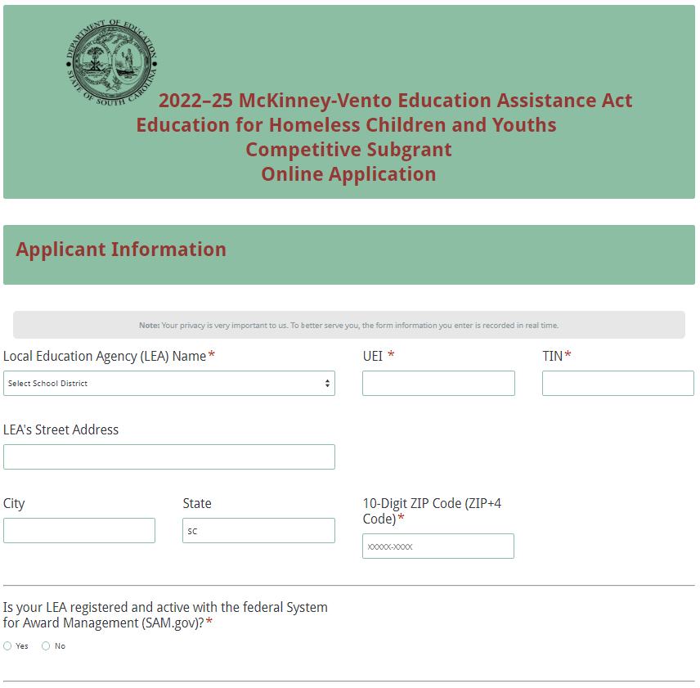
Indicate whether or not the district is registered and active with SAM.gov. If the district does not have an active SAM registration, the following message will be displayed. Refer to the information on page 6 on updating a registration in SAM to comply with 2 CFR Part 25.
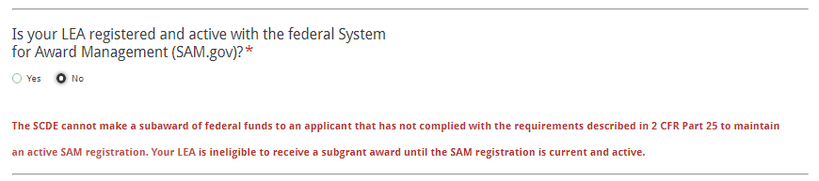
If the district selects “Yes” to indicate that their SAM registration is active, enter the date the current SAM registration expires.
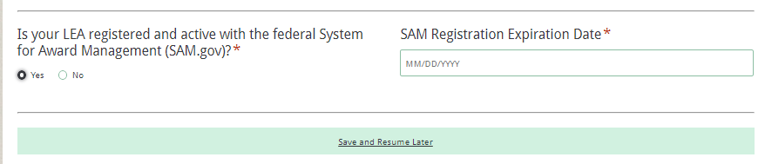
Enter the contact information for the McKinney-Vento LEA liaison. If the liaison’s mailing address is the same as the LEA, click on “Same as LEA’s Address” and the fields will automatically populate. If the address is different, enter the appropriate information, including the 10-digit ZIP Code. Because the application submission confirmation will be sent only to this e-mail address, you must reenter the e-mail address to validate that it is correct.
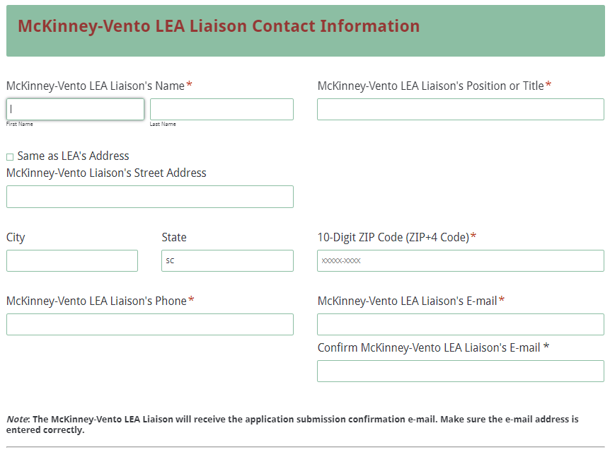
Indicate whether or not the McKinney-Vento LEA liaison will also serve as the project coordinator for this subgrant. Provide the additional information on the liaison to include the number of months they have been in this position, the percentage of a full-time equivalent (FTE) that will be devoted to the McKinney-Vento subgrant activities, and the other duties for which the liaison will be responsible.
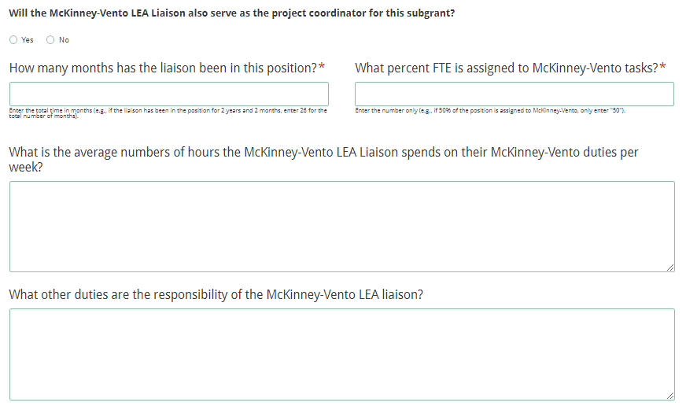
If the liaison will serve as the coordinator, click on “Same as McKinney-Vento Liaison” and the name, position or title, phone number, and e-mail address fields will automatically populate. If the liaison will not serve as the project coordinator, enter the coordinator’s contact information.
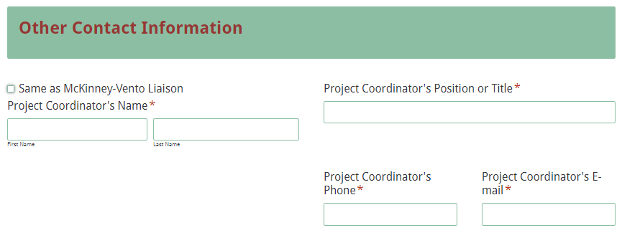
Enter the contact information for the district superintendent and the financial director. The superintendent is the authorized representative for the district and has the authority to enter into legally binding contractual agreements on behalf of the district. The names in the online application must match the names as provided on the Certification Signature Page.
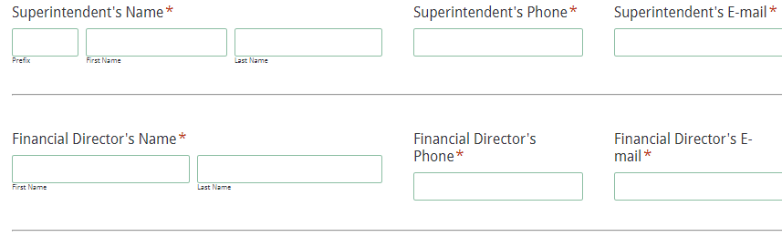
Provide the total number of homeless children and youths in the district by grade level for the 2020–21 school year to date as identified in PowerSchool. The field for the total identified homeless will automatically calculate. Enter the total student population for the district. The percent homeless field will auto-calculate the percentage of student homelessness for the district.
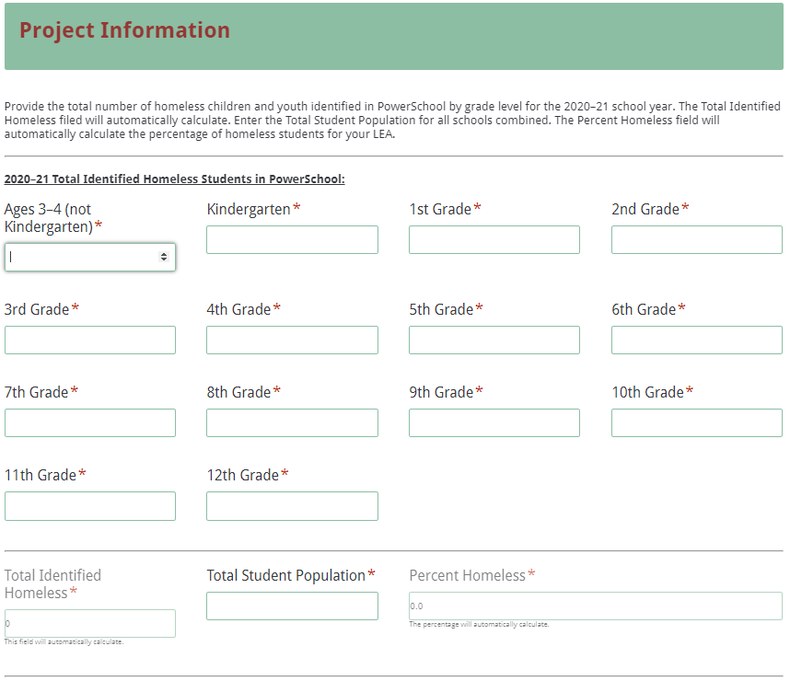
Answer the questions as instructed on pages 16–25 of the RFP. The Needs Statement has subsections 1e through 1i. For 1a, indicate the appropriate services to be provided through the subgrant, and then provide a brief description.
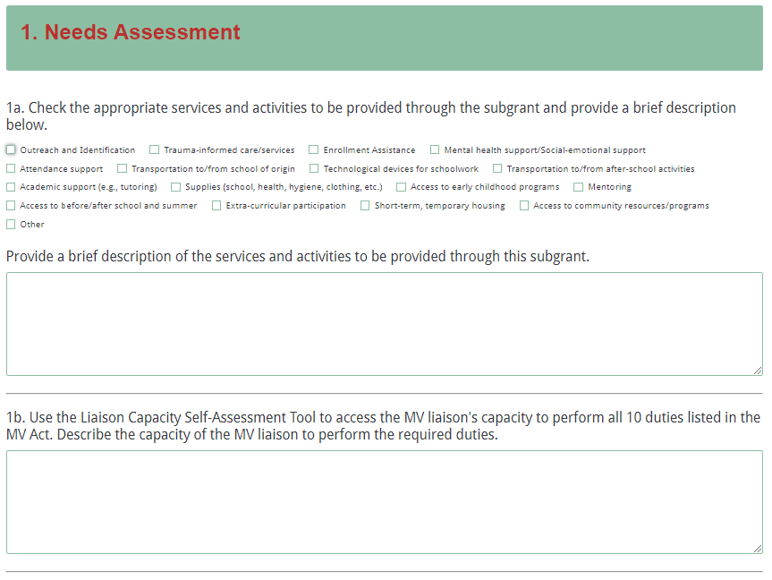
Subsection 1e is further broken down into subsections i–v and relates to data trends and comparisons for the applicant’s MV program.
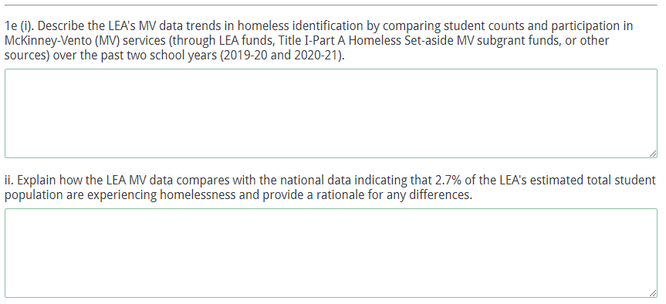
Many of the questions in the application require the applicant to provide a brief description or explanation of different components in the MV program. Question 3a for instance asks applicants to describe the level and quality of internal collaborations in the LEA. Type the response in the space provided.
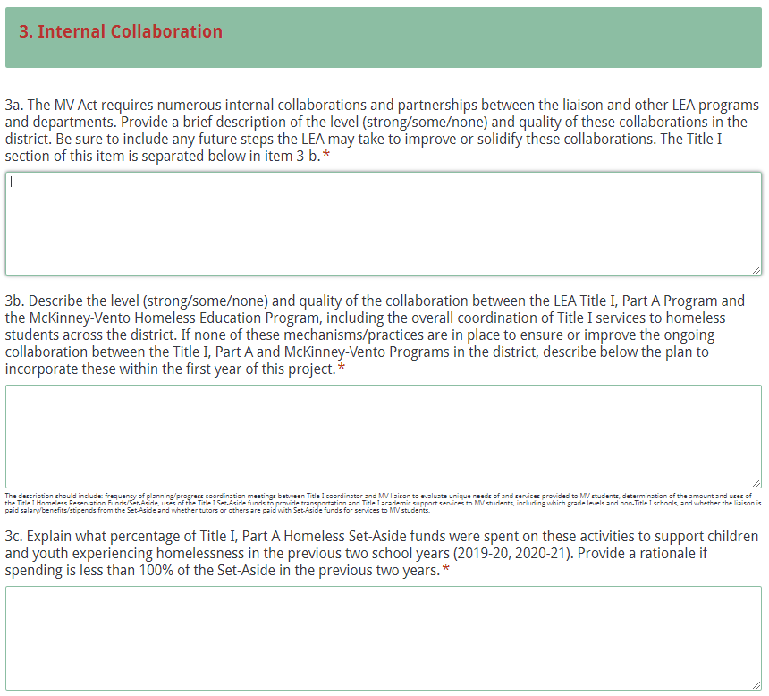
All amounts in the Funding Information and Budget Summary sections should be entered using whole dollars (no cents). Fill in all fields and enter 0 (zero) for line items that are not applicable.

In the Funding Information section, enter the total amount of subgrant funds requested for the first year of the project (July 1, 2022, through June 30, 2023).
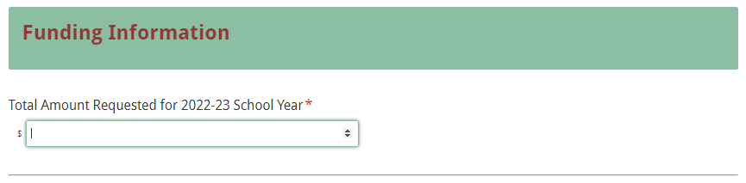
Enter the line-item totals for the funds requested for year one. The Total Funds Requested field will automatically calculate. The Total Funds Requested amount must match the Total Amount Requested for Year One under the Funding Information section.
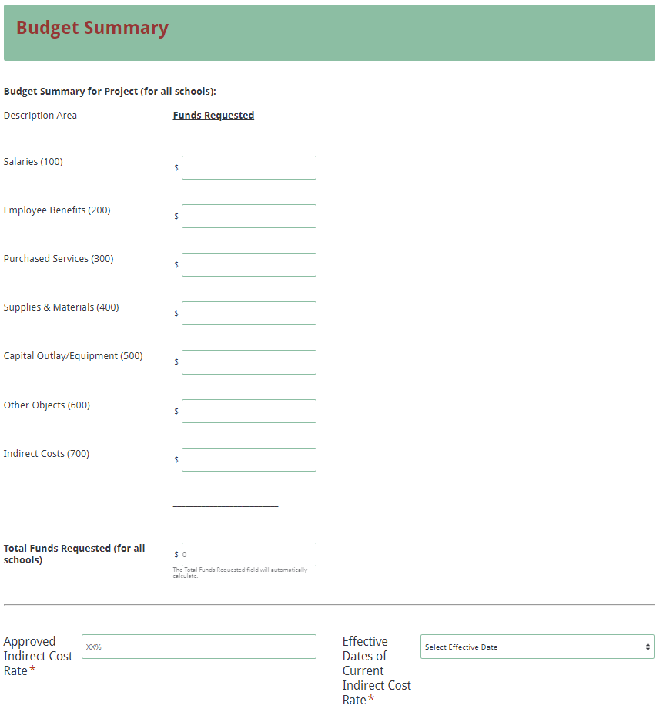
Enter the district’s current indirect cost rate percentage approved by the SCDE. Provide the beginning and ending dates of the effective period of the current indirect cost rate agreement.
Prepare each of the proposal attachments (i.e., Project Abstract, Application Narrative, Budget Narrative, Appendices, and Pre-Award Audit Questionnaire) following the preceding instructions on pages 16–28. Ensure that each attachment is saved in the proper format as either a PDF or Excel document. Pay close attention to attachments that must be scanned together into a single document. The online application will only allow one document to be uploaded for each attachment. Upload the attachments where indicated in the following screenshot. All attachments are required; you will not be able to submit the application without uploading all five documents.
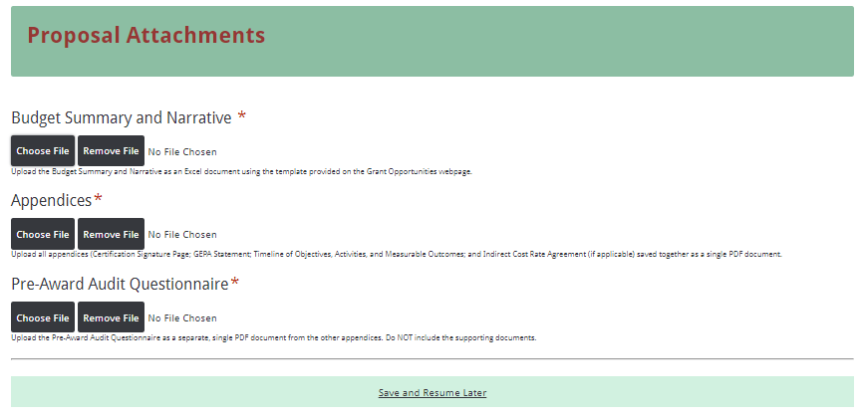
Thoroughly review the summary on the Data Review and Confirmation Page to verify that the information has been entered correctly in the online application prior to submitting. You will not be able to access the completed application form after it has been submitted. If any of the entries are incorrect, click on the "Previous" button at the bottom of each screen to return to the appropriate section(s) and reenter the correct information.
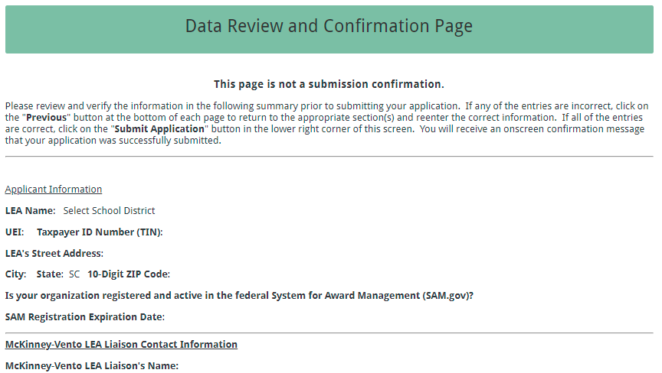
If all of the entries are correct, click on the “Submit Application” button in the lower right corner of this screen to complete the submission process.
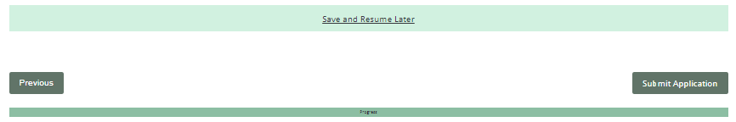
Once the application is submitted, the following message will be displayed on the screen.
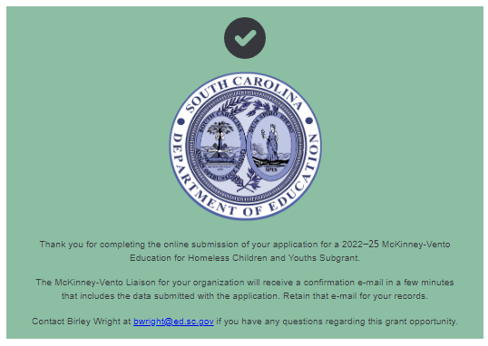
The following confirmation message will be sent to the e-mail address provided for the McKinney-Vento LEA liaison in the online application. If the liaison does not receive a confirmation e-mail, then the application did not successfully upload. You must go back and resubmit the entire online form, including all attachments, in order for your application to be considered for funding. Only the most recently submitted application will be reviewed.
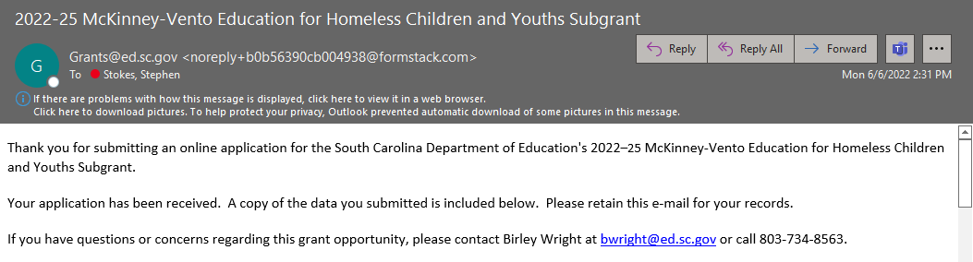
An e-mail confirmation that the subgrant application was successfully submitted does not account for the quality of the uploaded documents or the completeness of the online form. The confirmation e-mail only notifies you that the online application has been submitted and received. Applicants are responsible for ensuring that the information entered in the online form, including all attachments, is accurate and complete in order for the application to be reviewed and considered for funding.

Appendix A: Definitions of Terms Used

De-obligation—The downward adjustment of the obligations recorded in a grant award document. It is caused by factors such as (1) termination of part of the project, (2) reduction in material prices, (3) cost savings, or (4) correction of recorded amounts.

Enrolled and enrollment includes attending classes and participating fully in school activities.

Homeless children and youths are defined by the McKinney-Vento Homeless Assistance Act as individuals who lacks a fixed, regular, and adequate nighttime residence, including
- children and youths who are
- sharing the housing of other persons due to loss of housing, economic hardship, or a similar reason (sometimes referred to as doubled-up);
- living in motels, hotels, trailer parks, or camping grounds due to the lack of alternative adequate accommodations;
- living in emergency or transitional shelters; or
- abandoned in hospitals;
- children and youths who have a primary nighttime residence that is a public or private place not designed for or ordinarily used as a regular sleeping accommodation for human beings;
- children and youths who are living in cars, parks, public spaces, abandoned buildings, substandard housing, bus or train stations, or similar settings; and
- migratory children who qualify as homeless for the purposes of this subtitle because the children are living in circumstances described above.

Local education agency (LEA) is a public board of education or school district.

Memorandum of Agreement (MOA)—A document signed by the authorized representative(s) of each collaborative partner that clearly specifies the role, services, contributions, expertise, and funding for each partner.

The term unaccompanied youth includes a homeless child or youth not in the physical custody of a parent or guardian.

School of origin is the school that the child or youth attended when permanently housed or the school in which the child or youth was last enrolled.

Title I Schools—Schools with a 40 percent student population eligible for free or reduced-price lunch that receive or are eligible to receive Title I funds.

Title I Set-Aside—A sufficient amount of funds that a school district is required to reserve under Title I, Part A to provide services to students experiencing homelessness that are comparable to those provided to students in Title I schools. These services may include providing educationally related support services to children in shelters and other locations where children experiencing homelessness may live.

Appendix B: Selection Criteria and Reviewers’ Scoring Rubric

Selection Criteria

A total of 100 points is available to applications that meet the maximum score for each selection criteria. While the budget is assigned zero (0) points, the budget remains a critical component of the entire application. An application with an incomplete budget will not be funded.

The point values for each section of the application are as follows:

Narrative Sections | Points Available
Needs Assessment | 18
Project Administration | 6
Internal Collaboration and Coordination of Services | 10
Cross-District Collaboration | 10
Community Collaboration | 10
State-Level Collaboration | 6
Project Evaluation | 10
Timeline of Objectives, Activities and Measurable Outcomes | 30
Budget Narrative and Summary | 0
TOTAL | 100

Scoring Rubric
- Needs Assessment
Applicants must make a clear, concise, and well-supported statement of the need or problem to be addressed. The needs statement reflects the mission of the LEA's proposed project and fits with the purpose of the funding opportunity. This section must include references to LEA data on the educational challenges and related needs of children and youth experiencing homelessness served by the LEA. Services and activities to be provided through the subgrant should connect to the results of the LEA's needs assessment. To make a convincing case that students need the project, the applicant should conduct or report on a needs assessment to identify the major educational and non-educational needs of children and youth experiencing homelessness in the LEA and tailor the application to meet these needs. The information provided should be both factual and related to the problems addressed in the proposal. All items 1-a through 1-i must be completed by applicant.
1-a. The applicant fully describes additional needs of children and youth experiencing homelessness in the school district, as they relate to eligible uses of funds, including only those to be funded by this MV subgrant.  1-b. The applicant fully describes liaison's capacity to perform all 10 duties listed in the MV Act, demonstrates use of Liaison Capacity Self-Assessment Tool from School House Connection to assess their capacity and includes the liaison’s percentage of FTE, other LEA Role/Title, and number of years served as liaison.  1-c. The applicant fully describes prior training liaison has in Homeless Awareness, MV Law and regulations, LEA policies and procedures related to identification, enrollment, and support services for students experiencing homelessness.  1-d. The applicant fully describes major barriers (within and outside LEA) that limit identification, immediate enrollment, prompt provision of transportation, attendance, and school success of MV students in the LEA. | Acceptable | Fully Meets—14-18 points  Applicant provides a Needs Assessment that fully addresses all required items.
 | Acceptable | Adequate/Meets—10-13 points  Applicant provides a Needs Assessment that moderately addresses all required items or fully addresses at least two of the items.
 | Not  Acceptable | Limited/Approaches—5-9 points  Applicant provides a Needs Assessment that is limited or unclear in addressing at least two of the required items.
 | Not  Acceptable | Inadequate—1-4 points  Applicant provides a Needs Assessment that does not adequately address the required items.
- Needs Assessment (Continued)
1-e-i. The applicant fully describes LEA's data trends in homeless identification by comparing MV student counts and participation levels in MV services (through all fund sources used by the LEA program) over the past two school years (2019-20 and 2020-21).  1-e-ii. The applicant explains how LEA MV data compare (strong/some/none) with the National data indicating that on average 2.7% of an LEA's estimated total student population experience homelessness, and provides a rationale for any differences.  1-e-iii. The applicant explains how LEA MV data compare (strong/some/none) with the National data indicating expected rates of identification based on poverty data – between 6.5 and 10% of Pupils in Poverty (PIP) – and provides a rationale for any differences.  1-e-iv. The applicant fully describes LEA trends in Homeless Identification Counts by Primary Nighttime Residence and Grade Level.  1-e-v. The applicant fully describes LEA trends in participation rates of MV students in MV Services and in Title I-A services.  1-f. The applicant fully describes and summarizes data on the effectiveness of the LEA's MV services (for basic MV mandated services, as well as any additionally funded/donated services), listing the data sources. For example, improved attendance, improved participation and/or performance of students experiencing homelessness in statewide assessments, reduced absenteeism, etc.  1-g. The applicant fully describes how LEA determines whether the MV services provided were effective.  1-h. The applicant fully describes how program impact data are collected and by whom, includes all titles/roles of staff (including teams or committees) analyzing data for decision-making in the MV Program and related areas. |  | Acceptable | Fully Meets—14-18 points  Applicant provides a Needs Assessment that fully addresses all required items.
 |  | Acceptable | Adequate/Meets—10-13 points  Applicant provides a Needs Assessment that moderately addresses all required items or fully addresses at least two of the items.
 |  | Not  Acceptable | Limited/Approaches—5-9 points  Applicant provides a Needs Assessment that is limited or unclear in addressing at least two of the required items.
 |  | Not  Acceptable | Inadequate—1-4 points  Applicant provides a Needs Assessment that does not adequately address the required items.
1-i. The applicant provides a complete overview of the LEA’s MV services for students in the following special populations who are experiencing homelessness (may add other subgroups as appropriate).  - Preschool-aged children  - Unaccompanied youth  - Rural children and youth  - Eligible migrant children and youth  - Eligible multilingual learners  - Eligible immigrant/refugee children and youth  - Tribal children and youth  - LGBTQ+ children and youth  - Pregnant/parenting/caregiving youth  - Eligible children and youth with IEPs, 504 plans or other individualized learning plans | Acceptable |  |  | Fully Meets—14-18 points  Applicant provides a Needs Assessment that fully addresses all required items.
Adequate/Meets—10-13 points
Applicant provides a Needs Assessment that moderately addresses all required items or fully addresses at least two of the items.
 | Not  Acceptable |  |  | Limited/Approaches—5-9 points  Applicant provides a Needs Assessment that is limited or unclear in addressing at least two of the required items.
Inadequate—1-4 points
Applicant provides a Needs Assessment that does not adequately address the required items.
Reviewer’s Comments

- McKinney-Vento Education Project Administration
Project administration and management includes oversight of day-to-day activities and ongoing fiscal administration. Applicants must consider their mechanisms and internal controls for monitoring activities and compliance, collecting and gathering data for routine analysis and periodic reports, disbursing and tracking funds, reconciling expenditures, and retaining records. The item must include the administrative structure, including roles and duties for the proposed project. All items 2-a through 2-c must be completed by applicant.
2-a. The applicant fully describes training and other supports provided to liaison to ensure s/he has the capacity to carry out the required duties described in the MV Act (§ 11432(g)(6)(A), including the training, technical assistance and any other supports the LEA provides for the liaison.  2-b. The applicant fully describes how the LEA promotes meaningful involvement of parents/guardians/caregivers of MV children and youth in the activities and services proposed and includes descriptions of any activities in the project that will engage parents.  2-c. If hiring additional staff/contractors/vendors, applicant includes position, qualifications and responsibilities for each role in the description. If not hiring project staff this section may be left blank. | Acceptable | Fully Meets— 6 points  Applicant describes Project Administration that fully addresses all required items.
 | Acceptable | Adequate/Meets— 4-5 points  Applicant describes Project Administration that moderately addresses all required items or fully addresses at least two of the items.
 | Not  Acceptable | Limited/Approaches— 2-3 points  Applicant describes Project Administration that is limited or unclear in addressing at least two of the required items.
 | Not  Acceptable | Inadequate— 1 point  Applicant describes Project Administration that does not adequately address the required items.
Reviewer’s Comments

- Internal Collaboration and Coordination of Services
Applicants must provide information on the collaborations within the LEA that support the identification of and support services to children and youth experiencing homelessness, including internal department collaboration, Title I, Part A collaboration, and particularly how the Title I, Part A Homeless Reservation (Set-Aside) funds are determined and spent. Applicants must describe the level and quality of these internal collaborations, as well as explaining the mechanisms and practices in place to ensure or improve these internal collaborations. If the LEA has none of these mechanisms or practices currently in place, the applicant must describe the plan to incorporate these within the first year of this project. All items 3-a through 3-c must be completed by applicant.
3-a. The applicant fully describes the level (strong/some/none) and quality of LEA internal collaborations, as mandated by the MV Act. The applicant includes future steps LEA may take to improve or solidify internal collaborations. The Title I section is separate, below in item 3-b.  3-b. The applicant fully describes the level (strong/some/none) and quality of collaboration between the LEA Title I, Part A Program and the MV Homeless Education Program includes mechanism for overall coordination of Title I services to students experiencing homelessness across the district, frequency of meetings between program coordinators, and how the Title I Homeless Set-Aside is used in the LEA. (See items described in RFP on pages 18–19.)  If none of these mechanisms/practices are in place to ensure or improve the ongoing collaboration between the Title I, Part A and MV Programs, the applicant fully describes a plan to incorporate these within the first year of this project.  3-c. The applicant fully explains what percentage of Homeless Set-Aside funds were spent on activities/supports for children and youth experiencing homelessness in the previous two school years (2019-20, 2020-21), including rationale if spending is less than 100% of the Set-Aside. | Acceptable | Fully Meets— 9-10 points  Applicant’s description of Internal Collaboration fully addresses all required items.
 | Acceptable | Adequate/Meets— 6-8 points  Applicant’s description of Internal Collaboration moderately addresses all required items or fully addresses at least two of the items.
 | Not  Acceptable | Limited/Approaches— 3-5 points  Applicant’s description of Internal Collaboration is limited or unclear in addressing at least two of the required items.
 | Not  Acceptable | Inadequate— 1-2 points  Applicant’s description of Internal Collaboration does not adequately address the required items.
Reviewer’s Comments

- Cross-District Collaboration
Applicants must focus descriptions on how the LEA will collaborate with adjacent or contiguous districts, districts across county lines, and districts across state lines (if near a state boundary) to identify and provide services to children and youth experiencing homelessness. Applicants must describe the level and quality of these cross-district collaborations, as well as explaining the mechanisms and practices in place to ensure or improve these collaborations. If the LEA has none of these mechanisms or practices currently in place, the applicant must describe the plan to incorporate these within the first year of this project. Item 4 must be completed by applicant.
4. The applicant fully describes the level (strong/some/none) and quality of collaborations between the liaison, other MV program staff and liaisons in other districts, to identify and provide services to children and youth experiencing homelessness, including:  - adjacent or contiguous districts  - districts across county lines  - districts across the state  - LEAs bordering state lines (if applicable)  If the LEA does not currently have collaborations with such other districts, a plan is provided to incorporate such collaboration within the first year of the project in the comment box below. | Acceptable | Fully Meets— 8-10 points  Applicant’s description of Cross-District Collaboration fully addresses all required items.
 | Acceptable | Adequate/Meets— 5-7 points  Applicant’s description of Cross-District  Collaboration moderately addresses all required items or fully addresses at least three of the items.
 | Not  Acceptable | Limited/Approaches— 3-4 points  Applicant’s description of Cross-District  Collaboration is limited or unclear in addressing at least two of the required items.
 | Not  Acceptable | Inadequate— 1-2 points  Applicant’s description of Cross-District  Collaboration does not adequately address the required items.
Reviewer’s Comments

- Community Collaboration
Applicants must focus on ALL the partners the LEA and liaison work with throughout the school year, in the summer and beyond, to meet the needs of children and youth experiencing homelessness. Applicants must describe the level and quality of these community collaborations, as well as explaining the mechanisms and practices in place to ensure or improve these collaborations. Applicant must also describe the effectiveness and impact of the community collaborations and coordinated community services to children, youth and families experiencing homelessness provided by these collaborations. If the LEA has none of these mechanisms or practices currently in place, the applicant must describe the plan to incorporate these within the first year of this project. All items 5-a through 5-b must be completed by applicant.
5-a. The applicant fully describes partnerships the MV Program and/or MV liaison has within the local community, as shown on pages 19–20 of the RFP. If the applicant does not currently have collaborations with outside agencies, organizations or programs, provide the LEA’s plan to initiate and build such collaborations within the first year of the project.  5-b. The applicant fully describes the effectiveness and impact of the LEA’s community collaborations and coordinated community services to children, youth and families experiencing homelessness. If the applicant does not currently have any such collaborations with outside agencies, organizations or programs, describe the LEA’s expected outcomes and impacts of such collaborations. |  |  | Acceptable |  |  | Fully Meets— 8-10 points  Applicant’s description of Community Collaboration fully addresses all required items.
Adequate/Meets— 6-7 points
Applicant’s description of Community
Collaboration moderately addresses all required items.
 |  |  | Not  Acceptable |  |  | Limited/Approaches— 3-5 points  Applicant’s description of Community  Collaboration is limited or unclear in addressing at least one of the required items.
Inadequate— 1-2 points
Applicant’s description of Community
Collaboration does not adequately address the required items.
Reviewer’s Comments

- State-Level Collaboration
Applicants must describe the LEA’s collaboration at the state level, including agencies listed on page 20 of the RFP, including only those in which the LEA/liaison has participated. Applicant must address the outcomes of the LEA's state-level collaborations. If the LEA has none of these collaborative mechanisms or practices currently in place, the applicant must describe the plan to incorporate these within the first year of this project. All items 6-a through 6-b must be completed by applicant.
6-a. The applicant fully describes State-level activities or collaborations as identified on page 20 of the RFP in which the LEA liaison and/or MV Program has directly participated. If the applicant does not currently have State-level collaborations a plan is provided for building and sustaining these during the grant period.  6-b. The applicant provides and fully describes data on the outcomes and impacts of the LEA’s State-level collaborations. If the applicant does not currently have State-level collaborations a plan is provided describing the LEA’s expected outcomes and impacts of such collaborations. |  | Acceptable |  | Fully Meets— 6 points  Applicant’s description of State-level Collaboration fully addresses all required items.
Adequate/Meets— 4-5 points
Applicant’s description of State-level Collaboration moderately addresses all required items.
 |  | Not  Acceptable |  | Limited/Approaches— 2-3 points  Applicant’s description of State-level Collaboration is limited or unclear in addressing at least one of the required items.
Inadequate— 1 point
Applicant’s description of State-level Collaboration does not adequately address the required items.
Reviewer’s Comments

- Project Evaluation
Applicants must provide a plan to evaluate the project’s measurable outcomes and demonstrate, using scientific methods, as applicable, if and to what extent the project succeeded in meeting project objectives. All items 7-a through 7-e must be completed by applicant.
7-a. The applicant fully describes how the LEA will determine whether adjustments or enhancements to the project or activities are needed, based on periodic data collection and analysis.  7-b. The applicant fully describes ways the LEA will determine whether all activities in the project have been fully implemented as planned.  7-c. The applicant fully describes how progress will be tracked (based on measurable outcomes), how frequently, and by whom.  7-d. The applicant fully describes methods planned to evaluate the impact of the project and the data categories to be used, citing all data sources.  7-e. The applicant fully explains who is responsible for documentation and evaluation of this project, including each person’s LEA title or role (names are optional) and their responsibility in the evaluation of the project, including individuals/committees/teams/groups. | Acceptable |  |  |  | Fully Meets— 11-12 points  Applicant’s description of the Project Evaluation fully addresses all required items.
Adequate/Meets— 8-10 points
Applicant’s description of the Project Evaluation moderately addresses all required items or fully addresses at least two of the items.
 | Not  Acceptable |  |  |  | Limited/Approaches— 5-7 points  Applicant’s description of the Project Evaluation is limited or unclear in addressing at least two of the required items.
Inadequate— 0-4 points
Applicant’s description of the Project Evaluation does not adequately address at least the required items.
Reviewer’s Comments

- Timeline of Objectives, Activities & Measurable Outcomes
Applicants MUST use the form provided with the subgrant application. An example of a Timeline is included in the RFP attachment list on page 59. Timeline Activities to be funded must be in addition to, rather than take the place of regular LEA MV activities, services and practices that are required to be provided for children and youth experiencing homelessness or for all students. Applicants should use concise descriptions. Full sentences are not required in the Timeline. Applicants may add pages to each objective, as necessary. The SCDE Timeline Template must be completed and uploaded with the application. Applicants should be able to fill in this sentence if objectives are SMART: Who will do What to/for Whom by When to accomplish This Result, as evidenced by What Data?
8-a. Applicant’s Objectives are all in the SMART format.  8-b. Timeline includes an estimated start/end date for each activity in the Timeline. Ditto marks and “same as above” are not acceptable in any cell of the Timeline.  8-c. Activities included in the Timeline provide a clear, concise description of the specific ways the LEA plans to meet its objectives.  8-d. Activities under each objective fully address the stated needs of LEA's children and youth experiencing homelessness and must be directly relevant to that objective.  8-e. Timeline indicates the anticipated number or percentage (# or %) of children and youth experiencing homelessness to be impacted by each activity.  8-f. Measurable outcomes and documentation of each activity are provided for each activity.  8-g. Specific measurable outcomes are identified with data sources listed in the Timeline, as suggested on pages 21–22 of the RFP.  8-h. Each person/role involved in a project activity is identified by title or district role (i.e., MV liaison, Title I Director, financial office staff, etc.). Multiple individuals in committees or teams are be identified. | Acceptable |  |  |  | Fully Meets— 28-30 points  Applicant’s Timeline fully states and/or details all required items.
Adequate/Meets— 18-27 points
Applicant’s Timeline moderately stating and/or detailing at least 6 required items.
 | Not  Acceptable |  |  |  | Limited/Approaches— 11-17 points  Applicant’s Timeline is limited or unclear in stating and/or detailing at least three of the required items.
Inadequate— 0-10 points
Applicant’s Timeline does not adequately state and/or detail in at least 4 required items.
Reviewer’s Comments

- Budget Narrative and Summary
Applicants must include all planned expenditures of MV subgrant funds in the Budget Narrative tab of the application spreadsheet. The totals for each object code will automatically enter in the Budget Summary tab of the spreadsheet. Items described must be allowable, appropriate, reasonable, and adequate for the scope of the project. Items must relate to the activities in the Timeline and must be related to the stated needs of children and youth experiencing homelessness within the LEA. Descriptions in the Budget Narrative items must quantify or provide detail as to the total amounts were determined. Applicants must include any formulas used to calculate the costs.
The applicant’s Budget Narrative spreadsheet tab includes all planned expenditures for the project in the proper object codes, and meets all the following requirements:  - Items are all allowable, appropriate, reasonable, and adequate for the scope of the project.  - Items all relate to the activities in the Timeline and must be related to the stated needs of children and youth experiencing homelessness.  - Descriptions in all Budget Narrative object codes quantify or provide detail as to how the total amounts were determined.  - Applicants included any formulas used to calculate the total costs for items included.  - The applicant completed the LEA information section at the top of the Budget Summary Form. |  |  | Acceptable |  |  |  | Adequate/Meets— 0 points  Applicant provides a Budget Narrative that meets all requirements.
 |  |  | Not  Acceptable |  |  |  | Inadequate— 0 points  Applicant provides a Budget Narrative that does not meet requirements.
Reviewer’s Comments

Appendix C: Required SCDE Forms

Certification Signature Page
(This form must be signed by the individual from each proposed district, school, or organization who holds the title listed below.)

Certification
I hereby certify that, to the best of my knowledge, the information and data contained in this application are true and correct. The applicant’s governing body has duly authorized this application and documentation, and the applicant will comply with the Program Specific Assurances (if applicable) and the SCDE Assurances and Terms and Conditions if the grant is awarded. The applicant is registered and current (active) on the federal System for Award Management (SAM).

Authorized Official (should be superintendent of school district)
Name:
Position: | Email:
Telephone: | Fax:

Signature of Authorized Official: | Typed name of Authorized Official:
Date Signed:
Signature of Financial Official: | Typed Name of Financial Official:
Date Signed:
Signature of McKinney-Vento Liaison: | Typed Name of McKinney-Vento Liaison:
Date Signed:
Signature of Project Coordinator (if liaison is not project coordinator): | Typed Name of Project Coordinator:
Date Signed:

Please complete, print, and obtain signatures prior to submission. Include the signed, scanned form in the required appendices as indicated on page 34.

Assurances and Terms and Conditions for Federal Subawards

Assurances

- Has the legal authority to apply for federal assistance and the institutional, managerial, and financial capability (including funds sufficient to pay the nonstate share of project costs) to ensure proper planning, management, and completion of the project described in this application.
- Will give the South Carolina Department of Education (SCDE) access to and the right to examine all records, books, papers, or documents related to this award and will establish a proper accounting system in accordance with generally accepted accounting principles (GAAP) or agency directives.
- Has an accounting system with sufficient internal controls, a clear audit trail, and written cost-allocation procedures as necessary. The financial management systems are capable of distinguishing expenditures that are attributable to this grant from those that are not attributable to this grant. This system is able to identify costs by programmatic year and by budget line item and to differentiate among direct, indirect, and administrative costs. In addition, the applicant will maintain adequate supporting documents for the expenditures (federal and nonfederal) and in-kind contributions, if any, that it makes under this grant. Costs are shown in books or records (e.g., disbursements ledger, journal, payroll register) and are supported by a source document such as a receipt, travel voucher, invoice, bill, or in-kind voucher.
- Will also comply with the Office of Management and Budget 2 CFR Part 200 Subpart E-Cost Principles related to the allowability, reasonableness, and allocability of costs consistent with the approved budget and also by maintaining required support for salaries and wages. Required support includes certifications and/or personnel activity records depending upon the amount of time spent on cost objectives.
- Will approve all expenditures, document receipt of goods and services, and record payments on the applicant’s accounting records prior to submission of reimbursement claims to the SCDE for costs related to this grant.
- Will initiate and complete work within the applicable time frame after receipt of approval by the SCDE.
- Will not discriminate against any employee or applicant for employment because of race, color, religion, age, sex, national origin, or disability and comply with Title VI of the Civil Rights Act of 1964, Section 504 of the Rehabilitation Act of 1973, Title IX of the Education Amendments of 1972, the Age Discrimination Act of 1975, and Titles I, II, and III of the Americans with Disabilities Act of 1990 (ADA). The grantee will take affirmative action to ensure that applicants for employment and the employees during the period of their employment are treated without regard to their race, color, religion, age, sex, national origin, or disability.
- Has no policy that prevents, or otherwise denies, participation in constitutionally protected prayer in public schools as set forth in the Guidance on Constitutionally Protected Prayer in Public Education (20 U.S.C. § 7904).
- Will comply with the Family Educational Rights and Privacy Act. (20 U.S.C. §1232g; 34 CFR Part 99).
- Will comply with the Ethics, Government Accountability, and Campaign Reform Act (S.C. Code Ann. § 2-17-10 et seq. and § 8-13-100 et seq. (Supp. 2021)).
- Will comply with the South Carolina Drug Free Workplace Act (S.C. Code Ann. § 44-107-10 et seq. (Supp. 2021) if the amount of this award is $50,000 or more and the federal Drug Free Workplace Act of 1988 (41 USC 702).
- Will provide information to the SCDE, as requested, regarding the reporting requirements of the Federal Funding Accountability and Transparency Act (FFATA), which requires the SCDE to file a FFATA subaward report by the end of the month following the month in which it awards any subgrant equal to or greater than $25,000.
- Will comply with 2 CFR Part 25 and register and receive a unique entity identifier, fulfill the requirement for the System for Award Management, maintain the currency of the registration throughout the full grant term, and allow access by the granting agency to ensure compliance.
- Will comply with 2 CFR Part 200.112 and disclose in writing any potential conflict of interest to the SCDE.
- Will comply with 2 CFR Part 200.113 and disclose in writing to the SCDE all violations of federal criminal law involving fraud, bribery, or gratuity violations potentially affecting the federal award.
- Will comply with conditions under Executive Order 13513 “Federal Leadership on Reducing Text Messaging While Driving” (October 1, 2009) by refraining from text messaging while driving during official grant business. Relatedly, the applicant will refrain from emailing while driving during official grant business.

Terms and Conditions

- Completeness of Proposal. All proposals should be complete and carefully worded and must contain all of the information requested by the South Carolina Department of Education (SCDE). If you do not believe a section applies to your proposal, please indicate that fact.
- Non-awards/Termination. The SCDE reserves the right to reject any and all applications and to refuse to grant monies under this solicitation. If the SCDE rejects an application, the applicant has a right to request a hearing, as provided by 2 CFR Part 200.341 and 34 CFR Part 76.401, if it alleges the SCDE’s actions violate a state or federal statute or regulation by (1) disapproving of or failing to approve the application or project, in whole or in part, or (2) failing to provide funds in amounts in accordance with the requirements of statutes and regulations.
After it has been awarded, the SCDE may terminate a grant by giving the grantee written notice of termination. In the event of a termination after award, the SCDE shall reimburse the grantee for allowable expenses incurred up to the notification of termination. In addition, this grant may be terminated by the SCDE if the grantee fails to perform as promised in its proposal. Federal grants will be terminated in accordance with 2 CFR Part 200.339 and 200.340.
In the event that this grant is terminated, the grantee shall have a right to a hearing as set forth in 34 CFR Part 76.783. The grantee must notify the SCDE of its request for a hearing within 30 days of receiving written notice of the termination. If a hearing is requested, the SCDE will conduct the hearing in accordance with the procedures outlined in 34 CFR Part 76.401(d)(2)–(7).
- Reduction in Budgets and Negotiations. The SCDE reserves the right to negotiate budgets with applicants. The SCDE may, at its sole discretion, determine that a proposed budget is excessive and may negotiate a lower budget with the applicant. The applicant may at that time negotiate or withdraw its proposal. In addition, the SCDE may desire to fund a project but not at the level proposed. In that case, the SCDE shall notify the applicant of the amount that can be funded, and the applicant and the SCDE shall negotiate a modification to the proposal to accommodate the lower budget. All final decisions are that of the SCDE.
- Amendments to Grants. Amendments are permitted generally for budgets, grant end date, and management upon the mutual agreement of the parties involved and will become effective when specified in writing and signed by both parties. However, amendments to scope of work that significantly alter the original application proposal may trigger partial or full termination consistent with 2 CFR Part 200.339 and 200.340.
- Use of Grant Funds. Funds awarded are to be expended only for purposes and activities covered by the approved project plan and approved budget and budget narrative.
- Submission of Expenditure Reports. Claims for reimbursement must be made at least quarterly and consistent with calendar quarters (e.g., an expenditure report claim for costs for January 1 through March 30 must be filed by May 15).
- Obligation of Grant Funds. Grant funds may not be obligated prior to the effective date or subsequent to the end or termination date of the grant period. No obligations are allowed after the end of the grant period. The final request for expenditure report claims must be submitted no later than forty-five (45) days after the end of the grant period unless the scope of work for the grant states a shorter reporting period.
- Deobligation of Funds. After a final expenditure report claim has been submitted to the SCDE, the grantee will go through the official deobligation process with the SCDE.
- Documentation. The grantee must provide for accurate and timely recording of receipts and expenditures. The grantee’s accounting system should distinguish receipts and expenditures attributable to each grant. The grantee must review the memo regarding “Guidelines for Retaining Documentation to Support Expenditure Claims.”
- Travel Costs. Travel costs, if allowed under this solicitation, must not exceed limits noted in the United States General Services Administration (GSA) per diem rates for lodging, except in the case of conference lodging required for program-required training. In the case that conference-related lodging exceeds the GSA per diem rate, the grantee shall follow their entity’s written procedure for obtaining prior approval to exceed a GSA rate for a conference hotel. Meals and incidentals are limited by the state budget proviso, currently not to exceed $35 per day for in-state travel and $50 for out-of-state travel (see page 86 of the State of South Carolina Statewide Disbursement Regulations). Mileage reimbursement must follow the current Office of Comptroller General instructions, which is consistent with the published IRS rates.
- Honoraria. Amounts paid in honoraria, if allowed under this grant, must be consistent with SCDE policies. Applicants should check with the program office before budgeting for honoraria.
- Reports. The grantee shall submit, as required or instructed by the awarding program office, all reports (programmatic, financial, or evaluation) within the specified period or date and in the prescribed format. An expenditure claim report must be filed by August 15 for all expenditures incurred by June 30 in order to comply with the generally accepted accounting principles (GAAP) and the production of the State's Comprehensive Annual Financial Report.
- Copyright. The grantee is free to copyright any books, publications, or other copyrightable materials developed in the course of this grant. However, the SCDE reserves a royalty-free, nonexclusive, and irrevocable license to reproduce, publish, or otherwise use, and to authorize others to use, the copyrighted work developed under this grant.
- Certification Regarding Lobbying, Suspension, and Debarment. By submitting an application, the applicant certifies, to the best of its knowledge and belief, that the
- Applicant and/or any of its principals, subgrantees, or subcontractors
  - Have not paid or will not pay to any person any federally appropriated funds for the purpose of influencing or attempting to influence an officer or employee of any agency, a Member of Congress, an officer or employee of Congress, or any employee of a Member of Congress in connection with making any federal grant and the extension continuation, renewal, amendment, or modification of any federal grant, as defined at 34 CFR Part 82.105 and 82.110. If any funds other than federally appropriated funds have been paid or will be paid to any person for influencing or attempting to influence an officer or employee of any agency, a Member of Congress, an officer or employee of Congress, or any employee of a Member of Congress in connection with this federal grant, the undersigned shall complete and submit Standard Form LLL, “Disclosure of Lobbying Activities,” in accordance with its instructions.
  - Are not presently debarred, suspended, proposed for debarment, or declared ineligible for the award of contracts by any state or federal agency as stated at 2 CFR Part 180 or 2 CFR Part 3485.
  - Have not, within a three-year period preceding this application, been convicted of or had a civil judgment rendered against them for commission of fraud or a criminal offense in connection with obtaining, attempting to obtain, or performing a public (federal, state, or local) contract or subcontract; violated federal or state antitrust statutes relating to the submission of offers; or committed embezzlement, theft, forgery, bribery, falsification or destruction of records, making false statements, tax evasion, or receiving stolen property.
  - Are not presently indicted for, or otherwise criminally or civilly charged by a governmental entity with, commission of any of the offenses enumerated above.
- Applicant has not, within a three-year period preceding this application, had one or more contracts terminated for default by any public (federal, state, or local) entity.
- Audits.
- Entities expending $750,000 or more in federal awards:
Entities that expend $750,000 or more in federal awards during the fiscal year are required to have an audit performed in accordance with the provisions of 2 CFR Part 200.501, et seq. Except for the provisions for biennial audits provided in 2 CFR Part 200.504 (a) and (b), audits must be performed annually as stated at 2 CFR Part 200.504. A grantee that passes through funds to subrecipients has the responsibility of ensuring that federal awards are used for authorized purposes in compliance with federal program laws, federal and state regulations, and grant agreements. The director of the OMB, who will review this amount every two years, has the option of revising the threshold upward.
- Entities expending less than $750,000 in federal awards:
Entities that expend less than $750,000 in a fiscal year in federal awards are exempt from the audit requirements in 2 CFR Part 200.504. However, such entities are not exempt from other federal requirements (including those to maintain records) concerning federal awards provided to the entity. The entity’s records must be available for review or audit by the SCDE and appropriate officials of federal agencies, pass-through entities, and the General Accounting Office (GAO).
- Records. The grantee shall retain federal grant records, including financial records and supporting documentation, for a minimum of six (6) years after the end date of the grant when the final expenditure report claim for reimbursement and all final reports have been submitted, unless informed otherwise or in the case of litigation.
- Electronic Signature Agreement. I agree that my electronic signature is the legally binding equivalent to my handwritten signature.

Program-Specific Assurances

I certify that this applicant will abide by the following stipulations in federal law regarding the education of homeless children and youths:

- Ensure that services provided with these funds shall not replace the regular academic program and shall be designed to expand upon or improve services provided as part of the school’s regular academic program.
- Ensure that the LEA’s combined fiscal effort per student, or the aggregate expenditures of that agency and the state with respect to the provision of free public education by such agency for the fiscal year preceding the fiscal year for which the determination is made, was not less than 90 percent of such combined fiscal effort or aggregate expenditures for the second fiscal year preceding the fiscal year for which the determination is made.
- Ensure that the McKinney-Vento Liaison or program coordinator will
  - attend required meetings and professional development,
  - have access to the PowerSchool Student Information System,
  - be assigned a role in the grants accounting processing system (GAPS), and
  - submit all required reports and data to the SCDE by the required date.
- Ensure that the liaison and any applicable staff must comply with under Executive Order 13513, "Federal Leadership On Reducing Text Messaging While Driving."
- Ensure that the activities of the homeless education program does not segregate, isolate, stigmatize, or segregate homeless child or youth in a separate school, or in a separate program within a school, based on such child’s or youth’s status as homeless.
- Ensure that the LEA is in compliance with Section 722(g)(3)–(7) of the McKinney-Vento Act to include the following:
- The LEA of each homeless child and youth to be assisted shall, according to the child’s or youth’s best interest,
  - continue the education of each homeless child and youth in the school of origin for the duration of homelessness in any case in which a family becomes homeless between academic years or during an academic year or for the remainder of the academic year if the child or youth becomes permanently housed during an academic year; or,
  - enroll the child or youth in any public school that nonhomeless students who live in the attendance area in which the child or youth is actually living are eligible to attend;
- In determining best interest school selection, the LEA should,
  - presume that continuing in the school of origin is in the best interest of the child or youth if consistent with the wishes of the parent or guardian;
  - consider student-centered factors related to the best interest of the child or youth, including factors related to the impact of mobility on achievement, education, health, and safety of homeless children and youths, giving priority to the request of the child’s or youth’s parent or guardian or the unaccompanied youth.
- If after conducting the best interest determination based on the mandates listed above, the LEA determines that it is not in the best interest of the child or youth to attend the school of origin or the school requested by the parent, guardian, or unaccompanied youth, the LEA must
  - provide a written explanation of the reasons for its determination in a manner and form understandable to such parent, guardian, or unaccompanied youth, including information regarding their right to appeal the decision; and
  - ensure that the liaison will assist any unaccompanied youth in placement or enrollment decisions, giving priority to the student’s wishes. If the placement decision conflicts with the unaccompanied youth’s wishes, a written notice including the right to appeal will be provided by the LEA.
- A homeless child or youth shall be immediately enrolled in the selected school, even if records normally required for enrollment are not available. The enrolling school shall assist in obtaining relevant academic and other records, including immunization and medical records.
- Any record ordinarily kept by the school, including immunization records, academic records, birth certificates, guardianship records, and evaluation for special services or programs of each homeless child or youth, shall be maintained so that the records are made available in a timely fashion when a child or youth enters a new district.
- If a dispute arises over eligibility, or school selection or enrollment in a school, the student shall be immediately enrolled in the school in which enrollment is sought pending final resolution of the dispute, including all appeals. The parent or guardian of the student shall be provided with a written explanation of any decisions regarding eligibility, school selection, or enrollment made by the school, the LEA, or the SEA, including the right to appeal the decision. If the student is an unaccompanied youth, the liaison will make sure the same procedures occur. The liaison shall carry out the dispute resolution process as expeditiously as possible.
- The choice regarding placement shall be made regardless of whether the child or youth lives with the homeless parents or has been temporarily placed elsewhere.
- Information about the living situation of a homeless child or youth shall be treated as a student education record and shall not be deemed to be directory information.
- Each homeless child or youth shall be provided comparable services offered to other students in the selected school, including transportation services, educational services for which the child or youth meets the eligibility criteria (such as compensatory educational programs for the disadvantaged and educational programs for children with disabilities, students with limited English proficiency, and for the gifted and talented students), career and technology education, gifted and talented programs, and school nutrition.
- The LEA will coordinate with local social services agencies and other agencies or programs providing services to such children or youths and their families, and with other LEAs on interdistrict issues, such as transportation or transfer of school records. Coordination should be provided to raise the awareness of school personnel and service providers of the effects of short-term stays in a shelter and other challenges associated with homelessness.
- The LEA will designate an appropriate staff person as the liaison for the education of homeless children and youths to ensure that the following responsibilities are carried out:
  - Homeless children and youths are identified by school personnel through outreach and activities coordinated with other entities and agencies.
  - Homeless children and youths are enrolled in and have a full and equal opportunity to succeed in a school of that LEA.
  - Homeless families, children, and youths have access to and receive educational services for which such families, children, and youths are eligible, including Head Start, Early Head Start, early intervention services under part C of IDEA, and other preschool programs administered by the LEA; referrals to health care, dental, mental health, and substance abuse services; housing services; and other appropriate services.
  - The parents or guardians of homeless children and youths are informed of educational and related opportunities available to their children and are provided with meaningful opportunities to participate in the education of their children.
  - Public notice of the educational rights of homeless children and youths is disseminated in locations frequented by parents, guardians, and unaccompanied youths, including schools, shelters, public libraries, laundromats, and soup kitchens, in a manner and form understandable to the parents, guardians, and unaccompanied youth.
  - Enrollment disputes are mediated in accordance with Section 722(3)(E) of the McKinney-Vento Act.
  - The parent or guardian of a homeless child or youth, and any unaccompanied youth, is fully informed of all transportation services, including transportation to the school of origin, and is assisted in accessing transportation to the selected school.
  - Unaccompanied homeless youth are informed of their status as independent students and are provided assistance to receive verification of such status for FASFA purposes.
- The LEA will review and revise any policies that may act as barriers to the enrollment of homeless children and youths in school. Consideration shall be given to issues concerning transportation requirements, immunization, residency, birth certificates, school records or other documentation, and guardianship. Special attention shall be given to ensuring the enrollment and attendance of homeless children and youths who are not currently attending school.

South Carolina Department of Education

Pre-Award Audit Questionnaire

Visit the SCDE’s Office of Auditing Services Web site to access the Pre-Audit Award Questionnaire for LEAs and State Agencies.

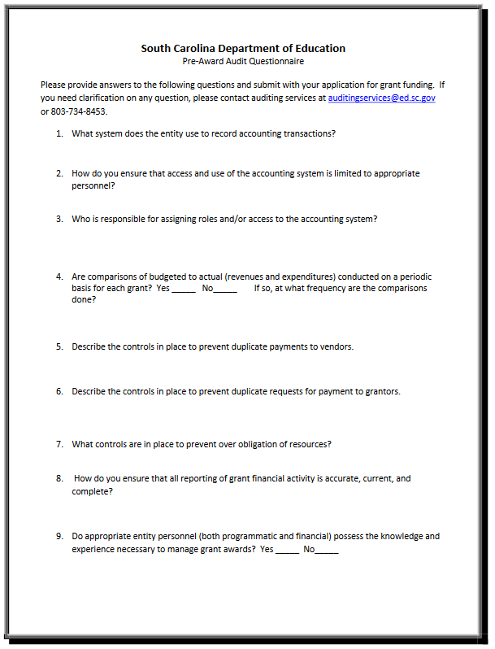

Instructions for GEPA Statement of Compliance

The purpose of this enclosure is to inform you about a new provision in the Department of Education's General Education Provisions Act (GEPA) that applies to applicants for new grant awards under Department programs. This provision is Section 427 of GEPA, enacted as part of the Improving America's Schools Act of 1994 (Public Law (P.L.) 103-382).
To Whom Does This Provision Apply?
Section 427 of GEPA affects applicants for new grant awards under this program. ALL APPLICANTS FOR NEW AWARDS MUST INCLUDE INFORMATION IN THEIR APPLICATIONS TO ADDRESS THIS NEW PROVISION IN ORDER TO RECEIVE FUNDING UNDER THIS PROGRAM.
(If this program is a state-formula grant program, a state needs to provide this description only for projects or activities that it carries out with funds reserved for state-level uses. In addition, local school districts or other eligible applicants that apply to the state for funding need to provide this description in their applications to the state for funding. The state would be responsible for ensuring that the school district or other local entity has submitted a sufficient Section 427 statement as described below.)

What Does This Provision Require?
Section 427 requires each applicant for funds (other than an individual person) to include in its application a description of the steps the applicant proposes to take to ensure equitable access to, and participation in, its federally assisted program for students, teachers, and other program beneficiaries with special needs. This provision allows applicants discretion in developing the required description. The statute highlights six types of barriers that can impede equitable access or participation: gender, race, national origin, color, disability, or age. Based on local circumstances, you should determine whether these or other barriers may prevent your students, teachers, etc. from such access or participation in the federally funded project or activity. The description in your application of steps to be taken to overcome these barriers need not be lengthy; you may provide a clear and succinct description of how you plan to address those barriers that are applicable to your circumstances. In addition, the information may be provided in a single narrative, or, if appropriate, may be discussed in connection with related topics in the application.

Section 427 is not intended to duplicate the requirements of civil rights statutes, but rather to ensure that, in designing their projects, applicants for federal funds address equity concerns that may affect the ability of certain potential beneficiaries to fully participate in the project and to achieve to high standards. Consistent with program requirements and its approved application, an applicant may use the federal funds awarded to it to eliminate barriers it identifies.

What are Examples of How an Applicant Might Satisfy the Requirement of This Provision?
The following examples may help illustrate how an applicant may comply with Section 427.
- An applicant that proposes to carry out an adult literacy project serving, among others, adults with limited English proficiency might describe in its application how it intends to distribute a brochure about the proposed project to such potential participants in their native language.
- An applicant that proposes to develop instructional materials for classroom use might describe how it will make the materials available on audio tape or in Braille for students who are blind.
- An applicant that proposes to carry out a model science program for secondary students and is concerned that girls may be less likely than boys to enroll in the course might indicate how it intends to conduct "outreach" efforts to girls to encourage their enrollment.
- An applicant that proposes a project to increase school safety might describe the special efforts it will take to address concern of lesbian, gay, bisexual, and transgender students, and efforts to reach out to and involve the families of LGBT students.
We recognize that many applicants may already be implementing effective steps to ensure equity of access and participation in their grant programs, and we appreciate your cooperation in responding to the requirements of this provision.

Estimated Burden Statement for GEPA Requirements
According to the Paperwork Reduction Act of 1995, no persons are required to respond to a collection of information unless such collection displays a valid OMB control number. Public reporting burden for this collection of information is estimated to average 1.5 hours per response, including time for reviewing instructions, searching existing data sources, gathering and maintaining the data needed, and completing and reviewing the collection of information. The obligation to respond to this collection is required to obtain or retain benefit (Public Law 103-382. Send comments regarding the burden estimate or any other aspect of this collection of information, including suggestions for reducing this burden, to the U.S. Department of Education, 400 Maryland Ave., SW, Washington, DC 20210-4537 or email ICDocketMgr@ed.gov and reference the OMB Control Number 1894-0005.

Timeline of Objectives, Activities, and Measurable Outcomes Template
McKinney-Vento Homeless Assistance Act
2022–25 Education for Homeless Children and Youths Subgrant

Use a new page for each objective; add lines as needed. Save all pages as a single PDF document to upload with the appendices.

Objective Number: |  | Objective:

Activity Number | Start/  End Date | Activity to Achieve Objective | # or % of  M-V students to be impacted | Data Source(s) | Measurable Outcome | Person/Agency Responsible

Budget Narrative Template

Use the budget format file that accompanies this funding opportunity announcement at the SCDE’s Grant Opportunities webpage to develop the required Budget Narrative. Each year of the 3-year funding period must be completed on designated tab within the budget narrative template. The screenshot below is for informational purposes only.

