Request for Proposals (RFP)
Application Package

2025–26 Innovation Grant

The Innovation Grant is a grant program funded by the General Appropriations Bill H. 4025 of 2025, authorized by proviso 1A.56. (SDE-EIA: Grants Committee) and administered by the South Carolina Department of Education.

Deadline for Receipt of Applications: June 30, 2025, at 5:00 p.m.

For questions about the Innovation Grant, contact:
Phillip Cease, phcease@ed.sc.gov

Issued by:
South Carolina Department of Education
Office of Government Relations and Policy
849 Learning Lane
West Columbia, SC 29172-3171

TABLE OF CONTENTS

PART I: General Information 1
A. Introduction and Purpose 1
B. Eligible Applicants 2
C. Timeline of Granting Process 2
D. Program and State Requirements 2
E. Review and Selection Process 3
F. Appeals Process 3

PART II: Application Overview, Content, and Instructions 5
A. Application Overview 5
B. Online Application Instructions 5
C. Application Attachments 6
1. Certification Signature Page 6
2. Application Narrative 6
3. Budget Narrative 7
4. Letters of Support 8
D. Deadline and Submission Procedures 8
E. Screenshots of the Online Application Form and Submission Instructions 8

Appendix C: Required SCDE Forms 14
Certification Signature Page 14
Assurances and Terms and Conditions for State Awards 15
Budget Narrative Template 19

PART I: General Information

Introduction and Purpose

The purpose of the Innovation Grant Program is to support innovative pilot initiatives in public school districts and schools that include the criteria listed in Proviso 1A.56 of H. 4025, the General Appropriations Bill of 2025, 1st Regular Session of the 126th South Carolina General Assembly:

1A.56. (SDE-EIA: Grants Committee) (A) Of the funds appropriated to the Department of Education for Innovation Grants, the grants committee shall accept applications per the established process for new grantees not to exceed the amount appropriated by the General Assembly.
(B) The process shall include the application and selection process. The grants committee must be comprised of seven members, one member of the Senate appointed by the Chairman of the Senate Finance Committee, one member of the House of Representatives appointed by the Chairman of the House Ways and Means Committee, two members selected from the education community and three members selected from the business community. The suggested criteria for awarding the grants to schools or school districts or directly purchasing services must include, but are not limited to:
(1) identification of key measurable benchmarks to raise student achievement and ensure all students are prepared to graduate college, career and civic ready;
(2) innovative strategies to close student achievement gaps in reading and mathematics, with a focus on schools with an academic achievement rating of below average and unsatisfactory;
(3) a demonstrated ability to implement the initiative or model as outlined in the application; and
(4) a demonstrated ability to be both replicable and scalable with priority given to projects grounded in evidence-based practices that have significantly impacted student achievement outcomes.
(C) Notice of grant opportunities and applications shall be posted on the department’s website by May 30th. Applications for funding must be submitted to the department by June 30th. Notification of grant awards and final grant amounts shall be sent to applicants by July 31st.
(D) Applicants who commit to a match will be given priority in the selection process. The match may be met by funds or by in-kind donations, such as technology, to be further defined by the grants committee. Public school districts and schools that have high poverty and low achievement will receive priority for grants when their applications are judged to meet the criteria established for the grant program. De-identified student level data shall be submitted, including a definition of program fidelity. The committee shall submit an annual report to the Governor, the Chairman of House Ways and Means and the Chairman of Senate Finance by June 30th.
(E) Grantees will be required to participate in an external evaluation by selecting an evaluator approved by the department.
(F) The grants committee must award at least one grant to an applicant providing an assessment tool that will provide each district with a local inventory dashboard of education software programs used by their students and teachers, and that includes an aggregate dashboard of program usage from across the state, for the department. Additionally, the system must provide a compilation of usage data by educator and student, be able to conduct rapid cycle evaluations to measure the effectiveness of education software programs based on student outcomes, and support evidence-based analysis of education software programs aligned to the required levels of evidence in the Every Student Succeeds Act. Any system procured must meet the state and agency minimum IT security standards as prescribed by the department. The department is authorized to carry forward and expend any balance for funds authorized in the prior fiscal year for Innovation Grants that provide an assessment tool as described herein in the current fiscal year.

Award amounts will be based on the final amount appropriated in General Appropriations Bill H. 4025 of 2025, the quality of applications received, and total funding requested. Final budgets may be negotiated based on demonstrated needs. All grant awards are contingent upon total allocations to the SCDE.

The maximum grant period is one year, ending on June 30, 2026. All grants are subject to the availability of state funds.

Eligible Applicants

All South Carolina school districts, South Carolina schools, nonprofit, and for-profit entities are eligible to apply. Public school districts and schools that have high poverty and low achievement will receive priority for grants.

Timeline of Granting Process

Date | Activity/Action
June 30, 2025 | Deadline for receipt of applications
July 31, 2025 | Notification of awards
June 30, 2026 | Funding period ends; projects must end
July 12, 2026 | Final report(s) due to the SCDE

Program and State Requirements

Applicants must indicate in their application which of the following priority area will be addressed by their proposed program:
- Literacy
- Raise student achievement to ensure College, Career, and Military readiness
- Close student achievement gaps, with a focus on below average and unsatisfactory schools
- Applied Learning and Workforce Development
- STEM/STEAM
- Character Development
- Civics Education.
Grantees are required to participate in an external evaluation using an evaluator approved by the Department.

The Innovation Grant program is authorized by proviso 1A.56. (SDE-EIA: Grants Committee) of H. 4025, the General Appropriations Act of 2025 (see pages 1–2). Applicants are reminded that, if funded, their programs must comply with this proviso. Applicants must also comply with other provisos in the Act, including Proviso 117.20 (Subsistence Expenses & Mileage), Proviso 1.78 (Partisanship Curriculum), and any other applicable provisos.

Applicants should review the Assurances and Terms and Conditions for State Awards (on pages 15–18) to ensure that, if awarded a grant, they are capable of full compliance, especially with all the referenced regulations and state laws, in order to enter into an agreement with the SCDE for this program. Pursuant to S.C. Code Ann. §8-13-700 (Supp. 2024) the applicant must disclose any potential conflict of interest to the SCDE in accordance with the SC Ethics Reform Act conflict of interest policy. A signed Certification Signature Page (see page 14) is required with the grant application and legally binds the applicant to the agency’s Assurances and Terms and Conditions.

Review and Selection Process

Only those grant applications that are received by the deadline and deemed complete and in compliance will be forwarded for review and funding consideration. All required materials must be submitted for the application to be considered complete and eligible for review. Program staff will conduct an initial review of applications for completeness and compliance with the application instructions. No incomplete applications will be forwarded to the Innovation Grants Committee or considered for funding.

The Innovation Grants Committee will review applications forwarded for review. Following the committee’s selection process, awards will be made to applicants determined to be qualified to receive funds based on responses that meet the criteria established for the grant program. Public school districts and schools that have high poverty and low achievement will receive priority for grants when their applications are judged to meet the criteria established for the grant program. Projects grounded in evidence-based practices that have significantly impacted student achievement outcomes and applicants that commit to a match will be given priority in the selection process.

The SCDE reserves the right to negotiate final budgets and to disqualify costs associated with any line items that are unallowable, unallocable, unreasonable, or inconsistent with the program’s goals or the proposed project’s activities and strategies.

Appeals Process

An applicant who has submitted a proposal that the SCDE does not fund has 30 calendar days after receiving notification that the proposal is not funded to request a review of the process. Scores may not be appealed; the SCDE will not rescore applications. An unfunded applicant may inquire as to whether or not the application process was followed.

The request for review must be directed to the State Superintendent of Education and must state the reasons for the request. The Superintendent may delegate to a deputy superintendent the authority to conduct a review. The deputy superintendent will issue a decision after the review of the information submitted by the applicant and the program office. This decision will be the final decision of the agency. The applicant may appeal the agency’s decision to the Administrative Law Court under the terms of the Administrative Procedures Act.

PART II: Application Overview, Content, and Instructions

Read all guidelines and criteria carefully before preparing your application. Only applications that include all sections and appendices and fully adhere to these guidelines will be reviewed and considered for funding. Incomplete applications will not be reviewed.

Application Overview

Applicants are encouraged to prepare all of the following elements of the application before beginning the online submission process. Do not wait until the last minute to submit an application. Use the following overview as a checklist to ensure that the application is complete with items labeled accordingly and presented in the order outlined below. Verify that all narrative components and appendices are included prior to uploading attachments.

The Innovation Grant online application is organized into the following sections:
- Online Form
- Applicant Information
- Contact Information
- Alternate Contact Information
- Program Information
- Funding Information
- Application Attachments
  - Certification Signature Page
  - Application Narrative
  - Budget Narrative
  - Letters of Support (if applicable)

Online Application Instructions

Applications must be submitted using the online application form: 2025–26 Innovation Grant Fund - Formstack. The online submission is organized into two sections—Online Form and Application Attachments. Use the screenshots on pages 9–13 as guides for preparing the following information for input into the online form.

Provide the applicant organization’s name, the school’s name (if applicable), and the applicant’s federal employer ID number (contact the applicant organization’s finance office for assistance). Provide the mailing address including the full Zip Code +4. Provide full contact information for the primary contact for the application (name, role/position, email, phone) and for an alternate contact for the application.

Provide the proposed Program Name and a brief (3-4 sentence) description of the program. In the form, enter the number of students, teachers, and others that the proposed program will serve (see screenshot on page 10).
In the Funding Information section of the online form, enter the total funds requested for the proposed program. Ensure that this total equals the total in the Budget Narrative (pages 7–8 and 19).

Application Attachments

Use the following instructions to complete all application attachments for upload as separate items in the “Application Attachments” section of the online application form (see screenshot on page 11).

Certification Signature Page
Print the Certification Signature Page (page 14) and obtain the appropriate signatures. This form includes the certification of the SCDE’s Assurances and Terms and Conditions for State Awards (pages 15–18), so that document is not required to be included in the application. However, retain the copy included in this RFP for your records and ensure that all signatories have copies of each document.

By signing the Certification Signature Page, the signatories assure that they will comply with all the assurance and terms and conditions for the project/program. All signatories must understand that they are signing a document that is legally binding in the event a grant is awarded. Applications that do not include the signed Certification Signature Page will not be reviewed or considered for funding.

After obtaining all required signatures, scan and save the Certification Signature Page as a single PDF document to be uploaded where indication in the online application form.

Application Narrative
Use the following directions to write the application narrative and organize it into sections following the sequence presented below. Do not combine sections. Required components must be located in their designated sections in order to be scored.

When completed, save the document as a single PDF document to be uploaded where indicated in the “Application Attachments” section of the online application.

- Program Details (500-800 words)
Describe the proposed program.

- Priority Area (300 – 500 words)
Identify one priority area to be addressed by the program and explain how the proposed program aligns with the priority area. The allowable priority areas are:
    - Literacy
    - Raise student achievement to ensure College, Career, and Military readiness
    - Close student achievement gaps, with a focus on below average and unsatisfactory schools
    - Applied Learning and Workforce Development
    - STEM/STEAM
    - Character Development
    - Civics Education

- Target Population (300 – 500 words)
Identify the specific target population the proposed program will serve (including the demographics, grade level, characteristics, number of students/teachers/leaders). Discuss why this group was chosen as the target population.

- Service Area
If the proposed project is to serve a statewide population, state such. If the proposed project is not a statewide proposal
- Describe how the program can be replicated and scaled to a statewide level. (300 words); and
- Identify the schools or districts that have agreed to participate in your program if funded (100 words).

- Partnerships (500 words)
Describe any partners and/or organization(s) that will be involved in the proposed program and their role(s) in the implementation process.

- Prior Innovation Grants (100 words)
If your organization or proposed project has never received Innovation Grants funding in the past, state such. If your organization or proposed project has funding from the Innovation Grants Fund in the past, list the years and the amount of funding received for each award year.

- The Problem Your Program Will Address
- Describe the problem the proposed program will address. In your answer provide the specific qualitative and quantitative data that was gathered to determine this problem (500 words).
- Describe how the proposed program will address the identified problem (500 words).
- Describe how you will know the program has succeeded. Include how you will identify and measure the program’s success (500 words).

Budget Narrative
Using the linked spreadsheet (page 19), provide a single, one-page Budget Narrative for the tab labeled “100% Grant Budget.” Applicants are strongly encouraged to complete the tabs labeled “75% Grant Budget” and “50% Grant Budget” due to the limited amount of funding. Amounts for the tab “Budget Summary” will automatically populate.
Include estimates for matching funds and in-kind contributions, if applicable. Provide the following:
- A brief description and rationale for each of the expenses.
- A description of any matching funds or in-kind donations you will receive (100 words).
- A per pupil cost of the proposed program, using the number of students included in Program Information in the online form (see screenshot on page 11; 100 words).

The budget narrative should not exceed one page for each proposed budget – one page for 100% funded, one page for 75% funded, one page for 50% funded. Ensure the totals in these budget narratives equal the totals on the budget summary page.

- Letters of Support (if applicable)
Combine any applicable letters of support into a single PDF document to be uploaded where indicated in the “Application Attachments” section of the online application.

Deadline and Submission Procedures

- Applications must be submitted online using the online application form before 5 p.m. on June 30, 2025.
- Only applications that adhere to all of the guidelines and directions set forth in this RFP will be reviewed and considered for funding.
- No hard copy applications will be accepted. Applications delivered by hand, postal mail, email, or fax will not be accepted.
- Applications must originate from the applicant. Applications that are plagiarized from the Internet, other grants, or other resources will not be considered for funding.
- Applications will not be returned. Keep a copy of the entire application for your records.

Screenshots of the Online Application Form and Submission Instructions

The SCDE encourages applicants to prepare all parts of the application before beginning the online submission process. Make sure all information submitted is accurate, including formal or official names such as the school district, and that spelling is correct. Do not use abbreviations or acronyms. All fields marked with a red asterisk are required; you will not be able to proceed to the next screen of the application without entering all required information.

If necessary, you may save your progress in the online application and return to the form later. Click on the “Save and Resume Later” link to save your progress. You will be prompted to create a password to securely save your form. You will have the option of copying and saving the link to the partially completed form or entering an email address to have the link emailed to you. Be sure to enter the email address correctly as SCDE personnel cannot access the hyperlink or the incomplete application. Use the link to access the application from any computer within thirty (30) days to complete the online submission. Without the link and password or after thirty days, the data previously entered cannot be retrieved, and you will have to begin a new application. A saved application is not a submitted application.

Note that when saving the online application form, the attachments and signature fields will not be included in the saved form (see screenshot below). Those fields must be populated again before submitting the application form.
The following screenshots are for informational purposes only and are provided to assist applicants in compiling all items needed to complete the online submission. Make sure all information submitted is accurate, including formal or official names such as the applicant organization, and that spelling is correct. Do not use abbreviations or acronyms. All fields marked with a red asterisk are required; you will not be able to proceed to the next screens of the application without entering all information on each screen.

Enter the official name of the applicant organization (school district or organization), along with the name of the school to be served, if applicable. Enter the applicant’s Federal Employer ID number.
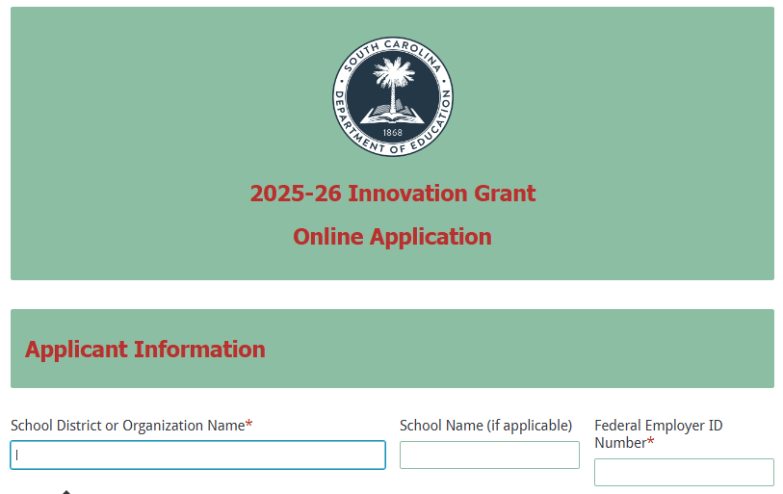
Enter the applicant’s address, including the full zip code (zip+4).
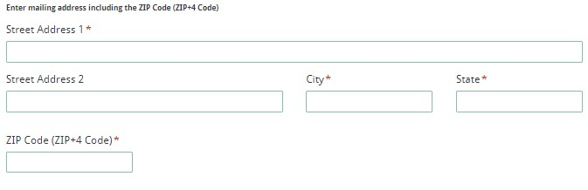
Enter the contact person’s name, role/position, email address, and phone number. These are required fields; an applicant will not be able to proceed to the next page of the application without entering this information. The application submission confirmation message will be sent only to this email address. Reenter the email address to confirm that it is correct.
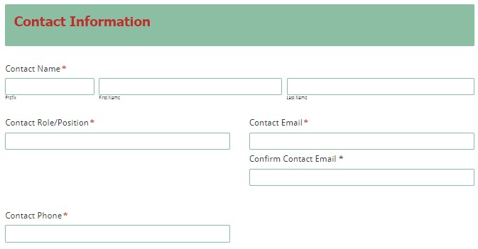

Enter the name, role/position, email address, and phone number for an alternate contact who can address this application. These are required fields; an applicant will not be able to proceed to the next page of the application without entering this information.
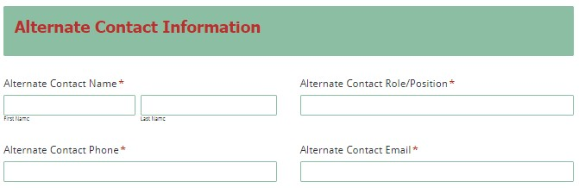
In the next section of the online application form, enter the name of the proposed program, a brief description (3-4 sentences) of the program, and the number of persons (students/teachers/others) to be served.
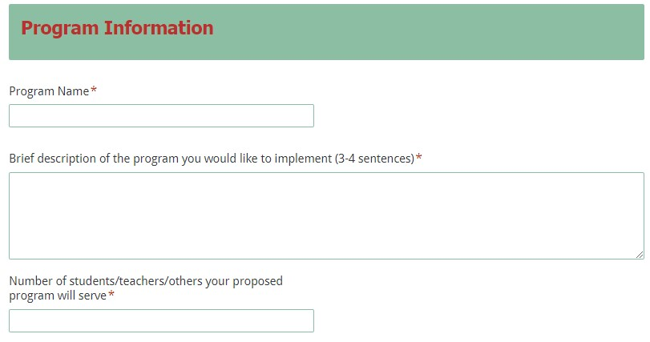
In the Funding Information section, enter the total amount of funding requested in whole dollars (no cents). This amount must match the total funds requested in the budget narrative.

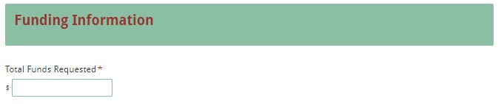

Upload the application attachments in the appropriate format following the instructions on pages 6–8. Note that the attachments with an asterisk are required; you will not be able to submit the application without attaching those documents.
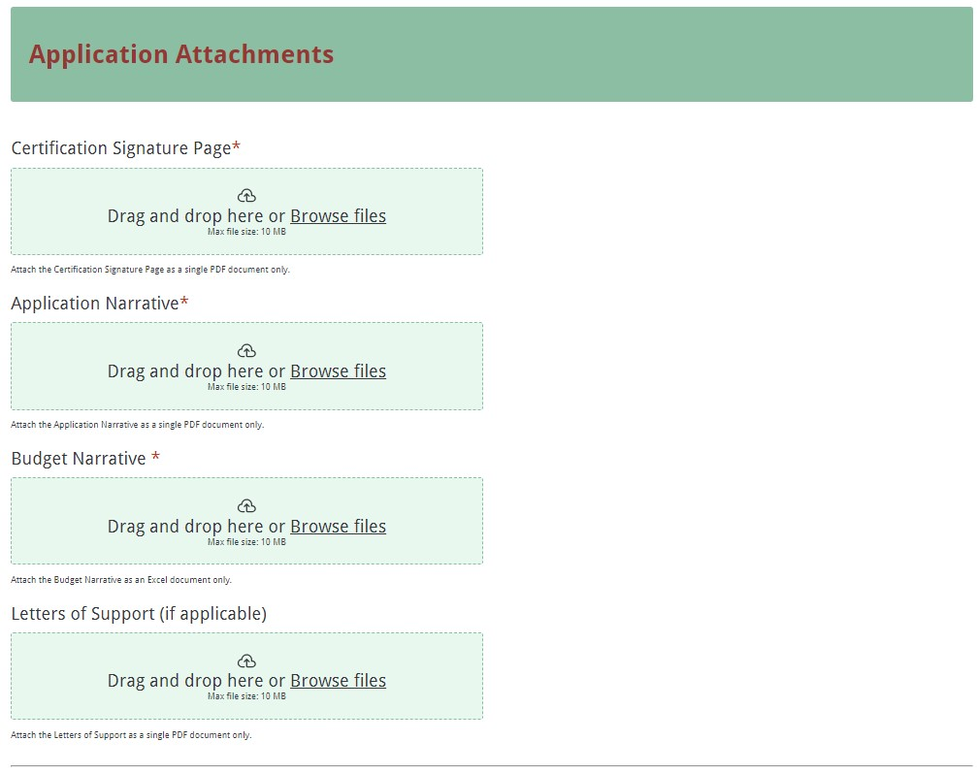

Data Review and Confirmation Page
Before submitting the application, thoroughly review the summary on the Data Review and Confirmation Page to verify that all information has been entered correctly in the online application prior to submitting. You will not be able to access the completed application form after it has been submitted so it is particularly important to ensure that all of the information in the application has been entered correctly.
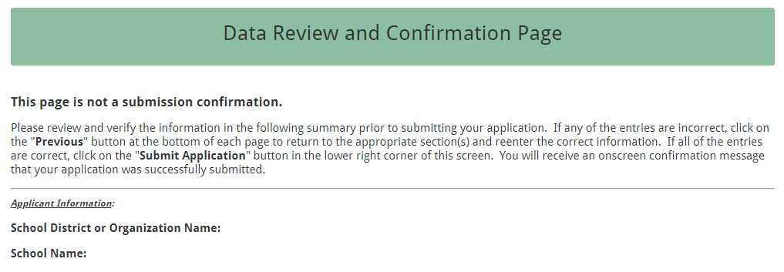

If any entries are incorrect, click on the “Previous” button at the bottom left corner of each screen to return to the appropriate section(s) and reenter the correct information. Then click on the “Next” button in the lower right corner of each screen to return to the Data Review Page. Note: This page is not a confirmation of the submission of an application.

After verifying that all entries are correct, click on the "Submit Application" button in the lower right corner of this screen in order to complete the submission process.

After submitting the application, the following message will be displayed on the screen.
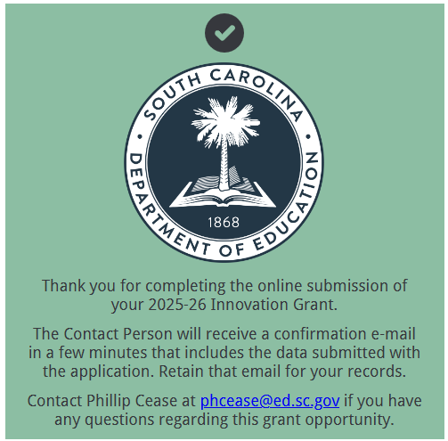
The following confirmation message will be e-mailed to the address provided for the Contact under Contact Information in the online form.
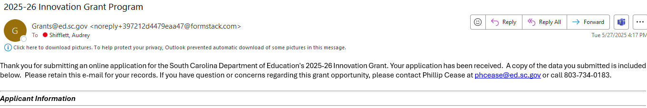

If the Contact does not receive a confirmation e-mail, then the application did not successfully transmit. You must go back and resubmit the entire online form, including all attachments, in order for your application to be considered for funding. Only the most recently submitted application will be reviewed.

An e-mail confirmation that the grant application was successfully submitted does not account for the quality of the uploaded attachments or the completeness of the online form. The confirmation e-mail only notifies you that the online application has been submitted and received. Applicants are responsible for ensuring that the information entered in the online form, including all attachments, is accurate and complete for the application to be reviewed and considered for funding.

Appendix C: Required SCDE Forms

Certification Signature Page
(This form must be signed by the individual from each proposed district, school, or organization who holds the title listed below.)

Certification
I hereby certify that, to the best of my knowledge, the information and data contained in this application are true and correct. The applicant’s governing body has duly authorized this application and documentation.

Authorized Official (must be CEO of organization or superintendent of school district)
Name:
Position: | Email:
Telephone: | Fax:

Signature of Authorized Official: | Typed name of Authorized Official:
Date Signed:
Signature of Financial Official: | Typed Name of Financial Official:
Date Signed:
Signature of Grant Manager (if applicable): | Typed Name of Grant Manager:
Date Signed:
Signature of Principal (if applicable): | Typed Name of Principal:
Date Signed:

Please complete, print, and obtain signatures prior to submission. Include the signed, scanned form in the required application attachments as indicated on page 6.

Assurances and Terms and Conditions for State Awards
For informational purposes only
The applicant certifies to abide by the SCDE Assurances and Terms and Conditions by signing and submitting the Certification Signature Page.

Assurances
I certify that this applicant
- Has the legal authority to apply for state assistance and the institutional, managerial, and financial capability (including funds sufficient to pay the nonstate share of project costs) to ensure proper planning, management, and completion of the project described in this application.
- Will give the South Carolina Department of Education (SCDE) access to and the right to examine all records, books, papers, or documents related to this award and will establish a proper accounting system in accordance with generally accepted accounting principles (GAAP) or agency directives.
- Has an accounting system that includes sufficient internal controls, a clear audit trail, and written cost-allocation procedures as necessary. The financial management systems are capable of distinguishing expenditures that are attributable to this grant from those that are not attributable to this grant. This system is able to identify costs by programmatic year and by budget line item and to differentiate among direct, indirect, and administrative costs. In addition, the applicant will maintain adequate supporting documents for the expenditures and in-kind contributions, regardless of the type of funds, if any, that it makes under this grant. Costs are shown in books or records (e.g., disbursements ledger, journal, payroll register) and are supported by a source document such as a receipt, travel voucher, invoice, bill, or in-kind voucher.
- Will also comply with GAAP as it relates to budgets, budget amendments, and expenditure claim submissions.
- Will approve all expenditures, document receipt of goods and services, and record payments on the applicant’s accounting records prior to submission of reimbursement claims to the SCDE for costs related to this grant.
- Will initiate and complete work within the applicable time frame after receipt of approval by the SCDE.
- Will not discriminate against any employee or applicant for employment because of race, color, religion, age, sex, national origin, or disability. The applicant will take affirmative action to ensure that applicants for employment and the employees during the period of their employment are treated without regard to their race, color, religion, age, sex, national origin, or disability.
- Will comply with the Ethics, Government Accountability, and Campaign Reform Act (S.C. Code Ann. § 2-17-10 et seq. and § 8-13-100 et seq. (Supp. 2024)).
- Will comply with the Drug Free Workplace Act (S.C. Code Ann. § 44-107-10 et seq. (Supp. 2024)) if the amount of this award is $50,000 or more.
- Will comply with the requirements of Proviso 1.78, H. 4025, 126th Leg., 2nd Reg. Sess. (S.C. 2025), available at https://www.scstatehouse.gov/sess126_2025-2026/appropriations2025/crp1b.pdf.
- Will not use grant funds in a manner inconsistent with the South Carolina Department of Education (SCDE) guidance to districts and staff on federal education policy changes and terminology and data collection practices. Those documents are available at https://ed.sc.gov/newsroom/school-district-memoranda-archive/update-on-federal-education-policy-changes/update-on-federal-education-policy-changes-memo/ and https://ed.sc.gov/newsroom/guidance-regarding-terminology-and-data-collection-practices/.
- Will not use grant funds in a manner inconsistent with state regulations including Regulation 43-170. Guidance is available at https://ed.sc.gov/state-board/state-board-of-education/uniform-procedure-for-selection-or-reconsideration-of-instructional-materials/.

Terms and Conditions

- Completeness of Proposal. All proposals should be complete and carefully worded and must contain all of the information requested by the South Carolina Department of Education (SCDE). If you do not believe a section applies to your proposal, please indicate that fact.
- Non-awards/Termination. The SCDE reserves the right to reject any and all applications and to refuse to grant monies under this solicitation. If the SCDE rejects an application, the applicant has a right to request a review of the process consistent with the appeals process presented in the Request for Proposals (RFP).
After it has been awarded, the SCDE may terminate a grant by giving the grantee written notice of termination. In the event of a termination after award, the SCDE shall reimburse the grantee for expenses incurred up to the notification of termination. In addition, this grant may be terminated by the SCDE if the grantee fails to perform as promised in its proposal.
Upon the termination of a grant, the grantee shall have the right to a review process. The grantee must notify the SCDE of its request within 30 days of receiving written notice of the termination.
- Reduction in Budgets and Negotiations. The SCDE reserves the right to negotiate budgets with potential grantees. The SCDE may, at its sole discretion, determine that a proposed budget is excessive and may negotiate a lower budget with the applicant. The applicant may at that time negotiate or withdraw its proposal. In addition, the SCDE may desire to fund a project but not at the level proposed. In that case, the SCDE shall notify the applicant of the amount that can be funded, and the applicant and the SCDE shall negotiate a modification to the proposal to accommodate the lower budget. All final decisions are that of the SCDE.
- Amendments to Grants. Amendments are permitted upon the mutual agreement of the parties and will become effective when specified in writing and signed by both parties.
- Use of Grant Funds. Funds awarded are to be expended only for purposes and activities covered by the approved project plan, budget, and budget narrative.
- Submission of Expenditure Reports. Claims for reimbursement must be made at least quarterly and consistent with calendar quarters (e.g., an expenditure report claim for costs for January 1 through March 30 must be filed by May 15).
- Obligation of Grant Funds. Grant funds may not be obligated prior to the effective date or subsequent to the end or termination date of the grant period. No obligations are allowed after the end of the grant period. The final request for expenditure report claims must be submitted no later than forty-five (45) days after the end of the grant period unless the scope of work for the grant states a shorter reporting period.
- Deobligation of Funds. After a final expenditure claim has been submitted to the SCDE, the grantee will go through the official deobligation process with the SCDE.
- Documentation. The grantee must provide for accurate and timely recording of receipts and expenditures. The grantee’s accounting system should distinguish receipts and expenditures attributable to each grant. The grantee must review the memo regarding “Guidelines for Retaining Documentation to Support Expenditure Claims.”
- Travel Costs. Travel costs, if allowed under this solicitation, must not exceed limits noted in the United States General Services Administration (GSA) per diem rates for lodging, except in the case of conference lodging required for program-required training. In the case that conference-related lodging exceeds the GSA per diem rate, the grantee shall follow their entity’s written procedure for obtaining prior approval to exceed a GSA rate for a conference hotel. Meals and incidentals are limited by the state budget proviso, currently not to exceed $35 per day for in-state travel and $50 for out-of-state travel (see page 81 of the State of South Carolina Statewide Disbursement Regulations). Mileage reimbursement must follow the current Office of Comptroller General instructions, which is consistent with the published IRS rates.
- Honoraria. Amounts paid in honoraria, if allowed under this grant, must be consistent with SCDE policies. Applicants should check with the program office before budgeting for honoraria.
- Reports. The grantee shall submit, as required or instructed by the awarding program office, all reports (programmatic, financial, or evaluation) within the specified period or date and in the prescribed format. An expenditure claim report must be filed by July 5 for all expenditures incurred by June 30 in order to comply with the generally accepted accounting principles (GAAP) and the production of the State's Annual Comprehensive Financial Report.
- Copyright. The grantee is free to copyright any books, publications, or other copyrightable materials developed in the course of this grant. However, the SCDE reserves a royalty-free, nonexclusive, and irrevocable license to reproduce, publish, or otherwise use, and to authorize others to use, the copyrighted work developed under this grant.
- Certification Regarding Suspension and Debarment. By submitting an application, the applicant certifies, to the best of its knowledge and belief, that the
- Applicant and/or any of its principals, subgrantees, or subcontractors
  - are not presently debarred, suspended, proposed for debarment, or declared ineligible for the award of contracts by any state or federal agency; have not, within a three-year period preceding this application, been convicted of or had a civil judgment rendered against them for commission of fraud or a criminal offense in connection with obtaining, attempting to obtain, or performing a public (federal, state, or local) contract or subcontract; violation of federal or state antitrust statutes relating to the submission of offers; or commission of embezzlement, theft, forgery, bribery, falsification or destruction of records, making false statements, tax evasion, or receiving stolen property; and
  - are not presently indicted for, or otherwise criminally or civilly charged by a governmental entity with, commission of any of the offenses enumerated above.
- Applicant has not, within a three-year period preceding this application, had one or more contracts terminated for default by any public (federal, state, or local) entity.
- Audits. Although this Assurances, Terms, and Conditions document is for a state award, federal audit requirements apply as follows:
- Entities expending $1,000,000 or more in federal awards:
Entities that expend $1,000,000 or more in federal awards during the fiscal year are required to have an audit performed in accordance with the provisions of 2 CFR Part 200.501, et seq. Except for the provisions for biennial audits provided in 2 CFR Part 200.504 (a) and (b), audits must be performed annually as stated at 2 CFR Part 200.504. A grantee that passes through funds to subrecipients has the responsibility of ensuring that federal awards are used for authorized purposes in compliance with federal program laws, federal and state regulations, and grant agreements. The director of the OMB, who will review this amount every two years, has the option of revising the threshold upward. Audits must be conducted in accordance with Government Auditing Standards (Yellow Book).
- Entities expending less than $1,000,000 in federal awards:
Entities that expend less than $1,000,000 in a fiscal year in federal awards are exempt from the audit requirements in 2 CFR Part 200.504. However, such entities are not exempt from other federal requirements (including those to maintain records) concerning federal awards provided to the entity. The entity’s records must be available for review or audit by the SCDE and appropriate officials of federal agencies, pass-through entities, and the General Accounting Office (GAO). Audits must be conducted in accordance with Government Auditing Standards (Yellow Book).
- Records. The grantee shall retain grant records, including financial records and supporting documentation, for a minimum of six (6) years after the end date of the grant when the final expenditure report claim for reimbursement and all final reports have been submitted, unless informed otherwise or in case of litigation.
- Electronic Signature Agreement. I agree that my electronic signature is the legally binding equivalent to my handwritten signature.

Budget Narrative Template

For informational purposes only

Use the template on the SCDE’s Grant Opportunities webpage to complete the budget narrative.
Applicants must complete the tab labeled “100% Grant Budget.” Applicants are strongly encouraged to complete the tabs labeled “75% Grant Budget” and “50% Grant Budget” due to the limited amount of funding. Amounts for the tab “Budget Summary” will automatically populate.
