Request for Proposals (RFP)
Application Package

Education and Economic Development Act (EEDA)
Preparing College- and Career-Ready Graduates
2026–27 Competitive Grant

The EEDA Preparing College- and Career-Ready Graduates (PCCRG) Competitive Grant is funded by the South Carolina Education and Economic Development Act, authorized by S.C. Code Ann§ 59-59-10 et seq., and administered by the South Carolina Department of Education.

Deadline for Receipt of Applications: 5:00 p.m., January 16, 2026

Technical Assistance for Applicants: 10:00 a.m., November 19, 2025

For questions about the EEDA PCCRG Grant, contact:
Tiffany Dorsey, 803-734-1650, tldorsey@ed.sc.gov

Issued by:
South Carolina Department of Education
Office of Career Services
849 Learning Lane
West Columbia, SC 29172-3171

TABLE OF CONTENTS

PART I: General Information 1
A. Introduction and Purpose 1
B. Eligible Applicants 1
C. Competitive Priorities 2
D. Timeline of Granting Process 2
E. Technical Assistance Sessions for Applicants 2
F. Statutory and State Requirements 3
G. Authorized Activities 5
H. Unauthorized Activities 5
I. Program Accountability and Monitoring 5
J. Fiscal Operations 8
K. Supplement, Not Supplant 8
L. Review and Selection Process 8
M. Appeals Process 10

PART II: Application Overview, Content, and Instructions 11
A. Application Overview 11
B. Application Narrative Format 11
C. Online Application Submission 12
D. Project Abstract 12
E. Application Narrative Content 12
1. Statement of Need 13
2. Project Design 13
3. Management and Sustainability 15
4. Evaluation and Dissemination 16
F. Application Budget 17
G. Appendices 20
H. Deadline and Submission Procedures 21
I. Screenshots of Online Application Submission Forms 21

Appendix A: Definitions of Terms Used 29

Appendix B: Selection Criteria and Reviewers’ Scoring Rubric 30

Appendix C: Required SCDE Forms 39
Certification Signature Page 39
Assurances and Terms and Conditions for State Awards 40
Goals, Objectives, and Outcomes Worksheet 44
Timeline of Activities Template 45
Project Weekly Schedule Template 46
Budget Forecast and Narrative Format Guidance 47

PART I: General Information

Introduction and Purpose

The South Carolina General Assembly passed the South Carolina Education and Economic Development Act of 2005 (EEDA) to provide “for the development of a curriculum organized around a career cluster system that must provide students with both strong academics and real-world problem-solving skills” (S.C. Code Ann § 59-59-20 et seq.). More specifically, the EEDA requires schools address the needs of students “at risk for being poorly prepared for the next level of study or for dropping out of school” (S.C. Code Ann § 59-59-150).

To support these efforts, the General Assembly has provided funding to the South Carolina Department of Education (SCDE). The SCDE has set aside a portion of these EEDA funds for the Preparing College- and Career-Ready Graduates (PCCRG) competitive grants to help schools implement evidence-based strategies and/or models specifically designed to address the academic and career development needs of students with academic deficiencies so that, upon completing high school, these students meet the criteria defined in the Profile of the South Carolina Graduate codified by the General Assembly in Act 195 (2016).

Approximately $1.5 million will be available for new grants in this FY 2026–27 funding cycle. The SCDE anticipates awarding approximately 10 grants. Award amounts will be determined based on the quality of applications received and total funding requested. Final budgets may be negotiated based on demonstrated needs. All grant awards are contingent upon total allocations to the SCDE by the SC General Assembly.

The maximum grant period is one year and is subject to the availability of state funds and projects meeting all Preparing College- and Career- Ready Graduates program requirements. The 2026–27 grant budget period is July 1, 2026, through June 30, 2027.

The subgrantee may obligate funds upon receipt of the grant award notice. However, no funds will be disbursed until after July 1, 2026, or 30 days after the SCDE’s receipt of the signed Grant Award Notification (GAN).

Eligible Applicants

Eligible applicants are SC school districts proposing to serve students in grades 3–12 who are at risk. A student who is at risk is any student who, because of his or her individual needs, requires temporary or ongoing interventions to achieve in school and to graduate with meaningful options for his or her future (see section F. Statutory and State Requirements starting on page 3).

A district may submit one or more applications that propose to serve a cohort of students in grades 3–12 attending elementary, middle, junior high, and/or high schools. School districts with sites that currently receive EEDA grants funds may apply for funding to operate projects at new sites. However, priority will be given to school districts that currently do not receive funds. Districts may propose to serve up to three schools per application.

Competitive Priorities

The SCDE has established four competitive priorities for the PCCRG 2026–27 funding cycle.

Priority 1—Alternative School Programs: 10 points added to applications that propose to serve a specific cohort of students attending alternative school programs approved by the SCDE.

Priority 2—The District Index of Taxpaying Ability for Debt Millage: 5 points added to applications for districts eligible based on their district index of taxpaying ability (ITA). See page 29 for a list of eligible districts. The standard ITA represents the district’s relative fiscal capability to raise revenue for school operations from property tax in comparison to all districts.

Priority 3 —Priority Schools: 10 points added to applications that propose to serve one or more schools that has/have been designated as Priority Schools by the SCDE. (see definition and information on page 29)

Priority 4 – Target population: 5 points added to applications that propose to serve a cohort that is at least 40% of the total student population.

An application can qualify for a maximum of thirty (30) competitive priority points.

Applicants must complete the competitive priorities section of the online application and must clearly meet the specified criteria for each priority to earn points. Also, an application must earn a minimum average score of 80 points to be eligible to receive competitive priority points.

Timeline of Granting Process

Date | Activity/Action
November 19, 2025 | Pre-application technical assistance webinar
January 16, 2026 | Deadline for receipt of applications
April 2026 | Advanced notification of awards
July 1, 2026 | Funding period begins; projects can begin
January 16, 2027 | Interim report(s) due to the SCDE
June 30, 2027 | Funding period ends, projects must end
August 16, 2027 | Final report(s) due to the SCDE

Technical Assistance Sessions for Applicants

The Office of Career & Technical Education & Student Transition Services will offer a pre-application technical assistance session via Adobe Connect on November 19, 2025, from 10:00 a.m. until 11:30 a.m. No password is required to join the session. Participants should enter their full names when logging in to the session. Participants will be able to log in 30 minutes prior to the start of the session to test their equipment’s audio settings and to download/access handouts. While attendance is not required to apply, it is highly recommended.

Statutory and State Requirements

Sections 59-59-55 and 59-59-150 of the EEDA, as detailed below, established specific criteria for this program:

Section 59-59-55 The State Board of Education (SBE) shall develop a state model for addressing at-risk students. This model shall include various programs and curriculum proven to be effective for at-risk students.

Section 59-59-150 By July 2007, the State Board of Education shall promulgate regulations outlining specific objective criteria for districts to use in the identification of students at risk for being poorly prepared for the next level of study or for dropping out of school. The criteria must include diagnostic assessments to identify strengths and weaknesses in the core academic areas. The process for identifying these students must be closely monitored by the State Department of Education in collaboration with school districts to ensure that students are being properly identified and provided timely, appropriate guidance and assistance and to ensure that no group is disproportionately represented. The regulations also must include evidence-based model programs for at-risk students designed to ensure that these students have an opportunity to graduate with a state high school diploma. The regulation also must include an evaluation of model programs in place in each school to ensure the programs are providing students an opportunity to progress to the next level and to eventually graduate with a state high school diploma.

To fulfill Section 59-59-55, the SBE developed a state model that was presented in the At-Risk Student Intervention Implementation Guide. In 2012, the programs and curriculum listed in the Guide were replaced with the Model Programs as compiled by the National dropout prevention center’s Model Programs Database. Applicants must comply with the specific objective criteria for identifying at-risk students as legislated by Section 59-59-150 and categorized in the SBE’s At-Risk Student Regulation (R43-274.1). Additionally, applicants must select strategies and/or models that are recommended by the National Dropout Prevention Center/Network.

Students—depending on their degree of resiliency and connectedness to caring adults in the home, in the community, and/or at school—may respond differently to those things frequently cited as barriers, predictors, or indicators of being “at risk.” Therefore, educators and other responsible adults working with students should consider the whole child, who might have both short-term and long-term needs requiring intervention (per SBE Regulation 43-274.1.).

The following are characteristic situations/behaviors of at-risk students that applicants must consider:
  - poor academic performance—a GPA of 2.0, or lower, on a 4.0 scale—in the core content areas,
  - poverty,
  - unstable home-life (transience, homelessness, single-parent home, incarceration of a parent/sibling, forms of abuse, drug, or alcohol use),
  - teen pregnancy/teen parenthood,
  - unhealthy social attachments and interactions,
  - history of disciplinary action or intervention,
  - high number of absences and/or truancy,
  - poor health or nutrition,
  - limited English language skills,
  - inadequate opportunities for success in school,
  - learning disabilities,
  - disengagement,
  - work that interferes with school, and
  - and previous grade retention.

Per R.43-274.1, school districts are encouraged to carefully review a variety of assessments in diagnosing students’ academic difficulties and selecting appropriate short- and long-term interventions, including the following:
- statewide assessment results used for accountability purposes and other state-funded (e.g., formative) assessments,
- Preliminary Scholastic Assessment Test (PSAT) results,
- district- or school-adopted computer-aided instruction (CAI) assessments,
- end-of-course examination results,
- classroom-level assessments related to the South Carolina College- and Career-Ready Standards, and/or
- other district-approved diagnostic assessments (including the Measures of Academic Progress (MAP)) for grades and subjects that do not participate in the state’s testing program.

Universal Entity Identifier (UEI) and System of Award Management—2 CFR Part 25
All applicants must obtain a unique entity identifier (UEI) from the federal System for Award Management (SAM). The applicant must include a valid UEI in the online application. For assistance and more information, see the Federal Service Desk frequently asked questions. This requirement applies to all the SCDE’s state grants.

Applicants should review the Assurances and Terms and Conditions for State Awards (see pages 40–43) to ensure that, if awarded a grant, they are capable of full compliance, especially with all the referenced state laws and regulations, and to enter into an agreement with the SCDE for this program. Pursuant to S.C. Code Ann. §8-13-700 (Supp. 2024), the applicant must disclose any potential conflict of interest to the SCDE in accordance with the SC Ethics Reform Act conflict of interest policy. A signed Certification Signature Page (see page 39) is required with the grant application and legally binds the applicant to the agency’s assurances, and terms and conditions.

PowerSchool Requirement
All PCCRG grantees must code all project participants in PowerSchool to enable evaluation activities.

Authorized Activities

Allowable activities include:
- evidence-based academic and career-related activities that occur during school, after school, and/or during the summer months.
- activities associated with all strategies and/or models that demonstrate a direct and/or indirect link to students:
  - meeting the criteria defined in the Profile of the South Carolina Graduate (see page 30):
  - being academically prepared for, and promoted to, the next grade level; and
  - reducing the dropout rate, and/or increasing the high school graduation rate.

Unauthorized Activities

Funds must not be used for unauthorized and/or unallowable activities, which include:
- the renovation or construction of facilities,
- overnight field trips,
- incentives or stipends for students,
- purchase of clothing,
- purchase of vehicles,
- support for political or religious activities,
- purchases of equipment and supplies with a value of $5,000 or more per unit;
- purchases of electronics and technology with a value of $1,000 or more per unit without prior approval, and
- subgranting components of the project to outside vendors.

Funds used for any purpose other than those approved in the grant application will be disallowed.

Program Accountability and Monitoring

The SCDE is responsible for monitoring PCCRG grant implementation to support students who meet the definition of at-risk in accordance with the following program accountability requirements:
- Each recipient receiving funds through this RFP meets the eligibility requirements for the grant described herein, and the applicant has provided all required assurances that it will comply with all program implementation and reporting requirements established through this RFP.
- Each recipient receiving funds through this RFP appropriately uses these funds as described in this application package.
- Each recipient implements activities funded through this application within the timeline in which the funds provided are to be used.

Applicants may be subjected to an evaluation of their financial system, internal controls processes, and policies and procedures by the SCDE’s Office of Audit Services before a grant award is issued or during the grant term. Visit the Office of Audit Services to access the review process and procedures.
Applicants awarded PCCRG grant funds must satisfy periodic reporting and accountability requirements throughout the term of the grant. These requirements address: (1) program accountability; (2) performance reporting; (3) annual budget; (4) monitoring; (5) program evaluation; and (6) technical assistance.

    - Program Accountability
Each grantee is responsible for carrying out its responsibilities in accordance with Sections 59-59-55 and 59-59-150 of the EEDA Code of Laws - Title 59 - Chapter 59 - South Carolina Education And Economic Development Act (scstatehouse.gov); all applicable statutes, regulations, and programmatic guidance; and its approved grant application and work plan. Grantees are also required to submit periodic reports to the SCDE to report on the use of grant funds and the progress of grant activities.

    - Performance Reporting
Performance reporting requirements include those for both programmatic reporting and fiscal reporting. The subgrantee is responsible for ensuring that all required performance reports are accurate, complete, and submitted on time.

Programmatic Reporting Requirements
The grantee is responsible for submitting a narrative that discusses the progress towards the projected outcomes, effectiveness, and overall impact of the project twice during the project year. An interim performance report must be submitted to the SCDE no later than January 16, 2027. The interim report should address any challenges/obstacles encountered and detail how those are being addressed to ensure the goals will be met. A final performance report must be submitted to the SCDE no later than August 16, 2027. Progress toward achieving grant goals and objectives will be monitored through the reporting process.

Fiscal Reporting Requirements
Grant funds will be disbursed within 30 days upon the receipt of a signed GAN. The grantee is responsible for ensuring that all expenditures are aligned to the approved budget for authorized activities (see Section G) and for retaining accurate and complete documentation and records of all expenditures. The grantee must submit a final fiscal and programmatic report that covers the full performance period of the grant (July 1, 2026, through June 30, 2027) to the SCDE by August 16, 2027. Reports are subject to verification. The SCDE reserves the right to recover any funds used for expenditures that are determined to be unauthorized for the project, including funds not expended according to the approved budget.

    - Project Budget
A project budget of projected expenditures to be funded by the grant must be submitted with the application using the template provided on the Grant Opportunities Webpage. Upon receipt of the signed GAN, each grantee will receive their disbursement of funds within 30 days. Expenditures must align with the final approved budget and used for the approved authorized activities.

    - Monitoring
The SCDE will monitor PCCRG grantees by reviewing and approving the progress reports and annual performance reports. All information in monitoring reports is subject to verification.

The SCDE may conduct programmatic and financial monitoring site visits. Grantees must agree to site visits conducted by the SCDE or state program representatives. The purpose of site visits is to validate information provided in fiscal and programmatic reports and to gather more detailed information on implementation efforts and challenges from interviews and observations.

The SCDE may require additional information from the grantee, verify information with the authorizing agency, or require the submission of additional documentation including, but not limited to, invoices, receipts, and personnel time and effort reports. Prior to a site visit, the grantee may be required to submit additional relevant information that will allow the SCDE to conduct a useful, efficient, and effective visit. The SCDE may require electronic submission of documents instead of paper-copy submissions.

SCDE staff will verify the contents of all documentation submitted. Grant recipients may be asked to revise reports when
- unallowable expenses are found.
- reports are confusing or difficult to understand.
- there are unexplained discrepancies between the proposed use of grant funds, as provided in the annual budget, and actual expenditures found in the submitted documentation.

    - Program Evaluation
Grantee Project Monitoring and Evaluation
Grantees are required to conduct ongoing monitoring and evaluation to ensure project goals are on track to be achieved. While hiring an external monitoring and evaluation contractor is not required, it is also not prohibited. Cost must be reasonable and is subject to negotiation by the SCDE. Progress toward meeting project goals is to be reported through the annual progress review process.

A final project evaluation report is to be completed and submitted by August 16, 2027. The final evaluation report must address project success toward each goal stated in the application.

If a grantee fails to complete the final project evaluation report before the end of the grant period, or if any of the performance requirements in section I.2 are not completed, the SCDE may consider the grantee high-risk and elect to discontinue funding or disqualify the grantee from future funding opportunities. In addition, if the grantee applies for and is approved for subsequent funding for the following project year, funds may be held until the grantee has fulfilled all performance and reporting requirements of the previously approved grant project.

    - Technical Assistance to Grantees
Grantees are required to participate in any technical assistance that the SCDE may conduct for the Preparing College- and Career-Ready Graduates Grant. Delivery of such technical assistance may include in-person meetings, webinars and conference calls.

Fiscal Operations

Grantees must use grant funds for allowable grant expenditures during the grant period. Subject to financial risk analysis, the SCDE will disburse funds upon receipt of a signed GAN for the entire grant period and require documentation of allowable expenditures made under that allocation. The SCDE will deobligate any unspent funds remaining at the end of the grant period or funds expended on unallowable activities. Matching or in-kind funds are not required; however, matching, and in-kind funds are an indicator of potential sustainability of an EEDA PCCRG project.

Allowable Costs
EEDA PCCRG grant funds are provided solely to support a grantee’s efforts related to the evidence-based, at-risk student strategies and/or models specified in the approved grant application. As such, funds may be used for salaries/benefits, transportation, and supplies/materials.

Unallowable Costs
Grant funds may not be used to provide student stipends or incentives, provide overnight field trips or clothing items, construct facilities, purchase vehicles, or support political or religious activities. No part of the project may be subgranted to vendors. Grant funds may not be used for new construction or purchases that do not directly support the approved work plan. Purchases of equipment or electronics (items with a value of $1,000 or more per unit) must receive prior approval. Funds may not be used for any purpose other than those approved in the grant application. Indirect costs are not allowable for this grant program.

Supplement, Not Supplant

EEDA PCCRG grant funds must supplement, not supplant, existing services and may not be used to supplant federal, state, local, or non-federal funds. Projects may not use grant funds to pay for existing levels of services funded from any other sources. If current expenditures are being paid from state or local public funds, the applicant may not replace those funds with grant funds.

Review and Selection Process

Only those grant applications that are received by the deadline and deemed complete will be forwarded for review and funding consideration. All required materials, including forms and appendices, must be submitted for the application to be considered complete and eligible for review. The SCDE’s Office of Career Services will conduct an initial review of all grant applications for completeness and compliance with the RFP instructions.

Three reviewers from diverse backgrounds without a personal stake in any applicant being funded will evaluate each application based on the quality of the proposed activities and the applicant’s capability to implement the proposed project. The review team will be comprised of experienced grant readers from various professions and entities, including the SCDE.

Reviewers will use the scoring rubric on pages 30–38 to read and score each application independently. After the three reviewers have individually scored an application, the scores will be averaged. An application can earn up to a maximum of 100 points for an average score. Applications must earn an average score of 80 points or higher to receive competitive priority points.

Competitive priority points will be assigned by the SCDE program manager, added to the application’s average score, and awarded only once per application to determine a final total score.

Applications will be ranked by final total scores. Subject to the SCDE’s approval and the availability of funds, grant awards will be made starting with applications that earned a final total score of 80 points or higher. If funds remain following these awards, the SCDE will consider funding the remaining applications until all funds are allocated.

Prior to making awards, the SCDE’s Office of Audit Services may conduct a pre-award risk assessment of the applicant organization. Based upon the results of this assessment, special conditions may be applied to the award that may include, but are not limited to, requirements for more frequent programmatic or financial reporting, increased monitoring of grant activities, and the provision of additional technical assistance.

The SCDE reserves the right to interview applicants recommended for funding, request additional documentation, and make site visits as appropriate to ensure compliance with state requirements.

Applicants who currently receive or have previously received EEDA PCCRG grant funds will be subject to a review of historical data, including financial data for evidence of timely submission of budgets and expenditure reports and accuracy of amendment requests, expenditures and supporting documents, and performance outcomes data. This review is to confirm compliance and performance during the previous funding periods before decisions about final awards are made. The SCDE reserves the right to not make an award if the data review reveals that the applicant did not adhere to the previous grant/program’s guidelines or meet the prior project’s goals and objectives.

The SCDE reserves the right to negotiate final budgets and to disqualify costs associated with line items that are unallowable, unallocable, unreasonable, or inconsistent with the proposed project’s activities and strategies.

Grant awards are not final until an SCDE grant award notice (GAN) is fully executed. Advanced notification of funding will be sent in April 2026, to the authorized official listed on the Certification Signature Page. Awards will be issued in July 2026. After the notification of awards, copies of the reviewers’ comments and score sheets will be available upon request.

Appeals Process

An applicant who has submitted a proposal that the SCDE does not fund has 30 calendar days after receiving notification that the proposal is not funded to request a review of the process. Scores may not be appealed; the SCDE will not rescore applications. An unfunded applicant may inquire as to whether or not the application process was followed. The request for review must be directed to the State Superintendent of Education and must state the reasons for the request. The Superintendent may delegate to a deputy superintendent the authority to conduct a review. The deputy superintendent will issue a decision after the review of the information submitted by the applicant and the program office. This decision will be the final decision of the agency. The applicant may appeal the agency’s decision to the Administrative Law Court under the terms of the Administrative Procedures Act.

PART II: Application Overview, Content, and Instructions

Read all guidelines and criteria carefully before preparing your application. Adhere to font, format, page limit, and organizational requirements. Only applications that include all sections and appendices and fully adhere to these guidelines will be reviewed and considered for funding. Incomplete applications will not be reviewed.

Application Overview

Applications must be submitted online. Applicants are encouraged to prepare all the items for the application before beginning the online submission process. Use the following overview as a checklist to ensure submission of a complete application with items labeled accordingly and presented in the order outlined below. The 2026–27 EEDA PCCRG grant online application is organized into the following sections (see screenshots on pages 21–28):

- Online Forms Section
- Applicant Information
- Competitive Priorities
- Contact Information
  - Project Director/Grant Director Information
  - Superintendent Information
  - Financial Director Information
- School Information
- Funding Information
- Budget Summary
- Proposal Attachments
- Project Abstract
- Application Narrative (including a table of contents)
  - Statement of Need
  - Project Design
  - Project Management and Sustainability
  - Project Evaluation and Dissemination
- Budget Forecast and Narrative
- Appendices
  - Certification Signature Page
  - Timeline of Activities and Project Weekly Schedule
  - Résumés of Project Director/Grant Manager and Key Personnel

Application Narrative Format

Length of Narrative: | Maximum of 16 pages for the application narrative only, excluding the table of contents, Timeline of Activities, and Project Weekly Schedule. (place the Timeline of Activities, and Project Weekly Schedule in the appendices)
Required Font/Size: | Times New Roman or Arial/11 or 12.
Margins: | 1” on all sides.
Page Numbers: | Number all pages in the Bottom right.
Spacing: | Double-space the narrative; charts and tables may be single-spaced.
Final File Format: | PDF document.

Each section must be clearly identified. Sections may not be combined. Reviewers will not consider information requested in one section that is provided in another section. Incomplete proposals will not be considered.

Online Application Submission

Proposals must be submitted using the online application form. The online submission is organized into two sections—Online Forms and Proposal Attachments.

Provide the primary applicant’s 12-character alphanumeric UEI and Taxpayer Identification Number (TIN) in the application form. Applicants should contact their organization’s finance office for assistance with these items.

Use the following instructions to compile and complete all proposal attachments prior to submitting your application. Verify that all components of the narrative and appendices are included prior to uploading attachments. Follow the directions in each section for saving the documents and refer to the screenshot on page 26 for upload locations.

Project Abstract

In one double-spaced page, summarize the proposed project. Identify the applicant, the amount of funding requested, the target school(s), and the specific number of students to be served. Briefly and concisely summarize the project goals, objectives, key elements, and anticipated outcomes of the strategies and/or models to be implemented. Note: If 50 students are proposed to be served, those 50 students are expected to receive services through each project component.

When completed, save the abstract as a single PDF document to be uploaded as an attachment in the online application (see page 26).

Application Narrative Content

Use the following directions to write the application narrative and organize it into sections following the sequence presented below. Include a table of contents as the first page of the narrative (not included in the page limit). Do not combine sections. To be scored, required components must be located in their designated sections.

When complete, save the entire narrative as a single PDF document to be uploaded into the online application where indicated in the proposal attachments section.

Statement of Need (maximum of 20 points available)

The needs statement is a key element of a proposal that makes a clear, concise, and well-supported statement of the need or problem to be addressed. The needs statement should reflect the mission of the applicant organization and fit with the purpose of the funding opportunity.

a. Criteria for Determining the Targeted Cohort
Provide a detailed description of the existing problem that the school/district faces by identifying the specific eligibility criteria used to identify the targeted cohort. Provide both the number and percentage of students in grades 3−12 eligible to participate in the proposed project based on the selected eligibility criteria presented on pages 3–4.

Identify:
- the most critical issues/obstacles (e.g., absenteeism, retention rates, discipline, dropout rates).
- who the issue/obstacles affect.
- circumstances, situations, external/internal influences cause(d) the issues.
- what will happen if the issues remain unresolved.

b. Needs of the Targeted Cohort
Indicate the actual number of students in the proposed cohort and discuss the lack of opportunities or activities designed to help improve the targeted cohort’s world class knowledge, world class skills, and/or life and career characteristics as defined in the Profile of the South Carolina Graduate. Clearly demonstrate the need for supplemental rather than duplicative activities and/or services at the proposed site(s). Additionally, discuss the district’s lack of or limited financial resources to adequately and effectively implement evidence-based strategies and/or models designed to address the needs of the targeted cohort at the proposed site(s).

Project Design (maximum of 45 points available)
Identify the specific evidence-based strategies and/or models proposed to be implemented and explain how the proposed strategies and/or models meet all mandates, including being evidence-based, in the SBE’s At-Risk Student Regulation (R.43-274.1). Show how the strategies and/or models will address the needs of the targeted cohort and not be a whole school reform initiative. What need(s) identified in the previous section will these strategies and/or models address? How will these strategies and/or models address these identified need(s)? How will implementing these strategies and/or models be a significant supplement to existing projects/activities?

Identify the site(s) where the strategies and/or models will be implemented, the specific number of students to be served at each site, the process to be used for selecting participants that will ensure that the population to receive services will not disproportionately represent any group of students, and the process for monitoring the participants’ progress until they earn a high school diploma.

a. Goals and Objectives
Goals and objectives are clear statements of what the applicant proposes to accomplish with this project. All goals and objectives must reflect the results of the needs assessment, mirror the purpose of the project, and address the need(s) identified in section 1.

Goals are general statements about desired outcomes that will result from the project. What are the short- and long-term goals associated with the proposed strategies and/or models?

Objectives must be specific, measurable, achievable, relevant, and time-specific (SMART). SMART objectives are statements that explain one way that the applicant will know when the goal has been achieved. What objectives have you set to attain each goal?

In determining goals and objectives, address how the proposed project will enable the applicant to accomplish each by providing a direct link to:
      - improving participants’ world class knowledge.
      - improving participants’ world class skills.
      - improving participants’ life and career characteristics.
      - helping the school reduce its failure, retention, and/or dropout rates.
      - helping the applicable high school increase its graduation rate.

Applicants may use the Goals, Objectives, and Outcomes Worksheet on page 44 to develop project goals and objectives. Do not include this worksheet(s) in the application.

b. Strategies and Activities
Describe the instructional strategies and activities that will take place during the project to achieve the project objectives and work toward the proposed goal(s). Instructional strategies and activities must be evidence-based interventions and should be based on clearly connecting the stated goals and objectives with the need for services.

Instructional strategies are considered those tasks that are the catalyst to help the client achieve objectives. For example, in a classroom, instructional strategies are what the teacher does/plans so that students learn.

Activities are considered those tasks that the target population (client) does to achieve objectives and to advance their abilities. For example, in a classroom, activities are what the students do to learn.

For each activity, include the number of hours per week, days of the week, and number of weeks per year that the activities will be provided; the provider for each activity; and the rationale for the selection of the activities based on the needs identified in the Statement of Need (section 1), characteristics of the targeted cohort, and specific research.

c. Coordination with Other Programs
Describe plans to coordinate and/or combine the project’s activities with other federal, state, and local programs to make the most effective use of public resources (without supplanting) Appropriate programs could include Title I funds, Title IV funds, School Improvement Grant (SIG) funds, SC Lottery funds, and county or city funds.

In discussing the coordination plans, address each of the following:
- Describe current projects or programs available at the proposed site(s) that are designed to address the identified needs.
- Identify the deficiencies in the current projects or programs and the resulting gaps.
- Explain how implementing the proposed model will be a significant supplement to current programs/activities.
- Describe how current projects or programs will be coordinated and/or combined with the proposed project to maximize impact.

d. Timeline of Activities and Project Weekly Schedule
Include a complete Timeline of Activities and a Project Weekly Schedule as appendix items following the instructions on pages 20–21. The Timeline of Activities must include a chronological timeline of major project events/activities that clearly indicates (by month) when each project activity begins and ends, how each activity relates to a particular objective, the evidence that proves the activity has been completed or data to be collected, and who is responsible for overseeing the activity. The Project Weekly Schedule must detail all instructional activities occurring at any point (before, during, or afterschool) during the regular school year and all activities that will occur during the proposed intersession periods. See pages 45 and 46 for related templates.

Management and Sustainability (maximum of 20 points available)
Applicants must describe the overall management and sustainability plan for the project to demonstrate that the staffing and fiscal resources to be allocated to the project are adequate to launch an EEDA Preparing College- and Career-Ready Graduates project and to sustain high quality services for students beyond the life cycle of the grant.

a. Management Plan
The management section outlines the plan to manage the project to ensure that the project progresses toward achieving the proposed goal(s) and objectives. Identify the chain of command/organizational structure for decision-making that will affect the project. Include who will supervise the project director and discuss where the project fits into the overall district or school structure. Identify any professional development or training for staff and explain why it will be necessary for the project’s success.

Identify who will manage the project and that person’s experience and credentials. Explain how much time the project director will dedicate to managing this project and how this amount of time is appropriate to oversee all aspects of the project, including the timely submission of all programmatic and financial reports. Although the project director’s position does not have to be full-time, the project director must commit an appropriate amount of time to the project’s operations. Include a résumé or vitae for the project director (or the grant director if a project director has not yet been designated) as an appendix item (see page 21).

Identify other key personnel assigned to the project, their responsibilities related to this project, and their experience and credentials. Include résumés, vitae, or a paragraph summary for each key personnel as an appendix item (see page 21).

b. Sustainability Plan
The sustainability section must address the applicant’s plan to ensure that the project will maintain its activities during the full project term and beyond the grant funding period. Describe the role each partner will play in sustaining the project. Explain how funds will be used to provide supplemental rather than duplicative activities and/or services throughout the year of funding and not supplant other federal, state, or local funds or other resources. Explain conceptually how funding will continue for core activities after the grant ends.

Evaluation and Dissemination (maximum of 15 points available)

  - Evaluation Plan
The evaluation section must describe the applicant’s plan to evaluate the project’s outcomes and prove, using scientific methods and a range of data, if and how well the project worked in realizing its project goal(s) and objectives. Baseline and benchmark data appropriate for the cohort to be served may include:
- attendance,
- absenteeism,
- discipline problems/referrals,
- number of students retained in grade,
- GPAs (for high school) or average numeric grades (for elementary and middle school)
- percentage of target population on grade level,
- percentage of target population who stay in school,
- percentage of target population who complete an Individual Graduation Plan,
- percentage of target population earning Carnegie units for graduation,
- attitude of target population toward school and learning, and
- percentage of target population who graduate on time.

Describe the outcome measures that will be used to assess the impact of the proposed project on student learning and behavior. Describe the types of data that will be collected, how and when the data will be collected and analyzed, who (identified by position) will be responsible for each data collection, and how results will be presented to demonstrate that each objective has been met. Explain how the data will be analyzed, reported, and subsequently used to improve the overall quality of the project or activity. Identify the different audiences who will be provided with the evaluation data and reports.

  - Dissemination Plan
The dissemination plan must describe how and with whom the applicant will share information about the project’s successes and challenges so that the project will contribute to the district’s or school’s efforts to continue (a) producing graduates who meet the characteristics identified in the Profile of the South Carolina Graduate, (b) improving academic performance, (c) reducing dropout rates, and (d) increasing high school graduation rates. Additionally, the dissemination plan should show how the project will contribute to the knowledge about this field or become a model for others to replicate.

Application Budget

While the budget is assigned zero (0) points, the budget is a critical component of the entire application. No application with an incomplete budget will be funded.

The application budget consists of two parts: the Budget Summary and the Budget Narrative. All proposed expenditures for the grant funding period must be itemized in the Budget Summary and detailed in the Budget Narrative. Budget items not explained in the application narrative will not be funded.

- The Budget Summary provides a financial overview and must include all proposed expenditures for the project. Each line item of the Budget Summary must correspond to the totals for the Budget Forecast and Narrative (discussed below). Provide the budget details in the online application Budget Summary section (see screenshot on page 26).

- The Budget Narrative must provide straightforward evidence that the budget is appropriate and justified based on the needs assessment. Use the Excel budget file that accompanies this funding opportunity announcement on the Grant Opportunities Web page to provide a detailed Budget Forecast and Narrative that includes estimates for matching funds and in-kind contributions, if applicable (see page 47). Structure the Budget Forecast and Narrative line-item categories to parallel the line-item categories of the Budget Summary. Include all formulas used to calculate each line-item expense. This narrative must demonstrate that all expenditures are allowable, reasonable, and allocable, as well as being adequate to support the activities of the project.

All project costs must also connect directly to the performance goals, objectives, activities, and strategies in the application narrative. Appropriate personnel and other resources should be carefully allocated for the tasks and activities described in the application. Applicants should ensure that the budget will cover project expenses. It is important for applicants to demonstrate how existing school resources, such as computer labs, libraries, and classrooms, will be leveraged to conduct project activities.
Because sustainability of the proposed project is of paramount importance, an applicant should indicate any matching and/or in-kind funding as a clear sign of sustainability plans and potential. In addition, demonstrate the use of supplemental funds available to the schools and districts (such as Title I). Although matching funds are not required and give no “competitive edge” to any application, all in-kind contributions from partners (such as the use of community recreational areas, staff, supplies, etc.) should be included. Matching and in-kind funds cannot reflect costs used in calculating the indirect cost rate.

The following describes the line items that should be budgeted in each category.

Salaries/Stipends (100)
This category includes pay for salaries for staff members and substitutes and stipends for teachers. The total percentage of time charged to the grant and to non-grant funds cannot exceed 100 percent of the total time worked by any staff member.

Employee Benefits (200)
FICA, workers’ compensation, health insurance, and other employee benefits costs should be included here. These costs will represent a percentage of the total in Salaries/Stipends (100).

Purchased Services (300)
Expenses such as consultant fees, travel/transportation costs, telephone costs, and other purchased services will be included here. This includes amounts paid for personal services rendered by personnel who are not on the payroll and for other specialized services purchased by the organization. While a product may or may not result from the transaction, the primary reason for the purchase is the service provided. Note: Salaries for direct teachers and project staff should be recorded in Salaries/Stipends (100) and not in this section.

For a grantee to pay a vendor, a contract must be in place. At a minimum, the contract should include the scope of services, the duration of the contract, and the method and amount of payment; the contract must be executed by both parties. Consulting/service contracts must be procured in accordance with South Carolina Procurement Law.

- Contractual Services
Detail the expenditures associated with services to be provided by individuals or companies as indicated in the contractual agreement(s) for the proposed project.

For a grantee to pay a vendor with state funds, a contract must be in place. At a minimum, the contract should include the scope of services, the duration of the contract, and the method and amount of payment; the contract must be executed fully by both parties. Consulting/service contracts must be procured in accordance with SC Procurement Law. A copy of each contract must be submitted to the program office within 30 days of receipt of the official grant award from the SCDE.

Applicants/grantees must ensure that they do not enter a contract with any vendor that is debarred, suspended, or ineligible for participation in federal and state programs by
- checking the Excluded Parties List (EPLS) at the federal System for Award Management (SAM) Website (applicants are encouraged to review the guidance for searching “exclusions” provided via the “Help” page before conducting searches);
- collecting a certification from the vendor and attaching it to the contract; or
- adding a clause or condition to the contract that indicates the vendor is eligible.

- Travel
All applicants must plan and budget for transportation, as necessary. Detail the expenditures associated with transporting students and the expenditures associated with business travel. Applicants should carefully assess costs associated with student transportation because often projects must rely on additional buses to ensure that students are returned home in a timely manner after the approved project hours have been met. Applicants may not use funds to purchase a vehicle to transport students.

Applicants should budget funds for the project director and at least two other staff members to travel to Columbia, South Carolina, for one meeting hosted by the SCDE. Grantees must use the prevailing state per diem (page 81 of the State of South Carolina Statewide Disbursement Regulations), follow the current Office of Comptroller General instructions for mileage reimbursement (which is consistent with the published IRS rates), and follow the federal General Services Administration allowable lodging rate for allowable use of state funds for travel budgeting. See item J. Travel of the Assurances and Terms and Conditions for State Awards on page 42.

- Property Leases and Rentals
Facilities costs are considered indirect or administrative costs; therefore, applications requesting such costs are subject to a pre-award evaluation by the program office. Applicants should identify the associated costs and clearly present the method of calculation in the Budget Narrative. Costs for facility leases and rentals must be consistent with the current fair market value in the local service area. The SCDE will negotiate these budget items prior to making an award.

Supplies and Materials (400)
Include the amounts paid for material items of an expendable nature. It is recommended that applicants group items into categories to avoid listing every item; however, make sure that such expenditures are aligned with relevant project characteristics (objectives, number of participants, frequency of activity, etc.). Allow for maintenance, repair, and replacement costs over the grant life cycle of the proposed project for any equipment that totals $5,000 and below.

Capital Outlay/Equipment (500)
Equipment and supplies totaling more than $5,000 per unit are not allowable (see part I, section H). Itemize furniture, fixtures and equipment that total $5,000 and below per unit under Supplies and Materials.

Other Objects (600)
This category includes expenditures such as postage, liability insurance fees, and copyright fees that do not neatly fit into the other categories. This category has no use in the EEDA PCCRG grant.

Indirect Costs (700)
Indirect costs are not allowed.

Ensure that the totals in the Budget Forecast and Narrative equal the totals in the Budget Summary. When finalized, save the Budget Forecast and Narrative as an Excel file to be uploaded into the online application as the Budget Forecast and Narrative attachment (see page 26 for upload location).

The SCDE reserves the right to disqualify, disallow, and negotiate costs associated with any line item proposed in the budget. If any line-item cost is determined to be excessive, given the nature and scope of the entire project or of a particular activity, the SCDE can request the applicant reduce the cost of the line item or ask the applicant to assume a portion of the cost before the budget is approved and funds are awarded.

Funds will be disbursed in full to grantees upon the satisfaction of the submission of all required documentation or any additional requests for information. Grantees may not obligate funds prior to the receipt of a grant award notice. No expenditures incurred prior to July 1, 2026, are allowed.

Appendices

All items of the appendices must be scanned into a single PDF document to be uploaded into the online application where indicated on page 26.

Certification Signature Page
Print the Certification Signature Page (see page 39) and obtain the appropriate signatures. This form includes the certification of the SCDE’s Assurances and Terms and Conditions for State Awards and any applicable program-related conditions conveyed in this RFP. Those documents are not required to be included in the applicant’s proposal submission. However, retain the copy included in this RFP for your records and ensure that the signatories and partner organizations have copies of each document.

By signing the Certification Signature Page, the signatories assure that they will comply with all the assurance and terms and conditions for the project/program. All signatories must understand that they are signing a document that is legally binding in the event a grant is awarded. Applications that do not include the signed Certification Signature Page will not be reviewed or considered for funding.

Timeline of Activities
Include a Timeline of Activities that includes each benchmark activity (including evaluation and management components), when each project activity begins and ends, how each activity relates to a particular objective, and who is responsible for overseeing the activity. A template for this timeline is included on page 45. The Timeline of Activities may be single-spaced.

Weekly Schedule
Include a Weekly Schedule that details all activities, including those that occur during the intersession periods. The intersession periods must include a minimum of 20 hours of instruction time per week. A template for this Weekly Schedule is included on page 46. The Weekly Schedule may be single-spaced.

Résumés of Project Director/Grant Manager and Key Personnel
Include a résumé or vita for the project director. For any other key personnel to be involved in this program, include a résumé, vita, or a paragraph summary.

Deadline and Submission Procedures

- Applications must be submitted online using the online application form before 5:00pm on January 16, 2026.
- Only applications that adhere to all of the guidelines and directions set forth in this RFP will be reviewed and considered for funding.
- No hard copy applications will be accepted. Applications delivered by hand, postal mail, email, or fax will not be accepted.
- Applications must originate from the applicant. Applications that are plagiarized from the Internet, other grants, or other resources will not be considered for funding.
- Do not attach or submit any additional materials other than what is specifically required. Any additional materials will be disposed of without review.
- Applications will not be returned. Keep a copy of the entire application for your records.

Screenshots of Online Application Submission Forms

The following screenshots are for informational purposes only and are provided to assist applicants in compiling all elements needed to complete the online submission. Complete the attachments for the online application as directed in the preceding instructions. The SCDE encourages applicants to prepare all elements of the application prior to beginning the online submission process. Make sure all information submitted is accurate, including the official names of the school district, schools, and contacts, and that spelling is correct. Do not use abbreviations or acronyms. All fields marked with an asterisk are required; you will not be able to submit the application without entering all required information.

If necessary, you may save your progress in the online application and return to the form later. Click on the “Save and Resume Later” link to save your progress. You will be given the option of copying and saving the link to the partially completed form or entering an email address to have the link emailed to you. Be sure to enter the email address correctly as SCDE personnel cannot access the link or the incomplete application. Using this link, you can access the application from any computer within thirty days to complete the online submission. Without the link or after thirty days, the data previously entered is irretrievable, and you will have to begin a new application. A saved application is not a submitted application. You must follow all the steps described on pages 22–28 to complete the submission process.

Enter the official name and address of the applicant organization (school district) including the 10-digit character ZIP Code (ZIP+4 Code). Enter the UEI and TIN. Select the number of schools (up to three) to be served through this project. Indicate whether the applicant is applying for competitive priority points.

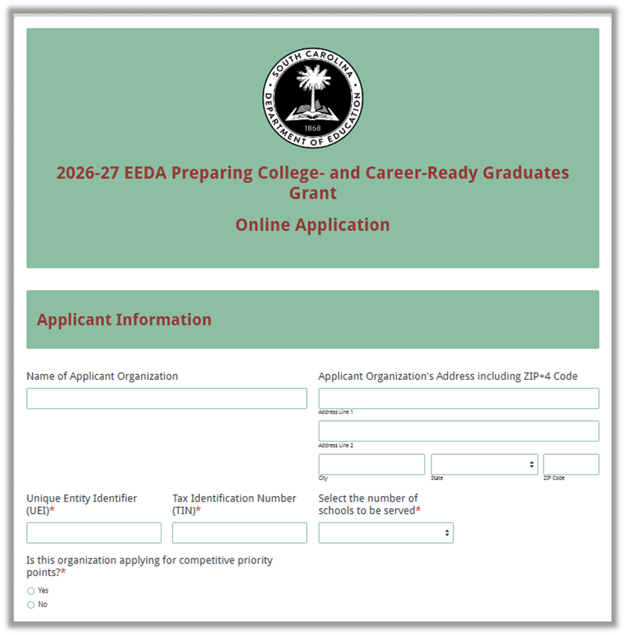

Select all the competitive priority categories for which bonus points are sought. Indicate the page numbers in the application narrative where evidence supports the proposed project’s eligibility for each criteria.
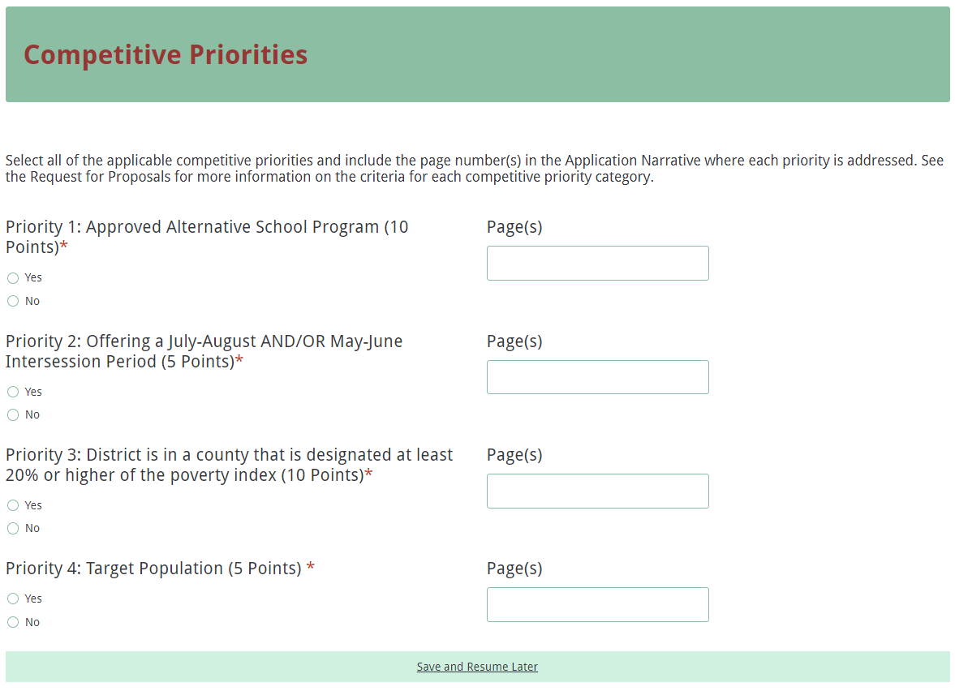

Enter the contact information for the project director/grant director, superintendent, and district’s financial director. The project director’s/grant director’s email must be reentered for validation. The confirmation of a successful online application submission will be sent only to this email address.
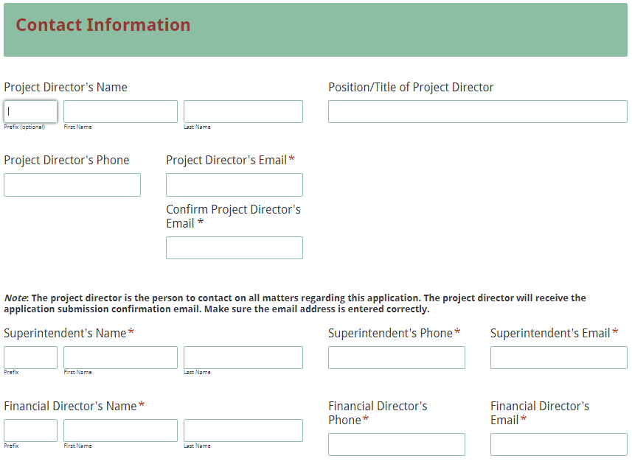
Separate project detail information fields for each school will display based on the number of schools to be served that was selected in the Applicant Information section. Enter the official name of the school; do not use abbreviations or acronyms. Enter the contact information for the principal. Enter the number of students to be served in the targeted cohort, select all school levels to be served, and provide the name of the evidence-based strategy and/or model to be implemented. Indicate whether or not the school will offer a pre-school year intersession, a post-school year intersession, and/or an afterschool program.
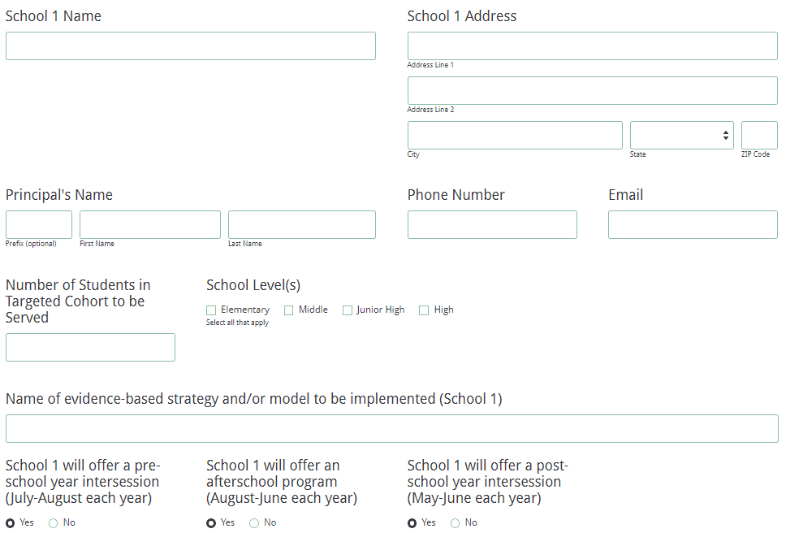

Provide the requested details for each intersession or after-school activity for the project, including the number of weeks, days per week, and hours per day each activity will operate. Indicate the start and end date and specific days of the week and times for each activity.
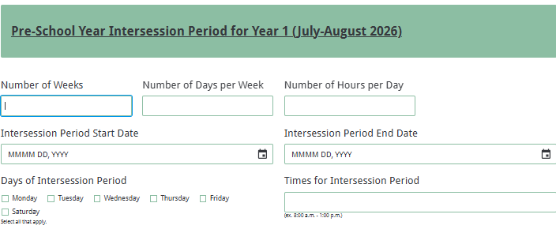
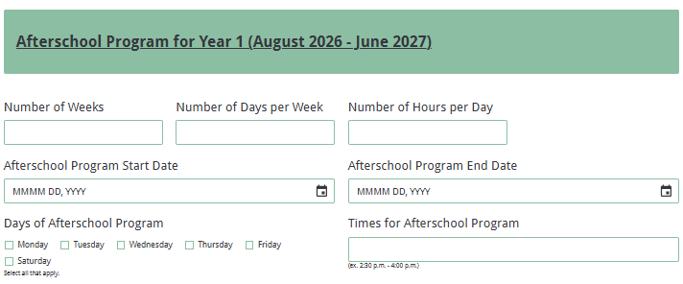
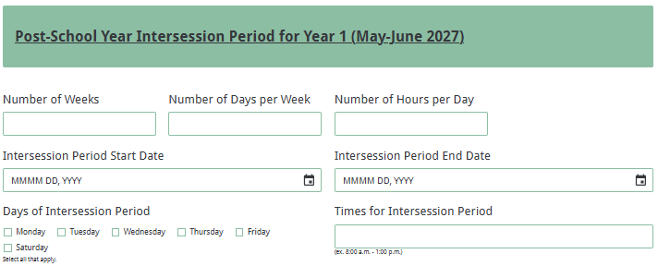

Enter all amounts in the Funding Information and Budget Summary sections using whole dollars (no cents). Fill in all budget fields. Enter 0 (zero) for line items that are not applicable to the project. In the Funding Information section, enter the total amount of funding requested to provide grant activities in all schools between July 1, 2026, and June 30, 2027.
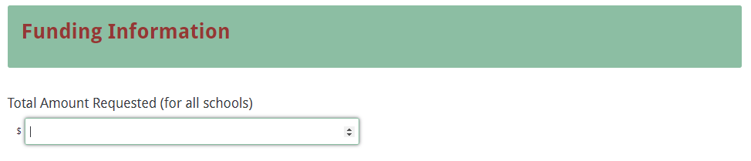

In the Budget Summary section, enter the grant funds requested for each budget category for the operation of all schools to be served and any in-kind or matching funds committed to the project during this same period. The total project costs for each category line will automatically be calculated as will the totals for all three columns.
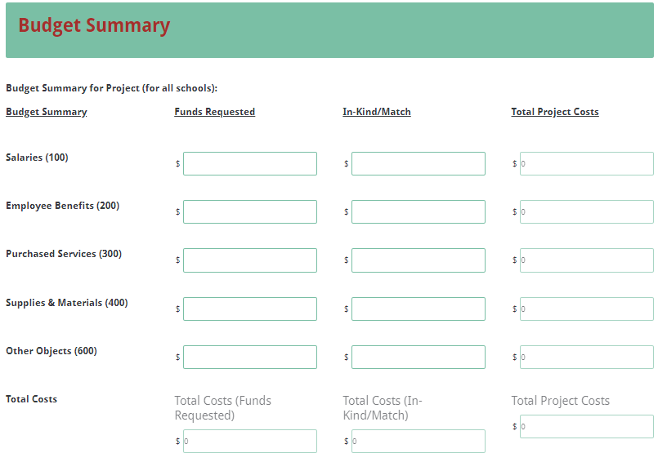

Upload the proposal attachments in the appropriate document format following the instructions provided in this RFP. Pay close attention to attachments that must be scanned together into a single document. The online application will only allow one document to be uploaded for each attachment. You will not be able to submit the application without all required attachments.
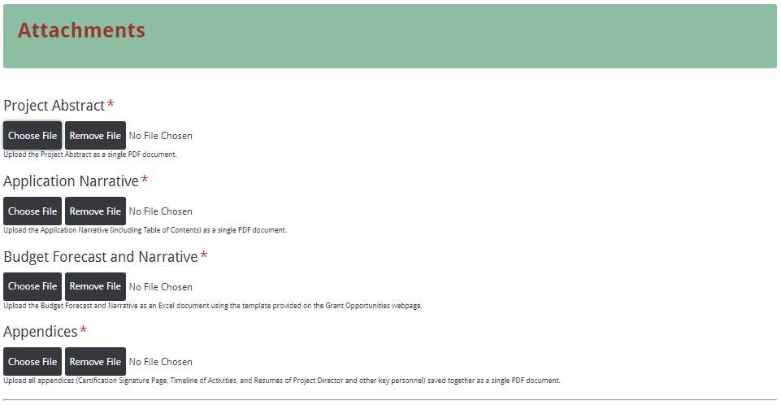

Thoroughly review the summary on the Data Review and Confirmation Page to verify that the information has been entered correctly in the online application prior to submitting. You will not be able to access the completed application form after it has been submitted so it is very important to ensure that all information in the application has been entered correctly.

If any entries are incorrect, click on the "Previous" button at the bottom left corner of each screen to return to the appropriate section(s) and reenter the correct information. Then click on the “Next” button in the lower right corner of each screen to return to the Data Review and Confirmation Page. Note: This page is not a confirmation of the submission of an application.
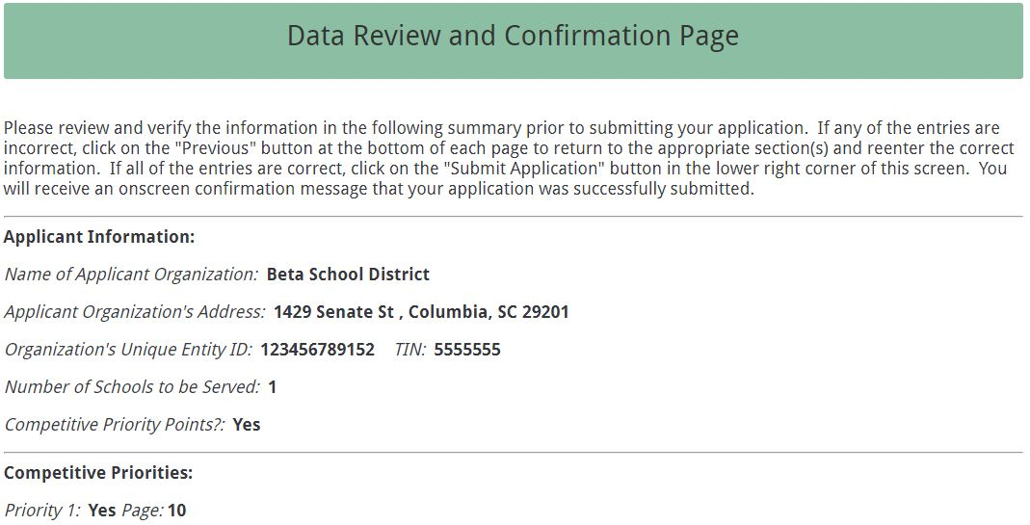

After verifying that all entries are correct, click on the "Submit Form" button in the lower right corner of this screen to complete the submission process.
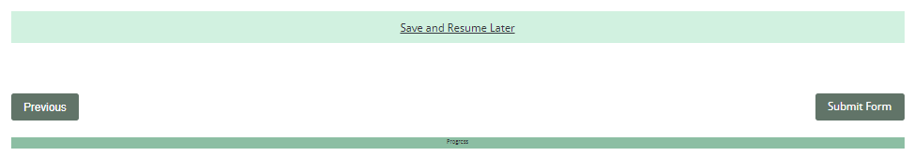

Once you submit the application, the following message will be displayed on the screen.

The following confirmation message will be sent to the email address provided for the project director/grant director. If the project director/grant director does not receive a confirmation email, then the application was not successfully submitted. You must go back and resubmit the entire online form, including all attachments, for your application to be considered for funding. Only the most recently submitted application will be reviewed.
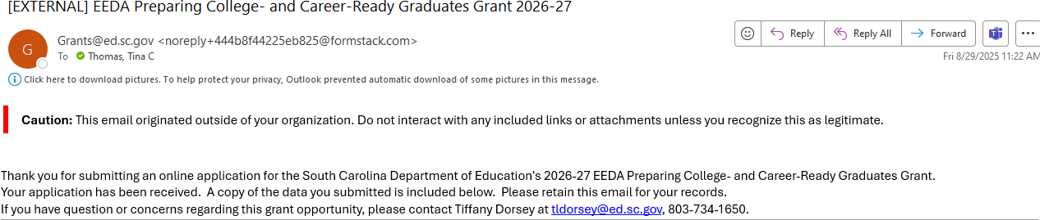

An email confirmation that the grant application was successfully submitted does not account for the quality of the uploaded documents or the completeness of the online form. The confirmation email only notifies you that the online application has been submitted and received. Applicants are responsible for ensuring that the information entered in the online form, including all attachments, is accurate and complete for the application to be reviewed and considered for funding.

Appendix A: Definitions of Terms Used

At-Risk Student—Any student who, because of his or her individual needs, requires temporary or ongoing interventions in order to achieve in school and to graduate with meaningful options for his or her future.

District Index of Taxpaying Ability for Debt Millage—An assessment of school district need as indicated by the district index of taxpaying ability (ITA), district median family income, and district average daily membership. It compares the value of taxable property in the school district with the total value of all taxable property in the state. The standard ITA represents the district’s relative fiscal capability to raise revenue for school operations from property tax in comparison to all districts.
Districts eligible for this priority are listed below:

Abbeville | Dorchester 4 | Lee
Aiken | Edgefield | Lexington 4
Allendale | Fairfield | Marlboro
Anderson 3 | Florence 1 | Marion
Bamberg | Florence 2 | McCormick
Barnwell | Florence 3 & the Continuum | Orangeburg
Chester | Florence 5 | Saluda
Chesterfield | Greenwood 51 | Spartanburg 3
Clarendon | Hampton | Union
Colleton | Jasper | Williamsburg
Dillon 3 | Laurens 55
Dillon 4 | Laurens 56

Intersession Period—The period prior to the new school year in the months of July–August and the period following the end of the school year during the months of May–June. All intersession periods must include a minimum of 20 hours of instruction time per week for all sites to be served.

National Dropout Prevention Center/Network (NDPC/N)—A clearinghouse of information for educators, parents, students, business leaders, community leaders, and other government officials on issues related to dropout prevention and on strategies that are designed to increase the graduation rate in America's schools. See the NDPC/N Web page at http://www.dropoutprevention.org/.

Poverty Index—An index that measures the percentage of households in a country deprived along three dimensions –monetary poverty, education, and basic infrastructure services – to capture a more complete picture of poverty. ( https://rfa.sc.gov/data-research/population-demographics/census-state-data-center/socioeconomic-data/Population-with-percent-in-poverty-by-county-2011-2020 ).

Priority Schools—The SCDE uses the designation of Priority Schools as schools performing in the bottom 10% of all schools in their grade span (elementary, middle or high). In order for a school to exit Priority status, the school must no longer be ranked in the bottom 10% of schools at the end of the three years of a cycle. The next identification will occur in Fall 2025. https://ed.sc.gov/districts-schools/school-improvement/school-improvement-programs/state-priority-schools/

Profile of the South Carolina Graduate—This framework identifies the characteristics that are believed to be vital to helping our state stay competitive in today's global economy as it addresses the need and solution for a sustainable, educated, and qualified workforce:



Appendix B: Selection Criteria and Reviewers’ Scoring Rubric

Selection Criteria
A total of 130 points (including competitive priority points) is available to applications that meet the maximum score for each selection criteria. While the budget is assigned zero (0) points, the budget remains a critical component of the entire application. An application with an incomplete budget will not be funded.

The point values for each section of the application are as follows:

Narrative Sections | Points Available
Project Abstract | 0
Statement of Need | 20
Project Design | 45
Project Management and Sustainability | 20
Evaluation and Dissemination | 15
Budget (Summary and Narrative) | 0
SUBTOTAL | 100
Competitive Priorities (bonus points available) | up to 30
TOTAL | up to 130

Scoring Rubric

Project Abstract: The applicant must provide a one-page narrative that fully addresses all three of the following:
- summarizes the proposed project;
- identifies the applicant, the amount of funding requested, the target school(s), and the number of students to be served; and
- briefly and concisely summarizes the project goals, objectives, key elements, and anticipated outcomes of the strategies and/or models to be implemented.
Acceptable
Adequate/Meets—0 points
Applicant provides a narrative that fully addresses all required items.
Not Acceptable
Inadequate—0 points
Applicant provides a narrative that does not adequately addresses all required items.
Score
Adequate/Meets: ☐ Inadequate: ☐
Reviewer’s Comments

1.a. Needs Statement—Criteria for Determining the Targeted Cohort:
The applicant must provide a narrative that:
- details a description of the existing problem that the school district faces by identifying.
- what the most critical issues are (e.g., absenteeism, retention rates, discipline, dropout rates),
- who is affected by these issues,
- what the causes of these issues are, and
- what will happen if these issues are not resolved.
- indicates the specific eligibility criteria used to identify the targeted cohort by providing both the number and percentage of students in grades 3−12 who are eligible to participate in the proposed project based on the eligibility criteria of poor academic performance and/or behaviors and characteristics of students at risk of dropping out of school.
Acceptable
Fully Meets— 9–10 points
Applicant provides a narrative that is a fully detailed description of all required items.
Adequate/Meets— 6–8 points
Applicant provides a narrative that is a moderately detailed description of all required items.
Not Acceptable
Limited/Approaches— 3–5 points
Applicant provides a narrative that is limited or incomplete in describing all required items.
Inadequate— 0–2 points
Applicant provides a narrative that does not describe all required items.
Score
Reviewer’s Comments

1.b. Needs Statement—Needs of Targeted Cohort: The applicant must provide a narrative that indicates/discusses the following:
- The number of students in the proposed cohort.
- The lack of opportunities or activities designed to help improve the targeted cohort’s world class knowledge, world class skills, and/or life and career characteristics as defined in the Profile of the South Carolina Graduate.
- The need for supplemental rather than duplicative activities and/or services at the proposed site(s).
- The district’s lack of or limited financial resources to implement evidence-based strategies adequately and effectively and/or models designed to address the needs of the targeted cohort at the proposed site(s).
Acceptable
Fully Meets— 9–10 points
Applicant provides a narrative that is a fully detailed description of all required items.
Adequate/Meets— 6–8 points
Applicant provides a narrative that moderately addresses all required items.
Not Acceptable
Limited/Approaches— 3–5 points
Applicant provides a narrative that is limited or incomplete in describing all required items.
Inadequate— 0–2 points
Applicant provides a narrative that does not describe all required items.
Score
Reviewer’s Comments

2.a. Project Design—Goals and Objectives: The applicant must provide a narrative that addresses all three of the following:
- Presents goals and objectives that reflect the results of the needs assessment, mirror the purpose of the project, and address identified needs.
- Provides objectives that are specific, measurable, achievable, relevant, and time specific.
- Addresses how, in determining goals and objectives, the proposed project will enable the applicant to accomplish each of the following by providing a direct link to:
- improving participants’ world class knowledge.
- improving participants’ world class skills.
- improving participants’ life and career characteristics.
- helping the school reduce its failure, retention, and/or dropout rates; and
- helping the applicable high school increase its graduation rate.
Acceptable
Fully Meets— 9–10 points
Applicant provides a narrative that fully addresses all three required items.
Adequate/Meets— 6–8 points
Applicant provides a narrative that moderately addresses all three required items.
Not Acceptable
Limited/Approaches— 3–5 points
Applicant provides a narrative that is limited or incomplete in addressing all required items.
Inadequate— 0–2 points
Applicant provides a narrative that does not address all three required items.
Score
Reviewer’s Comments
2.b. Project Design—Strategies and Activities: The applicant must provide a narrative that identifies the following:
- specific instructional strategies and activities that will take place during the project to achieve the goals and objectives.
- activities and strategies that are evidence-based interventions that clearly connect the stated goals and objectives with the needs for services.
- for each activity, the number of hours per week, days of the week, and number of weeks per year that the activities will be provided; the provider for each activity; and the rationale for the selection of the activities based on the needs identified in the Statement of Need, characteristics of the targeted cohort, and specific research.
Acceptable
Fully Meets— 18–20 points
Applicant provides a narrative that fully describes all required items.
Adequate/Meets—12–17 points
Applicant provides a narrative that moderately describes all required items.
Not Acceptable
Limited/Approaches—6–11 points
Applicant provides a narrative that is limited or incomplete in describing all required items.
Inadequate -0–5 points
Applicant provides a narrative that does not describe all required items.
Score
Reviewer’s Comments

2.c. Project Design—Coordination with Other Programs: The applicant must provide a narrative that describes plans to coordinate and/or combine the project’s activities with other federal, state, and local programs to make the most effective use of public resources (without supplanting) and address all four of the following:
- Describe current projects or programs that are available at the proposed site(s) that are designed to address the identified needs.
- Identify the deficiencies in the current projects or programs and the resulting gaps.
- Explain how implementing the proposed model will be a significant supplement to current programs/activities.
- Describe how current projects or programs will be coordinated and/or combined with the proposed project to maximize impact.
Acceptable
Fully Meets— 9–10 points
Applicant provides a narrative that fully describes plans and addresses all required items.
Adequate/Meets— 6–8 points
Applicant provides a narrative that moderately describes plans and addresses all required items.
Not Acceptable
Limited/Approaches— 3–5 points
Applicant provides a narrative that is limited or incomplete in describing plans and addressing all required items
Inadequate— 0–2 points
Applicant provides a narrative that does not describe plans and address all required items.
Score
Reviewer’s Comments

2.d. Project Design—Timeline of Activities and Project Weekly Schedule: The applicant includes a complete
- Timeline of Activities that provides a chronological timeline of major project events/activities that clearly indicates (by month) when each project activity begins and ends, how each activity relates to a particular objective, the evidence that proves the activity has been completed or data to be collected, and who is responsible for overseeing the activity; and
- Project Weekly Schedule that details all instructional activities occurring at any point (before, during, or afterschool) during the regular school year and all activities that will occur during the proposed intersession periods.
Acceptable
Fully Meets— 4–5 points
Applicant provides a complete and detailed Timeline of Activities and Project Weekly Schedule that address all required items.
Adequate/Meets—-2–3 points
Applicant includes a moderately complete Timeline of Activities and Project Weekly Schedule that moderately addresses all required items.
Not Acceptable
Limited/Approaches—1 point
Applicant provides a limited or incomplete Timeline of Activities and Project Weekly Schedule that does not address all required items.
Inadequate -0 points
Applicant does not provide a Timeline of Activities and/or Project Weekly Schedule.
Score
Reviewer’s Comments
3.a. Project Management and Sustainability—Management Plan: The applicant must provide a narrative that provides/identifies all of the following:
- A plan to manage the project to ensure that the project progresses toward achieving the proposed goal(s) and objectives.
- The chain of command/organizational structure for decision-making that will affect the project, including who will supervise the project director and where the project fits into the overall district or school structure.
- Any professional development or training for staff and explaining why it will be necessary for the project’s success.
- The person who will manage the project, their experience, and credentials.
- How much time the project director will dedicate to managing this project, and how this amount of time is appropriate to oversee all aspects of the project, including the timely submission of all programmatic and financial reports.
- Other key personnel assigned to the project, their responsibilities related to the project, and their experience and credentials.
- Résumés or vitae for the project director (or grant director if a project director has not yet been designated) and all key personnel as an appendix item.
Acceptable
Fully Meets—9–10 points
Applicant provides a narrative that fully addresses all required items.
Adequate/Meets—6–8 points
Applicant provides a narrative that moderately addresses all required items.
Not Acceptable
Limited/Approaches—3–5 points
Applicant provides a narrative that is limited or incomplete in addressing all required items.
Inadequate—0–2 points
Applicant provides a narrative that does not address all required items.
Score
Reviewer’s Comments

3.b. Project Management and Sustainability—Sustainability Plan: The applicant must provide a narrative that addresses the plan to ensure that the project will maintain its activities during the full project term and beyond the grant funding period and
- describes the role each partner will play in sustaining the project;
- explains how funds will be used to provide supplemental rather than duplicative activities and/or services and not supplant other federal, state, or local funds or other resources; and
- explains conceptually how funding will continue for core activities after the grant ends.
Acceptable
Fully Meets— 9–10 points
Applicant provides a narrative that fully addresses all required items.
Adequate/Meets— 6–8 points
Applicant provides a narrative that moderately addresses all required items.
Not Acceptable
Limited/Approaches— 3–5 points
Applicant provides a narrative that is limited or incomplete in addressing all required items.
Inadequate - 0–2 points
Applicant provides a narrative that does not address all required items.
Score
Reviewer’s Comments

4.a. Project Evaluation and Dissemination—Evaluation Plan: The applicant must provide a narrative that
- provides a plan to evaluate the project’s outcomes and prove, using scientific methods and a range of data, if and how well the project worked in realizing its goals and objective;
- describes the outcome measures that will be used to assess the impact of the proposed project on student learning and behavior;
- describes the types of data that will be collected, how and when the data will be collected and analyzed, who (identified by position) will be responsible for each data collection, and how results will be presented to demonstrate that each objective has been met;
- explains how the data will be analyzed, reported, and subsequently used to improve the overall quality of the project or activity; and
- identifies the different audiences who will be provided with the evaluation data and reports.

Acceptable
Fully Meets— 9–10 points
Applicant provides a narrative that fully addresses all required items.
Adequate/Meets— 6–8 points
Applicant provides a narrative that moderately addresses all required items.
Not Acceptable
Limited/Approaches— 3–5 points
Applicant provides a narrative that is limited or incomplete in addressing all required items.
Inadequate - 0–2 points
Applicant provides a narrative that does not address all required items.
Score
Reviewer’s Comments

4.b. Project Evaluation and Dissemination—Dissemination Plan: The applicant must provide a narrative that describes
- how and with whom they will share information about the project’s successes and challenges so that the project will contribute to the district’s/school’s efforts to continue
- producing graduates who meet the characteristics identified in the Profile of the South Carolina Graduate,
- improving academic performance,
- reducing dropout rates, and
- increasing high school graduation rates.
- shows how the project will contribute to the knowledge about this field or become a model for others to replicate.
Acceptable
Fully Meets— 4–5 points
Applicant provides a narrative that fully describes all required items.
Adequate/Meets— 2–3 points
Applicant provides a narrative that moderately describes all required items.
Not Acceptable
Limited/Approaches— 1 point
Applicant provides a narrative that is limited or incomplete in describing all required items.
Inadequate - 0 points
Applicant provides a narrative that does not describe all required items.
Score
Reviewer’s Comments

Budget Summary and Budget Forecast and Narrative: The applicant must provide all four of the following:
- a Budget Summary in the online form that computes correctly,
- a complete Budget Forecast and Narrative,
- totals in the Budget Narrative that correctly reflect the line item totals in the Budget Summary, and
- items in the Budget Narrative that directly correspond to or reflect strategies and activities for the project.
Acceptable
Adequate/Meets—0 points
Applicant provides all four (4) of the required items.
Not Acceptable
Inadequate—0 points
Applicant does not provide all four (4) of the required items.
Score
Adequate/Meets: ☐ Inadequate: ☐
Reviewer’s Comments

Appendix C: Required SCDE Forms

Certification Signature Page
(This form must be signed by the individual from each proposed district, school, or organization who holds the title listed below.)

Certification
I hereby certify that, to the best of my knowledge, the information and data contained in this application are true and correct. The applicant’s governing body has duly authorized this application and documentation, and the applicant will comply with the Program Specific Assurances (if applicable) and the SCDE Assurances and Terms and Conditions if the grant is awarded.

Authorized Official)
Name:
Position: | Email:
Telephone: | Fax:

Signature of Authorized Official: | Typed name of Authorized Official:
Date Signed:
Signature of Financial Official: | Typed Name of Financial Official:
Date Signed:
Signature of Principal: | Typed Name of Principal:
Date Signed:
Signature of Principal: | Typed Name of Principal:
Date Signed:
Signature of Principal: | Typed Name of Principal:
Date Signed:

Please complete, print, and obtain ALL signatures, as required, prior to submission. Include the signed, scanned form in the required appendices as indicated on page 20.

Assurances and Terms and Conditions for State Awards

For informational purposes only
The applicant certifies to abide by the SCDE Assurances and Terms and Conditions by signing and submitting the Certification Signature Page.

Assurances

I certify that this applicant
Has the legal authority to apply for state assistance and the institutional, managerial, and financial capability (including funds sufficient to pay the nonstate share of project costs) to ensure proper planning, management, and completion of the project described in this application.
- Will give the South Carolina Department of Education (SCDE) access to and the right to examine all records, books, papers, or documents related to this award and will establish a proper accounting system in accordance with generally accepted accounting principles (GAAP) or agency directives.
- Has an accounting system that includes sufficient internal controls, a clear audit trail, and written cost-allocation procedures as necessary. The financial management systems are capable of distinguishing expenditures that are attributable to this grant from those that are not attributable to this grant. This system is able to identify costs by programmatic year and by budget line item and to differentiate among direct, indirect, and administrative costs. In addition, the applicant will maintain adequate supporting documents for the expenditures and in-kind contributions, regardless of the type of funds, if any, that it makes under this grant. Costs are shown in books or records (e.g., disbursements ledger, journal, payroll register) and are supported by a source document such as a receipt, travel voucher, invoice, bill, or in-kind voucher.
- Will also comply with GAAP as it relates to budgets, budget amendments, and expenditure claim submissions.
- Will approve all expenditures, document receipt of goods and services, and record payments on the applicant’s accounting records prior to submission of reimbursement claims to the SCDE for costs related to this grant.
- Will initiate and complete work within the applicable time frame after receipt of approval by the SCDE.
- Will not discriminate against any employee or applicant for employment because of race, color, religion, age, sex, national origin, or disability. The applicant will take affirmative action to ensure that applicants for employment and the employees during the period of their employment are treated without regard to their race, color, religion, age, sex, national origin, or disability.
- Will comply with the Ethics, Government Accountability, and Campaign Reform Act (S.C. Code Ann. § 2-17-10 et seq. and § 8-13-100 et seq. (Supp. 2024)).
- Will comply with the Drug Free Workplace Act (S.C. Code Ann. § 44-107-10 et seq. (Supp. 2024)) if the amount of this award is $50,000 or more.
- Will comply with the requirements of Proviso 1.78, H. 4025, 126th Leg., 2nd Reg. Sess. (S.C. 2025), available at https://www.scstatehouse.gov/sess126_2025-2026/appropriations2025/crp1b.pdf.
- Will not use grant funds in a manner inconsistent with the South Carolina Department of Education (SCDE) guidance to districts and staff on federal education policy changes and terminology and data collection practices. Those documents are available at https://ed.sc.gov/newsroom/school-district-memoranda-archive/update-on-federal-education-policy-changes/update-on-federal-education-policy-changes-memo/ and https://ed.sc.gov/newsroom/guidance-regarding-terminology-and-data-collection-practices/.
- Will not use grant funds in a manner inconsistent with state regulations including Regulation 43-170. Guidance is available at https://ed.sc.gov/state-board/state-board-of-education/uniform-procedure-for-selection-or-reconsideration-of-instructional-materials/.

Terms and Conditions

- Completeness of Proposal. All proposals should be complete and carefully worded and must contain all of the information requested by the South Carolina Department of Education (SCDE). If you do not believe a section applies to your proposal, please indicate that fact.
- Non-awards/Termination. The SCDE reserves the right to reject any and all applications and to refuse to grant monies under this solicitation. If the SCDE rejects an application, the applicant has a right to request a review of the process consistent with the appeals process presented in the Request for Proposals (RFP).
After it has been awarded, the SCDE may terminate a grant by giving the grantee written notice of termination. In the event of a termination after award, the SCDE shall reimburse the grantee for expenses incurred up to the notification of termination. In addition, this grant may be terminated by the SCDE if the grantee fails to perform as promised in its proposal.
Upon the termination of a grant, the grantee shall have the right to a review process. The grantee must notify the SCDE of its request within 30 days of receiving written notice of the termination.
- Reduction in Budgets and Negotiations. The SCDE reserves the right to negotiate budgets with potential grantees. The SCDE may, at its sole discretion, determine that a proposed budget is excessive and may negotiate a lower budget with the applicant. The applicant may at that time negotiate or withdraw its proposal. In addition, the SCDE may desire to fund a project but not at the level proposed. In that case, the SCDE shall notify the applicant of the amount that can be funded, and the applicant and the SCDE shall negotiate a modification to the proposal to accommodate the lower budget. All final decisions are that of the SCDE.
- Amendments to Grants. Amendments are permitted upon the mutual agreement of the parties and will become effective when specified in writing and signed by both parties.
- Use of Grant Funds. Funds awarded are to be expended only for purposes and activities covered by the approved project plan, budget, and budget narrative.
- Submission of Expenditure Reports. Claims for reimbursement must be made at least quarterly and consistent with calendar quarters (e.g., an expenditure report claim for costs for January 1 through March 30 must be filed by May 15).
- Obligation of Grant Funds. Grant funds may not be obligated prior to the effective date or subsequent to the end or termination date of the grant period. No obligations are allowed after the end of the grant period. The final request for expenditure report claims must be submitted no later than forty-five (45) days after the end of the grant period unless the scope of work for the grant states a shorter reporting period.
- Deobligation of Funds. After a final expenditure claim has been submitted to the SCDE, the grantee will go through the official deobligation process with the SCDE.
- Documentation. The grantee must provide for accurate and timely recording of receipts and expenditures. The grantee’s accounting system should distinguish receipts and expenditures attributable to each grant. The grantee must review the memo regarding “Guidelines for Retaining Documentation to Support Expenditure Claims.”
- Travel Costs. Travel costs, if allowed under this solicitation, must not exceed limits noted in the United States General Services Administration (GSA) per diem rates for lodging, except in the case of conference lodging required for program-required training. In the case that conference-related lodging exceeds the GSA per diem rate, the grantee shall follow their entity’s written procedure for obtaining prior approval to exceed a GSA rate for a conference hotel. Meals and incidentals are limited by the state budget proviso, currently not to exceed $35 per day for in-state travel and $50 for out-of-state travel (see page 81 of the State of South Carolina Statewide Disbursement Regulations). Mileage reimbursement must follow the current Office of Comptroller General instructions, which is consistent with the published IRS rates.
- Honoraria. Amounts paid in honoraria, if allowed under this grant, must be consistent with SCDE policies. Applicants should check with the program office before budgeting for honoraria.
- Reports. The grantee shall submit, as required or instructed by the awarding program office, all reports (programmatic, financial, or evaluation) within the specified period or date and in the prescribed format. An expenditure claim report must be filed by July 5 for all expenditures incurred by June 30 in order to comply with the generally accepted accounting principles (GAAP) and the production of the State's Annual Comprehensive Financial Report.
- Copyright. The grantee is free to copyright any books, publications, or other copyrightable materials developed in the course of this grant. However, the SCDE reserves a royalty-free, nonexclusive, and irrevocable license to reproduce, publish, or otherwise use, and to authorize others to use, the copyrighted work developed under this grant.
- Certification Regarding Suspension and Debarment. By submitting an application, the applicant certifies, to the best of its knowledge and belief, that the
- Applicant and/or any of its principals, subgrantees, or subcontractors
  - are not presently debarred, suspended, proposed for debarment, or declared ineligible for the award of contracts by any state or federal agency; have not, within a three-year period preceding this application, been convicted of or had a civil judgment rendered against them for commission of fraud or a criminal offense in connection with obtaining, attempting to obtain, or performing a public (federal, state, or local) contract or subcontract; violation of federal or state antitrust statutes relating to the submission of offers; or commission of embezzlement, theft, forgery, bribery, falsification or destruction of records, making false statements, tax evasion, or receiving stolen property; and
  - are not presently indicted for, or otherwise criminally or civilly charged by a governmental entity with, commission of any of the offenses enumerated above.
- Applicant has not, within a three-year period preceding this application, had one or more contracts terminated for default by any public (federal, state, or local) entity.
- Audits. Although this Assurances, Terms, and Conditions document is for a state award, federal audit requirements apply as follows:
- Entities expending $1,000,000 or more in federal awards:
Entities that expend $1,000,000 or more in federal awards during the fiscal year are required to have an audit performed in accordance with the provisions of 2 CFR Part 200.501, et seq. Except for the provisions for biennial audits provided in 2 CFR Part 200.504 (a) and (b), audits must be performed annually as stated at 2 CFR Part 200.504. A grantee that passes through funds to subrecipients has the responsibility of ensuring that federal awards are used for authorized purposes in compliance with federal program laws, federal and state regulations, and grant agreements. The director of the OMB, who will review this amount every two years, has the option of revising the threshold upward. Audits must be conducted in accordance with Government Auditing Standards (Yellow Book).
- Entities expending less than $1,000,000 in federal awards:
Entities that expend less than $1,000,000 in a fiscal year in federal awards are exempt from the audit requirements in 2 CFR Part 200.504. However, such entities are not exempt from other federal requirements (including those to maintain records) concerning federal awards provided to the entity. The entity’s records must be available for review or audit by the SCDE and appropriate officials of federal agencies, pass-through entities, and the General Accounting Office (GAO). Audits must be conducted in accordance with Government Auditing Standards (Yellow Book).
- Records. The grantee shall retain grant records, including financial records and supporting documentation, for a minimum of six (6) years after the end date of the grant when the final expenditure report claim for reimbursement and all final reports have been submitted, unless informed otherwise or in case of litigation.
- Electronic Signature Agreement. I agree that my electronic signature is the legally binding equivalent to my handwritten signature.

Goals, Objectives, and Outcomes Worksheet

Goal _____:

Objective _____:

Directions
1. Identify a result you expect to achieve through this program.
2. Describe what you will do to achieve this result.
3. What data will you collect to prove that you have achieved this result?
4. Are there target benchmarks for progress toward achieving this result over time?
5. Combine the information from Steps 1-4 into one sentence. (This combined statement is a performance measure)
6. How long will it take to achieve this result?
7. What baseline data will you need to have to measure achievement of this result?

Timeline of Activities Template

Start Date–End Date | Activity to Achieve Objective | Related Objective and Goal | Evidence that Proves Activity has been Completed OR Data to be Collected from Activity | Persons/Agency Responsible

Project Weekly Schedule Template

Name of Primary Applicant: _____________________________________________________

Modify and add rows as needed Each activity should specify subject, location, and person responsible.

EEDA Preparing College- and Career-Ready Graduates Program
at _______________________________________________________ (school)
Dates __________________________ Year _______
GRADES | TIME | Monday | Tuesday | Wednesday | Thursday | Friday | Saturday  (HS only)

Revised ____________ (date)

Budget Forecast and Narrative Format Guidance

Use the Excel budget file accompanying this funding opportunity announcement the Grant Opportunities Web page to develop the Budget Forecast and Narrative.

Applicants should insert rows in the budget spreadsheet as needed to clarify information In-kind/matching funds are not required for this grant and provide no “competitive edge.”

