Request for Proposals (RFP)
Application Package

The Workforce Innovation and Opportunity Act (WIOA):
Adult Education and Family Literacy Act (AEFLA) Programs
2025–30 Competitive Subgrants

The Adult Education and Family Literacy Act programs are funded by Title II: Adult Education and Family Literacy Act (AEFLA), authorized by Public Law 113-128, and administered by the South Carolina Department of Education.

Deadline for Receipt of Applications: March 31, 2025, at 5:00 p.m.

Pre-Application Technical Assistance Webinars
Adult Education Program: February 10, 2025, 10:00 am and 2:00 pm
Corrections Education Program: February 11, 2025, 2:00 pm
Family Literacy Program: February 12, 2025, 10:00 am
Integrated English Literacy/Civics Education Program: February 12, 2:00 pm

Email of Intent Deadline: February 21, 2025

For questions about the AEFLA Programs, email adultedgrants@ed.sc.gov and copy the appropriate program contact:
- Adult Education Program—Andrena Duren, aduren@ed.sc.gov
- Corrections Education Program—Jennifer Wheeler, jcwheeler@ed.sc.gov
- Family Literacy Program—Harriette Jenerette, hjeneret@ed.sc.gov
- Integrated English Literacy/Civics Education Program—Wendy Griffin, ggriffin@ed.sc.gov

Issued by:
South Carolina Department of Education
Office of Adult Education
849 Learning Lane
West Columbia, SC 29172-3171

TABLE OF CONTENTS
PART I: General Information 1
A. Introduction and Purpose 1
B. Eligible Applicants 3
C. Competitive Priorities 4
D. Timeline of Subgranting Process 4
E. Technical Assistance Sessions for Applicants 4
F. Statutory, Federal Regulations, and Other Requirements 4
F. Authorized Activities 15
G. Unauthorized Activities 15
H. Program Accountability and Monitoring 15
I. Fiscal Operations 21
J. Supplement, Not Supplant 25
K. Review and Selection Process 25
L. Appeals Process 27

PART II: Application Overview, Content, and Instructions 28
A. Application Overview 28
B. Application Narrative Format 29
C. Online Application Submission 29
D. Program Abstract 29
E. Application Narrative Content 30
Consideration 1 Commitment to Serve Individuals in Need 30
Consideration 2. Serving Individuals with Disabilities 31
Consideration 3. Past Effectiveness 32
Consideration 4. One-Stop System Alignment 33
Consideration 5.&6. Evidence-Based Instructional Practices 34
Consideration 7. Activities Implementation, Technology Use, and Delivery Method 35
Consideration 8. Contextualized Instruction 36
Consideration 9. Instructor and Staff Qualifications 37
Consideration 10.&11. Partner Coordination, Support Services, and Service Flexibility 39
Consideration 12. Performance Management and Outcomes 41
Consideration 13. English Language Acquisition (ELA) and Civics Education 42
F. Application Budget 43
G. Attachments 47
H. Deadline and Submission Procedures 51
I. Screenshots of Online Application Submission Forms 52
Screenshots of the AEFLA Main Application Online Form 52
Main Application Attachments and Data Review and Confirmation Pages 67
Screenshots of the Program-Specific Attachment Forms 71
Submission of Program-Specific Attachment Forms 76

Appendix A: Definitions of Terms Used 78

Appendix B: Selection Criteria and Reviewers’ Scoring Rubric 89

Appendix C: Required SCDE Forms 90
Certification Signature Page 90
Assurances and Terms and Conditions for Federal Awards 91
Program-Specific Assurances 95
Pre-Award Audit Questionnaire for Non-LEAs 96
Instructions for General Education Provisions Act (GEPA) Statement of Compliance 101
Request for Taxpayer Identification Number and Certification 102

Appendix D: Optional Forms and Information 103
Adult Education Program Estimated Number of Participants to be Served 103
SC County Population Numbers by Age and High School Credential Attainment 105
SC County Population Numbers by Race and High School Credential Attainment 111
South Carolina Performance Measures for AEFLA 119
Measurable Skill Gains 120
Adult Education College and Career Navigator Job Description 122
Counties Required to Provide English Language Acquisition (ELA) Services 125
Recruitment and Retention Action Plan 127
Partner Identification and Funding Request Form 130
Past Effectiveness Chart 131
AEFLA Program Budget Planning Form and Budget Narrative Template 136
AEFLA Partners and Partnership Coordination 137
Weekly Schedule 139
Acronyms List 140
Allowable and Unallowable Expenditures per Subgrant Program 142
AEFLA Core Program Staff Responsibilities 145
Family Literacy Program Partner Verification Form 148
Family Literacy One-to-One Match Verification Form 149
Four Component Family Literacy Site Information Form 150
Early Care and Education Career Pathway Site Information Form 151
South Carolina Local Workforce Development Areas 152

PART I: General Information

Introduction and Purpose

The Adult Education and Family Literacy Act (AEFLA) is authorized by the Workforce Innovation and Opportunity Act (WIOA) of 2014. The WIOA is designed to help job seekers access employment, education, training, and support services to succeed in the labor market and to match employers with the skilled workers they need to compete in the global economy. The WIOA brings together, in strategic coordination, federal core programs of skill development such as:
- employment and training services for adults, dislocated workers, and youth and Wagner-Peyser employment services administered by the U.S. Department of Labor (USDOL) through formula grants to states; and
- adult education and literacy programs and Vocational Rehabilitation state grant programs that assist individuals with disabilities in obtaining employment as administered by the U.S. Department of Education (USED).

The purpose of AEFLA is to create a partnership among the federal government, states, and localities to provide, on a voluntary basis, adult education and literacy activities, in order to—
- assist adults to become literate and obtain the knowledge and skills necessary for employment and economic self-sufficiency;
- assist adults who are parents or family members to obtain the education and skills that—
- are necessary to becoming full partners in the educational development of their children; and
- lead to sustainable improvements in the economic opportunities for their family;
- assist adults in attaining a secondary school diploma and in the transition to postsecondary education and training, including through career pathways; and
- assist immigrants and other individuals who are English language learners in—
- improving their—
- reading, writing, speaking, and comprehension skills in English; and
- mathematics skills; and
- acquiring an understanding of the American system of government, individual freedom, and the responsibilities of citizenship.

The South Carolina Department of Education (SCDE) must use a competitive process to award eligible local providers/applicants subgrants for the development, implementation, and improvement of adult education and literacy activities within South Carolina. Each eligible provider receiving a subgrant must use the funding to establish or operate programs that provide adult education and literacy activities, including programs that provide such activities concurrently.

AEFLA funds are to support subgrant programs in Adult Education, Corrections Education, Family Literacy, and Integrated English Literacy/Civics Education (IEL/CE). To be eligible to apply for the Family Literacy subgrant or the IEL/CE subgrant, an applicant must apply for the Adult Education subgrant.

The table below indicates the approximate number of programs to be funded and the available funding for new subgrants in the 2025–30 funding cycle. Award amounts will be determined per program based on the quality of applications received and total funding requested. Awards may vary depending upon program size, population (number of anticipated enrollees), and number of subgrantees within the county service area.

An applicant may submit a single application to serve multiple service areas. An applicant may partner with other providers to serve multiple service areas. Final budgets may be negotiated based on demonstrated needs. All subgrant awards are contingent upon total allocations to the SCDE by the USED.

Approximate Available Funding for New Subgrants
Program | Available  Funds | Subgrants and Amounts
Adult Education | $7,000,000 | - Approximately 55 subgrants  - Subgrants range from $5,000 to $500,000
Corrections Education | $500,000 | - Approximately 6 subgrants  - 1 statewide subgrant up to $400,000  - 5 subgrants up to $20,000
Family Literacy | $450,000 | - Approximately 15 subgrants  - Subgrants range from $5,000 to $60,000  - Requires 1:1 match
IEL/CE | $433,000 | - Approximately one (1) subgrant in each local workforce area (see the South Carolina Local Workforce Development Areas on page 152)  - Minimum award: $20,000

The maximum subgrant period is five years, July 1, 2025, through June 30, 2030, and is subject to the availability of federal funds and the subgrantee meeting all applicable program requirements (Adult Education, Corrections Education, Family Literacy, and IEL/CE). The year one subgrant budget period is July 1, 2025, through June 30, 2026. Funds may not be carried over to subsequent years.

Official subaward documents will be processed annually as continuation of funding is not automatic. In determining continuation funding, the SCDE will consider the subgrantee’s evidence of a project’s effectiveness in achieving objectives, timely submission and quality of all required reports (including the interim and annual progress reports), and rationale for budget expenditures. Submission of a continuation application may also be required in subsequent years.

The subgrantee may obligate funds upon receipt of the grant award notice. However, no funds will be disbursed until after July 1, 2025. Subgrant payments are made on a cost-reimbursement basis so applicants should have at least three months of operating funds at their disposal to implement the program to compensate for any delays in receiving reimbursement payments.

Eligible Applicants

Eligible applicants (i.e., eligible providers) are organizations that can prove evidence of demonstrated effectiveness in providing adult education and literacy activities. Eligible applicants may include—
    - a local educational agency (LEA, i.e., school district);
    - a community-based organization or faith-based organization;
    - a volunteer literacy organization;
    - an institution of higher education;
    - a public or private nonprofit agency;
    - a library;
    - a public housing authority;
    - a nonprofit institution not described in any of items 1 through 7 that has the ability to provide adult education and literacy activities to eligible individuals;
    - a consortium or coalition of the agencies, organizations, institutions, libraries, or authorities described in any of items 1. through 8.; and
    - a partnership between an employer and an entity described in any of items 1 through 9.

All four subgrant programs require evidence of demonstrated effectiveness for an applicant to be considered. To show demonstrated effectiveness in providing adult education and literacy activities, an eligible provider must submit:
  - Participant Performance Record—two previous years of performance data from July 1, 2017, through June 30, 2024, on improving the skills of eligible individuals, while enrolled in an Adult Education program, particularly eligible individuals who have low levels of literacy, in the domains of:
- reading,
- writing,
- mathematics,
- English language acquisition,
- secondary school diploma,
- Integrated Education and Training,
- Workplace Literacy.
  - Participant Outcomes—two previous years of performance data from July 1, 2017, through June 30, 2024, on post-exit outcomes for participants related to:
- employment,
- attainment of secondary school diploma or its recognized equivalent, and
- transition to postsecondary education and/or training.

More information on performance and outcomes can be found at the National Reporting System for Adult Education (NRS) website. Instructions on how to submit documentation of demonstrated effectiveness are on pages 131–135.

An applicant that is unable to provide evidence of their demonstrated effectiveness in providing adult education and literacy activities will not be considered for funding, and their application will not be reviewed.

Competitive Priorities

No competitive priority points are available for this competition.

Timeline of Subgranting Process

Date | Activity/Action
February 10, 2025 | Pre-application technical assistance webinars for Adult Education program
February 11, 2025 | Pre-application technical assistance webinars for Corrections Education program
February 12, 2025 | Pre-application technical assistance webinars for Family Literacy program, and IEL/CE program
February 21, 2025 | Deadline for email of intent
March 31, 2025 | Deadline for receipt of application
June–July 2025 | Notification of awards; new subgrantee technical assistance session
July 1, 2025 | Year One funding period begins; projects can begin
January 30, 2026 | Interim report due to the SCDE
June 30, 2026 | Year One funding period ends; projects must end
August 30, 2026 | Annual report and final Year One expenditures due to the SCDE

Technical Assistance Sessions for Applicants

The SCDE’s Office of Adult Education (OAE) will offer pre-application technical assistance webinars.
- The Adult Education program session will be presented twice on February 10, 2025. The first session will be from 10:00 a.m. until 12:00 p.m. via Adobe Connect. The second session will be from 2:00 p.m. until 4:00 p.m. via Adobe Connect.
- The Corrections Education program session will be on February 11, 2025, from 2:00 p.m. until 4:00 p.m. via Adobe Connect.
- The Family Literacy program subgrant session will be on February 12, 2025, from 10:00 a.m. until 12:00 p.m. via Adobe Connect.
- The IEL/CE program subgrant session will be on February 12, 2025, from 2:00 p.m. until 4:00 p.m. via Adobe Connect.

No password is required to join the sessions. Participants should enter their full names when logging in. Participants will be able to log in 15 minutes prior to the start of each session to test their equipment’s audio settings and to download/print handouts. While participation is not mandatory to submit an application, it is highly recommended.

Statutory, Federal Regulations, and Other Requirements

Required Thirteen Considerations
In accordance with the WIOA, the SCDE must consider the following for all applicants when awarding all program subgrants:
- the degree to which the eligible provider (applicant) would be responsive to—
  - Regional needs as identified in the local workforce development plan; and
  - Serving individuals in the community who were identified in such plan as most in need of adult education and literacy activities, including individuals—
- who have low levels of literacy skills; or
- who are English language learners;
- the ability of the eligible provider (applicant) to serve eligible individuals with disabilities, including eligible individuals with learning disabilities;
- past effectiveness of the eligible provider (applicant) in improving the literacy of eligible individuals, to meet state-adjusted levels of performance for the primary indicators of performance described in section 116, especially with respect to eligible individuals who have low levels of literacy (see §463.155);
- the extent to which the eligible provider (applicant) demonstrates alignment between proposed activities and services and the strategy and goals of the local plan under the WIOA section 108, as well as the activities and services of the one-stop partners;
- whether the eligible provider's program—
- is of sufficient intensity and quality, and based on the most rigorous research available so that participants achieve substantial learning gains; and
- uses instructional practices that include the essential components of reading instruction;
- whether the eligible provider's activities, including whether reading, writing, speaking, mathematics, and English language acquisition instruction delivered by the eligible provider, are based on the best practices derived from the most rigorous research available and appropriate, including scientifically valid research and effective educational practice;
- whether the eligible provider's activities effectively use technology, services and delivery systems, including distance education in a manner sufficient to increase the amount and quality of learning and how such technology, services, and systems lead to improved performance;
- whether the eligible provider’s activities provide learning in context, including through integrated education and training, so that an individual acquires the skills needed to transition to and complete postsecondary education and training programs, obtain and advance in employment leading to economic self-sufficiency, and to exercise the rights and responsibilities of citizenship;
- whether the eligible provider's activities are delivered by well-trained instructors, counselors, and administrators who meet any minimum qualifications established by the state, where applicable, and who have access to high quality professional development, including through electronic means;
- whether the eligible provider’s activities coordinate with other available education, training, and social service resources in the community, such as by establishing strong links with elementary schools and secondary schools, postsecondary educational institutions, institutions of higher education, local workforce development boards (LWDBs), one-stop centers, job training programs, and social service agencies, business, industry, labor organizations, community-based organizations, nonprofit organizations, and intermediaries, in the development of career pathways;
- whether the eligible provider's activities offer the flexible schedules and coordination with federal, state, and local support services (such as child care, transportation, mental health services, and career planning) that are necessary to enable individuals, including individuals with disabilities or other special needs, to attend and complete programs;
- whether the eligible provider maintains a high quality information management system that has the capacity to report measurable participant outcomes (consistent with the WIOA section 116) (see §463.155) and to monitor program performance; and
- whether the local area(s) in which the eligible provider is located has a demonstrated need for additional English language acquisition programs and civics education programs.

Application narrative instructions in Part II of this RFP are designed to assist the applicant with demonstrating responsiveness to these required thirteen considerations.

To comply with Section 427 of the General Education Provisions Act (GEPA), each subgrant application must include an appropriate GEPA statement of compliance as described on page 101 for submission as an attachment to the application (see page 49).

Applicable Federal Regulations
Applicants should review the following federal regulations, accessible at the electronic Code of Federal Regulations (e-CFR) Web site, which are applicable to the AEFLA subgrant programs. Applicants are reminded that, if funded, their programs must comply with these regulations. 0
- 2 CFR Part 25—Universal Identifier and System of Award Management
- 2 CFR Part 170—Reporting Subaward and Executive Compensation Information
- 2 CFR Part 175—Award Term for Trafficking in Persons
- 2 CFR Part 180—OMB Guidelines to Agencies on Governmentwide Debarment and Suspension (Nonprocurement), as adopted at 2 CFR Part 3485
- 2 CFR Part 200—Uniform Administrative Requirements, Cost Principles, and Audit Requirements for Federal Awards (Note: 2 CFR Part 200.211(b)(1)) requires that a grant recipient’s name match the name associated with their unique entity identifier (UEI) as defined at 2 CFR Part 25.315).
- 20 CFR Part 678.420—Description of the One-Stop Delivery System under Title I of the Workforce Innovation and Opportunity Act
- 34 CFR Part 76—State-Administered Programs
- 34 CFR Part 77—Definitions that Apply to Department Regulations
- 34 CFR Part 81—General Education Provisions Act Enforcement
- 34 CFR Part 82—New Restrictions on Lobbying
- 34 CFR Part 84—Governmentwide Requirements for Drug-Free Workplace (Financial Assistance Grants)
- 34 CFR Part 86—Drug and Alcohol Prevention
- 34 CFR Part 99—Family Educational Rights and Privacy.
- 34 CFR Part 462—Measuring Educational Gain in the National Reporting System for Adult Education
- 34 CFR Part 463—Adult Education and Family Literacy Act

Additional information on select federal government-wide regulations is presented below:

Universal Identifier and System of Award Management—2 CFR Part 25
All applicants must obtain a unique entity identifier (UEI) from the federal System for Award Management (SAM). The applicant must include a valid UEI in the online application. The SCDE will not make a subaward of federal funds to an applicant that does not comply with the requirements described in 2 CFR 25 to provide a valid UEI. For assistance and more information, see the Federal Service Desk frequently asked questions.

Note that for an organization to receive a direct grant from the federal government, the organization must be registered and maintain an active registration in SAM prior to and throughout the application and award process. To receive a subaward from the SCDE, only the valid UEI is required.

Reporting Subaward and Executive Compensation Information—2 CFR Part 170
The Federal Funding Accountability and Transparency Act (FFATA) of 2006 (Public Law 109–282), as amended by Section 6202 of Public Law 110–252, requires primary grantees of federal grants and cooperative agreements to report information on subgrantee obligations and executive compensation. FFATA promotes open government by enhancing the federal government’s accountability for its stewardship of public resources. This is accomplished by making government information, particularly information on federal spending, accessible to the public.

Primary grantees, like the SCDE, are required to report actions that obligate $25,000 or more in federal grant funds to first-tier subgrantees. This information must be reported in the governmentwide FFATA Subaward Reporting System (FSRS). In order to access FSRS a current SAM registration is required. A primary grantee and first-tier subgrantees must also report total compensation for each of its five most-highly compensated executives. Every primary and first-tier subgrantee must register in SAM and obtain a UEI prior to being eligible to receive a grant or subgrant award. Additional information will be provided to subgrant recipients upon award.

Program Income–2 CFR Part 200.307
Ordinarily, program income is deducted from total allowable program costs, and all program income, except for tuition and fees charged to students and employers earned by a subgrantee under an AEFLA subaward, must be deducted. A local subgrantee charging reasonable and necessary tuition or fees to students and employers may use that income to provide additional adult education and literacy services that it would otherwise be unable to provide. Program income from tuition and fees must be (1) governed by the terms of the agreement between the SCDE and the local subgrantee to which the state provides federal funds, (2) accounted for in program records, and (3) used only for costs allowable under AEFLA.

Applicants should also review the Assurances and Terms and Conditions for Federal Subawards and the Program-Specific Assurances (located on pages 91–95) to ensure that, if awarded a subgrant, they are capable of full compliance, especially with all the referenced federal regulations and state laws, in order to enter into an agreement with the SCDE for this program. For example, in compliance with 2 CFR Part 200.112, an applicant must disclose in writing any potential conflict of interest to the SCDE in accordance with the USED’s and USDOL’s conflict of interest policy. A signed Certification Signature Page (page 90) is required with the application and legally binds the applicant to the agency’s Assurances and Terms and Conditions and the Program-Specific Assurances.

Primary Indicators of Performance
Section 116 of the WIOA establishes performance accountability indicators and performance reporting requirements to assess the effectiveness of states and local areas in achieving positive outcomes for individuals served by the workforce development system’s six core programs. Adult education is one of the six core workforce development programs. The AEFLA performance measures will contribute to the state’s WIOA primary indicators of performance. The WIOA core programs in South Carolina include:
- WIOA Title I: the programs authorized under and administered by the South Carolina Department of Employment and Workforce (SCDEW):
  - Adult
  - Dislocated Worker
  - Youth
- WIOA Title II: the AEFLA program, authorized under the and administered by the SCDE OAE;
- WIOA Title III: the Employment Service program authorized under the Wagner-Peyser Act, as administered by the SCDEW; and
- WIOA Title IV: the Vocational Rehabilitation program authorized under Title I of the Rehabilitation Act of 1973, as amended by the and administered by the:
  - South Carolina Vocational Rehabilitation Department
  - South Carolina Commission for the Blind

Under the WIOA, six primary indicators of performance apply to all six core programs. The primary indicators of performance focus on employment, median earnings, credential attainment, and measurable skill gains. In accordance with the WIOA Title I (Sec. 116) and Title II (Sec. 212), the primary indicators of performance include:
- the percentage of program participants who are in unsubsidized employment during the second quarter after exit from the program;
- the percentage of program participants who are in unsubsidized employment during the fourth quarter after exit from the program;
- the median earnings of program participants who are in unsubsidized employment during the second quarter after exit from the program;
- the percentage of program participants who obtain a recognized postsecondary credential or a secondary school diploma or its recognized equivalent during participation in, or within one year after exit, from the program;
- the percentage of program participants who, during a program year, are in an education or training program that leads to a recognized postsecondary credential or employment and who are achieving measurable skill gains toward such a credential or employment (see pages 120–121 for guidance on measurable skill gains as related to adult education); and
- the indicators of effectiveness in serving employers.

Performance Measures
Performance measures are used to quantitatively assess the implementation and outcomes of AEFLA programs and the effectiveness of the programs in serving students. AEFLA programs are held accountable for the WIOA primary indicators of performance. Subgrantees will be given specific guidance on how to document program performance.

A primary measure of participant and program performance is Measurable Skill Gains (MSG). MSG can be demonstrated through educational functioning level gain, receipt of a secondary diploma or its recognized equivalent, and entry into postsecondary education or training. Students participating in Workplace Literacy or Integrated Education and Training programs have two additional MSG: progress toward milestones and passage of a technical or occupational skills exam. For additional information about MSG, see pages 120–121.

Subgrantees providing activities and services under Adult Education, Corrections Education, Family Literacy, and IEL/CE must meet or exceed adult education performance levels as determined by the SCDE OAE. Each subgrantee’s program performance contributes to the overall success of the state in meeting or exceeding the federally agreed upon performance level. The chart on page 119 shows the prior-year performance levels that AEFLA programs have been expected to meet or exceed. Target performance levels increase annually; thus, subgrantees awarded funds under this RFP must also project and expect continuous improvement in their performance levels. The South Carolina Performance Measures for AEFLA located on page 119 reflect the AEFLA-related performance levels for PY 2021-25.

Program requirements for the individual subgrant programs follows below. Adult Education program information is provided on pages 9–10. Corrections Education information is provided on pages 10–12. Family Literacy information is provided on pages 12–14 and IEL/CE information is provided on pages 14–15. Note: To be eligible to apply for the Family Literacy subgrant or the IEL/CE subgrant, an applicant must apply for the Adult Education subgrant.

Staffing Requirements
South Carolina requires that every AEFLA subgrantee maintain key staff to perform specific core duties. Staffing needs depend on funding, program design, such as size of the program, hours of operation (i.e. day/evening classes), distance education opportunities, services offered, and satellite sites. The SCDE OAE recommends that staff be cross trained to serve in more than one capacity to meet program requirements.

Core positions are needed to effectively operate an AEFLA subgrant program (Adult Education, Corrections, Family Literacy and IEL/CE) and perform subgrant activities. Position titles, duties, and responsibilities may vary as determined by the subgrantee, but primary staff functions should remain consistent with core duties as reflected in the AEFLA Core Program Staff Responsibilities located on pages 145–147.

Adult Education Program Requirements
In accordance with the WIOA Title II, (Section 231), required local activities include one or more of the following categories:
- Adult education*
- Literacy*
- Workplace adult education and literacy
- Family Literacy
- English language acquisition*
- IEL/CE
- Workforce preparation*
- Integrated Education and Training (IET)**
*South Carolina requires that all subgrantees provide, or provide access to, the activities denoted by an asterisk above. Other activities listed may be provided at the discretion of the subgrantee.
**South Carolina requires that all subgrantees collaborate in the effort to develop a Local Workforce Area Integrated Education and Training program(s) with eligible students. This effort is to be led by Adult Education program directors assigned as Local Workforce area liaisons. This does not preclude Adult Education programs from developing individual IET programs.

South Carolina requires that every Adult Education program provider have a College and Career Navigator (CCN) or a position on staff that is responsible for career planning and career development of students. Expected CCN job duties and qualifications are located on pages 122–124.

Adult Education Eligible Individuals
Adult Education programs must serve individuals who are eligible to receive services. In compliance with South Carolina State Board Regulation 43-259, an individual eligible to participate must be at least eighteen years of age unless there is local school board or school district superintendent approval or verification of school withdrawal (no student under the age of sixteen may be assigned to the adult education program for any reason). In addition, the individual must not be enrolled in or required to be enrolled in secondary school under state law. An individual must also meet one or more of the following criteria to be eligible to receive services:
- is basic skills deficient;
- does not have a secondary school diploma or its recognized equivalent, and has not achieved an equivalent level of education; or
- is an English language learner.

Corrections Education Program Requirements
In accordance with the WIOA Title II, Section 225(b), funds are to be used for the cost of educational programs for criminal offenders in correctional institutions and for other institutionalized individuals, including academic programs for
- Adult education and literacy activities*
- Special education, as determined by the eligible agency
- Secondary school credit**
- IET
- Career pathways*
- Concurrent enrollment
- Peer tutoring
- Transition to re-entry initiatives and other post release services with the goal of reducing recidivism.
*South Carolina requires that all subgrantees provide the activities denoted by one asterisk above. Other activities listed may be provided at the discretion of the subgrantee.
**Subgrantees may offer secondary school credit in the form of a high school equivalency diploma (HSED) or high school diploma (HSD). For more information, see requirements regarding “Corrections Education Eligible Individuals” below.

South Carolina requires that every Corrections Education program provider have a CCN or a position on staff that is responsible for career planning and career development of students. Expected job duties and qualifications of the CCN are on pages 122–124.

Corrections Education subgrantees must give priority to serving individuals who are likely to leave the correctional institution within five years of participation in the program.

Corrections Education Eligible Individuals
Corrections Education programs must serve individuals who are eligible to receive services in compliance with South Carolina State Board Regulation 43-259 and/or South Carolina State Board Regulation 43-229.

Local Detention Facilities
Adult Education programs operating in local detention facilities must serve individuals who are eligible to receive services. In compliance with South Carolina State Board Regulation 43-259, an individual eligible to participate must be at least 18 years of age unless there is local school board or school district superintendent approval or verification of school withdrawal (no student under the age of 16 may be assigned to the adult education program for any reason). In addition, the individual must not be enrolled in or required to be enrolled in secondary school under state law. An individual must also meet one or more of the following criteria to be eligible to receive services:
- is basic skills deficient;
- does not have a secondary school diploma or its recognized equivalent, and has not achieved an equivalent level of education; or
- is an English language learner.

SC State Prisons
Adult Education programs operating in state prisons must serve individuals who are eligible to receive services. In compliance with South Carolina State Board Regulation 43-259 and South Carolina State Board Regulation 43-229 an individual eligible to participate must be at least 22 years of age. Students who become 21 years old after September 1 of the school year will remain under the secondary grade pupil classification for the entire school year. Students over public-school age will be assigned to the adult education program. In addition, the individual must not be enrolled in or required to be enrolled in secondary school under state law. An individual must also meet one or more of the following criteria to be eligible to receive services:
- is basic skills deficient;
- does not have a secondary school diploma or its recognized equivalent, and has not achieved an equivalent level of education; or
- is an English language learner.

Federal Prisons
Adult Education programs operating in federal prisons must serve individuals who are eligible to receive services. In compliance with South Carolina State Board Regulation 43-259, an individual eligible to participate must be at least 18 years of age unless there is local school board or school district superintendent approval or verification of school withdrawal (no student under the age of 16 may be assigned to the adult education program for any reason). In addition, the individual must not be enrolled in or required to be enrolled in secondary school under state law. An individual must also meet one or more of the following criteria to be eligible to receive services:
- is basic skills deficient;
- does not have a secondary school diploma or its recognized equivalent, and has not achieved an equivalent level of education; or
- is an English language learner.

Family Literacy Program Requirements
An applicant must apply for the Adult Education subgrant to be eligible to apply for the Family Literacy subgrant.

The purpose of the Family Literacy subgrant is to provide an initiative that interrupts generational poverty and low literacy by equipping adult students who are parents or guardians and their children for lifelong learning and economic stability. Family Literacy provides adult education students who are parents or guardians with opportunities to improve their academic skills and use those skills to enhance the literacy skills of their children.

The Family Literacy subgrant is an extension of services that may be offered by local adult education programs.

Family Literacy program participation must support the interwoven goals of adult education and family literacy for adults to obtain a high school equivalency diploma (HSED), high school diploma (HSD), improve English language skills, enter employment, retain employment, transition to post-secondary education or training, choose a career pathway, and obtain the educational skills necessary to become full partners in the educational development of their children. An additional goal is to remove childcare barriers experienced by an enrolled student who is a parent or guardian, and to increase the student’s ability to participate fully in the adult education program.

Family Literacy programs are required to include the four components of Family Literacy: Adult Education, Parent Education, Interactive Literacy Activities, and Early Care and Education. The initiative must provide a broad array of services for the student to not only gain educational skills and earn a secondary school diploma or its equivalent but also gain the skills to become the primary teacher for their children and prepare both the parent and the child for success in later life. The components of a Family Literacy program are:
- Adult Literacy (i.e., Adult Education) with the goal of obtaining a high school diploma, high school equivalent diploma, improve English language skills, obtain a career readiness certificate, participate in a career pathway, postsecondary education, or join the military;*
- Training for Parents (i.e., Parent Education), guardians, or family members regarding how to be the primary teacher for their children and full partners in the education of their children;*
- Educational Activities between Parent and Child (i.e., Interactive Literacy Activities (ILA)) between parents or family members and their children. ILA must be supported by partnerships such as with the local school district, Head Start, Early Head Start, First Steps to School Readiness, and private partnerships;*
- Early Childhood Services (i.e., Early Care and Education (ECE)) is age-appropriate education to prepare children for success in school and life experiences. ECE begins with access to childcare. Childcare services (onsite or offsite) may be supported by partnerships such as the local school district, Head Start, Early Head Start, First Steps to School Readiness and/or private partnerships;*
- Home visitation (applicable as determined by partner(s))
- ECE Career Pathway; and
- IET.
*South Carolina requires that all subgrantees provide the four required components denoted by an asterisk above. Other listed activities may be provided at the subgrantee’s discretion.

Family Literacy Program Partner Verification
Applicants must complete a Family Literacy Program Partner Verification Form if proposing that any component of Family Literacy be offered by another entity. For example, if the ECE component and/or the ILA components are not provided by the Adult Education program, a Partner Verification Form must be completed and signed verifying how and the frequency in which the component(s) will be offered. (A screenshot of the Family Literacy Program Partner Verification Form is on page 148.)

Family Literacy Program One to One Match
Applicants must confirm commitment to Family Literacy initiatives through a financial contribution equal to, or greater than, the subgrant amount. This one-to-one match may be provided in monetary form or through in-kind contributions, such as goods and services. Eligible in-kind contributions may include non-monetary resources that partners, agencies, sponsoring organizations, and/or the subgrantee’s organization provide to support the initiative. In-kind contributions may be in the form of staff (teachers, childcare assistants, clerical, etc.), classroom space, resources, materials, etc. (A screenshot of the Family Literacy One-to-One Match Verification Form is on page 149.)

Family Literacy funds must be used to support an all-inclusive family literacy initiative. The initiative must include the four components of family literacy and activities that lead to readiness for postsecondary education or training, career advancement, and economic self-sufficiency.

Family Literacy Eligible Individuals
Participation in the Family Literacy Program initiative is limited to adults and out-of-school youth, age sixteen (16) or older, who have a child(ren) ages birth (0) to eight (8) years, per South Carolina’s requirement. This includes being a parent or legal guardian whom the child lives with or who has been designated by the judicial system to act in place of the parent and meet one or more of the following criteria:
  - are enrolled in an adult education program;
  - are not enrolled or required to be enrolled in a secondary school under state law;
  - are basic skills deficient;
  - do not have a secondary school diploma or equivalent, and have not achieved an equivalent level of education; and/or
  - are English language learners.

Integrated English Literacy and Civics Education (IEL/CE) Program Requirements
An applicant must apply for the Adult Education subgrant to be eligible to apply for the IEL/CE subgrant.

Services provided through the IEL/CE program must include education services that enable adult English language learners (ELLs) to achieve competency in the English language and acquire the basic and more advanced skills needed to function effectively as parents, workers, and citizens. As part of the IEL/CE program requirements, each program must provide services that
- include instruction in literacy and English language acquisition and instruction on the rights and responsibilities of citizenship and civic participation;
- are designed to
  - prepare adults who are ELLs for, and place such adults in, unsubsidized employment in in-demand industries and occupations that lead to economic self-sufficiency; and
  - integrate with the local workforce development system and its functions to carry out the activities of the program; and
- may include workforce training.

All IEL/CE subgrantees must provide the following local activities:
- Integrated English Literacy and Civics Education,
- English language acquisition,
- workforce preparation, and
- development and implementation of an IET program with eligible ESL students.

Programs should provide opportunities for English Language learners to participate in instruction a minimum of six (6) hours per week, with a minimum total duration of 50 hours.

South Carolina requires that every IEL/CE program provider have a CCN or a position on staff that is responsible for career planning and career development of students. Expected job duties and qualifications of the CCN are on pages 122–124.

IEL/CE Eligible Individuals
Adult education programs in South Carolina must serve individuals who are eligible to receive services. In compliance with South Carolina State Board of Education Regulation 43-259, an individual eligible to participate in an adult education program must be at least eighteen years of age unless there is local school board or school district superintendent approval or verification of school withdrawal. (No student under the age of sixteen may be assigned to the adult education program for any reason.) In addition, the individual must not be enrolled in or required to be enrolled in secondary school under state law. An individual must also meet one or more of the following criteria to be eligible to receive services:
- is basic skills deficient;
- does not have a secondary school diploma or its recognized equivalent, and has not achieved an equivalent level of education; or
- is an English language learner.

Authorized Activities

Authorized Adult Education and Literacy activities are programs, activities, and services that include:
- Adult Education
- Literacy
- Workplace Adult Education and Literacy activities
- Family Literacy activities
- English language acquisition activities
- Integrated English Literacy and Civics education (IEL/CE)
- Workforce preparation activities
- Integrated Education and Training (IET)

Subgrant funds must be used to establish or operate one or more programs (Adult Education, Corrections Education, Family Literacy and IEL/CE) that provide adult education and literacy activities, including programs that provide such activities concurrently.

Unauthorized Activities

Funds must not be used for the purpose of supporting or providing programs, services, or activities for individuals who are not eligible individuals as defined in AEFLA. The only exception is when such programs, services, or activities are related to Family Literacy activities; however, prior to funding providing Family Literacy activities for individuals who are not eligible individuals, the subgrantee shall attempt to coordinate with programs and services that do not receive funding under AEFLA.

South Carolina prohibits the use of corrections education subgrant funds for providing services for individuals under 22 who are incarcerated in the state prison system. South Carolina also prohibits the use of corrections subgrant funds to serve individuals in Corrections Education programs or provide services after release.

Program Accountability and Monitoring

The SCDE is responsible for monitoring AEFLA program (Adult Education, Corrections Education, Family Literacy, and IEL/CE) implementation in accordance with the following program accountability requirements:
- Each subrecipient receiving an award through this funding round meets the eligibility requirements for the subgrant described herein, and the applicant has provided all required assurances that it will comply with all program implementation and reporting requirements established through this RFP.
- Each subrecipient receiving an award through this funding round appropriately uses these funds as described in this RFP.
- Each subrecipient implements activities funded through this application within the timeline in which the funds provided are to be used.

To fulfill its monitoring responsibilities, the SCDE requires subgrantees to submit appropriate fiscal and program documentation per guidance provided by the SCDE OAE. In addition, representatives of the state may conduct site visits to funded applicants. The purpose of these visits is to validate information submitted by applicants and to gather additional information from interviews and observations for monitoring and evaluation purposes.

In compliance with 2 CFR Part 200.205, the SCDE will conduct a pre-award risk assessment for potential subgrantees before a subgrant award is issued. For LEAs, the SCDE will use results of the most recent risk assessment required under §200.332, conducted in early 2024, as the pre-award risk assessment for this competition. Non-LEAs must submit a Pre-award Audit Questionnaire - Non-LEA with their application as described on pages 96–100. The SCDE’s Office of Audit Services will evaluate this questionnaire and may conduct a further evaluation of the applicant’s financial system, internal controls, and policies and procedures. Visit the SCDE’s Office of Audit Services to access the review process and procedures.

The SCDE’s Office of Audit Services reserves the right to conduct a further evaluation of the applicant’s financial system, internal controls, and policies and procedures.

Applicants awarded subgrant funds must satisfy periodic reporting and accountability requirements throughout the term of the subgrant. These requirements address: (1) program accountability; (2) performance reporting; (3) annual budget; (4) monitoring; (5) program evaluation; and (6) technical assistance.
    - Program Accountability
Each subgrantee is responsible for carrying out its responsibilities in accordance with AEFLA (Title II of the WIOA); all applicable statutes, regulations, and programmatic guidance; and its approved subgrant application and work plan. Subgrantees are also required to submit periodic reports to the SCDE to report on the use of subgrant funds and the progress of subgrant activities.

    - Performance Reporting
Performance reporting requirements include those for both programmatic reporting and fiscal reporting. The subgrantee is responsible for ensuring that all required performance reports are accurate, complete, and submitted on time.

Performance Reporting Data Management
South Carolina Adult Education uses the Literacy Adult Community Education System (LACES) web-based application by Genius SIS for the collection of state adult education data and NRS data. Subgrantees are responsible for allocating sufficient staffing resources to collect NRS measures data according to requirements, verify the data, and report the data in LACES. LACES is provided free of charge to subgrantees.

Programmatic Reporting Requirements
The SCDE uses various reports to gather data on projects and initiatives and account for the funds expended in local adult education programs. Reports allow the SCDE and local programs to understand how local programs are performing throughout the school year. Some reports are submitted quarterly, bi-annually and/or annually.

Subgrantees will be evaluated through an examination of program elements including enrollment, retention, MSG, Career Readiness Certificate (CRC) attainment, IET program participation, Workplace Literacy, employment and post-secondary education or training transition data obtained through LACES. More information on the reporting tables is available at the NRS website.

Required reports for the Adult Education program include, but are not limited to, the following:
- Desktop Monitoring Tool (DMT) − The DMT is submitted three times per year: January 30, April 30, and after the end of each school year. Data such as MSG, HSD, HSED, and CRC numbers are collected from local programs as a part of this monitoring. Performance is assessed by comparing prior school year data to current school year state standards and by comparing current year MSG, HSD, HSED, CRC numbers to prior year numbers. The DMT also includes aggregate averages for each educational functioning level.
- College and Career Navigator Accountability Report (CNAR) − The CNAR documents the provisions of career services through the local program’s CCN and/or designated career development services provider and outcomes of assisting students in transitioning to employment and/or postsecondary education or training. CNAR codes are entered into the LACES database by local program staff prior to the reporting dates. Data for this report is extracted from the LACES database by the OAE for statewide monitoring on January 15 and July 15. Local program monitoring using the CNAR also occurs during the formal and informal compliance monitoring process.
- Interim and Annual Performance Reports − The interim and annual performance reports must be submitted to report project progress no later than January 30 and August 30 each year. Requirements will be provided to subgrantees. Progress toward achieving subgrant goals and objectives will be monitored through this report process.
- Additional Reports − Reports that are submitted to the SCDE include the Effectiveness in serving Employers (ESE) Report, Local Program Income Report, Maintenance of Effort, and Master Schedule.

Required reports for the Corrections Education program include, but are not limited to,
- Desktop Monitoring Tool (DMT) − The DMT is submitted twice a year: January 30 and after the end of each school year. Data such as MSG, HSD, HSED, and CRC numbers are collected from local programs as a part of this monitoring. Performance is assessed by comparing prior school year data to current school year state standards and by comparing current year MSG, HSD, HSED, CRC numbers to prior year numbers. The DMT also includes aggregate averages for each educational functioning level.
- College and Career Navigator Accountability Report (CNAR) − The CNAR documents the provisions of career services through the local program’s CCN and/or designated career development services provider and outcomes of assisting students in transitioning to employment and/or postsecondary education or training. CNAR codes are entered into the LACES database by local program staff prior to the reporting dates. Data for this report is extracted from the LACES database by the OAE for statewide monitoring on January 15th and July 15th. Local program monitoring using the CNAR also occurs during the formal and informal compliance monitoring process.
- Interim and Annual Performance Reports − The interim and annual performance reports must be submitted to report project progress no later than January 30 and August 30 each year. Requirements will be provided to subgrantees. Progress toward achieving subgrant goals and objectives will be monitored through this report process.

Required reports for the Family Literacy program include, but are not limited to, the following:
- Interim and Annual Performance Reports − The interim and annual performance reports must be submitted to report project progress no later than January 30 and August 30 each year. Requirements will be provided to subgrantees. Progress toward achieving subgrant goals and objectives will be monitored through this report process.

Required reports for the IEL/CE program include, but are not limited to, the following:
- Interim and Annual Performance Reports − The interim and annual performance reports must be submitted to report project progress no later than January 30 and August 30 each year. Requirements will be provided to subgrantees. Progress toward achieving subgrant goals and objectives will be monitored through this report process.

Progress toward achieving subgrant goals and objectives will be monitored through the above performance report processes. Programs that do not submit the required reports by the deadlines outlined above may be deemed ineligible for future AEFLA funds.

Fiscal Reporting Requirements
All expenditure reports must be submitted through the SCDE’s grants accounting processing system (GAPS). GAPS training will be provided to subgrantees during the subgrantee post-award meeting. Submission of expenditure reports will be accepted monthly but is required at least quarterly throughout the subgrant award period (see the following table).

The expenditure reporting due dates for the AEFLA programs are:
Quarter | Reporting Period | Report Due Date
1st Quarter | July 1–September 30 | November 15
2nd Quarter | October 1–December 31 | February 15
3rd Quarter | January 1–March 31 | May 15
4th Quarter | April 1–June 30 | August 15

    - Project Budget
A project budget of projected expenditures to be funded by the subgrant must be submitted with the application. Approved budgets must be uploaded into GAPS by subgrantees after the receipt of the grant award notification and prior to submitting any reimbursement requests.

    - Monitoring
The SCDE will monitor subgrantees by reviewing and approving the progress reports and annual performance reports. All information in monitoring reports is subject to verification. In addition, subgrantees will participate in one or two of three monitoring activities annually:

Formal Monitoring―Each program will participate in comprehensive formal compliance monitoring a minimum of one time per subgrant cycle. This monitoring includes review of adherence to the WIOA Thirteen Considerations and state regulations. The review consists of:
- the submission of written documentation of program activities
- financial reports
- student records
- student attendance
- inventory observations
- instructional observations
- staff interviews

Informal Monitoring
The OAE is required to conduct an annual review of each Adult Education subgrant recipient for federal compliance with the WIOA regulations. Subgrant activities for one-fourth of adult education providers will be formally monitored each year. The remaining three-fourths of the programs will be monitored annually by OAE through the administration of an online Informal Program Review survey. The Informal Program Review process is fully virtual and is a scaled and modified version of the formal Compliance Monitoring Review. During the Informal Program Review process OAE collects data elements of some WIOA and SC Considerations that are not included in the Interim and Annual subgrant reports.

Intensive Technical Assistance Program (ITAP)
Annually, the OAE monitors all subgrantee programs for overall performance. Local programs that perform below the 65% performance aggregate average threshold are required to participate in the ITAP that is carried out by the OAE. The OAE offers these trainings to support directors and to assist them with strengthening data productivity if the aggregate average falls below the 65% threshold (based on state negotiated measures).

Subgrantees must agree to site visits conducted by SCDE, state or federal program representatives. The purpose of site visits is to validate information provided in fiscal and program reports and to gather more detailed information on implementation efforts and challenges from interviews and observations for monitoring and evaluation purposes.

The SCDE may require additional information from the subgrantee, verify information with the authorizing agency, or require the submission of additional documentation including, but not limited to, invoices, receipts, and personnel time and effort reports. Prior to a site visit, the subgrantee may be required to submit additional relevant information that will allow the SCDE to conduct a useful, efficient, and effective visit. The SCDE may require electronic submission of documents instead of a paper-copy submission.

SCDE staff will verify the contents of documentation submitted. Subgrantee may be asked to revise reports when
- reports are confusing or difficult to understand;
- required information is not submitted;
- non-allowable expenses are found; or
- there are unexplained discrepancies between the proposed use of subgrant funds, as provided in the annual budget, and actual expenditures found in the submitted documentation.

    - Program Evaluation
Subgrantee Project Monitoring and Evaluation
Subgrantees are required to conduct ongoing monitoring and evaluation to ensure project goals are achieved. While hiring an external monitoring and evaluation contractor is not required, it is also not prohibited. Progress toward meeting project goals is to be reported through the annual progress review process.

A final project evaluation report is to be completed at the conclusion of the subgrant period. The final evaluation report must address project success toward each goal stated in the application. If a subgrantee fails to conduct the final project evaluation report at the conclusion of the subgrant period, or if any of the applicable performance requirements located on pages 8–17 are not completed, the SCDE may consider the subgrantee a high risk and elect to discontinue funding or disqualify the subgrantee from future funding opportunities.

SCDE External Review
The USED or its representatives may conduct evaluations of the AEFLA programs. Subgrant recipients are required to comply with any request by the USED or its evaluation subcontractor, or the SCDE and its evaluation subcontractor, including but not limited to, requests for information, site visits, interviews, completing surveys, or participating in data collections.

    - Technical Assistance to Subgrantees
Subgrantees are required to participate in any technical assistance that the SCDE may conduct related to completing and filing reports or other requirements of the AEFLA programs subgrant. Delivery of such technical assistance may include in-person meetings, webinars, and conference calls.

Fiscal Operations

Subgrantees must use subgrant funds only for allowable expenditures during the subgrant period. AEFLA programs subgrant funds are disbursed on a reimbursement basis. The SCDE will de-obligate any unspent funds remaining at the end of the subgrant period for reallocation to other sub grantees. Carryover is not allowed.

Indirect costs are allowable; applicants must use their restricted indirect cost rate. Applicants who do not have a federally negotiated indirect cost rate should contact the SCDE’s Office of Audit Services to negotiate an interim rate if they want to include indirect costs in their budget request. If the applicant is a school or school district, the restricted indirect cost rate of the school district must be used.

Applicants should review the cost principles in 2 CFR Part 200.432 and the USED’s frequently asked questions (FAQs) to assist U.S. Department of Education (ED) Grantees to appropriately use federal funds for food, conferences, and meetings (dated August 2024) prior to developing budget items.

The OAE requires a 1:1 match of funds or in-kind contributions for the Four Component Family Literacy subgrant. Matching funds or in-kind are not required for the Adult Education program, the Corrections Education program, or the IEL/CE program; however, matching and in-kind funds are an indicator of potential long-term sustainability of a program.

Adult Education and Corrections Education Allowable Costs
- Salaries and Employee Benefits:
- Teacher and Teacher Aides
- Administrators
- Support Staff (supervisors, counselors, administrative support, custodians, et al.)
- Instructional and Administrative Staff time while participating in professional development and/or improvement of instruction
- Capital Outlay (Equipment)*
- Services
- Travel*
- Advertising/Marketing/Public Relations*
- Audit services*
- Publication and Printing
- Conferences/Meetings*
- Office Supplies
- Postage
- Diplomas
- Custodial Supplies
- Instructional Materials, Books, Computers, Software, etc.
- Student education
- Improvement of instruction/staff development (professional development/training and education)
- Integrated Education & Training:
- Teacher, Administrators, and Support Staff Salaries and Benefits
- Purchased Services
- Supplies & Materials
- Public Utilities (if not part of calculations for indirect cost rate)
- Telephone
- Internet
- Rent of Real Property/Equipment*
- Maintenance and Repairs
- Insurance and Indemnification
- Professional Memberships and Subscriptions
- Collections of Improper Payments
- Taxes*
*Requires approval from the SCDE OAE and the applicant/eligible provider’s governing board as applicable.

Adult Education subgrantees can use a portion of the five (5) percent administrative funds made available under the AEFLA to maintain the one-stop delivery system (SC Works) in their local area, including payment of the infrastructure costs for the SC Works Centers, in accordance with the methods agreed upon by the LWDB and as described in the memorandum of understanding or the determination of the Governor regarding state one-stop infrastructure funding (34 CFR Part 463).

Corrections Education Additional Allowable Costs
Corrections Education funds must be used for the cost of educational programs for criminal offenders in correctional institutions and other institutionalized individuals, including the following academic programs:
    - Adult education and literacy activities,
    - Special education, as determined by the eligible agency,
    - Secondary school credit,
    - Integrated education and training,
    - Career pathways,
    - Concurrent enrollment, and
    - Peer tutoring.

Corrections Education funds may also be used to support educational programs for transition to re-entry initiatives and other post-release services (prior to release) with the goal of reducing recidivism. Such use of funds may include educational counseling or case work to support incarcerated individuals’ transition to re-entry and other post-release services (prior to release). Examples include assisting incarcerated individuals to develop plans for post-release education program participation, assisting students in identifying and applying for participation, but not the cost of participation, in post-release programs, and performing direct outreach to community-based program providers on behalf of re-entering students.

Corrections Education subgrantees receiving funds to carry out a program for criminal offenders within a correctional institution must give priority to programs serving individuals who are likely to leave the correctional institution within five (5) years of participation in the program.

Family Literacy Allowable Costs
- Salaries and Employee Benefits
  - Teacher (Coordinator, Parent Education, ILA, ECE, Teacher Aides)
  - Support Staff (coordinators, childcare staff, administrative support)
  - Instructional and Administrative Staff time while participating in professional development and/or improvement of instruction
- Capital Outlay (Equipment)*
- Services
- Travel*
- Advertising/Marketing/Public Relations*
- Publication and Printing
- Office Supplies
- Postage
- Instructional Materials, Books, Software, etc.
  - Student education
  - Improvement of instruction/staff development (professional development/training and education)
- Conferences, training, and/or workshops*
- Resources for family literacy enrollees participating in an early care and education career pathway.
*Requires approval from the SCDE OAE and the applicant/eligible provider’s governing board.

IEL/CE Allowable Costs
- Salaries and Employee Benefits
  - Teacher and Teacher Aides
  - Support Staff (coordinators, counselors, administrative support)
  - Instructional and Administrative Staff time while participating in professional development and/or improvement of instruction
- Capital Outlay (Equipment)*
- Services
- Travel**
- Advertising/Marketing/Public Relations*
- Publication and Printing
- Office Supplies
- Postage
- Instructional Materials, Books, Software, etc.
  - Student education
  - Improvement of instruction/staff development (professional development/training and education)
- Integrated Education & Training:
  - Teachers (excluding post-secondary instructors), Administrators, and Support Staff Salaries and Benefits
  - Purchased Services
  - Supplies & Materials
*Requires approval from the OAE and the applicant/eligible provider’s governing board.

**Travel and meals to participate in meetings provided by the OAE may be allowable.

Unallowable Costs
Subgrantees may not use any AEFLA program subgrant funds for any costs that provide for any unauthorized activities described in Section G (see page 15).

Adult Education and Corrections Education Unallowable Costs
All subgrants must be used in accordance with statutory requirements and the cost principles in 2 CFR Part 200. Unallowable costs include, but are not limited to, the following:
- Alcoholic Beverages,
- Commencement and Convocation,
- Entertainment,
- Fundraising,
- Goods or Services – personal use,
- Lobbying, and
- Student Activity.
South Carolina prohibits the use of Corrections Education funds for the costs incurred for eligible individuals’ participation in post-release programs or services after release.

Family Literacy Unallowable Costs
Unallowable costs include, but are not limited to, the following:
- Alcoholic Beverages
- Commencement and Convocation
- Entertainment
- Fundraising
- Goods or Services – personal use
- Lobbying

IEL/CE Unallowable Costs
Unallowable costs include, but are not limited to, the following:
- Alcoholic Beverages
- Commencement and Convocation
- Construction
- Entertainment
- Fundraising
- Goods or Services—personal use
- Lobbying

Supplement, Not Supplant

AEFLA subgrant funds must supplement, not supplant, existing services and may not be used to supplant federal, state, local, or non-federal funds. Projects may not use subgrant funds to pay for existing levels of services funded from any other sources. If current expenditures are being paid from state or local public funds, a funded applicant may not begin paying for those expenditures from these subgrant funds. AEFLA subgrant funds may not be used for new construction, or purchases that do not directly support the approved work plan. An applicant also cannot remove or transfer funding from this federally supported program to another program because this subgrant has been received.

Review and Selection Process

Only those subgrant applications that are received by the deadline, have met the demonstrated effectiveness eligibility requirement, and deemed complete will be forwarded for review and funding consideration. All required materials including forms and appendices must be submitted for the application to be considered complete and eligible for review. Program staff will conduct an initial review of applications for completeness and compliance with the RFP instructions. No incomplete applications will be forwarded to the selected reviewers or considered for funding.

Three independent reviewers from diverse backgrounds, without a vested interest in any applicant being funded, will evaluate each application based on the quality of the proposed activities and the capability of the applicant to implement the proposed project. The review team will be comprised of experienced grant readers from various professions and entities, including the SCDE.

In accordance with the WIOA, each application will be reviewed by its Local Workforce Development Board (LWDB) to determine alignment with the LWDB’s plan. If an applicant’s intended service delivery area includes more than one LWDB area, each LWDB must review the application. Applicants are prohibited from communicating with the LWDB regarding an application after the application due date.

AEFLA Application Review Process:
- The OAE will check applications for completeness and compliance with the RFP instructions and will determine if the demonstrated effectiveness eligibility requirement has been met.
- Complete applications meeting the demonstrated effectiveness prerequisite will be forwarded to the respective LWDBs.
- The LWDBs will use a rubric to review applicable sections of the applications for alignment with the LWDB plans and submit recommendations to the SCDE. LWDB recommendations will serve as supplemental information for the application review.
- Three independent reviewers will evaluate each application based on the quality of the proposed activities and the capability of the applicant to implement the proposed project. These reviewers will use a separate scoring rubric to read and score each application independently.
- After the three reviewers have individually scored each application, the scores will be averaged.
- Applications will be ranked by the averaged scores.

Reviewers will use the scoring rubric to read and score each application independently. After the three reviewers have individually rated each application, the scores will be averaged. An Adult Education application can earn an average of up to 474 points. A Corrections Education application can earn an average of up to 430 points. A Family Literacy application can earn an average of up to 488 points. An Integrated English Literacy and Civics Education application can earn an average of up to 467 points.

Applications will be ranked by averaged scores. Subject to the SCDE’s final approval, the availability of federal funds, geographic equity, and the inclusion of priority programming, grant awards will be made starting with applications that earned an average score of 330 points or higher. To the extent practical, the SCDE will award subgrants equitably among geographic regions within the state to include rural and urban communities. If funds remain following these awards, the SCDE will consider funding remaining applications that earned an average score within the adequate/meets range until all funds are allocated.

Before final award decisions are made, applicants who previously received AEFLA funding will be subject to a review of historical data (including financial data for evidence of timely submission and accuracy of budgets, expenditure reports, amendment requests, and supporting documents) to confirm compliance and performance during the previous grant periods. The SCDE will also consider progress in achieving the objectives as set forth in the previously funded applications and reported in the annual progress reports and monitoring; the effectiveness of the funded project in meeting the purposes of the AEFLA program as reported in the annual progress reports and monitoring; and the reported ability to sustain work supported by previous funding. The SCDE reserves the right to not grant an award if the data review reveals that the applicant did not adhere to the previous subgrant’s guidelines or meet the project’s goals and objectives.

Prior to making awards, the SCDE’s Office of Audit Services will conduct a pre-award risk assessment. Based upon the results of this assessment, special conditions may be applied to the award that may include, but are not limited to, requirements for more frequent programmatic or financial reporting, increased monitoring of subgrant activities, and the provision of additional technical assistance. The SCDE reserves the right to interview applicants recommended for funding, request additional documentation, and make a site visit as appropriate to ensure compliance with federal requirements.

The SCDE reserves the right to negotiate final budgets and/or to disqualify costs associated with any line items that are unallowable, unallocable, unreasonable, or inconsistent with the program’s goals or the proposed project’s activities and strategies.

Continuation awards are contingent upon the subgrantee’s meeting all reporting requirements and demonstrating substantial progress toward meeting project objectives and use of all funds requested in the previous grant award period. The SCDE will review the subgrantee’s prior year’s audit, year-end reports, thoroughness and timeliness in submitting reports and annual budgets, and the availability of funds before awarding any continuation grants.

Grant awards are not final until an SCDE subgrant award notice is fully executed. Notification of funding will be sent by June–July 2025 to the authorized official listed on the Certification Signature Page. After the notification of awards, copies of the reviewers’ comments and score sheets will be sent to the contact person identified in the online application, if requested.

Appeals Process

An applicant who has submitted a proposal that the SCDE does not fund has 30 calendar days after receiving notification that the proposal is not funded to request a review of the process. Scores may not be appealed; the SCDE will not rescore applications. An unfunded applicant may inquire as to whether or not the application process was followed. The request for review must be directed to the State Superintendent of Education and must state the reasons for the request. The SCDE will conduct a hearing in accordance with the provisions of 34 CFR Part 76.401.

PART II: Application Overview, Content, and Instructions

Read all guidelines and criteria carefully before preparing your application. Adhere to font, format, page limit, and organizational requirements. Only applications that include all sections and appendices and fully adhere to these guidelines will be reviewed and considered for funding. Incomplete applications will not be reviewed.

Application Overview

Applicants are encouraged to prepare all of the following elements of the application before beginning the online submission process. Do not wait until the last minute to submit an application. Use the following overview as a checklist to ensure that the application is complete with items labeled accordingly and presented in the order outlined below. Verify that all narrative components and appendices are included prior to uploading attachments. It is suggested that the checklist be used as a resource to verify and organize all elements of the application.

An applicant will complete an AEFLA Main Application online form and a separate online attachment form for each proposed subgrant program. The AEFLA Main Application online form is organized into the following sections (also see the screenshots beginning on page 52).

AEFLA MAIN APPLICATION FORM OVERVIEW
- Online Form Sections
- Applicant Information
- Demonstrated Effectiveness
- Authorized Official’s Contact Information
- Proposed Program-Specific Contact Information*
- Proposed Program-Specific Secondary Contact Information*
- Proposed Program-Specific Program Information*
- Proposed 2025-26 Program-Specific Budget Summary*
- Application Attachments
  - Certification Signature Page
  - Demonstrated Effectiveness Documentation
  - Request for Tax Identification Number and Certification (W-9)
  - Pre-award Audit Questionnaire for non-LEAs
  - Policies to Accommodate Students and Staff with Disabilities
  - Indirect Cost Rate Agreement

*Specific fields for Adult Education, Corrections Education, Family Literacy, and IEL/CE program application information are organized into program-specific program information sections in the AEFLA Main Application Form. The form will open these additional program-specific sections if the applicant is proposing more than one program (i.e., Adult Education Program and Family Literacy Program or IEL/CE Program). See the screenshots on pages 55–58 for Adult Education, pages 59–62 for Corrections Education, pages 62–64 for Family Literacy, and pages 64–67 for IEL/CE).

Application Narrative Format

Length of Narrative: | Maximum of 60 pages per application narrative. The program abstract, table of contents, and appendices are excluded from the page limit.
Required Font/Size: | Times New Roman/12 or Arial/12. Charts and tables may be in Times New Roman/11 or Arial/11.
Margins: | 1” on all sides.
Page Numbers: | Insert page numbers on the bottom right at the 0.5 inch margin. All pages of the application narrative must be numbered.
Spacing: | Double-spaced. Text in charts and tables may be single-spaced.
Final File Format: | Separate PDF documents

Each section must be clearly identified using the headings provided in the instructions below. Sections may not be combined. Reviewers will not consider information requested in one section that is provided in another section. Incomplete proposals will not be considered.

Online Application Submission

Applications must be submitted using the online application form and program-specific attachment form(s). All applicants must complete the AEFLA Main Application online form and the specific online program attachment form(s) for their proposed program(s) (Adult Education, Corrections Education, Family Literacy, and IEL/CE).

Provide the primary applicant’s 12-character alphanumeric UEI and Taxpayer Identification Number (TIN) in the application form. (See page 7 for more information.) Applicants should contact their organization’s finance office if they need assistance with these items.

Use the following instructions to compile and complete all proposal attachments prior to submitting your application. Verify that all components of the narrative and appendices are included prior to uploading attachments. Follow the directions in each section for saving the documents and refer to the screenshots on pages 67-77 for upload locations.

Program Abstract

In no more than two pages, double-spaced, concisely present the
- applicant’s organization and its mission,
- program(s) being proposed (i.e., Adult Education, Corrections Education, Family Literacy, or IEL/CE),
- target population to be served with the proposed program(s),
- anticipated number of individuals to be served in year one,
- proposed service area (i.e., county or counties),
- documented need for the program(s) and services and a list of the adult education and literacy activities to be provided,
- amount of funding requested,
- career pathway of the proposed program, and
- Local Workforce Development Board (LWDB) plan(s) with which the proposed program aligns.

When completed, save this page as a single PDF document to be uploaded as an attachment in the online program-specific attachment form (see screenshots on pages 71–77).

Application Narrative Content

Applicants for all programs (i.e., Adult Education, Corrections Education, Family Literacy, and IEL/CE) must use the following directions to write the application narrative addressing all 13 considerations for the specific program. Organize the application narrative(s) into sections following the sequence and headings presented below. Do not combine sections. Required components/information must be located in their designated sections in order to be scored. Include a table of contents as the first page of the narrative (the table of contents is not included in the page limit).

When complete, save the entire narrative as a single PDF document for the specific program application to be uploaded where indicated in the attachments section of the appropriate online application.

Consideration 1 Commitment to Serve Individuals in Need
The SCDE will consider the degree to which the applicant (eligible provider) would be responsive to—
- regional needs as identified in the local plan under the WIOA section 108 (LWDB plan); and
- serving individuals in the community who were identified in the specific local plan as most in need of adult education and literacy activities, including individuals—
- who have low levels of literacy skills or
- who are English Language Learners (ELLs).

The applicant must provide a narrative that responds to the following for the specific program (i.e., Adult Education, Corrections Education, Family Literacy, IEL/CE), for which funding is requested.
1.a. Describe the population to be served by the proposed program, applying local and regional demographics. Provide evidence of the need for such a program in the service delivery area using quantitative and/or qualitative data. The description should include, but not be limited to, levels of educational attainment, including data on individuals with low literacy levels and ELLs in the community, and labor market information including current unemployment data, short- and long-term employer needs, high school graduation rates, and postsecondary enrollment and completion. Cite sources.
- For Family Literacy applicants, include families where the head of household lacks a high school diploma or equivalent.

1.b. Identify and review the most current LWDB plan with which the proposed program will align. What are the proposed education and workforce priorities for the program based on the local plan and community demographics?

1.c. List the specific program activities that will be provided to address the needs of individuals who will be served. Describe how the program will meet the needs of the community through the identified activities.
- For Corrections Education applicants, include how program staff will meet the needs of incarcerated individuals in correctional institutions through the identified academic programs.
- For Family Literacy applicants, include adult education, parent education, interactive literacy activities, and early care and education (i.e. childcare).
- For IEL/CE applicants, focus on the adult education and literacy activities to address the particular needs of
- individuals with limited English proficiency,
- individuals pursuing citizenship, and
- individuals with multiple barriers to employment.

1.d. Outline the program’s recruitment and retention action plan by completing the Recruitment and Retention Action Plan template located on pages 127–129.
- For Corrections Education applicants, include an explanation of how priority will be given to individuals who are likely to leave the correctional institution within five (5) years of participation in the Corrections Education program.
- For Family Literacy applicants, include how program staff will recruit and retain parents/guardians of children who are considered at-risk of school failure. (See the definition for at-risk student and a list of at-risk variables in appendix A.)
- For IEL/CE applicants, include specific activities that will be implemented to recruit and retain individuals with limited English proficiency.

Consideration 2. Serving Individuals with Disabilities
The SCDE will consider the ability of the applicant/eligible provider to serve eligible individuals with disabilities, including eligible individuals with learning disabilities.

The applicant must provide a narrative that responds to the following for the specific program (i.e., Adult Education, Corrections Education, Family Literacy, IEL/CE), for which funding is requested.

2.a. Describe how the applicant organization will identify students with disabilities and the organization’s ability to serve individuals with disabilities (i.e., physical, mental, emotional, and learning), including students ages 22 and older. Include a copy of the organization’s policies to accommodate students and staff with disabilities as an attachment for the primary applicant’s online application (see page 48).

2.b. Describe how the applicant organization will collaborate and partner with other organizations and agencies to assist and support serving eligible individuals with disabilities.

2.c. What steps will the applicant organization take to promote the inclusion of students with disabilities and ensure equitable access to program activities and services?

Consideration 3. Past Effectiveness
The SCDE will consider past effectiveness of the applicant/eligible provider in improving the literacy of eligible individuals to meet state-adjusted levels of performance for the primary indicators of performance described in WIOA section 116, especially with respect to eligible individuals who have low levels of literacy.

The applicant must provide a narrative that responds to the following for the specific program (i.e., Adult Education, Corrections Education, Family Literacy, IEL/CE), for which funding is requested.

3.a. Describe the applicant organization’s previous experiences, past successes, and unique qualifications to serve individuals in need of adult education and literacy services.
- For Corrections Education applicants, focus on past service to incarcerated individuals in correctional institutions.
- For Family Literacy applicants, focus on past service to students who are parents and are in need of Family Literacy services.
- For IEL/CE applicants, focus on past service to ELLs.

3.b. Describe how the applicant organization has effectively served eligible individuals in the past. Include:
- Performance data from July 2017–June 2024 to demonstrate the organization’s record of improving the skills of eligible individuals, particularly eligible individuals who have low levels of literacy, in the applicable content domains of:
- reading
- writing
- mathematics,
- English language acquisition
- secondary school diploma
- Integrated Education and Training
- Workplace Literacy
- A table to reflect the two previous years of performance data from July 2017–June 2024 as a part of the narrative or complete the Past Effectiveness Chart on pages 132–135). If you complete the Past Effectiveness Chart, reference it in your response and include it as an attachment. For additional information and to assist with documenting past effectiveness, visit the National Reporting System for Adult Education (NRS) website.
- The number of individuals served during each of the selected two consecutive years.

3.c. Describe how the applicant organization has assisted eligible individuals in successfully attaining a high school diploma or equivalent and transitioning to postsecondary education, training and/or employment within the program year. As a part of the explanation, provide:
- Performance data from July 2017–June 2024 on the outcomes of participants, particularly eligible individuals who have low levels of literacy, related to
- employment,
- attainment of secondary school diploma or its recognized equivalent, and
- transition to postsecondary education and/or training.
- A table to reflect two previous years of performance data from July 2017–June 2024 as a part of the narrative or complete the Past Effectiveness Chart located on pages 132–135. When completing the Past Effectiveness Chart, reference it in your response and include it as an attachment.
- The number of individuals served during each of the selected two years.
  - For Corrections Education applicants, describe adult education and literacy services provided to incarcerated individuals.
  - For IEL/CE applicants, discuss assistance to ELLs.

Consideration 4. One-Stop System Alignment
The SCDE will consider the extent to which the applicant/eligible provider demonstrates alignment between proposed activities and services and the strategy and goals of the local plan under the WIOA section 108, as well as the activities and services of the one-stop partners.

The applicant must provide a narrative that responds to the following for the specific program (i.e., Adult Education, Corrections Education, Family Literacy, IEL/CE) for which funding is requested.

4.a. Describe how the applicant’s activities and services will align with the strategies and goals of the LWDB’s plan and the activities and services of local SC Works Center(s), WIOA core partners, and any additional one-stop partners. At a minimum, align the proposed program with the activities and services of the WIOA core partners.

In addition, prepare the following for inclusion as attachments to the application:
- Complete the AEFLA Partners and Partnership Coordination table (shown with a screenshot on pages 137–138) to indicate partners and collaborative efforts that have been established or will be established with partners to meet mutual goals and strategies.
- Include letters of commitment and/or MOUs/MOAs (first page and signature page only) as attachments.

4.b. For Adult Education applicants only, describe how your organization will support the services and/or operation of SC Works Center(s) and the SC Works system as described in the WIOA section 121(b)(1)(A), as appropriate and applicable. Include a description of the services that will be delivered and/or received through the one-stop delivery system.

4.c. Explain the processes and procedures the program will use for promoting and implementing student concurrent enrollment in the WIOA Title I, III and IV programs and activities as it relates to individuals in need of adult education and literacy services. Include how your organization will coordinate the referral, intake, and orientation of eligible participants into core partner programs.
- For Corrections Education applicants, focus on incarcerated individuals.
- For Family Literacy applicants, focus on individuals in need of family literacy services.
- For IEL/CE applicants, focus on ELLs.

Consideration 5. & 6. Evidence-Based Instructional Practices
The SCDE will consider whether the applicant’s/eligible provider’s program—
- is of sufficient intensity and quality, and based on the most rigorous research available so that participants achieve substantial learning gains; and
- uses instructional practices that include the essential components of reading instruction.

The SCDE will consider whether the applicant’s/eligible provider’s activities, including whether reading, writing, speaking, mathematics, and ELA instruction delivered by the eligible provider, are based on the best practices derived from the most rigorous research available and appropriate, including scientifically valid research and effective educational practice.

The applicant must provide a narrative that responds to the following for the specific program (i.e., Adult Education, Corrections Education, Family Literacy, IEL/CE) for which funding is requested.

5. & 6.a. Describe how the proposed program design and schedule will be of sufficient intensity (hours per week) and duration (number of weeks) to promote substantial learning gains of participants. Include distance and in-person course offerings.
- For Family Literacy applicants, describe how the program design and schedule for inclusion of the four components of Family Literacy will accommodate students and align with required Family Literacy and adult education attendance requirements while meeting parenting, literacy and numeracy gains.
- For IEL/CE applicants, include how the program design and schedule will ensure that ELLs will make substantial learning gains in reading, writing, speaking, mathematics, English language acquisition, as well as receive instruction on the rights and responsibilities of citizenship.

5. & 6.b. Describe how instructional practices, curricula, and proposed program activities, including reading, writing, speaking, mathematics, and English language acquisition instruction (if applicable), will be of sufficient quality and based on best practices derived from the most rigorous, scientifically valid research and effective educational strategies.
- For Family Literacy applicants, in addition to the program activities listed above, include parent education curricula.

5. & 6.c. Describe how the curriculum and instructional practices will provide instruction on the essential components of reading.

5 & 6.d. Describe the resources the applicant’s organization will employ to ensure that students achieve learning gains.
5. & 6.e. Describe how the SC Adult Education Curriculum Framework, which includes the SC College- and Career-Ready Standards, will guide instructional practices to lead to substantial learning gains.
- For IEL/CE applicants, in addition to the SC Adult Education Curriculum Framework include the SC English Language Proficiency Standards .

5. & 6.f. Describe the criteria and process for evaluating program quality and instructional practices. How often will evaluations occur? Describe the plan for making program improvements.

Consideration 7. Activities Implementation, Technology Use, and Delivery Method
The SCDE will consider whether the applicant’s/eligible provider’s activities effectively use technology, services, and delivery systems, including distance education, in a manner sufficient to increase the amount and quality of learning and how such technology, services, and systems lead to improved performance.

The applicant must provide a narrative that responds to the following for the specific program (i.e., Adult Education, Corrections Education, Family Literacy, IEL/CE) for which funding is requested.

7.a. Describe how your organization will effectively use technology products, tools, and resources to conduct adult education and literacy activities. Address:
- your organization’s plan to give access to and integrate technology in the classroom and the adult education program;
- the specific technology products, tools, and resources that will be used;
- how technology will be used to improve the quality of learning; and
- how staff will be trained to use the technology products, tools, and resources.
- For IEL/CE applicants, focus on services and instruction delivered to ELLs.

7.b. Describe current or proposed strategies for incorporating elements from BRIDGES Digital Skills Framework into instruction that enable learners to find, evaluate, organize, create, and communicate information.
- For Family Literacy applicants, focus on students who are parents/guardians.
- For IEL/CE applicants, focus on ELLs.

7.c. Describe current and proposed blended and distance education opportunities and any other instructional delivery methods that the program will implement to increase the accessibility and quality of learning. What percentage of your course offerings will include blended and distance offerings? How will the program ensure substantial learning gains for distance learning students?
- For Corrections Education applicants, include if applicable.
- For Family Literacy applicants, focus on how blended and distance instruction will be incorporated into the four primary components of Family Literacy.
- For IEL/CE applicants, focus on ELLs.

Consideration 8. Contextualized Instruction
The SCDE will consider whether the applicant’s/eligible provider’s activities provide learning in context, including through integrated education and training (IET), so that an individual acquires the skills needed to transition to and complete postsecondary education and training programs, obtain and advance in employment leading to economic self-sufficiency, and to exercise the rights and responsibilities of citizenship.

The applicant must provide a narrative that responds to the following for the specific program (i.e., Adult Education, Corrections Education, Family Literacy, IEL/CE) for which funding is requested.

8.a. How will the organization use contextualized instruction (excluding IET) to meet the needs of area employers, workers, and jobseekers as described in the local workforce development board plan. Include all of the following:
- A description of the resources, tools, and materials that will be used to deliver contextualized instruction;
- Strategies and processes that will be employed to implement contextualized instruction;
- Partnerships and collaborative efforts that will support contextualized instruction, including Career and Technical Education (CTE), technical colleges and other training providers;
- A description of how the program will provide workforce preparation skills to individuals in need of adult education and literacy services; and
- A description of how your organization’s contextualized instruction will support individuals acquiring skills needed to:
- transition to and complete postsecondary education and training programs,
- obtain and advance in employment leading to economic self-sufficiency, and
- exercise the rights and responsibilities of citizenship.
- For Corrections Education applicants, focus on incarcerated individuals, ideally those who are likely to leave the correctional institution within five (5) years of participation in the program.
- For Family Literacy applicants, focus on Family Literacy participants.
- For IEL/CE applicants, focus on ELLs.

8.b. Describe the organization’s strengths in the establishment of career pathways for individuals in the community. Describe the experience the applicant has had in supporting individuals while they attend/pursue occupational training to include Career and Technical Education (CTE), technical colleges and other training providers. Include examples of supportive contextualized curricula, workforce preparation activities and other supportive services.

8.c. Describe how the program will collaborate with other AEFLA-funded programs in the local workforce area to develop and implement a common IET program that serves students from each program. Include information about the program’s current and potential partners that may be integral to the implementation of the IET program. Also describe the strengths your program would have to offer in the development of a collaborative Workforce Area IET. Note: This item is not applicable for the Corrections Education application.

8.d. For applicants that have previously received AEFLA funding, describe the OAE-approved IET program. For applicants that have not previously received AEFLA funding, describe how the organization would develop and implement a viable IET program. For all applicants, provide details regarding the IET program components such as:
- alignment of IET opportunity with local workforce needs
- occupational skills training provider(s)
- a description of the concurrent nature of the IET program
- contextualized curricula
- the industry-recognized credential attached to this IET program
- post-secondary education
- workforce training
- workforce preparation activities
- apprenticeships
- other career pathway components.
- For Corrections Education applicants, this item is optional. Applicants not proposing IET will receive 8 points.
- For Family Literacy applicants, this item is optional. Applicants not proposing IET will receive 8 points.

8.e. Describe how the program will promote IET program opportunities for eligible students. Provide specific details of these opportunities. How will students be introduced to, access, and participate in the IET program?
- For Corrections Education applicants, this item is optional. Applicants not proposing IET will receive 4 points.

8.f. Describe how the program will use applicable models of contextualized instruction and IET to help eligible adult students develop the skills required to advance in an educational setting, transition to post-secondary education and/or training, or become employed.
- For Corrections Education applicants, this item is optional. Applicants not proposing IET will receive 12 points.

Consideration 9. Instructor and Staff Qualifications
The SCDE will consider whether the applicant’s/eligible provider’s activities are delivered by well-trained instructors, counselors, and administrators who meet South Carolina’s minimum qualifications, where applicable, and who have access to high quality professional development, including through electronic means.

The applicant must provide a narrative that responds to the following for the specific program (i.e., Adult Education, Corrections Education, Family Literacy, IEL/CE) for which funding is requested.
9.a. Describe how your organization will ensure there are highly trained instructors, counselors, and administrators who meet minimum state qualifications and program-related requirements in accordance with South Carolina State Board Regulation 43-259, II.C.
- For Corrections Education applicants, document the relevant faculty and staff associated with the Corrections Education program.
- For Family Literacy applicants, document relevant faculty and staff associated with the Family Literacy program.
- For IEL/CE applicants, document relevant faculty and staff associated with the IEL/CE program.

9.b. Provide an overview of how your organization delivers professional development activities to ensure that instructors and staff are trained in current research, best practices, and evidence-based instructional strategies in working with students that lead to effective program outcomes. Include answers to the following:
- Explain how instructors and staff will have access to high quality professional development including in-person and virtual opportunities.
- What professional development opportunities will be offered and delivered beyond what the state will provide?
- How will you ensure part-time staff, as well as full-time staff, receive and participate in professional development?
- For Corrections Education applicants, focus on professional development activities to better serve incarcerated individuals.
- For Family Literacy applicants, focus on professional development activities to better serve Family Literacy participants.
- For IEL/CE applicants, focus on professional development activities to better serve ELLs.

9.c. Explain the organization’s orientation process for new instructors and staff.
- How will the organization ensure new instructors and staff are acclimated to and knowledgeable of adult education instruction, policies, procedures and intake orientation processes?
- How will state and program priorities/goals be communicated to new and current instructors and staff? How often is communication provided and information shared?
- How will the organization ensure implementation of priorities, goals, and federal and state regulations among all instructors and staff?
- For Corrections Education applicants, focus on the orientation processes for new Corrections Education instructors and staff.
- For Family Literacy applicants, focus on how new instructors and staff will be acclimated to and obtain knowledge about adult education instruction, parent education curricula, early care and education curricula, policies, guidelines, procedures, and intake orientation processes.
- For IEL/CE applicants, focus on the orientation processes for new ESL instructors and staff.

9.d. Describe the process for observing and evaluating instructors and staff. How will instructor performance be evaluated against student retention and performance outcomes? How will instructors and staff be commended? How will performance issues be addressed and reconciled?

Consideration 10. & 11. Partner Coordination, Support Services, and Service Flexibility
The SCDE will consider:
- whether the applicant’s/eligible provider’s activities coordinate with other available education, training, and social service resources in the community, such as by establishing strong links with elementary schools and secondary schools, postsecondary educational institutions, institutions of higher education, local workforce investment boards, one-stop centers, job training programs, social service agencies, business, industry, labor organizations, community-based organizations, nonprofit organizations, and intermediaries, for the development of career pathways; and
- whether the applicant’s/eligible provider’s activities offer flexible schedules and coordination with federal, state, and local support services (such as childcare, transportation, mental health services, and career planning) that are necessary to enable individuals, including individuals with disabilities or other special needs, to attend and complete programs.

The applicant must provide a narrative that responds to the following for the specific program (i.e., Adult Education, Corrections Education, Family Literacy, IEL/CE) for which funding is requested.

10. & 11.a. Excluding the program’s planned or implemented IET program, identify and describe the organization’s existing career pathway(s) or the plan to implement a career pathway(s) over the next program year.
- Describe how students will be introduced to career pathways during intake and orientation.
- Describe how the organization will coordinate activities with other available education, training, and social service resources in the community for the development of career pathways.
- If the student decides to participate in a career pathway, how will they be enrolled in and/or participate in the career pathway?

10. & 11.b. Describe the organization’s enrollment process (e.g., managed enrollment, open-entry/open-exit). Describe the student intake and orientation process at both main and satellite sites.
- Include how student barriers and needs will be identified and the plan and/or process to address individual student barriers and need for support services and accommodations, either internally or in partnership with other community services.
- Include details regarding barriers to participation such as childcare, transportation, mental health, disabilities, economic barriers, etc.
- For Corrections Education applicants, focus on details regarding barriers to participation for incarcerated individuals.
- For Family Literacy applicants, focus on Family Literacy program participants.
- For IEL/CE applicants, focus on IEL/CE program participants.

10. & 11.c. Excluding partnerships and collaborations identified in Consideration 4: One-Stop System Alignment (located on pages 33–34) and Consideration 8: Contextualized Instruction (located on pages 36–37), list and describe any additional strong linkages the organization will establish to support students, including individuals with disabilities or other special needs, in acquiring the skills needed to transition to and complete postsecondary education and training programs and obtain and advance in employment.
- How will these linkages reduce student barriers and assist with student participation and program completion?
- Outline the following on the AEFLA Partners and Partnership Coordination chart (located on pages 137-138) to include:
  - the activities and/or support services to be provided by the partner,
  - the type of partner,
  - the way that activities/services will be coordinated, and
  - the referral process to connect students with local partner organization services.
- Include letters of commitment/support or MOUs/MOAs (first page and signature page only) in the attachments.

10. & 11.d. Describe how the program offers flexible class schedules to best accommodate student needs. Include specific justifications for scheduling decisions. Complete the Weekly Schedule (using the template located on page 139) for the main and satellite sites and include it in the appendices where indicated. Include all synchronous opportunities, both virtual and in-person.
- For Corrections Education applicants, provide the weekly class schedule for Corrections Education program participants only.
- For Family Literacy applicants, provide the weekly class schedule for Family Literacy program participants only. Include each of the four components.
- For IEL/CE applicants, provide the weekly class schedule for IEL/CE program participants only.

10. & 11.e. Every applicant organization must have a CCN or a position on staff that is responsible for career planning and career development of students. Expected job duties and qualifications of the CCN are provided on pages 123–124. Address each of the following as it relates to the CCN or equivalent for the proposed program.
- Clearly define the job description and qualifications of the proposed program’s CCN. How many hours will they work each week to fulfill job responsibilities? If the CCN is not full-time, explain how job responsibilities will be met.
- Explain how the CCN will aid in the development and implementation of career pathways.
- Explain how the CCN or equivalent will identify and connect students to support services and other activities and services to ensure successful transition into and completion of postsecondary education/training and/or employment.
- Describe the process the applicant’s organization will use to assist students in obtaining employment and/or entering post-secondary education or training.

For Family Literacy applicants only:
10. & 11.f. Describe how the program will provide continued support to parents as their child(ren) transition(s) to the next educational level (e.g., transition from preschool to pre-kindergarten, kindergarten to first grade).

Consideration 12. Performance Management and Outcomes
The SCDE will consider whether the eligible provider maintains a high-quality information management system that has the capacity to report measurable participant outcomes (consistent with the WIOA section 116) and to monitor program performance.

The applicant must provide a narrative that responds to the following for the specific program (i.e., Adult Education, Corrections Education, Family Literacy, IEL/CE) for which funding is requested.

12.a. Describe the organization’s experience and capacity to use an information management system.
- Describe the information management system your organization currently uses to report participant outcomes.
- How are instructors and staff trained to use the information management system?

12.b. Describe how the applicant’s organization collects data, enters data, ensures data reliability, corrects errors and resolves issues. Include how the organization:
- collects and transfers student information to data entry personnel;
- enters data;
- ensures data reliability;
- corrects errors;
- resolves data issues;
- tracks and reports student attendance for all instruction types:
  - in-person synchronous,
  - online synchronous,
  - asynchronous; and
- tracks and reports student assessments.

12.c. Measurable skill gains (MSG) are a critical component of student and program performance. See pages 120–121 for a description of MSG. Describe your organization’s proposed process for managing and monitoring the following types of MSG: Post-testing for EFL gain; Carnegie unit accrual (if applicable); HSD attainment (if applicable); HSED attainment; and entry into post-secondary education/training within the program year. In your response, address:
- how often program performance will be monitored,
- how data will be used for program management and program improvement,
- the processes and procedures that will be implemented to ensure student and program goals are met;
- how student goals and outcomes will be communicated to instructors and the student, as appropriate; and
- the steps to be taken should there be deficiencies in meeting one or more NRS levels.

12.d. Review South Carolina Performance Measures for AEFLA on page 119. Provide 3–5 strategies that your program will employ to meet the state-adjusted levels of performance as described in the WIOA Section 116(b)(3).

12.e Describe how the applicant organization will track and measure students’ transition into postsecondary education, training, and/or employment. Include:
- staff responsible for managing and conducting follow-up surveys;
- frequency of conducting follow-up;
- method for determining students who are eligible for follow-up; and
- method of conducting follow-up survey.

12.f. Describe how the organization will ensure timely submission of required reports to the SCDE.

For Family Literacy applicants only, follow the instructions for 12.g–i below:

12.g. Describe the proposed process for:
- administering required pre- and post-parent education surveys and partner assessments,
- conferencing with students,
- setting and entering new parent education goals and/or career goals, and
- involving students in a career pathway.

12.h. Describe how the applicant’s organization will communicate the students’ parenting and academic goals to instructors (Parent Education and ABE instructors).

12.i. Describe how the applicant’s organization will consistently document, assess, and collect data for students who frequently set new goals and/or move to the next level of an existing goal.

Consideration 13. English Language Acquisition (ELA) and Civics Education
The SCDE will consider whether the local area(s) in which the applicant/eligible provider is located have a demonstrated need for additional English Language Acquisition (ELA) programs and civics education programs.

South Carolina requires all Adult Education applicants provide access to English Language Acquisition (ELA) activities. Applicants located in counties with a Limited English Proficient (LEP) population of 1,000 individuals or more will be required to offer local program Adult ESL services; see the Counties Required to Provide English Language Acquisition Services located on pages 125–126 to determine if local ELA activities are required. Programs with less than 1000 LEP individuals in their county will be required to provide access to ELA services. Corrections Education applicants must provide access to ELA activities if there is a demonstrated need within the correctional facility(ies).

The applicant must provide a narrative that responds to the following for the specific program (i.e., Adult Education, Corrections Education, Family Literacy, IEL/CE) for which funding is requested.

13.a. Provide data and information on the ELL population in applicant/eligible provider’s local area and the anticipated growth of the ELL population. Reference any applicable data sources used.
- For Corrections Education applicants, describe the demonstrated need based on demographics within the current incarcerated population.
- For IEL/CE applicants, describe the demonstrated need for IEL/CE program participants only.

13.b. Describe the organization’s experience and/or ability to provide instruction and/or access to services for English language learners.

13.c. Describe the organization’s plans to provide services to and/or access to ELA and civics education and the curriculum and materials (e.g., textbooks, software) that will be used. Include how the organization plans to deliver this instruction (virtually, in-person, hybrid, or other form of delivery).

13.d. Describe how ESL student participation will be promoted. Include strategies that the program will use to recruit and retain ESL students.

For Family Literacy applicants only, include:
13.e. If planning to offer ELA activities, describe how the program will recruit and retain ESL students who are parents/guardians for participation in Family Literacy activities.

For IEL/CE applicants only, include:
13.f. Detail the program’s experience and ability to provide ELA and civics education to ESL students. Include information regarding:
- instructor qualifications/experience working with this population; and
- instructional strategies to be implemented to promote substantial learning gains in the areas of ELA and civics education for this population.

Application Budget

While the budget is assigned zero points, the budget is a critical component of the entire application. No application with an incomplete budget will be funded.

The application budget consists of the Budget Summary, the Budget Planning Form, and Budget Narrative. All proposed expenditures for year one must be itemized in the Budget Summary and detailed in the Budget Planning Form and Budget Narrative. Budget items not explained in the proposed application narrative will not be funded. A separate Budget Summary and the Budget Planning Form and Budget Narrative must be completed as described below for each proposed program (Adult Education, Corrections Education, Family Literacy and/or IEL/CE).

- The Budget Summary is the financial overview of the subgrant and must include all proposed expenditures for the project. Each line item of the Budget Summary must correspond to the line items of the Budget Narrative (discussed below). Provide the budget details for the first year of the program in the online application Budget Summary section (see screenshot on page 58).
- The Budget Planning Form and Budget Narrative must provide clear evidence that the budget is appropriate and justified based on the proposed program activities, services, and requirements and any other requirements as indicated in the WIOA Title II. Use the budget template (Excel spreadsheet link and screenshot on page 136) to provide a detailed Budget Planning Form and Budget Narrative that includes estimates for matching funds and in-kind contributions, if applicable.
- Structure the Budget Planning Form and Budget Narrative line-item categories to parallel the line-item categories of the Budget Summary. Include all formulas used to calculate each line-item expenditure. This narrative must demonstrate that all expenditures are allowable, reasonable, and allocable; are adequate to support the activities of the project; and directly connect to the goals and objectives in the application/proposal narrative and any requirements as indicated in the WIOA Title II.
- A budget should be submitted for the selected Family Literacy initiative (i.e., Four Component Family Literacy). The Family Literacy initiative requires cost sharing (a one-to-one-match).
- Ensure that the totals in the Budget Summary equal the totals in the Budget Planning Form and Budget Narrative.
- Review 2 CFR Part 200 Subpart E Cost Principles, specifically §§ 200.403–200.405, for additional information on the allowability, reasonableness, and allocability of costs for federal subawards. Per 2 CFR 200.403, except where otherwise authorized by statute, costs must meet the following general criteria to be allowable under federal awards:
- Be necessary and reasonable for the performance of the federal award and be allocable thereto under these principles.
- Conform to any limitations or exclusions set forth in these principles or in the federal award as to types or amount of cost items.
- Be consistent with policies and procedures that apply uniformly to both federally financed and other activities of the non-federal entity.
- Be accorded consistent treatment. A cost may not be assigned to a federal award as a direct cost if any other cost incurred for the same purpose in like circumstances has been allocated to the federal award as an indirect cost.
- Be determined in accordance with generally accepted accounting principles (GAAP), except, for state and local governments and Indian tribes only, as otherwise provided for in this part.
- Not be included as a cost or used to meet cost sharing or matching requirements of any other federally financed program in either the current or a prior period. See also §200.306 (b) [cost sharing or matching paragraph (b)].
- Be adequately documented. See also §§200.300 [statutory and national policy requirements] through 200.309 [period of performance] of this part.
- When finalized, save the Budget Planning Form and Budget Narrative as an Excel spreadsheet to be uploaded into the applicable program-specific online form as indicated on pages 71–75.
The General Provisions for Selected Items of Cost are listed in 2 CFR §§ 200.420–200.475.

Because sustainability of the proposed project is of paramount importance, an applicant should indicate any matching and/or in-kind funding as a clear sign of sustainability plans and potential. In addition, demonstrate the use of supplemental funds available to the schools and districts (such as Title I). Although matching funds are not required and give no “competitive edge” to any application, all in-kind contributions from partners (such as the use of community recreational areas, staff, supplies, etc.) should be included. Matching and in-kind funds cannot reflect costs used in calculating the indirect cost rate.

The Family Literacy program requires a one-to-one match. Although matching funds are not required for the Adult Education, Corrections Education, and IEL/CE subgrants and give no “competitive edge” to any application, all in-kind contributions from partners (such as the use of community recreational areas, staff, supplies, etc.) should be included. Matching and in-kind funds cannot reflect costs used in calculating the indirect cost rate.

The following describes the line items that should be budgeted in each category.

Salaries/Stipends (100)
This category includes pay for salaries for staff members and substitutes and stipends for teachers. The total percentage of time charged to the subgrant and to non-grant funds cannot exceed 100 percent of the total time worked by any staff member.

Employee Benefits (200)
FICA, workers’ compensation, health insurance, and other employee benefits costs should be included here. These costs will represent a percentage of the total in Salaries/Stipends (100).

Purchased Services (300)
Expenses such as consultant fees, travel/transportation costs, telephone costs, and other purchased services will be included here. This includes amounts paid for personal services rendered by personnel who are not on the payroll and for other specialized services purchased by the organization. While a product may or may not result from the transaction, the primary reason for the purchase is the service provided. Note: Salaries for direct teachers and project staff should be recorded in Salaries/Stipends (100) and not in this section.

For a subgrantee to pay a vendor with federal funds, a contract must be in place. At a minimum, the contract should include the scope of services, the duration of the contract, and the method and amount of payment; the contract must be executed by both parties. Consulting/service contracts must be procured in accordance with procurement regulations in 2 CFR Part 200 (see § 200.317 to § 200.326 and Appendix II). LEA applicants should also review South Carolina Procurement Law.

In compliance with 2 CFR Part 180.300, subgrantees must ensure that they do not enter into a contract with any vendor that is debarred, suspended, or ineligible (i.e., excluded) for participation in federal programs by
- checking the Exclusions at the federal SAM Web site (Review the “To search for active exclusions in SAM.gov,” available here, prior to conducting searches.);
- collecting a certification from the vendor and attaching it to the contract; or
- adding a clause or condition to the contract that indicates the vendor is eligible.

Supplies and Materials (400)
Include the amounts paid for material items of an expendable nature. It is recommended that applicants group items into categories to avoid listing every item; however, make sure that such expenditures are aligned with relevant project characteristics (objectives, number of participants, frequency of activity, etc.). Allow for maintenance, repair, and replacement costs over the subgrant life cycle of the proposed project for any equipment that totals $5,000 and below.

Capital Outlay/Equipment (500)
Equipment and supplies totaling more than $5,000 per unit are not allowable (see part I, section H). Itemize furniture, fixtures and equipment that total $5,000 and below per unit under Supplies and Materials. Applicants are reminded that equipment purchased with federal funds must be managed in compliance with 2 CFR Part 200 Subpart D § 200.313 (and § 200.439 as applicable). See part I, section F for more information on applicable federal regulations.

Other Objects (600)
This category includes expenditures such as postage, liability insurance fees, and copyright fees that do not neatly fit into the other categories.

Indirect Costs (700)
Indirect costs are allowed. Indirect costs represent the operating expenses that are not readily identified with a particular grant, contract, project function, or activity, but are necessary for the general operation of an organization and the conduct of activities it performs. In theory, expenses like heat, electricity, accounting, and personnel might be charged directly if little meters could record minutes in a cross-cutting manner; however, practical difficulties preclude such an approach. Therefore, cost allocation plans or indirect cost rates are used to distribute those costs to benefiting revenue sources.

To charge indirect costs to a subgrant, a subgrantee must have an approved indirect cost rate agreement. If the applicant is not an LEA, include a copy of the approved indirect cost rate agreement as an attachment. If the applicant is an LEA, the current restricted indirect cost rate of the school district must be used. Per 2 CFR Part 200.414, any non-federal entity that has never received a negotiated indirect cost rate, may elect to charge a de minimis rate of 10% of modified total direct costs, which may be used indefinitely. Costs must be consistently charged as either indirect or direct costs but may not be double-charged or inconsistently charged as both. If chosen, this methodology must be used consistently for all federal awards until such time as a non-federal entity chooses to negotiate a rate, which the non-federal entity may apply to do at any time. Any non-federal entity that elects to apply for a rate should contact the SCDE Office of Audit Services for guidance on applying for a rate.
The SCDE reserves the right to disqualify, disallow, and negotiate costs associated with any line item proposed in the budget. If any line-item cost is determined to be excessive, given the nature and scope of the entire project or of a particular activity, the SCDE can request the applicant reduce the cost of the line item or ask the applicant to assume a portion of the cost before the budget is approved and funds are awarded.

Funds will be disbursed on a reimbursement basis upon the receipt of expenditure reports with all supporting documentation from the subgrantees. Subgrantees may not obligate funds prior to the receipt of a grant award notice. No expenditures incurred prior to July 1. 2025, will be reimbursed. Applicants should have at their disposal at least three months of sustainable funds to implement the program prior to SCDE reimbursement. Subgrantees are not permitted to pick up their reimbursements from the SCDE office.

Attachments

Separate and specific attachments must be completed for the AEFLA Main Application online form and the program-specific application form for each subgrant program being proposed (Adult Education, Corrections Education, Family Literacy, and IEL/CE).

Attachments to the AEFLA Main Application Online Form

All applicants will submit an AEFLA Main Application online form that includes completing the following attachments, as applicable. When finalized, save or scan the attachments as individual PDF documents for uploading separately into the Main Application online form (see screenshots beginning on page 68 for upload locations).

Certification Signature Page
Print the Certification Signature Page (on page 90) and obtain the appropriate signatures. This form includes the certification of the SCDE’s Assurances and Terms and Conditions for Federal Subawards and the program-related conditions conveyed in this RFP (located on pages 91–95). Those documents are not required to be included in the applicant’s proposal submission. However, retain the copy included in this RFP for your records and ensure that the signatories and partner organizations have copies of each document.

By signing the Certification Signature Page, the signatories assure that they will comply with all the assurances and terms and conditions for the project/program. All signatories must understand that they are signing a document that is legally binding in the event a subgrant is awarded. Applications that do not include the signed Certification Signature Page will not be reviewed or considered for funding.

Demonstrated Effectiveness Documentation
As described on page 3, an applicant organization must provide evidence of demonstrated effectiveness in providing adult education and literacy activities to be considered an eligible applicant under this subgrant. An eligible provider must show demonstrated effectiveness in providing adult education and literacy activities by submitting:
- Participant Performance Record— two previous years of performance data from July 2017 – June 2024 on improving the skills of eligible individuals, particularly eligible individuals who have low levels of literacy, in the content domains of:
  - reading,
  - writing,
  - mathematics, and
  - English language acquisition
  - secondary school diploma,
  - Integrated Education and Training,
  - Workplace Literacy.

- Participant Outcomes— two previous years of performance data from July 2017 – June 2024 on outcomes for participants related to:
  - employment,
  - attainment of secondary school diploma or its recognized equivalent, and
  - transition to postsecondary education and training.

Data and/or information on the applicant’s performance record and participant outcomes for two years of performance data from July 2017 – June 2024, should be provided in no more than two pages and uploaded into the online application.

Request for Taxpayer Identification Number and Certification (W-9) (if applicable)
If the applicant is not an LEA, complete the W-9 Request for Taxpayer Identification Number and Certification form (see sample on page 102) for the primary applicant organization for inclusion in the application attachments.

Pre-Award Audit Questionnaire for Non-LEAs
Non-LEAs will complete the Pre-Award Audit Questionnaire for Non-LEAs. When completed, scan the questionnaire as a separate document and include it in the attachments (see screenshots beginning on page 96). Do not submit the supporting documents with the application. The SCDE’s Office of Audit Services will review this questionnaire as part of the pre-award risk assessment and may conduct a further evaluation of the applicant’s financial system, internal controls, and policies and procedures.

Policies to Accommodate Students and Staff with Disabilities
Include the organization’s policies to accommodate students and staff with disabilities as described in the American Disabilities Act of 1990 (42 U.S.C. 12102), WIOA Section 3(25), and the IDEA. In addition, include the organization’s procedures to ensure that individuals with disabilities, including those with individualized education plans (IEP) and 504 plans (plans for special services and accommodations) have equitable access to accommodations, programs, activities, and transition services.

Indirect Cost Rate Agreement (non-LEAs only)
If charging indirect costs to the subgrant, non-LEA organizations must include a copy of the negotiated indirect cost rate agreement from their cognizant agency. LEAs are not required to include their indirect cost rate agreement but should indicate the district’s current restricted indirect cost rate as negotiated with the SCDE.
Appendices to the Program-Specific Attachment Form(s)

Separate and specific appendices must be completed for each AEFLA program being proposed (Adult Education, Corrections Education, Family Literacy, and IEL/CE). When finalized, save the attachments in the order that follows into one PDF document to be uploaded into the appropriate program-specific online form. For an Adult Education application, see the upload location screenshot on pages 71–72. For a Corrections Education application, see the screenshot on pages 72-73. For a Family Literacy application, see the screenshot on pages 73–74. For an IEL/CE application, see the screenshot on page 74–75.

GEPA Statement
Pursuant to section F of this RFP, Statutory Requirements, all applicants for AEFLA program funds are required to provide a GEPA Statement (page 6). Follow the Instructions for GEPA Statement of compliance on page 101 to create a GEPA Statement for the proposed AEFLA program project. A separate GEPA Statement of compliance is required for all programs being proposed.

Recruitment and Retention Action Plan
Outline the proposed program’s recruitment and retention action plan by completing the Recruitment and Retention Action Plan form located on pages 127–129; a template is also available on the Grant Opportunities webpage for the specific AEFLA program being proposed (Adult Education, Corrections Education, Family Literacy, and IEL/CE).

Past Effectiveness Chart (if applicable)
If choosing to provide a Past Effectiveness Chart in response to Consideration 3 (instead of providing a table within the narrative), see the sample chart and instructions on pages 131–135 or access the chart on the Grant Opportunities webpage for the specific AEFLA program being proposed (see above). Enter appropriate data to complete the chart. Be sure to reference the Past Effectiveness Chart in your response to Consideration 3.

Partners and Partnership Coordination
In response to Consideration 4 and Considerations 10 & 11, complete the AEFLA Partners and Partnership Coordination chart (on pages 137–138 and on the Grant Opportunities webpage for the specific AEFLA program being proposed). Indicate partners and collaborative efforts that have been established or will be established with partners to meet mutual goals and strategies. In the chart, outline the activities and/or support services to be provided by the partner; the type of partner (core, one-stop, or other); how activities/services will be coordinated, and the referral process.

Weekly Schedule
Include a Weekly Schedule that details all proposed activities; a template is on page 139 and on the Grant Opportunities webpage for the specific AEFLA program. The Weekly Schedule may be single-spaced.

Letters of Commitment, MOUs, MOAs
As applicable for Consideration 4, include any letters of commitment and the first page and signature page of any MOUs and MOAs.

Letters of Support (if applicable)
Provide a letter of support from each partner organization. The letter of support must indicate the specific support to be provided by the partner organization, including the financial commitment with the amount and services to be provided for all in-kind donations.

Partner Identification and Funding Request Form/Family Literacy Program Partner Verification Form
As applicable, include a Partnership Identification and Funding Request Form (page 130) or Family Literacy Program Partner Verification Form (page 148) for each partner institution/organization that your organization will contract with to provide adult education and literacy services and/or activities. These forms are also available on the Grant Opportunities webpage for the specific AEFLA program being proposed.

If applicable, applicants proposing Family Literacy programs that plan to partner for services must complete the Family Literacy Program Partner Verification Form. Provide the partners’ organizational title, address and enter the cost sharing and/or contributing one to match. Describe the services to be offered and enter the estimated value of the service (this applies to cost sharing and may apply to the required one-to-one matches); and check the type of service(s) that apply. If applicable, check other and enter other services not listed.

AEFLA Core Program Staff and Responsibilities
South Carolina requires that every AEFLA subgrantee maintain key staff to perform specific core duties (see pages 145–147 for more information). Staffing needs depend on funding, program design such as: size of the program, hours of operation (i.e. day/evening classes), services offered, and satellite sites. In a one-page document, include the titles of the anticipated positions for your proposed program as referenced in the AEFLA Core Program Staff and Responsibilities beginning on page 145.

Résumés for Key Leadership
Include a résumé or curriculum vita for the applicable leader for the proposed program (i.e., the Adult Education program director, the Corrections Education subgrant lead, the Family Literacy subgrant lead, and/or IEL/CE subgrant lead). Limit each résumé or curriculum vita to 2 pages.

For Family Literacy Programs Only
Applicants proposing a Family Literacy program must also complete and submit the following forms. Follow the instructions for each form (below) to include it in the Family Literacy attachment form (pages 73–74). In addition to the copies included in this RFP, these forms are available on the Grant Opportunities webpage for the Family Literacy Program.

- Family Literacy One-to-One Match Verification Form
To confirm commitment to Family Literacy initiatives through a financial contribution equal to, or greater than, the subgrant award, applicants must complete this form (page 149). When completed, include this form with the other program-specific attachments into one PDF document to be uploaded into the Family Literacy attachment form.
- Four Component Family Literacy Site Information Form
Complete the available Site Information Form for each site proposing a Four Component Family Literacy Initiative (see the sample on page 150). Upload this form as a separate attachment where indicated in the Family Literacy attachment form.
- Early Care and Education Career Pathway Site Information Form
Complete the available Site Information Form for each site proposing an Early Care and Education Career Pathway (see the sample on page 151). Upload this form as a separate attachment where indicated in the Family Literacy attachment form.

Deadline and Submission Procedures

- Applicants should email an intent to apply by February 21, 2025, to the OAE at adultedgrants@ed.sc.gov. Include the following in the email:
  - applicant’s name;
  - primary contact person’s name, address, phone number, and email address;
  - subgrant program(s) (i.e., Adult Education, Corrections Education, Family Literacy, and IEL/CE) for which the applicant plans to apply;
  - county or counties to be served for each proposed program; and
  - local workforce development board with which the proposed program(s) will align.
An email of intent to apply is not required but will help the SCDE prepare for the application submission and review process.
- Applications must be submitted online. Each applicant will complete an AEFLA Main Application online form and submit separate program-specific attachments for each proposed subgrant the applicant indicates in the main application online form:
- Adult Education Subgrant Attachments
- Corrections Education Subgrant Attachments
- Family Literacy Subgrant Attachments
- IEL/CE Subgrant Attachments
- Applications must be submitted via the online forms with only two exceptions: 1) the applicant does not have access to the internet, or 2) the applicant does not have the capacity to upload large documents (no greater than 25 MB) into the online forms. Any applicant with an exception must notify the OAE at adultedgrants@ed.sc.gov of their intention not to submit using the online forms by 5:00 p.m. on March 17, 2025 (two weeks before the application deadline). The OAE will provide directions for submission.
- Only applications that adhere to all of the guidelines and directions set forth in this RFP will be reviewed and considered for funding.
- Applications must originate from the applicant. Applications that are plagiarized from the Internet, other grant applications, or second-party resources will not be considered for funding. Subgrants are not transferrable.
- Do not attach or submit any additional materials other than what is specifically required. Any additional materials will be disposed of without review.
- Applications will not be returned. Keep a copy of the entire application for your records.
- A complete application must include all required documentation and appendices.
- Applications must be received no later than 5:00 p.m. on March 31, 2025. Applications received after this deadline will not be considered. Because technology issues may arise, applicants are encouraged to submit well in advance of the deadline. No exceptions to the deadline will be made regardless of circumstances.

Screenshots of Online Application Submission Forms

The following screenshots are for informational purposes only and are provided to assist applicants in compiling all elements needed to complete the online submission forms. Complete the applications as directed in the preceding instructions. The SCDE encourages applicants to prepare all items for all program applications before beginning the online submission process.

Make sure all information submitted is accurate, including formal or official names of the applicant organization and authorized official, and that spelling is correct. Do not use abbreviations or acronyms. All fields marked with a red asterisk are required; you will not be able to proceed to the next screen of the application without entering all required information.

If necessary, you may save your progress in the online application form and return to the form later. Click on the “Save and Resume Later” link to save your progress. You will be prompted to create a password to securely save your form. You will be given the option of copying and saving the link to the partially completed form or entering an email address to have the link emailed to you. Be sure to enter the email address correctly as SCDE personnel cannot access the hyperlink or the incomplete application form. Use the link to access the application form from any computer within thirty (30) days to complete the online submission. Without the link and password or after thirty days, the data previously entered cannot be retrieved and you will have to begin a new application form.

Note: the attachments and signature fields will not be included in the saved form (see screenshot below). Those fields must be populated again before submitting the application form.
Note: You are not required to save an application in order to submit an application.

A saved application form is not a submitted application. You must follow all of the steps beginning on this page to complete the submission process.

Screenshots of the AEFLA Main Application Online Form
All applicants must complete the AEFLA Main Application form before completing the program-specific attachment forms (Adult Education, Corrections Education, Family Literacy and IEL/CE). Be sure to accurately select the programs being proposed where indicated in the Main Application form; this will lead to additional form fields and sections for the proposed programs opening in the main form.
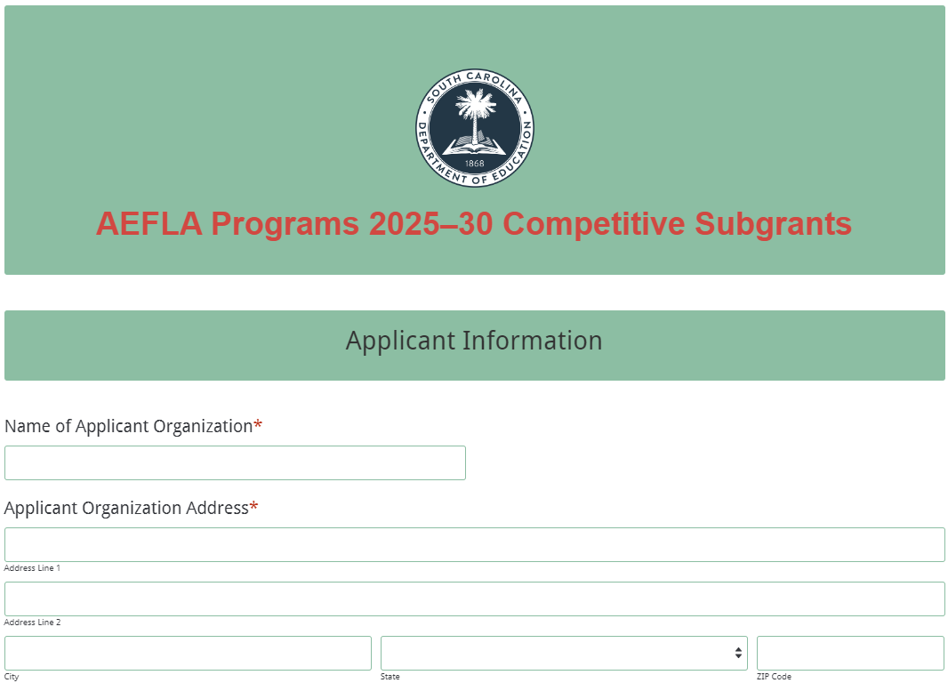
Enter the official name of the applicant organization and the applicant organization’s physical address with the full ZIP Code (ZIP+4).

Indicate if the organization has received AEFLA funds in the past from the SCDE. If you received funds in the past, enter the last year you received funds. Select the organization’s type.
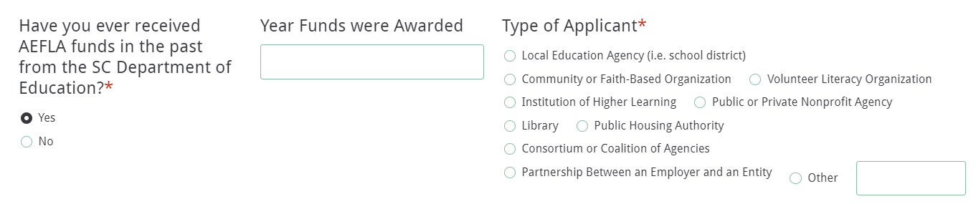
Provide the organization’s phone number, Web site address, UEI, and tax identification number (TIN). Select all of the programs for which the applicant organization is applying (i.e., Adult Education, Corrections Education, Family Literacy, IEL/CE). Be sure this information is correct as the applicant will get access to application forms for only the programs selected. Note: an applicant must apply for the Adult Education subgrant to be eligible to apply for the Family Literacy and/or IEL/CE subgrants.
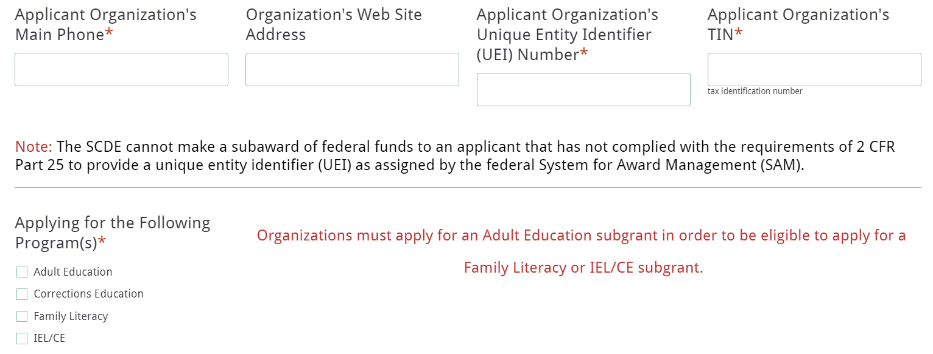
An applicant must demonstrate past effectiveness by providing performance data on its record of improving the skills of eligible individuals, particularly eligible individuals who have low levels of literacy, in the content domains of reading, writing, mathematics, and ELA. Answer the questions as indicated in the screenshot below. Note: Applicants that are unable to provide evidence of their demonstrated effectiveness in providing adult education and literacy activities will not be considered for funding.
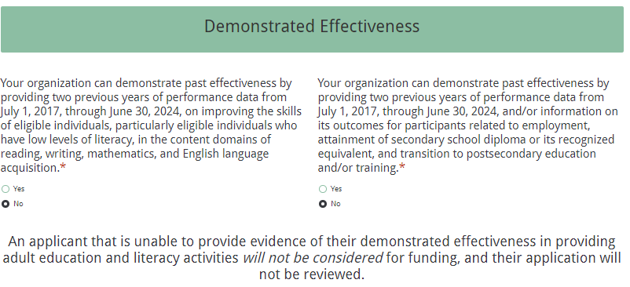

Enter the name, title, and contact information for the authorized official who has the authority to enter into legally binding contractual agreements on behalf of the applicant entity. The name, as entered, must match the authorized official’s name on the Certification Signature Page. The authorized official’s email address must be entered twice as this person will receive the email confirmation of submission.
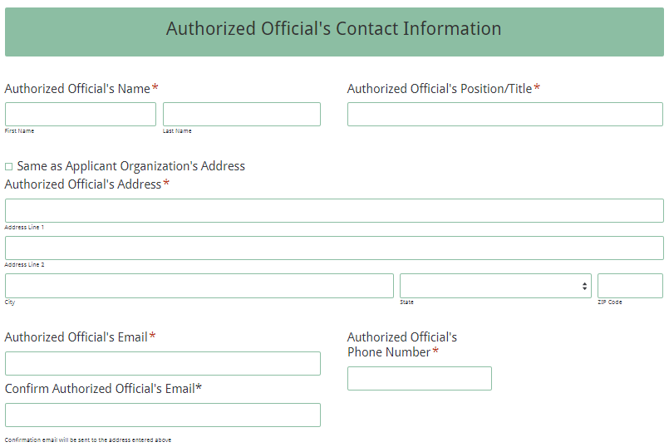
Based on the subgrant program(s) the applicant selected in response to “Applying for the Following Programs” section (see screenshot on page 54), begin completing the specific subgrant program (i.e., Adult Education, Corrections Education, Family Literacy, and/or IEL/CE) information requested. If you did not complete that section correctly for the program(s) your organization is proposing to apply, click the “Previous” button at the bottom of the screen until you return to that form entry field and select the appropriate programs.

The following screenshots are guides for compiling information to complete the remaining sections of the main application form as applicable to the organization’s proposed programs:
- Adult Education screenshots—pages 55–58
- Corrections Education screenshots—pages 59–62
- Family Literacy screenshots—pages 62–64
- IEL/CE screenshots—pages 64–67.

Adult Education Section of Main Application Form
Enter the official name of the applicant organization for the Adult Education Program. If the applicant organization is the same as entered in the Main Application form, click the box “Same as Applicant Organization Name.”
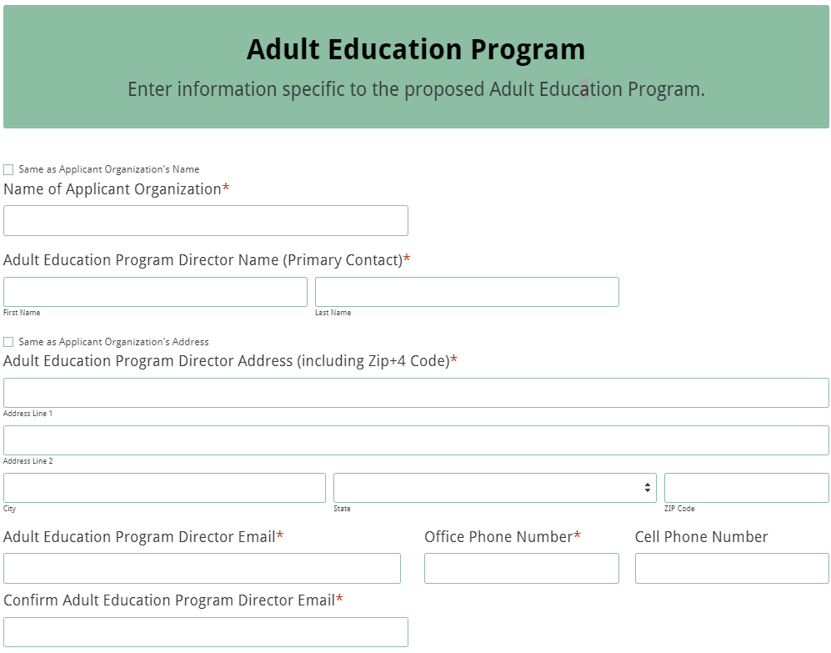

Enter the name and contact information for the Adult Education Program Director. This person will serve as the primary contact for the organization’s Adult Education Subgrant Program. If the program director’s address is the same as the applicant organization’s address, click the check box to auto-populate the fields.

Enter the name and contact information for the Adult Education Secondary Contact person. This person will serve as the backup contact for the organization’s Adult Education subgrant program.
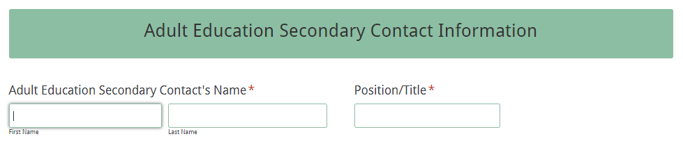
If the secondary contact’s address is the same as the applicant organization’s address, click the check box to auto-populate the fields.
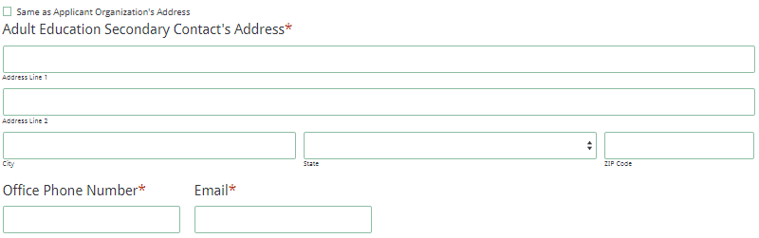
Answer the question about the organization providing access to Adult Education and Literacy and Integrated Education and Training. If you are not providing these services, you will not be able to proceed and will be reminded that the organization must include those services in order to be considered for funding.
Answer the question about English Language Acquisition (ELA) activities as well.
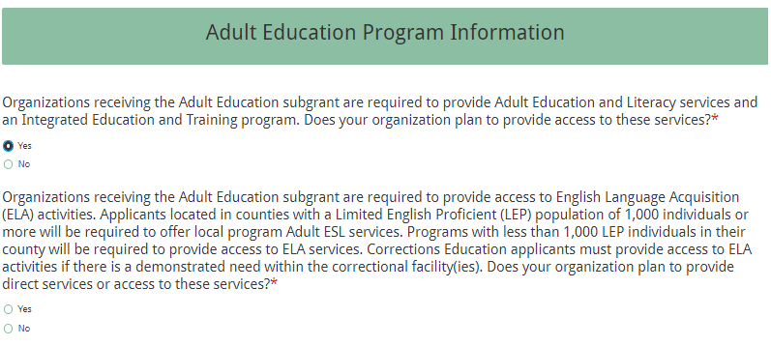

If the organization is proposing to provide the required services and selected “yes,” then select the additional activities and services the program will provide. Enter the total number of staff (both full and part-time) that this subgrant will cover. Check the counties to be served.
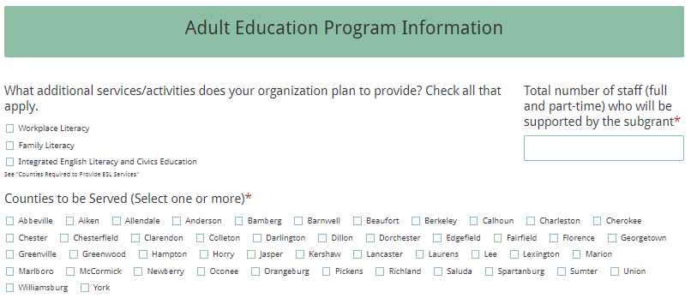
Indicate which LWDB(s) is associated with your proposed Adult Education program.
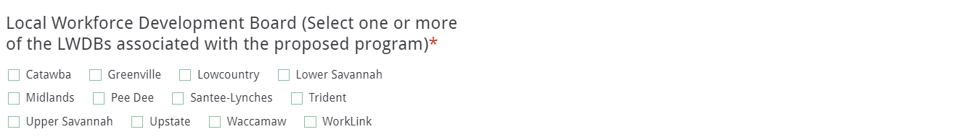

In the budget summary section, enter the line item totals for subgrant funds requested for year one and enter the total estimated in-kind or matching funds for the first year.
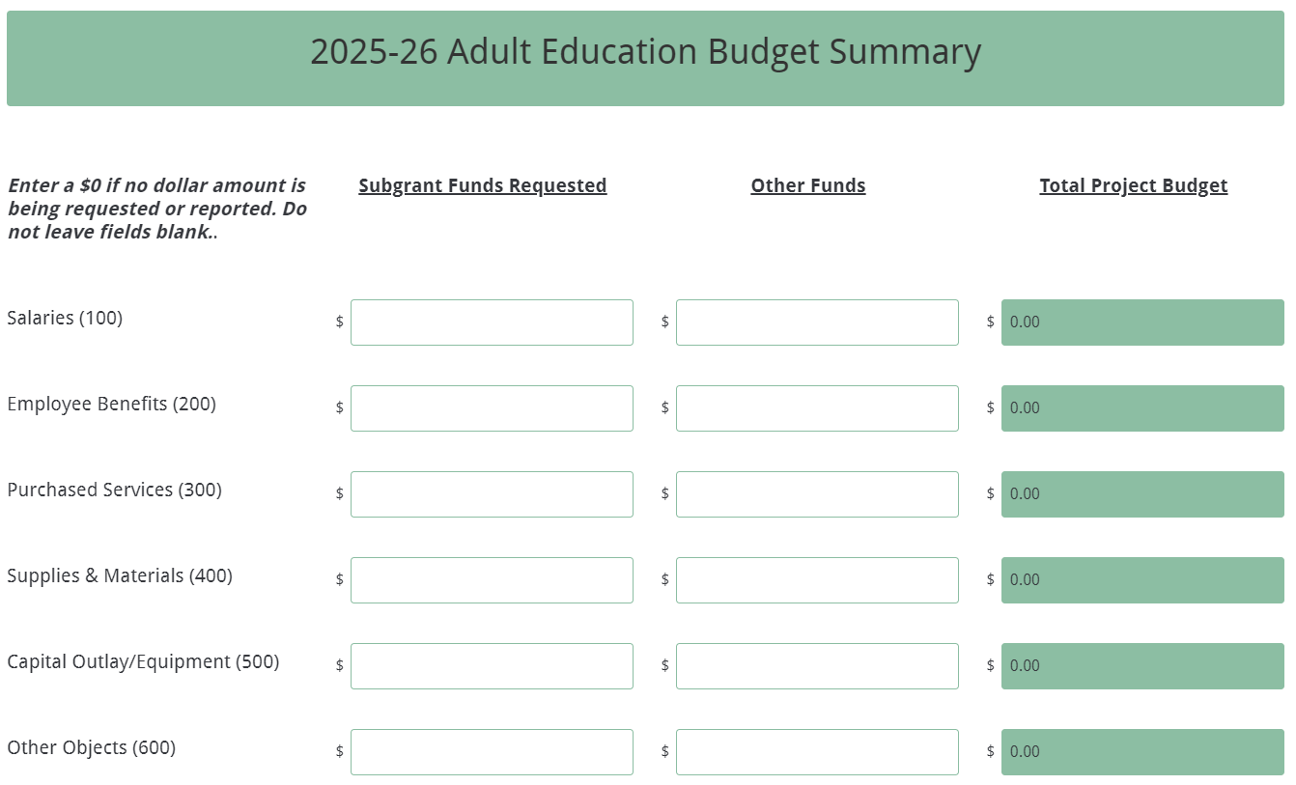

The Total Project Costs fields for each column and the Total Project Budget fields for each line item will automatically calculate. Enter the applicant organization’s indirect cost rate percentage approved by the cognizant agency.
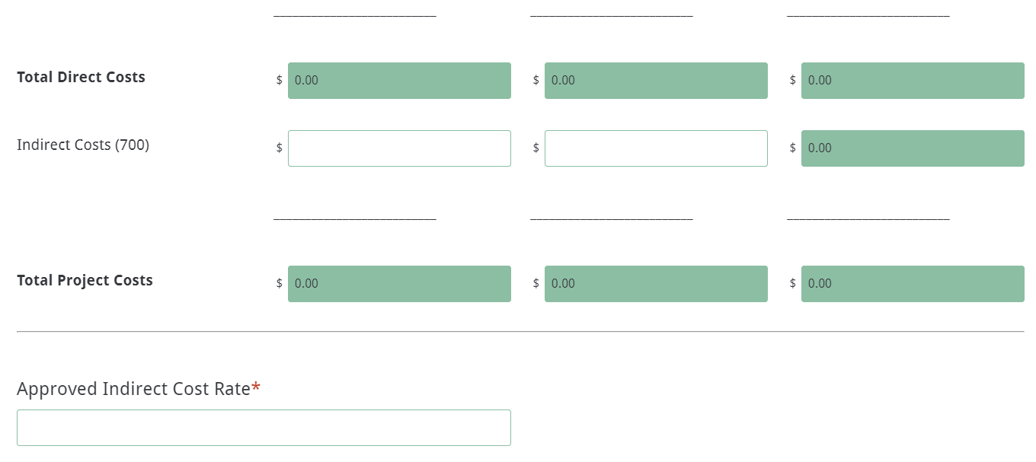
If the applicant is only applying for an Adult Education subgrant, to complete this submission see pages 67–69 for details on reviewing the Main Application Attachments and Data Review and Confirmation page. Select “submit” when ready and select the hyperlink for Adult Education on the onscreen confirmation form to proceed to the Adult Education Attachments form (see screenshots of this form on pages 71–72).

If the applicant is proposing other subgrant programs, click the next button to continue to the next subgrant program based on the selections made at the beginning of the online form.

Corrections Education Section of Main Application Form
Enter the official name of the applicant organization for the Corrections Education Program. If the applicant organization is the same as entered in the Main Application form, click the box “Same as Applicant Organization Name.” If the program director’s address is the same as the applicant organization’s address, click the check box to auto-populate the fields.

Enter the name and contact information for the Corrections Education Program Director. This person will serve as the primary contact for the organization’s proposed Corrections Education subgrant program.
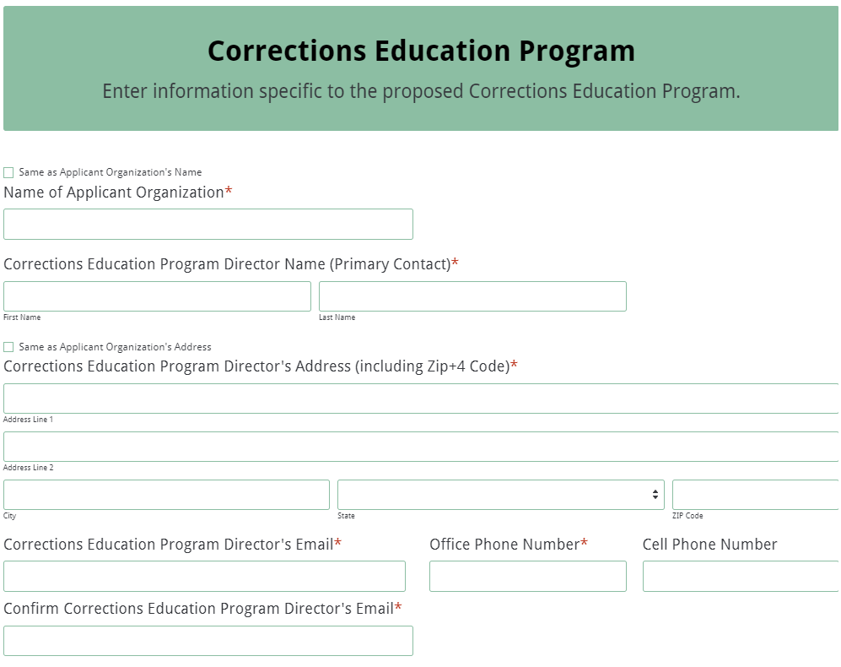

Enter the name and contact information for the Corrections Education Secondary Contact person. This person will serve as the backup contact for the organization’s Corrections Education program. If the secondary contact’s address is the same as the applicant organization’s address, click the check box to auto-populate the fields.
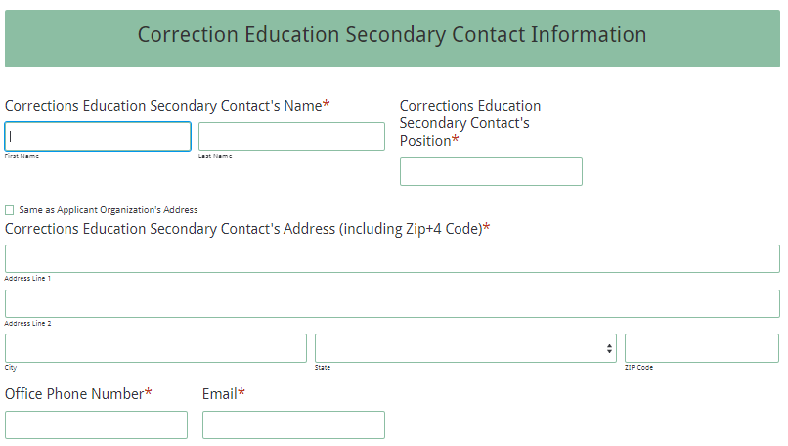
Respond to the question about the organization providing access to Adult Education and Literacy and a Career Pathways program. If you are not providing these services, you will not be able to proceed and will be reminded that the organization must include those services in order to be considered for funding.
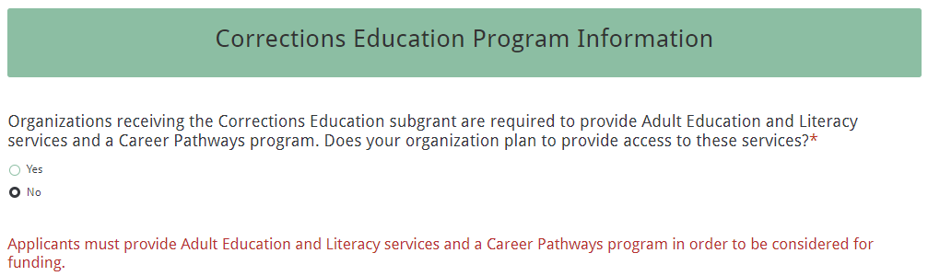
If the organization is proposing to provide the required services and selected “yes,” then select the additional activities and services the program will provide. Enter the total number of staff (both full and part-time) that this subgrant will cover.
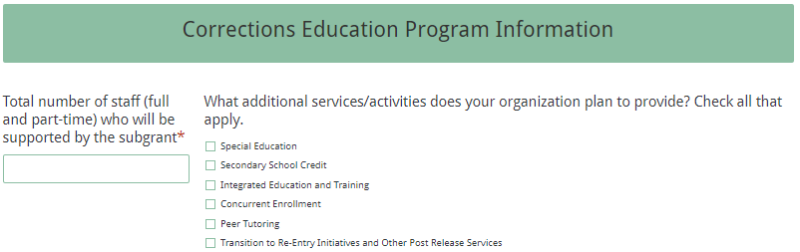
Check the counties to be served. Indicate which LWDB(s) is associated with your proposed Corrections Education program.
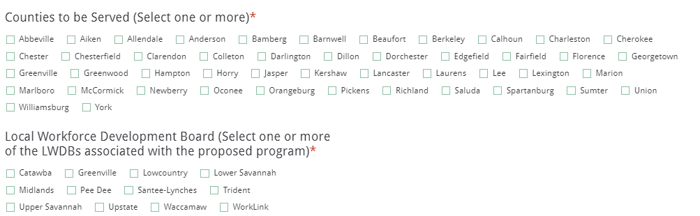

Enter the line item totals for subgrant funds requested for year one, as well as the total estimated in-kind or matching funds for the first year.
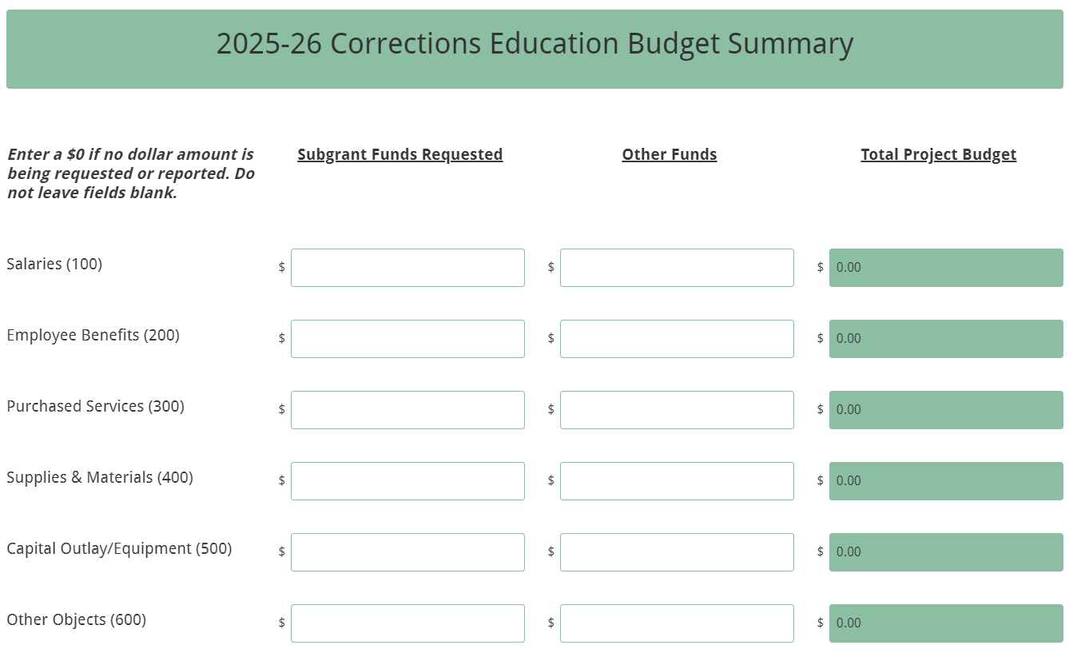

The Total Project Costs fields for each column and the Total Project Budget fields for each line item will automatically calculate. Enter the applicant organization’s indirect cost rate percentage approved by the cognizant agency.
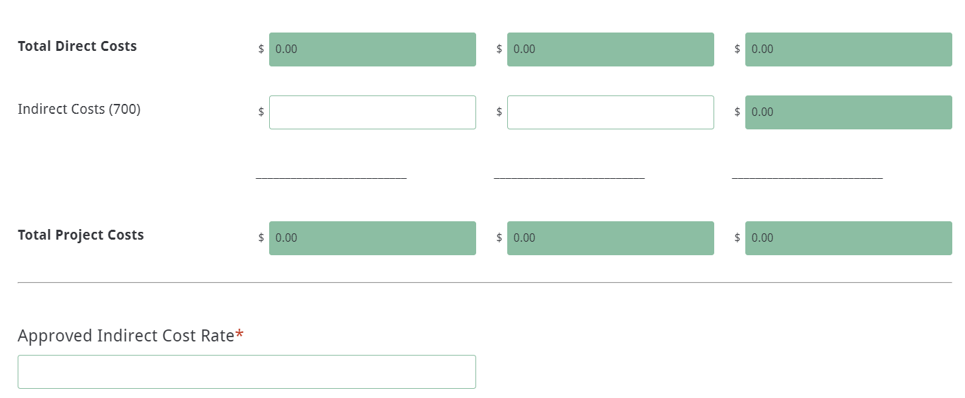
If the applicant is only applying for a Corrections Education subgrant, complete this submission (see pages 69–71 for reviewing the Data Review and Confirmation page) and select the hyperlink for Corrections Education on the onscreen confirmation form to proceed to the Corrections Education Attachments form (see form screenshots beginning on page 72).

If the applicant is applying for other subgrant programs, click the next button to the next subgrant program based on the selections made at the beginning of the online form.

Family Literacy Section of Main Application Form
Enter the official name of the applicant organization for the Family Literacy Program. Click the “Same as Applicant Organization’s Name” for the applicant organization’s name to auto-populate. Enter the name and contact information for the Family Literacy Program Director. This person will serve as the primary contact for the organization’s Family Literacy Subgrant Program.
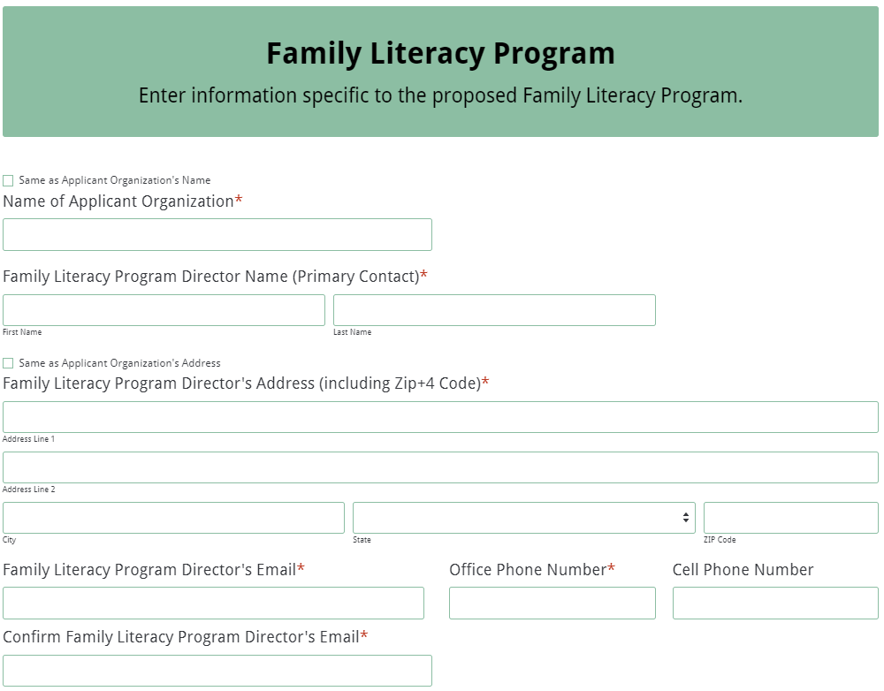

If the program director’s address is the same as the applicant organization’s address, click the check box to auto-populate the fields.

Enter the name and contact information for the Family Literacy Secondary Contact person. This person will serve as the backup contact for the organization’s Family Literacy subgrant program.
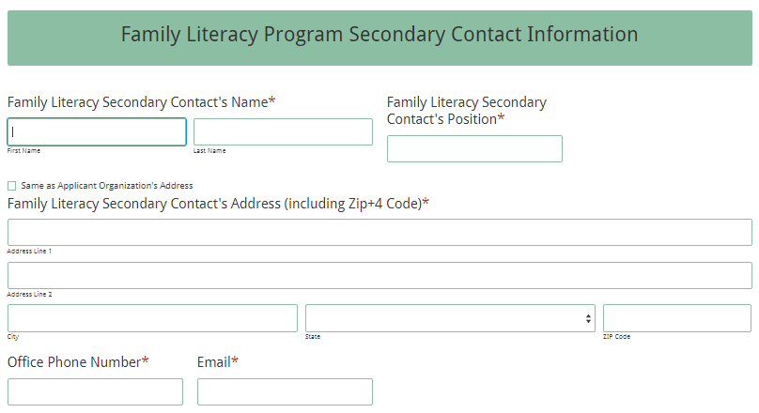

Enter the total number of staff (both full and part-time) that this subgrant will cover.
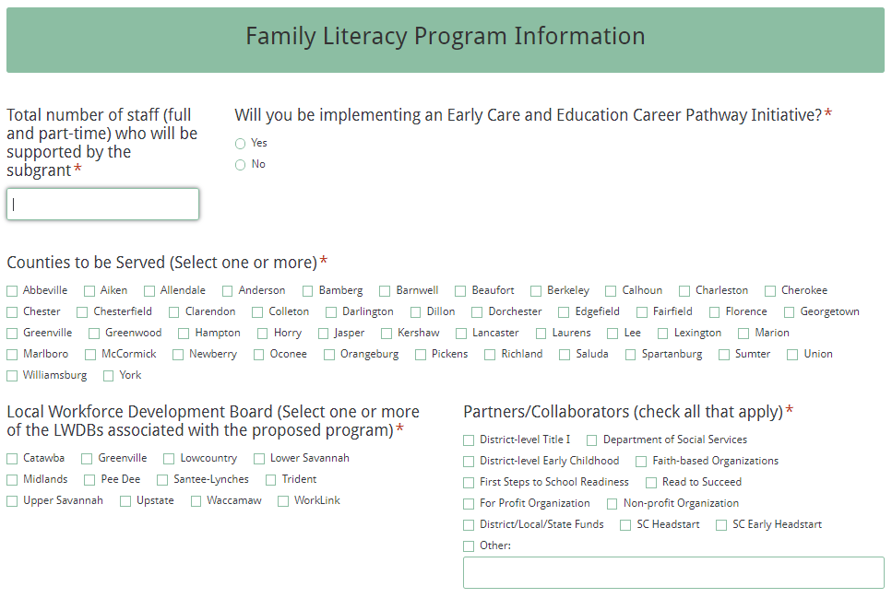

Check the counties to be served, indicate which LWDB(s) is associated with the proposed Family Literacy program, and select all types of Partners/Collaborators for the program.

Enter the line item totals for subgrant funds requested for year one, as well as the total estimated in-kind or matching funds for the first year.
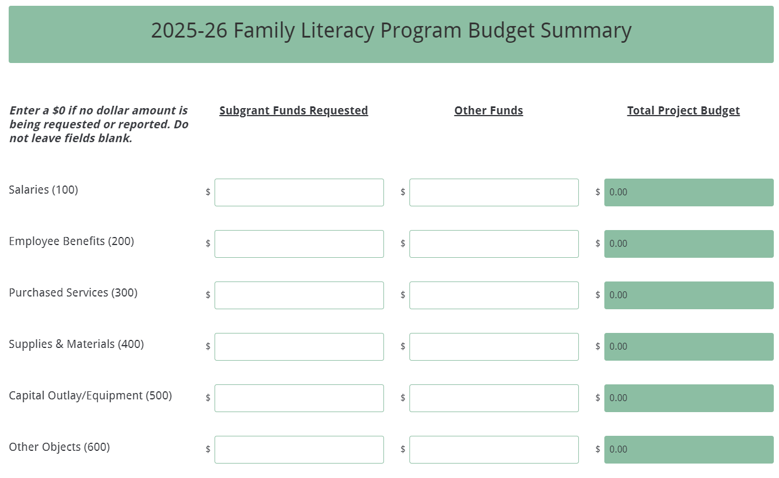
The Total Project Costs fields for each column and the Total Project Budget fields for each line item will automatically calculate. Enter the applicant organization’s indirect cost rate percentage approved by the cognizant agency.
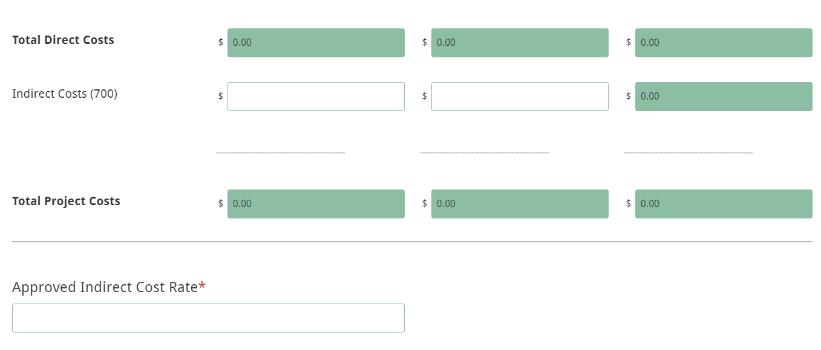
If the applicant is applying for another subgrant program, click the next button to the next subgrant program based on the selections made at the beginning of the online form. Continue to enter the information requested based on the instructions provided on the next pages.

If the applicant has completed the Family Literacy section and is not applying for an additional subgrant, complete this submission by reviewing the Data Review and Confirmation page (see pages 69–71) and select the hyperlink for Family Literacy on the onscreen confirmation to proceed to the Family Literacy Attachments form (see form screenshots starting on page 73).

IEL/CE Section of Main Application Form
Enter the official name of the applicant organization for the IEL/CE Program. If the applicant organization is the same as entered in the Main Application form, click the box “Same as Applicant Organization Name.” Enter the name and contact information for the IEL/CE Program Director. This person will serve as the primary contact for the organization’s IEL/CE subgrant program. If the program director’s address is the same as the applicant organization’s address, click the check box to auto-populate the fields.
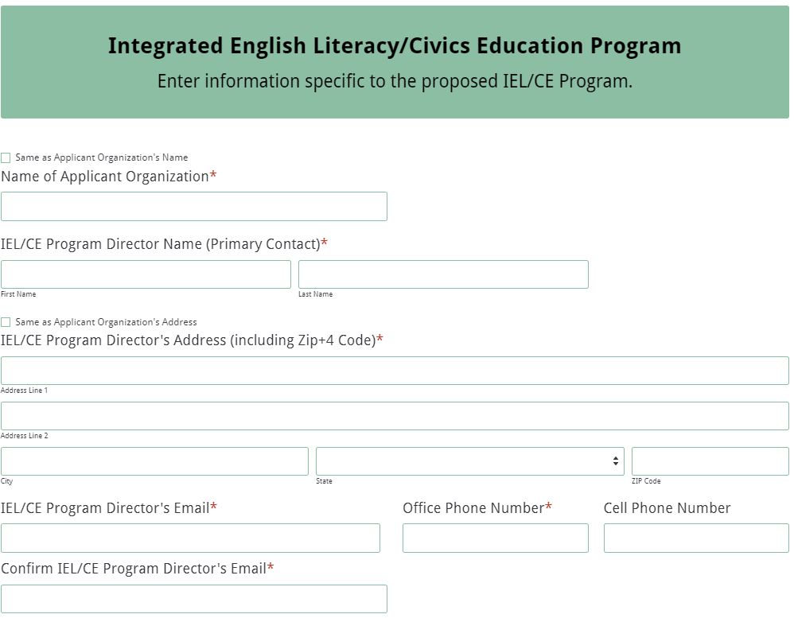

Enter the name and contact information for the IEL/CE Secondary Contact person. This person will serve as the backup contact for the organization’s IEL/CE subgrant program.
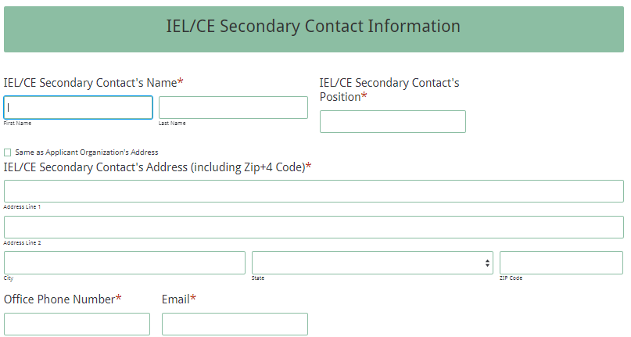
Answer the question about the organization providing access to Integrated Education and Training, Integrated English Literacy and Civics Education, English Language Acquisition, and Workforce Preparation services. If the organization selects “no,” you will not be able to proceed as the organization must include those services in order to be considered for funding.
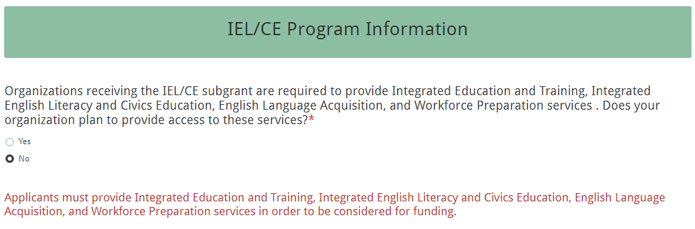

If the organization is proposing to provide the required services and selects “yes,” next select the additional activities and services the program will provide. Enter the total number of staff (both full and part-time) that this subgrant will cover. Check the counties to be served. Indicate which LWDB(s) is associated with your proposed IEL/CE program.
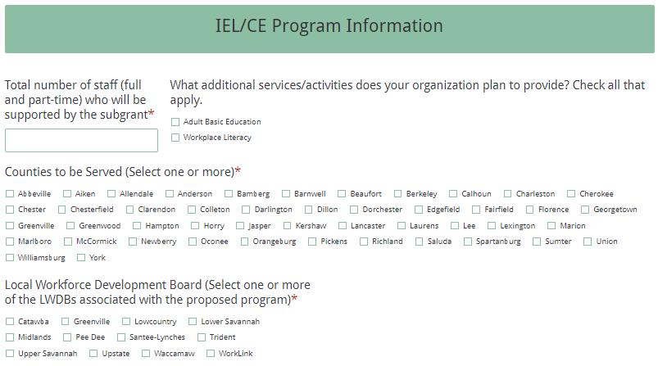

Enter the line item totals for subgrant funds requested for year one, as well as the total estimated in-kind or matching funds for the first year.
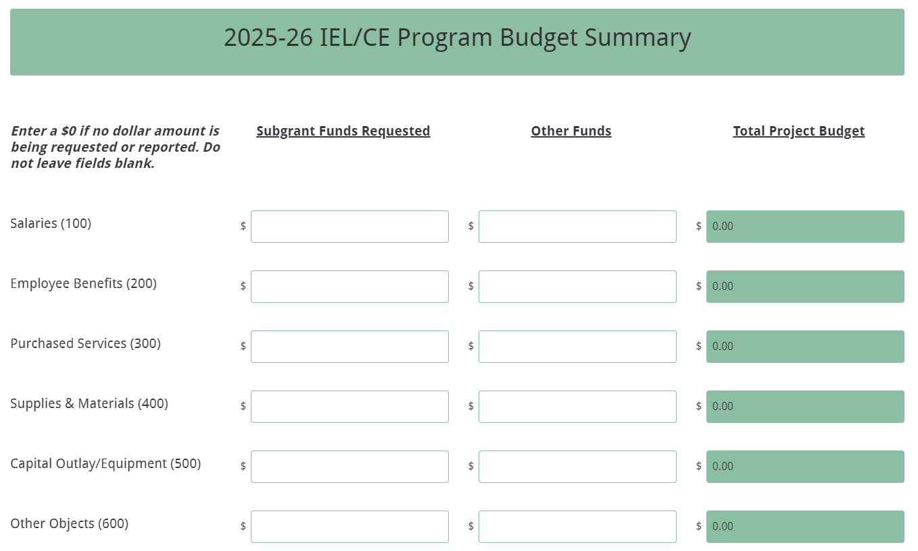

The Total Project Costs fields for each column and the Total Project Budget fields for each line item will automatically calculate. Enter the applicant organization’s indirect cost rate percentage approved by the cognizant agency.
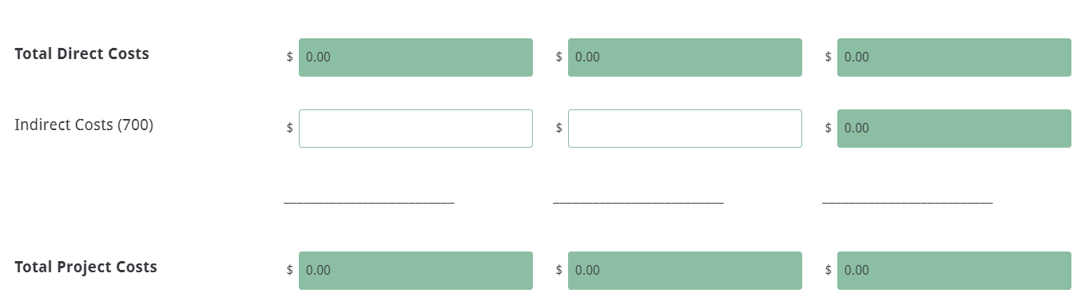

Click the next button to proceed to complete this submission (see next section, especially the Data Review and Confirmation page information) and select the appropriate hyperlinks on the onscreen confirmation form to proceed to the IEL/CE program-specific attachments form (see the screenshots of this form beginning on page 75).

Main Application Attachments and Data Review and Confirmation Pages
The last section of the Main Application form is the Application Attachments. Prepare each attachment (i.e., the Demonstrated Effectiveness Documentation, Request for Tax ID Number, the Pre-Award Audit Questionnaire, Policies to Accommodate Students and Staff with Disabilities, and the Indirect Cost Rate Agreement, if applicable) as directed on pages 47–48. Ensure that each attachment is saved as a PDF document. The online application form will only allow one document to be uploaded for each attachment.

Upload the attachments where indicated in the following screenshot. All attachments except the Indirect Cost Rate Agreement are required. The agreement is not required for LEA applicants and applicants that do not elect to take indirect costs.
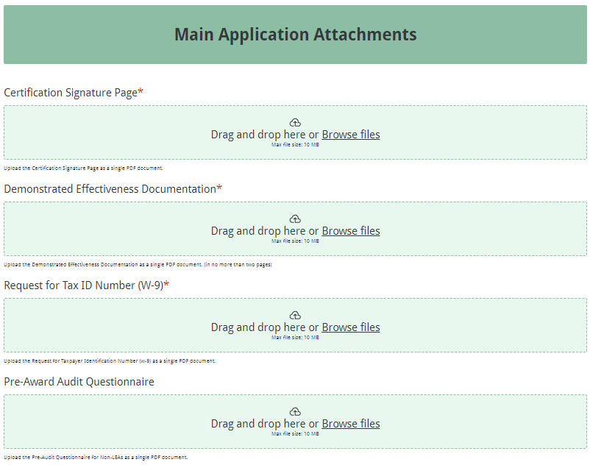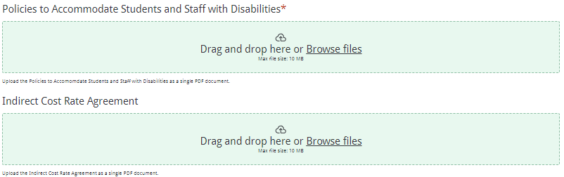

Note: LEAs are not required to complete the Pre-Award Questionnaire or the Request for Tax ID Number. LEAs also are not required to submit their indirect cost rate agreement. These fields will not show in the Main Application Attachments for LEAs (see screenshot below).
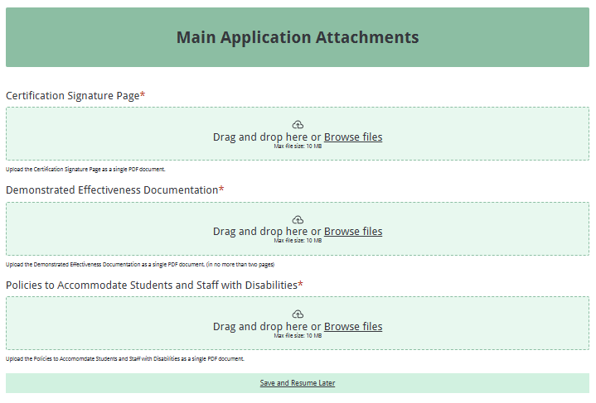
Thoroughly review the summary on the Data Review and Confirmation Page to verify that the information has been entered correctly in the online application form prior to submitting.
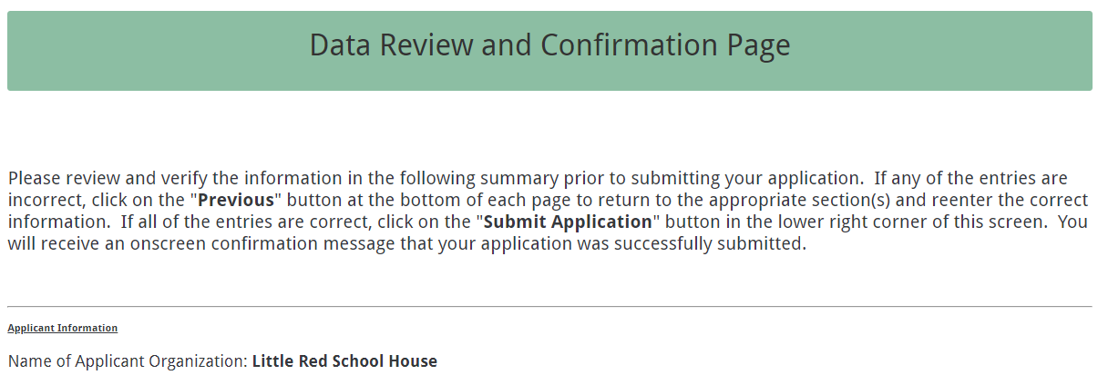
You will not be able to access the completed application form after it has been submitted. If any of the entries are incorrect, click on the "Previous" button at the bottom of each screen to return to the appropriate section(s) and reenter the correct information.
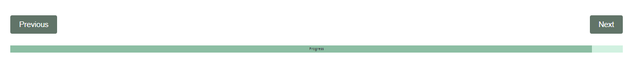

If all entries are correct, click on the “Submit Form” button in the lower right corner of this screen to complete the submission process.
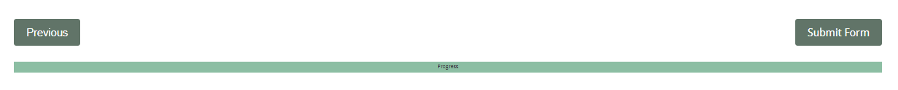
Once the application is submitted, the following message will be displayed on the screen with links to the program-specific attachments.
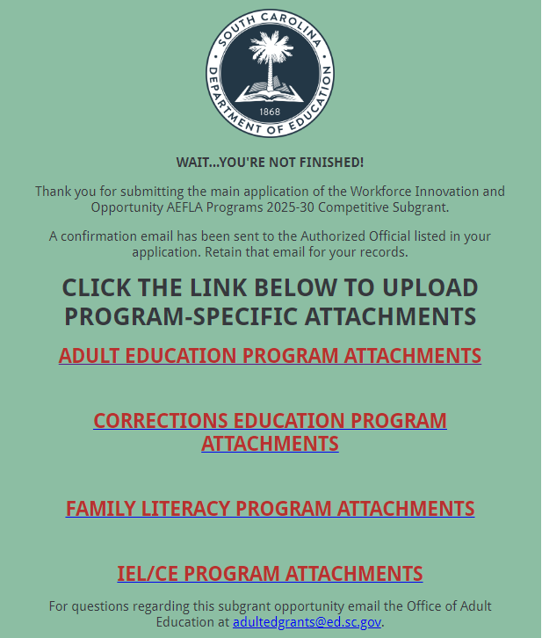

The following submission confirmation will be sent to the email address provided for the authorized official in the online application.
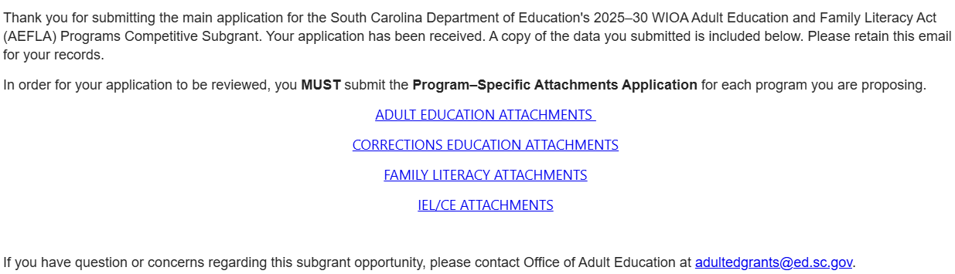

If the authorized official does not receive a confirmation email, then the application organization did not successfully upload. You must go back and resubmit the entire online form, including all attachments, in order for your program application(s) to be considered for funding. Only the most recently submitted, complete online application will be reviewed.

An email confirmation that an application was successfully submitted does not account for the quality of the uploaded documents or the completeness of the online form. The confirmation email only notifies you that the online application has been submitted. Applicants are responsible for ensuring that the information entered in the online form, including all attachments, is accurate and complete in order for the program application(s) to be reviewed and considered for funding.

Screenshots of the Program-Specific Attachment Forms
Prepare the specific program attachments (i.e., the Program Abstract, the Application Narrative, the Budget Planning Form and Budget Narrative, and the Appendices) following the preceding instructions in this RFP for each subgrant program being proposed. Ensure that each attachment is saved in the proper format as either a PDF or Excel document. Pay close attention to attachments that must be scanned together into a single document. Use the following program-specific screenshots as a guide for submitting the required attachments form(s).

Adult Education Attachments Form
Enter the Applicants Organization’s name and the Authorized Official’s email address.
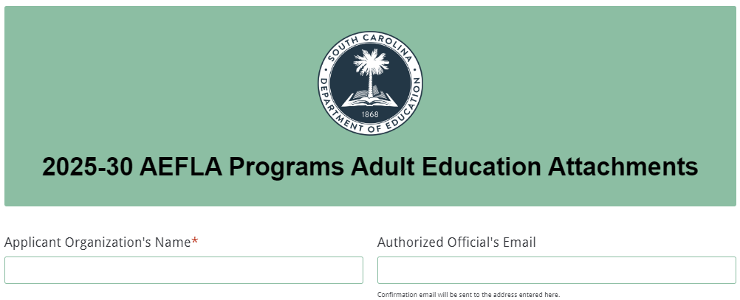

Upload the attachments where indicated in the following screenshot. The Adult Education Attachments consist of the Program Abstract, Application Narrative, Budget Planning Form and Budget Narrative, and the Appendices. Follow the directions on pages 49–51 to prepare and save the documents in the appropriate format. The online application will only allow one document to be uploaded for each attachment. All attachments are required; you will not be able to submit the application without uploading all four documents.
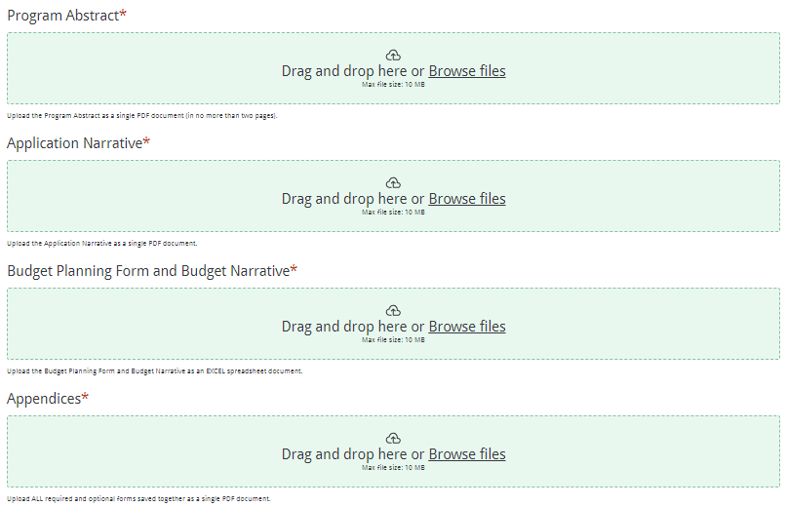

After clicking submit form, follow the instructions on pages 76–77 to complete your submission or enter other program-specific attachment forms.

Corrections Education Attachments Form
Enter the Applicants Organization’s name and the Authorized Official’s email address.
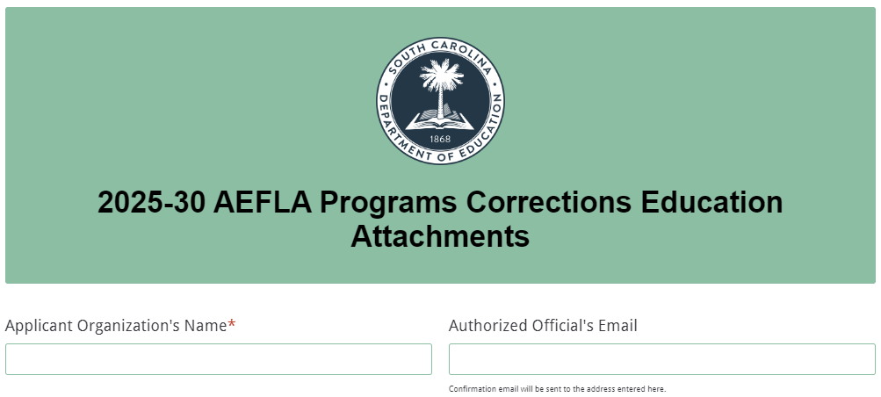

Upload the attachments where indicated in the following screenshot. The Corrections Education Attachments consist of the Program Abstract, Application Narrative, Budget Planning Form and Budget Narrative, and the Appendices. Follow the directions beginning on page 49 to prepare and save the documents in the appropriate format. The online application will only allow one document to be uploaded for each attachment. All attachments are required; you will not be able to submit the application without uploading all four documents.

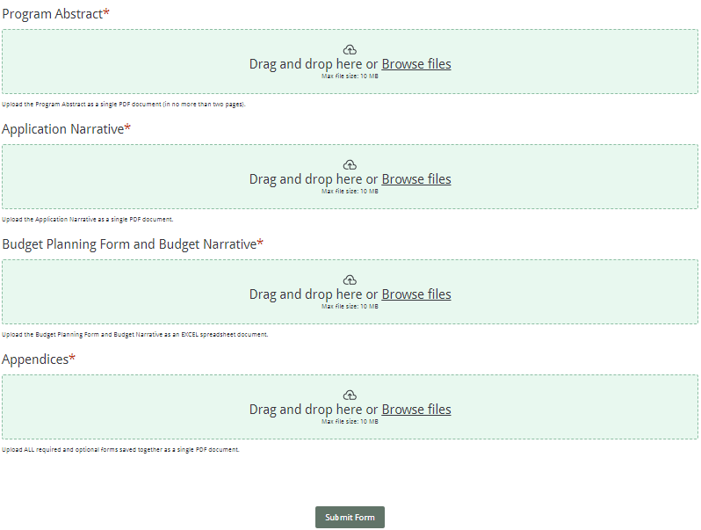
After clicking submit form, follow the instructions on pages 76–77 to complete your submission or enter other program-specific attachment forms.

Family Literacy Attachments Form
Enter the Applicants Organization’s name and the Authorized Official’s email address.
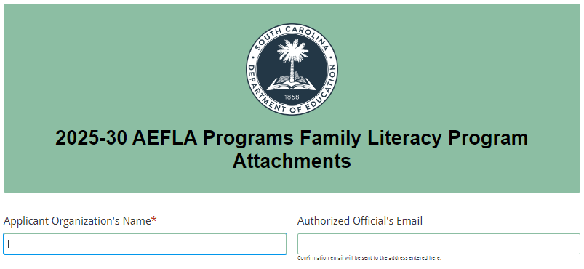
Upload the attachments where indicated in the following screenshot. The Family Literacy attachments consist of the Program Abstract, Application Narrative, Budget Planning Form and Budget Narrative, Four Component Family Literacy Program Information, Early Care and Education Career Pathway Program Information, and Appendices. Follow the directions beginning on page 49 to prepare and save the documents in the appropriate format.

The online application will only allow one document to be uploaded for each attachment. Attachments marked with an asterisk are required; you will not be able to submit the application without uploading all required attachments.

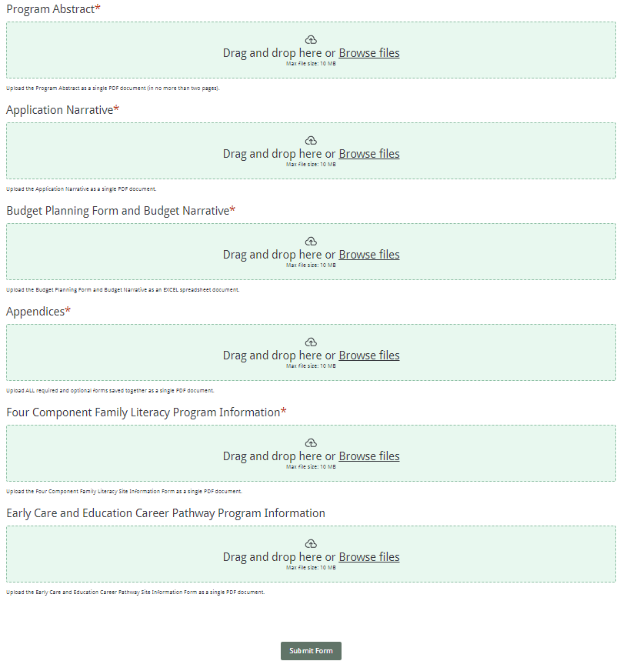
After clicking submit, follow the instructions on pages 76–77 to complete your submission or enter other program-specific attachment forms.

IEL/CE Attachments Form
Enter the Applicants Organization’s name and the Authorized Official’s email address.
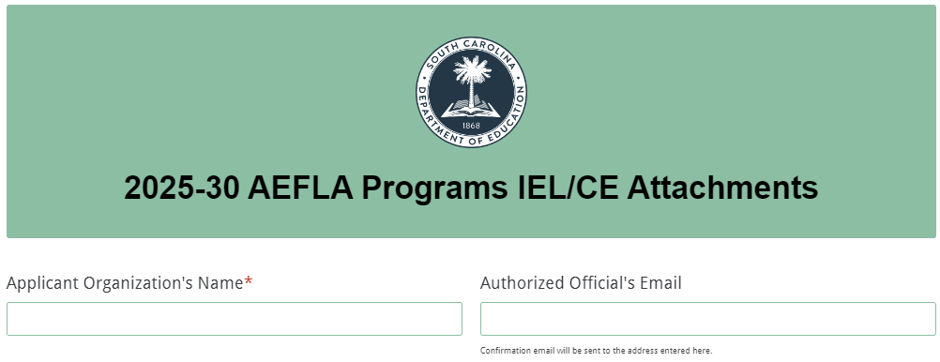

Upload the attachments where indicated in the following screenshot. The IEL/CE Attachments consist of the Program Abstract, Application Narrative, Budget Planning Form and Budget Narrative, and the Appendices. Follow the directions beginning on page 49 to prepare and save the documents in the appropriate format. The online application will only allow one document to be uploaded for each attachment. All attachments are required; you will not be able to submit the application without uploading all four documents.
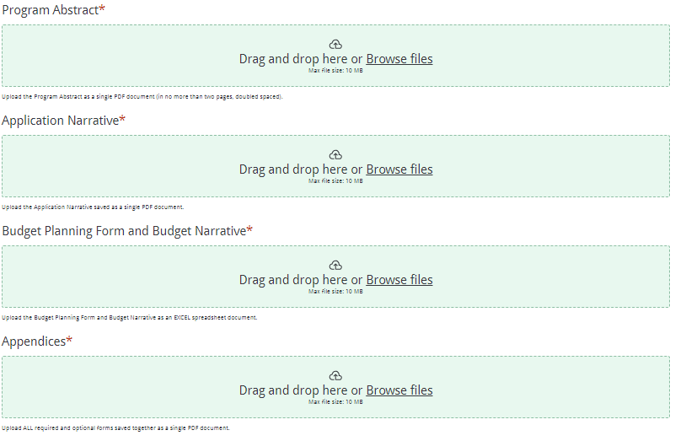

After clicking submit form, follow the instructions below to complete your submission or enter other program-specific attachment forms.
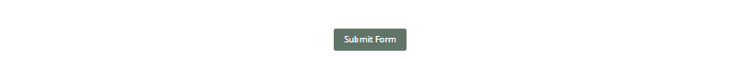

Submission of Program-Specific Attachments Form(s)
Once the application is submitted, the following message will be displayed on the screen. Hyperlinks to the program-specifics attachments forms are provided to allow you to continue to enter the other program-specific attachment forms for the subgrant programs your organization is proposing.
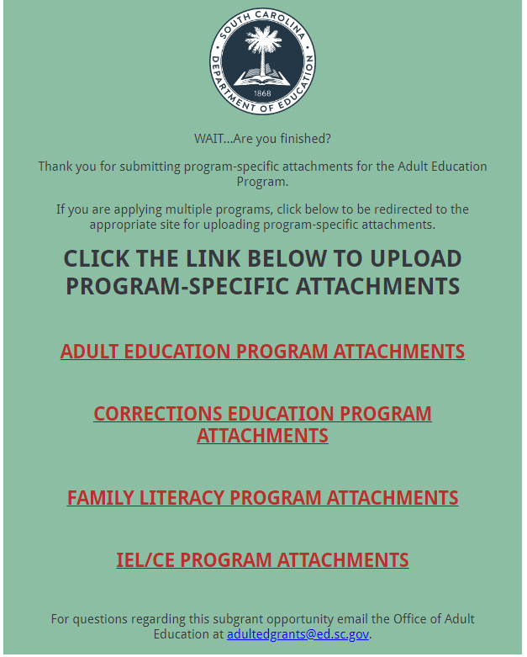

The following submission confirmation will be sent to the email address provided for the authorized official in the online application.
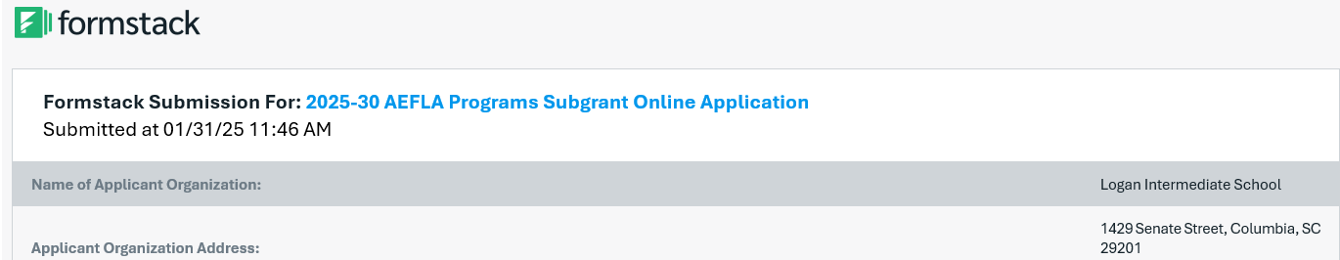

If the authorized official does not receive a confirmation email, then the application organization did not successfully upload. You must go back and resubmit the entire online form, including all attachments, in order for your program application(s) to be considered for funding. Only the most recently submitted online application will be reviewed.

An email confirmation that an application was successfully submitted does not account for the quality of the uploaded documents or the completeness of the online form. The confirmation e-mail only notifies you that the online application has been submitted. Applicants are responsible for ensuring that the information entered in the online form, including all attachments, is accurate and complete in order for the program application(s) to be reviewed and considered for funding.

Appendix A: Definitions of Terms Used

Administrative Costs—Costs incurred in connection with the following activities:
      - Planning;
      - Administration, including carrying out performance accountability requirements;
      - Professional development;
      - Providing adult education and literacy services in alignment with local workforce plans, including promoting co-enrollment in programs and activities under title I, as appropriate; and
      - Carrying out the one-stop partner responsibilities described in 20 CFR Part 678.420, including contributing to the infrastructure costs of the one-stop delivery system.
(Authority: 29 U.S.C. 3323, 3322, 3151)

Adult Basic Education (ABE)—A program of instruction designed for adults who lack competence in reading, writing, speaking, problem solving, or computation at a level necessary to function in society, on a job, or in the family. ABE includes curriculum and instruction to help students progress within educational functioning levels, as determined by Tests of Adult Basic Education (TABE) or WorkKeys (Applied Math and Workplace Documents only) and/or to obtain a high school diploma or its equivalent.

Adult Education—Academic instruction and education services below the postsecondary level that increase an individual’s ability to:
    - read, write, and speak in English and perform mathematics or other activities necessary for the attainment of a secondary school diploma or its recognized equivalent;
    - transition to postsecondary education and training; and
    - obtain employment.

Adult Education and Literacy Activities—Programs, activities, and services that include adult education, literacy, workplace adult education and literacy activities, family literacy activities, English language acquisition activities, integrated English literacy and civics education, workforce preparation activities, or integrated education and training

Americans with Disabilities Act of 1990 (ADA)—An Act that prohibits discrimination and ensures equal opportunity for persons with disabilities in employment, state and local government services, public accommodations, commercial facilities, and transportation. It also mandates the establishment of TDD/telephone relay services. The ADA is codified at 42 U.S.C. 12101 et seq. On July 15, 2016, the Final Rule was signed revising the ADA title II and III regulations to implement the requirements of the ADA Amendments Act of 2008. The Final Rule was published in the Federal Register on August 11, 2016, and took effect on October 11, 2016. Congress enacted the ADA Amendments Act to make a number of significant changes to the meaning and interpretation of the ADA definition of “disability” to ensure that the definition of disability would be broadly construed and applied without extensive analysis. Additional information about the ADA can be accessed at the U.S. Department of Justice’s Americans with Disabilities website.

Applicant—The entity or organization that meets the definition of eligible provider (see below) and is therefore eligible to apply for funds offered under this RFP. If the application is approved, the “applicant” becomes a subgrantee.

At-Risk Student—Any student who, because of his or her individual needs, requires temporary or ongoing interventions in order to achieve in school and to graduate with meaningful options for their future.

Family Literacy At-Risk Factors
Eligible for free school lunch (103% of federal poverty level or below) | Experience instability and inadequate basic capacity within the home and/or family | Eligibility for the Supplemental Nutrition Assistance Program (SNAP)
Demonstrate significant developmental delays | Inadequate access to needed family services | Poor health (physical, mental, emotional)
Child abuse and neglect | Child is in foster care | Incarcerated parent
Inadequate parenting skills/practices | Teen parent | Limited English proficiency
Poverty | Free or reduced-price school lunch | Temporary Assistance for Needy Families (TANF) for families at 50 percent of the poverty level

Basic Skills Deficient—The term ‘‘basic skills deficient’’ means, with respect to an individual— (A) who is a youth, that the individual has English reading, writing, or computing skills at or below the 8th grade level on a generally accepted standardized test; or (B) who is a youth or adult, that the individual is unable to compute or solve problems, or read, write, or speak English, at a level necessary to function on the job, in the individual’s family, or in society.

Career Pathway—A career pathway is a combination of rigorous and high-quality education, training, and other services that—
    - aligns with the skill needs of industries in the economy of the state or regional economy involved;
    - prepares an individual to be successful in any of a full range of secondary or postsecondary education options, including apprenticeships registered under the Act of August 16, 1937 (commonly known as the National Apprenticeship Act; 50 Stat. 664, chapter 663; 29 U.S.C. 50 et seq.) (referred to individually in this Act as an ‘‘apprenticeship,’’ except in section 171);
    - includes counseling to support an individual in achieving the individual’s education and career goals;
    - includes, as appropriate, education offered concurrently with and in the same context as workforce preparation activities and training for a specific occupation or occupational cluster;
    - organizes education, training, and other services to meet the particular needs of an individual in a manner that accelerates the educational and career advancement of the individual to the extent practicable;
    - enables an individual to attain a secondary school diploma or its recognized equivalent, and at least one recognized postsecondary credential; and
    - helps an individual enter or advance within a specific occupation or occupational cluster.

Cognizant Agency—The entity responsible for negotiating indirect cost rate proposals with applicant organizations. The SCDE serves as the cognizant agency for all public school districts in South Carolina.

Collaborative Partner—An organization that provides routine, regular, and ongoing services to the project as outlined in a signed memorandum of agreement (e.g., the regular use of facilities and equipment, mentors/tutors). A collaborative partner plays a critical role in sustaining the project.

Core Program/Partner—A program/partner authorized under a core program provision. The WIOA Core Programs include:
- WIOA Title I: the programs authorized under and administered by the South Carolina Department of Employment and Workforce (SCDEW):
  - Adult
  - Dislocated Worker
  - Youth
- WIOA Title II: the AEFLA program, authorized under the and administered by the OAE;
- WIOA Title III: the Employment Service program authorized under the Wagner-Peyser Act, as administered by the SCDEW; and
- WIOA Title IV: the Vocational Rehabilitation program authorized under Title I of the Rehabilitation Act of 1973, as amended by the and administered by the:
  - South Carolina Vocational Rehabilitation Department
  - South Carolina Commission for the Blind

Core Program/Partner Concurrent enrollment or co-enrollment—Enrollment by an eligible individual in two or more of the six core programs administered under the WIOA. See definition of Core Program/Partner above.

Contextualized Instruction—A set of teaching, learning and assessment practices that are aimed directly at developing the skills and knowledge that adults need to deal with specific situations or perform specific tasks, and that they have identified as important and meaningful to themselves “right now” in their everyday lives. In addition to focusing on the possession of basic skills and knowledge, contextualized instruction focuses on the active application of those skills and that knowledge “in a context:” This context should be as “real-world” as is feasible.

Contextualized instruction is also an instructional strategy that integrates the teaching of literacy skills and job content to move learners more successfully and quickly toward their educational and employment goals.
Correctional Institution—The term “correctional institution” means any—
  - Prison;
  - Jail;
  - Reformatory;
  - Work farm;
  - Detention center;
  - Halfway house;
  - Community-based rehabilitation center; or
  - Any other similar institution designed for the confinement or rehabilitation of criminal offenders.

Criminal Offender—Any individual who is charged with or convicted of any criminal offense.

Demonstrated Effectiveness— For an organization to be eligible to apply for a subgrant under AEFLA, the organization must be able to demonstrate effectiveness in providing adult education and literacy activities. Demonstrated effectiveness is a requirement for an organization to be an eligible provider (i.e., eligible applicant) to receive AEFLA funds.
According to 34 CFR Part 463.24, an eligible provider must demonstrate past effectiveness by providing performance data on its record of improving the skills of eligible individuals, particularly eligible individuals who have low levels of literacy, in the content domains of reading, writing, mathematics, English language acquisition, and other subject areas relevant to the services contained in the State's application for funds. An eligible provider must also provide information regarding its outcomes for participants related to employment, attainment of secondary school diploma or its recognized equivalent, and transition to postsecondary education and training. There are two ways in which an eligible provider may meet these requirements:
(1) An eligible provider that has been funded under title II of the WIOA must provide performance data required under section 116 to demonstrate past effectiveness.
(2) An eligible provider that has not been previously funded under title II of the Act must provide performance data to demonstrate its past effectiveness in serving basic skills deficient eligible individuals, including evidence of its success in achieving outcomes listed above.
(Authority: 29 U.S.C. 3272(5))

Demonstrated effectiveness is not the same as past effectiveness, though the data used may be similar or the same. Demonstrated effectiveness is a requirement for an organization to be an eligible provider (i.e., eligible applicant) to receive AEFLA funds. Past effectiveness is a consideration for awarding AEFLA funding. See the definition for past effectiveness on page 86.

De-obligation—The downward adjustment of the obligations recorded in a subaward document. It is caused by factors such as (1) termination of part of the project, (2) reduction in material prices, (3) cost savings, or (4) correction of recorded amounts.

Digital Literacy—Skills associated with using technology to enable users to find, evaluate, organize, create, and communicate information.
Educational Functioning Level (EFL)—The levels at which students are placed based on their ability to perform literacy-related tasks in specific content areas. Each level describes a set of skills and competencies that students entering at that level can do in the areas of reading, writing, numeracy, speaking, listening, and functional and workplace areas. There are six levels for adult basic education (ABE), and six levels for English Second Language (ESL).

Educational Functioning Level (EFL) Gain—An educational functioning level gain can be demonstrated in one of three ways: pre-testing/post-testing; completion of a Carnegie credit; or enrollment in postsecondary after adult education program exit. See appendix D.

Eligible Agency—The sole entity or agency in a state or an outlying area responsible for administering or supervising policy for adult education and literacy activities in the state or outlying area, respectively, consistent with the law of the state or outlying area, respectively. In South Carolina, the SCDE Office of Adult Education is the eligible agency.

Eligible Individual—An individual who meets the following criteria:
- is at least eighteen (18) years of age unless there is local school board or school district superintendent approval;
- is not enrolled or required to be enrolled in secondary school under state law; and
- either—
- is basic skills deficient;
- does not have a secondary school diploma or its recognized equivalent, and has not achieved an equivalent level of education; or
- is an English Language Learner.

Eligible Provider—An organization that has demonstrated effectiveness in providing adult education and literacy activities that may include—
- a local educational agency (LEA; i.e., school district);
- a community-based organization or faith-based organization;
- a volunteer literacy organization;
- an institution of higher education;
- a public or private nonprofit agency;
- a library;
- a public housing authority;
- a nonprofit institution that is not described in any of subparagraphs (A) through (G) and has the ability to provide adult education and literacy activities to eligible individuals;
- a consortium or coalition of the agencies, organizations, institutions, libraries, or authorities described in any of subparagraphs (a) through (h); and
- a partnership between an employer and an entity described in any of subparagraphs (a) through (i).

English Language Acquisition Program—A program of instruction designed to help eligible individuals who are English language learners achieve competence in reading, writing, speaking, and comprehension of the English language; and that leads to attainment of a secondary school diploma or its recognized equivalent; and transition to postsecondary education and training or employment.
English Language Learner (ELL)—An eligible individual who has limited ability in reading, writing, speaking, or comprehending the English language, and whose native language is a language other than English; or who lives in a family or community environment where a language other than English is the dominant language.

Essential Components of Reading Instruction—As defined in section 1208 of the Elementary and Secondary Education Act of 1965 (20 U.S.C. 6368), the term essential components of reading instruction means explicit and systematic instruction in phonemic awareness; phonics; vocabulary development; reading fluency, including oral reading skills; and reading comprehension strategies.

Family Literacy Activities—Activities that are of sufficient intensity and quality to make sustainable improvements in the economic prospects for a family and that better enable parents or family members to support their children’s learning needs, and that integrate all of the following activities:
- Parent or family adult education and literacy activities that lead to readiness for postsecondary education or training, career advancement, and economic self- sufficiency;
- Interactive literacy activities between parents or family members and their children;
- Training for parents or family members regarding how to be the primary teacher for their children and full partners in the education of their children; and
- An age-appropriate education to prepare children for success in school and life experiences.

High School Diploma (HSD)⎯ See S.C. Reg. § 43-234—Defined Program, Grades 9–12 and Graduation Requirements for requirements for earning a South Carolina high school diploma.

High School Equivalency Diploma (HSED)⎯ See S.C. Reg. § 43-259–Adult Education for requirements for earning a South Carolina high school equivalency diploma. The SCDE Office of Adult Education has approved the General Educational Development (GED) as the high school equivalency test.

Individuals with Disabilities⎯ More than one individual with a disability. An individual with a disability as defined in section 3 of the Americans with Disabilities Act of 1990 (42 U.S.C. 12102): disability means, with respect to an individual, a physical or mental impairment that substantially limits one or more major life activities of such individual; a record of such an impairment; or being regarded as having such an impairment. According to the Final Rule Implementing the ADA Amendments Act of 2008, physical or mental impairment includes, but is not limited to, contagious and noncontagious diseases and conditions such as the following: orthopedic, visual, speech, and hearing impairments, and cerebral palsy, epilepsy, muscular dystrophy, multiple sclerosis, cancer, heart disease, diabetes, intellectual disability, emotional illness, dyslexia and other specific learning disabilities, Attention Deficit Hyperactivity Disorder, Human Immunodeficiency Virus infection (whether symptomatic or asymptomatic), tuberculosis, drug addiction, and alcoholism.

According to the Individuals with Disabilities Education Act , a child with a disability means a child evaluated in accordance with 34 CFR Part 300.304 through §300.311 as having an intellectual disability, a hearing impairment (including deafness), a speech or language impairment, a visual impairment (including blindness), a serious emotional disturbance, an orthopedic impairment, autism, traumatic brain injury, and other health impairment, a specific learning disability, deaf-blindness, or multiple disabilities, and who, by reason thereof, needs special education and related services.

Individuals with Disabilities Education Act (IDEA) ⎯A law that makes available a free appropriate public education to eligible children with disabilities throughout the nation and ensures special education and related services to those children. IDEA governs how states and public agencies provide early intervention, special education, and related services to eligible infants, toddlers, children, and youth with disabilities. Infants and toddlers, birth through age two, with disabilities and their families receive early intervention services under IDEA Part C. Children and youth ages three through 21 receive special education and related services under IDEA Part B. Additional information about IDEA can be accessed at the U.S. IDEA website.

Integrated Education and Training (IET)—A service approach that provides adult education and literacy activities concurrently and contextually with workforce preparation activities and workforce training for a specific occupation or occupational cluster for the purpose of educational and career advancement and that is a part of a developed career pathway.

Integrated English Literacy and Civics Education (IEL/CE)—Education services provided to English language learners who are adults, including professionals with degrees and credentials in their native countries, that enables such adults to achieve competency in the English language and acquire the basic and more advanced skills needed to function effectively as parents, workers, and citizens in the United States. Such services shall include instruction in literacy and English language acquisition and instruction on the rights and responsibilities of citizenship and civic participation and may include workforce training.

Literacy—An individual’s ability to read, write, and speak in English, compute, and solve problems, at levels of proficiency necessary to function on the job, in the family of the individual, and in society.

Local Educational Agency (LEA)—A school district as defined in section 9101 of the Elementary and Secondary Education Act of 1965 (20 U.S.C. 7801), an LEA is a public board of education or other public authority legally constituted within a state for either administrative control or direction of, or to perform a service function for, public elementary schools or secondary schools in a city, county, township, school district, or other political subdivision of a state, or of or for a combination of school districts or counties that is recognized in a state as an administrative agency for its public elementary schools or secondary schools.

Measurable Skill Gains (MSG)— The Office of Career, Technical, and Adult Education (OCTAE) Program Memorandum (PM) 17-2 defines MSG as the percentage of program participants who, during a program year, are in an education or training program that leads to a recognized postsecondary credential or employment and who are achieving measurable skill gains—defined as documented academic, technical, occupational, or other forms of progress toward such a credential or employment. Depending on the type of education or training program, documented progress is defined as one of the following:
- Documented achievement of at least one educational functioning level of a participant who is receiving instruction below the postsecondary education level;
- Documented attainment of a secondary school diploma or its recognized equivalent;
- Secondary or postsecondary transcript or report card for a sufficient number of credit hours that shows a participant is meeting the State unit's academic standards;
- Satisfactory or better progress report, towards established milestones, such as completion of OJT or completion of one year of an apprenticeship program or similar milestones, from an employer or training provider who is providing training; or
- Successful passage of an exam that is required for a particular occupation or progress in attaining technical or occupational skills as evidenced by trade-related benchmarks such as knowledge-based exams.
This indicator is used to demonstrate participants’ progress toward achieving a credential or employment and is a critical component of student and program performance. Adult education programs are able to determine their success in helping students gain desired and required skills using the measurable skill gains indicator. For additional information about MSG, see pages 120–121.
Memorandum of Agreement (MOA)—A document signed by the authorized representative(s) of each collaborative partner that clearly specifies the role, services, contributions, expertise, and funding for each partner. An MOA may also be known as a Memorandum of Understanding (MOU).

One-Stop Delivery System—A seamless customer-focused service delivery network that brings together workforce development, educational, and other human resource services. The one-stop delivery system enhances access to the programs' services and improves long-term employment outcomes for individuals receiving assistance. One-Stop partners administer separately funded programs as a set of integrated streamlined services to customers.

Title I of the WIOA assigns responsibilities at the local, state, and federal level to ensure the creation and maintenance of a one-stop delivery system that enhances the range and quality of education and workforce development services that employers and individual customers can access. The system must include at least one comprehensive physical center in each local area as described in 34 CFR Part 463.305. The system may also have additional arrangements to supplement the comprehensive center as described in §463.300.

One-Stop Partner—Within the one-stop delivery system, there are required and additional partners. Required One-Stop Partners: Section 121(b)(1)(B) of the WIOA identifies the entities that are required partners in the local one-stop delivery systems. Entities that carry out the following programs are identified by the WIOA as required partners in the workforce system:
- Adult, Dislocated Worker, and Youth Programs
- Adult Education and Family Literacy Act Programs
- Wagner-Peyser Employment Services Programs
- Rehabilitation Programs for Individuals with Disabilities
- Post-Secondary Career and Technical Education Programs (Perkins)
- Community Services Block Grant Employment and Training Activities
- Native American Programs
- HUD Employment and Training Activities
- Job Corps Programs
- Veterans Employment and Training Programs
- Migrant and Seasonal Farmworker Programs
- Senior Community Service Employment Programs
- Trade Adjustment Assistance Programs
- Unemployment Compensation Programs
- YouthBuild Programs
- Temporary Assistance for Needy Families (TANF) Programs
- Second Chance Act Programs

Additional One-Stop Partners: Other entities that carry out a workforce development program, including federal, state, or local programs and programs in the private sector, may serve as additional partners in the one-stop delivery system if the local workforce development board and chief elected official(s) approve the entity's participation. Additional partners may include, but are not limited to:
- Employment and training programs administered by the Social Security Administration, including the Ticket to Work and Self-Sufficiency Program;
- Employment and training programs carried out by the Small Business Administration;
- Supplemental Nutrition Assistance Program (SNAP) employment and training programs;
- Client Assistance Program authorized under Section 112 of the Rehabilitation Act of 1973;
- Programs authorized under the National and Community Service Act of 1990; and
- Other appropriate federal, state or local programs, including, but not limited to, employment, education, and training programs provided by public libraries or in the private sector.

Past Effectiveness—In awarding subgrants for adult education and literacy activities to eligible providers, the eligible agency (SCDE) must consider the degree to which the eligible provider (applicant) is responsive to all 13 considerations, as defined by the WIOA Section 231(e). The third consideration under this section relates to an eligible provider’s past effectiveness in providing adult education and literacy activities (WIOA Section 231(e)(3)). As the eligible agency awarding AEFLA funds in the state, SCDE should consider the degree to which the eligible provider has been effective, in the past, in improving the literacy of eligible individuals, to meet state-adjusted levels of performance for the primary indicators of performance described in Section 116, especially with respect to eligible individuals who have low levels of literacy. Also see 34 CFR Part 463.20.

Past effectiveness is not the same as demonstrated effectiveness, though the data used may be similar or the same. Past effectiveness is a consideration for awarding AEFLA funding. Demonstrated effectiveness is a requirement for an organization to be an eligible provider (i.e., eligible applicant) to receive AEFLA funds. See the definition for demonstrated effectiveness on page 81.

Peer Tutoring—An instructional model that uses one institutionalized individual to assist in providing or enhancing learning opportunities for other institutionalized individuals. A peer tutoring program must be structured and overseen by educators who assist with training and supervising tutors, setting educational goals, establishing an individualized plan of instruction, and monitoring progress.

Postsecondary Educational Institution—An institution of higher education that provides not
less than a two-year program of instruction that is acceptable for credit toward a bachelor’s degree; a tribally controlled college or university; or a nonprofit educational institution offering certificate or apprenticeship programs at the postsecondary level.

Primary Applicant—The organization that serves as the fiscal agent in either a joint or consortium application. The primary applicant is responsible for the programmatic and fiduciary management of the subgrant.

Progress—Progress occurs when an adult learner makes advances or gains within the educational functioning level.

Receipt of a Secondary Credential—Receipt of a secondary credential is one of five ways that adult education participants can demonstrate measurable skill gains. Adult education participants can gain a secondary credential by obtaining passing scores on state-approved high school equivalency tests or obtaining a secondary diploma. The SCDE Office of Adult Education has approved the General Educational Development (GED) as the high school equivalency test.

Re-Entry and Post-Release Services—Services provided to an incarcerated individual prior to release from a correctional institution that are designed to promote successful adjustment to the community and prevent recidivism. Examples include education, employment services, substance abuse treatment, housing support, mental and physical health care, and family reunification services.

Test of Adult Basic Education (TABE)—A standardized testing instrument designed for assessment purposes and to identify an adult learner’s educational functioning level.

The Workforce Innovation and Opportunity Act (WIOA)—Legislation signed into law in July of 2014, (WIOA—P.L.112-128) that reforms federal employment, adult education, and vocational rehabilitation programs to create an integrated, "one-stop" system of workforce investment and education activities for adults and youth. Entities that carry out activities funded under the AEFLA are mandatory partners in this one-stop delivery system.

Workplace Adult Education and Literacy Activities—Adult education and literacy activities offered by an eligible provider in collaboration with an employer or employee organization at a workplace or an off-site location that is designed to improve the productivity of the workforce.

Workforce Preparation Activities—Activities, programs, or services designed to help an individual acquire a combination of basic academic skills, critical thinking skills, digital literacy skills, and self-management skills, including competencies in using resources, using information, working with others, understanding systems, and obtaining skills necessary for successful transition into and completion of postsecondary education or training, or employment.

Appendix B: Selection Criteria and Reviewers’ Scoring Rubric

Selection Criteria
The point value for each section of an application is the same for each program application (i.e., Adult Education, Corrections Education, Family Literacy, and IEL/CE), as indicated below. An Adult Education application can earn an average of up to 474 points. A Corrections Education can earn an average of up to 430 points. A Family Literacy can earn an average of up to 488 points. An Integrated English Literacy and Civics Education application can earn an average of up to 467.

Narrative Sections |  | Points Available*
Consideration 1 | Commitment to serve individuals in need | 40
Consideration 2 | Serving individuals with disabilities | 24
Consideration 3 | Demonstrated effectiveness | 40
Consideration 4 | One-stop system alignment | 36-48
Considerations 5 & 6 | Evidence-based instructional practices | 56
Consideration 7 | Activities implementation, technology use and delivery method | 24
Consideration 8 | Contextualized instruction | 47-79
Consideration 9 | Instructor and staff qualifications | 18
Considerations 10 & 11 | Partner coordination, support services, and service flexibility | 46–56
Consideration 12 | Performance management and outcomes | 52–70
Consideration 13 | English language acquisition and civics education | 47–52
TOTAL |  | 430-488
*Available points will differ based on the specific AEFLA subgrant program application requirements.

Scoring Rubric
Each section of an application narrative will be assigned a score by reviewers using the scoring rubric; it summarizes the required elements of the program-specific application narrative and the point ranges assigned to each section. The scoring system is used to indicate how well an application meets the funding criteria for the proposed project.

Each LWDB, for their respective local workforce area, will use a rubric to review applicable sections of an application(s) for alignment with the LWDB plans and submit recommendations to the SCDE. LWDB recommendations will serve as supplemental information for the application review.

Appendix C: Required SCDE Forms

Certification Signature Page
(This form must be signed by the individual from each proposed district, school, or organization who holds the title listed below.)

Certification
I hereby certify that, to the best of my knowledge, the information and data contained in this application are true and correct. The applicant’s governing body has duly authorized this application and documentation, and the applicant will comply with the Program Specific Assurances (if applicable) and the SCDE Assurances and Terms and Conditions if the subgrant is awarded. The applicant has an active unique entity identifier (UEI) in the federal System for Award Management (SAM).

Authorized Official (CEO/executive director of organization or school district superintendent)
Name:
Position: | Email:
Telephone: | Fax:

Signature of Authorized Official: | Typed name of Authorized Official:
Date Signed:
Signature of Financial Official: | Typed Name of Financial Official:
Date Signed:
Signature of Adult Education Director: | Typed Name of Adult Education Director:
Date Signed:

Please complete, print, and obtain signatures prior to submission. Include the signed, scanned form in the required attachments as indicated on page 47.

Assurances and Terms and Conditions for Federal Awards

For informational purposes only
The applicant certifies to abide by the SCDE Assurances and Terms and Conditions by signing and submitting the Certification Signature Page.

I certify that this applicant
- Has the legal authority to apply for federal assistance and the institutional, managerial, and financial capability (including funds sufficient to pay the nonstate share of project costs) to ensure proper planning, management, and completion of the project described in this application.
- Will give the South Carolina Department of Education (SCDE) access to and the right to examine all records, books, papers, or documents related to this award and will establish a proper accounting system in accordance with generally accepted accounting principles (GAAP) or agency directives.
- Has an accounting system with sufficient internal controls, a clear audit trail, and written cost-allocation procedures as necessary. The financial management systems are capable of distinguishing expenditures that are attributable to this grant from those that are not attributable to this grant. This system is able to identify costs by programmatic year and by budget line item and to differentiate among direct, indirect, and administrative costs. In addition, the applicant will maintain adequate supporting documents for the expenditures (federal and nonfederal) and in-kind contributions, if any, that it makes under this grant. Costs are shown in books or records (e.g., disbursements ledger, journal, payroll register) and are supported by a source document such as a receipt, travel voucher, invoice, bill, or in-kind voucher.
- Will also comply with the Office of Management and Budget 2 CFR Part 200 Subpart E-Cost Principles related to the allowability, reasonableness, and allocability of costs consistent with the approved budget and also by maintaining required support for salaries and wages. Required support includes certifications and/or personnel activity records depending upon the amount of time spent on cost objectives.
- Will approve all expenditures, document receipt of goods and services, and record payments on the applicant’s accounting records prior to submission of reimbursement claims to the SCDE for costs related to this grant.
- Will initiate and complete work within the applicable time frame after receipt of approval by the SCDE.
- Will not discriminate against any employee or applicant for employment because of race, color, religion, age, sex, national origin, or disability and comply with Title VI of the Civil Rights Act of 1964, Section 504 of the Rehabilitation Act of 1973, Title IX of the Education Amendments of 1972, the Age Discrimination Act of 1975, and Titles I, II, and III of the Americans with Disabilities Act of 1990 (ADA). The grantee will take affirmative action to ensure that applicants for employment and the employees during the period of their employment are treated without regard to their race, color, religion, age, sex, national origin, or disability.
- Has no policy that prevents, or otherwise denies, participation in constitutionally protected prayer in public schools as set forth in the Guidance on Constitutionally Protected Prayer in Public Education (20 U.S.C. § 7904).
- Will comply with the Family Educational Rights and Privacy Act. (20 U.S.C. §1232g; 34 CFR Part 99).
- Will comply with the Ethics, Government Accountability, and Campaign Reform Act (S.C. Code Ann. § 2-17-10 et seq. and § 8-13-100 et seq. (Supp. 2024)).
- Will comply with the South Carolina Drug Free Workplace Act (S.C. Code Ann. § 44-107-10 et seq. (Supp. 2024) if the amount of this award is $50,000 or more and the federal Drug Free Workplace Act of 1988 (41 USC 702).
- Will provide information to the SCDE, as requested, regarding the reporting requirements of the Federal Funding Accountability and Transparency Act (FFATA), which requires the SCDE to file a FFATA subaward report by the end of the month following the month in which it awards any subgrant equal to or greater than $25,000.
- Will comply with 2 CFR Part 25 and receive a unique entity identifier (UEI) and provide the UEI anytime requested by the SCDE.
- Will comply with 2 CFR Part 200.112 and disclose in writing any potential conflict of interest to the SCDE.
- Will comply with 2 CFR Part 200.113 and disclose in writing to the SCDE all violations of federal criminal law involving fraud, bribery, or gratuity violations potentially affecting the federal award.
- Will comply with conditions under Executive Order 13513 “Federal Leadership on Reducing Text Messaging While Driving” (October 1, 2009) by refraining from text messaging while driving during official grant business. Relatedly, the applicant will refrain from emailing while driving during official grant business.

Terms and Conditions

- Completeness of Proposal. All proposals should be complete and carefully worded and must contain all of the information requested by the South Carolina Department of Education (SCDE). If you do not believe a section applies to your proposal, please indicate that fact.
- Non-awards/Termination. The SCDE reserves the right to reject any and all applications and to refuse to grant monies under this solicitation. If the SCDE rejects an application, the applicant has a right to request a hearing, as provided by 2 CFR Part 200.341 and 34 CFR Part 76.401, if it alleges the SCDE’s actions violate a state or federal statute or regulation by (1) disapproving of or failing to approve the application or project, in whole or in part, or (2) failing to provide funds in amounts in accordance with the requirements of statutes and regulations.
After it has been awarded, the SCDE may terminate a grant by giving the grantee written notice of termination. In the event of a termination after award, the SCDE shall reimburse the grantee for allowable expenses incurred up to the notification of termination. In addition, this grant may be terminated by the SCDE if the grantee fails to perform as promised in its proposal. Federal grants will be terminated in accordance with 2 CFR Part 200.339 and 200.340.
In the event that this grant is terminated, the grantee shall have a right to a hearing as set forth in 34 CFR Part 76.783. The grantee must notify the SCDE of its request for a hearing within 30 days of receiving written notice of the termination. If a hearing is requested, the SCDE will conduct the hearing in accordance with the procedures outlined in 34 CFR Part 76.401(b)–(c).
- Reduction in Budgets and Negotiations. The SCDE reserves the right to negotiate budgets with applicants. The SCDE may, at its sole discretion, determine that a proposed budget is excessive and may negotiate a lower budget with the applicant. The applicant may at that time negotiate or withdraw its proposal. In addition, the SCDE may desire to fund a project but not at the level proposed. In that case, the SCDE shall notify the applicant of the amount that can be funded, and the applicant and the SCDE shall negotiate a modification to the proposal to accommodate the lower budget. All final decisions are that of the SCDE.
- Amendments to Grants. Amendments are permitted generally for budgets, grant end date, and management upon the mutual agreement of the parties involved and will become effective when specified in writing and signed by both parties. However, amendments to scope of work that significantly alter the original application proposal may trigger partial or full termination consistent with 2 CFR Part 200.339 and 200.340.
- Use of Grant Funds. Funds awarded are to be expended only for purposes and activities covered by the approved project plan and approved budget and budget narrative.
- Submission of Expenditure Reports. Claims for reimbursement must be made at least quarterly and consistent with calendar quarters (e.g., an expenditure report claim for costs for January 1 through March 30 must be filed by May 15).
- Obligation of Grant Funds. Grant funds may not be obligated prior to the effective date or subsequent to the end or termination date of the grant period. No obligations are allowed after the end of the grant period. The final request for expenditure report claims must be submitted no later than ninety (90) days after the end of the grant period unless the scope of work for the grant states a shorter reporting period.
- Deobligation of Funds. After a final expenditure report claim has been submitted to the SCDE, the grantee will go through the official deobligation process with the SCDE.
- Documentation. The grantee must provide for accurate and timely recording of receipts and expenditures. The grantee’s accounting system should distinguish receipts and expenditures attributable to each grant. The grantee must review the memo regarding “Guidelines for Retaining Documentation to Support Expenditure Claims.”
- Travel Costs. Travel costs, if allowed under this solicitation, must not exceed limits noted in the United States General Services Administration (GSA) per diem rates for lodging, except in the case of conference lodging required for program-required training. In the case that conference-related lodging exceeds the GSA per diem rate, the grantee shall follow their entity’s written procedure for obtaining prior approval to exceed a GSA rate for a conference hotel. Meals and incidentals are limited by the state budget proviso, currently not to exceed $35 per day for in-state travel and $50 for out-of-state travel (see page 81 of the State of South Carolina Statewide Disbursement Regulations). Mileage reimbursement must follow the current Office of Comptroller General instructions, which is consistent with the published IRS rates.
- Honoraria. Amounts paid in honoraria, if allowed under this grant, must be consistent with SCDE policies. Applicants should check with the program office before budgeting for honoraria.
- Reports. The grantee shall submit, as required or instructed by the awarding program office, all reports (programmatic, financial, or evaluation) within the specified period or date and in the prescribed format. An expenditure claim report must be filed by August 15 for all expenditures incurred by June 30 in order to comply with the generally accepted accounting principles (GAAP) and the production of the State's Annual Comprehensive Financial Report.
- Copyright. The grantee is free to copyright any books, publications, or other copyrightable materials developed in the course of this grant. However, the SCDE reserves a royalty-free, nonexclusive, and irrevocable license to reproduce, publish, or otherwise use, and to authorize others to use, the copyrighted work developed under this grant.
- Certification Regarding Lobbying, Suspension, and Debarment. By submitting an application, the applicant certifies, to the best of its knowledge and belief, that the
- Applicant and/or any of its principals, subgrantees, or subcontractors
  - Have not paid or will not pay to any person any federally appropriated funds for the purpose of influencing or attempting to influence an officer or employee of any agency, a Member of
Congress, an officer or employee of Congress, or any employee of a Member of Congress in connection with making any federal grant and the extension continuation, renewal, amendment, or modification of any federal grant, as defined at 34 CFR Part 82.105 and 82.110. If any funds other than federally appropriated funds have been paid or will be paid to any person for influencing or attempting to influence an officer or employee of any agency, a Member of Congress, an officer or employee of Congress, or any employee of a Member of Congress in connection with this federal grant, the undersigned shall complete and submit Standard Form LLL, “Disclosure of Lobbying Activities,” in accordance with its instructions.
  - Are not presently debarred, suspended, proposed for debarment, or declared ineligible for the award of contracts by any state or federal agency as stated at 2 CFR Part 180 or 2 CFR Part 3485.
  - Have not, within a three-year period preceding this application, been convicted of or had a civil judgment rendered against them for commission of fraud or a criminal offense in connection with obtaining, attempting to obtain, or performing a public (federal, state, or local) contract or subcontract; violated federal or state antitrust statutes relating to the submission of offers; or committed embezzlement, theft, forgery, bribery, falsification or destruction of records, making false statements, tax evasion, or receiving stolen property.
  - Are not presently indicted for, or otherwise criminally or civilly charged by a governmental entity with, commission of any of the offenses enumerated above.
- Applicant has not, within a three-year period preceding this application, had one or more contracts terminated for default by any public (federal, state, or local) entity.
- Audits.
- Entities expending $1,000,000 or more in federal awards:
Entities that expend $1,000,000 or more in federal awards during the fiscal year are required to have an audit performed in accordance with the provisions of 2 CFR Part 200.501, et seq. Except for the provisions for biennial audits provided in 2 CFR Part 200.504 (a) and (b), audits must be performed annually as stated at 2 CFR Part 200.504. A grantee that passes through funds to subrecipients has the responsibility of ensuring that federal awards are used for authorized purposes in compliance with federal program laws, federal and state regulations, and grant agreements. The director of the OMB, who will review this amount every two years, has the option of revising the threshold upward. Audits must be conducted in accordance with Government Auditing Standards (Yellow Book).
- Entities expending less than $1,000,000 in federal awards:
Entities that expend less than $1,000,000 in a fiscal year in federal awards are exempt from the audit requirements in 2 CFR Part 200.504. However, such entities are not exempt from other federal requirements (including those to maintain records) concerning federal awards provided to the entity. The entity’s records must be available for review or audit by the SCDE and appropriate officials of federal agencies, pass-through entities, and the General Accounting Office (GAO). Audits must be conducted in accordance with Government Auditing Standards (Yellow Book).
- Records. The grantee shall retain federal grant records, including financial records and supporting documentation, for a minimum of six (6) years after the end date of the grant when the final expenditure report claim for reimbursement and all final reports have been submitted, unless informed otherwise or in the case of litigation.
- Electronic Signature Agreement. I agree that my electronic signature is the legally binding equivalent to my handwritten signature.

Program-Specific Assurances

For informational purposes only
The applicant agrees to abide by the SCDE Program-Specific Assurances by signing and submitting the Certification Signature Page

The US Department of Education’s Division of Adult Education and Literacy, within its Office of Career, Technical, and Adult Education, administers the Adult Education and Family Literacy Act (AEFLA). The South Carolina Department of Education (SCDE) administers South Carolina’s state subgrant program through its Office of Adult Education.

The applicant’s organization ensures that it will

- Comply with the AEFLA, Title II of the Workforce Innovation and Opportunity Act (WIOA), which is the principal source of federal funding for states for adult education programs. The purpose of AEFLA’s basic state grant program is to—
  - assist adults to become literate and obtain the knowledge and skills necessary for employment and economic self-sufficiency;
  - assist adults who are parents or family members to obtain the education and skills that—
    - are necessary to becoming full partners in the educational development of their children; and
    - lead to sustainable improvements in the economic opportunities for their family;
  - assist adults in attaining a secondary school diploma and in the transition to postsecondary education and training, including through career pathways; and
  - assist immigrants and other individuals who are English language learners in—
    - improving their—
      - reading, writing, speaking, and comprehension skills in English; and
      - mathematics skills; and
    - acquiring an understanding of the American system of Government, individual freedom, and the responsibilities of citizenship.
- Comply with Title II of the Workforce Innovation and Opportunity Act (WIOA) as referenced in the Adult Education and Family Literacy Act (AEFLA) Resource Guide, including
- Performance accountability,
- One-Stop Partners’ Roles and Responsibilities,
- Competitions,
- AEFLA activities, and
- Integrated English Literacy/Civics Education (IEL/CE), if applicable.

South Carolina Department of Education

Pre-Award Audit Questionnaire for Non-LEAs

Visit the SCDE’s Office of Audit Services website to access the Pre-Award Audit Questionnaire for Non-LEAs

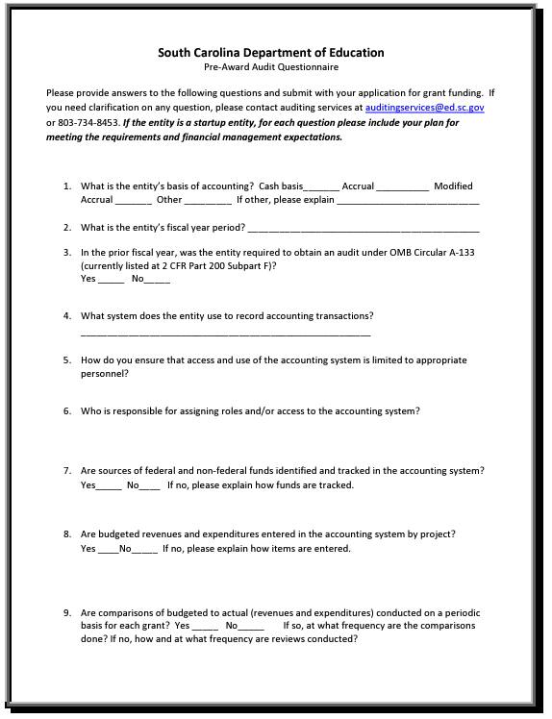

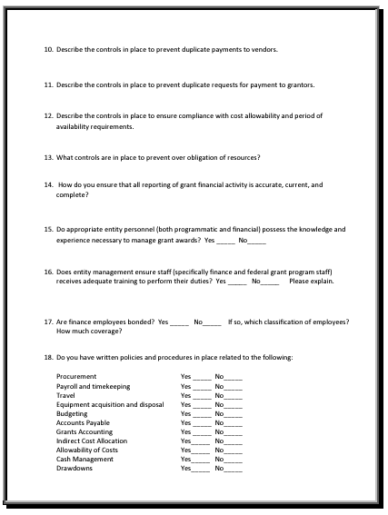

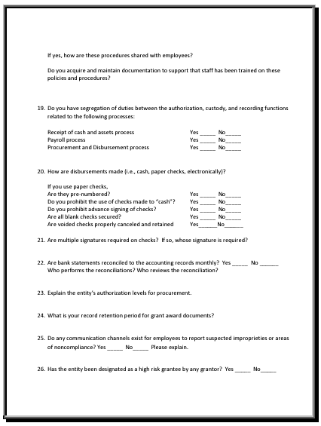

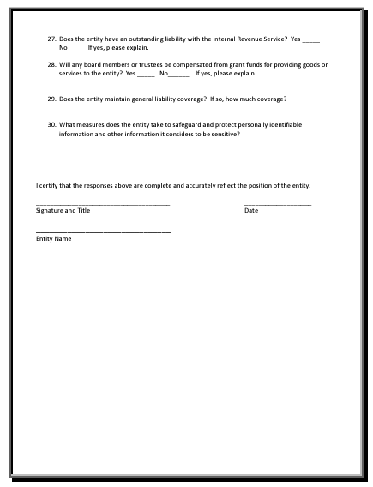

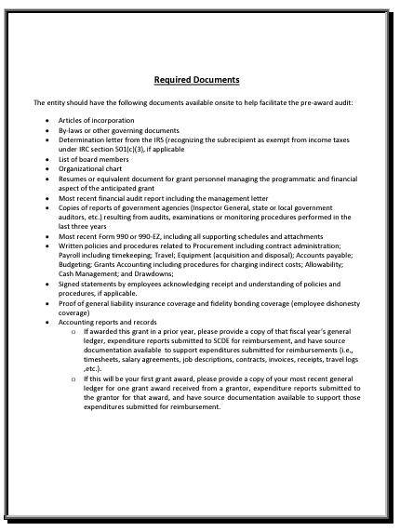

Instructions for General Education Provisions Act (GEPA) Statement of Compliance

NOTICE TO ALL APPLICANTS:
EQUITY FOR STUDENTS, EDUCATORS, AND OTHER PROGRAM BENEFICIARIES
OMB Control Number 1894-0005
Expiration 2/28/2026

Section 427 of the General Education Provisions Act (GEPA) (20 U.S.C. 1228a) applies to applicants for subgrant awards under this program.

ALL APPLICANTS FOR NEW GRANT AWARDS MUST INCLUDE THE FOLLOWING INFORMATION IN THEIR APPLICATIONS TO ADDRESS THIS PROVISION IN ORDER TO RECEIVE FUNDING UNDER THIS PROGRAM.

Please prepare a narrative that responds to the following requests for information:

- Describe how your entity’s existing mission, policies, or commitments ensure equitable access to, and equitable participation in, the proposed project or activity.

- Based on your proposed project or activity, what barriers may impede equitable access and participation of students, educators, or other beneficiaries?

- Based on the barriers identified, what steps will you take to address such barriers to equitable access and participation in the proposed project or activity?

- What is your timeline, including targeted milestones, for addressing these identified barriers?

Notes:
- Applicants are not required to have mission statements or policies that align with equity in order to submit an application.
- Applicants may identify any barriers that may impede equitable access and participation in the proposed project or activity, including, but not limited to, barriers based on economic disadvantage, gender, race, ethnicity, color, national origin, disability, age, language, migrant status, rural status, homeless status or housing insecurity, pregnancy, parenting, or caregiving status, and sexual orientation.
- Applicants may have already included some or all of this required information in the narrative sections of their applications or their project plans. In responding to this requirement, for each question, applicants may provide a cross-reference to the section(s) and page number(s) in their applications or project plans that includes the information responsive to that question in this narrative or may restate that information in this narrative.

Request for Taxpayer Identification Number and Certification
Go to the IRS Web site for an easy-to-complete version of this form.
(To be completed by fiscal agent)
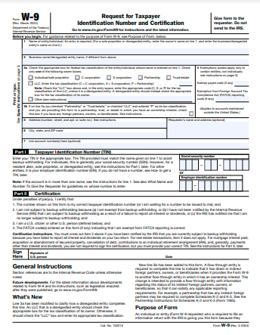

Appendix D: Optional Forms and Information

Adult Education Program Estimated Number of Participants to be Served Based on Market Penetration

For the Adult Education program, up to 55 subgrants will be awarded based on the availability of funds. An 8 percent market penetration is the targeted participant goal per county.
County | Total <High School Diplomas (HSD) 18-64 | % of 18-64 population < HSD | 8% Market Penetration Goal
Abbeville | 1,820 | 9% | 146
Aiken | 10,095 | 8% | 808
Allendale | 717 | 16% | 86
Anderson | 14,623 | 9% | 1170
Bamberg | 1,262 | 12% | 101
Barnwell | 1,837 | 12% | 147
Beaufort | 8,672 | 6% | 694
Berkeley | 13,288 | 8% | 1063
Calhoun | 810 | 7% | 65
Charleston | 18,048 | 6% | 1444
Cherokee | 4,643 | 11% | 371
Chester | 2,698 | 11% | 216
Chesterfield | 4,223 | 12% | 338
Clarendon | 3,260 | 13% | 261
Colleton | 2,940 | 10% | 235
Darlington | 4,752 | 10% | 380
Dillon | 2,735 | 13% | 219
Dorchester | 9,658 | 8% | 773
Edgefield | 2,688 | 13% | 215
Fairfield | 1,630 | 9% | 130
Florence | 8,986 | 9% | 719
Georgetown | 3,508 | 7% | 281
Greenville | 31,891 | 8% | 2551
Greenwood | 4,999 | 9% | 400
Hampton | 2,206 | 15% | 176
Horry | 19,079 | 7% | 1526
Jasper | 2,164 | 10% | 173
Kershaw | 4,161 | 8% | 333
Lancaster | 6,144 | 8% | 492
Laurens | 6,619 | 13% | 530
Lee | 1,781 | 13% | 142
Lexington | 15,481 | 7% | 1,238
McCormick | 720 | 9% | 58
Marion | 1,840 | 8% | 147
Marlboro | 2,928 | 14% | 234
Newberry | 2,934 | 10% | 235
Oconee | 5,974 | 10% | 478
Orangeburg | 6,275 | 9% | 502
Pickens | 8,976 | 9% | 718
Richland | 20,019 | 6% | 1,602
Saluda | 1,915 | 13% | 153
Spartanburg | 21,523 | 9% | 1,722
Sumter | 5,954 | 7% | 476
Union | 2,781 | 13% | 222
Williamsburg | 2,794 | 11% | 224
York | 13,596 | 6% | 1,088

SC County Population Numbers by Age and High School Credential Attainment

County | Total Population 18 to 24 years | Less than high school graduate | Total Population 25 to 34 years | Less than high school graduate | Total Population 35 to 44 years | Less than high school graduate | Total Population 45 to 64 years | Less than high school graduate
Abbeville County | 2,386 | 377 | 2,457 | 243 | 2,635 | 255 | 6,660 | 945
Male | 1,251 | 196 | 1,154 | 58 | 1,310 | 234 | 3,259 | 477
Female | 1,135 | 181 | 1,303 | 185 | 1,325 | 21 | 3,401 | 468
Aiken County | 13,466 | 1,868 | 21,483 | 1955 | 19,885 | 1,921 | 44,589 | 4,351
Male | 6,709 | 1,357 | 10,620 | 1391 | 9,648 | 1,031 | 21,796 | 2,287
Female | 6,757 | 511 | 10,863 | 564 | 10,237 | 890 | 22,793 | 2,064
Allendale County | 867 | 361 | 852 | 129 | 983 | 342 | 2,191 | 246
Male | 570 | 290 | 498 | 86 | 587 | 210 | 1,185 | 140
Female | 297 | 71 | 354 | 43 | 396 | 132 | 1,006 | 106
Anderson County | 17,826 | 2,964 | 24,594 | 2113 | 24,775 | 3,265 | 54,046 | 6,281
Male | 8,833 | 1,721 | 11,983 | 1123 | 11,895 | 1,956 | 26,383 | 3,392
Female | 8,993 | 1,243 | 12,611 | 990 | 12,880 | 1,309 | 27,663 | 2,889
Bamberg County | 1,822 | 244 | 1,196 | 350 | 1,649 | 101 | 3,130 | 567
Male | 1,062 | 178 | 540 | 252 | 753 | 90 | 1,479 | 387
Female | 760 | 66 | 656 | 98 | 896 | 11 | 1,651 | 180
Barnwell County | 2,028 | 502 | 2,159 | 264 | 2,397 | 365 | 5,341 | 706
Male | 948 | 242 | 1,221 | 159 | 1,113 | 178 | 2,530 | 377
Female | 1,080 | 260 | 938 | 105 | 1,284 | 187 | 2,811 | 329
Beaufort County | 18,880 | 2,278 | 20,181 | 1210 | 18,706 | 1,904 | 45,213 | 3,250
Male | 11,607 | 1,413 | 10,270 | 637 | 9,273 | 1,119 | 20,991 | 1,793
Female | 7,273 | 865 | 9,911 | 573 | 9,433 | 785 | 24,222 | 1,457
Berkeley County | 22,045 | 2,401 | 33,098 | 2828 | 31,485 | 2,509 | 56,938 | 5,550
Male | 12,830 | 1,397 | 16,526 | 1276 | 15,561 | 1,770 | 27,697 | 2,714
Female | 9,215 | 1,004 | 16,572 | 1552 | 15,924 | 739 | 29,241 | 2,836
Calhoun County | 996 | 90 | 1,355 | 67 | 1,748 | 206 | 4,063 | 447
Male | 583 | 19 | 594 | 55 | 841 | 165 | 1,963 | 243
Female | 413 | 71 | 761 | 12 | 907 | 41 | 2,100 | 204
Charleston County | 34,764 | 3,602 | 65,845 | 3915 | 56,879 | 3,300 | 101,916 | 7,241
Male | 17,681 | 2,231 | 32,132 | 2442 | 28,351 | 1,888 | 49,012 | 4,292
Female | 17,083 | 1,371 | 33,713 | 1473 | 28,528 | 1,412 | 52,904 | 2,949
Cherokee County | 5,261 | 888 | 7,351 | 1033 | 6,477 | 875 | 14,884 | 1,847
Male | 2,791 | 536 | 3,571 | 594 | 3,132 | 456 | 7,401 | 937
Female | 2,470 | 352 | 3,780 | 439 | 3,345 | 419 | 7,483 | 910
Chester County | 2,535 | 563 | 3,824 | 473 | 3,722 | 269 | 8,921 | 1,393
Male | 1,244 | 277 | 1,816 | 263 | 1,750 | 152 | 4,394 | 837
Female | 1,291 | 286 | 2,008 | 210 | 1,972 | 117 | 4,527 | 556
Chesterfield County | 3,493 | 643 | 5,193 | 408 | 4,693 | 762 | 12,338 | 2,410
Male | 1,807 | 398 | 2,586 | 305 | 2,241 | 535 | 6,183 | 1,533
Female | 1,686 | 245 | 2,607 | 103 | 2,452 | 227 | 6,155 | 877
Clarendon County | 2,730 | 535 | 3,506 | 700 | 3,277 | 592 | 8,260 | 1,433
Male | 1,652 | 449 | 1,713 | 426 | 1,607 | 270 | 3,981 | 844
Female | 1,078 | 86 | 1,793 | 274 | 1,670 | 322 | 4,279 | 589
Colleton County | 2,988 | 530 | 4,734 | 537 | 4,267 | 471 | 10,265 | 1,402
Male | 1,489 | 296 | 2,418 | 357 | 2,065 | 276 | 4,874 | 805
Female | 1,499 | 234 | 2,316 | 180 | 2,202 | 195 | 5,391 | 597
Darlington County | 5,734 | 990 | 7,618 | 897 | 6,898 | 687 | 16,710 | 2,088
Male | 2,820 | 554 | 3,698 | 365 | 3,195 | 379 | 7,931 | 1,315
Female | 2,914 | 436 | 3,920 | 532 | 3,703 | 308 | 8,779 | 773
Dillon County | 2,442 | 309 | 3,433 | 491 | 3,272 | 514 | 7,204 | 1,421
Male | 1,159 | 186 | 1,639 | 297 | 1,528 | 186 | 3,382 | 842
Female | 1,283 | 123 | 1,794 | 194 | 1,744 | 328 | 3,822 | 579
Dorchester County | 13,253 | 2,109 | 21,961 | 1759 | 22,672 | 2,700 | 41,373 | 3,090
Male | 6,756 | 1,277 | 10,958 | 950 | 11,062 | 1,673 | 20,115 | 1,578
Female | 6,497 | 832 | 11,003 | 809 | 11,610 | 1,027 | 21,258 | 1,512
Edgefield County | 2,483 | 319 | 3,198 | 547 | 3,594 | 934 | 7,352 | 888
Male | 1,537 | 254 | 1,836 | 506 | 2,217 | 604 | 3,950 | 677
Female | 946 | 65 | 1,362 | 41 | 1,377 | 330 | 3,402 | 211
Fairfield County | 1,727 | 188 | 2,179 | 279 | 2,335 | 326 | 6,089 | 837
Male | 942 | 98 | 991 | 185 | 1,211 | 178 | 2,883 | 379
Female | 785 | 90 | 1,188 | 94 | 1,124 | 148 | 3,206 | 458
Florence County | 12,285 | 1,630 | 17,068 | 1472 | 16,725 | 1,389 | 34,794 | 4,495
Male | 5,937 | 1,041 | 7,989 | 890 | 8,008 | 892 | 16,097 | 2,581
Female | 6,348 | 589 | 9,079 | 582 | 8,717 | 497 | 18,697 | 1,914
Georgetown County | 4,450 | 799 | 5,981 | 578 | 6,086 | 633 | 17,403 | 1,498
Male | 2,365 | 547 | 2,880 | 366 | 2,876 | 381 | 8,032 | 897
Female | 2,085 | 252 | 3,101 | 212 | 3,210 | 252 | 9,371 | 601
Greenville County | 46,482 | 6,102 | 73,132 | 5708 | 68,529 | 7,118 | 133,354 | 12,963
Male | 23,027 | 3,267 | 36,111 | 3535 | 33,942 | 4,153 | 65,171 | 7,745
Female | 23,455 | 2,835 | 37,021 | 2173 | 34,587 | 2,965 | 68,183 | 5,218
Greenwood County | 7,253 | 645 | 8,232 | 719 | 8,025 | 1,311 | 17,107 | 2,324
Male | 3,330 | 400 | 3,843 | 465 | 3,731 | 550 | 8,141 | 1,478
Female | 3,923 | 245 | 4,389 | 254 | 4,294 | 761 | 8,966 | 846
Hampton County | 1,815 | 457 | 2,396 | 516 | 2,496 | 535 | 4,849 | 698
Male | 1,055 | 261 | 1,389 | 355 | 1,508 | 481 | 2,457 | 431
Female | 760 | 196 | 1,007 | 161 | 988 | 54 | 2,392 | 267
Horry County | 28,378 | 3,424 | 39,058 | 3820 | 38,380 | 4,268 | 99,278 | 7,567
Male | 14,135 | 2,050 | 19,227 | 1838 | 18,850 | 2,465 | 46,876 | 4,021
Female | 14,243 | 1,374 | 19,831 | 1982 | 19,530 | 1,803 | 52,402 | 3,546
Jasper County | 2,476 | 519 | 3,461 | 462 | 3,594 | 257 | 8,046 | 926
Male | 1,544 | 361 | 1,734 | 364 | 1,972 | 157 | 3,842 | 510
Female | 932 | 158 | 1,727 | 98 | 1,622 | 100 | 4,204 | 416
Kershaw County | 4,895 | 858 | 7,677 | 776 | 8,197 | 971 | 17,658 | 1,556
Male | 2,526 | 475 | 3,695 | 392 | 4,005 | 694 | 8,612 | 830
Female | 2,369 | 383 | 3,982 | 384 | 4,192 | 277 | 9,046 | 726
Lancaster County | 6,391 | 818 | 11,600 | 1043 | 12,953 | 1,618 | 24,984 | 2,665
Male | 3,262 | 374 | 5,928 | 503 | 6,473 | 713 | 12,204 | 1,437
Female | 3,129 | 444 | 5,672 | 540 | 6,480 | 905 | 12,780 | 1,228
Laurens County | 5,865 | 971 | 8,286 | 1322 | 7,890 | 1,239 | 18,109 | 3,087
Male | 2,899 | 523 | 4,220 | 681 | 3,780 | 715 | 8,787 | 1,785
Female | 2,966 | 448 | 4,066 | 641 | 4,110 | 524 | 9,322 | 1,302
Lee County | 1,678 | 403 | 2,046 | 317 | 2,084 | 238 | 4,372 | 823
Male | 912 | 338 | 1,232 | 317 | 1,217 | 145 | 2,070 | 382
Female | 766 | 65 | 814 | 0 | 867 | 93 | 2,302 | 441
Lexington County | 22,965 | 3,371 | 38,904 | 2975 | 38,838 | 3,397 | 78,689 | 5,738
Male | 11,762 | 1,809 | 19,142 | 1813 | 18,984 | 1,903 | 38,718 | 3,627
Female | 11,203 | 1,562 | 19,762 | 1162 | 19,854 | 1,494 | 39,971 | 2,111
McCormick County | 588 | 101 | 751 | 84 | 1,088 | 211 | 2,656 | 324
Male | 441 | 81 | 364 | 84 | 734 | 178 | 1,404 | 194
Female | 147 | 20 | 387 | 0 | 354 | 33 | 1,252 | 130
Marion County | 2,335 | 320 | 3,197 | 321 | 3,666 | 484 | 7,486 | 715
Male | 1,131 | 117 | 1,512 | 251 | 1,885 | 356 | 3,404 | 433
Female | 1,204 | 203 | 1,685 | 70 | 1,781 | 128 | 4,082 | 282
Marlboro County | 2,264 | 413 | 3,671 | 591 | 3,411 | 626 | 7,150 | 1,298
Male | 1,264 | 363 | 2,336 | 480 | 1,980 | 487 | 3,681 | 944
Female | 1,000 | 50 | 1,335 | 111 | 1,431 | 139 | 3,469 | 354
Newberry County | 3,855 | 481 | 4,198 | 421 | 3,955 | 673 | 10,206 | 1,359
Male | 2,069 | 253 | 2,170 | 207 | 1,934 | 399 | 5,022 | 892
Female | 1,786 | 228 | 2,028 | 214 | 2,021 | 274 | 5,184 | 467
Oconee County | 5,852 | 870 | 9,092 | 706 | 7,927 | 1,382 | 21,899 | 3,016
Male | 3,162 | 533 | 4,497 | 399 | 3,900 | 776 | 10,937 | 1,709
Female | 2,690 | 337 | 4,595 | 307 | 4,027 | 606 | 10,962 | 1,307
Orangeburg County | 9,228 | 1,206 | 9,679 | 1252 | 8,747 | 861 | 21,294 | 2,956
Male | 4,404 | 685 | 4,560 | 797 | 4,043 | 444 | 9,921 | 1,628
Female | 4,824 | 521 | 5,119 | 455 | 4,704 | 417 | 11,373 | 1,328
Pickens County | 24,018 | 1,669 | 15,779 | 1346 | 13,864 | 1,853 | 30,884 | 4,108
Male | 12,917 | 934 | 8,075 | 789 | 7,046 | 761 | 15,168 | 2,092
Female | 11,101 | 735 | 7,704 | 557 | 6,818 | 1,092 | 15,716 | 2,016
Richland County | 63,712 | 5,231 | 60,198 | 4170 | 51,850 | 4,100 | 95,333 | 6,518
Male | 32,673 | 3,147 | 29,205 | 2471 | 24,739 | 2,224 | 44,860 | 3,582
Female | 31,039 | 2,084 | 30,993 | 1699 | 27,111 | 1,876 | 50,473 | 2,936
Saluda County | 1,521 | 391 | 1,928 | 253 | 2,273 | 304 | 5,321 | 967
Male | 828 | 238 | 1,001 | 150 | 1,227 | 172 | 2,732 | 613
Female | 693 | 153 | 927 | 103 | 1,046 | 132 | 2,589 | 354
Spartanburg County | 30,408 | 3,310 | 45,667 | 3824 | 40,010 | 4,654 | 84,038 | 9,735
Male | 15,168 | 2,011 | 22,427 | 2104 | 19,771 | 3,113 | 41,388 | 5,315
Female | 15,240 | 1,299 | 23,240 | 1720 | 20,239 | 1,541 | 42,650 | 4,420
Sumter County | 10,647 | 1,342 | 14,479 | 944 | 12,123 | 1,213 | 25,005 | 2,455
Male | 5,556 | 673 | 7,478 | 593 | 5,827 | 793 | 11,639 | 1,370
Female | 5,091 | 669 | 7,001 | 351 | 6,296 | 420 | 13,366 | 1,085
Union County | 2,049 | 504 | 3,215 | 478 | 2,925 | 391 | 7,698 | 1,408
Male | 1,024 | 232 | 1,509 | 207 | 1,408 | 151 | 3,656 | 696
Female | 1,025 | 272 | 1,706 | 271 | 1,517 | 240 | 4,042 | 712
Williamsburg County | 2,386 | 446 | 3,806 | 398 | 3,683 | 629 | 8,361 | 1,321
Male | 1,222 | 328 | 2,144 | 341 | 2,007 | 520 | 3,908 | 687
Female | 1,164 | 118 | 1,662 | 57 | 1,676 | 109 | 4,453 | 634
York County | 23,980 | 3,071 | 34,342 | 1822 | 40,283 | 2,351 | 75,336 | 6,352
Male | 11,641 | 1,743 | 16,505 | 840 | 19,642 | 1,520 | 37,059 | 3,590
Female | 12,339 | 1,328 | 17,837 | 982 | 20,641 | 831 | 38,277 | 2,762

SC County Population Numbers by Race and High School Credential Attainment

County | African American/Black | American Indian or Alaska Native | Asian | Hispanic or Latino | Native Hawaiian and Other Pacific Islander | Other Race | Two or more races | White
 | Less than high school graduate | Less than high school graduate | Less than high school graduate | Less than high school graduate | Less than high school graduate | Less than high school graduate | Less than high school graduate | Less than high school graduate
Abbeville County | 986 | 25 | 0 | 55 | 0 | 0 | 27 | 1,514
Male | 598 | 0 | 0 | 37 | 0 | 0 | 27 | 672
Female | 388 | 25 | 0 | 18 | 0 | 0 | 0 | 842
Aiken County | 4,030 | 42 | 62 | 1,473 | 4 | 249 | 1,283 | 6,864
Male | 1,988 | 9 | 15 | 995 | 0 | 141 | 907 | 3,488
Female | 2,042 | 33 | 47 | 478 | 4 | 108 | 376 | 3,376
Allendale County | 996 | 11 | 17 | 12 | 0 | 10 | 2 | 162
Male | 474 | 11 | 0 | 12 | 0 | 10 | 2 | 125
Female | 522 | 0 | 17 | 0 | 0 | 0 | 0 | 37
Anderson County | 3,212 | 181 | 139 | 1,420 | 0 | 549 | 611 | 13,353
Male | 1,383 | 98 | 84 | 789 | 0 | 289 | 405 | 6,972
Female | 1,829 | 83 | 55 | 631 | 0 | 260 | 206 | 6,381
Bamberg County | 1,626 | 0 | 0 | 45 | 0 | 45 | 0 | 366
Male | 1,013 | 0 | 0 | 45 | 0 | 45 | 0 | 218
Female | 613 | 0 | 0 | 0 | 0 | 0 | 0 | 148
Barnwell County | 1,240 | 0 | 0 | 145 | 0 | 62 | 35 | 1,033
Male | 659 | 0 | 0 | 120 | 0 | 62 | 34 | 472
Female | 581 | 0 | 0 | 25 | 0 | 0 | 1 | 561
Beaufort County | 2,610 | 48 | 76 | 2,754 | 0 | 1,838 | 703 | 3,411
Male | 1,258 | 17 | 0 | 1,627 | 0 | 1,074 | 221 | 1,926
Female | 1,352 | 31 | 76 | 1,127 | 0 | 764 | 482 | 1,485
Berkeley County | 4,629 | 161 | 379 | 1,881 | 6 | 1,188 | 988 | 8,014
Male | 2,507 | 92 | 162 | 1,158 | 4 | 628 | 370 | 3,897
Female | 2,122 | 69 | 217 | 723 | 2 | 560 | 618 | 4,117
Calhoun County | 902 | 0 | 8 | 117 | 0 | 61 | 36 | 407
Male | 493 | 0 | 0 | 56 | 0 | 34 | 20 | 249
Female | 409 | 0 | 8 | 61 | 0 | 27 | 16 | 158
Charleston County | 10,637 | 122 | 276 | 3,612 | 209 | 2,334 | 543 | 6,755
Male | 5,466 | 73 | 171 | 2,426 | 111 | 1,686 | 332 | 3,549
Female | 5,171 | 49 | 105 | 1,186 | 98 | 648 | 211 | 3,206
Cherokee County | 1,379 | 36 | 0 | 302 | 0 | 78 | 156 | 4,011
Male | 648 | 23 | 0 | 211 | 0 | 78 | 81 | 1,961
Female | 731 | 13 | 0 | 91 | 0 | 0 | 75 | 2,050
Chester County | 1,397 | 8 | 6 | 74 | 0 | 0 | 61 | 1,852
Male | 697 | 0 | 6 | 74 | 0 | 0 | 53 | 994
Female | 700 | 8 | 0 | 0 | 0 | 0 | 8 | 858
Chesterfield County | 1,950 | 65 | 0 | 599 | 0 | 219 | 151 | 3,283
Male | 1,082 | 45 | 0 | 450 | 0 | 134 | 105 | 1,899
Female | 868 | 20 | 0 | 149 | 0 | 85 | 46 | 1,384
Clarendon County | 2,569 | 22 | 12 | 252 | 0 | 114 | 123 | 1,477
Male | 1,315 | 22 | 12 | 83 | 0 | 42 | 59 | 843
Female | 1,254 | 0 | 0 | 169 | 0 | 72 | 64 | 634
Colleton County | 1,541 | 143 | 0 | 261 | 0 | 67 | 142 | 1,829
Male | 770 | 143 | 0 | 93 | 0 | 19 | 102 | 1,024
Female | 771 | 0 | 0 | 168 | 0 | 48 | 40 | 805
Darlington County | 3,228 | 7 | 23 | 241 | 0 | 114 | 181 | 2,639
Male | 1,604 | 7 | 11 | 114 | 0 | 66 | 74 | 1,456
Female | 1,624 | 0 | 12 | 127 | 0 | 48 | 107 | 1,183
Dillon County | 1,559 | 183 | 0 | 274 | 0 | 176 | 149 | 1,983
Male | 757 | 144 | 0 | 133 | 0 | 131 | 9 | 872
Female | 802 | 39 | 0 | 141 | 0 | 45 | 140 | 1,111
Dorchester County | 3,488 | 103 | 228 | 1,663 | 0 | 951 | 628 | 4,914
Male | 1,863 | 61 | 114 | 750 | 0 | 501 | 252 | 2,639
Female | 1,625 | 42 | 114 | 913 | 0 | 450 | 376 | 2,275
Edgefield County | 1,535 | 0 | 0 | 653 | 0 | 128 | 261 | 1,324
Male | 1,052 | 0 | 0 | 560 | 0 | 110 | 232 | 942
Female | 483 | 0 | 0 | 93 | 0 | 18 | 29 | 382
Fairfield County | 1,678 | 3 | 38 | 27 | 0 | 1 | 106 | 608
Male | 850 | 0 | 26 | 27 | 0 | 1 | 4 | 296
Female | 828 | 3 | 12 | 0 | 0 | 0 | 102 | 312
Florence County | 5,857 | 61 | 261 | 869 | 0 | 472 | 244 | 4,867
Male | 3,189 | 13 | 162 | 464 | 0 | 284 | 146 | 2,576
Female | 2,668 | 48 | 99 | 405 | 0 | 188 | 98 | 2,291
Georgetown County | 1,933 | 0 | 29 | 287 | 0 | 252 | 33 | 2,147
Male | 1,110 | 0 | 0 | 134 | 0 | 113 | 0 | 1,045
Female | 823 | 0 | 29 | 153 | 0 | 139 | 33 | 1,102
Greenville County | 9,123 | 564 | 787 | 8,297 | 43 | 4,234 | 2,391 | 18,622
Male | 4,355 | 316 | 415 | 4,788 | 0 | 2,611 | 1,306 | 10,457
Female | 4,768 | 248 | 372 | 3,509 | 43 | 1,623 | 1,085 | 8,165
Greenwood County | 2,823 | 2 | 19 | 571 | 0 | 88 | 311 | 2,862
Male | 1,296 | 2 | 0 | 311 | 0 | 71 | 175 | 1,585
Female | 1,527 | 0 | 19 | 260 | 0 | 17 | 136 | 1,277
Hampton County | 1,158 | 4 | 9 | 329 | 0 | 306 | 57 | 985
Male | 686 | 0 | 9 | 238 | 0 | 206 | 40 | 618
Female | 472 | 4 | 0 | 91 | 0 | 100 | 17 | 367
Horry County | 3,766 | 42 | 525 | 3,566 | 10 | 1,394 | 1,115 | 15,604
Male | 1,811 | 41 | 335 | 1,909 | 0 | 711 | 745 | 7,887
Female | 1,955 | 1 | 190 | 1,657 | 10 | 683 | 370 | 7,717
Jasper County | 770 | 2 | 48 | 584 | 0 | 303 | 95 | 956
Male | 456 | 2 | 22 | 407 | 0 | 195 | 40 | 516
Female | 314 | 0 | 26 | 177 | 0 | 108 | 55 | 440
Kershaw County | 1,176 | 5 | 8 | 865 | 0 | 558 | 188 | 3,142
Male | 613 | 5 | 0 | 310 | 0 | 252 | 61 | 1,730
Female | 563 | 0 | 8 | 555 | 0 | 306 | 127 | 1,412
Lancaster County | 1,995 | 17 | 118 | 1,030 | 0 | 265 | 499 | 4,804
Male | 875 | 4 | 28 | 674 | 0 | 235 | 356 | 2,097
Female | 1,120 | 13 | 90 | 356 | 0 | 30 | 143 | 2,707
Laurens County | 2,305 | 33 | 19 | 710 | 0 | 445 | 236 | 5,077
Male | 1,164 | 9 | 7 | 405 | 0 | 234 | 182 | 2,815
Female | 1,141 | 24 | 12 | 305 | 0 | 211 | 54 | 2,262
Lee County | 1,659 | 0 | 0 | 60 | 0 | 36 | 38 | 476
Male | 850 | 0 | 0 | 42 | 0 | 18 | 26 | 307
Female | 809 | 0 | 0 | 18 | 0 | 18 | 12 | 169
Lexington County | 2,878 | 91 | 445 | 3,086 | 0 | 1,062 | 1,305 | 12,180
Male | 1,662 | 72 | 183 | 1,889 | 0 | 714 | 584 | 6,717
Female | 1,216 | 19 | 262 | 1,197 | 0 | 348 | 721 | 5,463
McCormick County | 724 | 0 | 0 | 48 | 0 | 12 | 36 | 413
Male | 515 | 0 | 0 | 21 | 0 | 12 | 9 | 240
Female | 209 | 0 | 0 | 27 | 0 | 0 | 27 | 173
Marion County | 1,472 | 28 | 0 | 230 | 0 | 215 | 16 | 1,410
Male | 731 | 28 | 0 | 172 | 0 | 157 | 3 | 752
Female | 741 | 0 | 0 | 58 | 0 | 58 | 13 | 658
Marlboro County | 1,723 | 197 | 0 | 258 | 0 | 166 | 87 | 1,559
Male | 1,226 | 118 | 0 | 214 | 0 | 166 | 87 | 920
Female | 497 | 79 | 0 | 44 | 0 | 0 | 0 | 639
Newberry County | 1,677 | 0 | 0 | 829 | 0 | 366 | 330 | 1,401
Male | 924 | 0 | 0 | 430 | 0 | 158 | 207 | 884
Female | 753 | 0 | 0 | 399 | 0 | 208 | 123 | 517
Oconee County | 514 | 22 | 14 | 1,013 | 0 | 711 | 149 | 6,110
Male | 219 | 0 | 11 | 600 | 0 | 484 | 45 | 3,066
Female | 295 | 22 | 3 | 413 | 0 | 227 | 104 | 3,044
Orangeburg County | 5,717 | 55 | 133 | 420 | 0 | 160 | 134 | 2,731
Male | 2,772 | 48 | 71 | 167 | 0 | 48 | 70 | 1,425
Female | 2,945 | 7 | 62 | 253 | 0 | 112 | 64 | 1,306
Pickens County | 1,129 | 75 | 28 | 554 | 0 | 283 | 295 | 8,907
Male | 445 | 58 | 5 | 270 | 0 | 120 | 135 | 4,386
Female | 684 | 17 | 23 | 284 | 0 | 163 | 160 | 4,521
Richland County | 12,865 | 108 | 654 | 1,945 | 46 | 1,149 | 773 | 4,924
Male | 7,003 | 57 | 214 | 1,140 | 7 | 679 | 271 | 2,549
Female | 5,862 | 51 | 440 | 805 | 39 | 470 | 502 | 2,375
Saluda County | 655 | 29 | 0 | 615 | 0 | 224 | 224 | 1,108
Male | 368 | 0 | 0 | 350 | 0 | 156 | 144 | 565
Female | 287 | 29 | 0 | 265 | 0 | 68 | 80 | 543
Spartanburg County | 6,582 | 138 | 998 | 4,428 | 0 | 1,911 | 1,692 | 15,877
Male | 3,319 | 118 | 505 | 3,028 | 0 | 1,321 | 1,009 | 8,565
Female | 3,263 | 20 | 493 | 1,400 | 0 | 590 | 683 | 7,312
Sumter County | 4,440 | 3 | 84 | 494 | 0 | 366 | 139 | 2,750
Male | 2,498 | 3 | 18 | 263 | 0 | 198 | 36 | 1,537
Female | 1,942 | 0 | 66 | 231 | 0 | 168 | 103 | 1,213
Union County | 1,252 | 0 | 0 | 101 | 0 | 42 | 200 | 2,082
Male | 514 | 0 | 0 | 61 | 0 | 28 | 118 | 1,001
Female | 738 | 0 | 0 | 40 | 0 | 14 | 82 | 1,081
Williamsburg County | 2,145 | 6 | 8 | 580 | 0 | 506 | 26 | 1,146
Male | 1,190 | 4 | 0 | 431 | 0 | 365 | 7 | 611
Female | 955 | 2 | 8 | 149 | 0 | 141 | 19 | 535
York County | 3,607 | 208 | 477 | 1,989 | 11 | 725 | 1,124 | 8,662
Male | 1,768 | 113 | 198 | 1,093 | 0 | 317 | 530 | 4,812
Female | 1,839 | 95 | 279 | 896 | 11 | 408 | 594 | 3,850

South Carolina Performance Measures for AEFLA

Adult Education, Corrections Education, and Family Literacy subgrantees must meet or exceed AEFLA performance levels as determined by the SCDE Office of Adult Education. This chart shows prior-year performance levels that subgrant programs have been expected to meet/exceed.
AEFLA Performance Measures
Based on National Reporting System (NRS) Criteria
Measurable Skill Gains (as reported on NRS Table 4) |  |  | Performance Levels
 |  |  | 7/1/2022-6/30/2023 | 7/1/2023-6/30/2024 | 7/1/2024-6/30/2025
Adult Basic Education (ABE) | ABE Level 1 (Beginning Literacy) |  | 37% | 38% | 39%
Adult Basic Education (ABE) | ABE Level 2 (Beginning Basic Education) |  | 35% | 36% | 39%
Adult Basic Education (ABE) | ABE Level 3 (Intermediate Low) |  | 36% | 37% | 39%
Adult Basic Education (ABE) | ABE Level 4 (Intermediate High) |  | 43% | 44% | 47%
Adult Basic Education (ABE) | ABE Level 5 (Low Adult Secondary) |  | 44% | 45% | 46%
Adult Basic Education (ABE) | ABE Level 6 (High Adult Secondary) |  | 45% | 46% | 46%
English Second Language (ESL) | ESL Level 1(Beginning Literacy) |  | 40% | 41% | 42%
English Second Language (ESL) | ESL Level 2 (Beginning Low) |  | 45% | 46% | 46%
English Second Language (ESL) | ESL Level 3 (Beginning High) |  | 45% | 46% | 46%
English Second Language (ESL) | ESL Level 4 (Intermediate Low) |  | 40% | 41% | 42%
English Second Language (ESL) | ESL Level 5 (Intermediate High) |  | 35% | 36% | 39%
English Second Language (ESL) | ESL Level 6 (Advanced) |  | 40% | 41% | 42%
Core Outcome Measures (as reported on NRS Table 5)
Employment/  Training | Employment 2nd Quarter after exit | 31.0% |  | 31.5% | 38.6%
Employment/  Training | Employment 4th Quarter after exit | 31.5% |  | 31.5% | 46%
Employment/  Training | Median earnings 2nd Quarter after exit | $3,300 |  | $3,300 | $3680.00
Employment/  Training | Attained any credential (unduplicated) | 40.0% |  | 40.5% | 41%
Each subgrantee’s program performance contributes to the state’s overall success in meeting or exceeding the federally-agreed-upon performance level. In most cases, performance levels have increased annually; thus, subgrantees funded under this RFP must project and expect continuous improvement in their performance levels.

AEFLA performance levels will be shared with subgrantees at a later time. The AEFLA performance measures will contribute to the state’s WIOA primary indicators of performance.

Measurable Skill Gains

Measurable skill gains (MSG) are a critical component of student and program performance. Individuals enroll in adult education programs for many different reasons, but most often they attend to complete their high school diploma or equivalent and to gain the skills they need to be successful in the workplace and their everyday lives. Under the WIOA, adult education programs are able to determine their success in helping students gain desired and required skills using the measurable skill gains indicator.

What is MSG indicator?
MSG is a WIOA-required indicator used to demonstrate participants’ progress toward achieving a credential or employment.

How are measurable skill gains measured?
There are five (5) types of Measurable Skill Gains. Depending on the type of education or training program, documented progress is defined as one of the following:
- Documented achievement of at least one educational functioning level of a participant who is receiving instruction below the postsecondary education level;
Programs may measure educational functioning level gain in one of four ways:
  - States may compare the participant’s initial educational functioning level, as measured by a pretest, with the participant’s educational functioning level, as measured by a post-test;
  - States that offer adult high school programs that lead to a secondary school diploma or its recognized equivalent may measure and report educational gain through the awarding of credits or Carnegie units;
  - States may report an educational functioning level gain for participants who enroll in postsecondary education and training during the program year; or
  - States may report and educational functioning level for participants who pass a subtest on a High School Equivalency Exam
- Documented attainment of a secondary school or its recognized equivalent;
- Secondary or postsecondary transcript or report card for sufficient credit hours that shows a participant is meeting the state unit’s academic standards;
- Satisfactory or better progress report, toward established milestones, such as completion of on-the-job training or completion of 1 year of an apprenticeship program or similar milestones, from an employer or training provider who is providing training; or
- Successfully passing an exam that is required for a particular occupation or progress in attaining technical or occupational skills, as evidenced by trade-related benchmarks such as knowledge-based exams.

Types of Adult Education Measurable Skill Gains (MSGs) Under the WIOA

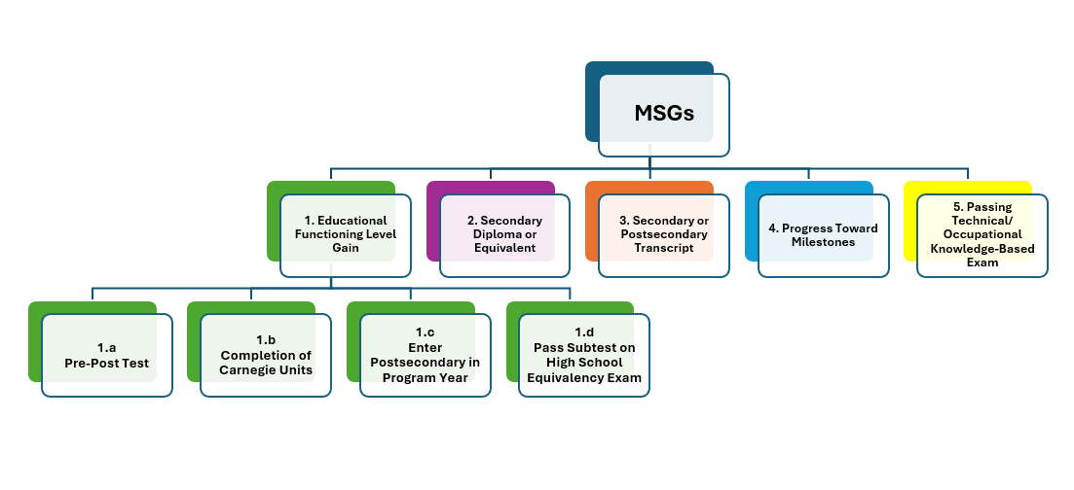
Who is included in the Measurable Skill Gain (MSG)?

MSG is reported for all participants (adults who receive 12 or more contact hours) for each period of participation (POP). A POP is created once the student has been administered a pre-test and accumulates 12 instructional hours. However, participants who are forced to exit the program due to the following extenuating circumstances are excluded:
- Incarceration or entry into a 24-hour support facility such as a hospital or treatment center;
- Medical treatment that lasts more than 90 days;
- Being called into active duty in the National Guard or other armed services for at least 90 days; and/or
- Death.

For additional Information on MSG, visit the NRS website.

Adult Education College and Career Navigator Job Description

TITLE: Adult Education College and Career Navigator

QUALIFICATIONS:
- A Bachelor’s Degree or higher from an accredited college or university. At least one year of successful experience in career counseling, employment placement, college placement, or student services.
- Computer literacy required. Proficiency in Microsoft Office products, specifically Word, Excel, and PowerPoint.
Alternative job qualifications as determined by the adult education program should be approved by the SCDE Office of Adult Education (OAE).

IMMEDIATE SUPERVISOR(S): Adult Education Director

SALARY: To be determined by the local adult education program

JOB SUMMARY:
- Assist adult education students with supportive services needs while receiving adult education services by identifying and connecting students to support services and activities to ensure successful transition into and completion of postsecondary education/training and/or employment.
- Research information and community services to best assist adult education students.
- Counsel students, one-on-one or in a group, providing them information on available community and educational services and informing students of postsecondary and/or employment options.
- Aid the Adult Education Director and staff in the development and implementation of career pathways.
- Assist students in career planning, goal-setting, and developing career/college plans.
- Track student progress through identified pathway benchmarks and follow-up with students to reconfirm goals or assist with alternate pathways according to changing student needs and interest.
- Identify and collaborate with other available education, training, and social service resources, such as establishing strong links with secondary schools, postsecondary educational institutions, institutions of higher education, local workforce investment boards, one-stop centers, job training programs, and social service agencies, business, industry, labor organizations, community-based organizations, nonprofit organizations, and intermediaries, for overall program success and individual student success.

PERFORMANCE RESPONSIBILITIES:
- Coordinate Student Community Referral System
- Employment (One-Stops—SC Works Centers): Coordinate with local One-Stop intensive services and employment opportunities for the purpose of matching students with full-time or part-time employment.
- Assist in job placement (part-time or full-time).
- Conduct information sessions with all partners.
- Use student interest/career inventories to direct students along a career pathway.
- Develop, both short-term and long-term, individual career plans.
- Coordinate with the local One-Stop counselor to meet with potential students to explore employment or offer intensive services for those students who meet eligibility guidelines.
- Offer skill training in job application completion (paper and computer based), interview skills, and resume preparation to prepare students for the world of work.
- Armed Forces
- Contact recruiters (e.g., Army, Navy, Air Force, Marines, and National Guard) to establish informational sessions for potential adult education students.
- Regularly schedule recruiters to meet with individual or small groups to provide opportunities for students to explore military options.
- Host Armed Services Vocational Aptitude Battery (ASVAB) testing on adult education site.
- Coordinate student records with recruiters to ensure transition into the military.
- Postsecondary/training
- Present information about local postsecondary/other training opportunities to students and their availability.
- Coordinate on-site visits with the technical college admissions counselors to include Educational Opportunity Center (EOC), TRIO, and traditional technical college admissions program for the purpose of sharing program information with adult education students highlighting certificate, diploma, and degree programs.
- Arrange on-site campus visits.
- Schedule with the technical college the student administration of the ACCUPLACER test at the local adult education site.
- Provide student assistance with financial aid information and forms to be completed.
- Guide adult education students through the application process.
- Student Accountability
- Maintain a student database to include contact/attendance and student placement.
- Work in tandem with the adult education teachers and staff to promote students achieving their goals.
- Maintain complete and accurate records and reports and prepares such reports as may be required by the SCDE OAE.

- Professional Responsibilities
- Participate in meetings and workshops sponsored by the OAE, the SC Adult Education Technical Assistance Network (TAN), and other professional development activities.
- Attend and successfully complete the National Career Development Facilitator (CDF) certification training.
- Prepare and disseminate promotional and program materials.
- Communicate to local community resources on a regular basis any progress or challenges that impact the transition initiative.

EVALUATION:
Performance of this job will be evaluated annually by the local Adult Education Director with assistance from the SCDE OAE.

Counties Required to Provide English Language Acquisition (ELA) Services

In a county with a Limited English Proficient (LEP)* population of 1,000 individuals or more, adult education providers must offer local ELA services as a part of the Adult Education program. Adult education providers in the counties highlighted below are required to offer ELA services. In counties with less than 1,000 individuals who speak limited English, adult education providers must provide an option for students to participate in English language instruction. This requirement does not apply to the Corrections Education and Family Literacy programs.

South Carolina LEP Population Data
County | Total Population | LEP Population
Abbeville County | 23,352 | 192
Aiken County | 157,291 | 4,158
Allendale County | 8,806 | 62
Anderson County | 184,474 | 2,717
Bamberg County | 13,900 | 89
Barnwell County | 21,185 | 211
Beaufort County | 172,692 | 7,843
Berkeley County | 195,293 | 6,212
Calhoun County | 14,005 | 128
Charleston County | 371,032 | 8,518
Cherokee County | 53,433 | 1,077
Chester County | 32,408 | 301
Chesterfield County | 43,409 | 1,136
Clarendon County | 32,352 | 323
Colleton County | 35,449 | 553
Darlington County | 63,300 | 623
Dillon County | 28,750 | 470
Dorchester County | 145,951 | 2,940
Edgefield County | 25,760 | 837
Fairfield County | 21,666 | 124
Florence County | 129,922 | 1,758
Georgetown County | 58,714 | 791
Greenville County | 466,752 | 24,009

County | Total Population | LEP Population
Greenwood County | 65,885 | 1,723
Hampton County | 18,708 | 434
Horry County | 305,089 | 8,525
Jasper County | 26,229 | 1,700
Kershaw County | 60,790 | 874
Lancaster County | 84,193 | 1,930
Laurens County | 62,890 | 1,196
Lee County | 16,703 | 42
Lexington County | 269,321 | 8,359
McCormick County | 9,329 | 18
Marion County | 29,576 | 536
Marlboro County | 25,709 | 434
Newberry County | 35,748 | 1,231
Oconee County | 72,673 | 1,673
Orangeburg County | 83,452 | 1,020
Pickens County | 116,526 | 1,970
Richland County | 384,410 | 11,018
Saluda County | 19,050 | 1,636
Spartanburg County | 283,872 | 10,798
Sumter County | 99,941 | 1,548
Union County | 28,099 | 159
Williamsburg County | 30,141 | 311
York County | 242,605 | 5,600

Reference: US Census Bureau. 2018 American Community Survey, 5-year Estimates Data Profile. Retrieved May 15, 2024.

*The term Limited English Proficient (LEP) refers to any person who reported speaking English “less than very well,” as classified by the US Census Bureau. Population estimates are for individuals age 5 and older.

Recruitment and Retention Action Plan

Complete a separate Recruitment and Retention Action Plan for each proposed program (Adult Education, Corrections Education, Family Literacy and/or IEL/CE). Guidance on completing the Action Plan follows below.

Program Name: List the name of the program.

County/Counties to be Served: List the county or counties that will be served by your program.

Program Type: Indicate if the program is an Adult Education, Corrections Education, Family Literacy, or IEL/CE program. If you are applying for more than one program, you will need to complete a separate Action Plan for each program.

Total Anticipated Number of Participants: Indicate the total number of program participants you anticipate serving in each year of the program (Years 1–5).

Target Group/Area & Target Enrollment Number:
- Indicate the target group or area in which recruitment efforts will be focused. For example, the target group may be young adults. A target area may be broad scale (e.g., county-wide) or in a specific locale (e.g., a neighborhood or school).
- The target enrollment number should reflect how many students you anticipate enrolling from that target group or area. Your target enrollment may change per period depending on how many “new” students your program can accommodate.
- In the table, use a separate row section for each target group/area to outline the timeframe, recruitment activities, retention strategies, and lead person for that particular group/area.

Timeframe: List the beginning and ending dates in which the recruitment activities and retention strategies will be implemented.

Recruitment Activities: Outline specific recruitment activities that your program will conduct to attract and enroll students. Outline how you will stay visible and promote your program. Indicate who, what, when, where, and how your activities will attract new students.

Retention Strategies: Retention strategies should be centered on student barriers and interest. Once students are enrolled, how will you get them to “persist”? Indicate who, what, when, where, and how your activities will encourage students to persist with your program.
Person(s) Responsible: Recruitment and retention will often be neglected or occur haphazardly if not assigned to a specific person or group. Assign one or more staff to lead recruitment efforts.

P
rogram Name:
County or Counties to be Served:
Program Type: ☐ Adult Education ☐ Corrections Education ☐ Family Literacy ☐ IEL/CE
Total Anticipated Number of Participants: Year 1 Click or tap here to enter text. Year 2 Click or tap here to enter text.
Year 3 Click or tap here to enter text. Year 4 Click or tap here to enter text.
Year 5 Click or tap here to enter text.

Target Group/Area & Target Enrollment Number:
Recruitment Activities
Start/end dates:
Specific activities:
Person(s) responsible:
Retention Strategies
Start/end dates:
Specific activities:
Person(s) responsible:
Target Group/Area & Target Enrollment Number:
Recruitment Activities
Start/end dates:
Specific activities:
Person(s) responsible:
Retention Strategies
Start/end dates:
Specific activities:
Person(s) responsible:
Target Group/Area & Target Enrollment Number:
Recruitment Activities
Start/end dates:
Specific activities:
Person(s) responsible:
Retention Strategies
Start/end dates:
Specific activities:
Person(s) responsible:

Target Group/Area & Target Enrollment Number:
Recruitment Activities
Start/end dates:
Specific activities:
Person(s) responsible:
Retention Strategies
Start/end dates:
Specific activities:
Person(s) responsible:
Target Group/Area & Target Enrollment Number:
Recruitment Activities
Start/end dates:
Specific activities:
Person(s) responsible:
Retention Strategies
Start/end dates:
Specific activities:
Person(s) responsible:

Partner Identification and Funding Request Form

Name of Applicant:

Name of Project:

Include a Partnership Identification Form for each partner institution/organization.
Name of Partner Institution
Type of Institution/Organization
Primary Contact Information
Name
Title
Complete Address
Telephone |  | Fax
Email

Please describe the services and responsibilities of this partner in implementing the proposed subgrant project.

On the form below, list only the funding this partner will receive from the subgrant.
 | Direct Cost Requested for Partner | YEAR 1 | YEAR 2 | YEAR 3 | YEAR 4 | YEAR 5 | TOTAL
 | 1. Salaries & Wages  (Professional and Clerical) |  |  |  |  |  | $
 | 2. Employee Benefits
 | 3. Travel in State
 | 4. Travel Out of State
 | 5. Materials and Supplies
 | 6. Consultants and Contracts
 | 7. Teacher Stipends
 | 8. Equipment (Purchased)
9. Other (Equipment rental, printing, etc.)
 | Total Funding to Partner from Subgrant

By signing below, I authorize this agency to participate in this subgrant program, and I certify that the agency is committed to completing the services described above and will apply the funds outlined in the budget above to these services.

Signature of Authorized Official | Date

Printed Name of Authorized Official | Date

Past Effectiveness Chart

For Consideration 3. Past Effectiveness, the SCDE will consider past effectiveness of the applicant/eligible provider in improving the literacy of eligible individuals, to meet state-adjusted levels of performance for the primary indicators of performance described in the WIOA section 116, especially with respect to eligible individuals who have low levels of literacy.

For this consideration, applicants have the option of including a table to reflect two consecutive years of performance data as a part of the narrative response or completing a Past Effectiveness Chart for the proposed program. When completing this chart, please include performance standards contained in the AEFLA State Standards 2017-2024 chart (located on page 135) for the selected years of performance data submitted.

If selecting to submit a Past Effectiveness Chart, complete the appropriate chart for each proposed program (form available on the grant opportunity webpage for Adult Education, Corrections Education, Family Literacy, and IEL/CE). For each proposed program, reference the completed chart in the narrative response to consideration 3, and include the chart as an attachment in the application.

The following (pages 132–133) is an example format for a Past Effectiveness Chart for the Adult Education, Corrections Education, and IEL/CE programs. The Past Effectiveness Chart for the Family Literacy program will include the Adult Education past effectiveness chart and the Family Literacy chart addition on page 134.
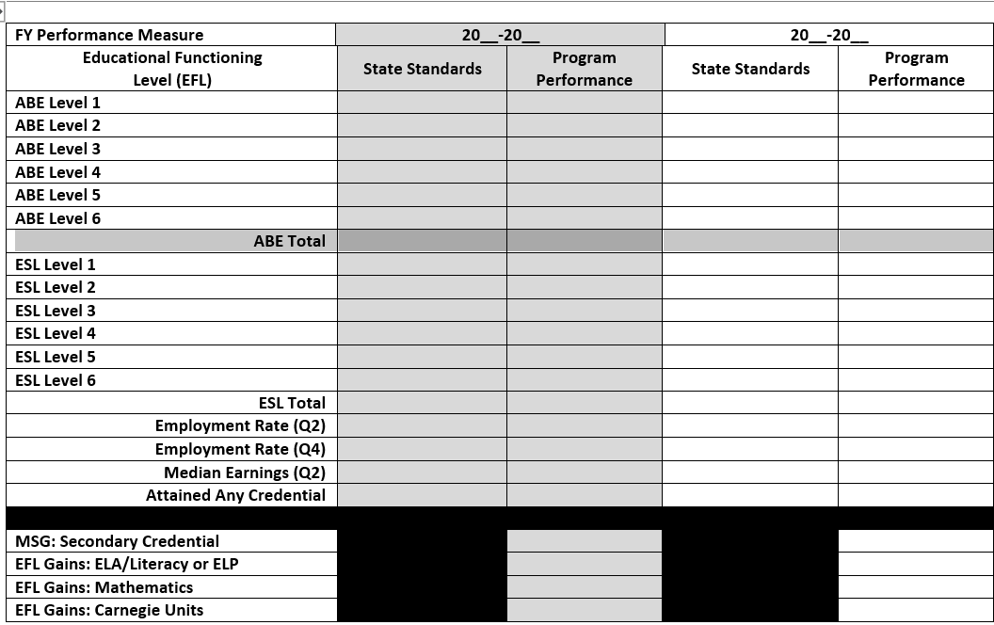
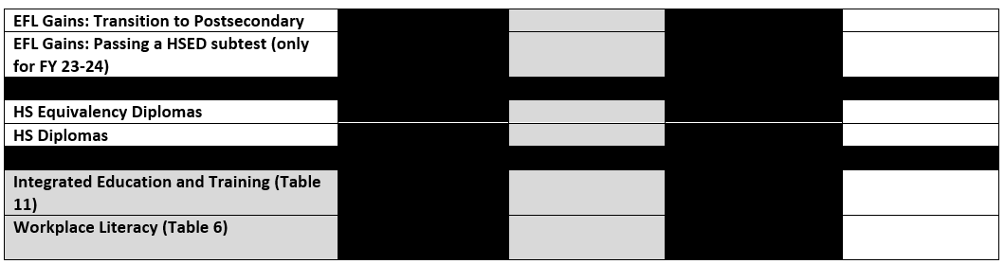
Subgrantees providing activities and services under Adult Education, Corrections Education, Family Literacy, and Integrated English Literacy and Civics Education (IEL/CE) programs are expected to meet or exceed AEFLA performance levels as determined by the SCDE Office of Adult Education (OAE).

Each subgrantee’s program performance contributes to the overall success of the state in meeting or exceeding the federally-agreed-upon performance levels. This chart shows the performance levels that AEFLA programs have been expected to meet or exceed in the past. In most cases, performance levels have increased annually; thus, funds awarded under this RFP must also project and expect continuous improvement in their performance levels.

AEFLA related performance levels will be shared with subgrantees. The AEFLA performance measures will contribute to the state’s WIOA primary indicators of performance.
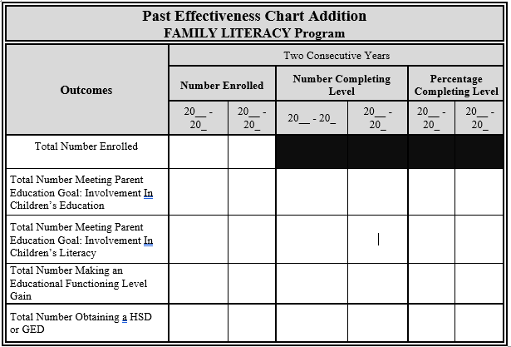

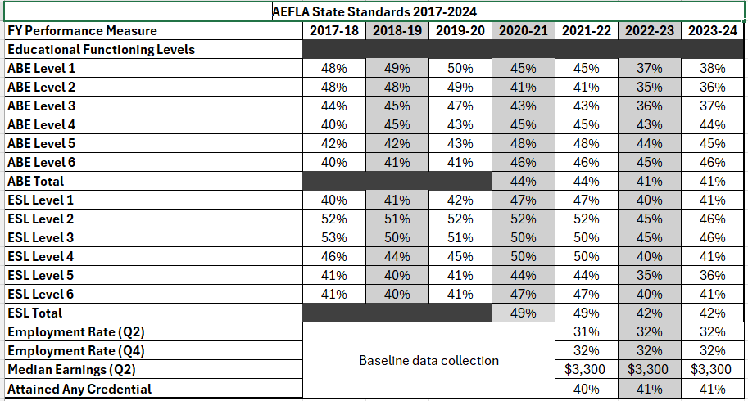

AEFLA Program Budget Planning Form and Budget Narrative Template

Use the Excel files to complete the Program Budget Planning Form and Budget Narrative for the first year of the proposed programs. Links to the Excel files are on the program-specific Grant Opportunities pages: Adult Education Program and Corrections Education Program, Family Literacy Program, IEL/CE Program.

An abbreviated example of page 1 of the Adult Education Budget Planning Form is below.

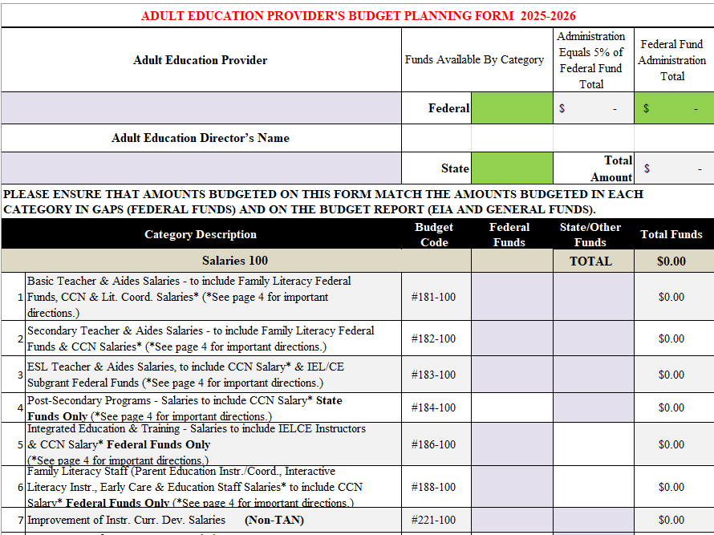

AEFLA Partners and Partnership Coordination

The AEFLA Partners and Partnership Coordination table applies to Considerations 4 and 10 & 11 (responses to items 4a, 10 & 11. as applicable). In the table on the next page, outline and describe any partnerships and collaborative efforts that have been established or will be established for the benefit of the students and program.
Complete a separate table for each proposed program (Adult Education, Corrections Education, Family Literacy, and/or IELCE). Guidance on completing the AEFLA Partners and Partnership Coordination table follows below.
Program Name: List the name of the program.

County/Counties to be Served: List the counties that will be served by your program.

Program Type: Indicate if the program is an Adult Education, Corrections Education, Family Literacy and/or IEL/CE program. If you are applying for more than one program, you will need to complete a separate Action Plan for each program.

Partner: List the name of the organization, entity, and/or agency with which your program will partner.

Partner Type: There are various partners within the workforce and education system. Indicate the partner type as one of the following: Core (WIOA Title 1-Adult, Dislocated and Youth services, WIOA Title III-Wagner-Peyser, WIOA Title IV-Vocational Rehabilitation), One-Stop, or other.

Activities and/or Support Services: List the activities (e.g., conducting a workshop) and/or support services (transportation, etc.) the partner will offer adult education students.

Service Coordination/Partnership Agreement: Describe how services will be coordinated between your organization and the partner and what services the partner will provide or briefly describe the agreement or partnership arrangement.

Referral Process: Outline the referral process, to and from, the partner. Indicate your contact person and/or person responsible for all or parts of the referral process.
Program Name:
County/Counties to be Served:
Program Type: ☐ Adult Education ☐ Corrections Education ☐ Family Literacy ☐ IEL/CE

Partner | Partner Type | Activities and/or  Support Service(s) | Service Coordination/  Partnership Agreement | Referral Process
Transport X  EXAMPLE | Other | Transportation | Transport X will provide bus passes at a reduced rate to AE students with an adult education ID. | Students receive a voucher from the AE receptionist and provide that to the bus driver. Vouchers are reconciled on a monthly basis.
Transport X  EXAMPLE | Other | Job Shadowing | Students with an interest in truck driving can shadow a bus driver for a 2-3 day period. The bus driver receives an evaluation form to assess the student. The student receives a self-reflection form to help assess continued interest in the field. | Once students complete 20 hours, they can sign-up with the CCN to shadow a bus driver. The CCN coordinates with the HR manager a time for the student to shadow a bus driver.

Weekly Schedule

Program Name:
Program Type: ☐ Adult Education ☐ Corrections Education ☐ Family Literacy ☐ IEL/CE

Location (Indicate “Virtual” if delivery is synchronous and delivered virtually) | Teacher and  Teaching Assistant | Course/Level  (For Family Literacy applicants, include Family Literacy Component) | Day(s) | Time | Number of Weeks
Distance Education Guidelines

Acronyms List

AE | Adult Education
AEFLA | Adult Education and Family Literacy Act
CCN | College and Career Navigator
CFR | Code of Federal Regulations
CNAR | College and Career Navigator Accountability Report
CRC | Career Readiness Certificate
D&B | Dun and Bradstreet
DMT | Desktop Monitoring Tool
DSS | Department of Social Services
DUNS | Data Universal Numbering System
ECE | Early Care and Education
ECERS | Early Childhood Environment Rating Scale
e-CFR | Electronic Code of Federal Regulations
FL | Family Literacy
EFL | Educational Functioning Level
ELA | English Language Acquisition
ELLs | English Language Learner
ESL | English as a Second Language
FICA | Federal Insurance Contributions Act
FFATA | Federal Funding Accountability and Transparency Act
FSRS | FFATA Subaward Reporting System
GAAP | General Accepted Accounting Principles
GAPS | Grants Accounting Processing System
GEPA | General Education Provisions Act
HSD | High School Diploma
HSED | High School Equivalency Diploma
IEL/CE | Integrated English Literacy/Civics Education
IET | Integrated Education and Training
IEP | Individualized Education Plans
ILA | Interactive Literacy Activities
ITERS | Infant Toddler Environment Rating Scale
LACES | Literacy Adult Community Education System
LEA | Local Educational Agency
LEP | Limited English Proficient
LWDB | Local Workforce Development Board
MOA | Memorandum of Agreement
MOU | Memorandum of Understanding
MSG | Measurable Skill Gains
NCRC | National Career Readiness Certificate
NRS | National Reporting System
OAE | Office of Adult Education
OMB | Office of Management and Budget
PAT | Parents As Teachers
PE | Parent Education
PEP | Parent Education Profile
PPE | Practical Parent Education
RFP | Request for Proposals
SAM | Systems for Award Management
SAMMI | System for Award Management Managed Identifier
SCDE | South Carolina Department of Education
SCDEW | South Carolina Department of Employment and Workforce
TIN | Tax ID Number
USDA | US Department of Agriculture
USDOL | US Department of Labor
USED | US Department of Education
WIOA | Workforce Innovation and Opportunity Act

Allowable and Unallowable Expenditures per Subgrant Program
Item | Adult Education | Corrections Education | Family Literacy | IEL/CE
Administrators | Allowable | Allowable | Allowable | Allowable
Adult education and literacy activities | Allowable | Allowable | Allowable | Allowable
Advertising* | Allowable | Allowable | Allowable | Allowable
Alcoholic beverages | Unallowable | Unallowable | Unallowable | Unallowable
Audit services* | Allowable | Allowable | Allowable | Allowable
Books | Allowable | Allowable | Allowable | Allowable
Capital outlay (equipment) | Allowable | Allowable | Allowable | Allowable
Career pathways | Allowable | Allowable | Allowable | Allowable
Childcare | Allowable | Allowable | Allowable | Allowable
Collections of improper payments | Allowable | Allowable | Allowable | Allowable
Commencement and convocation | Unallowable | Unallowable | Unallowable | Unallowable
Computers | Allowable | Allowable | Allowable | Allowable
Concurrent enrollment | Allowable | Allowable | Allowable | Allowable
Conferences and meetings* | Allowable | Allowable | Allowable | Allowable
Conferences, training, and/or workshops | Unallowable | Unallowable | Unallowable | Unallowable
Construction | Unallowable | Unallowable | Unallowable | Unallowable
Costs for eligible individuals' participation in post-release programs or services | Unallowable | Unallowable | Unallowable | Unallowable
Custodial supplies | Allowable | Allowable | Unallowable | Unallowable
Diplomas | Allowable | Allowable | Allowable | Allowable
Employee benefits | Allowable | Allowable | Allowable | Allowable
Entertainment | Unallowable | Unallowable | Unallowable | Unallowable
Equipment* (requires SCDE OAE approval) | Allowable | Allowable | Allowable | Allowable
Fundraising | Unallowable | Unallowable | Unallowable | Unallowable
High school diploma preparation | Allowable | Allowable | Allowable | Allowable
Integrated Education and Training program (IET) | Allowable | Allowable | Allowable | Allowable
Improvement of instruction | Allowable | Allowable | Allowable | Allowable
Instructional and administrative staff time while participating in professional development | Allowable | Allowable | Allowable | Allowable
Instructional materials | Allowable | Allowable | Allowable | Allowable
Insurance and indemnification | Allowable | Unallowable | Unallowable | Unallowable
Internet | Allowable | Allowable | Allowable | Allowable
Lobbying | Unallowable | Unallowable | Unallowable | Unallowable
Maintenance and repairs | Allowable | Unallowable | Unallowable | Unallowable
Office supplies | Allowable | Allowable | Allowable | Allowable
Peer tutoring | Allowable | Allowable | Allowable | Allowable
Personal use of goods or services | Unallowable | Unallowable | Unallowable | Unallowable
Postage | Allowable | Unallowable | Unallowable | Unallowable
Printing | Allowable | Allowable | Allowable | Allowable
Professional memberships and subscriptions | Allowable | Allowable | Allowable | Allowable
Public relations | Allowable | Allowable | Allowable | Allowable
Public utilities | Allowable | Unallowable | Unallowable | Unallowable
Publication | Unallowable | Unallowable | Unallowable | Unallowable
Purchased services | Allowable | Allowable | Allowable | Allowable
Rent of equipment | Unallowable | Unallowable | Unallowable | Unallowable
Rent of real property | Allowable | Unallowable | Unallowable | Unallowable
Salaries | Allowable | Allowable | Allowable | Allowable
Secondary school credit | Allowable | Allowable | Allowable | Allowable
Software | Allowable | Allowable | Allowable | Allowable
Special education | Allowable | Allowable | Allowable | Allowable
Staff development | Allowable | Allowable | Allowable | Allowable
Student activity | Unallowable | Unallowable | Unallowable | Unallowable
Student education | Allowable | Allowable | Allowable | Allowable
Supplies and materials | Allowable | Allowable | Allowable | Allowable
Support staff | Allowable | Allowable | Allowable | Allowable
Taxes* | Allowable | Unallowable | Unallowable | Unallowable
Teacher and teacher aides | Allowable | Allowable | Allowable | Allowable
Teacher, admin, support staff salaries and benefits | Allowable | Allowable | Allowable | Allowable
Telephone | Allowable | Unallowable | Unallowable | Unallowable
Transportation | Allowable | Allowable | Allowable | Allowable
Travel* | Allowable | Allowable | Allowable | Allowable
Travel and meals | Unallowable | Unallowable | Unallowable | Unallowable

*requires SCDE approval

AEFLA Core Program Staff Responsibilities

South Carolina requires that every AEFLA subgrantee maintain key staff to perform specific core duties. Staffing needs (full or part-time) depend on funding, program design such as: size of the program, hours of operation (i.e. day/evening classes), services offered, and satellite sites. It is recommended that staff be cross-trained to serve in more than one capacity to meet program requirements.

The following are core positions needed to effectively operate an AEFLA subgrant program (Adult Education, Corrections, Family Literacy and IEL/CE) and perform subgrant activities. Position titles, duties, and responsibilities may vary as determined by the subgrantee but primary staff functions should remain consistent with the following recommended and/or required AEFLA core program staff.

AEFLA Subgrant Program Staff:
- Director/Coordinator*^
- Administrative Assistant
- Instructional Staff*^
  - Adult Basic Education
    - Literacy Teacher
    - Basic Teacher
    - Secondary Teacher
  - HSED/HSD Teacher
  - English as a Second Language Teacher
  - Specific Subgrant Staff
    - Corrections Education Teacher
    - IEL/CE- ESL Teacher
    - Family Literacy
      - Parent Education Teacher
      - Early Care and Education (Childcare) Teacher
        - Early Care and Education (Childcare) Assistant Teacher
- Data Entry Specialist*^
- College and Career Navigator (CCN)*^
- Test Administrator(s)*^
  - TABE
  - BEST Plus/BEST Literacy
  - Career Readiness
- Instructional Assistant
- Tutors and Volunteers
* Required- programs must have a position on staff that is responsible for the job duties associated with the position.
^ Specialized training required. Attendance at annual, quarterly and ongoing professional development is mandatory.
Adult Education Director
The responsibility of the adult education director is to coordinate and collaborate/partner with the school community and local agencies to provide an array of services to meet the educational needs of the uneducated and undereducated population. Adult education directors are hired and assigned duties at the discretion of the school district or the local community based organization’s board.

Program Coordinator
This is an administrative position with varying functions either working under the direction of the adult education director or as the program’s primary administrator. Program coordinators are hired and assigned duties at the discretion of the school district or the local community based organization’s board.

Data Entry Specialist
The Data Entry Specialist is responsible for entering student information into the Learning Management System. This position is responsible for entering and verifying data quality through diagnostic tools embedded in the data management software.

Administrative Assistant
The Administrative Assistant is responsible for supporting the program director/coordinator and assists in the coordination the activities of students and program staff. This position provides clerical and technological support to enhance the adult education program.

Instructional Staff

Adult Education Teacher (Literacy, Basic and Secondary) and HSED/HSD
The Adult Education Teacher is responsible for analyzing data to guide instruction which includes whole group, small group and individualized instruction; effectively plan lessons based on student abilities; and monitoring student progress (measurable skill gains) and readiness to take the GED and/or set new or additional literacy or career goals.

English as a Second Language (ESL) Teacher
The English as a Second Language Teacher is responsible for the planning and delivery of instruction to increase the English language proficiency of limited English proficient individuals.

Family Literacy – Parent Education Teacher
The Family Literacy – Parent Education Teacher is responsible for providing instruction on topics relevant to and of interest to parents/guardians. The Family Literacy – Parent Education Teacher promotes effective parenting skills; ensures required data collection; coordinates family literacy services to assist the adult learner in meeting literacy and employment goals; monitors student progress (measurable skill gains) and readiness to or set new or additional parent education, literacy, or career goals. Responsibilities also include collaborating with instructional staff and the CCN to support and coordinate instruction to assist students in meeting parenting, literacy, and career goals.

Family Literacy Early Care and Education (Childcare)Teacher (on site)
The Family Literacy Early Care and Education Teacher is responsible for assisting in the coordination of the childcare classroom activities.

Family Literacy Early Care and Education (Childcare) Assistant Teacher (on site)
The Family Literacy Early Care and Education Assistant Teacher is responsible for assisting in the coordination of childcare classroom activities.

College and Career Navigator (CCN)
The College and Career Navigator (CCN) is responsible for assisting with the recruitment of students and transitioning of students from programs after receiving their secondary school diploma or its equivalent and Career Readiness Certificate (CRC) to their next move whether it is college, armed forces, or post-secondary education and/or training or employment. South Carolina requires that every Adult Education program provider have a College and Career Navigator (CCN) or a position on staff that is responsible for career planning and career development of students. Expected job duties and qualifications of the CCN are provided on pages 122–124.

Instructional Assistant
The Instructional Assistant is responsible for assisting the supervising teacher in the classroom.

Tutors and Volunteers
Tutors and volunteers are responsible for assisting students at the direction of the supervising teacher.

Test Administrator (TABE, BEST Plus/BEST Literacy and Career Readiness)
The Test Administrator is responsible for administering TABE, BEST Plus/Best Literacy and/or the career readiness assessment. Test Administrators are responsible for detailed guidance in protecting test security; administering tests in a standardized manner; facilitating policies and procedures for creating a fair and appropriate testing environment; and assisting in the type, size, setup and seating arrangements of the testing room.

Family Literacy Program Partner Verification Form

Adult Education Program: Click here to enter text. Year: Click here to enter text.

Directions: 1) List the partner and contact information, 2) check the Family Literacy component provided by the partner, and 3) describe the partner contribution that supports the Family Literacy component.

(1) Partner Title and Address | (2) Component Provided by Partner | (3) Describe Partner Contribution / Service(s)
Click here to enter text. | ☐ Parent Education  ☐ Interactive Literacy Activities  ☐ Early Care and Education  ☐ Other Click here to enter text. | Click here to enter text.
Click here to enter text. | ☐ Parent Education  ☐ Interactive Literacy Activities  ☐ Early Care and Education  ☐ Other Click here to enter text. | Click here to enter text.
Click here to enter text. | ☐ Parent Education  ☐ Interactive Literacy Activities  ☐ Early Care and Education  ☐ Other Click here to enter text. | Click here to enter text.
Click here to enter text. | ☐ Parent Education  ☐ Interactive Literacy Activities  ☐ Early Care and Education  ☐ Other Click here to enter text. | Click here to enter text.
Click here to enter text. | ☐ Parent Education  ☐ Interactive Literacy Activities  ☐ Early Care and Education  ☐ Other Click here to enter text. | Click here to enter text.
Click here to enter text. | ☐ Parent Education  ☐ Interactive Literacy Activities  ☐ Early Care and Education  ☐ Other Click here to enter text. | Click here to enter text.

Family Literacy One-to-One Match Verification Form

Applicant: Click here to enter text. Year: Click here to enter text.

Applicants must confirm commitment to Family Literacy initiatives through a financial contribution equal to, or greater than the subgrant award. This one-to-one match may be provided in monetary form or through in-kind contributions, such as goods and services. Eligible in-kind contributions may include non-monetary resources that partners, sponsoring organizations and/or the grantee’s institution provides. Support for the project may be in the form of staff (e.g., teachers, assistants), classroom space, resources, materials.

Directions: 1) List partner(s) and contact information, 2) check services that apply or check other and describe the service(s) not listed, 3) provide a description of the service(s), and 4) enter the estimated value of the service provided.

(1) Partner(s) and Contact Information | (2) Type of Service(s) | (3) Description of Service(s) | (4) Estimated Value
Click here to enter text. | ☐ Space  ☐ Staffing  ☐ Equipment  ☐ Other Click here to enter text. | Click here to enter text. | Click here to enter text.
Click here to enter text. | ☐ Space  ☐ Staffing  ☐ Equipment  ☐ Other Click here to enter text. | Click here to enter text. | Click here to enter text.
Click here to enter text. | ☐ Space  ☐ Staffing  ☐ Equipment  ☐ Other Click here to enter text. | Click here to enter text. | Click here to enter text.
Click here to enter text. | ☐ Space  ☐ Staffing  ☐ Equipment  ☐ Other Click here to enter text. | Click here to enter text. | Click here to enter text.

Four Component Family Literacy Site Information Form

Screenshot below is for informational purposes only.
Complete the fillable form located on the Family Literacy Grant Opportunity webpage for each site you are proposing a Four Component Family Literacy Initiative.

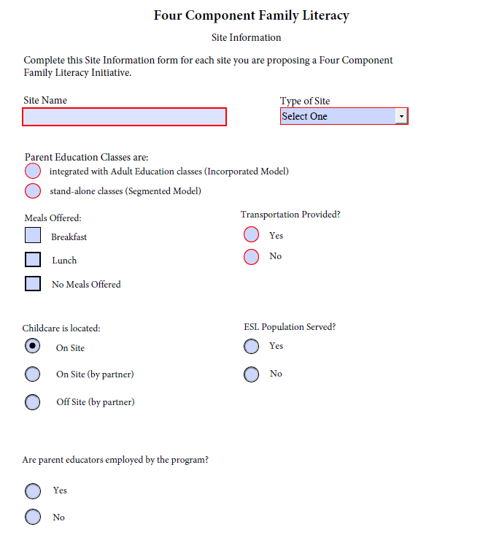

Early Care and Education Career Pathway Site Information Form

Screenshot below is for informational purposes only.
Complete the fillable form located on the Family Literacy Grant Opportunity webpage for each site you are proposing an Early Care and Education Career Pathway.

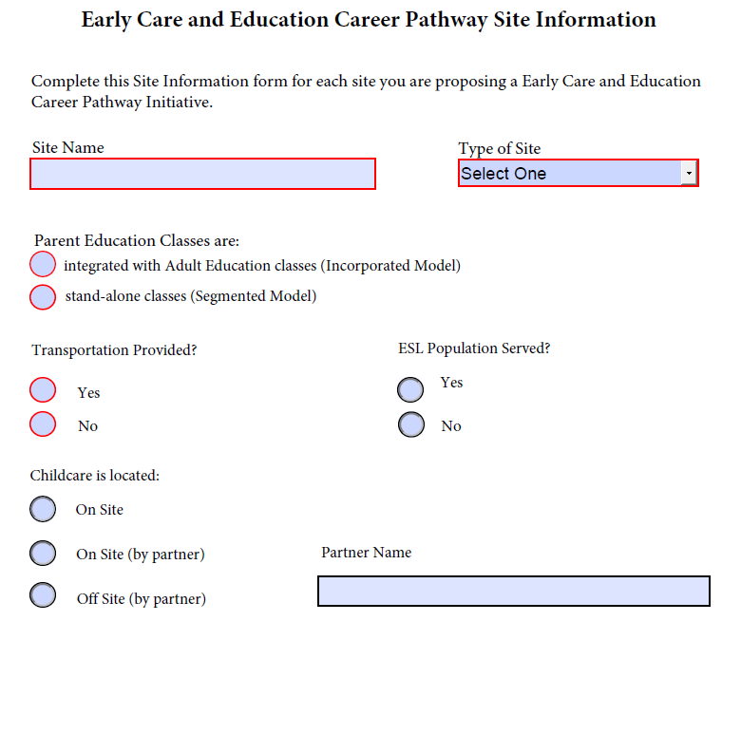

South Carolina Local Workforce Development Areas
CATAWBA  Chester  Lancaster  York | GREENVILLE  Greenville | LOWCOUNTRY  Beaufort  Colleton  Hampton  Jasper | LOWER SAVANNAH  Aiken  Allendale  Barnwell  Bamberg  Calhoun  Orangeburg
MIDLANDS  Fairfield  Lexington  Richland | PEE DEE  Chesterfield  Darlington  Dillon  Florence  Marion  Marlboro | SANTEE-LYNCHES  Clarendon  Kershaw  Lee  Sumter | TRIDENT  Berkeley  Charleston  Dorchester
UPPER SAVANNAH  Abbeville  Edgefield  Greenwood  Laurens  McCormick  Newberry  Saluda | UPSTATE  Cherokee  Spartanburg  Union | WACCAMAW  Georgetown  Horry  Williamsburg | WORKLINK  Anderson  Oconee  Pickens
