Note deadline extension
Request for Proposals (RFP)
Application Package

2020-21 Arts Curricular Innovation Grants—
Innovative Arts Works
Discretionary Grant

The Arts Curricular Innovation Grants (ACIG) is a grant program funded annually by
the General Assembly of the state of South Carolina, authorized by the General Appropriations Act, and administered by the South Carolina Department of Education.

Deadline for Receipt of Applications: 5:00 p.m., April 9, 2020 May 8, 2020

Technical Assistance for Applicants: 4:00 p.m., February 18, 2020

For ACIG and RFP questions, contact:
Scott Scrivner, Visual and Performing Arts Grant Manager
803-734-6019, sscrivner@ed.sc.gov

Issued by:
South Carolina Department of Education (SCDE)
Office of Standards and Learning
1429 Senate Street, Suite 607-B
Columbia, SC 29201

TABLE OF CONTENTS

PART I: General Information 1
A. Introduction and Purpose 1
B. Eligible Applicants 2
C. Timeline of Granting Process 2
D. Technical Assistance Sessions for Applicants 2
E. Statutory and State-Level Program Requirements 2
F. Authorized Activities 3
G. Unauthorized Activities 4
H. Program Accountability and Monitoring 4
I. Fiscal Operations 8
J. Supplement, Not Supplant 8
K. Review and Selection Process 8
L. Appeals Process 9

PART II: Application Overview, Content, and Instructions 10
A. Application Overview 10
B. Application Narrative Format 11
C. Online Application Submission 11
D. Application Narrative Content 12
1. Project Abstract 12
2. Needs Assessment 12
3. Academic Standards Implementation 13
4. Goal and Objectives 14
5. Strategies and Action Steps/Activities 14
6. Project Evaluation and Dissemination Plan 15
7. Past Performance of Grant Manager 16
8. Budget Narrative and Budget Summary 17
9. Timeline of Activities 20
E. Appendices 20
F. Deadline and Submission Procedures 22
G. Screenshots of Online Application Submission Forms 22

Appendix A: Definitions of Terms Used 30

Appendix B: Selection Criteria and Reviewers’ Scoring Rubric 32

Appendix C: Required SCDE Forms 42
Certification Signature Page 42
Assurances and Terms and Conditions for State Awards 43
Arts Curricular Innovation Grant Manager Past Performance Form 46

Appendix D: Other Forms and Information 47
Professional Development Summer Arts Teacher Institutes 47
2020 SCDE Professional Development Summer Arts Teacher Institutes Participation Form 52
Letter of Agreement for SCAAP Participation 53
Timeline of Activities Template 54
CLIA Lesson Plan Template 55

PART I: General Information

Introduction and Purpose

The South Carolina General Assembly annually allocates funds to the South Carolina Department of Education (SCDE) for arts curricular programs under the Education Improvement Act (EIA). The SCDE administers these funds in accordance with the legislative proviso:

1A.8. (SDE-EIA: XII.A.1-Arts in Education) Funds appropriated in Part IA, Section 1, XIII.A.1. Arts Curricula shall be used to support innovative practices in arts education curriculum, instruction, and assessment in the visual and performing arts including dance, music, theatre, and visual arts which incorporates strengths from the Arts in Education sites. They shall also be used to support the advancement of the implementation of the visual and performing arts academic standards. These funds shall be distributed to schools and school districts under a competitive grants program; however, up to thirty-three percent of the total amount of the grant fund shall be made available as “Aid to Other Agencies” to facilitate the funding of professional development arts institutes that have been approved by the State Department of Education for South Carolina arts teachers, appropriate classroom teachers, and administrators. Arts Curricular Grants funds may be retained and carried forward into the current fiscal year to be expended in accordance with the proposed award. (2019–20 General Appropriations Act, Proviso 1A.8.)

The purpose of the 2020–21 Arts Curricular Innovation Grants (ACIG) is to assist schools and districts in developing and implementing arts initiatives that support quality arts education programs that significantly improve student achievement in the arts. ACIG funds must be used to develop quality comprehensive and sequential arts programs (dance, music, theatre, and visual arts) that operate during the regular school day. The ACIG features three grant programs—the Distinguished Arts Program (DAP) grant, Innovative Arts Works (IAW) grant, and the Arts Teacher Institute Grant. This Request for Proposals (RFP) is specific to the Innovative Arts Works grant. The RFP for the DAP grant and Arts Teacher Institutes grant is issued separately.

Innovative Arts Works grants are designed to support limited, small-scale, innovative arts projects. Funding is not continuous. Applicants must apply annually to be considered for funding. Successful proposals will include dance, media arts, music, theatre, visual arts, or any combination of these arts areas.

Approximately $110,000 will be allocated for the 2020–21 ACIG to support approximately 25 new Innovative Arts Works grants: 5 awards for school districts and 20 awards for schools. The maximum Innovative Arts Works grant award to a school district is $6,000, and the maximum grant award to a school is $4,000. The SCDE is not bound by any estimates in this notice. All funding is contingent upon appropriations from the South Carolina General Assembly.

The grant period for an Innovative Arts Works award is July 1, 2020, through May 28, 2021, subject to the availability of funds and the grantee meeting all project requirements. All goods and services must be received and activities and purchases must be completed by May 28, 2021. Grants are not transferable. The SCDE reserves the right to replicate, adapt, and publish materials developed with funding from the ACIG Innovative Arts Works grants.

Eligible Applicants

All South Carolina K–12 public schools and school districts are eligible to apply for only one grant type—either an Innovative Arts Works grant or a Distinguished Arts Program (DAP) grant—under the ACIG program.

A school may submit only one grant application for either an Innovative Arts Works grant or a DAP grant. Multiple schools within a district may apply and receive school-level Innovative Arts Works grants if their district does not submit a DAP grant application.

If a school district submits a DAP grant application, schools within that district are ineligible to submit a grant application under the ACIG program. For the purposes of this RFP, a school district is defined as a local educational agency that serves students on multiple campuses.

Schools and school districts that fail to submit the required annual/final reports for any currently funded ACIG program will not be considered for an award during this funding cycle.

Timeline of Granting Process

Date | Activity/Action
February 18, 2020 | Technical assistance session
April 9, 2020 May 8, 2020 | Deadline for receipt of applications
August 2020 | Notification of awards
July 1, 2020 | Funding period begins; Innovative Arts Works projects can begin
May 28, 2021 | Funding period ends; Innovative Arts Works projects end
June 11, 2021, or end of 2020–21 project activities (whichever occurs first) | Innovative Arts Works final evaluation report and fiscal report due to SCDE

Technical Assistance Sessions for Applicants

The Office of Standards and Learning will offer a pre-application technical assistance session via Adobe Connect on February 18, 2020, from 4:00 p.m. until 5:30 p.m. No password is required to join the session. Participants should enter their full names when logging in to the session. Participants will be able to log in 30 minutes prior to the start of the session to test their equipment’s settings and to download/print handouts. While participation is not mandatory in order to submit an application, it is highly recommended.

Statutory and State-Level Program Requirements

ACIG-funded Innovative Arts Works projects must
- promote innovative development and implementation of appropriate curricula, instruction, and assessment based on the 2017 South Carolina College- and Career- Ready Standards for Visual and Performing Arts Proficiency (2017 Standards); and
- serve as the foundation to support quality arts instruction and the growth of dance, music, theatre, and visual arts programs in South Carolina schools.

To determine needs at the individual site for implementing the 2017 Standards, applicants must conduct a needs assessment using the Opportunity-to-Learn: Standards (OTLS) for Arts Education Worksheets. If the arts program has additional needs that do not align with the OTLS, such as program promotion or advocacy needs, the applicant may use another needs assessment but must provide justification for using the alternative survey tool.

Applicants should review the Assurances and Terms and Conditions for State Awards (on pages 43–45) to ensure that, if awarded a grant, they are capable of full compliance, especially with all the referenced state laws, in order to enter into an agreement with the SCDE for this project. Pursuant to S.C. Code Ann. § 8-13-700 (Supp. 2019), the applicant must disclose any potential conflict of interest to the SCDE in accordance with the SC Ethics Reform Act conflict of interest policy. A signed Certification Signature Page (see page 42) is required with the grant application and legally binds the applicant to the agency’s Assurances and Terms and Conditions.

Authorized Activities

Innovative Arts Works applicants may budget grant funds for any or all activities as detailed below:
- Plan, develop, and purchase resources to implement arts education curricula, instruction, and assessment based on the 2017 South Carolina College- and Career- Ready Standards for Visual and Performing Arts Proficiency (2017 Standards).
- Hire certified arts specialists or contract with professional artists approved by the South Carolina Arts Commission (SCAC). All artists must be listed by name and the topics and 2017 Standards that they will address. Applicants should place this information in the Strategies and Action Steps/Activities narrative section D.5 of the grant application. (For an applicant to contract with an artist other than those on the SCAC Artist Roster, the desired artist must provide a unique service not found on the roster. Justification for contracting with an artist not on the SCAC Artist Roster must be provided for funding for the artist to be allocated.)
- Provide teacher professional development programs for arts specialists or appropriate classroom teachers. These may include professional development Summer Arts Teacher Institutes that are approved by the SCDE (see the list of Professional Development Summer Arts Teacher Institutes on pages 47–51).

In addition, all Innovative Arts Works applicants that are elementary schools have the option to participate in the administration of the South Carolina Arts Assessment Program (SCAAP) as a major part of an ongoing needs assessment and evaluation. The objective of SCAAP is to allow educators and school districts to assess students' arts achievement based on the 2017 Standards. Each test includes multiple-choice items and performance tasks. SCAAP items and tasks have been developed by arts educators from across the state and were field-tested in fourth-grade classrooms. Test items reflect the implementation of the 2017 Standards.

Specific SCAAP Requirements:
- All districts that receive an Innovative Arts Works grant and choose to participate in SCAAP will select three elementary schools to participate in the assessments. The arts grant manager must complete the Letter of Agreement for SCAAP Participation form for the three schools, including their principals’ and arts teachers’ consents, to participate in SCAAP. All completed Letter of Agreement for SCAAP Participation forms must be submitted with the grant application.
- For a school-level ACIG application, the grant manager will complete the Letter of Agreement for SCAAP Participation form for his or her elementary school.
- A minimum of 100 fourth-grade students in schools that receive an Innovative Arts Works grant and opt to participate in SCAAP must participate in each of the music and visual arts multiple-choice assessments. In addition, at least 40 students from each school must complete each of the music and visual arts performance tasks. The designated district arts grant manager will collaborate with the University of South Carolina, College of Education, Evaluation, and Measurement Center (formally known as the Office of Program and Evaluation) personnel to provide professional development and to administer the test. The SCAAP program director can be contacted via e-mail at SCAAP@mailbox.sc.edu.
- Personnel from the school or district are responsible for selecting the students and administering the test.

Applicants do not need to budget for SCAAP administration. Applicants should indicate SCAAP participation by checking the appropriate box on the online form and by submitting the SCAAP participation form located on page 53. Applicants may include in the proposal budget an expenditure of no more than two substitute days per test administrator for SCAAP.

Unauthorized Activities

Innovative Arts Works grant funds may not be used for or to support out-of-state travel, graduate-level courses, or professional memberships. Costs for food, snacks, and meals are unallowable. ACIG grant funds may not be used for new construction or capital improvements to existing structures such as carpet and laminate covering. Applications based on the 2010 South Carolina Visual and Performing Arts Curriculum Standards are not eligible for funding and will not be reviewed. Indirect costs are not allowed.

Program Accountability and Monitoring

The SCDE is responsible for monitoring the ACIG Innovative Arts Works grant implementation in accordance with the following program accountability requirements:
- Each applicant receiving funding through this RFP meets the eligibility requirements for the grant described herein, and the applicant has provided all required assurances that it will comply with all program implementation and reporting requirements established through this RFP.
- Each applicant receiving funding through this RFP appropriately uses these funds as described in this application package.
- Each applicant implements activities funded through this application within the timeframe in which the funds provided are to be used.

To fulfill its monitoring responsibilities, the SCDE requires grantees to submit appropriate fiscal and program documentation following guidance provided by the SCDE program office.

Applicants may be subjected to an evaluation of their financial system, internal controls processes, and policies and procedures by the SCDE’s Office of Auditing Services before a grant award is issued or during the grant term. The review process and procedures are accessible at http://ed.sc.gov/finance/auditing/pre-award-audit-resources/.

Applicants awarded grant funds must satisfy periodic reporting and accountability requirements throughout the term of the grant. Such grantees may be required to submit an interim and final report to the SCDE. These requirements address the following areas: (1) program accountability; (2) performance reporting; (3) project budget; (4) monitoring; (5) program evaluation; and (6) technical assistance.

    - Program Accountability
Each grantee is responsible for carrying out its responsibilities in accordance with the Arts in Education Proviso (see page 1) and the approved grant work plan and budget. Grantees are also required to submit periodic reports to the SCDE to report on the use of grant funds and the progress of grant activities.

    - Performance Reporting
Performance reporting requirements include those for both programmatic reporting and fiscal reporting. The grantee is responsible for ensuring that all reports are accurate, complete, and submitted on time. Achievement of grant goals and objectives will be monitored through the final report process.

Programmatic Reporting Requirements
All grantees must submit a final evaluation report to the SCDE’s Office of Standards and Learning by June 11, 2021, or at the conclusion of the project’s activities, whichever occurs first. Grantees will receive directions for completing the final report. Failure to submit this report on time may eliminate the applicant from consideration in subsequent ACIG funding cycles.

Districts receiving ACIG funds must document how the grant funding affected student achievement in the arts and implementation of the 2017 Standards at all participating schools in the district.

In addition, grantees must include with the final report a Curriculum Leadership Institute in the Arts (CLIA) lesson plan by each arts teacher who participated in grant activities. Each teacher involved in the grant project must develop a CLIA lesson plan (see page 55 for template) that focuses on at least one 2017 standard that was listed in the Academic Standards Implementation section of the Application Narrative and taught during the grant period.

The final project evaluation report must include all of the following:
- A one-page, double-spaced abstract summarizing the number of students, teachers, and greater learning community affected by the grant and the grant activities, including a list of accomplishments of the arts program supported by grant funding.
- A narrative that includes a clear explanation of
  - how the project was evaluated;
  - how this grant affected student achievement in the arts;
  - how the 2017 Standards were implemented;
  - the extent to which the goals and objectives were achieved and strategies were implemented; and
  - an explanation of how grant activities will be institutionalized after the grant cycle.
- Support materials that include
  - an itemized report of expenditures aligned with the approved budget, including details and the benefit of each expenditure;
  - copies of the evaluation tools used to measure the goals and objectives;
  - copies of curriculum guides, printed resources, and other instructional materials developed as a part of the grant project; and
  - copies of lesson plans, developed as part of the grant project, that follow CLIA-format lesson plans from all teachers affected by the grant, including all teachers who attended Summer Arts Teacher Institutes (see CLIA Lesson Plan Format and Explanation)

Fiscal Reporting Requirements
All expenditure reports must be submitted through the SCDE’s grants accounting processing system (GAPS). GAPS training will be provided to grantees. Submission of expenditure reports will be accepted monthly but is required at least quarterly throughout the grant award period (see the following table). Grantees are responsible for ensuring that reports are accurate, complete, and submitted on time. Grantees must submit a final fiscal report to the SCDE that covers the duration of the grant award.

Fiscal Reporting and Expenditure Claim Due Dates
for ACIG Innovative Arts Works Grants
Reporting Period | Report Due Date
July 1–September 30, 2020 | November 10, 2020
October 1–December 31, 2020 | February 10, 2021
January 1–March 12, 2021 | May 10, 2021
March 13–May 28, 2021 | June 11, 2021

- Project Budget
A project budget of projected expenditures to be funded by the ACIG grant must be submitted with the application. Approved budgets must be uploaded into GAPS by grantees following grant award notification and prior to submitting any reimbursement payment requests. Training on uploading budgets will be provided to grantees.

- Monitoring
The SCDE will monitor grantees by reviewing and approving the GAPS expenditure report claims and the final financial report as well as by reviewing the progress reports and annual performance reports. All information in reports is subject to verification.

The SCDE may conduct programmatic and financial monitoring site visits. Grantees must agree to site visits conducted by the SCDE or state program representatives. The purpose of site visits is to validate information provided in fiscal and program reports and to gather more detailed information on implementation efforts and challenges from interviews and observations for monitoring and evaluation purposes.

The SCDE may require additional information from the grantee, verify information with the authorizing agency, or require the submission of additional documentation including, but not limited to, invoices, receipts, and personnel time and effort reports. Prior to a site visit, the grantee may be required to submit additional relevant information that will allow the SCDE to conduct a useful, efficient, and effective visit. The SCDE may require electronic submission of documents instead of a paper-copy submission.

SCDE staff will verify the contents of documentation submitted. Grant recipients may be asked to revise reports when
- non-allowable expenses are found;
- reports are confusing or difficult to understand; or
- there are unexplained discrepancies between the proposed use of grant funds, as provided in the project budget, and actual expenditures found in the submitted documentation.

- Program Evaluation⎯Grant Recipient Project Monitoring and Evaluation
Grantees are required to conduct ongoing monitoring and evaluation to ensure project goals are achieved. Progress toward meeting project goals is to be reported through the final report process.

A final project evaluation report is to be completed before the end of the grant period. The final evaluation report must address project success toward each goal stated in the application. If a grantee fails to conduct the final project evaluation report before the end of the grant period, or if any of the performance requirements in section H.2 are not completed, the SCDE may consider the grantee a high risk and elect to discontinue funding or disqualify the grantee from future funding opportunities.

Grantees should report
- the number of students and teachers who started in the Innovative Arts Works project and how many finished;
- the extent to which the students successfully met the stated 2017 Standards for the project;
- the challenges encountered if students did not meet the stated 2017 Standards; and
- the impact that the services, materials, and equipment supported by the grant had in raising student participation in the arts and enabling the implementation of the 2017 Standards.

- Technical Assistance to Grantees
Grantees are required to participate in all technical assistance that the SCDE may conduct for the ACIG Innovative Arts Works grant. Delivery of such technical assistance may include webinars and conference calls.

Fiscal Operations

Grantees must use grant funds for allowable grant expenditures during the grant period. ACIG grant funds are disbursed on a reimbursement basis. The SCDE will deobligate any unspent funds remaining at the end of the grant period. Matching or in-kind funds are not required.

Allowable Costs
Grant funds must be used in accordance with the statutory and state requirements and the allowable project activities stated in section F. A grantee must use ACIG Innovative Arts Works grant funds for approved budget items to accomplish the allowable project activities.

Unallowable Costs
ACIG grant funds may not be used for purchases that do not directly support the approved project work plan. As presented in section G, grant funds may not be used for or to support out-of-state travel, graduate-level courses, professional memberships, or costs for food, snacks, and meals. ACIG grant funds may not be used for new construction or capital improvements to existing structures such as carpet and laminate covering. Indirect costs are not allowed.

Supplement, Not Supplant

Innovative Arts Works grant funds must supplement, not supplant, existing services and may not be used to supplant federal, state, local, or non-federal funds. Projects may not use grant funds to pay for existing levels of services funded from any other sources.

Review and Selection Process

The SCDE’s Office of Standards and Learning will conduct an initial review of all grant applications for completeness and compliance with application and eligibility guidelines. All required materials, including forms and appendices, must be submitted for the application to be considered complete and eligible for review. Only those applications that are received by the deadline and deemed complete by the program office will be forwarded for review and funding consideration.

Three reviewers from diverse backgrounds without a vested interest in any application being funded will evaluate each application based on the quality of the proposed activities and the capability of the applicant to implement the proposed ACIG project. The review panels will include registered graduates of the South Carolina Arts Assessment Institute or individuals with a background in assessment.

Reviewers will use the scoring rubric on pages 32–41 to read and rate each application independently. After the reviewers have individually scored an application, the three scores will be averaged. An Innovative Arts Works grant application can earn up to 100 points for an average score. Applications that fail to earn an average score of 50 or higher will not be eligible for funding.

Applications recommended for funding will be rank-ordered by averaged scores. Subject to the SCDE’s final approval and the availability of funding, grant awards will be made starting with applications that earned an average score of 80 points or higher. To the extent practical, the SCDE will award grants equitably among geographic regions within the state to include rural and urban communities. If funds remain following these awards, the SCDE will consider funding the remaining applications that earned an average score within the adequate/meets range until all funds are allocated.

The SCDE reserves the right to interview applicants recommended for funding, request additional documentation, and make site visits as appropriate to ensure compliance with state requirements.

Grant awards are not final until an SCDE grant award notice (GAN) is fully executed. Notification of funding will be sent in August 2020 to the authorized official listed on the Certification Signature Page. After the notification of awards, copies of the reviewers’ comments and score sheets will be made available upon request.

Appeals Process

An applicant who has submitted a proposal that the SCDE does not fund has 30 calendar days after receiving notification that the proposal is not funded to request a review of the process. Scores may not be appealed. An unfunded applicant may inquire as to whether or not the application process was followed. The request for review must be directed to the State Superintendent of Education and must state the reasons for the request. The Superintendent may delegate to a deputy superintendent the authority to conduct a review. The deputy superintendent will issue a decision after the review of the information submitted by the applicant and the program office. This decision will be the final decision of the agency. The applicant may appeal the agency’s decision to the Administrative Law Court under the terms of the Administrative Procedures Act.

PART II: Application Overview, Content, and Instructions

Read all guidelines and criteria carefully before preparing your application. Adhere to font, format, page limit, and organizational requirements. Only applications that include all sections and appendices and fully adhere to these guidelines will be reviewed and considered for funding. Incomplete applications will not be reviewed.

Application Overview

Applications must be submitted online. Applicants are encouraged to prepare all items for the application before beginning the online submission process. Do not wait until the last minute to submit an application. Applicants should use the following overview as a checklist to ensure that they submit a complete application with items labeled accordingly and presented in the order outlined below.

The ACIG Innovative Arts Works Grant Application is organized into the following sections (also see screenshots on pages 22–29):
- Online Forms
  - Applicant Information
  - Contact Information
  - Project Information
  - Budget Summary
- Proposal Attachments
- Application Narrative
- Table of Contents (include a page number for each item)
- 1. Project Abstract
- 2. Needs Assessment
- 3. Academic Standards Implementation
- 4. Goal and Objectives
- 5. Strategies and Action Steps/Activities
- 6. Project Evaluation and Dissemination Plan
- 7. Past Performance of Grant Manager (page 46)
- 8. Budget Narrative
- 9. Timeline of Activities (not included in page limit)
- Appendices
- 1. Certification Signature Page (page 42)
- 2. Letters of Commitment
- 3. Opportunity-to-Learn Standards (OTLS) Survey Samples
- 4. Alternative Survey Tool(s) (if applicable)
- 5. Professional Development Summer Arts Teacher Institute Participation Form (if
applicable)
- 6. 2020-21 Letter of Agreement for SCAAP Participation (if applicable)
- 7. Application Overview as Checklist (copied from this page)

Application Narrative Format

Length of Narrative: | Maximum of 10 pages, not including the table of contents, Project Abstract, Timeline of Activities, and Budget Narrative.
Required Font/Font Size: | Times New Roman/12 or Arial/12.
Margins: | 1” on all sides.
Page Numbers: | Number all pages in narrative consecutively at bottom right of pages.
Spacing: | Double-space all sections of the Application Narrative. Text in tables and charts may be single-spaced.
Final File Format: | PDF document.

Each section must be clearly identified using the numerals and headings provided in the following instructions. Sections may not be combined. Reviewers will not score information requested in one section that is provided in another section. Incomplete proposals will not be considered.

Online Application Submission

Applications must be submitted using the online application form. The online application form is only accessible by the links provided in this RFP and on the grant opportunities Web page dedicated to this funding opportunity. The online application is organized into two sections—Online Forms and Proposal Attachments.

The Online Forms contains the information to be entered online. Use the screenshots on pages 22–29 to compile the following information prior to submitting your application:
  - Applicant Information
  - Contact Information
  - Grant Manager
  - District Superintendent
  - Financial Director
  - School Principal (for school grants)
  - Project Information
  - Budget Summary

Provide the school district’s nine-digit Data Universal Numbering System (DUNS) number and the Taxpayer Identification Number (TIN) in the online application form. The DUNS number is a unique identifier assigned by Dun & Bradstreet, Inc. (D&B). Applicants should contact their district’s finance office for assistance with these items.

Use the following instructions to compile and complete all proposal attachments prior to submitting your application. Verify that all components of the narrative and appendices are included prior to uploading attachments. Follow the directions in each section for saving the documents and refer to the screenshot on page 27 for upload locations.

Application Narrative Content

Use the following directions to write the Application Narrative and organize it into sections following the sequence presented below. Include a table of contents as the first page of the narrative (not included in the page limit). Do not combine sections.

When complete, save the entire narrative as a single PDF document to be uploaded into the online application where indicated in the Proposal Attachments section.

The Application Narrative for the Innovative Arts Works grant must be detailed and include a thorough description of the goals and objectives, needs assessment, standards implementation, strategies and action steps/activities, and evaluation plan for the proposed project. The narrative must also include a detailed and itemized budget.

The narrative sections must clearly relate to one another, and the logic of the narrative should flow smoothly from one section to another. Reviewers should be able to see throughout the narrative clear evidence of plans for implementing curriculum, instruction, and student assessment based on the 2017 South Carolina College- and Career- Ready Standards for Visual and Performing Arts Proficiency (2017 Standards).

The planning process for the Innovative Arts Works grant must begin with a thorough needs assessment that includes surveys using the OTLS worksheets. This assessment will reveal the needs of the individual school or district program and, as a result, help the applicant determine appropriate goals and objectives.

During the project, the progress toward meeting the stated goals and objectives should be periodically examined through formative assessment that leads to a final summative assessment or the project’s evaluation plan.

The goal of the application must be to improve student achievement in the visual and performing arts in relation to the implementation of the 2017 Standards.

Project Abstract (0 points available)

In one page, identify the applicant (school and/or district), the title of the project, and the amount of funds requested. Summarize the proposal, including the target audience and the number of students, teachers, and members of the overall education community who will benefit from the proposed project. Briefly summarize the needs, goal, and objectives; standards implementation; strategies and action steps/activities; and evaluation plans, including expected outcomes of the project.

Needs Assessment (Maximum of 20 points available)

Applicants must conduct a needs assessment using the OTLS Arts Education Program Assessment Worksheets for dance, music, theatre, and visual arts available on the SCDE website (click on the link “Opportunities-to-Learn Standards” and then select the appropriate Program Assessment). The OTLS worksheets will help applicants to identify the strengths and areas for improvement of their current arts program; identify participants’ expertise and knowledge; and help reveal the needs of students, teachers, administrators, parents, and other stakeholders in the context of the 2017 Standards. Teachers and administrators must assess their own effectiveness as well as students’ needs and outcomes.

The OTLS worksheets include the areas of curriculum and scheduling, staffing, materials and equipment, and facilities. If the arts program has additional needs that do not align with the OTLS, such as program promotion or advocacy needs, the applicant may use another form of needs assessment and must provide justification for using the alternative needs assessment. Include copies of any alternative survey assessment as an attachment (see page 21).

2.a. Summarize the needs identified for your students and the arts education program as a result of administering the OTLS survey, including the names of the survey respondents and a conclusion. Discuss what students need in terms of their abilities to apply the 2017 Standards in their work and how these needs align with the implementation of the 2017 Standards.

2.b. Discuss the resources and/or or professional development training for arts and/or classroom teachers that are needed to enable them to best implement the 2017 Standards, meet the needs identified for the arts education program, and raise student achievement in the arts.

Include as a part of the appendices (see page 21) four to five summary sheets of actual OTLS survey responses from the arts area for which you propose focusing grant funds to demonstrate the audiences surveyed (e.g., a teacher survey, a parent survey, and an administrator survey). Include only the survey summary sheets (not complete surveys) with a signature and date of the person who completed out the survey.

Academic Standards Implementation (Maximum of 20 points available)

Applicants must demonstrate how the017 Standards will be addressed in terms of instruction, curriculum, and student assessment. State specific standards and indicators and explain how they are aligned with appropriate grant activities. Standards implementation must reflect information gathered as a result of the needs assessment. Applicants addressing the Academic Standards for Media Arts and Design must do so through the integration of these standards in dance, music, theatre, and visual arts courses.

Answer the following questions in this section:
- What were the results of the most recent OTLS survey? Provide a summary, including the names of the respondents, a four to five page summary of the responses, and the conclusions. If using an alternate needs assessment, what is the justification for doing so?
- Which specific academic standards and indicators will be implemented? How are these standards aligned with identified needs, appropriate activities, and budgetary allocations?
- As a result of this proposed project, how will teachers implement the standards in terms of curricula, instruction, and assessment and how will students apply the standards in their work?

Goal and Objectives (Maximum of 20 points available)

The goal of the proposed Innovative Arts Works project must be to significantly improve student achievement in the arts through curriculum, instruction, and assessment based on the implementation of the 2017 Standards. In determining the goals and objectives of the proposed project, the applicant must address how to improve World Class Knowledge, World Class Skills, and Life and Career Characteristics as outlined in the Profile of the South Carolina Graduate (see page 31 in Definitions of Terms Used). Objectives must be determined from the needs assessment (using the OTLS survey and/or a justified alternative means of assessment); be related to implementing the 2017 Standards; and be specific, measurable, achievable, relevant, and time-specific (i.e., SMART).

Clearly describe who is to be affected by the proposed project, what changes will occur within the target population, and what the expected outcomes are for students by the end of the grant period. The objectives should indicate a logical progression and clear achievement outcomes as related to the Profile of the South Carolina Graduate at the end of the project. Well-written objectives will always answer the following question: Who is going to do what, when, and to what extent?

Answer the following questions in this section:

- What are the SMART objectives for the project to support the goal of significantly improving student achievement in the arts through curriculum, instruction, and assessment based on the 2017 Standards? How are the objectives aligned with the Profile of the South Carolina Graduate?
- Who is to be affected by the project, what art area(s) will be included, and what instructional level(s) is (are) to be addressed? What are the expected outcomes for students?

Strategies and Action Steps/Activities (Maximum of 15 points available)

Describe the planned strategies and action steps/activities to accomplish the stated goal and objectives and thereby bring about the intended growth in students’ knowledge and skills in the arts during the grant period. Applications must include and detail innovative practices to enhance, accelerate, and assure student achievement in the arts and implement the 2017 Standards. Applicants must embed innovative practices in the strategies and action steps/activities. Innovative practices include strategies to engage students more effectively in the study of the arts and offer culturally diverse opportunities in the arts, thus increasing participation. These practices should be in addition to routine practices. Strategies and action steps/activities may reflect proven practices and/or resources modeled elsewhere; however, the strategies and action steps/activities must not be copied verbatim from other sources. Strategies and action steps/activities must result from the needs assessment using the OTLS survey or alternative instrument.

Note: Any activities that require funding must be described in the Strategies and Action Steps/Activities section and must be explained in the Budget Narrative or the item(s) will not be funded.

Answer the following questions in this section:

- What strategies and action steps/activities are planned for meeting the goal and objectives?
- How will the strategies and action steps/activities bring about growth in students’ knowledge and skills in terms of the implementation of the 2017 Standards?
- What innovative practices will be used to enhance, accelerate, and ensure student achievement and engagement in the arts and implement the 2017 Standards? What research supports these practices?
- How will the materials and services budgeted support the objectives, activities, and standards?
- How will the project be sustained after the end of the funding period?

Project Evaluation and Dissemination Plan (Maximum of 15 points available)

To monitor progress and to assess impact, the applicant must include a clear, detailed evaluation and dissemination plan. The evaluation plan must include a summative assessment of the effectiveness of the project’s curriculum, instruction, and assessment in terms of student achievement in the arts. The goal and objectives must be assessed, providing evidence that the identified needs have been addressed. Therefore, efforts to provide ongoing assessment of progress (through benchmarks) throughout the implementation phase will make the evaluation more meaningful.

Carefully consider the methods that will be used to measure and document the extent to which the goal and objectives of the project are achieved. Use various types of assessments in the evaluation, such as interviews, focus groups, surveys, observation checklists, alternative assessments, criterion-referenced tests, and portfolios. Thoroughly describe the planned evaluation.

Applicants should ensure that, if funded, they will be able to report
- the number of students and teachers who started in the Innovative Arts Works project and how many finished;
- the extent to which the students successfully met the stated 2017 Standards of the project;
- the challenges encountered if students did not meet the stated 2017 Standards; and
- the impact that the services, materials, and equipment supported by the grant had in raising student participation in the arts through World Class Knowledge, World Class Skills, and Life and Career Characteristics as outlined in the Profile of the South Carolina Graduate and enabling the implementation of the 2017 Standards.

Include plans to monitor progress throughout the project by employing several phases of formative assessment and providing for continuous feedback, signals to adjust, and documentation. Describe how the data will be gathered, organized, and analyzed; how the results will be presented; and how these results justify the need for funding.

The evaluation plan is not simply a list of activities or accomplishments, nor is it a collection of receipts. Keep in mind that the realization of planned events or the purchase of resources may have little to do with high-quality learning experiences for students and their arts achievement.

Applicants planning to administer SCAAP should indicate that in this section. In addition, indicate that your school will participate in SCAAP by checking the appropriate box in the online application. The specific SCAAP requirements for Innovative Arts Works applicants are presented on page 4. Do not include SCAAP as a line item in the grant budget.

In the dissemination plan, include strategies for sharing results of the project with others, such as presentations at school board meetings and state conferences, news articles, and school-wide meetings. Identify any replicable products that will be produced as a result of the project, if applicable.

Answer the following questions in this section:

- What procedures and/or instruments will be used to measure the attainment of the goal and each objective and to assess the effectiveness of the project?
- How will data be gathered, organized, and analyzed; how often; and who will be involved?
- What will be done to modify the project should any adjustments be needed during the project year?
- How will the project results (successes and challenges) be shared and disseminated?
- What replicable products and/or strategies, if applicable, will be produced as a result of this project?

Past Performance of Grant Manager (Maximum of 5 points available)

A grant manager’s job must include time for oversight and development of arts curricula. Therefore, the grant manager’s job description must stipulate that this individual will be allowed to devote an appropriate amount of time to the oversight and management of the arts grant project, to the development of arts curricula, and to the professional development of district/school arts educators (if applicable).

The arts grant manager must be certified in at least one arts area or be responsible for arts education leadership/oversight within the school or district. A grant manager must be assigned to only one Arts Curricular Innovation Grant. Grant managers must not manage multiple ACIG grants.

Complete the ACIG Manager Past Performance Form (page 46) and insert it in this section of the Application Narrative. The grant manager must be the same person listed as the grant manager in the online application. Remember that the applicant for the grant is the district or school name.

Budget Narrative and Budget Summary (0 points available)

All applicants must submit an appropriate budget. While the budget receives no points, an inaccurate, unreasonable, unjustified, or non-itemized budget will result in the application being excluded from consideration. The proposed budget must provide clear evidence that the expenditures are appropriate and justified to support the strategies and action steps/activities. Budget items not explained in the Application Narrative will not be funded. Consult with the district’s financial director for the amount of purchases to be included under the capital outlay category.

Up to 30 percent of the proposed budget may be allocated for scholarships for arts teachers to attend the Summer Arts Teacher Institutes (listed on pages 47–51), including the costs of reasonable accommodations for persons with disabilities who are attending SCDE-approved professional development activities (e.g., interpreters). This amount must be included in the total grant funds requested by applicants but will not be reflected in the final awards released to the school districts. The funding for the institutes will be held by the SCDE and paid directly to the institute providers.

Elementary schools have the option of participating in SCAAP for the Innovative Arts Works grants at no cost but must indicate their desire to do so in the Application Narrative and the online application. Costs for SCAAP participation should not be included in the budget. The $3,000 assessment cost per school will be automatically calculated in the Total ACIG Project Budget section of the Budget Summary in the online application based on the number of schools to be served (see page 27).

The application budget consists of two parts: the Budget Summary and the Budget Narrative. All proposed expenditures for the grant funding period must be itemized in the Budget Summary and detailed in the Budget Narrative. Budget items not explained in the Application Narrative will not be funded.

- The Budget Summary is the financial overview of the project and must reflect all proposed expenditures for the project. Each line item of the Budget Summary must correspond to the individual line items of the Budget Narrative (discussed below). Provide the Budget Summary in the online application Budget Summary section. A separate line item in the online Budget Summary is included for funds allocated for the Summer Arts Teacher Institutes, if applicable. Do not include in-kind/match. Indirect costs are not allowed.

- The Budget Narrative (double-spaced, maximum of four pages) must provide clear evidence that the budget is appropriate and justified based on the proposed activities resulting from the needs assessment and the implementation of the 2017 Standards. This Budget Narrative must include an itemized expenditure list that details the specific planned expenditures, such as salaries/stipends, employee benefits, purchased services, supplies/materials, and other objects. Do not list budget items in broad, general categories such as arts supplies, planning activities, or costumes. Structure the Budget Narrative line-item categories to parallel the line-item categories of the Budget Summary. Include all formulas used to calculate each line-item expense. Artist residency topics should be specific and cite the artist(s) by name. Applicants should contact artists for residency costs. Do not submit purchase orders for itemized lists. Be sure that the totals reflected in this narrative equal the totals presented in the Budget Summary. When finalized, insert the Budget Narrative as section 8 of the Application Narrative.

All expenditures of funds received under this grant must be audited by a certified public accountant as a part of the district’s annual audit. Check all budget references to assure that totals are the same throughout the grant application (Budget Narrative, itemized lists, and Budget Summary).

Budget Categories (Object Codes)

Expenditure categories are grouped by “object” codes on the budget report form. Applicants should seek the assistance of the district financial official to ensure that expenses are properly identified and entered in correct categories on the budget report form. The district financial official must sign the Certification Signature Page form (page 42).

The following descriptions identify the services/items that should be budgeted to each category. Applicants should only budget items essential to carry out the proposed Innovative Arts Works grant activities.

Salaries/Stipends (100)
This category includes substitute teacher pay, stipends for teachers, and salaries for employees within the district. Applicants that budget for salaries must also budget for Employee Benefits (200). Applicants that opt to participate in the SCAAP may include in the project budget an expenditure of no more than two substitute days per test administrator.

Employee Benefits (200)
Payroll taxes, workers’ compensation, health insurance, and other worker-benefit costs will be included here. These costs will represent a percentage of the total in Salaries/Stipends (100). Applicants should consult the district’s finance office for the appropriate benefits based on budgeted salaries.

Purchased Services (300)
Expenses such as consultant fees, artist residencies, travel/transportation costs, telephone services, and other purchased services will be included here. Amounts paid for personal services rendered by personnel who are not on the payroll and for other special services purchased by the organization are allowable. While a product may or may not result from the transaction, the primary reason for the purchase is the service provided. Note: Funds allocated for professional development Summer Arts Teacher Institutes should be entered in the Summer Arts Teacher Institutes Funds Budgeted line item of the Budget Summary and not under Purchased Services (300).

For a grantee to pay a vendor with state funds, a contract must be in place. At a minimum, the contract should include the scope of services, the duration of the contract, and the method and amount of payment; the contract must be executed by both parties. Consulting/service contracts (excluding contracts with SCAC-approved artists-in-residence) must be procured in accordance with SC Procurement Law (see https://procurement.sc.gov/legal/procurement-law). A copy of each contract must be submitted to the program office within 30 days of receipt of the official grant award from the SCDE.

Applicants/grantees must ensure that they do not enter into a contract with any vendor that is debarred, suspended, or ineligible for participation in federal programs by
- checking the Excluded Parties List (EPLS) at the federal System for Award Management (SAM) website⎯https://www.sam.gov/SAM/ (Applicants are encouraged to review the user guides for exclusions provided via the “Help” page prior to conducting searches.);
- collecting a certification from the vendor and attaching it to the contract; or
- adding a clause or condition to the contract that indicates the vendor is eligible.

Supplies and Materials (400)
Amounts paid for material items of an expendable nature are included here. Itemize every item and make sure that such expenditures are aligned with relevant program characteristics (objectives, number of participants, frequency of activity, etc.).

Capital Outlay/Equipment (500)
Identify type and specify quantity. The cost threshold for equipment is determined by each district. Contact your district finance office for the threshold for your district. Any electronic or equipment item requested that costs below the threshold must be budgeted under the Supplies and Materials (400) category.

Other Objects (600)
This category includes expenditures that do not neatly fit into the other categories above, such as postage, copyright fees, or those expenditures deemed appropriate by the district.

The SCDE reserves the right to disqualify, disallow, and negotiate costs associated with any line item proposed in the budget that are unallowable, unreasonable, or inconsistent with the program’s goals or the proposed project’s activities and strategies. If any line item cost is determined to be excessive, given the nature and scope of the entire project or of a particular activity, the SCDE can request the applicant reduce the cost of the line item or ask the applicant to assume a portion of the cost before the budget is approved and funds are awarded.

Funds will be disbursed on a reimbursement basis upon receipt of expenditure reports with all supporting documentation. Grantees may not obligate funds prior to the receipt of a grant award notice. No expenditures incurred prior to July 1, 2020, will be reimbursed.

Timeline of Activities (Maximum of 5 points available)

Complete a chronological Timeline of Activities for each objective that indicates the major strategies and action steps/activities of the project and the personnel responsible for each activity (see the template on page 54). Construct the chronology only after thoroughly investigating the time required to plan, execute, and evaluate each activity. Include plans to gather continuous feedback and monitor progress regularly and frequently using several phases of formative assessment.

The timeline should include ordering and receiving supplies; scheduling adequate facilities; arranging professional development workshops; planning for and administering SCAAP (if applicable); registering for and attending summer institutes; scheduling and preparing for staff meetings; meetings with parents; disseminating project information; evaluating the project; and submitting necessary reports. The Timeline of Activities does not count toward the narrative page limit.

Appendices

The following information is required. All sections of the appendices must be scanned into a single PDF document in the order in which they are listed on page 10. The single PDF document should be uploaded into the appendices section of the online application system where indicated in the screenshot on page 27.

- Certification Signature Page
Print the Certification Signature Page (see page 42) and obtain the appropriate signatures. Note: This form includes certification of the SCDE’s Assurances and Terms and Conditions for State Awards and any applicable program-related conditions conveyed in this RFP. Those documents are not required to be included in the application submission. However, retain the copy included in this RFP for your records and ensure that the signatories have copies of all documents.
By signing the Certification Signature Page, the signatories assure that they will comply with all the assurances and terms and conditions for the project. All signatories must understand that they are signing a document that is legally binding in the event a grant is awarded. Applications that do not include the signed Certification Signature Page will not be reviewed or considered for funding.

- Letters of Commitment
To be considered complete and acceptable for review, the Innovative Arts Works grant application must include two letters of commitment. These letters must verify strong support for the project and contain a statement from the district superintendent or school principal that the ACIG funds will be used solely for the stated purposes of the proposed arts project.

For a district application, the participating district superintendent must write one letter, and another participating administrator, teacher, community leader, or other stakeholder may write the other letter.

For a school application, the district superintendent must write one letter, and the participating school principal must write the other letter.

The grant manager or grant writer may not write a letter of commitment; however, a principal who will serve as the grant manager must write a letter of commitment.

- Opportunity-to-Learn Standards (OTLS) Survey Samples
Include, as a sample, four to five survey responses of the actual OTLS survey administered to represent the audiences surveyed (e.g., a teacher survey, a parent survey, and an administrator survey) as described on page 13. For an Innovative Arts Works Grant you are only required to complete the surveys for the arts area(s) to be supported by this grant funding.

- Alternative Survey Tool (if applicable)
Include a sample of any alternative survey tool used in the needs assessment. Applicants are allowed to use an alternative survey tool if the content of the OTLS survey does not cover their arts program needs.

- Professional Development Summer Arts Teacher Institute Participation Form (Optional)
For applicants planning to attend Summer Arts Teacher Institutes, complete and include the Professional Development Summer Arts Teacher Institute Participation Form (see page 52). Provide the teacher’s name and the institute that the teacher plans to attend. Applicants will not be held to this list; however, it will provide the institute planners with an idea of the need for specific professional development Summer Arts Teacher Institutes.

- 2020-21 Letter of Agreement for SCAAP Participation (Optional)
Applicants choosing to participate in the administration of SCAAP should complete and include the 2020-21 Letter of Agreement for SCAAP Participation form (page 53). Applicants must indicate their SCAAP participation in the online application and address their intent in the Strategies and Action Steps/Activities section of the narrative. Applicants should not include the costs of participation in SCAAP in their total grant funds requested. The funding allocated for SCAAP will be automatically included in the Total ACIG Project Budget section of the online application based on the number of schools selected to be served. Refer to the specific SCAAP Requirements for Innovative Arts Works Applicants on page 4.

- Application Overview as Checklist
Copy the Application Overview on page 10, indicate all application items included in the submission by checking the appropriate boxes, and submit this page as the application checklist.

Deadline and Submission Procedures

- Applications must be submitted using the online application form no later than 5:00 p.m. on April 9, 2020 May 8, 2020. Applications received after this deadline will not be considered.
- Only applications that adhere to all of the guidelines and directions in this RFP will be reviewed and considered for funding. Complete applications must include two letters of commitment. District- and school-level grants must include a letter from the superintendent, and school grants must include a letter from the principal (see page 21).
- No hard copy applications will be accepted. Applications delivered by hand, mail, electronic mail (e-mail), or fax will not be accepted.
- Applications must originate from the applicant. Applications that are plagiarized from the Internet, other grants (including previous ACIG grant applications from other schools and districts), or resources will not be considered for funding. In the case of two or more applicants submitting identical or extremely similar proposals, all involved applicants will be excluded from consideration. ACIG proposals should reflect the individual needs and planning of the applicant school or district as determined through their needs assessment using the OTLS survey (see pages 12–13).
- Applications will not be returned. Keep a copy of the entire application for your records.

Screenshots of Online Application Submission Forms

The following screenshots are for informational purposes only and are provided to assist applicants in compiling all elements needed to complete the online submission. Complete the attachments for the online application as directed in the preceding instructions. The SCDE encourages applicants to prepare all elements of the application prior to beginning the online submission process. Make sure all information submitted is accurate, including formal or official names of organizations and contacts, and that spelling is correct. Do not use abbreviations or acronyms.

If necessary, you may save your progress and return to the form later. Click on the “Save and Resume Later” link to save your progress. You will be given the option of copying and saving the link to the partially completed form or entering an e-mail address to have the link e-mailed to you. Be sure to enter the e-mail address correctly as SCDE personnel cannot access the link or the incomplete application. Using this link, you can access the application from any computer within thirty days to complete the online submission. Without the link or after thirty days, the data previously entered cannot be retrieved, and you will have to begin a new application.

A saved application is not a submitted application. You must follow all of the steps described on page 27–28 to complete the submission process. Fields denoted by a red asterisk are required fields; applicants will not be able to proceed to the next screens of the application without entering this information.

Select the applicant type (school or school district). Enter the official name of the applicant organization and mailing address with the 10-digit ZIP Code (ZIP+4 Code). The applicant name entered must match the district’s name as registered with Dun and Bradstreet, Inc. Enter the nine-digit DUNS number and the TIN for the school district.

If the district is the applicant organization, select the number of schools to be served (up to three). Provide a descriptive title for the project.
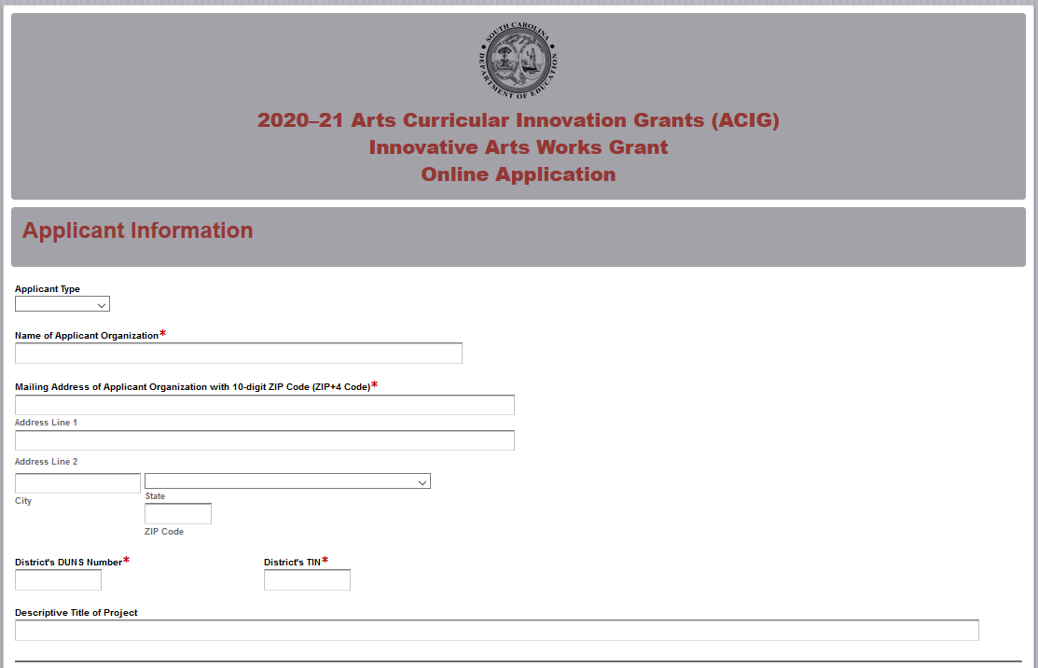
If the applicant organization is a school, you will be prompted to enter the name and mailing address of the school district in addition to the information requested above. Select the grade level to be served by the project.
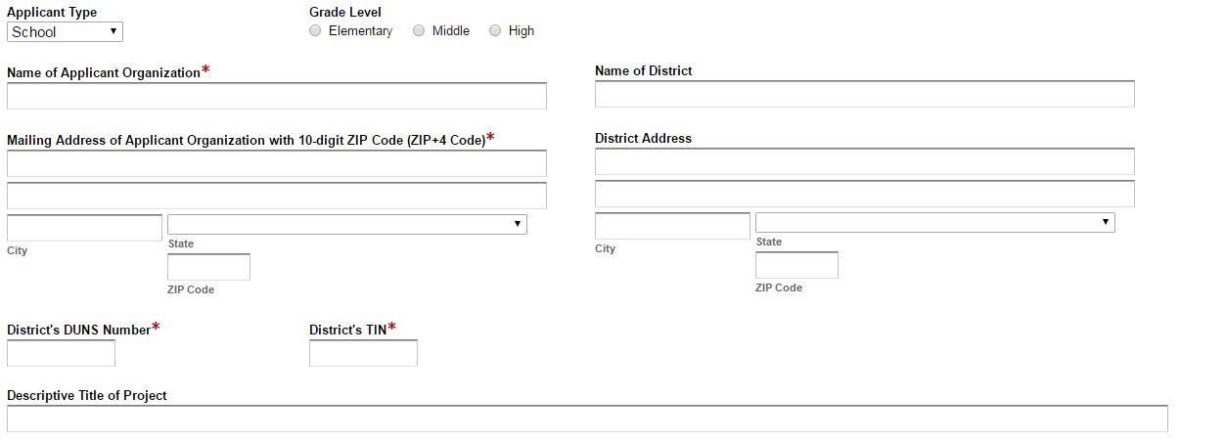
Enter the contact information for the grant manager. The name entered in the online application must match the name as shown on the Certification Signature Page. Select “Same as Applicant Organization’s Address” if the school’s mailing address is the same as the information entered on the first screen. The data will automatically populate these fields. If the address is different, enter the appropriate information. The grant manager’s e-mail is a required field. The confirmation of a successful online application submission will be sent only to this e-mail address. Reenter the e-mail address to validate that it is correct.
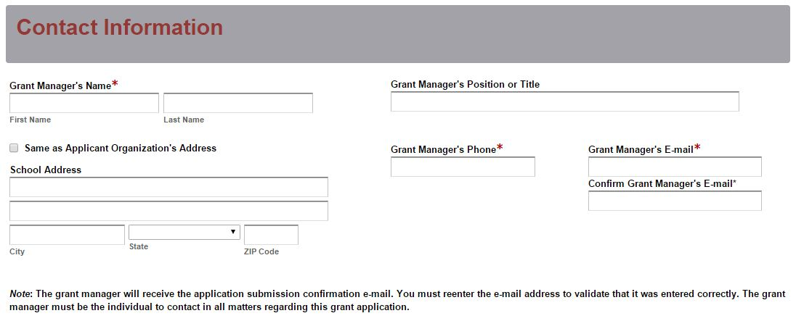
Enter the contact information for the district’s superintendent and finance director. The names entered in the online application must match the names on the Certification Signature Page. Select “Same as Applicant Organization’s Address” or “Same as District’s Address” if the superintendent’s mailing address is the same as the information entered on the first screen. The data will automatically populate these fields. If the address is different, enter the appropriate information.
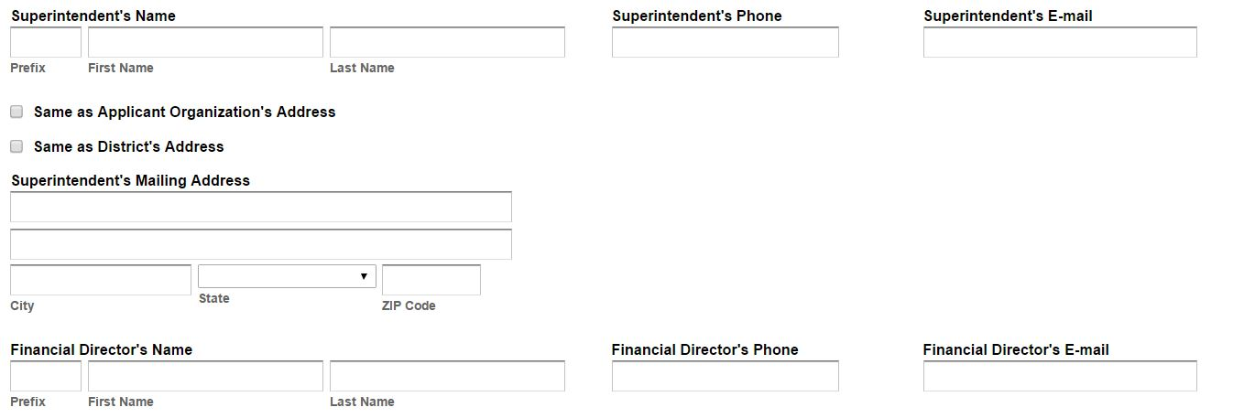
For school applicants, enter the principal’s contact information. The name entered in the online application must match the name on the Certification Signature Page.
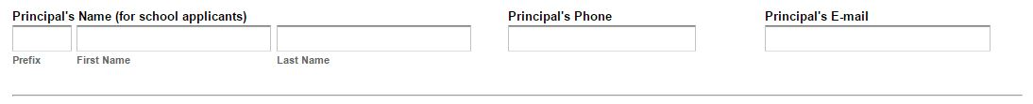
Select all of the applicable arts areas that the project will address. For applicants that are elementary schools, indicate whether or not the school will participate in SCAAP. Indicate whether or not the district or school will participate in the Summer Arts Teacher Institutes. Enter the number of students, teachers, and members of the overall education community who will benefit from the proposed project.
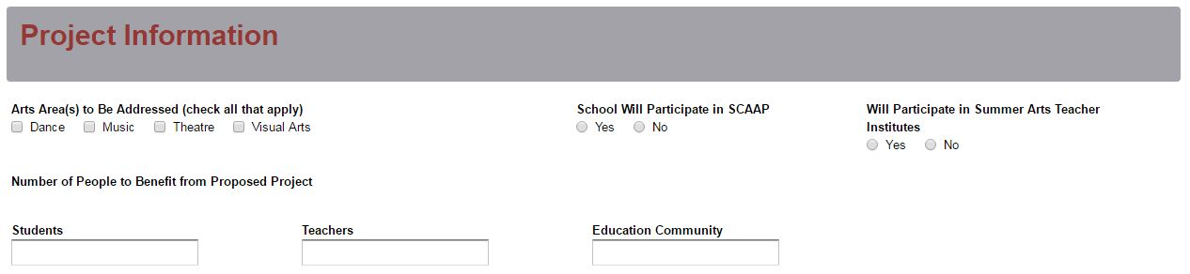
District applicants must provide the name(s) of the school(s) that will participate (up to three). For each school, indicate the grade level. For each elementary school to be served, indicate whether or not the school will participate in SCAAP.
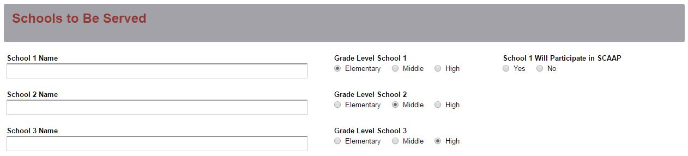
Provide a brief description of up to three major action steps/activities of the project.
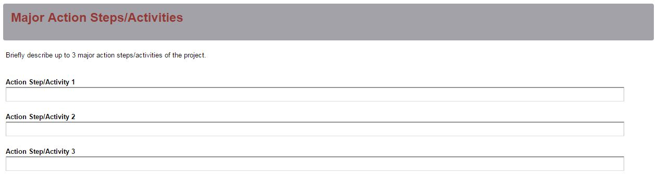
In the Budget Summary section, enter all amounts using only whole dollars (no cents). Fill in all fields and enter 0 (zero) for line items that are not applicable to the project.

Enter the line item totals by object code for the grant funds being requested for the applicant’s operating budget. The amounts for each line item must equal the corresponding line item totals in the Budget Narrative. The field for Total Grantee Budget will automatically calculate.

Enter the amount of funds budgeted for the Summer Arts Teacher Institutes, if applicable. This amount may be up to of 30 percent of the total funds being requested. The Total Funds Requested field in the online application will automatically calculate.

For an elementary school electing to participate in SCAAP, the $3,000 allocated for the cost of the assessments will automatically be displayed in the Budget Summary and will calculate into the Total ACIG Project Budget.

For a district electing to participate in SCAAP, the $3,000 allocated for the cost of the assessments per participating elementary school will automatically be displayed in the Budget Summary and will calculate into the Total ACIG Project Budget.

The funds allocated for SCAAP should not be deducted from the total funds being requested by the applicant, and the final grant awards will not be reduced by this amount. The costs for SCAAP are included in the Budget Summary as an indicator of the total ACIG funds allocated for each project. The fields for Total Funds Requested and Total ACIG Project Budget will be the same for applicants that are ineligible for or opt out of participation in SCAAP.
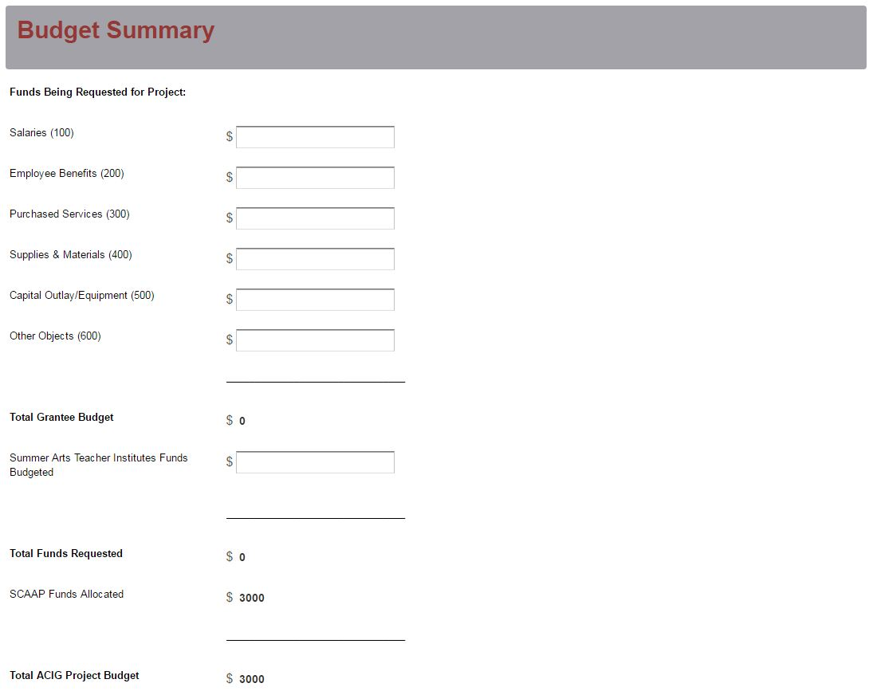
On the following screen, upload the Application Narrative and the appendices as proposal attachments. Save the Application Narrative as a single PDF document and all of the appendices (in the order as listed on page 10) as a single PDF document. The online application will only allow one document to be uploaded for each attachment. You will not be able to submit the application without attaching both of these required documents.
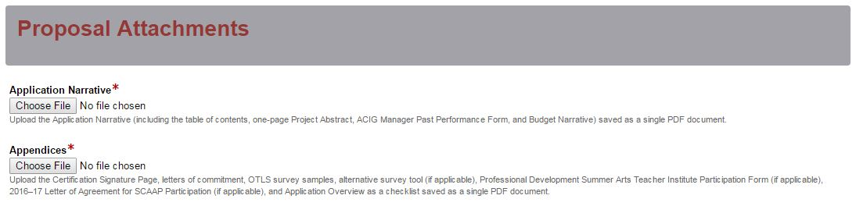
Thoroughly review the summary on the Data Review Page to verify that the information has been entered correctly in the online application prior to submitting. You will not be able to access the completed application form after it has been submitted so it is very important to ensure that all of the information in the application has been entered correctly. If any entries are incorrect, click on the "Previous" button at the bottom left corner of each screen to return to the appropriate section(s) and reenter the correct information. Then click on the “Next” button in the lower right corner of each screen to return to the Data Review Page. Note: This page is not a confirmation of the submission of an application.
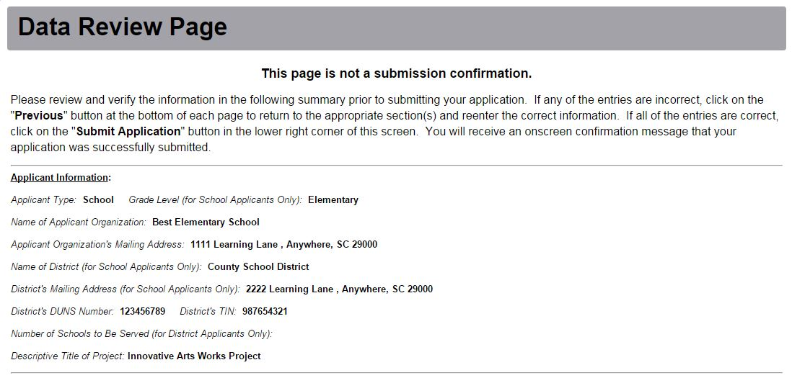
After verifying that all entries are correct, click on the "Submit Application" button in the lower right corner of this screen in order to complete the submission process.
Once the application is submitted, the following message will be displayed on the screen.
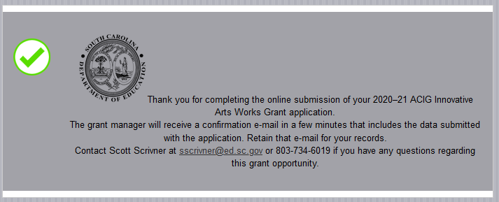
The following confirmation message will be sent to the e-mail address provided for the grant manager. If the grant manager does not receive a confirmation e-mail, then the application did not successfully transmit. You must go back and resubmit the entire online form, including all attachments, in order for your application to be considered for funding. Only the most recently submitted application will be reviewed.

To access the online application, only use the link provided in this RFP and on the grant opportunity Web page. Do not use a search engine, email, or any other method of navigating to the online application. Check the confirmation email after submission to ensure that you applying to the current grant cycle.

An e-mail confirmation that the grant application was successfully submitted does not account for the quality of the uploaded documents or the completeness of the online form. The confirmation e-mail only notifies you that the online application has been submitted and received. Applicants are responsible for ensuring that the information entered in the online form, including all attachments, is accurate and complete in order for the application to be reviewed and considered for funding.

Appendix A: Definitions of Terms Used

2017 South Carolina College- and Career- Ready Standards for Visual and Performing Arts Proficiency (2017 Standards)—A series of eight documents that individually address the arts areas of dance, design, choral music, general music, instrumental music, media arts, theatre, and visual arts from kindergarten through high school. The standards delineate what the state’s students should know and be able to do in these content areas. The eight documents are intended to be used not only as the basis for curricula, instruction, and assessment in the arts disciplines in South Carolina schools but also as a concise statement about expectations for learning in the arts for policy makers, education administrators, teachers, and instructional and community leaders.

Action Steps—Detailed descriptions of the actions required to implement respective strategies, including priority activities, schedules/timelines, leadership responsibilities, and associated costs.

Deobligation—The downward adjustment of the obligations recorded in a grant award document. It is caused by factors such as (1) termination of part of the project, (2) reduction in material prices, (3) cost savings, or (4) correction of recorded amounts.

Evaluation—A description of the procedures and methods by which progress toward strategic goals and action plan objectives will be regularly assessed and monitored.

Goals—Statements of the district’s or school’s long-term (3–5 years) arts education goals for students stated in results-oriented terms.

Greater Learning Community—The greater learning community can include but is not limited to parents, volunteer, and artists who have benefited from goods and services that you have provided your students through the ACIG grant opportunity. This can include parent and community member attendance to school performances and volunteers who directly work with students supported by grant funds.

Opportunity-to-Learn: Standards (OTLS) for Arts Education Program Assessment Worksheets—In 1997, the Arts in Basic Curriculum (ABC) Project reformatted the OTLS into a series of worksheets for use by ABC sites. In 2000, the worksheets were incorporated into the ABC’s process for developing strategic arts education plans and used at the 2000–07 Arts Education Leadership Institute (AELI). The worksheets directly reflect the wording of the original publication (with some minor editing) and include spaces to check whether the standard is lacking, is met, or is exceeded in a given school or school system.

Overall Education Community—Includes all people who learn and benefit from the ACIG programs such as teachers, teaching assistants, students, parents, and volunteers.

Profile of the South Carolina Graduate—This framework identifies the characteristics that are believed to be vital to helping our state stay competitive in today's global economy as it addresses the need and solution for a sustainable, educated, and qualified workforce.
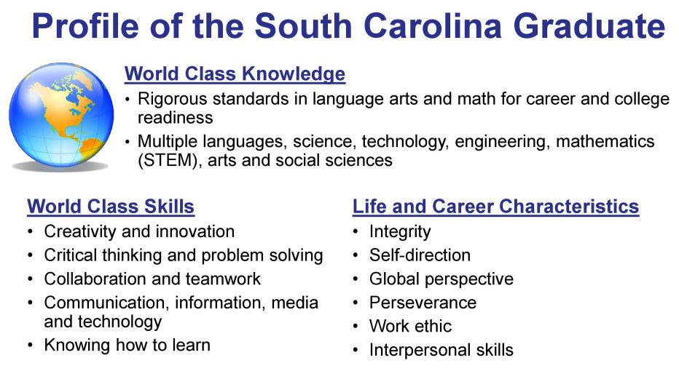

South Carolina Arts Assessment Program (SCAAP)—A collaborative effort among the South Carolina Department of Education (SCDE), the University of South Carolina (USC), and SC arts educators. The purpose of SCAAP is to develop arts assessments in four arts areas aligned to the 2017 Standards. With the SCAAP assessments, arts educators and school district personnel can authentically measure and evaluate their students' arts achievement. Moreover, because the SCAAP assessments are based on state-wide curriculum standards, the assessment has the potential to unify instructional objectives in arts classrooms throughout the state and serve as a model for other states interested in measuring student achievement in the arts and improving arts education.

Strategies—Statements of the initiatives through which the district’s or the school’s strategic goals will be met stated in “concrete” language and in measurable terms.

Appendix B: Selection Criteria and Reviewers’ Scoring Rubric

Selection Criteria

Narrative Sections | Points Available
1. Project Abstract | 0
2. Needs Assessment | 20
3. Academic Standards Implementation | 20
4. Goal and Objectives | 20
5. Strategies and Action Steps/Activities | 15
6. Project Evaluation and Dissemination Plan | 15
7. Past Performance of Grant Manager | 5
8. Budget Narrative | 0
9. Timeline of Activities | 5
Total Points Available | 100

Appendix B: Scoring Rubric

Project Abstract: The applicant must, in one page, identify the applicant (school and/or district), the title of the project, and the amount of funds requested. The applicant must also summarize the proposal, including the target audience, the number of students, teachers, and members of the overall education community who will benefit from the proposed project, and briefly summarize the needs, goal, and objectives; standards implementation; strategies and action steps/activities; and evaluation plans, including the expected outcomes of the project.
The applicant provides a one-page abstract that clearly  - identifies the applicant (school and/or district), the title of the project, and the total amount of funds requested;  - summarizes the proposal, including the target audience and the number of students, teachers, and members of the greater learning community who will benefit from the proposed project; and  - briefly summarizes the need, goal(s) and objectives, standards implementation, strategies and action steps/activities, and evaluation plans, including the expected outcomes of the project. | Acceptable | Adequate/Meets—0 points  Applicant provides a one-page abstract that fully addresses all required items.
 | Not Acceptable | Inadequate—0 points  Applicant provides a one-page abstract that does not adequately address all required items.
Reviewer’s Comments
2.a. Needs Assessment: Summarize the needs identified for your students and the arts education program as a result of administering the OTLS survey, including the names of the survey respondents and a conclusion. Discuss what students need in terms of their abilities to apply the 2017 Standards in their work and how these needs align with the implementation of the 2017 Standards. If an alternate needs assessment was used, justify its use and the results of the survey.

The applicant provides:  - a summary of needs identified for your students and the arts education program as a result of administering the OTLS survey, including the names of the survey respondents and a conclusion.  - a discussion of what students need in terms of their abilities to apply the 2017 Standards in their work and how these needs align with the implementation of the 2017 Standards.  - the results and justification for use of an alternative needs assessment (if applicable). | Acceptable | Fully Meets—9–10 points  Applicant provides a narrative that fully addresses the required items.
 | Acceptable | Adequate/Meets—6–8 points  Applicant provides a narrative that moderately addresses the required items.
 | Not Acceptable | Limited/Approaches—3–5 points  Applicant provides a narrative that is limited or incomplete in addressing the required items.
 | Not Acceptable | Inadequate—0–2 points  Applicant provides a narrative that does not adequately address the required items.
Reviewer’s Comments
2.b. Needs Assessment: Include in the narrative the resources and/or or professional development training for arts and/or classroom teachers that are needed to enable them to best implement the 2017 Standards, meet the needs identified for the arts education program, and raise student achievement in the arts.
The applicant must provide a narrative that fully discusses the resources and/or professional development training for arts and/or classroom teachers that are needed to enable them to best implement the 2017 Standards, meet the needs identified for the arts education program, and raise student achievement in the arts. | Acceptable | Fully Meets—9–10 points  Applicant provides a narrative that fully discusses the required items.
 | Acceptable | Adequate/Meets—6–8 points  Applicant provides a narrative that moderately discusses the required items.
 | Not Acceptable | Limited/Approaches—3–5 points  Applicant provides a narrative that is limited or incomplete in discussing the required items.
 | Not Acceptable | Inadequate—0–2 points  Applicant provides a narrative that does not adequately discuss the required items.

Reviewer’s Comments
3.a. Academic Standards Implementation: The applicant must identify the specific academic standards and indicators to be implemented and discuss how these standards are aligned with identified needs, appropriate activities, and budgetary allocations.
The applicant must provide a narrative that fully addresses the following two items:  - identifies the specific academic standards and indicators to be implemented; and  - discusses how these standards are aligned with identified needs, appropriate activities, and budgetary allocations. | Acceptable | Fully Meets—9–10 points  Applicant provides a narrative that fully addresses both required items.
 | Acceptable | Adequate/Meets—6–8 points  Applicant provides a narrative that moderately addresses both required items.
 | Not Acceptable | Limited/Approaches—3-5 point  Applicant provides a narrative that is limited or incomplete in addressing both required items.
 | Not Acceptable | Inadequate—0-2 points  Applicant provides a narrative that does not adequately address both required items.
Reviewer’s Comments
3.b. Academic Standards Implementation: The applicant must describe, as a result of the proposed project, how teachers will implement the standards in terms of instruction, curricula, and assessment and how students will apply the 2017 Standards in their work.

The applicant must provide a narrative that fully addresses the following two items:  - how teachers will implement the standards in terms of instruction, curricula, and assessment as a result of the proposed project; and  - how students will apply the 2017 Standards in their work as a result of the proposed project. | Acceptable | Fully Meets—9–10 points  Applicant provides a narrative that fully describes both required items.
 | Acceptable | Adequate/Meets— 6–8 points  Applicant provides a narrative that moderately describes both required items.
 | Not Acceptable | Limited/Approaches—3–5 points  Applicant provides a narrative that is limited or incomplete in describing both required items
 | Not Acceptable | Inadequate—0–2 points  Applicant provides a narrative that does not adequately describe both required items.
Reviewer’s Comments
4.a. Goals and Objectives: The applicant must address the following questions:
- What are the SMART objectives for the project to support the goal of significantly improving student achievement in the arts through curriculum, instruction, and assessment based on the 2017 Standards?
- How are the objectives aligned with the Profile of the South Carolina Graduate?

The applicant must provide a narrative that fully addresses both of the following:  - SMART objectives that support the goal of significantly improving student achievement in the arts through curricula, instruction, and assessment based on the 2017 Standards, and  - how the objectives are aligned with the Profile of the South Carolina Graduate. | Acceptable | Fully Meets—9–10 points  Applicant provides a narrative that is a fully addresses both required items.
 | Acceptable | Adequate/Meets—6–8 points  Applicant provides a narrative that moderately addresses both required items.
 | Not Acceptable | Limited/Approaches—3-5 point  Applicant presents a narrative that is limited or incomplete in addressing both required items.
 | Not Acceptable | Inadequate—0-2 points  Applicant presents a narrative that does not adequately address both required items.

Reviewer’s Comments
4.b. Goal and Objectives: The applicant must address the following questions:
- Who is to be affected by the project, what art area(s) will be included, and what instructional level(s) is (are) to be addressed?
- What are the expected outcomes for students? What changes will occur within the target population?
The applicant must provide a narrative that fully addresses the following four items:  - who will be affected by the project,  - the art area(s) to be included,  - the instructional level(s) to be addressed, and  - the expected outcomes for students.  - the changes that will occur within the target population | Acceptable | Fully Meets—9–10 points  Applicant provides a narrative that fully addresses all required items.
 | Acceptable | Adequate/Meets—6–8 points  Applicant provides a narrative that moderately addresses all required items.
 | Not Acceptable | Limited/Approaches—3–5 points  Applicant provides a narrative that is limited or incomplete in addressing all required items.
 | Not Acceptable | Inadequate—0–2 points  Applicant provides a narrative that does not adequately address all required items.
Reviewer’s Comments
5.a.–5.c. Strategies and Action Steps/Activities: The applicant must address the following questions:
- What strategies and action steps/activities are planned for meeting the goal and objectives?
- How will the strategies and action steps/activities bring about growth in students’ knowledge and skills in terms of the implementation of the 2017 Standards?
- What innovative practices will be used to enhance, accelerate, and assure student achievement and engagement in the arts and implement the 2017 Standards? What research supports these practices?

The applicant must provide a narrative that fully addresses the following four items:  - the strategies and action steps/activities planned for meeting the goal(s) and objectives;  - how the strategies and action steps/activities will be used to bring about growth in students’ knowledge and skills in terms of the implementation of the 2017 Standards;  - the innovative practices that will be used to enhance, accelerate, and assure student achievement and engagement in the arts and implement the new standards; and the research that supports these practices; and  - the research that supports these practices. | Acceptable | Fully Meets—9–10 points  Applicant provides narrative that a fully addresses all required items.
 | Acceptable | Adequate/Meets—6–8 points  Applicant provides a narrative that moderately addresses all required items.
 | Not Acceptable | Limited/Approaches—3–5 points  Applicant provides a narrative that is incomplete or limited in addressing all required items.
 | Not Acceptable | Inadequate—0–2 points  Applicant provides a narrative that does not adequately address all required items.
Reviewer’s Comment

5.d.–e. Strategies and Action Steps/Activities: The applicant must address the following questions:
- How will the materials and services budgeted support the objectives, activities, and standards?
- How will the project be sustained after the end of the funding period?
The applicant must provide a narrative that fully addresses the following two items:  - how the materials and services budgeted support the objectives, activities, and standards; and  - how the project will be sustained after the end of the funding period. | Acceptable | Adequate/Meets—5 points  Applicant provides a narrative that fully addresses both required items.
 | Not Acceptable | Inadequate—0 points  Applicant provides a narrative that does not adequately address both required items.

Reviewer’s Comments
6.a.–e. Project Evaluation and Dissemination Plan: The applicant must address the following questions:
- What procedures and/or instruments will be used to measure the attainment of the goal and each objective and to assess the effectiveness of the project?
- How will data be gathered, organized, and analyzed; how often; and who will be involved?
- What will be done to modify the project should any adjustments be needed during the project year?
- How will the project results (successes and challenges) be shared and disseminated?
- What replicable products and/or strategies, if applicable, will be produced as a result of this project?

The applicant must provide a narrative that fully addresses the following five items:  - the procedures and/or instruments to be used to measure the attainment of each goal and objective and assess project effectiveness;  - how data will be gathered, organized, and analyzed; how often this will happen; and who will be involved;  - what will be done to modify the project should adjustments be needed during the project year;  - how project results (successes and challenges) will be presented and disseminated; and  - what replicable products and/or strategies will, if applicable, be produced as a result of the proposed project. | Acceptable | Fully Meets—12–15 points  The applicant provides a narrative that fully addresses all required items.
 | Acceptable | Adequate/Meets—8–11 points  The applicant provides a narrative that moderately addresses all required items.
 | Not Acceptable | Limited/Approaches—4–7 points  The applicant provides a narrative that is limited or incomplete addressing all required items.
 | Not Acceptable | Inadequate—0–3 points  The applicant provides a narrative that does not adequately address all required items.
Reviewer’s Comments
7. Past Performance of Grant Manager: The applicant must present a complete ACIG Manager Past Performance Form that indicates certification in at least one arts area or responsibility for arts education leadership/oversight within the school or district.

The applicant presents a complete ACIG Manager Past Performance Form that indicates certification in at least one arts area or responsibility for arts education leadership/oversight within the school or district. | Acceptable | Adequate/Meets—5 points  The applicant presents a complete ACIG Manager Past Performance Form that indicates certification in at least one arts area or responsibility for arts education leadership/oversight within the school or district.
 | Not Acceptable | Inadequate—0 points  The applicant does not present a complete ACIG Manager Past Performance Form that indicates certification in at least one arts area or responsibility for arts education leadership/oversight within the school or district.
Reviewer’s Comments
8. Budget Narrative: The applicant must provide a complete Budget Narrative that provides clear evidence that the budget is justified based on the proposed activities resulting from the needs assessment, includes an itemized expenditure list that details the specific planned expenditures, describes the project activities that will necessitate the expenditure of each line item, and reflects correct calculations for all line items and the total budget.
The applicant provides all five of the following:  - a complete Budget Narrative;  - clear evidence that the budget is justified based on the proposed activities resulting from the needs assessment;  - an itemized expenditure list that details the specific planned expenditures;  - a description of project activities that will necessitate the expenditure of each line item; and  - correct calculations for all line items and the total budget. | Acceptable | Adequate/Meets—0 points  Applicant provides all five required items.
 | Not Acceptable | Inadequate—0 points  Applicant did not provide all five required items.
Reviewer’s Comments

9. Timeline of Activities: The applicant must provide a chronological Timeline of Activities for each objective that indicates the major action steps and strategies and the personnel responsible for each activity.
(Sample activities include ordering and receiving supplies; scheduling adequate facilities; arranging of professional development workshops; administering the SCAAP; registering for and attending summer institutes; scheduling and preparing for staff meetings; meetings with parents; disseminating project information; evaluating the project; and submitting necessary reports.)
The applicant must provide a detailed chronological Timeline of Activities for each objective that indicates the major action steps and strategies and the personnel responsible for each activity. | Acceptable | Fully Meets—4–5 points  The applicant provides a full and detailed Timeline of Activities.
 | Acceptable | Adequate/Meets—2–3 points  The applicant provides a moderately full and detailed Timeline of Activities.
 | Not Acceptable | Limited/Approaches—1 point The applicant provides a limited or incomplete Timeline of Activities.
 | Not Acceptable | Inadequate—0 points  The applicant does not provide an adequate Timeline of Activities.
Reviewer’s Comments

Appendix C: Required SCDE Forms

Certification Signature Page

Certification
I hereby certify that, to the best of my knowledge, the information and data contained in this application are true and correct. The applicant’s governing body has duly authorized this application and documentation, and the applicant will comply with the SCDE Assurances and Terms and Conditions for State Awards if the grant is awarded.

Authorized Official Representative (Should be superintendent of school district)
Name:
Position:
Telephone: | E-mail:
Signature of Authorized Official Representative: |  | Date:

District Financial Official
Name:
Position:
Telephone: | E-mail:
Signature of District Financial Official: |  | Date:

Principal (if school is applicant)
Name:
Position:
Telephone: | E-mail:
Signature of Principal: |  | Date:

Grant Manager
Name:
Position:
Telephone: | E-mail:
Signature of Grant Manager: |  | Date:

Please complete, print, and obtain signatures prior to submission. Include the signed, scanned form in the required appendices as indicated on pages 20–21.

Assurances and Terms and Conditions for State Awards

Assurances

- Has the legal authority to apply for state assistance and the institutional, managerial, and financial capability (including funds sufficient to pay the nonstate share of project costs) to ensure proper planning, management, and completion of the project described in this application.
- Will give the South Carolina Department of Education (SCDE) access to and the right to examine all records, books, papers, or documents related to this award and will establish a proper accounting system in accordance with generally accepted accounting principles (GAAP) or agency directives.
- Has an accounting system that includes sufficient internal controls, a clear audit trail, and written cost-allocation procedures as necessary. The financial management systems are capable of distinguishing expenditures that are attributable to this grant from those that are not attributable to this grant. This system is able to identify costs by programmatic year and by budget line item and to differentiate among direct, indirect, and administrative costs. In addition, the applicant will maintain adequate supporting documents for the expenditures and in-kind contributions, regardless of the type of funds, if any, that it makes under this grant. Costs are shown in books or records (e.g., disbursements ledger, journal, payroll register) and are supported by a source document such as a receipt, travel voucher, invoice, bill, or in-kind voucher.
- Will also comply with GAAP as it relates to budgets, budget amendments, and expenditure claim submissions.
- Will approve all expenditures, document receipt of goods and services, and record payments on the applicant’s accounting records prior to submission of reimbursement claims to the SCDE for costs related to this grant.
- Will initiate and complete work within the applicable time frame after receipt of approval by the SCDE.
- Will not discriminate against any employee or applicant for employment because of race, color, religion, age, sex, national origin, or disability. The applicant will take affirmative action to ensure that applicants for employment and the employees during the period of their employment are treated without regard to their race, color, religion, age, sex, national origin, or disability.
- Will comply with the Ethics, Government Accountability, and Campaign Reform Act (S.C. Code Ann. § 2-17-10 et seq. and § 8-13-100 et seq. (Supp. 2017)).
- Will comply with the Drug Free Workplace Act (S.C. Code Ann. § 44-107-10 et seq. (Supp. 2017)) if the amount of this award is $50,000 or more.

Terms and Conditions

- Completeness of Proposal. All proposals should be complete and carefully worded and must contain all of the information requested by the South Carolina Department of Education (SCDE). If you do not believe a section applies to your proposal, please indicate that fact.
- Non-awards/Termination. The SCDE reserves the right to reject any and all applications and to refuse to grant monies under this solicitation. If the SCDE rejects an application, the applicant has a right to request a review of the process consistent with the appeals process presented in the Request for Proposals (RFP).
After it has been awarded, the SCDE may terminate a grant by giving the grantee written notice of termination. In the event of a termination after award, the SCDE shall reimburse the grantee for expenses incurred up to the notification of termination. In addition, this grant may be terminated by the SCDE if the grantee fails to perform as promised in its proposal.
Upon the termination of a grant, the grantee shall have the right to a review process. The grantee must notify the SCDE of its request within 30 days of receiving written notice of the termination.
- Reduction in Budgets and Negotiations. The SCDE reserves the right to negotiate budgets with potential grantees. The SCDE may, at its sole discretion, determine that a proposed budget is excessive and may negotiate a lower budget with the applicant. The applicant may at that time negotiate or withdraw its proposal. In addition, the SCDE may desire to fund a project but not at the level proposed. In that case, the SCDE shall notify the applicant of the amount that can be funded, and the applicant and the SCDE shall negotiate a modification to the proposal to accommodate the lower budget. All final decisions are that of the SCDE.
- Amendments to Grants. Amendments are permitted upon the mutual agreement of the parties and will become effective when specified in writing and signed by both parties.
- Use of Grant Funds. Funds awarded are to be expended only for purposes and activities covered by the approved project plan, budget, and budget narrative.
- Submission of Expenditure Reports. Claims for reimbursement must be made at least quarterly and consistent with calendar quarters (e.g., an expenditure report claim for costs for January 1 through March 30 must be filed by May 10).
- Obligation of Grant Funds. Grant funds may not be obligated prior to the effective date or subsequent to the end or termination date of the grant period. No obligations are allowed after the end of the grant period. The final request for expenditure report claims must be submitted no later than thirty (30) days after the end of the grant period.
- Deobligation of Funds. After a final expenditure claim has been submitted to the SCDE, the grantee will go through the official deobligation process with the SCDE.
- Documentation. The grantee must provide for accurate and timely recording of receipts and expenditures. The grantee’s accounting system should distinguish receipts and expenditures attributable to each grant. The grantee must review the memo regarding “Guidelines for Retaining Documentation to Support Expenditure Claims.”
- Travel Costs. Travel costs, if allowed under this solicitation, must not exceed limits noted in the United States General Services Administration regulations for lodging. Meals and incidentals are limited by the state budget proviso, currently not to exceed $25 per day for in-state travel and $32 for out-of-state travel (see page 91 of the State of South Carolina Statewide Disbursement Regulations). Mileage reimbursement must follow the current Office of Comptroller General instructions, which is consistent with the published IRS rates.
- Honoraria. Amounts paid in honoraria, if allowed under this grant, must be consistent with SCDE policies. Applicants should check with the program office before budgeting for honoraria.
- Reports. The grantee shall submit, as required or instructed by the awarding program office, all reports (programmatic, financial, or evaluation) within the specified period or date and in the prescribed format. An expenditure claim report must be filed by July 5 for all expenditures incurred by June 30 in order to comply with the generally accepted accounting principles (GAAP) and the production of the State's Comprehensive Annual Financial Report.
- Copyright. The grantee is free to copyright any books, publications, or other copyrightable materials developed in the course of this grant. However, the SCDE reserves a royalty-free, nonexclusive, and irrevocable license to reproduce, publish, or otherwise use, and to authorize others to use, the copyrighted work developed under this grant.
- Certification Regarding Suspension and Debarment. By submitting an application, the applicant certifies, to the best of its knowledge and belief, that the
- Applicant and/or any of its principals, subgrantees, or subcontractors
  - are not presently debarred, suspended, proposed for debarment, or declared ineligible for the award of contracts by any state or federal agency; have not, within a three-year period preceding this application, been convicted of or had a civil judgment rendered against them for commission of fraud or a criminal offense in connection with obtaining, attempting to obtain, or performing a public (federal, state, or local) contract or subcontract; violation of federal or state antitrust statutes relating to the submission of offers; or commission of embezzlement, theft, forgery, bribery, falsification or destruction of records, making false statements, tax evasion, or receiving stolen property; and
  - are not presently indicted for, or otherwise criminally or civilly charged by a governmental entity with, commission of any of the offenses enumerated above.
- Applicant has not, within a three-year period preceding this application, had one or more contracts terminated for default by any public (federal, state, or local) entity.
- Audits. Although this Assurances, Terms, and Conditions document is for a state award, federal audit requirements apply as follows:
- Entities expending $750,000 or more in federal awards:
Entities that expend $750,000 or more in federal awards during the fiscal year are required to have an audit performed in accordance with the provisions of 2 CFR Part 200.501, et seq. Except for the provisions for biennial audits provided in 2 CFR Part 200.504 (a) and (b), audits must be performed annually as stated at 2 CFR Part 200.504. A grantee that passes through funds to subrecipients has the responsibility of ensuring that federal awards are used for authorized purposes in compliance with federal program laws, federal and state regulations, and grant agreements. The director of the OMB, who will review this amount every two years, has the option of revising the threshold upward.
- Entities expending less than $750,000 in federal awards:
Entities that expend less than $750,000 in a fiscal year in federal awards are exempt from the audit requirements in 2 CFR Part 200.504. However, such entities are not exempt from other federal requirements (including those to maintain records) concerning federal awards provided to the entity. The entity’s records must be available for review or audit by the SCDE and appropriate officials of federal agencies, pass-through entities, and the General Accounting Office (GAO).
- Records. The grantee shall retain grant records, including financial records and supporting documentation, for a minimum of six (6) years after the end date of the grant when the final expenditure report claim for reimbursement and all final reports have been submitted, unless informed otherwise or in case of litigation.
- Electronic Signature Agreement. I agree that my electronic signature is the legally binding equivalent to my handwritten signature.

Arts Curricular Innovation Grant Manager Past Performance Form

You may attach an additional sheet if you wish to add information or need more space (limit to 2 pages). The grant manager must be the same person listed in the online application. Designate only one grant manager per grant. Please complete this form for inclusion in the narrative as instructed on pages 16–17.

Type of Grant: Innovative Arts Works Grant
Name of Applicant (District or School):
District (if School is applicant)
Arts Curricular Grant Manager Information
Name:
Job Title:
E-mail:
Phone Number:
Job Duties for ACIG Project Management:
Describe Time Management for Project:
Educational Background:
Additional Fine Arts Training and/or Experience:
Accomplishments or Awards:
Active Memberships in Professional Organizations:
Years of Experience: |  | ______ |  |  | Certification Areas:
What professional development summer institutes or similar training has the grant manager candidate completed?

Appendix D: Other Forms and Information

Professional Development Summer Arts Teacher Institutes

Below is a list of professional development arts institutes/courses for elementary, middle, and secondary schools in the arts disciplines of dance, music, theatre, and the visual arts. This list represents possible selections that may be offered in June 2021. Innovative Arts Works applicants may budget for Summer Arts Teacher Institutes as an optional activity.

Applicants planning to apply for funding to attend professional development Summer Arts Teacher Institutes must complete and include the tentative Professional Development Summer Arts Teacher Institutes Participation Form (see page 52). Please provide the teacher’s name and the institute that the teacher plans to attend. Applicants will not be held to this list; however, it will provide the planners with an idea of which institutes need to be offered.

All arts teachers in the ACIG school must have taken CLIA and Arts Assessment Institute I (AAI–I) before any classroom teachers and administrators are permitted to register for arts integration institutes. After all visual and performing arts teachers have completed CLIA and AAI–I, schools and districts may enroll classroom teachers and administrators in arts integration institutes. Arts teachers must show proof of CLIA and AAI–I participation. Arts teachers must have successfully completed CLIA and AAI–I before they may advance to the next tier of institutes. Note: Institute attendees must be returning certified teachers within the district. All equipment (such as computers) and materials distributed as part of an institute becomes the property of the school that receives the ACIG grant and does not follow the grant manager if he or she leaves that school.

Registration for the professional development Summer Arts Teacher Institutes will be available upon notification of this grant award. The specific location and week of each institute will be announced during fall institute registration. Acceptance in arts institutes is on a first-come, first-served basis.

The cost for each institute may change at the time of fall institute registration.

All courses are
- focused on standards-based arts curricula, instruction, and assessment;
- offered in collaboration with an accredited college or university for three graduate credits with a minimum of 45 contact hours;
- provided as residential institutes (with room and board for participants unless otherwise stated);
- evaluated on the basis of an assessment instrument approved by the SCDE in terms of quality and its potential impact on student learning; and
- held during June 2021.
South Carolina Arts Leadership for Success Academy (SCALSA) |  |  | $1,600 per teacher
This institute is designed for arts teachers who have taught fewer than three years and for critical needs teachers in the arts. SCALSA emphasizes the development of standards-based arts curricula, instruction, and assessment through
- developing standards-based arts lessons;
- studying strategies for evaluations currently implemented for teacher certification;
- developing long-range lesson planning including instruction on how to develop a CLIA lesson plan for future use in grant development and in future institutes;
- studying arts classroom management strategies; and
- identifying teaching and learning styles.

Curriculum Leadership Institute in the Arts (CLIA) |  |  | $1,400 per teacher
Designed for the experienced arts teacher, this institute emphasizes
- developing and teaching complex standards-based lesson plans with embedded assessment;
- studying models of best instructional practice;
- reviewing the steps in the SLO cycle;
- working with colleagues in your arts discipline to write an SLO that could be implemented at the classroom level;
- studying arts education support strategies; and
- developing a multi-arts professional network.
Arts Assessment Institute Classroom Assessment (AAI–I) (Prerequisite SCALSA with instructor’s recommendation or CLIA) |  |  | $1,200 per teacher
AAI–I will develop professional educators who
- study the purposes and uses of assessment;
- align assessments with local and state standards;
- construct assessments to best determine knowledge in skills and processes related to the 2017 South Carolina College- and Career- Ready Standards for Visual and Performing Arts Proficiency;
- demonstrate an understanding of the basic principles of measurement and evaluation;
- develop standards-based SLOs and corresponding assessments to demonstrate student growth;
- design and embed assessment strategies within instructional lessons and units;
- apply the relationship of national and state standards, curriculum development, instruction, and assessment; and
- reflect on their assessment practices and the role of assessment in their professional and personal lives.

Media Arts and Technology Institute (Prerequisite CLIA and Arts Assessment Institute Classroom Assessment) |  |  | $3,000 per teacher
This institute will provide art teachers with an opportunity to develop standards-based lesson plans and guides that incorporate technology to enhance student learning. Each participant will be provided with appropriate equipment, a computer, and software, which will become the property of their schools at the conclusion of the institute.

Participating teachers will
- receive training in various software programs, apps, and media literacy;
- develop strategies for using the equipment, computer, and software with students; and
- develop lesson plans that use technology to implement the 2017 South Carolina College- and Career- Ready Standards for Visual and Performing Arts Proficiency.

Arts Teacher as Artist Institute (Prerequisite CLIA and Arts Assessment Institute Classroom Assessment) |  |  | $1,200 per teacher
This institute is designed to expand the artistic knowledge and skills of arts teachers for enriching standards-based curricula, instruction, and assessment. Teachers will have the opportunity to strengthen their own art in classes taught by highly regarded teachers and professional artists. Through this “art for art’s sake” approach, teachers will practice their art and learn new techniques to apply to their school situation. Classes will be designed to meet teachers’ needs based on survey responses and identified curricular needs. These may include
- Drama (Playwriting and/or Technical Theatre),
- Music (Improvisation and Composition—Vocal and Instrumental, K–12),
- Visual Arts (Media to be determined), and/or
- Dance (Dance Education).

Video Production in the Arts Institute (Prerequisite CLIA and Arts Assessment Institute Classroom Assessment) |  |  | $2,500 per teacher
Using video technology to create projects across the art forms is the focus of this institute. No previous video experience needed. Participants will learn to design, shoot, and edit arts-related videos. The course will also emphasize strategies for applying video production skills to the classroom. Each participant will be provided with appropriate equipment that will become the property of their schools at the conclusion of the institute.

Participating teachers will
- discover methods to engage your students as critical thinkers about media arts;
- learn how to design and implement a community-based video with students, including setting up production teams;
- conduct interviews and video to create a short documentary; and
- practice writing narration and incorporating music, graphics, and photos into a documentary.
Strategic Arts Planning Institute (No Prerequisite) $1,400 per teacher

This institute is designed to support schools and districts in writing a strategic arts plan. Schools and Districts must bring a planning team of 4–5 participants to the institute to write a comprehensive strategic arts plan that includes dance, design, media arts, music, theatre, and visual arts. The purpose of developing a strategic arts plan is to significantly improve student achievement in the visual and performing arts based on the implementation of the 2017 South Carolina College- and Career- Ready Standards for Visual and Performing Arts Proficiency. This institute is provided for participants who currently need help with their strategic arts plan and/or grants management, who are interested in creating innovative opportunities in the arts for their students, or who have never written a strategic plan for the arts.

Curriculum and Instruction for Artistically Gifted and Talented Students Institute (Prerequisite CLIA, Arts Assessment, and Discovering the Nature and Needs of the Artistically Gifted and Talented Learner Institute) |  |  | $1,200 per teacher
This institute is designed for the arts teacher who is interested in beginning an endorsement certificate for serving artistically gifted and talented students. The course is designed to:
- prepare teachers to design appropriate curriculum for gifted and talented students,
- explore curriculum models, instructional strategies, and assessments to meet the needs and abilities of gifted and talented students,
- develop and write units and lesson plans for serving artistically gifted and talented students, and
- explore issues related to psycho-social needs of the artistically gifted and talented students.

Creative Teaching in the Classroom Institute (Prerequisite CLIA and Arts Assessment Institute Classroom Assessment) |  |  | $1,000 per teacher
This institute is designed for elementary classroom teachers (administrators and arts specialists welcome) who do not have a strong background in the visual and performing arts but are interested in integrating the arts in their classroom. Board (meals) is not provided with this institute.

The institute includes
- all materials, including books and CDs;
- three and one-half days at Charleston’s Spoleto Festival, including three performances; and
- two Saturday sessions—place and date to be announced.

Participating teachers will
- explore the stages of the creative thinking process and identify methods to engage students in creative thinking;
- build knowledge of the basic elements of each major art form (music, drama, visual art, dance);
- refine lesson-planning skills to embed opportunities for creative thinking and self-expression through the arts; and
- identify “natural-fit” connections between South Carolina content area standards and the arts.

Muse Machine Institute (Prerequisite CLIA and Arts Assessment Institute Classroom Assessment) |  |  | $1,000 per teacher
This institute is for classroom teachers of all grade levels and subjects. No background in the visual and performing arts is necessary. The course provides hands-on activities in the visual and performing arts taught by professional artists, instruction in the multiple intelligences, and guidance in using the arts across the curriculum. In addition to classroom instruction hours, participants are required to attend and critique four separate arts events from the areas of visual arts, music, theater, dance, historic preservation, and opera.

Participating teachers will
- gain knowledge about incorporating the arts in their own classroom (especially in the areas of science, technology, engineering, arts, and mathematics (STEAM));
- write critically about their experiences in attending four arts events (visual art exhibition, concert, theater production, dance performance);
- develop a lesson plan (using the CLIA Lesson Plan format) that will include STEAM challenges;
- participate in STEAM challenges during the weeklong intense instruction; and
- visit a company that focuses on innovation and STEAM thinking.

Arts Integration Teacher Institute (Prerequisite CLIA and Arts Assessment Institute Classroom Assessment) |  | $1,000 per teacher
This institute is designed for classroom teachers who wish to learn strategies to integrate the arts across the curriculum. Presenters provide instruction on a variety of comprehensive arts-integration strategies taught by nationally recognized Kennedy Center teaching artists. In addition to classroom instruction hours, participants are required to attend one performance from a recommended list and participate in scheduled online discussions before and after the institute meets.

Teachers enrolled in this institute experience imaginative new methods to integrate the arts into every content area. All workshops are interactive and hands-on, giving educators an opportunity to learn by participating and by sharing with colleagues. This institute supports the implementation of the 2017 South Carolina College- and Career- Ready Standards for Visual and Performing Arts Proficiency and provides teachers with resource materials for curriculum design.

2021 SCDE Professional Development Summer Arts Teacher Institutes Participation Form

School:
District:
Complete this form to indicate tentative participation of your teachers in the SCDE-approved professional development Summer Arts Teacher Institutes. This will allow us to plan and organize arts institutes based on need. Note: Teachers must complete the prerequisites (SCALSA with instructor’s recommendation or CLIA and Arts Assessment Institute Classroom Assessment) before they are allowed to move to the next tier of institutes.

- South Carolina Arts Leadership for Success Academy (SCALSA)  Teacher name(s): | $1,600
- Curriculum Leadership Institute in the Arts (CLIA)  Teacher name(s): | $1,400
- Arts Assessment Institute Classroom Assessment I (AAI–I)  Teacher name(s): | $1,200
- Media Arts and Technology Institute  Teacher name(s): | $3,000
- Arts Teacher as Artist Institute (check area) □ Dance □ Music □ Theatre □ Visual Arts  Teacher name(s): | $1,200
- Video Production in the Arts Institute  Teacher name(s): | $2,500
- Strategic Arts Planning Institute  Teacher name(s): | $1,400
- Curriculum and Instruction for Artistically Gifted and Talented Students Institute  Teacher name(s): | $1,200
- Creative Teaching in the Classroom Institute  Teacher name(s): | $1,000
- Muse Machine Institute  Teacher name(s): | $1,000
Total Cost of Institutes | $

Letter of Agreement for SCAAP Participation
2021 South Carolina Arts Assessment Program
(Include this signed letter in your Innovative Arts Works application.)

This agreement is to confirm that our school’s fourth-grade students will participate in the 2021 SCAAP web-based music and visual arts assessments. We understand that participation in the SCAAP program requires our school to
- appoint two test administrators to attend a training session conducted by the SCAAP personnel at the University of South Carolina (USC), College of Education, Research, Evaluation, and Measurement Center (formally the Office of Program Evaluation);
- coordinate test administration at our school and schedule testing sessions in school computer labs;
- administer the music and visual arts multiple-choice test to all or a minimum of 100 fourth-grade students;
- administer the music and visual arts performance tasks to all or a minimum of forty students; and
- organize and return testing materials to the SCAAP office at USC in a timely manner.

One form must be completed for each school participating in SCAAP. If you have any questions concerning the SCAAP, contact the SCAAP personnel by phone at 803-777-3459 or 803-777-1246, via e-mail at scaap@mailbox.sc.edu, or visit http://scaap.ed.sc.edu.

Please provide the following information:
Has this school/district administered SCAAP during a previous school year? Circle one: Yes No
Approximate number of fourth-grade students and classrooms during the 2020-21 school year. _____Students/_____Classes
School: | District:
School Address: | Phone:
School Address: | Fax:
Principal’s Name: | Principal’s Signature:
Principal’s E-mail Address:

Music Teacher’s Name: | Music Teacher’s Signature:
Music Teacher’s E-mail Address: | Previously administered SCAAP? Circle one: Yes No
Visual Arts Teacher’s Name: | Visual Arts Teacher’s Signature:
Visual Arts Teacher’s E-mail Address: | Previously administered SCAAP? Circle one: Yes No
Grant Manager’s Name: | Grant Manager’s E-mail:
District Financial Manager’s Name: | District Financial Manager’s E-mail:

Timeline of Activities Template

Use one chart for each goal and objective; add pages as necessary.
Type of Grant: Innovative Arts Works Grant
School, District:

Goal:

Objective:

Start Date–End Date | Strategies and Action Steps/Activities to Achieve Objective | Procedures to Evaluate this Activity | Responsible Personnel for  A. Implementing Activity  B. Evaluating Achievement
1.

2.

3.

4.

CLIA Lesson Plan Template

Each teacher who is affected by this grant must submit a lesson plan to be included with the grantee’s final report. You may add lines as needed. This form is available on the SCDE’s Visual and Performing Arts’ Support Documents and Resources webpage.

Lesson Writer
School
Grade Level

Lesson Title and Arts Area
Statement about the Writer, Long Range Plans, and Lesson Development

Unit Description

Essential Question
2017 South Carolina College- and Career-Ready Standards for Visual and Performing Arts Proficiency

Learning Targets
Criteria for Assessment
Description of Instruction
Teacher Procedures
Student Tasks
Materials
Resources
Attachments: Assessment Instruments, etc.
Curriculum Connections and Content Area Standards

Notes:

