Request for Proposals (RFP)
Application Package

Arts Curricular Innovation Grants
2024–25 Distinguished Arts Program (DAP)
Discretionary Grant

The Arts Curricular Innovation Grants (ACIG) Program is funded by the
General Assembly of the State of South Carolina through Proviso 1A.8 of the General Appropriations Act and administered by the South Carolina Department of Education (SCDE).

Deadline for Receipt of Applications: 5:00 p.m., May 31, 2024

Technical Assistance for Applicants: 3:30 p.m., April 29, 2024

For programmatic questions about this ACIG Program, contact:
Roger E. Simpson, Jr.
Education Associate for Visual and Performing Arts
803-734-0715; rsimpson@ed.sc.gov

For reporting questions about this ACIG Program, contact:
Stephen Stokes
Education Associate for Data and Reporting
803-734-3461; sstokes@ed.sc.gov

Issued by:
South Carolina Department of Education
Office of Assessment and Standards
1429 Senate Street
Columbia, SC 29201-3730

TABLE OF CONTENTS
PART I: General Information 1
A. Introduction and Purpose 1
B. Eligible Applicants 2
C. Timeline of Granting Process 2
D. Technical Assistance Sessions for Applicants 2
E. Statutory and Other Requirements 2
F. Authorized Activities 4
G. Unauthorized Activities 5
H. Program Accountability and Monitoring 5
I. Fiscal Operations 8
J. Supplement, Not Supplant 9
K. Review and Selection Process 9
L. Appeals Process 10

PART II: Application Overview, Content, and Instructions 11
A. Application Overview 11
B. Application Narrative Format 12
C. Online Application Submission 12
D. Application Narrative Content 13
1. Project Abstract 13
2. Needs Assessment 13
3. Academic Standards Implementation 14
4. Goals and Objectives 15
5. Strategies and Action Steps/Activities 15
6. Management and Sustainability 16
7. Project Evaluation and Dissemination Plan 17
8. Strategic Arts Plan 18
E. Budget Narrative and Budget Summary 19
F. Appendices 22
G. Deadline and Submission Procedures 24
H. Screenshots of Online Application Submission Forms 24

Appendix A: Definitions of Terms Used 32

Appendix B: Selection Criteria and Reviewers’ Scoring Rubric 34

Appendix C: Required SCDE Forms 44
Certification Signature Page 44
Assurances and Terms and Conditions for State Awards 45
Arts Curricular Grant Manager Past Performance Form 48
Professional Development Arts Teacher Institutes 49
2025 SCDE Professional Development Arts Teacher Institutes Participation Form 54
Strategic Arts Plan Mission and Vision Statements Template 55
Strategic Arts Plan Template 56

Appendix D: Other Forms and Information 57
Letter of Agreement for 2024-25 SC Arts Assessment Program Participation 57
CLIA Lesson Plan Template 58

PART I: General Information

Introduction and Purpose

The South Carolina General Assembly annually allocates funds to the South Carolina Department of Education (SCDE) for arts curricular programs under the Education Improvement Act (EIA). The SCDE administers these funds in accordance with the legislative proviso:

1A.8. (SDE-EIA: Arts in Education) Funds appropriated in Part IA, Section 1, VIII.A.1. Arts Curricula shall be used to support innovative practices in arts education curriculum, instruction, and assessment in the visual and performing arts including dance, music, theatre, and visual arts which incorporates strengths from the Arts in Education sites. They shall also be used to support the advancement of the implementation of the visual and performing arts academic standards. These funds shall be distributed to schools and school districts under a competitive grants program; however, up to thirty-three percent of the total amount of the grant fund shall be made available as Aid to Other Agencies to facilitate the funding of professional development arts institutes that have been approved by the State Department of Education for South Carolina arts teachers, appropriate classroom teachers, and administrators. Arts Curricular Grants funds may be retained and carried forward into the current fiscal year to be expended in accordance with the proposed award. (2023–24 General Appropriations Act, Proviso 1A.8.)

The purpose of the 2024-25 Arts Curricular Innovation Grants (ACIG) Program is to assist schools and districts in developing and implementing arts initiatives that support quality arts education programs that significantly improve student achievement in the arts. ACIG funds must be used to develop quality comprehensive and sequential arts programs (dance, music, theatre, and visual arts) that operate during the regular school day. The ACIG features three grant programs: Distinguished Arts Program (DAP), Arts Enhancement Program (AEP), and Arts Teacher Institutes (ATI). This Request for Proposals (RFP) is specific to the DAP. The RFPs for the AEP and ATI are issued separately.

DAP grants provide funds for one-year projects. Successful DAP proposals must indicate that the applicant will include all arts forms—dance, music, theatre, and visual arts—over a three-year period of their strategic arts plan.

Approximately $700,000 will be allocated for the 2024-25 DAP to support schools and districts in developing and implementing arts initiatives that support quality arts education programs that significantly improve student achievement in the arts. The maximum DAP award to a school district is $40,000; the maximum DAP award to a school is $18,000. The SCDE is not bound by any estimates in this notice. All funding is contingent upon appropriations from the South Carolina General Assembly.

The grant period for a DAP award is July 1, 2024, through May 30, 2025, subject to the availability of funds and the grantee meeting all project requirements. All goods and services must be received and activities and purchases for this budget period must be completed by May 30, 2025. Grants are not transferable. The SCDE reserves the right to replicate, adapt, and publish materials developed with funding from the ACIG DAP grants.

Eligible Applicants

All South Carolina K–12 public schools and school districts are eligible to apply for only one grant type⎯either an AEP grant or a DAP grant⎯under the ACIG program.

A school may submit only one grant application for either an AEP grant or a DAP grant. Multiple schools within a school district may apply and receive school-level AEP and DAP grants if the district does not submit a DAP grant application.

If a school district submits a DAP grant application, schools within that district are ineligible to submit a grant application under the ACIG program. For the purposes of this RFP, a school district is defined as a local educational agency that serves students on multiple campuses.

Schools and school districts that fail to submit the required annual/final reports for any currently funded ACIG program will not be considered for an award during this funding cycle.

Timeline of Granting Process

Date | Activity/Action
April 29, 2024 | Pre-Application technical assistance session
May 31, 2024 | Deadline for receipt of applications
July 2024 | Notification of awards
July 1, 2024 | Funding period begins; DAP projects can begin
May 30, 2025 | Funding period ends
June 14, 2025, or end of 2024-25 project activities (whichever occurs first) | Deadline for final programmatic and financial reports

Technical Assistance Sessions for Applicants

The Office of Assessment and Standards will offer a pre-application technical assistance session via Adobe Connect on April 29, 2024, from 3:30 p.m. until 5:00 p.m. No password is required to join the session. Participants should enter their full names when logging in to the session. Participants will be able to log in up to 30 minutes prior to the start of the session to evaluate their equipment’s settings and to access the handouts. While participation is not mandatory in order to submit an application, it is highly recommended.

Statutory and Other Requirements

ACIG-funded DAP projects must:
- promote innovative development and implementation of appropriate curricula, instruction, and assessment based on the 2017 South Carolina College- and Career-Ready Standards for Visual and Performing Arts Proficiency (2017 Standards); and
- serve as the foundation to support quality arts instruction and the growth of dance, music, theatre, visual arts, media arts, and design programs in South Carolina schools.

To determine needs at the individual site for implementing the 2017 Standards, applicants must conduct a needs assessment using the Opportunity-to-Learn Standards (OTLS) for Arts Education Worksheets. Needs assessments are active for a three-year period. Applicants in this funding round for school year (SY) 2024-25 may provide results and discuss findings from a needs assessment conducted for SY 2022–23 or later.

If the arts program has additional needs that do not align with the OTLS, such as program promotion, advocacy, media arts, or design thinking needs, the applicant may use another form of needs assessment but must provide justification for using the alternative needs assessment.

Credit must be given to the SCDE in all media released concerning arts events, programs, or products made as a result of receiving grant funds.

Districts and schools applying for ACIG funding must plan to strategically implement a quality comprehensive and sequential arts education program that includes dance, music, theatre, and visual arts. Applicants proposing to address the Academic Standards for Media Arts and Design may do so in their strategic arts plan (see page 18) or through the integration of these standards into dance, music, theatre, and visual arts courses.

A complete DAP application must contain an Application Narrative and a strategic arts plan that encompasses the timeframe of the proposed project.

Each arts teacher involved in the DAP grant project must write and submit a Curriculum Leadership Institute for the Arts (CLIA)–format lesson plan (see template on page 58). The lesson plan must focus on at least one of the standards included in the Academic Standards Implementation section of the Application Narrative (see pages 14–15) and must be taught during the grant period. Lesson plans must be submitted with the final grant report.

Unique Entity Identifier (UEI) and System of Award Management (SAM)—2 CFR Part 25
Applicants must be registered in the SAM prior to submitting their application and maintain the SAM registration throughout the application and award process to comply with 2 CFR Part 25. The application must include the twelve-character UEI in the online subgrant application. Contact your finance office for assistance with your entity’s UEI. Please note that the SCDE will not make an award to an applicant until the applicant has complied with the requirements to provide a valid UEI and maintain an active SAM registration with current information.

Applicants should review the Assurances and Terms and Conditions for State Awards (pages 45–47) to ensure that, if awarded a grant, they are capable of full compliance, especially with all the referenced state laws, in order to enter into an agreement with the SCDE for this program. Pursuant to S.C. Code Ann. § 8-13-700 (Supp. 2023), the applicant must disclose any potential conflict of interest to the SCDE in accordance with the SC Ethics Reform Act conflict of interest policy. A signed Certification Signature Page (see page 44) is required with the application and legally binds the applicant to the agency’s Assurances and Terms and Conditions.

Authorized Activities

DAP applicants must use grant funds to achieve all of the following items:
- Plan, develop, and implement arts education curricula, instruction, and assessment based on the 2017 Standards. For schools at any level (elementary, middle, or high), participation in the South Carolina Arts Assessment Program (SCAAP) will fulfill part of the required assessment activities.
- Develop lesson plans and curriculum guides based on the 2017 Standards and purchase resources required to implement the lessons.
- Provide teacher professional development programs for arts specialists and/or appropriate classroom teachers. Participation in the SCDE-approved professional development Arts Teacher Institutes will fulfill this requirement.
- Use 30 percent of the total proposal budget for scholarships for returning certified teachers to participate in the SCDE-approved annual professional development Arts Teacher Institutes (see pages 49–53). Applicants should include proof of institute attendance in the Strategies and Action Steps/Activities section of the proposal.

DAP applicants may also use grant funds for the following optional items:
- Hire certified arts specialists or contract with professional artists approved by the South Carolina Arts Commission (SCAC). (Note: For an applicant to contract with an artist other than those in the SC Arts Directory, the desired artist must provide a unique service not offered by an artist in the SC Arts Directory. Justification for contracting with an artist not in the SC Arts Directory must be provided in order for funding for this artist to be allocated.) Applicants must list all artists by name with the topics and the standards they will address in the Strategies and Action Steps/Activities section of the application narrative (see page 15).
- Use up to 10 percent of the total budget to attend state-level professional development arts education conferences, including the cost of substitute teachers.
- Use up to 10 percent of the total budget for arts integration/infusion activities. Activities designated for arts integration purposes include attendance at arts integration conferences and SCDE-approved Arts Teacher Institutes. These funds may be designated for use by classroom teachers.
- Participate in the piloting of SCAAP performance tasks to build a bank of classroom assessments available to all arts teachers in South Carolina. The objective of SCAAP is to develop and disseminate classroom assessment materials (instructions, prompts, rubrics, and sample student work) to help arts educators improve instruction through high-quality classroom assessment. The SCAAP classroom assessments have been developed by arts educators from across the state and are aligned to the 2017 Standards. The SCAAP requirements for DAP applicants are on pages 23–24.

Unauthorized Activities

Grant funds may not be used for or to support out-of-state travel, graduate-level courses, or professional memberships. Costs for food, snacks, and meals are unallowable. ACIG DAP funds may not be used for new construction or capital improvements to existing structures such as carpet and laminate coverings. Applications based on the 2010 South Carolina Visual and Performing Arts Curriculum Standards are not eligible for funding and will not be reviewed. Indirect costs are not allowed.

Program Accountability and Monitoring

The SCDE is responsible for monitoring the ACIG DAP grant implementation in accordance with the following program accountability requirements:
- Each applicant receiving funding through this RFP meets the eligibility requirements for the grant described herein, and the applicant has provided all required assurances that it will comply with all program implementation and reporting requirements established through this RFP.
- Each applicant receiving funding through this RFP appropriately uses these funds as described in this application package.
- Each applicant implements activities funded through this application within the timeframe in which the funds provided are to be used.

To fulfill its monitoring responsibilities, the SCDE requires grantees to submit appropriate fiscal and program documentation following guidance provided by the SCDE program office.

Applicants may be subjected to an evaluation of their financial system, internal controls processes, and policies and procedures by the SCDE’s Office of Auditing Services before a grant award is issued or during the grant term. The review process and procedures are available on the SCDE Pre-award Audit Resources web site.

Applicants awarded grant funds must satisfy periodic reporting and accountability requirements throughout the term of the grant. Grantees may be required to submit quarterly and annual progress reports to the SCDE. These requirements address (1) program accountability, (2) performance reporting, (3) project budget, (4) monitoring, (5) program evaluation, and (6) technical assistance.

      - Program Accountability
Each grantee is responsible for fulfilling its responsibilities in accordance with the General Appropriations Act, Proviso 1A.8, and the approved grant proposal and budget. Grantees are also required to submit periodic reports to the SCDE to report on the use of grant funds and the progress of grant activities.

      - Performance Reporting
Performance reporting requirements include those for both programmatic reporting and fiscal reporting. The grantee is responsible for ensuring that all reports are accurate, complete, and submitted on time. Achievement of grant goals and objectives will be monitored through the final report process.

Programmatic Reporting Requirements
All grantees must submit a final report to the SCDE’s Office of Assessment and Standards by June 14, 2025, or at the conclusion of the year’s project activities, whichever occurs first. Grantees will receive directions for completing the final report. Failure to submit this report on time may eliminate the applicant from consideration in subsequent ACIG funding cycles.

Districts receiving ACIG DAP funds must document how the grant funding affected student achievement in the arts and implementation of the 2017 Standards at all participating schools in the district.

In addition, grantees must include with the final report a CLIA Lesson Plan by each arts teacher who participated in grant activities. Each arts teacher involved in the grant project must develop a CLIA Lesson Plan (see template on page 58) that focuses on at least one standard that was listed in the Academic Standards Implementation section of the Application Narrative and was taught during the grant period.

The final project evaluation report must include all of the following items. Applicants should ensure that, if funded, they will be able to address all items in their final report.
- An abstract summarizing the number of students, teachers, and greater learning community affected by the grant and the grant activities, including a list of accomplishments of the arts program supported by grant funding.
- A narrative that includes a clear explanation of
  - how the project was evaluated;
  - how this grant affected student achievement in the arts;
- the number of students and teachers who participated in the project activities;
- the impact that the services, materials, and equipment supported by the grant had in raising student participation in the arts and enabling the implementation of the 2017 Standards;
- the extent to which the students successfully met the stated standards of the project;
- the extent to which student achievement in the arts improved through World Class Knowledge, World Class Skills, and Life and Career Characteristics in the arts as outlined in the Profile of the South Carolina Graduate;
- the challenges encountered if students did not meet the stated new standards;
  - how the new standards were implemented;
  - the extent to which the goals and objectives were achieved and strategies were implemented;
  - the results and findings during the grant period; and
  - an explanation of how grant activities will be institutionalized after the grant funding ends.

- Support materials that include
  - an itemized report of expenditures aligned with the approved budget, including details and the benefit of each expenditure;
  - copies of the evaluation tools used to measure the goals and objectives;
  - copies of curriculum guides, printed resources, and other instructional materials developed as a part of the grant project;
  - copies of lesson plans developed as part of the grant project that follow CLIA-format lesson plans from all arts teachers affected by the grant, including all teachers who attended Arts Teacher Institutes (see CLIA Lesson Plan and Explanation); and
  - minutes of steering committee meetings (including sign-in sheets/attendance lists of members).

Fiscal Reporting Requirements
All expenditure reports must be submitted through the SCDE’s grants accounting processing system (GAPS). GAPS training will be provided to grantees. Expenditure reports will be accepted monthly but must be submitted at least quarterly throughout the grant award period (see table below). Grantees are responsible for ensuring that reports are accurate, complete, and submitted on time. Grantees must submit a final fiscal report to the SCDE that covers the duration of the grant award.

Fiscal Reporting and Expenditure Claim Due Dates for ACIG DAP Grants
Reporting Period | Report Due Date
July 1–September 30, 2024 | November 9, 2024
October 1–December 31, 2024 | February 7, 2025
January 1–March 16, 2025 | May 10, 2025
March 17–May 30, 2025 | June 14, 2025

- Project Budget
A project budget of projected expenditures to be funded by the DAP grant must be submitted as part of the application. Approved budgets must be uploaded into GAPS by grantees following grant award notification and prior to submitting any reimbursement payment requests. Training on uploading budgets will be provided to grantees.

- Monitoring
The SCDE will monitor grantees by reviewing and approving the GAPS expenditure report claims and the final financial report as well as by reviewing progress reports and the annual performance reports. All information in reports is subject to verification.

The SCDE may conduct programmatic and financial monitoring site visits. Grantees must agree to site visits conducted by the SCDE or state program representatives. The purpose of site visits is to validate information provided in fiscal and program reports and to gather more detailed information on implementation efforts and challenges from interviews and observations for monitoring and evaluation purposes.

The SCDE may require additional information from the grantee, verify information with the authorizing agency, or require the submission of additional documentation including, but not limited to, invoices, receipts, and personnel time and effort reports. Prior to a site visit, the grantee may be required to submit additional relevant information that will allow the SCDE to conduct a useful, efficient, and effective visit. The SCDE may require electronic submission of documents instead of a paper-copy submission.

SCDE staff will verify the contents of documentation submitted. Grant recipients may be asked to revise reports when
- non-allowable expenses are found;
- reports are confusing or difficult to understand; or
- there are unexplained discrepancies between the proposed use of grant funds, as provided in the annual budget, and actual expenditures found in the submitted documentation.

- Program Evaluation—Grant Recipient Project Monitoring and Evaluation
Grantees are required to conduct ongoing monitoring and evaluation to ensure project goals are achieved. Progress toward meeting project goals is to be reported through the final report process.

Applicants must ensure that if funded, they will work with SCDE to establish baseline and trend data concerning the growth and development of K–12 arts education programs and the effects of ACIG funding on school arts programs and student achievement.

Applicants must complete a final project evaluation report before the end of the grant period. The final evaluation report must address project success toward each goal stated in the proposal. If a grantee fails to conduct the final project evaluation report before the end of the grant period, or if any of the performance requirements in this section are not completed, the SCDE may consider the grantee a high risk and elect to discontinue funding or disqualify the grantee from future funding opportunities.

- Technical Assistance to Grantees
Grantees are required to participate in all technical assistance that the SCDE may conduct for the ACIG DAP grant. Delivery of such technical assistance may include webinars and conference calls.

Fiscal Operations

Grantees must use grant funds for allowable grant expenditures during the grant period. ACIG DAP grant funds are disbursed on a reimbursement basis. The SCDE will deobligate any unspent funds remaining at the end of the grant period. Matching or in-kind funds are not required.

Allowable Costs
Grant funds must be used in accordance with the statutory and state requirements and the allowable project activities stated in section F. A grantee must use ACIG DAP grant funds for approved budget items to accomplish the allowable project activities.
Unallowable Costs
DAP grant funds may not be used for purchases that do not directly support the approved project work plan. As presented in section G, grant funds may not be used for or to support out-of-state travel, graduate-level courses, or professional memberships. Cost for food, snacks, and meals are unallowable. ACIG DAP grant funds may not be used for new construction or capital improvements to existing structures such as carpet and laminate covering. Indirect costs are not allowed (see definition on page 32).

Supplement, Not Supplant

ACIG DAP grant funds must supplement, not supplant, existing services and may not be used to supplant federal, state, local, or non-federal funds. Programs may not use grant funds to pay for existing levels of services funded from any other sources.

Review and Selection Process

The SCDE’s Office of Assessment and Standards will conduct an initial review of all grant proposals for completeness and compliance with proposal and eligibility guidelines. All required materials, including forms and appendices, must be submitted for the proposal to be considered complete and eligible for review. Only those proposals that are received by the deadline and deemed complete by the program office will be forwarded for review and funding consideration.

Three reviewers from varied backgrounds without a personal stake in any proposal being funded will evaluate each proposal based on the quality of the proposed activities and the capability of the applicant to implement the proposed DAP project. The review panels will include registered graduates of the South Carolina Arts Assessment Institute or individuals with a background in assessment.

Reviewers will use the scoring rubric on pages 34–43 to read and rate each proposal independently. After the reviewers have individually scored a proposal, the three scores will be averaged. A DAP grant proposal can earn up to 130 points. Proposals that fail to earn an average score of 80 or higher may not be considered for funding.

Proposals recommended for funding will be rank ordered by averaged scores. Subject to the SCDE’s final approval and the availability of funding, grant awards will be made starting with proposals that earned an average score of 100 points or higher. To the extent practical, the SCDE will award grants equitably among geographic regions within the state to include rural and urban communities. If funds remain following these awards, the SCDE will consider funding the remaining proposals that earned an average score within the adequate/meets range until all funds are allocated.

The SCDE reserves the right to interview applicants recommended for funding, request additional documentation, and make site visits as appropriate to ensure compliance with state requirements.

Awards are not final until an SCDE grant award notice (GAN) is fully executed. Notification of funding will be sent in July 2024 to all individuals listed on the Certification Signature Page. After the notification of awards, copies of the reviewers’ comments and score sheets will be made available, upon request.

Appeals Process

An applicant who has submitted a proposal that the SCDE does not fund has 30 calendar days after receiving notification that the proposal is not funded to request a review of the process. Scores may not be appealed. An unfunded applicant may inquire as to whether or not the proposal process was followed. The request for review must be directed to the State Superintendent of Education and must state the reasons for the request. The Superintendent may delegate to a deputy superintendent the authority to conduct a review. The deputy superintendent will issue a decision after the review of the information submitted by the applicant and the program office. This decision will be the final decision of the agency. The applicant may appeal the agency’s decision to the Administrative Law Court under the terms of the Administrative Procedures Act.

PART II: Application Overview, Content, and Instructions

Read all guidelines and criteria carefully before preparing your application. Adhere to font, format, page limit, and organizational requirements. Only applications that include all sections and appendices and fully adhere to these guidelines will be reviewed and considered for funding. Incomplete applications will not be reviewed.

Application Overview

Applications must be submitted online. Applicants are encouraged to prepare all items for the application before beginning the online submission process. Do not wait until the last minute to submit an application. Applicants should use the following overview as a checklist to ensure that they submit a complete application with items labeled accordingly and presented in the order outlined below. The ACIG DAP Grant Application is organized into the following sections (also see screenshots on pages 24–31):

- Online Form Section
  - Applicant Information
  - Contact Information
    - Grant Manager
    - District Superintendent
    - Financial Director
    - School Principal (for school grants)
  - Project Information
  - Budget Summary and Narrative Spreadsheet (Excel File)
- Proposal Attachments
- Application Narrative
  - Table of Contents (include a page number for each item)
  - 1. Project Abstract
  - 2. Needs Assessment
  - 3. Academic Standards Implementation
  - 4. Goals and Objectives
  - 5. Strategies and Action Steps/Activities
  - 6. Management and Sustainability (with ACIG Manager Past Performance Form)
  - 7. Project Evaluation and Dissemination Plan
  - 8. Strategic Arts Plan
- Budget Summary and Narrative
- Appendices
  - 1. Certification Signature Page
  - 2. Letters of Commitment
  - 3. Opportunity-to-Learn Standards (OTLS) Survey Samples
  - 4. Alternative Survey Tool (if applicable)
  - 5. Professional Development Arts Teacher Institute Participation Form
  - 6. 2024-25 Letter of Agreement for SCAAP Participation (if applicable)

Application Narrative Format

Length of Narrative: | Maximum of 18 pages, not including the table of contents, Project Abstract, mission and vision statements, strategic arts plan, and Budget Narrative
Required Font/Font Size: | Times New Roman/12 or Arial/12
Margins: | 1” on all sides.
Page Numbers: | Number all pages in narrative consecutively at bottom right of pages
Spacing: | Double-space all sections of the Application Narrative.  Text in tables and charts may be single-spaced.
Final File Format: | PDF document

Each section must be clearly identified using the numeral and headings provided in the following instructions. Sections may not be combined. Reviewers will not score information requested in one section that is provided in another section. Incomplete proposals will not be considered.

Online Application Submission

Applications must be submitted using the online form. The online submission is organized into two sections—Online Form Section and Proposal Attachments.

The Online Form Section contains the information to be entered online. Use the screenshots on pages 24–31 to compile the following information prior to submitting your application:
- Applicant Information
- Contact Information
  - Grant Manager
  - District Superintendent
  - Financial Director
  - School Principal (for school grants)
- Project Information
- Budget Summary and Narrative Spreadsheet.

The school district’s Unique Entity Identifier (UEI) number and Taxpayer Identification Number (TIN) must be accurate in the online application form. Applicants should contact the district’s finance office for assistance with these items.

Use the following instructions to compile and complete all proposal attachments prior to beginning to submit your application. Verify that all components of the narrative and appendices are included prior to uploading attachments. Follow the directions in each section for saving the documents and refer to the screenshot on page 29 for upload locations.

Application Narrative Content

Use the following directions to write the Application Narrative and organize it into sections following the sequence presented below. Include a table of contents as the first page of the narrative (not included in the page limit). Do not combine sections.

When complete, save the entire narrative as one PDF document to upload with the online application as indicated in the proposal attachments section (see page 29).

The Application Narrative for the DAP grant must include a detailed and thorough description of the goals and objectives, needs assessment, standards implementation, strategies and action steps/activities, and evaluation plan for the proposed project. The narrative must also align with the detailed and itemized budget narrative for the 2024-25 project year.

The narrative sections must clearly relate to one another, and the logic of the narrative should flow smoothly from one section to another. Reviewers should be able to see throughout the narrative clear evidence of plans for implementing curriculum, instruction, and student assessment based on the 2017 Standards. Similar information requested in multiple sections should be included in each section. Reviewers will not give points for missing information requested in any section even if it is provided in another section.

The planning process for the DAP grant must begin with a thorough needs assessment that includes survey data collected through the use of the OTLS worksheets. This assessment will reveal the needs of the individual school or district programs and, as a result, help the applicant determine appropriate goals and objectives.

During the project, progress toward meeting the stated goals and objectives should be periodically reviewed through formative assessments leading up to the final summative assessment as outlined in the project’s evaluation plan.

The goal of the proposal must be to significantly improve student achievement in the arts through curriculum, instruction, and assessment based on the implementation of the 2017 Standards.

Project Abstract (0 points available)
In one (double-spaced) page, identify the applicant (school and/or district), the title of the project, and the total amount of funds requested. Summarize the proposal, including the target audience and the number of students, teachers, and members of the overall education community who will benefit from the proposed project. Briefly summarize the needs, goal(s) and objectives, standards implementation, strategies and action steps/activities, and evaluation plans, including expected outcomes of the project.

Needs Assessment (Maximum of 20 points available)
Applicants must conduct a needs assessment using the OTLS Arts Education Program Assessment Worksheets for dance, music, theatre, and visual arts available on the SCDE Visual and Performing Arts Instructional Resources website (click on the link “Opportunities-to-Learn Standards” and then select the appropriate Program(s) and Assessment). The OTLS worksheets will help applicants to identify the strengths and areas for improvement of their current arts program; identify participants’ expertise and knowledge; and help reveal the needs of students, teachers, administrators, parents, and other stakeholders in the context of the 2017 Standards. Teachers and administrators must assess their own effectiveness as well as students’ needs and outcomes.

The OTLS worksheets include the areas of curriculum and scheduling, staffing, materials and equipment, and facilities. If the arts program has additional needs that do not align with the OTLS, such as program promotion or advocacy needs, the applicant may use another form of needs assessment and must provide justification for using the alternative needs assessment. Include copies of any alternative survey tool in the online application attachments section (see page 29).

a. Summarize the needs identified for students and the arts education program as a result of administering the OTLS survey, including the names of the survey respondents and a conclusion. Discuss what students need in terms of their abilities to apply the 2017 Standards in their work and how these needs align with the implementation of these standards. If an alternative survey tool was used, discuss the results and provide a justification for its use.
b. Discuss the resources and/or or professional development training for arts and/or classroom teachers that are needed to enable them to best implement the 2017 Standards, meet the needs identified for the arts education program, and raise student achievement in the arts.

Include as a part of the appendices (see page 29), data collected from four to five actual OTLS surveys representing the arts area(s) from which you propose focusing grant funds to demonstrate the audiences surveyed (e.g., a teacher survey, a parent survey, and an administrator survey). Do not include the entire survey; only include the organized data collected from the surveys.

Academic Standards Implementation (Maximum of 15 points available)
Applicants must demonstrate how the 2017 Standards will be addressed in terms of instruction, curriculum, and student assessment. State specific standards and indicators and explain how they are aligned with appropriate grant activities. Standards implementation must reflect information gathered as a result of the needs assessment. Applicants addressing College- and Career-Ready Standards for Media Arts and Design may do so through the integration of these standards in dance, music, theatre, and/or visual arts courses.

Answer the following questions in this section:
- Which specific academic standards and indicators will be implemented? How are these standards aligned with identified needs, appropriate activities, and budgetary allocations?
- As a result of this proposed project, how will teachers implement the standards in terms of curricula, instruction, and assessment, and how will students apply the standards in their work?

Goals and Objectives (Maximum of 20 points available)
The primary goal of the proposed DAP project must be to significantly improve student achievement in the arts through curriculum, instruction, and assessment based on the implementation of the 2017 Standards. In determining the goal(s) and objectives of the proposed project, the applicant must address how to improve World Class Knowledge, World Class Skills, and Life and Career Characteristics as outlined in the Profile of the South Carolina Graduate (see page 33). Any additional goals must be determined from the needs assessment (using the OTLS survey and/or a justified alternative means of assessment) and be related to implementing the 2017 Standards. Innovative practices and design thinking should be included in goal(s) and objectives for implementing the 2017 Standards. Objectives must be determined from the needs assessment (using the OTLS survey and/or a justified alternative means of assessment); relate to implementing the new standards; and be specific, measurable, achievable, relevant, and time-specific (i.e., SMART).

Clearly describe who will be affected by the proposed project, what changes will occur within the target population, and the expected outcomes for students by the end of the grant period. The objectives should indicate a logical progression with clear success criteria/outcomes to be achieved by the end of the project as related to the Profile of the South Carolina Graduate. Well-written objectives will always answer the following question: Who is going to do what, when, and to what extent?

Answer the following questions in this section:

- What are the SMART objectives for the project to support the goal of significantly improving student achievement in the arts through curriculum, instruction, and assessment based on the 2017 Standards? (If including an additional goal or goals, present SMART objectives to support the goal(s).)
- Who will be affected by the project, what arts area(s) will be included, and what instructional level(s) will be addressed? What are the expected outcomes for students?
- How will innovative practices and design thinking be implemented in alignment with the 2017 standards? What specific goals and objectives related to arts education and the Profile of the South Carolina Graduate are stated in the district’s strategic plan or in the school renewal plan?

Strategies and Action Steps/Activities (Maximum of 20 points available)
Describe the planned strategies and action steps/activities to accomplish the stated goal(s) and objectives and thereby bring about the intended growth in students’ knowledge and skills in the arts during the grant period. Proposals must include and detail innovative practices to enhance, accelerate, and assure student achievement in the arts and to implement the 2017 Standards. Applicants must embed innovative practices in the strategies and action steps/activities. Innovative practices include strategies to engage students more effectively in the study of the arts and offer varied opportunities in the arts, thus increasing participation. These practices should be in addition to routine practices. Strategies and action steps/activities may reflect proven practices and/or resources modeled elsewhere. Strategies and action steps/activities must result from the needs assessment using the OTLS survey.

Applicants planning to administer SCAAP should indicate such in this section and also indicate that the school will participate in SCAAP by checking the appropriate box in the online application. See pages 23–24 for the specific SCAAP requirements.

While strategies and action steps/activities may include proven practices and/or resources modeled elsewhere, the strategies and action steps/activities must not be copied verbatim from other sources and must result from the needs assessment using the OTLS survey. Note: Any activities that require funding must be described in the Strategies and Action Steps/Activities section and must be explained in the Budget Narrative or the item(s) will not be funded.

Answer the following questions in this section:
- What strategies and action steps/activities are planned for meeting the goal(s) and objectives?
- How will the strategies and action steps/activities bring about growth in students’ knowledge and skills in terms of the implementation of the 2017 Standards? How will the design standards be implemented within your existing visual and performing arts programs to foster growth in student achievement?
- What innovative practices will be used to enhance, accelerate, and ensure student achievement and offer varied opportunities in the arts and to implement the new standards? What research supports these practices?
- How will the budgeted materials and services support the objectives, activities, and standards?
- Who will participate in the planned professional development Arts Teacher Institutes, and how will teacher participation support the objectives outlined in your strategic arts plan?

Management and Sustainability (Maximum of 15 points available)
Applicants must identify a grant manager for the proposed DAP project. This individual must be allowed to devote an appropriate amount of time to the oversight and management of the arts grant project, to the development of arts curricula, and to the professional development of district/school arts educators. The grant manager must be certified in at least one arts area or be responsible for arts education leadership/oversight within the school or district. A grant manager must be assigned to only one ACIG-funded project. Grant managers must not manage multiple grants.

Also, applicants must indicate the arts steering committee that will work with the grant manager to oversee the proposed DAP project. The arts steering committee is expected to take an active role in assuring that high quality arts programs for students will be supported. The arts steering committee should include arts and classroom teachers, administrators, students, parents, artists, community members, and other stakeholders. Applicants are encouraged to use the arts steering committee that oversees their strategic plan for the arts but may propose a different committee if needed.

To address sustainability of the proposed DAP project beyond the grant period, applicants should discuss how project activities will be institutionalized after the end of the grant period.

Address the following items in this section (include the form and answer questions):
- Complete the ACIG Manager Past Performance Form (page 48) for the proposed grant manager and insert it in this section of the Application Narrative. The form must clearly demonstrate that the grant manager is certified in at least one arts area or is responsible for arts education/leadership oversight within the school or district. Limit this form to no more than two pages because it counts toward the 18-page narrative limit. The grant manager must be the same person listed as the grant manager in the online application. Remember that the grant applicant is the district or school.
- What is the composition of the arts steering committee that will assist the grant manager with oversight of the proposed DAP project? For each member, include their name, specific title, professional affiliation, relationship to the school or district, and role on the committee. What efforts will be used to ensure that the composition of the steering committee will reflect the school’s or district’s student population? What strategies will be used to ensure that the steering committee is comprised of a cross-section of arts and classroom teachers, administrators, students, parents, artists, community members, and other stakeholders?
- How will the DAP project activities be sustained after the end of the grant period?

Project Evaluation and Dissemination Plan (Maximum of 15 points)
To monitor progress and to assess impact, the applicant must include a clear, detailed evaluation and dissemination plan. The evaluation plan must include a summative assessment of the effectiveness of the project’s curriculum, instruction, and assessment in terms of student achievement in the arts. Each goal and objective must be assessed, providing evidence that the identified needs have been addressed. Therefore, efforts to provide ongoing assessments of progress (through benchmarks) throughout the implementation phase will make the evaluation more meaningful.

Carefully consider the methods that will be used to measure and document the extent to which the goal(s) and objectives of the project are achieved. Use various types of assessments in the evaluation, such as interviews, focus groups, surveys, observation checklists, alternative assessments, criterion-referenced tests, and portfolios. Thoroughly describe the planned evaluation.

Include plans to monitor progress throughout the process by employing several phases of formative assessment and providing for continuous feedback, signals to adjust, and documentation. Describe how the data will be gathered, organized, and analyzed; how the results will be presented; and how these results justify the need for funding.

Applicants planning to administer SCAAP should indicate that in this section. In addition, indicate that your school will participate in SCAAP by checking the appropriate box in the online application. The specific SCAAP requirements for DAP applicants are presented on pages 23–24. Do not include SCAAP as a line item in the grant budget.

The evaluation plan is not simply a list of activities or accomplishments, nor is it a collection of receipts. Keep in mind that the realization of planned events or the purchase of resources may have little to do with high-quality learning experiences for students and their arts achievement.

In the dissemination plan, include strategies for sharing results of the project with others, such as presentations at school board meetings and state conferences, news articles, and school-wide meetings. Identify any replicable products that will be produced as a result of the project, if applicable. Note: credit must be given to the SCDE in all media released concerning arts events, programs, or products made as a result of receiving grant funds.

Answer the following questions in this section:
- What procedures and/or instruments will be used to measure the attainment of the goal(s) and each objective and to assess the effectiveness of the project?
- How will data be gathered, organized, and analyzed; how often; and who will be involved?
- What will be done to modify the project should any adjustments be needed?
- How will the project results (successes and challenges) be shared and disseminated?
- What replicable products, if applicable, and/or strategies will be produced as a result of this project?

Strategic Arts Plan (Maximum of 25 points available–no page limit)
Applicants must present a strategic arts plan that indicates an updated and continuous three years of growth. This strategic arts plan must focus on curriculum, instruction, assessment, and materials needed to build a comprehensive arts program based on the 2017 Standards and should be used to significantly improve student achievement in the visual and performing arts.

The strategic arts plan should include all the components identified below, elements of which will be scored by the reviewers (see appendix B for the scoring rubric):
- Use the template on page 55 to present the applicant’s arts mission statement and vision statements. The mission statement should describe the purpose of the district’s or school’s arts education program stated in results-oriented terms. The vision statements should represent where the applicant’s arts program should be after they have successfully implemented the strategic arts plan. Include the arts mission and vision statements in section 8 of the Application Narrative.
Following this page, use the Strategic Arts Plan template on page 56 to present the following information. Copy and add as many pages as needed to complete the plan specific to the proposed project. This section does not count towards the 18-page limit.
- Goal(s) and Objectives—include the goal(s) and objectives. Goal(s) and objectives should indicate a logical progression of the strategic plan for achievement in the arts. Use a separate form for each project objective.
- Strategies and Action Steps/Activities to Achieve Objectives—include the planned strategies and action steps/activities in chronological order to accomplish each of the stated objectives. Identify the personnel responsible for the implementation of each strategy and action step/activity. Applicants are encouraged, as a best practice, to detail innovative (non-routine) practices to enhance, accelerate, and assure student achievement in the arts and to implement the 2017 Standards. Innovative practices include strategies to engage students more effectively in the study of the arts, offer varied opportunities in the arts, and implement design thinking thus increasing participation. Strategies and action steps/activities should also include proven practices and/or resources modeled elsewhere, but they must not be copied verbatim from other sources and must result from a needs assessment (OTLS survey).
- Procedures to Evaluate this Activity—include the planned evaluation procedures for each listed strategy and action step/activity and the personnel responsible for evaluating student achievement. Be sure to include the means for evaluating each goal and objective.

Applicants may add rows to the table and add as many form pages as needed to complete the strategic arts plan. Include the strategic arts plan in section 8 of the Application Narrative.

Budget Narrative and Budget Summary

All applicants must submit an appropriate budget. While the budget receives no points, an inaccurate, unreasonable, unjustified, or non-itemized budget will result in the application being excluded from consideration. The proposed budget must provide clear evidence that the expenditures are appropriate and justified to support the strategies and action steps/activities. Budget items not explained in the Strategies and Action Steps/Activities section will not be funded. Applicants should consult with the school district’s financial director for the cost thresholds that qualify purchases to be classified under the capital outlay category prior to submitting an application.

The budget template spreadsheet consists of two tabs: the Budget Summary and the Budget Narrative. Information in the Budget Summary will self-populate based on entries in the Budget Narrative. All proposed expenditures for the grant funding period must be itemized and detailed in the Budget Narrative. Budget items not explained in the Application Narrative will not be funded. Upload the Budget Summary and Budget Narrative in the attachments section of the online application (see page 29). A separate line item in the online Budget Summary is included for funds allocated for the Arts Teacher Institutes. Indirect costs are not allowed.

All expenditures of funds received under this grant must be audited by a certified public accountant as a part of the district’s annual audit. Check all budget references to assure that totals are the same throughout the grant application (Budget Narrative, itemized lists, and Budget Summary).

Budget Categories (Object Codes)
Expenditure categories are grouped by “object” codes on the budget report form. Applicants should seek the assistance of the district’s financial official to ensure that expenses are properly identified and entered into correct categories on the budget report form. The district financial official must sign the Certification Signature Page (page 44).

The following descriptions identify the services/items that should be budgeted to each category.

Salaries/Stipends (100)
This category may include substitute pay (if paid directly by the district), stipends for teachers, and salaries for employees within the district. Applicants that budget for salaries must also budget for Employee Benefits (200). Check with your district’s finance office for appropriate benefits based on budgeted salaries. Applicants that opt to participate in SCAAP may include in the project budget an expenditure of no more than two substitute days per test administrator.

Employee Benefits (200)
FICA, workers’ compensation, health insurance, and other worker-benefit costs will be included here. These costs will represent a percentage of the total in Salaries/Stipends (100). Applicants should consult the district’s finance office for benefits percentage of salaries.

Purchased Services (300)
Expenses such as consultant fees, artist residencies, travel/transportation costs, and other purchased services will be included here. Amounts paid for personal services (e.g., substitutes) rendered by personnel who are not on the payroll and for other specialized services purchased by the organization are allowable. While a product may or may not result from the transaction, the primary reason for the purchase is the service provided. Note: Funds allocated for professional development Arts Teacher Institutes should be entered in the Arts Teacher Institutes Funds Budgeted line item of the Budget Summary and not under Purchased Services (300).

For a grantee to pay a vendor with state funds, a contract must be in place. At a minimum, the contract should include the scope of services, the duration of the contract, and the method and amount of payment; the contract must be executed by both parties. Consulting/service contracts (excluding contracts with artists in the SC Art Directory) must be procured in accordance with South Carolina Procurement Law. A copy of each contract must be submitted to the program office within 30 days of receipt of the official grant award from the SCDE.

Applicants/grantees must ensure that they do not enter into a contract with any vendor that is debarred, suspended, or is ineligible for participation in federal programs by
- checking the Advanced Search-Exclusions at the federal SAM Web site (review the Quick Start Guide for Advanced Search-Exclusions provided via the “Help” page prior to conducting searches.);
- collecting a certification from the vendor and attaching it to the contract; or
- adding a clause or condition to the contract that indicates the vendor is eligible.

Supplies and Materials (400)
Amounts paid for material items of an expendable nature are included here. Itemize every item and make sure that such expenditures are aligned with relevant program characteristics (objectives, number of participants, frequency of activity, etc.).

Capital Outlay/Equipment (500)
Identify type and specify quantity. The cost threshold for equipment is determined by each district. Contact your district finance officer for the threshold for your district. Any electronic or equipment item requested that costs below the threshold must be budgeted under the Supplies and Materials (400) category.

Other Objects (600)
This category includes expenditures that do not neatly fit into the other categories above, such as postage, copyright fees, or those expenditures deemed appropriate by the district.

DAP Budget Requirements
1. A minimum of 30 percent of the proposed budget must be used for scholarships for SCDE-approved professional development Arts Teacher Institutes (offerings for 2025 are on pages 49–53). All arts teachers from schools and districts receiving a DAP award must have successfully completed the Curriculum Leadership Institute for the Arts and Arts Assessment I (Classroom Assessment) before they can proceed to other arts institutes and before classroom teachers and administrators are allowed to register for arts integration institutes.

Note: The funds designated for scholarships will be sent directly to the appropriate institute and will not be sent to your school district. The funds allocated for the institutes should not be included in the Total Grantee Budget but will be included in the Total Funds Requested amount (see the Budget Summary screenshot on page 28). These funds will not be reflected in the official grant award documents. Registration for the Arts Teacher Institutes will take place in the fall. Budget allocations for reasonable expenditures for accommodations should be made for persons with disabilities who are attending SCDE-approved professional development Arts Teacher Institutes (e.g., interpreters).

2. As an optional (not required) activity, an applicant may use up to 10 percent of the total proposed budget for arts integration/infusion activities (page 4). These funds may be designated for use by classroom teachers. In addition, an applicant may use up to 10 percent of the total proposed budget for attendance at state-level professional development arts education conferences (page 4).

The SCDE reserves the right to disqualify, disallow, and negotiate costs associated with any line item proposed in the budget that are unallowable, unallocable, unreasonable, or inconsistent with the program’s goals or the proposed project’s activities and strategies. If any line-item cost is determined to be excessive, given the nature and scope of the entire project or of a particular activity, the SCDE can request the applicant reduce the cost of the line item or ask the applicant to assume a portion of the cost before the budget is approved and funds are awarded.

Funds will be disbursed on a reimbursement basis upon the receipt of expenditure reports with all supporting documentation from the grantees. Grantees may not obligate funds prior to the receipt of a grant award notice. No expenditures incurred prior to July 1, 2024, will be reimbursed.

Appendices

The following information is required. All sections of the appendices must be scanned into a single PDF document in the order in which they are listed on page 11. The single PDF document should be uploaded into the appendices section of the online application system as indicated in the screenshot on page 29.

- Certification Signature Page
Print the Certification Signature Page (see page 44) and obtain the appropriate signatures. Note: This form includes certification of the SCDE’s Assurances and Terms and Conditions for State Awards and any applicable program-related conditions conveyed in this RFP. Those documents are not required to be included in the application submission. However, retain the copy included in this RFP for your records and ensure that the signatories have copies of all documents.

By signing the Certification Signature Page, the signatories assure that they will comply with all the assurances and terms and conditions for the project. All signatories must understand that they are signing a document that is legally binding in the event a grant is awarded. Applications that do not include the signed Certification Signature Page will not be reviewed or considered for funding.

- Letters of Commitment
To be considered complete and acceptable for review, the DAP grant application must include two letters of commitment. These letters must verify strong support for the project and contain a statement from the district superintendent or school principal that the arts grant funds will be used solely for purposes that are stated for the proposed arts program.

For a district application, the participating district superintendent must write one letter, and another participating administrator, teacher, arts steering committee member, community leader, or other stakeholder may write the other letter.

For a school application, the district superintendent must write one letter, and the participating school principal must write the other letter.

The grant manager or grant writer may not write a letter of commitment; however, a principal who will serve as the grant manager must write a letter of commitment.
- Opportunity-to-Learn Standards (OTLS) Survey Samples
Include, as a sample, four to five survey responses of the actual OTLS survey administered to represent the audiences surveyed (e.g., a teacher survey, a parent survey, and an administrator survey) as described on pages 13–14.

- Alternative Survey Tool (if applicable)
Include a sample of any alternative survey tool used in the needs assessment. Applicants are allowed to use an alternative survey tool if the content of the OTLS survey does not cover their arts program needs.

- Professional Development Arts Teacher Institute Participation Form
For applicants planning to attend Arts Teacher Institutes in 2025, complete and include the Professional Development Arts Teacher Institute Participation Form (page 57). Provide the teacher’s name and the institute that the teacher plans to attend. Applicants will not be held to this list; however, it will provide the institute planners with an idea of the need for specific professional development Arts Teacher Institutes.

- 2024-25 Letter of Agreement for SCAAP Participation (Optional)
DAP applicants have the option to participate in the piloting of South Carolina Arts Assessment Program (SCAAP) performance tasks to build a bank of classroom assessments available to all arts teachers in South Carolina. Participation should be included in the Strategies and Action Steps/Activities section of the narrative. Applicants should not include the costs of participation in SCAAP in their total grant funds requested. The funding allocated for SCAAP will automatically be included in the Total DAP Project Budget section of the online application based on the number of schools to be served. The 2024-25 Letter of Agreement for SCAAP Participation form is on page 64. Applicants will also indicate SCAAP participation in the online submission.

Specific SCAAP Requirements for DAP Applicants:
- Elementary, middle, and high schools are now able to participate in the SCAAP classroom assessment piloting process.
- Personnel from the school are responsible for selecting the students and piloting their assigned classroom assessment task.
- One class of students must participate in the piloting of a SCAAP classroom assessment task. The SCAAP team will assign each school a grade level and specific classroom assessment to pilot for both music and visual arts.
- The grant manager and arts teachers in each school will collaborate with the team at the University of South Carolina’s Research, Evaluation, and Measurement Center to receive the support needed to pilot the classroom assessments. For more information or for questions, contact the SCAAP program director via email at SCAAP@mailbox.sc.edu.
- District applicants that choose to participate in SCAAP must select three schools to participate in the assessments. The arts grant manager must complete a Letter of Agreement for SCAAP Participation form for each of the three schools, including their principals’ and arts teachers’ consents, to participate in SCAAP. All completed Letters of Agreement for SCAAP Participation must be submitted with the grant application.
- School applicants that choose to participate in SCAAP for 2024-25 must submit a Letter of Agreement for SCAAP Participation form. The grant manager for a school-level grant will complete the Letter of Agreement for SCAAP Participation form for his or her school.

- Application Overview as Checklist
Copy the Application Overview on page 11, indicate all application items included in the submission by checking the appropriate boxes, and submit this page as the application checklist.

Deadline and Submission Procedures

- Applications must be submitted online at no later than 5:00 p.m. on May 31, 2024. Applications received after this deadline will not be considered for funding.
- Only applications that adhere to all the guidelines and directions in this RFP will be reviewed and considered for funding. Complete applications must include two letters of commitment. District- and school-level grants must include a letter from the superintendent, and school grants must include a letter from the principal.
- No hard copy applications will be accepted. Applications delivered by hand, postal mail, email, or fax will not be accepted.
- Applications must originate from the applicant. Proposals that are plagiarized from the Internet, other grants (including previous DAP grant applications from other schools and districts), or other resources will not be considered for funding. In the case of two or more applicants submitting identical or extremely similar proposals, all involved applicants will be excluded from consideration. DAP proposals should reflect the individual needs and planning of the applicant school or district as determined through their needs assessment using the OTLS survey (see part II, section D.2).
- Applications will not be returned. Keep a copy of the entire application for your records. Note: To access the online application, only use the link provided in this RFP or on the grant opportunity Web page. Do not use a search engine, email, or any other method of navigating to the online application. Following submission, be sure to check the confirmation email to ensure that you applied for the current grant cycle (2024-25).

Screenshots of Online Application Submission Forms

The following screenshots are for informational purposes only and are provided to assist applicants in compiling all elements needed to complete the online submission. Complete the attachments for the application as directed in the preceding instructions. The SCDE encourages applicants to prepare all elements of the application prior to beginning the online submission process. Make sure all information submitted is accurate, including formal or official names of organizations and contacts, and that spelling is correct. Do not use abbreviations or acronyms.

If necessary, you may save your progress and return to the form later. Click the “Save and Resume Later” link to save your progress. You will be given the option of copying and saving the link to the partially completed form or entering an email address to have the link emailed to you. Be sure to enter the email address correctly as SCDE personnel cannot access the link or the incomplete application. Using this link, you can access the application from any computer within 30 days to complete the online submission. Without the link or after 30 days, the data previously entered cannot be retrieved and you will have to begin a new application.

A saved application is not a submitted application. You must follow all the steps described on pages 29–31 to complete the submission process. Fields denoted by a red asterisk are required fields; you will not be able to proceed to the next screens of the application without entering this information.
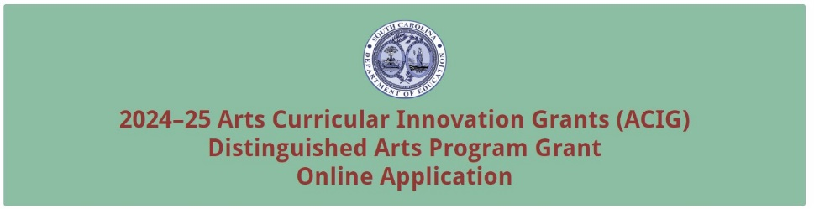
Select the applicant type (school or school district). Enter the official name of the applicant organization and school district’s mailing address with the 10-digit ZIP Code (ZIP+4 Code). Enter the school district’s Unique Entity Identifier and the Taxpayer Identification Number (TIN). If the district is the applicant organization, select the number of schools to be served (up to three). Provide a descriptive title of the project.
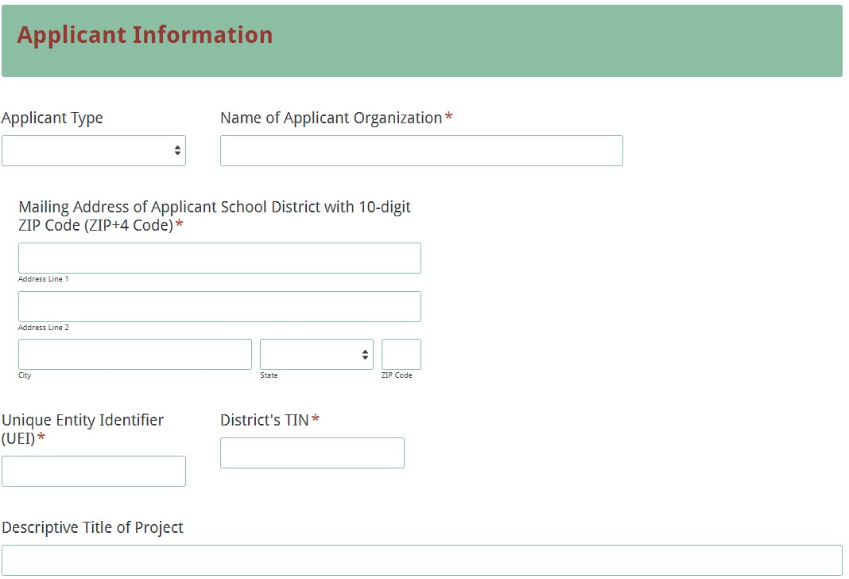
If a school is the applicant organization, you will be prompted to enter the name of the school district in addition to the information requested above. Select the grade level to be served by the project.
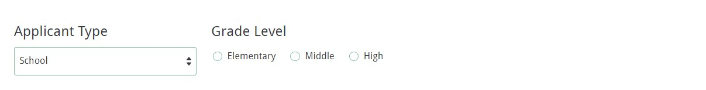
Enter the contact information for the grant manager. The name entered in the online application must match the name as shown on the Certification Signature Page. Select “Same as Applicant Organization’s Address” if the school’s mailing address is the same as the information entered on the first screen. The data will automatically populate these fields. If the address is different, enter the appropriate information. The grant manager’s email is a required field. The confirmation of a successful online application submission will be sent only to this email address. Reenter the email address to validate that it is correct.
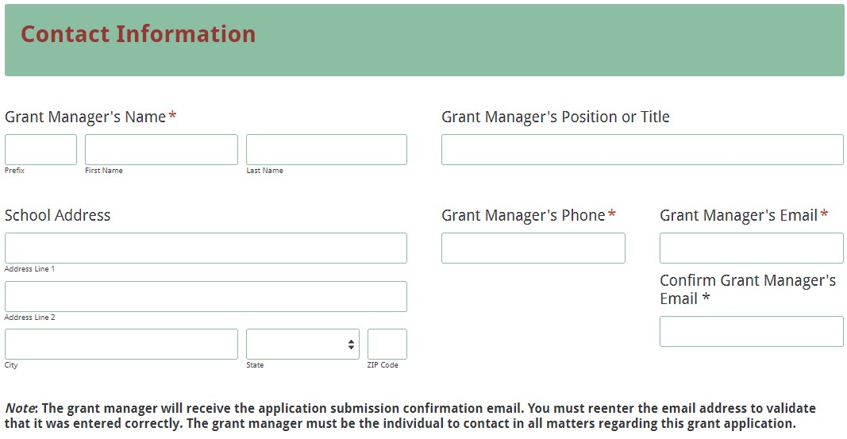
Enter the contact information for the district’s superintendent and finance director. The names entered in the online application must match the name as shown on the Certification Signature Page.
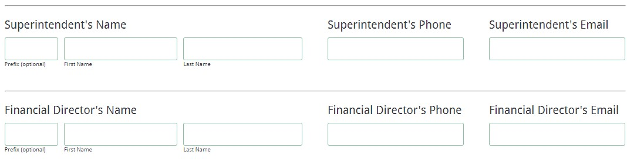
For school applicants, enter the contact information for the principal. The name entered in the online application must match the name on the Certification Signature Page.
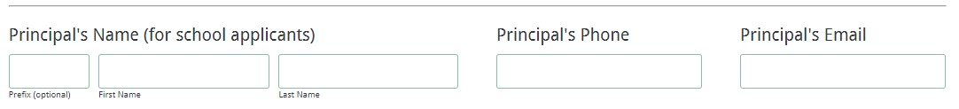Select all of the applicable arts areas that will be addressed by the project. Identify whether or not the school will participate in SCAAP. Enter the number of students, teachers, and members of the overall education community who will benefit from the proposed project.
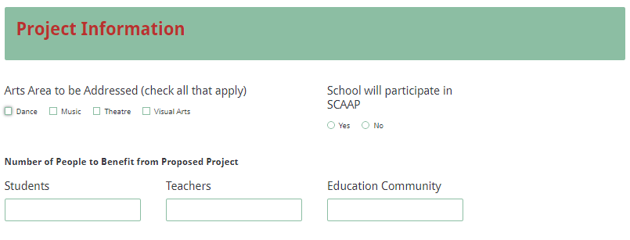
District applicants must provide the name(s) of the school(s) that will participate (up to three). For each school, indicate the grade level. For each school to be served, indicate whether or not the school will participate in the SCAAP.
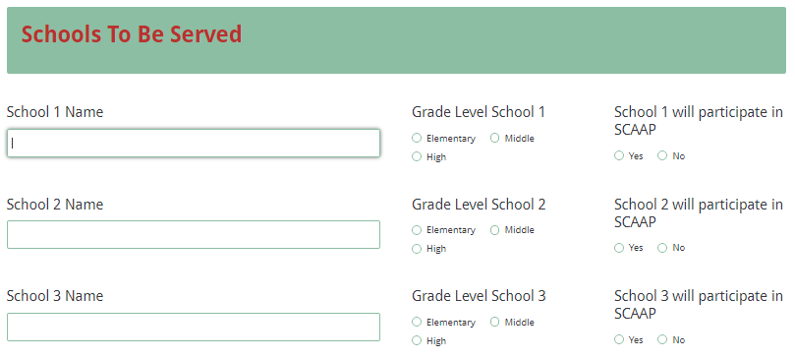
Provide a brief, one sentence description of up to five major action steps/activities of the project.
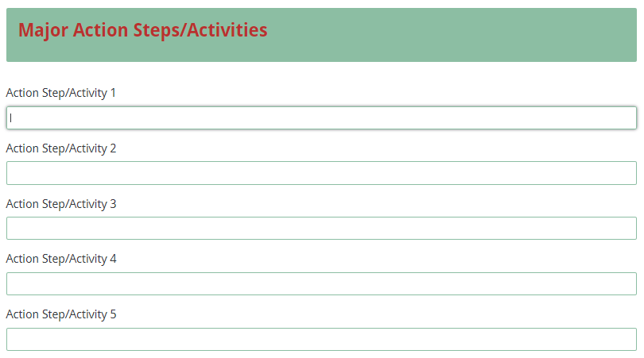
All amounts in the Budget Summary section should be entered using only whole dollars (no cents). Fill in all fields and enter 0 (zero) for line items that are not applicable to the project.
Enter the line-item totals by object code for the grant funds being requested for the applicant’s operating budget. The amounts for each line item must equal the corresponding line-item totals in the Budget Narrative. The Total Grantee Budget field will automatically calculate.
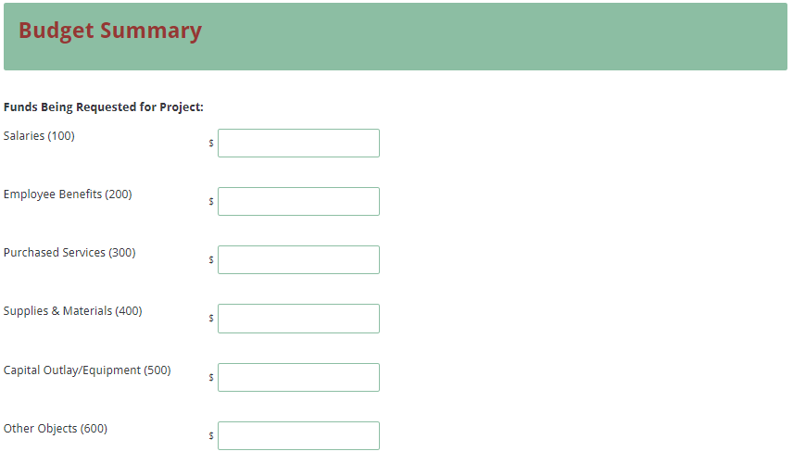
Enter the amount of funds budgeted for professional development scholarships for the Arts Teacher Institutes. This amount should be a minimum of 30 percent ($5,400 school; $12,000 district) of the total funds requested. Funds for these institutes have their own line item in the Budget Summary and therefore should not be included in purchased services or any other part of the budget. The Total Funds Requested field will automatically calculate.

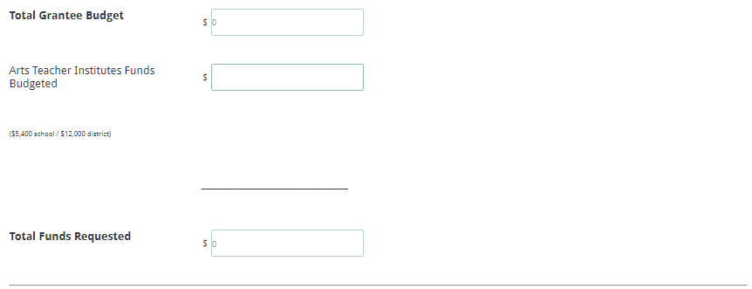
On the next form screen, upload the completed Application Narrative, Budget Summary and Narrative, and appendices as the proposal attachments.
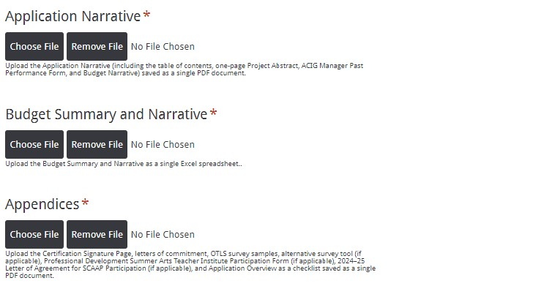
The online application will only allow one document to be uploaded for each attachment. You will not be able to submit the application without attaching all of the required attachments.

On the next screen, thoroughly review the Data Review Page to verify that all information has been entered correctly in the online application. You will not be able to access the completed application form after it is submitted so it is particularly important to ensure that all of the information in the application has been entered correctly.
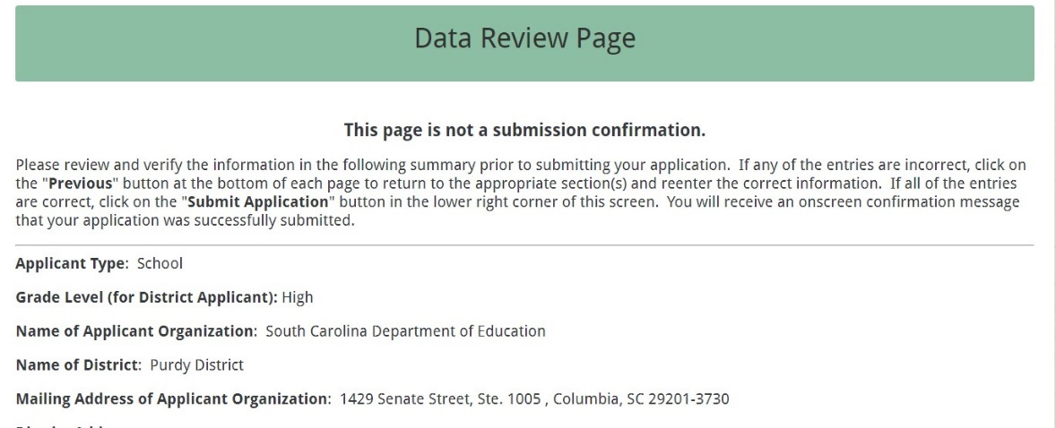
If any entries are incorrect, click on the “Previous” button at the bottom left corner of each screen to return to the appropriate section(s) and reenter the correct information. Then click on the “Next” button in the lower right corner of each screen to return to the Data Review Page.

Note: This page is not a confirmation of the submission of an application.

After verifying that all entries are correct, click the "Submit Application" button in the lower right corner of this screen in order to complete the submission process.
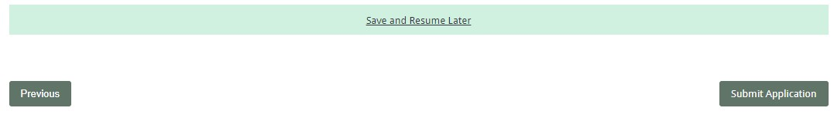
After submitting the application, the following message will be displayed on the screen.
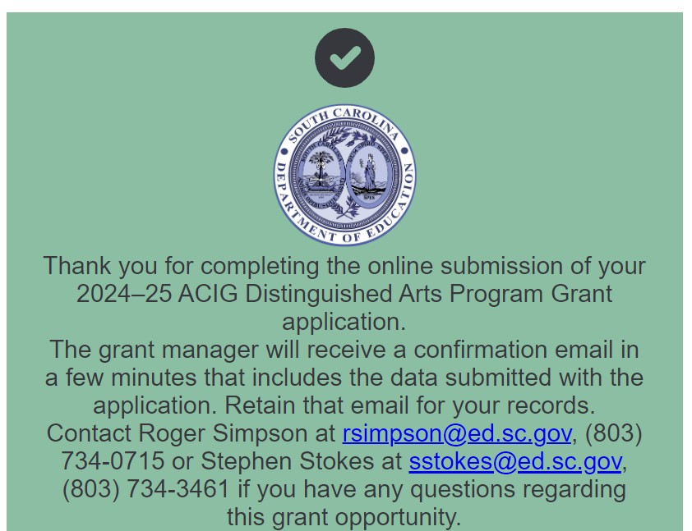

The following confirmation message will be emailed to the address provided for the grant manager.
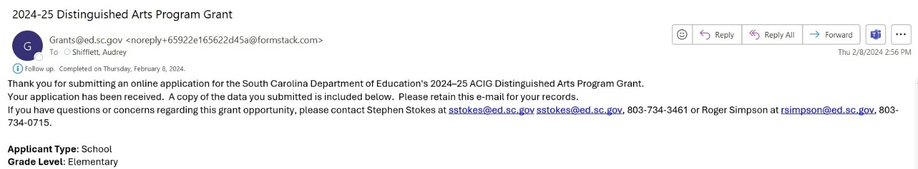
If the grant manager does not receive a confirmation email, then the application did not successfully transmit. You must go back and resubmit the entire online form, including all attachments, in order for your application to be considered for funding. Only the most recently submitted application will be reviewed.

An email confirmation that the grant application was successfully submitted does not account for the quality of the uploaded documents or the completeness of the online form. The confirmation email only notifies you that the online application has been submitted and received. Applicants are responsible for ensuring that the information entered in the online form, including all attachments, is accurate and complete in order for the application to be reviewed and considered for funding.

Appendix A: Definitions of Terms Used

2017 South Carolina College- and Career-Ready Standards for Visual and Performing Arts Proficiency (2017 Standards)—A series of eight documents that individually address the arts areas of dance, design, choral music, general music, instrumental music, media arts, theatre, and visual arts in a proficiency based model from pre-kindergarten through high school. The standards delineate what the state’s students should know and be able to do in these content areas. The eight documents are intended to be used not only as the basis for curricula, instruction, and assessment in the arts disciplines in South Carolina schools but also as a concise statement about expectations for learning in the arts for policy makers, education administrators, teachers, and instructional and community leaders.

Action Steps—Detailed descriptions of the actions required to implement respective strategies, including priority activities, schedules/timelines, leadership responsibilities, and associated costs.

Comprehensive Arts Program—A comprehensive sequential arts program includes dance, media arts, music, theatre, and visual arts based on the 2017 Standards. The arts program articulates from kindergarten through twelfth grade and grows in the depth and scope of the arts form that is taught. Instruction in the arts is delivered by arts specialists. Arts specialists are teachers appropriately trained and licensed and certified by the state of South Carolina to teach dance, music, theatre, or visual arts.

Evaluation—A description of the procedures and methods by which progress toward goals and objectives will be regularly assessed and monitored.

Greater Learning Community—The greater learning community can include but is not limited to parents, volunteers, and artists who have benefited from goods and services that you have provided your students through the ACIG DAP grant opportunity. This can include parent and community member attendance at school performances and volunteers who directly work with students supported by grant funds.

Goals—Statements of the district’s or school’s long-term (3–5 years) arts education goals for students stated in results-oriented terms.

Indirect cost—An expense (such as for advertising, computing, maintenance, security, supervision) incurred in joint usage and, therefore, difficult to assign to or identify with a specific cost object or cost center (department, function, program). Indirect costs are usually constant for a wide range of output, and are grouped under fixed costs. Indirect costs are not allowable for the DAP grant.

Mission Statement—A description of the purpose of the district’s or school’s arts education program stated in results-oriented terms.

Opportunity-to-Learn: Standards (OTLS) for Arts Education Program Assessment Worksheets—These worksheets directly reflect the wording of the original publication (with some minor editing) and include spaces to check whether the standard is lacking, is met, or is exceeded in a given school or school system.

Overall Education Community—Includes all people who learn and benefit from the ACIG programs such as teachers, teaching assistants, students, parents, and volunteers.

Profile of the South Carolina Graduate—This framework identifies the characteristics that are believed to be vital in helping our state stay competitive in today's global economy as it addresses the need and solution for a sustainable, educated, and qualified workforce.
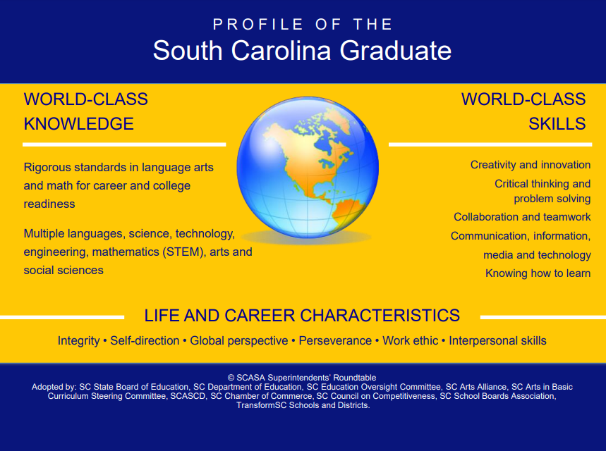

Strategies—Statements of the initiatives through which the district’s or the school’s goals will be met stated in “concrete” language and in measurable terms.

Vision Statements—A description of what the district’s or school’s arts education program should look like in 2025 and beyond. Vision statements should address instructional objectives, quality, and delivery systems as well as the relationship of the arts to other curricula areas and the community.

Appendix B: Selection Criteria and Reviewers’ Scoring Rubric

Selection Criteria

Narrative Sections | Maximum Points Available
1. Project Abstract | 0
2. Needs Assessment | 20
3. Academic Standards Implementation | 15
4. Goals and Objectives | 20
5. Strategies and Action Steps/Activities | 20
6. Management and Sustainability | 15
7. Project Evaluation and Dissemination Plan | 15
8. Strategic Arts Plan | 25
Budget Narrative and Summary | 0
TOTAL | 130

Scoring Rubric

- Project Abstract: The applicant must include a one-page abstract that fully addresses the following items:
- identifies the applicant (school and/or district), the title of the project, and the total amount of funds requested;
- summarizes the proposal, including the target audience and the number of students, teachers, and members of the overall education community who will benefit from the proposed project; and
- briefly summarizes the need, goal(s) and objectives, standards implementation, strategies and action steps/activities, and evaluation plans, including the expected outcomes of the project.
Acceptable
Adequate/Meets—0 points
Applicant provides a narrative that fully addresses all required items.
Not Acceptable
Inadequate—0 points
Applicant provides a narrative that does not adequately addresses all required items.
Score
Reviewer’s Comments

2.a. Needs Assessment: The applicant must provide a narrative that fully addresses the following items:
- summarizes the needs identified for students and the arts education program as a result of administering the OTLS survey, including the names of the survey respondents and a conclusion;
- discusses what students need in terms of their abilities to apply the 2017 Standards in their work and how these needs align with the implementation of the 2017 Standards; and
- if applicable, discusses the results of any alternative survey tool and provides a justification for its use.
Acceptable
Fully Meets—9–10 points
Applicant provides a narrative that fully addresses all required items.
Adequate/Meets—6–8 points
Applicant provides a narrative that moderately addresses all required items.
Not Acceptable
Limited/Approaches—3–5 points
Applicant provides a narrative that is limited or unclear in addressing all required items.
Inadequate—0–2 points
Applicant provides a narrative that does not adequately address all required items.
Score
Reviewer’s Comments

2.b. Needs Statement: The applicant must provide a narrative that fully discusses the resources and/or professional development training for arts and/or classroom teachers that are needed to enable them to best
- implement the 2017 Standards,
- meet the needs identified for the arts education program, and
- raise student achievement in the arts.
Acceptable
Fully Meets—9–10 points
Applicant provides a narrative that fully discusses all required items.
Adequate/Meets—6–8 points
Applicant provides a narrative that moderately discusses all required items.
Not Acceptable
Limited/Approaches—3–5 points
Applicant provides a narrative that is limited or unclear in discussing all required items.
Inadequate—0–2 points
Applicant provides a narrative that does not adequately discuss all required items.

Score
Reviewer’s Comments

3.a. Academic Standards Implementation: The applicant must provide a narrative that fully addresses the following two items:
- identifies the specific academic standards and indicators to be implemented; and
- discusses how these standards are aligned with identified needs, appropriate activities, and budgetary allocations.
Acceptable
Fully Meets—4–5 points
Applicant provides a narrative that fully addresses both required items.
Adequate/Meets—2–3 points
Applicant provides a narrative that moderately addresses both required items.
Not Acceptable
Limited/Approaches—1 point
Applicant provides a narrative that is limited or unclear in addressing both required items.
Inadequate—0 points
Applicant provides a narrative that does not adequately address both required items.
Score
Reviewer’s Comments

3.b. Academic Standards Implementation: The applicant must provide a narrative that fully addresses the following two items:
- how teachers will implement the standards in terms of instruction, curricula, and assessment as a result of the proposed project; and
- how students will apply the standards in their work as a result of the proposed project.
Acceptable
Fully Meets—8–10 points
Applicant provides a narrative that fully addresses both required items.
Adequate/Meets—5–7 points
Applicant provides a narrative that moderately addresses both required items.

Not Acceptable
Limited/Approaches—2–4 points
Applicant provides a narrative that is limited or unclear in addressing both required items.
Inadequate—0–1 point
Applicant provides a narrative that does not adequately address both required items.
Score
Reviewer’s Comments

4.a. Goals and Objectives: The applicant must provide a narrative that fully addresses the following:
- SMART objectives that support the goal of significantly improving student achievement in the arts through curricula, instruction, and assessment based on the 2017 Standards.
- If applicable, SMART objectives to support any additional goal(s).
Acceptable
Fully Meets—8-10 points
Applicant provides a narrative with clear and detailed SMART objectives to support the goal.
Adequate/Meets—5-7 points
Applicant provides a narrative with moderately SMART objectives to support the goal.
Not Acceptable
Limited/Approaches—2-4 points
Applicant provides a narrative with limited or incomplete SMART objectives to support the goal.
Inadequate—0-1 point
Applicant does not provide a narrative with SMART objectives to support the goal
Score
Reviewer’s Comments

4.b.–4.c. Goals and Objectives: The applicant must provide a narrative that address the following:
- who will be affected by the project,
- the art area(s) to be included,
- the instructional level(s) to be addressed,
- the expected outcomes for students,
- how innovative practices in design thinking will be implemented to the new 2017 standards; and
- the specific goals and objectives related to arts education and the Profile of the South Carolina Graduate that are stated in the district’s strategic plan or in the school renewal plan.
- If applicable, SMART objectives to support any additional goal(s).
Acceptable
Fully Meets—8-10 points
Applicant provides a narrative that fully addresses all required items.
Adequate/Meets—5-7 points
Applicant provides a narrative that moderately addresses the required items.
Not Acceptable
Limited/Approaches—2-4 points
Applicant provides a narrative that is limited or incomplete in addressing the required items.
Inadequate—0-1 point
Applicant provides a narrative that does not adequately address the required items.
Score
Reviewer’s Comments

5.a.–5.c. Strategies and Action Steps/Activities: 5.d.–e. Strategies and Action Steps/Activities: the strategies and action steps/activities planned for meeting the goal(s) and objectives;
- how the strategies and action steps/activities will be used to bring about growth in students’ knowledge and skills in terms of the implementation of the 2017 Standards;
- how the new design thinking standards will be implemented within the existing visual and performing arts programs to foster growth in student achievement;
- the innovative practices that will be used to enhance, accelerate, and assure student achievement and to offer varied opportunities in the arts and to implement the new standards; and
- the research that supports the innovative practices.
Acceptable
Fully Meets—8-10 points
Applicant provides a narrative that fully addresses all required items.
Adequate/Meets—5-7 points
Applicant provides a narrative that moderately addresses all required items.

Not Acceptable
Limited/Approaches—2-4 points
Applicant provides a narrative that is limited or incomplete in addressing all required items.
Inadequate—0-1 point
Applicant provides a narrative that does not adequately address all required items.
Score
Reviewer’s Comments

5.d.–e. Strategies and Action Steps/Activities: The applicant must provide a detailed narrative that
- discusses how the materials and services budgeted support the objectives, activities, and standards; and
- identifies who will participate in the planned professional development Arts Teacher Institutes and how teacher participation will support the objectives outlined in the strategic arts plan.
Acceptable
Fully Meets—8-10 points
Applicant provides a narrative that fully addresses all required items.
Adequate/Meets—5-7 points
Applicant provides a narrative that moderately addresses all required items.
Not Acceptable
Limited/Approaches—2-4 points
Applicant provides a narrative that is limited or incomplete in addressing all required items.
Inadequate—0-1 point
Applicant provides a narrative that does not adequately address all required items.
Score
Reviewer’s Comments

6.a. Management and Sustainability: The applicant must present a complete ACIG Manager Past Performance Form that clearly demonstrates certification in at least one arts area or responsibility for arts education leadership/oversight within the school or district.

|Acceptable
Adequate/Meets—5 points
The applicant presents a complete ACIG Manager Past Performance Form that clearly demonstrates certification in at least one arts area or responsibility for arts education leadership/oversight within the school or district.
Not Acceptable
Inadequate—0 points
The applicant does not present a complete ACIG Manager Past Performance Form that clearly demonstrates certification in at least one arts area or responsibility for arts education leadership/oversight within the school or district.
Score
Reviewer’s Comments

6.b.–6.c. Management and Sustainability: The applicant must provide a narrative that addresses all of the following items:
- presents the composition of the arts steering committee that will assist the grant manager with oversight of the proposed DAP project with each member’s name, specific title, professional affiliation, relationship to the school or district, and role on the committee;
- describes the efforts that will be used to ensure that the composition of the committee reflects the school’s or district’s student population;
- describes the strategies that will be used to ensure that the committee is comprised of a cross-section of arts and classroom teachers, administrators, students, parents, artists, community members, and other stakeholders; and
- discusses how the project activities will be sustained after the end of the grant period.
Acceptable
Fully Meets—8-10 points
Applicant provides a narrative that fully addresses all required items.
Adequate/Meets—5-7 points
Applicant provides a narrative that moderately addresses all required items.
Not Acceptable
Limited/Approaches—2-4 points
Applicant provides a narrative that is limited or incomplete in addressing all required items.
Inadequate—0-1 point
Applicant provides a narrative that does not adequately address all required items.
Score

Reviewer’s Comments

7.a.–7.c. Project Evaluation and Dissemination Plan: The applicant must provide a narrative that describes all three of the following:
- the procedures and/or instruments that will be used to measure the attainment of the goal(s) and each objective and to assess the effectiveness of the proposed project;
- how the data will be gathered, organized, and analyzed, along with how often and who will be involved; and
- what will be done to modify the project should any adjustments be needed.
Acceptable
Fully Meets—8-10 points
Applicant provides a narrative that fully describes all three required items.
Adequate/Meets—5-7 points
Applicant provides a narrative that moderately addresses all three required items.
Not Acceptable
Limited/Approaches—2-4 points
Applicant provides a narrative that is limited or incomplete in addressing all three required items.
Inadequate—0-1 point
Applicant provides a narrative that does not adequately address all three required items.
Score
Reviewer’s Comments

7.d.–7.e. Project Evaluation and Dissemination Plan: The applicant must provide a narrative that fully describes how the project results (successes and challenges) will be shared and disseminated and, if applicable, what replicable products and/or strategies will be produced as a result of this project.
Acceptable
Fully Meets—4-5 points
Applicant provides a narrative that fully describes the required items.
Adequate/Meets—2-3 points
Applicant provides a narrative that moderately addresses the required items.

Not Acceptable
Limited/Approaches—1 point
Applicant provides a narrative that is limited or incomplete in addressing the required items.
Inadequate—0 points
Applicant provides a narrative that does not adequately address the required items.
Score
Reviewer’s Comments

8.a. Strategic Arts Plan: The applicant clearly presents the following:
- an arts mission statement that describes the purpose of the district’s or school’s arts education program stated in results-oriented terms, and
- vision statements that describe what the applicant’s arts education program should look like after they have successfully implemented the strategic arts plan.
Acceptable
Adequate/Meets—3-5 points
Applicant clearly presents the items listed in 8.a.
Not Acceptable
Inadequate — 0-2 points
Applicant does not present the items listed in 8.a.
Score
Reviewer’s Comments

8.b.–8.d. Strategic Arts Plan: The applicant must provide a complete strategic arts plan that fully includes all six of the following:
- goals and objectives indicating a logical progression of the strategic plan for achievement in the arts;
- the planned strategies and action steps/activities, in chronological order, to accomplish each stated objective;
- the personnel responsible for implementing each action step/activity;
- the planned evaluation procedures for each listed strategy and action step/activity;
- the personnel responsible for evaluating student achievement; and
- the means for evaluating each goal and objective.

Acceptable
Fully Meets—15-20 points
Applicant provides a strategic arts plan that fully includes all six required items.
Adequate/Meets—5-7 points
Applicant provides a strategic arts plan that moderately includes all six required items.
Not Acceptable
Limited/Approaches—2-4 points
Applicant provides a strategic arts plan that is limited or incomplete in including all six required items.
Inadequate—0-1 point
Applicant provides a strategic arts plan that does not adequately include all six required items.
Score
Reviewer’s Comments

Budget Narrative and Summary: The applicant must provide a complete Budget Narrative with all of the following:
- clear evidence that the budget is appropriate and justified based on the proposed activities resulting from the needs assessment and the implementation of the 2017 Standards;
- an itemized expenditure list that details the specific planned expenditures;
- a description of project activities that will necessitate the expenditure of each line item; and
- correct calculations for all line items and the total budget.

Acceptable
Adequate/Meets—0 points
The applicant provides a complete budget narrative that includes all required items.
Not Acceptable
Inadequate—0 points
The applicant does not provide a complete budget narrative that includes all required items.
Score
Reviewer’s Comments

Appendix C: Required SCDE Forms

Certification Signature Page
(This form must be signed by the individual from each proposed district, school, or organization who holds the title listed below.)

Certification
I hereby certify that, to the best of my knowledge, the information and data contained in this application are true and correct. The applicant’s governing body has duly authorized this application and documentation, and the applicant will comply with the SCDE Assurances and Terms and Conditions for State Awards if the grant is awarded.

Authorized Official Representative (Must be superintendent of school district)
Name:
Position:
Telephone: | Email:
Signature of Authorized Official Representative: |  | Date:

District Financial Official
Name:
Position:
Telephone: | Email:
Signature of District Financial Official: |  | Date:

Principal (if school is applicant)
Name:
Position:
Telephone: | Email:
Signature of Principal: |  | Date:

Grant Manager
Name:
Position:
Telephone: | Email:
Signature of Grant Manager: |  | Date:

Please complete, print, and obtain signatures prior to submission. Include the signed, scanned form in the appendices as indicated on page 29.

Assurances and Terms and Conditions for State Awards

Assurances

I certify that this applicant
- Has the legal authority to apply for state assistance and the institutional, managerial, and financial capability (including funds sufficient to pay the nonstate share of project costs) to ensure proper planning, management, and completion of the project described in this application.
- Will give the South Carolina Department of Education (SCDE) access to and the right to examine all records, books, papers, or documents related to this award and will establish a proper accounting system in accordance with generally accepted accounting principles (GAAP) or agency directives.
- Has an accounting system that includes sufficient internal controls, a clear audit trail, and written cost-allocation procedures as necessary. The financial management systems are capable of distinguishing expenditures that are attributable to this grant from those that are not attributable to this grant. This system is able to identify costs by programmatic year and by budget line item and to differentiate among direct, indirect, and administrative costs. In addition, the applicant will maintain adequate supporting documents for the expenditures and in-kind contributions, regardless of the type of funds, if any, that it makes under this grant. Costs are shown in books or records (e.g., disbursements ledger, journal, payroll register) and are supported by a source document such as a receipt, travel voucher, invoice, bill, or in-kind voucher.
- Will also comply with GAAP as it relates to budgets, budget amendments, and expenditure claim submissions.
- Will approve all expenditures, document receipt of goods and services, and record payments on the applicant’s accounting records prior to submission of reimbursement claims to the SCDE for costs related to this grant.
- Will initiate and complete work within the applicable time frame after receipt of approval by the SCDE.
- Will not discriminate against any employee or applicant for employment because of race, color, religion, age, sex, national origin, or disability. The applicant will take affirmative action to ensure that applicants for employment and the employees during the period of their employment are treated without regard to their race, color, religion, age, sex, national origin, or disability.
- Will comply with the Ethics, Government Accountability, and Campaign Reform Act (S.C. Code Ann. § 2-17-10 et seq. and § 8-13-100 et seq. (Supp. 2023)).
- Will comply with the Drug Free Workplace Act (S.C. Code Ann. § 44-107-10 et seq. (Supp. 2023)) if the amount of this award is $50,000 or more.

Terms and Conditions

- Completeness of Proposal. All proposals should be complete and carefully worded and must contain all of the information requested by the South Carolina Department of Education (SCDE). If you do not believe a section applies to your proposal, please indicate that fact.
- Non-awards/Termination. The SCDE reserves the right to reject any and all applications and to refuse to grant monies under this solicitation. If the SCDE rejects an application, the applicant has a right to request a review of the process consistent with the appeals process presented in the Request for Proposals (RFP).
After it has been awarded, the SCDE may terminate a grant by giving the grantee written notice of termination. In the event of a termination after award, the SCDE shall reimburse the grantee for expenses incurred up to the notification of termination. In addition, this grant may be terminated by the SCDE if the grantee fails to perform as promised in its proposal.
Upon the termination of a grant, the grantee shall have the right to a review process. The grantee must notify the SCDE of its request within 30 days of receiving written notice of the termination.
- Reduction in Budgets and Negotiations. The SCDE reserves the right to negotiate budgets with potential grantees. The SCDE may, at its sole discretion, determine that a proposed budget is excessive and may negotiate a lower budget with the applicant. The applicant may at that time negotiate or withdraw its proposal. In addition, the SCDE may desire to fund a project but not at the level proposed. In that case, the SCDE shall notify the applicant of the amount that can be funded, and the applicant and the SCDE shall negotiate a modification to the proposal to accommodate the lower budget. All final decisions are that of the SCDE.
- Amendments to Grants. Amendments are permitted upon the mutual agreement of the parties and will become effective when specified in writing and signed by both parties.
- Use of Grant Funds. Funds awarded are to be expended only for purposes and activities covered by the approved project plan, budget, and budget narrative.
- Submission of Expenditure Reports. Claims for reimbursement must be made at least quarterly and consistent with calendar quarters (e.g., an expenditure report claim for costs for January 1 through March 30 must be filed by May 15).
- Obligation of Grant Funds. Grant funds may not be obligated prior to the effective date or subsequent to the end or termination date of the grant period. No obligations are allowed after the end of the grant period. The final request for expenditure report claims must be submitted no later than forty-five (45) days after the end of the grant period unless the scope of work for the grant states a shorter reporting period.
- Deobligation of Funds. After a final expenditure claim has been submitted to the SCDE, the grantee will go through the official deobligation process with the SCDE.
- Documentation. The grantee must provide for accurate and timely recording of receipts and expenditures. The grantee’s accounting system should distinguish receipts and expenditures attributable to each grant. The grantee must review the memo regarding “Guidelines for Retaining Documentation to Support Expenditure Claims.”
- Travel Costs. Travel costs, if allowed under this solicitation, must not exceed limits noted in the United States General Services Administration (GSA) per diem rates for lodging, except in the case of conference lodging required for program-required training. In the case that conference-related lodging exceeds the GSA per diem rate, the grantee shall follow their entity’s written procedure for obtaining prior approval to exceed a GSA rate for a conference hotel. Meals and incidentals are limited by the state budget proviso, currently not to exceed $35 per day for in-state travel and $50 for out-of-state travel (see page 81 of the State of South Carolina Statewide Disbursement Regulations). Mileage reimbursement must follow the current Office of Comptroller General instructions, which is consistent with the published IRS rates.
- Honoraria. Amounts paid in honoraria, if allowed under this grant, must be consistent with SCDE policies. Applicants should check with the program office before budgeting for honoraria.
- Reports. The grantee shall submit, as required or instructed by the awarding program office, all reports (programmatic, financial, or evaluation) within the specified period or date and in the prescribed format. An expenditure claim report must be filed by July 5 for all expenditures incurred by June 30 in order to comply with the generally accepted accounting principles (GAAP) and the production of the State's Comprehensive Annual Financial Report.
- Copyright. The grantee is free to copyright any books, publications, or other copyrightable materials developed in the course of this grant. However, the SCDE reserves a royalty-free, nonexclusive, and irrevocable license to reproduce, publish, or otherwise use, and to authorize others to use, the copyrighted work developed under this grant.
- Certification Regarding Suspension and Debarment. By submitting an application, the applicant certifies, to the best of its knowledge and belief, that the
- Applicant and/or any of its principals, subgrantees, or subcontractors
  - are not presently debarred, suspended, proposed for debarment, or declared ineligible for the award of contracts by any state or federal agency; have not, within a three-year period preceding this application, been convicted of or had a civil judgment rendered against them for commission of fraud or a criminal offense in connection with obtaining, attempting to obtain, or performing a public (federal, state, or local) contract or subcontract; violation of federal or state antitrust statutes relating to the submission of offers; or commission of embezzlement, theft, forgery, bribery, falsification or destruction of records, making false statements, tax evasion, or receiving stolen property; and
  - are not presently indicted for, or otherwise criminally or civilly charged by a governmental entity with, commission of any of the offenses enumerated above.
- Applicant has not, within a three-year period preceding this application, had one or more contracts terminated for default by any public (federal, state, or local) entity.
- Audits. Although this Assurances, Terms, and Conditions document is for a state award, federal audit requirements apply as follows:
- Entities expending $750,000 or more in federal awards:
Entities that expend $750,000 or more in federal awards during the fiscal year are required to have an audit performed in accordance with the provisions of 2 CFR Part 200.501, et seq. Except for the provisions for biennial audits provided in 2 CFR Part 200.504 (a) and (b), audits must be performed annually as stated at 2 CFR Part 200.504. A grantee that passes through funds to subrecipients has the responsibility of ensuring that federal awards are used for authorized purposes in compliance with federal program laws, federal and state regulations, and grant agreements. The director of the OMB, who will review this amount every two years, has the option of revising the threshold upward.
- Entities expending less than $750,000 in federal awards:
Entities that expend less than $750,000 in a fiscal year in federal awards are exempt from the audit requirements in 2 CFR Part 200.504. However, such entities are not exempt from other federal requirements (including those to maintain records) concerning federal awards provided to the entity. The entity’s records must be available for review or audit by the SCDE and appropriate officials of federal agencies, pass-through entities, and the General Accounting Office (GAO).
- Records. The grantee shall retain grant records, including financial records and supporting documentation, for a minimum of six (6) years after the end date of the grant when the final expenditure report claim for reimbursement and all final reports have been submitted, unless informed otherwise or in case of litigation.
- Electronic Signature Agreement. I agree that my electronic signature is the legally binding equivalent to my handwritten signature.

Arts Curricular Grant Manager Past Performance Form

You may attach an additional sheet if you wish to add information or need more space (limit to 2 pages). The grant manager must be the same person listed in the online application. The grant manager must ensure that, if funded, school(s) will work with SCDE to establish data concerning the growth and development of K–12 arts education programs and the effects of ACIG funding on school arts programs and student achievement.

Complete this form and include in the narrative as instructed on page 17.

Name of Applicant (District or School):
District (if School is applicant)
Arts Curricular Grant Manager Information
Name:
Job Title:
Email:
Phone Number:
Job Duties for ACIG Project Management:
Educational Background, Fine Arts Training and/or Experience:
Accomplishments or Awards:
Active Memberships in Professional Organizations:
Years of Experience: |  | ______ |  | Certification Areas:
What SCDE professional development Arts Teacher Institutes and similar training has the grant manager candidate completed?

Professional Development Arts Teacher Institutes

SCDE-Approved Choices for 2024-25 Arts Curricular Innovation Grants Recipients

Below is a list of professional development arts institutes/courses for elementary, middle, and secondary schools in the arts disciplines of dance, music, theatre, and the visual arts. This list represents possible selections that may be offered in June 2025.

Applicants planning to apply for funding to attend professional development Arts Teacher Institutes must complete and include the tentative Professional Development Arts Teacher Institutes Participation Form (page 54). Please provide the teacher’s name and the institute that the teacher plans to attend. Applicants will not be held to this list; however, it will provide the planners with an idea of which institutes need to be offered.

All arts teachers in the DAP school must have taken CLIA and Arts Assessment Institute I (AAI–I) before any classroom teachers and administrators are permitted to register for arts integration institutes, including Creative Teachers, Arts Integration, and Muse Machine. After all visual and performing arts teachers have completed CLIA and AAI–I, schools and districts may enroll classroom teachers and administrators in arts integration institutes. Arts teachers must show proof of CLIA and AAI–I participation. Arts teachers must have successfully completed CLIA and AAI–I before they may advance to the next tier of institutes.

Note: Institute attendees must be returning certified teachers within the district. All equipment (such as computers) and materials distributed as part of an institute becomes the property of the school that receives the DAP grant and does not follow the grant manager if he or she leaves that school.

Registration for the professional development Arts Teacher Institutes will be available after notification of this grant award. The specific location and week of each institute will be announced during fall institute registration. Acceptance in arts institutes is on a first-come, first-served basis.

The cost for each institute may change at the time of fall institute registration.

All courses are
- focused on standards-based arts curricula, instruction, and assessment;
- offered in collaboration with an accredited college or university for three graduate credits with a minimum of 45 contact hours;
- provided as residential institutes (with room and board for participants unless otherwise stated);
- evaluated on the basis of an assessment instrument approved by the SCDE in terms of quality and its potential impact on student learning; and
- held during June 2025.

South Carolina Arts Leadership for Success Academy (SCALSA) $1,600 per teacher
This institute is designed for arts teachers who have taught fewer than three years and for critical needs teachers in the arts. SCALSA emphasizes the development of standards-based arts curricula, instruction, and assessment through
- develop standards-based arts lessons following the Curriculum Leadership Institute in the Arts (CLIA) lesson plan for future use in grant development and in future institutes;
- study strategies for Assisting, Developing, and Evaluating Professional Teaching (ADEPT) success to include the writing of student learning objectives (SLOs) as they apply to the Teacher Evaluation System, as well as information on Summative ADEPT Formal Evaluation of Teachers (Rubric 4.0) and other evaluations currently implemented for teacher certification;
- develop long-range lesson plans needed to meet indicators required under new evaluation/observation guidelines;
- study arts classroom management strategies; and
- identify teaching and learning styles to benefit student achievement.

Curriculum Leadership Institute in the Arts (CLIA) $1,400 per teacher
Designed for the experienced arts teacher, this institute emphasizes
- developing and teaching complex standards-based lesson plans with embedded assessment;
- studying models of best instructional practice;
- reviewing the steps in the SLO cycle;
- working with colleges in your arts discipline to write an SLO that could be implemented at the classroom level;
- studying arts education support strategies; and
- developing a multi-arts professional network.

Arts Assessment Institute Classroom Assessment (AAI–I) $1,200 per teacher
(Prerequisite: SCALSA with instructor’s recommendation or CLIA)
AAI–I will develop professional educators who
- study the purposes and uses of assessment;
- align assessments with local and state standards;
- construct assessments to best determine knowledge in skills and processes related to the 2017 Standards;
- demonstrate an understanding of the basic principles of measurement and evaluation;
- develop standards-based student learning objectives and corresponding assessments to demonstrate student growth;
- design and embed assessment strategies within instructional lessons and units;
- apply the relationship of national and state standards, curriculum development, instruction, and assessment; and
- reflect on their assessment practices and the role of assessment in their professional and personal lives.
Media Arts and Technology Institute $3,000 per teacher
(Prerequisite: CLIA and Arts Assessment Institute Classroom Assessment)
This institute will provide art teachers with an opportunity to develop standards-based lesson plans and guides that incorporate technology to enhance student learning. Each participant will be provided with appropriate equipment, a computer, and software, which will become the property of their schools at the conclusion of the institute.
Participating teachers will
- receive training in various software programs, apps, and media literacy;
- develop strategies for using the equipment, computer, and software with students; and
- develop lesson plans that use technology to implement the 2017 South Carolina College- and Career- Ready Standards for Visual and Performing Arts Proficiency.

Dance Teacher as Artist Institute $1,400 per teacher
(Prerequisite: CLIA and Arts Assessment Institute Classroom Assessment)
This institute is taught by master teachers experienced in dance education at all levels from elementary through graduate school. The purpose of this institute is to positively impact artistic literacy in the dance classroom. The emphasis of the institute is to investigate which core principles and processes drive each artistic process in dance and to experience how to effectively channel them into professional practice. The South Carolina College- and Career-Ready Standards for Dance Proficiency and strategies for their implementation in dance will be a basis of the work. Participants in this institute will become more fluent in each of the artistic dance processes and learn specific approaches to expand artistic literacy. Inquiry-based methods and materials will be provided to each participant for use during the institute and becomes the property of the participant’s school upon completion of the institute.

Music Teacher as Artist Institute $1,400 per teacher
(Prerequisite: CLIA and Arts Assessment Institute Classroom Assessment)
This institute will provide participants with resources and strategies to:
- increase student achievement in music performance through a strengthened understanding of the content specific to this art form;
- evaluate potential student outcomes and effectiveness of varying texts, technology, and literature specific to the content;
- develop curricula, instruction, and assessments that align with on the 2017 South Carolina College- and Career-Ready Standards for Visual and Performing Arts Proficiency; and
- support colleagues through knowledge gained from institute participation.

Contemporary Dance Pedagogy Institute $1,400 per teacher
(Prerequisite: CLIA and Arts Assessment Institute Classroom Assessment)
This institute is taught by professors in dance education to assist participants to
  - expand dance educators’ pedagogies and techniques in a variety of dance styles and idioms;
  - recognize contributions of various communities on dance traditions and practices throughout the world and develop strategies for more expanded pedagogies;
  - design lessons plans aligned with Artistic Process: Connecting (Anchor Standards 6 and 7) from the 2017 South Carolina College- and Career-Ready Standards for Dance Proficiency; and
  - develop a cohesive system of assessment that can be utilized in the K-12 dance classroom.

Muse Machine Institute $1,200 per teacher
(Prerequisite: CLIA and Arts Assessment Institute Classroom Assessment)
This institute is for classroom teachers of all grade levels and subjects. No background in the visual and performing arts is necessary. The course provides hands-on activities in the visual and performing arts taught by professional artists, instruction in the multiple intelligences, and guidance in using the arts across the curriculum. In addition to classroom instruction hours, participants are required to attend and critique four separate arts events from the areas of visual arts, music, theater, dance, historic preservation, and opera.
Participating teachers will
- gain knowledge about incorporating the arts in their own classroom (especially in the areas of science, technology, engineering, arts, and mathematics (STEAM));
- write critically about their experiences in attending four arts events (visual art exhibition, concert, theater production, dance performance);
- develop a lesson plan (using the CLIA Lesson Plan format) that will include STEAM challenges;
- participate in STEAM challenges during the weeklong intense instruction; and
- visit a company that focuses on innovation and STEAM thinking.

Design Lab Teacher Institute $1,400 per teacher
(Prerequisite: CLIA and Arts Assessment Institute Classroom Assessment)
Participants in the Design Lab Teacher Institute should be prepared to successfully:
- implement the 2017 College- and Career-Ready Standards for Design Proficiency in their arts curriculum to promote college- and career-readiness;
- apply common elements in design education: working in teams, integrating through the design process across discipline areas, and using design materials and techniques;
- construct and present design challenges to their peers and instructors for feedback;
- use design as a mode of working and learning through the process of research, prototyping, and giving and receiving feedback on the results in reflective practice; and
- practice skills and strategies such as listening/responding, participatory research, storytelling, and reflecting.

Arts Integration Leaders Institute $1,250 per participant
(Prerequisite: CLIA and Arts Assessment Institute Classroom Assessment)
This institute is taught by master teachers and coaches. The Arts Integration Leadership Institute (AILI) should be designed to prepare teachers, curriculum coaches, and other relevant stakeholders to lead arts integration related professional learning opportunities as well as coordinating the development of authentic arts integration lessons through the use of innovative strategies. Through this experience that may include virtual sessions, a weeklong institute, and/or other in-person arrangements, participants will engage in professional learning to:
- develop skills necessary to lead professional development related to:
  - defining arts integration;
  - analyzing and identifying standards that genuinely align for greater student impact;
  - identifying and selecting arts integration strategies for effective instruction; and
  - designing arts integrated lessons.
- develop the capacity to lead collaborative environments and the implementation of arts integration learning experiences.

Strategic Arts Planning Institute $4,000 per team
This institute is designed to support schools and districts in writing a strategic arts plan. Schools and Districts must bring a planning team of 4–5 participants to the institute to write a comprehensive strategic arts plan that includes dance, design, media arts, music, theatre, and visual arts. The purpose of developing a strategic arts plan is to significantly improve student achievement in the visual and performing arts based on the implementation of the 2017 Standards. This institute is provided for participants who currently need help with their strategic arts plan and/or grants management, who are interested in creating innovative opportunities in the arts for their students, or who have never written a strategic plan for the arts.

Joint Arts Administrators Institute $1000 per participant
This institute provides professional development opportunities in the arts for district arts coordinators, principals of arts focused schools, school-based arts administrators, and the larger arts education community throughout the year. This institute works in partnership with the SCDE to design professional development in topics such as:
- standards implementation,
- arts assessment,
- arts integration,
- best practices in artistically gifted and talented programs,
- college and career readiness in the arts,
- STEAM,
- arts education advocacy techniques,
- using the latest arts education research,
- implementation of a strategic arts plan, and
- updates from statewide arts education partners.

2025 SCDE Professional Development Arts Teacher Institutes Participation Form

School: _________________________________________________________________ __

District: __________________________________________________________________

Complete this form to indicate tentative participation of your teachers in the SCDE-approved professional development Arts Teacher Institutes. This will allow us to plan and organize arts institutes based on need. Note: Teachers must complete the prerequisites (SCALSA with instructor’s recommendation or CLIA and Arts Assessment Institute Classroom Assessment) before they are allowed to move to the next tier of institutes.

- South Carolina Arts Leadership for Success Academy (SCALSA)  Teacher name(s): | $1,600
- Curriculum Leadership Institute in the Arts (CLIA)  Teacher name(s): | $1,400
- Arts Assessment Institute Classroom Assessment I (AAI–I)  Teacher name(s): | $1,200
- Media Arts and Technology Institute  Teacher name(s): | $3,000
- Dance Teacher as Artist Institute  Teacher name(s): | $1,400
- Music Teacher as Artist Institute  Teacher name(s): | $1,400
- Contemporary Dance Pedagogy Institute  Teacher name(s): | $1,400
- Muse Machine Institute  Teacher name(s): | $1,200
- Design Lab Teacher Institute  Teacher name(s): | $1,400
- Arts Integration Leaders Institute  Participant(s) names: | $1,250
- Strategic Arts Planning Institute (Team of 4)  Team member names: | $4,000
- Joint Arts Administrator Institute  Participant names(s): | $1,000
Total Cost of Institutes | $

Strategic Arts Plan Mission and Vision Statements Template

Distinguished Arts Program
District:
School:

Arts Education Mission Statement

Arts Education Vision Statement(s)

Strategic Arts Plan Template
Use one chart for each goal and objective; add rows and pages as necessary.

Goal:
Objective:

Start Date–End Date | Action Steps to Achieve Objective | Responsible Personnel for Implementing the Action Step | Estimated Cost
1.
2.
3.
4.
5

Evaluation:

Indicators of Success | Date Reached

1.

2.

3.

4.

5.

Appendix D: Other Forms and Information

Letter of Agreement for 2024-25 SC Arts Assessment Program Participation

This agreement is to confirm that our school (elementary, middle, or high school) will participate in the 2024-25 piloting of SCAAP classroom assessment performance tasks. We understand that participation in SCAAP piloting requires our school to appoint a music and visual arts teacher to attend an online preparation session conducted by the SCAAP personnel at the University of South Carolina (USC), Research, Evaluation, and Measurement Center; pilot one music and one visual arts performance task with one class of students at an assigned grade level; share five pieces of sample student work from the piloting process in each arts area with the SCAAP team via an online upload; and participate in follow-up surveys or other collection of feedback on the classroom assessment and rubrics piloted.

Complete and submit one form with your DAP application for each school participating in SCAAP. If you have questions concerning SCAAP, contact the SCAAP team via email at scaap@mailbox.sc.edu or by phone at 803-777-3459 or 803-777-1246.

Please provide the following information:
Has this school/district administered SCAAP during a previous school year? Circle one: Yes No
School: | District:
School Address: | Phone:
Principal’s Name: | Principal’s Signature:
Principal’s Email Address:
Music Teacher’s Name: | Music Teacher’s Signature:
Music Teacher’s Email Address: | Previously administered SCAAP? Circle one: Yes No
Visual Arts Teacher’s Name: | Visual Arts Teacher’s Signature:
Visual Arts Teacher’s Email Address: | Previously administered SCAAP? Circle one: Yes No
Dance Teacher’s Name: | Dance Teacher’s Signature:
Dance Teacher’s Email Address: | Previously administered SCAAP? Circle one: Yes No
Theatre Teacher’s Name: | Theatre Teacher’s Signature:
Theatre Teacher’s Email Address: | Previously administered SCAAP? Circle one: Yes No
Grant Manager’s Name: | Grant Manager’s Email:

CLIA Lesson Plan Template

Each teacher who is affected by this grant must submit a lesson plan to be included with the grantee’s final report. You may add lines as needed. This form is available on the SCDE’s Visual and Performing Arts’ Support Documents and Resources webpage.

Lesson Writer
School
Grade Level
Lesson Title and Arts Area
Statement about the Writer, Long Range Plans, and Lesson Development
Unit Description
Essential Question
2017 South Carolina College- and Career-Ready Standards for Visual and Performing Arts Proficiency (17 Standards)
Learning Targets
Criteria for Assessment
Description of Instruction
Teacher Procedures
Student Tasks
Materials
Resources
Attachments: Assessment Instruments
Curriculum Connections and Content Area Standards

