Request for Proposals (RFP)
Application Package

Arts Curricular Innovation Grants
2023 Arts Teacher Institutes
Discretionary Grant

The Arts Curricular Innovation Grant (ACIG) Program is a grant program funded by the
General Assembly of the state of South Carolina authorized by Proviso 1A.8 of the
General Appropriations Act and administered by the South Carolina Department of Education.

Deadline for Receipt of Applications: November 30, 2022, at 5:00 p.m.

Technical Assistance for Applicants: October 19, 2022, at 3:30 p.m.

For programmatic questions, contact:
Roger Simpson, Education Associate for the Visual and Performing Arts
803-734-0715; rsimpson@ed.sc.gov

For reporting, fiscal/budget, and RFP-specific questions, contact:
L. Monique Curry, Education Associate for Data and Reporting
803-734-3461; lmcurry@ed.sc.gov

Issued by:
South Carolina Department of Education
Office of Assessment and Standards
1429 Senate Street
Columbia, SC 29201

TABLE OF CONTENTS
PART I: General Information 1
A. Introduction and Purpose 1
B. Eligible Applicants 6
C. Timeline of Granting Process 7
D. Technical Assistance Sessions for Applicants 7
E. Statutory and Other Requirements 7
F. Authorized Activities 8
G. Unauthorized Activities 8
H. Program Accountability and Monitoring 8
I. Fiscal Operations 11
J. Supplement, Not Supplant 12
K. Review and Selection Process 12
L. Appeals Process 13

PART II: Application Overview, Content, and Instructions 14
A. Application Overview 14
B. Application Narrative Format 14
C. Online Application Submission 15
D. Project Narrative Content 15
1. Project Description 15
2. Evaluation Design 16
3. Institute Syllabus………………………………………………………………………16
E. Application Budget 16
F. Appendices 19
G. Deadline and Submission Procedures 20
H. Screenshots of Online Application Submission Forms 20

Appendix A: Definitions of Terms Used 26

Appendix B: Selection Criteria and Reviewers’ Scoring Rubric 27

Appendix C: Required SCDE Forms 33
Certification Signature Page 33
Assurances and Terms and Conditions for State Awards 34
Budget Narrative Template 37

PART I: General Information

Introduction and Purpose

The South Carolina General Assembly annually allocates funds to the South Carolina Department of Education (SCDE) for arts curricular programs under the Education Improvement Act (EIA). The SCDE administers these funds in accordance with the legislative proviso:

1A.8. (SDE-EIA: Arts in Education) Funds appropriated in Part IA, Section 1,
VIII.A.1. Arts Curricula shall be used to support innovative practices in arts education curriculum, instruction, and assessment in the visual and performing arts including dance, music, theatre, and visual arts which incorporates strengths from the Arts in Education sites. They shall also be used to support the advancement of the implementation of the visual and performing arts academic standards. These funds shall be distributed to schools and school districts under a competitive grants program; however, up to thirty-three percent of the total amount of the grant fund shall be made available as Aid to Other Agencies to facilitate the funding of professional development arts institutes that have been approved by the State Department of Education for South Carolina arts teachers, appropriate classroom teachers, and administrators. Arts Curricular Grants funds may be retained and carried forward into the current fiscal year to be expended in accordance with the proposed award.

The Arts Curricular Innovation Grants (ACIG) currently consist of three grant programs: Arts Teacher Institutes, Equitable Arts Advancement Program (EAAP), and Distinguished Arts Program (DAP). This Request for Proposals (RFP) is specific to the Arts Teacher Institutes grant. The RFPs for the EAAP and the DAP grants are issued separately.

The purpose of the ACIG Arts Teacher Institutes program is to provide support to eligible organizations for administering arts institutes that provide professional development in arts content to South Carolina arts teachers, other academic teachers, and arts administrators. Grant awards are to provide Arts Teacher Institutes as tuition-free graduate courses or professional development that directly supports quality arts education programs that will significantly improve student achievement in the arts.

All Arts Teacher Institutes are
  - focused on standards-based arts curricula, instruction, and assessment;
  - provided as residential institutes (with room and board for participants, unless otherwise stated); and
  - evaluated based on an assessment instrument approved by the SCDE in terms of quality and its potential impact on student learning.

Seven arts institutes are offered in collaboration with an accredited college or university and will award three graduate credits with a minimum of 45 contact hours (indicated by “GC”) to participants who successfully complete the institute.

Approximately $478,000 will be distributed on a competitive basis for 12 Arts Teacher Institutes. The grant-funding period will be February 1, 2023, through June 30, 2023. Institutes must begin after February 1, 2023, and must conclude no later than June 30, 2023. Post-institute meetings and follow up on application of learning is encouraged and may be completed after June 30, 2023.

The SCDE anticipates making one grant award to provide each of the following approved institutes for 2023. Applicants must submit a separate application for each arts institute they propose to provide. All arts institutes must be approved by the SCDE.

Arts Assessment Institute Classroom Assessment (AAI-I)
Maximum grant award for this institute is approximately $45,000 to serve 40 participants. (GC)
This institute should be taught by a master teacher or professor in visual or performing arts with teaching coaches to assist participants during a one-week institute and virtual follow-up sessions to
- develop proficiency-based arts assessments to determine knowledge and skills based on the 2017 South Carolina College- and Career-Ready Standards for Visual and Performing Arts Proficiency;
- study the purposes and uses of best practices in arts assessment;
- align assessments with local and state standards;
- develop standards-based student learning objectives; and
- design and embed assessment strategies within instructional lessons and units.

Arts Integration Collaborative Teaching Institute (AICTI)
Maximum grant award for this institute is approximately $50,000 to serve 50 teachers. (GC)
This institute should be taught by master teachers and coaches with experience in planning and presenting arts integrated lessons. The Arts Integration Collaborative Teaching Institute (AICTI) must be designed for teams of teachers within the same school, ideally two arts and two core content teachers, to develop innovative strategies that result in authentic arts integration lessons through a collaborative learning model. Through this experience that may include virtual sessions, a weeklong institute, and/or other in-person arrangements, teams of teachers (arts and non-arts) engage in hands-on, content-based professional learning to:
- engage in the development and implementation of arts integrated lesson plans; and
- develop the capacity to collaboratively design and implement an arts integration learning experience (lesson or unit) through the ability to
  - define arts integration;
  - analyze and identify standards that genuinely align for greater student impact;
  - identify and select arts integration strategies for effective instruction;
  - collaboratively design and develop arts integrated lessons; and
  - student learning outcomes through virtual follow-up sessions.

Culturally Responsive Dance Pedagogy Institute (CRDPI)
Maximum grant award for this institute is approximately $30,000 to serve 25 participants.
This institute should be taught by a master teacher or professor in dance education to assist participants during a one-week institute and virtual follow-up sessions to
  - expand dance education content currently being taught in South Carolina’s K-12 schools;
  - support the development of dance curriculum that reflects the history and diversity of South Carolina;
  - recognize contributions of various communities on dance traditions and practices currently taught and develop strategies for more diverse pedagogies;
  - design lessons plans aligned with Artistic Process: Connecting (Anchor Standards 6 and 7) from the 2017 South Carolina College- and Career-Ready Standards for Dance Proficiency; and
  - develop a cohesive system of assessment that can be utilized in the K-12 dance classroom.

Curriculum Leadership Institute in the Arts I (CLIA-I)
Maximum grant award for this institute is approximately $60,000 to serve 48 participants. (GC)
This institute should be taught by master teachers and coaches from each arts area and must provide participants with resources and strategies during a one-week learning institute and virtual follow-up sessions to
  - develop and teach complex standards-based learning based on the 2017 South Carolina College- and Career-Ready Standards for Visual and Performing Arts Proficiency;
  - include an embedded assessment that emphasizes student growth through the SCCCRVPA proficiency standards;
  - study models of best instructional practice;
  - work with colleges to review Student Learning Objectives (SLOs) that could be implemented at the classroom level; and
  - study arts education support strategies and develop a multi-arts professional network.

Dance Teacher as Artist Institute
Maximum grant award for this institute is approximately $35,000 to serve 25 participants. (GC)
This institute should be taught by master teachers experienced in dance education at all levels from elementary through graduate school. This one-week institute with virtual follow-up sessions must provide participants with resources and strategies to:
- develop artistic literacy in the dance classroom;
- investigate core principles and processes that drive each artistic process in dance;
- experience how to effectively channel core principals and processes into professional practice;
- become more fluent in each of the artistic dance processes; and
- learn specific approaches to expand artistic literacy.
Inquiry-based methods and materials should be provided to each participant for use during the institute that will become the property of the participant’s school upon completion of the institute. The 2017 South Carolina College- and Career-Ready Standards for Dance Proficiency and strategies for their implementation in dance should be a basis for the work during this institute.

Design Lab Teacher Institute:
Maximum grant award for this institute is approximately $35,000 to serve 25 participants.
This institute should be taught by master teachers and coaches and provide professional learning to prepare K-8 arts educators across disciplines to implement the 2017 College- and Career-Ready Standards for Design Proficiency and analyze the relationship to the Design Thinking Process. This institute should be designed to help participants:
- examine how the Design Thinking Process can be used as a natural connector of transdisciplinary concepts that promotes college and career readiness;
- analyze the role of design education as an approach to real-world challenges, personalized learning, critical thinking through decision-making, developing communication skills, integrating learning concepts from many disciplines, and building community; and
- cultivate a community of arts educators who will use the design thinking standards in their teaching to create and share instructional materials and resources to mentor other arts educators.
Participants in the Design Lab Teacher Institute should be prepared to successfully:
- implement the 2017 College- and Career-Ready Standards for Design Proficiency in their arts curriculum to promote college- and career-readiness;
- apply common elements in design education: working in teams, integrating through the design process across discipline areas, and using design materials and techniques;
- construct and present design challenges to their peers and instructors for feedback;
- use design as a mode of working and learning through the process of research, prototyping, and giving and receiving feedback on the results in reflective practice; and
- practice skills and strategies such as listening/responding, participatory research, storytelling, and reflecting.

Guitar Teacher as Artist Institute
Maximum grant award for this institute is approximately $30,000 to serve 25 participants.
This institute should be taught by a master teacher or professor with extensive knowledge of the various guitar pedagogies and experience with guitar instruction, assessment, and performance. This one-week institute with virtual follow-up sessions must provide participants with resources and strategies to:
- increase student achievement in guitar performance through a strengthened understanding of the content specific to this art form;
- evaluate potential student outcomes and effectiveness of varying texts, technology, and literature specific to the content;
- develop curricula, instruction, and assessments that align with on the 2017 South Carolina College- and Career-Ready Standards for Visual and Performing Arts Proficiency; and
- support colleagues through knowledge gained from institute participation.

Media Arts and Technology Institute (MATI)
Maximum grant award for this institute is approximately $45,000 to serve 20 participants. (GC)
This institute should be taught by a master teacher or professor with experience using technology to teach media arts across all disciplines. Through a one-week learning institute and follow-up sessions, participants must be provided with resources and strategies to:
- develop lesson plans that use technology and media arts and are aligned with the 2017 South Carolina College- and Career-Ready Standards for Visual and Performing Arts Proficiency;
- implement and support technology and media arts integration;
- use various software programs and apps in the classroom; and
- promote media literacy among students and colleagues.

Muse STEAM Institute
Maximum grant award for this institute is approximately $30,000 to serve 25 participants. (GC)
This institute should be taught by professional artists and master teachers with experience practicing arts infusion thorough the STEAM (science, technology, engineering, arts, and mathematics) model. This one-week institute with virtual follow-up sessions must focus on STEAM curriculum, instruction, and assessment to enhance participants’ capacity to
- create hands-on STEAM lessons that are aligned with the 2017 South Carolina College- and Career-Ready Standards for Visual and Performing Arts Proficiency;
- provide instruction that supports the four learning modalities and the Theory of Multiple Intelligences;
- assess and provide feedback based on the arts portion of a STEAM lesson;
- support colleagues in using the arts across the curriculum.
In addition to the classroom instruction hours, this institute must include at least one field trip to a company that focuses on innovation and STEAM thinking.

South Carolina Arts Leadership for Success Academy (SCALSA)
Maximum grant award for this institute is approximately $50,000 to serve 25 participants. (GC)
This institute should be taught by master teachers and designed for arts teachers who have taught fewer than three years and for alternative certification teachers in the arts. SCALSA should emphasize the development of standards-based arts curricula, instruction, and assessment by working with teachers through a one-week learning academy and virtual follow-up sessions to
- develop standards-based arts lessons following the Curriculum Leadership Institute in the Arts (CLIA) lesson plan for future use in grant development and in future institutes;
- study strategies for Assisting, Developing, and Evaluating Professional Teaching (ADEPT) success to include the writing of student learning objectives (SLOs) as they apply to the Teacher Evaluation System, as well as information on Summative ADEPT Formal Evaluation of Teachers (Rubric 4.0) and other evaluations currently implemented for teacher certification;
- develop long-range lesson plans needed to meet indicators required under new evaluation/observation guidelines.
- study arts classroom management strategies; and
- identify teaching and learning styles to benefit student achievement.

Strategic Arts Planning Institute (SAP)
Maximum grant award for this institute is approximately $48,000 to serve 10 teams of teachers. (Up to 80 percent of seats (32) may be prioritized for EAAP schools.)
This institute should be designed to support schools and districts with developing and drafting a comprehensive strategic arts plan that includes dance, design, media arts, music, theatre, and visual arts. The primary goal of the strategic arts plan should be to significantly improve student achievement in the visual and performing arts through the implementation of innovative practices that align with the 2017 South Carolina College- and Career-Ready Standards for Visual and Performing Arts Proficiency. Participating schools or districts must bring a team of four to five participants to the one-week institute for assistance with:
- developing a strategic arts plan;
- applying for and managing Arts Curricular Innovation Grants; and
- implementing or improving innovative opportunities in the arts for their students.

Joint Arts Administrators Institute
Maximum grant award for this institute is approximately $20,000 to conduct a minimum of four (4) professional development opportunities throughout the year. Graduate course credit is not awarded for this institute although participants can receive contact hours toward recertification.
This institute should provide professional development opportunities in the arts for district arts coordinators, principals of arts-focused schools, school-based arts administrators, and the larger arts education community throughout the grant cycle. This institute will work in partnership with the SCDE to design professional development in:
- standards implementation
- arts assessment
- arts integration
- best practices in artistically gifted and talented programs
- college- and career-readiness in the arts\
- STEAM
- arts education advocacy techniques
- using the latest arts education research
- implementation of a strategic arts plan
- updates from statewide arts education partners

Eligible Applicants

An eligible applicant is
- a South Carolina public or private institution of higher education (IHE),
- a nonprofit organization with an arts focus working in partnership with a public or private IHE in the state,
- the South Carolina Governor’s School for the Arts and Humanities, and
- the South Carolina Governor’s School for Science and Mathematics.

Timeline of Granting Process

Date | Activity/Action
October 19, 2022 | Pre-application technical assistance session(s)
November 30, 2022 | Deadline for receipt of application
January 2023 | Notification of awards
February 1, 2023 | Funding period begins; projects can begin
February 2023 | New grantee webinar
May 16, 2023 | Interim report(s) due to the SCDE
June 30, 2023 | Funding period ends; projects must end
July 28, 2023 | Final report(s) due to the SCDE

Technical Assistance Sessions for Applicants

The Office of Assessment and Standards will offer a pre-application technical assistance session via Adobe Connect on October 19, 2022, from 3:30 p.m. until 5:30 p.m. No password is required to join the session. Participants should enter their full names when logging in to the session. Participants will be able to log in 30 minutes prior to the start of the session to test their equipment’s audio settings and to download/print handouts. While participation is not mandatory in order to submit an application, it is highly recommended.

Statutory and Other Requirements

The SCDE will announce the approved Summer Arts Institutes and coordinate registration for all participants. Class size for each program will be reviewed and negotiated with the SCDE prior to the grant award. Class sizes will influence the final grant award.

The SCDE manages registration. Educators with an ACIG grant for the 2022–23 school year have first priority for registration. Note that the CLIA-I, SCALSA, and AAI-I also have a seating priority. Participants must be enrolled by first, second, and then third priority.
  - First priority—all arts teachers in the ACIG school or district must have taken CLIA-I and AAI-I before any classroom teachers and administrators are permitted to register for arts integration institutes.
  - Second priority—after all visual and performing arts teachers have completed CLIA-I and AAI-I, schools and districts may enroll classroom teachers and administrators in other institutes. Arts teachers must show proof of CLIA-I and AAI-I participation. Arts teachers must have successfully completed CLIA-I and AAI-I before they may advance to the next tier of institutes.
  - Third priority—an arts educator from a school or district who did not receive an ACIG grant for the 2022–23 school year.
Once participants are enrolled based these priorities, if open seats remain in an institute, the professor or coordinator must contact Education Associate L. Monique Curry (lmcurry@ed.sc.gov) to confirm procedures for filling the course. Grantees must use the waiting list managed by the SCDE to maintain maximum funding capacity for their institute. Participants must be chosen from the waiting list upon availability.

The institute coordinator, professor and/or master teacher for each funded course must participate in a webinar with the SCDE (February 2023) to clarify institute expectations, enrollment procedures, and reporting requirements. Grantees will be notified about this webinar after the awards are made.

Applicants should review the Assurances and Terms and Conditions for State Awards (on pages 34–36) to ensure that, if awarded a grant, they are capable of full compliance, especially with all regulations and state laws, in order to enter into an agreement with the SCDE for this program.

Pursuant to S.C. Code Ann. § 8-13-700 (Supp. 2021), the applicant must disclose any potential conflict of interest to the SCDE in accordance with the SC Ethics Reform Act conflict of interest policy. A signed Certification Signature Page (see page 33) is required with the grant application and legally binds the applicant to the agency’s Assurances and Terms and Conditions for State Awards.

Authorized Activities

Allowable expenses include the cost of hiring a professor of record, master teacher/coaches, coordinator, and/or artist-in-residence; materials and supplies for participants (including technology and media applications as applicable to the specific institute), rental space, room/lodging, meals, currently not to exceed $35 per day (based on departure time), and the per diem rates for lodging in the location of the institute (see Section J. Travel Costs in the Terms and Conditions on page 35 for more information).

Unauthorized Activities

Funds must not be used for:
- indirect costs (see definition on page 26),
- mileage to and from an institute for participants, coordinators, master teachers, and professors,
- promotion of and/or registration for the institute, and
- IHE’s application fee for students to enroll in the graduate course, medical fees, and recreational fees.

Program Accountability and Monitoring

The SCDE is responsible for monitoring ACIG Arts Teacher Institutes implementation of activities that provide professional development in arts content to South Carolina arts teachers, classroom teachers, and arts administrators in accordance with the following program accountability requirements:
- Each applicant receiving funds through this RFP meets the eligibility requirements for the grant described herein, and the applicant has provided all required assurances that it will comply with all program implementation and reporting requirements established through this RFP.
- Each recipient receiving funds through this RFP appropriately uses these funds as described in this application package.
- Each recipient implements activities funded through this application within the timeline in which the funds provided are to be used.

Applicants may be subjected to an evaluation of their financial system, internal controls processes, and policies and procedures by the SCDE’s Office of Auditing Services before a grant award is issued or during the grant term. Visit the Office of Auditing Services to access the review process and procedures.

Applicants awarded grant funds must satisfy periodic reporting and accountability requirements throughout the term of the grant. These requirements address: (1) program accountability; (2) performance reporting; (3) annual budget; (4) monitoring; (5) program evaluation; and (6) technical assistance.

    - Program Accountability
Each grantee is responsible for carrying out its responsibilities in accordance with legislation proviso SDE- Education Improvement Act (EIA) administered by SCDE (Proviso 1A.8); all applicable statutes, regulations, and programmatic guidance; and its approved grant application and work plan. Grantees are also required to submit periodic reports to the SCDE to report on the use of grant funds and the progress of grant activities to include, but not be limited to:
- progress made toward planning and implementing the designated Arts Teacher Institute,
- dates and agenda for pre- and post-Arts Teacher Institute meetings, and
- copies of any changes to the syllabus used for the institute.

    - Performance Reporting
Performance reporting requirements include those for both programmatic reporting and fiscal reporting. The grantee is responsible for ensuring that all required performance reports are accurate, complete, and submitted on time. Achievement of grant goals and objectives will be monitored through the final report process.

Programmatic Reporting Requirements
Final programmatic performance reports must be submitted to the SCDE no later than July 28, 2023. Progress toward achieving grant goals and objectives will be monitored during that time.

The following is required of all grant recipients, and these requirements are to be reported in the final report, at a minimum, for each institute:
- a roster of teachers who attended including their school, district, and arts or content area;
- a copy of ALL institute course materials;
- final itemized expenditure report;
- evaluations tools used; and
- a written program evaluation at the conclusion of the institute regarding the changes in participants knowledge and skills as a result of the professional learning.

Fiscal Reporting Requirements
Of the grant funds awarded, 75 percent will be disbursed upon receipt of a signed Grant Award Notification (GAN). The remainder of the grant funds will be allocated upon receipt and approval of the interim report, due May 16, 2023. Submission of expenditure reports will be accepted monthly but is required as outlined in the table below. Grantees must submit a final fiscal report to the SCDE that covers the duration of the grant award.

The expenditure reporting due dates for the ACIG Arts Teacher Institutes are:

 | Reporting Period | Report Due Date
Interim | February 1 - April 30, 2023 | May 16, 2023
Final | May 1 – June 30, 2023 | July 28, 2023

    - Project Budget
A project budget of projected expenditures to be funded by the grant must be submitted with the application. Approved budgets will be maintained by the Data and Reporting Education Associate. Any amendments to budget must be approved by SCDE prior to the expenditure.

    - Monitoring
The SCDE will monitor grantees by reviewing and approving the progress reports and final performance reports. All information in monitoring reports is subject to verification.

The SCDE may conduct programmatic and financial monitoring site visits. Grantees must agree to site visits conducted by SCDE or state program representatives. The purpose of site visits is to validate information provided in fiscal and program reports and to gather more detailed information on implementation efforts and challenges from interviews and observations for monitoring and evaluation purposes.

The SCDE may require additional information from the grantee, verify information with the authorizing agency, or require the submission of additional documentation including, but not limited to, invoices, receipts, and personnel time and effort reports. Prior to a site visit, the grantee may be required to submit additional relevant information that will allow the SCDE to conduct a useful, efficient, and effective visit. The SCDE may require electronic submission of documents instead of a paper-copy submission.

SCDE staff will verify the contents of documentation submitted. Grantee may be asked to revise reports when
- non-allowable expenses are found;
- reports are confusing or difficult to understand; or
- there are unexplained discrepancies between the proposed use of grant funds, as provided in the approved budget, and actual expenditures found in the submitted documentation.

    - Program Evaluation
Grantee Project Monitoring and Evaluation
Grantees are required to conduct ongoing monitoring and evaluation to ensure project goals are achieved. While hiring an external monitoring and evaluation contractor is not required, it is also not prohibited. Progress toward meeting project goals is to be reported through the final report review process.

A final project evaluation report is to be completed before the end of the grant period. The final evaluation report must address project success toward each goal stated in the application. If a grantee fails to conduct the final project evaluation report before the end of the grant period, or if any of the performance requirements in section I.2 are not completed, the SCDE may consider the grantee a high risk and elect to discontinue funding or disqualify the grantee from future funding opportunities.

    - Technical Assistance to Grantees
Grantees are required to participate in all technical assistance that the SCDE may conducts related to the ACIG Arts Teacher Institutes grant. Delivery of such technical assistance may include in-person meetings, webinars and conference calls.

Fiscal Operations

Grantees must use grant funds for allowable grant expenditures during the grant period. ACIG Arts Teacher Institutes grant funds are disbursed in two increments: 75 percent upon the submission of the signed GAN and the remaining 25 percent upon the approval of the interim report due May 16, 2023. The SCDE will de-obligate any unspent funds remaining at the end of the grant period for reallocation to other grantees. Indirect costs are unallowable.

The SCDE reserves the right to withdraw or recoup funding pursuant to the grant agreement, and the grantee must agree to pay a refund if the SCDE determines that the funds were not expended in accordance with allowable activities in the approved grant application, the grant agreement, and assurances.

Allowable Costs
Grants must be used in accordance with statutory, state, and regulatory requirements stated in Section E. Grant funds may be used to support the activities stated in Section F.

Unallowable Costs
Grantees may not use ACIG Arts Teacher Institutes grant funds for indirect costs (see appendix A: Definitions of Terms Used). Grant funds may not be used for new construction, mileage, college or university application fees, medical, recreation, parking, or other fees and purchases that do not directly support the approved work plan.

Supplement, Not Supplant

ACIG Arts Teacher Institute grant funds must supplement, not supplant, existing services and may not be used to supplant federal, state, local, or non-federal funds. Projects may not use grant funds to pay for existing levels of services funded from any other sources.

Review and Selection Process

The SCDE’s Office of Assessment and Standards will conduct an initial review of all grant applications for completeness and compliance with application and eligibility guidelines. All required materials including forms and appendices must be submitted for the application to be considered complete and eligible for review. Only applications that are received by the deadline and deemed complete by the program office will be forwarded for review and funding consideration. No late or incomplete applications will be forwarded to the selected reviewers or considered for funding.

A minimum of three reviewers from diverse backgrounds without a vested interest in any application being funded will evaluate each application based on the quality of the proposed activities and the capability of the applicant to implement the proposed Arts Teacher Institute course(s). The review team will be comprised of experienced grant readers from various professions and entities, including the SCDE, and will include arts program coordinators from South Carolina school districts or individuals with a background in arts education. Consideration will be given to equitable statewide representation. Any arts program coordinator referenced in an application will be excluded from the review process.

Reviewers will use the scoring rubric on pages 27–32 to read and score each application independently. After the reviewers have individually rated an application, the three scores will be averaged. An application can earn up to 80 points for an average score.

Applications will be ranked by averaged scores. Applications that earn an average score of 40 points or higher will receive first consideration for funding. If funds remain following these awards, the SCDE will consider funding the remaining applications that earned an average score within the adequate/meets range until all funds are allocated. Consideration will be given to ensure that each Arts Teacher Institute is offered to meet the needs of arts educators. The SCDE may negotiate with the applicant to make changes recommended by the review panel for any approved grants.

Before final award decisions are made, applicants who have previously received Arts Teacher Institutes funding will be subject to a review of historical data (including financial data for evidence of timely submission of budgets and expenditure reports and supporting documents, accuracy of amendment requests, and performance outcomes data) to confirm compliance and performance during the previous funding periods. The SCDE reserves the right to not grant an award if the data reviewed reveals that applicant did not adhere to the grant’s guidelines or meet the project’s goals and objectives.

The SCDE reserves the right to interview applicants recommended for funding, request additional documentation, and make site visits as appropriate to ensure compliance with state requirements and to assess the risk of making a grant award.

Grant awards are not final until an SCDE grant award notice (GAN) is fully executed. Notification of funding will be sent in January 2023 to the institute coordinator listed in the online application. After the notification of awards, copies of the reviewers’ comments and score sheets will be sent to the institute coordinator.

Appeals Process

An applicant who has submitted a proposal that the SCDE does not fund has 30 calendar days after receiving notification that the proposal is not funded to request a review of the process. Scores may not be appealed; the SCDE will not rescore applications. An unfunded applicant may inquire as to whether or not the application process was followed. The request for review must be directed to the State Superintendent of Education and must state the reasons for the request. The Superintendent may delegate to a deputy superintendent the authority to conduct a review. The deputy superintendent will issue a decision after the review of the information submitted by the applicant and the program office. This decision will be the final decision of the agency. The applicant may appeal the agency’s decision to the Administrative Law Court under the terms of the Administrative Procedures Act.

PART II: Application Overview, Content, and Instructions

Read all guidelines and criteria carefully before preparing your application. Adhere to font, format, page limit, and organizational requirements. Only applications that include all sections and appendices and fully adhere to these guidelines will be reviewed and considered for funding. Incomplete applications will not be reviewed.

Application Overview

Applicants are encouraged to prepare all of the following elements of the application before beginning the online submission process. Do not wait until the last minute to submit an application. Use the following overview as a checklist to ensure that the application is complete with items labeled accordingly and presented in the order outlined below. Verify that all narrative components and appendices are included prior to uploading attachments.

The ACIG Arts Teacher Institutes grant online application is organized into the following sections (also see the screenshots on pages 20–25):
- Online Forms
- Applicant Information
- Institute Information
- Institute Coordinator Contact Information
- Funding Information
- Budget Summary
- Proposal Attachments
- Project Narrative (include table of contents)
  - Project Description
  - Evaluation Design
  - Institute Syllabus
- Budget Narrative
- Appendices
  - Certification Signature Page (located in this RFP)
  - Evaluation Instruments
  - Resume of Institute Coordinator, Professor of Record, and/or Master Teacher
  - Letter of Commitment

Application Narrative Format

Length of Narrative: | Maximum of 15 pages excluding the table of contents and institute syllabi
Required Font/Size: | Times New Roman or Calibri/12
Margins: | 1” on all sides.
Page Numbers: | Bottom right-hand corner
Spacing: | Double-spacing throughout narrative. Charts and tables may be single-spaced.
Final File Format: | PDF document.
Each section must be clearly identified. Sections may not be combined. Reviewers will not consider information requested in one section that is provided in another section. Incomplete proposals will not be considered.

Online Application Submission

Proposals must be submitted using the online application form. The online submission is organized into two sections—Online Forms and Proposal Attachments.

Provide the primary applicant’s Unique Entity Identifier (UEI) and Taxpayer Identification Number (TIN) in the application form. Applicants should contact their organization’s finance office if they need assistance with these items.

Use the following instructions to compile and complete all proposal attachments prior to submitting your application. Verify that all components of the narrative and appendices are included prior to uploading attachments. Follow the directions in each section for saving the documents and refer to the screenshot on page 23 for upload locations.

Project Narrative Content

Use the following directions to write the application/proposal narrative and organize it into sections following the sequence presented below. Include a table of contents as the first page of the narrative (not included in the page limit). Do not combine sections. Required components must be located in their designated sections in order to be scored.

When complete, save the entire narrative in a single PDF document to be uploaded into the online application as indicated in the proposal attachments section.

1. Project Description (maximum of 40 points available)
    - Provide a detailed description of the Arts Teacher Institute that addresses each of the following items:
      - Name of the proposed institute (see approved institutes on pages 2–6);
      - Name of the institute coordinator, professor of record, and/or master teacher for the institute with their rank and a brief discussion of their prior experience in providing Arts Teacher Institutes. The SCDE expects that the proposed professor of record for an institute holds an advanced degree and has significant experience in arts education/arts integration;
      - Scope of the project;
      - Overall goals for the institute and SMART objectives;
      - Instructional approach and content of the institute;
      - Primary target audience; and
      - Minimum and maximum number of participants to be served.

    - Provide an explanation of the Arts Teacher Institute that includes:
      - Location of the institute and whether or not the location directly affects the goals and objectives of the institute,
      - Type of delivery format—traditional (class meetings at a physical location for the duration of the institute) or a hybrid or blended model—that will be used to deliver the institute and an explanation of any unique needs for delivery (see appendix A—Definitions of Terms), and
      - Reason the method for delivering the institute is the most effective way to address the needs of the participants to be served.

2. Evaluation Design (maximum of 20 points available)
Explain the techniques, methods, and/or instruments used for determining the outcomes, effectiveness, impact, and changes resulting from the overall project to provide graduate courses and professional development in arts education/arts integration through the specific arts institute that includes
- how participants will be evaluated for the required components of the institute and whether or not grades be awarded,
- how data will be collected (when and by whom) and assessed,
- how the participants’ evaluation responses will be used to evaluate the effectiveness of the institute and/or student achievement and plans for subsequent institutes, and
- how the results will be presented to demonstrate that the institute objectives have been met.

3. Institute Syllabus (maximum of 20 points available)
Provide a syllabus that summarizes the content, participant activities, and requirements for the proposed institute. The syllabus must
- include clearly defined SMART objectives;
- clearly address the specific performance standards for the institute;
- articulate clearly how readings, assignments, and assessments will ensure competency with the specific institute standards;
- clearly describe how the proposed institute will incorporate the 2017 Standards and best practice in arts education;
- detail the institute components, including the meeting dates and items to reflect adequate duration and frequency of instructional activities; and
- describe the required materials and resources that will be provided to participants.

Application Budget

While the budget is assigned zero (0) points, the budget is a critical component of the entire application. No application with an incomplete budget will be funded.

The application budget consists of two parts: the Budget Summary and the Budget Narrative for the proposed institute. All proposed expenditures for the grant funding period must be itemized in the Budget Summary and detailed in the Budget Narrative. Budget items not explained in the Project Narrative (see section D) will not be funded.

- The Budget Summary is the financial overview of the grant and must include all proposed expenditures for the institute. Each line item of the Budget Summary must correspond to the line items of the Budget Narrative (discussed below). Provide a Budget Summary for the period February 1, 2023, through June 30, 2023, in the online application Budget Summary section (see screenshot on page 23).

- The Budget Narrative must provide clear evidence that the expenditures are appropriate and justified to support the activities of the proposed institute. Use the Excel budget template that accompanies this funding opportunity at the grant opportunities web page (see page 37 for information) to develop the institute Budget Narrative. The Budget Narrative line-item categories are structured to parallel the line-item categories of the Budget Summary. Include all formulas used to calculate each line-item expense. Provide a detailed breakdown (hourly rate, cost per item, cost per student, etc.) for each expense, including all materials and supplies. For example: “Participants will receive two textbooks for this institute. One text is titled [insert name of textbook] and is priced at ($55 x 25 participants = $1,375). The other is titled [insert name of textbook] and is priced at ($15 x 25 participants = $375).” Expenditures should be reasonable and adequate to complete the project and must be directly connected to the institute details.

No more than 50% of total grant funds may be budgeted or expended for salaries and benefits to individuals fulfilling the following roles:

Fiscal Agent – no more than 5% of the total grant award amount
The Fiscal Agent may retain no more than 5% of the grant award for authorized salaries, services, or supplies that support the institute beyond its actual operation. (e.g., accounting services, financial officer salary, etc.)

Institute Coordinator – no more than 10% of the total grant award amount
If more than one coordinator has a role in the project, the total expenditure for coordinators should still not exceed 10% of total grant award.

Master Teacher – no more than 10% of the total grant award amount
If Master Teacher also serves as Institute Coordinator or Professor of Record, the total salary should not exceed 10% of total grant award.

Professor of Record – no more than 5% of the total grant award amount
If Professor of Record also serves as a Master Teacher, the total salary should not exceed 10% of total grant award.

Coach – no more than 5% of the total grant award amount
Institute Coaches should not serve in additional roles including but not limited to: Coordinator, Master Teacher, or Professor of Record.

Guest Artist/Speaker
Guest Artists/Speakers should not be serving in any other paid role serving the related institute.

To help with establishing budget categories, the following general descriptions identify the line items that should be budgeted for each.

Salaries/Stipends (100)
This category includes salaries and stipends for institute coordinators, professors of record, and master teachers. Applicants that budget for salaries must also budget for Employee Benefits (200). Check with your finance office for appropriate benefits based on budgeted salaries.

Employee Benefits (200)
FICA, workers’ compensation, health insurance, and other worker-benefit costs are included here. These costs will represent a percentage of the total in Salaries/Stipends (100). Applicants should consult with their finance office for the benefits percentage of salaries.

Purchased Services (300)
Expenses such as consultant fees, summer professional development arts institutes, artist residencies, travel/transportation costs, telephone services, and other purchased services are included here. Amounts paid for personal services rendered by personnel who are not on the payroll and for other specialized services purchased by the organization are allowable. While a product may or may not result from the transaction, the primary reason for the purchase is the service provided.

For a grantee to pay a vendor, a contract must be in place. At a minimum, the contract should include the scope of services, the duration of the contract, and the method and amount of payment; the contract must be executed by both parties. Consulting/service contracts must be procured in accordance with South Carolina Procurement Law. Applicants/grantees must ensure that they do not enter a contract with any vendor that is debarred, suspended, or ineligible for participation in federal programs by
- checking the Excluded Parties List at the federal System for Award Management (SAM) website (Applicants are encouraged to review the user guides for exclusions provided via the “Help” page prior to conducting searches.);
- collecting a certification from the vendor and attaching it to the contract; or
- adding a clause or condition to the contract that indicates the vendor is eligible.

Supplies and Materials (400)
Amounts paid for material items of an expendable nature are included here. Itemize every item and make sure that such expenditures are aligned with relevant program characteristics (objectives, number of participants, frequency of activity, etc.).

Other Objects (600)
This category includes expenditures that do not neatly fit into the other categories above, such as postage, copyright fees, or those expenditures deemed appropriate by the applicant organization.

The SCDE reserves the right to disqualify, disallow, and negotiate costs associated with any line item proposed in the budget. If any line-item cost is determined to be excessive, given the nature and scope of the entire project or of a particular activity, the SCDE can request the applicant reduce the cost of the line item or ask the applicant to assume a portion of the cost before the budget is approved and funds are awarded.

Funds will be disbursed 75 percent upon receipt of the signed GAN and the remaining 25 percent on the basis upon the receipt of the interim reports with all supporting documentation from the grantees. Grantees may not obligate funds prior to the receipt of a grant award notice. No expenditures incurred prior to February 1, 2023, will be reimbursed. Applicants should have at their disposal at least three months of sustainable funds to implement the program prior to SCDE reimbursement. Grantees are not permitted to pick up their reimbursements from the SCDE office.

Appendices
All items of the appendices must be scanned into a single PDF document to be uploaded into the online application where indicated on page 23.

- Certification Signature Page
Print the Certification Signature Page (see page 33) and obtain the appropriate signatures. Note: This form includes certification of the SCDE’s Assurances and Terms and Conditions for State Awards and any applicable program-related conditions conveyed in this RFP. The assurances and terms and conditions are not required to be included in the application. However, retain the copy included in this RFP for your records and ensure that each signatory has copies of all documents.

By signing the Certification Signature Page, the signatories assure that they will comply with all the assurances and terms and conditions for the program. All signatories must understand that they are signing a document that is legally binding in the event a grant is awarded. Applications that do not include the signed Certification Signature Page will not be reviewed or considered for funding.

- Evaluation Instruments
Include a copy of the course evaluation instrument(s) to be used for the proposed institute. The evaluation instrument(s) is subject to approval by the SCDE.

- Résumé(s) of Institute Coordinator, Professor of Record, and/or Master Teacher
Include a résumé (maximum of two pages each) for the institute coordinator, professor of record, and for the master teacher (if applicable), that includes his or her experience with the Arts Teacher Institutes programs.

- Letter of Commitment
Include a letter of commitment from the IHE or nonprofit arts agency to verify strong support for the Arts Teacher Institute. The letter must contain a statement from the IHE or nonprofit arts agency that the arts grant funds will be used solely for purposes that are stated for the proposed arts institute

Deadline and Submission Procedures

- Applications must be submitted online before 5:00 p.m. on November 30, 2022.
- Only applications that adhere to all of the guidelines and directions set forth in this RFP will be reviewed and considered for funding.
- No hard copy applications will be accepted. Applications delivered by hand, postal mail, email, or fax will not be accepted.
- Applications must originate from the applicant. Applications that are plagiarized from the Internet, other grants, or other resources will not be considered for funding.
- Do not attach or submit any additional materials other than what is specifically required. Any additional materials will be disposed of without review.
- Applications will not be returned. Keep a copy of the entire application for your records.

Screenshots of Online Application Submission Forms

The following screenshots are for informational purposes only and are provided to assist applicants in compiling all items needed to complete the online submission. Complete the attachments for the online application as directed in the preceding instructions. The SCDE encourages applicants to prepare all items of the application prior to beginning the online submission process. To access the application form, use only the hyperlink in this RFP (above) or the hyperlink on the grant opportunities Web site. Do not search for the application form through a browser or a search engine, such as Google, because you may be erroneously directed to old forms that are not acceptable.

When completing the form, make sure spelling is correct and all information submitted is accurate, including formal or official names such as the applicant organization and contact persons. Do not use abbreviations or acronyms. All fields marked with a red asterisk are required; you will not be able to proceed to the next screen of the application without entering all required information.

If necessary, you may save your progress in the online application and return to the form later. Click on the “Save and Resume Later” link to save your progress. You will be prompted to create a password to securely save your form. You will have the option of copying and saving the link to the partially completed form or entering an e-mail address to have the link e-mailed to you. Be sure to enter the e-mail address correctly, as SCDE personnel cannot access the link or the incomplete application. Using the link, you can access the application from any computer within thirty days to complete the online submission. Without the link or after thirty days, the data previously entered cannot be retrieved, and you will have to begin a new application. A saved application is not a submitted application. You must follow all of the steps described on pages 20–25 to complete the submission process.
Enter the official name of the applicant organization and select the applicant type (IHE, nonprofit organization with an arts focus, or local educational agency). Enter the name and e-mail address for the authorized official of the applicant organization. The name entered in the online application must match the name as shown on the Certification Signature Page. Enter the applicant organization’s physical address with the 10-digit ZIP code (ZIP+4), UEI, and TIN.
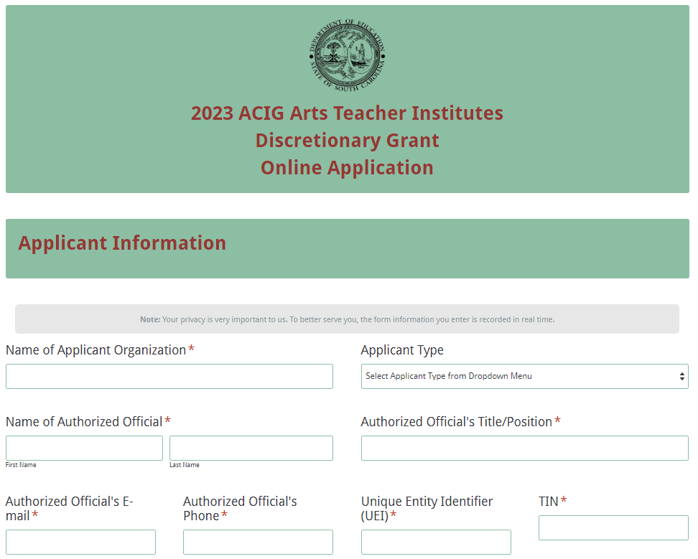
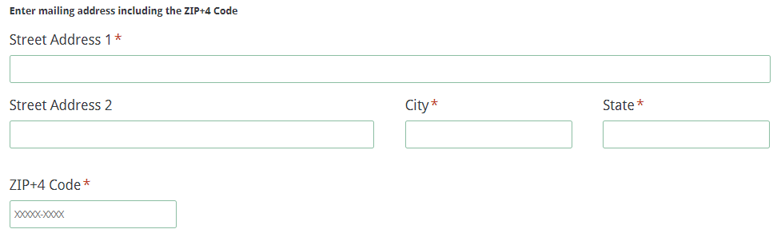

Select the name of the institute from the dropdown menu. Enter the physical location where the proposed institute will be held. Select the institute start and end dates.
Indicate the number of participants to be served.
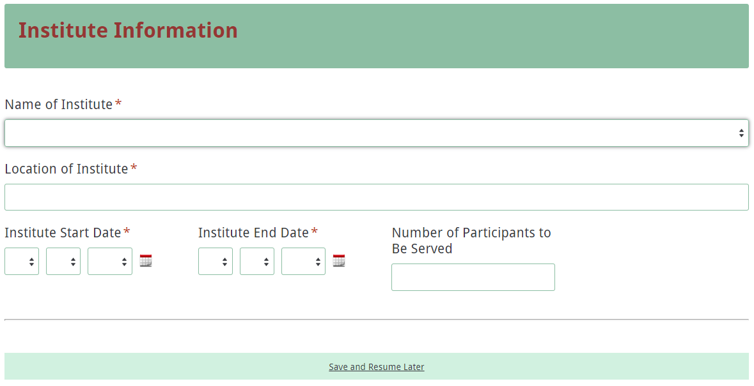
Enter the contact information for the institute coordinator. The name as entered in the online application must match the name entered on the Certification Signature Page. The institute coordinator’s e-mail is a required field. The confirmation of a successful online application submission will be sent only to this e-mail address. Reenter the e-mail address to confirm that it is correct.
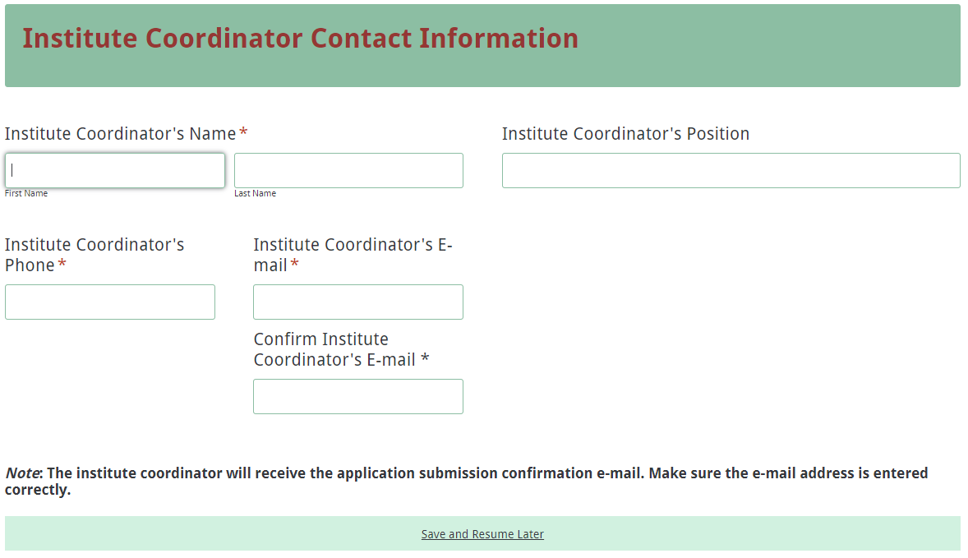
Enter all amounts in the Funding Information and Budget Summary sections using whole dollars (no cents). Fill in all fields and enter 0 (zero) for line items that are not applicable to the project. Enter the total amount of the Arts Teacher Institutes funds being requested for the project.
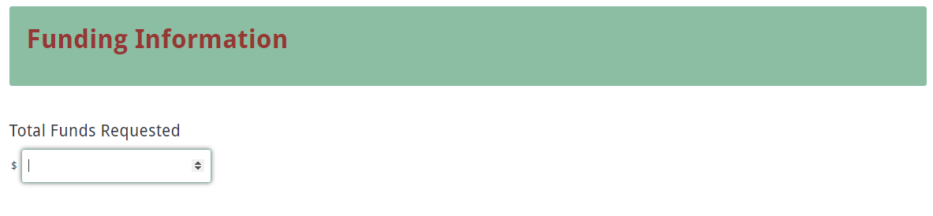
Enter the line item totals for the Arts Teacher Institutes funds requested. The Total Costs (Funds Requested) field will automatically calculate. This amount must match the total funds requested under the Funding Information section.
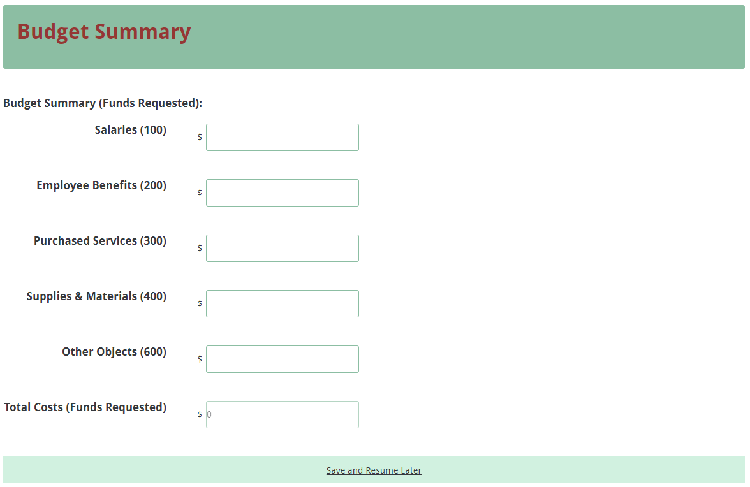
Prepare each of the proposal attachments (i.e., Project Narrative, Budget Narrative, and Appendices) following the preceding instructions in the RFP. Pay close attention to attachments that must be scanned together into a single document. The online application will only allow one document to be uploaded for each attachment. Upload the attachments where indicated in the following screenshot. All attachments are required; you will not be able to submit the application without uploading all three documents.
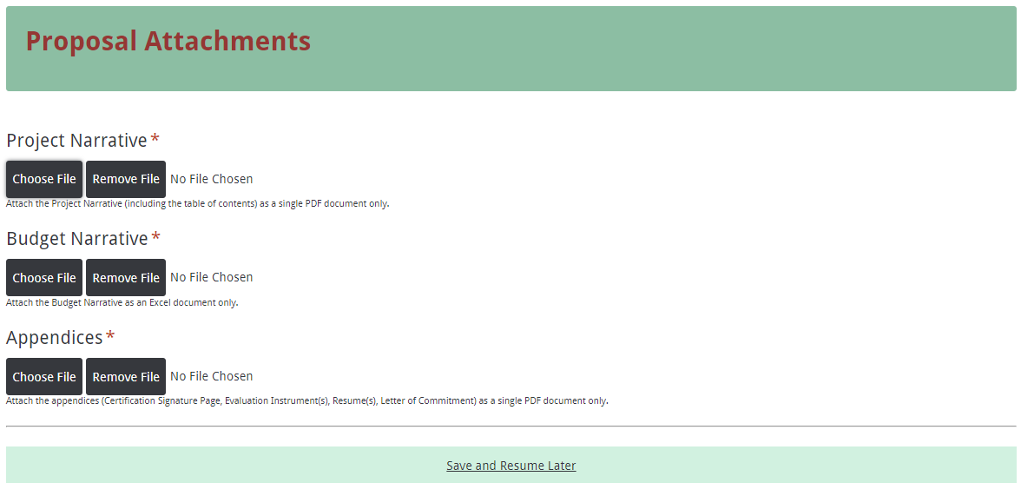
Thoroughly review the summary on the Data Review and Confirmation Page to verify that the information has been entered correctly in the online application prior to submitting. You will not be able to access the completed application form after it has been submitted. If any of the entries are incorrect, click on the "Previous" button at the bottom of each page to return to the appropriate section(s) and reenter the correct information.
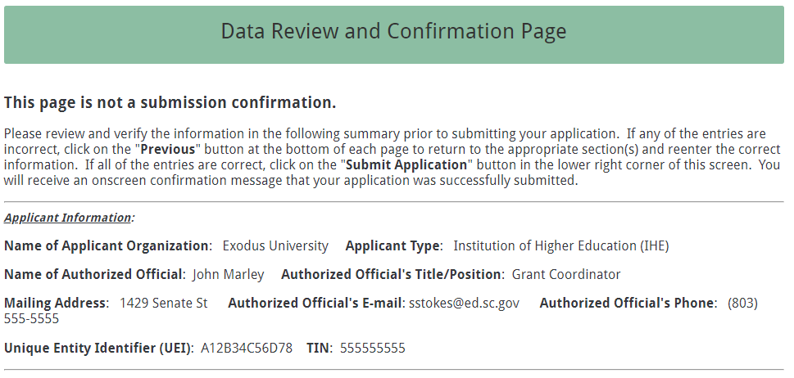
If all of the entries are correct, click on the “Submit Application” button in the lower right corner of this screen to complete the submission process.
Once the application is submitted, the following message will be displayed on the screen, and a submission confirmation will be sent to the e-mail address provided for the institute coordinator.
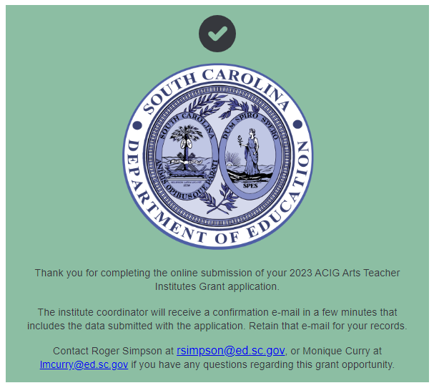
If the institute coordinator does not receive a confirmation e-mail, first verify that the e-mail was not sent to his or her junk mail box. If the e-mail is not received, then the application may not have successfully uploaded. You must go back and resubmit the entire online form, including all attachments, for your application to be considered for funding.
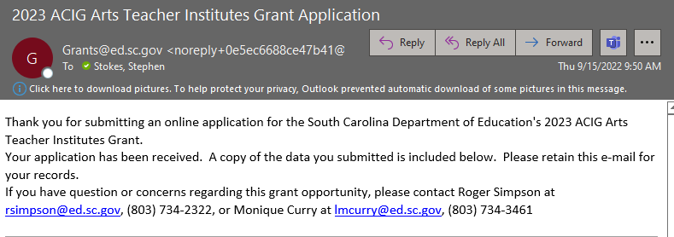

An e-mail confirmation that your grant application was successfully submitted does not account for the quality of the uploaded documents or the completeness of the online form. The confirmation e-mail only notifies you that the online application has been submitted. Applicants are responsible for ensuring that the information entered in the online form, including all attachments, is accurate and complete for the application to be reviewed and considered for funding.

Appendix A: Definitions of Terms Used

De-obligation—the downward adjustment of the obligations recorded in a grant award document. It is caused by factors such as (1) termination of part of the project, (2) reduction in material prices, (3) cost savings, or (4) correction of recorded amounts.

Evaluation—a description of the procedures and methods by which progress toward goals and objectives will be regularly assessed and monitored.

Fiscal Agent—an organization that acts on behalf of another party performing various fiscal duties.

Goals—Statements of the arts teacher institutes objectives for teachers stated in results-oriented terms.

Hybrid or Blended Learning Model—A course that combines traditional and face-to-face class time with online and out-of-class coursework.

Indirect Costs—an expense (such as for computing, maintenance, security, supervision) incurred in joint usage and, therefore, difficult to assign to or identify with a specific cost objective or cost center (department, function, program). Indirect costs are usually constant for a wide range of output and are grouped under fixed costs.

Institute Coordinator—an experienced educator who assists the primary professor in the delivery of the institute by ordering materials, contacting participants, maintaining an accurate roster of participants, and organizing materials for instruction. A coordinator can be a visual or performing arts teacher, arts integration specialist, regular classroom teacher, or an arts administrator.

Master Teacher—an experienced educator who possesses a minimum of five years of experience in teaching visual or performing arts or arts integration and delivers the instruction for the institute. A master teacher works with a professor of record to approve the proposed institute syllabus and submit final grades for graduate course credit.

Professor of Record—an arts educator who holds an advanced arts education degree and serves as a professor at a college or post-secondary institution. A professor of record delivers instruction for the institute or mentors and supervises course work for credit.

Supplant—to “replace” or “take the place of”. Funds distributed for this activity are state funds and must be used specifically for the activity outlined in this proposal as the primary source of funding

Supplement—to “build upon” or “add to”. Additional resources may be used to enhance the award distributed for the activities outlined in this proposal but not replace

Appendix B: Selection Criteria and Reviewers’ Scoring Rubric

Selection Criteria

A total of 80 points is available to applications that meet the maximum score for each selection criteria. While the budget is assigned zero (0) points, the budget remains a critical component of the entire application. An application with an incomplete budget will not be funded.

The point values for each section of the application are as follows:

Narrative Sections | Points Available
Project Description | 40
Evaluation Design | 20
Institute Syllabus | 20
Budget (Summary and Narrative) | 0
TOTAL | 80

Each section of the application narrative will be assigned a score using the following rubric, which summarizes the required elements of the application narrative and the point ranges assigned to each section.

The scoring system is used to indicate how well an application meets the funding criteria for the project. While the budget is assigned zero points, the budget remains a critical component of the entire application. Grant readers and raters are asked to review the proposed budget and make recommendations to determine an acceptable or not acceptable budget.
Reviewer’s Scoring Rubric
1.a. Project Description: The applicant must provide a detailed description of the Arts Teacher Institute that addresses each of the following items:
- Name of the proposed institute;
- Name of the institute coordinator, professor of record, and/or master teacher for the specific institute, with their rank, and a brief discussion of their prior experience in providing Arts Teacher Institutes (The SCDE expects that the proposed professor of record holds an advanced degree and has significant experience in arts education/arts integration.);
- Scope of the project;
- Overall goals for the institute and objectives that are specific, measurable, achievable, relevant, and time-specific (SMART);
- Instructional approach and content of the institute;
- Primary target audience; and
- Minimum and maximum number of participants to be served.
Applicant provides a narrative that is a detailed description of the Arts Teacher Institute that addresses all of the following items:  - Name of the proposed institute;  - Name of the institute coordinator, professor of record, and/or master teacher for the specific institute, with their rank and a brief discussion of their prior experience in providing Arts Teacher Institutes;  - Scope of the project;  - Overall goals for the institute and SMART objectives;  - Instructional approach and content of the institute;  - Primary target audience; and  - Minimum and maximum number of participants to be served. | Acceptable | Fully Meets—20 points  Applicant provides a narrative that fully describes all required items.
 | Acceptable | Adequate/Meets—15 points  Applicant provides a narrative that moderately describes all required items.
 | Not Acceptable | Limited/Approaches—10 points  Applicant provides a narrative that is limited or unclear in describing all required items.
 | Not Acceptable | Inadequate—5 point(s)  Applicant provides a narrative that does not adequately describe all required items.
Reviewer’s Comments:
1.b. Project Description: The applicant must provide an explanation of the Arts Teacher Institutes that includes:
  - Location of the institute and whether or not the location directly affects the goals and objectives of the institute,
  - Type of delivery format—traditional (class meetings at a physical location for the duration of the institute) or a hybrid or blended model—that will be used to deliver the institute and an explanation of any unique needs for delivery (see appendix A—Definitions of Terms Used), and
  - Reason the method for delivering the institute is the most effective way to address the needs of the participants to be served.
Applicant provides a narrative that is an explanation of the Arts Teacher Institutes that includes:  - Location of the institute and whether or not the location directly effects the goals and objectives of the institute,  - Type of delivery format—traditional (class meetings at a physical location for the duration of the institute) or a hybrid or blended model—that will be used to deliver the institute and an explanation of any unique needs or delivery of the institute, and  - Reason the method for delivering the institute is the most effective way to address the needs of the participants to be served. | Acceptable | Fully Meets—20 points  Applicant provides a narrative that fully explains all required items.
 | Acceptable | Adequate/Meets—15 points  Applicant provides a narrative that moderately explains all required items.
 | Not Acceptable | Limited/Approaches—10 points  Applicant provides a narrative that is limited or unclear in explaining all required items.
 | Not Acceptable | Inadequate—5 points  Applicant provides a narrative that does not adequately explain all required items.
Reviewer’s Comments:
2. Evaluation Design: The applicant must explain the techniques, methods, and/or instruments used for determining the outcomes, effectiveness, impact, and changes resulting from the overall project to provide graduate courses and professional development in arts education/arts integration through the specific arts institute that includes
    - how participants will be evaluated for the required components of the institute and whether or not grades will be awarded,
    - how data will be collected (when and by whom) and assessed,
    - how the participants’ evaluation responses will be used to evaluate the effectiveness of the institute and/or student achievement and plans for subsequent institutes, and
    - how the results will be presented to demonstrate that the institute objectives have been met.
The applicant provides a narrative that explains the techniques, methods, and/or instruments used for determining the outcomes, effectiveness, impact, and changes resulting from the project to provide graduate courses and professional development in arts education/arts integration through the specific arts institute that includes  - how participants will be evaluated for the require components of the institute and whether or not grades will be awarded,  - how data will be collected (when and by whom) and assessed,  - how the participants’ evaluation responses will be used to evaluate the effectiveness of the institute and/or student achievement and plans for subsequent institutes, and  - how the results will be presented to demonstrate that the institute objectives have been met. | Acceptable | Fully Meets—20 points  Applicant provides a narrative that fully explains all required items.
 | Acceptable | Adequate/Meets—15 points  Applicant provides a narrative that moderately explains all required items.
 | Not Acceptable | Limited/Approaches—10 points  Applicant provides a narrative that is limited or unclear in explaining all required items.
 | Not Acceptable | Inadequate—5 points  Applicant provides a narrative that does not adequately explain all required items.
Reviewer’s Comments:

3. Institute Syllabus: The applicant must provide a syllabus that summarizes the content, participant activities, and requirements for the proposed institute. The syllabus must
  - include clearly defined SMART objectives;
  - clearly address the specific performance standards for the institute;
  - articulate clearly how readings, assignments, and assessments will ensure competency with the specific institute standards;
  - clearly describe how the proposed institute will incorporate the 2017 South Carolina College- and Career-Ready Standards for Visual and Performing Arts Proficiency (2017 Standards) and best practice in arts education;
  - detail the institute components, including the meeting dates and items to reflect adequate duration and frequency of instructional activities; and
  - describe the required materials and resources that will be provided to participants.
Applicant provides a syllabus that summarizes the content, participant activities, and requirements for the proposed institute, and addresses all seven of the following items:  - Includes clearly defined SMART objectives;  - Clearly addresses the specific performance standards for the institute;  - Articulates clearly how the course readings, assignments, and assessments will ensure competency with the specific institute standards;  - Clearly describes how the proposed institute will incorporate the 2017 Standards and best practice in arts education;  - Details the institute components, including the meeting dates and items to reflect adequate duration and frequency of instructional activities; and  - Describes the required materials and resources that will be provided to participants. | Acceptable | Fully Meets—20 points  Applicant provides a syllabus that fully summarizes the proposed institutes and includes all required items.
 | Acceptable | Adequate/Meets—15 points  Applicant provides a syllabus that moderately summarizes the proposed institutes and includes all required items.
 | Not Acceptable | Limited/Approaches—10 points  Applicant provides a syllabus that is limited or unclear in summarizing the proposed institutes and including all required items.
 | Not Acceptable | Inadequate—5 points  Applicant provides a syllabus that does not adequately summarize the proposed institute or include all required items.
Reviewer’s Comments:
Budget Narrative: The applicant must provide a Budget Narrative that demonstrates clear evidence that the expenditures are appropriate and justified to support the activities in the proposed institute. The line-item categories in the narrative must parallel the line-item categories of the Budget Summary in the online application. Applicants must include all formulas used to calculate each line-item expense. The Narrative must provide a detailed breakdown for each expense, including materials and supplies. Expenditures must be reasonable and adequate to complete the project and must be directly connected to the institute details.
The applicant provides a Budget Narrative that addresses all five of the following:  - Clear evidence that the expenditures are appropriate and justified to support the activities in the proposed institute;  - Line-item categories in the narrative that parallel the line-item categories of the Budget Summary in the online application;  - All formulas used to calculate each line-item expense;  - A detailed breakdown for each expense, including materials and supplies; and  - Expenditures that are reasonable and adequate to complete the project and are directly connected to the institute details. | Acceptable | Adequate/Meets—0 points  Applicant provides a budget that addresses all five required items.
 | Not Acceptable | Inadequate—0 points  Applicant provides a budget that does not address all five required items.
Reviewer’s Comments:

Appendix C: Required SCDE Forms

Certification Signature Page
(This form must be signed by the individual from each proposed district, school, or organization who holds the title listed below.)

Certification

I hereby certify that, to the best of my knowledge, the information and data contained in this application are true and correct. The applicant’s governing body has duly authorized this application and documentation, and the applicant will comply with the Program Specific Assurances (if applicable) and the SCDE Assurances and Terms and Conditions if the grant is awarded.

Authorized Official (should be CEO of organization or superintendent of school district)
Name:
Position: | Email:
Telephone: | Fax:

Signature of Authorized Official: | Typed name of Authorized Official:
Date Signed:
Signature of Financial Official: | Typed Name of Financial Official:
Date Signed:
Signature of Grant Manager (if applicable): | Typed Name of Grant Manager:
Date Signed:
Signature of Arts Institute Coordinator (if applicable): | Typed Name of Coordinator:  Telephone:
Date Signed:

Please complete, print, and obtain signatures prior to submission. Include the signed, scanned form in the required appendices as indicated on page 23.

Assurances and Terms and Conditions for State Awards

For informational purposes only

Assurances
I certify that this applicant
- Has the legal authority to apply for state assistance and the institutional, managerial, and financial capability (including funds sufficient to pay the nonstate share of project costs) to ensure proper planning, management, and completion of the project described in this application.
- Will give the South Carolina Department of Education (SCDE) access to and the right to examine all records, books, papers, or documents related to this award and will establish a proper accounting system in accordance with generally accepted accounting principles (GAAP) or agency directives.
- Has an accounting system that includes sufficient internal controls, a clear audit trail, and written cost-allocation procedures as necessary. The financial management systems are capable of distinguishing expenditures that are attributable to this grant from those that are not attributable to this grant. This system is able to identify costs by programmatic year and by budget line item and to differentiate among direct, indirect, and administrative costs. In addition, the applicant will maintain adequate supporting documents for the expenditures and in-kind contributions, regardless of the type of funds, if any, that it makes under this grant. Costs are shown in books or records (e.g., disbursements ledger, journal, payroll register) and are supported by a source document such as a receipt, travel voucher, invoice, bill, or in-kind voucher.
- Will also comply with GAAP as it relates to budgets, budget amendments, and expenditure claim submissions.
- Will approve all expenditures, document receipt of goods and services, and record payments on the applicant’s accounting records prior to submission of reimbursement claims to the SCDE for costs related to this grant.
- Will initiate and complete work within the applicable time frame after receipt of approval by the SCDE.
- Will not discriminate against any employee or applicant for employment because of race, color, religion, age, sex, national origin, or disability. The applicant will take affirmative action to ensure that applicants for employment and the employees during the period of their employment are treated without regard to their race, color, religion, age, sex, national origin, or disability.
- Will comply with the Ethics, Government Accountability, and Campaign Reform Act (S.C. Code Ann. § 2-17-10 et seq. and § 8-13-100 et seq. (Supp. 2021)).
- Will comply with the Drug Free Workplace Act (S.C. Code Ann. § 44-107-10 et seq. (Supp. 2021)) if the amount of this award is $50,000 or more.

Terms and Conditions

- Completeness of Proposal. All proposals should be complete and carefully worded and must contain all of the information requested by the South Carolina Department of Education (SCDE). If you do not believe a section applies to your proposal, please indicate that fact.
- Non-awards/Termination. The SCDE reserves the right to reject any and all applications and to refuse to grant monies under this solicitation. If the SCDE rejects an application, the applicant has a right to request a review of the process consistent with the appeals process presented in the Request for Proposals (RFP).
After it has been awarded, the SCDE may terminate a grant by giving the grantee written notice of termination. In the event of a termination after award, the SCDE shall reimburse the grantee for expenses incurred up to the notification of termination. In addition, this grant may be terminated by the SCDE if the grantee fails to perform as promised in its proposal.
Upon the termination of a grant, the grantee shall have the right to a review process. The grantee must notify the SCDE of its request within 30 days of receiving written notice of the termination.
- Reduction in Budgets and Negotiations. The SCDE reserves the right to negotiate budgets with potential grantees. The SCDE may, at its sole discretion, determine that a proposed budget is excessive and may negotiate a lower budget with the applicant. The applicant may at that time negotiate or withdraw its proposal. In addition, the SCDE may desire to fund a project but not at the level proposed. In that case, the SCDE shall notify the applicant of the amount that can be funded, and the applicant and the SCDE shall negotiate a modification to the proposal to accommodate the lower budget. All final decisions are that of the SCDE.
- Amendments to Grants. Amendments are permitted upon the mutual agreement of the parties and will become effective when specified in writing and signed by both parties.
- Use of Grant Funds. Funds awarded are to be expended only for purposes and activities covered by the approved project plan, budget, and budget narrative.
- Submission of Expenditure Reports. Claims for reimbursement must be made at least quarterly and consistent with calendar quarters (e.g., an expenditure report claim for costs for January 1 through March 30 must be filed by May 15).
- Obligation of Grant Funds. Grant funds may not be obligated prior to the effective date or subsequent to the end or termination date of the grant period. No obligations are allowed after the end of the grant period. The final request for expenditure report claims must be submitted no later than forty-five (45) days after the end of the grant period unless the scope of work for the grant states a shorter reporting period.
- Deobligation of Funds. After a final expenditure claim has been submitted to the SCDE, the grantee will go through the official deobligation process with the SCDE.
- Documentation. The grantee must provide for accurate and timely recording of receipts and expenditures. The grantee’s accounting system should distinguish receipts and expenditures attributable to each grant. The grantee must review the memo regarding “Guidelines for Retaining Documentation to Support Expenditure Claims.”
- Travel Costs. Travel costs, if allowed under this solicitation, must not exceed limits noted in the United States General Services Administration (GSA) per diem rates for lodging, except in the case of conference lodging required for program-required training. In the case that conference-related lodging exceeds the GSA per diem rate, the grantee shall follow their entity’s written procedure for obtaining prior approval to exceed a GSA rate for a conference hotel. Meals and incidentals are limited by the state budget proviso, currently not to exceed $35 per day for in-state travel and $50 for out-of-state travel (see page 81 of the State of South Carolina Statewide Disbursement Regulations). Mileage reimbursement must follow the current Office of Comptroller General instructions, which is consistent with the published IRS rates.
- Honoraria. Amounts paid in honoraria, if allowed under this grant, must be consistent with SCDE policies. Applicants should check with the program office before budgeting for honoraria.
- Reports. The grantee shall submit, as required or instructed by the awarding program office, all reports (programmatic, financial, or evaluation) within the specified period or date and in the prescribed format. An expenditure claim report must be filed by July 5 for all expenditures incurred by June 30 in order to comply with the generally accepted accounting principles (GAAP) and the production of the State's Comprehensive Annual Financial Report.
- Copyright. The grantee is free to copyright any books, publications, or other copyrightable materials developed in the course of this grant. However, the SCDE reserves a royalty-free, nonexclusive, and irrevocable license to reproduce, publish, or otherwise use, and to authorize others to use, the copyrighted work developed under this grant.
- Certification Regarding Suspension and Debarment. By submitting an application, the applicant certifies, to the best of its knowledge and belief, that the
- Applicant and/or any of its principals, subgrantees, or subcontractors
  - are not presently debarred, suspended, proposed for debarment, or declared ineligible for the award of contracts by any state or federal agency; have not, within a three-year period preceding this application, been convicted of or had a civil judgment rendered against them for commission of fraud or a criminal offense in connection with obtaining, attempting to obtain, or performing a public (federal, state, or local) contract or subcontract; violation of federal or state antitrust statutes relating to the submission of offers; or commission of embezzlement, theft, forgery, bribery, falsification or destruction of records, making false statements, tax evasion, or receiving stolen property; and
  - are not presently indicted for, or otherwise criminally or civilly charged by a governmental entity with, commission of any of the offenses enumerated above.
- Applicant has not, within a three-year period preceding this application, had one or more contracts terminated for default by any public (federal, state, or local) entity.
- Audits. Although this Assurances, Terms, and Conditions document is for a state award, federal audit requirements apply as follows:
- Entities expending $750,000 or more in federal awards:
Entities that expend $750,000 or more in federal awards during the fiscal year are required to have an audit performed in accordance with the provisions of 2 CFR Part 200.501, et seq. Except for the provisions for biennial audits provided in 2 CFR Part 200.504 (a) and (b), audits must be performed annually as stated at 2 CFR Part 200.504. A grantee that passes through funds to subrecipients has the responsibility of ensuring that federal awards are used for authorized purposes in compliance with federal program laws, federal and state regulations, and grant agreements. The director of the OMB, who will review this amount every two years, has the option of revising the threshold upward.
- Entities expending less than $750,000 in federal awards:
Entities that expend less than $750,000 in a fiscal year in federal awards are exempt from the audit requirements in 2 CFR Part 200.504. However, such entities are not exempt from other federal requirements (including those to maintain records) concerning federal awards provided to the entity. The entity’s records must be available for review or audit by the SCDE and appropriate officials of federal agencies, pass-through entities, and the General Accounting Office (GAO).
- Records. The grantee shall retain grant records, including financial records and supporting documentation, for a minimum of six (6) years after the end date of the grant when the final expenditure report claim for reimbursement and all final reports have been submitted, unless informed otherwise or in case of litigation.
- Electronic Signature Agreement. I agree that my electronic signature is the legally binding equivalent to my handwritten signature.

South Carolina Department of Education

Budget Narrative Template

For information purposes only.
Go to the SCDE Grant Opportunities page to access the Excel spreadsheet.

