Request for Proposals (RFP)
Application Package

Arts Curricular Innovation Grants
2021 Arts Teacher Institutes
Discretionary Grant

The Arts Curricular Innovation Grants (ACIG) Program is funded by the
General Assembly of the State of South Carolina through Proviso 1A.8 of the General Appropriations Act, and administered by the South Carolina Department of Education (SCDE).

Deadline for Receipt of Applications: 5:00 p.m., December 7, 2020

Technical Assistance for Applicants: 3:30 p.m., November 20, 2020

For questions about the ACIG Program grant, contact:
Gary Seaboldt, Education Associate for Visual and Performing Arts
803-734-0323; gseaboldt@ed.sc.gov

L. Monique Curry, Data and Reporting Education Associate
803-734-3461; lmcurry@ed.sc.gov

Issued by:
South Carolina Department of Education
Office of Standards and Learning
1429 Senate Street, Suite 607-B
Columbia, SC 29201

TABLE OF CONTENTS
PART I: General Information 1
A. Introduction and Purpose 1
B. Eligible Applicants 6
C. Timeline of Granting Process 6
D. Technical Assistance Sessions for Applicants 7
E. Statutory and Other Requirements 7
F. Authorized Activities 8
G. Unauthorized Activities 8
H. Program Accountability and Monitoring 8
I. Fiscal Operations 11
J. Review and Selection Process 11
K. Appeals Process 12

PART II: Application Overview, Content, and Instructions 13
A. Application Overview 13
B. Application Narrative Format 13
C. Online Application Submission 14
D. Application Narrative Content 14
1. Project Description 14
2. Evaluation Design 15
3. Institute Syllabus 15
E. Application Budget 15
F. Appendices 17
G. Deadline and Submission Procedures 18
H. Screenshots of Online Application Submission Forms 18

Appendix A: Definitions of Terms Used 23

Appendix B: Selection Criteria and Reviewers’ Scoring Rubric 24

Appendix C: Required SCDE Forms 30
Certification Signature Page 30
Assurances and Terms and Conditions for State Awards 31
Budget Narrative Template 34

PART I: General Information

Introduction and Purpose

The South Carolina General Assembly annually allocates funds to the South Carolina Department of Education (SCDE) for arts curricular programs under the Education Improvement Act (EIA). The SCDE administers these funds in accordance with the legislative proviso:

1A.8. (SDE-EIA: Arts in Education) Funds appropriated in Part IA, Section 1, VIII.A.1. Arts Curricula shall be used to support innovative practices in arts education curriculum, instruction, and assessment in the visual and performing arts including dance, music, theatre, and visual arts which incorporates strengths from the Arts in Education sites. They shall also be used to support the advancement of the implementation of the visual and performing arts academic standards. These funds shall be distributed to schools and school districts under a competitive grants program; however, up to thirty-three percent of the total amount of the grant fund shall be made available as Aid to Other Agencies to facilitate the funding of professional development arts institutes that have been approved by the State Department of Education for South Carolina arts teachers, appropriate classroom teachers, and administrators. Arts Curricular Grants funds may be retained and carried forward into the current fiscal year to be expended in accordance with the proposed award.

The 2020–21 Arts Curricular Innovation Grants (ACIG) features three grant programs—the Arts Teacher Institutes grants, Innovative Arts Works grants, and Distinguished Arts Program (DAP) grants. This Request for Proposals (RFP) is specific to the Arts Teacher Institutes grants. The RFPs for the Innovative Arts Works and the DAP grants are issued separately.

The purpose of the ACIG Arts Teacher Institutes program is to provide support to eligible organizations for administering summer arts institutes that provide professional development in arts content to South Carolina arts teachers, classroom teachers, and arts administrators. Grant awards are to provide Arts Teacher Institutes as tuition-free graduate courses or professional development that directly support quality arts education programs that will significantly improve student achievement in the arts. Eight of the arts institutes will also award graduate credit hours to participants who successfully complete the institute.

All arts teacher institutes are
- focused on standards-based arts curricula, instruction, and assessment;
- offered in collaboration with an accredited college or university for three graduate credits with a minimum of 45 contact hours (with the exception of the Joint Arts Administrators Institute and the Strategic Arts Planning Institute);
- provided as residential institutes (with room and board for participants, unless otherwise stated);
- evaluated on the basis of an assessment instrument approved by the SCDE in terms of quality and its potential impact on student learning; and
- held in June 2021.
Approximately $515,000 will be distributed on a competitive basis for eleven summer Arts Teacher Institutes. The grant-funding period will be February 1, 2021, through June 28, 2021. Institutes must begin after February 1, 2021, and must conclude no later than June 28, 2021. Post-institute meetings and coursework may be completed after June 28, 2021.

The SCDE anticipates making one grant award to provide each of the following approved institutes for summer 2021. Applicants must submit a separate application for each arts institute they propose to provide. All arts institutes must be approved by the SCDE.

South Carolina Arts Leadership for Success Academy (SCALSA)
Maximum grant award for this institute is approximately $50,000 to serve 25 participants.

This institute is taught by master teachers and coaches. It is designed for arts teachers who have taught fewer than three years and for critical needs teachers in the arts. SCALSA emphasizes the development of standards-based arts curricula, instruction, and assessment by working with teachers through a one-week learning academy, as well as virtual follow-up sessions to
- develop standards-based arts lessons following the Curriculum Leadership Institute in the Arts (CLIA) lesson plan for future use in grant development and in future institutes;
- study strategies for Assisting, Developing, and Evaluating Professional Teaching (ADEPT) success to include the writing of student learning objectives (SLOs) as they apply to the Teacher Evaluation System, as well as information on Summative ADEPT Formal Evaluation of Teachers (Rubric 4.0) and other evaluations currently implemented for teacher certification;
- develop long-range lesson plans needed to meet indicators required under new evaluation/observation guidelines;
- study arts classroom management strategies; and
- identify teaching and learning styles to benefit student achievement.

Curriculum Leadership Institute in the Arts I (CLIA-I)
Maximum grant award for this institute is approximately $65,000 to serve 48 participants.

This institute is taught by master teachers and coaches from each arts area and must provide participants with resources and strategies during a one-week learning institute, as well as virtual follow-up sessions to
- develop and teach complex standards-based learning based on the 2017 South Carolina College- and Career-Ready Standards for Visual and Performing Arts Proficiency (2017 Standards)
- with embedded assessment that emphasizes student growth through the SCCCRVPA proficiency standards,
- study models of best instructional practice,
- work with colleges to review SLOs that could be implemented at the classroom level, and
- study arts education support strategies and develop a multi-arts professional network.

Arts Assessment Institute Classroom Assessment (AAI-I)
Maximum grant award for this institute is approximately $50,000 to serve 40 participants.

This institute is taught by a master teacher or professor in visual arts and music with teaching coaches to assist participants in developing proficiency-based arts assessments to determine knowledge and skills based on the 2017 Standards. Through weeklong learning and virtual follow-up sessions, participants will study the purposes and uses of best practices in arts assessment, align assessments with local and state standards, develop standards based student learning objectives, and design and embed assessment strategies within instructional lessons and units.

Media Arts and Technology Institute (for all arts teachers)
Maximum grant award for this institute is approximately $50,000 to serve 15 participants.

This institute is taught by a master teacher or professor who has experience using technology and media arts across all disciplines to encourage teachers to integrate media arts and literacy into their classrooms. Participants in this institute will learn to develop technology and media arts integration strategies for using selective software titles and provided equipment with students. They will receive extensive training in various software programs, apps, and media literacy, while developing lesson plans that use technology and media arts to implement the 2017 Standards. Technology equipment will be provided to each participant for use during the institute and becomes the property of the participant’s school upon completion of the institute.

Dance Teacher as Artist Tier II Institute
Maximum grant award for this institute is approximately $40,000 to serve approximately 25 participants.

This level 2 dance institute is to provide greater expertise in mastering the holistic 6DC Model of Educational Dance and is taught by master teachers experienced in dance education at all levels from elementary through graduate school. The purpose of this institute is to broaden and deepen the artistic experience provided in the studio regarding the principles of total body connectivity, principals of choreographic design as they relate to composing and critiquing dance works, and positively impact artistic literacy in the dance classroom. The emphasis of the institute is to investigate which core principles and processes drive each artistic process in dance and to experience how to effectively channel them into professional practice. The 2017 Standards for Dance and strategies for their implementation in dance will be a basis of the work.

Participants must have completed level one of Dance Teacher as Artist in 2019 or 2020 prior to registering for this institute. This institute will build on the knowledge and skills from the level one institute by increasing participants depth of knowledge in each of the artistic dance processes and instructional approaches to expand artistic literacy. Inquiry-based methods and materials will be provided to each participant for use during the institute and becomes the property of the participant’s school upon completion of the institute.

Creative Teaching in the Classroom Institute
Maximum grant award for this institute is approximately $50,000 to serve up to 50 participants.

This institute is taught by a master teacher in arts integration and is designed for elementary classroom teachers (administrators and arts specialists welcome) who do not have a strong background in the visual and performing arts but are interested in integrating the arts in their classroom.

This institute must focus on teaching strategies in arts integration from each major art form; planning lessons that include creative expression and creative thinking strategies through the arts; and building basic knowledge in each art through participants attending scheduled performances and art exhibitions during the Spoleto Festival USA 2021.

This institute includes
- all materials, including books and CDs;
- three and one-half days in Charleston for the Spoleto Festival USA 2021, including three performances;
- two Saturday sessions—place and date to be announced; and
- overnight accommodations in Charleston, SC during the Spoleto Festival USA 2021.

Muse -STEAM Institute
Maximum grant award for this institute is approximately $30,000 to serve 25 participants.

This institute is taught by professional artists and master teachers in integration and design concepts to provide hands-on design challenges in the visual and performing arts, instruction in the multiple intelligences, and guidance in using the arts across the curriculum. In addition to classroom instruction hours, this institute must include a field trip to a company that focuses on innovation and science, technology, engineering, arts, and mathematics (STEAM) thinking.

The institute must focus on curriculum, assessment, and instruction in STEAM and provide a STEAM challenges for participants using the new 2017 Standards.

Curriculum and Instruction for Artistically Gifted and Talented Students
Maximum grant award for this institute is approximately $36,000 to serve 30 teachers.

This course is designed to:
- prepare teachers to design appropriate curriculum for artistically gifted students;
- explore curriculum models, instructional strategies, and assessments to meet the needs and abilities of gifted and talented students;
- develop and write units and lesson plans for serving artistically gifted and talented students; and
- explore issues related to psycho-social needs of the artistically gifted and talented student.

Strategic Arts Planning Institute
Maximum grant award for this institute is approximately $44,000 to serve approximately 40 teachers (up to 35 percent of seats (14) may be prioritized for non-DAP schools as needed). Graduate course credit is not awarded for this institute although participants can receive contact hours.

This institute is designed to support schools and districts in writing a strategic arts plan. Schools and Districts must bring a planning team of 4–5 participants to the institute to write a comprehensive strategic arts plan that includes dance, design, media arts, music, theatre, and visual arts. The purpose of developing a strategic arts plan is to significantly improve student achievement in the visual and performing arts based on the implementation of the 2017 Standards. This institute is provided for participants who currently need help with their strategic arts plan and/or grants management, who are interested in developing/improving innovative opportunities in the arts for their students with ongoing virtual support throughout the school year.

Joint Arts Administrators Institute
Maximum grant award for this institute is approximately $12,000 to conduct a minimum of four professional development days throughout the year. Graduate course credit is not awarded for this institute although participants can receive contact hours toward recertification.

This institute provides professional development opportunities in the arts for district arts coordinators, principals of arts focused schools, school-based arts administrators, and the larger arts education community throughout the year. This institute works in partnership with the SCDE to design professional development in topics such as:
- standards implementation,
- arts assessment,
- arts integration,
- best practices in artistically gifted and talented programs,
- college and career readiness in the arts,
- STEAM,
- arts education advocacy techniques,
- using the latest arts education research,
- implementation of a strategic arts plan, and
- updates from statewide arts education partners.

Arts Integration Collaborative Teaching Institute
Maximum grant award for this institute is approximately $50,000 to serve approximately 50 teachers

This institute is taught by master teachers and coaches. The Arts Integration Collaborative Teaching Institutes (AICTI) is designed for teams of teachers within the same school, ideally two arts and two core content teachers to develop innovative strategies that result in authentic arts integration lessons through a collaborative learning model. Through this experience, teams of teachers (arts and non-arts) engage in hands-on, content-based professional learning to:
- engage in the development and implementation of arts integrated lesson plans; and
- develop the capacity to collaboratively design and implement an arts integration learning experience (lesson or unit) through the ability to
  - define arts integration,
  - analyze and identify standards that genuinely align for greater student impact,
  - identify and select arts integration strategies for effective instruction,
  - collaboratively design, develop arts integrated lessons, and
  - analyze student learning outcomes through virtual follow-up sessions.

Creativity Coaches Institute
Maximum grant award for this institute is approximately $40,000 to serve approximately 30 teachers.

This institute, offered by master teachers and coaches, invests in the increased need for support and demand for world-class skills and appreciation of how the arts have traditionally nurtured such skills. This institute will focus on creativity theories and the implications and applications of creativity in the educational setting. Participants will compare adult learning, andragogy, to student learning, pedagogy, in order to design effective learning experiences by:
- Defining differences between student learning and adult learning theories.
- Defining creativity development theories to identify practices that support and suppress creativity.
- Identify and analyze facilitation strategies and methods for effective professional learning experiences.
- Develop the ability to identify and analyze the proficiencies of the profile of the South Carolina Graduate.
- Develop a professional learning experience that supports the ability to address competency-based education practices with a focus on creativity-fostering practices.
- analyze professional learning outcomes through virtual follow-up sessions.

Eligible Applicants

An eligible applicant is
- a South Carolina public or private institution of higher education (IHE),
- a nonprofit organization with an arts focus working in partnership with a public or private IHE in the state,
- the South Carolina Governor’s School for the Arts and Humanities, and
- the South Carolina Governor’s School for Science and Mathematics.

A nonprofit organization must have a fully executed letter of agreement with its partnering IHE to offer an institute and include a copy of the agreement with their application (see page 14).

Timeline of Granting Process

Date | Activity/Action
November 20, 2020 | Technical assistance session for applicants
December 7, 2020 | Deadline for receipt of applications
February 2021 | Notification of awards
February 1, 2021 | Funding period begins
March 2021 | New grantee meeting
July 9, 2021 | Funding period ends; final expenditure reports due; last date for institutes to conclude
July 29, 2021 | Final programmatic reports due

Technical Assistance Sessions for Applicants

The SCDE’s Office of Standards and Learning will offer a technical assistance webinar via Adobe Connect on November 20, 2020, from 3:30-5:00 p.m. to assist eligible applicants in understanding this RFP and how to apply for this grant. No password is required to join the session. Participants should enter their full names when logging in. Participants will be able to log in 30 minutes prior to the start time to test their audio settings and download/print handouts. While participation is not mandatory in order to submit an application, it is highly recommended.

Statutory and Other Requirements

The SCDE will announce the approved Summer Arts Institutes and coordinate registration for all participants. Class size for each program will be reviewed and negotiated with the SCDE prior to the grant award. Class sizes will influence the final grant award.

Registration is managed by the SCDE. Educators who received an ACIG grant for the 2020–21 school year have first priority for registration. Note that the CLIA, SCALSA, and AAI-I also have a seating priority. Participants must be enrolled by first, second, and then third priority.
- First priority—all arts teachers in the ACIG school or district must have taken CLIA-I and AAI-I before any classroom teachers and administrators are permitted to register for arts integration institutes, including Creative Teachers, Arts Integration, and Muse Machine.
- Second priority—after all visual and performing arts teachers have completed CLIA-I and AAI-I, schools and districts may enroll classroom teachers and administrators in arts integration institutes. Arts teachers must show proof of CLIA-I and AAI-I participation. Arts teachers must have successfully completed CLIA-I and AAI-I before they may advance to the next tier of institutes.
- Third priority—an arts educator from a school or district who did not receive an ACIG grant for the 2020–21 school year.

Once participants are enrolled for these priorities, if open seats remain in an institute, the professor or coordinator must contact Gary Seaboldt, Education Associate for the Visual and Performing Arts, to confirm procedures for filling the course. Grantees must use the waiting list maintained by the SCDE to maintain maximum funding capacity for their institute. Participants must be chosen from this waiting list upon availability.

The institute coordinator, professor and/or master teacher for each funded course must participate in a webinar with the SCDE (March 2021) to clarify institute expectations, enrollment procedures, and reporting requirements. Grantees will be notified about this webinar after the awards are made.

Applicants should review the Assurances and Terms and Conditions for State Awards (on pages 31–33) to ensure that, if awarded a grant, they are capable of full compliance, especially with all regulations and state laws, in order to enter into an agreement with the SCDE for this program. Pursuant to S.C. Code Ann. § 8-13-700 (Supp. 2019), the applicant must disclose any potential conflict of interest to the SCDE in accordance with the SC Ethics Reform Act conflict of interest policy. A signed Certification Signature Page (see page 30) is required with the grant application and legally binds the applicant to the agency’s Assurances and Terms and Conditions for State Awards.

Authorized Activities

Allowable expenses include the cost of hiring a professor of record, master teacher/coaches, coordinator, artist-in-residence, materials and supplies for participants (including computers and software as applicable to the specific arts institute), rental space, room/lodging, meals, and the cost of graduate credit. Grantee must stay within the state per diem rates for meals, currently not to exceed $35 per day (based on departure time), and the per diem rates for lodging in the location of the institute (see Section J. Travel Costs in the Terms and Conditions on page 32 for more information).

Unauthorized Activities

Funds must not be used for:
- indirect costs (see definition on page 23),
- mileage to and from an institute for participants, coordinators, master teachers, or professors,
- promotion of or registration for the institute, and
- an IHE’s application fee for students to enroll in the graduate course, medical fees, and recreational fees.

Program Accountability and Monitoring

The SCDE is responsible for monitoring the implementation of the summer Arts Teacher Institutes to provide professional development activities and graduate courses for South Carolina public school teachers and administrators assigned to teach visual and performing arts students in accordance with the following program accountability requirements:

- Each applicant receiving funding through this RFP meets the eligibility requirements for the grant described herein, and the applicant has provided all required assurances that it will comply with all program implementation and reporting requirements established through this RFP.
- Each applicant receiving funding through this RFP appropriately uses these funds as described in this application package.
- Each applicant implements activities funded through this application within the timeline in which the funds provided are to be used.

Applicants may be subjected to an evaluation of their financial system, internal controls processes, and policies and procedures by the SCDE’s Office of Auditing Services before a grant award is issued or during the grant term. The review process and procedures are accessible at the Office of Auditing Services webpage.

Applicants awarded grant funds must satisfy periodic reporting and accountability requirements throughout the term of the grant. These requirements address (1) program accountability, (2) performance reporting, (3) project budget, (4) monitoring, (5) program evaluation, and (6) technical assistance.

    - Program Accountability
Each grantee is responsible for carrying out its responsibilities in accordance with its approved grant application and work plan. Grantees are also required to submit periodic reports to the SCDE to report on the use of grant funds and the progress of grant activities to include:
- progress made toward planning and implementing the designated Arts Teacher Institute,
- dates and agenda for pre- and post-Arts Teacher Institute meetings, and
- copies of any changes to the syllabus used for the institute.

    - Performance Reporting
Performance reporting requirements include those for both programmatic reporting and fiscal reporting. The grantee is responsible for ensuring that all reports are accurate, complete, and submitted on time. Achievement of grant goals and objectives will be monitored through the final report process.

Programmatic Reporting Requirements
The following is required of all grant recipients, and these requirements are to be reported in the final report in the period the activity occurred. The final programmatic report is due on or before July 29, 2021. The grantee will provide the SCDE with a final report that includes, at a minimum, the following for each institute:
- a roster of teachers who attended including their school, district, and arts or content area;
- a copy of the completed institute;
- evaluations; and
- a written program evaluation at the conclusion of the institute regarding the changes in participants knowledge and skills as a result of the professional learning.

Fiscal Reporting Requirements
Of the grant funds awarded, 75 percent will be disbursed upon receipt of a signed Grant Award Notification (GAN). The remainder of the grant funds will be allocated upon receipt and approval of the interim report, due May 15, 2021. All grant recipients must submit expenditure reports according to the table below. The grantee is responsible for ensuring that reports are accurate, complete, and submitted on time.

Reporting Due Dates for the Arts Teacher Institute Program Grant:

Reporting Period | Report Due Date
February 1–April 30, 2021 – Interim | May 15, 2021
May 1–June 28, 2021 – Final | July 5, 2021

    - Project Budget
A project budget of projected expenditures to be funded by the grant must be submitted with the application.

    - Monitoring
The SCDE will monitor grantees by reviewing and approving the interim report and the final report. All information in these reports is subject to verification.

The SCDE may conduct site visits. Grantees must agree to site visits conducted by SCDE program representatives. The purpose of site visits is to validate information provided in fiscal and program reports and to gather more detailed information on implementation efforts and challenges from interviews and observations for monitoring and evaluation purposes.

The SCDE may require additional information from the grantee, verify information with the authorizing agency, or require the submission of additional documentation such as invoices, receipts, and personnel time and effort reports. Prior to a site visit, the grantee may be required to submit additional relevant information that will allow the SCDE to conduct a useful, efficient, and effective visit. The SCDE may require electronic submission of documents instead of a paper-copy submission.

SCDE staff will verify the contents of documentation submitted. Grantees may be asked to revise reports when
- non-allowable expenses are found;
- reports are confusing or difficult to understand; or
- unexplained discrepancies between the proposed use of grant funds, as provided in the approved budget, and actual expenditures are found in the submitted documentation.

    - Program Evaluation
Grantees are required to conduct ongoing monitoring and evaluation to ensure project goals are achieved. Progress toward meeting project goals is to be reported through the final report process.

Grantees are required to comply with any evaluation requests by the SCDE, including, but not limited to, requests for information, site visits, interviews, completing surveys, or participating in data collections.

A final project report is to be completed and must address project success toward each goal and objective stated in the application. If any of the performance requirements in section H are not completed, the SCDE may consider the grantee a high risk regarding future funding opportunities.

    - Technical Assistance to Grantees
Grantees are required to participate in all technical assistance that the SCDE conducts related to the Arts Teacher Institutes grant. Delivery of such technical assistance may include webinars and conference calls.

Fiscal Operations

Grantees must use grant funds only for allowable grant expenditures during the grant period.

The SCDE will disburse 75 percent of the Arts Teacher Institute grant funds upon receipt of the signed grant award document, estimated during February 2021. Documentation of allowable expenditures through April 30, 2021, must be included in the interim report, due May 15, 2021 (see table in section H). Remaining funds will be released upon approval of a grantee’s interim report. Final documentation of allowable expenditures must be received by July 5, 2021.

The SCDE reserves the right to withdraw or recoup funding pursuant to the grant agreement, and the grantee must agree to pay a refund if the SCDE determines that the funds were not expended in accordance with allowable activities in the approved grant application, the grant agreement, and assurances.

Allowable Costs
Grants must be used in accordance with the statutory and state requirements stated in section E. Grant funds may be used to support the activities stated in section F.

Unallowable Costs
Indirect costs are not allowed (see appendix A: Definitions of Terms Used). Grant funds may not be used for new construction; mileage; college or university application fees; medical, recreation, parking, or other fees; and purchases that do not directly support the approved work plan.

Review and Selection Process

The SCDE’s Office of Standards and Learning will conduct an initial review of all grant applications for completeness and compliance with application and eligibility guidelines. All required materials including forms and appendices must be submitted for the application to be considered complete and eligible for review. Only applications that are received by the deadline and deemed complete by the program office will be forwarded for review and funding consideration.

Three reviewers from diverse backgrounds without a vested interest in any application being funded will evaluate each application based on the quality of the proposed activities and the capability of the applicant to implement the proposed Arts Teacher Institute course(s). The review team will be comprised of experienced grant readers from various professions and entities, including the SCDE, and will include arts program coordinators from South Carolina school districts or individuals with a background in arts education. Consideration will be given to equitable statewide representation. Any arts program coordinator referenced in an application will be excluded from the review process.

Reviewers will use the scoring rubric on pages 24–29 to read and score each application independently. After the reviewers have individually rated an application, the three scores will be averaged. An application can earn up to 80 points for an average score.

Applications will be rank-ordered by averaged scores. Applications that earn an average score of 40 points or higher will receive first consideration for funding. If funds remain following these awards, the SCDE will consider funding the remaining applications that earned an average score within the adequate/meets range until all funds are allocated. Consideration will be given to ensure that each Arts Teacher Institute is offered to meet the needs of arts educators. The SCDE may negotiate with the applicant to make changes recommended by the review panel for any approved grants.

Before final award decisions are made, applicants who have previously received Arts Teacher Institutes funding will be subject to a review of historical data (including financial data for evidence of timely submission of budgets and expenditure reports and supporting documents, accuracy of amendment requests, and performance outcomes data) to confirm compliance and performance during the previous funding periods. The SCDE reserves the right to not grant an award if the data reviewed reveals that applicant did not adhere to the grant’s guidelines or meet the project’s goals and objectives.

The SCDE reserves the right to interview applicants recommended for funding, request additional documentation, and make site visits as appropriate to ensure compliance with state requirements and to assess the risk of making a grant award.

Grant awards are not final until an SCDE grant award notice (GAN) is fully executed. Notification of funding will be sent in February 2021 to the institute coordinator listed in the online application. After the notification of awards, copies of the reviewers’ comments and score sheets will be sent to the institute coordinator.

Appeals Process

An applicant who has submitted a proposal that the SCDE does not fund has 30 calendar days after receiving notification that the proposal is not funded to request a review of the process. Scores may not be appealed. An unfunded applicant may inquire as to whether or not the application process was followed. The request for review must be directed to the State Superintendent of Education and must state the reasons for the request. The Superintendent may delegate to a deputy superintendent the authority to conduct a review. The deputy superintendent will issue a decision after the review of the information submitted by the applicant and the program office. This decision will be the final decision of the agency. The applicant may appeal the agency’s decision to the Administrative Law Court under the terms of the Administrative Procedures Act.

PART II: Application Overview, Content, and Instructions

Read all guidelines and criteria carefully before preparing your application. Adhere to font, format, page limit, and organizational requirements. Only applications that include all sections and appendices and fully adhere to these guidelines will be reviewed and considered for funding. Incomplete applications will not be reviewed.

Application Overview

Applications must be submitted online. Applicants are encouraged to prepare all items for the application before beginning the online submission process. Do not wait until the last minute to submit an application. Applicants should use the following overview as a checklist to ensure that they submit a complete application with items labeled accordingly and presented in the order as outlined below. The Arts Teacher Institutes online application is organized into the following sections:

- Online Forms Sections
- Applicant Information
- Institute Information
- Institute Coordinator Contact Information
- Funding Information
- Budget Summary
- Proposal Attachments
- Project Narrative (include a table of contents)
  - Project Description
  - Evaluation Design
  - Institute Syllabus
- Budget Narrative
- Appendices
  - Certification Signature Page
  - Evaluation Instruments
  - Résumé of Institute Coordinator, Professor of Record, and/or Master Teacher
  - Letter of Commitment

Application Narrative Format

Length of Project Narrative: | Maximum of 15 pages, excluding the table of contents and institute syllabus.
Required Font/Size: | Times New Roman/12 or Arial/12.
Margins: | 1” on all sides.
Page Numbers: | Bottom right-hand corner.
Spacing: | Double-spacing throughout narrative. Charts and tables may be single-spaced.
Final File Format: | PDF document.
Each section must be clearly identified using the headings provided in the instructions below. Sections may not be combined. Reviewers will not consider information requested in one section that is provided in another section.

Online Application Submission

Applications must be submitted using the online application form. The online submission is organized into two sections—Online Forms and Proposal Attachments.

Provide the applicant’s nine-digit Data Universal Numbering System (DUNS) number and Taxpayer Identification Number (TIN) in the online application form. Applicants should contact their organization’s finance office for assistance with these items.

Use the following instructions to compile and complete all proposal attachments prior to submitting your application. Verify that all components of the narrative and appendices are completed prior to uploading attachments. Follow the directions in each section for saving the documents and refer to the screenshot on page 21 for upload locations.

Application Narrative Content

Use the following directions to write the project narrative and organize it into sections following the sequence presented below. Include a table of contents as the first page of the narrative (not included in the page limit). Do not combine sections. Required components must be located in their designated sections in order to be scored.

When complete, save the entire narrative as a single PDF document to be uploaded into the online application where indicated in the proposal attachments section (see page 21).

Project Description (maximum of 40 points available)

- Provide a detailed description of the Arts Teacher Institute that addresses each of the following items:
- Name of the proposed institute (see approved institutes on pages 2–5);
- Name of the institute coordinator, professor of record, and/or master teacher for the specific institute with their rank and a brief discussion of their prior experience in providing Arts Teacher Institutes. The SCDE expects that the proposed professor of record for an institute holds an advanced degree and has significant experience in arts education/arts integration;
- Scope of the project;
- Overall goals for the institute and objectives that are SMART;
- Instructional approach and content of the institute;
- Primary target audience; and
- Minimum and maximum number of participants to be served.

- Provide an explanation of the Arts Teacher Institute that includes:
  - Location of the institute and whether or not the location directly affects the goals and objectives of the institute,
  - Type of delivery format—traditional (class meetings at a physical location for the duration of the institute) or a hybrid or blended model—that will be used to deliver the institute and an explanation of any unique needs for delivery (see appendix A—Definitions of Terms), and
  - Reason the method for delivering the institute is the most effective way to address the needs of the participants to be served.

Evaluation Design (maximum of 20 points available)
Explain the techniques, methods, and/or instruments used for determining the outcomes, effectiveness, impact, and changes resulting from the overall project to provide graduate courses and professional development in arts education/arts integration through the specific arts institute that includes
    - how participants will be evaluated for the required components of the institute and whether or not grades be awarded,
    - how data will be collected (when and by whom) and assessed,
    - how the participants’ evaluation responses will be used to evaluate the effectiveness of the institute and/or student achievement and plans for subsequent institutes, and
    - how the results will be presented to demonstrate that the institute objectives have been met.

Institute Syllabus (maximum of 20 points available)
Provide a syllabus that summarizes the content, participant activities, and requirements for the proposed institute. The syllabus must
- include clearly defined SMART objectives;
- clearly address the specific performance standards for the institute;
- articulate clearly how readings, assignments, and assessments will ensure competency with the specific institute standards;
  - clearly describe how the proposed institute will incorporate the 2017 Standards and best practice in arts education;
  - detail the institute components, including the meeting dates and items to reflect adequate duration and frequency of instructional activities; and
  - describe the required materials and resources that will be provided to participants.

Application Budget

While the budget is assigned zero (0) points, the budget is a critical component of the entire application. No application with an incomplete budget will be funded.

The application budget consists of two parts: the Budget Summary and the Budget Narrative for the proposed institute. All proposed expenditures for the grant funding period must be itemized in the Budget Summary and detailed in the Budget Narrative. Budget items not explained in the Project Narrative (see section D) will not be funded.
- The Budget Summary is the financial overview of the grant and must include all proposed expenditures for the institute. Each line item of the Budget Summary must correspond to the line items of the Budget Narrative (discussed below). Provide a Budget Summary for the period February 1, 2021, through June 28, 2021, in the online application Budget Summary section (see screenshot on page 20).

- The Budget Narrative must provide clear evidence that the expenditures are appropriate and justified to support the activities of the proposed institute. Use the Excel budget template that accompanies this funding opportunity at the grant opportunities web page (see page 34 for information) to develop the institute Budget Narrative. The Budget Narrative line-item categories are structured to parallel the line-item categories of the Budget Summary. Include all formulas used to calculate each line-item expense. Provide a detailed breakdown (hourly rate, cost per item, cost per student, etc.) for each expense, including all materials and supplies. For example: “Participants will receive two textbooks for this institute. One text is titled [insert name of textbook] and is priced at ($55 x 25 participants = $1,375). The other is titled [insert name of textbook] and is priced at ($15 x 25 participants = $375).” Expenditures should be reasonable and adequate to complete the project and must be directly connected to the institute details.

To help with establishing budget categories, the following general descriptions identify the line items that should be budgeted for each.

Salaries/Stipends (100)
This category includes salaries and stipends for institute coordinators, professors of record, and master teachers. Applicants that budget for salaries must also budget for Employee Benefits (200). Check with your finance office for appropriate benefits based on budgeted salaries.

Employee Benefits (200)
FICA, workers’ compensation, health insurance, and other worker-benefit costs are included here. These costs will represent a percentage of the total in Salaries/Stipends (100). Applicants should consult with their finance office for the benefits percentage of salaries.

Purchased Services (300)
Expenses such as consultant fees, summer professional development arts institutes, artist residencies, travel/transportation costs, telephone services, and other purchased services are included here. Amounts paid for personal services rendered by personnel who are not on the payroll and for other specialized services purchased by the organization are allowable. While a product may or may not result from the transaction, the primary reason for the purchase is the service provided.

For a grantee to pay a vendor, a contract must be in place. At a minimum, the contract should include the scope of services, the duration of the contract, and the method and amount of payment; the contract must be executed by both parties. Consulting/service contracts must be procured in accordance with South Carolina Procurement Law.

Applicants/grantees must ensure that they do not enter a contract with any vendor that is debarred, suspended, or ineligible for participation in federal programs by
- checking the Excluded Parties List at the federal System for Award Management (SAM) website (Applicants are encouraged to review the user guides for exclusions provided via the “Help” page prior to conducting searches.);
- collecting a certification from the vendor and attaching it to the contract; or
- adding a clause or condition to the contract that indicates the vendor is eligible.

Supplies and Materials (400)
Amounts paid for material items of an expendable nature are included here. Itemize every item and make sure that such expenditures are aligned with relevant program characteristics (objectives, number of participants, frequency of activity, etc.).

Other Objects (600)
This category includes expenditures that do not neatly fit into the other categories above, such as postage, copyright fees, or those expenditures deemed appropriate by the applicant organization.

The SCDE reserves the right to negotiate final budgets and to disqualify costs associated with line items that are unallowable, unreasonable, or inconsistent with the proposed project’s activities and strategies.

Appendices

All items of the appendices must be scanned into a single PDF document to be uploaded into the online application where indicated on page 21.

- Certification Signature Page
Print the Certification Signature Page (see page 30) and obtain the appropriate signatures. Note: This form includes certification of the SCDE’s Assurances and Terms and Conditions for State Awards and any applicable program-related conditions conveyed in this RFP. The assurances and terms and conditions are not required to be included in the application. However, retain the copy included in this RFP for your records and ensure that each signatory has copies of all documents.

By signing the Certification Signature Page, the signatories assure that they will comply with all the assurances and terms and conditions for the program. All signatories must understand that they are signing a document that is legally binding in the event a grant is awarded. Applications that do not include the signed Certification Signature Page will not be reviewed or considered for funding.

- Evaluation Instruments
Include a copy of the course evaluation instrument(s) to be used for the proposed institute. The evaluation instrument(s) is subject to approval by the SCDE.

- Résumé(s) of Institute Coordinator, Professor of Record, and/or Master Teacher
Include a résumé (maximum of two pages each) for the institute coordinator, professor of record, and for the master teacher (if applicable), that includes his or her experience with the Arts Teacher Institutes programs.

- Letter of Commitment
Include a letter of commitment from the IHE or nonprofit arts agency to verify strong support for the Arts Teacher Institute. The letter must contain a statement from the IHE or nonprofit arts agency that the arts grant funds will be used solely for purposes that are stated for the proposed arts institute.

Deadline and Submission Procedures

- Applications must be submitted online before 5:00 p.m. on December 7, 2020. The online application will not accept submissions after this deadline has passed.
- Only applications that adhere to all of these guidelines and directions in this RFP will be reviewed and considered for funding.
- No hardcopy applications will be accepted. Applications delivered by hand, postal mail, e-mail, or fax will not be accepted.
- Applications must originate from the applicant. Applications that are plagiarized from the internet, other grants, or resources will not be considered for funding.
- Do not attach or submit any additional materials other than what is specifically required. Any additional materials will be disposed of without review.
- Applications will not be returned. Keep a complete copy of the entire application for your records.

Screenshots of Online Application Submission Forms

The following screenshots are for informational purposes only and are provided to assist applicants in compiling all items needed to complete the online submission. Complete the attachments for the online application as directed in the preceding instructions. The SCDE encourages applicants to prepare all items of the application prior to beginning the online submission process. To access the application form, use only the hyperlink in this RFP (above) or the hyperlink on the grant opportunities Web site. Do not search for the application form through a browser or a search engine, such as Google, because you may be erroneously directed to old forms that are not acceptable. When completing the form, make sure spelling is correct and all information submitted is accurate, including formal or official names such as the applicant organization and contact persons. Do not use abbreviations or acronyms. All fields marked with a red asterisk are required; you will not be able to proceed to the next screen of the application without entering all required information.

If necessary, you may save your progress in the online application and return to the form later. Click on the “Save and Resume Later” link to save your progress. You will be prompted to create a password to securely save your form. You will have the option of copying and saving the link to the partially completed form or entering an e-mail address to have the link e-mailed to you. Be sure to enter the e-mail address correctly, as SCDE personnel cannot access the link or the incomplete application. Using this link you can access the application from any computer within thirty days to complete the online submission. Without the link or after thirty days, the data previously entered cannot be retrieved, and you will have to begin a new application. A saved application is not a submitted application. You must follow all of the steps described on pages 19–22 to complete the submission process.

Enter the official name of the applicant organization and select the applicant type (IHE, nonprofit organization with an arts focus, or local educational agency). The name as entered must match the registered DUNS name. Enter the name and e-mail address for the authorized official of the applicant organization. The name entered in the online application must match the name as shown on the Certification Signature Page. Enter the applicant organization’s physical address with the 10-digit ZIP code (ZIP+4), DUNS number, and TIN.
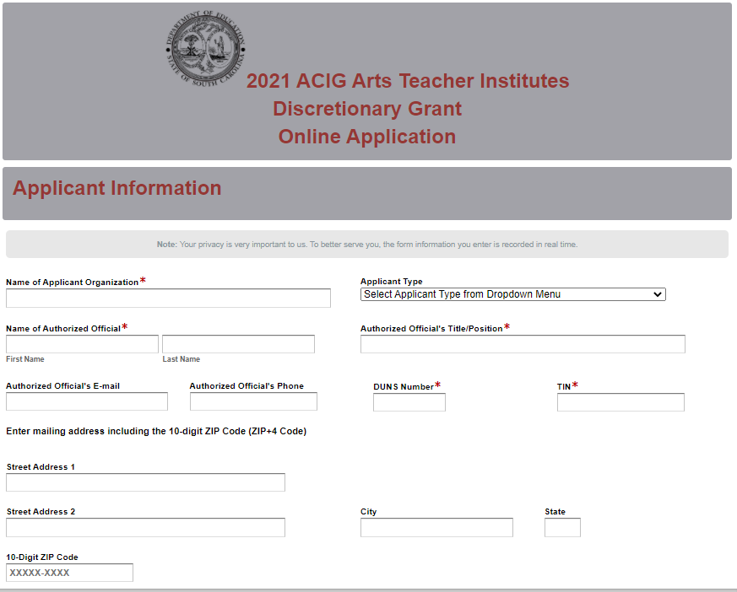
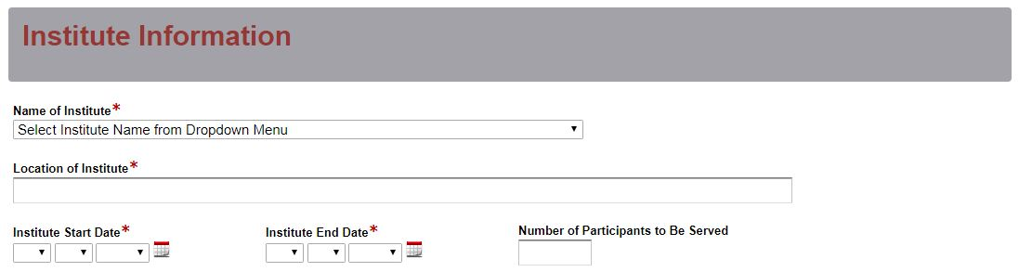
Select the name of the institute from the dropdown menu. Enter the physical location where the proposed institute will be held. Select the institute start and end dates.
Indicate the number of participants to be served.

Enter the contact information for the institute coordinator. The name as entered in the online application must match the name entered on the Certification Signature Page. The institute coordinator’s e-mail is a required field. The confirmation of a successful online application submission will be sent only to this e-mail address. Reenter the e-mail address to confirm that it is correct.
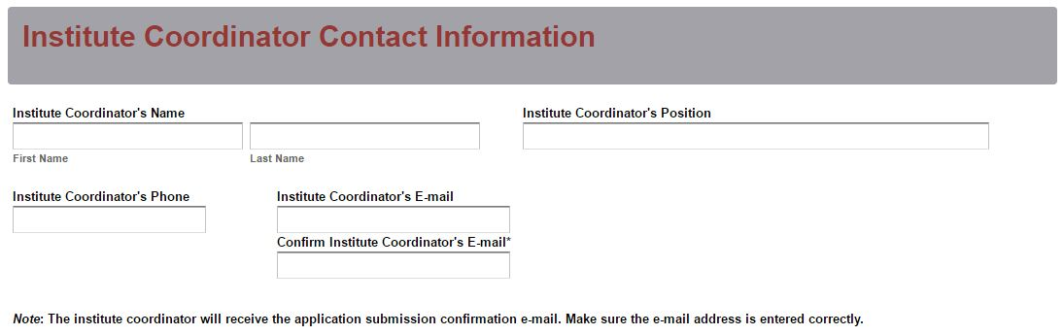
Enter all amounts in the Funding Information and Budget Summary sections using whole dollars (no cents). Fill in all fields and enter 0 (zero) for line items that are not applicable to the project. Enter the total amount of the Arts Teacher Institutes funds being requested for the project.
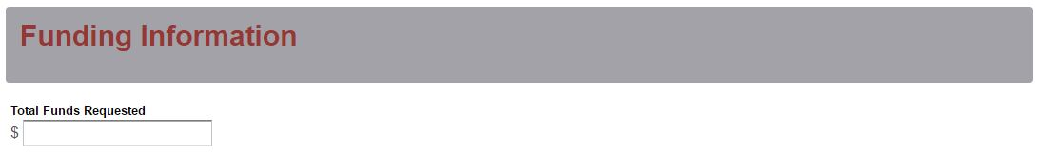
Enter the line item totals for the Arts Teacher Institutes funds requested. The Total Costs (Funds Requested) field will automatically calculate. This amount must match the total funds requested under the Funding Information section.
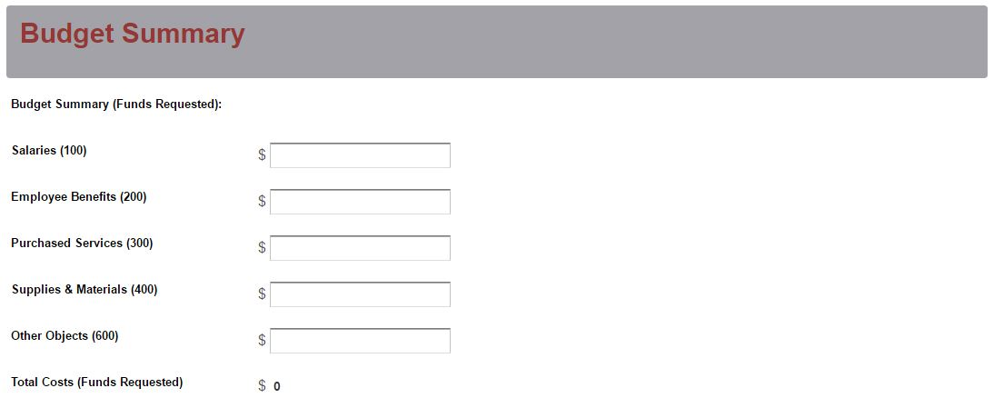
Prepare each of the proposal attachments (i.e., Project Narrative, Budget Narrative, and Appendices) following the preceding instructions in the RFP. Pay close attention to attachments that must be scanned together into a single document. The online application will only allow one document to be uploaded for each attachment. Upload the attachments where indicated in the following screenshot. All attachments are required; you will not be able to submit the application without uploading all three documents.
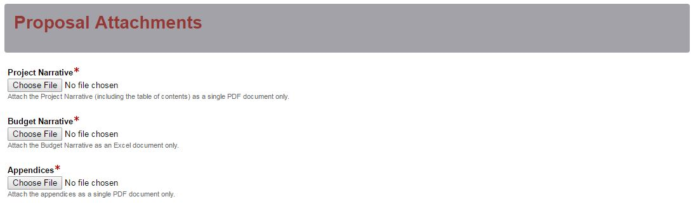
Thoroughly review the summary on the Data Review and Confirmation Page to verify that the information has been entered correctly in the online application prior to submitting. You will not be able to access the completed application form after it has been submitted. If any of the entries are incorrect, click on the "Previous" button at the bottom of each page to return to the appropriate section(s) and reenter the correct information.
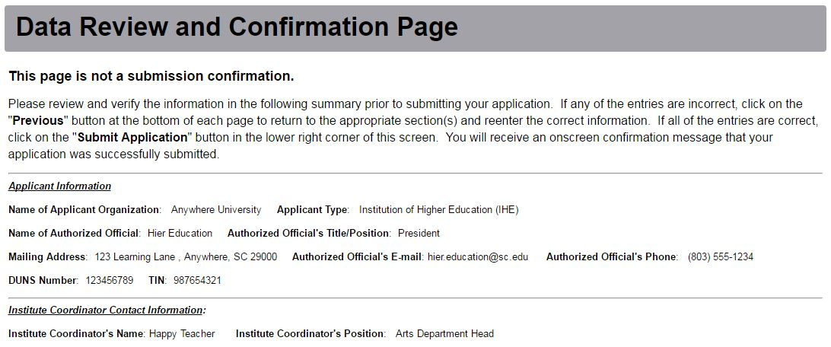
If all of the entries are correct, click on the “Submit Application” button in the lower right corner of this screen to complete the submission process.
Once the application is submitted, the following message will be displayed on the screen, and a submission confirmation will be sent to the e-mail address provided for the institute coordinator.
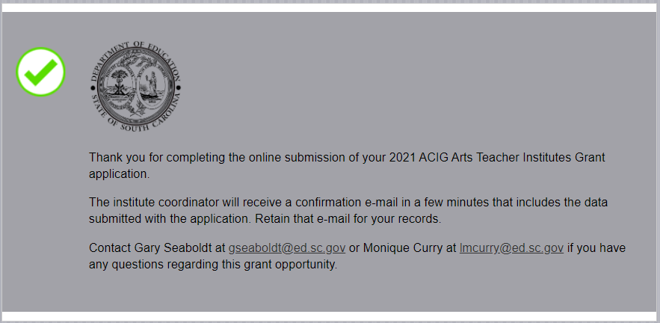
If the institute coordinator does not receive a confirmation e-mail, first verify that the e-mail was not sent to his or her junk mail box. If the e-mail is not received, then the application may not have successfully uploaded. You must go back and resubmit the entire online form, including all attachments, in order for your application to be considered for funding.

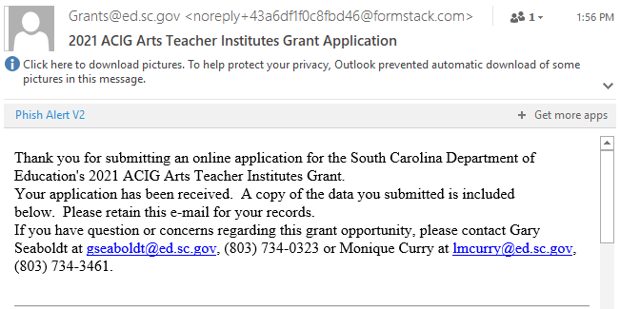

An e-mail confirmation that your grant application was successfully submitted does not account for the quality of the uploaded documents or the completeness of the online form. The confirmation e-mail only notifies you that the online application has been submitted. Applicants are responsible for ensuring that the information entered in the online form, including all attachments, is accurate and complete in order for the application to be reviewed and considered for funding.

Appendix A: Definitions of Terms Used

deobligation. The downward adjustment of the obligations recorded in a grant award document. It is caused by factors such as (1) termination of part of the project, (2) reduction in material prices, (3) cost savings, or (4) correction of recorded amounts.

evaluation. A description of the procedures and methods by which progress toward goals and objectives will be regularly assessed and monitored.

goals. Statements of the arts teacher institutes goals for teachers stated in results-oriented terms.

hybrid or blended learning model. A model of course design that combines traditional, face-to-face class time with online and out-of-class coursework.

indirect cost. An expense (such as for computing, maintenance, security, supervision) incurred in joint usage and, therefore, difficult to assign to or identify with a specific cost object or cost center (department, function, program). Indirect costs are usually constant for a wide range of output, and are grouped under fixed costs. Recovery of indirect costs is not allowable for this grant program.

institute coordinator. An experienced educator who assists the primary professor in the delivery of the institute by ordering materials, contacting participants, maintaining an accurate roster of participants and organizing materials for instruction. A coordinator can be a visual or performing arts teacher, arts integration specialist, regular classroom teacher, or an arts administrator.

master teacher. An experienced educator who possesses a minimum of five years of experience in teaching visual or performing arts or arts integration and delivers the instruction for the institute. A master teacher works with a professor of record to approve the proposed institute syllabus and submit final grades for graduate course credit.

professor of record. An arts educator who holds an advanced arts education degree and serves as a professor at a college or post-secondary institution. A professor of record delivers instruction for the institute or mentors and supervises course work for credit.

Appendix B: Selection Criteria and Reviewers’ Scoring Rubric

Selection Criteria

A total of 80 points is available to meet the selection criteria.

The point values for each section of the application are as follows:
Narrative Sections | Points Available
- Project Description | 40
- Evaluation Design | 20
- Institute Syllabus | 20
- Budget Narrative | 0
TOTAL | 80

Each section of the application narrative will be assigned a score using the following rubric, which summarizes the required elements of the application narrative and the point ranges assigned to each section.

The scoring system is used to indicate how well an application meets the funding criteria for the project. While the budget is assigned zero points, the budget remains a critical component of the entire application. Grant readers and raters are asked to review the proposed budget and make recommendations to determine an acceptable or not acceptable budget.

Reviewer’s Scoring Rubric
1.a. Project Description: The applicant must provide a detailed description of the Arts Teacher Institute that addresses each of the following items:
- Name of the proposed institute;
- Name of the institute coordinator, professor of record, and/or master teacher for the specific institute, with their rank, and a brief discussion of their prior experience in providing Arts Teacher Institutes (The SCDE expects that the proposed professor of record holds an advanced degree and has significant experience in arts education/arts integration.);
- Scope of the project;
- Overall goals for the institute and objectives that are specific, measurable, achievable, relevant, and time-specific (SMART);
- Instructional approach and content of the institute;
- Primary target audience; and
- Minimum and maximum number of participants to be served.
Applicant provides a narrative that is a detailed description of the Arts Teacher Institute that addresses all of the following items:  - Name of the proposed institute;  - Name of the institute coordinator, professor of record, and/or master teacher for the specific institute, with their rank and a brief discussion of their prior experience in providing Arts Teacher Institutes;  - Scope of the project;  - Overall goals for the institute and SMART objectives;  - Instructional approach and content of the institute;  - Primary target audience; and  - Minimum and maximum number of participants to be served. | Acceptable | Fully Meets—20 points  Applicant provides a narrative that fully describes all required items
 | Acceptable | Adequate/Meets—15 points  Applicant provides a narrative that moderately describes all required items
 | Not Acceptable | Limited/Approaches—10 points  Applicant provides a narrative that is limited or unclear in describing all required items
 | Not Acceptable | Inadequate—5 point(s)  Applicant provides a narrative that does not adequately describe all required items.
Reviewer’s Comments:
1.b. Project Description: The applicant must provide an explanation of the Arts Teacher Institutes that includes:
  - Location of the institute and whether or not the location directly affects the goals and objectives of the institute,
  - Type of delivery format—traditional (class meetings at a physical location for the duration of the institute) or a hybrid or blended model—that will be used to deliver the institute and an explanation of any unique needs for delivery (see appendix A—Definitions of Terms Used), and
  - Reason the method for delivering the institute is the most effective way to address the needs of the participants to be served.
Applicant provides a narrative that is an explanation of the Arts Teacher Institutes that includes:  - Location of the institute and whether or not the location directly effects the goals and objectives of the institute,  - Type of delivery format—traditional (class meetings at a physical location for the duration of the institute) or a hybrid or blended model—that will be used to deliver the institute and an explanation of any unique needs or delivery of the institute, and  - Reason the method for delivering the institute is the most effective way to address the needs of the participants to be served. | Acceptable | Fully Meets—20 points  Applicant provides a narrative that fully explains all required items
 | Acceptable | Adequate/Meets—15 points  Applicant provides a narrative that moderately explains all required items
 | Not Acceptable | Limited/Approaches—10 points  Applicant provides a narrative that is limited or unclear in explaining all required items
 | Not Acceptable | Inadequate—5 points  Applicant provides a narrative that does not adequately explain all required items.
Reviewer’s Comments:
2. Evaluation Design: The applicant must explain the techniques, methods, and/or instruments used for determining the outcomes, effectiveness, impact, and changes resulting from the overall project to provide graduate courses and professional development in arts education/arts integration through the specific arts institute that includes
    - how participants will be evaluated for the required components of the institute and whether or not grades will be awarded,
    - how data will be collected (when and by whom) and assessed,
    - how the participants’ evaluation responses will be used to evaluate the effectiveness of the institute and/or student achievement and plans for subsequent institutes, and
    - how the results will be presented to demonstrate that the institute objectives have been met.
The applicant provides a narrative that explains the techniques, methods, and/or instruments used for determining the outcomes, effectiveness, impact, and changes resulting from the project to provide graduate courses and professional development in arts education/arts integration through the specific arts institute that includes  - how participants will be evaluated for the require components of the institute and whether or not grades will be awarded,  - how data will be collected (when and by whom) and assessed,  - how the participants’ evaluation responses will be used to evaluate the effectiveness of the institute and/or student achievement and plans for subsequent institutes, and  - how the results will be presented to demonstrate that the institute objectives have been met. | Acceptable | Fully Meets—20 points  Applicant provides a narrative that fully explains all required items
 | Acceptable | Adequate/Meets—15 points  Applicant provides a narrative that moderately explains all required items
 | Not Acceptable | Limited/Approaches—10 points  Applicant provides a narrative that is limited or unclear in explaining all required items
 | Not Acceptable | Inadequate—5 points  Applicant provides a narrative that does not adequately explain all required items
Reviewer’s Comments:
3. Institute Syllabus: The applicant must provide a syllabus that summarizes the content, participant activities, and requirements for the proposed institute. The syllabus must
  - include clearly defined SMART objectives;
  - clearly address the specific performance standards for the institute;
  - articulate clearly how readings, assignments, and assessments will ensure competency with the specific institute standards;
  - clearly describe how the proposed institute will incorporate the 2017 South Carolina College- and Career-Ready Standards for Visual and Performing Arts Proficiency (2017 Standards) and best practice in arts education;
  - detail the institute components, including the meeting dates and items to reflect adequate duration and frequency of instructional activities; and
  - describe the required materials and resources that will be provided to participants.
Applicant provides a syllabus that summarizes the content, participant activities, and requirements for the proposed institute, and addresses all seven of the following items:  - Includes clearly defined SMART objectives;  - Clearly addresses the specific performance standards for the institute;  - Articulates clearly how the course readings, assignments, and assessments will ensure competency with the specific institute standards;  - Clearly describes how the proposed institute will incorporate will incorporate the 2017 Standards and best practice in arts education;  - Details the institute components, including the meeting dates and items to reflect adequate duration and frequency of instructional activities; and  - Describes the required materials and resources that will be provided to participants. | Acceptable | Fully Meets—20 points  Applicant provides a syllabus that fully summarizes the proposed institutes and includes all required items
 | Acceptable | Adequate/Meets—15 points  Applicant provides a syllabus that moderately summarizes the proposed institutes and includes all required items
 | Not Acceptable | Limited/Approaches—10 points  Applicant provides a syllabus that is limited or unclear in summarizing the proposed institutes and including all required items
 | Not Acceptable | Inadequate—5 points  Applicant provides a syllabus that does not adequately summarize the proposed institute or include all required items
Reviewer’s Comments:
Budget Narrative: The applicant must provide a Budget Narrative that demonstrates clear evidence that the expenditures are appropriate and justified to support the activities in the proposed institute. The line-item categories in the narrative must parallel the line-item categories of the Budget Summary in the online application. Applicants must include all formulas used to calculate each line-item expense. The Narrative must provide a detailed breakdown for each expense, including materials and supplies. Expenditures must be reasonable and adequate to complete the project and must be directly connected to the institute details.
The applicant provides a Budget Narrative that addresses all five of the following:  - Clear evidence that the expenditures are appropriate and justified to support the activities in the proposed institute;  - Line-item categories in the narrative that parallel the line-item categories of the Budget Summary in the online application;  - All formulas used to calculate each line-item expense;  - A detailed breakdown for each expense, including materials and supplies; and  - Expenditures that are reasonable and adequate to complete the project and are directly connected to the institute details. | Acceptable | Adequate/Meets—0 points  Applicant provides a budget that addresses all five required items.
 | Not Acceptable | Inadequate—0 points  Applicant provides a budget that does not address all five required items.
Reviewer’s Comments:

Appendix C: Required SCDE Forms

Certification Signature Page
(This form must be signed by the individual from each proposed district, school, or organization who holds the title listed below.)

Certification
I hereby certify that, to the best of my knowledge, the information and data contained in this application are true and correct. The applicant’s governing body has duly authorized this application and documentation, and the applicant will comply with the SCDE Assurances and Terms and Conditions for State Awards if the grant is awarded.

Authorized Official (duly authorized representative such as president, CEO, or superintendent)
Name:

Position: | E-mail:
Telephone: | Fax:

Signature of Authorized Official:

Date Signed:

Authorized Financial Official
Name:

Signature of Financial Official:

Date Signed:

Arts Institutes Coordinator
Name:

Signature of Arts Institutes Coordinator:

Date Signed:

Please complete, print, and obtain signatures prior to submission. Include the signed, scanned form in the required appendices as indicated on page 17.

Assurances and Terms and Conditions for State Awards

Assurances

- Has the legal authority to apply for state assistance and the institutional, managerial, and financial capability (including funds sufficient to pay the nonstate share of project costs) to ensure proper planning, management, and completion of the project described in this application.
- Will give the South Carolina Department of Education (SCDE) access to and the right to examine all records, books, papers, or documents related to this award and will establish a proper accounting system in accordance with generally accepted accounting principles (GAAP) or agency directives.
- Has an accounting system that includes sufficient internal controls, a clear audit trail, and written cost-allocation procedures as necessary. The financial management systems are capable of distinguishing expenditures that are attributable to this grant from those that are not attributable to this grant. This system is able to identify costs by programmatic year and by budget line item and to differentiate among direct, indirect, and administrative costs. In addition, the applicant will maintain adequate supporting documents for the expenditures and in-kind contributions, regardless of the type of funds, if any, that it makes under this grant. Costs are shown in books or records (e.g., disbursements ledger, journal, payroll register) and are supported by a source document such as a receipt, travel voucher, invoice, bill, or in-kind voucher.
- Will also comply with GAAP as it relates to budgets, budget amendments, and expenditure claim submissions.
- Will approve all expenditures, document receipt of goods and services, and record payments on the applicant’s accounting records prior to submission of reimbursement claims to the SCDE for costs related to this grant.
- Will initiate and complete work within the applicable time frame after receipt of approval by the SCDE.
- Will not discriminate against any employee or applicant for employment because of race, color, religion, age, sex, national origin, or disability. The applicant will take affirmative action to ensure that applicants for employment and the employees during the period of their employment are treated without regard to their race, color, religion, age, sex, national origin, or disability.
- Will comply with the Ethics, Government Accountability, and Campaign Reform Act (S.C. Code Ann. § 2-17-10 et seq. and § 8-13-100 et seq. (Supp. 2019)).
- Will comply with the Drug Free Workplace Act (S.C. Code Ann. § 44-107-10 et seq. (Supp. 2019)) if the amount of this award is $50,000 or more.

Terms and Conditions

- Completeness of Proposal. All proposals should be complete and carefully worded and must contain all of the information requested by the South Carolina Department of Education (SCDE). If you do not believe a section applies to your proposal, please indicate that fact.
- Non-awards/Termination. The SCDE reserves the right to reject any and all applications and to refuse to grant monies under this solicitation. If the SCDE rejects an application, the applicant has a right to request a review of the process consistent with the appeals process presented in the Request for Proposals (RFP).
After it has been awarded, the SCDE may terminate a grant by giving the grantee written notice of termination. In the event of a termination after award, the SCDE shall reimburse the grantee for expenses incurred up to the notification of termination. In addition, this grant may be terminated by the SCDE if the grantee fails to perform as promised in its proposal.
Upon the termination of a grant, the grantee shall have the right to a review process. The grantee must notify the SCDE of its request within 30 days of receiving written notice of the termination.
- Reduction in Budgets and Negotiations. The SCDE reserves the right to negotiate budgets with potential grantees. The SCDE may, at its sole discretion, determine that a proposed budget is excessive and may negotiate a lower budget with the applicant. The applicant may at that time negotiate or withdraw its proposal. In addition, the SCDE may desire to fund a project but not at the level proposed. In that case, the SCDE shall notify the applicant of the amount that can be funded, and the applicant and the SCDE shall negotiate a modification to the proposal to accommodate the lower budget. All final decisions are that of the SCDE.
- Amendments to Grants. Amendments are permitted upon the mutual agreement of the parties and will become effective when specified in writing and signed by both parties.
- Use of Grant Funds. Funds awarded are to be expended only for purposes and activities covered by the approved project plan, budget, and budget narrative.
- Submission of Expenditure Reports. Claims for reimbursement must be made at least quarterly and consistent with calendar quarters (e.g., an expenditure report claim for costs for January 1 through March 30 must be filed by May 15).
- Obligation of Grant Funds. Grant funds may not be obligated prior to the effective date or subsequent to the end or termination date of the grant period. No obligations are allowed after the end of the grant period. The final request for expenditure report claims must be submitted no later than forty-five (45) days after the end of the grant period unless the scope of work for the grant states a shorter reporting period.
- Deobligation of Funds. After a final expenditure claim has been submitted to the SCDE, the grantee will go through the official deobligation process with the SCDE.
- Documentation. The grantee must provide for accurate and timely recording of receipts and expenditures. The grantee’s accounting system should distinguish receipts and expenditures attributable to each grant. The grantee must review the memo regarding “Guidelines for Retaining Documentation to Support Expenditure Claims.”
- Travel Costs. Travel costs, if allowed under this solicitation, must not exceed limits noted in the United States General Services Administration (GSA) per diem rates for lodging, except in the case of conference lodging required for program-required training. In the case that conference-related lodging exceeds the GSA per diem rate, the grantee shall follow their entity’s written procedure for obtaining prior approval to exceed a GSA rate for a conference hotel. Meals and incidentals are limited by the state budget proviso, currently not to exceed $35 per day for in-state travel and $50 for out-of-state travel (see page 86 of the State of South Carolina Statewide Disbursement Regulations). Mileage reimbursement must follow the current Office of Comptroller General instructions, which is consistent with the published IRS rates.
- Honoraria. Amounts paid in honoraria, if allowed under this grant, must be consistent with SCDE policies. Applicants should check with the program office before budgeting for honoraria.
- Reports. The grantee shall submit, as required or instructed by the awarding program office, all reports (programmatic, financial, or evaluation) within the specified period or date and in the prescribed format. An expenditure claim report must be filed by July 5 for all expenditures incurred by June 30 in order to comply with the generally accepted accounting principles (GAAP) and the production of the State's Comprehensive Annual Financial Report.
- Copyright. The grantee is free to copyright any books, publications, or other copyrightable materials developed in the course of this grant. However, the SCDE reserves a royalty-free, nonexclusive, and irrevocable license to reproduce, publish, or otherwise use, and to authorize others to use, the copyrighted work developed under this grant.
- Certification Regarding Suspension and Debarment. By submitting an application, the applicant certifies, to the best of its knowledge and belief, that the
- Applicant and/or any of its principals, subgrantees, or subcontractors
  - are not presently debarred, suspended, proposed for debarment, or declared ineligible for the award of contracts by any state or federal agency; have not, within a three-year period preceding this application, been convicted of or had a civil judgment rendered against them for commission of fraud or a criminal offense in connection with obtaining, attempting to obtain, or performing a public (federal, state, or local) contract or subcontract; violation of federal or state antitrust statutes relating to the submission of offers; or commission of embezzlement, theft, forgery, bribery, falsification or destruction of records, making false statements, tax evasion, or receiving stolen property; and
  - are not presently indicted for, or otherwise criminally or civilly charged by a governmental entity with, commission of any of the offenses enumerated above.
- Applicant has not, within a three-year period preceding this application, had one or more contracts terminated for default by any public (federal, state, or local) entity.
- Audits. Although this Assurances, Terms, and Conditions document is for a state award, federal audit requirements apply as follows:
- Entities expending $750,000 or more in federal awards:
Entities that expend $750,000 or more in federal awards during the fiscal year are required to have an audit performed in accordance with the provisions of 2 CFR Part 200.501, et seq. Except for the provisions for biennial audits provided in 2 CFR Part 200.504 (a) and (b), audits must be performed annually as stated at 2 CFR Part 200.504. A grantee that passes through funds to subrecipients has the responsibility of ensuring that federal awards are used for authorized purposes in compliance with federal program laws, federal and state regulations, and grant agreements. The director of the OMB, who will review this amount every two years, has the option of revising the threshold upward.
- Entities expending less than $750,000 in federal awards:
Entities that expend less than $750,000 in a fiscal year in federal awards are exempt from the audit requirements in 2 CFR Part 200.504. However, such entities are not exempt from other federal requirements (including those to maintain records) concerning federal awards provided to the entity. The entity’s records must be available for review or audit by the SCDE and appropriate officials of federal agencies, pass-through entities, and the General Accounting Office (GAO).
- Records. The grantee shall retain grant records, including financial records and supporting documentation, for a minimum of six (6) years after the end date of the grant when the final expenditure report claim for reimbursement and all final reports have been submitted, unless informed otherwise or in case of litigation.
- Electronic Signature Agreement. I agree that my electronic signature is the legally binding equivalent to my handwritten signature.

Budget Narrative Template

For informational purposes only.
Go to the SCDE Grant Opportunities page to access the Excel spreadsheet.

