Request for Proposals (RFP)
Application Package

Arts Curricular Innovation Grants
2024–25 Arts Enhancement Program (AEP)
Discretionary Grant

The Arts Curricular Innovation Grants (ACIG) Program is funded by the
General Assembly of the State of South Carolina through Proviso 1A.8 of the General Appropriations Act and administered by the South Carolina Department of Education (SCDE).

Deadline for Receipt of Applications: 5:00 p.m., June 3, 2024

Technical Assistance for Applicants: 3:30 p.m., May 2, 2024

For programmatic questions about this ACIG Program, contact:
Roger Simpson, Education Associate for the Visual and Performing Arts
803-734-0715; rsimpson@ed.sc.gov

For reporting questions about this ACIG Program, contact:
Stephen Stokes, Monitoring and Reporting Education Associate
803-734-3461; sstokes@ed.sc.gov

Issued by:
South Carolina Department of Education
Office of Assessment and Standards
1429 Senate Street
Columbia, SC 29201-3137

TABLE OF CONTENTS

PART I: General Information 1
A. Introduction and Purpose 1
B. Eligible Applicants 2
C. Timeline of Granting Process 2
D. Technical Assistance Sessions for Applicants 2
E. Statutory and Other Requirements 2
F. Authorized Activities 3
G. Unauthorized Activities 3
H. Program Accountability and Monitoring 3
I. Fiscal Operations 7
J. Supplement, Not Supplant 7
K. Review and Selection Process 7
L. Appeals Process 8

PART II: Application Overview, Content, and Instructions 9
A. Application Overview 9
B. Application Narrative Format 9
C. Online Application Submission 10
D. Application Narrative Content 10
E. Budget Summary and Narrative 12
F. Appendices 14
G. Deadline and Submission Procedures 15
H. Screenshots of Online Application Submission Forms 15

Appendix A: Definitions of Terms Used 21

Appendix B: Selection Criteria and Reviewers’ Scoring Rubric 23

Appendix C: Required SCDE Forms 26
Certification Signature Page 26
Assurances and Terms and Conditions for State Awards 27

Appendix D: Professional Development Arts Teacher Institutes 30
Professional Development Arts Teacher Institutes 30
2025 SCDE Professional Development Summer Arts Teacher Institutes Participation Form 35

PART I: General Information

Introduction and Purpose

The South Carolina General Assembly annually allocates funds to the South Carolina Department of Education (SCDE) for curricular arts programs under the Education Improvement Act (EIA). The SCDE administers these funds in accordance with the legislative proviso:

1A.8. (SDE-EIA: XII.A.1-Arts in Education) Funds appropriated in Part IA, Section 1, XIII.A.1. Arts Curricula shall be used to support innovative practices in arts education curriculum, instruction, and assessment in the visual and performing arts including dance, music, theatre, and visual arts which incorporates strengths from the Arts in Education sites. They shall also be used to support the advancement of the implementation of the visual and performing arts academic standards. These funds shall be distributed to schools and school districts under a competitive grants program; however, up to thirty-three percent of the total amount of the grant fund shall be made available as “Aid to Other Agencies” to facilitate the funding of professional development arts institutes that have been approved by the State Department of Education for South Carolina arts teachers, appropriate classroom teachers, and administrators. Arts Curricular Grants funds may be retained and carried forward into the current fiscal year to be expended in accordance with the proposed award.

The purpose of the 2024–25 Arts Curricular Innovation Grants (ACIG) is to assist schools and districts in developing and implementing arts initiatives that support quality arts education programs that significantly improve student achievement in the arts. ACIG funds must be used to develop quality comprehensive and sequential arts programs (dance, music, theatre, and visual arts) that operate during the regular school day. The ACIG features three grant programs: Distinguished Arts Program (DAP), Arts Enhancement Program (AEP), and Arts Teacher Institutes (ATI). This Request for Proposals (RFP) is specific to the Arts Enhancement Program (AEP). The RFPs for the DAP and ATI are issued separately.

AEP grants are designed to support the development and expansion of school arts programs, including dance, music, theatre, and/or visual art. Proposals may support an individual arts area or multiple arts areas. All four arts areas are not required for grant eligibility.

Approximately $350,000 will be allocated for the 2024–25 AEP to support up to 35 AEP grants. The maximum AEP grant award is $10,000. The SCDE is not bound by any estimates in this notice. All funding is contingent upon appropriations from the South Carolina General Assembly.

The grant period for an AEP award is July 1, 2024, through May 30, 2025, subject to the availability of funds and the grantee meeting all project requirements. All goods and services must be received as well as all activities and purchases must be completed by May 30, 2025. Grants are not transferable. The SCDE reserves the right to replicate, adapt, and publish materials developed with funding from the AEP grants.

Eligible Applicants

All South Carolina Title I schools and/or South Carolina Priority schools, as identified by the SCDE are eligible to apply for an AEP grant. A school may submit only one grant proposal for either an AEP grant or a DAP grant. Multiple schools within a district may apply and receive AEP grants if their district does not submit a DAP grant proposal.

Schools (DAP/AEP) and districts (DAP) that fail to submit the required annual/final reports for any currently funded ACIG program will not be considered for an award during this funding cycle.

Timeline of Granting Process

Date | Activity/Action
May 2, 2024 | Technical assistance session
June 3, 2024 | Deadline for receipt of applications
July 2024 | Notification of awards and Post Award training session (TBD)
July 1, 2024 | Funding period begins; AEP projects can begin
May 30, 2025 | Funding period ends; AEP projects end
June 13, 2025, or end of 2024–25 project activities (whichever occurs first) | AEP final evaluation report and fiscal report due to SCDE

Technical Assistance Sessions for Applicants

The Office of Assessment and Standards will offer a pre-application technical assistance session via Adobe Connect on May 2, 2024, from 3:30 p.m. until 5:00 p.m. No password is required to join the session. Participants should enter their full names when logging in to the session. Participants will be able to log in 15 minutes prior to the start of the session to test their equipment’s settings and to access handouts. While participation is not mandatory to submit a proposal, it is highly recommended.

Statutory and Other Requirements

ACIG-funded AEP grants must:
- promote development, implementation, and sustainment of appropriate curricula, instruction, and assessment based on the 2017 South Carolina College- and Career- Ready Standards for Visual and Performing Arts Proficiency (2017 Standards);
- serve to support quality arts instruction and the growth of arts programs in South Carolina schools.

Unique Entity ID (UEI) and System of Award Management—2 CFR Part 25
Applicants must be registered in the SAM prior to submitting an application and maintain their SAM registration throughout the application and award process to comply with 2 CFR Part 25. The application must include the twelve-character Unique Entity Identifier (UEI) in the online AEP application. Contact your finance office for assistance with your entity’s UEI. Please note that the SCDE will not make an award to an applicant until the applicant has complied with the requirements to provide a valid, publicly viewable UEI and maintain an active SAM registration with current information.

Applicants should review the Assurances and Terms and Conditions for State Awards (on pages 27-29) to ensure that, if awarded a grant, they are capable of full compliance, especially with all the referenced state laws, in order to enter into an agreement with the SCDE for this project. Pursuant to S.C. Code Ann. § 8-13-700 (Supp. 2023), the applicant must disclose any potential conflict of interest to the SCDE in accordance with the SC Ethics Reform Act conflict of interest policy. A signed Certification Signature Page (see page 26) is required with the grant application and legally binds the applicant to the agency’s Assurances and Terms and Conditions.

Authorized Activities

AEP grant proposals may budget funds for any or all activities as detailed below:
- Plan, develop, and purchase resources to implement arts education curricula, instruction, and assessment based on the 2017 Standards.
- Use up to 10 percent of the total budget to attend state-level professional development arts education conferences, including the cost of substitute teachers.
- Participate in professional development Summer Arts Teacher Institutes that are approved by the SCDE (see the list of Professional Development Summer Arts Teacher Institutes on pages 30–34).

Unauthorized Activities

AEP grant funds may not be used for or to support out-of-state travel, graduate-level courses, professional memberships, food, snacks, or meals. ACIG grant funds may not be used for new construction or permanent capital improvements to existing structures such as carpet and laminate covering. Proposals based on the 2010 South Carolina Visual and Performing Arts Curriculum Standards are not eligible for funding and will not be reviewed. Indirect costs are not allowed.

Program Accountability and Monitoring

The SCDE is responsible for monitoring the ACIG AEP grant implementation in accordance with the following program accountability requirements:
- Each recipient meets the eligibility requirements for the grant described herein, and the recipient has provided all required assurances that it will comply with all program implementation and reporting requirements established through this RFP.
- Each recipient appropriately uses these funds as described in this application package.
- Each recipient implements activities (as described in the school’s proposal) within the timeframe in which the funds provided are to be used.

To fulfill its monitoring responsibilities, the SCDE requires grantees to submit appropriate fiscal and program documentation following guidance provided by the SCDE program office.
Applicants may be subjected to an evaluation of their financial system, internal controls processes, and policies and procedures by the SCDE’s Office of Auditing Services before a grant award is issued or during the grant term. Visit the review process and procedures for more information.

Applicants awarded grant funds must satisfy interim and final SCDE reporting requirements. These requirements address the following areas: (1) program accountability; (2) performance reporting; (3) project budget; (4) monitoring; (5) program evaluation; and (6) technical assistance.

    - Program Accountability
Each grantee is responsible for carrying out its responsibilities in accordance with the Arts in Education Proviso (see page 1) and the approved grant work plan and budget. Grantees are also required to submit final reports to the SCDE as documentation of the use of grant funds and grant activities.

    - Performance Reporting
Performance reporting requirements include those for both programmatic reporting and fiscal reporting. The grantee is responsible for ensuring that all reports are accurate, complete, and submitted on time. Achievement of grant goals and objectives will be monitored through the final report process.

Programmatic Reporting Requirements
All grantees must submit a final evaluation report to the SCDE’s Office of Assessment and Standards by June 13, 2025. Grantees will receive directions for completing the final report. Failure to submit this report on time may eliminate the applicant from consideration in subsequent ACIG funding cycles.

Grantees are required to conduct ongoing monitoring and evaluation to ensure project goals are achieved. Progress toward meeting project goals is to be reported through the final report process.

A final project evaluation report is to be completed before the end of the grant period. The final evaluation report must address project success toward each goal stated in the application. If a grantee fails to conduct the final project evaluation report before the end of the grant period, or if any of the performance requirements in section H.2 are not completed, the SCDE may consider the grantee a high risk and elect to discontinue funding or disqualify the grantee from future funding opportunities.

The final project evaluation report must include all of the following:
- Reflective Project Narrative:
  - Detail the implementation of standards, goals, and objectives: refer back to application strategies/action steps to share specific projects, programs, activities, etc. that were implemented during the 2024–25 school year in alignment with the approved budget.
  - Detail how students were impacted through program implementation.
    - How were students impacted by the availability of grant funds?
    - What opportunities were students afforded through the implementation of identified standards, goals, and objectives otherwise unavailable prior to grant funding?
- Itemized Budget Summary to reflect expenditures throughout the AEP grant period.
- Arts Advancement Showcase
  - Provide a narrative of how you have shared your arts program in your school, district, and community.
  - Provide sample artwork, performance programs, classroom projects that have been shared with the school, district, and/or community.
  - Outline steps you have taken/will take to promote your arts program(s) and garner support from stakeholders.

Fiscal Reporting Requirements
All expenditure reports must be submitted through the SCDE’s grants accounting processing system (GAPS). GAPS training will be provided to grantees. Submission of expenditure reports will be accepted monthly but is required at least quarterly throughout the grant award period (see table below). Grantees are responsible for ensuring that reports are accurate, complete, and submitted on time. Grantees must submit a final fiscal report to the SCDE that covers the duration of the grant award.

Applicants must submit an initial budget with the application. The grantee is responsible for ensuring that all expenditures are aligned to the approved budget for authorized activities (see section F on page 3) and for retaining accurate and complete documentation and records of all expenditures.

Fiscal Reporting and Expenditure Claim Due Dates for ACIG AEP Grants
Reporting Period | Report Due Date
July 1–September 30, 2024 | November 9, 2024
October 1–December 31, 2024 | February 7, 2025
January 1–March 16, 2025 | May 10, 2025
March 17–May 30, 2025 | June 13, 2025

- Project Budget
A project budget of projected expenditures to be funded by the AEP grant must be submitted with the proposal. Expenditures must align with the final approved budget and must be for authorized activities only (See section F). Approved budgets must be uploaded into GAPS by grantees following grant award notification and prior to submitting any reimbursement payment requests. Training on uploading budgets will be provided to grantees.

- Monitoring
The SCDE will monitor grantees by reviewing and approving the GAPS expenditure report claims and the final financial report as well as by reviewing progress reports and the annual performance reports. All information in reports is subject to verification.
The SCDE may conduct programmatic and financial monitoring site visits. Grantees must agree to site visits conducted by the SCDE or state program representatives. The purpose of site visits is to validate information provided in fiscal and program reports and to gather more detailed information on implementation efforts and challenges from interviews and observations for monitoring and evaluation purposes.

The SCDE may require additional information from the grantee, verify information with the authorizing agency, or require the submission of additional documentation including, but not limited to, invoices, receipts, and personnel time and effort reports. Prior to a site visit, the grantee may be required to submit additional relevant information that will allow the SCDE to conduct a useful, efficient, and effective visit. The SCDE may require electronic submission of documents instead of a paper-copy submission.

SCDE staff will verify the contents of documentation submitted. Grant recipients may be asked to revise reports when
- non-allowable expenses are found;
- reports are confusing or difficult to understand; or
- there are unexplained discrepancies between the proposed use of grant funds, as provided in the project budget, and actual expenditures found in the submitted documentation.

- Program Evaluation—Grant Recipient Project Monitoring and Evaluation
Grantees are required to conduct ongoing monitoring and evaluation to ensure project goals are achieved. Progress toward meeting project goals is to be reported through the final report process.

Applicants must ensure that if funded, they will work with SCDE to establish baseline and trend data concerning the growth and development of K–12 arts education programs and the effects of ACIG funding on school arts programs and student achievement.

A final project evaluation report is to be completed before the end of the grant period. The final evaluation report must address project success toward each goal stated in the application. If a grantee fails to conduct the final project evaluation report before the end of the grant period, or if any of the performance requirements in this section are not completed, the SCDE may consider the grantee a high risk and elect to discontinue funding or disqualify the grantee from future funding opportunities.

- Technical Assistance to Grantees
Grantees are required to participate in all technical assistance that the SCDE may conduct for the AEP grant. Delivery of such technical assistance may include webinars and conference calls.

Fiscal Operations

Grantees must use grant funds for allowable grant expenditures during the grant period. ACIG grant funds are disbursed on a reimbursement basis. The SCDE will deobligate any unspent funds remaining at the end of the grant period. Matching or in-kind funds are not required.

The SCDE reserves the right to withdraw or recoup funding pursuant to the grant agreement, and the grantee must agree to pay a refund if the SCDE determines that the AEP grant funds were not expended in accordance with allowable activities in the approved grant application, the grant agreement, and assurances.

Allowable Costs
Grant funds must be used in accordance with the statutory and state requirements and the allowable project activities stated in section F. A grantee must use AEP grant funds for approved budget items to accomplish the allowable project activities.

Unallowable Costs
AEP grant funds may not be used for purchases that do not directly support the approved project work plan. As presented in section G, grant funds may not be used for or to support out-of-state travel, graduate-level courses, professional memberships, or costs for food, snacks, and meals. AEP grant funds may not be used for new construction or capital improvements to existing structures such as carpet and laminate covering. Indirect costs are not allowed.

Supplement, Not Supplant

AEP grant funds must supplement, not supplant, existing services and may not be used to supplant federal, state, local, or non-federal funds. Projects may not use grant funds to pay for existing levels of services funded from any other sources.

Review and Selection Process

The SCDE’s Office of Assessment and Standards will conduct an initial review of all AEP grant applications for completeness and compliance with application and eligibility guidelines. All required materials, including forms and appendices, must be submitted for the application to be considered complete and eligible for review. Only those applications that are received by the deadline and deemed complete by the program office will be forwarded for review and funding consideration.

Three reviewers from varied backgrounds without a personal stake in any proposal being funded will evaluate each application based on the quality of the proposed activities and the capability of the applicant to implement the proposed AEP project. The review panels will include registered graduates of the South Carolina Arts Assessment Institute or individuals with a background in assessment.

Reviewers will use the scoring rubric on pages 23–25 to read and rate each application independently. After the reviewers have individually scored an application, the three scores will be averaged. An AEP grant application can earn up to 100 points. Applications that fail to earn an average score of 60 or higher may not be considered for funding.

Applications recommended for funding will be rank ordered by averaged scores. Subject to the SCDE’s final approval and the availability of funding, grant awards will be made starting with applications that earned an average score of 100 points.

The SCDE reserves the right to interview applicants recommended for funding, request additional documentation, and make site visits as appropriate to ensure compliance with state requirements.

Grant awards are not final until an SCDE grant award notice (GAN) is fully executed. Notification of funding will be sent in July 2024 to the authorized official listed on the Certification Signature Page. After the notification of awards, copies of the reviewers’ comments and score sheets will be made available upon request.

Appeals Process

An applicant who has submitted a proposal that the SCDE does not fund has 30 calendar days after receiving notification that the proposal is not funded to request a review of the process. Scores may not be appealed. An unfunded applicant may inquire as to whether or not the application process was followed. The request for review must be directed to the State Superintendent of Education and must state the reasons for the request. The Superintendent may delegate to a deputy superintendent the authority to conduct a review. The deputy superintendent will issue a decision after the review of the information submitted by the applicant and the program office. This decision will be the final decision of the agency. The applicant may appeal the agency’s decision to the Administrative Law Court under the terms of the Administrative Procedures Act.

PART II: Application Overview, Content, and Instructions

Read all guidelines and criteria carefully before preparing your application. Adhere to font, format, page limit, and organizational requirements. Only applications that include all sections and appendices and fully adhere to these guidelines will be reviewed and considered for funding. Incomplete applications will not be reviewed.

Application Overview

Applications must be submitted online. Applicants are encouraged to prepare all of the following elements of the application before beginning the online submission process. Do not wait until the last minute to submit an application. Use the following overview as a checklist to ensure that the application is complete with items labeled accordingly and presented in the order outlined below. Verify that all narrative components and appendices are included prior to uploading attachments.

The ACIG Arts Enhancement Program (AEP) application is organized into the following sections (also see screenshots on pages 15–20):
- Online Form Sections
  - Applicant Information
  - Contact Information
  - Program Information
  - Application Narrative
  - 1. Project Abstract
  - 2. Standards Implementation/Goal and Objectives
  - 3. Strategies and Action Steps/Activities
  - 4. Program Evaluation/Dissemination Plan
  - Budget Summary and Narrative
- Appendices
- 1. Certification Signature Page
- 2. Letter of Commitment
- 3. Professional Development Arts Teacher Institute Participation Form (if applicable)

Application Narrative Format

The recommended format for the narrative section of the application is as follows:

Length of Narrative: | Maximum of 10 pages
Required Font/Size: | Times New Roman or Arial 12 point font.
Margins: | 1” on all sides.
Page Numbers: | All pages numbered in bottom right
Spacing: | Double-spaced; Charts and tables may be single-spaced
Final File Format: | PDF document.

Each section must be clearly identified. Sections may not be combined. Reviewers will not consider information requested in one section that is provided in another section. Incomplete proposals will not be considered.

Online Application Submission

Proposals must be submitted using the online application form. The online submission is organized into two sections—Online Forms and Proposal Attachments. Screenshots of the online forms are provided later in this guidance (pages 15–20).

The school district’s Unique Entity Identifier (UEI) number and Taxpayer Identification Number (TIN) MUST be accurate in the online application form. Applicants should contact their district’s finance office for assistance with these items.

Use the following instructions to compile and complete all proposal attachments prior to submitting your application. Verify that all components of the narrative and appendices are included prior to uploading attachments. Follow the directions in each section for saving the documents and refer to the screenshot on page 19 for upload locations.

Application Narrative Content

Use the following directions to complete the Application Narrative.

The Application Narrative for the AEP grant must be detailed and include a thorough description of the goals and objectives aligned to standards implementation, strategies and action steps/activities, and evaluation plan for the proposed project.

The goal of the application must be to significantly improve student achievement in the arts through curriculum, instruction, and assessment aligned with the 2017 South Carolina College- and Career-Ready Standards for Visual and Performing Arts Proficiency (2017 Standards).

Reviewers should see, throughout the narrative, clear evidence of plans for implementing curriculum, instruction, and student assessment aligned with the 2017 Standards.

  - Project Abstract (0 points available)

In one page or less, identify the applicant (school and district), the title of the project, and the amount of funds requested. Summarize the application, including the target audience and the number of students, teachers, and members of the overall education community who will benefit from the proposed project. Briefly summarize the goal and objectives, standards implementation, strategies and action steps/activities, and expected outcomes of the project.

  - Standards Implementation/Goal and Objectives (Maximum of 30 points available)

The goal of Arts Enhancement Program grant proposals must be to significantly improve student achievement in the arts through curriculum, instruction, and assessment aligned with the 2017 Standards.

Applicants may identify 1-4 objectives. List each learning objective developed to support student achievement, along with corresponding 2017 Standards, and briefly describe the anticipated outcomes for student impact for each objective.

  - Strategies and Action Steps/Activities (Maximum of 40 points available)

Briefly describe the planned strategies and action steps/activities to accomplish each objective. Each objective should be accompanied by strategies and action steps/activities and include practices to improve, enhance, accelerate, and assure student achievement in the arts aligned with the 2017 Standards.

Note: Any activities that require funding must be described in the Strategies and Action Steps/Activities section and must be explained in the Budget Narrative or the item(s) will not be funded.

Ensure the strategies and action steps include the following information:
- How each strategy/action step will bring about growth in students’ knowledge and skills in terms of the implementation of the 2017 Standards.
- Practices used to improve and ensure student achievement and engagement in the arts and using the 2017 Standards.
- How the materials budgeted support the objectives, activities, and standards.

  - Project Evaluation and Dissemination Plan (Maximum of 30 points available)

To monitor progress and to assess impact, the applicant must include a clear, detailed evaluation and dissemination plan. The evaluation plan must include a summative assessment of the effectiveness of the project’s curriculum, instruction, and assessment in terms of student achievement in the arts for each identified goal and objective.

Answer the following questions in this section:
- What procedures and/or models will be used to measure the attainment of the goal and each objective and to assess the effectiveness of the project?
- How will the project results (successes and challenges) be shared and disseminated?
- What replicable products and/or strategies, if applicable, will be produced as a result of this project?

Budget Summary and Narrative (0 points available)

All applicants must submit an appropriate budget. While the budget receives no points, an inaccurate, unreasonable, unjustified, or non-itemized budget will result in the application being excluded from consideration. The proposed budget must provide clear evidence that the expenditures are appropriate and justified to support the strategies and action steps/activities. Budget items not explained in the Strategies and Action Steps/Activities section will not be funded. Applicants should consult with the school district’s financial director for the cost thresholds that qualify purchases to be classified under the capital outlay category.

Up to 10 percent of the proposed budget may be allocated for arts teachers to attend state-level arts education professional development conferences, including the cost of substitute teachers.

Up to 30 percent of the proposed budget may be allocated for scholarships for arts teachers to attend SCDE Arts Teacher Institutes (listed on pages 30-34), including the costs of reasonable accommodations for persons with disabilities who are attending SCDE-approved professional development activities. This amount must be included in the total grant funds requested by applicants but will not be reflected in the final awards released to the school districts. The funding for the institutes will be held by the SCDE and paid directly to the institute providers.

The budget template spreadsheet (located at the AEP Grant Opportunities web page) consists of two tabs: the Budget Summary and the Budget Narrative. Information in the Budget Summary will self-populate based on entries in the Budget Narrative. All proposed expenditures for the grant funding period must be itemized and detailed in the Budget Narrative. Budget items not explained in the Application Narrative will not be funded. Upload the Budget Summary and Budget Narrative in the attachments section of the online application. A separate line item in the online Budget Summary is included for funds allocated for the Arts Teacher Institutes, if applicable. Indirect costs are not allowed.

All expenditures of funds received under this grant must be audited by a certified public accountant as a part of the district’s annual audit. Check all budget references to assure that totals are the same throughout the grant application. (Application Narrative, Budget Narrative, and Budget Summary).

Budget Categories (Object Codes)

The following descriptions identify the services/items that should be budgeted to each category. Only applicable categories have been included for organizational purposes. Applicants should only budget items essential to carry out the proposed Arts Enhancement Program grant activities.

Purchased Services (300)
Expenses such as consultant fees, artist residencies, travel/transportation costs, and other purchased services will be included here. Amounts paid for personal services rendered by personnel who are not on the payroll and for other special services purchased by the organization are allowable. While a product may or may not result from the transaction, the primary reason for the purchase is the service provided. Note: Funds allocated for Arts Teacher Institutes should be entered in the Summer Arts Teacher Institutes Funds Budgeted line item of the Budget Summary and not under Purchased Services (300).

For a grantee to pay a vendor with state funds, a contract must be in place. At a minimum, the contract should include the scope of services, the duration of the contract, and the method and amount of payment; the contract must be executed by both parties. Consulting/service contracts (excluding contracts with SCAC-approved artists-in-residence) must be procured in accordance with SC Procurement Law (see https://procurement.sc.gov/legal/procurement-law). A copy of each contract must be submitted to the program office within 30 days of receipt of the official grant award from the SCDE.

Applicants/grantees must ensure that they do not enter into a contract with any vendor that is debarred, suspended, or ineligible for participation in federal programs by
- checking the exclusion records at the federal System for Award Management (SAM) website (Applicants are encouraged to review the user guides for exclusions provided via the “Help” page prior to conducting searches.);
- collecting a certification from the vendor and attaching it to the contract; or
- adding a clause or condition to the contract that indicates the vendor is eligible.

Supplies and Materials (400)
Amounts paid for material items of an expendable nature are included here. Itemize every item and make sure that such expenditures are aligned with relevant program characteristics (objectives, number of participants, frequency of activity, etc.).

Capital Outlay/Equipment (500)
Identify type and specify quantity. The cost threshold for equipment is determined by each district. Applicants should consult with the school district’s financial director for the cost thresholds that qualify purchases to be classified under the capital outlay category. Any electronic or equipment item requested that costs below the threshold must be budgeted under the Supplies and Materials (400) category.

Other Objects (600)
This category includes expenditures that do not fit into the other categories above, such as postage, copyright fees, or those expenditures deemed appropriate by the district.

The SCDE reserves the right to disqualify, disallow, and negotiate costs associated with any line item proposed in the budget that are unallowable, unreasonable, or inconsistent with the program’s goals or the proposed project’s activities and strategies. If any line item cost is determined to be excessive, given the nature and scope of the entire project or of a particular activity, the SCDE can request the applicant reduce the cost of the line item or ask the applicant to assume a portion of the cost before the budget is approved and funds are awarded.
The SCDE reserves the right to disqualify, disallow, and negotiate costs associated with any line item proposed in the budget. If any line-item cost is determined to be excessive, given the nature and scope of the entire program or of a particular activity, the SCDE can request the applicant reduce the cost of the line item or ask the applicant to assume a portion of the cost before the budget is approved and funds are awarded.

Grantees may not obligate funds nor incur project expenses before receiving a grant award notice.

The SCDE will reimburse funds after July 1, 2024, and documentation is required for allowable expenditures made under this allocation. Expenditures incurred before July 1, 2024, will not be reimbursed.

Appendices

The following information is required. All sections of the appendices must be combined into a single PDF document in the order in which they are listed on page 9. The single PDF document should be uploaded into the appendices section of the online application as displayed in the screenshot on page 19.

- Certification Signature Page
Print the Certification Signature Page (see page 26) and obtain the appropriate signatures. Note: This form includes certification of the SCDE’s Assurances and Terms and Conditions for State Awards and any applicable program-related conditions conveyed in this RFP. The Assurances and Terms and Conditions documents are not required to be included in the application submission; however, retain the copy included in this RFP for your records and ensure that the signatories have copies of all documents.

By signing the Certification Signature Page, the signatories assure that they will comply with the assurances and terms and conditions for the project. All signatories must understand that they are signing a document that is legally binding in the event a grant is awarded. Applications that do not include the signed Certification Signature Page will not be reviewed or considered for funding.

- Letter of Commitment
Include a required letter of commitment from the school principal to verify strong support for the project. The letter must contain a statement that the ACIG funds will be used solely for the stated purposes of the proposed arts project.

The grant manager or grant writer may not write a letter of commitment; however, a principal who will serve as the grant manager must write a letter of commitment.

- Professional Development Arts Teacher Institute Participation Form (Optional)
For applicants planning for teachers to attend Arts Teacher Institutes, complete and include the Professional Development Arts Teacher Institute Participation Form (see page 35). Provide the teacher’s name and the institute that the teacher plans to attend. Applicants will not be held to this list; however, it will provide the institute planners with an idea of the need for specific Arts Teacher Institutes.

Deadline and Submission Procedures

- Applications must be submitted using the online application form no later than 5:00 p.m. on June 3, 2024. Applications received after this deadline will not be considered.
- Only applications that adhere to all the guidelines and directions in this RFP will be reviewed and considered for funding. Complete applications must include a letter of commitment from the school principal as part of the appendices.
- No hard copy applications will be accepted. Applications delivered by hand, mail, electronic mail (email), or fax will not be accepted.
- Applications must be the original work and ideas of the applicant. Applications that are plagiarized from the internet, other grants (including previous ACIG grant applications from other schools and districts), or other resources will not be considered for funding. In the case of two or more applicants submitting identical or extremely similar proposals, all involved applicants will be excluded from consideration.
- Applications will not be returned. Applicants should keep a copy of the application for their records.

Screenshots of Online Application Submission Forms

The following screenshots are for informational purposes only and are provided to assist applicants in compiling all elements needed to complete the online submission. The SCDE encourages applicants to prepare all elements of the application prior to beginning the online submission process. Make sure all information submitted is accurate, including formal or official names of organizations and contacts, and that spelling is correct. Do not use abbreviations or acronyms.

If necessary, you may save your progress and return to the form later. Click on the “Save and Resume Later” link to save your progress. You will be given the option of copying and saving the link to the partially completed form or entering an email address to have the link emailed to you. Be sure to enter the email address correctly as SCDE personnel cannot access the link or the incomplete application. Using this link, you can access the application from any computer within thirty days to complete the online submission. Without the link or after thirty days, the data previously entered cannot be retrieved, and you will have to begin a new application.

A saved application is not a submitted application. You must follow all of the steps described on pages 15–20 to complete the submission process. Fields denoted by a red asterisk are required fields; applicants will not be able to proceed to the next screens of the application without entering this information.

Enter the name of the school and the grade level to be served by the project. Enter the official name of the applicant organization and mailing address with the ZIP Code (ZIP+4 Code).

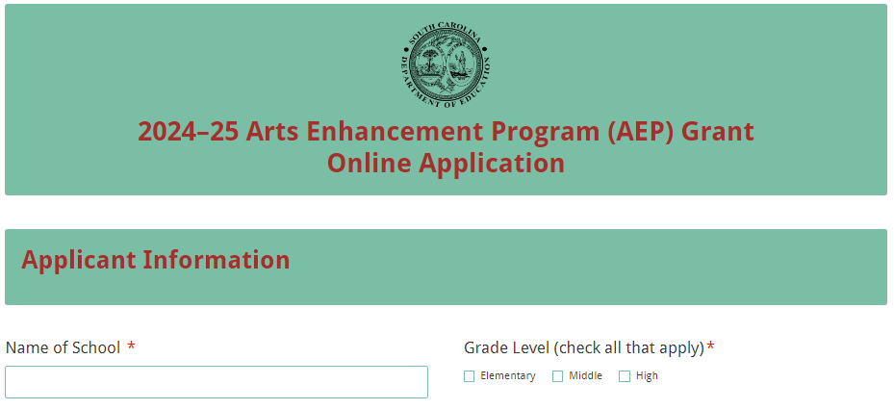
Enter the name and mailing address of the school district. Enter the Unique Entity Identifier (UEI) and the Taxpayer Identification Number (TIN) for the school district and then provide a descriptive title for the project. Contact the district finance office for assistance with the UEI and TIN.
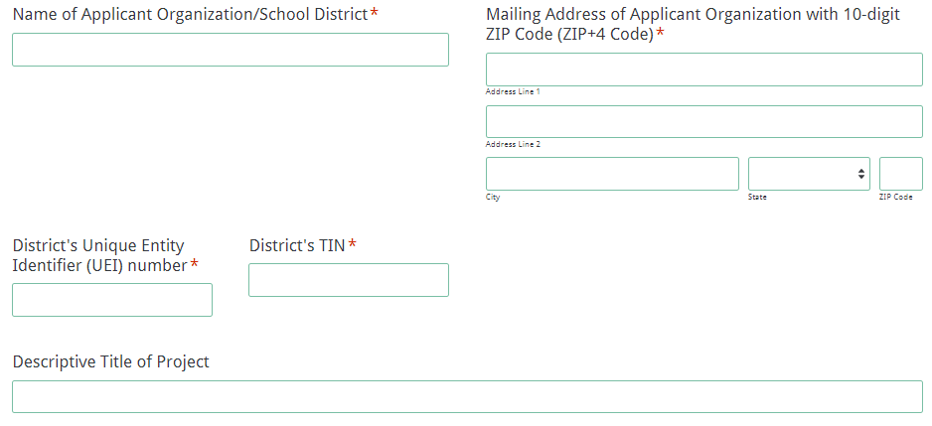
Enter the contact information for the grant manager. The name entered in the online application must match the name as shown on the Certification Signature Page. The grant manager’s email is a required field. The confirmation of a successful online application submission will be sent only to this email address. Reenter the email address to validate that it is correct.
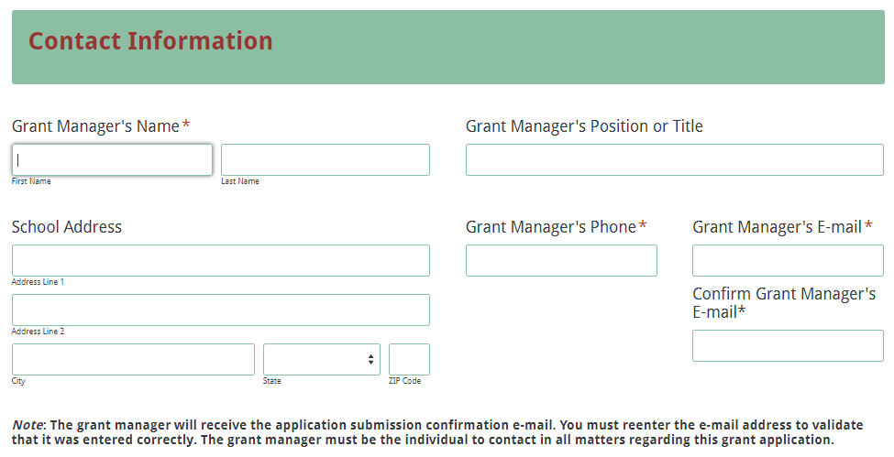
Enter the contact information for the district’s superintendent and finance director. The names entered in the online application must match the names on the Certification Signature Page. Select “Same as Applicant Organization’s Address” if the superintendent’s mailing address is the same as the information entered on the first screen. The data will automatically populate these fields. If the address is different, enter the appropriate information.
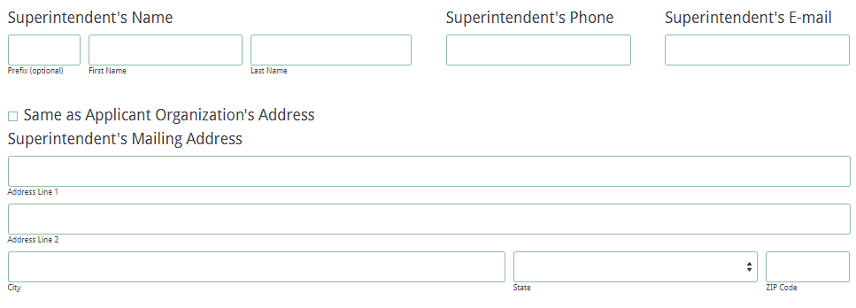
Enter the contact information for the applicant organization’s Financial Director. The name entered in the online application must match the name on the Certification Signature Page.
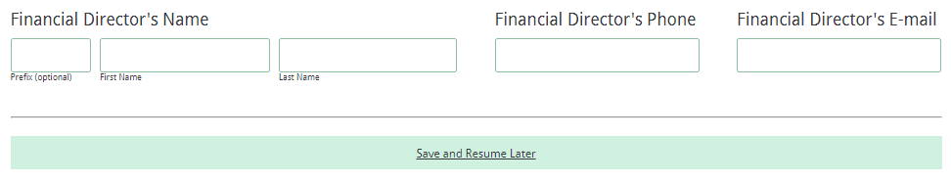
In the Budget Summary section, enter all amounts using only whole dollars (no cents). Fill in all fields and enter 0 (zero) for line items that are not applicable to the project.

Enter the line-item totals by object code for the grant funds being requested for the applicant’s operating budget. The amounts for each line item must equal the corresponding line-item totals in the Budget Narrative. The field for Total Grantee Budget will automatically calculate.

Enter the amount of funds budgeted for the Summer Arts Teacher Institutes, if applicable. This amount may be up to 30 percent of the total funds being requested. The Total Funds Requested field in the online application will automatically calculate.
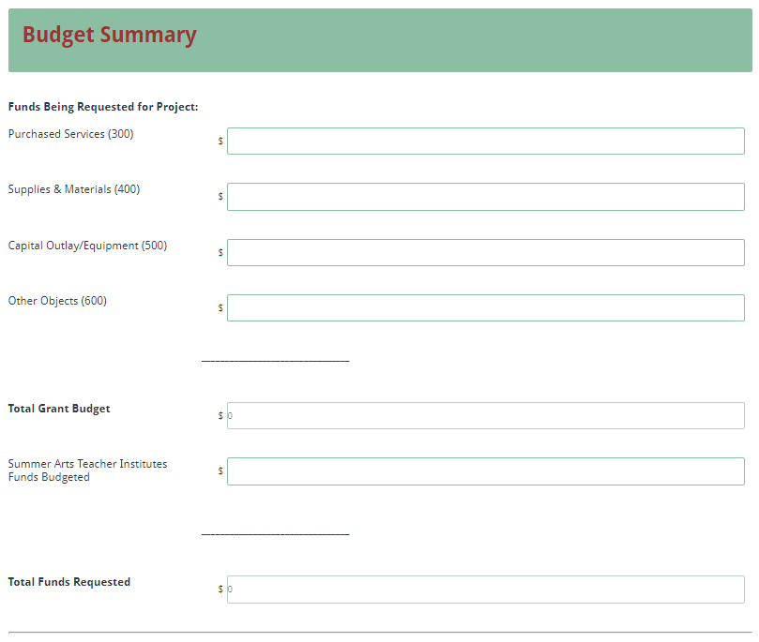
On the following screen, upload the Application Narrative, the Budget Summary and Narrative, and the appendices as proposal attachments. Save the Application Narrative as a single PDF document and all of the appendices (in the order as listed on page 9) as a single PDF document. The online application will only allow one document to be uploaded for each attachment. You will not be able to submit the application without attaching these required documents.
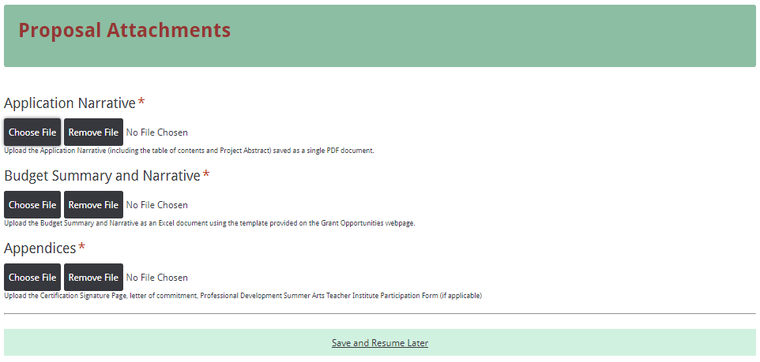
Thoroughly review the summary on the Data Review Page to verify that the information has been entered correctly in the online application prior to submitting. You will not be able to access the completed application form after it has been submitted so it is very important to ensure that all of the information in the application has been entered correctly. If any entries are incorrect, click on the "Previous" button at the bottom left corner of each screen to return to the appropriate section(s) and reenter the correct information. Then click on the “Next” button in the lower right corner of each screen to return to the Data Review Page. Note: This page is not a confirmation of the submission of an application.
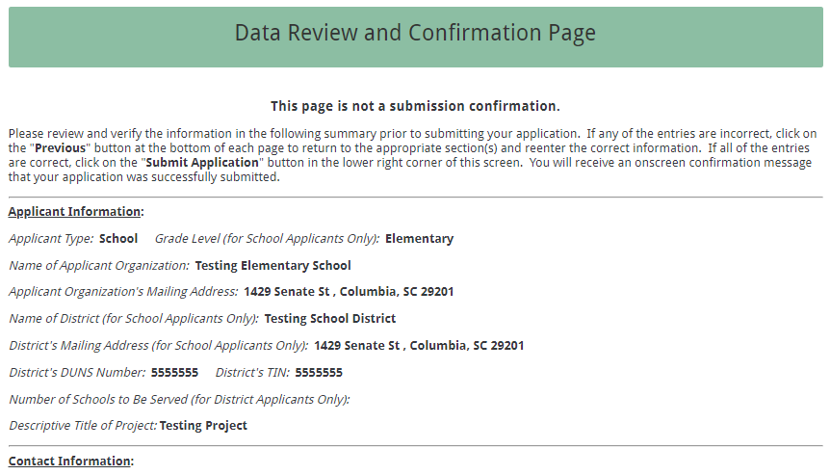
After verifying that all entries are correct, click on the "Submit Application" button in the lower right corner of this screen in order to complete the submission process.
Once the application is submitted, the following message will be displayed on the screen.
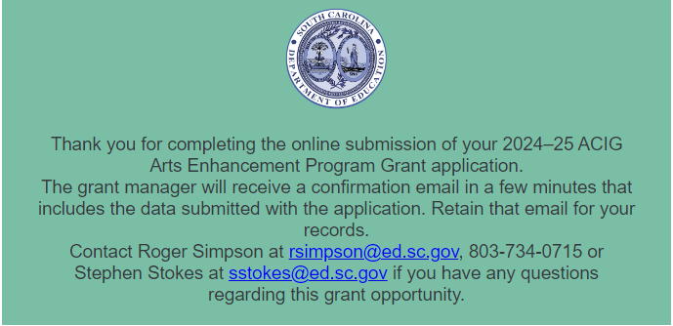
The following confirmation message will be sent to the email address provided for the grant manager. If the grant manager does not receive a confirmation email, then the application did not successfully transmit. You must go back and resubmit the entire online form, including all attachments, in order for your application to be considered for funding. Only the most recently submitted application will be reviewed.

Do not use a search engine, email, or any other method of navigating to the online application. Check the confirmation email after submission to ensure that you applying to the current grant cycle.
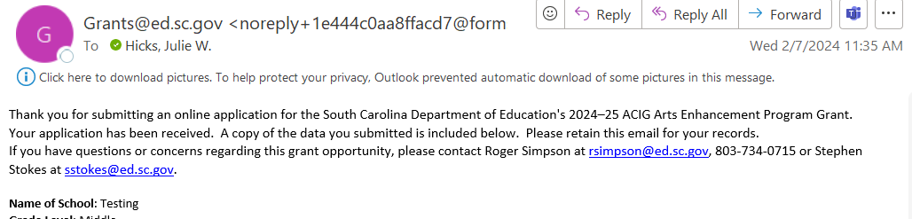
An email confirmation that the grant application was successfully submitted does not account for the quality of the uploaded documents or the completeness of the online form. The confirmation email only notifies you that the online application has been submitted and received. Applicants are responsible for ensuring that the information entered in the online form, including all attachments, is accurate and complete in order for the application to be reviewed and considered for funding.

Appendix A: Definitions of Terms Used

2017 South Carolina College- and Career- Ready Standards for Visual and Performing Arts Proficiency (2017 Standards)—A series of eight documents that individually address the arts areas of dance, design, choral music, general music, instrumental music, media arts, theatre, and visual arts from kindergarten through high school. The standards delineate what the state’s students should know and be able to do in these content areas. The eight documents are intended to be used not only as the basis for curricula, instruction, and assessment in the arts disciplines in South Carolina schools but also as a concise statement about expectations for learning in the arts for policy makers, education administrators, teachers, and instructional and community leaders.

Action Steps—Detailed descriptions of the actions required to implement respective strategies, including priority activities, schedules/timelines, leadership responsibilities, and associated costs.

Deobligation—The downward adjustment of the obligations recorded in a grant award document. It is caused by factors such as (1) termination of part of the project, (2) reduction in material prices, (3) cost savings, or (4) correction of recorded amounts.

Evaluation—A description of the procedures and methods by which progress toward strategic goals and action plan objectives will be regularly assessed and monitored.

Goals—Statements of the district’s or school’s long-term (3–5 years) arts education goals for students stated in results-oriented terms.

Greater Learning Community—The greater learning community can include but is not limited to parents, volunteer, and artists who have benefited from goods and services that you have provided your students through the ACIG grant opportunity. This can include parent and community member attendance to school performances and volunteers who directly work with students supported by grant funds.

Overall Education Community—Includes all people who learn and benefit from the ACIG programs such as teachers, teaching assistants, students, parents, and volunteers.

Profile of the South Carolina Graduate—This framework identifies the characteristics that are believed to be vital to helping our state stay competitive in today's global economy as it addresses the need and solution for a sustainable, educated, and qualified workforce.
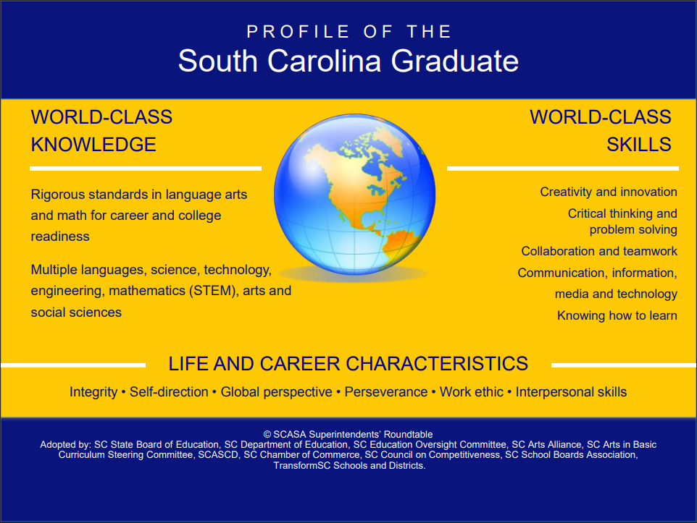

Strategies—Statements of the initiatives through which the district’s or the school’s strategic goals will be met stated in “concrete” language and in measurable terms.

Appendix B: Selection Criteria and Reviewers’ Scoring Rubric

Selection Criteria

Narrative Sections | Maximum Points Available
1. Project Abstract | 0
2. Standards Implementation/Goals and Objectives | 30
3. Strategies and Action Steps/Activities | 40
4. Project Evaluation and Dissemination Plan | 30
5. Budget Narrative | 0
Total Points Available | 100

Scoring Rubric

1. Project Abstract: The applicant provides project abstract in one page or less that includes the following:
- The school, district, project title, and amount of funds requested;
- A summary of the application, including the target audience and the number of students, teachers, and members of the overall education community who will benefit from the proposed project; and
- A brief summary of the goals and objectives, standards implementation, strategies and action steps/activities, and includes expected outcomes of the project.
Acceptable
Adequate/Meets—0 points
Applicant provides a narrative that fully addresses all required items.
Not Acceptable
Inadequate—0 points
Applicant provides a narrative that does not adequately addresses all required items.
Score
Reviewer’s Comments

2. Standards Implementation/Goals & Objectives: The applicant
- lists each learning objective developed to support student achievement along with the corresponding 2017 Standards; and
- briefly describes the anticipated outcomes for student impact for each objective.
Acceptable
Fully Meets—25–30 points
Applicant provides a narrative that fully addresses all required items.
Adequate/Meets—20–24 points
Applicant provides a narrative that moderately addresses all required items.
Not Acceptable
Limited/Approaches—15–19 points
Applicant provides a narrative that is limited or unclear in addressing all required items.
Inadequate—0–14 points
Applicant provides a narrative that does not adequately address the required items.
Score
Reviewer’s Comments

3. Strategies & Action Steps/Activities: The applicant provides a narrative that fully addresses the following:
- briefly describes the planned strategies and action steps/activities to accomplish each objective;
- includes practices to improve, enhance, accelerate, and assure student achievement in the arts and to implement the 2017 Standards;
- includes
  - how each strategy/action step will bring about growth in students’ knowledge and skills in terms of the implementation of the 2017 Standards;
  - the practices to be used to improve and ensure student achievement and engagement in the arts and implement the 2017 Standards; and
  - how the materials budgeted support the objectives, activities, and standards.

Acceptable
Fully Meets—35–40 points
Applicant provides a narrative that fully addresses all required items.
Adequate/Meets—25–34 points
Applicant provides a narrative that moderately addresses all required items.
Not Acceptable
Limited/Approaches—15–24 points
Applicant provides a narrative that is limited or unclear in addressing all required items.
Inadequate—0–14 points
Applicant provides a narrative that does not adequately address all required items.
Score
Reviewer’s Comments

4. Project Evaluation & Dissemination Plan: The applicant clearly describes a detailed plan to evaluate the project’s outcomes and prove if and how well the project worked including:
  - procedures and/or instruments to be used to measure the attainment of the goal and each objective and to assess the effectiveness of the project;
  - how the project results (successes and challenges) will be shared and disseminated; and
  - the replicable products and/or strategies, if applicable, to be produced as a result of the project.
Acceptable
Fully Meets—25–30 points
Applicant provides a narrative that fully describes all required items.
Adequate/Meets—20–24 points
Applicant provides a narrative that moderately describes all required items.
Not Acceptable
Limited/Approaches—15–19 points
Applicant provides a narrative that is limited or unclear in describing all required items.
Inadequate—0–14 points
Applicant provides a narrative that does not adequately describe the required items.
Score
Reviewer’s Comments

5. Budget Summary and Narrative: The applicant provides all of the following:
- a complete budget summary
- an itemized expenditure list that details the specific planned expenditures; and
- correct calculations for all line items and the total budget.
Acceptable
Adequate/Meets—0 points
Applicant provides a budget narrative that provides all required items.
Not Acceptable
Inadequate—0 points
Applicant provides a budget narrative that did not provide all required items.
Score
Reviewer’s Comments

Appendix C: Required SCDE Forms

Certification Signature Page
(This form must be signed by the individual from each proposed district, school, or organization who holds the title listed below.)

Certification
I hereby certify that, to the best of my knowledge, the information and data contained in this application are true and correct. The applicant’s governing body has duly authorized this application and documentation, and the applicant will comply with the SCDE Assurances and Terms and Conditions for State Awards if the grant is awarded.

Authorized Official Representative (Superintendent of school district)
Name:
Position:
Telephone: | Email:
Signature of Authorized Official Representative: |  | Date:

District Financial Official
Name:
Position:
Telephone: | Email:
Signature of District Financial Official: |  | Date:

Principal
Name:
Position:
Telephone: | Email:
Signature of Principal: |  | Date:

Grant Manager
Name:
Position:
Telephone: | Email:
Signature of Grant Manager: |  | Date:

Please complete, print, and obtain signatures prior to submission. Include the signed, scanned form in the appendices as indicated on page 19.

Assurances and Terms and Conditions for State Awards

Assurances
I certify that this applicant
- Has the legal authority to apply for state assistance and the institutional, managerial, and financial capability (including funds sufficient to pay the nonstate share of project costs) to ensure proper planning, management, and completion of the project described in this application.
- Will give the South Carolina Department of Education (SCDE) access to and the right to examine all records, books, papers, or documents related to this award and will establish a proper accounting system in accordance with generally accepted accounting principles (GAAP) or agency directives.
- Has an accounting system that includes sufficient internal controls, a clear audit trail, and written cost-allocation procedures as necessary. The financial management systems are capable of distinguishing expenditures that are attributable to this grant from those that are not attributable to this grant. This system is able to identify costs by programmatic year and by budget line item and to differentiate among direct, indirect, and administrative costs. In addition, the applicant will maintain adequate supporting documents for the expenditures and in-kind contributions, regardless of the type of funds, if any, that it makes under this grant. Costs are shown in books or records (e.g., disbursements ledger, journal, payroll register) and are supported by a source document such as a receipt, travel voucher, invoice, bill, or in-kind voucher.
- Will also comply with GAAP as it relates to budgets, budget amendments, and expenditure claim submissions.
- Will approve all expenditures, document receipt of goods and services, and record payments on the applicant’s accounting records prior to submission of reimbursement claims to the SCDE for costs related to this grant.
- Will initiate and complete work within the applicable time frame after receipt of approval by the SCDE.
- Will not discriminate against any employee or applicant for employment because of race, color, religion, age, sex, national origin, or disability. The applicant will take affirmative action to ensure that applicants for employment and the employees during the period of their employment are treated without regard to their race, color, religion, age, sex, national origin, or disability.
- Will comply with the Ethics, Government Accountability, and Campaign Reform Act (S.C. Code Ann. § 2-17-10 et seq. and § 8-13-100 et seq. (Supp. 2023)).
- Will comply with the Drug Free Workplace Act (S.C. Code Ann. § 44-107-10 et seq. (Supp. 2023)) if the amount of this award is $50,000 or more.

Terms and Conditions

- Completeness of Proposal. All proposals should be complete and carefully worded and must contain all of the information requested by the South Carolina Department of Education (SCDE). If you do not believe a section applies to your proposal, please indicate that fact.
- Non-awards/Termination. The SCDE reserves the right to reject any and all applications and to refuse to grant monies under this solicitation. If the SCDE rejects an application, the applicant has a right to request a review of the process consistent with the appeals process presented in the Request for Proposals (RFP).
After it has been awarded, the SCDE may terminate a grant by giving the grantee written notice of termination. In the event of a termination after award, the SCDE shall reimburse the grantee for expenses incurred up to the notification of termination. In addition, this grant may be terminated by the SCDE if the grantee fails to perform as promised in its proposal.
Upon the termination of a grant, the grantee shall have the right to a review process. The grantee must notify the SCDE of its request within 30 days of receiving written notice of the termination.
- Reduction in Budgets and Negotiations. The SCDE reserves the right to negotiate budgets with potential grantees. The SCDE may, at its sole discretion, determine that a proposed budget is excessive and may negotiate a lower budget with the applicant. The applicant may at that time negotiate or withdraw its proposal. In addition, the SCDE may desire to fund a project but not at the level proposed. In that case, the SCDE shall notify the applicant of the amount that can be funded, and the applicant and the SCDE shall negotiate a modification to the proposal to accommodate the lower budget. All final decisions are that of the SCDE.
- Amendments to Grants. Amendments are permitted upon the mutual agreement of the parties and will become effective when specified in writing and signed by both parties.
- Use of Grant Funds. Funds awarded are to be expended only for purposes and activities covered by the approved project plan, budget, and budget narrative.
- Submission of Expenditure Reports. Claims for reimbursement must be made at least quarterly and consistent with calendar quarters (e.g., an expenditure report claim for costs for January 1 through March 30 must be filed by May 15).
- Obligation of Grant Funds. Grant funds may not be obligated prior to the effective date or subsequent to the end or termination date of the grant period. No obligations are allowed after the end of the grant period. The final request for expenditure report claims must be submitted no later than forty-five (45) days after the end of the grant period unless the scope of work for the grant states a shorter reporting period.
- Deobligation of Funds. After a final expenditure claim has been submitted to the SCDE, the grantee will go through the official deobligation process with the SCDE.
- Documentation. The grantee must provide for accurate and timely recording of receipts and expenditures. The grantee’s accounting system should distinguish receipts and expenditures attributable to each grant. The grantee must review the memo regarding “Guidelines for Retaining Documentation to Support Expenditure Claims.”
- Travel Costs. Travel costs, if allowed under this solicitation, must not exceed limits noted in the United States General Services Administration (GSA) per diem rates for lodging, except in the case of conference lodging required for program-required training. In the case that conference-related lodging exceeds the GSA per diem rate, the grantee shall follow their entity’s written procedure for obtaining prior approval to exceed a GSA rate for a conference hotel. Meals and incidentals are limited by the state budget proviso, currently not to exceed $35 per day for in-state travel and $50 for out-of-state travel (see page 81 of the State of South Carolina Statewide Disbursement Regulations). Mileage reimbursement must follow the current Office of Comptroller General instructions, which is consistent with the published IRS rates.
- Honoraria. Amounts paid in honoraria, if allowed under this grant, must be consistent with SCDE policies. Applicants should check with the program office before budgeting for honoraria.
- Reports. The grantee shall submit, as required or instructed by the awarding program office, all reports (programmatic, financial, or evaluation) within the specified period or date and in the prescribed format. An expenditure claim report must be filed by July 5 for all expenditures incurred by June 30 in order to comply with the generally accepted accounting principles (GAAP) and the production of the State's Comprehensive Annual Financial Report.
- Copyright. The grantee is free to copyright any books, publications, or other copyrightable materials developed in the course of this grant. However, the SCDE reserves a royalty-free, nonexclusive, and irrevocable license to reproduce, publish, or otherwise use, and to authorize others to use, the copyrighted work developed under this grant.
- Certification Regarding Suspension and Debarment. By submitting an application, the applicant certifies, to the best of its knowledge and belief, that the
- Applicant and/or any of its principals, subgrantees, or subcontractors
  - are not presently debarred, suspended, proposed for debarment, or declared ineligible for the award of contracts by any state or federal agency; have not, within a three-year period preceding this application, been convicted of or had a civil judgment rendered against them for commission of fraud or a criminal offense in connection with obtaining, attempting to obtain, or performing a public (federal, state, or local) contract or subcontract; violation of federal or state antitrust statutes relating to the submission of offers; or commission of embezzlement, theft, forgery, bribery, falsification or destruction of records, making false statements, tax evasion, or receiving stolen property; and
  - are not presently indicted for, or otherwise criminally or civilly charged by a governmental entity with, commission of any of the offenses enumerated above.
- Applicant has not, within a three-year period preceding this application, had one or more contracts terminated for default by any public (federal, state, or local) entity.
- Audits. Although this Assurances, Terms, and Conditions document is for a state award, federal audit requirements apply as follows:
- Entities expending $750,000 or more in federal awards:
Entities that expend $750,000 or more in federal awards during the fiscal year are required to have an audit performed in accordance with the provisions of 2 CFR Part 200.501, et seq. Except for the provisions for biennial audits provided in 2 CFR Part 200.504 (a) and (b), audits must be performed annually as stated at 2 CFR Part 200.504. A grantee that passes through funds to subrecipients has the responsibility of ensuring that federal awards are used for authorized purposes in compliance with federal program laws, federal and state regulations, and grant agreements. The director of the OMB, who will review this amount every two years, has the option of revising the threshold upward.
- Entities expending less than $750,000 in federal awards:
Entities that expend less than $750,000 in a fiscal year in federal awards are exempt from the audit requirements in 2 CFR Part 200.504. However, such entities are not exempt from other federal requirements (including those to maintain records) concerning federal awards provided to the entity. The entity’s records must be available for review or audit by the SCDE and appropriate officials of federal agencies, pass-through entities, and the General Accounting Office (GAO).
- Records. The grantee shall retain grant records, including financial records and supporting documentation, for a minimum of six (6) years after the end date of the grant when the final expenditure report claim for reimbursement and all final reports have been submitted, unless informed otherwise or in case of litigation.
- Electronic Signature Agreement. I agree that my electronic signature is the legally binding equivalent to my handwritten signature.

Appendix D: Professional Development Arts Teacher Institutes

Professional Development Arts Teacher Institutes

Below is a list of professional development arts institutes/courses for elementary, middle, and secondary schools in the arts disciplines of dance, music, theatre, and the visual arts. This list represents possible selections that may be offered in June 2025. Arts Enhancement Program applicants may budget for Arts Teacher Institutes as an optional activity.

Applicants planning to apply for funding to attend professional development Arts Teacher Institutes must complete and include the tentative Professional Development Arts Teacher Institutes Participation Form (see page 35). Please provide the teacher’s name and the institute that the teacher plans to attend. Applicants will not be held to this list; however, it will provide the planners with an idea of which institutes need to be offered.

All arts teachers in the ACIG school must have taken CLIA and Arts Assessment Institute I (AAI–I) before any classroom teachers and administrators are permitted to register for institutes. After all visual and performing arts teachers have completed CLIA and AAI–I, schools and districts may enroll classroom teachers and administrators in arts institutes. Arts teachers must show proof of CLIA and AAI–I participation. Arts teachers must have successfully completed CLIA and AAI–I before they may advance to the next tier of institutes. Note: Institute attendees must be returning certified teachers within the district. All equipment (such as computers) and materials distributed as part of an institute becomes the property of the school that receives the ACIG grant and does not follow the grant manager or institute attendee if he or she leaves that school.

Registration for the professional development Arts Teacher Institutes will be available upon notification of this grant award. The specific location and week of each institute will be announced during institute registration. Acceptance in arts institutes is on a first-come, first-served basis.

The cost for each institute may change at the time of institute registration.

All institutes are
- focused on standards-based arts curricula, instruction, and assessment;
- provided as residential institutes (with room and board for participants unless otherwise stated); and
- evaluated on the basis of an assessment instrument approved by the SCDE in terms of quality and its potential impact on student learning.
South Carolina Arts Leadership for Success Academy (SCALSA) $1000 per teacher
This institute is designed for arts teachers who have taught fewer than three years and for critical needs teachers in the arts. SCALSA emphasizes the development of standards-based arts curricula, instruction, and assessment through
- developing standards-based arts lessons;
- studying strategies for evaluations currently implemented for teacher certification;
- developing long-range lesson planning including instruction on how to develop a CLIA lesson plan for future use in grant development and in future institutes;
- studying arts classroom management strategies; and
- identifying teaching and learning styles.

Curriculum Leadership Institute in the Arts (CLIA) $700 per teacher
Designed for the experienced arts teacher, this institute emphasizes
- developing and teaching complex standards-based lesson plans with embedded assessment;
- studying models of best instructional practice;
- reviewing the steps in the SLO cycle;
- working with colleagues in your arts discipline to write an SLO that could be implemented at the classroom level;
- studying arts education support strategies; and
- developing a multi-arts professional network.

Arts Assessment Institute (AAI) $600 per teacher
(Prerequisite SCALSA with instructor’s recommendation or CLIA)
AAI will develop professional educators who
- study the purposes and uses of assessment;
- align assessments with local and state standards;
- construct assessments to best determine knowledge in skills and processes related to the 2017 South Carolina College- and Career- Ready Standards for Visual and Performing Arts Proficiency;
- demonstrate an understanding of the basic principles of measurement and evaluation;
- develop standards-based SLOs and corresponding assessments to demonstrate student growth;
- design and embed assessment strategies within instructional lessons and units;
- apply the relationship of national and state standards, curriculum development, instruction, and assessment; and
- reflect on their assessment practices and the role of assessment in their professional and personal lives.

Media Arts and Technology Institute $1600 per teacher
(Prerequisite CLIA and Arts Assessment Institute)
This institute will provide art teachers with an opportunity to develop standards-based lesson plans and guides that incorporate technology to enhance student learning. Each participant will be provided with appropriate equipment, a computer, and software, which will become the property of their schools at the conclusion of the institute.
Participating teachers will
- receive training in various software programs, apps, and media literacy;
- develop strategies for using the equipment, computer, and software with students; and
- develop lesson plans that use technology to implement the 2017 South Carolina College- and Career- Ready Standards for Visual and Performing Arts Proficiency.

Dance Teacher as Artist Institute $700 per teacher
This institute is taught by master teachers experienced in dance education at all levels from elementary through graduate school. The purpose of this institute is to positively impact artistic literacy in the dance classroom. The emphasis of the institute is to investigate which core principles and processes drive each artistic process in dance and to experience how to effectively channel them into professional practice. The South Carolina College- and Career-Ready Standards for Dance Proficiency and strategies for their implementation in dance will be a basis of the work. Participants in this institute will become more fluent in each of the artistic dance processes and learn specific approaches to expand artistic literacy. Inquiry-based methods and materials will be provided to each participant for use during the institute and becomes the property of the participant’s school upon completion of the institute.

Music Teacher as Artist Institute $700 per teacher
This institute will provide participants with resources and strategies to:
- increase student achievement in music performance through a strengthened understanding of the content specific to this art form;
- evaluate potential student outcomes and effectiveness of varying texts, technology, and literature specific to the content;
- develop curricula, instruction, and assessments that align with on the 2017 South Carolina College- and Career-Ready Standards for Visual and Performing Arts Proficiency; and
- support colleagues through knowledge gained from institute participation.

Theatre Teacher as Artist Institute $700 per teacher
This institute will be taught by a master teacher or professor with extensive knowledge of the various theatre pedagogies and experience with theatre instruction, assessment, and performance. This one-week institute with virtual follow-up sessions must provide participants with resources and strategies to:
- increase student achievement in theatre arts through a strengthened understanding of the content specific to this art form;
- evaluate potential student outcomes and effectiveness of varying scripts, technology, and literature specific to the content;
- develop curricula, instruction, and assessments that align with on the 2017 South Carolina College- and Career-Ready Standards for Visual and Performing Arts Proficiency; and
- support colleagues through knowledge gained from institute participation.

Muse Machine Institute $700 per teacher
(Prerequisite CLIA and Arts Assessment Institute)
This institute is for classroom teachers of all grade levels and subjects. No background in the visual and performing arts is necessary. The course provides hands-on activities in the visual and performing arts taught by professional artists, instruction in the multiple intelligences, and guidance in using the arts across the curriculum. In addition to classroom instruction hours, participants are required to attend and critique four separate arts events from the areas of visual arts, music, theater, dance, historic preservation, and opera.
Participating teachers will
- gain knowledge about incorporating the arts in their own classroom (especially in the areas of science, technology, engineering, arts, and mathematics (STEAM));
- write critically about their experiences in attending four arts events (visual art exhibition, concert, theater production, dance performance);
- develop a lesson plan (using the CLIA Lesson Plan format) that will include STEAM challenges;
- participate in STEAM challenges during the weeklong intense instruction; and
- visit a company that focuses on innovation and STEAM thinking.

Design Lab Teacher Institute $700 per teacher
(Prerequisite CLIA and Arts Assessment Institute)
Participants in the Design Lab Teacher Institute should be prepared to successfully:
- implement the 2017 College- and Career-Ready Standards for Design Proficiency in their arts curriculum to promote college- and career-readiness;
- apply common elements in design education: working in teams, integrating through the design process across discipline areas, and using design materials and techniques;
- construct and present design challenges to their peers and instructors for feedback;
- use design as a mode of working and learning through the process of research, prototyping, and giving and receiving feedback on the results in reflective practice; and
- practice skills and strategies such as listening/responding, participatory research, storytelling, and reflecting.

Arts Integration Leaders Institute $700 per participant
(Prerequisite CLIA and Arts Assessment Institute)
This institute is taught by master teachers and coaches. The Arts Integration Leadership Institute (AILI) should be designed to prepare teachers, curriculum coaches, and other relevant stakeholders to lead arts integration related professional learning opportunities as well as coordinating the development of authentic arts integration lessons through the use of innovative strategies. Through this experience that may include virtual sessions, a weeklong institute, and/or other in-person arrangements, participants will engage in professional learning to:
- develop skills necessary to lead professional development related to:
  - defining arts integration;
  - analyzing and identifying standards that genuinely align for greater student impact; and
  - identifying and selecting arts integration strategies for effective instruction;
  - designing arts integrated lessons.
- develop the capacity to lead collaborative environments and the implementation of arts integration learning experiences.

Strategic Arts Planning Institute (No Prerequisite)
This institute is designed to support schools and districts in writing a strategic arts plan. Schools and Districts must bring a planning team of 4–5 participants to the institute to write a comprehensive strategic arts plan that includes dance, design, media arts, music, theatre, and visual arts. The purpose of developing a strategic arts plan is to significantly improve student achievement in the visual and performing arts based on the implementation of the 2017 South Carolina College- and Career- Ready Standards for Visual and Performing Arts Proficiency. This institute is provided for participants who currently need help with their strategic arts plan and/or grants management, who are interested in creating innovative opportunities in the arts for their students, or who have never written a strategic plan for the arts. At least four schools receiving an AEP grant will be able to attend the Strategic Arts Planning Institute at no cost. Spots will be available on a first come, first served basis. Schools securing a spot that fail to attend the institute will be ineligible for ACIG Program funding from the SCDE for the two subsequent grant cycles

2025 SCDE Professional Development Summer Arts Teacher Institutes Participation Form

School:

District:

Complete this form to indicate tentative participation of your teachers in the SCDE-approved professional development Summer Arts Teacher Institutes. This will allow us to plan and organize arts institutes based on need. Note: Teachers must complete the prerequisites (SCALSA with instructor’s recommendation or CLIA and Arts Assessment Institute Classroom Assessment) before they are allowed to move to the next tier of institutes.

- South Carolina Arts Leadership for Success Academy (SCALSA)  Teacher name(s): | $1000
- Curriculum Leadership Institute in the Arts (CLIA)  Teacher name(s): | $700
- Arts Assessment Institute Classroom Assessment I (AAI)  Teacher name(s): | $600
- Media Arts and Technology Institute  Teacher name(s): | $1,600
- Dance Teacher as Artist  Teacher name(s): | $700
- Guitar Teacher as Artist  Teacher name(s): | $700
- Theatre Teacher as Artist  Teacher name(s): | $700
- Muse Machine Institute  Teacher name(s): | $700
- Design Lab Teacher Institute  Teacher name(s): | $700
- Arts Integration Leaders Institute  Participant name(s): | $700
- Strategic Arts Planning Institute  Team member names: | No Cost
Total Cost of Institutes | $

