Application Package

American Rescue Plan (ARP) Elementary and Secondary Schools Emergency Relief Fund—Homeless Children and Youth
ARP Homeless II Subgrant

The ARP Homeless II is a supplemental subgrant funded by the U.S. Department of Education, authorized by the American Rescue Plan Act of 2021, section 2001(b)(1), and administered by the South Carolina Department of Education.

Revised August 31, 2022

Application Available: March 4, 2022

Application Closes: December 1, 2022

Technical Assistance for Applicants: 10:00 a.m. on September 14, 2022

For questions about the ARP Homeless II and the McKinney-Vento Education for Homeless Children and Youth Program, contact:
Zach Taylor, Team Lead: Diversity, Inclusion, & Access
803-734-8219; ztaylor@ed.sc.gov

Issued by:
South Carolina Department of Education
Office of Federal and State Accountability
1429 Senate Street, Suite 501-A
Columbia, SC 29201

TABLE OF CONTENTS

PART I: General Information 1
A. Introduction and Purpose 1
B. Eligible Applicants 2
C. Timeline of Subgranting Process 2
D. Technical Assistance Sessions for Applicants 2
E. Statutory, Federal Regulations, and Other Requirements 2
F. Authorized Activities 6
G. Unauthorized Activities 8
H. Program Accountability and Monitoring 8
I. Fiscal Operations 11
J. Application Review Process 12

PART II: Application Overview, Content, and Instructions 13
A. Application Overview 13
B. Online Application Submission 13
C. Application Budget 14
D. Appendices 16
E. Application Submission Procedures 17
F. Screenshots of Online Application Submission Forms 17

Appendix A: Definitions of Terms Used 24

Appendix B: Required SCDE Forms 26
Certification Signature Page 26
Assurances and Terms and Conditions for Federal Subawards 27
Terms and Conditions 28
Program-Specific Assurances 31
Instructions for GEPA Statement of Compliance 32
ARP Homeless II District Allocations 33
Budget Narrative Template 35

PART I: General Information

Introduction and Purpose

The American Rescue Plan (ARP) Act of 2021 included $800 million to support the specific and urgent needs of homeless children and youth in recognition of the extraordinary impact of the pandemic on students experiencing homelessness. As a result of the COVID-19 pandemic, students experiencing homelessness are increasingly under-identified, as learning outside of school building settings impeded the critical role of educators and staff in schools and districts to properly identify students, and these students have remained underserved by schools, districts, and states.

Through the ARP—Homeless Children and Youth (ARP-HCY) fund, the U.S. Department of Education (USED) has allocated federal funds on a formula basis to the South Carolina Department of Education (SCDE). In compliance with the Notice of Final Requirements (NFR) published by the USED on July 9, 2021, the SCDE will allocate $8,787,324 as ARP Homeless II formula subgrants to support the work of the designated Homeless Liaison in each local education agency (LEA), as required by the McKinney–Vento Act, and build capacity in LEAs for identifying and serving their homeless children and youth.

As described in the NFR, the SCDE must award ARP Homeless II subgrants to each LEA according to the following formula:
- 50 percent in proportion to the amount that each LEA received under Title I, Part A for the most recent fiscal year (i.e., fiscal year 2020), and
- 50 percent in proportion to the number of homeless children and youth identified by each LEA relative to all LEAs in the state, using the greater of the number of homeless children and youth in either the 2018–19 or 2019–20 school year in each LEA.

The USED developed this formula to ensure funds are distributed based on the needs of LEAs, as it considers both the LEAs’ number of low-income students and the number of homeless children and youth. Allowing the use of the greater number of homeless children and youth in either 2018–19 or 2019–20 school year takes into consideration the potential for undercounting in 2019–20 school year due to the COVID-19 pandemic.

The ARP Homeless II funds are to be used for the purpose of supporting the work of the designated Homeless Liaison, identifying students experiencing homelessness by increasing program capacity (i.e., hiring staff) to provide wrap-around services in light of the challenges of COVID-19, and providing the assistance needed to enable homeless children and youth to attend school and participate fully in school activities. LEAs may use funds to address the urgent needs of homeless children and youth, including academic, social, emotional, and mental health needs. LEAs also may use funds to increase capacity by hiring staff, dedicating resources, and planning partnerships with community-based organizations (CBOs). LEAs also may use funds as allowable under the McKinney-Vento Education for Homeless Children and Youth Program (EHCY, also known as McKinney-Vento; see page 11).

LEAs have a unique opportunity with this funding to impact students experiencing homelessness through long term, high impact strategies. The SCDE anticipates awarding subgrants to all eligible South Carolina LEAs for the amounts listed on pages 33–34. The funding period is July 1, 2021, through September 30, 2024. The subgrantee may obligate funds upon receipt of the subgrant award notice.

Eligible Applicants

All LEAs are eligible applicants. Given the substantial funding allocated under ARP-HCY, the USED promulgated the EHCY regulations to allow for ARP Homeless II fund to be distributed to LEAs by formula rather than competition to ensure that the majority of LEAs will receive subgrants. See pages 33–34 for projected subaward amounts.

Timeline of Subgranting Process

Date | Activity/Action
March 4, 2022 | Window for receipt of applications opens
September 14, 2022 | Pre-application technical assistance session
December 1, 2022 | Deadline: Window for receipt of applications closes at 11:59 p.m.
July 1, 2021 | Funding period begins
Annually by October 30 | Interim programmatic report(s) due to the SCDE
September 30, 2024 | Funding period ends: Deadlines for all goods and services to be received
October 30, 2024 | Final programmatic report(s) due to the SCDE

Technical Assistance Sessions for Applicants

The Office of Federal and State Accountability (OFSA) will offer a pre-application technical assistance webinar via Adobe Connect on September 14th, from 10:00–11:00 a.m. No password is required to join the session. Participants should enter their full names when logging in to the session. Participants will be able to log in 30 minutes prior to the start of the session to test their equipment’s audio settings and to download/print handouts. While participation is not mandatory in order to submit an application, it is highly recommended.

Statutory, Federal Regulations, and Other Requirements

Applicants must propose projects that adhere to the ARP Act of 2021, section 2001(b)(1), and the McKinney-Vento program requirements.

Statutory Requirements
As authorized under the ARP and administered by the SCDE, this ARP Homeless II subgrant must support the work of the LEA’s designated Homeless Liaison and build capacity in the LEA for identifying homeless children and youth and providing homeless children and youth with
- wrap-around services in light of the challenges of COVID–19, and
- assistance needed to enable homeless children and youth to attend school and participate fully in school activities.

These funds will be used by LEAs to increase capacity by hiring staff, dedicating resources, and planning partnerships with CBOs, among other strategies. When responding to the impact of the COVID-19 pandemic on homeless students, the uses of funds may include expenses that are reasonable and necessary to facilitate the identification, enrollment, retention, and educational success of homeless children and youth.

Civil Rights and General Education Provisions Act (GEPA) Statement. Section 504 of the Rehabilitation Act obligates an applicant to ensure that their McKinney-Vento program is accessible to persons with disabilities, and Title VI of the Civil Rights Act of 1964 obligates an applicant to ensure non-discrimination against students based on race, color, sex, and national origin. To comply with Section 427 of the General Education Provisions Act (GEPA), the applicant must include an appropriate GEPA statement of compliance as described on page 32. Given the supplemental nature of this subgrant, applicants are encouraged to review the GEPA statement of compliance they submitted with their previous McKinney–Vento program subgrant application, as applicable, to determine whether modifications are needed for this application.

Prohibition Against Segregating Homeless Students. To the maximum extent practical, services shall be provided through programs and mechanisms that integrate children and youth experiencing homelessness with their housed peers. Activities undertaken must not isolate or stigmatize homeless children and youth.

Applicable Federal Regulations
Applicants should review the following federal regulations, accessible at the electronic Code of Federal Regulations (e-CFR) website, which are applicable to the ARP Homeless II subgrant. Applicants are reminded that, if funded, their programs must comply with these laws and regulations.
- ARP Act of 2021, section 2001 (b)(1), Homeless II
- Notice of Final Requirements–American Rescue Plan Act Homeless Children and Youth Program
- McKinney-Vento Homeless Assistance Act, Subtitle VII-B (42 U.S.C. § 11431 et seq.)
- 2 CFR Part 25—Universal Identifier and System for Award Management
- 2 CFR Part 170—Reporting Subaward and Executive Compensation Information
- 2 CFR Part 175—Award Term for Trafficking in Persons
- 2 CFR Part 180—OMB Guidelines to Agencies on Governmentwide Debarment and Suspension (Nonprocurement) as adopted at 2 CFR Part 3485
- 2 CFR Part 200—Uniform Administrative Requirements, Cost Principles, and Audit Requirements for Federal Awards as adopted at 2 CFR Part 3474 (Note: 2 CFR Part 200.211(b)(1) requires that a grant recipient’s name match their registered name associated with its unique entity identifier as discussed and defined at 2 CFR Part 25).
- 34 CFR Part 76—State-Administered Programs
- 34 CFR Part 77—Definitions that Apply to Department Regulations
- 34 CFR Part 79—Intergovernmental Review of Department of Education Programs and Activities
- 34 CFR Part 81—General Education Provisions Act Enforcement

The regulations 2 CFR Part 200, 2 CFR Part 180, and 34 CFR Part 76–99 are accessible at the Education Department General Administrative Regulations (EDGAR) and other Applicable Grant Regulations.

Additional information on select government wide regulations is presented below:

Unique Entity Identifier and System for Award Management—2 CFR Part 25
The LEA must be registered in the federal System for Award Management (SAM) prior to submitting an application and maintain their SAM registration throughout the application and award process to comply with 2 CFR Part 25. All LEAs with an active SAM registration have a unique entity identifier (UEI). The application must include the UEI in the online subgrant application. Contact your finance office for assistance with your UEI. For more information on the transition from DUNS to UEI visit SAM.gov. Please note that the SCDE will not make a subaward of federal funds to an applicant until the applicant has complied with the requirements described in 2 CFR 25 to provide a valid unique entity identifier and maintain an active SAM registration with current information.

Reporting Subaward and Executive Compensation Information—2 CFR Part 170
The Federal Funding Accountability and Transparency Act (FFATA) of 2006 (P.L. 109–282), as amended by Section 6202 of P.L. 110–252, requires primary grantees of federal grants and cooperative agreements to report information on subgrantee obligations and executive compensation. FFATA promotes open government by enhancing the federal government’s accountability for its stewardship of public resources. This is accomplished by making government information, particularly information on federal spending, accessible to the general public.

The Family Educational Rights and Privacy Act (FERPA) is a federal law that protects the privacy of student education records (20 U.S.C. § 1232g; 34 CFR Part 99). This law applies to all subgrantees under this program.

Applicants should review the Assurances and Terms and Conditions for Federal Subawards (pages 27–30) and the Program-Specific Assurances (page 31) to ensure that, if awarded a subgrant, they are capable of full compliance, especially with all the referenced federal regulations and state laws, in order to enter into an agreement with the SCDE for this program. For example, in compliance with 2 CFR Part 200.112, applicants must disclose in writing any potential conflict of interest to the SCDE in accordance with the USED’s conflict of interest policy. A signed Certification Signature Page (see page 26) is required with the subgrant application and legally binds the applicant to the agency’s assurances and terms and conditions.

State-Level ARP Homeless II Program Requirements
An applicant must provide a plan in their application to use the ARP Homeless II subgrant to support the work of the designated Homeless Liaison and expand or to improve upon their McKinney-Vento program and services. Subgrant funds may not be used for purchases that do not directly support the approved application.
LEAs must use a minimum of 40 percent of the ARP Homeless II funds to increase identification, awareness, outreach, and collaboration efforts. In addition, not more than 20 percent of the funds may be used for the excess cost of transportation to and from the school of origin, or for short-term emergency housing. An LEA may contact the Office of Federal and State Accountability to request a waiver for the transportation and short-term emergency housing limit. Activities must be based on identified needs.

All LEAs must use PowerSchool to submit data. Upon identification as homeless, the liaison or designated person must enter the student’s homeless status in PowerSchool by identifying the primary nighttime residence at the time of identification. The LEA must also indicate if the student is an unaccompanied homeless youth. In addition, subgrantees must report outcome-based data for evaluation purposes, including measures for academic performance. Each subgrantee is required to designate a person to be responsible for submitting all program data by deadlines set by the SCDE. However, the McKinney-Vento Liaison is ultimately responsible for all elements and the timely submission of all reports.

Applicants are encouraged to use this simple tool to assess the capacity of their McKinney-Vento (MV) liaison to meet the duties listed in the law.

State-Level ARP Homeless II Program Requirements

State educational agencies and LEAs must use ARP Homeless II funds to identify homeless children and youth, to provide homeless children and youth with wrap-around services to address the challenges of COVID-19, and to enable homeless children and youth to attend school and fully participate in school activities. The following state level primary objectives are directly aligned with the Dear Colleague Letter and Notice of Final Requirements. Although the MV program office in each district is responsible for achieving one or more of the objectives listed below to support the overall needs of students experiencing homelessness, this should be a collaborative effort within the district and community. At minimum, evidence for achieving one or more state-level primary objectives must be included in the annual report (see page 9). However, SCDE may request such evidence of, or progress towards achievement of the LEA’s state-level primary objectives during any form of monitoring (see page 10).

State Level Primary Objectives

Build/Enhance LEA MV Program Capacity
Build capacity to strengthen and improve the district’s McKinney-Vento (MV) program to enable entire school staff to recognize, identify, and support all eligible homeless children and youth, and to address the urgent and complex needs of students experiencing homelessness in a time-sensitive manner so that the LEA’s annual count of homeless students equals at least 10% of the LEA’s total count of Pupils in Poverty (PIP) or 2.9 percent of total student population (per national average) by September 30, 2024.

Provide technical assistance and professional development to all MV Program staff, school and district staff, and CBOs.
Ensure that the district's MV Program staff attend appropriate technical assistance/professional development (TA/PD) in order to have the capacity to address the urgent needs of students experiencing homelessness, including academic, social, emotional, and physical/mental health needs, and provide other assistance needed (food, transportation, temporary housing, etc.) to enable homeless children and youth to attend school and participate fully in school activities. The LEA staff will coordinate with CBOs for TA/PD as needed.

Build and/or enhance the LEA's McKinney-Vento Program to address the urgent needs of children and youth experiencing homelessness
Dedicate and use appropriate LEA resources to expanding the district's MV Program to address the urgent needs of students experiencing homelessness, including academic, social, emotional, and physical/mental health needs, and provide other assistance needed (food, transportation, supplies, etc.) to enable homeless children and youth to attend school and participate fully in school activities.

Build and/or enhance district and community collaboration to address the urgent needs of children and youth experiencing homelessness
Collaborate and coordinate with state agencies and CBOs, including faith-based groups, to plan and develop partnerships or contracts to provide wrap-around services and other assistance needed, in light of the challenges of COVID-19, to address the urgent needs of students experiencing homelessness, including academic, social, emotional, and physical/mental health needs, and provide other assistance needed (food, transportation, temporary housing, etc.) to enable homeless children and youth to attend school and participate fully in school activities, particularly to include historically underserved populations.

Authorized Activities

ARP Homeless II funds will be used by LEAs to increase capacity by hiring staff, dedicating resources, and planning partnerships with CBOs, among other strategies. In addition, LEAs must ensure that all costs are reasonable and necessary and that these uses of funds align with the purpose of, and other requirements in, the McKinney-Vento Homeless Assistance Act (see page 3). LEAs should consider the extraordinary impact of the pandemic on students experiencing homelessness when making decisions about how to use funds. LEAs may use ARP Homeless II funds for any of the sixteen allowable uses permitted by the McKinney-Vento Act (42 U.S.C. §11433(d)).
- The provision of tutoring, supplemental instruction, and enriched educational services that are linked to the achievement of the same challenging state academic standards as the State establishes for other children and youths.
- The provision of expedited evaluations of the strengths and needs of homeless children and youths, including needs and eligibility for programs and services (such as educational programs for gifted and talented students, children with disabilities, and English learners, services provided under title I of the ESEA, 20 U.S.C. 6301 et seq., or similar state or local programs, programs in career and technical education, and school nutrition programs).
- Professional development and other activities for educators and specialized instructional support personnel that are designed to heighten the understanding and sensitivity of such personnel to the needs of homeless children and youths, the rights of such children and youths under this part, and the specific educational needs of runaway and homeless youths.
- The provision of referral services to homeless children and youths for medical, dental, mental, and other health services.
- The provision of assistance to defray the excess cost of transportation for students under section 722(g)(4)(A) of the McKinney-Vento Act, not otherwise provided through federal, state, or local funding, where necessary to enable students to attend the school selected under section 732(g)(3) of the McKinney-Vento Act.
- The provision of developmentally appropriate early childhood education programs, not otherwise provided through federal, state, or local funding, for preschool-aged homeless children.
- The provision of services and assistance to attract, engage, and retain homeless children and youths, particularly homeless children and youths who are not enrolled in school, in public school programs and services provided to non-homeless children and youths.
- The provision for homeless children and youths of before- and after-school, mentoring, and summer programs in which a teacher or other qualified individual provides tutoring, homework assistance, and supervision of educational activities.
- If necessary, the payment of fees and other costs associated with tracking, obtaining, and transferring records necessary to enroll homeless children and youths in school, including birth certificates, immunization or other required health records, academic records, guardianship records, and evaluations for special programs or services.
- The provision of education and training to the parents and guardians of homeless children and youths about the rights of, and resources available to, such children and youths, and other activities designed to increase the meaningful involvement of parents and guardians of homeless children or youths in the education of such children or youths.
- The development of coordination between schools and agencies providing services to homeless children and youths, as described in section 722(g)(5) of the McKinney-Vento Act.
- The provision of specialized instructional support services (including violence prevention counseling) and referrals for such services.
- Activities to address the particular needs of homeless children and youths that may arise from domestic violence and parental mental health or substance abuse problems.
- The adaptation of space and purchase of supplies for any non-school facilities made available under section 723(a)(2) of the McKinney-Vento Act to provide services under section 723(d) of the McKinney-Vento Act.
- The provision of school supplies, including those supplies to be distributed at shelters or temporary housing facilities, or other appropriate locations.
- The provision of other extraordinary or emergency assistance needed to enable homeless children and youths to attend school and participate fully in school activities.

In addition, ARP Homeless II funds may be used for any expenses that are reasonable and necessary to facilitate the identification, enrollment, retention, and educational success of children and youth experiencing homelessness, such as:
- providing wraparound services (which could be provided in collaboration with and/or through contracts with CBOs, and could include academic support, trauma-informed care, social-emotional support, and mental health services);
- purchasing needed supplies (e.g., Personal Protective Equipment (PPE), eyeglasses, school supplies, personal care items);
- providing transportation to enable children and youth to attend classes and participate fully in school activities;
- purchasing cell phones or other technological devices for unaccompanied youth to enable the youth to attend and fully participate in school activities;
- providing access to reliable, high-speed internet for students through the purchase of internet-connected devices/equipment, mobile hotspots, wireless service plans, or installation of community Wi-Fi Hotspots (e.g., at homeless shelters), especially in underserved communities;
- after exhausting other options, paying for short-term, temporary housing (e.g., a few days in a motel) when such emergency housing is the only reasonable option for COVID-safe temporary housing and when necessary to enable the homeless child or youth to attend school and participate fully in school activities (including summer school); and
- after exhausting other options, providing store cards/prepaid debit cards to purchase materials necessary for students to participate in school activities.

Unauthorized Activities

ARP Homeless II funds must not be used for:
- rent or utilities;
- long-term motel or other housing;
- non-educational field trips (such as amusement or fun parks);
- high-priced educational field trips;
- incentives for students or project staff;
- religious activities;
- promotional items;
- purchase, construction, or renovation of a building;
- purchases that do not directly support the approved plan; or
- replacing (i.e., supplanting) the use of McKinney-Vento subgrant funds or ESSER subgrant funds.

Program Accountability and Monitoring

The SCDE is responsible for monitoring ARP Homeless II subgrant implementation to facilitate the identification, enrollment, retention, and educational success of homeless children and youth in accordance with the following program accountability requirements.
- Each subrecipient receiving funds through ARP Homeless II meets the eligibility requirements for the subgrant described herein, and the applicant has provided all required assurances that it will comply with all program implementation and reporting requirements established through this application package.
- Each subrecipient receiving funds through this ARP Homeless II appropriately uses these funds as described in this application package.
- Each subrecipient implements activities funded through this application within the timeline in which the funds provided are to be used.

In compliance with 2 CFR Part 200.332(b), the SCDE conducted a risk assessment in early 2021 of all South Carolina LEAs, including the existing subgrantees who are eligible to apply for this ARP Homeless II subgrant. The SCDE’s Office of Auditing Services will use this risk assessment in lieu of the pre-award risk assessment and may conduct a further evaluation of the applicant’s financial system, internal controls, and policies and procedures, if deemed necessary.

Applicants awarded subgrant funds must satisfy periodic reporting and accountability requirements throughout the term of the subgrant. These requirements address: (1) program accountability; (2) performance reporting; (3) project budget; (4) monitoring; (5) program evaluation; and (6) technical assistance.

    - Program Accountability
Each subgrantee is responsible for carrying out its responsibilities in accordance with the ARP Act of 2021, section 2001 (b)(1),and the McKinney-Vento Homeless Assistance Act, Subtitle VII-B (42 U.S.C. § 11431 et seq.); all applicable statutes, regulations, and programmatic guidance; and its approved subgrant application and work plan. Subgrantees are required to submit periodic reports to the SCDE to report on the use of subgrant funds and the progress of subgrant activities.

    - Performance Reporting
Performance reporting requirements include those for both programmatic reporting and fiscal reporting. The subgrantee is responsible for ensuring that all required performance reports are accurate, complete, and submitted on time.

Programmatic Reporting Requirements
Annual performance progress reports must be submitted to the SCDE no later than October 30 each year. Progress toward achieving ARP Homeless II subgrant goals and objectives will be monitored through this report. The project coordinator is responsible for the timely submission of all reports.

LEAs must comply with reporting requirements established by USED, including those outlined in the McKinney-Vento program. In addition, the following data elements are required to be reported in the annual performance progress report for the full academic year(s) of the ARP Homeless II subgrant (July 1 through June 30):
- the number of students experiencing homelessness identified by supports funded by ARP Homeless II funds;
- the number of homeless students supported through ARP Homeless II funding; and
- specific details about supports and services funded by ARP Homeless II funds received by homeless students.

Fiscal Reporting Requirements
All expenditure reports must be submitted through the SCDE’s grants accounting processing system (GAPS). Submission of expenditure reports will be accepted monthly but is required at least quarterly throughout the grant award period (see the following table). Subgrantees must submit a final fiscal report to the SCDE that covers the duration of the subgrant award.

The expenditure reporting due dates for the ARP Homeless II subaward are:
Reporting Period | Report Due Date
July 1–September 30 | October 5
October 1–December 31 | January 5
January 1–March 31 | April 5
April 1–June 30 | July 5
Final Expenditure Report | November 15, 2024

    - Project Budget
The project budget will include a budget narrative and budget summary of planned expenditures to be funded by the subgrant must be submitted with the application. Approved budgets must be uploaded into GAPS by subgrantees after the receipt of the grant award notification and prior to submitting any reimbursement requests.

    - Monitoring
The SCDE will monitor subgrantees by reviewing and approving the annual progress performance reports. All information in monitoring reports is subject to verification.

The SCDE may conduct programmatic and financial monitoring site visits. Subgrantees must agree to site visits conducted by SCDE or federal program representatives. The purpose of site visits is to validate information provided in fiscal and program reports and to gather more detailed information on implementation efforts and challenges from interviews and observations for monitoring and evaluation purposes.

The SCDE may require additional information from the subgrantee, verify information with the authorizing agency, or require the submission of additional documentation including, but not limited to, invoices, receipts, and personnel time and effort reports. Prior to a site visit, the subgrantee may be required to submit additional relevant information that will allow the SCDE to conduct a useful, efficient, and effective visit. The SCDE may require electronic submission of documents instead of a paper-copy submission.

SCDE staff will verify the contents of documentation submitted. Subgrantees may be asked to revise reports when:
- non-allowable expenses are found;
- reports are confusing or difficult to understand; or
- there are unexplained discrepancies between the proposed use of subgrant funds, as provided in the annual budget, and actual expenditures found in the submitted documentation.
    - Program Evaluation
Subgrantee Project Monitoring and Evaluation
Subgrantees are required to conduct ongoing monitoring and evaluation to ensure ARP Homeless II project goals are achieved. Progress toward meeting project goals is to be reported through the annual progress review process.

A final project evaluation report is to be completed immediately following the end of the subgrant period. The final evaluation report must address project success toward each goal stated in the application. If a subgrantee fails to conduct the final project evaluation report before the end of the subgrant period, or if any of the performance requirements in section I.2 are not completed, the SCDE may consider the subgrantee a high risk and elect to discontinue funding or disqualify the subgrantee from future funding opportunities.

SCDE External Review
If applicable at any time during the term of the ARP Homeless II or after, subgrantees are required to comply with any request by the USED for evaluation or the SCDE, including, but not limited to, requests for information, site visits, interviews, completing surveys, or participating in data collections.

    - Technical Assistance to Subgrantees
Subgrantees are required to participate in any technical assistance that the SCDE may conduct for the ARP Homeless II subgrant. Delivery of such technical assistance may include in-person meetings, webinars, and conference calls. Dates to be determined.

Fiscal Operations

Subgrantees must use subgrant funds for allowable activities and expenditures during the subgrant period. ARP Homeless II subgrant funds are disbursed on a reimbursement basis. The SCDE will deobligate any unspent funds remaining at the end of the subgrant.

Indirect costs are allowable. Applicants may use the unrestricted indirect cost rate of the school district, but may choose to use their restricted rate, which is lower. Matching or in-kind funds are not required.

Allowable Costs
Subgrant funds must be used in accordance with statutory and regulatory requirements for allowable activities as presented in Section F (pages 6–8). Subgrant funds may be used for the development and implementation of educational and related services for homeless children and youth. These services are to be made available during school hours; before and after school; and on holidays, weekends, and/or vacations. Services must be designed to expand upon or improve services provided to homeless students as part of the school's regular academic program.

Subgrantees should review the cost principle(s) in 2 CFR Part 200. All costs must be reasonable and necessary, and the uses of funds must align with the purpose of and other requirements in the ARP and the McKinney-Vento statute.

Unallowable Costs
A subgrantee may not use ARP Homeless II subgrant funds for any costs that provide for any unauthorized activities that are described in Section G (page 8).

Application Review Process

Only those subgrant applications that are received within the application window and deemed complete will be reviewed and considered for funding. All required materials including attachments must be submitted for the application to be considered complete and eligible for review.

The Office of Federal and State Accountability will review each application for completeness and compliance with section 2001(b)(1) of the ARP, the McKinney-Vento Act, and the application instructions.

The SCDE reserves the right to negotiate budgets and to disqualify costs associated with any line items that are unallowable, unallocable, unreasonable, or inconsistent with the purpose of the subgrant or the proposed activities and strategies.

Subgrant awards are not final until an SCDE grant award notice (GAN) is fully executed. Notification of funding will be sent to the superintendent listed on the Certification Signature Page.

PART II: Application Overview, Content, and Instructions

Read all guidelines and criteria carefully before preparing your application. Adhere to font, format, page limit, and organizational requirements. Only applications that include all sections and appendices and fully adhere to these guidelines will be reviewed and considered for funding. Incomplete applications will not be reviewed.

Application Overview

Applicants are encouraged to prepare all the following elements of the application before beginning the online submission process. Do not wait until the last minute to submit an application. Use the following overview as a checklist to ensure that the application is complete with items labeled accordingly and presented in the order outlined below. Verify that all narrative components and appendices are included prior to uploading attachments.

The ARP Homeless II online application is organized into the following sections (also see the screenshots on pages 17-23):

- Online Form
- ARP Homeless II Application
  - Applicant Information
  - McKinney-Vento Liaison Contact Information
  - Project Coordinator’s Contact Information
  - Program-related Questions
  - Attachments
- Appendices (to upload in the Online ARP Homeless II Application)
  - Certification Signature Page (located in this application package)
  - GEPA Statement of Compliance (instructions on page 32)
  - Indirect Cost Rate Agreement (if applicable)

Online Application Submission

Applications must be submitted using the online application form. Applications must include the information requested in the Online Application Sections and include the Application Attachments as outlined below.

Applicants will be able to save their progress online, but it is strongly recommended to complete all application components numerated above before starting the online application form.

Provide the primary applicant’s Unique Entity Identifier (UEI) and Taxpayer Identification Number (TIN) in the application form. Applicants should contact their organization’s finance office if they need assistance with these items.

Use the following instructions to compile and complete all proposal attachments prior to submitting your application. Verify that all components of the narrative and appendices are included prior to uploading attachments. Follow the directions in each section for saving the documents and refer to the screenshot on pages 17–23 for upload locations.

Application Budget

The application budget consists of two parts: the Budget Summary and the Budget Narrative. All proposed expenditures for the grant funding period must be itemized in the Budget Summary and detailed in the Budget Narrative. Applications with an incomplete budget or budget items not explained (see pages 35) will not be funded. Use the excel budget template (available to download on the SCDE’s ARP Homeless I Grant Opportunities webpage) to provide the application budget.

- The Budget Summary is the financial overview of the subgrant plan and must include all proposed expenditures for Year 1 of the project. Each line item of the Budget Summary must correspond to the line items of the Budget Narrative (discussed below).

- The Budget Narrative must provide clear evidence that the budget is appropriate and justified based on the needs assessment. Use the template on the SCDE’s Grant Opportunities webpage (see screenshot on page 35) to provide a detailed Budget Narrative to include any in-kind or matching contributions. Structure the Budget Narrative line-item categories to parallel the line-item categories of the Budget Summary. Include all formulas used to calculate each line-item expense. This narrative must demonstrate that all expenditures are allowable, reasonable, and allocable; adequate to support the activities of the project; and directly connect to the goals and objectives in the application narrative.

Ensure that the total in the Budget Summary equals the total in the Budget Narrative. When finalized, save the Budget Narrative as an Excel spreadsheet to be uploaded into the online application where indicated in the proposal attachments section (see page 22).

Review 2 CFR Part 200 Subpart E Cost Principles, specifically, §§ 200.403–200.405, for additional information on the allowability, reasonableness, and allocability of costs for federal grant awards. The General Provisions for Selected Items of Cost are listed in 2 CFR §§ 200.420–200.475. When finalized, save the Budget Narrative as an Excel spreadsheet to be uploaded into the online application where indicated.

The following describes the line items that should be budgeted in each category.

Salaries/Stipends (100)
This category includes pay for the McKinney-Vento district liaison, school social workers, graduation coaches, and staff members and stipends for tutors/teachers. Include the percent FTE and a brief description of their responsibilities funded by this project. For hourly wages, state the hourly pay rate and the planned hours on the project. The duties should align with the objective(s) and activities. The total percentage of time charged to the subgrant and to non-grant funds cannot exceed 100 percent of the total time worked by any staff member.

Employee Benefits (200)
FICA, workers’ compensation, health insurance, and other employee benefits costs should be included here. These costs will represent a percentage of the total in Salaries/Stipends (100).

Purchased Services (300)
Expenses such as consultant fees, travel/transportation costs, telephone costs, and other purchased services will be included here. This includes amounts paid for personal services rendered by personnel who are not on the payroll and for other specialized services purchased by the organization. While a product may or may not result from the transaction, the primary reason for the purchase is the service provided. Note: Salaries for direct teachers and project staff should be recorded in Salaries/Stipends (100) and not in this section.

For a subgrantee to pay a vendor with federal funds, a contract must be in place. At a minimum, the contract should include the scope of services, the duration of the contract, and the method and amount of payment; the contract must be executed by both parties. Consulting/service contracts must be procured in accordance with procurement regulations in 2 CFR Part 200 (see § 200.317 to § 200.326 and Appendix II). LEA applicants should also review South Carolina Procurement Law.

In compliance with 2 CFR Part 180.300, subgrantees must ensure that they do not enter into a contract with any vendor that is debarred, suspended, or ineligible (i.e., excluded) for participation in federal programs by:
- checking the Exclusions at the federal SAM website (download and review the Quick Start Guide for Searching Exclusions before conducting searches.);
- collecting a certification from the vendor and attaching it to the contract; or
- adding a clause or condition to the contract that indicates the vendor is eligible.

Supplies and Materials (400)
Include the amounts paid for material items of an expendable nature. It is recommended that applicants group items into categories to avoid listing every item; however, make sure that such expenditures are aligned with relevant project characteristics (objectives, number of participants, frequency of activity, etc.). Allow for maintenance, repair, and replacement costs over the grant life cycle of the proposed project for any equipment that totals $5,000 and below.

Capital Outlay/Equipment (500)
Equipment and supplies totaling more than $5,000 per unit are not allowable (see part I, section H). Itemize furniture, fixtures, and equipment that total $5,000 and below per unit under Supplies and Materials. Applicants are reminded that equipment purchased with federal funds must be managed in compliance with 2 CFR Part 200 Subpart D § 200.313 (and § 200.439 as applicable). See part I, section F for more information on applicable federal regulations.

Other Objects (600)
This category includes expenditures such as postage, liability insurance fees, and copyright fees that do not neatly fit into the other categories.

Indirect Costs (700)
Indirect costs are allowed. Indirect costs represent the operating expenses that are not readily identified with a particular grant, contract, project function, or activity, but are necessary for the general operation of an organization and the conduct of activities it performs. In theory, expenses like heat, electricity, accounting, and personnel might be charged directly if little meters could record minutes in a cross-cutting manner; however, practical difficulties preclude such an approach. Therefore, cost allocation plans or indirect cost rates are used to distribute those costs to benefiting revenue sources.

To charge indirect costs to a subgrant, a subgrantee must have an approved indirect cost rate agreement. A copy of the approved indirect cost rate agreement must be included as an appendix item. The applicant should use its restricted indirect cost rate.

The SCDE reserves the right to disqualify, disallow, and negotiate costs associated with any line item proposed in the budget. If any line-item cost is determined to be excessive, given the nature and scope of the entire project or of a particular activity, the SCDE can request the applicant reduce the cost of the line item or ask the applicant to assume a portion of the cost before the budget is approved and funds are awarded.

Funds will be disbursed on a reimbursement basis upon the receipt of expenditure reports with all supporting documentation from the subgrantees. Given the purpose of the ARP Homeless II funds, subgrantees may request reimbursement for allowable pre-award costs. No expenditures incurred prior to July 1, 2021 will be reimbursed. Subgrantees are not permitted to pick up their reimbursements from the SCDE office.

Appendices

All items of the appendices must be scanned into a single PDF document to be uploaded into the online application as indicated on page 22.

Certification Signature Page
This form includes the certification of the SCDE’s Assurances and Terms and Conditions for Federal Subawards and all program-related conditions conveyed in this RFP. Those documents are not required to be included in the applicant’s proposal submission. However, retain the copy included in this RFP for your records and ensure that the signatories and partner organizations have copies of each document.

By signing the Certification Signature Page, the signatories assure that they will comply with all the assurance and terms and conditions for the program. All signatories must understand that they are signing a document that is legally binding in the event a subgrant is awarded. Applications that do not include the signed Certification Signature Page will not be reviewed or considered for funding.
GEPA Statement
All applicants must provide a GEPA Statement. Follow the instructions on page 35 to create a GEPA Statement for the proposed ARP Homeless II project. When finalized, save the GEPA Statement to be scanned with all other appendices and uploaded as one PDF document into the online application in the appendices section.

Application Submission Procedures

- Applications must be submitted using the online application form.
- Only applications that adhere to all guidelines and directions will be reviewed and considered for funding.
- No hard copy applications will be accepted. Applications delivered by hand, postal mail, email, or fax will not be accepted.
- Applications must originate from the applicant. Applications that are plagiarized from the Internet, other grants, or other resources will not be considered for funding.
- Do not attach or submit any additional materials other than what is specifically required. Any additional materials will be disposed of without review.
- Applications will not be returned. Keep a copy of the entire application for your records.

Screenshots of Online Application Submission Forms

The following screenshots are for informational purposes only and are provided to assist applicants in compiling all items needed to complete the online submission. Complete the attachments for the online application as directed in the preceding instructions. The SCDE encourages applicants to prepare all parts of the application before beginning the online submission process.

Make sure all information submitted is accurate, including formal or official names such as the school district, and that spelling is correct. Do not use abbreviations or acronyms. All fields marked with a red asterisk are required; you will not be able to proceed to the next screen of the application without entering all required information.

If necessary, progress may be saved in the online application and returned to the form later. Click on the “Save and Resume Later” link to save your progress. There will be a prompt to create a password to securely save the form. An option will be given to copy and save the link to the partially completed form or entering an email address to have the link emailed. Be sure to enter the email address correctly as SCDE personnel cannot access the hyperlink or the incomplete application. Use the link to access the application from any computer within thirty days to complete the online submission. Without the link and password or after thirty days, the data previously entered cannot be retrieved and a new application will need to be started. A saved application is not a submitted application. Follow all the steps described on pages 21–23 to complete the submission process.

Enter the name of the applicant organization (i.e., school district) using the dropdown menu. The name as entered must match the registered UEI name. Enter the applicant organization’s physical address with the 10-digit ZIP Code (ZIP+4 Code), UEI number, and TIN (tax identification number).

Indicate whether or not the district is registered and active with SAM.gov. The district must have an active SAM registration in order to proceed with the application.

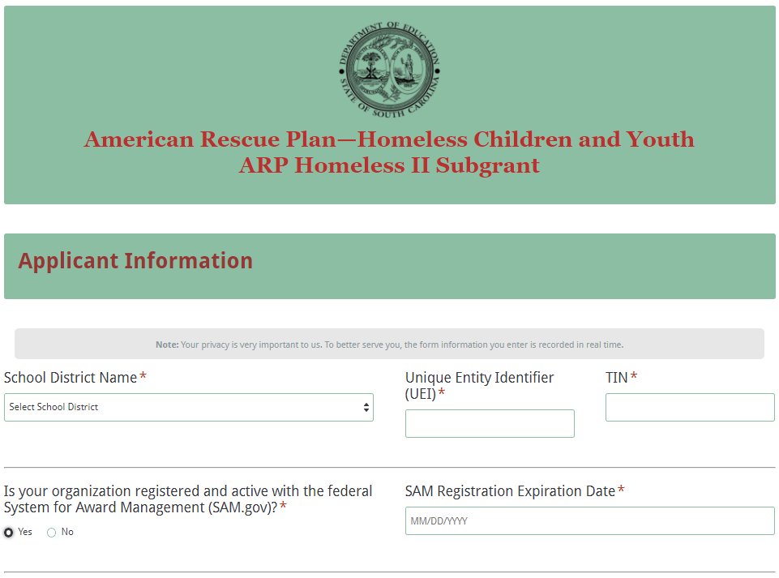

Enter the name and position of the applicant’s McKinney-Vento district liaison. Because the application submission confirmation will be sent only to this e-mail address, reenter the e-mail address to validate that it is correct.
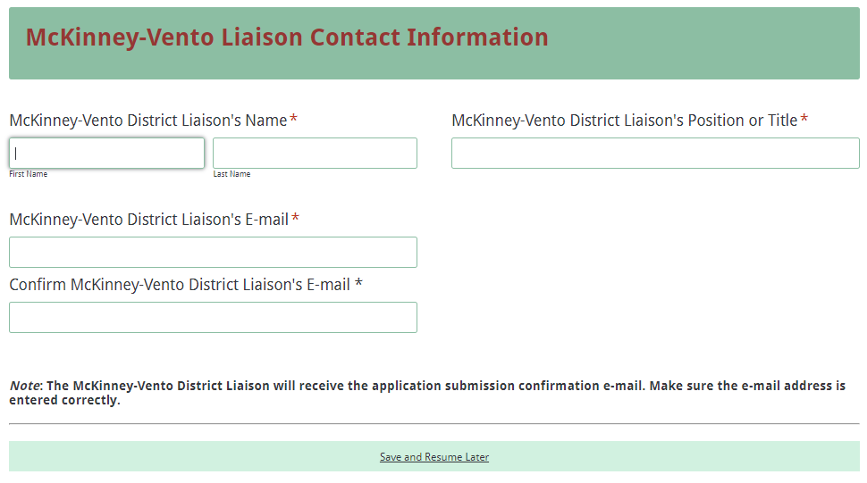

If the liaison will serve as the project coordinator, click on “Same as McKinney-Vento Liaison” and the name, position, and e-mail address fields will automatically populate. If the liaison will not serve as the project coordinator, enter the coordinator’s contact information.
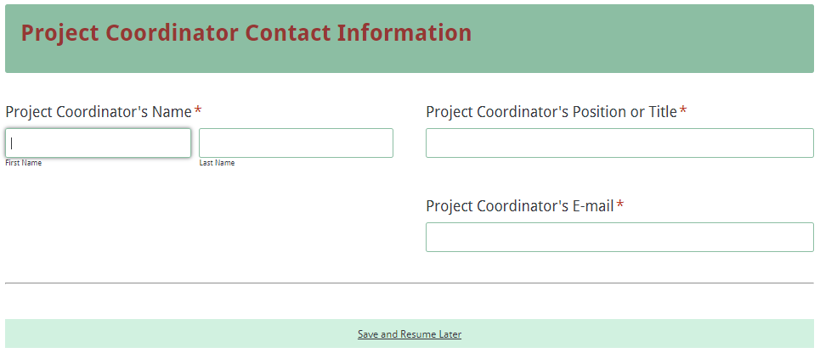

Identify the urgent needs of children and youth experiencing homelessness in the applicant’s district. The identified needs must correlate to the eligible uses of funds.
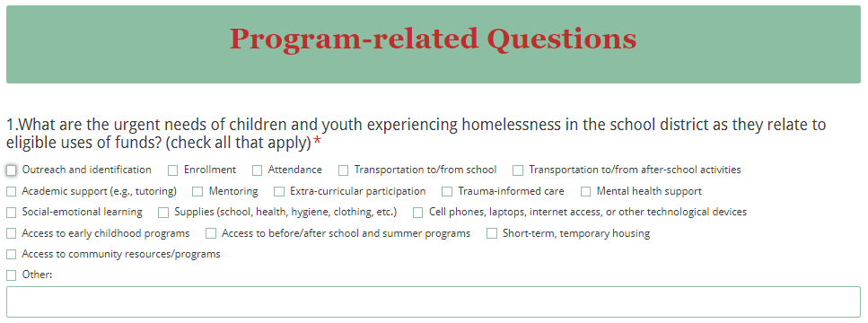

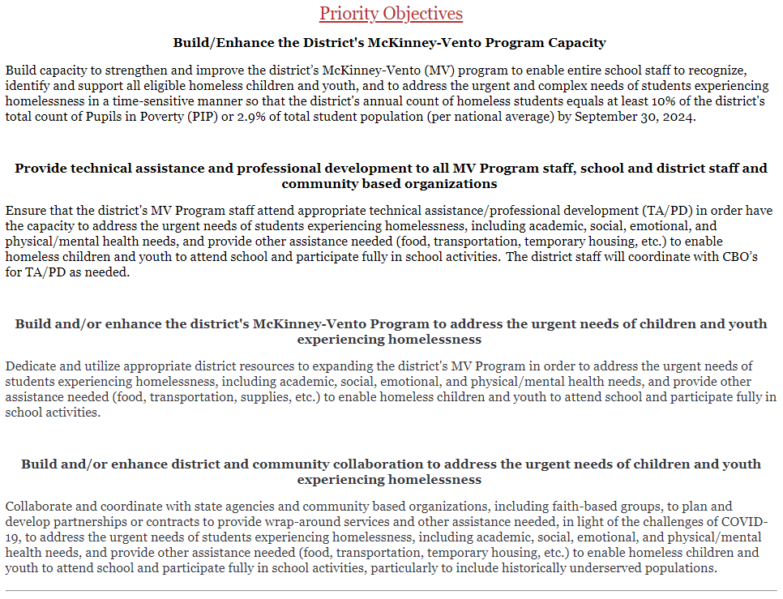

Indicate how the applicant’s district plans to use the funds to build the district’s capacity to identify and support children and youth experiencing homelessness. Check each one that applies to the applicant’s organization, and briefly describe the plan in the spaces provided.
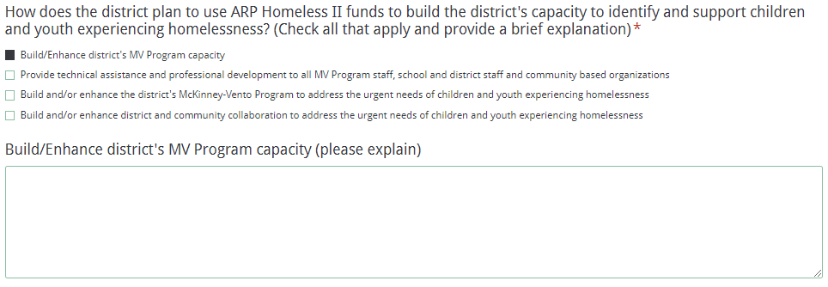

Indicate which historically underserved populations the district plans to include for services. Check all that apply.
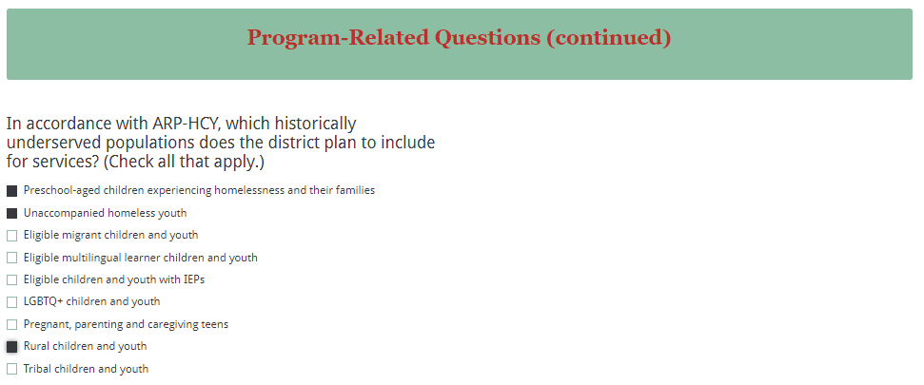

Identify the types of data the district plans to use to evaluate the impact of the ARP Homeless II funds. Then, identify the policies and/or practices currently in place in the applicant’s district relating to youth experiencing homelessness.
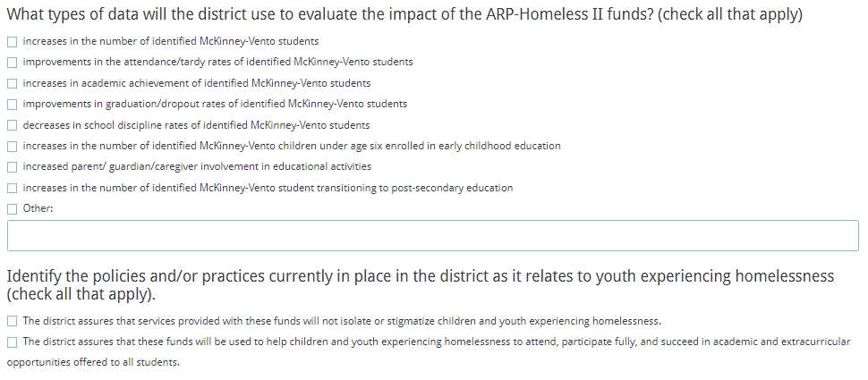

In order to be eligible for funding, the district must check all boxes indicated in the screenshot below to indicate an understanding of all program assurances.
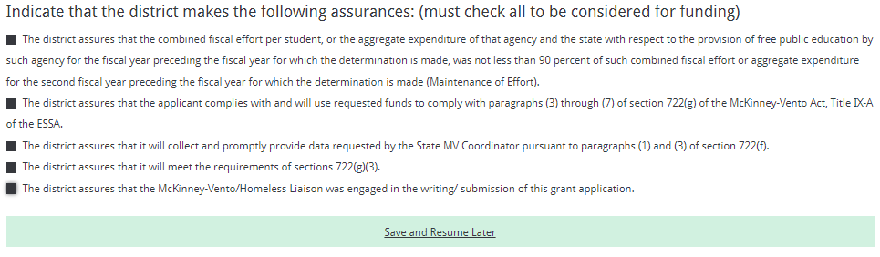

Enter the district’s current indirect cost rate percentage approved by the SCDE. Provide the beginning and ending dates of the effective period of the current indirect cost rate agreement. LEAs may select to use their unrestricted indirect cost rate for the ARP Homeless II funding.
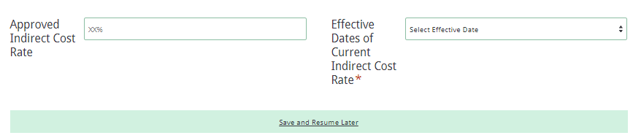
Prepare each of the proposal attachments (i.e. Budget Narrative, and Appendices) following the preceding instructions on pages 13–17. Ensure that each attachment is saved in the proper format as either a PDF or Excel document. Pay close attention to attachments that must be scanned together into a single document. The online application will only allow one document to be uploaded for each attachment.

Upload the attachments as indicated in the following screenshot. All attachments are required; the application cannot be submitted without uploading all five documents.

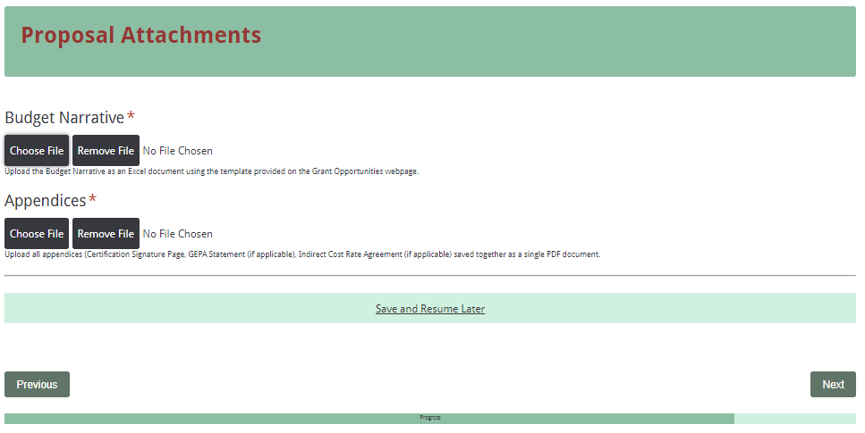

Thoroughly review the summary on the Data Review and Confirmation Page to verify that the information has been entered correctly in the online application prior to submitting. The completed application form cannot be accessed after it has been submitted. If any of the entries are incorrect, click on the "Previous" button at the bottom of each screen to return to the appropriate section(s) and reenter the correct information.

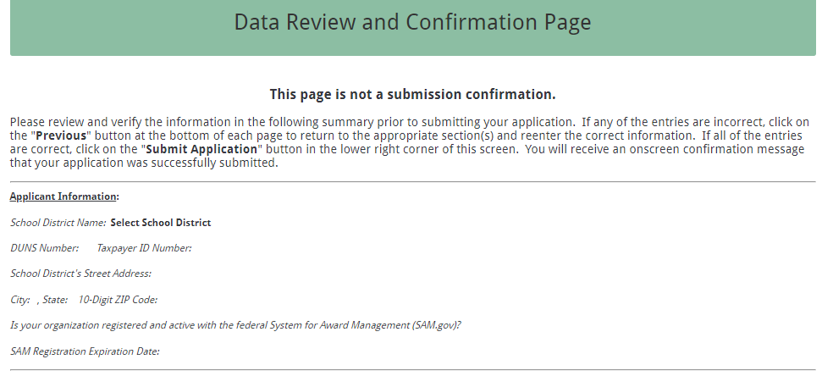

If all the entries are correct, click on the “Submit Application” button in the lower right corner of this screen to complete the submission process.
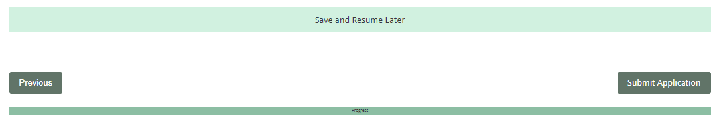
Once the application is submitted, the following message will be displayed on the screen.

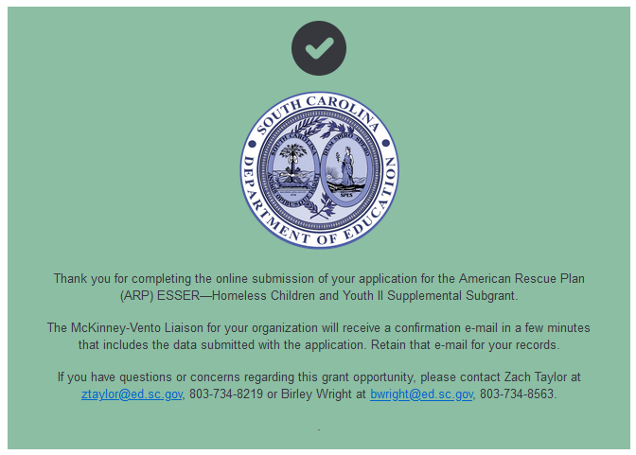
The following confirmation message will be sent to the e-mail address provided for the McKinney-Vento LEA liaison in the online application. If the liaison does not receive a confirmation e-mail, then the application did not successfully upload. If this happens, go back and resubmit the entire online form, including all attachments, in order for the application to be considered for funding. Only the most recently submitted application will be reviewed.
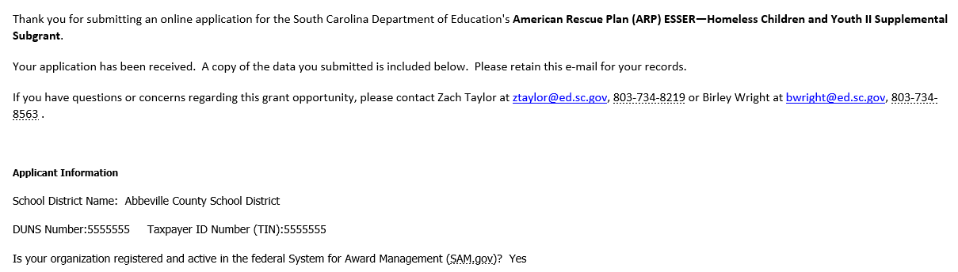

An e-mail confirmation that the subgrant application was successfully submitted does not account for the quality of the uploaded documents or the completeness of the online form. The confirmation e-mail only serves as notification that the online application has been submitted and received. Applicants are responsible for ensuring that the information entered in the online form, including all attachments, is accurate and complete for the application to be reviewed and considered for funding.

Appendix A: Definitions of Terms Used

At-Risk Student—Any student who, because of his or her individual needs, requires temporary or ongoing interventions to achieve in school and to graduate with meaningful options for his or her future.

Collaborative Partner—An organization that provides routine, regular, and ongoing services to the project as outlined in a signed memorandum of agreement (e.g., the regular use of facilities and equipment, mentors/tutors). A collaborative partner plays a critical role in sustaining the project as grant funds decrease.

De-obligation—The downward adjustment of the obligations recorded in a grant award document. It is caused by factors such as (1) termination of part of the project, (2) reduction in material prices, (3) cost savings, or (4) correction of recorded amounts.

Enrolled and enrollment includes attending classes and participating fully in school activities.

Homeless children and youth are defined by the McKinney-Vento Homeless Assistance Act as individuals who lack a fixed, regular, and adequate nighttime residence, including:
- children and youth who are:
  - sharing the housing of other persons due to loss of housing, economic hardship, or a similar reason (sometimes referred to as doubled-up);
  - living in motels, hotels, trailer parks, or camping grounds due to the lack of alternative adequate accommodations;
  - living in emergency or transitional shelters; or
  - abandoned in hospitals;
- children and youth who have a primary nighttime residence that is a public or private place not designed for or ordinarily used as a regular sleeping accommodation for human beings;
- children and youth who are living in cars, parks, public spaces, abandoned buildings, substandard housing, bus or train stations, or similar settings; and
- migratory children who qualify as homeless for the purposes of this subtitle because the children are living in circumstances described above.

Local education agency (LEA) is a public board of education or school district.

Memorandum of Agreement (MOA)—A document signed by the authorized representative(s) of each collaborative partner that clearly specifies the role, services, contributions, expertise, and funding for each partner.

School of origin is the school that the child or youth attended when permanently housed or the school in which the child or youth was last enrolled.

Title I Schools—Schools with a 75% or higher poverty rate must be served; below that threshold, districts have flexibility. A district may choose to serve any school with a rate above 35% or a rate that is higher than the district’s average poverty rate.

Unaccompanied homeless youth include a homeless child or youth not in the physical custody of a parent or guardian.

Appendix B: Required SCDE Forms

Certification Signature Page
(This form must be signed by the individual from each proposed district who holds the title listed below.)

Certification
I hereby certify that, to the best of my knowledge, the information and data contained in this application are true and correct. The applicant’s governing body has duly authorized this application and documentation, and the applicant will comply with the Program Specific Assurances and the SCDE Assurances and Terms and Conditions if the grant is awarded. The applicant is registered and current (active) on the federal System for Award Management (SAM).

Authorized Official (superintendent of school district)
Name:
Position: | Email:
Telephone: | Fax:

Signature of Authorized Official: | Typed name of Authorized Official:
Date Signed:
Signature of Financial Official: | Typed Name of Financial Official:
Date Signed:
Signature of McKinney-Vento Liaison: | Typed Name of McKinney-Vento Liaison:
Date Signed:
Signature of Project Coordinator (if liaison is not project coordinator): | Typed Name of Project Coordinator:
Date Signed:

Please complete, print, and obtain signatures prior to submission. Include the signed, scanned form in the required appendices as indicated on page 16.

Assurances and Terms and Conditions for Federal Subawards

For informational purposes only
The applicant certifies to abide by the SCDE Assurances and Terms and Conditions by signing and submitting the Certification Signature Page.

Assurances

- Has the legal authority to apply for federal assistance and the institutional, managerial, and financial capability (including funds sufficient to pay the nonstate share of project costs) to ensure proper planning, management, and completion of the project described in this application.
- Will give the South Carolina Department of Education (SCDE) access to and the right to examine all records, books, papers, or documents related to this award and will establish a proper accounting system in accordance with generally accepted accounting principles (GAAP) or agency directives.
- Has an accounting system with sufficient internal controls, a clear audit trail, and written cost-allocation procedures as necessary. The financial management systems are capable of distinguishing expenditures that are attributable to this grant from those that are not attributable to this grant. This system is able to identify costs by programmatic year and by budget line item and to differentiate among direct, indirect, and administrative costs. In addition, the applicant will maintain adequate supporting documents for the expenditures (federal and nonfederal) and in-kind contributions, if any, that it makes under this grant. Costs are shown in books or records (e.g., disbursements ledger, journal, payroll register) and are supported by a source document such as a receipt, travel voucher, invoice, bill, or in-kind voucher.
- Will also comply with the Office of Management and Budget 2 CFR Part 200 Subpart E-Cost Principles related to the allowability, reasonableness, and allocability of costs consistent with the approved budget and also by maintaining required support for salaries and wages. Required support includes certifications and/or personnel activity records depending upon the amount of time spent on cost objectives.
- Will approve all expenditures, document receipt of goods and services, and record payments on the applicant’s accounting records prior to submission of reimbursement claims to the SCDE for costs related to this grant.
- Will initiate and complete work within the applicable time frame after receipt of approval by the SCDE.
- Will not discriminate against any employee or applicant for employment because of race, color, religion, age, sex, national origin, or disability and comply with Title VI of the Civil Rights Act of 1964, Section 504 of the Rehabilitation Act of 1973, Title IX of the Education Amendments of 1972, the Age Discrimination Act of 1975, and Titles I, II, and III of the Americans with Disabilities Act of 1990 (ADA). The grantee will take affirmative action to ensure that applicants for employment and the employees during the period of their employment are treated without regard to their race, color, religion, age, sex, national origin, or disability.
- Has no policy that prevents, or otherwise denies, participation in constitutionally protected prayer in public schools as set forth in the Guidance on Constitutionally Protected Prayer in Public Education (20 U.S.C. § 7904).
- Will comply with the Family Educational Rights and Privacy Act. (20 U.S.C. §1232g; 34 CFR Part 99).
- Will comply with the Ethics, Government Accountability, and Campaign Reform Act (S.C. Code Ann. § 2-17-10 et seq. and § 8-13-100 et seq. (Supp. 2021)).
- Will comply with the South Carolina Drug Free Workplace Act (S.C. Code Ann. § 44-107-10 et seq. (Supp. 2021) if the amount of this award is $50,000 or more and the federal Drug Free Workplace Act of 1988 (41 USC 702).
- Will provide information to the SCDE, as requested, regarding the reporting requirements of the Federal Funding Accountability and Transparency Act (FFATA), which requires the SCDE to file a FFATA subaward report by the end of the month following the month in which it awards any subgrant equal to or greater than $25,000.
- Will comply with 2 CFR Part 25 and register and receive a unique entity identifier, fulfill the requirement for the System for Award Management, maintain the currency of the registration throughout the full grant term, and allow access by the granting agency to ensure compliance.
- Will comply with 2 CFR Part 200.112 and disclose in writing any potential conflict of interest to the SCDE.
- Will comply with 2 CFR Part 200.113 and disclose in writing to the SCDE all violations of federal criminal law involving fraud, bribery, or gratuity violations potentially affecting the federal award.
- Will comply with conditions under Executive Order 13513 “Federal Leadership on Reducing Text Messaging While Driving” (October 1, 2009) by refraining from text messaging while driving during official grant business. Relatedly, the applicant will refrain from emailing while driving during official grant business.

Terms and Conditions

- Completeness of Proposal. All proposals should be complete and carefully worded and must contain all of the information requested by the SCDE. If you do not believe a section applies to your proposal, please indicate that fact.
- Non-awards/Termination. The SCDE reserves the right to reject any and all applications and to refuse to grant monies under this solicitation. If the SCDE rejects an application, the applicant has a right to request a hearing, as provided by 2 CFR Part 200.341 and 34 CFR Part 76.401, if it alleges the SCDE’s actions violate a state or federal statute or regulation by (1) disapproving of or failing to approve the application or project, in whole or in part, or (2) failing to provide funds in amounts in accordance with the requirements of statutes and regulations.
After it has been awarded, the SCDE may terminate a grant by giving the grantee written notice of termination. In the event of a termination after award, the SCDE shall reimburse the grantee for allowable expenses incurred up to the notification of termination. In addition, this grant may be terminated by the SCDE if the grantee fails to perform as promised in its proposal. Federal grants will be terminated in accordance with 2 CFR Part 200.339 and 200.340.
In the event that this grant is terminated, the grantee shall have a right to a hearing as set forth in 34 CFR Part 76.783. The grantee must notify the SCDE of its request for a hearing within 30 days of receiving written notice of the termination. If a hearing is requested, the SCDE will conduct the hearing in accordance with the procedures outlined in 34 CFR Part 76.401(d)(2)–(7).
- Reduction in Budgets and Negotiations. The SCDE reserves the right to negotiate budgets with applicants. The SCDE may, at its sole discretion, determine that a proposed budget is excessive and may negotiate a lower budget with the applicant. The applicant may at that time negotiate or withdraw its proposal. In addition, the SCDE may desire to fund a project but not at the level proposed. In that case, the SCDE shall notify the applicant of the amount that can be funded, and the applicant and the SCDE shall negotiate a modification to the proposal to accommodate the lower budget. All final decisions are that of the SCDE.
- Amendments to Grants. Amendments are permitted generally for budgets, grant end date, and management upon the mutual agreement of the parties involved and will become effective when specified in writing and signed by both parties. However, amendments to scope of work that significantly alter the original application proposal may trigger partial or full termination consistent with 2 CFR Part 200.339 and 200.340.
- Use of Grant Funds. Funds awarded are to be expended only for purposes and activities covered by the approved project plan and approved budget and budget narrative.
- Submission of Expenditure Reports. Claims for reimbursement must be made at least quarterly and consistent with calendar quarters (e.g., an expenditure report claim for costs for January 1 through March 30 must be filed by May 15).
- Obligation of Grant Funds. Grant funds may not be obligated prior to the effective date or subsequent to the end or termination date of the grant period. No obligations are allowed after the end of the grant period. The final request for expenditure report claims must be submitted no later than forty-five (45) days after the end of the grant period unless the scope of work for the grant states a shorter reporting period.
- Deobligation of Funds. After a final expenditure report claim has been submitted to the SCDE, the grantee will go through the official deobligation process with the SCDE.
- Documentation. The grantee must provide for accurate and timely recording of receipts and expenditures. The grantee’s accounting system should distinguish receipts and expenditures attributable to each grant. The grantee must review the memo regarding “Guidelines for Retaining Documentation to Support Expenditure Claims.”
- Travel Costs. Travel costs, if allowed under this solicitation, must not exceed limits noted in the United States General Services Administration (GSA) per diem rates for lodging, except in the case of conference lodging required for program-required training. In the case that conference-related lodging exceeds the GSA per diem rate, the grantee shall follow their entity’s written procedure for obtaining prior approval to exceed a GSA rate for a conference hotel. Meals and incidentals are limited by the state budget proviso, currently not to exceed $35 per day for in-state travel and $50 for out-of-state travel (see page 86 of the State of South Carolina Statewide Disbursement Regulations). Mileage reimbursement must follow the current Office of Comptroller General instructions, which is consistent with the published IRS rates.
- Honoraria. Amounts paid in honoraria, if allowed under this grant, must be consistent with SCDE policies. Applicants should check with the program office before budgeting for honoraria.
- Reports. The grantee shall submit, as required or instructed by the awarding program office, all reports (programmatic, financial, or evaluation) within the specified period or date and in the prescribed format. An expenditure claim report must be filed by August 15 for all expenditures incurred by June 30 in order to comply with the generally accepted accounting principles (GAAP) and the production of the State's Comprehensive Annual Financial Report.
- Copyright. The grantee is free to copyright any books, publications, or other copyrightable materials developed in the course of this grant. However, the SCDE reserves a royalty-free, nonexclusive, and irrevocable license to reproduce, publish, or otherwise use, and to authorize others to use, the copyrighted work developed under this grant.
- Certification Regarding Lobbying, Suspension, and Debarment. By submitting an application, the applicant certifies, to the best of its knowledge and belief, that the
- Applicant and/or any of its principals, subgrantees, or subcontractors
  - Have not paid or will not pay to any person any federally appropriated funds for the purpose of influencing or attempting to influence an officer or employee of any agency, a Member of Congress, an officer or employee of Congress, or any employee of a Member of Congress in connection with making any federal grant and the extension continuation, renewal, amendment, or modification of any federal grant, as defined at 34 CFR Part 82.105 and 82.110. If any funds other than federally appropriated funds have been paid or will be paid to any person for influencing or attempting to influence an officer or employee of any agency, a Member of Congress, an officer or employee of Congress, or any employee of a Member of Congress in connection with this federal grant, the undersigned shall complete and submit Standard Form LLL, “Disclosure of Lobbying Activities,” in accordance with its instructions.
  - Are not presently debarred, suspended, proposed for debarment, or declared ineligible for the award of contracts by any state or federal agency as stated at 2 CFR Part 180 or 2 CFR Part 3485.
  - Have not, within a three-year period preceding this application, been convicted of or had a civil judgment rendered against them for commission of fraud or a criminal offense in connection with obtaining, attempting to obtain, or performing a public (federal, state, or local) contract or subcontract; violated federal or state antitrust statutes relating to the submission of offers; or committed embezzlement, theft, forgery, bribery, falsification or destruction of records, making false statements, tax evasion, or receiving stolen property.
  - Are not presently indicted for, or otherwise criminally or civilly charged by a governmental entity with, commission of any of the offenses enumerated above.
- Applicant has not, within a three-year period preceding this application, had one or more contracts terminated for default by any public (federal, state, or local) entity.
- Audits.
- Entities expending $750,000 or more in federal awards:
Entities that expend $750,000 or more in federal awards during the fiscal year are required to have an audit performed in accordance with the provisions of 2 CFR Part 200.501, et seq. Except for the provisions for biennial audits provided in 2 CFR Part 200.504 (a) and (b), audits must be performed annually as stated at 2 CFR Part 200.504. A grantee that passes through funds to subrecipients has the responsibility of ensuring that federal awards are used for authorized purposes in compliance with federal program laws, federal and state regulations, and grant agreements. The director of the OMB, who will review this amount every two years, has the option of revising the threshold upward.
- Entities expending less than $750,000 in federal awards:
Entities that expend less than $750,000 in a fiscal year in federal awards are exempt from the audit requirements in 2 CFR Part 200.504. However, such entities are not exempt from other federal requirements (including those to maintain records) concerning federal awards provided to the entity. The entity’s records must be available for review or audit by the SCDE and appropriate officials of federal agencies, pass-through entities, and the General Accounting Office (GAO).
- Records. The grantee shall retain federal grant records, including financial records and supporting documentation, for a minimum of six (6) years after the end date of the grant when the final expenditure report claim for reimbursement and all final reports have been submitted, unless informed otherwise or in the case of litigation.
- Electronic Signature Agreement. I agree that my electronic signature is the legally binding equivalent to my handwritten signature.

Program-Specific Assurances

I certify that this applicant will abide by the following stipulations in federal law regarding the education of homeless children and youth:

- The LEA assures that services provided with these funds will not isolate or stigmatize children and youth experiencing homelessness.
- The LEA assures that these funds will be used to help children and youth experiencing homelessness to attend, participate fully, and succeed in academic and extracurricular opportunities offered to all students.
- The LEA assures that services provided with these funds will supplement, expand, improve upon, or provide access to existing services provided as part of a school's academic or extracurricular program, but not replace such services.
- The LEA assures that the combined fiscal effort per student, or the aggregate expenditure of that agency and the state with respect to the provision of free public education by such agency for the fiscal year preceding the fiscal year for which the determination is made, was not less than 90 percent of such combined fiscal effort or aggregate expenditure for the second fiscal year preceding the fiscal year for which the determination is made (Maintenance of Effort).
- The LEA assures that the applicant complies with and will use requested funds to comply with paragraphs (3) through (7) of section 722(g) of the McKinney-Vento Act, Title IX-A of the ESSA.
- The LEA assures that it will collect and promptly provide data requested by the State MV Coordinator pursuant to paragraphs (1) and (3) of section 722(f).
- The LEA assures that it will meet the requirements of sections 722(g)(3).
- The LEA assures that the McKinney-Vento/Homeless Liaison was engaged in the writing/ submission of this grant application.

Instructions for GEPA Statement of Compliance
OMB Control No. 1894-0005 (Exp. 06/30/2023)

NOTICE TO ALL APPLICANTS
The purpose of this enclosure is to inform you about the following provision in the Department of Education's General Education Provisions Act (GEPA) that applies to applicants for new grant awards under Department programs. This provision is Section 427 of GEPA, enacted as part of the Improving America's Schools Act of 1994 (Public Law (P.L.) 103-382).
To Whom Does This Provision Apply?
Section 427 of GEPA affects applicants for new subgrant awards under this program. ALL APPLICANTS FOR NEW AWARDS MUST INCLUDE INFORMATION IN THEIR APPLICATIONS TO ADDRESS THIS NEW PROVISION IN ORDER TO RECEIVE FUNDING UNDER THIS PROGRAM.
What Does This Provision Require?
Section 427 requires each applicant for funds (other than an individual person) to include in its application a description of the steps the applicant proposes to take to ensure equitable access to, and participation in, its federally-assisted program for students, teachers, and other program beneficiaries with special needs. This provision allows applicants discretion in developing the required description. The statute highlights six types of barriers that can impede equitable access or participation: gender, race, national origin, color, disability, or age. Based on local circumstances, you should determine whether these or other barriers may prevent your students, teachers, etc. from such access or participation in the federally-funded project or activity. The description in your application of steps to be taken to overcome these barriers need not be lengthy; you may provide a clear and succinct description of how you plan to address those barriers that are applicable to your circumstances. In addition, the information may be provided in a single narrative, or, if appropriate, may be discussed in connection with related topics in the application.

Section 427 is not intended to duplicate the requirements of civil rights statutes, but rather to ensure that, in designing their projects, applicants for federal funds address equity concerns that may affect the ability of certain potential beneficiaries to fully participate in the project and to achieve to high standards. Consistent with program requirements and its approved application, an applicant may use the federal funds awarded to it to eliminate barriers it identifies.
What are Examples of How an Applicant Might Satisfy the Requirement of This Provision?
The following examples may help illustrate how an applicant may comply with Section 427.
- An applicant that proposes to carry out an adult literacy project serving, among others, adults with limited English proficiency might describe in its application how it intends to distribute a brochure about the proposed project to such potential participants in their native language.
- An applicant that proposes to develop instructional materials for classroom use might describe how it will make the materials available on audio tape or in braille for students who are blind.
- An applicant that proposes to carry out a model science program for secondary students and is concerned that girls may be less likely than boys to enroll in the course, might indicate how it intends to conduct "outreach" efforts to girls to encourage their enrollment.
- An applicant that proposes a project to increase school safety might describe the special efforts it will take to address concern of lesbian, gay, bisexual, and transgender students, and efforts to reach out to and involve the families of LGBT students.
We recognize that many applicants may already be implementing effective steps to ensure equity of access and participation in their grant programs, and we appreciate your cooperation in responding to the requirements of this provision.
Estimated Burden Statement for GEPA Requirements
According to the Paperwork Reduction Act of 1995, no persons are required to respond to a collection of information unless such collection displays a valid OMB control number. Public reporting burden for this collection of information is estimated to average 1.5 hours per response, including time for reviewing instructions, searching existing data sources, gathering and maintaining the data needed, and completing and reviewing the collection of information. The obligation to respond to this collection is required to obtain or retain benefit (Public Law 103-382. Send comments regarding the burden estimate or any other aspect of this collection of information, including suggestions for reducing this burden, to the U.S. Department of Education, 400 Maryland Ave., SW, Washington, DC 20210-4537 or email ICDocketMgr@ed.gov and reference the OMB Control Number 18

ARP Homeless II District Allocations

LEAs | ARP Homeless II Allocation
Abbeville | $33,816.19
Aiken | $286,347.46
Allendale | $27,261.23
Anderson 1 | $178,432.33
Anderson 2 | $48,944.89
Anderson 3 | $63,685.28
Anderson 4 | $48,492.01
Anderson 5 | $176,249.82
Bamberg 1 | $12,104.03
Bamberg 2 | $10,034.31
Barnwell 19 | $10,128.60
Barnwell 29 | $16,430.41
Barnwell 45 | $21,199.88
Beaufort | $244,067.78
Berkeley | $289,682.42
Calhoun | $28,222.30
Charleston | $490,595.19
Charter Institute at Erskine | $108,440.80
Cherokee | $69,320.61
Chester | $45,916.27
Chesterfield | $65,978.55
Clarendon 2 | $33,981.86
Clarendon 4 | $19,388.24
Colleton | $90,499.01
Darlington | $134,857.63
Dillon 3 | $18,791.27
Dillon 4 | $74,095.46
Dorchester 2 | $123,456.30
Dorchester 4 | $26,174.42
Edgefield | $28,614.26
Fairfield | $70,127.20
Florence 1 | $203,186.23
Florence 2 | $9,846.23
Florence 3 | $42,852.67
Florence 4 | $12,389.18
Florence 5 | $10,353.83
Georgetown | $89,110.50
Greenville | $829,428.79
Greenwood 50 | $193,218.20
Greenwood 51 | $16,259.04
Greenwood 52 | $10,570.42
Hampton | $75,305.92
Horry | $499,545.94
Jasper | $77,527.00
Kershaw | $56,012.91
Lancaster | $77,683.23
Laurens 55 | $85,378.52
Laurens 56 | $48,779.84
Lee | $52,777.78
Lexington 1 | $124,896.58
Lexington 2 | $98,383.37
Lexington 3 | $18,304.63
Lexington 4 | $34,880.97
Lexington 5 | $121,124.77
Marion 10 | $104,943.64
Marlboro | $65,034.01
McCormick | $11,786.97
Newberry | $47,617.12
Oconee | $70,700.05
Orangeburg | $149,187.75
Pickens | $688,376.42
Richland 1 | $386,947.18
Richland 2 | $286,103.60
Saluda | $19,606.07
SC Public Charter District | $141,006.46
Spartanburg 6 | $121,087.33
Spartanburg 1 | $25,961.20
Spartanburg 2 | $53,494.71
Spartanburg 3 | $185,110.21
Spartanburg 4 | $12,847.22
Spartanburg 5 | $29,753.33
Spartanburg 7 | $165,038.02
Sumter | $183,259.99
Union | $36,092.96
Williamsburg | $70,523.23
York 01 | $47,203.35
York 2 (York) | $29,193.78
York 3 (Clover) | $141,383.84
York 4 (Rock Hill) | $31,912.97

Budget Narrative Template

Use the budget format file that accompanies this funding opportunity announcement at the SCDE’s Grant Opportunities webpage to develop the required Budget Narrative. The screenshot below is for informational purposes only.

