Request for Proposals (RFP)
Application Package

2023 African American History Instructional Materials Discretionary Grant–Round Two

The African American History Instructional Materials Grant is a grant program funded by the South Carolina General Assembly, authorized by the General Appropriations Act, Proviso 1A.2, and administered by the South Carolina Department of Education.

Deadline for Receipt of Applications: 4:00 p.m., January 19, 2023

Technical Assistance for Applicants: 3:30 p.m., December 14, 2022

For questions about the African American History Instructional Materials contact:
Stephen Corsini
Social Studies Education Associate
803-734-8335
spcorsini@ed.sc.gov

Issued by:
South Carolina Department of Education (SCDE)
Office of Assessment and Standards
1429 Senate Street, Suite 611-C
Columbia, SC 29201

TABLE OF CONTENTS

PART I: General Information 1
A. Introduction and Purpose 1
B. Eligible Applicants 2
C. Timeline of Granting Process 2
D. Technical Assistance Sessions for Applicants 2
E. Statutory and State Requirements 2
F. Authorized Activities 3
G. Unauthorized Activities 4
H. Program Accountability and Monitoring 4
I. Fiscal Operations 8
J. Supplement, Not Supplant 8
K. Review and Selection Process 8
L. Appeals Process 9

PART II: Application Overview, Content, and Instructions 10
A. Application Overview 10
B. Application Narrative Format 10
C. Online Application Submission 11
D. Application Narrative Content 11
1. Project Summary 11
2. Strategies and Activities 12
3. Management and Sustainability 13
4. Evaluation of Project Outcomes 13
E. Application Budget 14
F. Pre-Award Audit Questionnaire 15
G. Appendices 16
H. Deadline and Submission Procedures 17
I. Screenshots of Online Application Submission Forms 17

Appendix A: Selection Criteria and Reviewers’ Scoring Rubric 22

Appendix B: Required SCDE Forms 29
Certification Signature Page 29
Assurances and Terms and Conditions for State Awards 30
Historic Site Visit Action Plan Form 34
SCDE Pre-Award Audit Questionnaire 35
SCDE Office of Standards and Learning Unit Template 36

PART I: General Information

Introduction and Purpose

The South Carolina General Assembly has authorized funds allocated to the South Carolina Department of Education (SCDE) through legislative proviso 1A.2 (SDE-EIA: African American History) to be used for the development of additional instructional materials for African American History curricula.

The SCDE will award grant funds to nonprofit organizations, school districts, or institutions of higher education for the development of new instructional materials aligned to the 2019 South Carolina Social Studies College- and Career-Ready Standards (2019 Standards) via one of the following approaches listed below (see pages 12–13 for details):
- Develop and host a new or recurring African American Historic Sites Professional Learning Opportunity (PLO) for K-12 teachers that includes professional learning at prominent historic sites in South Carolina as it applies to any K-12 standards. The PLO then uses the provided template to guide teachers in the development of a minimum of ten (10) inquiry-based instructional lessons with supporting materials (Instructional Materials) that connect the sites with identified course standards and provide options to assess student learning; or
- Develop and host an African American Instructional Materials Professional Learning Opportunity (PLO) for K-12 teachers that provides professional learning about South Carolina African American history as it applies to any K-12 standards. The PLO then uses the provided template to guide teachers in the development of a minimum of ten (10) inquiry-based instructional lessons with supporting materials that connect the content from the professional learning with identified course standards and provide options to assess student learning.

All Instructional Materials must be original creations and cannot be copied or plagiarized from existing ones. Any additional resources must be properly cited. Applicants must submit a separate application for each approach. Applicants may submit proposals to extend existing work created as previous award recipients.

Approximately $200,000 will be available for new grants in this 2023 funding cycle. The SCDE anticipates awarding up to $75,000 for one African American Historic Sites PLO proposal and several awards up to $10,000 for the Instructional Lessons PLO proposals. Award amounts will be determined based on the quality of applications received and total funding requested. All grant awards are contingent upon total allocations to the SCDE by the South Carolina General Assembly.

This 2023 grant project period is February 9, 2023, through June 23, 2023, and is subject to the availability of state funds and projects meeting all African American History Instructional Materials Grant program requirements.

The grantee may obligate funds upon receipt of the grant award notice. However, no expenditures will be reimbursed until after successful completion and verification of the first benchmark on March 10, 2023. Grant payments are made on a cost-reimbursement basis so applicants should have at least three months of operating funds at their disposal to implement the program to accommodate any delays in receiving reimbursement payments.

Eligible Applicants

Eligible applicants are nonprofit organizations, school districts, and institutions of higher education that are capable of developing an African American Historic Sites PLO or an Instructional Lessons PLO for teachers aligned to the 2019 Standards emphasizing South Carolina African American history and the contributions of African Americans to the Palmetto State. Applicants must maintain an active Unique Entity Identifier (UEI) and publicly accessible registration in SAM.gov.

Timeline of Granting Process

Date | Activity/Action
December 14, 2022 | Technical assistance session
January 19, 2023 | Deadline for receipt of application for Round Two
February 2023 | Notification of awards for Round Two
February 9, 2023 | Project period begins; projects can begin
February 23, 2023 | Post-Award Technical Assistance Session
March, 2 2023 | Benchmark 1 report due to the SCDE
March 12, 2023 | Historic Sites Experiences may begin
April 14, 2023 | Benchmark 2 report due to the SCDE
June 23, 2023 | Funding period ends; projects must end
July 5, 2023 | Final expenditure report due to the SCDE
July 20, 2023 | Final programmatic report and instructional materials due to the SCDE

Technical Assistance Sessions for Applicants

The SCDE’s Office of Assessment and Standards will offer a technical assistance webinar via Adobe Connect on December 14, 2022, from 3:30 p.m. – 5:00 p.m. to assist eligible applicants in understanding this RFP and how to apply for this grant. No password is required to join the session. Participants should enter their full names when logging in. Participants will be able to log in 30 minutes prior to the start time to test their audio settings and download/print handouts. While participation is not mandatory to apply, it is highly recommended. The webinar will be recorded.

Statutory and State Requirements

Both programmatic and fiscal reporting is required as stated in the Reporting Requirements tables (see pages 5–7). The grantee is responsible for ensuring that all reports are accurate, complete, and submitted on time. Achievement of grant goals and objectives will be monitored throughout the reporting process. Failure to meet deadlines may result in a loss of funding and may eliminate the applicant from consideration for future funding.

Universal Entity Identifier (UEI) and System of Award Management—2 CFR Part 25
All grant applicants must obtain a UEI and maintain a registration in the federal System for Award Management (SAM). On April 4, 2022, the federal government stopped using the DUNS Number to uniquely identify entities. Now, entities doing business with the federal government use the UEI created in SAM.gov. They no longer have to go to a third-party website to obtain their identifier. This transition allows the government to streamline the entity identification and validation process, making it easier and less burdensome for entities to do business with the federal government.

Applicants must be registered in the SAM prior to submitting an application and maintain their SAM registration throughout the application and award process to comply with 2 CFR Part 25. The application must include the UEI in the online subgrant application. Contact your finance office for assistance with your entity’s UEI. Please note that the SCDE will not make an award to an applicant until the applicant has complied with the requirements to provide a valid UEI and maintain an active SAM registration with current information.

Applicants should review the Assurances and Terms and Conditions for State Awards on pages 30–32 to ensure that if awarded a grant, they are capable of full compliance with all the referenced regulations and state laws in order to enter into an agreement with the SCDE for this program. Pursuant to S.C. Code Ann. §8-13-700 (Supp. 2021) the applicant must disclose any potential conflict of interest to the SCDE in accordance with the SC Ethics Reform Act conflict of interest policy. A signed Certification Signature Page (see page 29) is required with the grant application and legally binds the applicant to the agency’s Assurances and Terms and Conditions for State Awards.

Authorized Activities

All projects must align to the 2019 Standards. The applicant must propose to develop new inquiry-based instructional materials using one of the following approaches:

- Develop and host a new or recurring African American Historic Sites Professional Learning Opportunity (PLO) for K-12 teachers that includes professional learning at prominent historic sites in South Carolina as it applies to any K-12 standards. The PLO then uses the provided template to guide teachers in the development of a minimum of ten (10) inquiry-based instructional lessons with supporting materials (Instructional Materials) that connect the sites with identified course standards and provide options to assess student learning; or
- Develop and host an African American Instructional Materials Professional Learning Opportunity (PLO) for K-12 teachers that provides professional learning about South Carolina African American history as it applies to any K-12 standards. The PLO then uses the provide template to guide teachers in the development of a minimum of ten (10) inquiry-based instructional lessons with supporting materials that connect the content from the professional learning with identified course standards and provide options to assess student learning.

Instructional Materials developed for the African American Historic Sites PLO must reference information acquired from the site visit. External resources may also be included.

All Instructional Materials must also connect to a theme or Key Concept within the course and include opportunities for students to use the skills as identified in the standards. All Instructional Materials must include clear guidance for teachers to monitor and assess student learning.

For all proposed projects, applicants must clearly articulate the process for determining alignment with the standards, the rationale for the standard(s) chosen, and the process used to select participants. Applicants must clearly explain how the proposal is unique, or not easily available, and would facilitate instruction to reach the depth of the standards.

All proposed Instructional Materials must utilize the lesson template found on the Grants Opportunity Webpage. All Instructional Materials must be made accessible to individuals with disabilities. The grant awardee is responsible for working with the Office of Assessment and Standards to ensure all created materials are uploaded to the Instruction Hub. Details on this procedure will be provided to grantees in the Post-award Technical Assistance Session.

Grants must be used in accordance with statutory and regulatory requirements. Grant funds may be used to provide participant stipends, cover the cost of all materials, and salaries. For the Historic Sites PLO, lodging, mileage reimbursement, and meal per diem at the government rate is acceptable.

Unauthorized Activities

Grant funds must not be used for graduate-level courses, professional memberships, or indirect costs. Out-of-state travel must be justified and requires prior approval by the SCDE’s Office of Assessment and Standards.

Program Accountability and Monitoring

The SCDE is responsible for monitoring grantee development of Instructional Materials for African American History curricula in accordance with the following program accountability requirements:
- Each recipient receiving funds meets the eligibility requirements for the grant described herein, and the applicant has provided all required assurances that it will comply with all program implementation and reporting requirements established through this RFP.
- Each recipient receiving funds appropriately uses these funds as described in this RFP.
- Each recipient implements activities funded through this application within the timeline in which the funds provided are to be used.

The SCDE will conduct a pre-award risk assessment of potential grantees before a grant award is issued. As part of the application requirements, applicants must submit a completed Pre-Award Audit Questionnaire (see page 35). Applicants may be subjected to an evaluation of their financial system, internal controls, and policies and procedures by the SCDE’s Office of Auditing Services.

Applicants awarded grant funds must satisfy periodic reporting and accountability requirements throughout the term of the grant. These requirements address: (1) program accountability; (2) performance reporting; (3) annual budget; (4) monitoring; (5) program evaluation; and (6) technical assistance.

    - Program Accountability
Each grantee is responsible for carrying out its responsibilities in accordance with proviso 1A.2 (SDE-EIA: African American History); all applicable statutes, regulations, and programmatic guidance; and its approved grant application and work plan. Grantees are also required to submit periodic reports to the SCDE specifying the use of grant funds and the progress of the instructional units being developed.

    - Performance Reporting
Performance reporting requirements include those for both programmatic reporting and fiscal reporting. The grantee is responsible for ensuring that all required performance reports are accurate, complete, and submitted on time.

Programmatic Reporting Requirements
Progress toward achieving grant goals and objectives will be monitored through the benchmark and final performance reports. The Benchmark 1 report is due no later than March 2, 2023, and the Benchmark 2 report is due by April 14, 2023. A final programmatic report must be submitted to the SCDE no later than July 20, 2023. Programmatic reporting will be submitted via an online form. Details to be provided to grantees in post-award technical assistance (PATA).

Programmatic reporting tables indicate the requirements per approach. Requirements are to be reported in the period the activity occurred:

Table 1: African American Historic Sites PLO Reporting Deadlines
Benchmark #1 – Deadline March 2, 2023
Evidence of progress towards completion:
- Narrative detailing progress towards arranging site visits;
- Narrative explaining how grantee will provide professional learning to participants at each visited site;
- Revised Historic Site Visit Action Plan Forms (if applicable);
- Draft of participant application and explanation of application process;
- Record of expenditures; and
- Other evidence as required by the SCDE.
Benchmark #2 – Deadline April 14, 2023
- List of participants chosen through the application process;
- Finalized travel itinerary including deposits/confirmations, locations, and dates;
- Revised Historic Site Visit Action Plan Forms (if applicable);
- Narrative detailing progress towards the development of inquiry-based instructional lessons with supporting materials;
- Metric used to determine the quality and historical accuracy of the inquiry-based instructional lessons with supporting materials;
- Record of expenditures;
- Draft of Participant Evaluation Survey; and
- Other evidence as required by the SCDE.
Final Reporting Deadlines
- Final record of expenditures―July 5, 2023
- Final programmatic report―July 20, 2023
- Inquiry-based instructional lessons with supporting materials ―July 20, 2023
  - Completed Instructional Materials aligned to grade level standards in PDF (Portable Document Format) format accessible to individuals with disabilities. The grant awardee is responsible for collecting these from individual teachers and submitting them via the online link provided by SCDE and following the procedures shared during the PATA session for preparation for the Instruction Hub.
  - Upon SCDE review of the Instructional Materials, the grant awardee is responsible for making any necessary revisions and understands units will not be published if revisions are not made.
  - Participant Evaluation Survey results.
Table 2: African American Instructional Materials PLO Reporting Deadlines
Benchmark #1 – Deadline March 2, 2023
- Narrative detailing progress towards the development of Instructional Materials;
- Narrative explaining how grantee will provide professional learning to participants;
- Draft of participant application and application process;
- Record of expenditures; and
- Other evidence as required by the SCDE.
Benchmark #2 – Deadline April 14, 2023
- List of participants chosen through the application process;
- Metric used to determine the quality and historical accuracy of the Instructional Materials;
- One-page narrative detailing status of Instructional Materials progress towards completion;
- Record of expenditures;
- Draft of Participant Evaluation Survey; and
- Other evidence as required by the SCDE.
Deadline for Final Products and Report
- Final record of expenditures―July 5, 2023
- Final programmatic report―July 20, 2023
- Inquiry-based instructional lessons with supporting materials – July 20,2023
  - Completed Instructional Materials aligned to grade level standards in PDF format accessible to individuals with disabilities. The grant awardee is responsible for collecting these from individual teachers and submitting them via the online link provided by SCDE and following the procedures shared during the PATA session for preparation for the Instruction Hub.
  - Upon SCDE review of the Instructional Materials the grant awardee is responsible for making any necessary revisions and understands units will not be published if revisions are not made.
  - Participant Evaluation Survey results.

Fiscal Reporting Requirements
All expenditure reports must be submitted through the SCDE’s grants accounting processing system (GAPS). GAPS training will be provided to grantees during the grantee post-award meeting. Submission of expenditure reports will be accepted monthly but, at a minimum, must meet reporting deadlines in the applicable table on pages 5–7.

    - Project Budget
A project budget of projected expenditures to be funded by the grant must be submitted with the application. Approved budgets must be uploaded into GAPS by grantees after the receipt of the grant award notification and prior to submitting reimbursement requests.

    - Monitoring
The SCDE will monitor grantees by reviewing and approving the benchmark reports and final performance reports. All information in reports is subject to verification.
The SCDE may conduct programmatic and financial monitoring site visits. Grantees must agree to site visits conducted by the SCDE. The purpose of site visits is to validate information provided in fiscal and program reports and to gather more detailed information on implementation efforts and challenges from interviews and observations for monitoring and evaluation purposes.

The SCDE may require additional information from the grantee, verify information with the authorizing agency, or require the submission of additional documentation including, but not limited to, invoices, receipts, and personnel time and effort reports. Prior to a site visit, the grantee may be required to submit additional relevant information that will allow the SCDE to conduct a useful, efficient, and effective visit. The SCDE may require electronic submission of documents instead of a paper-copy submission.

SCDE staff will verify the contents of documentation submitted. Grantees may be asked to revise reports when
- non-allowable expenses are found;
- reports are confusing or difficult to understand; or
- there are unexplained discrepancies between the proposed use of grant funds, as provided in the annual budget, and actual expenditures found in the submitted documentation; or
- Instructional materials proposed are unclear.

    - Program Evaluation
Progress toward meeting project goals will be evaluated through the benchmark reports detailed in Tables 1-3 on pages 5–7.

A final programmatic report must be submitted by July 20, 2023. The report must include project success toward goals stated in the application. If a grantee fails to submit the final programmatic report in a timely manner, or if any of the performance requirements in section H.2 (see pages 5–7) are not completed, the SCDE may consider the grantee a high risk and elect to disqualify the grantee from future funding opportunities.

    - Technical Assistance to Grantees
Grantees are required to participate in any technical assistance that the SCDE may conduct related to completing and filing reports or other requirements of the African American History Instructional Materials Project grant. Delivery of such technical assistance may include in-person meetings, webinars, and conference calls.

Fiscal Operations

Grantees must use grant funds for allowable grant expenditures during the grant period only. African American History Instructional Materials grant funds are disbursed upon verification of attainment of required benchmarks and approval of reimbursement requests submitted via GAPS. The SCDE will de-obligate any unspent funds remaining at the end of the grant period for reallocation to other grantees for purposes allowed under the authorizing legislation.

Matching or in-kind funds are not required; however, matching and in-kind funds are an indicator of potential long-term sustainability of an African American History program.

Allowable Costs
Grants must be used in accordance with statutory and regulatory requirements. Grant funds may be used to provide participant stipends, cover all materials costs, and salaries. For the multi-day experience, lodging, travel, and meal per diem at the government rate is acceptable.

Unallowable Costs
Grantees may not use African American History Instructional Materials grant funds for any costs that provide for any unauthorized activities described in Section G (see page 4), or for activities designed to promote itself or its programs to parents or the community. African American History Instructional Materials grant funds may not be used for new construction or purchases that do not directly support the approved work plan.

Supplement, Not Supplant

African American History Instructional Materials grant funds must supplement, not supplant, existing services and may not be used to supplant federal, state, local, or non-federal funds. Projects may not use grant funds to pay for existing levels of services funded from any other sources.

Review and Selection Process

Only those grant applications that are received by the deadline and deemed complete will be forwarded for review and funding consideration. All required materials, including forms and appendices, must be submitted for the application to be considered complete and eligible for review. Program staff will conduct an initial review of applications for completeness and compliance with the RFP instructions. Incomplete applications will not be reviewed or considered for funding.

Applications are reviewed by a diverse panel of experienced grant readers from various professions and entities with no vested interest in any applicant or proposal. Each application will be evaluated based on the quality of the proposed activities and the capability of the applicant to implement the proposed project.

Applications will be reviewed using the scoring rubric on pages 22-28. After the reviewers have individually rated each application, the scores will be calculated and ranked by average score. Upon meeting the SCDE’s final approval, awards will be given based on the availability of funds and geographic equity. Before final awards are made, applicants who have previously received African American History Instructional Materials funding will be subject to a review of historical data (including financial data for evidence of timely submission and accuracy of budgets, expenditure reports, amendment requests, and supporting documents) to confirm compliance and performance during the previous grant periods. The SCDE will also consider progress in achieving the objectives as set forth in the previously funded applications, the effectiveness of the funded project in meeting the purposes of the African American History Instructional Materials program, and the ability to sustain work supported by previous funding. The SCDE reserves the right to not grant an award if the data review reveals that the applicant did not adhere to the previous grant’s guidelines or meet the project’s goals and objectives.

The SCDE reserves the right to interview applicants recommended for funding, request additional documentation, and make a site visit as appropriate to ensure compliance with state requirements.

The SCDE reserves the right to negotiate final budgets and to disqualify costs associated with any line items that are unallowable, unallocable, unreasonable, or inconsistent with the program’s goals or the proposed project’s activities and strategies.

Grant awards are not final until an SCDE grant award notice is fully executed. Notification of funding will be sent in December to the authorized official listed on the Certification Signature Page. After the notification of awards, copies of the reviewers’ comments and score sheets will be sent to the contact person identified in the online application.

Appeals Process

An applicant who has submitted an application that the SCDE does not fund has 30 calendar days after receiving notification that the application is not funded to request a review of the process. Scores may not be appealed; the SCDE will not rescore applications. An unfunded applicant may inquire as to whether or not the application process was followed. The request for review must be directed to the State Superintendent of Education and must state the reasons for the request. The Superintendent may delegate to a deputy superintendent the authority to conduct a review. The deputy superintendent will issue a decision after the review of the information submitted by the applicant and the program office. This decision will be the final decision of the agency. The applicant may appeal the agency’s decision to the Administrative Law Court under the terms of the Administrative Procedures Act.

PART II: Application Overview, Content, and Instructions

Read all guidelines and criteria carefully before preparing your application. Adhere to font, format, page limit, and organizational requirements. Only applications that include all sections and appendices and fully adhere to these guidelines will be reviewed and considered for funding. Incomplete applications will not be reviewed.

Application Overview

Applicants are encouraged to prepare all of the following elements of the application before beginning the online submission process. Do not wait until the last minute to submit an application. Use the following overview as a checklist to ensure that the application is complete with items labeled accordingly and presented in the order outlined below. Verify that all narrative components and appendices are included prior to uploading attachments.

The African American History Instructional Materials Grant online application is organized into the following sections (also see the screenshots on pages 17–21):
- Online Forms
- Applicant Information
- Contact Information
  - Authorized Official Information
  - Project Director Contact Information
- Budget Summary
- Application Attachments
- Application Narrative
  - Project Summary
  - Strategies and Activities
  - Management and Sustainability
  - Evaluation and Dissemination
- Budget Narrative
- Pre-Award Audit Questionnaire
- Appendices
  - Certification Signature Page (located in this RFP)
  - Proof of Nonprofit Status
  - Request for Tax Identification Number and Certification (W-9)
  - Résumés for Project Manager and Key Staff Members
  - Historic Site Action Plan Form

Application Narrative Format

Length of Narrative: | Maximum of 10 pages excluding the table of contents, budget, and attachments
Required Font/Size: | Times New Roman or Arial 12
Margins: | 1” on all sides
Page Numbers: | Insert either top right or bottom right

Spacing: | Double-space all narratives; single space all charts and tables
Final File Format: | PDF document saved as Applicant Name Narrative 2023

Each section must be clearly identified. Sections may not be combined. Reviewers will not consider information requested in one section that is provided in another section. Incomplete applications will not be considered.

Online Application Submission

Applications must be submitted using the online application form. The online submission is organized into two sections—Online Forms and Application Attachments.

Provide the primary applicant’s twelve-character UEI (see page 3) and Taxpayer Identification Number (TIN) in the application form. Applicants should contact their organization’s finance office if they need assistance with these items.

Use the following instructions to compile and complete all application attachments prior to submitting your application. Verify that all components of the narrative and appendices are included prior to uploading attachments. Follow the directions in each section for saving the documents and refer to pages 19–20 for upload locations.

Application Narrative Content

Use the following directions to write the application narrative and organize it into sections following the sequence presented below. Include a table of contents as the first page of the narrative (not included in the page limit). Do not combine sections. Required components must be located in their designated sections in order to be scored.

When complete, save the entire narrative as a single PDF document to be uploaded into the online application where indicated in the application attachments section.

Project Summary (maximum of 20 points available)

An applicant must provide a narrative that in 2–4 double-spaced pages describes:
- the applicant’s organization and its mission,
- the target population to be served with the proposed project,
- the amount of funding requested, and
- the goals and objectives of the proposed project including a description of:
- Develop and host a new or recurring African American Historic Sites Professional Learning Opportunity (PLO) for K-12 teachers that includes professional learning at prominent historic sites in South Carolina as it applies to any K-12 standards. The PLO then uses the provided template to guide teachers in the development of a minimum of ten (10) inquiry-based instructional lessons with supporting materials (Instructional Materials) that connect the sites with identified course standards and provide options to assess student learning; or
- Develop and host an African American Instructional Materials Professional Learning Opportunity (PLO) for K-12 teachers that provides professional learning about South Carolina African American history as it applies to any K-12 standards. The PLO then uses the provided template to guide teachers in the development of a minimum of ten (10) inquiry-based instructional lessons with supporting materials that connect the content from the professional learning with identified course standards and provide options to assess student learning.

Strategies and Activities (maximum of 20 points available)

Activities are considered those tasks that the client does to achieve objectives. For example, in a classroom, activities are what the students do to learn.

Strategies are considered those tasks that are the catalyst to help the applicant achieve objectives. For example, in a classroom, strategies are what the teacher does/plans for the students to do so that they learn. What strategies will be employed to allow your participants to learn the African American history you are exploring? What strategies will be employed to allow your participants to learn the essentials of an inquiry-based instructional lesson that incorporates the information from the professional learning?

Strategies and activities must be scientific or evidence-based, interventions; they must be related to methods/design that the applicant will pursue to help the applicant achieve the goal of creating genuine instructional lessons. Like objectives, strategies and activities use action verbs such as work, create, and hire.

Both strategies and activities must relate to the line item costs in the budget narrative for the proposed project. Any activities that require funding must be described in the strategies and activities section and must be explained in the budget narrative or the item(s) will not be funded. If a strategy or activity does not “equate to a dollar sign,” it is not a true strategy or activity.

In addition, the applicant will need to describe how the instructional lessons are to be developed on time and created within the proposed budget.

Applicants proposing an African American Historic Sites PLO must provide a narrative that clearly describes strategies and activities to be used developing the applicable African American History instructional lessons including:
- a timeline and description of the application and selection process for hiring educators to create ten (10) inquiry-based instructional lessons following the provided lesson template;
- a description of the historic significance of the sites intended to visit and their relationship to specific African American history in South Carolina, complete with an explanation of the associated professional learning surrounding each site, and specific connections to the content, skills, and themes of the target course as described in the 2019 Standards;
- If a recurring visit, a thorough description of the program enhancements, and the data leading to those enhancements, since the original Historic Sites PLO was offered;
- an explanation of activities/weekly work schedule that thoroughly describes when work on creation of the lessons will be conducted in relation to the site visits, and how each phase relates to the specific objective; and
- how the instructional lessons are to be developed on time, checked for historical accuracy, and created within the proposed budget.

Applicants proposing an Instructional Lessons PLO must provide a narrative that clearly describes strategies and activities to be used developing the applicable African American History instructional materials including:
- a timeline and description of the application and selection process for hiring educators to create ten (10) inquiry-based instructional lessons following the provided lesson template;
- an explanation of activities and professional learning opportunities for the participants to assist them in acquiring professional knowledge and developing lessons that impact student learning, and a description of the targeted topic for each unit that explains how it aligns to the 2019 Standards and employs the skills and themes in the targeted course; and
- how the instructional lessons are to be developed on time, checked for historical accuracy, and created within the proposed budget.

Management and Sustainability (maximum of 10 points available)

The management section outlines the applicant’s plan to manage the project including the chain of command, who will manage the project, and the responsibilities of the project director and key staff members.

The sustainability section must address what the applicant will do to ensure that the instructional materials are in use during 2023–24 school year.

The applicant must provide a narrative that describes:
- the plan to manage the project, including
  - the chain of command,
  - who will manage the project,
  - the responsibilities of the project director and key staff members
- the plans for ensuring the instructional materials are in use during the 2023–24 school year.

Evaluation of Project Outcomes (maximum of 10 points available)

The evaluation section describes the applicant’s plan to evaluate the project’s outcomes to include how the professional learning provided enhanced the participants’ knowledge, how the historic sites (if applicable) will promote African American history to students, and how the materials created by the participants will be assessed for quality.

Applicants must provide a narrative that describes:
- how the professional learning enhanced participants’ knowledge of African American history,
- how the historic sites (if applicable) will contribute to student knowledge of African American history, and
- how instructional materials created by participants will be developed on time, within budget, and be of high quality.

Application Budget

While the budget is assigned zero points, the budget is a critical component of the entire application. No application with an incomplete budget will be funded.

The application budget consists of two parts: the Budget Summary and the Budget Narrative. All proposed expenditures for the grant funding period must be itemized in the Budget Summary and detailed in the Budget Narrative. Budget items not explained in the application narrative will not be funded.

- The Budget Summary is the financial overview of the grant and must include all proposed expenditures for the project. Each line item of the Budget Summary must correspond to the line items of the Budget Narrative (discussed below). Provide the budget details for January 2023-June 24, 2023, in the online application Budget Summary section (see screenshot on page 19)
- The Budget Narrative must provide clear evidence that the budget is appropriate and justified based on the needs of developing the unit. Use an Excel spreadsheet to provide a detailed Budget Narrative that includes estimates for matching funds and in-kind contributions, if applicable. Structure the Budget Narrative line-item categories to parallel the line-item categories of the Budget Summary. Include all formulas used to calculate each line-item expense. This narrative must demonstrate that all expenditures are allowable, reasonable, and allocable; are adequate to support the activities of the project; and directly connect to the goals and objectives in the application narrative.

Ensure that the totals in the Budget Summary equal the totals in the Budget Narrative.

The following describes the line items that should be budgeted in each category.

Salaries/Stipends (100)
This category includes pay for salaries for staff members and substitutes and stipends for teachers. The total percentage of time charged to the grant and to non-grant funds cannot exceed 100 percent of the total time worked by any staff member.

Employee Benefits (200)
FICA, workers’ compensation, health insurance, and other employee benefits costs should be included here. These costs will represent a percentage of the total in Salaries/Stipends (100).

Purchased Services (300)
Expenses such as consultant fees, travel/transportation costs, telephone costs, and other purchased services will be included here. This includes amounts paid for personal services rendered by personnel who are not on the payroll and for other specialized services purchased by the organization. While a product may or may not result from the transaction, the primary reason for the purchase is the service provided. Note: Salaries for direct teachers and project staff should be recorded in Salaries/Stipends (100) and not in this section.

For a grantee to pay a vendor, a contract must be in place. At a minimum, the contract should include the scope of services, the duration of the contract, and the method and amount of payment; and be executed by both parties. Consulting/service contracts must be procured in accordance with the applicant’s documented procurement policy and applicable state regulations.

Grantees must ensure that they do not enter into a contract with any vendor that is debarred, suspended, or ineligible for participation in grant programs by
- checking the exclusions list at the federal System for Award Management (SAM) Web site (Applicants are encouraged to review the user guides for exclusions provided via the “Help” page prior to conducting searches.);
- collecting a certification from the vendor and attaching it to the contract; or
- adding a clause or condition to the contract that indicates the vendor is eligible.

Supplies and Materials (400)
Include the amounts paid for material items of an expendable nature. It is recommended that applicants group items into categories to avoid listing every item; however, make sure that such expenditures are aligned with relevant project characteristics (objectives, number of participants, frequency of activity, etc.). Allow for maintenance, repair, and replacement costs over the grant life cycle of the proposed project for any equipment that totals $5,000 and below.

Other Objects (600)
This category includes expenditures such as postage, liability insurance fees, and copyright fees that do not neatly fit into the other categories.

The SCDE reserves the right to disqualify, disallow, and negotiate costs associated with any line item proposed in the budget. If any line item cost is determined to be excessive, given the nature and scope of the entire project or of a particular activity, the SCDE can request the applicant reduce the cost of the line item or ask the applicant to assume a portion of the cost before the budget is approved and funds are awarded.

Funds will be disbursed on a reimbursement basis upon the receipt of expenditure reports with all supporting documentation from the grantees. Grantees may not obligate funds prior to the receipt of a grant award notice. No expenditures incurred prior to January 2023 will be reimbursed. Applicants should have at their disposal at least three months of sustainable funds to implement the program prior to SCDE reimbursement. Grantees are not permitted to pick up their reimbursements from the SCDE office.

Pre-Award Audit Questionnaire

Complete the applicable (LEAs and State Agencies or Non-LEAs) SCDE Pre-Award Audit Questionnaire which is available on Office of Auditing Services Web site (see page 35). Scan the completed questionnaire as a PDF document and upload into the online application as indicated on page 20. The SCDE’s Office of Auditing Services will review this questionnaire as part of the pre-award risk assessment and may conduct a further evaluation of the applicant’s financial system, internal controls, and policies and procedures.

Appendices

All items of the appendices must be scanned into a single PDF document to be uploaded into the online application where indicated on page 20.

Certification Signature Page
Print the Certification Signature Page (see page 29) and obtain the appropriate signatures. This form includes the certification of the SCDE’s Assurances and Terms and Conditions for State Awards and any applicable program-related conditions conveyed in this RFP. Those documents are not required to be included in the applicant’s application submission. However, retain the copy included in this RFP for your records and ensure that the signatories and partner organizations have copies of each document.

By signing the Certification Signature Page, the signatories assure that they will comply with all the assurance and terms and conditions for the project/program. All signatories must understand that they are signing a document that is legally binding in the event a grant is awarded. Applications that do not include the signed Certification Signature Page will not be reviewed or considered for funding.

Proof of Nonprofit Status
Include the nonprofit’s IRS Determination Letter and your recognition by the South Carolina Secretary of State. Applications that do not include these documents will not be reviewed or considered for funding.

Request for Taxpayer Identification Number and Certification (W-9)
Complete the W-9 Request for Taxpayer Identification Number and Certification form (sample located on page 33) for the primary applicant organization for inclusion in the application attachments.

Résumés of Project Director and Key Personnel
Include a résumé or vita for the project director. For any other key personnel to be involved in this program, include a résumé, vita, or a paragraph summary.

Historic Site Visit Action Plan Form (if applicable)
For applications for the African American Historic Sites PLO, include a Historic Site Visit Action Plan Form (page 34) for each site the applicant is considering for educators to visit. Brief, but thorough descriptions should reveal to the application reviewers how visiting the site enhances knowledge of it and connection to the standards that mere reading about the site would not accomplish. Applications that do not include a Historic Site Action Plan Form for each site will not be reviewed or considered for funding.

The lesson template to be used is included in this RFP. The Grants Opportunity Webpage also contains a link to it.

Deadline and Submission Procedures

- Applications must be submitted online using the online application form. Only applications that adhere to all of the guidelines and directions set forth in this RFP will be reviewed and considered for funding.
- No hard copy applications will be accepted. Applications delivered by hand, postal mail, e-mail, or fax will not be accepted.
- Applications must originate from the applicant. Applications that are plagiarized from the Internet, other grants, or other resources will not be considered for funding.
- Do not attach or submit any additional materials other than what is specifically required. Any additional materials will be disposed of without review.
- Applications will not be returned. Keep a copy of the entire application for your records.
- A complete application must include all required documentation and appendices.
- Applications must be received no later than 4:00 p.m. EST on January 19, 2023. Applications received after this deadline will not be considered. Because potential technology issues may arise, it is best to submit well in advance of the deadline. No exceptions to the deadline will be entertained regardless of circumstances.

Screenshots of Online Application Submission Forms

The following screenshots are for informational purposes only and are provided to assist applicants in compiling all items needed to complete the online submission. Complete the attachments for the online application as directed in the preceding instructions. The SCDE encourages applicants to prepare all parts of the application before beginning the online submission process.

Make sure all information submitted is accurate, including formal or official names such as the school district, and that spelling is correct. Do not use abbreviations or acronyms. All fields marked with a red asterisk are required; you will not be able to proceed to the next screen of the application without entering all required information.

If necessary, you may save your progress in the online application and return to the form later. Click on the “Save and Resume Later” link to save your progress. You will be given the option of copying and saving the link to the partially completed form or entering an e-mail address to have the link e-mailed to you. Be sure to enter the e-mail address correctly as SCDE personnel cannot access the link or the incomplete application. Using this link you can access the application from any computer within thirty days to complete the online submission. Without the link or after thirty days, the data previously entered cannot be retrieved, and you will have to begin a new application.

A saved application is not a submitted application. You must follow all the steps described on pages 19–21 to complete the submission process. Enter the official name of the applicant organization. Enter the organization’s physical address, 10-digit ZIP Code (ZIP+4), Unique Entity ID, and TIN (tax identification number). Select the project(s) being proposed. Fields denoted by a red asterisk are required fields; applicants will not be able to proceed to the next screens of the application without entering this information.
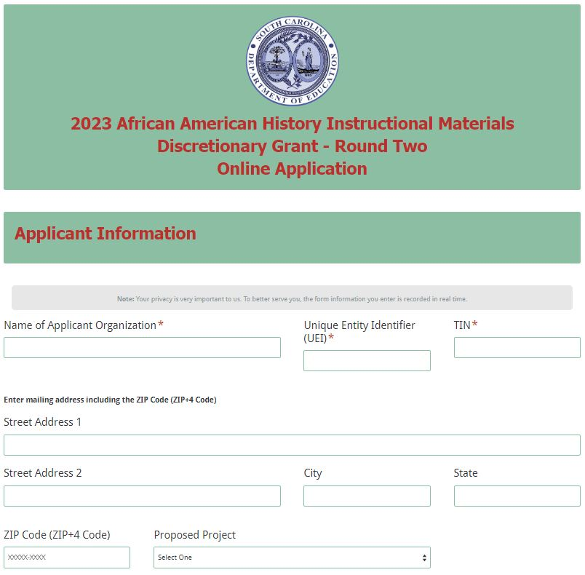
Enter the contact information for the authorized official for the organization including their title/position, phone number, and e-mail address. The authorized official is an individual who can enter into legally binding agreements on behalf of the organization. The name as entered in the online application must match the name as shown on the Certification Signature Page.

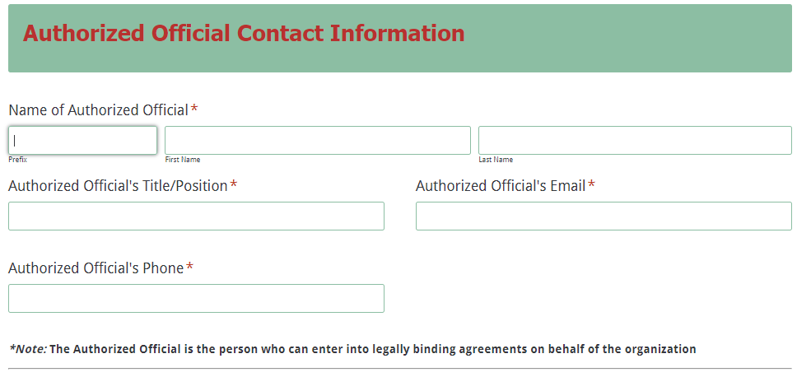
Enter the contact information for the project director including their title/position, phone number, and e-mail address. The confirmation e-mail of a successful online application submission will be sent only to this e-mail address. Reenter the e-mail address to confirm that it is correct.
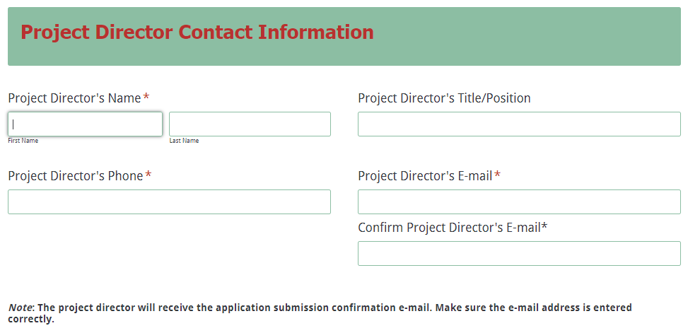
Enter the line-item breakdowns for the grant funds requested using only whole dollars (no cents). Fill in all fields and enter 0 (zero) for line items that are not applicable to the project. The amounts for each line item and the total funds requested must match the amounts in the Budget Narrative. The Total Grant Funds Requested field will automatically calculate.
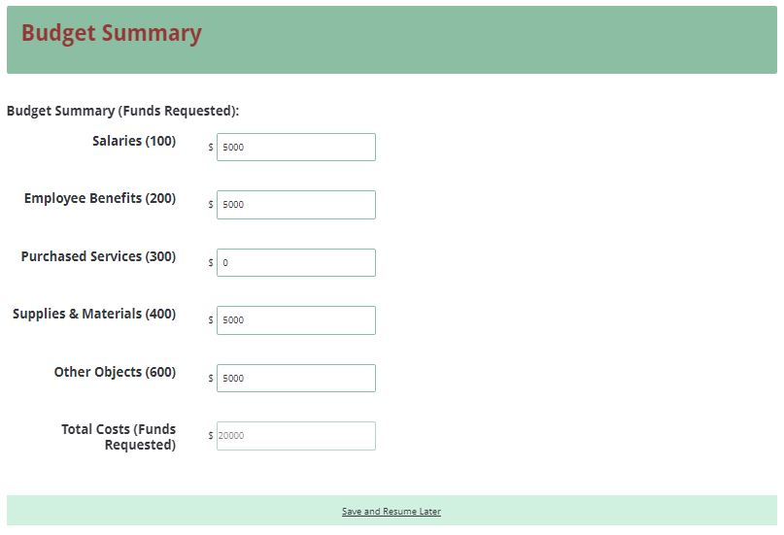
Prepare each of the application attachments (i.e., Application Narrative, Budget Narrative, Pre-Award Audit Questionnaire and Appendices) following the preceding instructions on pages 10–17. Ensure that each attachment is saved in the proper format as either a PDF or Excel document. Pay close attention to attachments that must be scanned together into a single document. The online application will only allow one document to be uploaded for each attachment.

Upload the attachments where indicated in the following screenshot. All attachments are required; you will not be able to submit the application without uploading all four documents.
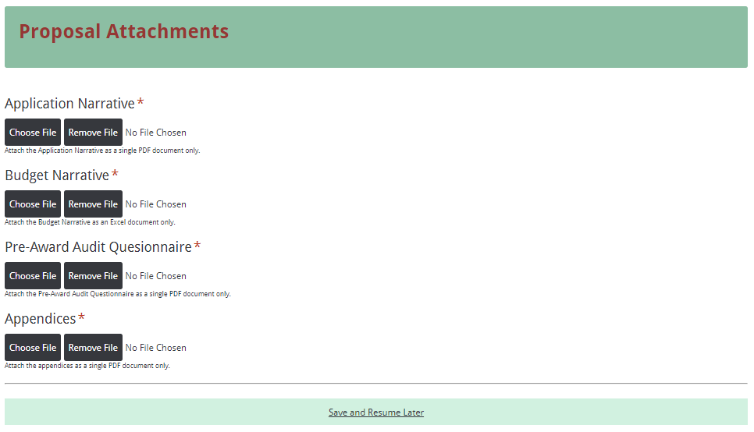
Thoroughly review the summary on the Data Review and Confirmation Page to verify that the information has been entered correctly in the online application prior to submitting. You will not be able to access the completed application form after it has been submitted. If any of the entries are incorrect, click on the "Previous" button at the bottom of each page to return to the appropriate section(s) and reenter the correct information.
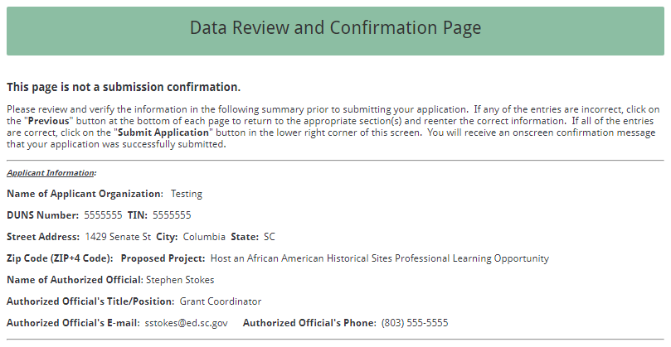
Once all the entries are correct, click on the “Submit Application” button in the lower right corner of this screen to complete the submission process.
Once the application is submitted, the following message will be displayed on the screen and a submission confirmation will be sent to the e-mail address provided for the project director in the online application.
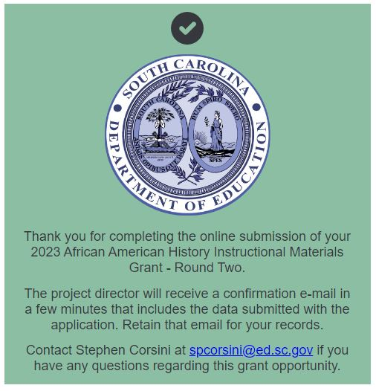
If the project director does not receive a confirmation e-mail, then the application did not successfully upload. You must go back and resubmit the entire online form, including all attachments, in order for your application to be considered for funding.
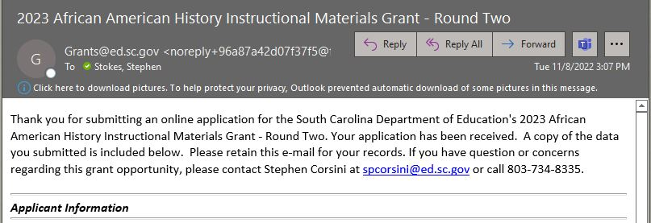
An e-mail confirmation that the grant application was successfully submitted does not account for the quality of the uploaded documents or the completeness of the online form. The confirmation e-mail only notifies you that the online application has been submitted. Applicants are responsible for ensuring that the information entered in the online form, including all attachments, is accurate and complete in order for the application to be reviewed and considered for funding.

Appendix A: Selection Criteria and Reviewers’ Scoring Rubric

Selection Criteria

A total of 60 points is available to applications that meet the maximum score for each selection criteria. Required criteria will only be scored within its appropriate section. While required criteria may be contained elsewhere in a proposal, points will only be earned for its inclusion in the correct section. While the budget is assigned zero (0) points, the budget remains a critical component of the entire application. An application with an incomplete budget will not be funded.

The point values for each section of the application are as follows:

Narrative Sections | Points Available
Project Summary | 20
Activities and Strategies | 20
Management and Sustainability | 10
Evaluation of Project Outcomes | 10
TOTAL | 60

Scoring Rubric
1. Project Summary: The applicant must concisely describe the applicant’s organization and its mission, the target population to be served with the proposed project, the amount of funding requested, and the goals and objectives of the proposed project including a description of the plans to develop and host either:
- Develop and host a new or recurring African American Historic Sites Professional Learning Opportunity (PLO) for K-12 teachers that includes professional learning at prominent historic sites in South Carolina as it applies to any K-12 standards. The PLO then uses the provided template to guide teachers in the development of a minimum of ten (10) inquiry-based instructional lessons with supporting materials (Instructional Materials) that connect the sites with identified course standards and provide options to assess student learning; or
- Develop and host an African American Instructional Materials Professional Learning Opportunity (PLO) for K-12 teachers that provides professional learning about South Carolina African American history as it applies to any K-12 standards. The PLO then uses the provided template to guide teachers in the development of a minimum of ten (10) inquiry-based instructional lessons with supporting materials that connect the content from the professional learning with identified course standards and provide options to assess student learning.

Project summary should include a description of how the instructional materials are to be developed on time, checked for historical accuracy, and created within the proposed budget.
An applicant must provide a narrative that describes:  - the applicant’s organization and its mission,  - the target population to be served with the proposed project,  - the amount of funding requested,  - the goals and objectives of the proposed project including detailed descriptions of stages of the development plans,  - Identified 2019 Standards and themes and the reason for selecting those standards,  - Proposed topics of instructional materials and the data supporting their selection, and  - Description of the metric used to determine historical accuracy. | Acceptable | Exceeds—16–20 points  Applicant provides a narrative that describes all required items in rich detail.
 | Acceptable | Adequate/Meets—11-15 points  Applicant provides a narrative that describes all the required items.

 | Not Acceptable | Limited/Approaches—6-10 points  Applicant provides a narrative that is either missing 1 or 2 required items or provides limited or unclear descriptions.
 | Not Acceptable | Inadequate—0–5 points  Applicant provides a narrative that is missing several required items and/or does not adequately describe all required items.
Reviewer’s Comments

2.a. Strategies and Activities (for African American Historic Sites Professional Learning Opportunity applicants only): The applicant must provide a narrative that clearly describes strategies and activities to be used developing the African American History instructional lessons including a timeline and description of the application and selection process for participants; the historic sites intended to visit with descriptions of the associated African American content that connects with it; an explanation of the associated professional learning surrounding each site with its specific connection to the content, skills, and themes of the target course as described in the 2019 Standards; and an explanation of activities/weekly work schedule that thoroughly describes when work on creation of the instructional materials will be conducted in relation to the site visits, and how each phase relates to the specific objective. In addition, the applicant will need to describe how the instructional materials are to be developed on time, checked for historical accuracy, and created within the proposed budget.
The applicant provides a narrative that fully describes strategies and activities to be used in developing the African American History instructional materials including:  - a timeline and description of the application and selection process for participants, the historic sites intended to visit with descriptions of the historical content associated with each, an explanation of the associated professional learning surrounding each site and its specific connection to the content, skills, and themes of the target course as described in the 2019 Standards, and | Acceptable | Exceeds—16–20 points  Applicant provides a narrative that describes all required items in rich detail.
 | Acceptable | Adequate/Meets—11-15 points  Applicant provides a narrative that describes all the required items.

- an explanation of activities/weekly work schedule that thoroughly describes when work on creation of the lessons will be conducted in relation to the site visits, and how each phase relates to the specific objective;  - how the instructional materials are to be developed on time, checked for historical accuracy, and created within the proposed budget. | Not Acceptable | Limited/Approaches—6-10 points  Applicant provides a narrative that is either missing 1 or 2 required items or provides limited or unclear descriptions.
 | Not Acceptable | Inadequate—0–5 points  Applicant provides a narrative that is missing several required items and/or does not adequately describe all required items.
Reviewer’s Comments

2.b. Strategies and Activities (for Instructional Lessons Professional Leaning Opportunity applicants only): The applicant must provide a narrative that clearly describes strategies and activities to be used developing the African American History instructional lessons including a timeline and description of the application and selection process for hiring educators to create ten (10) inquiry-based instructional lessons with supporting materials, an explanation of activities and professional learning opportunities for the participants to assist them in developing lessons that impact student learning, and a description of the targeted topic for each lesson and the reason for their selection that explains how it aligns to the 2019 Standards and employs the skills and themes in the targeted course. In addition, the applicant will need to describe how the instructional materials are to be developed on time and created within the proposed budget.
The applicant provides a narrative that fully describes strategies and activities to be used in developing the African American History instructional units including:  - a timeline and description of the application and selection process for hiring educators to create ten (10) inquiry-based instructional lessons, | Acceptable | Exceeds—16–20 points  Applicant provides a narrative that describes all required items in rich detail.
 | Acceptable | Adequate/Meets—11-15 points  Applicant provides a narrative that describes all the required items.

- an explanation of activities and professional learning opportunities for the participants to assist them in developing lessons that impact student learning, and a description of the targeted topic for each lesson that explains how it aligns to the 2019 Standards and employs the skills and themes in the targeted course; and  - how the instructional lessons are to be developed on time, checked for historical accuracy, and created within the proposed budget. | Not Acceptable | Limited/Approaches—6-10 points  Applicant provides a narrative that is either missing 1 or 2 required items or provides limited or unclear descriptions.
 | Not Acceptable | Inadequate—0–5 points  Applicant provides a narrative that is missing several required items and/or does not adequately describe all required items.
Reviewer’s Comments

3. Management and Sustainability: The management section outlines the applicant’s plan to manage the project including the chain of command, who will manage the project, and responsibilities for the project director and key staff members. The sustainability section must address what the applicant will do to ensure that the instructional materials are in use during the 2023–24 school year.
The applicant must provide a narrative that describes:  - the applicant’s plan to manage the project, including  - the chain of command,  - who will manage the project,  - the responsibilities of the project director and key staff members; including the final preparation for the materials for uploading to the Instruction Hub; and  - what the applicant will do to ensure that the instructional materials are in use during the 2023-24 school year. | Acceptable | Exceeds—8–10 points  Applicant provides a narrative that describes all required items in rich detail.
 | Acceptable | Adequate/Meets—5–7 points  Applicant provides a narrative that describes all required items.

 | Not Acceptable | Limited/Approaches—2–4 points  Applicant provides a narrative that is limited or unclear in describing all required items.
 | Not Acceptable | Inadequate—0–1 point  Applicant provides a narrative that is missing several required items and/or does not adequately describe all required items.
Reviewer’s Comments
4. Evaluation of Project Outcomes: The applicant must provide a plan to evaluate the project’s outcomes to include how the professional learning provided enhanced the participants’ knowledge, how the historic sites (if applicable) will promote African American history to students, and how the instructional materials created by the participants will be assessed for quality. The applicant must describe how the instructional lessons are to be developed on time and created within the proposed budget.
Applicants must provide a narrative that describes:  - how the applicant will determine if the professional learning enhanced participants’ knowledge of African American history,  - how the historic sites (if applicable) will contribute to student knowledge of African American history,  - how instructional materials created by participants will be developed on time, within budget, and of high quality,  - the submission of completed materials to be used throughout the state. | Acceptable | Fully Meets—8–10 points  Applicant provides a narrative that describes all required items in rich detail.
 | Acceptable | Adequate/Meets—5–7 points  Applicant provides a narrative that describes all required items.
 | Acceptable | Inadequate—0–1 point  Applicant provides a narrative that is missing several required items and/or does not adequately describe all required items.
Reviewer’s Comments

Appendix B: Required SCDE Forms

Certification Signature Page

Certification
I hereby certify that, to the best of my knowledge, the information and data contained in this application are true and correct. The applicant’s governing body has duly authorized this application and documentation, and the applicant will comply with the SCDE Assurances and Terms and Conditions for State Awards if the grant is awarded.

Authorized Official
Name:
Position: | E-mail:
Telephone: | Fax:

Signature of Authorized Official:

Date Signed:

Financial Official
Name:
Position: | E-mail:
Telephone: | Fax:
Signature of Financial Official:

Date Signed:

Please complete, print, and obtain signatures prior to submission. Include the signed, scanned form in the required appendices as indicated on page 20.

Assurances and Terms and Conditions for State Awards

Assurances
- Has the legal authority to apply for state assistance and the institutional, managerial, and financial capability (including funds sufficient to pay the nonstate share of project costs) to ensure proper planning, management, and completion of the project described in this application.
- Will give the South Carolina Department of Education (SCDE) access to and the right to examine all records, books, papers, or documents related to this award and will establish a proper accounting system in accordance with generally accepted accounting principles (GAAP) or agency directives.
- Has an accounting system that includes sufficient internal controls, a clear audit trail, and written cost-allocation procedures as necessary. The financial management systems are capable of distinguishing expenditures that are attributable to this grant from those that are not attributable to this grant. This system is able to identify costs by programmatic year and by budget line item and to differentiate among direct, indirect, and administrative costs. In addition, the applicant will maintain adequate supporting documents for the expenditures and in-kind contributions, regardless of the type of funds, if any, that it makes under this grant. Costs are shown in books or records (e.g., disbursements ledger, journal, payroll register) and are supported by a source document such as a receipt, travel voucher, invoice, bill, or in-kind voucher.
- Will also comply with GAAP as it relates to budgets, budget amendments, and expenditure claim submissions.
- Will approve all expenditures, document receipt of goods and services, and record payments on the applicant’s accounting records prior to submission of reimbursement claims to the SCDE for costs related to this grant.
- Will initiate and complete work within the applicable time frame after receipt of approval by the SCDE.
- Will not discriminate against any employee or applicant for employment because of race, color, religion, age, sex, national origin, or disability. The applicant will take affirmative action to ensure that applicants for employment and the employees during the period of their employment are treated without regard to their race, color, religion, age, sex, national origin, or disability.
- Will comply with the Ethics, Government Accountability, and Campaign Reform Act (S.C. Code Ann. § 2-17-10 et seq. and § 8-13-100 et seq. (Supp. 2021)).
- Will comply with the Drug Free Workplace Act (S.C. Code Ann. § 44-107-10 et seq. (Supp. 2021)) if the amount of this award is $50,000 or more.

Terms and Conditions

- Completeness of Proposal. All proposals should be complete and carefully worded and must contain all of the information requested by the South Carolina Department of Education (SCDE). If you do not believe a section applies to your proposal, please indicate that fact.
- Non-awards/Termination. The SCDE reserves the right to reject any and all applications and to refuse to grant monies under this solicitation. If the SCDE rejects an application, the applicant has a right to request a review of the process consistent with the appeals process presented in the Request for Proposals (RFP).
After it has been awarded, the SCDE may terminate a grant by giving the grantee written notice of termination. In the event of a termination after award, the SCDE shall reimburse the grantee for expenses incurred up to the notification of termination. In addition, this grant may be terminated by the SCDE if the grantee fails to perform as promised in its proposal.
Upon the termination of a grant, the grantee shall have the right to a review process. The grantee must notify the SCDE of its request within 30 days of receiving written notice of the termination.
- Reduction in Budgets and Negotiations. The SCDE reserves the right to negotiate budgets with potential grantees. The SCDE may, at its sole discretion, determine that a proposed budget is excessive and may negotiate a lower budget with the applicant. The applicant may at that time negotiate or withdraw its proposal. In addition, the SCDE may desire to fund a project but not at the level proposed. In that case, the SCDE shall notify the applicant of the amount that can be funded, and the applicant and the SCDE shall negotiate a modification to the proposal to accommodate the lower budget. All final decisions are that of the SCDE.
- Amendments to Grants. Amendments are permitted upon the mutual agreement of the parties and will become effective when specified in writing and signed by both parties.
- Use of Grant Funds. Funds awarded are to be expended only for purposes and activities covered by the approved project plan, budget, and budget narrative.
- Submission of Expenditure Reports. Claims for reimbursement must be made at least quarterly and consistent with calendar quarters (e.g., an expenditure report claim for costs for January 1 through March 30 must be filed by May 15).
- Obligation of Grant Funds. Grant funds may not be obligated prior to the effective date or subsequent to the end or termination date of the grant period. No obligations are allowed after the end of the grant period. The final request for expenditure report claims must be submitted no later than forty-five (45) days after the end of the grant period unless the scope of work for the grant states a shorter reporting period.
- Deobligation of Funds. After a final expenditure claim has been submitted to the SCDE, the grantee will go through the official deobligation process with the SCDE.
- Documentation. The grantee must provide for accurate and timely recording of receipts and expenditures. The grantee’s accounting system should distinguish receipts and expenditures attributable to each grant. The grantee must review the memo regarding “Guidelines for Retaining Documentation to Support Expenditure Claims.”
- Travel Costs. Travel costs, if allowed under this solicitation, must not exceed limits noted in the United States General Services Administration (GSA) per diem rates for lodging, except in the case of conference lodging required for program-required training. In the case that conference-related lodging exceeds the GSA per diem rate, the grantee shall follow their entity’s written procedure for obtaining prior approval to exceed a GSA rate for a conference hotel. Meals and incidentals are limited by the state budget proviso, currently not to exceed $35 per day for in-state travel and $50 for out-of-state travel (see page 81 of the State of South Carolina Statewide Disbursement Regulations). Mileage reimbursement must follow the current Office of Comptroller General instructions, which is consistent with the published IRS rates.
- Honoraria. Amounts paid in honoraria, if allowed under this grant, must be consistent with SCDE policies. Applicants should check with the program office before budgeting for honoraria.
- Reports. The grantee shall submit, as required or instructed by the awarding program office, all reports (programmatic, financial, or evaluation) within the specified period or date and in the prescribed format. An expenditure claim report must be filed by July 5 for all expenditures incurred by June 30 in order to comply with the generally accepted accounting principles (GAAP) and the production of the State's Comprehensive Annual Financial Report.
- Copyright. The grantee is free to copyright any books, publications, or other copyrightable materials developed in the course of this grant. However, the SCDE reserves a royalty-free, nonexclusive, and irrevocable license to reproduce, publish, or otherwise use, and to authorize others to use, the copyrighted work developed under this grant.
- Certification Regarding Suspension and Debarment. By submitting an application, the applicant certifies, to the best of its knowledge and belief, that the
- Applicant and/or any of its principals, subgrantees, or subcontractors
  - are not presently debarred, suspended, proposed for debarment, or declared ineligible for the award of contracts by any state or federal agency; have not, within a three-year period preceding this application, been convicted of or had a civil judgment rendered against them for commission of fraud or a criminal offense in connection with obtaining, attempting to obtain, or performing a public (federal, state, or local) contract or subcontract; violation of federal or state antitrust statutes relating to the submission of offers; or commission of embezzlement, theft, forgery, bribery, falsification or destruction of records, making false statements, tax evasion, or receiving stolen property; and
  - are not presently indicted for, or otherwise criminally or civilly charged by a governmental entity with, commission of any of the offenses enumerated above.
- Applicant has not, within a three-year period preceding this application, had one or more contracts terminated for default by any public (federal, state, or local) entity.
- Audits. Although this Assurances, Terms, and Conditions document is for a state award, federal audit requirements apply as follows:
- Entities expending $750,000 or more in federal awards:
Entities that expend $750,000 or more in federal awards during the fiscal year are required to have an audit performed in accordance with the provisions of 2 CFR Part 200.501, et seq. Except for the provisions for biennial audits provided in 2 CFR Part 200.504 (a) and (b), audits must be performed annually as stated at 2 CFR Part 200.504. A grantee that passes through funds to subrecipients has the responsibility of ensuring that federal awards are used for authorized purposes in compliance with federal program laws, federal and state regulations, and grant agreements. The director of the OMB, who will review this amount every two years, has the option of revising the threshold upward.
- Entities expending less than $750,000 in federal awards:
Entities that expend less than $750,000 in a fiscal year in federal awards are exempt from the audit requirements in 2 CFR Part 200.504. However, such entities are not exempt from other federal requirements (including those to maintain records) concerning federal awards provided to the entity. The entity’s records must be available for review or audit by the SCDE and appropriate officials of federal agencies, pass-through entities, and the General Accounting Office (GAO).
- Records. The grantee shall retain grant records, including financial records and supporting documentation, for a minimum of six (6) years after the end date of the grant when the final expenditure report claim for reimbursement and all final reports have been submitted, unless informed otherwise or in case of litigation.
- Electronic Signature Agreement. I agree that my electronic signature is the legally binding equivalent to my handwritten signature.
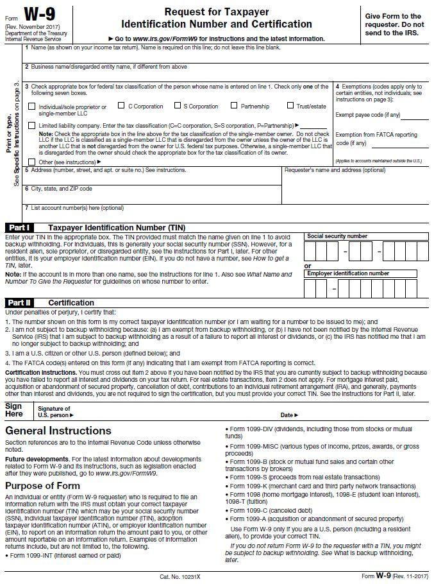

Historic Site Visit Action Plan Form

Objective for Site Visit:
(Each proposed site requires a Historic Site Visit Action Plan Form)

Site location
Site Contact/Curator
Historic significance of site
Provide a description of the connection(s) between the 2019 Standards and the historic site.
Proposed date to visit
Total Budget for Site Visit

SCDE Pre-Award Audit Questionnaire
Visit the SCDE’s Office of Auditing Services website to access the appropriate Pre-Award Audit Questionnaire for the applicant type.

For Non-LEAs
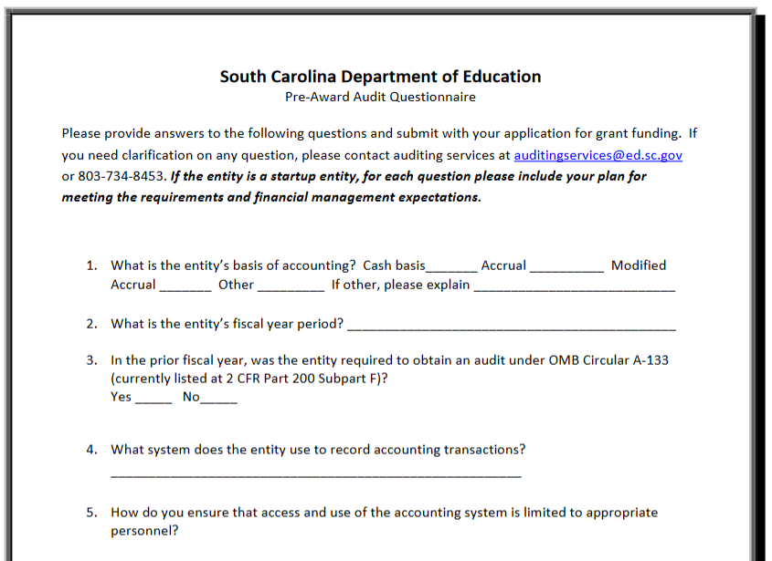

For LEAs, Nonprofits, and other State Agencies
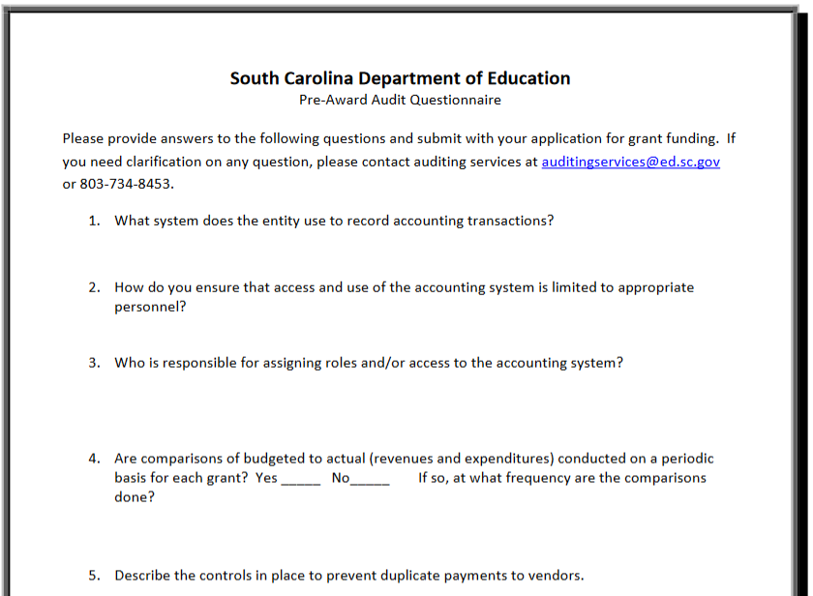

SCDE Office of Standards and Learning Unit Template

Title: | Total number of lessons in unit:
Content/Topic/Concept: | Developed By:
Grade level: | Unit Length/Time:
Unit Format: (Check) | Materials Needed:
  In-person
  Virtual -SYNC
  Virtual -ASYN
  Hybrid
Purpose: What Profile of the South Carolina Graduate skills are address and develop beyond the classroom?

Essential Question: What overarching question(s) address the learning? (Note: these are not content-specific questions.)
Connections to Prior Learning/ Setting Purpose/Preassessment (Opening): What do students already know and can do, and how will this inform instruction?

Differentiation: What options, strategies, opportunities, models allow differentiation in content, process, and/or product among special populations, including gifted and talented and multi-lingual learners?
Guiding Questions for Planning:
- Does the unit objective align to the rigor of the standard?
- Do all components of the unit align to the rigor of the unit objective?
- Does the plan include student engagement opportunities in every component of the unit?
(1. The Opening (Need for the learning), 2. New Learning, 3. Practice, 4. Assessment/Product, 5. Reflection on the learning)
- Where are opportunities for student collaboration to enhance understanding of the objective?

Approximate Time: ______________
Essential Question/Generalization:
Standards Addressed: What content standard(s) is the lesson’s focus? | Student Performance Objective: What will the student know or able to do by the end of lesson? Make sure this is aligned to the intent and rigor of the standard(s).
Sequence of Student Engagement: How will students engage with and own new content to meet the rigor of the objectives?  Each row represents a different step in the lesson. Please insert/delete rows as needed. | Success Criteria: What will students say, do, make, or write to show progress toward the learning objective(s). How will formative assessment data influence next steps? NOTE: Criterion could address multiple standards, but all standards should be addressed. Success Criteria may not be required for each step.
Product(s): What is the student work? How will success toward the objective be measured?

Closure/Reflection: How will students reflect on their learning in reference to one of the following: the learning objective, the success criteria, and an exemplar?

