
State of South Carolina

DEPARTMENT OF EDUCATION
Ellen E. Weaver
State Superintendent of Education

Request for Proposals (RFP)
Application Package

Career Cluster Partnership Program
Competitive Grant
2026-27

The Career Cluster Partnership is a discretionary grant program authorized by the South Carolina H. 5126 General Appropriations Bill 2026-27, Proviso 1A.27 and administered by the South Carolina Department of Education’s Office of Career and Technical Education.

Deadline for Receipt of Applications: 4:00 p.m. EDT, July 31, 2026

Technical Assistance for Applicants: 10:00 a.m. EDT, July 14, 2026

Email of Intent Deadline: July 16, 2026

For questions, contact:
Tiffany Dorsey, (803) 734-1650; tldorsey@ed.sc.gov

Issued by:
South Carolina Department of Education
Division of College and Career Readiness
Office of Career Readiness
849 Learning Lane
West Columbia, SC 29172-3171

TABLE OF CONTENTS

PART I: General Information 1
A. Introduction and Purpose 1
B. Eligible Applicants 1
C. Competitive Priorities 1
D. Timeline of Granting Process 2
E. Technical Assistance Sessions for Applicants 2
F. Statutory and State-Level Requirements 2
G. Authorized Activities 4
H. Unauthorized Activities 4
I. Program Accountability and Monitoring 4
J. Fiscal Operations 7
K. Supplement, Not Supplant 8
L. Review and Selection Process 8
M. Appeals Process 9

PART II: Application Overview, Content, and Instructions 10
A. Application Overview 10
B. Application Narrative Format 10
C. Online Application Submission 11
D. Program Abstract 11
E. Proposal Narrative Content 11
1. Statement of Need 11
2. Program Design 12
3. Organizational Capacity and Program Management 13
4. Statement Regarding Competitive Priority 13
F. Application Budget 13
G. Required Attachments 14
H. Deadline and Submission Procedures 15
I. Screenshots of Online Application Submission Forms 16

Appendix A: Definitions of Terms Used 22

Appendix B: Selection Criteria and Reviewers’ Scoring Rubric 23

Appendix C: Required SCDE Forms 28
Certification Signature Page 28
Assurances and Terms and Conditions for State Awards 29
Office of Career Readiness Program Staff Listing by Cluster Area 33
Budget Narrative Template 34
Request for Taxpayer Identification Number and Certification 35
Partner Identification and Funding Request Form 36

Appendix D: Additional Information 37
Proviso 1A.27 Career Cluster Industry Partnerships 37

PART I: General Information

Introduction and Purpose

The South Carolina General Assembly has provided funds to the South Carolina Department of Education (SCDE) through a legislative proviso (H. 5126 General Appropriations Bill 2026-27, Proviso 1A.27) for one year to award grants on a competitive basis to private-sector statewide trade associations that provide nationally certified programs in career and technical education representing the automotive, construction, engineering, healthcare, mechanical contracting/construction, and hospitality and tourism career clusters. The purpose of this program is to support instructor/student training and student testing in industry clusters to increase the state’s skilled workforce. The SCDE administers the program through its Office of Career Readiness.

Approximately $800,000 will be awarded through competitive grants. Grant awards are contingent upon funding from the South Carolina General Assembly. The SCDE will award at least one grant of a minimum of $150,000, exclusively for career and technical education (CTE), in at least four of the specified career clusters. Additional awards will depend on the quality of applications. The grant funding period will be September 16, 2026, to June 30, 2027. For large programs with a statewide scope, funds may be carried over for up to three years.

The grantee may obligate funds upon receipt of the grant award notice. However, no funds will be disbursed until after September 16, 2026.

Eligible Applicants

Eligible applicants are private-sector statewide trade associations or educational foundations that fall under IRS code 501(c)(3) or 501(c)(6) that provide nationally certified programs in career and technical education representing the automotive, construction, engineering, healthcare, mechanical contracting/construction, and hospitality and tourism career clusters. Applicants may partner with trade organizations, corporations, or others to develop strong programs that provide direct support to students to further industry-specific career and technical education programs. Applicants must have a Unique Entity Identifier (UEI) in the federal SAM.gov and provide the UEI in the application.

Competitive Priorities

A priority for the 2026–27 program is student assessment, as stated in Proviso 1A.27. The Office of Career Readiness is primarily interested in student assessments for secondary program completers. Technical skill assessments of interest are listed at the Career and Technical Education Technical Skill Assessments website.

Applications that include, as part of the proposed program, the administration of the specific certification examinations listed on the referenced website will receive competitive priority points. Up to 20 competitive priority points are available. Ten points will be awarded for the first examination identified. Each successive examination will earn five (5) points. No more than 20 competitive priority points will be awarded to any application. Applicants are not eligible for competitive points unless their application earns an average score of 75 points or higher. Student-level assessment results will be due to the Office of Career Readiness by June 30, 2027.

Timeline of Granting Process

Date | Activity/Action
July 14, 2026 | Pre-application technical assistance session
July 16, 2026 | Deadline for email of intent
July 31, 2026 | Deadline for receipt of applications
October 2026 | Notification of awards
September 16, 2026 | Funding period begins; programs can begin
December 31, 2026 | Semi-annual progress reports due to the SCDE
June 30, 2027 | Funding period ends; programs must end and student-level assessment results due
July 31, 2027 | Final reports due to the SCDE

Technical Assistance Sessions for Applicants

The SCDE’s Office of Career Readiness will offer a pre-application technical assistance webinar via Adobe Connect on July 14, 2026, from 10:00 a.m. until 11:30 a.m. to assist eligible applicants in understanding this RFP and how to apply for this grant. No password is required to join the session. Participants should enter their full names when logging in. Participants will be able to log in 30 minutes prior to the start time to test their audio settings and download/print handouts. While participation is not mandatory to submit an application, it is highly recommended.

Statutory and State-Level Requirements

As authorized, the Career Clusters grant program requires:
- In its application, the applicant organization must
  - explain how they will use grant funds in direct support of students to further industry-specific career and technical education programs;
  - describe their program;
  - provide a history of their program, both nationally and within the state; and
  - include estimates of future employment growth in their industry and the national scope of their program.

- Grant recipients must administer, in conjunction with schools, end-of-course exams graded by a national industry organization. Technical skill assessments of interest are listed at the Career and Technical Education Technical Skill Assessments website.

- Grant recipients must submit a semi-annual progress report by December 30, 2026.

- Grant recipients must submit, by July 31, 2027, a final, published report detailing
- how the grant increased industry/employer awareness,
- the increased number of schools using the industry-based curriculum and partnered with the industry organization,
- the increased number of students in the program,
- an overview and analysis of the organization’s statewide student competition, and
- how the grant funds were spent in direct support of students.

For the final report, due July 31, 2027, grant recipients must produce a published deliverables item to share with the Office of Career Readiness that shows the numbers of students impacted, financial and programmatic narratives, and other elements to show success and areas of improvement.

Universal Entity Identifier (UEI) and System of Award Management—2 CFR Part 25
All grant applicants must obtain a unique entity identifier (UEI) through the federal System for Award Management (SAM). The applicant must include a valid UEI in the online application. See SAM.gov and contact your finance office for assistance with your entity’s UEI. The process takes time so begin your login.gov and UEI application well in advance of the application deadline.

Note: the SCDE will not issue an award until the applicant has complied with the requirement to provide a valid UEI.

SCDE Assurance and Terms and Conditions for State Awards
Applicants should review the Assurances and Terms and Conditions for State Awards (beginning on page 29) to ensure that, if awarded a grant, they are capable of full compliance, especially with all the referenced regulations and state laws, in order to enter into an agreement with the SCDE. Pursuant to S.C. Code Ann. § 8-13-700 (Supp. 2025), the applicant must disclose any potential conflict of interest to the SCDE in accordance with the SC Ethics Reform Act conflict of interest policy. A signed Certification Signature Page (see page 28) is required with the grant application and legally binds the applicant to the agency’s Assurances and Terms and Conditions for State Awards. Applicants and partners must be cognizant of each item contained in the SCDE’s Assurances and Terms and Conditions documents. Give particular attention to requirements for record keeping, internal controls, and travel costs.

Authorized Activities

The Career Cluster Partnership Program funds must be used to support the following activities and programs:
    - administration of end-of-course testing program and/or national certifications exams;
    - student recruitment into the industry career cluster;
    - programs to educate middle and high school career or guidance counselors about the industry;
    - professional development and training for teachers;
    - services to economically disadvantaged youth (as defined by eligibility for free or reduced-price lunch);
    - administration of business/employer awareness and partnerships that lead to experience-based, career-oriented experiences including internships, apprenticeships, mentoring, cooperative education, and service-learning;
    - one-year post-secondary scholarships in industry-specific degree programs, if applicable;
    - an organization’s statewide student competitions that lead to national competitions; and
    - career awareness programs for the industry career cluster.

Proposed programs should reflect the purpose of this program with the majority of activities in support of training and testing in the respective industry cluster. Salaries should be held to a minimum, and personnel, their qualifications, and their responsibilities must be included in the application. While computers and software are eligible expenditures, estimates should be reasonable, and all supplies and materials must be clearly tied to the proposed program’s goals and objectives.

Unauthorized Activities

Expenditures should be reasonable, necessary, and adequately documented to achieve the grant program’s goals and objectives. Costs for office furniture, construction, entertainment, and alcohol are not allowed. Note that the unallowable expenditures listed are not all-inclusive; applicants should use prudent judgment to determine that expenditures are allowable and align with the proposed program’s scope of work.

Program Accountability and Monitoring

The SCDE is responsible for monitoring the Career Cluster Partnership Grant implementation in accordance with the following program accountability requirements:
- Each recipient receiving funds through this RFP meets the eligibility requirements for the grant described herein, and the applicant has provided all required assurances that it will comply with all program implementation and reporting requirements established through this RFP.
- Each recipient receiving funds through this RFP appropriately uses these funds as described in this application package.
- Each recipient implements activities funded through this application within the timeline in which the funds provided are to be used.

To fulfill its monitoring responsibilities, the SCDE requires grantees to submit appropriate fiscal and program documentation following guidance provided by the SCDE’s Office of Career Readiness. In addition, representatives of the state may conduct site visits to funded applicants. The purpose of these visits is to validate information submitted by applicants and to gather additional information from interviews and observations for monitoring and evaluation purposes.

Applicants may be subjected to an evaluation of their financial system, internal controls processes, and policies and procedures by the SCDE’s Office of Audit Services before a grant award is issued or during the grant term. The review process and procedures are accessible at Pre-award Audit Resources website.

Applicants awarded grant funds must satisfy periodic reporting and accountability requirements throughout the term of the grant. These requirements address: (1) program accountability; (2) performance reporting; (3) annual budget; (4) monitoring; (5) program evaluation; and (6) technical assistance.

    - Program Accountability
Each grantee is responsible for carrying out its responsibilities in accordance with H. 5126 General Appropriations Bill 2026-27, Proviso 1A.27; all applicable statutes, regulations, and programmatic guidance; and its approved grant application and work plan. Grantees are also required to submit periodic reports to the SCDE to report on the use of grant funds and the progress of grant activities.

    - Performance Reporting
Performance reporting requirements include those for both programmatic reporting and fiscal reporting. The grantee is responsible for ensuring that all reports are accurate, complete, and submitted on time. Achievement of grant goals and objectives will be monitored through the final report process.

Programmatic Reporting Requirements
The following is required of all grant recipients and is to be reported in the final report for the period in which the activity occurred:
- how the grant increased industry/employer awareness,
- how the grant funds were spent in direct support of students,
- the total number of schools and increased number of schools using the industry-based curriculum and partnering with the industry organization,
- the total number of students and the increase in the number of students in supported programs, and
- an overview and analysis of the organization’s statewide student competition.

The Reporting Due Dates for the Career Cluster Program Grant:
Reports | Reporting Period | Report Due Date
Interim Report | September 16–December 30, 2026 | December 31, 2026
Testing Results  (if applicable) | September 16, 2026–June 30, 2027 | June 30, 2027
Final Detailed Program and Fiscal Report | September 16, 2026–June 30, 2027 | July 31, 2027

Fiscal Reporting Requirements
The grantee must submit a final fiscal report to the SCDE that covers the duration of the grant award.

    - Program Budget
A program budget of programed expenditures to be funded by the grant must be submitted with the application.

    - Monitoring
The SCDE will monitor grantees by reviewing and approving the final detailed program report that is due by July 31, 2027. All information in the final report is subject to verification.

The SCDE may conduct programmatic and financial monitoring site visits. Grantees must agree to site visits conducted by state program representatives. The purpose of site visits is to validate information provided in fiscal and program reports and to gather more detailed information on implementation efforts and challenges.

The SCDE may require additional information from the grantee, verify information with the authorizing agency, or require the submission of additional documentation including, but not limited to, invoices, receipts, and personnel time and effort reports. Prior to a site visit, the grantee may be required to submit additional relevant information that will allow the SCDE to conduct a useful, efficient, and effective visit. The SCDE may require electronic submission of documents instead of a paper-copy submission.

SCDE staff will verify the contents of documentation submitted. Grantees may be asked to revise reports when
- non-allowable expenses are found;
- reports are confusing or difficult to understand; or
- unexplained discrepancies between the proposed use of grant funds, as provided in the annual budget, and actual expenditures are found in the submitted documentation.

    - Program Evaluation
Grantee Project Monitoring and Evaluation
Grantees are required to conduct ongoing monitoring and evaluation to ensure project goals are achieved. While hiring an external monitoring and evaluation contractor is not required, it is also not prohibited. Progress toward meeting project goals is to be reported through the final detailed program report process.

A final detailed program report is to be completed before the end of the grant period. The final report must address project success toward each goal stated in the application. The report should be developed as a resource to share with stakeholders on program success and students supported. If a grantee fails to submit the final report before the end of the grant period, or if any of the performance requirements in section I.2 are not completed, the SCDE may consider the grantee a high risk and elect to discontinue funding or disqualify the grantee from future funding opportunities.

    - Technical Assistance to Grantees
Grantees are required to participate in all technical assistance that the SCDE may conduct related to completing and filing reports or other requirements of the Career Cluster Partnership Program. Delivery of such technical assistance may include in-person meetings, webinars, and conference calls.

Fiscal Operations

Grantees must use grant funds for allowable grant expenditures during the grant period. Career Cluster Partnership grant funds are disbursed on a direct payment. Matching or in-kind funds are not required; however, matching and in-kind funds are an indicator of potential long-term sustainability of a Career Clusters Partnership program.

Allowable Costs
Grants must be used in accordance with statutory and state requirements stated in section F., and grant funds must be used to support the activities stated in section G.

Unallowable Costs
The Career Cluster Partnership grant does not provide indirect costs or funds for administrative charges. Grant funds may not be used for office furniture or construction; travel or room and board for participants; college or university application fees; medical, recreation, parking, or other fees; entertainment or alcohol; and purchases that do not directly support the approved work plan.

Supplement, Not Supplant

Career Cluster Partnership grant funds must supplement, not supplant, existing services and may not supplant federal, state, local, or non-federal funds. Programs may not use grant funds to pay, in whole or in part, for existing levels of services funded from other sources.

Review and Selection Process

Only grant applications that are received by the deadline and deemed complete will be forwarded for review and funding consideration. All required materials including forms and attachments must be submitted for the application to be considered complete and eligible for review. Program staff will conduct an initial review of applications for completeness and compliance with the RFP. No incomplete applications will be forwarded to the reviewers or considered for funding.

Three reviewers from diverse backgrounds without a vested interest in any applicant being funded will evaluate each application based on the quality of the proposed activities and the capability of the applicant to implement the proposed program. The review team will be comprised of experienced grant readers from various professions and entities, including the SCDE.

Reviewers will use the scoring rubric beginning on page 23 to read and score each application independently. After the three reviewers have individually rated each application, the scores will be averaged. An application can earn up to 100 points for an average score.

Competitive priority points will be assigned to eligible applications earning an average score of 75 points or higher as rated by the reviewers. Priority points will be assigned by an impartial designee, added to the application’s averaged total score, and awarded only once per application. A maximum of 20 competitive priority points may be awarded for applications that meet the specific competitive priorities described on pages 1–2.

Applications will be rank ordered by average scores. Subject to the SCDE’s final approval, the availability of state funds, and the inclusion of priority points, grant awards will be made starting with applications that earned an average score of 75 points or higher. To the extent practical, the SCDE will award grants equitably among geographic regions within the state to include rural and urban communities. If funds remain following these awards, the SCDE will consider funding remaining applications earning an average score within the adequate/meets range until all funds are allocated.

Before final award decisions are made, applicants who previously received Career Cluster Partnership funding will be subject to a review of historical data (including financial data for evidence of timely submission and accuracy of budgets, expenditure reports, amendment requests, and supporting documents) to confirm compliance and performance during the previous grant periods. The SCDE will also consider progress in achieving the objectives set in the previously funded applications and reported in the annual progress reports; the effectiveness of the funded program in meeting the purposes of the Career Cluster Partnership Program as reported in the annual progress reports; and the reported ability to sustain work supported by previous funding. The SCDE reserves the right to not grant an award if the data review reveals that the applicant did not adhere to the previous grant’s guidelines or meet the program’s goals and objectives.

The SCDE reserves the right to negotiate final budgets and to disqualify costs associated with any line items that are unallowable, unallocable, unreasonable, or inconsistent with the program’s goals or the proposed project’s activities and strategies.

Grant awards are not final until an SCDE grant award notice is fully executed. Notification of funding will be sent in October 2026, to the authorized official listed on the Certification Signature Page. After the notification of awards, copies of the reviewers’ comments and score sheets will be sent to the contact person identified in the online application.

Appeals Process

An applicant who has submitted a proposal that the SCDE does not fund has 30 calendar days after receiving notification that the proposal is not funded to request a review of the process. Scores may not be appealed; the SCDE will not rescore applications. An unfunded applicant may inquire as to whether or not the application process was followed. The request for review must be directed to the State Superintendent of Education and must state the reasons for the request. The Superintendent may delegate to a deputy superintendent the authority to conduct a review. The deputy superintendent will issue a decision after the review of the information submitted by the applicant and the program office. This decision will be the final decision of the agency. The applicant may appeal the agency’s decision to the Administrative Law Court under the terms of the Administrative Procedures Act.

PART II: Application Overview, Content, and Instructions

Read all guidelines and criteria carefully before preparing your application. Adhere to font, format, page limit, and organizational requirements. Only applications that include all sections and attachments and fully adhere to these guidelines will be reviewed and considered for funding. Incomplete applications will not be reviewed.

Application Overview

Applicants are encouraged to prepare all of the following elements of the application before beginning the online submission process. Do not wait until the last minute to submit an application. Use the following overview as a checklist to ensure that the application is complete with items labeled accordingly and presented in the order outlined below. Verify that all narrative components and items are included prior to uploading attachments.

The Career Cluster Partnership application submission is organized into the following sections (see the screenshots beginning on page 16):
- Online Form
- Applicant Information
- Contact Person Information
- Authorized Official Information
- Budget Summary
- Proposal Attachments
  - Program Abstract
  - Proposal Narrative
  - Statement of Need
  - Program Design
  - Organizational Capacity and Program Management
  - Statement Regarding Competitive Priority
- Budget Narrative
- Required Attachments
  - Signature Certification Page
  - Copy of IRS Determination Letter
  - Request for Taxpayer Identification Number and Certification Form (W-9)
  - Partnership Identification Form(s)

Application Narrative Format

Length of Narrative: | Maximum of 8 pages for the proposal narrative only. This page limit excludes the abstract, table of contents, budget narrative, and the required and optional forms.
Required Font/Size: | Times New Roman/11 or 12 or Arial/11 or 12.
Margins: | 1” on all sides.
Page Numbers: | Bottom right-hand corner.
Spacing: | Double-spacing throughout narrative. Charts and tables may be single-spaced.
Final File Format: | PDF document.

Each section must be clearly identified using the headings provided in the instructions below. Sections may not be combined. Reviewers will not consider information requested in one section that is provided in another section. Incomplete proposals will not be considered.

Online Application Submission

Proposals must be submitted using the online application form. The online submission is organized into two sections—Online Form and Proposal Attachments.

Provide the primary applicant’s 12-digit alphanumeric UEI and Taxpayer Identification Number (TIN) in the application form. Applicants should contact their organization’s finance office if they need assistance with these items.

Use the following instructions to compile and complete all proposal attachments prior to submitting your application. Verify that all components of the narrative and appendices are included prior to uploading attachments. Follow the directions in each section for saving the documents and refer to the screenshot on page 19 for upload locations.

Program Abstract

In one page, concisely describe the applicant’s organization and its mission, the target population to be served, the documented need for the program as revealed in the statement of need, the goals and objectives of the proposed program, the anticipated impact(s), and the amount of funding requested.

When completed, save the abstract as a single PDF document to be uploaded as an attachment in the online application.

Proposal Narrative Content

Use the following directions to write the proposal narrative and organize it into sections following the sequence presented below. Include a table of contents as the first page of the narrative (not included in the page limit). Do not combine sections. Required components must be located in their designated sections in order to be scored.

When complete, save the entire narrative as a single PDF document to be uploaded into the online application where indicated in the proposal attachments section.

Statement of Need (maximum of 20 points)
Present the case for the proposed program in a clear, factual, and compelling manner. Explain the need for the activities and career cluster(s) planned for this program. Describe the target population. What is the impact of the need in South Carolina? What will happen if this need is not addressed? Include estimates of future industry employment growth.

Program Design (maximum of 55 points)
  - Goals and Objectives
State the goal(s) of the proposed program and the objectives to be achieved. All goals and objectives must mirror the purpose of the Career Cluster Partnership Program to support instructor/student training and student testing in industry clusters to increase the state’s skilled workforce and must reflect the needs identified for the program. Directly cite, integrate, and address two (2) goals or areas of need for the respective career cluster developed with SCDE CTE program staff. Use the program staff listing with career-cluster in the appendix (page 33) to contact the appropriate staff member for cluster goals/needs. Objectives must be specific, measurable, achievable, relevant, and time-specific. How does the proposed program solve the problem/condition based upon the needs that were identified?

Discuss the measures or data that will indicate that the objectives have been met. List the end-of-course exams that will be administered and graded by a national industry organization, if applicable. Include the name of any test, the career and technical education course with which it is associated, when the test will be given, and when and in what detail (i.e., by student) the results will be available to the SCDE’s Office of Career Readiness. Results must be provided by June 30, 2027.

- Strategies and Activities
As the heart of the proposed program, this narrative section will be judged on the quality of offerings and scope and sequence of the activities. Activities should increase the value and participation in Career and Technical Education (CTE) programs and improve the quality of those programs. Proposed activities must align with the authorized activities for this program as presented in Part I section G (page 4).

Explain the strategies and activities that will be conducted to meet the goal(s) and objectives for the program. Strategies and activities must be scientifically or evidence based.

As applicable to the program being proposed, address all of the following:
- describe the state-approved CTE course(s) that will be improved or expanded;
- specify improvements in curriculum, the addition of new programs, or improvements to existing programs; and
- list additions or improvements by school with an estimate of the expected impact.

- Evaluation
Detail the plan to evaluate the program’s outcomes and demonstrate, using scientific methods, if and how well the program worked. Indicate the applicant organization’s agreement to
- participate in any SCDE evaluation effort,
- provide an interim report on December 31, 2026, that describes progress made in accomplishing the program goals and objectives and activities resulting from the approved allowable uses of funds, and
- submit a final detailed program report that will describe
- how the grant increased industry/employer awareness,
- how the grant funds were spent in direct support of students,
- the total number of schools and increased number of schools using the industry-based curriculum and partnering with the industry organization,
- the total number of students and the increase in the number of students in supported programs, and
- an overview and analysis of the organization’s statewide student competition.

Organizational Capacity and Program Management (maximum of 25 points)
Explain the applicant organization’s mission. Describe the history and scope of the organization’s program nationally and within South Carolina. Describe previous grant experience that indicates the organization’s capacity to manage the proposed program.

Explain the plan to manage the proposed program, including the chain of command. Identify key program personnel, their credentials, and their responsibilities and time commitments on the proposed program.

Identify each partner in the proposed program, their roles, and their responsibilities related to the program’s goals and objectives.

Statement Regarding Competitive Priority (up to 20 bonus points)
Identify, by name, the specific examination(s) to be administered. Describe how they will be administered. Technical skill assessments of interest are listed at the Career and Technical Education Technical Skill Assessments website.

Application Budget

The budget is a critical component of the entire application. An application with an incomplete or incorrectly calculated budget will not be funded.

The budget is the financial equivalent of the proposal narrative. How will grant funds be spent to further industry-specific career and technical education programs? For example, while computers and software are eligible expenditures, such expenses should be clearly connected to the program goal(s) and objectives.

The application budget consists of two parts: the Budget Summary and the Budget Narrative. All proposed expenditures for the grant funding period must be itemized in the Budget Summary and detailed in the Budget Narrative. Budget items not explained in the application narrative will not be funded.
- The Budget Summary is the financial overview of the grant and must include all proposed expenditures for the program. Each line item of the Budget Summary must correspond to the line items of the Budget Narrative (discussed below). Provide the budget summary in the online application Budget Summary section (see screenshot on page 19).

- The Budget Narrative must provide clear evidence that the budget is appropriate and justified based on the needs assessment. Use the template on the SCDE’s Grant Opportunities webpage for Career Clusters to provide a detailed Budget Narrative (see template sample on page 34) to include any in-kind or matching contributions. Structure the Budget Narrative line-item categories to parallel the line-item categories of the Budget Summary. Include all formulas used to calculate each line-item expense. This narrative must also identify other funding sources used to support any of the allowable program activities. When finalized, save the budget narrative as an Excel spreadsheet to be uploaded in the proposal attachments section of the online application (see the screenshot on page 19).

Ensure that the totals in the Budget Summary equal the totals in the Budget Narrative.

For a subgrantee to pay a vendor, a contract must be in place. At a minimum, the contract should include the scope of services, the duration of the contract, and the method and amount of payment; the contract must be executed by both parties. Consulting/service contracts must be procured in accordance with South Carolina Procurement Law.

The SCDE reserves the right to negotiate final budgets and to disqualify, disallow, and negotiate costs associated with any line item proposed in the budget. If any line-item cost is determined to be excessive, given the nature and scope of the entire program or of a particular activity, the SCDE can request the applicant reduce the cost of the line item or ask the applicant to assume a portion of the cost before the budget is approved and funds are awarded.

Funds will be disbursed on a direct payment basis to grantees. Grantees may not obligate funds prior to the receipt of a grant award notice. Applicants should have at their disposal at least three months of sustainable funds to implement the program prior to SCDE payment.

Required Attachments

All of the following items must be scanned into one PDF document to be uploaded into the online application where indicated.

Certification Signature Page
Print the Certification Signature Page (page 28) and obtain the appropriate signatures. This form includes the certification of the SCDE’s Assurances and Terms and Conditions for State Awards and any applicable program-related conditions conveyed in this RFP. Those documents are not required to be included in the applicant’s proposal submission. However, retain the copy included in this RFP for your records and ensure that the signatories and partner organizations have copies of each document for review prior to signing the Certification Signature Page.

By signing the Certification Signature Page, the signatories assure that they will comply with all the assurance and terms and conditions for the program. All signatories must understand that they are signing a document that is legally binding in the event a grant is awarded. Applications that do not include the signed Certification Signature Page will not be reviewed or considered for funding.

Copy of IRS Determination Letter
Include a copy of the IRS Determination Letter affirming/granting 501(c)(3) or 501(c)(6) status to your institution/organization.

Request for Taxpayer Identification Number and Certification (W-9)
Complete the W-9 Request for Taxpayer Identification Number and Certification form (see sample on page 35) for the primary applicant organization for inclusion in the application attachments.

Partner Identification and Funding Request Form(s)
Complete and include a Partner Identification and Funding Request Form (page 36) for each partnering institution/organization.

Deadline and Submission Procedures

- Applicants should email an intent to apply by July 16, 2026, to Tiffany Dorsey in the Office of Career Readiness at tldorsey@ed.sc.gov. In the email, include the primary applicant’s name; the contact person’s name, address, phone number, and email address; the career cluster you propose to serve; and the organizations that comprise the partnership (if applicable). A notice of intent is not required but will help the SCDE prepare for the application submission and review process.
- Applications must be submitted using the online application form before 4:00 p.m. EDT on July 31, 2026.
- Only applications that adhere to all of the guidelines and directions set forth in this RFP will be reviewed and considered for funding.
- No hard copy applications will be accepted. Applications delivered by hand, postal mail, email, or fax will not be accepted.
- Applications must originate from the applicant. Applications that are plagiarized from the Internet, other grants, or other resources will not be considered for funding.
- Do not attach or submit any additional materials other than what is specifically required. Any additional materials will be disposed of without review.
- Applications will not be returned. Keep a copy of the entire application for your records.

Screenshots of Online Application Submission Forms

The following screenshots are for informational purposes only and are provided to assist applicants in compiling all items needed to complete the online submission. Complete the attachments for the online application as directed in the preceding instructions. The SCDE encourages applicants to prepare all parts of the application before beginning the online submission process.

Make sure all information submitted is accurate, including formal or official names such as the applicant organization, and that spelling is correct. Do not use abbreviations or acronyms. All fields marked with a red asterisk are required; you will not be able to proceed to the next screens of the application without entering all information on each screen.

If necessary, you may save your progress in the online application form and return to the form later. When saving the online application form, the attachments and signature fields will not be included in the saved form (see screenshot below). Those fields must be populated again before submitting the application form.
Click on the “Save and Resume Later” link to save your progress. You will be given the option of copying and saving the link to the partially completed form or entering an email address to have the link emailed to you. Be sure to enter the email address correctly as SCDE personnel cannot access the hyperlink or the incomplete application form.

Use the link to access the application form from any computer within thirty days to complete the online submission. Without the link and password or after thirty days, the data previously entered cannot be retrieved and you will have to begin a new application form. A saved application form is not a submitted application. You must follow all of the steps described on pages 17–19 to complete the submission process.
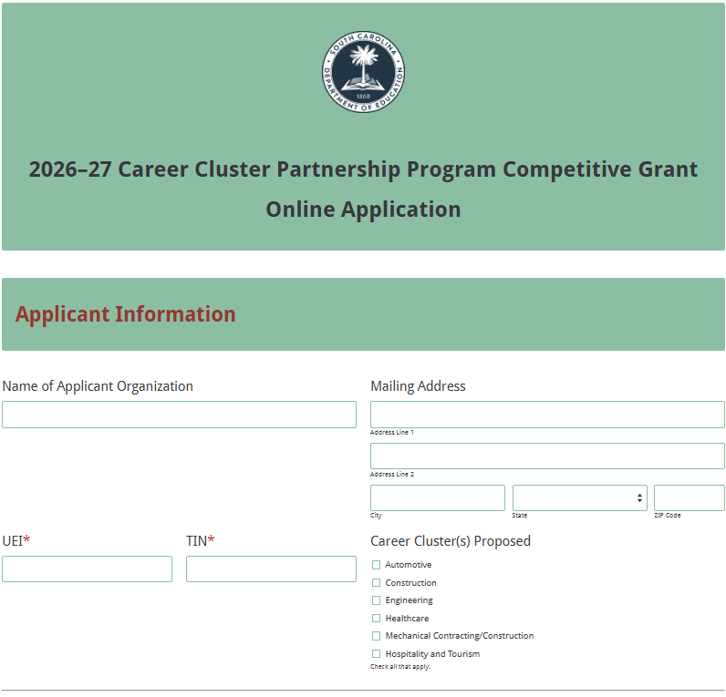

Enter the official name of the applicant organization. Enter the applicant organization’s physical address with the 10-digit ZIP Code (ZIP+4 Code), UEI, and TIN (tax identification number). The UEI and TIN are required fields; an applicant will not be able to proceed to the next screen of the application without entering this information. Select the career clusters being proposed.

Enter the contact person’s name, mailing address, and position. If the contact person’s mailing address is the same as the applicant organization, click on “Same as Applicant Organization’s Mailing Address” and the data will automatically populate these fields. If the address is different, enter the appropriate information. The contact person’s email is a required field. The application submission confirmation message will be sent only to this email address. Reenter the email address to confirm that it is correct. An applicant will not be able to proceed to the next page of the application without entering this information.
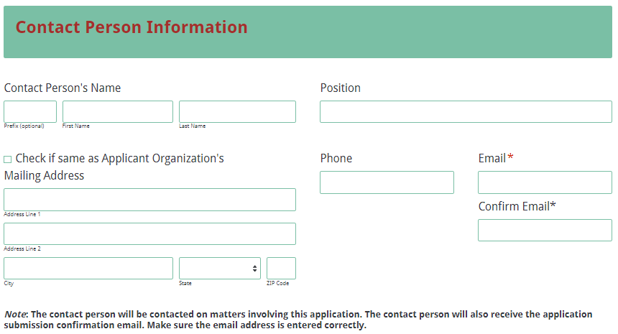

Enter the contact information for the authorized official of the applicant organization. The name entered in the online application must match the name shown on the Certification Signature Page. If the authorized official’s mailing address is the same as the applicant organization, click on “Same as Applicant Organization’s Mailing Address” and the data will automatically populate these fields. If the address is different, enter the appropriate information.
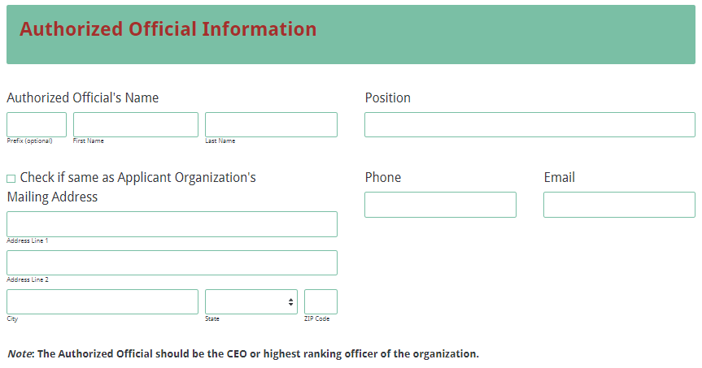

Enter all amounts in the budget summary section using whole dollars (no cents). Fill in all fields and enter 0 (zero) for line items that are not applicable to the program. Enter the line item totals for the Career Cluster Partnership Program funds requested and any in-kind/matching funds. The Total Costs (Funds Requested) field will automatically calculate. This amount must match the total funds requested in the budget narrative.
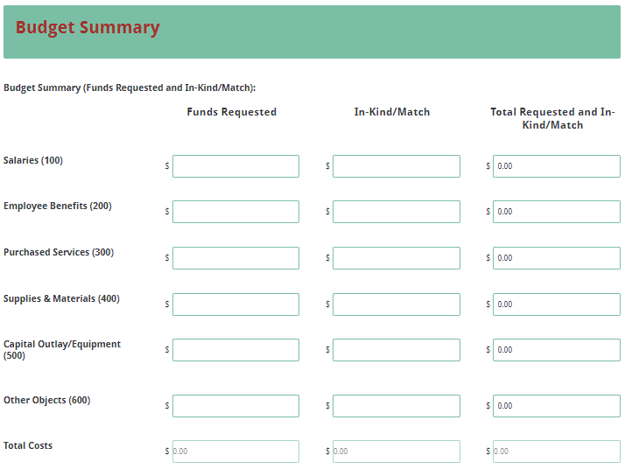
Upload the proposal attachments in the appropriate format following the instructions on pages 14–15. The attachments are required; you will not be able to submit the application without attaching all documents.
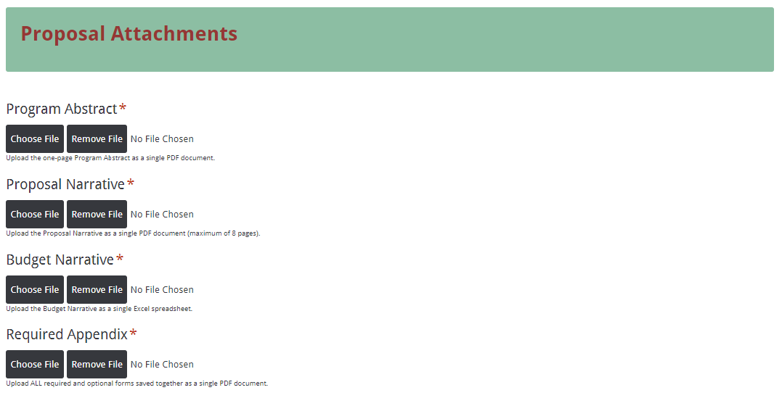

Thoroughly review the Data Review and Confirmation Page to verify that the information has been entered correctly in the online application prior to submitting. You will not be able to access the completed application form after it has been submitted.
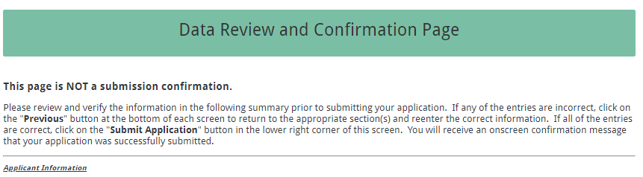

If any of the entries are incorrect, click on the "Previous" button at the bottom of each page to return to the appropriate section(s) and reenter the correct information. If all of the entries are correct, click on the “Submit Application” button in the lower right corner of this screen to complete the submission process.
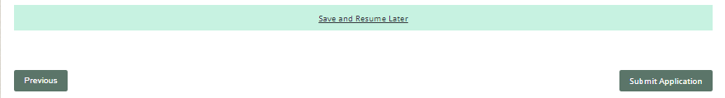

Once the application is submitted, the following message will be displayed on the screen, and a submission confirmation will be sent to the email address provided for the contact person in the online application.
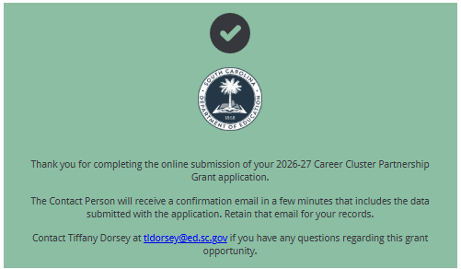

A submission confirmation will be sent to the email address provided for the contact person.

If the contact person does not receive a confirmation email, then the application did not successfully upload. You must go back and resubmit the entire online form, including all attachments, in order for your application to be considered for funding.

An email confirmation that your grant application was successfully uploaded does not account for the quality of the upload or its completeness. The confirmation email only notifies you that your online application has been submitted. Successfully uploaded grant narratives and appendices do not necessarily mean that the proposal attachments are complete and that your application will be read or considered for funding.

Appendix A: Definitions of Terms Used

Activities: Tasks that the grantee does to achieve objectives. For example, in a classroom, activities are what the students do to learn.

Deobligation: The downward adjustment of the obligations recorded in a grant award document. It is caused by factors such as (1) termination of part of the program, (2) reduction in materials prices, (3) cost savings, or (4) correction of recorded amounts.

Goals: General statements about desired changes and outcomes for the target population as result of the program.

Objectives: Statements that explain one way that the applicant will know when the goal has been achieved. Objectives must be specific, measurable, achievable, relevant, and time-specific.

Strategies: Tasks that are the catalyst to help the grantee achieve objectives. For example, in a classroom, strategies are what the teacher implements for the students to do so that they learn.

Appendix B: Selection Criteria and Reviewers’ Scoring Rubric

Selection Criteria

A total of 120 points, including competitive priority points, is available to applications that meet the maximum score for each selection criteria. While the budget is assigned zero (0) points, the budget remains a critical component of the entire application. An application with an incomplete budget will not be funded.

The point values for each section of the application are as follows:
Narrative Sections | Points Available
Statement of Need | 20
Program Design | 55
Organizational Capacity and Program Management | 25
Budget (Summary and Narrative) | 0
SUBTOTAL | 100
Competitive Priorities | up to 20
TOTAL | 120

Scoring Rubric
Program Abstract: The applicant must provide a one-page statement that fully addresses all of the following items:
- the applicant’s organization and its mission,
- the target population to be served,
- the documented need for the program as revealed in the statement of need,
- the goals and objectives of the proposed program,
- the anticipated impact(s),
- the amount of funding requested,
- and if applicable, indicates any categories for which they seek competitive priority points.

Acceptable
Adequate/Meets—0 points
Applicant provides a narrative that fully addresses all required items.
Not Acceptable
Inadequate—0 points
Applicant provides a narrative that does not adequately address all required items.
Score
Adequate/Meets ☐ Inadequate ☐
Reviewer’s Comments

1. Statement of Need—The applicant must provide a narrative that:
- presents the case for the proposed program in a clear, factual, and compelling manner;
- explains the need for the activities and career cluster(s) planned for this program;
- describes the target population;
- discusses the impact of the need in South Carolina and what will happen if this need is not addressed; and
- includes estimates of future industry employment growth.

Acceptable
Fully Meets—18–20 points
Applicant provides a narrative that fully addresses all required items.
Adequate/Meets—15–17 points
Applicant provides a narrative that moderately addresses all required items.
Not Acceptable
Limited/Approaches—8–14 points
Applicant provides a narrative that is limited or unclear in addressing all required items.
Inadequate—0–7 points
Applicant provides a narrative that does not adequately address all required items.
Score
Reviewer’s Comments

2.a. Program Design—Goals and Objectives: The applicant must provide a narrative that:
- states the goal(s) of the proposed program and the objectives to be achieved;
- presents goal(s) and objectives that mirror the purpose of the Career Cluster Partnership Program to support instructor/student training and student testing in industry clusters to increase the state’s skilled workforce;
- presents goal(s) and objectives that reflect the needs identified for the program;
- presents objectives that are specific, measurable, achievable, relevant, and time-specific;
- describes how the proposed program will solve the problem/condition based upon the identified needs;
- directly cites, integrates, and addresses at least one (1) goal from two (2) separate areas for the respective career cluster developed with SCDE CTE program staff
- discusses the measures or data that will indicate that the objectives have been met;
- lists the end-of-course exams that will be administered and graded by a national industry organization, if applicable; and
- includes the name of any test, the career and technical education course with which it is associated, when the test will be given, and when and in what detail (i.e., by student) the results will be available to the SCDE’s Office of Career Readiness.

Acceptable
Fully Meets—18–20 points
Applicant provides a narrative that fully addresses the identified program goals and all required items.
Adequate/Meets—15–17 points
Applicant provides a narrative that moderately addresses the identified program goals and all required items.
Not Acceptable
Limited/Approaches—8–14 points
Applicant provides a narrative that is limited or unclear in addressing all required items.
Inadequate—0–7 points
Applicant provides a narrative that does not adequately address the required items.
Score
Reviewer’s Comments

2.b. Program Design—Strategies and Activities: The applicant must provide a narrative that:
- explains the scientifically or evidence-based strategies and activities that will be conducted to meet the goal(s) and objectives for the program; and
- addresses, as applicable to the program being proposed, all of the following:
  - describes the state-approved CTE course(s) that will be improved or expanded as applicable to the proposed program;
  - specifies improvements in curriculum, the addition of new programs, or improvements to existing programs; and
  - lists additions or improvements by school with an estimate of the expected impact.

Acceptable
Fully Meets—18–20 points
Applicant provides a narrative that fully addresses all required items.
Adequate/Meets—15–17 points
Applicant provides a narrative that moderately addresses all required items.
Not Acceptable
Limited/Approaches—8–14 points
Applicant provides a narrative that is limited or unclear in addressing all required items.
Inadequate—0–7 points
Applicant provides a narrative that does not adequately address the required items.

Score
Reviewer’s Comments

2.c. Program Design—Evaluation: The applicant must provide a narrative that
- details their plan to evaluate the program’s outcomes and demonstrate, using scientific methods, if and how well the program worked; and
- indicates their organization’s agreement to participate in any SCDE evaluation effort, provide an interim report that describes progress made in accomplishing the program goals and objectives and activities resulting from the approved allowable uses of funds, and submit a final evaluation report that will describe
  - how the grant increased industry/employer awareness,
  - how grant funds were spent in direct support of students,
  - the total number of schools and increased number of schools using the industry-based curriculum and partnering with the industry organization,
  - the total number of students and the increase in the number of students in supported programs, and
  - an overview and analysis of the organization’s statewide student competition.

Acceptable
Fully Meets—14–15 points
Applicant provides a narrative that fully addresses all required items.
Adequate/Meets—12–13 points
Applicant provides a narrative that moderately addresses all required items.
Not Acceptable
Limited/Approaches—7–11 points
Applicant provides a narrative that is limited or unclear in addressing all required items.
Inadequate—0–6 points
Applicant provides a narrative that does not adequately address all the required items.
Score
Reviewer’s Comments

3. Organizational Capacity and Program Management: The applicant must provide a narrative that:
- explains their organization’s mission;
- describes the history and scope of the organization’s program nationally and within South Carolina;
- describes previous grant experience that indicates the organization’s capacity to manage the proposed program;
- explains the plan to manage the proposed program, including the chain of command;
- identifies key program personnel, their credentials, and their responsibilities and time commitments on the proposed program; and
- identifies each partner in the proposed program, their roles, and their responsibilities related to the program’s goals and objectives.
Acceptable
Fully Meets—23–25 points
Applicant provides a narrative that fully addresses all required items.
Adequate/Meets—18–22 points
Applicant provides a narrative that moderately addresses all required items.
Not Acceptable
Limited/Approaches—10–17 points
Applicant provides a narrative that is limited or unclear in addressing all required items.
Inadequate—0–9 points
Applicant provides a narrative that does not adequately addresses all the required items.
Score
Reviewer’s Comments

Budget Narrative: The applicant provides:
- a budget summary in the online form that calculates correctly;
- totals in the budget narrative that correctly reflect the line item totals in the budget summary;
- clear evidence that the expenditures are reasonable, appropriate, and justified to support the activities of the program;
- formulas used to calculate the costs for each item; and
- other funding sources used to support any of the allowable program activities.
Acceptable
Adequate/Meets—0 points
Applicant provides a budget narrative that addresses all required items.
Not Acceptable
Inadequate—0 points
Applicant provides a budget narrative that did not address all required items.
Score
Adequate/Meets ☐ Inadequate ☐
Reviewer’s Comments

Appendix C: Required SCDE Forms

Certification Signature Page
(This form must be signed by the individual from each proposed district, school, or organization who holds the title listed below.)

Certification
I hereby certify that, to the best of my knowledge, the information and data contained in this application are true and correct. The applicant’s governing body has duly authorized this application and documentation, and the applicant will comply with the SCDE Assurances and Terms and Conditions for State Awards if the grant is awarded. The applicant has an active unique entity identifier (UEI) in the federal System for Award Management (SAM)

Authorized Official (should be CEO of organization)
Name:
Position: | Email:
Telephone: | Fax:

Signature of Authorized Official: | Typed name of Authorized Official:
Date Signed:
Signature of Financial Official: | Typed Name of Financial Official:
Date Signed:

Please complete, print, and obtain signatures prior to submission. Include the signed, scanned form in the required attachments as indicated on page 15.

Assurances and Terms and Conditions for State Awards

For informational purposes only
The applicant certifies to abide by the SCDE Assurances and Terms and Conditions by signing and submitting the Certification Signature Page

Assurances
I certify that this applicant
- Has the legal authority to apply for state assistance and the institutional, managerial, and financial capability (including funds sufficient to pay the nonstate share of project costs) to ensure proper planning, management, and completion of the project described in this application.
- Will give the South Carolina Department of Education (SCDE) access to and the right to examine all records, books, papers, or documents related to this award and will establish a proper accounting system in accordance with generally accepted accounting principles (GAAP) or agency directives.
- Has an accounting system that includes sufficient internal controls, a clear audit trail, and written cost-allocation procedures as necessary. The financial management systems are capable of distinguishing expenditures that are attributable to this grant from those that are not attributable to this grant. This system is able to identify costs by programmatic year and by budget line item and to differentiate among direct, indirect, and administrative costs. In addition, the applicant will maintain adequate supporting documents for the expenditures and in-kind contributions, regardless of the type of funds, if any, that it makes under this grant. Costs are shown in books or records (e.g., disbursements ledger, journal, payroll register) and are supported by a source document such as a receipt, travel voucher, invoice, bill, or in-kind voucher.
- Will also comply with GAAP as it relates to budgets, budget amendments, and expenditure claim submissions.
- Will approve all expenditures, document receipt of goods and services, and record payments on the applicant’s accounting records prior to submission of reimbursement claims to the SCDE for costs related to this grant.
- Will initiate and complete work within the applicable time frame after receipt of approval by the SCDE.
- Will not discriminate against any employee or applicant for employment because of race, color, religion, age, sex, national origin, or disability. The applicant will take affirmative action to ensure that applicants for employment and the employees during the period of their employment are treated without regard to their race, color, religion, age, sex, national origin, or disability.
- Will comply with the Ethics, Government Accountability, and Campaign Reform Act (S.C. Code Ann. § 2-17-10 et seq. and § 8-13-100 et seq. (Supp. 2025)).
- Will comply with the Drug Free Workplace Act (S.C. Code Ann. § 44-107-10 et seq. (Supp. 2025)) if the amount of this award is $50,000 or more.
- Will comply with the requirements of Proviso 1.78, H. 4025, 126th Leg., 2nd Reg. Sess. (S.C. 2025), available at https://www.scstatehouse.gov/sess126_2025-2026/appropriations2025/crp1b.pdf.
- Will not use grant funds in a manner inconsistent with the South Carolina Department of Education (SCDE) guidance to districts and staff on federal education policy changes and terminology and data collection practices. Those documents are available at https://ed.sc.gov/newsroom/school-district-memoranda-archive/update-on-federal-education-policy-changes/update-on-federal-education-policy-changes-memo/ and https://ed.sc.gov/newsroom/guidance-regarding-terminology-and-data-collection-practices/.
- Will not use grant funds in a manner inconsistent with state regulations including Regulation 43-170. Guidance is available at https://ed.sc.gov/state-board/state-board-of-education/uniform-procedure-for-selection-or-reconsideration-of-instructional-materials/.

Terms and Conditions

- Completeness of Proposal. All proposals should be complete and carefully worded and must contain all of the information requested by the South Carolina Department of Education (SCDE). If you do not believe a section applies to your proposal, please indicate that fact.
- Non-awards/Termination. The SCDE reserves the right to reject any and all applications and to refuse to grant monies under this solicitation. If the SCDE rejects an application, the applicant has a right to request a review of the process consistent with the appeals process presented in the Request for Proposals (RFP).
After it has been awarded, the SCDE may terminate a grant by giving the grantee written notice of termination. In the event of a termination after award, the SCDE shall reimburse the grantee for expenses incurred up to the notification of termination. In addition, this grant may be terminated by the SCDE if the grantee fails to perform as promised in its proposal.
Upon the termination of a grant, the grantee shall have the right to a review process. The grantee must notify the SCDE of its request within 30 days of receiving written notice of the termination.
- Reduction in Budgets and Negotiations. The SCDE reserves the right to negotiate budgets with potential grantees. The SCDE may, at its sole discretion, determine that a proposed budget is excessive and may negotiate a lower budget with the applicant. The applicant may at that time negotiate or withdraw its proposal. In addition, the SCDE may desire to fund a project but not at the level proposed. In that case, the SCDE shall notify the applicant of the amount that can be funded, and the applicant and the SCDE shall negotiate a modification to the proposal to accommodate the lower budget. All final decisions are that of the SCDE.
- Amendments to Grants. Amendments are permitted upon the mutual agreement of the parties and will become effective when specified in writing and signed by both parties.
- Use of Grant Funds. Funds awarded are to be expended only for purposes and activities covered by the approved project plan, budget, and budget narrative.
- Submission of Expenditure Reports. Claims for reimbursement must be made at least quarterly and consistent with calendar quarters (e.g., an expenditure report claim for costs for January 1 through March 31 must be filed by May 1).
- Obligation of Grant Funds. Grant funds may not be obligated prior to the effective date or subsequent to the end or termination date of the grant period. No obligations are allowed after the end of the grant period. The final request for expenditure report claims must be submitted no later than forty-five (45) days after the end of the grant period unless the scope of work for the grant states a shorter reporting period.
- Deobligation of Funds. After a final expenditure claim has been submitted to the SCDE, the grantee will go through the official deobligation process with the SCDE.
- Documentation. The grantee must provide for accurate and timely recording of receipts and expenditures. The grantee’s accounting system should distinguish receipts and expenditures attributable to each grant. The grantee must review the memo regarding “Guidelines for Retaining Documentation to Support Expenditure Claims.”
- Travel Costs. Travel costs, if allowed under this solicitation, must not exceed limits noted in the United States General Services Administration (GSA) per diem rates for lodging, except in the case of conference lodging required for program-required training. In the case that conference-related lodging exceeds the GSA per diem rate, the grantee shall follow their entity’s written procedure for obtaining prior approval to exceed a GSA rate for a conference hotel. Meals and incidentals are limited by the state budget proviso, currently not to exceed $35 per day for in-state travel and $50 for out-of-state travel (see page 81 of the State of South Carolina Statewide Disbursement Regulations). Mileage reimbursement must follow the current Office of Comptroller General instructions, which is consistent with the published IRS rates.
- Honoraria. Amounts paid in honoraria, if allowed under this grant, must be consistent with SCDE policies. Applicants should check with the program office before budgeting for honoraria.
- Reports. The grantee shall submit, as required or instructed by the awarding program office, all reports (programmatic, financial, or evaluation) within the specified period or date and in the prescribed format. An expenditure claim report must be filed by July 5 for all expenditures incurred by June 30 in order to comply with the generally accepted accounting principles (GAAP) and the production of the State's Annual Comprehensive Financial Report.
- Copyright. The grantee is free to copyright any books, publications, or other copyrightable materials developed in the course of this grant. However, the SCDE reserves a royalty-free, nonexclusive, and irrevocable license to reproduce, publish, or otherwise use, and to authorize others to use, the copyrighted work developed under this grant.
- Certification Regarding Suspension and Debarment. By submitting an application, the applicant certifies, to the best of its knowledge and belief, that the
- Applicant and/or any of its principals, subgrantees, or subcontractors
  - are not presently debarred, suspended, proposed for debarment, or declared ineligible for the award of contracts by any state or federal agency; have not, within a three-year period preceding this application, been convicted of or had a civil judgment rendered against them for commission of fraud or a criminal offense in connection with obtaining, attempting to obtain, or performing a public (federal, state, or local) contract or subcontract; violation of federal or state antitrust statutes relating to the submission of offers; or commission of embezzlement, theft, forgery, bribery, falsification or destruction of records, making false statements, tax evasion, or receiving stolen property; and
  - are not presently indicted for, or otherwise criminally or civilly charged by a governmental entity with, commission of any of the offenses enumerated above.
- Applicant has not, within a three-year period preceding this application, had one or more contracts terminated for default by any public (federal, state, or local) entity.
- Audits. Although this Assurances, Terms, and Conditions document is for a state award, federal audit requirements apply as follows:
- Entities expending $1,000,000 or more in federal awards:
Entities that expend $1,000,000 or more in federal awards during the fiscal year are required to have an audit performed in accordance with the provisions of 2 CFR Part 200.501, et seq. Except for the provisions for biennial audits provided in 2 CFR Part 200.504 (a) and (b), audits must be performed annually as stated at 2 CFR Part 200.504. A grantee that passes through funds to subrecipients has the responsibility of ensuring that federal awards are used for authorized purposes in compliance with federal program laws, federal and state regulations, and grant agreements. The director of the OMB, who will review this amount every two years, has the option of revising the threshold upward. Audits must be conducted in accordance with Government Auditing Standards (Yellow Book).
- Entities expending less than $1,000,000 in federal awards:
Entities that expend less than $1,000,000 in a fiscal year in federal awards are exempt from the audit requirements in 2 CFR Part 200.504. However, such entities are not exempt from other federal requirements (including those to maintain records) concerning federal awards provided to the entity. The entity’s records must be available for review or audit by the SCDE and appropriate officials of federal agencies, pass-through entities, and the General Accounting Office (GAO). Audits must be conducted in accordance with Government Auditing Standards (Yellow Book).
- Records. The grantee shall retain grant records, including financial records and supporting documentation, for a minimum of six (6) years after the end date of the grant when the final expenditure report claim for reimbursement and all final reports have been submitted, unless informed otherwise or in case of litigation.
- Electronic Signature Agreement. I agree that my electronic signature is the legally binding equivalent to my handwritten signature.

Office of Career Readiness Program Staff Listing by Cluster Area

Program Staff & Career Cluster(s) | Contact Info
Anna Snipes, Career Pathways Specialist  - Healthcare and Human Services | 803-734-0372  alsnipes@ed.sc.gov
Heather Harmon, Career Pathways Specialist  - Hospitality Events & Tourism | 803-734-6959  haharmon@ed.sc.gov
Andrew Cook, Career Pathways Specialist  - Digital Technology and Management  - Entrepreneurship | 803-734-7168  acook@ed.sc.gov
B. T. Martin, Career Pathways Specialist  - Advanced Manufacturing  - Supply Chain and Transportation  - Energy and Natural Resources | 803-734-3398  btmartin@ed.sc.gov
Steven Watterson, Career Pathways Specialist  - Public Safety and Security  - Advanced Manufacturing and Construction | 803-734-8267  swatterson@ed.sc.gov

Budget Narrative Template

For informational purposes only
Use the template on the SCDE’s Grant Opportunities webpage to complete the budget narrative.

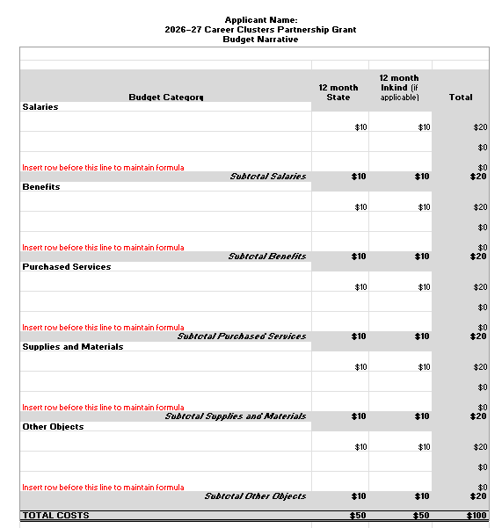

Request for Taxpayer Identification Number and Certification
Go to the IRS Web site for an easy-to-complete version of this form.
(To be completed by fiscal agent)
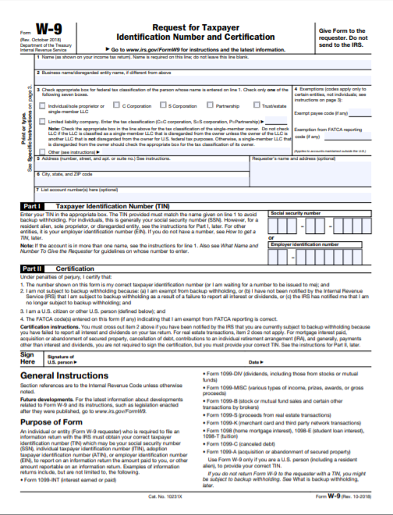

Partner Identification and Funding Request Form

Name of Applicant:
Name of Program:

Include a Partnership Identification Form for each partner institution/organization.

Name of Partner Institution
Type of Institution/Organization
Primary Contact Information
Name
Title
Complete Address
Telephone |  | Fax
Email

List only the funding this partner will receive from the grant.

Direct Cost Requested for Partner | TOTAL
1. Salaries & Wages (Professional and Clerical)
2. Employee Benefits
3. Travel In-State
4. Travel Out-of-State
5. Materials and Supplies
6. Consultants and Contracts
7. Teacher Stipends
8. Equipment (Purchase)
9. Other (Equipment Rental, Printing, etc.)
Total Funding to Partner from Grant

By signing below, I authorize this agency to participate in this grant program, and I certify that the agency is committed to completing the services described above and will apply the funds outlined in the budget above to these services.

Signature of Authorized Official Date

Printed Name of Authorized Official

Appendix D: Additional Information

Proviso 1A.27 Career Cluster Industry Partnerships
H. 5126 General Appropriations Bill 2026-27

1A.27. (SDE-EIA: Career Cluster Industry Partnerships) From the funds appropriated to the Department of Education, $800,000 must be provided as direct grants to the private sector statewide trade association or educational foundation providing nationally certified programs in career and technology education representing the automotive, construction, engineering, healthcare, mechanical contracting/construction, and hospitality tourism career clusters. Organizations applying for a grant must do so by July thirty-first and the Department of Education must award a minimum of one grant of at least $150,000 in at least four of these specified career clusters to be used exclusively for career and technology education. The recipient industry organization must conduct end-of-course exams graded by a national industry organization and must include in their grant request how the money will be spent in direct support of students to further industry-specific career technology education; a description and history of their program nationally and within South Carolina; estimates of future employment growth in their industry; and the national scope of their program. By August first of the following year, the organization must submit to the department a report detailing how the grant increased industry/employer awareness; the number of increased schools using the industry-based curriculum and partnered with the industry organization; the increased number of students in the program; and an overview and analysis of the organization's statewide student competition. The grant must be used for career awareness programs for that industry cluster; statewide student competitions leading to national competitions; teacher development and training; post-secondary scholarships in industry-specific degree programs; student recruitment into that career cluster programs; programs to educate middle and high school Career or Guidance Counselors about the industry; service to disadvantaged youth; and administering business/employer awareness and partnerships which help lead to experience-based, career-oriented experiences including internships, apprenticeships, mentoring, co-op education and service learning. The Office of Career and Technology Education of the department will develop goals with each career cluster on the number of new schools using the industry-based curriculum and partnered with that career cluster organization. These funds may not be used to supplant or replace, in whole or in part, other existing resources/assets sourced outside the present grant being used to provide the same services or programs. Organizations may carry-over grants for up to three years when a large project is identified in the grant application to be used at a future date; otherwise excess funds must be returned to the state. Organizations awarded must submit a semi-annual programmatic and financial report on the last day of December in addition to the final report due August first that has been audited by a third party accounting firm.

