Request for Proposals (RFP)
Application Package

2025-26 State Abstinence Until Marriage—Evidence-Based Programs
Discretionary Grant

The 2025-26 State Abstinence Until Marriage—Evidence-Based Programs is a grant program funded by the General Assembly of the state of South Carolina, authorized by the General Appropriations Act, Proviso 1.97, and administered by the South Carolina Department of Education.

Deadline for Receipt of Applications: July 15, 2025, at 4:30 p.m.

Technical Assistance for Applicants: June 12, 2025, at 2:00 p.m.

For questions about this program, contact:
Alexandria Cousar, Education Associate for the Office of Student Support, SCSRAE@ed.sc.gov

Issued by:
South Carolina Department of Education
Office of Student Support
849 Learning Lane
West Columbia, SC 29172-3171

TABLE OF CONTENTS
PART I: General Information 1
A. Introduction and Purpose 1
B. Eligible Applicants 2
C. Competitive Priority 2
D. Timeline of Granting Process 2
E. Technical Assistance Sessions for Applicants 2
F. Statutory and State Requirements 3
G. Authorized Activities 5
H. Unauthorized Activities 5
I. Program Accountability and Monitoring 6
J. Fiscal Operations 9
K. Review and Selection Process 9
L. Appeals Process 10

PART II: Application Overview, Content, and Instructions 12
A. Application Overview 12
B. Application Narrative Format 13
C. Online Application Submission 13
D. Program Abstract 13
E. Application Narrative Content 14
F. Application Budget 15
G. Appendices 17
H. Deadline and Submission Procedures 19
I. Screenshots of Online Application Submission Forms 19

Appendix A: Definitions of Terms Used 25

Appendix B: Selection Criteria and Reviewers’ Scoring Rubric 26

Appendix C: Required SCDE Forms 31
Certification Signature Page 31
Assurances and Terms and Conditions for State Awards 32
Program-Specific Assurances 36
Budget Narrative Template 37
Request for Taxpayer Identification Number and Certification 38

PART I: General Information

Introduction and Purpose

In 2024, the South Carolina General Assembly began allocating funds to the South Carolina Department of Education (SCDE) for the Abstinence-Until-Marriage Evidence-Based Programs. The SCDE administers these funds in accordance with the following legislative proviso:

1.97. (SDE: Abstinence Until Marriage Evidence-Based Programs Funding)
From the monies appropriated for the Continuation of Teen Pregnancy Prevention, grants must be awarded to separate private, nonprofit 501(c)(3) entities to provide Abstinence-Until-Marriage teen pregnancy prevention programs and services within the State that meet all of the A-H Title V, Section 510 definitions of Abstinence Education, as defined in the 2017 Social Security Act. Grants must be awarded utilizing a competitive grant process. Proposed programs/curricula must be certified by the National Abstinence Education Association (NAEA) as meeting and being in compliance with all of the Title V, Section 510 A-H requirement for abstinence-until-marriage education programs. Applicants must provide a budget for the proposed project for which the application is being made. Monies will be paid over a twelve month basis for services rendered. Unexpended funds shall be carried forward for the purpose of fulfilling the department's grant award notification. The programs implemented by the entity awarded a grant pursuant to this proviso may not violate any portion of the South Carolina Comprehensive Health Education Act when implemented in a school setting. An entity that violates any portion of the South Carolina Comprehensive Health Education Act must reimburse the State for all funds disbursed.

The SCDE solicits proposals from non-profit organizations that can document their capacity to implement Evidence-based programs that promote abstinence-until-marriage program services for youth ages 10-19 in priority areas of the state (see page 2).

Evidence-based programs are interventions, strategies, approaches, and/or program models that have been evaluated using rigorous evaluation design such as randomized controlled or high-quality quasi-experimental trials and that have demonstrated positive impacts for youth, families, and communities.

Approximately $546,972 will be available for new grants in this 2025-26 funding cycle, contingent on the approval of the General Appropriations Act of 2025-26. The SCDE anticipates awarding more than one grant. The award amount will be determined based on the quality of applications received and total funding requested. The final budget may be negotiated based on demonstrated needs. The maximum grant period is one (1) year, July 1, 2025, through June 30, 2026, and is subject to the availability of state funds and the funded project(s) meeting all State Abstinence Until Marriage – Evidence-Based Programs grant program requirements.

Grantees will be issued a grant award document; grantees are not permitted to pick up their reimbursements from the SCDE office. Funds will be disbursed on a reimbursement basis upon the receipt of expenditure reports with all supporting documentation. Applicants should have at their disposal at least three months of sustainable funds to implement the program prior to SCDE reimbursement. No expenditures obligated or incurred prior to July 1, 2025, will be reimbursed.

Eligible Applicants

An eligible applicant is a non-profit 501(c)(3) organization that demonstrates a minimum of a three (3) year documented history of providing abstinence until-marriage program services using the evidence-based curricula for which funding is being applied as outlined in the scope of grant proposal. The applicant’s proposed program curricula and services must meet all A-H Title V, Section 510 definitions of Abstinence Education, as defined in the 2017 Social Security Act (Section 510 of the Social Security Act (42 U.S.C. § 710), as amended by Section 50502 of the Bipartisan Budget Act of 2018, Public Law (Pub. L.) No. 115-123, and extended by the CARES Act, 2020 (Pub. L. No. 116-136)), and must be certified by the National Abstinence Education Association.

Competitive Priority

Competitive Priority points will be given to programs that propose to provide services in one or more of the twenty counties in SC with the highest teen pregnancy rates for age group 15-19. Applications proposing to serve one or more of the identified counties will receive an additional five (5) points.

Marlboro  Jasper  Colleton  Hampton  Dillon | Marion  Chester  Union  Barnwell  Cherokee | Lee  Laurens  Saluda  Chesterfield  Sumter | Florence  Allendale  Darlington  Greenwood  Clarendon

Applicants must include in their attachments a signed Memorandum of Agreement from their proposed partner(s) that states the partner’s location in one or more of these counties and provides an overview of the partner’s participation in the proposed program (see page 18).

Timeline of Granting Process

June 12, 2025 | Pre-application technical assistance session
July 15, 2025 | Deadline for receipt of application
August 2025 | Notification of awards; new grantee technical assistance session
July 1, 2025 | Funding period begins; projects can begin
June 30, 2026 | Funding period ends: projects must end
July 30, 2026 | Final report(s) due to the SCDE

Technical Assistance Sessions for Applicants

The Office of Student Support will offer a pre-application technical assistance session via Microsoft Teams on June 12, 2025, from 2:00 pm until 3:30 pm. Please use this Microsoft Teams link to register for the webinar. Participants will be able to log in 15 minutes prior to the start of the session to test their equipment’s audio settings. While participation is not mandatory in order to submit an application, it is highly recommended.

Statutory and State Requirements

In accordance with General Appropriations Bill 2025-26, H. Proviso 1.97, the State Abstinence Until Marriage – Evidence-Based Programs grant program has the following requirements.

    - Applicants must provide a budget and budget narrative to the SCDE that explains how the funds will be used. A budget summary and budget narrative are required for this application (see pages 15–17).
    - Prior to application, the proposed programs/curricula must be certified by Ascend as being curricula with research of effectiveness. The proposed programs/curricula must also be compliant with all of the Title V, Section 510(b)(2) A-H requirements for abstinence-until-marriage education programs.
    - The programs implemented by the entity awarded a grant may not violate any portion of the South Carolina Comprehensive Health Education Act when implemented in a school setting. An entity that violates any portion of the South Carolina Comprehensive Health Education Act must reimburse the State for all funds disbursed. All curriculum to be implemented in public schools must be approved by the school district in accordance with the South Carolina Comprehensive Health Education Act. Section 59-32-30 (B) directs the local school board to appoint a 13-member local advisory committee “consisting of two parents, three clergy, two health professionals, two teachers, two students, one being the president of the student body of a high school, and two other persons not employed by the local school district” to “assist in the selection of components and curriculum materials.”
    - Organizations awarded grants must provide quarterly reports on expenditures and participation to the SCDE within forty days of the end of each quarter.
    - Grantees failing to submit reports within forty days of the end of each quarter will be terminated.

Curricula to be used must meet all Title V, Section 510 (b)(2) A-H definitions, of the 2017 Social Security Act (42 U.S.C. §710) and must be certified by the National Abstinence Education Association (NAEA) as meeting and being in compliance with all of the Title V, Section 510(b)(2) A-H requirements for abstinence-until-marriage education programs.
- Ensure that programs planned with these funds do not contradict federal A-H guidelines as defined by Section 510(b)(2) of the 2017 Social Security Act, which states that the term “abstinence education” means an educational or motivational program which
  - Has as its exclusive purpose, teaching the social, psychological, and health gains to be realized by abstaining from sexual activity;
  - Teaches abstinence from sexual activity outside marriage as the expected standard for all school age children;
  - Teaches that abstinence from sexual activity is the only certain way to avoid out-of-wedlock pregnancy, sexually transmitted diseases, and other associated health problems;
  - Teaches that a mutually faithful monogamous relationship in context of marriage is the expected standard of human sexual activity;
  - Teaches that sexual activity outside of the context of marriage is likely to have harmful psychological and physical effects;
  - Teaches that bearing children out-of-wedlock is likely to have harmful consequences for the child, the child’s parents, and society;
  - Teaches young people how to reject sexual advances and how alcohol and drug use increases vulnerability to sexual advances; and
  - Teaches the importance of attaining self-sufficiency before engaging in sexual activity.

All curriculum to be implemented in public schools must be approved by the school district in accordance with the South Carolina Comprehensive Health Education Act. Section 59-32-30 (B) directs the local school board to appoint a 13-member local advisory committee “consisting of two parents, three clergy, two health professionals, two teachers, two students, one being the president of the student body of a high school, and two other persons not employed by the local school district” to “assist in the selection of components and curriculum materials.” See page 18 for instructions on providing the requirements for school-based activities.

  - State Goal and Performance Measures:
The overall goals of SC Abstinence Until Marriage Evidence-Based Programs are to decrease teen birth rates and teen HIV/STI rates in South Carolina by
- providing support for school or community-based, evidence-based, medically accurate, abstinence programs; and
- providing support for evidence–based mentoring, counseling, and adult supervision programs using positive youth development strategies designed to delay the initiation of sexual behavior among youth ages 10-19 residing in priority areas of the state.
The program aims to increase the proportion of adolescents postponing sexual activity to prevent teen pregnancy, teen births, and STIs. The program also aims to increase adult/community support for adolescents to delay sexual activity.

State-funded Abstinence Education Performance Measures for FY 2024-25:
- By June 30, 2026, a minimum of 400 SC youth, ages 10-19, will complete an SC Abstinence Until Marriage program in either a community, faith-based or school setting.
- By June 30, 2026, a minimum of 250 adults will have received information on SC Abstinence Until Marriage programs and techniques to assist in effectively communicating with youth on sexual health topics.

This grant funding is intended to contribute to the achievement of the state’s performance measures listed above.

Other State Requirements
Applicants must review the Assurances and Terms and Conditions for State Awards (on pages 32–35) and the Program-Specific Assurances (page 36) to ensure that, if awarded a grant, they are capable of full compliance, especially with all the referenced federal regulations and state laws, in order to enter into an agreement with the SCDE for this program. Pursuant to S.C. Code Ann. §8-13-700 (Supp. 2024) the applicant must disclose any potential conflict of interest to the SCDE in accordance with the SC Ethics Reform Act conflict of interest policy. A signed Certification Signature Page (see page 31) is required with the grant application and legally binds the applicant to the agency’s Assurances and Terms and Conditions.

All applicants must obtain a unique entity identifier (UEI) from the federal System for Award Management (SAM). The applicant must include a valid UEI in the online application. For assistance and more information, see the Federal Service Desk frequently asked questions. This requirement applies to all the SCDE’s state grants.

Authorized Activities

The successful applicants awarded under this grant competition will:
- Develop and submit a detailed program description and implementation plan with twelve-month goals and twelve-month objectives and activities. The plan must demonstrate the applicant organization’s ability to provide Abstinence Until Marriage education and/or mentoring programs to youth ages 10-19 in priority areas in the state as identified in the table on page 2.
- Provide educational programs for youth that are developmentally appropriate for the intended audience
- Ensure that all educational materials that are developed for use in the program are medically accurate.
- For school-based programs, provide letters of support from local school superintendents or other designated school contacts, if applicable. The letter from the local school superintendent should indicate when the local advisory committee will meet regarding the applicant’s proposed curriculum, per the South Carolina Comprehensive Health Education Act.
- For community and/or faith-based efforts, provide letters of support from key stakeholders of youth-serving organizations, if applicable.
- Ensure that programs planned with these funds do not contradict federal A-H guidelines as defined by Section 510(b)(2) of the 2017 Social Security Act (see pages 3-4).
- Use curricula and supporting materials that have evidence to support that they are effective for the chosen target population.
- Ensure that programs do not violate any portion of the SC Comprehensive Health Education Act when implemented in a school setting.
- Participate in the statewide Abstinence Until Marriage evaluation process by submission of demographic and implementation data on a monthly basis (i.e., attendance roster, pre and post surveys).
- Ensure that the SCDE’s Assurances and Terms and Conditions for State Grants and Program-Specific Assurances are followed during implementation of programs (pages 32–36) and the period of record retention.

Unauthorized Activities

Grant funds may not be used to purchase equipment (items with a value of $5,000 or more per unit); for construction projects, travel, or participant fees, to support political or religious activities, or for marketing or recruitment activities designed to promote the grantee or its programs to parents or the community. Funds must not be used in violation of any portion of the SC Comprehensive Health Education Act when implemented in a school setting. Indirect costs are not allowable. All funds must be expended in accordance with the approved grant budget.

Program Accountability and Monitoring

The SCDE is responsible for monitoring the State Abstinence Until Marriage – Evidence-Based Programs Grant implementation in accordance with the following program accountability requirements:
- Each recipient receiving funds through this RFP meets the eligibility requirements for the grant described herein, and the applicant has provided all required assurances that it will comply with all program implementation and reporting requirements established through this RFP.
- Each recipient receiving funds through this RFP appropriately uses these funds as described in this application package.
- Each recipient implements activities funded through this application within the timeline in which the funds provided are to be used.

Applicants may be subjected to an evaluation of their financial system, internal controls processes, and policies and procedures by the SCDE’s Office of Auditing Services before a grant award is issued or during the grant term. Visit the Office of Auditing Services to access the review process and procedures.

All applicants must complete the required Pre-Award Audit Questionnaire form located at https://scde.formstack.com/forms/pre_award_audit_oss. See page 19 for more information.

Applicants awarded grant funds must satisfy periodic reporting and accountability requirements throughout the term of the grant. These requirements address: (1) program accountability; (2) performance reporting; (3) annual budget; (4) monitoring; (5) program evaluation; and (6) technical assistance.
    - Program Accountability
Each grantee is responsible for carrying out its responsibilities in accordance with Proviso 1.100 of the 2024-25 SC General Appropriations Act; Section 510 of the Social Security Act (42 U.S.C. § 710), as amended by Section 50502 of the Bipartisan Budget Act of 2018, Public Law (Pub. L.) No. 115-123, and extended by the CARES Act, 2020 (Pub. L. No. 116-136); all applicable statutes, regulations, and programmatic guidance; and its approved grant application, grant budget, and work plan. Grantees are also required to submit periodic reports to the SCDE to report on the use of grant funds and the progress of grant activities.

    - Performance Reporting
Performance reporting requirements include those for both programmatic reporting and fiscal reporting. The subgrantee is responsible for ensuring that all required performance reports are accurate, complete, and submitted on time.
Programmatic Reporting Requirements
The following is required of all grant recipients, and these requirements are to be reported in the final report in the period the activity occurred:
- demographic of the students served,
- dosage each student received,
- statistics on parental involvement,
- number of activities and number of participants in individual activities.
Grantees will receive full details on all reporting requirements at the post-award training.

Fiscal Reporting Requirements
All expenditure reports must be submitted through the SCDE’s grants accounting processing system (GAPS) along with an email of the report to the program office. GAPS training and program office reporting will be provided to subgrantees during the subgrantee award meeting. Submission of expenditure reports will be accepted monthly but is required at least quarterly throughout the subgrant award period (see the following table). Subgrantees must submit a final fiscal report to the SCDE that covers the duration of the subgrant award.

The expenditure reporting due dates for the State Abstinence Until Marriage – Evidence-Based Programs Grant are:
- All expenditure reports must be submitted through the SCDE’s grants accounting processing system (GAPS). GAPS training will be provided during the subgrantee award meeting. Submission of expenditure reports will be accepted monthly but is required at least quarterly throughout the subgrant award period (see the following table).

- In addition to the GAPS submission, subgrantees will be required to submit a Reimbursement Report to SCDE by the same reporting due dates. The final reports will be due October 29, 2026.

- Subgrantees are responsible for ensuring that reports are accurate, complete, and submitted on time. Subgrantees must submit a final fiscal report to the SCDE that covers the duration of the subgrant award.

The expenditure report and reimbursement report due dates are as follows:
Reporting Period | Report Due Date
July 1–September 30 | October 15
October 1–December 31 | January 15
January 1–March 31 | April 15
April 1–June 30 | July 15
Note: The SCDE requests that grantees provide quarterly reports on expenditures and participation within 15 days of the end of each quarter. Per Proviso 1.96(G), grantees failing to submit reports within 40 days of the end of each quarter will be terminated.

    - Budget
A budget of projected expenditures to be funded by the grant must be submitted with the application. Approved budgets must be uploaded into GAPS by grantees after the receipt of the grant award notification and prior to submitting any reimbursement requests.

    - Monitoring
The SCDE will monitor grantees by reviewing and approving the progress reports and annual performance reports. All information in monitoring reports is subject to verification.

The SCDE may conduct programmatic and financial monitoring site visits. Grantees must agree to site visits conducted by the SCDE or other state program representatives. The purpose of site visits is to validate information provided in fiscal and program reports and to gather more detailed information on implementation efforts and challenges from interviews and observations for monitoring and evaluation purposes.

The SCDE may require additional information from the grantee, verify information with the authorizing agency, or require the submission of additional documentation including, but not limited to, invoices, receipts, and personnel time and effort reports. Prior to a site visit, the grantee may be required to submit additional relevant information that will allow the SCDE to conduct a useful, efficient, and effective visit. The SCDE may require electronic submission of documents instead of a paper-copy submission.

SCDE staff will verify the contents of documentation submitted. Grantee may be asked to revise reports when
- non-allowable expenses are found;
- reports are confusing or difficult to understand; or
- there are unexplained discrepancies between the proposed use of grant funds, as provided in the annual budget, and actual expenditures found in the submitted documentation.

    - Program Evaluation
Grantee Project Monitoring and Evaluation
Grantees are required to conduct ongoing monitoring and evaluation to ensure project goals are achieved. While hiring an external monitoring and evaluation contractor is not required, it is also not prohibited. Progress toward meeting project goals is to be reported through the annual progress review process.

A final project evaluation report is to be completed before the end of the grant period. The final evaluation report must address project success toward each goal stated in the application. If a grantee fails to conduct the final project evaluation report before the end of the grant period, or if any of the performance requirements in section I.2 are not completed, the SCDE may consider the grantee a high risk and elect to discontinue funding or disqualify the grantee from future funding opportunities.

    - Technical Assistance to Grantees
Grantees are required to participate in any technical assistance that the SCDE may conduct for the State Abstinence Until Marriage – Evidence-Based Programs Grant Program grant. Delivery of such technical assistance may include in-person meetings, webinars and conference calls.

Fiscal Operations

Grantees must use grant funds for allowable grant expenditures during the grant period. State Abstinence Until Marriage – Evidence-Based Programs Grant Program grant funds are disbursed on a reimbursement basis. Indirect costs are not allowed. Matching or in-kind funds are not required; however, matching and in-kind funds are an indicator of potential long-term sustainability of a State Abstinence Until Marriage program.

Allowable Costs
Grants must be used in accordance with statutory and regulatory requirements.

Unallowable Costs
Grantees may not use State Abstinence Until Marriage – Evidence-Based Programs grant funds for any costs that provide for any unauthorized activities described in Section H (see pages 5–6), including new construction or renovation or purchases that do not directly support the approved work plan and approved budget.

Review and Selection Process

Only those grant applications that are received by the deadline and deemed complete will be forwarded for review and funding consideration. All required materials including forms and appendices must be submitted for the application to be considered complete and eligible for review. Program staff will conduct an initial review of applications for completeness and compliance with the RFP instructions. No incomplete applications will be forwarded to the selected reviewers or considered for funding.

Three reviewers without a vested interest in any applicant being funded will evaluate each application based on the quality of the proposed activities and the capability of the applicant to implement the proposed project. The review team will be comprised of experienced grant readers from various professions and entities, including the SCDE.

Reviewers will use the scoring rubric on pages 26–30 to read and score each application independently. After the three reviewers have individually rated each application, the scores will be averaged. An application can earn up to 100 points for an average score.

Competitive priority points will be assigned by an impartial designee, added to the application’s average score, and be awarded only once per application to determine a final total score. A maximum of five (5) competitive priority points may be awarded for applications that meet the specific competitive priorities as presented on page 2.

Applications will be ranked by averaged scores. Subject to the SCDE’s final approval, the availability of state funds, geographic equity, and the inclusion of priority programming, grant awards will be made starting with applications that earned an average score of 80 points or higher. To the extent practical, the SCDE will award grants among geographic regions within the state to include rural and urban communities. If funds remain following these awards, the SCDE will consider funding remaining applications that earned an average score within the adequate/meets range until all funds are allocated.

Before final award decisions are made, applicants who previously received State Abstinence Until Marriage – Evidence-Based Program Grant funding from SCDE will be subject to a review of historical data (including financial data for evidence of timely submission and accuracy of budgets, expenditure reports, amendment requests, and supporting documents) to confirm compliance and performance during the previous grant periods. The SCDE will also consider progress in achieving the objectives as set forth in the previously funded applications and reported in the annual progress reports; the effectiveness of the funded project in meeting the purposes of the State Abstinence Until Marriage – Evidence-Based Program Grant as reported in the annual progress reports; and the reported ability to sustain work supported by previous funding. The SCDE reserves the right to not grant an award if the data review reveals that the applicant did not adhere to the previous grant’s guidelines or meet the project’s goals and objectives.

The SCDE reserves the right to reject any application from a nonresponsive or non-responsible applicant, regardless of score. A responsive applicant is one who
- has submitted an application that conforms in all material aspects to this RFP;
- demonstrates the present capability in all respects to perform fully the grant requirements; and
- has demonstrated by past performance the integrity and reliability which will assure good faith performance under an award made from this RFP.

The SCDE may base responsibility determinations on any available information, historical or contemporaneous, including information not contained in the applicant’s submission.

In addition, the SCDE reserves the right to negotiate final budgets and to disqualify costs associated with any line items that are unallowable, unallocable, unreasonable, or inconsistent with the program’s goals or the proposed project’s activities and strategies.

Grant awards are not final until an SCDE grant award notice is fully executed. Notification of funding will be sent by August 2025 to the authorized official listed on the Certification Signature Page. After the notification of awards, copies of the reviewers’ comments and score sheets will be sent to the contact person identified in the online application.

Appeals Process

An applicant who has submitted a proposal that the SCDE does not fund has 30 calendar days after receiving notification that the proposal is not funded to request a review of the process. Scores may not be appealed; the SCDE will not rescore applications. An unfunded applicant may inquire as to whether or not the application process was followed. The request for review must be directed to the State Superintendent of Education and must state the reasons for the request. The Superintendent may delegate to a deputy superintendent the authority to conduct a review. The deputy superintendent will issue a decision after the review of the information submitted by the applicant and the program office. This decision will be the final decision of the agency. The applicant may appeal the agency’s decision to the Administrative Law Court under the terms of the Administrative Procedures Act.

PART II: Application Overview, Content, and Instructions

Read all guidelines and criteria carefully before preparing your application. Adhere to font, format, page limit, and organizational requirements. Only applications that include all sections and appendices and fully adhere to these guidelines will be reviewed and considered for funding. Incomplete applications will not be reviewed.

Application Overview

Applicants are encouraged to prepare all of the following elements of the application before beginning the online submission process. Do not wait until the last minute to submit an application. Use the following overview as a checklist to ensure that the application is complete with items labeled accordingly and presented in the order outlined below. Verify that all narrative components and appendices are included prior to uploading attachments.

The State Abstinence Until Marriage – Evidence-Based Program Grant Program online application is organized into the following sections (also see the screenshots on pages 19-24):

Online Form
- Applicant Information
- Contact Information
  - Authorized Official Information
  - Contact Person Information
- Program Information
- Budget Summary
- Attachments
- Program Abstract
- Application Narrative
Table of Contents
  - Organizational History, Experience and Qualifications
  - Program Description
  - Implementation Plan with Goals and Objectives
  - Reporting and Evaluation
- Budget Narrative
- Appendices
  - Certification Signature Page (located in this RFP)
  - Request for Tax Identification Number and Certification (W-9)
  - Organization’s Board of Directors and officers
  - Résumés for Grant/Project Manager and Key Staff Members (if applicable)
  - Memorandums of Agreement from Collaborative Partners, if applicable
  - Letters of Support for School-based Activities, if applicable

Application Narrative Format

Length of Narrative: | Maximum of 25 pages, excluding a table of contents and the program abstract.
Required Font/Size: | Times New Roman or Arial/11 or 12.
Margins: | 1” on all sides.
Page Numbers: | Insert either top right or bottom right.
Spacing: | Double-spaced pages; may single-space charts and tables.
Final File Format: | PDF document.

Each section must be clearly identified. Sections may not be combined. Reviewers will not consider information requested in one section that is provided in another section. Incomplete proposals will not be considered.

Online Application Submission

Applications must be submitted using the online application. The online submission is organized into two sections—Online Forms and Proposal Attachments.

Provide the applicant’s Taxpayer Identification Number (TIN) in the application form. Applicants should contact their organization’s finance office if they need assistance with these items.

Use the following instructions to compile and complete all proposal attachments prior to submitting your application. Verify that all components of the narrative and appendices are included prior to uploading attachments. Follow the directions in each section for saving the documents and refer to the screenshot on page 22 for upload locations.

Program Abstract

In one page, concisely include the following information:
- A summary of the applicant’s ability to perform the services described in the application narrative and a statement that the applicant is willing to perform those services and enter into a grant agreement with SCDE.
- Service Area: The location of proposed program delivery with county/counties and zip codes(s).
- Curriculum: List of proposed curricula, version, and all support materials to be used for the project.
- Budget amount: requested amount.

When completed, save the summary as a single PDF document to be uploaded as an attachment in the online application (see page 22).

Application Narrative Content

Use the following directions to write the application narrative and organize it into sections following the sequence presented below. Include a table of contents as the first page of the narrative (not included in the page limit). Do not combine sections. Required components must be located in their designated sections in order to be scored.

When complete, save the entire narrative as a single PDF document to be uploaded into the online application where indicated in the proposal attachments section.

- Organizational History, Experience and Qualifications (maximum of 10 points)
- Describe the length of time the applicant organization has been in existence and its previous years of experience in serving youth. Include the number of years of experiences using the curriculum for which funding is being applied.
- List name and version of the curriculum to be used and describe all support materials to be used while implementing Abstinence Until Marriage and/or mentoring program.
- Provide a strong rationale for funding based on sustained and documented history of providing services to youth. Include prior grant performance, outcomes, and timely submission of reports.

- Program Description (maximum of 30 points)
- Describe the ability to begin provision of services within thirty (30) calendar days of grant execution.
- List and describe the abstinence education program to be provided with abstinence funds and how many youths will be served.
- Identify the selected Competitive Priority area, if applicable (see page 2).
- Describe the process to be used in providing the Abstinence Until Marriage education program to youth and describe the staffing needed to provide the services described. List the schools, faith-based, and/or other youth-serving community-based organizations with which your agency will collaborate. Explain how formal training is provided to educators on the program’s strategies, approaches, and interventions, including fidelity. This training must be delivered by professionals who can monitor performance and provide follow-up technical assistance.
- Describe the method of notifying parents of the youth to be served about the content to be provided and with the opportunity to preview the curriculum and exempt their children from the program if desired.
- Describe any training that educator staff will receive that involves understanding and responding to symptoms of chronic negative behavioral interactions and stress, as well as the behavioral and mental health consequences.

- Implementation Plan with Goals and Objectives (Maximum of 50 points)
- Describe how your program will provide abstinence education to youth populations that are high-risk or vulnerable for pregnancies or otherwise have special circumstances. Youth that are the most high-risk or vulnerable for pregnancies include underrepresented youth populations, youth in or aging out of foster care or adjudication systems, pregnant or parenting teens and runaway/homeless youth.
- Provide documentation of the evidence-base of the abstinence education program’s effectiveness for the chosen population. An evidence-based program is a program proven through rigorous evaluation to be effective at changing sexual risk-taking behavior among youth. There is a growing body of literature on effective interventions for reducing teen pregnancy. These interventions range in program models and target populations. Applicants must utilize an evidence-based approach that have demonstrated impacts on delaying initiation of sexual activity in teens. Applicants should select and implement programs with proven effectiveness for the target populations to be served. Higher points may be given to applicants using curricula with documentation of successfully demonstrating improved teen outcomes, which is based on research.
- Describe how harassment based on race, sexual orientation, gender, religion and national origin are prohibited.
- Describe services that any formal partners will be providing and their role towards accomplishing state objectives. Describe how your organization will collaborate with these partners while providing abstinence education and/or mentoring programs within the area to be served.
- Use SMART (Specific, Measurable, Achievable, Relevant and Timed) objectives to clearly define goals and objectives based on state’s performance objectives (page 4):
  - By June 30, 2026, a minimum of 400 youth, ages 10-19, will complete an SC Abstinence Until Marriage program in either a community, faith-based or school setting.
  - By June 30, 2026, a minimum of 250 adults will have received information on SC Abstinence Until Marriage programs and techniques to assist in effectively communicating with youth on sexual health topic.
- Describe any potential barriers or problems and how they will be addressed.

- Reporting and Evaluation (Maximum of 10 points)
  - Describe the experience the organization has in record keeping of when and how services are provided and evaluating programs to the target population.
  - Describe the system your organization will use to collect data on attendance, demographic information of youth served, unduplicated counts of youth and adults served, and success in demonstrating impacts on sexual behaviors of program participants. Include protocols and timelines for data collection.

Application Budget

While the budget is assigned 0 points, the budget is a critical component of the entire application. No application with an incomplete budget will be funded.

The application budget consists of two parts: the Budget Summary and the Budget Narrative. All proposed expenditures for the grant funding period must be itemized in the Budget Summary and detailed in the Budget Narrative. Budget items not explained in the application narrative (see pages 14–15 of this RFP) will not be funded.
Applicants must develop a twelve-month budget for July 1, 2025–June 30, 2026. The budget must clearly explain how the funds will be used.

Applicants must provide detailed narrative justifications for all planned expenditures by budget category. The justification must define all key program personnel by name, position title, qualifications (including education and experience), primary program function, linkage to one or more annual performance objectives, and percentage of time on the project. (see Attachment C for a sample budget summary form and instructions for completing narrative justification).

Describe how the organization will track program income, revenue, and expenditures.

- The Budget Summary is the financial overview of the grant and must include all proposed expenditures for the project. Each line item of the Budget Summary must correspond to the line items of the Budget Narrative (discussed below). Provide the budget details for July 1, 2025–June 30, 2026, in the online application Budget Summary section (see screenshot on page 22).
- The Budget Narrative must provide clear evidence that the budget is appropriate and justified based on the needs assessment. Use an Excel spreadsheet to provide a detailed Budget Narrative that includes estimates for matching funds and in-kind contributions, if applicable. A budget template is available; see page 37. Structure the Budget Narrative line-item categories to parallel the line-item categories of the Budget Summary. Include all formulas used to calculate each line-item expense. This narrative must show that all expenditures are allowable, reasonable, and allocable; are adequate to support the project's activities; and directly connect to the goals in the application/proposal narrative. When finalized, save the Budget Narrative as an Excel spreadsheet to be uploaded into the online application where indicated. Ensure that the totals in the Budget Summary equal the totals in the Budget Narrative.

The following describes the line items that should be budgeted in each category.

Salaries/Stipends (100)
This category includes pay for salaries for staff members and substitutes and stipends for teachers. The total percentage of time charged to the grant and to non-grant funds cannot exceed 100 percent of the total time worked by any staff member.

Employee Benefits (200)
FICA, workers’ compensation, health insurance, and other employee benefits costs should be included here. These costs will represent a percentage of the total in Salaries/Stipends (100).

Purchased Services (300)
Expenses such as consultant fees, travel/transportation costs, telephone costs, and other purchased services will be included here. This includes amounts paid for personal services rendered by personnel who are not on the payroll and for other specialized services purchased by the organization. While a product may or may not result from the transaction, the primary reason for the purchase is the service provided. Note: Salaries for direct teachers and project staff should be recorded in Salaries/Stipends (100) and not in this section.
For a grantee to pay a vendor with grant funds, a contract must be in place. At a minimum, the contract should include the scope of services, the duration of the contract, and the method and amount of payment; the contract must be fully executed by both parties. Consulting/service contracts must be procured in accordance with South Carolina Procurement Law.

Grantees must ensure that they do not enter into a contract with any vendor that is debarred, suspended, or ineligible (i.e., excluded) for participation in programs by
- checking the Exclusions at the federal SAM Web site (review the Quick Start Guide for Searching Exclusions, available here, prior to conducting searches.);
- collecting a certification from the vendor and attaching it to the contract; or
- adding a clause or condition to the contract that indicates the vendor is eligible.

Supplies and Materials (400)
Include the amounts paid for material items of an expendable nature. It is recommended that applicants group items into categories to avoid listing every item; however, make sure that such expenditures are aligned with relevant project characteristics (objectives, number of participants, frequency of activity, etc.). Allow for maintenance, repair, and replacement costs over the grant life cycle of the proposed project for any equipment that totals $5,000 and below.

Capital Outlay/Equipment (500)
Equipment and supplies totaling more than $5,000 per unit are not allowable (see part I, section H). Itemize furniture, fixtures and equipment that total $5,000 and below per unit under Supplies and Materials.

Other Objects (600)
This category includes expenditures such as postage, liability insurance fees, and copyright fees that do not neatly fit into the other categories.

Indirect Costs (700)
Indirect costs are not allowed.

The SCDE reserves the right to disqualify, disallow, and negotiate costs associated with any line item proposed in the budget. If any line item cost is determined to be excessive, given the nature and scope of the entire project or of a particular activity, the SCDE can request the applicant reduce the cost of the line item or ask the applicant to assume a portion of the cost before the budget is approved and funds are awarded.

Appendices

All items of the appendices must be scanned into a single PDF document to be uploaded into the online application where indicated on page 22.

Certification Signature Page
Print the Certification Signature Page (see page 31) and obtain the appropriate signatures. This form includes the certification of the SCDE’s Assurances and Terms and Conditions for State Awards and any applicable program-related conditions conveyed in this RFP. Those documents are not required to be included in the applicant’s proposal submission. However, retain the copy included in this RFP for your records and ensure that the signatories and partner organizations have copies of each document.

By signing the Certification Signature Page, the signatories assure that they will comply with all the assurance and terms and conditions for the project/program. All signatories must understand that they are signing a document that is legally binding in the event a grant is awarded. Applications that do not include the signed Certification Signature Page will not be reviewed or considered for funding.

Request for Taxpayer Identification Number and Certification (W-9)
Complete the W-9 Request for Taxpayer Identification Number and Certification form (sample located on page 38) for the primary applicant organization for inclusion in the application attachments.

Certificate of Existence
Provide a current Certificate of Existence, also known as a Certificate of Good Standing, from the South Carolina Secretary of State. This certificate states that an entity is in good standing with the Secretary of State’s Office, and has, to the best of the Secretary of State’s knowledge, filed all required tax returns with the Department of Revenue. The Certificate can be requested through the Business Entities Online Document Request system (https://businessfilings.sc.gov/businessfiling)
Résumés of Project Director/Grant Manager and Key Personnel
Include a résumé or vita for the project director/grant manager. For any other key personnel to be involved in this program, include a résumé, vita, or a paragraph summary.

Memorandums of Agreement, if applicable
Include a copy of all memorandums of agreement (MOAs) for the proposed program. The MOA must articulate the role, scope of services, in-kind contributions, and funding to be provided by each collaborative partner. The authorized officials of each partnering organization must sign an MOA regarding the proposed partnership(s). Applicants and partners are urged to develop one clear, specific MOA when possible.

Requirements for School-based Activities, if applicable
For projects providing instruction in K-12 public schools, provide evidence that the curriculum has been approved pursuant to the South Carolina Comprehensive Health Education Act (see page 4) in the form of school board minutes, district website list showing approval, and letter from district superintendent or the district-level personnel who supervises the selection of curriculum, such as an assistant superintendent for curriculum or a director of curriculum. Letters must be current for the school year for which the organization is applying.
Pre-Award Audit Questionnaire
In addition to the appendix items, complete the applicable SCDE Pre-Award Audit Questionnaire Form. Do not submit any supporting documents with the application. The SCDE’s Office of Auditing Services will review the submission as part of the pre-award risk assessment and may conduct a further evaluation of the applicant’s financial system, internal controls, and policies and procedures.

Deadline and Submission Procedures

- Applications must be submitted online using the online application form before 4:30 p.m. on July 15, 2025.
- Only applications that adhere to all of the guidelines and directions set forth in this RFP will be reviewed and considered for funding.
- No hard copy applications will be accepted. Applications delivered by hand, postal mail, email, or fax will not be accepted.
- Applications must originate from the applicant. Applications that are plagiarized from the Internet, other grants, or other resources will not be considered for funding.
- Do not attach or submit any additional materials other than what is specifically required. Any additional materials will be disposed of without review.
- Applications will not be returned. Keep a copy of the entire application for your records.

Screenshots of Online Application Submission Forms

The following screenshots are for informational purposes only and are provided to assist applicants in compiling all items needed to complete the online submission. Complete the attachments for the online application as directed in the preceding instructions. The SCDE encourages applicants to prepare all parts of the application before beginning the online submission process.

Make sure all information submitted is accurate, including formal or official names such as the applicant organization, and that spelling is correct. Do not use abbreviations or acronyms. All fields marked with a red asterisk are required; you will not be able to proceed to the next screen of the application without entering all required information.

If necessary, you may save your progress in the online application and return to the form later. Click on the “Save and Resume Later” link to save your progress. You will be given the option of copying and saving the link to the partially completed form or entering an email address to have the link emailed to you. Be sure to enter the email address correctly as SCDE personnel cannot access the hyperlink or the incomplete application. Use the link to access the application from any computer within thirty days to complete the online submission. Without the link and password or after thirty days, the data previously entered cannot be retrieved, and you will have to begin a new application. A saved application is not a submitted application. You must follow all of the steps described on pages 22–24 to complete the submission process.
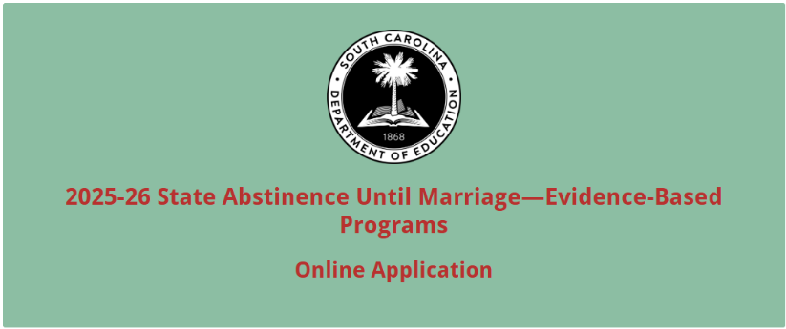

Enter the official name of the applicant organization. Enter the applicant organization’s physical address with the 10-digit ZIP Code (ZIP+4 Code), 12-character UEI, and TIN (tax identification number). Select the number of sites to be served.
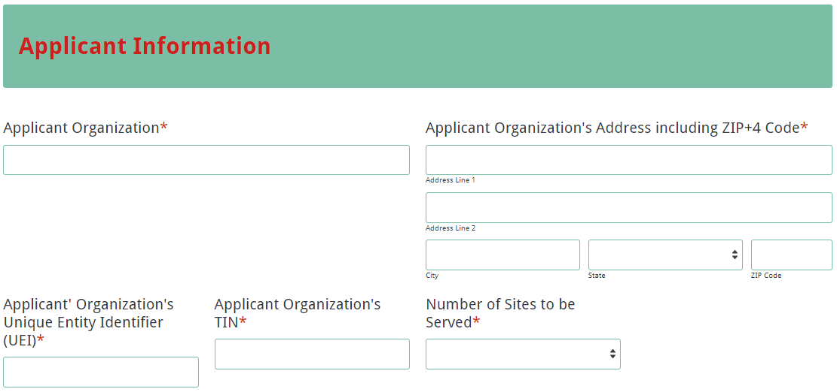

Enter contact information for the contact person. The name entered must match the name on the Certification Signature Page. The contact person’s email is a required field. The email confirmation of submission for the online application will be sent only to this email address. Reenter the email address to confirm that it is correct. Provide the name, phone number, and email address for the authorized official and finance executive.
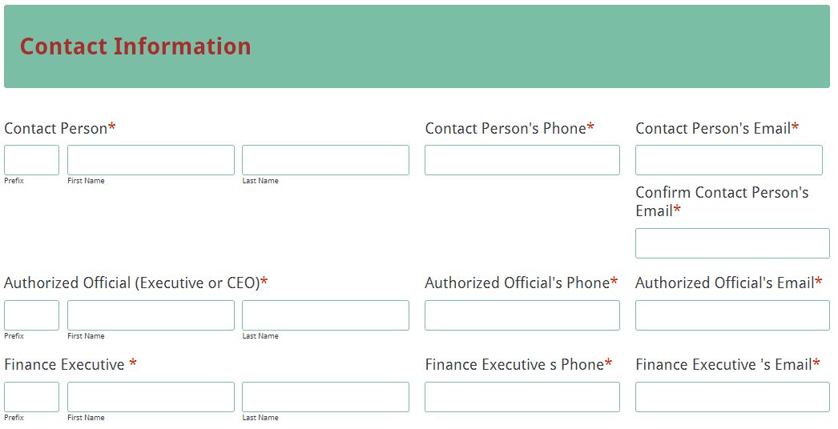

Based on the number of sites selected under the Applicant Information section, enter the site name, curriculum name, and the proposed number of students to be served for each site.
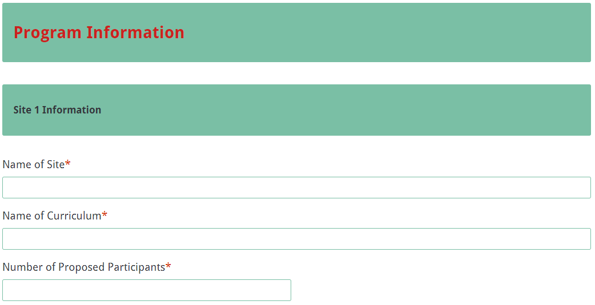

Enter the total amount of grant funds requested.
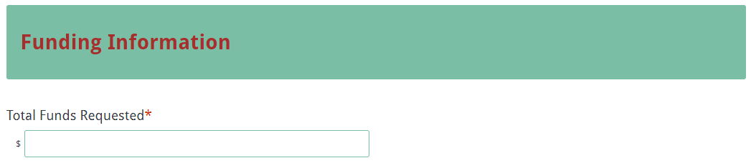

Complete the Budget Summary section using whole dollars (no cents). Fill in all fields and enter 0 (zero) for line items that are not applicable to the program. The total funds requested field will automatically calculate and populate. Ensure the total funds requested entered in the Funding Information section match the total funds requested in the Budget Summary.
Budget Summary Section
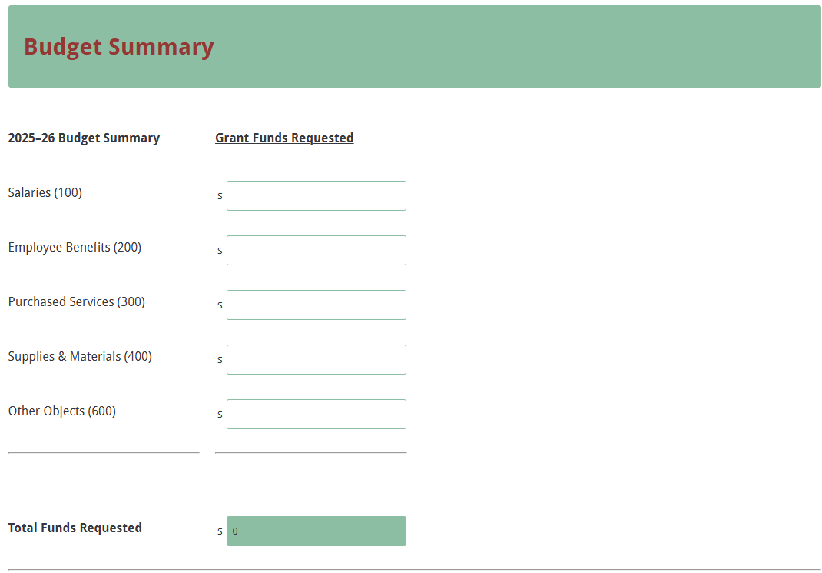
Upload the application attachments in the appropriate format following the instructions in the RFP; these attachments include the Program Abstract, Application Narrative, Budget Narrative, and Appendices. All attachments are required; you will not be able to submit the application without attaching all documents.
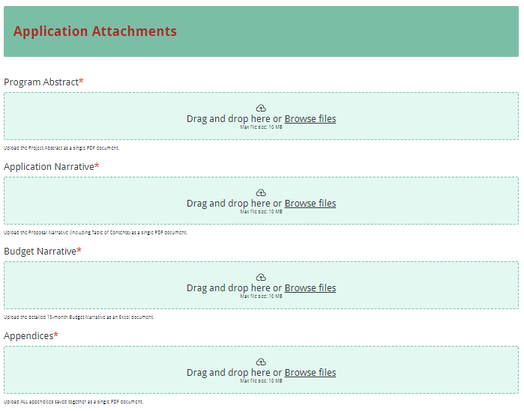

Thoroughly review the summary on the Data Review and Confirmation Page to verify that the information has been entered correctly in the online application prior to submitting. You will not be able to access the completed application form after it has been submitted. If any of the entries are incorrect, click on the "Previous" button at the bottom of each page to return to the appropriate section(s) and reenter the correct information.
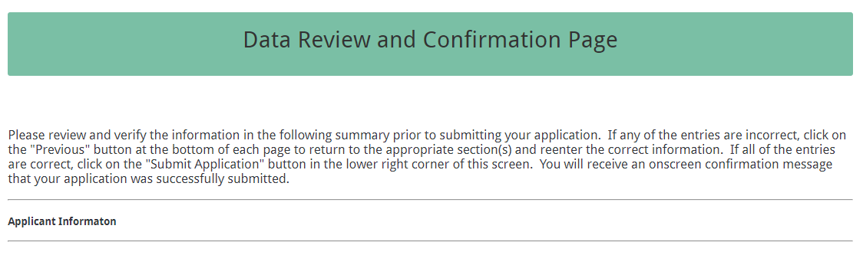

If all of the entries are correct, click on the “Submit Application” button in the lower right corner of this screen to complete the submission process.

Once the application is submitted, the following message will be displayed on the screen, and an email confirmation of submission will be sent to the email address provided for the contact person.
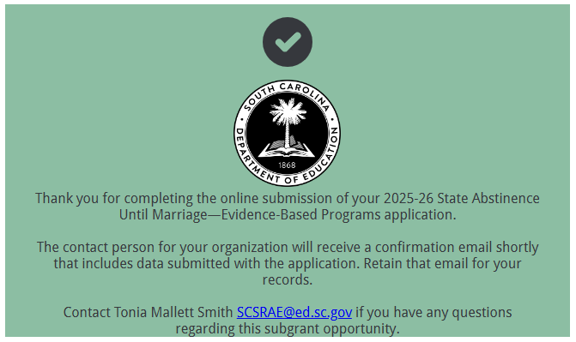

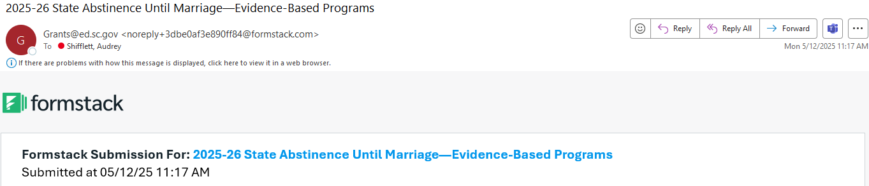

If the contact person does not receive a confirmation email, then the application did not successfully upload. You must go back and resubmit the entire online form, including all attachments, in order for your application to be considered for funding. Only the most recently submitted application will be reviewed.

An email confirmation that an application was successfully uploaded does not account for the quality of the uploaded documents or the completeness of the online form. The confirmation email only notifies you that your online application has been submitted. Applicants are responsible for ensuring that the information entered in the online form, including all attachments, is accurate and complete in order for the application to be reviewed and considered for funding.

Appendix A: Definitions of Terms Used

Collaborative Partner—An organization that provides routine, regular, and ongoing services to the project as outlined in a signed memorandum of agreement (e.g., the regular use of facilities and equipment, mentors/tutors). A collaborative partner plays a critical role in sustaining the project as grant funds decrease.

Evidence-Based—Interventions, strategies, approaches, and/or program models that have been evaluated using rigorous evaluation design such as randomized controlled or high-quality quasi-experimental trials and that have demonstrated positive impacts for youth, families, and communities.

Memorandum of Agreement (MOA)—A document signed by the authorized representative(s) of each collaborative partner that clearly specifies the role, services, contributions, expertise, and funding for each partner.

Appendix B: Selection Criteria and Reviewers’ Scoring Rubric

Selection Criteria

A total of 100 points is available to applications that meet the maximum score for each selection criteria. While the budget is assigned zero (0) points, the budget remains a critical component of the entire application. An application with an incomplete budget will not be funded.

The point values for each section of the application are as follows:
Narrative Sections | Points Available
Organizational History, Experience and Qualifications | 10
Program Description | 30
Implementation Plan with Goals and Objectives | 50
Reporting and Evaluation | 10
Budget (Summary and Narrative) | 0
TOTAL | 100

Scoring Rubric
Program Abstract: The applicant provides a project abstract in one page that includes the following:
- a summary of the applicant’s ability to perform the services described in the application and a statement that the applicant is willing to perform those services and enter into a grant agreement with SCDE,
- the location of proposed program delivery with county/counties and zip codes,
- a list of proposed curricula, version, and all support materials to be used for the project, and
- the requested Budget amount.
Acceptable
Adequate/Meets—0 points
Applicant provides a narrative that fully addresses all required items.
Not Acceptable
Inadequate—0 points
Applicant provides a narrative that does not adequately address all required items.
Score
Adequate/Meets ☐ Inadequate ☐
Reviewer’s Comments

1. Organizational History, Experience and Qualifications: The applicant must provide a narrative that:
- describes the length of time the applicant organization has been in existence and its previous years of experience in serving youth, including the number of years of experience using the curriculum for which funding is being applied;
- lists the name and version of the curriculum to be used and describes all support materials to be used while implementing Abstinence Until Marriage and/or mentoring program; and
- provides a strong rationale for funding based on sustained and documented history of providing services to youth, including prior grant performance, outcomes, and timely submission of reports.
Acceptable
Fully Meets—9–10 points
Applicant provides a statement that fully addresses all required items.
Adequate/Meets—7–8 points
Applicant provides a statement that moderately addresses all required items.
Not Acceptable
Limited/Approaches—4–6 points
Applicant provides a statement that is limited or unclear in addressing all required items.
Inadequate—0–3 points
Applicant provides a statement that does not adequately address all required items.
Score
Reviewer’s Comments

2. Program Description: The applicant must provide a narrative that:
- describes their ability to begin provision of services within thirty (30) calendar days of grant execution;
- lists and describes the abstinence education program to be provided with abstinence funds and how many youths will be served;
- describes the process to be used in providing the Abstinence Until Marriage education program to youth and describes the staffing needed to provide the services described,
- lists the schools, faith-based and/or other youth-serving community-based organizations with which your agency will collaborate, and
- explains how formal training is provided to educators on the program’s strategies, approaches, and interventions, including fidelity;
- describes the method of notifying parents of the youth to be served about the content to be provided and with the opportunity to preview the curriculum and exempt their children from the program if desired; and
- describes any training that educator staff will receive that involves understanding and responding to symptoms of chronic negative behavioral interactions and stress, as well as the behavioral and mental health consequences.
Acceptable
Fully Meets—25–30 points
Applicant provides a narrative that fully addresses all required items.
Adequate/Meets—20–24 points
Applicant provides a narrative that moderately addresses all required items.
Not Acceptable
Limited/Approaches—15–19 points
Applicant provides a narrative that is limited or unclear in addressing all required items.
Inadequate—0–14 points
Applicant provides a narrative that does not adequately address all required items.
Score
Reviewer’s Comments

3. Implementation Plan with Goals and Objectives: The applicant must provide a narrative that:
- describes how the program will provide abstinence education to youth populations that are high-risk or vulnerable for pregnancies or otherwise have special circumstances. Youth that are the most high-risk or vulnerable for pregnancies include underrepresented youth populations, youth in or aging out of foster care or adjudication systems, pregnant or parenting teens and runaway/homeless youth.
- describes how harassment based on race, sexual orientation, gender, religion and national origin are prohibited;
- describes services that any formal partners will be providing and their role towards accomplishing state objectives;
- describes how the organization will collaborate with these partners while providing abstinence education and/or mentoring programs within the area to be served;
- uses SMART (Specific, Measurable, Achievable, Relevant and Timed) objectives to clearly define goals and objectives based on state’s objectives:
  - By June 30, 2025, a minimum of 200 youth, ages 10-19, will complete an SC Abstinence Until Marriage program in either a community, faith-based or school setting.
  - By June 30, 2025, a minimum of 125 adults will have received information on SC Abstinence Until Marriage programs and techniques to assist in effectively communicating with youth on sexual health topic, and
- describes any potential barriers or problems and how they will be addressed.
Acceptable
Fully Meets—45–50 points
Applicant provides a narrative that fully describes all required items.
Adequate/Meets—39–49 points
Applicant provides a narrative that moderately describes all required items.
Not Acceptable
Limited/Approaches—21–38 points
Applicant provides a narrative that is limited or unclear in describing all required items.
Inadequate—0–20 points
Applicant provides a narrative that does not adequately describe the required items.
Score
Reviewer’s Comments

4. Reporting and Evaluation: The applicant must provide a narrative that:
- describes the experience the organization has in record keeping of when and how services are provided and evaluating programs to the target population; and
- describes the system the organization will use to collect data on attendance, demographic information of youth served, unduplicated counts of youth and adults served, and success in demonstrating impacts on sexual behaviors of program participants, including protocols and timelines for data collection.
Acceptable
Fully Meets—9–10 points
Applicant provides a narrative that fully describes all required items.
Adequate/Meets—7–8 points
Applicant provides a narrative that moderately describes all required items.
Not Acceptable
Limited/Approaches—4–6 points
Applicant provides a narrative that is limited or unclear in describing all required items.
Inadequate—0–3 points
Applicant provides a narrative that does not adequately describe the required items.
Score
Reviewer’s Comments

Budget Narrative: The applicant must provide a thorough and detailed budget narrative that
- provides clear evidence that the expenditures are appropriate, justified, reasonable, and adequate to complete the project; and
- includes the formulas used to calculate the cost for each line item.
Acceptable
Adequate/Meets—0 points
Applicant provides a budget narrative that provides all required items.
Not Acceptable
Inadequate—0 points
Applicant provides a budget narrative that did not provide all required items.
Score
Adequate/Meets ☐ Inadequate ☐
Reviewer’s Comments

Appendix C: Required SCDE Forms

Certification Signature Page
(This form must be signed by the individual from each proposed district, school, or organization who holds the title listed below.)

Certification
I hereby certify that, to the best of my knowledge, the information and data contained in this application are true and correct. The applicant’s governing body has duly authorized this application and documentation, and the applicant will comply with the Program Specific Assurances (see page 36) and the SCDE Assurances and Terms and Conditions if the grant is awarded. The applicant has an active unique entity identifier (UEI) in the federal System for Award Management (SAM).

Authorized Official (Executive Director or CEO of organization)
Name:
Position: | Email:
Telephone: | Fax:

Signature of Authorized Official: | Typed name of Authorized Official:
Date Signed:
Signature of Finance Executive: | Typed Name of Finance Executive:
Date Signed:
Signature of Contact Person: | Typed Name of Contact Person:
Date Signed:

Please complete, print, and obtain signatures prior to submission. Include the signed, scanned form in the required appendices as indicated on page 18.

Assurances and Terms and Conditions for State Awards

For informational purposes only
The applicant certifies to abide by the SCDE Assurances and Terms and Conditions by signing and submitting the Certification Signature Page.

Assurances
I certify that this applicant
- Has the legal authority to apply for state assistance and the institutional, managerial, and financial capability (including funds sufficient to pay the nonstate share of project costs) to ensure proper planning, management, and completion of the project described in this application.
- Will give the South Carolina Department of Education (SCDE) access to and the right to examine all records, books, papers, or documents related to this award and will establish a proper accounting system in accordance with generally accepted accounting principles (GAAP) or agency directives.
- Has an accounting system that includes sufficient internal controls, a clear audit trail, and written cost-allocation procedures as necessary. The financial management systems are capable of distinguishing expenditures that are attributable to this grant from those that are not attributable to this grant. This system is able to identify costs by programmatic year and by budget line item and to differentiate among direct, indirect, and administrative costs. In addition, the applicant will maintain adequate supporting documents for the expenditures and in-kind contributions, regardless of the type of funds, if any, that it makes under this grant. Costs are shown in books or records (e.g., disbursements ledger, journal, payroll register) and are supported by a source document such as a receipt, travel voucher, invoice, bill, or in-kind voucher.
- Will also comply with GAAP as it relates to budgets, budget amendments, and expenditure claim submissions.
- Will approve all expenditures, document receipt of goods and services, and record payments on the applicant’s accounting records prior to submission of reimbursement claims to the SCDE for costs related to this grant.
- Will initiate and complete work within the applicable time frame after receipt of approval by the SCDE.
- Will not discriminate against any employee or applicant for employment because of race, color, religion, age, sex, national origin, or disability. The applicant will take affirmative action to ensure that applicants for employment and the employees during the period of their employment are treated without regard to their race, color, religion, age, sex, national origin, or disability.
- Will comply with the Ethics, Government Accountability, and Campaign Reform Act (S.C. Code Ann. § 2-17-10 et seq. and § 8-13-100 et seq. (Supp. 2024)).
- Will comply with the Drug Free Workplace Act (S.C. Code Ann. § 44-107-10 et seq. (Supp. 2024)) if the amount of this award is $50,000 or more.
- Will comply with the requirements of Proviso 1.78, H. 4025, 126th Leg., 2nd Reg. Sess. (S.C. 2025), available at https://www.scstatehouse.gov/sess126_2025-2026/appropriations2025/crp1b.pdf.
- Will not use grant funds in a manner inconsistent with the South Carolina Department of Education (SCDE) guidance to districts and staff on federal education policy changes and terminology and data collection practices. Those documents are available at https://ed.sc.gov/newsroom/school-district-memoranda-archive/update-on-federal-education-policy-changes/update-on-federal-education-policy-changes-memo/ and https://ed.sc.gov/newsroom/guidance-regarding-terminology-and-data-collection-practices/.
- Will not use grant funds in a manner inconsistent with state regulations including Regulation 43-170. Guidance is available at https://ed.sc.gov/state-board/state-board-of-education/uniform-procedure-for-selection-or-reconsideration-of-instructional-materials/.

Terms and Conditions

- Completeness of Proposal. All proposals should be complete and carefully worded and must contain all of the information requested by the South Carolina Department of Education (SCDE). If you do not believe a section applies to your proposal, please indicate that fact.
- Non-awards/Termination. The SCDE reserves the right to reject any and all applications and to refuse to grant monies under this solicitation. If the SCDE rejects an application, the applicant has a right to request a review of the process consistent with the appeals process presented in the Request for Proposals (RFP).
After it has been awarded, the SCDE may terminate a grant by giving the grantee written notice of termination. In the event of a termination after award, the SCDE shall reimburse the grantee for expenses incurred up to the notification of termination. In addition, this grant may be terminated by the SCDE if the grantee fails to perform as promised in its proposal.
Upon the termination of a grant, the grantee shall have the right to a review process. The grantee must notify the SCDE of its request within 30 days of receiving written notice of the termination.
- Reduction in Budgets and Negotiations. The SCDE reserves the right to negotiate budgets with potential grantees. The SCDE may, at its sole discretion, determine that a proposed budget is excessive and may negotiate a lower budget with the applicant. The applicant may at that time negotiate or withdraw its proposal. In addition, the SCDE may desire to fund a project but not at the level proposed. In that case, the SCDE shall notify the applicant of the amount that can be funded, and the applicant and the SCDE shall negotiate a modification to the proposal to accommodate the lower budget. All final decisions are that of the SCDE.
- Amendments to Grants. Amendments are permitted upon the mutual agreement of the parties and will become effective when specified in writing and signed by both parties.
- Use of Grant Funds. Funds awarded are to be expended only for purposes and activities covered by the approved project plan, budget, and budget narrative.
- Submission of Expenditure Reports. Claims for reimbursement must be made at least quarterly and consistent with calendar quarters (e.g., an expenditure report claim for costs for January 1 through March 30 must be filed by May 15).
- Obligation of Grant Funds. Grant funds may not be obligated prior to the effective date or subsequent to the end or termination date of the grant period. No obligations are allowed after the end of the grant period. The final request for expenditure report claims must be submitted no later than forty-five (45) days after the end of the grant period unless the scope of work for the grant states a shorter reporting period.
- Deobligation of Funds. After a final expenditure claim has been submitted to the SCDE, the grantee will go through the official deobligation process with the SCDE.
- Documentation. The grantee must provide for accurate and timely recording of receipts and expenditures. The grantee’s accounting system should distinguish receipts and expenditures attributable to each grant. The grantee must review the memo regarding “Guidelines for Retaining Documentation to Support Expenditure Claims.”
- Travel Costs. Travel costs, if allowed under this solicitation, must not exceed limits noted in the United States General Services Administration (GSA) per diem rates for lodging, except in the case of conference lodging required for program-required training. In the case that conference-related lodging exceeds the GSA per diem rate, the grantee shall follow their entity’s written procedure for obtaining prior approval to exceed a GSA rate for a conference hotel. Meals and incidentals are limited by the state budget proviso, currently not to exceed $35 per day for in-state travel and $50 for out-of-state travel (see page 81 of the State of South Carolina Statewide Disbursement Regulations). Mileage reimbursement must follow the current Office of Comptroller General instructions, which is consistent with the published IRS rates.
- Honoraria. Amounts paid in honoraria, if allowed under this grant, must be consistent with SCDE policies. Applicants should check with the program office before budgeting for honoraria.
- Reports. The grantee shall submit, as required or instructed by the awarding program office, all reports (programmatic, financial, or evaluation) within the specified period or date and in the prescribed format. An expenditure claim report must be filed by July 5 for all expenditures incurred by June 30 in order to comply with the generally accepted accounting principles (GAAP) and the production of the State's Annual Comprehensive Financial Report.
- Copyright. The grantee is free to copyright any books, publications, or other copyrightable materials developed in the course of this grant. However, the SCDE reserves a royalty-free, nonexclusive, and irrevocable license to reproduce, publish, or otherwise use, and to authorize others to use, the copyrighted work developed under this grant.
- Certification Regarding Suspension and Debarment. By submitting an application, the applicant certifies, to the best of its knowledge and belief, that the
- Applicant and/or any of its principals, subgrantees, or subcontractors
  - are not presently debarred, suspended, proposed for debarment, or declared ineligible for the award of contracts by any state or federal agency; have not, within a three-year period preceding this application, been convicted of or had a civil judgment rendered against them for commission of fraud or a criminal offense in connection with obtaining, attempting to obtain, or performing a public (federal, state, or local) contract or subcontract; violation of federal or state antitrust statutes relating to the submission of offers; or commission of embezzlement, theft, forgery, bribery, falsification or destruction of records, making false statements, tax evasion, or receiving stolen property; and
  - are not presently indicted for, or otherwise criminally or civilly charged by a governmental entity with, commission of any of the offenses enumerated above.
- Applicant has not, within a three-year period preceding this application, had one or more contracts terminated for default by any public (federal, state, or local) entity.
- Audits. Although this Assurances, Terms, and Conditions document is for a state award, federal audit requirements apply as follows:
- Entities expending $1,000,000 or more in federal awards:
Entities that expend $1,000,000 or more in federal awards during the fiscal year are required to have an audit performed in accordance with the provisions of 2 CFR Part 200.501, et seq. Except for the provisions for biennial audits provided in 2 CFR Part 200.504 (a) and (b), audits must be performed annually as stated at 2 CFR Part 200.504. A grantee that passes through funds to subrecipients has the responsibility of ensuring that federal awards are used for authorized purposes in compliance with federal program laws, federal and state regulations, and grant agreements. The director of the OMB, who will review this amount every two years, has the option of revising the threshold upward. Audits must be conducted in accordance with Government Auditing Standards (Yellow Book).
- Entities expending less than $1,000,000 in federal awards:
Entities that expend less than $1,000,000 in a fiscal year in federal awards are exempt from the audit requirements in 2 CFR Part 200.504. However, such entities are not exempt from other federal requirements (including those to maintain records) concerning federal awards provided to the entity. The entity’s records must be available for review or audit by the SCDE and appropriate officials of federal agencies, pass-through entities, and the General Accounting Office (GAO). Audits must be conducted in accordance with Government Auditing Standards (Yellow Book).
- Records. The grantee shall retain grant records, including financial records and supporting documentation, for a minimum of six (6) years after the end date of the grant when the final expenditure report claim for reimbursement and all final reports have been submitted, unless informed otherwise or in case of litigation.
- Electronic Signature Agreement. I agree that my electronic signature is the legally binding equivalent to my handwritten signature.

Program-Specific Assurances
For informational purposes only.
The applicant agrees to abide by the SCDE Program-Specific Assurances by signing and submitting the Certification Signature Page.

I certify that this applicant
- Will implement a program or programs that do not contradict federal A-H guidelines as defined by Section 510(b)(2) of the 2017 Social Security Act, which states that “abstinence education” means an educational or motivational program which:
  - Has as its exclusive purpose, teaching the social, psychological, and health gains to be realized by abstaining from sexual activity;
  - Teaches abstinence from sexual activity outside marriage as the expected standard for all school age children;
  - Teaches that abstinence from sexual activity is the only certain way to avoid out-of-wedlock pregnancy, sexually transmitted diseases, and other associated health problems;
  - Teaches that a mutually faithful monogamous relationship in context of marriage is the expected standard of human sexual activity;
  - Teaches that sexual activity outside of the context of marriage is likely to have harmful psychological and physical effects;
  - Teaches that bearing children out-of-wedlock is likely to have harmful consequences for the child, the child’s parents, and society;
  - Teaches young people how to reject sexual advances and how alcohol and drug use increases vulnerability to sexual advances; and
  - Teaches the importance of attaining self-sufficiency before engaging in sexual activity.
- Will provide documentation upon request that the program’s curricula is included on the “Authentic Sexual Risk Curricula” website to confirm that the curricula is medically accurate and meets all federal A-H guidelines as defined by Section 510(b)(2) of the Social Security Act (See Section II. A. 9)
- Agrees to participate in the statewide Abstinence Until Marriage evaluation process by monthly submission of demographic and implementation data. Organizations must provide impact or outcome data, such as pre/posttest surveys that ask about participants confidence in using refusal skills, understanding of program material and/or intentions to remain abstinent.
- Agrees to use an electronic financial system for management of all grant funds.
- Agrees to allow SCDE program staff on-site for site visits and will make records available for financial, programmatic, evaluation, and other topical visits and audits.
- Will ensure the confidentiality and data security of client-specific information and personal identifiable information (PII).
- Will ensure that the program, when implemented in a school setting, does not violate any portion of the SC Comprehensive Health Education Act and will provide to the SCDE a letter of assurance, signed by a person who has the authority to commit the organization to a grant agreement, that the program will not violate any portion of the SC Comprehensive Health Education Act.
- Agrees to follow all the SCDE’s Assurances and Terms and Conditions during implementation of programs and the duration of the grant period, including these program-specific assurances.

Budget Narrative Template
For informational purposes only

Go to the SCDE Grant Opportunities webpage for the State Abstinence Until Marriage—Evidence-Based Program grant opportunity to obtain the Excel spreadsheet template.

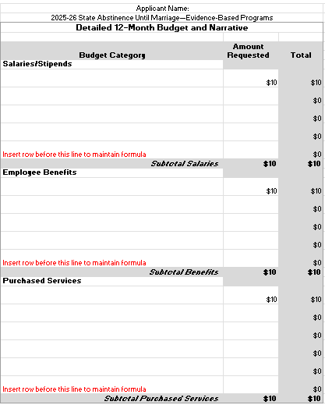

Request for Taxpayer Identification Number and Certification
Go to the IRS Web site for an easy-to-complete version of this form.
(To be completed by fiscal agent)
