Request for Applications (RFA)
Application Package

South Carolina Migrant Education Program
2024–25 Supplementary Subgrant Program

The South Carolina Migrant Education Program is a subgrant program funded by the Education of Migratory Children (Migrant Education Program (MEP)), authorized by Title I, Part C of the Elementary and Secondary Education Act (ESEA) of 1965, as amended by Every Student Succeeds Act (ESSA) of 2015; 20 U.S.C. 6391-6399, and administered by the South Carolina Department of Education.

REVISED May 20, 2024, to correct date on page 4

Deadline for Receipt of Applications: 5:00 p.m., June 7, 2024

Technical Assistance for Applicants: May 20, 2024

For questions about the Migrant Education Program and this competition, contact:
Zachary Taylor, 803-391-9393 or ztaylor@ed.sc.gov

Issued by:
South Carolina Department of Education
Office of Federal and State Accountability
1429 Senate Street
Columbia, SC 29201

TABLE OF CONTENTS

PART I: General Information 1
A. Introduction and Purpose 1
B. Eligible Applicants 2
C. Competitive Priorities 2
D. Timeline of Subgranting Process 2
E. Technical Assistance Sessions for Applicants 2
F. Statutory, Federal Regulations, and State-Level Program Requirements 3
G. Authorized Activities 13
H. Unauthorized Activities 13
I. Program Accountability and Monitoring 14
J. Fiscal Operations 17
K. Supplement, Not Supplant 18
L. Review and Selection Process 18
M. Appeals Process 19

PART II: Application Overview, Content, and Instructions 20
A. Application Overview 20
B. Online Form Sections 21
C. Application Attachments 32
D. Reviewing and Submitting Application 34
E. Deadline and Submission Procedures 35

Appendix A: Definitions of Terms Used 36

Appendix B: Selection Criteria and Reviewers’ Scoring Rubric 38

Appendix C: Required SCDE Forms 42
Certification Signature Page 42
Assurances and Terms and Conditions for Federal Subawards 43
Terms and Conditions 44
Migrant Education Program (MEP) Program-Specific Assurances 48
Pre-Award Audit Questionnaire for LEAs and State Agencies 50
Instructions from USED for GEPA Statement 53
Request for Taxpayer Identification Number and Certification 54
Title I, Part C Migrant Education Program Budget Narrative Template 55
Private (Non-Public) School Consultation Form 56
Total Eligible Migratory Students by LEA, ages 0–21,
including Out-of-School Youth (OSY), from September 1, 2022–August 30, 2023 57

PART I: General Information

Introduction and Purpose

The Education of Migratory Children is authorized by Title I, Part C of the Elementary and Secondary Education Act of 1965 (ESEA), as amended by the Every Student Succeeds Act (ESSA). The U.S. Department of Education (USED) provides a Migrant Education Program (MEP) formula grant to the South Carolina Department of Education (SCDE) to establish and improve education programs for migratory children and youth.

Title I, Part C, section 1301 of ESSA states that the purposes of the MEP are to
- support high-quality and comprehensive educational programs and services during the school year and, as applicable, during summer or intersession periods, that address the unique educational needs of migratory children;
- ensure that migratory children and youth who move among the states are not penalized in any manner by disparities among the states in curriculum, graduation requirements, and challenging state academic standards;
- ensure that migratory children and youth receive full and appropriate opportunities to meet the same challenging state academic standards that all children and youth are expected to meet;
- help migratory children overcome educational disruption, cultural and language barriers, social isolation, various health-related problems, and other factors that inhibit the ability of such children to do well in school; and
- ensure that migratory children and youth benefit from state and local systemic reforms.

The purpose of the 2024–25 South Carolina (SC) MEP subgrant is to improve educational opportunities for migratory children and youth to help them succeed in the regular school year, meet the same challenging state academic standards that all children and youth are expected to meet, and earn a high school diploma. The SCDE is offering subgrants to eligible local organizational agencies ((LOAs) as defined on page 2) to provide supplementary projects during the 2024–25 summer/intercession periods, and/or 2024–25 regular school year through September 30, 2025. The terms “migratory” and “immigrant” are not synonymous as they refer to different federal entitlements under ESSA (see definitions on page 36).

Approximately $250,000 will be available for new subgrants in this funding cycle. The SCDE anticipates awarding approximately four (4) subgrants. Award amounts will be determined based on the quality of applications received and total funding requested. Final budgets may be negotiated based on demonstrated needs. All subgrant awards are contingent upon total allocations to the SCDE by the USED.

The subgrant period is June 1, 2024, through September 30, 2025, and is subject to the availability of federal funds and projects meeting all MEP program requirements.

The subgrantee may obligate funds upon receipt of the grant award notice. However, no funds will be disbursed until after June 1, 2024. Grant payments are made on a cost-reimbursement basis so applicants should have at least three months of operating funds at their disposal to implement the program to compensate for any delays in receiving reimbursement payments.

Eligible Applicants

An eligible LOA is a local educational agency (LEA) or public or private agency that demonstrates the ability and capacity to manage a program that will serve all eligible migratory children and youth for the proposed service area. In some cases, two or more LEAs or other entities may partner to form an LOA. Additionally, LOAs may propose, and are encouraged, to serve and/or identify and recruit (ID&R) migratory children and youth in multiple LEAs.

To receive funding, an eligible LOA must submit an application to the SCDE as outlined in this document and propose to identify and serve a population of students from area(s) listed on the Total Eligible Migratory Students by LEA document (see page 57). Applications must include evidence of the LOA’s experience and capacity. Eligibility and selection for funding will be determined based on the LOA’s ability to fulfill the obligations required for the MEP.

Competitive Priorities

No competitive priority points are available for this competition.

Timeline of Subgranting Process

Date | Activity/Action
May 20, 2024 | Pre-application technical assistance session(s)
June 17June 7, 2024 | Deadline for receipt of application
June 2024 | Notification of awards
June 1, 2024 | Funding period begins; projects can begin
September 30, 2024 | Interim report(s) due to the SCDE
September 30, 2025 | Final date for obligating funds for activities
October 15, 2025 | Final program report due to the SCDE
December 30, 2025 | Final date for liquidation of funds for activities obligated prior to September 30, 2025

Technical Assistance Sessions for Applicants

The Office of Federal and State Accountability will offer a pre-application technical assistance session via Adobe Connect from 10:00 a.m. until 11:30 a.m. on Monday, May 20, 2024. No password is required to join the session. Participants should enter their full names when logging in to the session. Participants will be able to log in 30 minutes prior to the start of the session to test their equipment’s audio settings and to download/print handouts. While participation is not mandatory in order to submit an application, it is highly recommended.

Statutory, Federal Regulations, and State-Level Program Requirements

Applicants must propose projects that adhere to the following requirements for the MEP program from statute, federal guidance, and the state. Refer to the Definitions of Terms Used located in Appendix A on page 36 for Eligibility and Program Definitions (Title I, Part C, §1304 ESEA; 34 CFR Part 200.81).

Title I, Part C MEP Director
Each program must have a MEP director who is able to coordinate various components of the program, oversee all aspects of the program including the timely submission of all reports, provide regular monitoring of activities, and be available to attend all mandatory meetings, trainings, and conferences required by the SCDE.

Type of Program
Applicants must offer a program that will provide direct supplemental services to eligible migratory students during summer/intercession period and/or the regular school year for the duration of the project performance period.

Types of Service and Service Delivery
The Non-Regulatory Guidance for the Title I, Part C Education of Migratory Children (2017) states that LOAs may use MEP funds for the following types of services:
- Instructional services (e.g., educational activities for preschool-age children and instruction in elementary and secondary schools, such as tutoring programs).
- Support services (e.g., educationally related activities, such as advocacy for migratory children and youth; health, nutrition, and social services for migratory families; necessary educational supplies; and transportation).

LOAs may use a variety of service delivery designs. Examples include
- in-home instructional programs (e.g., family literacy services to the child at the place of residence, tutoring);
- school and community program collaborations to facilitate instructional and support services;
- distance learning programs;
- Title I school-wide programs; and
- onsite life skills, math, and reading lessons to out-of-school youth (OSY).

The Migrant Education Program and Title I Schoolwide Programs
Title I, Part C section 1306(b)(4) and 34 CFR Part 200.29(c)(1) and 200.86 require schools to first use the MEP funds, in consultation with migrant parents, to meet the special educational needs of migrant children before they may combine MEP funds in a schoolwide program. The special educational needs of migrant children are: 1) the unique needs that result from the effects of their migratory lifestyle, and 2) those other needs that are necessary to permit these students to participate effectively in school. The school also must document that these needs have been met before it may combine MEP funds in a schoolwide program.

Local Needs Assessment and Service Delivery Plan (Section 1306(a))
The applicant must conduct local needs assessment to identify and prioritize the special educational needs of the migratory children and youth to be served and to determine the specific services to be provided will help migratory children and youth achieve the SCDE’s overall measurable outcomes and performance targets.

In accordance with the SCDE’s statewide comprehensive needs assessment (CNA), statewide MEP goals are outlined below and include key strategies for implementing in the local program. LOAs must align activities with the SCDE’s key strategies for each measurable program outcome specified below. An LOA’s program application narrative section will serve as a local service delivery plan (SDP). The SDP can include additional that align with a local or regional CNA based on the unique needs of migratory children and youth and the area in which they reside.

The CNA and local needs assessment are used to
- determine the needs of migratory students to be served and how those needs relate to the priorities established by the SCDE,
- design local services, and
- select students for the receipt of those services.

Component 1
GOAL 1: PROFICIENCY IN ENGLISH LANGUAGE ARTS. Students in South Carolina will be proficient in reading, writing, speaking, listening, and language to ensure that all students are college and career ready in English language arts (ELA) no later than the end of high school.
Required Measurable Program Outcomes (MPOs):
1a. By the end of the 2024–25 academic year, and each academic year thereafter, migratory students will demonstrate at least a 10 percent gain from pre- to post-ELA assessments.
1b. By the end of the 2024–25 academic year, and each academic year thereafter, migratory students will be provided at least 12 hours of supplemental instructional time in reading and language arts.
1c. By the end of the 2024–25 academic year, and each academic year thereafter, the percentage of migratory students in grades 3–8 scoring at or above “meets expectations” on ELA state assessments will increase by 1%.
1d. By the end of the 2024–25 academic year, and each academic year thereafter, the percentage of migratory students in grades 9–12 receiving a score of 70% in English End-of-Course Examination Programs (EOCEP) will increase by 5%.
Key Strategies:
- Provide home literacy services.
- Provide small-group and individualized instruction as supplemental educational services.
- Provide staff development on meeting the migratory students’ ELA needs.
- Coordinate services for MEP students and families by collaborating with other offices such as the Title III Multilingual Learner Program (MLP), Adult Education, teachers, parent advocates, and agencies to promote educational and social services to MEP students and families.
- Establish summer instructional programs for migratory students.
- Provide mobilized ELA instructional and related support services at the place of residence or in settings accessible to migratory students and their families.

Component 2
GOAL 2: MATHEMATICS. Students in South Carolina will be proficient in comprehension of mathematical concepts, operations, relations, procedural fluency, and productive disposition to ensure that all students are college and career ready in mathematics no later than the end of high school.
Required MPOs:
2a. By the end of the 2024–25 academic year, and each academic year thereafter, migratory students will demonstrate at least a 10% gain from pre- to post-Math assessments.
2b. By the end of the 2024–25 academic year, and each academic year thereafter, migratory students will receive a minimum of 12 hours of supplemental instructional time in mathematics.
2c. By the end of the 2024–25 academic year, and each academic year thereafter, the percentage of migratory students in grades 3–8 scoring at or above “meets expectations” on ELA state assessments will increase by 1%.
2d. By the end of the 2024–25 academic year, and each academic year thereafter, the percentage of migratory students in grades 9–12 receiving at least a score of 70% Algebra End-of-Course Examination Programs (EOCEP) will increase by 5%.
Key Strategies:
- Provide small group and individualized instruction as supplemental educational services.
- Provide staff development on meeting the migratory students’ math needs.
- Provide in-service and technical assistance to schools regarding identification of MEP students, proper procedure for documentation, and provision of needed resources for mathematics instruction.
- Coordinate services for MEP students and families with other programs, such as the Title III Multilingual Learner Program, Adult Education, teachers, parent advocates, and agencies to promote educational and social services to MEP students and families.
- Provide mobilized Math instructional and related support services at the place of residence or in settings accessible to migratory students and their families.

Component 3
GOAL 3: SCHOOL READINESS, FAMILY ENGAGEMENT AND ADVOCACY. Children and youth in South Carolina will engage in play to develop individual approaches to learning; show curiosity, eagerness, and satisfaction as a learner; demonstrate initiative, engagement, and persistence in learning; demonstrate an ability to envision a goal and to accomplish it; and extend their learning through the use of memory, reasoning, and problem-solving skills. Furthermore, parents or guardians of migratory children and youth will receive both instructional literacy services and support services in order to increase involvement and engagement in the educational development of their children.
Required MPOs:
3a. By the end of the 2024–25 academic year, and each academic year thereafter, the number of preschool migratory children receiving supplemental academic and support services will increase by 5%.
3b. By the end of the 2024–25 academic year, and each academic year thereafter, at least one parent engagement curriculum will be provided to parents in order to prepare their children for public school and self-advocacy.
Key Strategies:
- Work to enhance communication between data in the South Carolina MIS2000 and the MSIX and East Coast Migrant Head Start Project (Child Plus) and PowerSchool to assist with accurate assessment and grade level.
- Provide resources and assistance in transition from pre-K to elementary school.
- Provide information packets and resources for parents to empower themselves and their families in preparation for public school.
- Coordinate with early childhood agencies to augment the identification and recruitment of pre-K migratory children.
3c. By the end of the 2024–25 academic year, and each academic year thereafter, a minimum of 95% of pre-K migratory students and youth and their parents with will be provided with supplemental literacy resources.
- Encourage speaking and storytelling in the home language.
- Emphasize the value of indigenous languages and cultures by selecting books that portray those traditions in a positive light.
- Inform migratory children, youth, and families about local libraries and instruct families on how to apply for a library card.
- Provide parents with a short introduction on the importance of reading and storytelling in their home language.
- Provide at least one training per year to encourage critical thinking and comprehension in children regardless of the parent’s own literacy.
- Emphasize resources to support needs identified in the USED Office of Migrant Education’s Seven Areas of Concern.
3d. By the end of the 2024–25 academic year, and each academic year thereafter, 100 percent of eligible students and their families will be provided with resource referrals in order to meet their needs outside of the classroom that hinder learning.
Key Strategies:
- Refer migratory students to local agencies based on immediate needs such as health, nutrition, student intervention services, special education (IEP Evaluations), additional federal programs such as McKinney-Vento Homeless, Title I, and Title III (Multilingual Learner Program).
3e. By the end of the 2024–25 academic year, and each academic year thereafter, local MEP program staff will receive at least one annual training on identifying and referring students for IEP evaluation.
3f. By the end of the 2024–25 academic year, and each academic year thereafter, MEP staff will provide at least one career awareness workshop for high school and OSY students.
Key Strategies:
- Collaborate with agencies such as the South Carolina Department of Employment and Workforce, local colleges/universities/technical colleges, and libraries to create job/career fair type services.
- Identify interested and motivated students to visit or take on a field trip to meet with different employers, colleges, or agencies.

Component 4
GOAL 4: GRADUATION FROM HIGH SCHOOL, CREDIT ACCRUAL, DROPOUT PREVENTION, AND SERVICES TO OUT-OF-SCHOOL YOUTH. The SCDE’s goal is to increase the high school graduation rate through efforts to better prepare students for success after graduation, whether their preference is to immediately enter the workforce or to continue their education. South Carolina’s goal is that each high school in the state will achieve a graduation rate of at least 90 percent.
Required MPOs:
4a. By the end of school year 2024–25, and each academic year thereafter, there will be a 1% increase in supplemental services to migratory students enrolled in high school.
Key Strategies
- Increase identification and recruitment (ID&R) efforts of migrant students in high school.
- Adopt/include a migrant parent survey in school registration packets.
- Increase outreach efforts to school principals and attend principal meetings at least once a year.
- Provide in-services and technical assistance to schools regarding ID&R of MEP students and proper procedures for documentation and provision of needed resources.
4b. By the end of school year 2024–25, and each academic year thereafter, migrant students identified and enrolled in high school will show a 5% increase in credit accrual towards graduation.
Key Strategies
- Monitor student progress through MSIX and note designated graduation school.
- Review students’ courses and number of credits; contact and discuss with guidance counselor a plan of action for credit accrual and graduation.
- Monitor high school students for progress every semester.
4c. By the end of school year 2024–25, and each academic year thereafter, there will be an increased awareness of support programs for potential migrant students, dropouts, and families in order to decrease the migrant dropout rate by 2%.
Key Strategies
  - Monitor lists of dropout and/or recently recovered dropout migratory students in each LOA at the end of each academic year.
  - Increase awareness of migrant students and their unique needs to principals and guidance counselors and increase contact to migrant families to explain the services offered by MEP.
  - Provide in-service and technical assistance to schools regarding potential dropouts of MEP students and proper procedures for documentation and provision of needed resources.
4d. By the end of the 2024–25 academic year, and each academic year thereafter, at least 25% of OSY students will demonstrate proficiency in instructional services based on the indicators of the SC OSY Student Profile.
Key Strategies
  - Engage in ID&R as soon as possible upon arrival date to ensure early enrollment and delivery of services.
  - Consult the U.S. Department of Labor’s H2A and H2B website listings for SC and crew leaders to determine proposed arrival dates and locations.
  - Use the Graduation and Outcomes for Success for Out-of-School Youth (iSOSY) life skills lessons.
  - Provide instruction in life skills using SC MEP personnel, including state recruiters, LOA personnel, and contracted service providers.
4e. By the end of the 2024–25 academic year, and each academic year thereafter, the number of OSY students receiving services will increase by 5%.
Key Strategies
  - Engage in ID&R as soon as possible upon arrival date to ensure early enrollment and delivery of services.
  - Consult the U.S. Department of Labor’s H2A and H2B website listings for SC and crew leaders to determine proposed arrival dates and locations.
  - Use iSOSY Academic Career Readiness Skills (ACReS) lessons for Pre GED.
  - Provide instruction in ELA using SC MEP personnel including LOA teachers and contracted service providers.
  - Contract with Adult Education to provide ESOL and ELA.
Note: For instructional services to OSY, list the proposed amount of individual contact time.

Evaluation of Services
LOAs must evaluate the implementation and results of summer and regular school year programs to measure the program’s impact on migratory children and determine effectiveness. Pre- and post-assessments and measurements of growth and proficiency levels on statewide assessments (if applicable) are common methods of evaluation for instructional services. LOAs must also evaluate the impact of support services by assessing the extent to which such services helped achieve measurable outcomes described within this application.

Identification and Recruitment (ID&R) (34 CFR Part 200.82(a)
Section 1304(c)(7) requires the SCDE to identify and recruit all eligible migrant children residing in South Carolina. For MEP, the term “identification” means determining the location and presence of migratory children and “recruitment” means making contact with migratory families, explaining the MEP, securing the necessary information to make a determination that the child is eligible for the MEP, and recording the basis of the child’s eligibility on a Certificate of Eligibility (COE).

The SCDE program office ultimately determines eligibility for MEP through review of all COEs. COEs are to be completed by SCDE-approved recruiters. The SCDE employs a state ID&R coordinator and state recruiters to perform and oversee statewide ID&R.

Subgrantee ID&R/Recruiter
To maximize services to migratory students, subgrantees may (but are not required to) participate in the ID&R process during the subgrant period. Employment of part- or full-time recruiters is allowable if the subgrantee recruiter is trained and approved by the SCDE MEP. Recruiters must be able to maintain flexible hours; travel to agricultural businesses and farms, housing areas, and migratory labor camps; and establish working relationships with community agencies, growers, and parents. The SCDE requires that the recruiter be verbally proficient in English and the predominate language spoken by the parents and OSY in the respective service region.

All subgrantees are encouraged to cross-train staff in ID&R policies and practices to facilitate student referrals to MEP state recruiters. The SCDE will provide updated eligible student lists on a regular basis to subgrantees to ensure supplemental service provision to all eligible MEP students.

Subgrantee Staff Requirements
Subgrantees must ensure that all staff are trained to operate with cultural awareness and sensitivity. In addition, subgrantees are required to include essential and relevant staff in SCDE MEP trainings and professional development. Subgrantee staff must be able to meaningfully communicate with OSY and parents to explain vital information about the MEP and Family Educational Rights and Privacy Act (FERPA), and to ascertain specific needs unique to migratory children, youth, and families.

The SCDE requires that at least one outreach staff member in the subgrant program be verbally proficient in English and the predominate language spoken by the parents and OSY in the respective service region.

Outreach staff members must be able to maintain flexible hours; travel to agricultural businesses and farms, housing areas, and migratory labor camps; and establish working relationships with community agencies, growers, and parents.

Priority for Services (PFS) (Section 1304(d))
In accordance with federal law, priority must be given to “migratory children who have made a qualifying move within the previous 1-year period and who— (1) are failing, or most at risk of failing, to meet the challenging state academic standards; or (2) have dropped out of school.”

LOAs are required to offer and document how services were offered to migratory PFS students first. LOAs must document the reason for each student’s PFS determination and a plan of action to address the student’s specific priority needs. PFS determinations are made by the LOA. If a student made a qualifying move during the previous 1-year period, the LOA must consider factors that contribute to that student being most at risk of failing. Such factors can include
- having any socio-emotional, cognitive, physical, behavioral, or developmental factors (suspected disabilities by parent and/or service provider is acceptable, regardless of whether or not an official evaluation or diagnosis has occurred);
- adverse childhood experiences (ACEs) or trauma as inferred by the parent, guardian, and/or service provider;
- performing below grade level on the assessment and/or performance data upon enrollment into the MEP;
- being a dual language learner (DLL) or an English language learner (ELL);
- having health factors that create barriers to education;
- experiencing homelessness, as defined by 42 U.S.C. 11301 et seq. of the McKinney-Vento Homeless Assistance Act (doubled-up, unsheltered, transitional housing, unaccompanied homeless youth);
- having an Individualized Education Plan (IEP) §1414(d)(1)(A), or Individualized Family Service Plan (IFSP) §1436, as defined by IDEA (as amended); and/or
- other factors with prior consultation and approval from SCDE MEP.

Parental Consultation (Section 1304(c)(3))
LOAs must demonstrate how migratory parents or guardians were consulted during the planning and implementation of the program. Subgrantees must establish and consult with a formal parent advisory council (PAC) for programs taking place during the regular school year within the specified performance period. Communication with parents/guardians must be meaningful and in a language and format that they understand. Such consultation must be thoroughly documented and reported to the SCDE in the program evaluation. More detail on parent consultation and parental involvement is provided in Chapter VII: Parental Involvement of the Non-Regulatory Guidance for the Title I, Part C Education of Migratory Children (2017).

Instructional and Support Services
The recommended minimum number of migratory children and youth to be served in any one program is 50. The SCDE will allow flexibility to LOAs for regions of the state with low or declining numbers if ID&R and increased number of supplemental services remain as centerpieces of an LOA’s service delivery plan (SDP) as specified in the application.

LOAs are strongly encouraged to provide programs of 120 hours for the duration of the program period, 100 hours of which must be instructional time to more fully address the achievement gap that many migratory children and youth exhibit. Instructional programs for OSY may combine hours to achieve recommended program hours. Instructional program service to any one camp location or grouped individuals should meet a minimum of 20 hours as part of the overall instructional program. A migratory family literacy program component may comprise the remaining 20 hours. The OSY circumstances may allow for variation on a case-by-case basis.

Program | Hours
Instructional Services | 100
Support Services | 20
Total Hours | 120

Instructional and support services to OSY may also include survival English, life skills instruction, or orientation to and/or assistance with community resources. By federal regulation, educationally related program service to eligible individuals must be provided on more than one occasion to be considered a service.

The SC MEP requires a minimum of 30 minutes contact for each educationally related service (OSY service, tutorial service, or family literacy service) with a minimum total of three contact hours for the eligible individual served for the duration of the project period.

All subgrantees must comply with Title I, Part C, and Title VIII, as applicable, of the ESEA, as amended, and the General Education Provisions Act (GEPA) and meet the requirements outlined below. Once the application is approved, the subgrantee is required to comply with all applicable statutory and regulatory requirements.

Applicable Federal Regulations
Applicants should review the following federal regulations, accessible at the electronic Code of Federal Regulations (e-CFR) Web site, which are applicable to the MEP. Applicants are reminded that, if funded, their programs must comply with these regulations.
- 2 CFR Part 25—Universal Identifier and System for Award Management
- 2 CFR Part 170—Reporting Subaward and Executive Compensation Information
- 2 CFR Part 175—Award Term for Trafficking in Persons
- 2 CFR Part 180—OMB Guidelines to Agencies on Governmentwide Debarment and Suspension (Nonprocurement), as adopted at 2 CFR Part 3485
- 2 CFR Part 200—Uniform Administrative Requirements, Cost Principles, and Audit Requirements for Federal Awards, as adopted at 2 CFR Part 3474 (Note: 2 CFR Part 200.211(b)(1) requires that a grant recipient’s name match their registered name associated with its unique entity identifier as defined at 2 CFR Part 25.315.)
- Education Department General Administrative Regulations (EDGAR) in 34 CFR Parts 76 (except for 76.650–76.662 participation of students enrolled in private schools), 77, 79, 81, 82, 84, 97, 98 and 99
- 34 CFR Part 200—Title I—Improving the Academic Achievement of the Disadvantaged
- 34 CFR Part 299—General Provisions.

Additional information on select federal governmentwide regulations is presented below:

Executive Order 13513 “Federal Leadership on Reducing Text Messaging While Driving” (October 1, 2009) Subgrantees must refrain from text messaging and emailing while driving during official grant business.

Civil Rights and General Education Provisions Act (GEPA)—P.L. 103-382
Section 427 of the GEPA obligates applicants to ensure equitable access to, and participation in, its federally assisted program for students, teachers, and other program beneficiaries with special needs. Applicants must include a GEPA statement in their application for MEP funding. See page 53 for further instructions.

Universal Identifier and System of Award Management—2 CFR Part 25
Applicants must be registered in the federal System for Award Management (SAM) prior to submitting an application and maintain their SAM registration throughout the application and award process to comply with 2 CFR Part 25. All LEAs with an active SAM registration have a unique entity identifier (UEI). Applicants must include the UEI in the online subgrant application. Contact your finance office for assistance with your UEI.
Please note that the SCDE will not make a subaward of federal funds to an applicant until the applicant has complied with the requirements described in 2 CFR 25 to provide a valid UEI and maintain an active, publicly searchable SAM registration.

Reporting Subaward and Executive Compensation Information—2 CFR Part 170
The Federal Funding Accountability and Transparency Act (FFATA) of 2006 (P.L. 109–282), as amended by Section 6202 of P.L. 110–252, requires primary grantees of federal grants and cooperative agreements to report information on subgrantee obligations and executive compensation. FFATA promotes open government by enhancing the federal government’s accountability for its stewardship of public resources. This is accomplished by making government information, particularly information on federal spending, accessible to the general public.

Family Educational Rights and Privacy Act (FERPA)
FERPA is a federal law that protects the privacy of student education records (20 U.S.C. § 1232g; 34 CFR Part 99). The law applies to all subgrantees under this program.

Private (Non-Public) School Participation
In accordance with Public Law 115–224, ESEA Title VIII, Part F Uniform Provisions, Subpart 1, Section 8501, as amended, all applicants must consult with non-public, private elementary and secondary schools, including religiously affiliated schools, located within the boundaries of the geographical area to be served during program planning and the development of their application.

To meet this requirement, applicants must consult with private school officials before making any decision that affects the opportunities of eligible private school children and youth to participate in the MEP project. Topics to discuss during this consultation include
- how the agency will identify the children’s and youth’s needs,
- what services the program will offer,
- how and where the agency will provide those services,
- how the agency will assess the services and use results of the assessment to improve those services,
- size and scope of the services to be provided,
- how and when the agency will make decisions about the delivery of services, and
- how the students will be served.

Section 8501(c)(1) provides topics that should be discussed in the consultation. Applicants should include in their application detailed plans to provide equitable services to any private school children identified for services as a result of this consultation. Applicants must engage in this required pre-application consultation and complete and submit the Private (Non-Public) School Consultation form with their application (see page 56).

SCDE Assurances and Terms and Conditions and MEP Program Assurances
Applicants should review the SCDE Assurances and Terms and Conditions for Federal Subawards (pages 43–46) and the MEP Program Assurances (page 47) to ensure that if awarded a subgrant, they are capable of full compliance, especially with all federal and state laws referenced, in order to enter into an agreement with the SCDE for this program. For example, in compliance with 2 CFR Part 200.112, applicants must disclose in writing any potential conflict of interest to the SCDE in accordance with the USED’s conflict of interest policy. A signed Certification Signature Page (see page 42) is required with the application and legally binds the applicant to the agency’s assurances and terms and conditions and the MEP program assurances.

Authorized Activities

Examples of MEP authorized activities include but are not limited to:
- Instructional services (e.g., activities for preschool-age migratory children and instruction in elementary and secondary schools, such as tutoring before and after school);
- Support services (e.g., acting as an advocate of migratory children, providing access to health and social service providers; providing migrant families with necessary supplies), provided these services relate to an identified educational need;
- Professional development (e.g., training programs for MEP subgrantee and/or school personnel to enhance their ability to understand and appropriately respond to the needs of migratory children)
  - Includes reasonable and necessary in- and out-of-state travel for MEP personnel to attend conferences as approved in the subgrant application;
- Parent Advisory Councils (PAC) and other parental involvement activities
  - Includes reasonable and necessary in- and out-of-state travel for MEP parents to attend meetings and/or conferences as approved in the subgrant application;
- ID&R activities, if applicable;
- Coordination activities with other agencies, both within the state and with other states nationwide, including the transfer of student records;
- Comprehensive needs assessment activities;
- Transportation for eligible MEP students and families to attend supplemental MEP activities and/or receive pre-approved supplemental services; and
- Evaluation of the MEP.

Unauthorized Activities

Funds must not be used for:
- New construction or purchases that do not directly support the work plan(s) outlined in the approved subgrant application and budget narrative;
- Core translation and interpretation services required under Title VI of the Civil Rights Act of 1964 for any LEA/LOA receiving federal funds;
- Unrestricted indirect cost rates or any indirect costs without an approved indirect cost rate agreement with the SCDE Office of Auditing Services prior to the start of the subgrant period of performance;
- Salaries, benefits, and expenses incurred by employees of the LOA who are not directly related to the MEP;
- Costs related to social activities such as potlucks, dances, holiday and graduation parties, celebrations, entertainment, including amusement, and diversion;
- Out-of-state travel to meetings or conferences solely for the purpose of disseminating information;
- Costs not aligned with the statewide CNA, key strategies of the statewide SDP or costs with no educational benefit; and
- Any cost that is not included in the approved application, budget narrative, or subsequent budget amendments.

Program Accountability and Monitoring

The SCDE is responsible for monitoring implementation of Title I, Part C of the Every Student Succeeds Act (ESSA), as amended, in accordance with the following program accountability requirements:
- Each subrecipient receiving funds through this RFA meets the eligibility requirements for the subgrant described herein, and the applicant has provided all required assurances that it will comply with all program implementation and reporting requirements established through this RFA.
- Each subrecipient receiving funds through this RFA appropriately uses these funds as described in this application package.
- Each subrecipient implements activities funded through this application within the timeline in which the funds provided are to be used.

In compliance with 2 CFR Part 200.205, the SCDE will conduct a pre-award risk assessment of potential subgrantees before a grant award is issued. As a part of this process, each applicant should complete the pre-award audit questionnaire included on pages 50–52 to submit with their application as described on page 33. The SCDE’s Office of Auditing Services will evaluate this questionnaire and may conduct a further evaluation of the applicant’s financial system, internal controls, and policies and procedures. Visit the Office of Auditing Services to access the review process and procedures.

Applicants awarded subgrant funds must satisfy periodic reporting and accountability requirements throughout the term of the subgrant. These requirements address: (1) program accountability; (2) performance reporting; (3) annual budget; (4) monitoring; (5) program evaluation; and (6) technical assistance.

    - Program Accountability
Each subgrantee is responsible for carrying out its responsibilities in accordance with Title I, Part C of ESSA, as amended, all applicable statutes, regulations, and programmatic guidance; and its approved subgrant application and work plan. Subgrantees are also required to submit periodic reports to the SCDE to report on the use of subgrant funds and the progress of subgrant activities.

    - Performance Reporting
Performance reporting requirements include those for both programmatic reporting and fiscal reporting. The subgrantee is responsible for ensuring that all required performance reports are accurate, complete, and submitted on time.

Programmatic Reporting Requirements
Annual performance reports must be submitted to the SCDE at dates specified by the program office of each year. Progress toward achieving subgrant goals and objectives will be monitored through the annual performance report process and periodically as requested by the program office.

The following is required of all subgrant recipients, and these requirements are to be reported in the annual progress report in the period the activity occurred:
- the total number of eligible migratory children identified;
- the total number of eligible migratory children enrolled and served in MEP;
- a description of how children were identified as priority for services and how many children received services;
- eligible migratory children identified as DLL or ELL with a state-approved language assessment tool;
- IDEA eligible child counts, number of breakout/counseling services by grade, migratory students eligible for continuation of services;
- eligible migratory students served with family literacy services, and eligible OSY served;
- copies of the enrollment and attendance for each class of instruction and enrollment/registration of any participants in a family literacy program class or home-based services;
- the measurable outcomes for the four components provided in the proposal;
- a list of the support services from multiple sources provided; and
- a list of the parent/guardian involvement activities.

The SCDE will provide additional guidance to subgrantees regarding the final evaluation report.

LOAs proposing to employ staff with ID&R roles and responsibilities are required to
- obtain COEs for children/youth who have made new qualifying moves;
- submit COEs via MIS2000 within 24 hours of a recruiter’s initial interview; and
- include in the electronic COE (e-COE) for OSY a completed OSY Profile.

The subgrantee’s ID&R staff will receive technical assistance and training on how to use e-COE.

For LOAs not proposing to employ staff with ID&R roles and responsibilities, student referrals must be submitted to state recruiters in a timely manner, tracked, and archived to facilitate student enrollments and provision of supplemental services.

Subgrantees are responsible for tracking individual student records in the respective service region. Student tracking data includes the types of services, the duration of each service provided, the date on which the service occurred, and additional comments or notes regarding the services to OSY, K–12, and pre-K. Student tracking data must be entered into MIS2000 within one week of the student being identified for eligible services. If data entry into MIS2000 does not occur daily, LOAs must develop a tracking system to ensure that services are recorded as they occur. The SCDE recommends the use of the MEP student tracking forms to assist with this process. Subgrantees will receive technical assistance and training in the entry of student tracking data into MIS2000.

In accordance with 34 CFR Part 200.85, each subgrantee must abide by the Migrant Student Information Exchange (MSIX) federal requirements and adhere to the SCDE MSIX interconnection security agreement (ISA). In addition, subgrantees are required to send and receive migratory student move notifications in MSIX to facilitate interstate coordination.

Fiscal Reporting Requirements
All expenditure reports must be submitted through the SCDE’s grants accounting processing system (GAPS). GAPS training will be provided to subgrantees during the subgrantee award meeting. Submission of expenditure reports will be accepted monthly but is required at least quarterly throughout the grant award period (see the following table). Subgrantees must submit a final fiscal report to the SCDE that covers the duration of the grant award. Funds may not be carried over.

The expenditure reporting due dates for the MEP are:

Title I, Part C MEP Programs | Expenditure Report Due
June 1, 2024–June 30, 2024 | August 15, 2024
July 1, 2024–September 30, 2024 | November 15, 2024
October 1, 2024–December 31, 2024 | February 15, 2025
January 1, 2025–March 31, 2025 | May 15, 2025
April 1, 2025–June 30, 2025 | August 15, 2025
July 1, 2025–September 30, 2025 | December 30, 2025

    - Project Budget
A project budget of projected expenditures to be funded by the subgrant must be submitted with the application. Approved budgets must be uploaded into GAPS by subgrantees after the receipt of the grant award notification and prior to submitting any reimbursement requests.

    - Monitoring
The SCDE will monitor subgrantees by reviewing and approving the progress reports and annual performance reports. All information in monitoring reports is subject to verification.

The SCDE may conduct programmatic and financial desk monitoring and/or site visits. Subgrantees must agree to site visits conducted by SCDE or federal program representatives. The purpose of desk monitoring and site visits is to validate information provided in fiscal and program reports and to gather more detailed information on implementation efforts and compliance with applicable regulations, terms, and conditions.

The SCDE may require additional information from the subgrantee, verify information with the authorizing agency, or require the submission of additional documentation including, but not limited to, invoices, receipts, and personnel time and effort reports. Prior to a site visit, the subgrantee may be required to submit additional relevant information that will allow the SCDE to conduct a useful, efficient, and effective visit. The SCDE may require electronic submission of documents instead of a paper-copy submission.

SCDE staff will verify the contents of documentation submitted. Subgrantee may be asked to revise reports when
- non-allowable expenses are found;
- reports are confusing or difficult to understand; or
- there are unexplained discrepancies between the proposed use of subgrant funds, as provided in the annual budget, and actual expenditures found in the submitted documentation.

    - Program Evaluation
Subgrantees are required to conduct ongoing monitoring and evaluation to ensure project goals are achieved. Progress toward meeting project goals is to be reported through the progress review process.

A final project evaluation report is to be completed before the end of the subgrant period. The final evaluation report must address project success toward each goal stated in the application. If a subgrantee fails to conduct the final project evaluation report before the end of the subgrant period, or if any of the performance requirements in section I.2 are not completed, the SCDE may consider the subgrantee a high risk and elect to discontinue funding or disqualify the subgrantee from future funding opportunities.

    - Technical Assistance to Subgrantees
Subgrantees are required to participate in all technical assistance that the SCDE conducts for the MEP subgrant. Delivery of such technical assistance may include in-person meetings, webinars, and conference calls.

Fiscal Operations

Subgrantees must use subgrant funds for allowable subgrant expenditures during the subgrant period. MEP subgrant funds are disbursed on a reimbursement basis. The SCDE will de-obligate any unspent funds remaining at the end of the subgrant period for reallocation to other subgrantees.

LOAs are permitted to budget indirect costs at the restricted rate in their approved indirect cost rate agreement. If an applicant LOA needs an indirect cost rate, they should contact the SCDE's Office of Auditing Services as soon as possible to initiate the process to negotiate a rate. Matching or in-kind funds are not required; however, matching and in-kind funds are an indicator of potential long-term sustainability of a MEP program.

Supplement, Not Supplant

MEP subgrant funds must supplement, not supplant, existing services and may not be used to supplant federal, state, local, or non-federal funds. Projects may not use subgrant funds to pay for existing levels of services funded from any other sources. MEP subgrant funds may not be used for new construction or purchases that do not directly support the approved work plan.

In accordance with the Title VI of the Civil Rights Act of 1964, Title I, Part C funds cannot be used for core translation and interpretation services, as this would supplant the LOA’s obligation in the absence of federal funds.

Review and Selection Process

Only those grant applications that are received by the deadline and deemed complete will be forwarded for review and funding consideration. All required materials including forms and appendices must be submitted for the application to be considered complete and eligible for review. Program staff will conduct an initial review of applications for completeness and compliance with the RFA instructions. No incomplete applications will be forwarded to the selected reviewers or considered for funding.

Each complete application will be reviewed using the Scoring Rubric included on page 38 to ensure that the proposed MEP will meet the needs of the proposed service area. In the instance that more than one LOA proposes to serve the same LEA area(s), three SCDE staff members will individually read and score each affected application independently. After the three reviewers have individually rated the applications, the scores will be averaged. The application that receives the highest average score will receive first consideration for funding.

Before final award decisions are made, applicants who previously received MEP funding will be subject to a review of historical data (including financial data for evidence of timely submission and accuracy of budgets, expenditure reports, amendment requests, and supporting documents) to confirm compliance and performance during the previous subgrant periods. The SCDE will also consider progress in achieving the objectives set forth in the previously funded applications and reported in the annual progress reports; the effectiveness of the funded project in meeting the purposes of the MEP as reported in the annual progress reports; and the reported ability to sustain work supported by previous funding. The SCDE reserves the right to not issue an award if the data review reveals that the applicant did not adhere to the previous subgrant’s guidelines or meet the project’s goals and objectives.

Prior to making awards, the SCDE’s Office of Auditing Services will conduct a pre-award risk assessment. Based upon the results of this assessment, special conditions may be applied to the award that may include, but are not limited to, requirements for more frequent programmatic or financial reporting, increased monitoring of subgrant activities, and the provision of additional technical assistance. The SCDE reserves the right to interview applicants recommended for funding, request additional documentation, and make a site visit as appropriate to ensure compliance with federal requirements.

The SCDE reserves the right to negotiate final budgets and to disqualify costs associated with any line items that are unallowable, unallocable, unreasonable, or inconsistent with the program’s goals or the proposed project’s activities and strategies.

Subgrant awards are not final until an SCDE grant award notice (GAN) is fully executed. Notification of funding will be sent to the superintendent/chief executive officer listed on the Certification Signature Page.

Appeals Process

An applicant who has submitted a proposal that the SCDE does not fund has 30 calendar days after receiving notification that the proposal is not funded to request a review of the process. Scores may not be appealed; the SCDE will not rescore applications. An unfunded applicant may inquire as to whether or not the application process was followed. The request for review must be directed to the State Superintendent of Education and must state the reasons for the request. The SCDE will conduct a hearing in accordance with the provisions of 34 CFR Part 76.401.

PART II: Application Overview, Content, and Instructions

Read all guidelines and criteria carefully before preparing your application. Adhere to format, character limit, and organizational requirements. Only applications that include all sections and attachments and fully adhere to these guidelines will be reviewed and considered for funding. Incomplete applications will not be reviewed.

Application Overview

Applicants are encouraged to prepare all of the following elements of the application before beginning the online submission process. Do not wait until the last minute to submit an application. Use the following overview as a checklist to ensure that the application is complete with items labeled accordingly and presented in the order outlined below.

The MEP online application is organized into the following sections (also see the screenshots on the online form sections starting on page 21):

Online Form Sections
- Applicant Information
- Evidence of Capacity to Serve Migrant Children
- Program Evaluation and Reporting
- MEP Director Information
- Title I Director Information (if applicable)
- Financial Officer Information
- Superintendent/Chief Executive Officer (CEO) Information
- Program Summary
- Program Application Narrative
  - Identification and/or Services for PFS Students
  - Parent Consultation and Involvement
  - Program Components that Address MEP
  - General Education Provisions Act (GEPA) Statement
- Budget Summary

Application Attachments
- MEP Director’s Résumé
- Private School Consultation Form
- Budget Narrative
- Certification Signature Page
- Pre-award Audit Questionnaire

Eligible LOAs must submit the MEP application online by 5:00 p.m., June 7, 2024. Applications must include the information requested in the Online Form Sections and the Applicant Attachments.
Use the following instructions to compile and complete the application and application attachments before going online. Follow the directions in each section below for drafting your application and/or saving the documents.

Online Form Sections

The following screenshots are for informational purposes only and are provided to assist applicants in compiling all items needed to complete the online form sections and application attachments. Complete the attachments for the online application as directed. The SCDE encourages applicants to prepare all parts of the application before beginning the online submission process.

Each section that requires a narrative is limited to no more than 1,500 words (10,337 characters including spaces) per section. Cut and paste the narrative for these sections into the boxes provided.

Make sure all information submitted is accurate, including formal or official names such as the school district, and that spelling is correct. Do not use abbreviations or acronyms. All fields marked with a red asterisk are required; you will not be able to proceed to the next screen of the application without entering all required information.

Applicants can save their progress online, but it is strongly recommended to complete all application components numerated above before starting the online application form. Applicants do not have to save the application in order to submit the application.

Applicant Information
Enter the LOA’s formal name and provide the street address and 10-digit ZIP code (ZIP + 4).
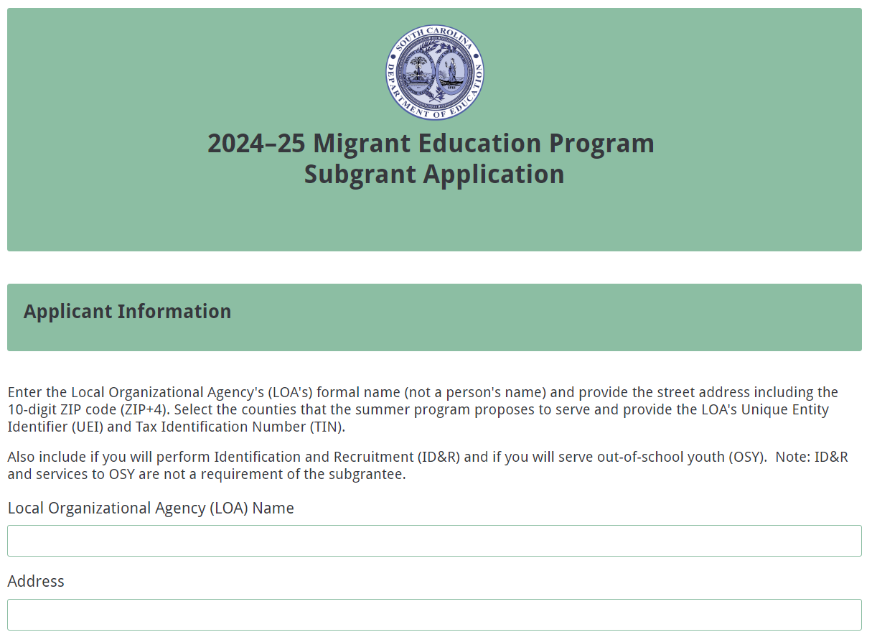
Select the counties that the proposed program will serve. Provide the 12-character alphanumeric unique entity identifier (UEI) and the Tax Identification Number (TIN). The LOA’s financial official can provide the UEI and TIN. Indicate whether you will be providing ID&R or services to OSY. Note: The subgrantee is not required to provide ID&R and services to OSY.
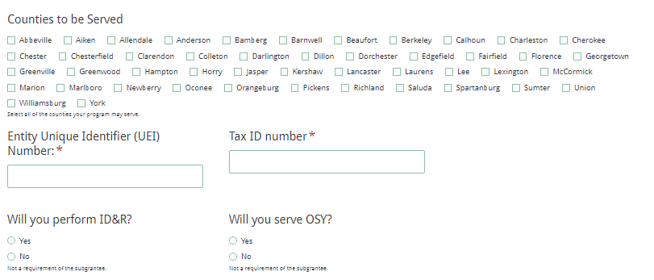
Evidence of Capacity to Serve Migrant Children
LOAs must have the capacity to provide migrant children supplementary services to help them overcome educational barriers to succeeding in school. Include the information requested below to provide evidence of the LOA’s ability to serve migrant children.

- Explain how the MEP program will be implemented efficiently and effectively.
- Describe the applicant’s capacity by describing how the types of activities proposed will meet the needs of the migratory children in the proposed service area. Include evidence that staff will work to identify and serve the migratory children. (Include a current résumé for the MEP director in the attachments section online (see page 32)
- Include a management plan for the program including the chain of command, who will manage the program, a brief job description for the MEP director, and the responsibilities and qualifications of each key staff member. Key staff members include recruiters (if applicable), outreach staff, service providers, liaisons, instructors, etc.
- Highlight successes in the MEP director’s past performance with similar programs.
- Include any professional development and training to be provided to all key staff throughout the subgrant period.
- Include a plan for collaboration and coordination with other state, local, federal programs, and/or community organizations to support wrap-around services to migratory children and youth.
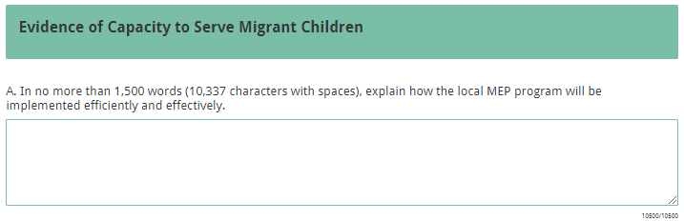
- Recruiters and/or outreach staff must be able to meaningfully communicate with parents/guardians and OSY to communicate all aspects of MEP. The SCDE recommends that recruiters and/or outreach staff be bilingual in English and the language most widely used in the area(s) to be served. Provide the number of recruiters and/or outreach staff in your program, how many are bilingual, and how many can meaningfully communicate with the parents/guardians and OSY about the MEP services.
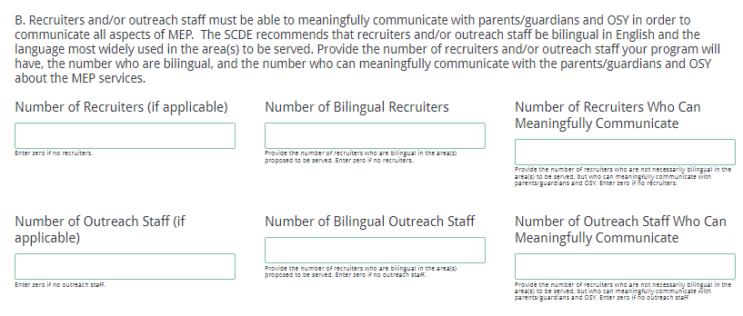
- Describe the LOA’s process for ensuring meaningful communication and translation and interpretation services. In accordance with the Title VI of the Civil Rights Act of 1964, Title I, Part C, funds cannot be used for core translation and interpretation services, as this would supplant the LOA’s obligation in the absence of federal funds. Within reason, Title I, Part C funds may be used to translation and interpretation for MEP-specific activities required to carry out the purpose of the subgrant.
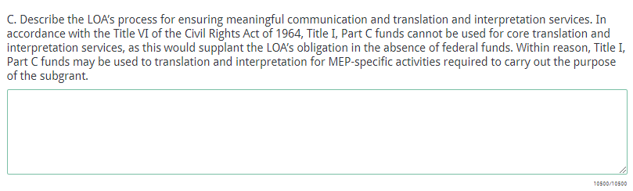
Program Evaluation and Reporting
Describe how the evaluation and data collection will take place. Include who will be responsible for entering and submitting the data in MIS2000 during the project period as specified on page 15. Describe how the data will be reviewed on an ongoing basis to determine if the program’s goals and outcomes stated will be met within the timeframe. Explain how you will be able to incorporate the outcomes of the evaluation in the planning for service improvement.
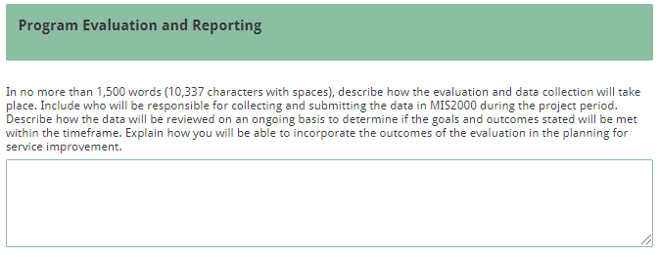
MEP Director Information
Provide the local MEP director’s formal name and contact information. The MEP director will receive the confirmation email upon submission of the application, so provide a valid email address. Check the box if the MEP director’s address is the same as the LOA’s address.
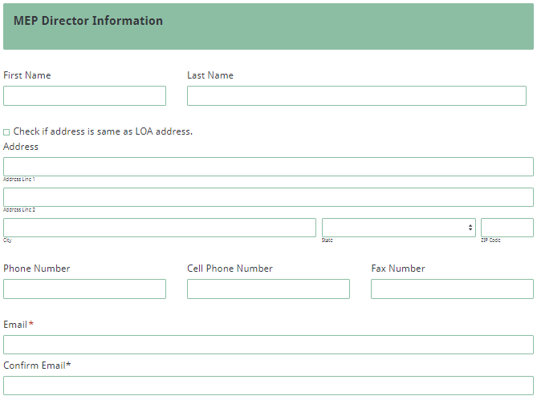
Title I Director Information (if applicable)
If applicable to the proposed MEP, provide the Title I director’s formal name. Check the box if the Title I director’s address is the same as the LOA’s address.
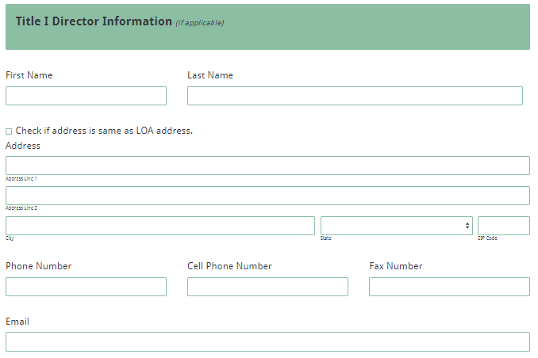
Financial Officer Information
Provide the financial officer’s formal name. Check the box if the financial officer’s address is the same as the LOA’s address.
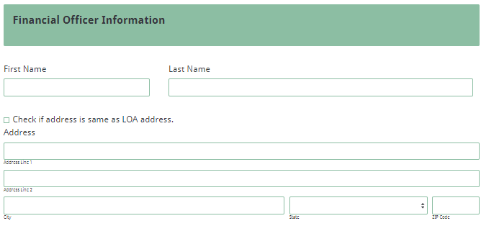
Superintendent/Chief Executive Officer (CEO) Information
Provide the superintendent’s or CEO’s formal name. Check the box if the superintendent/CEO’s address is the same as the LOA’s address.
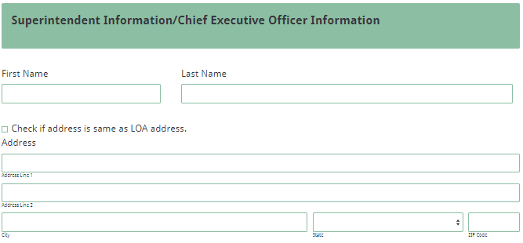
Program Summary
Provide the beginning and ending dates for the duration of the proposed local MEP. Include the number of hours per day, number of days per week, the hours of operation, and the number of weeks that services will be provided.
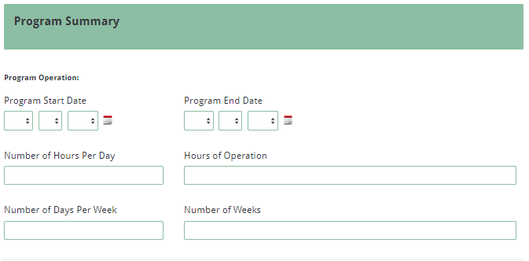
Program Application Narrative
Draft each section indicated below and save to copy and paste into the section boxes in the online form. Complete each section as applicable.

- Identification and/or Services for PFS Students
- Identification and/or Services for Eligible Migratory Children: Describe how program resources will be used to locate, identify, and enroll eligible migratory children and youth and provide support services that may address special needs such as health service(s), guidance, home-school contact, food service, transportation, facility maintenance, or other support service. If your program will rely on state recruiters for ID&R, explain how MEP student referrals will take place to facilitate student enrollments. Describe plans for coordinating services and activities with other federal, state, and local programs to ensure access to these resources for migratory students. State how you will coordinate with intrastate and interstate agencies to ensure the timely transfer of student records.
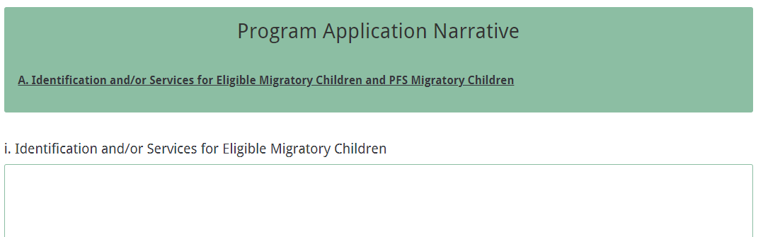
- Identification and Services for PFS Children: Based on the number of children identified and served in 2022–23 for the area to be served, state the process to be used for identifying priority-for-service children and youth (including OSY) and how their needs will be identified and met on a priority basis in the migrant program. See the 2022–23 list of students identified by LEA area on page 57.
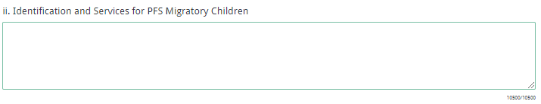
- Parent Consultation and Involvement
Parental involvement in the planning of program activities enables parents to understand the program and have informed conversations with MEP and school staff regarding their children’s education. Communication with parents must be meaningful and in a language and format that they understand. Such consultation should be documented and reported to the SCDE.

Describe how migratory parents and guardians will be consulted during the planning process of the migrant education program. Include how program resources will be used to promote migratory parent/guardian involvement activities within the MEP and/or provide migratory family literacy activities, including eligible migratory OSY, to promote achievement in English language arts and math. For family literacy, list the type of service and the amount of contact time proposed. Briefly explain how the program will collaborate and be coordinated with other resources, especially in the community.
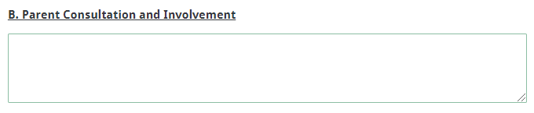
- Program Components that Address MEP
The following measurable performance objectives (MPOs) and key strategies were updated in 2017 to be used beginning in 2018–19 and each year thereafter. Use the information provided below as a guide in developing the LOA’s MEP for 2024-25 so that it aligns with the key strategies.

Based on the SCDE’s goals and measurable program outcomes for the MEP (see page 4), include a description of the strategies/activities to be used in each of the four components. The activities and associated costs in the budget narrative should mirror the strategies included in these components.

Component 1
GOAL 1: PROFICIENCY IN ENGLISH LANGUAGE ARTS. Students in South Carolina will be proficient in reading, writing, speaking, listening, and language to ensure that all students are college and career ready in English language arts (ELA) no later than the end of high school.
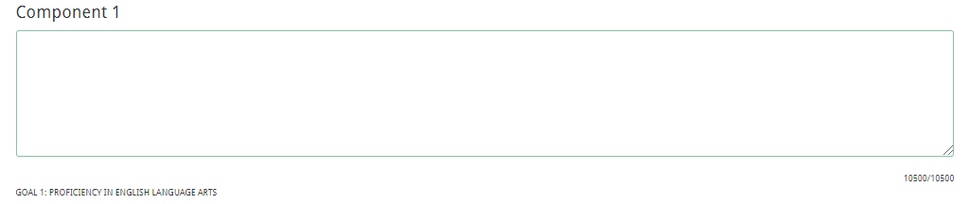
Component 2
GOAL 2: MATHEMATICS. Students in South Carolina will be proficient in comprehension of mathematical concepts, operations, relations, procedural fluency, and productive disposition to ensure that all students are college and career ready in mathematics no later than the end of high school.
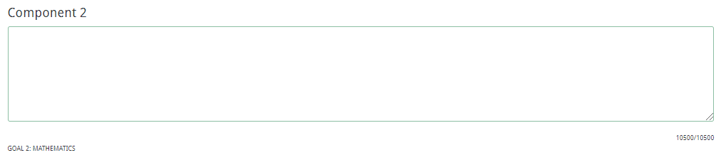
Component 3
GOAL 3: SCHOOL READINESS, FAMILY ENGAGEMENT AND ADVOCACY. Children and youth in South Carolina will engage in play to develop individual approaches to learning; show curiosity, eagerness, and satisfaction as a learner; demonstrate initiative, engagement, and persistence in learning; demonstrate an ability to envision a goal and to accomplish it; and extend their learning through the use of memory, reasoning, and problem-solving skills. Furthermore, parents or guardians of migratory children and youth will receive both instructional literacy services and support services in order to increase involvement and engagement in the educational development of their children.
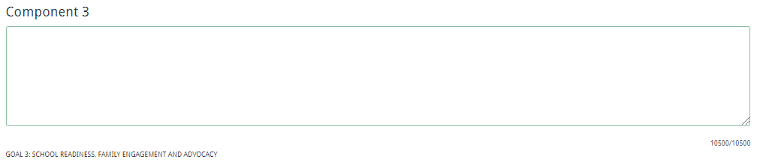
Component 4
GOAL 4: GRADUATION FROM HIGH SCHOOL, CREDIT ACCRUAL, DROPOUT PREVENTION, AND SERVICES TO OUT-OF-SCHOOL YOUTH. The SCDE’s goal is to increase the high school graduation rate through efforts to better prepare students for success after graduation, whether their preference is to immediately enter the workforce or to continue their education. South Carolina’s goal is that each high school in the state will achieve a graduation rate of at least 90 percent.
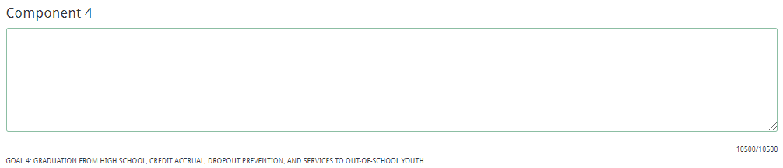
General Education Provisions Act (GEPA) Statement
Follow the instructions on page 53 to create a GEPA statement for the proposed MEP in a Word document to paste into the text box provided in the online form.
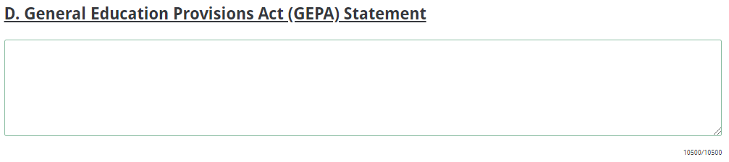

Application Budget
The application budget consists of two parts: the Budget Summary and the Budget Narrative. All proposed expenditures for the subgrant funding period must be itemized in the Budget Summary and detailed in the Budget Narrative. Budget items not explained in the application narrative will not be funded.

- The Budget Summary is the financial overview of the subgrant and must include all proposed expenditures for the project. Each budget category of the Budget Summary must correspond to the line items of the Budget Narrative (discussed below). Provide the budget details in the online application Budget Summary section.
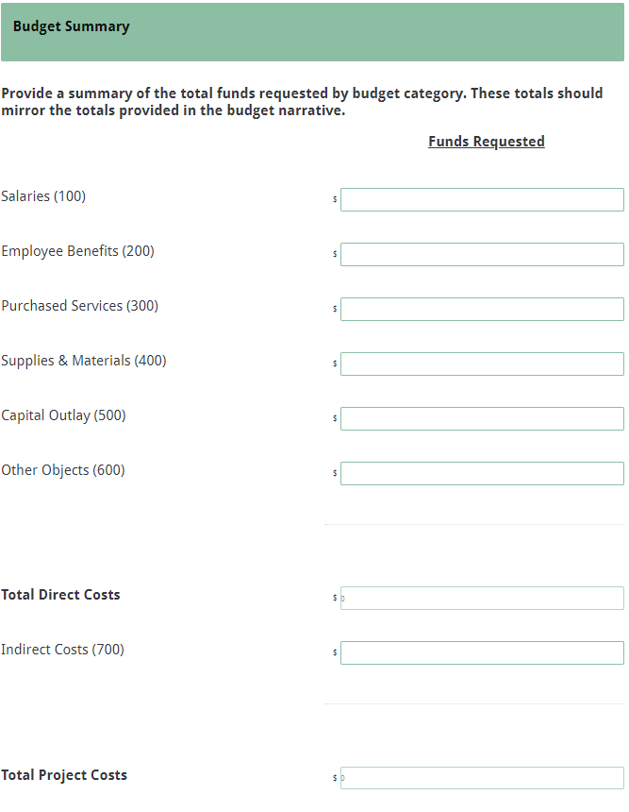
- The Budget Narrative must provide clear evidence that the budget is appropriate and justified based on the needs identified. Develop a detailed budget narrative in the Excel spreadsheet provided at the MEP Grant Opportunity website (accessible here). See a screenshot of the spreadsheet on page 55. List each line item by each MPO/strategy as detailed in the application. Include all calculations to justify that all costs are consistent with the program application narrative.

Ensure full vetting and compliance with 2 CFR Part 200—Uniform Administrative Requirements, Cost Principles, and Audit Requirements for Federal Awards when developing the budget narrative.
- Is the cost eligible, reasonable, necessary, and allocable?
- Is the cost consistent with policies, regulations, and procedures that apply uniformly to both federal and non-federal funds?

Save the budget narrative as an Excel spreadsheet labeled with the applying entity’s name, title of the document, and date to upload where indicated in the attachments section.

Ensure that the totals in the Budget Summary equal the totals in the Budget Narrative.

The following describes the line items that should be budgeted in each category.

Salaries/Stipends (100)
This category includes pay for salaries for staff members and substitutes and stipends for teachers. The total percentage of time charged to the subgrant and to non-grant funds cannot exceed 100 percent of the total time worked by any staff member.

Employee Benefits (200)
FICA, workers’ compensation, health insurance, and other employee benefits costs should be included here. These costs will represent a percentage of the total in Salaries/Stipends (100).

Purchased Services (300)
Expenses such as consultant fees, travel/transportation costs, telephone costs, and other purchased services will be included here. This includes amounts paid for personal services rendered by personnel who are not on the payroll and for other specialized services purchased by the organization. While a product may or may not result from the transaction, the primary reason for the purchase is the service provided. Note: Salaries for direct teachers and project staff should be recorded in Salaries/Stipends (100) and not in this section.

For a subgrantee to pay a vendor with federal funds, a contract must be in place. At a minimum, the contract should include the scope of services, the duration of the contract, and the method and amount of payment; the contract must be executed by both parties. Consulting/service contracts must be procured in accordance with procurement regulations in 2 CFR Part 200 (see § 200.317 to § 200.326 and Appendix II). LEA applicants should also review South Carolina Procurement Law.

In compliance with 2 CFR Part 180.300, subgrantees must ensure that they do not enter into a contract with any vendor that is debarred, suspended, or ineligible (i.e., excluded) for participation in federal programs by
- checking the Exclusions at the federal SAM Web site (review the Quick Start Guide for Searching Exclusions, available here, prior to conducting searches.);
- collecting a certification from the vendor and attaching it to the contract; or
- adding a clause or condition to the contract that indicates the vendor is eligible.

Supplies and Materials (400)
Include the amounts paid for material items of an expendable nature. It is recommended that applicants group items into categories to avoid listing every item; however, make sure that such expenditures are aligned with relevant project characteristics (objectives, number of participants, frequency of activity, etc.). Allow for maintenance, repair, and replacement costs over the grant life cycle of the proposed project for any equipment that totals $5,000 and below.

Capital Outlay/Equipment (500)
Equipment and supplies totaling more than $5,000 per unit are not allowable (see part I, section H). Itemize furniture, fixtures and equipment that total $5,000 and below per unit under Supplies and Materials. Applicants are reminded that equipment purchased with federal funds must be managed in compliance with 2 CFR Part 200 Subpart D § 200.313 (and § 200.439 as applicable). See part I, section F for more information on applicable federal regulations.

Other Objects (600)
This category includes expenditures such as postage, liability insurance fees, and copyright fees that do not neatly fit into the other categories.

Indirect Costs (700)
Indirect costs represent the operating expenses that are not readily identified with a particular grant, contract, project function, or activity, but are necessary for the general operation of an organization and the conduct of activities it performs. In theory, expenses like heat, electricity, accounting, and personnel might be charged directly if little meters could record minutes in a cross-cutting manner; however, practical difficulties preclude such an approach. Therefore, cost allocation plans or indirect cost rates are used to distribute those costs to benefiting revenue sources.

To charge indirect costs to a subgrant, a subgrantee must have an approved indirect cost rate agreement. If the applicant is a school or school district, the restricted indirect cost rate of the school district (in the case of an applicant that is a school, the district in which the school is located) must be used. Per 2 CFR Part 200.414, any non-federal entity that has never received a negotiated indirect cost rate, may elect to charge a de minimis rate of 10% of modified total direct costs, which may be used indefinitely. Prior approval from the SCDE program office is required when considering to elect a de minimis rate. Costs must be consistently charged as either indirect or direct costs, but may not be double-charged or inconsistently charged as both. If chosen, this methodology must be used consistently for all federal awards until such time as a non-federal entity chooses to negotiate a rate, which the non-federal entity may apply to do at any time. Any non-federal entity that elects to apply for a rate should contact the SCDE Office of Auditing Services for guidance on applying for a rate.

The SCDE reserves the right to disqualify, disallow, and negotiate costs associated with any line item proposed in the budget. If any line item cost is determined to be excessive, given the nature and scope of the entire project or of a particular activity, the SCDE can request the applicant reduce the cost of the line item or ask the applicant to assume a portion of the cost before the budget is approved and funds are awarded.

Funds will be disbursed on a reimbursement basis upon the receipt of expenditure reports with all supporting documentation from the subgrantees. Subgrantees may not obligate funds prior to the receipt of a grant award notice. No expenditures incurred prior to the start of the period of performance, July 1, 2023, will be reimbursed. Applicants should have at their disposal at least three months of sustainable funds to implement the program prior to SCDE reimbursement. Subgrantees are not permitted to pick up their reimbursements from the SCDE office.

Application Attachments

Prepare each application attachment (i.e., MEP Director’s Résumé, Private School Consultation Form, Budget Narrative, and Certification Signature Page and Pre-Award Audit Questionnaire) as directed below. The online application form will only allow one document to be uploaded per attachment. Upload the specific appendices where indicated in the following screenshot.

MEP Director’s Résumé
Obtain and save the résumé for the MEP director as a PDF document to upload in the attachments section.

Private School Consultation Form
Programs must consult with private school officials before making any decision that affects the opportunities of eligible private school children and youth to participate in the MEP project (see page 12). Complete and save the Private School Consultation Form located on page 56 as a PDF document to upload in the attachments section.

Budget Narrative
Save the budget narrative as an Excel spreadsheet (see page 30) labeled with the applicant entity’s name, title of the document, and date to upload where indicated in the attachments section.

Certification Signature Page
Print and acquire signatures on the Certification Signature Page (page 42) and scan as a PDF document to upload in the attachments section online labeled with the applying entity’s name, title of the document, and date. This page includes certification of the SCDE’s Assurances and Terms and Conditions for Federal Subawards (page 43) and the MEP Program-Specific Assurances (pages 48); therefore, applicants are not required to include those documents in their submitted application. However, ensure that each signatory has reviewed each document prior to signing the Certification Signature page and retain the copy included in these instructions for your records.

Pre-Award Audit Questionnaire
Complete the Pre-Award Audit Questionnaire (see page 50). Save the completed questionnaire as a separate document from appendix items. Do not submit the supporting documents with the application. The SCDE’s Office of Auditing Services will review this questionnaire as part of the pre-award risk assessment and may conduct a further evaluation of the applicant’s financial system, internal controls, and policies and procedures.
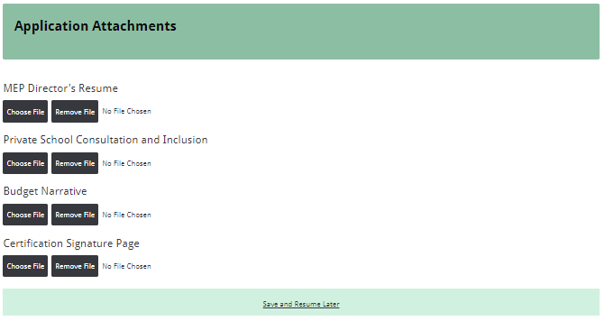
Saving Progress (if applicable)
If necessary, you may save your progress in the online application and return to the form later. Note that you do not have to save the form in order to submit your application. If you are prepared, you can enter and submit the application without having to save the form.

Click on the “Save and Resume Later” link to save your progress. You will have the option of copying and saving the link to the partially completed form or entering an email address to have the link emailed to you. Be sure to enter the email address correctly as SCDE personnel cannot access the hyperlink or the incomplete application. Use the link to access the application from any computer within thirty days to complete the online submission.

Note: A saved application is not a submitted application. Use the hyperlink to return to the incomplete application within thirty days to complete the online submission. Without the link or after thirty days, the data previously entered cannot be retrieved, and you will have to begin a new application. Additionally, you will not be able to use the link once you submit your application.

You must follow the steps described below to complete the submission process.

Reviewing and Submitting Application

After all information is entered into the online form and all appendices are uploaded and attached to the form, click the Next button at the bottom right of the form.
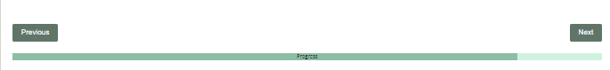
You will be directed to the MEP Data Review and Confirmation Page to review the information entered and attached. Complete your full review prior to submitting the application.
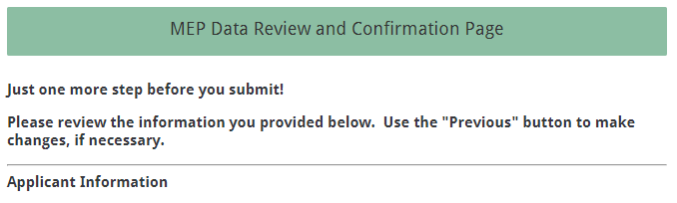
Click the previous button at the bottom of the page to return to your form and make any needed corrections. Note: You will not be able to return to an application that has been submitted, so verify the data and make any necessary changes at this time.
After all information entered is verified, click the “Submit Application” button to submit the completed application.

Once the application is submitted, you will receive the following message:
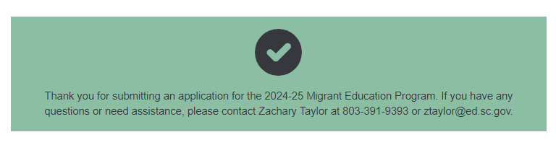
The MEP director will receive the submission confirmation email containing the information included in the application. Save this email along with the application attachments and this instruction document for your records. An email confirmation indicates that your application was uploaded successfully; however, it does not account for the quality of the upload or the completeness of the application. The confirmation email only notifies you that your online application was submitted.
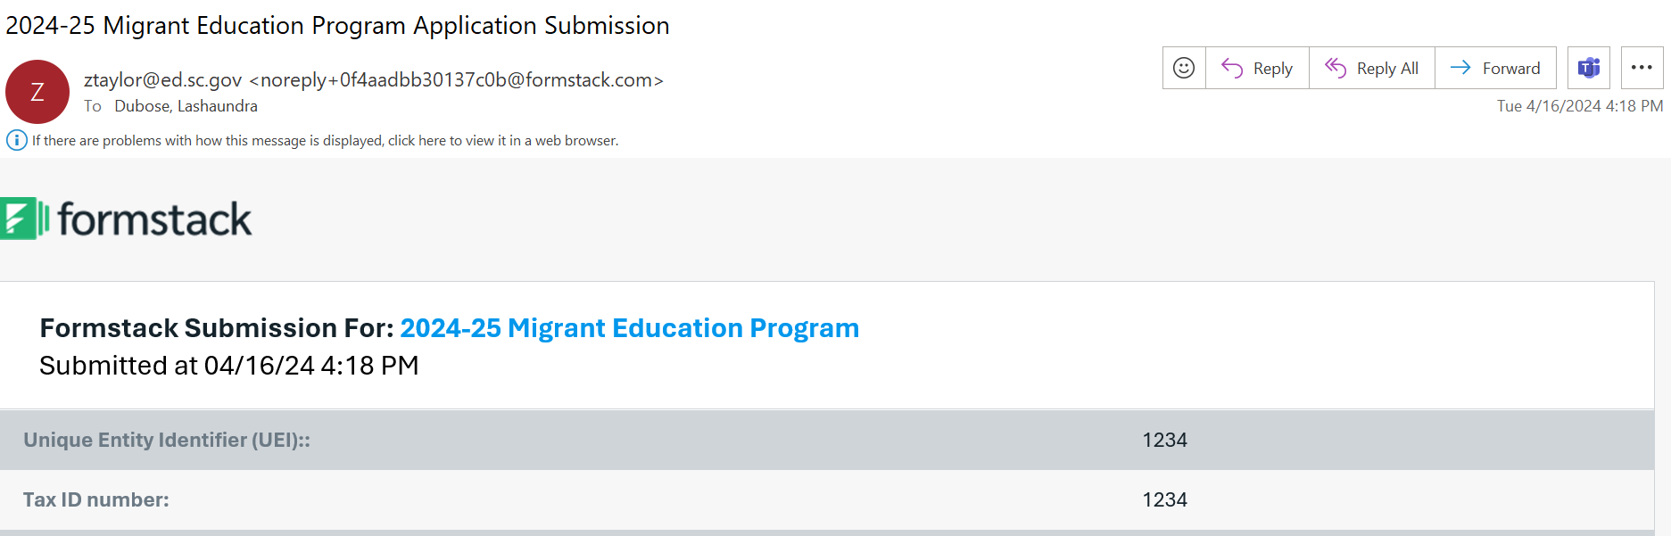
If changes need to be made after the application has been submitted, start another application submission and enter all information again. Only the latest, complete application will be reviewed and considered for funding.

Deadline and Submission Procedures

- Applications must be submitted online by 5:00 p.m., June 7, 2024.
- Only applications that adhere to all of the guidelines and directions set forth in this RFA will be reviewed and considered for funding.
- No hard copy applications will be accepted. Applications delivered by hand, postal mail, email, or fax will not be accepted.
- Applications must originate from the applicant. Applications that are plagiarized from the Internet, other grants, or other resources will not be considered for funding.
- Do not attach or submit any additional materials other than what is specifically required. Any additional materials will be disposed of without review.
- Applications will not be returned. Keep a copy of the entire application for your records.

Appendix A: Definitions of Terms Used

Agricultural Work (Section 1309(2) of ESEA)—The production or initial processing of raw agricultural products, such as crops, poultry, or livestock; dairy work; as well as the cultivation or harvesting of trees. It consists of work performed for wages or personal subsistence.

Continuation of Services (Section 1304(e) of ESEA)—Services may be continued if (1) a child who ceases to be a migratory child during a school term shall be eligible for services until the end of such term; (2) a child who is no longer a migratory child may continue to receive services for one additional school year, but only if comparable services are not available through other programs; and/or (3) students who were eligible for services in secondary school may continue to be served through credit accrual programs until graduation.

Fishing Work (34 CFR Part 200.81(c))—The catching or initial processing of fish or shellfish or the raising or harvesting of fish or shellfish at fish farms. It consists of work performed for wages or personal subsistence.

Migratory Agricultural Worker (Section 1309(2) of ESEA)—An individual who made a qualifying move in the preceding 36 months and, after doing so, engaged in new temporary or seasonal employment or personal subsistence in agriculture, which may be dairy work or the initial processing of raw agricultural products. If an individual did not engage in such new employment soon after a qualifying move, such individual may be considered a migratory agricultural worker if the individual actively sought such new employment and has a recent history of moves for temporary or seasonal agricultural employment.

Migratory Child (Section 1309(2) of ESEA)—A child who meets the following conditions:
1. The child is not older than 21 years of age; and
2. The child is
a. entitled to a free public education (through grade 12) under state law, or
b. not yet at grade level at which the LEA provides a free public education; and
3. The child made a qualifying move in the preceding 36 months as a migratory agricultural worker or a migratory fisher, or did so with, or to join a parent/guardian or spouse who is a migratory agricultural worker or a migratory fisher; and
4. With regard to the qualifying move identified in item 3, above, the child moved due to economic necessity from one residence to another residence, and
- from one school district (LEA) to another; or
- in a state that is comprised of a single school district, has moved from one administrative area to another within such district; or
- resides in a school district of more than 15,000 square miles and migrates a distance of 20 miles or more to a temporary residence.

Migratory Fisher (Section 1309(4) of ESEA)—An individual who made a qualifying move in the preceding 36 months and, after doing so, engaged in new temporary or seasonal employment or personal subsistence in fishing. If the individual did not engage in such new employment soon after the move, the individual may be considered a migratory fisher if the individual actively sought such new employment and has a recent history of moves for temporary or seasonal fishing employment.

Out-of-School Youth (OSY)—A youth that meets the definition of a “migratory child” but is not currently enrolled in a K–12 institution. This term could include students who have dropped out of school, youth who are working on a high school equivalency diploma (HSED) outside of a K–12 institution, and youth who are “here to work” only. It would not include children in preschool, nor does it include temporary absences (e.g., summer/intersession, suspension, or illness). Enrollment in school is not a condition affecting eligibility for the MEP.

Qualifying Move (Section 1309(5) of ESEA)—A move
- due to economic necessity;
- from one residence to another residence; and
- from one school district (LEA) to another school district, except—
- in the case of a state that is comprised of a single school district, a move qualifies if it is from one administrative area to another within such district; or
- in the case of a school district of more than 15,000 square miles, a move qualifies if it is over a distance of 20 miles or more to a temporary residence.

Qualifying Work (34 CFR Part 200.81)—Work that is temporary employment or seasonal employment or personal subsistence in agriculture or fishing (e.g., picking fruits and vegetables, pruning trees, or raking pine needles).

Seasonal Employment (34 CFR Part 200.81)—Employment that occurs only during a certain period of the year because of the cycles of nature and that, by its nature, may not be continuous or carried on throughout the year.

Temporary Employment (34 CFR Part 200.81)—Employment that lasts for a limited period of time, usually a few months, but no longer than 12 months. It typically includes employment where the employer states that the worker was hired for a limited time frame; the worker states that the worker does not intend to remain in that employment indefinitely; or the SEA has determined on some other reasonable basis that the employment is temporary. The definition includes employment that is constant and available year-round only if, within 18 months after the effective date of this regulation and at least once every three years thereafter, the SEA documents that, given the nature of the work, of those workers whose children were previously determined to be eligible based on the state’s prior determination of the temporary nature of such employment (or the children themselves if they are the workers), virtually no workers remained employed by the same employer more than 12 months.

Appendix B: Selection Criteria and Reviewers’ Scoring Rubric

Selection Criteria

The MEP application reviewers will use the following selection criteria in general to evaluate the quality and completeness of each application. In the event that two or more LOAs propose to operate the MEP in the same geographical region of the state, the SCDE will use the scoring to select the LOA most qualified for funding based on the selection criteria.

The review criteria for each section of the application are as follows:

1 = Weak | 2 = Medium | 3 = Strong
- Ideas are unclear with little/no support.  - Few examples are used throughout plan.  - Lacks relevant details. | - Ideas are broad with some support.  - Examples are used, but not throughout plan.  - Details are relevant, but not sufficient. | - Ideas are clear with sufficient support.  - Specific examples are used throughout plan.  - Details are relevant.

Scoring Rubric

Application Section | Yes/No | Application Quality  Score 1–3 | Notes
LOA Eligibility
- LEA, public/non-profit private agency, or partnership
- Registered and active with SAM
Signatures & Assurances
- All designees signed Certification Signature Page
Applicant Information
- Designates when services will be provided
- Includes LOA’s contact information including UEI and TIN
Evidence of Capacity
- Describes the plan to manage the program
- Includes the chain of command, who will manage the program, brief job description of MEP director, and responsibilities for each key staff member
Contact Information
- MEP Director Information
- Title I Director Information (if applicable)
- Financial Officer
- Superintendent/CEO
Program Summary
Depending on the type of service to be provided, the applicant includes all information requested.
Program Proposal Narrative
- Identification and Services
- States the process to be used for identifying priority for service children and youth (including Out-of-School Youth (OSY)).
- Describes how their identified needs will be met on a priority basis.

Application Section | Yes/No | Application Quality  Score 1–3 | Notes
Program Proposal Narrative
- Program Components that Address MEP
Includes the four components and describes the strategies/activities to be used.
- Goal 1: Proficiency in English Language Arts
- Goal 2: Mathematics
- Goal 3: School Readiness, Family Engagement and Advocacy
- Goal 4: Graduation from High School, Credit Accrual, Dropout Prevention, and Services to OSY
- Program resources to locate, identify, and enroll eligible migrant children in support services; plans to coordinate within LEAs to ensure access to programs; and LOA’s intrastate and interstate coordination efforts.
- Program has a process for identifying, documenting, and prioritizing services to eligible children who are deemed Priority for Service students.
- Program resources to promote migrant parent involvement (if family literacy, lists type of service and amount of contact time proposed); proposed collaboration and coordination with other resources; and as applicable, how will the PAC be involved.
- Recruiters are able to meaningfully communicate with students, parents, and OSY. A process for ensuring meaningful communication and translation and interpretation services for MEP students and families is in place and not supplanted by federal funds.

Application Section | Yes/No | Application Quality  Score 1–3 | Notes
- GEPA Statement
Statement represents overcoming barriers that would inhibit migrant children, parents, and OSY from participating in local program and local services.
Budget Summary
- Includes a budget summary of total funds requested.
- Summary mirrors the budget narrative total.
Application Attachments
MEP Director’s Résumé
Attached.
Private School Consultation Form
Shows evidence of consulting with private school officials before making any decisions that affect the opportunities of eligible private school children to participate in MEP.
Budget Narrative
Uses Excel spreadsheet and includes a detailed budget narrative listing each line item by MPO/strategy.

Appendix C: Required SCDE Forms

Certification Signature Page

Certification
I hereby certify by signing below, to the best of my knowledge, the information and data contained in this application are true and correct. The applicant’s governing body has duly authorized this application and documentation, and the applicant will comply with the Program Specific Assurances and the SCDE Assurances and Terms and Conditions for Federal Subawards if the subgrant is awarded. The applicant is registered and current (active) on the federal System for Award Management (SAM).

Please type the names requested below (or equivalent positions as determined by the LEA) and obtain signatures.
Title I, Part C MEP Director:
Signature: | Date:
Title I Director (if applicable):
Signature: | Date:
Financial Officer:
Signature: | Date:
Superintendent/Chief Executive Officer:
Signature: | Date:

Complete, print, and obtain signatures prior to submission. Include the signed, scanned form in the required application attachments as indicated on page 32.

Assurances and Terms and Conditions for Federal Subawards

Assurances

I certify that this applicant
- Has the legal authority to apply for federal assistance and the institutional, managerial, and financial capability (including funds sufficient to pay the nonstate share of project costs) to ensure proper planning, management, and completion of the project described in this application.
- Will give the South Carolina Department of Education (SCDE) access to and the right to examine all records, books, papers, or documents related to this award and will establish a proper accounting system in accordance with generally accepted accounting principles (GAAP) or agency directives.
- Has an accounting system with sufficient internal controls, a clear audit trail, and written cost-allocation procedures as necessary. The financial management systems are capable of distinguishing expenditures that are attributable to this grant from those that are not attributable to this grant. This system is able to identify costs by programmatic year and by budget line item and to differentiate among direct, indirect, and administrative costs. In addition, the applicant will maintain adequate supporting documents for the expenditures (federal and nonfederal) and in-kind contributions, if any, that it makes under this grant. Costs are shown in books or records (e.g., disbursements ledger, journal, payroll register) and are supported by a source document such as a receipt, travel voucher, invoice, bill, or in-kind voucher.
- Will also comply with the Office of Management and Budget 2 CFR Part 200 Subpart E-Cost Principles related to the allowability, reasonableness, and allocability of costs consistent with the approved budget and also by maintaining required support for salaries and wages. Required support includes certifications and/or personnel activity records depending upon the amount of time spent on cost objectives.
- Will approve all expenditures, document receipt of goods and services, and record payments on the applicant’s accounting records prior to submission of reimbursement claims to the SCDE for costs related to this grant.
- Will initiate and complete work within the applicable time frame after receipt of approval by the SCDE.
- Will not discriminate against any employee or applicant for employment because of race, color, religion, age, sex, national origin, or disability and comply with Title VI of the Civil Rights Act of 1964, Section 504 of the Rehabilitation Act of 1973, Title IX of the Education Amendments of 1972, the Age Discrimination Act of 1975, and Titles I, II, and III of the Americans with Disabilities Act of 1990 (ADA). The grantee will take affirmative action to ensure that applicants for employment and the employees during the period of their employment are treated without regard to their race, color, religion, age, sex, national origin, or disability.
- Has no policy that prevents, or otherwise denies, participation in constitutionally protected prayer in public schools as set forth in the Guidance on Constitutionally Protected Prayer in Public Education (20 U.S.C. § 7904).
- Will comply with the Family Educational Rights and Privacy Act. (20 U.S.C. §1232g; 34 CFR Part 99).
- Will comply with the Ethics, Government Accountability, and Campaign Reform Act (S.C. Code Ann. § 2-17-10 et seq. and § 8-13-100 et seq. (Supp. 2023)).
- Will comply with the South Carolina Drug Free Workplace Act (S.C. Code Ann. § 44-107-10 et seq. (Supp. 2023) if the amount of this award is $50,000 or more and the federal Drug Free Workplace Act of 1988 (41 USC 702).
- Will provide information to the SCDE, as requested, regarding the reporting requirements of the Federal Funding Accountability and Transparency Act (FFATA), which requires the SCDE to file a FFATA subaward report by the end of the month following the month in which it awards any subgrant equal to or greater than $25,000.
- Will comply with 2 CFR Part 25 and register and receive a unique entity identifier, fulfill the requirement for the System for Award Management, maintain the currency of the registration throughout the full grant term, and allow access by the granting agency to ensure compliance.
- Will comply with 2 CFR Part 200.112 and disclose in writing any potential conflict of interest to the SCDE.
- Will comply with 2 CFR Part 200.113 and disclose in writing to the SCDE all violations of federal criminal law involving fraud, bribery, or gratuity violations potentially affecting the federal award.
- Will comply with conditions under Executive Order 13513 “Federal Leadership on Reducing Text Messaging While Driving” (October 1, 2009) by refraining from text messaging while driving during official grant business. Relatedly, the applicant will refrain from emailing while driving during official grant business.

Terms and Conditions

- Completeness of Proposal. All proposals should be complete and carefully worded and must contain all of the information requested by the South Carolina Department of Education (SCDE). If you do not believe a section applies to your proposal, please indicate that fact.
- Non-awards/Termination. The SCDE reserves the right to reject any and all applications and to refuse to grant monies under this solicitation. If the SCDE rejects an application, the applicant has a right to request a hearing, as provided by 2 CFR Part 200.341 and 34 CFR Part 76.401, if it alleges the SCDE’s actions violate a state or federal statute or regulation by (1) disapproving of or failing to approve the application or project, in whole or in part, or (2) failing to provide funds in amounts in accordance with the requirements of statutes and regulations.
After it has been awarded, the SCDE may terminate a grant by giving the grantee written notice of termination. In the event of a termination after award, the SCDE shall reimburse the grantee for allowable expenses incurred up to the notification of termination. In addition, this grant may be terminated by the SCDE if the grantee fails to perform as promised in its proposal. Federal grants will be terminated in accordance with 2 CFR Part 200.339 and 200.340.
In the event that this grant is terminated, the grantee shall have a right to a hearing as set forth in 34 CFR Part 76.783. The grantee must notify the SCDE of its request for a hearing within 30 days of receiving written notice of the termination. If a hearing is requested, the SCDE will conduct the hearing in accordance with the procedures outlined in 34 CFR Part 76.401(d)(2)–(7).
- Reduction in Budgets and Negotiations. The SCDE reserves the right to negotiate budgets with applicants. The SCDE may, at its sole discretion, determine that a proposed budget is excessive and may negotiate a lower budget with the applicant. The applicant may at that time negotiate or withdraw its proposal. In addition, the SCDE may desire to fund a project but not at the level proposed. In that case, the SCDE shall notify the applicant of the amount that can be funded, and the applicant and the SCDE shall negotiate a modification to the proposal to accommodate the lower budget. All final decisions are that of the SCDE.
- Amendments to Grants. Amendments are permitted generally for budgets, grant end date, and management upon the mutual agreement of the parties involved and will become effective when specified in writing and signed by both parties. However, amendments to scope of work that significantly alter the original application proposal may trigger partial or full termination consistent with 2 CFR Part 200.339 and 200.340.
- Use of Grant Funds. Funds awarded are to be expended only for purposes and activities covered by the approved project plan and approved budget and budget narrative.
- Submission of Expenditure Reports. Claims for reimbursement must be made at least quarterly and consistent with calendar quarters (e.g., an expenditure report claim for costs for January 1 through March 30 must be filed by May 15).
- Obligation of Grant Funds. Grant funds may not be obligated prior to the effective date or subsequent to the end or termination date of the grant period. No obligations are allowed after the end of the grant period. The final request for expenditure report claims must be submitted no later than forty-five (45) days after the end of the grant period unless the scope of work for the grant states a shorter reporting period.
- Deobligation of Funds. After a final expenditure report claim has been submitted to the SCDE, the grantee will go through the official deobligation process with the SCDE.
- Documentation. The grantee must provide for accurate and timely recording of receipts and expenditures. The grantee’s accounting system should distinguish receipts and expenditures attributable to each grant. The grantee must review the memo regarding “Guidelines for Retaining Documentation to Support Expenditure Claims.”
- Travel Costs. Travel costs, if allowed under this solicitation, must not exceed limits noted in the United States General Services Administration (GSA) per diem rates for lodging, except in the case of conference lodging required for program-required training. In the case that conference-related lodging exceeds the GSA per diem rate, the grantee shall follow their entity’s written procedure for obtaining prior approval to exceed a GSA rate for a conference hotel. Meals and incidentals are limited by the state budget proviso, currently not to exceed $35 per day for in-state travel and $50 for out-of-state travel (see page 81 of the State of South Carolina Statewide Disbursement Regulations). Mileage reimbursement must follow the current Office of Comptroller General instructions, which is consistent with the published IRS rates.
- Honoraria. Amounts paid in honoraria, if allowed under this grant, must be consistent with SCDE policies. Applicants should check with the program office before budgeting for honoraria.
- Reports. The grantee shall submit, as required or instructed by the awarding program office, all reports (programmatic, financial, or evaluation) within the specified period or date and in the prescribed format. An expenditure claim report must be filed by August 15 for all expenditures incurred by June 30 in order to comply with the generally accepted accounting principles (GAAP) and the production of the State's Comprehensive Annual Financial Report.
- Copyright. The grantee is free to copyright any books, publications, or other copyrightable materials developed in the course of this grant. However, the SCDE reserves a royalty-free, nonexclusive, and irrevocable license to reproduce, publish, or otherwise use, and to authorize others to use, the copyrighted work developed under this grant.
- Certification Regarding Lobbying, Suspension, and Debarment. By submitting an application, the applicant certifies, to the best of its knowledge and belief, that the
- Applicant and/or any of its principals, subgrantees, or subcontractors
  - Have not paid or will not pay to any person any federally appropriated funds for the purpose of influencing or attempting to influence an officer or employee of any agency, a Member of Congress, an officer or employee of Congress, or any employee of a Member of Congress in connection with making any federal grant and the extension continuation, renewal, amendment, or modification of any federal grant, as defined at 34 CFR Part 82.105 and 82.110. If any funds other than federally appropriated funds have been paid or will be paid to any person for influencing or attempting to influence an officer or employee of any agency, a Member of Congress, an officer or employee of Congress, or any employee of a Member of Congress in connection with this federal grant, the undersigned shall complete and submit Standard Form LLL, “Disclosure of Lobbying Activities,” in accordance with its instructions.
  - Are not presently debarred, suspended, proposed for debarment, or declared ineligible for the award of contracts by any state or federal agency as stated at 2 CFR Part 180 or 2 CFR Part 3485.
  - Have not, within a three-year period preceding this application, been convicted of or had a civil judgment rendered against them for commission of fraud or a criminal offense in connection with obtaining, attempting to obtain, or performing a public (federal, state, or local) contract or subcontract; violated federal or state antitrust statutes relating to the submission of offers; or committed embezzlement, theft, forgery, bribery, falsification or destruction of records, making false statements, tax evasion, or receiving stolen property.
  - Are not presently indicted for, or otherwise criminally or civilly charged by a governmental entity with, commission of any of the offenses enumerated above.
- Applicant has not, within a three-year period preceding this application, had one or more contracts terminated for default by any public (federal, state, or local) entity.
- Audits.
- Entities expending $750,000 or more in federal awards:
Entities that expend $750,000 or more in federal awards during the fiscal year are required to have an audit performed in accordance with the provisions of 2 CFR Part 200.501, et seq. Except for the provisions for biennial audits provided in 2 CFR Part 200.504 (a) and (b), audits must be performed annually as stated at 2 CFR Part 200.504. A grantee that passes through funds to subrecipients has the responsibility of ensuring that federal awards are used for authorized purposes in compliance with federal program laws, federal and state regulations, and grant agreements. The director of the OMB, who will review this amount every two years, has the option of revising the threshold upward.
- Entities expending less than $750,000 in federal awards:
Entities that expend less than $750,000 in a fiscal year in federal awards are exempt from the audit requirements in 2 CFR Part 200.504. However, such entities are not exempt from other federal requirements (including those to maintain records) concerning federal awards provided to the entity. The entity’s records must be available for review or audit by the SCDE and appropriate officials of federal agencies, pass-through entities, and the General Accounting Office (GAO).
- Records. The grantee shall retain federal grant records, including financial records and supporting documentation, for a minimum of six (6) years after the end date of the grant when the final expenditure report claim for reimbursement and all final reports have been submitted, unless informed otherwise or in the case of litigation.
- Electronic Signature Agreement. I agree that my electronic signature is the legally binding equivalent to my handwritten signature.

Migrant Education Program (MEP) Program-Specific Assurances

For informational purposes only.
The applicant agrees to abide by the SCDE Program-Specific Assurances by signing and submitting the Certification Signature Page.

The applicant ensures that it will:

- Administer each ESEA program in accordance with all applicable statutes, regulations, program plans, and applications (Sec. 8306(a)(1));
- Comply with all programmatic requirements that apply to an ESEA program, including serving eligible entities, providing allowable activities, complying with all assurances, etc.;
- Ensure that migratory children and formerly migratory children who are eligible to receive services under Title I, Part A are selected to receive such services on the same basis as other children who are selected to receive services under Title I, Part A (Sec. 1112(c)(1));
- Provide services to eligible children attending private elementary schools and secondary schools in accordance with section 1117 of ESEA, and timely and meaningful consultation with private school officials regarding such services (sec. 1112(c)(2));
- Participate, if selected, in the National Assessment of Educational Progress in reading and mathematics in grades 4 and 8 carried out under Sec. 303(b)(3) of the National Assessment of Educational Progress Authorization Act (20 U.S.C. 9622(b)(3)) (Sec. 1112(c)(3));
- Coordinate and integrate services provided under this part with other educational services at the local educational agency (LEA) or individual school level, such as services for English learners, children with disabilities, migratory children, American Indian, Alaska Native, and Native Hawaiian children, and homeless children and youths, in order to increase program effectiveness, eliminate duplication, and reduce fragmentation of the instructional program (Sec. 1112(c)(4);
- Collaborate with the state or local child welfare agency to:
  - Designate a point of contact if the corresponding child welfare agency notifies the LEA, in writing, that the agency has designated an employee to serve as a point of contact for the LEA; and
  - Develop and implement clear written procedures, in accordance with Sec. 1112(c)(5)(B)(i-ii), governing how transportation to maintain children in foster care in their school of origin when in their best interest will be provided, arranged, and funded for the duration of the time in foster care (Sec. 1112(c)(5));
- Ensure, in the case of an LEA that chooses to use funds under Title I, Part A to provide early childhood education services to low-income children below the age of compulsory school attendance, that such services comply with the performance standards established under section 641A(a) of the Head Start Act (42 U.S.C. 9836a(a)) (Sec. 1112(c)(7).
- Ensure that all teachers and paraprofessionals working in a program supported with funds under Title I, Part A meet applicable state certification and licensure requirements, including any requirements for certification obtained through alternative routes to certification (Sec. 1112(c)(6));

- Establish and implement an LEA-wide salary schedule; a policy to ensure equivalence among schools in teacher, administrators, and other staff; and a policy to ensure equivalence among schools in the provision of curriculum materials and instructional supplies (Sec. 1118(c)(2));
- Ensure that the control of funds provided under each ESEA program and title to property acquired with program funds will be in a public agency or in a eligible private agency, institution, organization, or Indian tribe, if the law authorizing the program provides for assistance to those entities and the public agency, eligible private agency, institution, or organization, or Indian tribe will administer the funds and property to the extent required by authorizing statutes (Sec. 8306(a)(2));
- Adopt and use proper methods of administering each such program, including the enforcement of any obligations imposed by law on agencies, institutions, organizations, and other recipients responsible for carrying out each program and the correction of deficiencies in program operations that are identified through audits, monitoring, or evaluation (Sec. 8306(a)(3));
- Cooperate in carrying out any evaluation of each such program conducted by or for the South Carolina Department of Education (SCDE), the US Secretary of Education, or other federal officials (Sec. 8306(a)(4));
- Use such fiscal control and fund accounting procedures as will ensure proper disbursement of, and accounting for, federal funds paid to the applicant under each such program (Sec. 8306(a)(5));
- Submit such reports to the SCDE (which shall make the reports available to the Governor) and the Secretary may require to enable the SCDE and the Secretary to perform their duties under each such program (Sec. 8306(a)(6)(A));
- Maintain such records, provide such information, and afford such access to the records as the SCDE (after consultation with the Governor) or the Secretary may reasonably require to carry out the SCDE’s or the Secretary’s duties (Sec. 8306(a)(6)(B));
- Afford a reasonable opportunity for public comment on the application and consider each comment, before the application is submitted (Sec. 8306(a)(7));
- Comply with the requirements of Section 8501 regarding participation by private school children and teachers for all applicable ESEA programs (Sec. 8501);
- Comply with all ESEA program fiscal requirements, including, but not limited to, maintenance of effort, supplement not supplant, and comparability;
- Comply with state law requiring LEAs to expel from school for a period of not less than 1 year a student who is determined to have brought a firearm to a school, or to have possessed a firearm at a school, under the jurisdiction of LEAs in the state S.C. Code Ann. §59-63-235 (1995)(Sec. 8561);
- Comply with applicable sections of the Education Department General Administrative Regulations (EDGAR) in 34 Parts 75, 76, 77, 80 and 2 CFR Part 200.

Pre-Award Audit Questionnaire for LEAs and State Agencies

Download and complete the Pre-Award Audit Questionnaire for LEAs and State Agencies.
Non-LEAs must complete the Pre-award Audit Questionnaire for Non-LEAs.
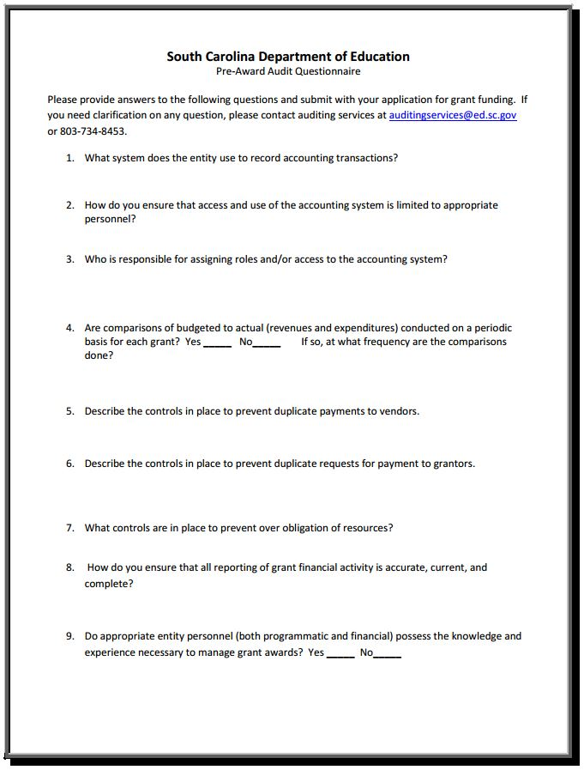
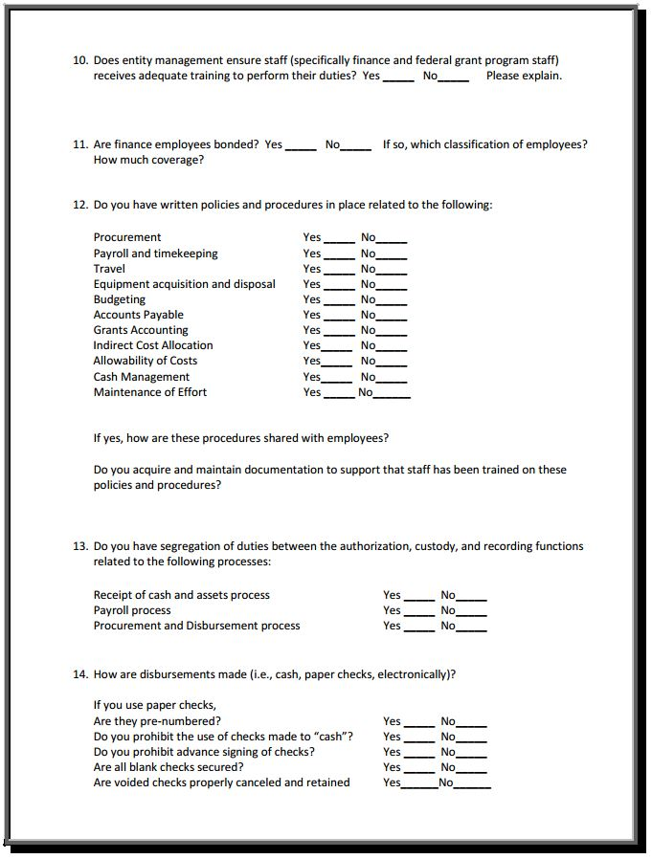
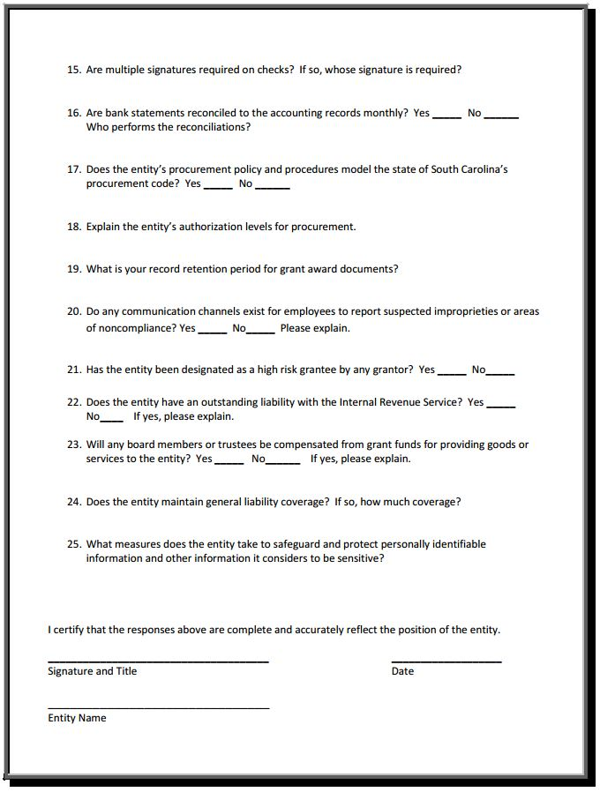

Instructions from USED for GEPA Statement
The purpose of this enclosure is to inform you about the following provision in the Department of Education's General Education Provisions Act (GEPA) that applies to applicants for new grant awards under Department programs. This provision is Section 427 of GEPA, enacted as part of the Improving America's Schools Act of 1994 (Public Law (P.L.) 103-382).
To Whom Does This Provision Apply?
Section 427 of GEPA affects applicants for new grant awards under this program. ALL APPLICANTS FOR NEW AWARDS MUST INCLUDE INFORMATION IN THEIR APPLICATIONS TO ADDRESS THIS NEW PROVISION IN ORDER TO RECEIVE FUNDING UNDER THIS PROGRAM.
What Does This Provision Require?
Section 427 requires each applicant for funds (other than an individual person) to include in its application a description of the steps the applicant proposes to take to ensure equitable access to, and participation in, its Federally-assisted program for students, teachers, and other program beneficiaries with special needs. This provision allows applicants discretion in developing the required description. The statute highlights six types of barriers that can impede equitable access or participation: gender, race, national origin, color, disability, or age. Based on local circumstances, you should determine whether these or other barriers may prevent your students, teachers, etc. from such access or participation in, the Federally-funded project or activity. The description in your application of steps to be taken to overcome these barriers need not be lengthy; you may provide a clear and succinct description of how you plan to address those barriers that are applicable to your circumstances. In addition, the information may be provided in a single narrative, or, if appropriate, may be discussed in connection with related topics in the application.
Section 427 is not intended to duplicate the requirements of civil rights statutes, but rather to ensure that, in designing their projects, applicants for Federal funds address equity concerns that may affect the ability of certain potential beneficiaries to fully participate in the project and to achieve to high standards. Consistent with program requirements and its approved application, an applicant may use the Federal funds awarded to it to eliminate barriers it identifies.
What are Examples of How an Applicant Might Satisfy the Requirement of This Provision?
The following examples may help illustrate how an applicant may comply with Section 427.
  - An applicant that proposes to carry out an adult literacy project serving, among others, adults with limited English proficiency, might describe in its application how it intends to distribute a brochure about the proposed project to such potential participants in their native language.
  - An applicant that proposes to develop instructional materials for classroom use might describe how it will make the materials available on audio tape or in braille for students who are blind.
  - An applicant that proposes to carry out a model science program for secondary students and is concerned that girls may be less likely than boys to enroll in the course, might indicate how it intends to conduct "outreach" efforts to girls, to encourage their enrollment.
  - An applicant that proposes a project to increase school safety might describe the special efforts it will take to address concern of lesbian, gay, bisexual, and transgender students, and efforts to reach out to and involve the families of LGBT students.
We recognize that many applicants may already be implementing effective steps to ensure equity of access and participation in their grant programs, and we appreciate your cooperation in responding to the requirements of this provision.
Estimated Burden Statement for GEPA Requirements
According to the Paperwork Reduction Act of 1995, no persons are required to respond to a collection of information unless such collection displays a valid OMB control number. Public reporting burden for this collection of information is estimated to average 1.5 hours per response, including time for reviewing instructions, searching existing data sources, gathering and maintaining the data needed, and completing and reviewing the collection of information. The obligation to respond to this collection is required to obtain or retain benefit (Public Law 103-382. Send comments regarding the burden estimate or any other aspect of this collection of information, including suggestions for reducing this burden, to the U.S. Department of Education, 400 Maryland Ave., SW, Washington, DC 20210-4537 or email ICDocketMgr@ed.gov and reference the OMB Control Number 1894-0005. (Exp. 06/30/2023)

Request for Taxpayer Identification Number and Certification
Go to the IRS Web site for an easy-to-complete version of this form.
(To be completed by fiscal agent)
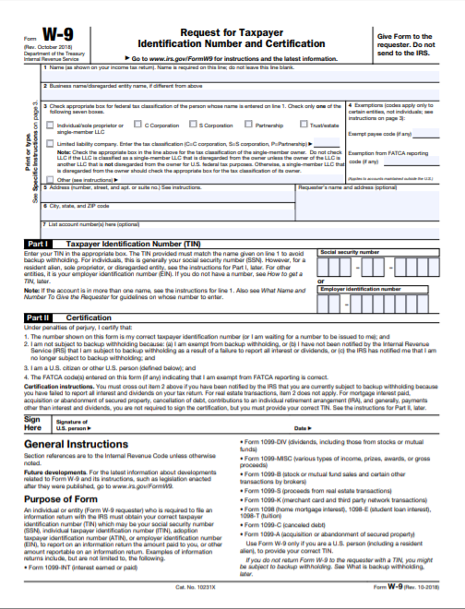

Title I, Part C Migrant Education Program Budget Narrative Template

Use the Budget Narrative Template located on the MEP Grant Opportunities Web page. See pages 29–32 for more information on the Budget Narrative.
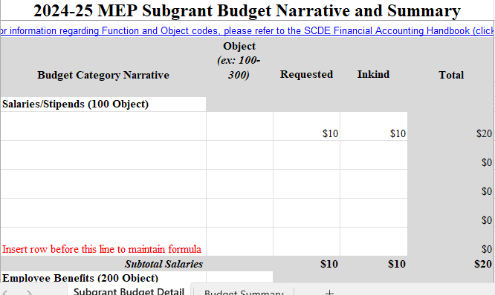

Private (Non-Public) School Consultation Form

The Elementary and Secondary Education Act (ESEA), as amended by the Every Student Succeeds Act (ESSA) of 2015, requires that public school districts (LEAs) receiving financial assistance under the Migrant Education Program (MEP), authorized under Title I, Part C, provide equitable services to eligible private school students (ESEA § 8501(b)(1)(A)).

To comply, LOAs are required to engage in timely and meaningful consultation with appropriate private school officials about the provision of program services to private school students. This consultation must occur during the design and development of the proposed program before any decision is made that impacts the opportunities for participation of private school students throughout the design, development, implementation, and assessment of the program services. The quality of the consultative process will likely influence the quality of services to private school students. (Authority: ESEA §8501(c)(3)–(4)).

Complete the following related to the involvement of eligible private school students in Title I, Part C, MEP subgrant activities.

There are no private schools located within the attendance boundaries of the school(s) proposed to be served by this project. (Signature below is required.)

There are private schools located within the attendance boundaries of the school(s) proposed to be served by this project (listed below). These private schools were consulted (methods listed below) prior to the development of the MEP application.

Private school(s) within the attendance boundaries of the school(s) proposed to be served by this project (add additional boxes as needed):
Name of Private School | Name and Title of Person Contacted | Date of Contact | Method of Contact (e.g., in person, phone, email, other) | To receive services?  (Yes or No*)
*If no, provide a brief explanation.

Signature of Applicant’s Authorized Representative Date

Signature of Private School Representative Date
(Add additional lines if more than one school)

Total Eligible Migratory Students by LEA, ages 0–21, including Out-of-School Youth (OSY), from September 1, 2022–August 30, 2023

LEA | # of Elgibile Students | LEA | # of  Elgibile Students
Aiken County Public School District | 49 | Hampton County School District | 10
Allendale County School District | 20 | Horry County Schools | 73
Anderson County School District Five | 1 | Jasper County School District | 20
Anderson County School District One | 6 | Kershaw County School District | 23
Bamberg County School District 2 | 5 | Laurens County School District 55 | 3
Bamberg County School District One | 18 | Lee County School District | 1
Bamberg County School District | 15 | Lexington County School District Four | 6
Barnwell County School District | 4 | Lexington County School District One | 8
Barnwell County School District 45 | 9 | Lexington County School District Three | 4
Beaufort County School District | 102 | Lexington County School District Two | 3
Berkeley County School District | 5 | Marion County School District 10 | 8
Charleston County School District | 99 | Orangeburg County School District | 11
Cherokee County School District 1 | 35 | Richland County School District One | 2
Chester County School District | 2 | Richland County School District Two | 1
Chesterfield County School District | 43 | Saluda County School District 1 | 12
Clarendon County School District | 17 | School District of Newberry County | 20
Colleton County School District | 108 | School District of Oconee County | 7
Darlington County School District | 10 | School District of Pickens County | 12
Dillon County School District 1 | 1 | Spartanburg School District Four | 14
Dillon School District 4 | 2 | Spartanburg School District Six | 5
Dorchester County Sch District Two | 1 | Spartanburg School District 2 | 7
Edgefield County School District | 45 | Sumter School District | 7
Florence County School District 2 | 5 | The School District of Greenville County | 44
Florence County School District 3 | 13 | Union County Schools | 2
Florence County School District 4 | 6 | Williamsburg County School District | 3
Florence County School District One | 29 | York County School District 1 | 2
Georgetown County School District | 5 | York County School District 3 | 4
Greenwood County School District 50 | 9 | York County School District 4 | 7
 |  | Total | 983

