Request for Proposals (RFP)
Application Package

Public Charter Schools Program—Planning and Implementation
2024–25 Discretionary (Competitive) Subgrant

The Public Charter Schools Program Planning and Implementation is a subgrant program funded by the US Department of Education, authorized by the Elementary and Secondary Education Act of 1965 as amended by the Every Student Succeeds Act, and administered by the South Carolina Department of Education.

Deadline for Receipt of Applications: April 15, 2024, 5:00 p.m.

Technical Assistance for Applicants: March 22, 2024, 10:00 a.m.

For questions, contact:
Gregory Dukes, Charter School Programs Manager
gdukes@ed.sc.gov
charterschools@ed.sc.gov

Lisa Suggs, Charter School Programs School Improvement/Innovation Team Lead
lmsuggs@ed.sc.gov

Issued by:
South Carolina Department of Education
Office of School Transformation
1429 Senate Street
Columbia, SC 29201-3730

The South Carolina Department of Education does not discriminate on the basis of race, color, religion, national origin, sex, sexual orientation, veteran status, or disability in admission to, treatment in, or employment in its programs and activities. Inquiries regarding the nondiscrimination policies should be made to the Employee Relations Manager, 1429 Senate Street, Columbia, South Carolina 29201, (803) 734-8781. For further information on federal nondiscrimination regulations, including Title IX, contact the Assistant Secretary for Civil Rights at OCR.DC@ed.gov or call 1-800-421-3481.
TABLE OF CONTENTS

PART I: General Information 1
A. Introduction and Purpose 1
B. Eligible Applicants 3
C. Competitive Priorities 4
D. Timeline of Subgranting Process 5
E. Technical Assistance Sessions for Applicants 5
F. Statutory, Federal Regulations, and State-Level Program Requirements 6
G. Applicable Federal Regulations 7
H. State-Level Program Requirements 8
I. Authorized Activities 9
J. Unauthorized Activities 9
K. Program Accountability and Monitoring 10
L. Fiscal Operations 16
M. Supplement, Not Supplant 18
N. Peer Review and Selection Process 18
O. Appeals Process 19

PART II: Application Overview, Content, and Instructions 20
A. Application Overview 20
B. Proposal Narrative Format 21
C. Online Application Submission 21
D. Project Abstract 21
E. Proposal Narrative Content 22
Section 1: The School and Its Stakeholders 22
Section 2: Financial Sustainability 23
Section 3: Governance and Management Plan 23
F. Application Budget 24
G. Appendices 28
H. Deadline and Submission Procedures 30
I. Screenshots of Online Application Submission Forms 30

Appendix A: Definitions of Terms Used 36

Appendix B: Selection Criteria and Reviewers’ Scoring Rubric 38

Appendix C: Required SCDE Forms 47
Certification Signature Page 47
Assurances and Terms and Conditions for Federal Subawards 48
Program-Specific Assurances 52
Instructions for GEPA Statement of Compliance 53
Request for Taxpayer Identification Number and Certification 54
Timeline of Activities/Workplan Chart 55
Proposed Planning and Implementation Budget Template 56

PART I: General Information

Introduction and Purpose

The South Carolina Charter Schools Act of 1996 (S.C. Code Ann. § 59-40-10 et seq. (Supp. 2023)) provides the mechanism for the design and operation of charter schools for the purposes of
- improving student learning;
- increasing learning opportunities for students;
- encouraging the use of a variety of productive teaching methods;
- establishing new forms of accountability;
- creating new professional development opportunities for teachers;
- assisting South Carolina in reaching academic excellence; and
- creating new, innovative, and more flexible ways of educating children within the public school system with the goal of closing achievement gaps between low-performing student groups and high-performing student groups.

As public schools, charter schools are nonreligious, non-home-based, nonprofit, and nondiscriminatory. The South Carolina Department of Education (SCDE) supports and encourages the creation of diverse models of learning for prospective and new charter schools, including those located in the rural communities of South Carolina.

In 2020, the SCDE received a Public Charter Schools Program (CSP) grant from the United States Department of Education (USED) to support the initial planning, program design, and implementation of new charter schools.

The purposes of the CSP (Title IV, Part C of the Elementary and Secondary Education Act of 1965 (ESEA), as amended by the Every Student Succeeds Act of 2015 (ESSA) (20 U.S.C. 7221-7221j)), as stated in the federal authorizing statute, is to
- expand opportunities for all students, particularly traditionally underserved students, to attend charter schools and meet challenging state academic standards;
- provide financial assistance for the planning, program design, and initial implementation of public charter schools;
- increase the number of high-quality charter schools available to students across the United States;
- evaluate the impact of charter schools on student achievement, families, and communities; share best practices between charter schools and other public schools;
- encourage states to provide facilities support to charter schools; and
- support efforts to strengthen the charter school authorizing process.

Contingent upon the receipt of federal funds, the SCDE will administer a CSP Planning and Implementation (P&I) subgrant program to expand the number of high-quality charter schools available to students across the state. This is a competitive subgrant program. Approved P&I subawards will begin in July 2024. To be considered for funding, subgrant applications must demonstrate compliance with the South Carolina Charter Schools Act. Information about the Charter Schools Act will be provided in the pre-application technical assistance session (see page 5).

Approximately $10 million dollars will be available for new P&I subgrants during the project term that begins during the 2024 funding cycle. The SCDE anticipates awarding approximately eight to ten subgrants. Award amounts are determined based on the designation of targeted or typical subgrantee.

Funds are distributed to subgrantees are via reimbursement in three phases, with the maximum allowed performance period for:
- Planning Phase (12 months): the funding period is July 1, 2024, through June 30, 2025, for initial costs associated with planning. Subgrantees may use up to a maximum of 18 months for Planning; however, after the 12-month Planning Phase, additional months for Planning proportionally decrease the available time period for Implementation Phase 2.
- Implementation Phase 1 (12 months): the funding period is July 1, 2025, through June 30, 2026.
- Implementation Phase 2 (up to 12 months): the funding period is July 1, 2026, through June 30, 2027. As noted above, the total time for Implementation 2 will be decreased proportionally for a charter school that uses additional months for their Planning Phase.

For an Implementation-only subgrant (24 months), the funding period for Implementation Phase 1 is July 1, 2024, through June 30, 2025 (12 months) and the funding period for Implementation Phase 2 is July 1, 2025, through June 30, 2026 (12 months).

Applicants may apply as a targeted applicant or as a typical applicant (see appendix A, Definitions of Terms Used). A targeted applicant must define “at-risk” in accordance with State Board of Education (SBE) Regulation 43-274.1 and be able to prove direct services to at-risk students, or demonstrate that it is an Alternative Education Campus (AEC, a charter school with an explicit mission to serve an enrolled student population as defined in S.C. Code Ann. § 59-40-111). A typical applicant is a charter school that does not meet the eligibility criteria for a targeted applicant.

The following information is provided for budget projection purposes. The combined total of Planning Phase and Implementation Phase 1 may not exceed $600,000 for a typical applicant and $700,000 for a targeted applicant.

Table 1: Funding Projections
 | Typical Applicant | Targeted Applicant
Funding Phase | Maximum Amount | Maximum Amount
Planning Phase | $250,000 | $300,000
Implementation Phase 1 | $250,000 | $300,000
Implementation Phase 2 | $250,000 | $300,000
*Opportunity Zone Supplement | $100,000 | $100,000
Maximum if funded for all phases | $850,000 | $1,000,000
*Opportunity Zone Supplement (see more information Opportunity Zones - Map) award is available to eligible subgrantees only.
The subgrantee may obligate funds upon receipt of the subgrant award notification. However, no funds will be disbursed until after the approved subgrant award notification is signed and executed and the revised detailed budget is approved. Subgrant funds are disbursed on a cost-reimbursement basis so applicants should have at least three months of operating funds at their disposal to implement the program to compensate for any delays in receiving reimbursement payments.

Subgrant awards are processed annually as continuation funding is not guaranteed. In determining continuation funding, the SCDE will consider the subgrantee’s evidence of their project’s effectiveness in achieving objectives, timely submission, and quality of all required reports and data (including the Project Performance Accountability and Reporting requirements, CSP benchmark reports, and Annual Progress reports), and rationale for budget expenditures. No subgrantee is authorized to move to the next funding phase without an official continuation award from the SCDE. Annual awards are contingent upon continued funding to the SCDE by the USED.

Eligible Applicants

An eligible applicant must meet one of the criteria below.
- A new charter school that has not yet received an approval/denial determination from its sponsor (authorizer) may also submit a subgrant application. However, to receive subgrant funds, the charter school must be officially approved by a sponsor (authorizer). Funds will not be awarded until the granting of a charter is confirmed.

- A new charter school that has received approval from its chartering sponsor (authorizer) to open in the 2024–25 or 2025–26 school year may submit a subgrant application for this funding round (see appendix A, Definition of Terms Used).

- A charter school that meets the federal definition of a charter school and in the first year of operation may apply for an implementation-only subgrant for up to 24 months.

According to 20 U.S.C. 7221i (6), an eligible applicant is any charter developer group that has applied to an authorized public chartering authority to operate a charter school and has provided adequate and timely notice to that authority and provided a copy of the proposal (part 1 only) to said authority. However, to receive CSP subgrant funds, a charter school must meet the following definition from 20 U.S.C. 7221i (2):

The term “charter school” means a public school that
- in accordance with a specific state statute authorizing the granting of charters to schools, is exempt from significant state or local rules that inhibit the flexible operation and management of public schools, but not from any rules relating to the requirements in paragraphs one through twelve of this definition;
- is created by a developer as a public school, or is adapted by a developer from an existing public school, and is operated under public supervision and direction;
- operates in pursuit of a specific set of educational objectives determined by the school's developer and agreed to by the authorized public chartering agency;
- provides a program of elementary or secondary education, or both;
- is nonsectarian in its programs, admissions policies, employment practices, and all other operations, and is not affiliated with a sectarian school or religious institution;
- does not charge tuition;
- complies with the Age Discrimination Act of 1975, Title VI of the Civil Rights Act of 1964, Title IX of the Education Amendments of 1972, Section 504 of the Rehabilitation Act of 1973, and Part B of the Individuals with Disabilities Education Act;
- is a school to which parents choose to send their children, and that admits students on the basis of a lottery if more students apply for admission than can be accommodated;
- agrees to comply with the same federal and state audit requirements as do other elementary schools and secondary schools in the state, unless such requirements are specifically waived for the purpose of this program;
- meets all applicable federal, state, and local health and safety requirements;
- operates in accordance with state law; and
- has a written performance contract with the authorized public chartering agency in the state that includes a description of how student performance will be measured in charter schools pursuant to state assessments that are required of other schools and pursuant to any other assessments mutually agreeable to the authorized public chartering agency and the charter school.

Employees of the SCDE are not eligible to apply for this subgrant; therefore, eligible charter developer groups must not include current SCDE employees.

In accordance with federal regulations, a previous subgrantee is ineligible to receive more than one planning and implementation subgrant.

Competitive Priorities

A maximum of 15 additional points is available for typical applicants and a maximum of 20 additional points is available for targeted applications that meet the criteria for competitive priorities. A typical application can qualify for any or all of the first three priorities, and a targeted applicant can qualify for any or all four priority categories.

Competitive Priority #1: District without any charter schools or proposed location within a designated Opportunity Zone (5 points)
To be eligible for this priority, the proposed charter school must be located within a district that currently does not have any operating charter schools. Alternately, the charter school may be proposing to physically locate at an address that is within a designated Opportunity Zone (see more information and a map at Opportunity Zones - Map).

Competitive Priority #2: Low-performing schools (5 points)
To be eligible for this priority, the applicant must propose to establish a charter school that is physically located within the attendance zone of one of the state’s lowest-performing schools and propose to serve the same grade levels (as determined by the Comprehensive Support and Improvement (CSI) List). The school would serve as a viable option for students who currently attend, or would otherwise attend, the state’s lowest-performing schools.
Competitive Priority #3: Closing achievement gaps (5 points)
To be eligible for this priority, the applicant must propose to address closing achievement gaps (i.e., gender, race/ethnicity, poverty, or ability levels). Targeted achievement gaps must be based on the needs of students projected to attend the charter school.

Competitive Priority #4: At-risk students (5 points for targeted applicants only)
To be eligible for this priority, the applicant must propose to serve at-risk students (as defined by SBE Regulation 43-274.1) or the charter school must be an AEC as described on page 2.

Applicants must identify which competitive priority is being sought in the Project Abstract, complete the competitive priorities section of the online application, and clearly provide evidence in the proposal narrative that the proposed project meets and fulfills the priority in order for a determination to be made that competitive priority points are justified. A statement that competitive priority points are being sought is not sufficient evidence for additional points to be awarded. Applicants must clearly meet the specified criteria for each priority to earn additional points for each category, up to a maximum of 20 points. Applicants scoring 80 or higher will be eligible for competitive points provided their application includes the supporting evidence to earn the competitive points.

Timeline of Subgranting Process

Date | Activity/Action
March 22, 2024 | Pre-application technical assistance session
April 15, 2024 | Deadline for receipt of applications
June 2024 | Notification of awards; post-award technical assistance session
July 1, 2024 | Planning funding period begins
September 15, 2024 | Benchmark report 1 deadline
December 15, 2024 | Benchmark report 2 deadline
March 15, 2025 | Benchmark report 3 deadline
June 30, 2025 | Planning funding period ends
July 1, 2025 | Implementation Year 1 funding period begins
September 15, 2025 | Benchmark report 4 deadline
December 15, 2025 | Benchmark report 5 deadline
March 15, 2026 | Benchmark report 6 deadline
June 30, 2026 | Implementation Year 1 funding period ends
July 1, 2026 | Implementation Year 2 funding period begins
September 15, 2026 | Benchmark report 7 deadline
December 15, 2026 | Benchmark report 8 deadline
March 15, 2027 | Benchmark report 9 deadline
June 30, 2027 | Implementation Year 2 funding period ends
August 15, 2027 | Final expenditure report due

Technical Assistance Sessions for Applicants

The SCDE Charter School Program will offer a pre-application technical assistance session via Adobe Connect on March 22, 2024, from 10:00 a.m. until 12:00 p.m. No password is required to join the session. Participants should enter their full names when logging in to the session. Participants will be able to log in 30 minutes prior to the start of the session to test their equipment’s audio settings and to download/print handouts. While participation is not mandatory in order to submit an application, it is highly recommended.

Statutory, Federal Regulations, and State-Level Program Requirements

Charter schools must provide evidence of improved student academic achievement for all groups of students described in Section 1111(b)(2)(C)(v) of the ESEA. Sponsors (authorizers) must use increases in student academic achievement for all groups of students described in Section 1111(b)(2)(C)(v) of the ESEA as the most important factor when determining to renew or revoke a school’s charter. Each sponsor (authorizer) and charter school must enter into a contractual agreement stating that student performance of all students described in Section 1111(b)(2)(C)(v) of the ESEA is the most important factor when determining to renew or revoke a school’s charter.

Planning phase: To receive a CSP P&I subgrant, an applicant must be officially approved by a sponsor (authorizer).

Each subgrantee is responsible for understanding and adhering to program guidelines to remain eligible for continuation funding. Each application must:
    - Comply with Section 427 of the General Education Provisions Act (GEPA) by providing an appropriate GEPA statement of compliance (see instructions on page 53);
    - Describe how the funds will be used, including a description of how such funds will be used in conjunction with funds from other federal programs administered by the USED;
    - Contain an assurance that the eligible applicant will annually provide the USED and the SCDE such information as may be required to determine if the charter school is making satisfactory progress toward achieving its stated objectives;
    - Contain an assurance that the eligible applicant will cooperate with the USED and the SCDE in evaluating the proposed program;
    - Contain a description of how the sponsor (authorizer) for the proposed charter school will comply with Sections 613(a)(5) and 613 (e)(1)(B) of the Individuals with Disabilities Education Act (IDEA), the Age Discrimination Act of 1975 (42 U.S.C. 6101, et seq.), Title VI of the Civil Rights Act of 1964 (42 U.S.C. 2000d, et seq.), Title IX of the Education Amendments of 1972 (20 U.S.C. 1681, et seq.), and Section 504 of the Rehabilitation Act of 1973 (29 U.S.C. 794) in the operation of the charter school.

Subgrantees must have an annual independent audit conducted by a qualified auditing or accounting firm and must file the audit annually to the Federal Audit Clearinghouse in accordance with 2 CFR Part 200.512(d). A copy of the annual audit must also be provided to the SCDE and the charter school’s sponsor (authorizer).

If an applicant believes that it is necessary to waive federal statutory or regulatory provisions or state or local rules generally applicable to public schools for the successful operation of their charter school, a request and justification for any waiver must be submitted as part of the application. The applicant must identify the specific section of federal law for which they are requesting a waiver.

Applicants should take particular care when contracting with a for-profit third party for the operation and administration of the school. Such contracts must be procured in accordance with procurement regulations in 2 CFR Part 200 (see §§ 200.317–200.326 and appendix II). In these cases, the subgrantee’s board of directors should be independent of the contractor, and the contract should be considered “arms-length” and be able to be terminated with minimal penalties to the charter school.

Applicable Federal Regulations

Applicants should review the following federal regulations, accessible at the electronic Code of Federal Regulations (e-CFR) website, that are applicable to the CSP P&I subgrant. Applicants are reminded that, if funded, their programs must comply with these regulations.
  - 2 CFR Part 25—Universal Identifier and System for Award Management
  - 2 CFR Part 170—Reporting Subaward and Executive Compensation Information
  - 2 CFR Part 175—Award Term for Trafficking in Persons
  - 2 CFR Part 180—OMB Guidelines to Agencies on Governmentwide Debarment and Suspension (Nonprocurement), as adopted at 2 CFR Part 3485
  - 2 CFR Part 200—Uniform Administrative Requirements, Cost Principles, and Audit Requirements for Federal Awards as adopted at 2 CFR Part
  - 34 CFR Part 75—Direct Grant Programs
  - 34 CFR Part 77—Definitions that Apply to Department Regulations
  - 34 CFR Part 79—Intergovernmental Review of Department of Education Programs and Activities
  - 34 CFR Part 81—General Education Provisions Act—Enforcement
  - 34 CFR Part 82—New Restrictions on Lobbying
  - 34 CFR Part 84—Governmentwide Requirements for Drug-Free Workplace (Financial Assistance)
  - 34 CFR Part 86—Drug and Alcohol Abuse Prevention
  - 34 CFR Part 97—Protection of Human Subjects
  - 34 CFR Part 98—Student Rights in Research, Experimental Programs, and Testing
  - 34 CFR Part 99—Family Educational Rights and Privacy.

Additional information on select government-wide regulations is presented below:

Unique Entity Identifier and System for Award Management—2 CFR Part 25
To comply with 2 CFR Part 25, all applicants must obtain a unique entity identifier (UEI) by registering in the federal System for Award Management (SAM). The applicant must be registered in SAM prior to submitting their application, maintain their publicly-searchable SAM registration throughout the application and award process, and include a valid UEI in the online application.

To register in SAM, the applicant organization must first be registered for a Login.gov account; see the Login.gov help center for assistance. Visit SAM.gov for more information. Once registered in Login.gov, the organization can register in SAM.gov using the “Register Your Entity or Get a Unique Entity ID” and “Get Started.” Applicants should contact their finance office if they need assistance with this item.

Note: the SAM registration process takes time. An applicant organization that does not have an active SAM registration and a UEI must take immediate action to begin the registration process.
The Certification Signature Page required for a complete application (see page 47) includes certification that the applicant organization is “registered and current (active) on the federal System for Award Management (SAM).” The SCDE will not make a subaward of federal funds unless the applicant is compliant with 2 CFR 25 and provides a valid UEI and maintains an active and current SAM registration.

Reporting Subaward and Executive Compensation Information—2 CFR Part 170
The Federal Funding Accountability and Transparency Act (FFATA) of 2006 (Public Law No. 109-282), as amended by Section 6202 of Public Law No. 110-252, requires primary grantees of federal grants and cooperative agreements to report information on subgrantee obligations and executive compensation. The FFATA promotes open government by enhancing the federal government’s accountability for its stewardship of public resources. This is accomplished by making government information, particularly information on federal spending, accessible to the general public.

Primary grantees, like the SCDE, are required to report actions that obligate $25,000 or more in federal grant funds to first-tier subgrantees. This information must be reported in the government-wide FFATA Subaward Reporting System (FSRS). A current SAM registration is required to access FSRS. A primary grantee and first-tier subgrantees must also report total compensation for each of its five most-highly compensated executives. Every primary and first-tier subgrantee must obtain a UEI number prior to being eligible to receive a grant or subgrant award. Additional information will be provided to subgrant recipients upon award.

State-Level Program Requirements

Each applicant must provide the SCDE a fidelity bond listed in favor of the SCDE before subgrant funds will be released. The fidelity bond must be issued in the amount equal to the total of the annual subgrant award, list the SCDE as a loss payee, and include standard employee dishonesty bond coverage that covers all employees responsible for the receipt or disbursement of subgrant finances. Costs associated with the fidelity bond should be included in the planning subgrant budget. A copy of the Certificate of Insurance must be submitted to the SCDE Charter Schools Program within 30 days of receipt of the official grant award notification from the SCDE. The fidelity bond is required for all phases of the subgrant.

In addition, charter schools are required to secure Director/Officers liability insurance and list the SCDE as a loss payee during Implementation Phase 1 and Phase 2 and present a copy of the certificate of insurance to the SCDE within 60 days of notice of approved budget.

The subgrantee is required to comply with any monitoring requests by the SCDE or its assignees, including, but not limited to, requests for information, site visits, interviews, completing surveys, or participating in data collections.

The subgrantee may not use grant funds to enter into any financial agreements with their authorizer or any agent that is presently employed by their authorizer. Grant funds are not allowed to be used to repay any types of loans.

Applicants should review the Assurances and Terms and Conditions for Federal Subawards (see pages 48–51) and the program specific assurances (see page 52) to ensure that, if awarded a subgrant, they are capable of full compliance with all the referenced federal regulations and state laws required to enter into an agreement with the SCDE for this program. For example, in accordance with 2 CFR Part 200.112, applicants must disclose in writing any potential conflict of interest to the SCDE in accordance with the USED’s conflict of interest policy. A signed Certification Signature Page (see page 47) is required with the subgrant application and legally binds the applicant to the agency’s assurances and terms and conditions.

Authorized Activities

Subgrant funds may be used to support the following activities.

- Preparing teachers, school leaders, and specialized instructional support personnel, including through paying the costs associated with—
  - providing professional development; and
  - hiring and compensating, during the eligible applicant’s planning period specified in the application for subgrant funds that is required under this section, one or more of the following:
    - Teachers.
    - School leaders.
    - Specialized instructional support personnel.
- Acquiring supplies, training, equipment (including technology), and educational materials (including developing and acquiring instructional materials).
- Carrying out necessary renovations to ensure that a new school building complies with applicable statutes and regulations, and minor facilities repairs (excluding construction).
- Providing one-time, startup costs associated with providing transportation to students to and from the charter school.
- Carrying out community engagement activities, which may include paying the cost of student and staff recruitment.
- Providing for other appropriate, non-sustained costs related to the opening and preparation for the operation of new charter schools when such costs cannot be met from other sources.
See the USED’s nonregulatory guidance for more information on allowable activities.

Unauthorized Activities

Funds cannot be used for:
- payment of non-profit status;
- acquisition, renovation, or enhancement of a facility;
- construction and any related construction activities, including architectural renderings and engineering activities such as:
  - the preparation of drawings and specifications for school facilities;
  - erecting, building, acquiring, altering, remodeling, repairing, or extending school facilities; (unless in compliance with Section 4303(h)(3) of the ESEA, which allows subgrantees to use CSP funds to carry out “necessary renovations to ensure that a new school building complies with applicable statutes and regulations, and minor facilities repairs);
  - inspecting and supervising the construction of school facilities; and
  - debt service for such activities;
- recurring operational expenses to include administrative and programmatic activities such as utilities, teacher and administrator salaries, and transportation of students;
- entering into financial agreements with authorizer or any agent that is employed by authorizer;
- repayment of any type of loan;
- indirect costs; and
- expenditures that are not “allowable, allocable, or reasonable” as defined in the USED’s nonregulatory guidance.

Program Accountability and Monitoring

The SCDE is responsible for monitoring CSP P&I subgrants in accordance with the following program accountability requirements.
- Each subrecipient receiving funds through this RFP meets the eligibility requirements for the subgrant described herein, and the applicant has provided all required assurances that it will comply with all program implementation and reporting requirements established through this RFP.
- Each subrecipient receiving funds through this RFP appropriately uses these funds as described in this application package.
- Each subrecipient implements activities funded through this application within the timeline in which the funds provided are to be used.

In compliance with 2 CFR Part 200.331, the SCDE will conduct a pre-award risk assessment on potential subgrantees before a subgrant award is issued. As a part of this process, each applicant must complete the pre-award audit questionnaire to submit with their application as described on page 28. The SCDE, Office of Auditing Services, will evaluate this questionnaire and may conduct a further evaluation of the applicant’s financial system, internal controls, and policies and procedures. Visit the Office of Auditing Services to access the review process and procedures.

Applicants awarded subgrant funds must satisfy periodic reporting and accountability requirements throughout the term of the subgrant. These requirements address: (1) program accountability; (2) performance reporting; (3) annual budget; (4) monitoring; (5) program evaluation; and (6) technical assistance.

- Program Accountability
Each subgrantee is responsible for carrying out its responsibilities in accordance with the ESEA, Title V, Part B, Subpart 1; all applicable statutes, regulations, and programmatic guidance; and its approved subgrant application and work plan. Subgrantees are also required to submit periodic reports to the SCDE to report on the use of subgrant funds and the progress of subgrant activities.

- Performance Reporting
Performance reporting requirements include those for both programmatic reporting and fiscal reporting. The subgrantee is responsible for ensuring that all required performance reports are accurate, complete, and submitted on time.

Programmatic Reporting Requirements
A subgrantee must work with its sponsor (authorizer) to provide benchmark information and submit required reports and documents. The SCDE Charter Schools Program will provide details on this process to subgrantees and their sponsors (authorizers), and additional information may be requested as needed.

If the submitted reports fail to comply with requested information, the allocation of funds for the next phase will be delayed until reports are complete and deemed satisfactory. Failure to submit any or all required reports and documentation can result in the charter school being deemed ineligible for future funding opportunities.

The following minimum benchmarks (Table 2) must be met for a subgrantee to progress to the next phase of their project. Inclusion of activities in this table does not mean the activity is an allowable expenditure of subgrant funds; some activities must be covered with other funding sources. Criteria indicating the overall status and health of the project must be met before additional subgrant funds are released.

Table 2: Minimum Benchmarks and Deadlines for CSP Funds
Benchmark #1 | Deadline
Evidence that the school is making progress and is on target to open as planned:  - Progress toward satisfying conditions placed on the charter by the sponsor (authorizer) (i.e., contingencies are being resolved), if applicable;  - Active UEI and SAM registration is current and active.  - Office established to answer public inquiries;  - School policies in the process of being drafted and adopted;  - Verified contact with the SCDE, Office of School Facilities, and potential sites identified;  - Verification of application submitted to Internal Revenue Service (IRS) for nonprofit status designation;  - Fidelity Bonding Insurance coverage in place;  - Planning committee members have registered for or completed initial Board training;  - Planning Committee documentation (i.e., board roster, terms, representation category);  - Compliance with fiscal and programmatic reporting requirements for the Planning Phase;  - Confirmed registration and participation in all required activities in the Public Charter School Alliance of South Carolina’s Incubator Program; and  - Other evidence as required by the SCDE. | September 15, 2024
Benchmark #2 | Deadline
Evidence that the school on target to open and expending Planning funds according to programmatic guidelines and goals established in the subgrantee application:  - Implementation of marketing plan for diverse groups;  - Facility secured with proof of occupancy (lease contract or equivalent) by charter school;  - Initiation of seeking and hiring school leader and educational staff;  - Letter provided by sponsor indicating school is on target to open as planned;  - Planning committee members have registered for or completed initial Board training;  - Planning Committee documentation (i.e., board roster, terms, representation category);  - Proof of nonprofit status from IRS;  - Evidence of participation in all required activities in the Public Charter School Alliance of South Carolina’s Incubator Program; and  - Other evidence as may be required by the SCDE. | December 15, 2024
Benchmark #3 | Deadline
Evidence that the school is on target to open, is expending Planning funds according to programmatic guidelines and goals, and is preparing to transition from Planning to Implementation Phase 1:  - Few staff openings remain and those hired meet state certification requirements;  - School leader under contract;  - Enrollment nearly completed and, if necessary, lottery planned or completed;  - Letter provided by sponsor indicating school is on target to open as planned;  - School data sheet with general school contact information is completed;  - Revised Implementation Phase 1 detailed budget worksheet submitted for approval;  - Evidence of participation in all required activities in the Public Charter School Alliance of South Carolina’s Incubator Program; and  - Other evidence as may be required by the SCDE. | March 15, 2025
Benchmark #4 | Deadline
Evidence that the school has completed all documentation for Planning and is expending Implementation Phase 1 funds according to programmatic guidelines and goals established in the subgrantee application:  - P&I Annual Program Performance Report for Planning Phase has been submitted;  - Updated inventory of assets purchased with Planning funds;  - Submit Retention letter to maintain CSP P&I inventory;  - Consolidated subgrant Activity report for Planning completed and submitted;  - Evidence of participation in all required activities in the Public Charter School Alliance of South Carolina’s Incubator Program; and  - Other evidence as may be required by the SCDE. | September 15, 2025
Benchmark #5 | Deadline
Evidence that the school is expending Implementation Phase 1 funds according to programmatic guidelines and goals established in the subgrantee application:  - Evidence of participation and completion of the Public Charter School Alliance of South Carolina’s Incubator Program; and  - Other evidence as may be required by the SCDE. | December 15, 2025
Benchmark #6 | Deadline
Evidence that the school is ready to move from Implementation Phase 1 to Implementation Phase 2:  - Revised Implementation Phase 2 detailed budget worksheet submitted for approval;  - Updated school data sheet with general school contact information is completed;  - Updated governing board documentation;  - Evidence of participation and completion of the Public Charter School Alliance of South Carolina’s Incubator Program; and  - Other evidence as may be required by the SCDE. | March 15, 2026
Benchmark #7 | Deadline
Evidence that the school has completed all documentation for Implementation Phase 1 and is expending Implementation Phase 2 funds according to programmatic guidelines and goals established in the subgrantee application:  - Updated inventory of assets purchased with Planning funds;  - Submit Retention letter to maintain CSP P&I inventory;  - Updated SMART Goals;  - Annual P&I Program Performance report for Planning has been submitted; and  - Consolidated subgrant Activity report for Planning completed and submitted;  - Evidence of participation in all required activities in the Public Charter School Alliance of South Carolina’s Incubator Program; and  - Other evidence as may be required by the SCDE. | September 15, 2026
Benchmark #8 | Deadline
Evidence that the school has completed required subgrantee activities and is preparing for subgrant close-out procedures:  - Evidence that the school is preparing to close-out and has all updated documentations available;  - Evidence of participation and completion of the Public Charter School Alliance of South Carolina’s Incubator Program; and  - Other evidence as may be required by the SCDE. | December 15, 2026
Benchmark #9 | Deadline
Evidence that the school has completed required close-out activities:  - Updated SMART goals;  - Complete Annual P&I Program Performance report for Implementation Phase 2;  - Final inventory of assets purchased with Implementation Phase 2 funds;  - Submit Retention letter to maintain CSP P&I inventory;  - Consolidated subgrant Activity report for Implementation Phase 2 completed and submitted;  - Updated governing board documentation; and  - Other evidence as may be required by the SCDE | March 15, 2027

Templates for all required reports are located on the Charter School Program Planning and Implementation Subgrant Web page. Annual performance reports must be submitted to the SCDE no later than June 30 each year. Progress toward achieving subgrant goals and objectives will be monitored through the annual performance report process.

At the end of the Planning, Implementation 1, and Implementation 2 phases, subgrantees are required to submit (no later than 30 days from the close of the subgrant cycle) a final subgrant report to the SCDE Charter Schools Program that details major programmatic accomplishments, a summary of expenditures, an inventory list with tag numbers, all requests to retain property for the charter school, and highlights of subgrant activities.

Subgrantees must submit the Charter School Annual Report to its sponsor (authorizer) by December 31 of each year. The SCDE Charter Schools Program will verify submission of the report.

Fiscal Reporting Requirements
All expenditure reports must be submitted through the SCDE’s Grants Accounting Processing System (GAPS). Training on the GAPS will be provided to all subgrantees. Submission of expenditure reports is required quarterly throughout the subgrant award period (see the following table). Subgrantees must submit a final fiscal report to the SCDE that covers the duration of the subgrant award.

The expenditure reporting due dates for the CSP P&I subgrant awards are:
Reporting Period | Quarterly Report Due Dates
January 1–March 31 | May 15
April 1–June 30 | August 15
July 1–September 30 | November 15
October 1–December 31 | February 15

- Project Budget
A project budget of projected expenditures to be funded by the subgrant must be submitted with the application. Subgrantees are required to resubmit the budget after the grant award notification is signed and executed. Approved budgets must be uploaded into GAPS by subgrantees after the receipt of the grant award notification and prior to submission of reimbursement requests. Training on uploading budgets will be provided to subgrantees. The annual budget must be submitted to the SCDE no later than the date communicated by the program office for each subsequent year of the project.

4. Monitoring
The SCDE will monitor subgrantees by reviewing and approving the benchmark progress reports and annual performance reports. All information in monitoring reports is subject to verification.

The SCDE will conduct programmatic and financial monitoring site visits. Subgrantees must agree to site visits conducted by the SCDE or state or federal program representatives. The purpose of site visits is to validate information provided in fiscal and program reports and to gather more detailed information on implementation efforts and challenges from interviews and observations for monitoring and evaluation purposes. The subgrantee may not use subgrant funds to enter into any financial agreements with their authorizer or any agent that is presently employed by an their authorizer. Grant funds are not allowed to be used to repay any types of loans.

The SCDE may require additional information from the subgrantee, verify information with the sponsoring (authorizing) agency, or require the submission of additional documentation including, but not limited to, invoices, receipts, contractual services agreements, non-conflict of interest forms, and personnel time and effort reports. Prior to a site visit, the subgrantee may be required to submit additional relevant information that will allow the SCDE to conduct a useful, efficient, and effective visit. The subgrantee is required to provide all information requested during a monitoring or site visit in a timely manner. The SCDE may require electronic submission of documents instead of a paper-copy submission.

SCDE staff will verify the contents of documentation submitted. A subgrantee may be asked to revise reports when
- non-allowable expenses are found;
- reports are confusing or difficult to understand; or
- there are unexplained discrepancies between the proposed use of subgrant funds, as provided in the annual budget, and actual expenditures found in the submitted documentation.

5. Program Evaluation
Subgrantee Project Monitoring and Evaluation
Subgrantees are required to conduct ongoing monitoring and evaluation to ensure project goals are achieved. Although hiring an external monitoring and evaluation contractor is not required, it is encouraged. Progress toward meeting project goals is to be reported through the annual progress review process.

A final project evaluation report is to be completed before the end of the subgrant period. The final evaluation report must address project success toward each goal stated in the application. If a subgrantee fails to conduct the final project evaluation report before the end of the subgrant period, or if any of the performance requirements in section I.2 are not completed, the SCDE may consider the subgrantee a high risk and elect to discontinue funding or disqualify the subgrantee from future funding opportunities.

SCDE External Review
The SCDE is required to contract for an external evaluation of the CSP subgrant. The USED or its representatives may conduct an evaluation of the CSP P&I subgrant as well. Subgrantees are required to comply with any request by the USED or its evaluation subcontractor, or the SCDE and its evaluation subcontractor, including, but not limited to, requests for information, site visits, interviews, completing surveys, or participating in data collections.

6. Technical Assistance to Subgrantees
Subgrantees are required to participate in all technical assistance that the SCDE may conduct for the CSP P&I subgrant. Delivery of such technical assistance may include in-person meetings, webinars, and conference calls.

Fiscal Operations

Subgrantees must use CSP P&I funds for allowable subgrant expenditures during the subgrant period as defined in the approved budget and workplan. CSP P&I subgrant funds are disbursed on a reimbursement basis. The SCDE will de-obligate any unspent funds remaining at the end of the subgrant period for reallocation to other subgrantees.

Matching or in-kind funds are not required; however, matching and in-kind funds are an indicator of potential long-term sustainability of a charter school.

Allowable Costs
Section 4303 of the Elementary and Secondary Education Act (ESEA), as amended by the Every Student Succeeds Act (ESS), requires that subgrant funds be used only for:
- Preparing teachers, school leaders, and specialized instructional support personnel, including through paying the costs associated with—
  - providing professional development; and
  - hiring and compensating, during the eligible applicant’s planning period specified in the application for subgrant funds that is required under this section, one or more of the following:
    - Teachers.
    - School leaders.
    - Specialized instructional support personnel.
- Acquiring supplies, training, equipment (including technology), and educational materials (including developing and acquiring instructional materials).
- A subgrantee may use CSP funds to acquire portable classrooms, provided that the classrooms are temporary and directly related to opening or preparing for the operation of a new charter school in accordance with the cost principles in the Uniform Guidance, acquisition of the portable classrooms also must be necessary, reasonable, and allocable to the subgrant (2 CFR 200.403-200.405).
- Providing one-time, startup costs associated with providing transportation to students to and from the charter school.
- Carrying out community engagement activities, which may include paying the cost of student and staff recruitment.
- Providing for other appropriate, non-sustained costs related to the opening and preparation for the operation of new charter schools when such costs cannot be met from other sources.
Budgeted items must align with the federal cost principles in 2 CFR Part 200. Subgrant funds must be used in accordance with statutory and regulatory requirements.

Unallowable Costs
Subgrantees may not use subgrant funds for any costs that provide for any unauthorized activities described in section J (page 9). Indirect costs are not allowed. Subgrant funds cannot be used for:
- payment of non-profit status;
- acquisition, renovation, or enhancement of a facility;
- construction and any related construction activities, including architectural renderings and engineering activities such as:
- the preparation of drawings and specifications for school facilities;
- erecting, building, acquiring, altering, remodeling, repairing, or extending school facilities; (unless in compliance with Section 4303(h)(3) of the ESEA, which allows subgrantees to use CSP funds to carry out “necessary renovations to ensure that a new school building complies with applicable statutes and regulations, and minor facilities repairs);
- inspecting and supervising the construction of school facilities; and
- debt service for such activities;
- recurring operational expenses to include administrative and programmatic activities such as utilities, teacher and administrator salaries, and transportation of students;
- entering into financial agreements with authorizer or any agent that is employed by authorizer;
- repayment of any type of loan;
- indirect costs; and
- expenditures that are not “allowable, allocable, or reasonable” as defined in the USED’s nonregulatory guidance.

Supplement, Not Supplant

All CSP P&I subgrant funds must supplement, not supplant, existing services and may not be used to supplant federal, state, local, or non-federal funds. Projects may not use subgrant funds to pay for existing levels of services funded from any other sources. The CSP P&I subgrant funds may not be used for new construction or purchases that do not directly support the approved work plan.

Peer Review and Selection Process

Only those subgrant applications that are received by the deadline and deemed complete will be forwarded for review and funding consideration. All required materials including forms and appendices must be submitted for the application to be considered complete and eligible for review. The SCDE Charter School Program staff will conduct an initial review of applications for completeness and compliance with the RFP instructions. No incomplete applications will be forwarded to the selected reviewers or considered for funding.

Three peer reviewers from diverse backgrounds without a vested interest in any application being funded will evaluate each application to assess the quality of the proposed activities and the capability of the applicant to implement the proposed project. Reviewers will be individuals with knowledge of and expertise with charter schools or alternative schools such as educators, school administrators, school board members, or charter developers. The peer review team will be selected to reflect a balance of backgrounds, experience, race, and ethnicities.

Reviewers will use the scoring rubric on pages 38–46 to read and score each application independently. After the three reviewers have individually rated each application, the scores will be averaged. An application can earn up to 100 points for an average score.

Competitive priority points will be assigned to eligible applications earning an average score of 80 or higher as rated by the reviewers. Priority points will be assigned by an impartial designee, added to the application’s average total score, and awarded only once per application. A maximum of 20 competitive priority points may be awarded for targeted applicants and a maximum of 15 points for typical applicants that meet the specific competitive priorities as defined on pages 4–5.

Applications will be rank ordered by averaged scores. Subject to the SCDE’s final approval, the availability of federal funds, geographic equity, and the inclusion of priority programming, subgrant awards will be made starting with applications that earned an average score of 80 points or higher. To the extent practical, the SCDE will award subgrants equitably among geographic regions within the state to include rural and urban communities. If funds remain following these awards, the SCDE will consider funding remaining applications that earned an average score within the adequate/meets range until all funds are allocated.

Prior to making awards, the SCDE, Office of Auditing Services, will conduct a pre-award risk assessment. Based upon the results of this assessment, special conditions may be applied to the award that may include, but are not limited to, requirements for more frequent programmatic or financial reporting, increased monitoring of subgrant activities, and the provision of additional technical assistance. The SCDE reserves the right to interview applicants recommended for funding, request additional documentation, and make a site visit as appropriate to ensure compliance with federal and state requirements.

The SCDE reserves the right to negotiate final budgets and to disqualify costs associated with any line items that are unallowable, unallocable, unreasonable, or inconsistent with the program’s goals or the proposed project’s activities and strategies.

Continuation awards are contingent upon the subgrantee’s meeting all reporting requirements and demonstrating substantial progress toward meeting project objectives and use of all funds requested in the previous subgrant award period. The SCDE will review the subgrantee’s prior year’s audit, year-end reports, thoroughness and timeliness in submitting reports and annual budgets, and the availability of funds before awarding any continuation subgrants.

Subgrant awards are not final until an SCDE subgrant award notice is fully executed. Notification of funding will be sent in July 2024 to the authorized official listed on the Certification Signature Page. After the notification of awards, copies of the reviewers’ comments and score sheets will be available upon request.

Appeals Process

An applicant who has submitted a proposal that the SCDE does not fund has 30 calendar days after receiving notification that the proposal is not funded to request a review of the process. Scores may not be appealed; the SCDE will not rescore applications. An unfunded applicant may inquire as to whether or not the application process was followed. The request for review must be directed to the State Superintendent of Education and must state the reasons for the request. The SCDE will conduct a hearing in accordance with the provisions of 34 CFR Part 76.401.

PART II: Application Overview, Content, and Instructions

Read all guidelines and criteria carefully before preparing your application. Adhere to font, format, page limit, and organizational requirements. Only applications that include all sections and appendices and fully adhere to these guidelines will be reviewed and considered for funding. Incomplete applications will not be reviewed.

Application Overview

Applicants are encouraged to prepare all elements of the application before beginning the online submission process. Do not wait until the last minute to submit an application. Use the following overview as a checklist to ensure that the application is complete with items labeled accordingly and presented in the order outlined below. Verify that all narrative components and appendices are included prior to uploading attachments.

The 2024–25 CSP P&I subgrant online application is organized into the following sections (see the screenshots on pages 30–35):

- Online Form
- Applicant Information
- Project Director Contact Information
- Competitive Priorities (if applicable)
- Funding Information
- Budget Summary
- Application Attachments
- Project Abstract
- Proposal Narrative
- Section 1: The School and Its Stakeholders
- Section 2: Financial Sustainability
- Section 3: Governance and Management Plan
- Budget Narrative
- Appendices
  - Certification Signature Page
  - GEPA Statement
  - Request for Tax Identification Number and Certification (W-9)
  - Timeline of Activities/Workplan
  - Organizational Chart
  - Résumé(s)/Credentials of Project Director
  - Letters from Sponsor (Authorizer)/School District
  - Notification to Sponsor (Authorizer) School District of Intent to Apply for Subgrant
  - Proof of Nonprofit Status from IRS or South Carolina Secretary of State
  - Summary List of Community Supporters (including parents) (Notarized statement)
  - Letter of Support from Each Partner Organization
  - Waiver Request (if applicable)
- Pre-Award Audit Questionnaire

Proposal Narrative Format

Length of Narrative: | Maximum of 35 pages, excluding the table of contents, required application forms, Project Abstract, Budget Narrative, and required appendices listed above.
Required Font/Size: | Times New Roman or Arial/11 or 12.
Margins: | 1” on all sides.
Page Numbers: | Insert bottom right. Required forms do not require page numbers.
Spacing: | Double-spaced pages. Tables or charts may be single-spaced.
Final File Format: | PDF document for all files except three-year budget, which should be an Excel document.

Each section must be clearly identified using the headings provided in the instructions below. Sections may not be combined. Reviewers will not consider information requested in one section that is provided in another section. Incomplete applications will not be considered.

Online Application Submission

Applications must be submitted using the online application form. The online submission is organized into two sections—Online Forms and Application Attachments.

Provide the primary applicant’s 12-digit UEI and Tax Identification Number (TIN) in the application form. Do not enter the sponsor’s (authorizer’s) UEI. The name used by recipients of federal funding must match their registered name in SAM.gov. Applicants should contact their organization’s finance office if they need assistance with these items (see page 7 for more information).

Use the following instructions to compile and complete all proposal attachments prior to submitting your application. Verify that all components of the narrative and appendices are complete prior to uploading attachments. Follow the directions in each section for saving the documents and refer to page 33 for upload locations.

Project Abstract

In one double-spaced page, concisely describe the applicant’s organization and its mission, the target population to be served with the proposed project, the documented need for the project as revealed by the organization’s needs assessment, the goals and objectives of the proposed project, the curriculum type, the amount of funding requested, and any special features of the proposed school operation. Also indicate any categories for which you are seeking competitive priority points.When completed, save the abstract as a single PDF document to be uploaded as an attachment in the online application (see page 33).

Proposal Narrative Content

Use the following instructions to write the proposal narrative and organize it into sections following the sequence presented below. Include a table of contents as the first page of the narrative (not included in the page limit). Each section must be clearly identified. Do not combine sections. Required components must be located in their designated sections in order to be scored.

When complete, save the entire narrative as a single PDF document to be uploaded into the online application where indicated in the proposal attachments section (see page 33).

Section 1: The School and Its Stakeholders (Maximum of 42 points available)

a. Mission of the Charter School and Relationship with Sponsor (Authorizer). State the mission of the new charter school and indicate any special features of the school’s operation or educational approach. Describe the type of curriculum to be implemented. Describe the relationship between the charter school and its sponsor (authorizer) (see appendix A, Definitions of Terms Used).

Note: In the required attachments, applicants must provide a copy of the approval letter from the sponsor (authorizer). An applicant that does not have an approval letter at the time of application should state such and include a letter from their prospective sponsor (authorizer) in the required attachments that states that the sponsor (authorizer) has received an application on behalf of the charter school group that is pending review. Also in the required attachments, applicants must include a copy of their notification to their sponsor (authorizer) of their intent to apply for this CSP subgrant (in compliance with Section 5203(d)(3)) and proof of their nonprofit status (see page 29).

b. Need for the Charter School. Include a clear statement of need for a charter school in the designated school district or location/region with specific details to support the need (such as student test performance, demographics, local school performance). Describe the target population to be served, including the grade levels and ages of students to be served. Include a detailed description of current opportunities available to the target population and the need for additional student learning opportunities. State the anticipated benefits to students from the new charter school. Include a brief description of the school’s plan to ensure that transportation is not a barrier for student access.

c. Support for the Charter School. Clearly describe the degree of support for the charter school from individuals and partner organizations within the community, including parents. Explain how individuals (parents) and partner organizations within the community will continue to be involved with the school and how these stakeholders will be involved in designing and implementing the charter school. Address innovative methods targeted to engage parents and community members in school planning and governance. Include a description of the use of effective parent, family, and community engagement strategies to operate the charter school. Describe the plan to inform students, parents, and the community about the charter school and describe how students will be given an equal opportunity to attend the school.

Note: A letter of support from each partner organization and a summary list, with signatures, of all community supporters, including parents, must be included in the application package. (A notarized statement is acceptable as verification of the list of signatures.)

d. Goals of the Charter School. The charter school’s goals as a Planning and Implementation subgrantee must be clearly described in the application. The applicant must outline the goals in a detailed narrative. Goals should be specific, measurable, attainable, realistic, and time-based (SMART). The applicant must include the plan to monitor progress towards meeting the established goals.

Section 2: Financial Sustainability (Maximum of 28 points available)

a. Include a clear and thoughtful plan for financial viability of the charter school beyond the subgrant-funding period. Provide evidence of a long-term, sound business plan based on an awareness of current funding for public schools. The plan must demonstrate that the applicant intends to maintain effective internal controls and fiscal management practices and show a reasonable promise of sustainability beyond the scope of this CSP subgrant.

b. Include contingency plans to deal with unanticipated budget reductions due to shortfalls in federal, state, and/or local revenue and a description of any public/private partnerships, including additional grant or funding opportunities. If applicable, include a description of how the subgrant funds will be used in conjunction with funds from other federal programs administered by the USED.

c. Justify the proposed three-year budget. The narrative should address how the applicant arrived at the selected items to be purchased, how the items directly correlate to the school’s educational plan, how the cost per item was calculated, and how budget items will supplement, not supplant, other revenue sources available to the charter school.

Section 3: Governance and Management Plan (Maximum of 30 points available)

a. Clearly and explicitly convey the plan to manage the charter school and the subgrant. Describe the school’s founders. Describe the school’s governance plans. Describe the board’s plans for school management and leadership, including plans to enter into a management or other comprehensive service agreement/contract, if applicable. Include a description of the roles and responsibilities of the school, partner organizations, and charter management organizations, including the administrative and contractual roles and responsibilities of such partners.

b. Thoroughly describe the project director’s responsibilities and duties in managing the subgrant to accomplish the charter school’s goals. Include an organizational chart indicating the chain of command and lines of direct report, school committees, and advisory groups and the qualifications and credentials for the project director in the required attachments. If the project director is already identified, provide their résumé.

c. Explain how the charter school’s planning initiative and the resulting charter school will be managed. Include an assurance with timeframe and lead contact that the subgrantee will provide all requested information to the USED and the SCDE as required to determine if the charter school is making satisfactory progress toward achieving its objectives. In the required attachments, provide a projected timeline/workplan of proposed major subgrant activities (e.g., community meetings, professional development activities, lottery if the school is oversubscribed, opening of charter school, election of governing board) and indicate the person(s) responsible for oversight and completion of each activity. A sample timeline/workplan format is included on page 55.

d. Describe how the sponsor (authorizer) for the charter school will comply with Sections 613(a)(5) and 613(e)(1)(B) of the Individuals with Disabilities Education Act (IDEA), the Age Discrimination Act of 1975 (42 U.S.C. 6101, et seq.), Title VI of the Civil Rights Act of 1964 (42 U.S.C. 2000d, et seq.), Title IX of the Education Amendments of 1972 (20 U.S.C. 1681, et seq.), and Section 504 of the Rehabilitation Act of 1973 (29 U.S.C. 794) (see page 6) in the operation of the charter school. Demonstrate an understanding of and the capacity to comply with the South Carolina Charter Schools Act, including strong board governance and stakeholder engagement.

Application Budget

While the budget is assigned zero (0) points, the budget is a critical component of the entire application. No application with an incomplete budget will be funded.

The budget must provide clear evidence that proposed expenditures are appropriate, justified, reasonable, and adequate to support proposed allowable activities to complete the project. The application budget must include legitimate and reasonable costs for achieving the goals of the charter school.

While in-kind/match is not required, the applicant may choose to indicate estimates for any firm in-kind commitments to support stated plans for sustainability.

The application budget must only propose Authorized Activities (page 9) and Allowable Costs (page 16) as outlined previously and as further outlined below.

Charter schools may use CSP subgrant funds only for post-award planning and design of the educational program, and initial implementation of a charter school. In accordance with ESEA § 4303(h) and as allowable under Uniform Guidance, an eligible subgrant under this program shall use funds to support activities to open and prepare for the operation of a new charter school which shall include one or more of the following activities:
- Preparing teachers, school leaders, and specialized instructional support personnel, including through paying the costs associated with—
  - providing professional development; and
  - hiring and compensating, during the eligible applicant’s planning period specified in the application for subgrant funds that is required under this section, one or more of the following:
    - Teachers.
    - School leaders.
    - Specialized instructional support personnel.
- Acquiring supplies, training, equipment (including technology), and educational materials (including developing and acquiring instructional materials).
- Carrying out necessary renovations to ensure that a new school building complies
with applicable statutes and regulations, and minor facilities repairs (excluding construction).
- Providing one-time, startup costs associated with providing transportation to students to and from the charter school.
- Carrying out community engagement activities, which may include paying the cost of student and staff recruitment.
- Providing for other appropriate, non-sustained costs related to the activities to open and prepare for the operation of a new charter school.

All of the expenses described above in (1) through (6) are allowable under the CSP subgrant only to the extent that they are related to the initial implementation of the charter school and cannot be met from state or local sources. CSP P&I subgrants generally may be awarded for a period of up to three years, with no more than 18 months used for planning and program design, and no more than two years (24 months) used for implementation of the charter school. Subgrantees may be granted up to 18 months for Planning (maximum) however, after a 12-month Planning Phase, any additional months for Planning proportionally decreases the available time period for Implementation Phase 2.

In addition, 2 CFR Part 200 establishes principles for determining allowable costs for federal subgrants. All costs must be reasonable, necessary, and allocable to meet the objectives of the subgrant.

The application budget consists of two parts: the Budget Summary and the Budget Narrative. All proposed expenditures for the subgrant funding period must be itemized in the Budget Summary and detailed in the Budget Narrative. Budget items not explained in the application narrative will not be funded.

- The Budget Summary is the financial overview of the subgrant and must include all proposed expenditures for the project. Each line item of the Budget Summary must correspond to the line items of the Budget Narrative (discussed below). Provide the budget details for the 2024–25 budget period in the online application Budget Summary section (see screenshot on page 34).

- The Budget Narrative must provide clear evidence that the budget is appropriate and justified based on the needs assessment. Use the formatted Excel template (see page 56) to provide a detailed Budget Narrative that includes estimates for matching funds and in-kind contributions, if applicable.

Structure the Budget Narrative line-item categories to parallel the line-item categories of the Budget Summary. Include all formulas used to calculate each line-item expense. This narrative must demonstrate that all expenditures are allowable, reasonable, and allocable; are adequate to support the activities of the project; and directly connect to the goals and objectives in the proposal narrative. Review 2 CFR Part 200 Subpart E Cost Principles, specifically §§ 200.403–200.405, for additional information on the allowability, reasonableness, and allocability of costs for federal grant awards. The General Provisions for Selected Items of Cost are listed in §§ 200.420–200.475; however, this program has more restrictive limitations on selected items of cost (see pages 16–17). When finalized, save the Budget Narrative as an Excel spreadsheet to be uploaded into the online application where indicated.

Ensure that the totals in the Budget Summary equal the totals in the Budget Narrative.

Because sustainability of the proposed project is of paramount importance, an applicant should indicate any matching and/or in-kind funding as a clear sign of sustainability plans and potential. In addition, demonstrate the use of supplemental funds available to the schools and districts (such as Title I). Although matching funds are not required and give no “competitive edge” to any application, all in-kind contributions from partners (such as the use of community recreational areas, staff, supplies, etc.) should be included. Note: matching and in-kind funds cannot include any costs that the applicant used as the basis for negotiating their indirect cost rate.

The following describes the line items that should be budgeted in each category.

Purchased Services (300)
Expenses such as consultant fees, travel/transportation costs, telephone costs, and other purchased services will be included here. This includes amounts paid for personal services rendered by personnel who are not on the payroll and for other specialized services purchased by the organization. While a product may or may not result from the transaction, the primary reason for the purchase is the service provided.

Note: Salaries are not allowed expenditures for the CSP P&I subgrant.

For a subgrantee to pay a vendor with federal funds, a contract must be in place. At a minimum, the contract should include the scope of services, the duration of the contract, and the method and amount of payment; the contract must be executed by both parties. Consulting/service contracts must be procured in accordance with procurement regulations in 2 CFR Part 200 (see §§ 200.317–200.326 and Appendix II). LEA applicants should also review South Carolina Procurement Law.

In compliance with 2 CFR Part 180.300, subgrantees must ensure that they do not enter into a contract with any vendor that is debarred, suspended, or ineligible for participation in federal programs by
- checking the exclusions list at the federal SAM Web site (Applicants are encouraged to review the user guides for exclusions provided via the “Help” page prior to conducting searches.);
- collecting a certification from the vendor and attaching it to the contract; or
- adding a clause or condition to the contract that indicates the vendor is eligible.

Supplies and Materials (400)
Include the amounts paid for material items of an expendable nature. It is recommended that applicants group items into categories to avoid listing every item; however, make sure that such expenditures are aligned with relevant project characteristics (objectives, number of participants, frequency of activity, etc.). Allow for maintenance, repair, and replacement costs over the subgrant life cycle of the proposed project for any equipment that totals $5,000 and below. Implementation-only projects allow for one-time purchases for start-up supplies and materials.

Capital Outlay/Equipment (500)
Applicants are reminded that equipment purchased with federal funds must be managed in compliance with 2 CFR Part 200.313 (and § 200.439 as applicable). See part I, section F for more information on applicable federal regulations.

Itemize furniture, fixtures and equipment that total $5,000 and below per unit under Supplies and Materials (400).

Other (600)
This category includes allowable expenditures such as postage, liability insurance fees, and copyright fees that do not neatly fit into the other categories.

Indirect Costs (700)
Indirect costs are not allowed.

The SCDE reserves the right to disqualify, disallow, and negotiate costs associated with any line item proposed in the budget. If any line-item cost is determined to be excessive, given the nature and scope of the entire project or of a particular activity, the SCDE can request the applicant reduce the cost of the line item or ask the applicant to assume a portion of the cost before the budget is approved and funds are awarded.

Funds will be disbursed on a reimbursement basis upon the receipt of expenditure reports with all supporting documentation from the subgrantees. Subgrantees may not obligate funds prior to the receipt of a subgrant award notice. Applicants should have at their disposal at least three months of sustainable funds to implement the program prior to SCDE reimbursement. Subgrantees are not permitted to pick up their reimbursements from the SCDE office.

Appendices

Once Items 1–12, below, of the appendices have been completed. Scan them into a single PDF document to be uploaded into the online application where indicated. Item 13 must be saved as a separate PDF document and uploaded where indicated in the screenshot on page 33.

- Certification Signature Page
Print the Certification Signature Page (see page 47) and obtain the appropriate signatures. This form includes the certification of the SCDE’s Assurances and Terms and Conditions for Federal Subawards and the program specific assurances conveyed in this RFP. Those documents are not required to be included in the online application submission. However, retain the copy included in this RFP for your records and ensure that each signatory and partner organization reviews each document prior to signing.

By signing the Certification Signature Page, the signatories assure that they will comply with all the assurance and terms and conditions for the project/program. All signatories must understand that they are signing a document that is legally binding in the event a subgrant is awarded. Applications that do not include the signed Certification Signature Page will not be reviewed or considered for funding.

- GEPA Statement
All applicants must provide a GEPA statement. Follow the instructions included in the GEPA Notice to All Applicants (page 53) to create a GEPA statement for the proposed project.

- Request for Taxpayer Identification Number and Certification (W-9)
Complete a W-9 Request for Taxpayer Identification Number and Certification form (see sample form on page 54) for the primary applicant organization for inclusion in the application attachments.

- Timeline of Activities/Workplan
Include a Timeline of Activities that indicates each benchmark activity (including evaluation and management components), when each project activity begins and ends, how each activity relates to a particular objective, and who is responsible for overseeing the activity. A template is included on page 55. The Timeline of Activities may be single-spaced.

- Organizational Chart
Provide an organizational chart that clearly indicates the chain of command of the charter school, including lines of direct report and roles of the school committees and advisory groups.

- Résumé(s)/Credentials of Project Director (Limited to 2 pages)
Include a résumé or a detailed description of credentials for the project director. Limit this attachment to two pages.

- Letter from Sponsor (authorizer)/School District
Provide a copy of the approval letter from the sponsor (authorizer). An applicant that has not received an approval letter should submit a letter from the prospective sponsor (authorizer) that indicates that the sponsor (authorizer) has received an application on behalf of the charter school group that is pending review.

- Notification to Sponsor (authorizer)/School District of Intent to Apply
Provide a copy of the notification sent to the sponsor (authorizer) indicating the applicant’s intent to apply for this CSP subgrant. In compliance with ESEA, Part B Section 5203(d)(3), the applicant must provide its sponsor (authorizer) with timely notice that they intend to apply for a subgrant and also provide a copy of their subgrant application to the sponsor (authorizer).

- Proof of Nonprofit Status from IRS or South Carolina Secretary of State
Include proof of nonprofit status. Consistent with 34 CFR Part 75.51, an applicant may show that it is a nonprofit organization by providing:
- documentation that shows that the IRS currently recognizes the applicant as an organization to which contributions are tax deductible under section 501(c)(3) of the Internal Revenue Code;
- statement from a state taxing body or State Attorney General certifying that the applicant is a nonprofit organization operating within the state, or
- certified copy of the applicant’s certificate of incorporation or similar document if it clearly establishes the nonprofit status of the applicant.
At the time of application, the applicant must include at least the proof of nonprofit status from the South Carolina Secretary of State, but may also include any other appropriate documentation.

- Summary List of Community Supporters (including parents)
Include a summary list of community supporters, including parents, to indicate the support of key individuals. To document support, a certified letter from a notary indicating sufficient signatures are on file for the charter school group will be acceptable.

- Letter of Support from Each Partner Organization
Provide a letter of support from each partner organization. The letter of support must indicate the specific support to be provided by the partner organization, including the financial commitment with the amount and services to be provided for all in-kind donations.

- Waiver Request (if applicable)
If seeking to waive federal statutory or regulatory provisions or state or local rules generally applicable to public schools, include a waiver request specifying the section of law, regulation, or rule to be waived; explain the reason for the request; and provide a justification for the waiver.

- Pre-Award Audit Questionnaire
Visit the SCDE’s Office of Auditing Services Website Pre-Award Audit Resources for more information on the audit process. Select the Pre-Award Audit Questionnaire for Non-LEAs to access the form.

Scan the completed questionnaire as a separate document from appendix items 1–12. Do not submit the supporting documents with the application. The SCDE’s Office of Auditing Services will review this questionnaire as part of the pre-award risk assessment and may conduct a further evaluation of the applicant’s financial system, internal controls, and policies and procedures. Once the form has been completed and saved as a PDF, upload as indicated on page 33.

Deadline and Submission Procedures

- Applications must be submitted online no later than 5:00 p.m. on April 15, 2024, using the online application form.
- Only applications that adhere to all of the guidelines and directions set forth in this RFP will be reviewed and considered for funding.
- No hard copy applications will be accepted. Applications delivered by hand, postal mail, email, or fax will not be accepted.
- Applications must originate from the applicant. Applications that are plagiarized from the Internet, other grants, or other resources will not be considered for funding.
- Do not attach or submit any additional materials other than what is specifically required. Any additional materials will be disposed of without review.
- Applications will not be returned. Keep a copy of the entire application for your records.

Screenshots of Online Application Submission Forms

The following screenshots are for informational purposes only and are provided to assist applicants in compiling all items needed to complete the online submission. Complete the attachments for the online application as directed in the preceding instructions. The SCDE encourages applicants to prepare all parts of the application before beginning the online submission process.

Make sure all information submitted is accurate, including formal or official names such as the official name of the applicant organization, and that spelling is correct. Do not use abbreviations or acronyms. All fields marked with a red asterisk are required; you will not be able to proceed to the next screen of the application without entering all required information.

If necessary, you may save your progress in the online application and return to the form later. Click on the “Save and Resume Later” link to save your progress. You will be given the option of copying and saving the link to the partially completed form or entering an email address to have the link emailed to you. Be sure to enter the email address correctly as SCDE personnel cannot access the hyperlink or the incomplete application. Use the link to access the application from any computer within thirty days to complete the online submission. Without the link and password or after thirty days, the data previously entered cannot be retrieved, and you will have to begin a new application. A saved application is not a submitted application. You must follow the steps described on pages 33–36 to complete the submission process.

Enter the official name of the applicant organization. The name as entered must match the registered name for the unique entity identified (UEI). The UEI and TIN are required fields; an applicant that doesn’t not a UEI or registered in SAM will not receive subgrant funds (if approved) until they are current and active. Indicate whether or not the applicant is registered and active with SAM. This is a required field.
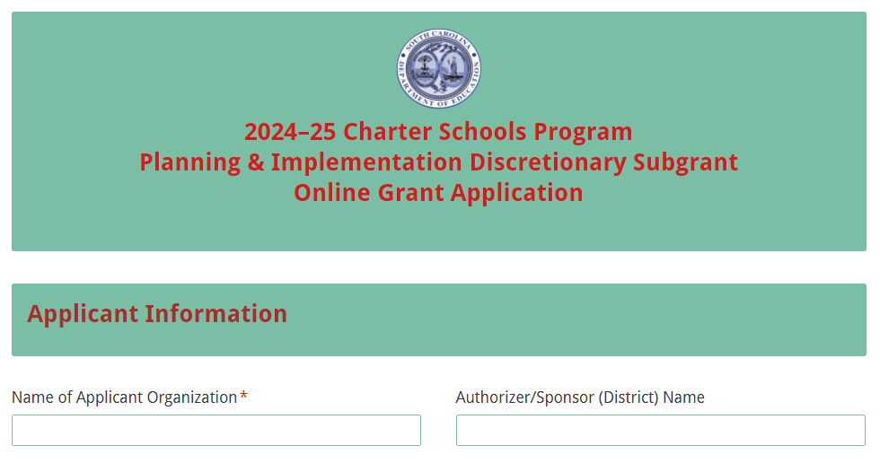
Enter the Author/Sponsor’s name, and the formal name of the Charter School. Provide the Applicant Organization’s address, UEI, and TIN.
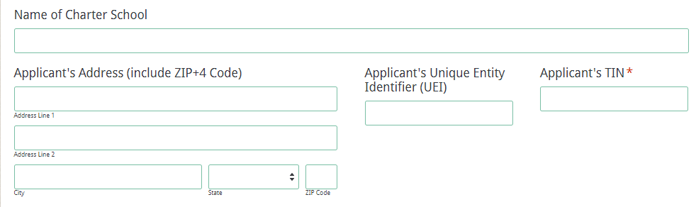
If the applicant selects “No” to indicate that they are not currently registered with SAM or that their status is inactive, the following message will be displayed. Refer to pages 7–8 or visit SAM.gov for more information.
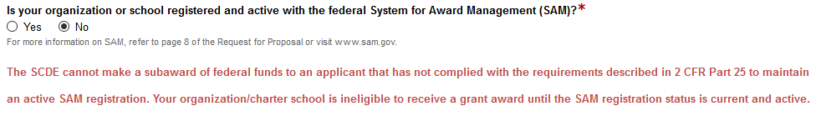
If the applicant is currently registered with SAM, enter the date your current SAM registration expires. Select whether the organization is applying for a Planning and Implementation subgrant or an Implementation Only subgrant. Also indicate if the organization is a targeted applicant or typical applicant (see definitions in appendix A. Definitions of Terms Used).
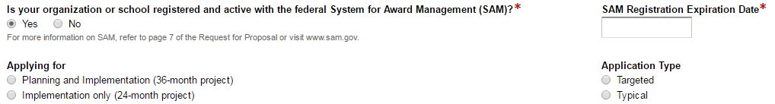
Enter the project director’s information. Select “Same as Applicant’s Address” if the project director’s mailing address is the same as the information entered on the first screen; the fields will automatically populate. If the address is different, enter the appropriate information. The project director’s email is a required field and must be re-entered. The confirmation of a successful online application submission will be sent only to this email address.
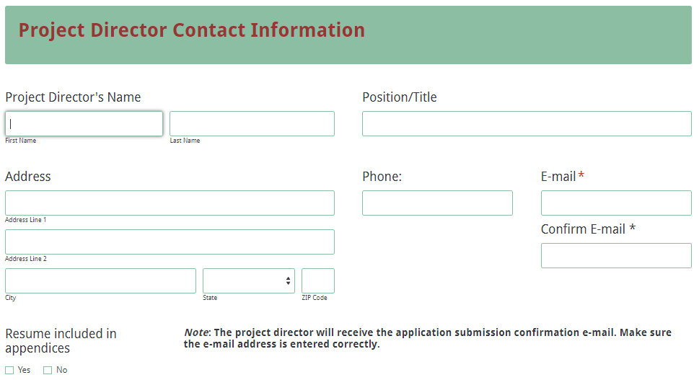
Select all competitive priority categories for which bonus points are sought and indicate the page number(s) in the proposal narrative where evidence can be found to support eligibility for each criteria. The fields for Competitive Priority 4 will only be displayed for targeted applicants.
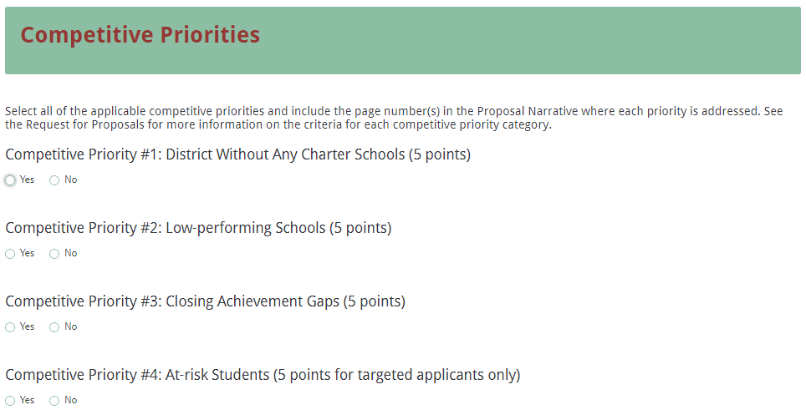
All amounts in the Funding Information and Budget Summary sections should be entered using whole dollars (no cents). Fill in all fields and enter zero (0) for line items that are not applicable. Enter the total estimated cost for all phases of the project. Enter the total amount of funding being requested for the first year of the project and the total in-kind or matching funds for the first year. Select the beginning and ending dates for phase one of the project.
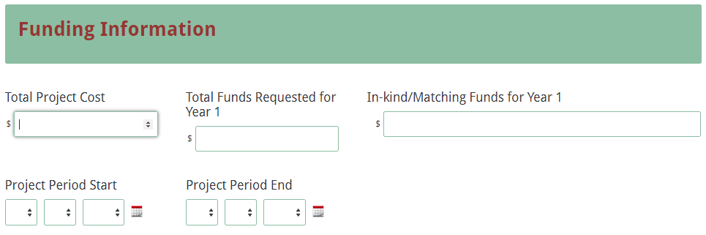
Enter the line item totals for funds requested for phase one. The Total Costs field will automatically calculate. This amount must match the total funds requested for year one above.
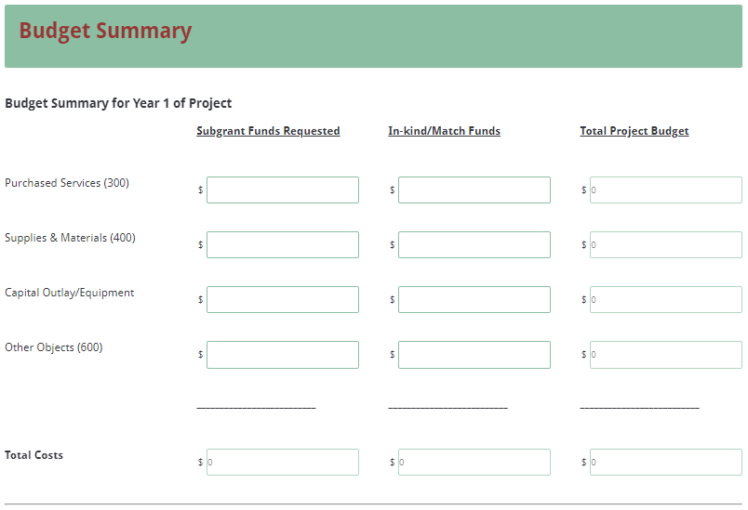
Prepare each of the application attachments (i.e., Project Abstract, Proposal Narrative, Budget Narrative, Appendices, and Pre-Award Audit Questionnaire) following the preceding instructions in this RFP. Ensure that each attachment is saved in the proper format as either a PDF or Excel document. Pay close attention to attachments that must be combined into a single document. The online application will only allow one document to be uploaded for each attachment. Upload the attachments where indicated in the following screenshot. All attachments are required; you will not be able to submit the application without uploading all five documents.
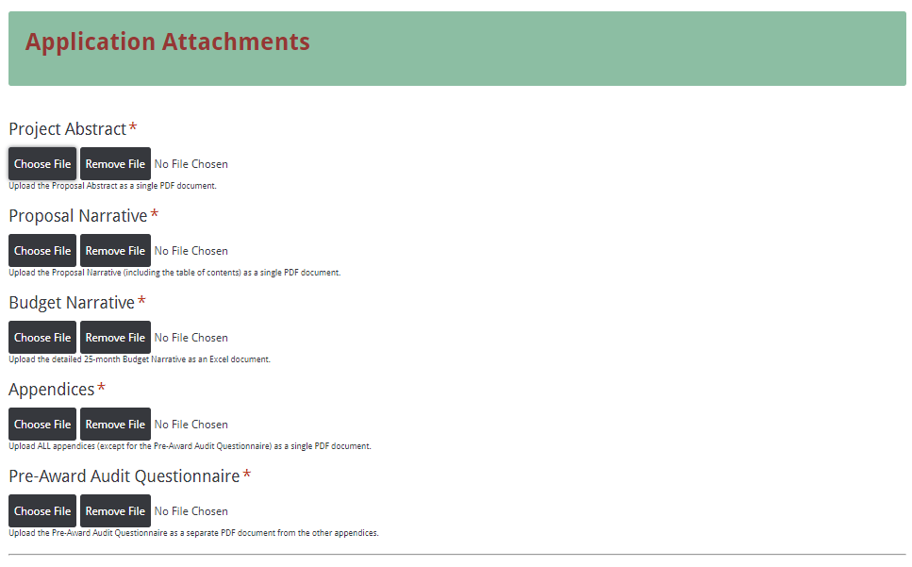
Thoroughly review the summary on the Data Review and Confirmation Page to verify that the information has been entered correctly in the online application prior to submitting. You will not be able to access the completed application form after it has been submitted. If any entries are incorrect, click on the “Previous” button at the bottom left corner of each screen to return to the appropriate section(s) and reenter the correct information. Then click on the “Next” button in the lower right corner of each screen to return to the Data Review and Confirmation Page. Note: This page is not a confirmation of the submission of an application.
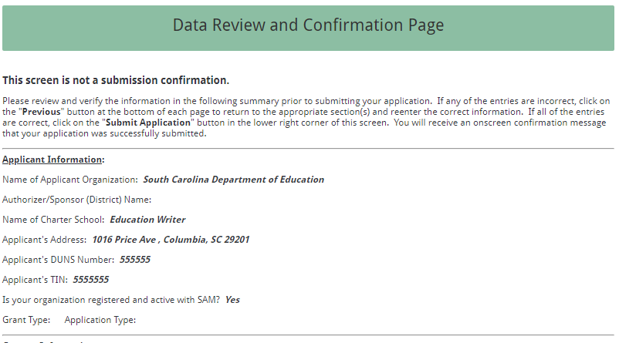
If all of the entries are correct, click on the “Submit Application” button in the lower right corner of this screen to complete the submission process.
Once the application is submitted, the following message will be displayed on the screen, and a submission confirmation will be sent to the email address provided for the project director in the online application.
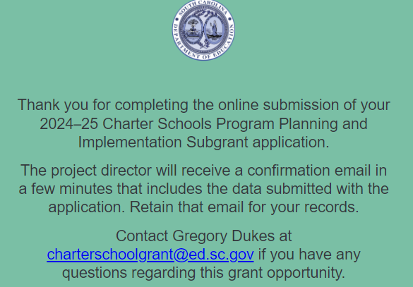
The following confirmation message will be sent to the email address provided for the project director. If the project director does not receive a confirmation email, then the application did not successfully transmit. You must go back and resubmit the entire online form, including all attachments, in order for your application to be considered for funding. Only the most recently submitted application will be reviewed.
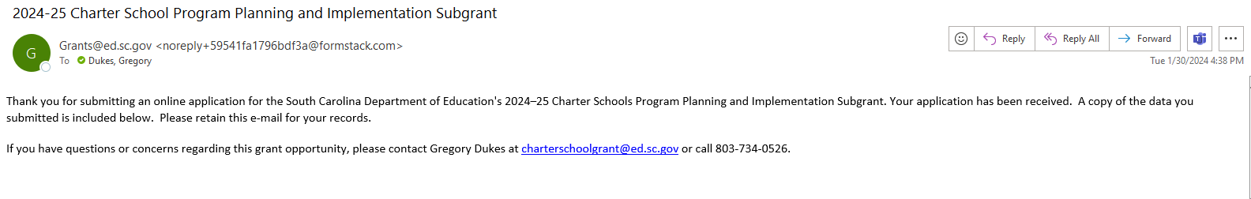

An email confirmation that the subgrant application was successfully submitted does not account for the quality of the uploaded documents or the completeness of the online form. The confirmation email only notifies you that the online application has been submitted and received. Applicants are responsible for ensuring that the information entered in the online form, including all attachments, is accurate and complete in order for the application to be reviewed and considered for funding.

Appendix A: Definitions of Terms Used

An approved charter constitutes an agreement, the terms of which represent a contract between the charter school and the charter school sponsor (authorizer).

The authorizer, also known as the sponsor, is the South Carolina Public Charter School District (SCPCSD) Board of Trustees, the local school board of trustees in which the charter school is located, or, as provided by law, a public institution of higher education (IHE) as defined in Section 59-103-5, or an independent IHE as defined in Section 59-113-50, from which the charter school requested its charter and which granted approval for the charter school’s existence. Only those public or independent IHEs that register with the SCDE may serve as charter school authorizers (sponsors), and the SCDE shall maintain a directory of those institutions. The sponsor (authorizer) of a charter school is the charter school’s local education agency (LEA), and a charter school is a school within that LEA. The sponsor (authorizer) retains responsibility for special education and shall ensure that students enrolled in its charter schools are served in a manner consistent with LEA obligations under applicable federal, state, and local law.

The authorized financial official is the duly authorized representative of the charter committee who maintains the finances, signs financial documents, and affirms the committee’s commitment to carry out the tasks proposed for the amount requested. This person provides oversight and guidance on financial matters related to the subgrant. The authorized financial official for this project must not have a financial interest in any contract that will or may be awarded pursuant to this project.

The authorized official is the duly authorized representative of the charter committee who signs all subgrant documents submitted to the SCDE and certifies the application, assurances, and terms and conditions. The authorized official for this project must not have a financial interest in any contract that will or may be awarded pursuant to this project.

Available funds are determined by the CSP subgrant amount awarded to the SCDE, the number and types of subgrantees in each funding phase, and state performance on CSP benchmarks.

A benchmark is a standard that must be met to move to the next phase of subgrant funding. Examples of benchmarks include, but are not limited to, the following: (1) a report of major subgrant activities completed from the previous subgrant phase; (2) a revised budget for the next subgrant phase; (3) an approved charter; or (4) a schedule for obtaining a facility.

A charter school is a public, nonreligious, non-home-based, nonprofit corporation forming a school that operates with a public school district, the SCPCSD, or a registered IHE, but is accountable to the school board of trustees, or in the case of technical colleges, the area commission of the sponsor (authorizer) that grants its charter.

A high-quality charter school is a charter school that will show evidence of strong academic results for the past three years (or over the life of the school, if the school has been open for fewer than three years), based on the following factors:
- Increased student academic achievement and attainment (including, if applicable and available, high school graduation rates and college and other postsecondary education enrollment rates) for all students, including, as applicable, educationally disadvantaged students served by the charter school;
- Either—
- Demonstrated success in closing historic achievement gaps for the subgroups of students described in Section 1111(b)(2)(C)(v)(II) of the ESEA; or
- No significant achievement gaps between any of the subgroups of students described in Section 1111(b)(2)(C)(v)(II) of the ESEA (20 U.S.C. 6311) at the charter school and significant gains in student academic achievement for all populations of students served by the charter school;
- Results (including, if applicable and available, performance on statewide tests, annual student attendance and retention rates, high school graduation rates, college and other postsecondary education attendance rates, and college and other postsecondary education persistence rates) for low-income and other educationally disadvantaged students served by the charter school that are above the average academic achievement results for such students in the state;
- Results on a performance framework established by the state or authorized public chartering agency for the purpose of evaluating charter school quality; and
- No significant compliance issues, particularly in the areas of student safety, financial management, and equitable treatment of students.

A secondary school is defined as any public school that contains grades no lower than seventh and no higher than twelfth (S.C. Code Ann. § 59-1-150).

A targeted applicant is a charter school that targets at-risk students as defined in accordance with SBE Regulation 43-274.1, or is an Alternative Education Campus (AEC charter school with an explicit mission to serve an enrolled student population as defined in S.C. Code Ann. § 59-40-111).

A typical applicant is a charter school that does not meet the eligibility criteria for a targeted applicant.

Appendix B: Selection Criteria and Reviewers’ Scoring Rubric

Selection Criteria

A total of 120 points (including competitive priority points) is available to applications that meet the maximum score for each selection criteria. While the budget is assigned zero (0) points, the budget remains a critical component of the entire application. An application with an incomplete budget will not be funded.

The point values for each section of the application are as follows:

Narrative Sections | Points Available
Project Abstract | 0
Section 1: The School and Its Stakeholders | 42
Section 2: Financial Sustainability | 28
Section 3: Governance and Management Plan | 30
Budget Summary and Narrative | 0
SUBTOTAL | 100
Competitive Priorities (Maximum bonus points available) | Up to 20
TOTAL | 120

Scoring Rubric

Project Abstract: The application provides a double-spaced, one-page abstract that concisely describes all of the following items:
- applicant’s organization,
- mission,
- target population to be served with the proposed project,
- documented need for the project as revealed by the needs assessment,
- goals and objectives of the proposed project,
- curriculum type,
- amount of funds requested,
- any special features of the proposed school’s operation, and
- any categories for which the applicant seeks competitive priority points.
Acceptable
Adequate/Meets—0 points
Applicant provides an abstract that fully addresses all required items.
Not Acceptable
Inadequate—0 points
Applicant provides an abstract that does not adequately address all required items.
Score

Reviewer’s Comments

1.a. School and Its Stakeholders—Mission of the Charter School and Relationship with Sponsor (authorizer): Applicant provides a narrative that fully addresses all of the following items and the attachments include the required items:
- states the mission of the new charter school;
- indicates any special features of the school’s operation or educational approach;
- describes the type of curriculum to be implemented;
- describes the relationship between its sponsor (authorizer) and the charter school; and
- if applicable, states that the applicant does not have an approval letter from their sponsor (authorizer) at the time of application and includes a letter from the prospective sponsor (authorizer) in the required attachments that states that the sponsor (authorizer) has received an application on behalf of the charter school group that is pending review.

Acceptable
Fully Meets—8–10 points
Applicant provides a narrative that fully describes all required items.
Adequate/Meets—6–7 points
Applicant provides a narrative that moderately describes all required items.
Not Acceptable
Limited/Approaches—3–5 points
Applicant provides a narrative that is limited or unclear in describing all required items.
Inadequate—0–2 points
Applicant provides a narrative that does not adequately describe all required items.
Score
Reviewer’s Comments

1.b. School and Its Stakeholders—Need for the Charter School The applicant provides a narrative that addresses all of the following:
- clearly states the need for the charter school in the designated district or location/region with specific supporting details (such as student test performance, demographics, local school performance);
- describes the target population to be served including grade levels and ages of students to be served;
- describes in detail the current opportunities available to the target population;
- indicates the need for additional student learning opportunities; and
- states the anticipated benefits to students from the new charter school.

Acceptable
Fully Meets—8–10 points
Applicant provides a narrative that fully describes all required items.
Adequate/Meets—6–7 points
Applicant provides a narrative that moderately describes all required items.
Not Acceptable
Limited/Approaches—3–5 points
Applicant provides a narrative that is limited or unclear in describing all required items.
Inadequate—0–2 points
Applicant provides a narrative that does not adequately describe all required items.
Score
Reviewer’s Comments

1.c. School and Its Stakeholders—Support for the Charter School: The applicant provides a narrative that addresses the following narrative item and the attachments include the required items:
- describes the degree of support for the charter school and continuing involvement by individuals and partner organizations within the community;
- explains how they will continue to involve individuals and partner organizations within the community;
- explains how these stakeholders will be involved in designing and implementing the new school;
- addresses innovative methods targeted to parents and community members in school planning and governance;
- describes plans to inform students and parents and the community about the new school;
- describes how students will be given an equal opportunity to attend the school;
- describes the use of effective parent, family, and community engagement strategies to operate the charter school; and
The attachments
- include a letter of support from each partner organization in the attachments; and
- include a summary list with signatures of community supporters, including parents, in the attachments.
Acceptable
Fully Meets—8–10 points
Applicant provides a narrative that fully describes all required items.
Adequate/Meets—5–7 points
Applicant provides a narrative that moderately describes all required items.

Not Acceptable
Limited/Approaches—2–4 points
Applicant provides a narrative that is limited or unclear in describing all required items.
Inadequate—0–1 point
Applicant provides a narrative that does not adequately describe all required items.
Score
Reviewer’s Comments

1.d. School and Its Stakeholders—Goals for the Charter School: The applicant provides a narrative that addresses all of the following:
- explains the established goals of the charter school and how they were selected;
- explains how the applicant plans to monitor progress toward meeting the established goals; and
- a completed Goals Narrative with goals that are:
  - specific,
  - measurable,
  - attainable,
  - realistic,
  - time-based, and
  - the monitoring tool or plan.
Acceptable
Fully Meets—10–12 points
Applicant provides a narrative that fully addresses all required items.
Adequate/Meets—6–9 points
Applicant provides a narrative that moderately addresses all required items.
Not Acceptable
Limited/Approaches—3–5 points
Applicant provides a narrative that is limited or unclear in addressing all required items.
Inadequate—0–2 points
Applicant provides a narrative that does not adequately address all required items.
Score
Reviewer’s Comments

2.a. Financial Sustainability: The applicant provides a narrative that presents a clear and thoughtful plan for the financial viability of the charter school that includes all of the following:
- evidence of a long-term, sound business plan based on an awareness of current funding for public schools;
- the intent to maintain effective internal controls and fiscal management practices; and
- a reasonable promise of sustainability beyond the scope of the CSP subgrant.
Acceptable
Fully Meets—7–10 points
Applicant provides a narrative that fully addresses all required items.
Adequate/Meets—5–6 points
Applicant provides a narrative that moderately addresses all required items.
Not Acceptable
Limited/Approaches—3–4 points
Applicant provides a narrative that is limited or unclear in addressing all required items.
Inadequate—0–2 points
Applicant provides a narrative that does not adequately address all required items.
Score
Reviewer’s Comments

2.b. Financial Sustainability: The applicant provides a narrative that addresses all of the following:
- includes contingency plans to deal with unanticipated budget reductions due to shortfalls in federal, state, and/or local revenue;
- describes any public/private partnerships, including additional grant or funding opportunities; and
- if applicable, describes how subgrant funds will be used in conjunction with funds from other federal programs administered by the USED.
Acceptable
Fully Meets—8–10 points
Applicant provides a narrative that fully describes all required items.
Adequate/Meets—5–7 points
Applicant provides a narrative that moderately describes all required items.
Not Acceptable
Limited/Approaches—2–4 points
Applicant provides a narrative that is limited or unclear in describing all required items.
Inadequate—0–1 point
Applicant provides a narrative that does not adequately describe all required items.
Score
Reviewer’s Comments

2.c. Financial Sustainability: The applicant provides a narrative to justify the proposed three-year budget that addresses all of the following:
- how they arrived at the selected items to be purchased;
- how the items directly correlate to the school’s educational plan;
- how the cost per item was calculated; and
- how budget items will supplement, not supplant, other revenue sources available to the charter school.
Acceptable
Fully Meets—8–10 points
Applicant provides a detailed narrative to justify the proposed three-year budget that fully addresses all required items.
Adequate/Meets—6–7 points
Applicant provides a detailed narrative to justify the proposed three-year budget that moderately addresses all required items.
Not Acceptable
Limited/Approaches—4–5 points
Applicant provides a detailed narrative to justify the proposed three-year budget that is limited or unclear in addressing all required items.
Inadequate—0–3 points
Applicant provides a detailed narrative to justify the proposed three-year budget that does not adequately address all required items.
Score
Reviewer’s Comments

3.a. Governance & Management Plan: The applicant provides a narrative that addresses all of the following:
- conveys a clear and explicit plan to manage the charter school and the subgrant;
- describes the school’s founders;
- describes the school’s governance plans;
- describes the board’s plans for school management and leadership;
- describes the roles and responsibilities of the school, partner organizations, and charter management organizations, including the administrative and contractual roles and responsibilities of such partners; and
- if applicable, includes plans to enter into a management or other comprehensive service agreement/contract.
Acceptable
Fully Meets—7–8 points
Applicant provides a narrative that fully addresses all required items.
Adequate/Meets—5–6 points
Applicant provides a narrative that moderately addresses all required items.
Not Acceptable
Limited/Approaches—3–4 points
Applicant provides a narrative that is limited or unclear in addressing all required items.
Inadequate—0–2 points
Applicant provides a narrative that does not adequately address all required items.
Score
Reviewer’s Comments

3.b. Governance & Management Plan: The applicant provides a narrative that addresses the following narrative item and the attachments include the required items:
- describes the project director’s responsibilities and duties in managing the subgrant to achieve the charter school’s objectives;
- includes, as an attachment, an organizational chart indicating the chain of command and lines of direct report and the roles of the school committees and advisory groups; and
- includes, as an attachment, either the qualifications and credentials for the project director position or the identified project director’s résumé.
Acceptable
Fully Meets—6–7 points
Applicant provides a narrative that fully addresses all required items.
Adequate/Meets—4–5 points
Applicant provides a narrative that moderately addresses all required items.
Not Acceptable
Limited/Approaches—2–3 points
Applicant provides a narrative that is limited or unclear in addressing all required items.
Inadequate—0–1 point(s)
Applicant provides a narrative that does not adequately address all required items.
Score

Reviewer’s Comments

3.c. Governance & Management Plan:
The applicant provides a narrative that addresses all of the following narrative items and the attachments include the required item:
- explains how the charter school’s planning initiative and the resulting charter school will be managed;
- includes an assurance, with a timeframe and a lead contact, that the subgrantee will provide annual information to the USED and the SCDE as required to determine if the charter school is making satisfactory progress toward achieving its objectives; and
- includes, as an attachment, a projected timeline/workplan of proposed major subgrant activities (e.g., community meetings, professional development activities, lottery if the school is oversubscribed, opening of charter school, election of governing board) and indicates the person(s) responsible for oversight and completion of each activity
Acceptable
Fully Meets—7–8 points
Applicant provides a narrative that fully addresses all required items.
Adequate/Meets—5–6 points
Applicant provides a narrative that moderately addresses all required items.
Not Acceptable
Limited/Approaches—3–4 points
Applicant provides a narrative that is limited or unclear in addressing all required items.
Inadequate—0–2 points
Applicant provides a narrative that does not adequately address all required items.
Score
Reviewer’s Comments

3.d. Governance & Management Plan:
The applicant provides a narrative that addresses all of the following:
- describes how the sponsor (authorizer) for the charter school will comply with Sections 613(a)(5) and 613(e)(1)(B) of the IDEA, the Age Discrimination Act of 1975, Title VI of the Civil Rights Act of 1964 , Title IX of the Education Amendments of 1972, and Section 504 of the Rehabilitation Act of 1973 in the operation of the charter school;
- demonstrates an understanding of and the capacity to comply with the South Carolina Charter School Act; and
- includes evidence of strong board governance and stakeholder engagement.
Acceptable
Fully Meets—6–7 points
Applicant provides a narrative that fully addresses all required items.
Adequate/Meets—4–5 points
Applicant provides a narrative that moderately addresses all required items.
Not Acceptable
Limited/Approaches—2–3 points
Applicant provides a narrative that is limited or unclear in addressing all required items.
Inadequate—0–1 point(s)
Applicant provides a narrative that does not adequately address all required items.
Score
Reviewer’s Comments

Budget Narrative: The applicant provides a thorough and detailed budget narrative that:
- calculates correctly;
- includes all formulas used to calculate line-item expenses; and
- provides clear evidence that the proposed expenditures are appropriate, justified, reasonable, and adequate to support the proposed allowable activities to complete the project.
Acceptable
Adequate/Meets—0 points
Applicant provides an abstract that fully addresses all required items.
Not Acceptable
Inadequate—0 points
Applicant provides an abstract that does not adequately address all required items.
Score
Reviewer’s Comments

Appendix C: Required SCDE Forms

Certification Signature Page

Certification
I hereby certify that, to the best of my knowledge, the information and data contained in this application are true and correct. The applicant’s governing body has duly authorized this application and documentation, and the applicant will comply with the Program-Specific Assurances and the SCDE Assurances and Terms and Conditions for Federal Subawards if the subgrant is awarded. The applicant is registered and current (active) on the federal System for Award Management (SAM).

Charter schools must provide evidence of improved student academic achievement for all groups of students described in Section 1111(b)(2)(C)(v) of the ESEA. Authorizers (sponsors) must use increases in student academic achievement for all groups of students described in Section 1111(b)(2)(C)(v) of the ESEA as the most important factor when determining to renew or revoke a school’s charter. Each sponsor (authorizer) and charter school must enter a contractual agreement stating that student performance of all students described in Section 1111(b)(2)(C)(v) of the ESEA is the most important factor when determining to renew or revoke a school’s charter.

Authorized Official Representative (duly authorized representative of charter committee)
Name:
Position: | Email:
Telephone: | Fax:

Signature of Authorized Official Representative: | Date:

Authorized Financial Official
Name:
Position: | Email:
Telephone: | Fax:

Signature of Authorized Financial Official: | Date:

Please complete, print, and obtain signatures prior to submission. Include the signed, scanned form in the Required Appendices as indicated on page 33.

Assurances and Terms and Conditions for Federal Subawards

Assurances

I certify that this applicant

- Has the legal authority to apply for federal assistance and the institutional, managerial, and financial capability (including funds sufficient to pay the nonstate share of project costs) to ensure proper planning, management, and completion of the project described in this application.
- Will give the South Carolina Department of Education (SCDE) access to and the right to examine all records, books, papers, or documents related to this award and will establish a proper accounting system in accordance with generally accepted accounting principles (GAAP) or agency directives.
- Has an accounting system with sufficient internal controls, a clear audit trail, and written cost-allocation procedures as necessary. The financial management systems are capable of distinguishing expenditures that are attributable to this grant from those that are not attributable to this grant. This system is able to identify costs by programmatic year and by budget line item and to differentiate among direct, indirect, and administrative costs. In addition, the applicant will maintain adequate supporting documents for the expenditures (federal and nonfederal) and in-kind contributions, if any, that it makes under this grant. Costs are shown in books or records (e.g., disbursements ledger, journal, payroll register) and are supported by a source document such as a receipt, travel voucher, invoice, bill, or in-kind voucher.
- Will also comply with the Office of Management and Budget 2 CFR Part 200 Subpart E-Cost Principles related to the allowability, reasonableness, and allocability of costs consistent with the approved budget and also by maintaining required support for salaries and wages. Required support includes certifications and/or personnel activity records depending upon the amount of time spent on cost objectives.
- Will approve all expenditures, document receipt of goods and services, and record payments on the applicant’s accounting records prior to submission of reimbursement claims to the SCDE for costs related to this grant.
- Will initiate and complete work within the applicable time frame after receipt of approval by the SCDE.
- Will not discriminate against any employee or applicant for employment because of race, color, religion, age, sex, national origin, or disability and comply with Title VI of the Civil Rights Act of 1964, Section 504 of the Rehabilitation Act of 1973, Title IX of the Education Amendments of 1972, the Age Discrimination Act of 1975, and Titles I, II, and III of the Americans with Disabilities Act of 1990 (ADA). The grantee will take affirmative action to ensure that applicants for employment and the employees during the period of their employment are treated without regard to their race, color, religion, age, sex, national origin, or disability.
- Has no policy that prevents, or otherwise denies, participation in constitutionally protected prayer in public schools as set forth in the Guidance on Constitutionally Protected Prayer in Public Education (20 U.S.C. § 7904).
- Will comply with the Family Educational Rights and Privacy Act. (20 U.S.C. §1232g; 34 CFR Part 99).
- Will comply with the Ethics, Government Accountability, and Campaign Reform Act (S.C. Code Ann. § 2-17-10 et seq. and § 8-13-100 et seq. (Supp. 2023)).
- Will comply with the South Carolina Drug Free Workplace Act (S.C. Code Ann. § 44-107-10 et seq. (Supp. 2023) if the amount of this award is $50,000 or more and the federal Drug Free Workplace Act of 1988 (41 USC 702).
- Will provide information to the SCDE, as requested, regarding the reporting requirements of the Federal Funding Accountability and Transparency Act (FFATA), which requires the SCDE to file a FFATA subaward report by the end of the month following the month in which it awards any subgrant equal to or greater than $25,000.
- Will comply with 2 CFR Part 25 and register and receive a unique entity identifier, fulfill the requirement for the System for Award Management, maintain the currency of the registration throughout the full grant term, and allow access by the granting agency to ensure compliance.
- Will comply with 2 CFR Part 200.112 and disclose in writing any potential conflict of interest to the SCDE.
- Will comply with 2 CFR Part 200.113 and disclose in writing to the SCDE all violations of federal criminal law involving fraud, bribery, or gratuity violations potentially affecting the federal award.
- Will comply with conditions under Executive Order 13513 “Federal Leadership on Reducing Text Messaging While Driving” (October 1, 2009) by refraining from text messaging while driving during official grant business. Relatedly, the applicant will refrain from emailing while driving during official grant business.

Terms and Conditions

- Completeness of Proposal. All proposals should be complete and carefully worded and must contain all of the information requested by the South Carolina Department of Education (SCDE). If you do not believe a section applies to your proposal, please indicate that fact.
- Non-awards/Termination. The SCDE reserves the right to reject any and all applications and to refuse to grant monies under this solicitation. If the SCDE rejects an application, the applicant has a right to request a hearing, as provided by 2 CFR Part 200.341 and 34 CFR Part 76.401, if it alleges the SCDE’s actions violate a state or federal statute or regulation by (1) disapproving of or failing to approve the application or project, in whole or in part, or (2) failing to provide funds in amounts in accordance with the requirements of statutes and regulations.
After it has been awarded, the SCDE may terminate a grant by giving the grantee written notice of termination. In the event of a termination after award, the SCDE shall reimburse the grantee for allowable expenses incurred up to the notification of termination. In addition, this grant may be terminated by the SCDE if the grantee fails to perform as promised in its proposal. Federal grants will be terminated in accordance with 2 CFR Part 200.339 and 200.340.
In the event that this grant is terminated, the grantee shall have a right to a hearing as set forth in 34 CFR Part 76.783. The grantee must notify the SCDE of its request for a hearing within 30 days of receiving written notice of the termination. If a hearing is requested, the SCDE will conduct the hearing in accordance with the procedures outlined in 34 CFR Part 76.401(d)(2)–(7).
- Reduction in Budgets and Negotiations. The SCDE reserves the right to negotiate budgets with applicants. The SCDE may, at its sole discretion, determine that a proposed budget is excessive and may negotiate a lower budget with the applicant. The applicant may at that time negotiate or withdraw its proposal. In addition, the SCDE may desire to fund a project but not at the level proposed. In that case, the SCDE shall notify the applicant of the amount that can be funded, and the applicant and the SCDE shall negotiate a modification to the proposal to accommodate the lower budget. All final decisions are that of the SCDE.
- Amendments to Grants. Amendments are permitted generally for budgets, grant end date, and management upon the mutual agreement of the parties involved and will become effective when specified in writing and signed by both parties. However, amendments to scope of work that significantly alter the original application proposal may trigger partial or full termination consistent with 2 CFR Part 200.339 and 200.340.
- Use of Grant Funds. Funds awarded are to be expended only for purposes and activities covered by the approved project plan and approved budget and budget narrative.
- Submission of Expenditure Reports. Claims for reimbursement must be made at least quarterly and consistent with calendar quarters (e.g., an expenditure report claim for costs for January 1 through March 30 must be filed by May 15).
- Obligation of Grant Funds. Grant funds may not be obligated prior to the effective date or subsequent to the end or termination date of the grant period. No obligations are allowed after the end of the grant period. The final request for expenditure report claims must be submitted no later than forty-five (45) days after the end of the grant period unless the scope of work for the grant states a shorter reporting period.
- Deobligation of Funds. After a final expenditure report claim has been submitted to the SCDE, the grantee will go through the official deobligation process with the SCDE.
- Documentation. The grantee must provide for accurate and timely recording of receipts and expenditures. The grantee’s accounting system should distinguish receipts and expenditures attributable to each grant. The grantee must review the memo regarding “Guidelines for Retaining Documentation to Support Expenditure Claims.”
- Travel Costs. Travel costs, if allowed under this solicitation, must not exceed limits noted in the United States General Services Administration (GSA) per diem rates for lodging, except in the case of conference lodging required for program-required training. In the case that conference-related lodging exceeds the GSA per diem rate, the grantee shall follow their entity’s written procedure for obtaining prior approval to exceed a GSA rate for a conference hotel. Meals and incidentals are limited by the state budget proviso, currently not to exceed $35 per day for in-state travel and $50 for out-of-state travel (see page 81 of the State of South Carolina Statewide Disbursement Regulations). Mileage reimbursement must follow the current Office of Comptroller General instructions, which is consistent with the published IRS rates.
- Honoraria. Amounts paid in honoraria, if allowed under this grant, must be consistent with SCDE policies. Applicants should check with the program office before budgeting for honoraria.
- Reports. The grantee shall submit, as required or instructed by the awarding program office, all reports (programmatic, financial, or evaluation) within the specified period or date and in the prescribed format. An expenditure claim report must be filed by August 15 for all expenditures incurred by June 30 in order to comply with the generally accepted accounting principles (GAAP) and the production of the State's Comprehensive Annual Financial Report.
- Copyright. The grantee is free to copyright any books, publications, or other copyrightable materials developed in the course of this grant. However, the SCDE reserves a royalty-free, nonexclusive, and irrevocable license to reproduce, publish, or otherwise use, and to authorize others to use, the copyrighted work developed under this grant.
- Certification Regarding Lobbying, Suspension, and Debarment. By submitting an application, the applicant certifies, to the best of its knowledge and belief, that the
- Applicant and/or any of its principals, subgrantees, or subcontractors
  - Have not paid or will not pay to any person any federally appropriated funds for the purpose of influencing or attempting to influence an officer or employee of any agency, a Member of
Congress, an officer or employee of Congress, or any employee of a Member of Congress in connection with making any federal grant and the extension continuation, renewal, amendment, or modification of any federal grant, as defined at 34 CFR Part 82.105 and 82.110. If any funds other than federally appropriated funds have been paid or will be paid to any person for influencing or attempting to influence an officer or employee of any agency, a Member of Congress, an officer or employee of Congress, or any employee of a Member of Congress in connection with this federal grant, the undersigned shall complete and submit Standard Form LLL, “Disclosure of Lobbying Activities,” in accordance with its instructions.
  - Are not presently debarred, suspended, proposed for debarment, or declared ineligible for the award of contracts by any state or federal agency as stated at 2 CFR Part 180 or 2 CFR Part 3485.
  - Have not, within a three-year period preceding this application, been convicted of or had a civil judgment rendered against them for commission of fraud or a criminal offense in connection with obtaining, attempting to obtain, or performing a public (federal, state, or local) contract or subcontract; violated federal or state antitrust statutes relating to the submission of offers; or committed embezzlement, theft, forgery, bribery, falsification or destruction of records, making false statements, tax evasion, or receiving stolen property.
  - Are not presently indicted for, or otherwise criminally or civilly charged by a governmental entity with, commission of any of the offenses enumerated above.
- Applicant has not, within a three-year period preceding this application, had one or more contracts terminated for default by any public (federal, state, or local) entity.
- Audits.
- Entities expending $750,000 or more in federal awards:
Entities that expend $750,000 or more in federal awards during the fiscal year are required to have an audit performed in accordance with the provisions of 2 CFR Part 200.501, et seq. Except for the provisions for biennial audits provided in 2 CFR Part 200.504 (a) and (b), audits must be performed annually as stated at 2 CFR Part 200.504. A grantee that passes through funds to subrecipients has the responsibility of ensuring that federal awards are used for authorized purposes in compliance with federal program laws, federal and state regulations, and grant agreements. The director of the OMB, who will review this amount every two years, has the option of revising the threshold upward.
- Entities expending less than $750,000 in federal awards:
Entities that expend less than $750,000 in a fiscal year in federal awards are exempt from the audit requirements in 2 CFR Part 200.504. However, such entities are not exempt from other federal requirements (including those to maintain records) concerning federal awards provided to the entity. The entity’s records must be available for review or audit by the SCDE and appropriate officials of federal agencies, pass-through entities, and the General Accounting Office (GAO).
- Records. The grantee shall retain federal grant records, including financial records and supporting documentation, for a minimum of six (6) years after the end date of the grant when the final expenditure report claim for reimbursement and all final reports have been submitted, unless informed otherwise or in the case of litigation.
- Electronic Signature Agreement. I agree that my electronic signature is the legally binding equivalent to my handwritten signature.

Program-Specific Assurances

For informational purposes only
The applicant agrees to abide by the SCDE Program-Specific Assurances by signing and submitting the Certification Signature Page

The applicant ensures that it will:

- Use the Planning and Implementation subgrant to plan and implement a charter school that aligns with the intent of the SC Charter School Act.
- Comply with the nonregulatory guidance provided by the US Department of Education (USED), regarding expenditures being allocable, allowable, and reasonable as determined by the USED.
- Comply with 2 CFR § 200.439 when purchasing equipment or disposing of equipment purchased with Planning and Implementation funds.
- Comply with all guidelines for meeting stated benchmarks in a time-sensitive manner.

Instructions for GEPA Statement of Compliance

This enclosure is to inform you about Section 427 of the U.S. Department of Education’s General Education Provisions Act (GEPA) that applies to applicants for new grant awards under Department programs. This provision is enacted as part of the Improving America’s Schools Act of 1994 (Public Law (P.L.) 103-382).

To Whom Does This Provision Apply?
Section 427 of GEPA affects applicants for new grant awards under this program. All applicants for new awards must include information in their applications to address this new provision in order to receive funding under this program.

What Does This Provision Require?
Section 427 requires each applicant for funds (other than an individual person) to include in its application a description of the steps the applicant proposes to take to ensure equitable access to, and participation in, its federally assisted program for students, teachers, and other program beneficiaries with special needs. This provision allows applicants discretion in developing the required description. The statute highlights six types of barriers that can impede equitable access or participation: gender, race, national origin, color, disability, or age. Based on local circumstances, you should determine whether these or other barriers may prevent your students, teachers, etc. from such access or participation in the federally funded project or activity. The description in your application of steps to be taken to overcome these barriers need not be lengthy; you may provide a clear and succinct description of how you plan to address those barriers that are applicable to your circumstances. In addition, the information may be provided in a single narrative, or, if appropriate, may be discussed in connection with related topics in the application.

Section 427 is not intended to duplicate the requirements of civil rights statutes, but rather to ensure that, in designing their projects, applicants for federal funds address equity concerns that may affect the ability of certain potential beneficiaries to fully participate in the project and to achieve to high standards. Consistent with program requirements and its approved application, an applicant may use the federal funds awarded to it to eliminate barriers it identifies.

The following examples may help illustrate how an applicant may comply with Section 427.
- An applicant that proposes to carry out an adult literacy project serving, among others, adults with limited English proficiency might describe in its application how it intends to distribute a brochure about the proposed project to such potential participants in their native language.
- An applicant that proposes to develop instructional materials for classroom use might describe how it will make the materials available on audio tape or in Braille for students who are blind.
- An applicant that proposes to carry out a model science program for secondary students and is concerned that girls may be less likely than boys to enroll in the course might indicate how it intends to conduct “outreach” efforts to girls to encourage their enrollment.
- An applicant that proposes a project to increase school safety might describe the special efforts it will take to address concern of lesbian, gay, bisexual, and transgender students, and efforts to reach out to and involve the families of LGBT students.

Many applicants may already be implementing effective steps to ensure equity of access and participation in their grant programs; we appreciate your cooperation in responding to the requirements of this provision.

Estimated Burden Statement for GEPA Requirements
According to the Paperwork Reduction Act of 1995, no persons are required to respond to a collection of information unless such collection displays a valid OMB control number. Public reporting burden for this collection of information is estimated to average 1.5 hours per response, including time for reviewing instructions, searching existing data sources, gathering and maintaining the data needed, and completing and reviewing the collection of information. The obligation to respond to this collection is required to obtain or retain benefit (Public Law 103-382). Send comments regarding the burden estimate or any other aspect of this collection of information, including suggestions for reducing this burden, to the U.S. Department of Education, 400 Maryland Ave., SW, Washington, DC 20210-4537 or email ICDocketMgr@ed.gov and reference the OMB Control Number 1894-0005.

Request for Taxpayer Identification Number and Certification

Go to the IRS Web site for an easy-to-complete version of this form.
(To be completed by fiscal agent)

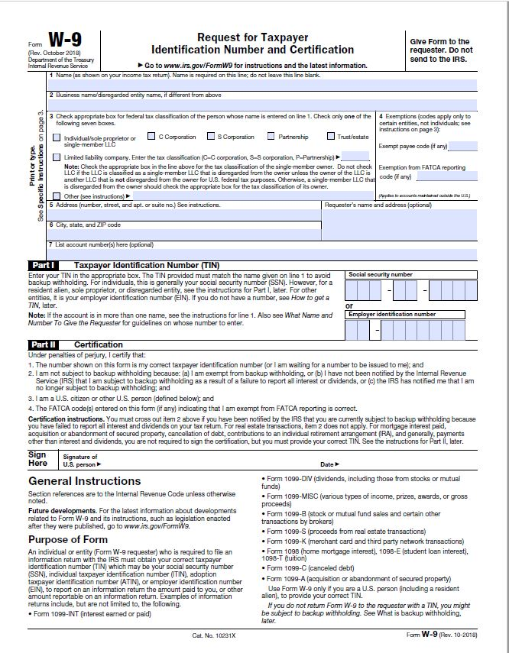

Timeline of Activities/Workplan Chart

Project Goal: To open and operate a high-quality charter school

Planning vs. Implementation: Subgrantees have, at a minimum, 6 months for Planning with a maximum up to 18 months. Implementation Phase 1 charter schools will have 12 months and Implementation Phase 2 charter schools may have from 3 to 12 months depending on the remaining time; 24 months is the maximum period of time for the Implementation phases. Subgrant awards may range from 33 months to a maximum total of 36 months. Please indicate the Planning and Implementation periods below:

Planning: _____ Implementation Phase 1: _____ Implementation Phase 2: ______

Anticipated Date of Charter School Opening: _________________________________________

Activity | Budget Item | Amount of Funds  (must align to Object Codes) | Timeline | Budget Justification

Proposed Planning and Implementation Budget Template

For informational purposes only
Go to the SCDE Grant Opportunities webpage for CSP Planning and Implementation Subgrant to obtain the Excel spreadsheet template.

