Request for Proposals (RFP)
Application Package

Nita M. Lowey 21st Century Community Learning Centers
2024–2025 Competitive Subgrant

The Nita M. Lowey 21st Century Community Learning Centers is a subgrant program funded by the U.S. Department of Education, authorized by the Elementary and Secondary Education Act of 1965, as amended by the Every Student Succeeds Act, Title IV, Part B (20 U.S.C. 7171‒7176), and administered by the South Carolina Department of Education.
(Assistance Listing 84.287C)

Deadline for Receipt of Applications: March 18, 2024, at 4:30 p.m.

Technical Assistance for Applicants: January 23, 2024, at 10:00 a.m.

For questions about the 21st Century Community Learning Centers subgrant, contact:
Joyce Patterson, jypatterson@ed.sc.gov or 803-734-8291, or
Amy Bosch, abosch@ed.sc.gov or 803-734-8114

Issued by:
South Carolina Department of Education
Office of Student Support (OSS)
1429 Senate Street, Suite 805
Columbia, SC 29201-3730

TABLE OF CONTENTS
PART I: General Information 1
A. Introduction and Purpose 1
B. Eligible Applicants 4
C. Competitive Priorities 4
D. Timeline of Subgranting Process 5
E. Technical Assistance Sessions for Applicants 5
F. Statutory, Federal Regulations, and State-Level Program Requirements 5
G. Authorized Activities 12
H. Unauthorized Activities 13
I. Program Accountability and Monitoring 13
J. Fiscal Operations 17
K. Supplement, Not Supplant 18
L. Peer Review and Selection Process 18
M. Appeals Process 20
PART II: Application Overview, Content, and Instructions 21
A. Application Overview 21
B. Application Narrative Format 22
C. Online Application Submission 22
D. Proposal Abstract 22
E. Application Narrative Content 23
1. Needs Statement 23
2. Project Design 24
3. Management 28
4. Adequacy of Resources and Sustainability 29
5. Timeline of Activities and Project Weekly Schedule 30
F. Application Budget 31
G. Appendices 35
H. Pre-Award Audit Questionnaire for LEAs and State Agencies or Non-LEAs 36
I. Deadline and Submission Procedures 36
J. Screenshots of Online Application Submission Forms 37
Appendix A: Definitions of Terms Used 48
Appendix B: Selection Criteria and Reviewers’ Scoring Rubric 50
Appendix C: Required SCDE Forms 61
Certification Signature Page 61
Assurances and Terms and Conditions for Federal Subawards 62
Program Specific Assurances 66
Instructions for GEPA Statement of Compliance 67
Request for Taxpayer Identification Number and Certification 68
Private School Consultation Form 69
Pre-Award Audit Questionnaire for LEAs and State Agencies 70
Pre-Award Audit Questionnaire for Non-LEAs 74
Budget Forecast and Narrative Format Guidance 79
Timeline of Activities Template 80
Project Weekly Schedule Template 81
Multi-Year Program Design and Performance Form Template 82
Appendix D: Optional SCDE Forms and Information 86
Project Director’s Position Description 86
Site Coordinator’s Position Description 88

PART I: General Information

Introduction and Purpose

The U.S. Department of Education (USED) allocates federal funds for the Nita M. Lowey 21st Century Community Learning Centers (21st CCLC) program on a formula basis to enable the South Carolina Department of Education (SCDE) to manage and monitor this competitive subgrant program.

The purpose of the 21st CCLC program, as stated in the federal authorizing statute and non-regulatory guidance, is to provide opportunities for communities to establish or expand activities in community learning centers that
- provide opportunities for academic enrichment, including providing tutorial services to help students, particularly students who attend low-performing schools, to meet the challenging state academic standards;
- offer students a broad array of additional services, programs, and activities, such as youth development activities, service learning, nutrition and health education, drug and violence prevention programs, counseling programs, arts, music, physical fitness and wellness programs, technology education programs, financial literacy programs, environmental literacy programs, mathematics, science, career and technical programs, internship or apprenticeship programs, and other ties to an in-demand industry sector or occupation for high school students that are designed to reinforce and complement the regular academic program of participating students; and
- offer families of students served by community learning centers opportunities for active and meaningful engagement in their children’s education, including opportunities for literacy and related educational development.

A 21st CCLC offers academic, artistic, and cultural enrichment opportunities to students and their families during non-school hours (before or after school) or periods when school is not in session (including holidays, weekends, or summers). A community learning center “assists students to meet the challenging state academic standards by providing the students with academic enrichment activities” (see the Every Student Succeeds Act (ESSA), Section 4201(b)(1)(A)). Centers also provide students with “a broad array of other activities (such as programs and activities described in subsection (a)(2)) during nonschool hours or periods when school is not in session.” A 21st CCLC must also serve the families of participating students with “opportunities for active and meaningful engagement in their children’s education, including opportunities for literacy and related educational development.”

A 21st CCLC can be located in an elementary or secondary school or other similarly accessible facility. Centers provide a range of high-quality services to support student learning and development, including tutoring and mentoring, homework assistance, academic enrichment (such as hands-on science or technology programs), and community service opportunities, as well as music, arts, sports, and cultural activities.

Approximately $3-5 million will be available for new subgrants in this FY 2024–25 funding cycle. The SCDE anticipates awarding approximately 10-15 subgrants. Award amounts will be determined based on the type of applicant and the number of students to be served. All funding and subgrant awards are contingent upon allocations to the SCDE by the USED.

The maximum subgrant funding period is four years (August 1, 2024, through July 31, 2028) and is subject to the availability of funds and programs meeting all project requirements. Subgrant awards will be issued annually as yearly continuation of funding is not automatic. The subgrant budget period for year one is August 1, 2024, through July 31, 2025.

The subgrantee may obligate funds on or after August 1, 2024. Subgrant payments are made on a cost-reimbursement basis, so applicants are required to have at least three months of operating funds at their disposal to implement the program to compensate for any delays in receiving reimbursements.

Applicants may propose to serve students who primarily attend—
- schools implementing comprehensive support and improvement activities (CSI) or additional targeted support and improvement activities (ATSI) under Section 4203 (a)(3)(A), and
- other schools determined by the LEA to need intervention and support; and
- the families of such students.

The lists of schools identified as ATSI and CSI are available on the SCDE Web site.

Subgrantees must serve the same cohort of students daily and keep attendance records of program participants. All student participants are required to be enrolled in all components of the program (i.e., before-school, after-school, summer) and attend regularly.

The following table provides the maximum funding available for proposed 21st CCLC programs under this competition. Federal law requires that the minimum amount that may be awarded to a subgrantee for any subgrant year is $50,000. Note: the maximum cost allowed per student is the total budget to operate an applicant’s proposed program. For example, for 100 students in a program operating for 12 hours per week, the total budget for years one and two would be $200,000 (100 students x $2,000) and would include all operating costs: salaries, fringe benefits, purchased services, supplies, other objects, and indirect cost. The table below indicates the maximum budget for years three and four.

Table 1: Funding Limits for New Projects
Operating at least 10 hours per week for at least 30 weeks (minimum requirements).
Hours of operation per week | Project Period | Maximum Request | Per Student Cost
12 or more hours | Year One | $200,000 | $2,000
12 or more hours | Year Two | $200,000 | $2,000
12 or more hours | Year Three | $180,000 | $2,000
12 or more hours | Year Four | $171,000 | $2,000
11 hours | Year One | $183,700 | $1,837
11 hours | Year Two | $183,700 | $1,837
11 hours | Year Three | $165,330 | $1,837
11 hours | Year Four | $157,064 | $1,837
10 hours | Year One | $167,000 | $1,670
10 hours | Year Two | $167,000 | $1,670
10 hours | Year Three | $150,300 | $1,670
10 hours | Year Four | $142,785 | $1,670

Optional Summer Programming
Applicants have the option of providing summer programming for each of the four project years. The purpose of summer programming is to provide additional weeks of academic remediation and acceleration activities, particularly in English language arts (ELA), math, and reading, after the school year ends. See page 10 for summer programming requirements. The number of students proposed to be served during the summer may be decreased by up to 50 percent of the regular school year enrollment but may not be less than 25 students.

The following table provides the maximum funding available for proposed 21st CCLC summer programs under this competition.

Table 2: Funding Limits for Summer Programming
Operating at least four hours per day for four days per week for four weeks (minimum requirements).
Hours of operation per week | Project Period | Maximum Request | Per Student Cost
16 or more hours | Summer 2025 (Year One) | $60,000 | $150/week
16 or more hours | Summer 2026 (Year Two) | $60,000 | $150/week
16 or more hours | Summer 2027 (Year Three) | $54,000 | $150/week
16 or more hours | Summer 2028 (Year Four) | $51,300 | $150/week

All programs, both regular school year and summer, will incur a 10 percent decrease in funding for year three and an additional five percent decrease in funding for year four. Funding will not be decreased below $50,000. Programs are not permitted to reduce the scope of their services to compensate for the decrease in funds in years three and four; therefore, applicants must address sustainability plans for continued services during years three and four of operations. Programs are expected to provide the same (or higher) levels of services to the same number of students for the same number of hours for the same number of weeks as indicated in the approved subgrant application. Programs may not charge any type of fees as a means of sustaining their program.

Pending the quality of proposals and federal allocation amounts, the SCDE reserves the right to not award subgrants for this funding cycle.

Renewability
The SCDE Office of Student Support (OSS) reserves the right to offer eligible subgrantees in year four of operation the option to receive a fifth year of funding, pending consideration of the subgrantee’s historical performance data and application. Offers for year five funding are at the discretion of the OSS.

Eligible Applicants

As detailed in 4201(b)(1)(B)(3), The term ‘‘eligible entity’’ means a local educational agency, community-based organization, Indian tribe or tribal organization (as such terms are defined in section 4 of the Indian Self-Determination and Education Act (25 U.S.C. 450b)), another public or private entity, or a consortium of 2 or more such agencies, organizations, or entities. As detailed in 2 CFR Part 3474.15, a faith-based organization is eligible to contract with grantees and subgrantees, including states, on the same basis as any other private organization, with respect to contracts for which such organizations are eligible and considering any permissible accommodation.

All applicants must meet the criteria of a joint applicant to be considered for funding (see Appendix A. Definitions of Terms Used). A joint applicant is at least two organizations that together submit a single application proposing a project to serve a school in an eligible school attendance area in which not less than 40 percent of the children are from low-income families, or not less than 40 percent of the children enrolled in the school are from such families. At least one of the organizations must be a school or LEA, and the other organization must be an entity other than a school or LEA.

Applicants may propose to serve students that are attending schools eligible to receive Title I funding. However, applicants may not propose to implement programs at a school or a site that is currently receiving 21st CCLC funds nor propose to serve students who attend schools that are currently receiving 21st CCLC funds (see 2024 Title I Served Schools).

Competitive Priorities

The SCDE has established five competitive priorities for this funding cycle. Applicants must complete the competitive priorities section of the online application to qualify for any competitive priority bonus points. Applicants that clearly meet the specified criteria for a priority can earn the competitive priority points for that category, up to a maximum of 30 points. An application must earn an average score of 80 points or higher for the application to be eligible for competitive priority points.

Priority 1: South Carolina Priority Schools (5 points): Five bonus points will be awarded to applications that propose to serve students who attend one of the SC priority schools.

Priority 2: ESSA Targeted Services Priority (5 points): Five bonus points will be awarded to applications that:
- Will serve students, and the families of those students, who primarily attend schools that are implementing CSI or ATSI.
- Will enroll students who may be at risk for academic failure, dropping out of school, involvement in criminal or delinquent activities, or who lack strong positive role models.

Priority 3: Expanding Services Priority (5 points): Five bonus points will be awarded to applications that demonstrate that the proposed activities are not accessible to students who would be served or would expand accessibility to high-quality services that may be available in the community.
Priority 4: 15 Hours per Week Operations (5 points): Five bonus points will be awarded to applications that propose a program that will operate a minimum of 15 hours per week, Monday through Friday.

Priority 5: Increasing Geographic Equity (10 Points): Ten bonus points will be awarded to applications that propose to serve an eligible school or schools in a South Carolina public school district/LEA that is not being served with a 21st CCLC subgrant in 2023–24 (see list below).

Abbeville | Dorchester Two | Horry | Spartanburg Four
Anderson 3 | Edgefield | Kershaw | Spartanburg Five
Anderson 4 | Fairfield | Laurens 56 | Spartanburg Six
Anderson 5 | Florence 4 | Lexington Four | Spartanburg 7
Bamberg | Greenville | McCormick | Clover/York 2
Chesterfield | Hampton | Saluda | Rock Hill/York 3
Dillon Three | Greenwood 52 | Spartanburg One | Fort Mill/York 4

Timeline of Subgranting Process

Date | Activity/Action
January 23, 2024 | Technical Assistance Webinar
March 18, 2024 | Deadline for receipt of applications
July–August 2024 | Notification of awards
August 1, 2024 | Funding period begins
September 9, 2024 | Deadline for programs to begin
September 2024 | New subgrantee meeting
October 7, 2024 | Deadline to code 21st CCLC students in PowerSchool
January 31, 2025 | Annual Programmatic Performance/Continuation Report Due
July 31, 2025 | Initial funding period ends

Technical Assistance Sessions for Applicants

The SCDE’s Office of Student Support (OSS) will offer a pre-application technical assistance webinar via Adobe Connect on January 23, 2024, from 10:00 a.m. until 12:00 p.m. No password is required to join the session. Participants should enter their full names when logging in to the session. Participants will be able to log in 30 minutes prior to the start of the session to test their equipment’s audio settings and to download/print handouts. While participation is not mandatory in order to submit an application, it is highly recommended.

Statutory, Federal Regulations, and State-Level Program Requirements

Applicants must propose projects that adhere to the following requirements for the 21st CCLC program from statute, federal guidance, and the state.

Target Population⎯Applicants must propose to serve
- students who primarily attend schools that—
- are implementing comprehensive support and improvement activities or targeted support and improvement activities under Sec. 4203(a)(3)(A)(i), and
- other schools determined by the LEA to be in need of intervention and support to improve student academic achievement and other outcomes, and
- the families of these students (see Section 4203 (a)(3)(A)(ii)).

Applicants may propose to serve students who attend one or more of the schools identified as FY 23 Title I Schools Served.

Academic Focus⎯A 21st CCLC must operate in a manner that maximizes the program’s impact on the academic performance of participating students. Applicants must propose academic instruction and enrichment activities to help students meet and exceed state and local standards in ELA, reading, and mathematics. Applicants may also provide academic instruction in other core content areas, targeted to the students’ needs and aligned to the instruction received during the school day.

Programmatic Operation⎯A 21st CCLC’s services must be provided outside the regular school day or during periods when school is not in session (i.e., before school, after school, evenings, weekends, holidays, or summer). A program may offer services to students during normal school hours on days when school is not in session (i.e., school holidays or teacher professional development days). Activities targeting adult family members may take place during regular school hours, as these times may be the most suitable for serving these populations.

Services and benefits provided to private school students must be secular and non-ideological.

If services are to be provided in a location other than a public school, the location must be at least as available, safe, conducive to learning, and accessible as a public school. SCDE staff may visit and tour locations that are not public schools prior to finalizing an award. The applicant is responsible for adhering to any local zoning and/or safety permits requirements.

Civil Rights and General Education Provisions Act (GEPA) Statement⎯Section 504 of the Rehabilitation Act of 1973 obligates applicants to ensure that their proposed 21st CCLC is accessible to persons with disabilities. Also, Title VI of the Civil Rights Act of 1964 obligates applicants to ensure non-discrimination against students based on race, color, sex, and national origin. Applicants must include an appropriate GEPA statement in their application that includes assurance and description of efforts to meet these obligations (see instructions on page 67).

Equitable Services for Private School Participation⎯In accordance with the Elementary and Secondary Education Act of 1965 (ESEA), as amended by the ESSA of 2015 (Public Law (P.L.) 114-95), Title VIII, Part F, §§ 8501–8506, applicants must consult with nonprofit private elementary and secondary schools, including religiously affiliated schools, located within the boundaries of the geographical area to be served during program planning and the development of their application. Section 8501(c)(1) provides topics that should be discussed and other important requirements for this consultation.

Applicants should include in their application detailed plans to provide equitable services to any private school children identified for services as a result of this consultation. Applicants must engage in this required pre-application consultation and complete and submit the Private School Consultation form (see page 69) with their application.

Applicable Federal Regulations
Applicants should review the Title IV, Part B of the ESEA, as amended by the ESSA, and the following federal regulations, accessible via the electronic Code of Federal Regulations (CFR) Web site, which are applicable to the 21st CCLC program. Applicants are reminded that, if funded, their programs must comply with these laws and regulations.
- 2 CFR Part 25—Universal Identifier and System for Award Management
- 2 CFR Part 170—Reporting Subaward and Executive Compensation Information
- 2 CFR Part 175—Award Term for Trafficking in Persons
- 2 CFR Part 180—OMB Guidelines to Agencies on Governmentwide Debarment and Suspension (Nonprocurement) as adopted at 2 CFR Part 3485
- 2 CFR Part 200—Uniform Administrative Requirements, Cost Principles, and Audit Requirements for Federal Awards as adopted at 2 CFR Part 3474 (Note: 2 CFR Part 200.211(b)(1) requires that a grant recipient’s name match their registered name associated with its unique entity identifier as discussed and defined at 2 CFR Part 25.)
- 34 CFR Part 76—State-Administered Programs
- 34 CFR 76.52—Eligibility of Faith-Based Organizations (FBOs) for a Grant and Nondiscrimination Against Those Organizations
- 34 CFR Part 77—Definitions that Apply to Department Regulations
- 34 CFR Part 81—General Education Provisions Act Enforcement
- 34 CFR Part 82—New Restrictions on Lobbying

Additional information on select government wide regulations is presented below:

Unique Entity Identifier and System for Award Management—2 CFR Part 25
To comply with 2 CFR Part 25, all applicants must obtain a unique entity identifier (UEI) by registering in the federal System for Award Management (SAM). The applicant must be registered in SAM prior to submitting their application, maintain their SAM registration throughout the application and award process, and include a valid UEI in the online application.

To register in SAM, the applicant organization must first be registered for a Login.gov account; see the Login.gov help center for assistance. Visit SAM.gov for more information. Once registered in Login.gov, the organization can register in SAM.gov using the “Register Your Entity or Get a Unique Entity ID” and “Get Started.” Applicants should contact their finance office if they need assistance with this item.

Please note that the SAM registration process takes time. If the applicant organization does not have an active SAM registration and a UEI, take immediate action to begin the registration process. The SCDE will not make a subaward of federal funds until the applicant is compliant with 2 CFR 25 and provides a valid UEI and maintains an active and current SAM registration.

Reporting Subaward and Executive Compensation Information—2 CFR Part 170
The Federal Funding Accountability and Transparency Act (FFATA) of 2006 (P.L. 109–282), as amended by Section 6202 of P.L. 110–252, requires primary grantees of federal grants and cooperative agreements to report information on subgrantee obligations and executive compensation. FFATA promotes open government by enhancing the federal government’s accountability for its stewardship of public resources. This is accomplished by making government information, particularly information on federal spending, accessible to the general public.

Primary grantees, like the SCDE, are required to report actions taken that obligate $50,000 or more in federal grant funds to first-tier subgrantees. This information must be reported in the government-wide FFATA Subaward Reporting System (FSRS). A primary grantee and first-tier subgrantees must also report total compensation for each of its five most-highly compensated executives. Every primary and first-tier subgrantee must register in SAM and obtain a UEI prior to being eligible to receive a subgrant award. Additional information will be provided to subgrantees upon award.

Applicants should review the Assurances and Terms and Conditions for Federal Subawards (pages 62–65) and the Program Specific Assurances (page 66) to ensure that, if awarded a subgrant, they are capable of full compliance, especially with all the referenced federal regulations and state laws, in order to enter into an agreement with the SCDE for this program. For example, in compliance with 2 CFR Part 200.112, applicants must disclose in writing any potential conflict of interest to the SCDE in accordance with the USED’s conflict of interest policy. A signed Certification Signature Page (see page 61) is required with the subgrant application and legally binds the applicant to the agency’s assurances and terms and conditions.

Federal 21st CCLC Requirements
An application proposing a 21st CCLC must include descriptions of all of the following, if applicable:
- before- and after-school, summer, or other non-school-time activities to be funded;
- how these activities are expected to improve student achievement;
- transportation plans to ensure that students will travel safely to and from the center and home;
- strategies to disseminate information about the center (including its location) to the community in a manner that is understandable and accessible;
- the federal, state, and local programs that will be combined or coordinated with the proposed project to make the most effective use of public resources (without supplanting);
- how the project’s activities will meet the measures of effectiveness (see page 49);
- the partnership between/among a school or LEA, a community-based organization, and/or another public or private organization;
- an evaluation of the community needs and available resources for the community learning center and a description of how the project proposed to be carried out in the center will address those needs (including the needs of working families);
- the applicant’s experience, or promise of success, in providing educational and related activities that will complement and enhance academic performance, achievement, and positive development of students; and
- how the applicant will use qualified senior citizens to serve as volunteers (if applicable).

An application proposing a 21st CCLC must also include a preliminary plan for how the 21st CCLC will continue after this funding ends, and assurances that
- the project will take place in a safe, easily accessible facility that is conducive to an effective learning environment; local zoning and/or safety permit requirements;
- the project was developed and will be carried out in active collaboration with the schools the students attend;
- the project will primarily target students who attend schools eligible for Title I school-wide programs and their families;
- the funds awarded will be used to increase the level of state, local, and other nonfederal funds that would, in the absence of these federal funds, be made available for authorized programs and activities and will not supplant federal, state, local, or nonfederal funds;
- the community is notified of the applicant’s intent to submit an application; and
- the applicant, after the submission, will make the application and any waiver request available for public review.

Pre-Screened List of External Organizations
In accordance with the ESSA, Title IV, Part B, 21st CCLC, the SCDE is required to post a list of pre-screened external organizations in South Carolina that have knowledge and expertise necessary to assist 21st CCLC subgrantees in carrying out the activities outlined in their approved subgrants. The term "external organization" is defined as:
(A) a nonprofit organization with a record of success in running or working with before and after school (or summer recess) programs and activities; or
(B) in the case of a community where there is no such organization, a nonprofit organization in the community that enters into a written agreement or partnership with an organization described in subparagraph (A) to receive mentoring or working with before and after school (or summer recess) programs and activities.
(ESSA, Section 4201(b)(4))

The external organization must meet the following minimum requirements
- Operate as nonprofit in good standing in South Carolina; and
- Have a minimum of five years’ experience operating or delivering services to out-of-school time programs in South Carolina.

Any applicant or partnering organization interested in being included on the list of pre-screened organizations must complete the ESSA External Organization Profile form. Note: this form is not required to submit an application or to enter into a contract with a vendor/external organization.

State-Level 21st CCLC Program Requirements
- Primary applicants that are not LEAs (i.e., school districts) must furnish to the SCDE a fidelity bond listed in favor of the SCDE before subgrant funds will be released. The fidelity bond must be issued in the amount equal to the total of the annual subgrant award and must include standard employee dishonesty bond coverage that covers all employees responsible for the receipt or disbursement of subgrant finances. The applicant must also secure a general liability policy in the amount of no less than $1,000,000 per occurrence. The SCDE must be listed as an "additional insured" and as a "certificate holder." Costs associated with the fidelity bond and the general liability policy may be included in the budget. A copy of each policy, along with a certificate of insurance and the “additional insured” endorsement, must be submitted to the 21st CCLC program office within 30 days of receipt of the official subgrant award from the SCDE.
- Applicants must address the following five focus areas in their objectives for the proposed 21st CCLC:
  - Academic Achievement (ELA, reading, and mathematics are required);
  - Attendance (in the regular school day);
  - Behavior (in the regular school day);
  - Family Literacy; and
  - Sustainability.
- Applicants may not propose to serve a population of students who attend a school or site that is currently served by a 21st CCLC program with funding that will continue during 2024–25.
- Primary applicants can submit multiple applications for this subgrant opportunity; however, the maximum number of applications funded per applicant will be limited to three (3) per funding cycle.
- Projects must establish an advisory board comprised of students, teachers, parents, and members of community agencies and businesses.
- Projects must start no later than September 9, 2024.
      - Hours of Operation:
All proposed 21st CCLC must, at a minimum, provide direct after school services to students for ten (10) hours per week at least four (4) days per week, Monday–Friday, for a minimum of 30 weeks. With the exception of Fridays, at least 50 percent of each day’s schedule must include academic instruction.
- The days of operation must be consistent from week to week. A project may choose to operate before school for a maximum of 30 minutes per day; however, the before school hours must be in addition to the required 10 hours after school, Saturday activities are optional but must not take the place of the 10 hours required for after-school programming.
- Summer operations and Saturday academies are optional as supplementary activities to after-school programming.
- Summer Program (optional) Requirements:
  - Offer activities/services consistent with the academic and enrichment goals and objectives identified in the application.
  - Operate a minimum of four hours a day, four days a week, for four weeks during June 1–July 31, each year.
- Maintain 10:1 ratio during the academic components. The SCDE encourages using certified educators in core subject areas.
- The SCDE does not offer Extended Learning Time (ELT) and is not accepting applications for ELT.
- During periods of direct academic instruction, a student-to-teacher ratio of 10:1 or less is required. The SCDE encourages using certified instructors in core subject areas to ensure instruction that correlates with the South Carolina Academic Standards.
- Applicants that propose not to employ certified educators to provide academic instruction show that the non-certified staff responsible for providing academic instruction are knowledgeable of the South Carolina academic standards and have the necessary subject matter credentials. Examples of acceptable non-certified staff include, but are not limited to, retired or former educators; third- or fourth-year college students majoring in education, English, reading, math, or another appropriate subject; and individuals who have earned a bachelor’s degree or higher in education, English, reading, math, or another appropriate subject.
- Subgrantees must maintain direct oversight of the implementation and administration of the 21st CCLC program for which they receive funding. Further sub granting of funds by the award recipient is not allowed. In addition, no more than 20 percent of the total subgrant award each year may be divested to any single vendor.
- Subgrantees are not allowed to charge students and their family members any fees. All costs associated with 21st CCLC program activities should be included in the project budget.
- Subgrantees are not allowed to use 21st CCLC funds for any food purchases, including snacks, unless these purchases are to be used as a part of an approved cooking class or cooking demonstration or a staff professional development activity. Additionally, subgrantees are not allowed to charge students or their parents for costs associated with supplemental snacks and meals. Applicants are encouraged to contact the appropriate school food service director within the LEA in which the proposed project will operate to obtain nutrition program information about the After-School Snack Program, the USDA Seamless Summer Option, and other options for providing breakfast, lunch, and/or snacks to program participants.
- The project director must be in place before the project begins. The project director is expected to attend all mandatory meetings.
- The primary applicant must serve as the fiscal agent and have an automated accounting system in place that is compliant with 2 CFR Part 200.302 Financial Management.
- Projects must maintain a minimum average daily attendance of at least 85 percent of their approved enrollment to continue receiving funding. If the average daily attendance falls below 85 percent of the approved enrollment, the award amounts in subsequent years will be reduced. Award amounts are based on a particular number of hours of operation, specific days of the week, and a specific number of students to be served per week. If any of these critical factors change, award amounts will be reduced.
- A favorable criminal background check must be on file for all staff and volunteers who will work directly with students before they are allowed to work for the project.
- All collaborative partners must be knowledgeable of the contents of the submitted application. The application should be written in collaboration with all partners, and applicants are required to include all partners throughout the project planning, grant writing, start-up, and implementation processes. For any agreement that involves a school, the district superintendent or his or her designee and the principal of each participating school must sign a memorandum of agreement (MOA) regarding the proposed 21st CCLC that includes all roles and responsibilities associated with the partnership. (Note: No more than 20 percent of the total subgrant award each year may be divested to any single vendor.) Applicants and partners are urged to develop one clear, specific MOA that articulates the role, scope of services, in-kind contributions, and funding to be provided to and by each partner. (Note: The district superintendent’s designee for signature must be a district-level official and cannot be a school-level official.)
- If the fiscal agent is a non-school entity, the MOA between that entity and the school district being served must mandate that the school district will be responsible for ensuring all 21st CCLC students are coded in PowerSchool, the state’s student information system.

Authorized Activities

Funds must be used to raise student achievement through activities that take place primarily after school but also before school, during intersession, on the weekend, and/or during the summer. The following activities are allowable:
- academic enrichment learning programs, mentoring programs, remedial education activities, and tutoring services, that are aligned with
  - the challenging state academic standards and any local academic standards; and
  - local curricula that are designed to improve student academic achievement;
- well-rounded education activities, including such activities that enable students to be eligible for credit recovery or attainment;
- literacy education programs, including financial literacy programs and environmental literacy programs;
- programs that support a healthy and active lifestyle, including nutritional education and regular, structured physical activity programs;
- services for individuals with disabilities;
- programs that provide after-school activities for students who are English learners that emphasize language skills and academic achievement;
- cultural programs;
- telecommunications and technology education programs;
- expanded library service hours;
- parenting skills programs that promote parental involvement and family literacy;
- programs that provide assistance to students who have been truant, suspended, or expelled to allow the students to improve their academic achievement;
- drug and violence prevention programs and counseling programs;
- programs that build skills in science, technology, engineering, and mathematics (STEM), including computer science, and that foster innovation in learning by supporting nontraditional STEM education teaching methods;
- programs that partner with in-demand fields of the local workforce or build career competencies and career readiness and ensure that local workforce and career readiness skills are aligned with the Carl D. Perkins Career and Technical Education Act of 2006 (20 U.S.C. 2301 et seq.) and the Workforce Innovation and Opportunity Act (29 U.S.C. 3101 et seq.); and
- conferences that are tied to 21st CCLC content, limited to two people, and have received prior approval by the SCDE 21st CCLC program office.

Unauthorized Activities

Funds must not be used to
- support activities that occur during the normal school hours unless such activities target adult family members of participating students;
- acquire equipment and supplies totaling more than $5,000 per unit;
- purchase any food including snacks unless the food is a part of an approved cooking class or cooking demonstration or a staff professional development activity;
- cover costs associated with field trips or other activities whose sole or primary purpose is entertainment (amusement parks, skating rinks, etc.);
- provide gift cards, gift certificates, or other monetary incentives for students;
- provide incentives for staff (bonuses, awards, luncheons, etc.);
- provide or support religious activities;
- cover costs associated with any marketing activities;
- cover costs associated with any type of grant writing or fundraising activities;
- pass-through or subgrant to another agency or entity to operate the 21st CCLC program;
- purchase buses or any vehicles;
- purchase, construct, or renovate a building; or
- purchase clothing.

Program Accountability and Monitoring

The SCDE is responsible for monitoring the 21st CCLC program implementation to establish or expand activities that provide opportunities for academic enrichment; offer students a broad array of additional services, programs, and activities; and offer families of students served with opportunities for literacy and related educational development, in accordance with the following program accountability requirements:
- Each applicant receiving funding through this RFP meets the eligibility requirements for the subgrant described herein, and the applicant has provided all required assurances that it will comply with all program implementation and reporting requirements established through this RFP.
- Each applicant receiving funding through this RFP appropriately uses these funds as described in this application package.
- Each applicant implements activities funded through this application within the timeline in which the funds provided are to be used.

In compliance with 2 CFR Part 200.331, the SCDE will conduct a pre-award risk assessment of potential subgrantees before a subgrant award is issued. As a part of the subgrant application requirements, all 21st CCLC applicants are required to complete the applicable Pre-Award Audit Questionnaire for LEAs and state agencies (see pages 70–73) or non-LEAs (see pages 74–78). As part of this process, applicants may be subjected to an evaluation of their financial system, internal controls, and policies and procedures by the SCDE’s Office of Auditing Services.
The completed questionnaire must be uploaded as a separate attachment from the other appendices in the online application form (see pages 36 and 46). Copies of the documents required to support the questionnaire should not be submitted with the online application. These documents will be reviewed at a later date. Based upon the results of this assessment, special conditions may be applied to the award that may include, but are not limited to, requirements for more frequent programmatic or financial reporting, increased monitoring of subgrant activities, and the provision of additional technical assistance. The SCDE reserves the right to interview applicants recommended for funding, request additional documentation, and visit proposed sites that are not school facilities to ensure compliance with federal requirements. Local zoning and/or safety permits requirements should be met.

Applicants awarded subgrant funds must satisfy periodic reporting and accountability requirements throughout the term of the subgrant. These requirements address (1) program accountability; (2) performance reporting; (3) annual budget; (4) monitoring; (5) program evaluation; and (6) technical assistance.

    - Program Accountability
Each subgrantee is responsible for carrying out its responsibilities in accordance with ESEA, as amended by ESSA, Title IV, Part B; all applicable statutes, regulations, and programmatic guidance; and its approved subgrant application and work plan. Subgrantees must maintain direct oversight of the program implementation and administration. Subgrantees are also required to submit periodic reports to the SCDE to report on the use of subgrant funds and the progress of subgrant activities.

    - Performance Reporting
Performance reporting requirements include those for both programmatic reporting and fiscal reporting. The subgrantee is responsible for ensuring that all required performance reports are accurate, complete, and submitted on time.

Programmatic Reporting Requirements
Annual programmatic performance/continuation reports must be submitted to the SCDE no later than January 31 of each year. Progress toward achieving subgrant goals and objectives will be monitored through the annual performance report process.

The following is required of all subgrantees, and these requirements are to be reported in the programmatic and financial reports in the period the activity occurred:
- Subgrantees are required to complete and submit several programmatic and financial reports during the funding period. The SCDE will provide awardees with the instructions, deadlines, and training for completing and submitting all required reports.
- Subgrantees must use the 21st CCLC online data collection and reporting systems to submit outcome-based data for evaluation purposes, including measures for academic performance, attendance (during the regular school year), and behavioral changes. All students enrolled in the program must be coded in PowerSchool (the state’s Student Information System) by October 7 each year. Instructions for coding students will be provided to subgrantees. Each subgrantee is required to designate a person to be responsible for submitting all project data by deadlines set by the SCDE. However, a subgrantee’s project director is ultimately responsible for all elements and the timely submission of all reports.

Data submitted must include, but are not limited to,
- student grades for each grading period;
- student-level data from annual standardized testing (grades 3–8) and end-of-course grades;
- student-level data regarding attendance and enrollment in the regular-school-day program and in the after-school program;
- student-level discipline data pertaining to referrals, suspensions, and expulsions;
- student-level data regarding participation in activities provided during the after-school program;
- school- and program-level data from surveys;
- qualitative data regarding the family literacy program; and
- qualitative data describing the project, including operational changes, staffing, and a discussion of how the project is meeting its stated objectives.

See Section L. Review and Selection Process for the conditions pertaining to continuation awards.

Fiscal Reporting Requirements
All expenditure reports must be submitted through the SCDE’s grants accounting processing system (GAPS). GAPS training will be provided during the subgrantee award meeting. Submission of expenditure reports will be accepted monthly but is required at least quarterly throughout the subgrant award period (see the following table).

Subgrantees are responsible for ensuring that reports are accurate, complete, and submitted on time. Subgrantees must submit a final fiscal report to the SCDE that covers the duration of the subgrant award.

The expenditure report due dates for the 21st CCLC program are as follows:
Reporting Period | Report Due Date
August 1–September 30, 2024 | November 15, 2024
October 1–December 31, 2024 | February 15, 2025
January 1–March 31, 2025 | May 15, 2025
April 1-June 30, 2025 | August 15, 2025*
July 1–31, 2025 | September 15, 2025
*In accordance with generally accepted accounting procedures (GAAP), all expenditures by the state’s fiscal year end, June 30 each year, must be reported by August 15 each year and goods and services received by June 30, each year, must be invoiced, paid, and claimed by August 15, each year. Otherwise, goods and services received by the end of each reporting period should be invoiced, paid, and claimed within 45 days after the close of the reporting period. Goods and services must be received within the reporting period to be claimed for that reporting period.

    - Annual Budget
An annual budget of projected expenditures to be funded by the subgrant must be submitted during the application process. Approved budgets must be uploaded into GAPS by subgrantees following subgrant award notification and prior to submitting any reimbursement payment requests. The annual budget must be submitted to the SCDE for each subsequent year of the subgrant.

    - Monitoring
The SCDE will monitor subgrantees by reviewing and approving the progress reports and annual performance reports. All information in monitoring reports is subject to verification.

The SCDE may conduct site visits. Subgrantees must agree to site visits conducted by the SCDE or federal program representatives. The purpose of site visits is to validate information provided in fiscal and program reports and to gather more detailed information on implementation efforts and challenges from interviews and observations for monitoring and evaluation purposes.

The SCDE may require additional information from the subgrantee, verify information with the authorizing agency, or require the submission of additional documentation including, but not limited to, invoices, receipts, and personnel time and effort reports. Prior to a site visit, subgrantees may be required to submit additional relevant information that will allow the SCDE to conduct a useful, efficient, and effective visit. The SCDE may require electronic submission of documents instead of paper-copy submissions.

The SCDE staff will verify the contents of documentation submitted. Subgrantees may be asked to revise reports when
- non-allowable expenses are found;
- reports are confusing or difficult to understand; and
- there are unexplained discrepancies between the proposed use of subgrant funds, as provided in the annual budget, and actual expenditures found in the submitted documentation.

The 21st CCLC program staff are responsible for onsite monitoring and/or desktop and providing technical assistance support to subgrantees that includes, but is not limited to
- review of program implementation and status,
- development of instructional strategies,
- meeting and training workshop facilitation,
- routine site reviews and compliance visits,
- quarterly and annual performance reports data review,
- reviews and recommendations of professional development for staff,
- budget management.

The SCDE’s 21st CCLC staff will provide technical assistance support to subgrantees on any areas identified through monitoring to include
- ensuring that the entity aligns the project activities with the challenging state academic standards;
- ensuring that the entity identifies and partners with external community organizations, if available;
- working with teachers, principals, parents, the local workforce, the local community, and other stakeholders to review and improve state policies and practices to support the implementation of effective programs; and
- coordinating 21st CCLC subgrant funds with other federal, state, and local funds to implement high-quality projects.

    - Program Evaluation
Subgrant Recipient Project Monitoring and Evaluation
Subgrantees are required to conduct ongoing monitoring and evaluation to ensure project goals are achieved.

A final project evaluation report is to be completed before the end of the subgrant period. The final evaluation report must address project success toward each goal stated in the application. If a subgrantee fails to complete the final project evaluation report before the end of the subgrant period, or if any of the performance requirements in Section I.2 are not completed, the SCDE may consider the subgrantee a high-risk and elect to discontinue funding or disqualify the subgrantee from future funding opportunities.

SCDE External Review
The SCDE is required to contract for an external evaluation of the 21st CCLC program. The USED or its representatives may conduct evaluations of the 21st CCLC program as well. Subgrantees are required to comply with any request by the USED or its subcontractor, or the SCDE and its evaluation subcontractor, including, but not limited to, requests for information, site visits, interviews, completing surveys, or participating in data collections.

6. Technical Assistance to Subgrantees
Subgrantees are required to participate in all technical assistance that the SCDE may conduct related to the 21st CCLC subgrant. Delivery of such technical assistance may include webinars and conference calls.

Fiscal Operations

Subgrantees must use 21st CCLC funds for allowable expenditures during the designated program-year period. Subgrantees must maintain direct control of the total subgrant award during the entire subgrant cycle. Matching or in-kind funds are not required; however, matching and in-kind funds are an indicator of potential sustainability of a 21st CCLC project and should, therefore, be indicated on the budget narrative.

Allowable Costs
Subgrant funds must be used in accordance with statutory and regulatory requirements. All costs must
- reflect resources necessary and be directly allocable to the project plan (goals, objectives, and activities);
- be reasonable for the performance of the project;
- conform to any limitations or exclusions as set forth in the RFP, program regulations, and federal cost principles;
- have a cost basis to support the identification of the amount (i.e., quantity X unit cost = total request);
- be administratively efficient;
- be treated in a consistent manner by the subgrantee as an item of cost, regardless of the source of funds involved;
- be categorized according to generally accepted accounting principles (GAAP); and
- not be included as an item of cost in any other federally funded program.

Unallowable Costs
Subgrantees may not use 21st CCLC subgrant funds for any costs that provide for any unauthorized activities described in Section H (see page 13). Subgrantees are not permitted to divest more than 20 percent of the total subgrant award each year to any single vendor.

Subgrantees may not subgrant or pass through to another entity to operate the 21st CCLC project. Any unspent funds remaining at the end of the subgrant period will be retained by the SCDE for reallocation to other subgrantees.

Supplement, Not Supplant

All 21st CCLC subgrant funds must supplement, not supplant, existing services and may not be used to supplant federal, state, local, or nonfederal funds. Projects may not use subgrant funds to pay for existing levels of services funded from any other sources or for any services mandated by state, federal, or local law. This requirement also applies to summer program funds which may not be used to pay for services such as the Summer Reading Camps. To do so would violate the basic “supplement, not supplant” requirement of federal programs.

Peer Review and Selection Process

Subgrant applications that are received by the deadline and deemed complete will be subject to a rigorous peer-review process. All required materials including forms and appendices must be submitted for the application to be considered complete and eligible for review. The SCDE 21st CCLC staff will conduct an initial review of applications for completeness, applicant eligibility, and compliance with the RFP instructions.

Three peer reviewers from diverse backgrounds without a vested interest in any applicant being funded will evaluate each application based on the quality of the proposed activities and the applicant’s capability to implement the proposed project. The peer review team will be comprised of experienced grant readers from various professions and entities, including the SCDE, with expertise in providing effective academic enrichment, youth development, and related services to children and youth.

Peer reviewers will use the scoring rubric on pages 50–60 to read and score each application independently. After the three reviewers have individually rated an application, the scores will be averaged. An application can earn up to a maximum of 100 points for an average score. Applications that fail to earn an average score in the adequate/meets range or higher as rated by the reviewers will not be eligible for funding.

Competitive priority points will be assigned by an impartial designee, added to the application’s average score, and be awarded only once per application to determine a final total score. A maximum of 30 competitive priority points may be awarded for applications that meet the specific competitive priorities as defined on pages 4–5.

Applications will be ranked by final scores. Subject to the SCDE’s approval, the availability of federal funds, geographic equity, and the inclusion of priority programming, subgrant awards will be made starting with applications that earned a final score of 80 points or higher. To the extent practical, the SCDE will award subgrants equitably among geographic regions within the state to include rural and urban communities. If funds remain following these awards, the SCDE will consider funding remaining applications earning a final score within the adequate/meets range until all funds are allocated.

The SCDE reserves the right to negotiate final budgets and to disqualify costs associated with line items that are unallowable, unallocable, unreasonable, or inconsistent with the proposed project’s activities and strategies.

Prior to making awards, the SCDE’s Office of Auditing Services will conduct a pre-award risk assessment. All 21st CCLC applicants are required to complete the applicable Pre-Award Audit Questionnaire as a part of the subgrant application requirements (see pages 13–14). Based upon the results of this assessment, special conditions may be applied to the award.

Applicants who currently receive 21st CCLC funding or have received 21st CCLC funds in the past will be subject to a review of historical data (including financial data for evidence of timely submission of budgets and expenditure reports and accuracy of amendment requests; expenditures and supporting documents; and data on enrollment, attendance, and student achievement) to confirm compliance and performance during the previous year/program before decisions about final awards are made. The SCDE reserves the right to not grant an award if the data review reveals that the applicant did not adhere to the previous subgrant’s guidelines or meet the project’s goals and objectives.

Continuation awards are contingent upon the subgrantee meeting all reporting requirements and demonstrating substantial progress toward meeting project objectives and use of all funds requested in the previous subgrant award period. The SCDE will review the subgrantee’s prior year’s audit, year-end reports, thoroughness, and timeliness in submitting reports, annual budget, and the availability of funds before awarding any continuation subgrants.

Subgrant awards are not final until an SCDE subgrant award notification is fully executed. Notification of funding will be sent in July–August 2024 to the authorized official listed on the Certification Signature Page. After the notification of awards, copies of the reviewers’ comments and score sheets will be emailed to the individual listed as the contact on the application.

Appeals Process

An applicant who has submitted a proposal that the SCDE does not fund has 30 calendar days after receiving notification that the proposal is not funded to request a review of the process. Scores may not be appealed; the SCDE will not rescore applications. An unfunded applicant may inquire as to whether the application process was followed. The request for review must be directed to the State Superintendent of Education and must state the reasons for the request. The SCDE will conduct a hearing in accordance with the provisions of 34 CFR Part 76.401.

PART II: Application Overview, Content, and Instructions

Read all guidelines and criteria carefully before preparing your application. Adhere to font, format, page limit, and organizational requirements. Only applications that include all sections and appendices and fully adhere to these guidelines will be reviewed and considered for funding. Incomplete applications will not be reviewed.

Application Overview

Applicants are encouraged to prepare all of the following elements of the application before beginning the online submission process. Do not wait until the last minute to submit an application. Use the following overview as a checklist to ensure that the application is complete with items labeled accordingly and presented in the order outlined below. Verify that all narrative components and appendices are included prior to uploading attachments. The online application for the Nita M. Lowey 21st Century Community Learning Centers (21st CCLC) program is organized into the following sections:

- Online Forms
- Primary Applicant Information
- Competitive Priorities
- Contact Information
  - Authorized Official
  - Contact Person
  - Project Director
  - Financial Official
- Collaborating Partners
- Program Information
- Program Site Information
- Funding Information
- Budget Summary

- Proposal Attachments
- Proposal Abstract
- Application Narrative (including a Timeline of Activities and Project Weekly Schedule)
- Budget Forecast and Narrative
- Appendices
  - Certification Signature Page
  - GEPA Statement
  - Request for Tax Identification Number and Certification (W-9)
  - Private School Consultation Form
  - Memorandums of Agreement
  - Résumé of Project Director (limited to 2 pages)
  - Indirect Cost Rate Agreement (if applicable)
  - Multi-Year Program Design and Performance Form
- Pre-Award Audit Questionnaire

Application Narrative Format

Length of Narrative: | Maximum of 18 pages, excluding the proposal abstract, table of contents, Timeline of Activities, and Project Weekly Schedule.
Required Font/Font Size: | Times New Roman/12 or Arial/12; the Timeline of Activities and Project Weekly Schedule may be in Times New Roman/11 or Arial/11.
Margins: | 1” on all sides.
Page Numbers: | Insert page numbers at bottom right. All pages of the application narrative must be numbered.
Spacing: | Double-spaced. Text in charts and tables may be single-spaced. The Timeline of Activities and Project Weekly Schedule may be single-spaced.
Final File Format: | PDF document for the proposal abstract, application narrative, appendices, and Pre-Award Audit Questionnaire; Excel document for the Budget Forecast and Narrative.

Each section must be clearly identified. Sections may not be combined. Incomplete proposals will not be considered.

Online Application Submission

Applications must be submitted using the online application form. The online submission is organized into two sections—Online Forms and Proposal Attachments.

Provide the primary applicant’s 12-character alphanumeric UEI and the Taxpayer Identification Number (TIN) in the online application form. Applicants should contact their organization’s finance office for assistance with these items (see page 7 for more information).

Use the following instructions to compile and complete all proposal attachments prior to submitting your application. Follow the directions in each section for saving the documents and refer to page 46 for upload locations.

Proposal Abstract

In one page, concisely describe the proposed project, the number of students to be served, the LEA(s) in which you will host the project, the unique name of the project (if any), the primary applicant’s name, the amount of funds requested, and a list of the collaborating partners. Also, indicate any categories for which you are seeking competitive priority points.

When complete, save the proposal abstract as a single PDF document to be uploaded as an attachment in the online application.

Application Narrative Content

Use the following directions to write the application narrative and organize it into sections following the sequence presented below. Include a table of contents as the first page of the narrative (not included in the page limit). Do not combine sections. Required components must be located in their designated sections in order to be scored.

When complete, save the entire narrative as a single PDF document to be uploaded into the online application were indicated in the proposal attachments section.

Needs Statement (Maximum of 20 points available)
The needs statement is a key element of a proposal that makes a clear, concise, and well-supported statement of the need or problem to be addressed. The needs statement reflects the mission of the applicant organization and fits with the purpose of the funding opportunity.

This section presents the case for the project and should be a clear, factual, and compelling statement of the need or problem(s), who is affected, what caused the need or problem(s), and what will happen if the need is not addressed, or the problem is not resolved.

To make a convincing case that students (public and private) need the proposed 21st CCLC program, including the summer program (if applicable), the applicant should conduct a needs assessment to determine the population’s needs that the proposed project will address regarding academic achievement (in the core subjects, particularly reading and math), school attendance, behavior during the school day, and family literacy.

- Explain the needs assessment process and its findings. Specifically, include
- involvement of the collaborative partners in the needs assessment process,
- needs of the community, and
- needs of the school(s).

- Explain the needs assessment process and its findings. Specifically include
- needs of the students to be served, including any specific student data pertaining to the needs to be addressed, and
- needs of the students’ families to be served.
- needs related to a summer program if such a program is proposed.

- If an after-school program or summer program—other than a 21st CCLC (ineligible to apply)—is currently operating at the proposed site, describe this current program and include the number of students being served, the number of paid staff, the source of funding, and how many days/hours per week the program is operating. Explain how the proposed 21st CCLC will operate in conjunction with the existing program. Consider impact on days/hours of operation, number of students served, services/activities provided, etc.

Project Design (Maximum of 40 points available)
The project design section includes the performance goals and objectives, the description of services and activities, and the evaluation strategies for the proposed 21st CCLC. Applicants must describe the goal(s), objectives, and services and explain how the proposed services will address the needs of students (public and private) and the needs of their working families. Proposed services must be closely aligned with identified needs.

Applicants must use the Multi-Year Program Design and Performance Form template (see pages 82–85) to develop a matrix that reflects the project design, including the performance goals, related objectives (performance measures), and strategies and activities.

- Performance Goals and Objectives (Performance Measures)
Goals and objectives are clear statements of what the applicant will accomplish with the proposed project. All goals and objectives must reflect the results of the needs assessment, mirror the purpose of the subgrant award, and address the needs identified in the previous section.

A goal is a statement that explains the purpose of the project. It sets the fundamental, long-range direction of the project. In short, what is the end result to be accomplished? Typically, goals are broad, general statements that express the desired change(s).

All 21st CCLC projects must address the following performance goals, based on the five focus areas listed on page 10, in their objectives (performance measures).
- Students regularly participating in the program will meet or exceed state and local academic achievement standards in ELA/reading and math.
- Students regularly participating in the program will show improvement in the performance measures of school attendance, classroom performance, and reduced disciplinary referrals.
- Students regularly participating in the program will demonstrate additional positive social and behavioral changes.
- Families of students regularly participating in the program will be afforded opportunities for family literacy activities and services.
- Subgrantees will have a strategy in place to support program sustainability.

Objectives are statements that define the methods the applicant will use to achieve the goal(s). Objectives break the goal down into smaller components that provide specific, measurable actions by which the goal can be accomplished. Objectives refer to activities to be carried out in a project and must be specific, measurable, achievable, relevant, and time-specific (i.e., SMART). Objectives are meant to be realistic targets for the project. They are written in the active voice and use action verbs. Well-written objectives will always answer the following question: Who is going to do what, when, and to what extent?
- For the purpose of this 21st CCLC competition, applicants must include the following objectives associated with measuring academic achievement, attendance, and behavior performance as aligned with performance goals i and ii.

Performance Goal | Objectives (Performance Measures)
- Students regularly participating in the program will meet or exceed state and local academic achievement standards in ELA/reading and math. | - Fifty (50) percent of regular program participants will increase their math grade by a half letter grade or five (5) percentage points from the first marking period to the last marking period of each academic year.  - Forty-five (45) percent of regular program participants will improve their mathematics performance level on the state standardized assessment from the prior year to the current year.  - Fifty (50) percent of regular program participants will increase their ELA/reading grade by a half letter grade or five (5) percentage points from the first marking period to the last marking period of each academic year.  - Forty-five (45) percent of regular program participants will improve their reading performance level on the state standardized assessment from the prior year to the current year.

If the needs assessment (see Section E.1. on page 23) revealed other requirements related to academic achievement, attendance, or behavior that are not reflected in the required objectives (performance measures), the applicant must develop additional objectives (performance measures) to address the needs of the population the project will serve and that are likely to be directly influenced by the project’s efforts. Be sure to add these objectives to the Multi-Year Program Design and Performance form.
- Applicants must also develop objectives (performance measures) related to the three remaining required performance goals for social and behavioral changes (iii), family literacy (iv), and sustainability (v).

Performance Goal | Objectives (Performance Measures)
- Students regularly participating in the program will show improvement in the performance measures of school attendance, classroom performance, and reduced disciplinary referrals. | - Ninety-two (92) percent of regular program participants will show improvement in school attendance by reducing their number of days absent from the prior year to the current year.  - Eighty (80) percent of regular program participants will show improvement in their school behavior by reducing their number of discipline incidents from the prior year to the current year.  - Ninety-two (92) percent of regular program participants will show improvement in classroom performance, including homework completion and class participation, from the first marking period to the last marking period of each academic year as reported by teachers.
If the application is funded, the stated objectives (performance measures) will be used to evaluate the project’s progress, so set realistic, yet challenging targets and make sure that the figures used are achievable and verifiable.

In this section of the narrative, clearly state the project’s performance goals; the required objectives (performance measures) to be attained; any additional objectives (performance measures) required as a result of the needs assessment; and the objectives (performance measures) related to social and behavioral change, family literacy, and sustainability goals. Ensure that goals and objectives are reflected in the Multi-Year Program Design and Performance form.

- Description of Strategies and Activities
Strategies are considered those tasks that are the catalyst to help the target population achieve objectives. For example, in a classroom, strategies are what the teacher does/plans for the students so that they learn.

Activities are considered to be those tasks that the target population of the project does to achieve objectives. For example, in a classroom, activities are what the students do to learn.

Strategies and activities must be based on evidence-based intervention. They must be related to the methods/design that the applicant will pursue to help the target population achieve the targeted outcomes (performance measures); and they are the specific actions that the target population will take to advance their abilities. Like objectives, strategies and activities use action verbs such as work, create, and hire. All objectives should connect to specific activities and strategies that the project will use to address the change. A single activity may influence, and be listed with, more than one objective.

Both strategies and activities must relate to the line item costs in the Budget Forecast and Narrative for the proposed project. All activities that require funding, including those offered during the summer (if applicable), must be described in the strategies and activities section and must be explained in the Budget Forecast and Narrative or the item(s) will not be funded.

Provide a clear, concise description of the project activities that will be provided for students (public and private) and their families (including how many students and family members will be served); a rationale for selecting these activities; and how the activities are expected to improve student academic achievement, decrease discipline problems, increase daily attendance, and achieve other stated objectives. Include these activities in the Multi-Year Program Design and Performance Form (see template on pages 82–85).

Address items in the following order:
- Describe the specific activities for students that will be undertaken to meet each project objective; include the number of hours per week, days of the week, and number of weeks per year that the site will provide services, along with the service provider or collaborative partner for each activity. Describe the specific activities that will be undertaken if a summer program will be operating.
- Describe how the proposed academic and enrichment activities are based upon the components of the measures of effectiveness regarding evidence-based research and best practices (see Appendix A. Definitions of Terms Used). Applicants must cite the sources of the research information included in the application. Discuss how the instructional activities and teaching strategies are designed to be innovative and engaging and will be coordinated with activities that occur during the regular school day. If a summer program will be operating, discuss how the instructional activities and teaching strategies are designed to be innovative and engaging and will be coordinated with activities that occur during the upcoming academic year.

- Student and Family Support
Provide a clear, concise description of the project services, including meals and activities that will be provided to support students (public and private) and their families (including how many family members will be served). Describe services that will be provided during the summer program, if applicable.
- Describe additional social and/or behavioral services that will be provided to support student success.
- Describe the types of snacks/meals that will be served daily, how they will be prepared, and the source of funds.
- Describe the specific activities that will be provided to address the literacy and related education needs of the participants’ families. Explain the involvement of the district’s Title I, family literacy, and adult education coordinators in providing services to families.

- Evaluation Strategies
The evaluation must detail the plan to use data to monitor progress toward the stated objectives. The federal Government Performance and Results Act (GPRA) has established project goals, objectives, and performance indicators for the 21st CCLC program that require
- clear benchmarks (assessed annually or more frequently) to monitor progress toward specific objectives (e.g., stating how students will be involved regularly in what activities for six months to reach an objective relating to improved reading and/or math scores or grades after one year of involvement); and
- outcome measures to assess impact on student learning and behavior that include standardized test scores and quarterly report cards and may include teacher, parent, and student surveys or interviews and other data collection instruments.

Describe the outcome measures that will be used to assess the impact of the proposed 21st CCLC on student learning and behavior. Describe the types of data that will be collected, how and when the data will be collected and analyzed, who (identified by position) will be responsible for each data collection, and how results will be presented to demonstrate that each objective has been met. Explain how the data will be analyzed, reported, and subsequently used to improve the overall quality of the project or activity. Identify the different audiences who will be provided with the evaluation data and reports.

The SCDE is responsible for the external evaluation of all funded projects and will assume all costs associated with this evaluation. All subgrantees must participate in the external evaluation as part of the requirements for local evaluation of the 21st CCLC program. While no other local/external evaluation is required for 21st CCLC projects, subgrantees may choose to participate in further evaluation processes at reasonable costs.

Management (Maximum of 15 points available)
The management section outlines the applicant’s plan to manage the project including the chain of command, who will manage all aspects of the project (including the summer program, if applicable), a job description for the project director, and responsibilities for each key staff member.

- Explain how the proposed 21st CCLC project, including the summer program (if applicable), will be implemented efficiently and effectively. Explain how challenges and obstacles will be resolved. To fully address these issues, applicants must
- Provide evidence of successful experience or the capacity to succeed in providing educational and enrichment activities to complement and enhance the academic performance, achievement, and positive development of students (public and private) and their families. Such evidence includes the applicant’s experience in managing and coordinating the types of activities they propose and their ability to perform the required services on time and within budget. To address this criterion, applicants must
  - Highlight success in managing similar projects.
  - Clearly define the job descriptions and qualifications of key staff, such as the project director and site coordinator. Sample job descriptions are provided on pages 86–89. Each project must have a project director who is able to coordinate various components of the subgrant; oversee all aspects of the project, including the timely submission of all reports; provide regular monitoring of each project site; and be available to attend all mandatory meetings, trainings, and conferences required by the SCDE. Applicants who propose to operate a single site will not receive funds for both a project director and a site coordinator or any configuration that exceeds full-time status. Include a résumé for the project director as an appendix item.
  - Describe plans and budget for ongoing staff training and professional development. Indicate topics, potential facilitators, and frequency.
- Describe how the proposed project was developed in collaboration with other organizations, including other schools or LEAs, community-based organizations, faith-based organizations, and other public and private organizations.
- Describe how the proposed project will be conducted in active collaboration with other organizations and explain how challenges and obstacles will be resolved.
- Identify members (and affiliations) of the advisory council. Explain the council’s role in project planning, implementation, monitoring, adjustment, and evaluation. Include the council’s meeting schedule (at least four times per year).
- Describe plans to coordinate federal, state, and local programs with the proposed project for the most effective use of public resources (without supplanting). For example, Title I, Adult Education, Summer Reading Camps, and McKinney-Vento funding may be used to provide complementary services to students. Funds awarded must be used only to supplement the level of federal, state, local, and other nonfederal funds and not to replace funds that would have been available to conduct activities if 21st CCLC funds had not been available.

- Applicants must
- Explain the strategies to be used to disseminate information about the 21st CCLC (including its location) to the community in an understandable and accessible manner.
- Explain the process used to notify the community of the applicant’s intention to apply for a 21st CCLC subgrant and the plan to make the application and any waiver request available for public review after it is submitted.

Adequacy of Resources and Sustainability (Maximum of 20 points available)
Applicants are required to detail their adequacy of resources to assure the SCDE that they are able to launch a 21st CCLC and sustain high quality services for students and their families.

  - Describe the adequacy of resources in the following order. Include a description of resources for before-school, Saturday, and summer programs, if applicable:
- Staffing of the 21st CCLC to ensure proper participant/teacher ratios (10:1) during academic instructional periods and enrichment activities, supervision, management, and adequate delivery of services. Explain plans to recruit and use volunteers, especially senior citizens.
- The site to be used, with details including its square footage, safety measures, and accessibility. What facilities, equipment, supplies, and other resources are available that make this the best site for the 21st CCLC? If the proposed 21st CCLC will be located in a facility other than an elementary or secondary school, describe how this alternate facility will be at least as available and accessible to participants as is a 21st CCLC program located in an elementary or secondary school. Local zoning and/or safety permits requirements.
- Partner contributions, for example financial and non-financial support (mentors, food, use of facilities, supplies and materials, etc.).

  - Applicants must include a detailed transportation plan that explains how students (public and private) will travel safely to and from the 21st CCLC and home. Include transportation details for before-school, Saturday, and summer programs, if applicable. The transportation plan must answer the following questions:
  - Who will provide transportation for this project?
  - Who will fund the transportation? (All applicants must plan and budget for transportation.)
  - How many buses will be used for this project? Include the maximum capacity of each bus. If buses are not being provided by a public school/district, describe the buses that will be used.
  - If the proposed 21st CCLC is a non-school site, what is the roundtrip distance in miles from the site to each targeted school to be served?
  - How long will it take each bus to complete its route when transporting students’ home?
  - How many students will ride each bus?
  - What is the contingency plan if fuel costs increase?
  - What is the logistical outline of the transportation plan (scheduled pick-up and drop-off times, routes, etc.)?
  - What other transportation details (management, field trips, car riders, etc.) are pertinent to the proposed 21st CCLC?

  - A plan for sustainability is a required part of the application that must describe how the 21st CCLC (including the summer program, if applicable) will continue to operate without changing the scope of services as subgrant funds decrease and after the subgrant funding ends. Because subgrant funding is intended as an incentive to promote the long-range establishment of out-of-school-time community programs, an applicant must include a reasonable plan for sustaining the 21st CCLC after subgrant funding ends. Application reviewers will closely examine the extent of community involvement and support.

To provide a complete sustainability plan, applicants must
- Provide a detailed description and explanation of the sustainability objective (see performance measure v. on page 24).
- Describe the funding plan to include goals and objectives in years one and two, names of partners and their commitments and contributions (financial and in-kind), other revenue sources, and any other strategies to be used for sustainability. Applicants may not charge fees as a means of sustaining their projects.
- Describe how costs will be covered in years three and four when funds decrease and thereafter when the subgrant funds cease.

Timeline of Activities and Project Weekly Schedule (Maximum of 5 points available)
Include a Timeline of Activities and a Project Weekly Schedule at the end of the proposal narrative. The Timeline of Activities and the Project Weekly Schedule, which must include the summer program (if applicable), do not count toward the page limit for the application narrative.

The Timeline of Activities must indicate, in chronological order, the major activities and strategies of the project. Applicants should construct a chronology only after having thoroughly investigated the time required to plan, execute, and evaluate each activity. Identify the personnel/partners responsible for key activities. A template for the Timeline of Activities is included on page 80.

Provide a Project Weekly Schedule in chart form that reflects adequate duration and frequency of instructional and enrichment activities offered during the academic year and summer months, if applicable. A template for the Project Weekly Schedule is included on page 81.

Application Budget

- The application budget consists of two parts: the Budget Summary and the Budget Forecast and Narrative. All proposed expenditures, including those related to the summer program (if applicable), for the first year of the subgrant must be itemized in the Budget Summary and detailed in the Budget Forecast and Narrative. Budget items not explained in the Description of Strategies and Activities section of the application narrative (see pages 26–27) will not be funded. Salaries/benefits must not exceed 65 percent of the total budget. The Budget Summary is the financial overview of the first year of the subgrant and must include all proposed expenditures for the project. Each line item of the Budget Summary must correspond to the totals for the line items for year one of the Budget Forecast and Narrative (discussed below). Provide the budget details for year one in the online application Budget Summary section (see screenshot on page 45).

- The Budget Forecast and Narrative must provide clear evidence that the budget is justified based on the needs assessment. Applicants must use the Excel Budget Forecast and Narrative Format Guidance on page 79 to provide a detailed four-year Budget Forecast and Narrative that includes estimates for matching funds and in-kind contributions, if applicable. Structure the Budget Forecast and Narrative line-item categories to parallel the categories of the Budget Summary. Include all formulas used to calculate each line-item expense. This narrative must demonstrate that all expenditures are allowable, reasonable, and allocable, as well as being adequate to support the activities of the project. Note: submission of a four-year Budget Forecast and Narrative does not guarantee four years of subgrant support; a budget summary and narrative must be submitted, negotiated, and approved annually (see pages 15–16). The Budget Forecast and Narrative should demonstrate the applicant's plans for sustaining the program as funding decreases and subsequently ends.

Review 2 CFR Part 200 Subpart E Cost Principles, specifically §§ 200.403–200.405, for additional information on the allowability, reasonableness, and allocability of costs for federal grant awards. The General Provisions for Selected Items of Cost are listed in 2 CFR §§ 200.420–200.476. The 21st CCLC program places more restrictive limitations on selected items of cost than those described in the regulations as detailed in the following pages.

Costs must also connect directly to the performance goals and objectives (measures) and activities and strategies in the proposal narrative. Ensure that the totals in year one of the Budget Forecast and Narrative equal the totals in the Budget Summary. When finalized, save the Excel file to be uploaded into the online application as the Budget Forecast and Narrative attachment (see screenshot on page 46 for upload location).

All costs, particularly those associated with personnel and equipment must be reasonable, necessary, allowable, and appropriate given the local market and the nature and scope of the proposed program. For instance, an application proposing a budget of $100,000 to serve 50 students may be considered reasonable; an application with a budget of $150,000 to serve 50 students will not be considered reasonable.

Carefully allocate appropriate personnel and other resources for the tasks and activities described in the application. Applicants should ensure that the budget will adequately cover program expenses, including transportation. (All applicants must plan and budget for transportation.) It is important for applicants to demonstrate how existing resources, such as computer labs, libraries, and classrooms, will be leveraged to carry out program activities.

Applicants should seek assistance from the partnering LEA’s finance office to ensure that expenses are properly identified. Applicants must include in the memorandums of agreement (MOAs) the financial commitment for all matching funds and in-kind contributions that indicates the amount and services being provided. (Note: No more than 20 percent of the total subgrant award each year may be divested to any single vendor.) All MOAs must be included as appendix items (see page 36).

Because sustainability of the project is of paramount importance, an applicant should indicate any matching and/or in-kind funding as a clear sign of sustainability plans and potential. In addition, demonstrate the use of supplemental funds available to schools and districts (such as Title I). Although matching funds are not required and give no “competitive edge” to any application, all in-kind contributions from partners (such as the use of community recreational areas, staff, supplies, etc.) must be included.

The SCDE reserves the right to disqualify, disallow, and negotiate costs associated with any line item proposed in the budget. If any line-item cost is determined to be excessive, given the nature and scope of the entire project or of a particular activity, the SCDE can request the applicant reduce the cost of the line item or ask the applicant to assume a portion of the cost before the budget is approved and funds are awarded.

Funds will be disbursed on a reimbursement basis following the submittal of expenditure claims in GAPS. Subgrantees must keep all supporting documentation for each claim submitted for monitoring and auditing purposes. Subgrantees may not obligate funds prior to the receipt of a subgrant award notification. No expenditures incurred prior to August 1, 2024, will be reimbursed. Applicants must have at their disposal at least three months of sustainable funds to implement the program prior to SCDE reimbursement. The SCDE reserves the right to deny funding if applicants fail to provide evidence of sustainable funds. Subgrantees are not permitted to pick up their reimbursements from the SCDE office.

Subgrantees are not permitted to reduce the scope of their services in years three and four to compensate for the decrease in 21st CCLC funds. Projects are expected to provide the same (or higher) levels of services to the same number of students for the same number of hours for the same number of weeks as indicated in the approved subgrant application.

No funds remaining from any subgrant cycle will be carried over into the next subgrant cycle; such funds will be de-obligated to the SCDE for reallocation to other subgrantees.

The following describes the line items that should be budgeted in each category.

Salaries/Stipends (100)
This category includes pay for substitutes, stipends for teachers, and salaries for staff members. Entities that are awarded multiple subgrants must ensure that the combined salary charged to the 21st CCLC subgrant for the project director is appropriate given the local market and the nature and scope of the proposed project and that the total percentage of time charged to the subgrants does not exceed 100 percent.

Employee Benefits (200)
FICA, workers’ compensation, health insurance, and other employee benefits costs should be included here. These costs will represent a percentage of the total in Salaries/Stipends (100).

Purchased Services (300)
Expenses such as consultant fees, travel/transportation costs, telephone costs, and other purchased services will be included here. This includes amounts paid for personal services rendered by personnel who are not on the payroll and for other specialized services purchased by the organization. While a product may or may not result from the transaction, the primary reason for the purchase is the service provided. Note: Salaries for direct teachers and project staff should be recorded in Salaries/Stipends (100) and not in this section. Also, applicants should not budget to divest more than 20 percent of the total subgrant award to any single vendor.

- Contractual Services
Detail the expenditures associated with services to be provided by individuals or firms as indicated in the contractual agreement(s) for the proposed project.

For a subgrantee to pay a vendor with federal funds, a contract must be in place. At a minimum, the contract should include the scope of services, the duration of the contract, and the method and amount of payment; the contract must be executed by both parties. Consulting/service contracts must be procured in accordance with procurement regulations in 2 CFR Part 200 (see §§ 200.317–200.326 and Appendix II). LEA applicants should also review the SC Procurement Law.

In compliance with 2 CFR Part 180.300, subgrantees must ensure that they do not enter into a contract with any vendor that is debarred, suspended, or ineligible for participation in federal programs by
- checking the exclusion records at the federal System for Award Management (SAM) Web site (Note: Applicants are encouraged to review the user guides for exclusions provided via the “Help” page prior to conducting searches.);
- collecting a certification from the vendor and attaching it to the contract; or
- adding a clause or condition to the contract that indicates the vendor is eligible.

A copy of each contract must be submitted to the 21st CCLC program office within 30 days of receipt of the official subgrant award notification from the SCDE.

- Travel
All applicants must plan and budget for transportation. Detail the expenditures associated with transporting students and the expenditures associated with business travel. Applicants should carefully assess costs associated with student transportation because often projects must rely on additional buses to ensure that students are returned home in a timely manner after the approved project hours have been met. Applicants may not use funds to purchase a vehicle to transport students.

Applicants should budget funds for the project director and a maximum of two other staff members to travel to Columbia, South Carolina, for meetings sponsored by the SCDE a minimum of twice during the first year. The travel budget may also include expenditures for a maximum of two individuals to attend at least one out-of-state conference pertaining to improving the effectiveness of community learning centers. Subgrantees must use the state per diem and mileage rates and the federal General Services Administration allowable lodging rate for budgeting and reimbursement calculations (see item J of the SCDE’s Terms and Conditions for Federal Subawards starting on page 62).

- Property Leases and Rentals
Facilities costs are generally considered indirect or administrative costs; therefore, applications requesting such costs are subject to a pre-award evaluation by the 21st CCLC program office. Applicants should identify the associated costs and clearly present the method of calculation in the Budget Forecast and Narrative. Costs for facility leases and rentals must be consistent with the current fair market value in the local service area. Such costs cannot be charged directly to the subgrant if these costs are also included in the indirect cost calculations. The SCDE will negotiate these budget items prior to making an award.

Supplies and Materials (400)
Include the amounts paid for material items of an expendable nature. It is recommended that applicants group items into categories to avoid listing every item; however, make sure that such expenditures are aligned with relevant project characteristics (objectives, number of participants, frequency of activity, etc.). Allow for maintenance, repair, and replacement costs over the four years of the proposed project for any equipment that totals $5,000 and below.

Capital Outlay/Equipment (500)
Equipment and supplies totaling more than $5,000 per unit are not allowable (see Part I, Section H). Itemize furniture, fixtures, and equipment that total $5,000 and below per unit under Supplies and Materials. Applicants are reminded that equipment purchased with federal funds must be managed in compliance with 2 CFR Part 200 Subpart D § 200.313 (and § 200.439 as applicable). See Part I, Section F for more information on applicable federal regulations.

Other (600)
This category includes expenditures such as postage, liability insurance fees, and copyright fees that do not neatly fit into the other categories.

Indirect Costs (700)
Indirect costs are allowed. Indirect costs represent the operating expenses that are not readily identified with a particular subgrant, contract, project function, or activity, but are necessary for the general operation of an organization and the conduct of activities it performs. In theory, expenses like heat, electricity, accounting, and personnel might be charged directly if little meters could record minutes in a cross-cutting manner; however, practical difficulties preclude such an approach. Therefore, cost allocation plans or indirect cost rates are used to distribute those costs to benefiting revenue sources.

To charge indirect costs to a subgrant, a subgrantee must have an approved indirect cost rate agreement. A copy of the approved indirect cost rate agreement must be included as an appendix item. Applicants must use their restricted indirect cost rate; in the case of an applicant that is a school, the restricted rate for the district in which the school is located must be used. Costs must be consistently charged as either indirect or direct costs but may not be double charged or inconsistently charged as both. Any nonfederal entity that elects to apply for a rate should contact the SCDE’s Office of Auditing Services for guidance on applying for a rate.

Appendices

All of the items in the appendices must be scanned into one PDF document to be uploaded into the online application as indicated in the screenshot on page 46.

    - Certification Signature Page
Print the Certification Signature Page (page 61) and obtain the appropriate signatures. This form includes certification of the SCDE’s Assurances and Terms and Conditions for Federal Subawards and the program-related conditions conveyed in this RFP. Those documents are not required to be included in the application submission. However, please retain the copy included in this RFP for your records and ensure that each signatory has a copy of each document.

By signing the Certification Signature Page, the signatories assure that they will comply with all the assurances and terms and conditions for the project. All signatories must understand that they are signing a document that is legally binding in the event a subgrant is awarded. Applications that do not include the signed Certification Signature Page will not be reviewed.

    - GEPA Statement
All applicants are required to provide a GEPA Statement. Follow the instructions on page 67 to create a GEPA statement for the proposed 21st CCLC project.

    - Request for Tax Identification Number and Certification (W-9)
Complete the W-9 Request for Tax Identification Number (TIN) and Certification form on page 68 for inclusion in the application attachments.

    - Private School Consultation Form
Applicants must provide evidence of compliance with the equitable services for private school participation requirement for the 21st CCLC program as detailed in Part I, Section F. Print and complete the Private School Consultation Form (see page 69) and obtain the appropriate signatures for inclusion in the application attachments.

    - Memorandums of Agreement (MOAs)
Include a copy of all MOAs for the proposed 21st CCLC. The MOA must articulate the role, scope of services, in-kind contributions, and funding to be provided to and by each collaborative partner. The district superintendent and the principal of each participating school along with any partners must sign an MOA regarding the proposed partnership(s). Applicants and partners are urged to develop one clear, specific MOA when possible.

    - Résumé of Project Director (limited to 2 pages)
Include the résumé of the project director for the proposed 21st CCLC.

    - Indirect Cost Rate Agreement (if applicable)
If charging indirect costs to the subgrant, the applicant must include a copy of the negotiated indirect cost rate agreement from their cognizant agency. School districts and public schools (including charter schools) should indicate the district’s restricted indirect cost rate as negotiated with the SCDE.

    - Multi-Year Program Design and Performance Form
This form is designed to capture the activities, data source(s) and evaluation methods, and budget categories impacted for each of the performance goals and objectives required by all 21st CCLC subgrantees (see template on pages 82–85). If additional performance goals and/or objectives associated with needs identified in the needs statement section are required, they must be added to the chart using the blank rows provided. For example, if low science performance is noted in the needs statement section, the applicant must develop a performance goal and objective(s) related to science. Complete the proposed target percentage, activities, data source(s) and evaluation methods, and budget sections for each objective.

Pre-Award Audit Questionnaire for LEAs and State Agencies or Non-LEAs

Complete the applicable SCDE Pre-Award Audit Questionnaire for LEAs and state agencies or non-LEAs (see pages 70–78). Scan the completed questionnaire as a separate document from appendix items 1–8. Do not submit any supporting documents with the application. The SCDE’s Office of Auditing Services will review this questionnaire as part of the pre-award risk assessment and may conduct a further evaluation of the applicant’s financial system, internal controls, and policies and procedures.

Deadline and Submission Procedures

- Applications must be submitted online before 4:30 p.m. on March 18, 2024. Applications received after this deadline will not be considered.
- Only applications that adhere to all of the guidelines and directions in this RFP will be reviewed and considered for funding.
- No hard copy applications will be accepted. Applications delivered by hand, postal mail, electronic mail (email), or fax will not be accepted.
- Applications must originate from the applicant. Applications that are plagiarized from the Internet, other grants, or other resources will not be considered for funding.
- Do not attach or submit any additional materials other than what is specifically required. Any additional materials will be disposed of without review.
- Applications will not be returned. Keep a copy of the entire application for your records.

Screenshots of Online Application Submission Forms

The following screenshots are for informational purposes only and are provided to assist applicants in compiling all elements needed to complete the online submission of their application. Complete the attachments for the online submission as directed in the preceding instructions. The SCDE encourages applicants to prepare all elements of the application prior to beginning the online submission process.

Make sure all information submitted is accurate, including formal or official names such as the school district, and that spelling is correct. Do not use abbreviations or acronyms. All fields marked with an asterisk are required; you will not be able to submit the application without entering all required information.

If necessary, you may save your progress in the online application and return to the form later. Click on the “Save and Resume Later” link to save your progress. You will be given the option of copying and saving the link to the partially completed form or entering an email address to have the link emailed to you. Be sure to enter the email address correctly as SCDE personnel cannot access the hyperlink or the incomplete application. Use the link to access the application from any computer within thirty days to complete the online submission. Without the link or after thirty days, the data previously entered cannot be retrieved, and you will have to begin a new application. A saved application is not a submitted application. You must follow all of the steps described on pages 46–47 to complete the submission process.
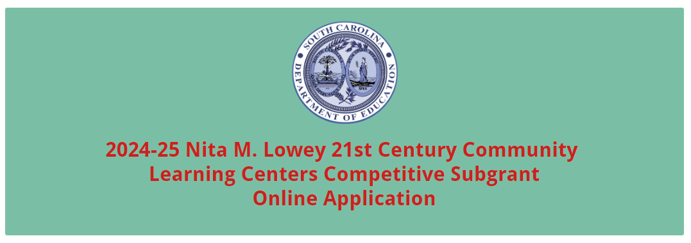
Enter the official name of the primary applicant organization. The names as entered must match the applicant organization’s registered name in SAM.gov. Select the type of applicant organization from the dropdown menu.

Enter the applicant organization’s physical address with the 10-digit ZIP Code (ZIP+4 Code), 12-digit alphanumeric UEI, and TIN. Provide a descriptive title of the project.

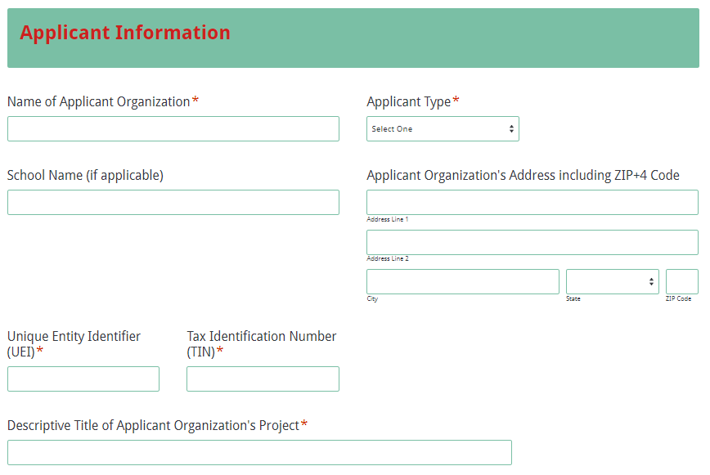
Indicate whether or not the primary applicant is registered and active with SAM. If the applicant does not have an active SAM registration, the following message will be displayed. Refer to the information on page 7 for registering in SAM or updating a registration to comply with 2 CFR Part 25.
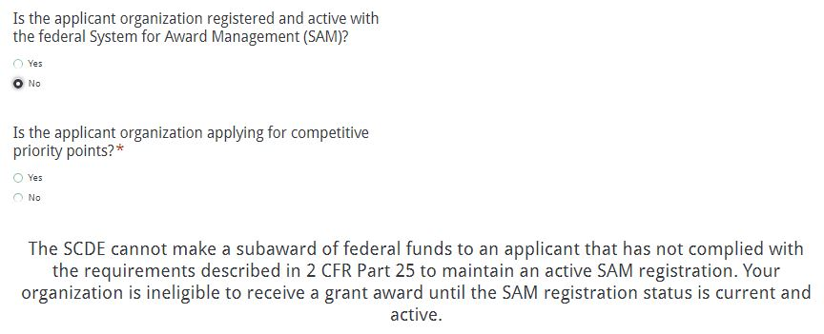
If selecting “Yes” to indicate an active SAM registration, enter the date that the applicant’s current SAM registration expires. Indicate whether or not you are applying for any of the competitive priorities.
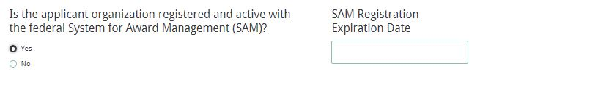
Select all of the competitive priority categories under which bonus points are being sought and indicate the page numbers in the application narrative where evidence can be found to support the proposed project’s eligibility for each criteria.
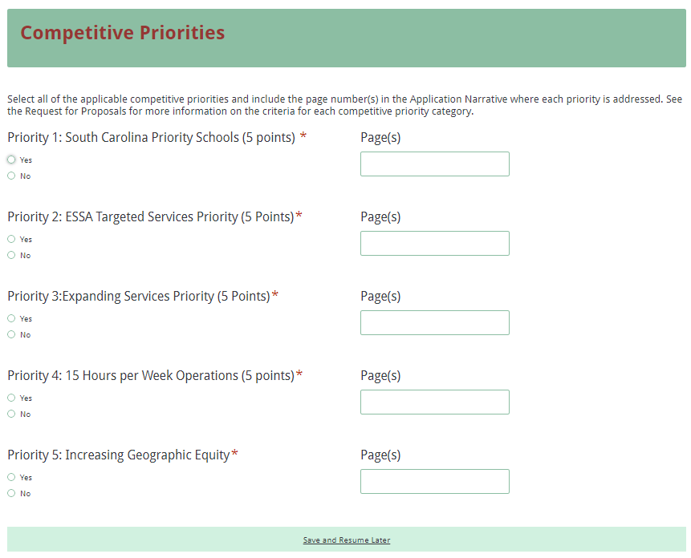
Enter the contact information for the authorized official who has the authority to enter into legally binding contractual agreements on behalf of the applicant entity. The name, as entered, must match the authorized official’s name on the Certification Signature Page.
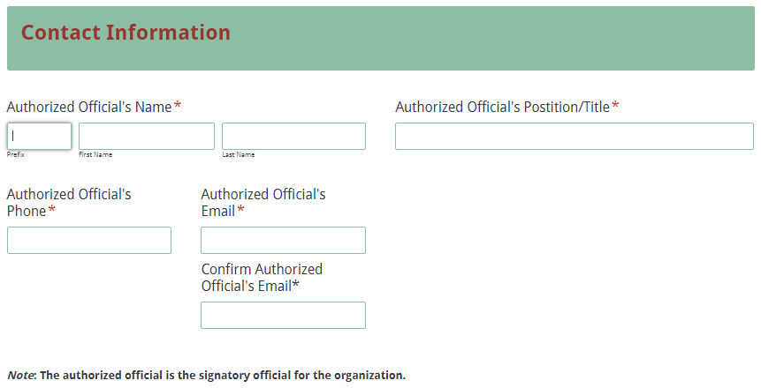
Enter the information for the person to be contacted in all matters relating to this application. 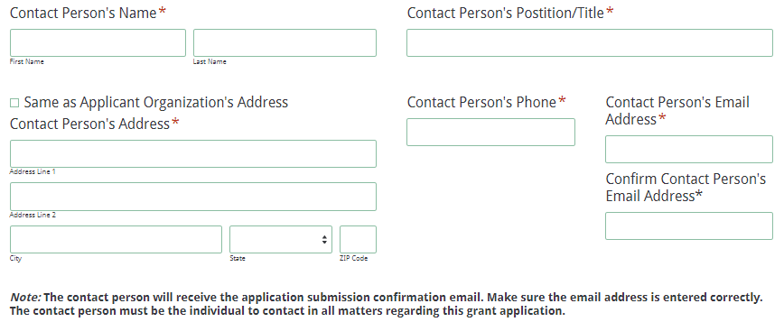
If the contact person’s mailing address is the same as the applicant organization, click on “Same as Applicant Organization’s Address” and the fields will automatically populate. If the address is different, enter the information. Note: the application submission confirmation will be sent only to the contact person’s email address. You must re-enter the email address to validate that it is entered correctly.

Enter the contact information for the project director and the financial officer.
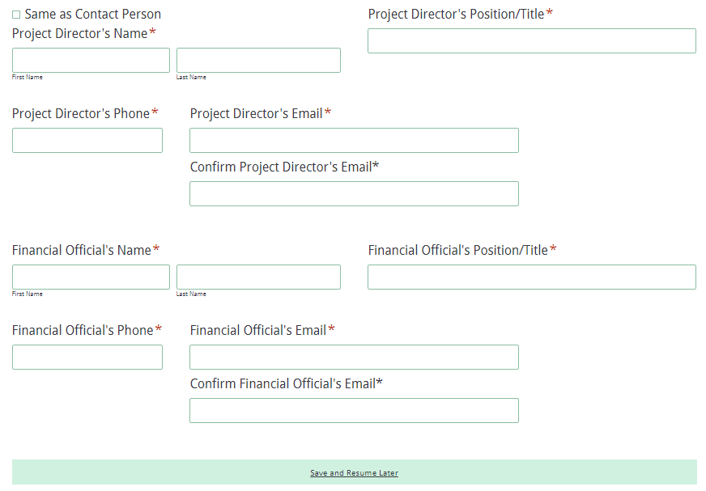
Select the number of collaborating partners (up to three). If you have more than three partners, enter the information only for the primary collaborating organizations that are investing the greatest amount of resources (staffing, facilities, in-kind/matching funds, etc.).
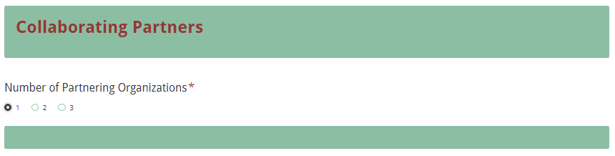
Information fields will be displayed for each organization based on the number selected. Enter the official name of the partner organization; do not use abbreviations or acronyms. Enter name of the authorized representative and their contact information.
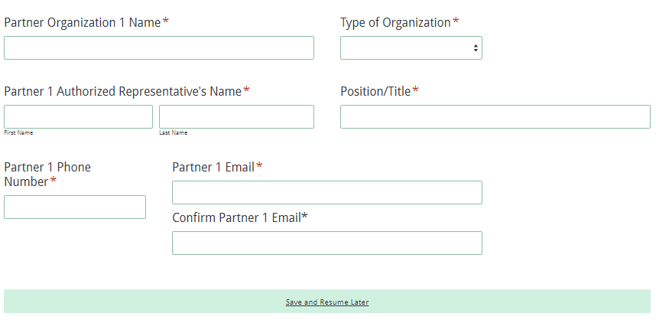
Choose the number of school districts (up to three) to be served through this project and enter the full name(s) for each district. Select the number of schools to be served (up to five) in each district and enter the full name(s) of each school.
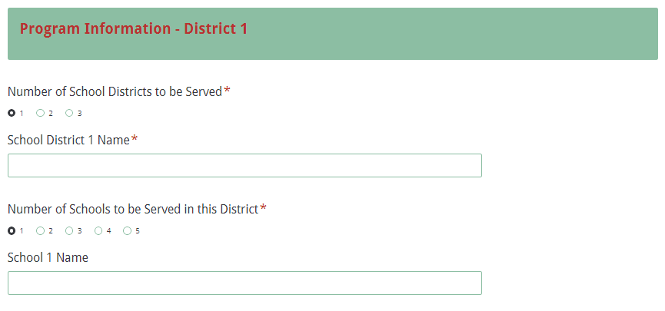
Provide details on the project for the number of students to be served and the beginning and ending dates of operation between August 1, 2024, and July 31, 2025. Identify the type(s) of program(s) being proposed and indicate the days of the week the program(s) will operate, the total hours per week, the total hours per day, the daily hours of operation, and the number of weeks the program will operate during the academic year.
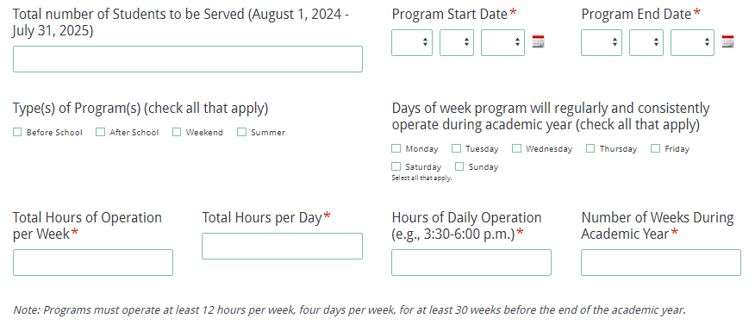
If summer hours will be offered, additional fields will be displayed. Provide the details on the summer operations for funding year one.
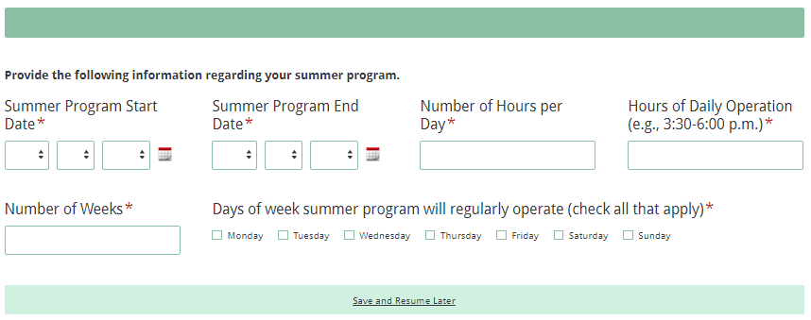
Indicate the activities that will be offered throughout the project by checking all of the applicable boxes. If activities to be offered are not included in the list, select the “Other” option and enter a description of those additional activities.
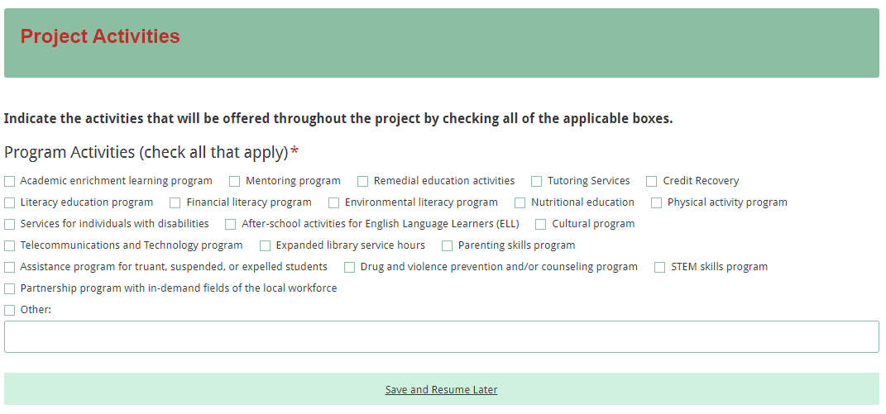
Select the number of proposed sites for the project (up to four). Provide details for each site, including the number of students to be served, the schools those students attend, and the days and hours of operation each week. Separate information fields will be displayed for the number of sites selected.
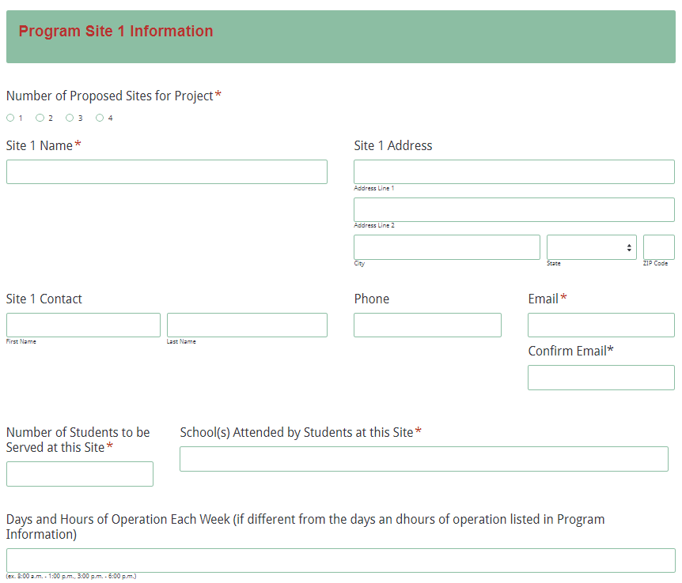
Indicate whether or not an after-school program currently operates at each site, and if so, provide the requested information.
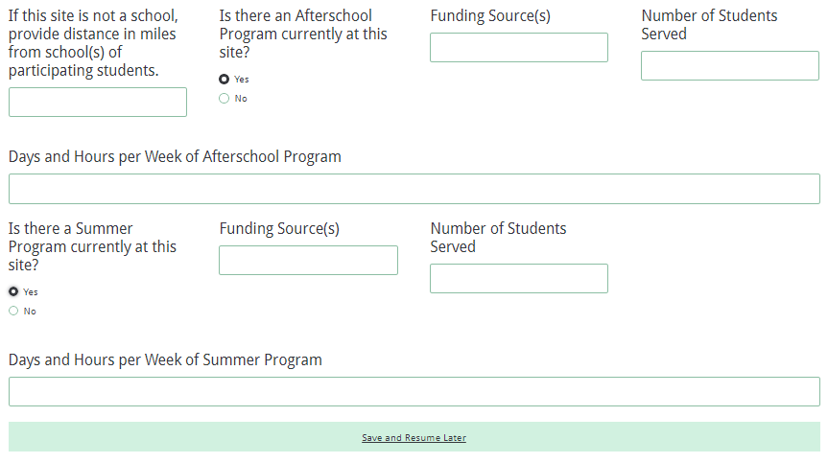
Indicate whether or not a summer program currently operates at each site, and if so, provide the requested information.
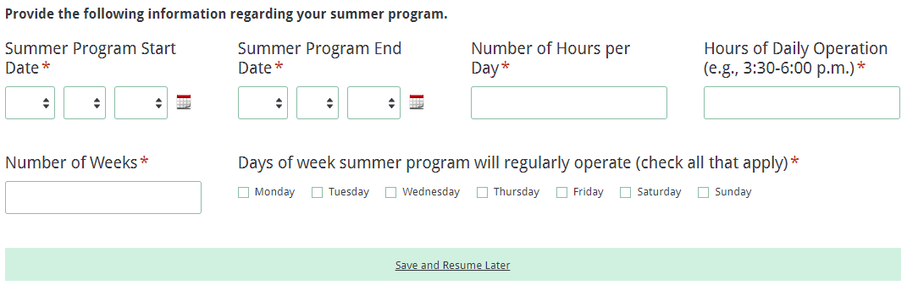
All amounts in the Funding Information and Budget Summary sections should be entered using whole dollars (no cents). Fill in all fields and enter 0 (zero) for line items that are not applicable.
In the Funding Information section, enter the total amount of funding requested for the first year of the project (August 1, 2024, through July 31, 2025). Enter the total estimated cost for all phases of the project over the 48-month period of operation.
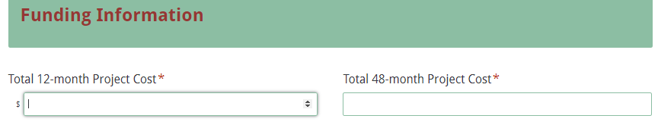
In the Budget Summary section, enter the line item totals for grant funds requested for year one, as well as the total estimated in-kind or matching funds for the first year. The Total Project
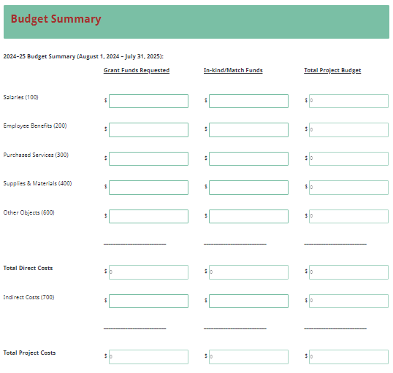
Costs fields for each column and the Total Project Budget fields for each line item will automatically calculate. The Total Project Costs amount in the Grant Funds Requested column must match the Total Amount Requested for Year One under the Funding Information section.

Enter the primary applicant organization’s indirect cost rate percentage approved by the cognizant agency. Provide the beginning and ending dates of the effective period of the current indirect cost rate agreement.
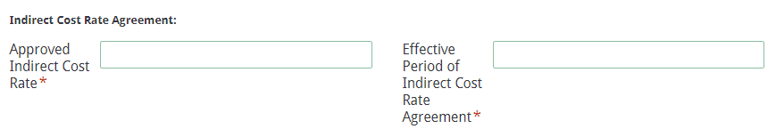
Prepare each of the proposal attachments (i.e., the Proposal Abstract, the Application Narrative, the Budget Forecast and Narrative, the Appendices, and the Pre-Award Audit Questionnaire) following the preceding instructions in this RFP. Ensure that each attachment is saved in the proper format as either a PDF or Excel document. Pay close attention to attachments that must be scanned together into a single document. The online application will only allow one document to be uploaded for each attachment.

Upload the attachments where indicated in the following screenshot. All attachments are required; you will not be able to submit the application without uploading all five documents.
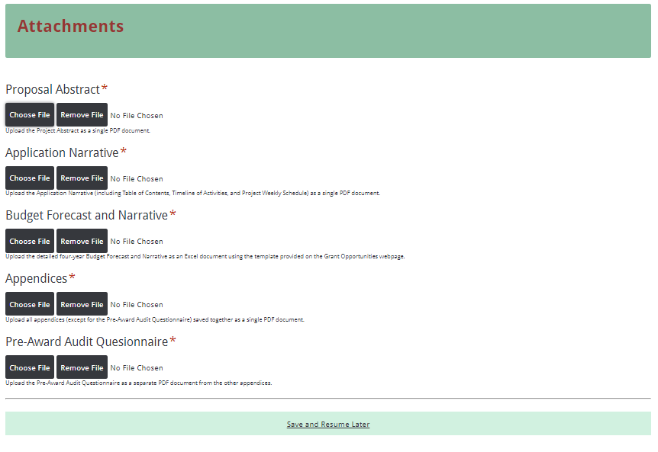
Thoroughly review the summary on the Data Review and Confirmation Page to verify that the information has been entered correctly in the online application prior to submitting. You will not be able to access the completed application form after it has been submitted.
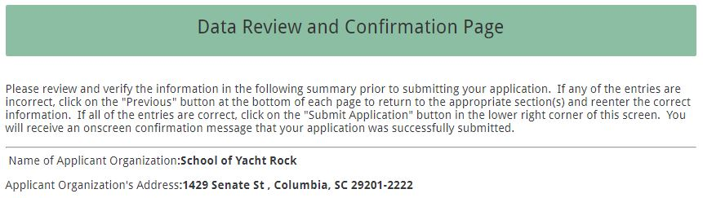
If any of the entries are incorrect, click on the "Previous" button at the bottom of each screen to return to the appropriate section(s) and reenter the correct information.

If all of the entries are correct, click on the “Submit Application” button in the lower right corner of this screen to complete the submission process.
Once the application is submitted, the following message will be displayed on the screen, and a submission confirmation will be sent to the email address provided for the contact person in the online application.

The following confirmation message will be sent to the email address provided for the contact person.
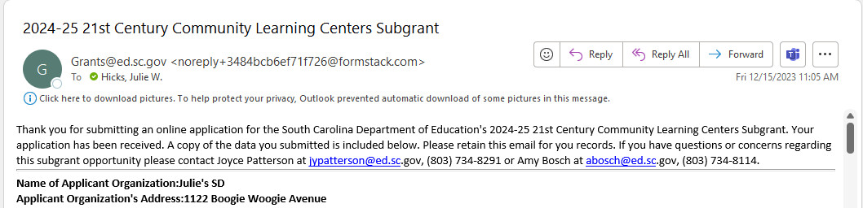
If the contact person does not receive a confirmation email, then the application did not successfully upload. You must go back and resubmit the entire online form, including all attachments, in order for your application to be considered for funding. Only the most recently submitted application will be reviewed.

An email confirmation that the application was successfully submitted does not account for the quality of the uploaded documents or the completeness of the online form. The confirmation email only notifies you that the online application has been submitted. Applicants are responsible for ensuring that the information entered in the online form, including all attachments, is accurate and complete in order for the application to be reviewed and considered for funding.

Appendix A: Definitions of Terms Used

A cognizant agency is the entity responsible for negotiating indirect cost rate proposals with applicant organizations. The SCDE serves as the cognizant agency for all public school districts in South Carolina.

A collaborative partner provides routine, regular, and ongoing services to the project as outlined in a signed memorandum of agreement (e.g., the regular use of facilities and equipment, mentors/tutors). A collaborative partner plays a critical role in sustaining the project as subgrant funds decrease.

A consulting/service contract is a contract delineating all duties, responsibilities, and expenses stemming from agreements between the fiscal agent and the proposed vendor to provide subgrant-funded project services. At a minimum, this signed document must include the name and address of the organization/vendor providing the service, where and what type of service and activities will be rendered, how often the service will be provided, and how much the service will cost. Consulting/service contracts must be procured in accordance with SC Procurement Law and must be executed by both parties.

Deobligation is the downward adjustment of the obligations recorded in a subgrant award document. It is caused by factors such as (1) termination of part of the project, (2) reduction in material prices, (3) cost savings, or (4) correction of recorded amounts.

Evidence-based research, as defined in Title VIII, Part A of ESEA, as reauthorized by ESSA, is research that applies rigorous, systematic, and objective procedures to obtain reliable and valid knowledge relevant to education activities and programs. This means a research activity, strategy, or intervention that
- demonstrates a statistically significant effect on improving student outcomes based on
  - strong evidence from at least one well-designed and well-implemented experimental study;
  - moderate evidence from at least one well-designed and well-implemented quasi-experimental study; or
  - promising evidence from at least one well-designed and well-implemented correlational study with statistical controls for selection bias; or
- demonstrates a rationale based on high-quality research findings or positive evaluation that such activity, strategy, or intervention is likely to improve student outcomes or other relevant outcomes and includes ongoing efforts to examine the effects of such activity, strategy, or intervention.

A joint applicant is at least two organizations that together submit a single application proposing a project to serve a school in an eligible school attendance area in which not less than 40 percent of the children are from low-income families, or not less than 40 percent of the children enrolled in the school are from such families. At least one of the organizations must be a school or district, and the other organization must be an entity other than a school or district. Joint applicants must collaborate in the planning and design of the project and, if awarded, must have significant ongoing involvement in the management and oversight of the project.
The measures of effectiveness govern a 21st CCLC subgrantee’s use of funds. Compliance with the measures of effectiveness requires a subgrantee to develop and implement programs and activities that
- are based upon an assessment of objective data regarding the need for before and after school (or summer recess) programs and activities in the schools and communities;
- are based upon an established set of performance measures aimed at ensuring the availability of high-quality academic enrichment opportunities;
- if appropriate, are based upon evidence-based research that the program or activity will help students meet the challenging state academic standards and any local academic standards;
- ensure that measures of student success align with the regular academic program of the school and the academic needs of participating students and include performance indicators and measures described in Title IV of ESEA, Section 4203(a)(14)(A); and
- collect the data necessary for the measures of student success described above.

A memorandum of agreement (MOA) is a document signed by the authorized representative(s) of each collaborative partner that clearly specifies the role, services, contributions, expertise, and funding of each partner. The district superintendent or his or her designee and the principal of each participating school must sign a MOA regarding the proposed 21st CCLC that includes all roles and responsibilities associated with the partnership.

The primary applicant is the organization that serves as the fiscal agent. The primary applicant is responsible for the programmatic and fiduciary management of the subgrant.

Appendix B: Selection Criteria and Reviewers’ Scoring Rubric

Selection Criteria

A total of 130 points (including competitive priority points) is available to applications that meet the maximum score for each selection criteria. While the budget is assigned zero (0) points, the budget remains a critical component of the entire application. An application with an incomplete budget will not be funded.

The point values for each section of the application are as follows:
Application Narrative Sections | Maximum Points Available
Proposal Abstract | 0
- Needs Statement | 20
- Project Design | 40
- Management | 15
- Adequacy of Resources and Sustainability | 20
- Timeline of Activities | 5
Budget Forecast and Narrative | 0
SUBTOTAL | 100
Competitive Priorities | 30
TOTAL | 130

Each section of the application narrative will be assigned a score by reviewers using the following rubric, which summarizes the required elements of the application narrative and the point ranges assigned to each section. The scoring system is used to indicate how well an application meets the funding criteria for the project.

Scoring Rubric

Proposal Abstract: The applicant must provide a one-page statement that fully addresses all of the following items:
- concisely describes the proposed project, the number of students to be served, and the school district(s) in which the project will be hosted;
- includes the unique name of the project (if any), the primary applicant’s name, the amount of funds requested, and a list of the collaborating partners;
- and if applicable, indicates any categories for which they seek competitive priority points.
Acceptable
Adequate/Meets—0 points
Applicant provides a narrative that fully addresses all required items.
Not Acceptable
Inadequate—0 points
Applicant provides a narrative that does not adequately addresses all required items.
Score

Reviewer’s Comments

1.a. Needs Statement: The applicant must provide a narrative that fully explains the needs assessment process, and its findings, including all three of the following:
- involvement of the collaborative partners in the needs assessment process,
- needs of the community, and
- needs of the school(s).
Acceptable
Fully Meets—9–10 points
Applicant provides a narrative that fully explains all required items.
Adequate/Meets—7–8 points
Applicant provides a narrative that moderately explains all required items.
Not Acceptable
Limited/Approaches—2–6 points
Applicant provides a narrative that is limited or unclear in explaining all required items.
Inadequate—0–1 points
Applicant provides a narrative that does not adequately explain all required items.
Score
Reviewer’s Comments

1.b. Needs Statement: The applicant must fully explain the needs assessment process and its findings, including both of the following:
- needs of the students to be served (including any student data pertaining to the needs to be addressed);
- needs of the students’ families to be served; and
- needs related to a summer program if such a program is proposed.
Acceptable
Fully Meets—9–10 points
Applicant provides a narrative that fully explains all required items.
Adequate/Meets—7–8 points
Applicant provides a narrative that moderately explains all required items.
Not Acceptable
Limited/Approaches—2–6 points
Applicant provides a narrative that is limited or unclear in explaining all required items.
Inadequate—0–1 points
Applicant provides a narrative that does not adequately explain all required items.

Score
Reviewer’s Comments

1.c. Needs Statement: The applicant must, if an after-school program or summer program—other than a 21st CCLC (ineligible to apply)—is currently operating at the proposed site, describe
- the current program and include
- the number of students being served,
- the number of paid staff,
- the source of funding, and
- how many days/hours per week the program is operating;
- how the proposed 21st CCLC will operate in conjunction with the existing program; and
- the impact of the proposed project on the existing program in terms of days/hours of operation, number of students served, services/activities provided, participation fees (if applicable), etc.
Acceptable
Adequate/Meets—0 points
Applicant provides a narrative that fully addresses all required items.
Not Acceptable
Inadequate—Deduct 5 points
Applicant provides a narrative that does not adequately address all required items.
Not Applicable
No after-school program or summer program is currently operating at the proposed site.
Score (if applicable)
Reviewer’s Comments

2.a.i.-ii. Project Design—Performance Goals and Objectives (Performance Measures): The applicant must provide a narrative that fully addresses all of the following as applicable to their proposed project:
- the performance goals stating that students regularly participating in the program will
  - meet or exceed state and local academic achievement standards in ELA/reading and math; and
  - show improvement in the performance measures of school attendance, classroom performance, and reduced disciplinary referrals;
- the required objectives (performance measures) to be attained under performance goals i and ii; and
- if applicable to meet their other identified needs, additional objectives to be attained under performance goals i and ii that are specific, measurable, achievable, relevant, and time-specific (SMART).
Acceptable
Fully Meets—4–5 points
Applicant provides a narrative that fully addresses all required items.
Adequate/Meets—3 points
Applicant provides a narrative that moderately addresses all required items.
Not Acceptable
Limited/Approaches—1–2 points
Applicant provides a narrative that is limited or unclear in addressing all required items.
Inadequate—0 points
Applicant provides a narrative that does not adequately address all required items.
Score
Reviewer’s Comments

2.a.iii.–v. Project Design—Performance Goals and Objectives (Performance Measures): The applicant must
- provide SMART objectives (performance measures) that fully address the following three performance goals:
- Students regularly participating in the program will demonstrate additional positive social and behavioral changes.
- Families of students regularly participating in the program will be afforded opportunities for family literacy activities and services.
- Subgrantees will have a strategy in place to support program sustainability.
- include all objectives (performance measures) in their Multi-Year Program Design and Performance Form (required appendix item).
Acceptable
Fully Meets—4–5 points
Applicant provides a narrative that fully addresses all required items.
Adequate/Meets—3 points
Applicant provides a narrative that moderately addresses all required items.
Not Acceptable
Limited/Approaches—1–2 points
Applicant provides a narrative that is limited or unclear in addressing all required items.
Inadequate—0 points
Applicant provides a narrative that does not adequately address all required items.

Score
Reviewer’s Comments

2.b. Project Design—Description of Strategies and Activities: The applicant must provide a narrative that fully describes the following items in order:
- specific activities for students that will be undertaken to meet each project objective, including the number of hours per week, days of the week, and number of weeks per year that the site will provide services, and the service provider or collaborative partner for each activity, and
- describe the specific activities that will be undertaken if a summer program will be operating.
- how the proposed academic and enrichment activities are based upon the components of the measures of effectiveness regarding evidence-based research and best practices (citing sources of research), and how the instructional activities and teaching strategies are designed to be innovative and engaging and will be coordinated with activities that occur during the regular school day, and
- if a summer program will be operating, discuss how the instructional activities and teaching strategies are designed to be innovative and engaging and will be coordinated with activities that occur during the upcoming academic year.
Acceptable
Fully Meets—9–10 points
Applicant provides a narrative that fully describes all required items in order.
Adequate/Meets—6–8 points
Applicant provides a narrative that moderately describes all required items in order.
Not Acceptable
Limited/Approaches—2–5 points
Applicant provides a narrative that is limited or unclear in describing all required items in order.
Inadequate—0–1 point
Applicant provides a narrative that does not adequately describe all required items in order.
Score
Reviewer’s Comments

2.c. Project Design—Student and Family Support: The applicant must provide a narrative that fully describes
- the project services, including meals and activities to be provided to support students (public and private) and their families (including how many family members will be served);
- additional social and/or behavioral services that will be provided to support student success;
- types of snacks/meals that will be served daily, how they will be prepared, and the source of funds;
- specific activities that will be provided to address the literacy and related educational needs of the participants’ families, including the involvement of the district’s Title I, family literacy, and adult education coordinators in providing services to families; and
- services that will be provided during the summer program, if applicable.
Acceptable
Fully Meets—9–10 points
Applicant provides a narrative that fully describes all required items in order.
Adequate/Meets—6–8 points
Applicant provides a narrative that moderately describes all required items in order.
Not Acceptable
Limited/Approaches—2–5 points
Applicant provides a narrative that is limited or unclear in describing all required items in order.
Inadequate—0–1 point
Applicant provides a narrative that does not adequately describe all required items in order.
Score
Reviewer’s Comments

2.d. Project Design—Evaluation Strategies: The applicant must provide a narrative that fully
- describes the outcome measures that will be used to assess the impact of the proposed 21st CCLC on student learning and behavior;
- describes the types of data that will be collected, how and when the data will be collected and analyzed, who (identified by position) will be responsible for each data collection, and how results will be presented to demonstrate that each objective has been met;
- explains how the data will be analyzed, reported, and subsequently used to improve the overall quality of the project or activity; and
- identifies the different audiences who will be provided with the evaluation data and reports.
Acceptable
Fully Meets—9–10 points
Applicant provides a narrative that fully describes all required items in order.
Adequate/Meets—6–8 points
Applicant provides a narrative that moderately describes all required items in order.

Not Acceptable
Limited/Approaches—2–5 points
Applicant provides a narrative that is limited or unclear in describing all required items in order.
Inadequate—0–1 point
Applicant provides a narrative that does not adequately describe all required items in order.
Score
Reviewer’s Comments

3.a. Management: The applicant must provide a narrative that fully explains how the proposed project, including the summer program (if applicable), will be implemented efficiently and effectively and how challenges and obstacles will be resolved by addressing the following:
- evidence of successful experience or the capacity to succeed in providing educational and enrichment activities to complement and enhance the academic performance, achievement, and positive development of students (public and private) and their families, including success in managing similar projects, clearly defined job descriptions and qualifications of key staff, and plans and budget for ongoing staff training and professional development, including topics, potential facilitators, and frequency;
- description of how the proposed project was developed in active collaboration with other organizations, including other schools or districts, community-based organizations, faith-based organizations, and other public and private organizations;
- description of how the proposed project will be conducted in active collaboration with other organizations, and an explanation of how challenges and obstacles will be resolved.
- list of members (and affiliations) of the advisory council; the council’s role in project planning, implementation, monitoring, adjustment, and evaluation; and the council’s meeting schedule (at least four times per year); and
- description of plans to coordinate federal, state, and local programs with the proposed project for the most effective use of public resources (without supplanting) and how Title I, Adult Education, Summer Reading Camps, and McKinney-Vento funding may be used to provide complementary services for students.
Acceptable
Fully Meets—8 –10 points
Applicant provides a narrative that fully addresses all required items.
Adequate/Meets—5–7 points
Applicant provides a narrative that moderately addresses all required items.
Not Acceptable
Limited/Approaches—3–4 points
Applicant provides a narrative that is limited or unclear in addressing all required items.

Inadequate—0–2 points
Applicant provides a narrative that does not adequately address all the required items.
Score
Reviewer’s Comments

3.b. Management: The applicant must provide a narrative that fully explains how the proposed project will be implemented efficiently and effectively and how challenges and obstacles will be resolved by explaining
- the strategies to be used to disseminate information about the 21st CCLC (including its location) to the community in an understandable and accessible manner, and
- the process used to notify the community of the applicant’s intention to apply for a 21st CCLC subgrant and the plan to make the application and any waiver request available for public review after it is submitted.
Acceptable
Fully Meets—4–5 points
Applicant provides a narrative that fully addresses all required items.
Adequate/Meets—3 points
Applicant provides a narrative that moderately addresses all required items.
Not Acceptable
Limited/Approaches—1–2 points
Applicant provides a narrative that is limited or unclear in addressing all required items.
Inadequate—0 points
Applicant provides a narrative that does not adequately address all required items.
Score
Reviewer’s Comments

4.a. Adequacy of Resources and Sustainability: The applicant must provide a narrative that fully addresses, in the following order, the adequacy of resources to ensure that they are able to launch a 21st CCLC, including the summer program (if applicable):
- Staffing of the 21st CCLC to ensure proper participant/teacher ratios during academic instructional periods and enrichment activities, supervision, management, and adequate delivery of services, including plans to recruit and use volunteers, especially senior citizens.
- The site to be used, with details including its square footage, safety measures, and accessibility, and the facilities, equipment, supplies, and other resources that are available to make this the best site for the 21st CCLC. For a proposed 21st CCLC that will be located in a facility other than an elementary or secondary school, applicant describes how this alternate facility will be at least as available and accessible to participants as is a 21st CCLC program located in an elementary or secondary school.
- Partner contributions, for example financial and non-financial support (mentors, food, use of facilities, supplies and materials, etc.)
Acceptable
Fully Meets—9-10 points
Applicant provides a narrative that fully addresses all required items in order.
Adequate/Meets—6-8 points
Applicant provides a narrative that moderately addresses all required items in order.
Not Acceptable
Limited/Approaches—2-5 points
Applicant provides a narrative that is limited or unclear in addressing all required items in order.
Inadequate—0-1 point
Applicant provides a narrative that does not adequately address all the required items in order.
Score
Reviewer’s Comments
4.b. Adequacy of Resources and Sustainability: Applicant must provide a detailed transportation plan that fully explains how students (public and private) will travel safely to and from the 21st CCLC and home, including transportation details for before-school, Saturday, and summer programs, if applicable. The transportation plan must answer the following questions:
  - Who will provide transportation for this project?
  - Who will fund the transportation? (All applicants must plan and budget for transportation.)
  - How many buses will be used for this project? Include the maximum capacity of each bus. If buses are not being provided by a public school/district, describe the buses that will be used.
  - If the proposed 21st CCLC is a non-school site, what is the roundtrip distance in miles from the site to each targeted school to be served?
  - How long will it take each bus to complete its route when transporting students home?
  - How many students will ride each bus?
  - What is the contingency plan if fuel costs increase?
  - What is the logistical outline of the transportation plan (scheduled pick-up and drop-off times, routes, etc.)?
  - What other transportation details (management, field trips, car riders, etc.) are pertinent to the proposed 21st CCLC?
Acceptable
Fully Meets—5 points
Applicant provides a narrative that fully addresses all required items.
Adequate/Meets—3–4 points
Applicant provides a narrative that moderately addresses all required items.
Not Acceptable
Limited/Approaches—1–2 points
Applicant provides a narrative that is limited or unclear in addressing all required items.
Inadequate—0 points
Applicant provides a narrative that does not adequately address the required items.
Score
Reviewer’s Comments

4.c. Adequacy of Resources and Sustainability: Applicant must provide a narrative that fully addresses all of the following:
- a detailed description and explanation of the sustainability objective;
- the funding plan including goals and objectives in years one and two, names of partners and their commitments and contributions, other revenue sources, and any other strategies to be used for sustainability; and
- how costs will be covered in years three and four when funds decrease and thereafter when the grant funds cease.
Acceptable
Fully Meets—5 points
Applicant provides a narrative that fully addresses all required items.
Adequate/Meets—3–4 points
Applicant provides a narrative that moderately addresses all required items.
Not Acceptable
Limited/Approaches—1–2 points
Applicant provides a narrative that is limited or unclear in addressing all required items.
Inadequate—0 points
Applicant provides a narrative that does not adequately address the required items.
Score
Reviewer’s Comments
5. Timeline of Activities and Project Weekly Schedule: Applicant must provide a Timeline of Activities that fully addresses all of the following:
- indicates the chronological order of the major activities and strategies of the project (including the summer program, if applicable),
- identifies personnel/partners responsible for key activities, and
- includes a Project Weekly Schedule that reflects adequate duration and frequency of instructional and enrichment activities, including those offered in the summer program, if applicable.
Acceptable
Adequate/Meets—5 points
Applicant provides a Timeline of Activities that fully addresses all required items.
Not Acceptable
Inadequate—0 points
Applicant provides a Timeline of Activities that does not adequately address all required items.
Score
Reviewer’s Comments

Budget Summary and Budget Forecast and Narrative: Applicant must provide all of the following:
- a Budget Summary in the online form that computes correctly,
- a complete Budget Forecast and Narrative that includes all formulas used to calculate line-by-line expenses,
- totals in the Budget Forecast and Narrative that correctly reflect the line item totals in the Budget Summary, and
- items in the Budget Forecast and Narrative that directly correspond to or reflect strategies and activities for the project.
Acceptable
Adequate/Meets—0 points
Applicant provides all four required items.
Not Acceptable
Inadequate—0 points
Applicant did not provide all four required items.
Score
Reviewer’s Comments

Appendix C: Required SCDE Forms

Certification Signature Page
(This form must be signed by the individual from each proposed district, school, or organization who holds the title listed below.)

Certification
I hereby certify that, to the best of my knowledge, the information and data contained in this application are true and correct. The applicant’s governing body has duly authorized this application and documentation, and the applicant will comply with the SCDE’s Assurances and Terms and Conditions for Federal Subawards and the program specific assurances if the subgrant is awarded. The applicant is registered and current (active) on the federal System for Award Management (SAM).

Authorized Official (should be the CEO of organization or superintendent of school district)
Name:
Position: | Email:
Telephone: | Fax:
Signature of Authorized Official: |  | Date Signed:

Financial Official
Name:
Position: | Email:
Telephone: | Fax:
Signature of Financial Official: |  | Date Signed:

Superintendent (if not Authorized Official)
Name:
Telephone: | Email:
Signature of Superintendent: |  | Date Signed:

Please complete, print, and obtain signatures prior to submission. Include the signed, scanned form in the appendices as indicated on page 36.

Assurances and Terms and Conditions for Federal Subawards

Assurances

I certify that this applicant
- Has the legal authority to apply for federal assistance and the institutional, managerial, and financial capability (including funds sufficient to pay the nonstate share of project costs) to ensure proper planning, management, and completion of the project described in this application.
- Will give the South Carolina Department of Education (SCDE) access to and the right to examine all records, books, papers, or documents related to this award and will establish a proper accounting system in accordance with generally accepted accounting principles (GAAP) or agency directives.
- Has an accounting system with sufficient internal controls, a clear audit trail, and written cost-allocation procedures as necessary. The financial management systems are capable of distinguishing expenditures that are attributable to this grant from those that are not attributable to this grant. This system is able to identify costs by programmatic year and by budget line item and to differentiate among direct, indirect, and administrative costs. In addition, the applicant will maintain adequate supporting documents for the expenditures (federal and nonfederal) and in-kind contributions, if any, that it makes under this grant. Costs are shown in books or records (e.g., disbursements ledger, journal, payroll register) and are supported by a source document such as a receipt, travel voucher, invoice, bill, or in-kind voucher.
- Will also comply with the Office of Management and Budget 2 CFR Part 200 Subpart E-Cost Principles related to the allowability, reasonableness, and allocability of costs consistent with the approved budget and also by maintaining required support for salaries and wages. Required support includes certifications and/or personnel activity records depending upon the amount of time spent on cost objectives.
- Will approve all expenditures, document receipt of goods and services, and record payments on the applicant’s accounting records prior to submission of reimbursement claims to the SCDE for costs related to this grant.
- Will initiate and complete work within the applicable time frame after receipt of approval by the SCDE.
- Will not discriminate against any employee or applicant for employment because of race, color, religion, age, sex, national origin, or disability and comply with Title VI of the Civil Rights Act of 1964, Section 504 of the Rehabilitation Act of 1973, Title IX of the Education Amendments of 1972, the Age Discrimination Act of 1975, and Titles I, II, and III of the Americans with Disabilities Act of 1990 (ADA). The grantee will take affirmative action to ensure that applicants for employment and the employees during the period of their employment are treated without regard to their race, color, religion, age, sex, national origin, or disability.
- Has no policy that prevents, or otherwise denies, participation in constitutionally protected prayer in public schools as set forth in the Guidance on Constitutionally Protected Prayer in Public Education (20 U.S.C. § 7904).
- Will comply with the Family Educational Rights and Privacy Act. (20 U.S.C. §1232g; 34 CFR Part 99).
- Will comply with the Ethics, Government Accountability, and Campaign Reform Act (S.C. Code Ann. § 2-17-10 et seq. and § 8-13-100 et seq. (Supp. 2023)).
- Will comply with the South Carolina Drug Free Workplace Act (S.C. Code Ann. § 44-107-10 et seq. (Supp. 2023) if the amount of this award is $50,000 or more and the federal Drug Free Workplace Act of 1988 (41 USC 702).
- Will provide information to the SCDE, as requested, regarding the reporting requirements of the Federal Funding Accountability and Transparency Act (FFATA), which requires the SCDE to file a FFATA subaward report by the end of the month following the month in which it awards any subgrant equal to or greater than $25,000.
- Will comply with 2 CFR Part 25 and register and receive a unique entity identifier, fulfill the requirement for the System for Award Management, maintain the currency of the registration throughout the full grant term, and allow access by the granting agency to ensure compliance.
- Will comply with 2 CFR Part 200.112 and disclose in writing any potential conflict of interest to the SCDE.
- Will comply with 2 CFR Part 200.113 and disclose in writing to the SCDE all violations of federal criminal law involving fraud, bribery, or gratuity violations potentially affecting the federal award.
- Will comply with conditions under Executive Order 13513 “Federal Leadership on Reducing Text Messaging While Driving” (October 1, 2009) by refraining from text messaging while driving during official grant business. Relatedly, the applicant will refrain from emailing while driving during official grant business.

Terms and Conditions

- Completeness of Proposal. All proposals should be complete and carefully worded and must contain all of the information requested by the South Carolina Department of Education (SCDE). If you do not believe a section applies to your proposal, please indicate that fact.
- Non-awards/Termination. The SCDE reserves the right to reject any and all applications and to refuse to grant monies under this solicitation. If the SCDE rejects an application, the applicant has a right to request a hearing, as provided by 2 CFR Part 200.341 and 34 CFR Part 76.401, if it alleges the SCDE’s actions violate a state or federal statute or regulation by (1) disapproving of or failing to approve the application or project, in whole or in part, or (2) failing to provide funds in amounts in accordance with the requirements of statutes and regulations.
After it has been awarded, the SCDE may terminate a grant by giving the grantee written notice of termination. In the event of a termination after award, the SCDE shall reimburse the grantee for allowable expenses incurred up to the notification of termination. In addition, this grant may be terminated by the SCDE if the grantee fails to perform as promised in its proposal. Federal grants will be terminated in accordance with 2 CFR Part 200.339 and 200.340.
In the event that this grant is terminated, the grantee shall have a right to a hearing as set forth in 34 CFR Part 76.783. The grantee must notify the SCDE of its request for a hearing within 30 days of receiving written notice of the termination. If a hearing is requested, the SCDE will conduct the hearing in accordance with the procedures outlined in 34 CFR Part 76.401(d)(2)–(7).
- Reduction in Budgets and Negotiations. The SCDE reserves the right to negotiate budgets with applicants. The SCDE may, at its sole discretion, determine that a proposed budget is excessive and may negotiate a lower budget with the applicant. The applicant may at that time negotiate or withdraw its proposal. In addition, the SCDE may desire to fund a project but not at the level proposed. In that case, the SCDE shall notify the applicant of the amount that can be funded, and the applicant and the SCDE shall negotiate a modification to the proposal to accommodate the lower budget. All final decisions are that of the SCDE.
- Amendments to Grants. Amendments are permitted generally for budgets, grant end date, and management upon the mutual agreement of the parties involved and will become effective when specified in writing and signed by both parties. However, amendments to scope of work that significantly alter the original application proposal may trigger partial or full termination consistent with 2 CFR Part 200.339 and 200.340.
- Use of Grant Funds. Funds awarded are to be expended only for purposes and activities covered by the approved project plan and approved budget and budget narrative.
- Submission of Expenditure Reports. Claims for reimbursement must be made at least quarterly and consistent with calendar quarters (e.g., an expenditure report claim for costs for January 1 through March 30 must be filed by May 15).
- Obligation of Grant Funds. Grant funds may not be obligated prior to the effective date or subsequent to the end or termination date of the grant period. No obligations are allowed after the end of the grant period. The final request for expenditure report claims must be submitted no later than forty-five (45) days after the end of the grant period unless the scope of work for the grant states a shorter reporting period.
- Deobligation of Funds. After a final expenditure report claim has been submitted to the SCDE, the grantee will go through the official deobligation process with the SCDE.
- Documentation. The grantee must provide for accurate and timely recording of receipts and expenditures. The grantee’s accounting system should distinguish receipts and expenditures attributable to each grant. The grantee must review the memo regarding “Guidelines for Retaining Documentation to Support Expenditure Claims.”
- Travel Costs. Travel costs, if allowed under this solicitation, must not exceed limits noted in the United States General Services Administration (GSA) per diem rates for lodging, except in the case of conference lodging required for program-required training. In the case that conference-related lodging exceeds the GSA per diem rate, the grantee shall follow their entity’s written procedure for obtaining prior approval to exceed a GSA rate for a conference hotel. Meals and incidentals are limited by the state budget proviso, currently not to exceed $35 per day for in-state travel and $50 for out-of-state travel (see page 81 of the State of South Carolina Statewide Disbursement Regulations). Mileage reimbursement must follow the current Office of Comptroller General instructions, which is consistent with the published IRS rates.
- Honoraria. Amounts paid in honoraria, if allowed under this grant, must be consistent with SCDE policies. Applicants should check with the program office before budgeting for honoraria.
- Reports. The grantee shall submit, as required or instructed by the awarding program office, all reports (programmatic, financial, or evaluation) within the specified period or date and in the prescribed format. An expenditure claim report must be filed by August 15 for all expenditures incurred by June 30 in order to comply with the generally accepted accounting principles (GAAP) and the production of the State's Comprehensive Annual Financial Report.
- Copyright. The grantee is free to copyright any books, publications, or other copyrightable materials developed in the course of this grant. However, the SCDE reserves a royalty-free, nonexclusive, and irrevocable license to reproduce, publish, or otherwise use, and to authorize others to use, the copyrighted work developed under this grant.
- Certification Regarding Lobbying, Suspension, and Debarment. By submitting an application, the applicant certifies, to the best of its knowledge and belief, that the
- Applicant and/or any of its principals, subgrantees, or subcontractors
  - Have not paid or will not pay to any person any federally appropriated funds for the purpose of influencing or attempting to influence an officer or employee of any agency, a Member of
Congress, an officer or employee of Congress, or any employee of a Member of Congress in connection with making any federal grant and the extension continuation, renewal, amendment, or modification of any federal grant, as defined at 34 CFR Part 82.105 and 82.110. If any funds other than federally appropriated funds have been paid or will be paid to any person for influencing or attempting to influence an officer or employee of any agency, a Member of Congress, an officer or employee of Congress, or any employee of a Member of Congress in connection with this federal grant, the undersigned shall complete and submit Standard Form LLL, “Disclosure of Lobbying Activities,” in accordance with its instructions.
  - Are not presently debarred, suspended, proposed for debarment, or declared ineligible for the award of contracts by any state or federal agency as stated at 2 CFR Part 180 or 2 CFR Part 3485.
  - Have not, within a three-year period preceding this application, been convicted of or had a civil judgment rendered against them for commission of fraud or a criminal offense in connection with obtaining, attempting to obtain, or performing a public (federal, state, or local) contract or subcontract; violated federal or state antitrust statutes relating to the submission of offers; or committed embezzlement, theft, forgery, bribery, falsification or destruction of records, making false statements, tax evasion, or receiving stolen property.
  - Are not presently indicted for, or otherwise criminally or civilly charged by a governmental entity with, commission of any of the offenses enumerated above.
- Applicant has not, within a three-year period preceding this application, had one or more contracts terminated for default by any public (federal, state, or local) entity.
- Audits.
- Entities expending $750,000 or more in federal awards:
Entities that expend $750,000 or more in federal awards during the fiscal year are required to have an audit performed in accordance with the provisions of 2 CFR Part 200.501, et seq. Except for the provisions for biennial audits provided in 2 CFR Part 200.504 (a) and (b), audits must be performed annually as stated at 2 CFR Part 200.504. A grantee that passes through funds to subrecipients has the responsibility of ensuring that federal awards are used for authorized purposes in compliance with federal program laws, federal and state regulations, and grant agreements. The director of the OMB, who will review this amount every two years, has the option of revising the threshold upward.
- Entities expending less than $750,000 in federal awards:
Entities that expend less than $750,000 in a fiscal year in federal awards are exempt from the audit requirements in 2 CFR Part 200.504. However, such entities are not exempt from other federal requirements (including those to maintain records) concerning federal awards provided to the entity. The entity’s records must be available for review or audit by the SCDE and appropriate officials of federal agencies, pass-through entities, and the General Accounting Office (GAO).
- Records. The grantee shall retain federal grant records, including financial records and supporting documentation, for a minimum of six (6) years after the end date of the grant when the final expenditure report claim for reimbursement and all final reports have been submitted, unless informed otherwise or in the case of litigation.
- Electronic Signature Agreement. I agree that my electronic signature is the legally binding equivalent to my handwritten signature.
.

Program Specific Assurances
For informational purposes only
The applicant agrees to abide by the SCDE Program Specific Assurances by signing and submitting the Certification Signature Page.

The applicant ensures that

- the project will take place in a safe, easily accessible facility that is conducive to an effective learning environment;
- the project was developed and will be carried out in active collaboration with the schools the students attend;
- the project will primarily target students who attend schools eligible for Title I school-wide programs and their families;
- the funds awarded will be used to increase the level of state, local, and other nonfederal funds that would, in the absence of these federal funds, be made available for authorized programs and activities and will not supplant federal, state, local, or nonfederal funds; This assurance also applies to Summer program funds which may not be used to pay for services, such as the Summer Reading Camps, which are required by state law.
- the community was notified of the applicant’s intent to submit an application; and
- the applicant, after the submission, will make the application and any waiver request available for public review.

Instructions for GEPA Statement of Compliance

The purpose of this enclosure is to inform you about the following provision in the US Department of Education's General Education Provisions Act (GEPA) that applies to applicants for new grant awards under Department programs. This provision is Section 427 of GEPA, enacted as part of the Improving America's Schools Act of 1994 (Public Law (P.L.) 103-382).

To Whom Does This Provision Apply?
Section 427 of GEPA affects applicants for new grant awards under this program. ALL APPLICANTS FOR NEW AWARDS MUST INCLUDE INFORMATION IN THEIR APPLICATIONS TO ADDRESS THIS NEW PROVISION IN ORDER TO RECEIVE FUNDING UNDER THIS PROGRAM.

What Does This Provision Require?
Section 427 requires each applicant for funds (other than an individual person) to include in its application a description of the steps the applicant proposes to take to ensure equitable access to, and participation in, its federally assisted program for students, teachers, and other program beneficiaries with special needs. This provision allows applicants discretion in developing the required description. The statute highlights six types of barriers that can impede equitable access or participation: gender, race, national origin, color, disability, or age. Based on local circumstances, you should determine whether these or other barriers may prevent your students, teachers, etc. from such access or participation in, the federally funded project or activity. The description in your application of steps to be taken to overcome these barriers need not be lengthy; you may provide a clear and succinct description of how you plan to address those barriers that are applicable to your circumstances. In addition, the information may be provided in a single narrative, or, if appropriate, may be discussed in connection with related topics in the application.

Section 427 is not intended to duplicate the requirements of civil rights statutes, but rather to ensure that, in designing their projects, applicants for federal funds address equity concerns that may affect the ability of certain potential beneficiaries to fully participate in the project and to achieve to high standards. Consistent with program requirements and its approved application, an applicant may use the Federal funds awarded to it to eliminate barriers it identifies.

What are Examples of How an Applicant Might Satisfy the Requirement of This Provision?
The following examples may help illustrate how an applicant may comply with Section 427.
- An applicant that proposes to carry out an adult literacy project serving, among others, adults with limited English proficiency, might describe in its application how it intends to distribute a brochure about the proposed project to such potential participants in their native language.
- An applicant that proposes to develop instructional materials for classroom use might describe how it will make the materials available on audio tape or in braille for students who are blind.
- An applicant that proposes to carry out a model science program for secondary students and is concerned that girls may be less likely than boys to enroll in the course, might indicate how it intends to conduct "outreach" efforts to girls, to encourage their enrollment.
- An applicant that proposes a project to increase school safety might describe the special efforts it will take to address concern of lesbian, gay, bisexual, and transgender students, and efforts to reach out to and involve the families of LGBT students.

We recognize that many applicants may already be implementing effective steps to ensure equity of access and participation in their grant programs, and we appreciate your cooperation in responding to the requirements of this provision.
Estimated Burden Statement for GEPA Requirements
According to the Paperwork Reduction Act of 1995, no persons are required to respond to a collection of information unless such collection displays a valid OMB control number. Public reporting burden for this collection of information is estimated to average 1.5 hours per response, including time for reviewing instructions, searching existing data sources, gathering and maintaining the data needed, and completing and reviewing the collection of information. The obligation to respond to this collection is required to obtain or retain benefit (Public Law 103-382. Send comments regarding the burden estimate or any other aspect of this collection of information, including suggestions for reducing this burden, to the U.S. Department of Education, 400 Maryland Ave., SW, Washington, DC 20210-4537 or email ICDocketMgr@ed.gov and reference the OMB Control Number 1894-0005.

Request for Taxpayer Identification Number and Certification
Visit the IRS Web site for an easy-to-complete version of this form. (To be completed by fiscal agent) 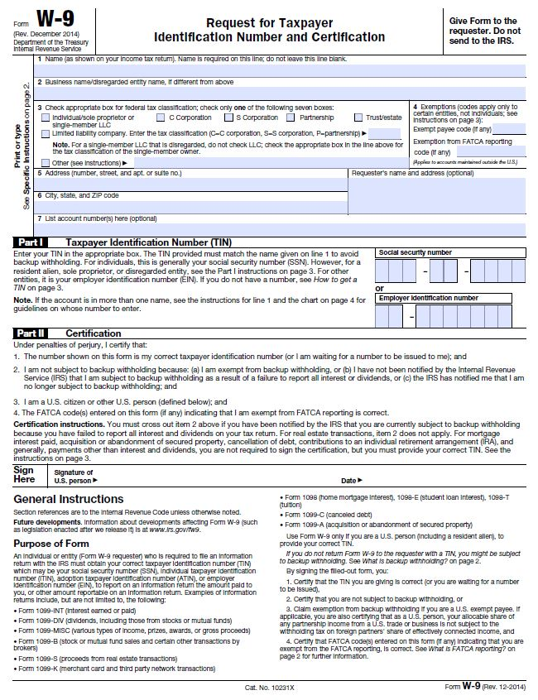

Private School Consultation Form

The Elementary and Secondary Education Act (ESEA), as reauthorized by the Every Student Succeeds Act (ESSA) of 2015, requires that public school districts receiving financial assistance under the 21st Century Community Learning Centers program (21st CCLC), authorized under Title VIII, Part F, provide equitable services to eligible private school students (ESEA §§ 8501–8506(b)(1)(B)).

To comply, public school districts are required to engage in timely and meaningful consultation with appropriate private school officials about the provision of program services to private school students. This consultation must occur during the design and development of the proposed project before any decision is made that impacts the opportunities for participation of private school students throughout the design, development, implementation, and assessment of the program services. The quality of the consultative process will likely have an effect on the quality of services to private school students. (Authority: ESEA § 8501(c)).

Please complete the following related to the involvement of eligible private school students in Title VIII, Part F, 21st CCLC subgrant activities.

There are no private schools located within the attendance boundaries of the school(s) proposed to be served by this project. (Signature below is required.)

There are private schools located within the attendance boundaries of the school(s) proposed to be served by this project (listed below). These private schools were consulted (methods listed below) prior to the development of the 21st CCLC application.

Private school(s) within the attendance boundaries of the school(s) proposed to be served by this project:
Name of Private School | Name and Title of Person Contacted | Date of Contact | Method of Contact (e.g., in person, phone, email, other) | To Receive Services? (Yes or No*)
*If no, please provide a brief explanation.

Signature of Applicant’s Authorized Representative Date

Signature of Private School Representative Date

Pre-Award Audit Questionnaire for LEAs and State Agencies
Visit the SCDE’s Office of Auditing Services Web site to access the Pre-Award Audit Questionnaire for LEAs and State Agencies.
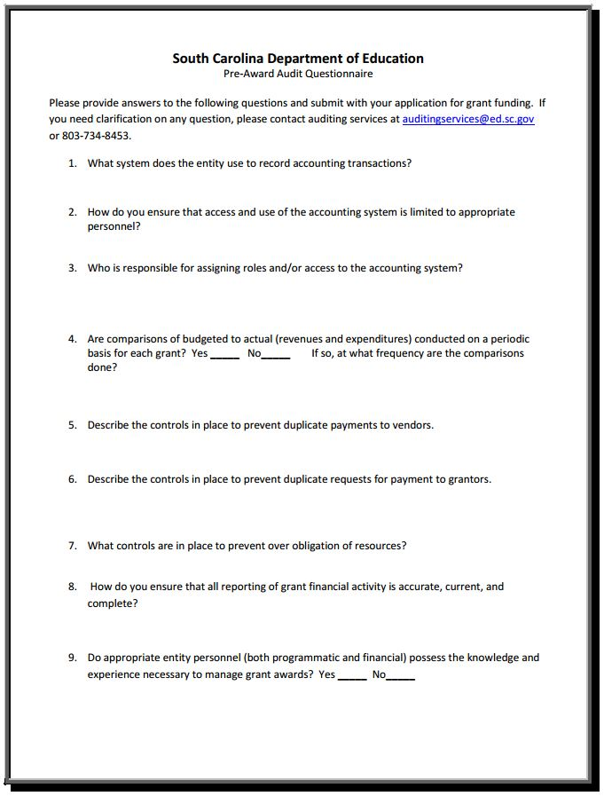
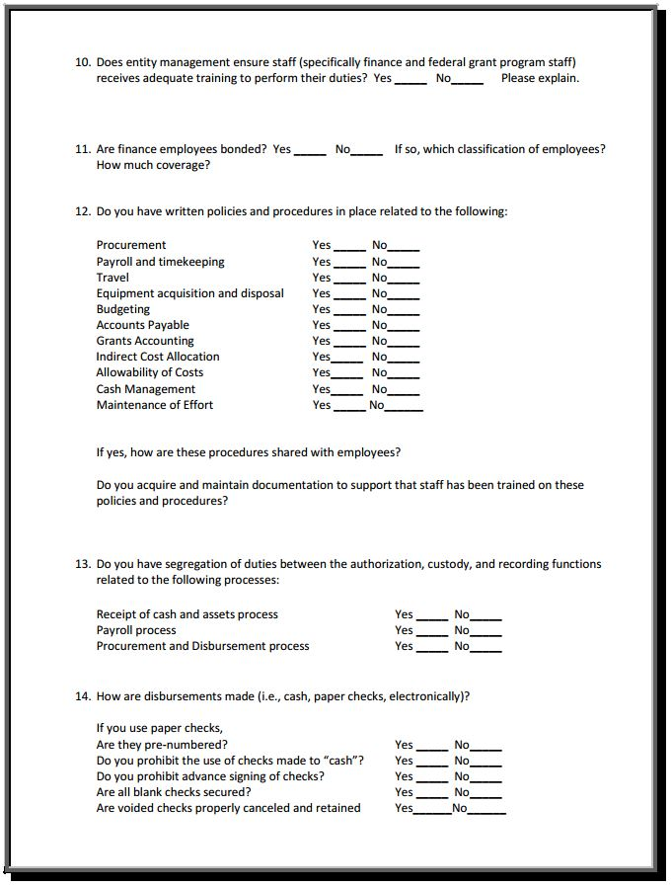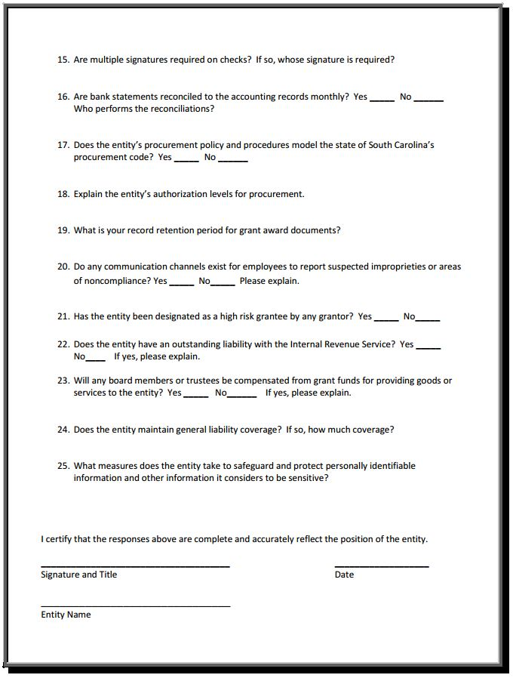
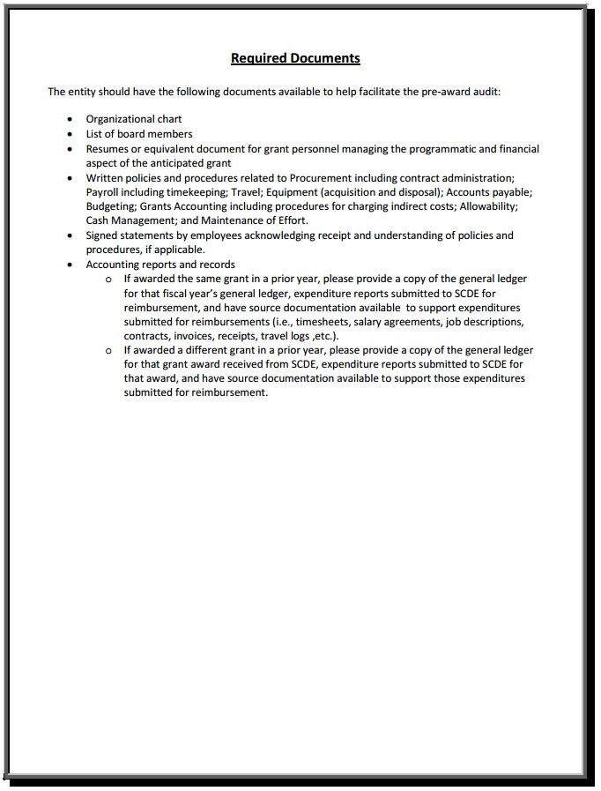

Pre-Award Audit Questionnaire for Non-LEAs
Visit the SCDE’s Office of Auditing Services Web site to access the Pre-Award Audit Questionnaire for Non-LEAs.
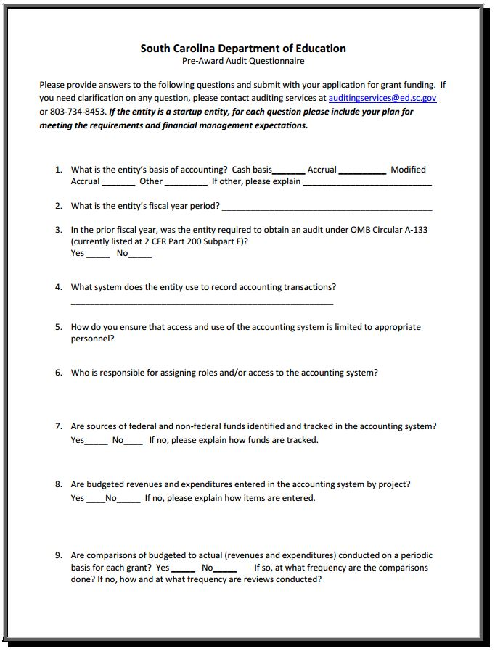
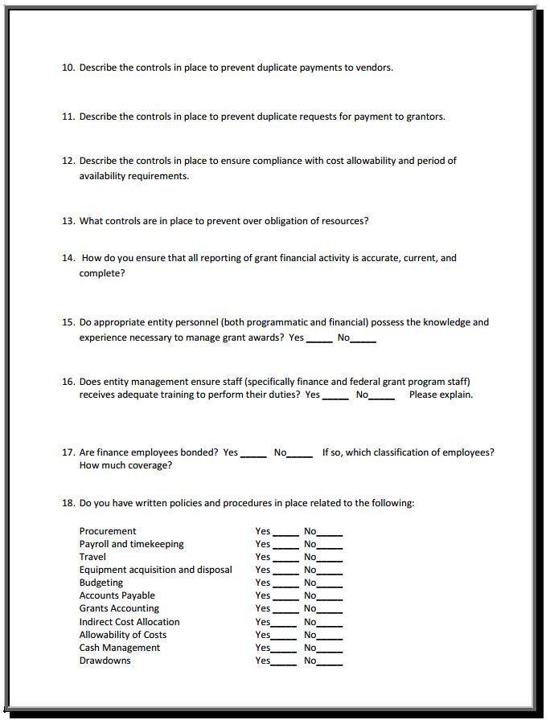
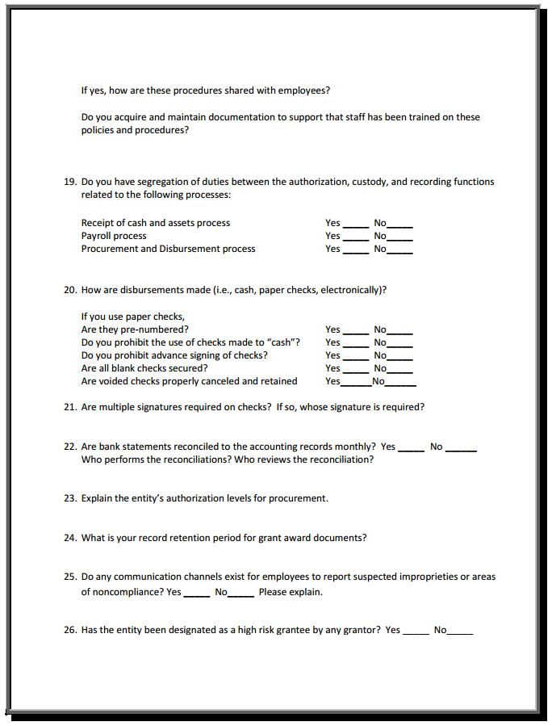
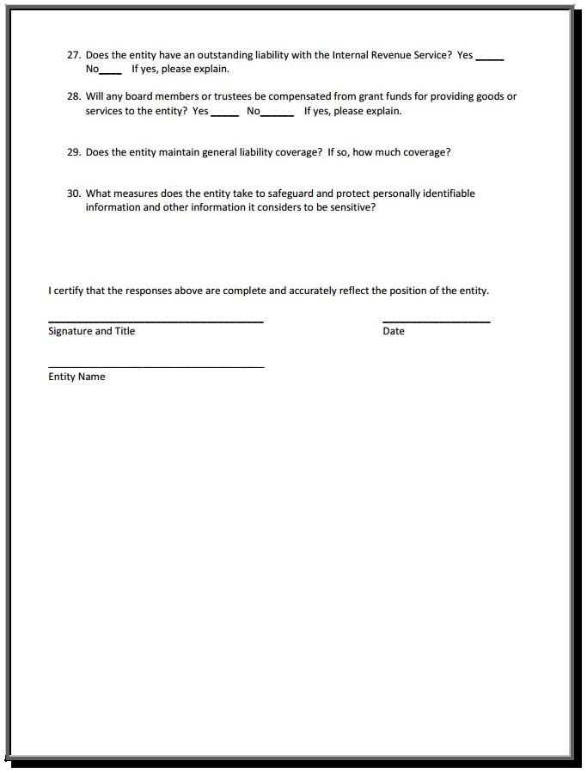
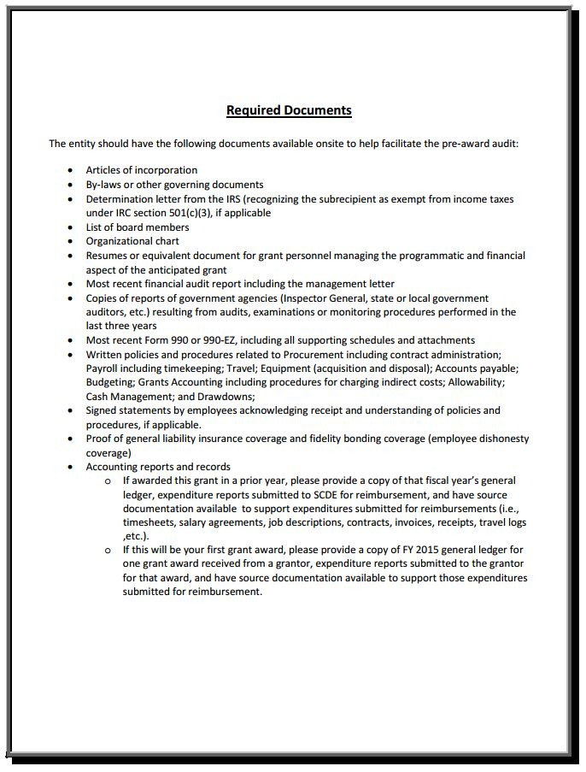

Budget Forecast and Narrative Format Guidance

Use the Excel budget file that accompanies this funding opportunity announcement to develop the Budget Forecast and Narrative. Applicants should insert rows in the budget spreadsheet as needed to clarify information. In-kind/matching funds are not required for this subgrant and provide no “competitive edge.”

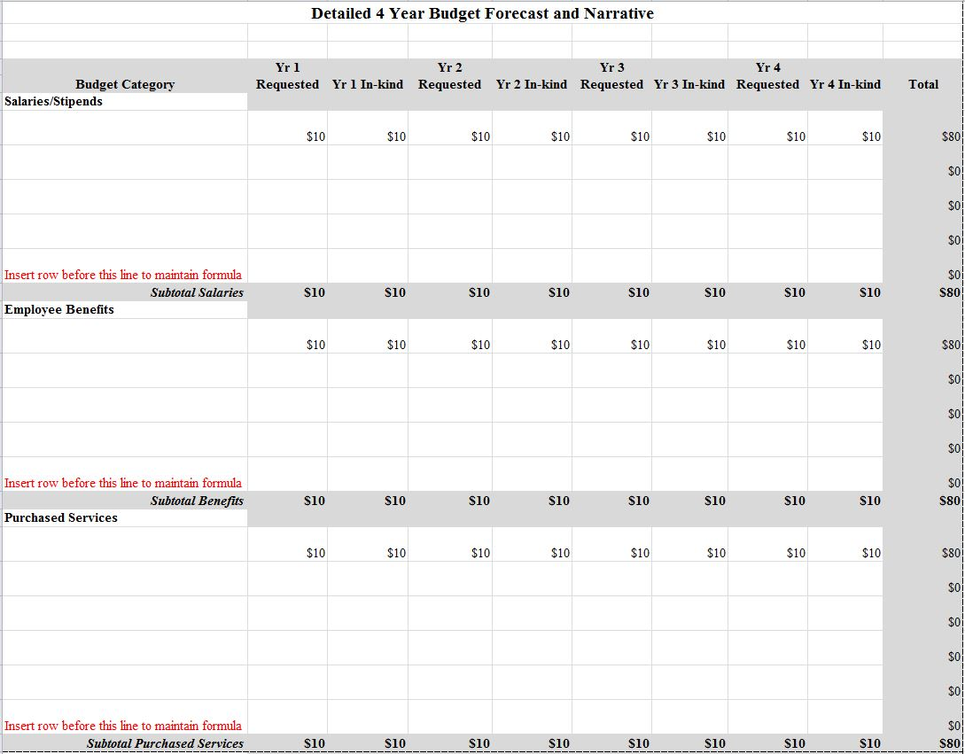

Timeline of Activities Template

Name of Primary Applicant: _______________________________________________

Add rows as needed.
Start Date–End Date | Activity to Achieve Objective | Related Objective and Goal | Evidence that Proves Activity Has Been Completed OR Data to Be Collected from Activity | Persons/Agency Responsible

Project Weekly Schedule Template

Name of Primary Applicant: _____________________________________________________

Modify and add rows as needed. Each activity should specify subject, location, and person responsible.

21st CCLC Program at ______________ (school or site)
- After-School Schedule, Year _______
GRADES | TIME | Monday | Tuesday | Wednesday | Thursday | Friday | Saturday  (HS only)

Multi-Year Program Design and Performance Form Template

The following performance goals and objectives (performance measures) are required of all 21st Century Community Learning Centers subgrantees. If additional objectives (performance measures) associated with needs identified in the needs statement section are required, they must be added to the chart using the blank rows provided. For example, if low science performance is noted in the needs statement section, the applicant must develop an objective (performance measure) related to science. Insert additional rows if necessary. Complete the Target %, Strategies and Activities, Data Source(s) and Evaluation Methods, and Budget sections for each Objective (Performance Measure).

Objective (Performance Measure) | Target  (%) | Strategies and Activities—Include those strategies, activities, and/or services specifically chosen to influence the area addressed by the performance indicator. | Data Source(s) and Evaluation Methods—List all data sources used to examine this indicator. | Budget—List the specific budget categories (salaries/benefits, purchased services, supplies, etc.) that will be impacted by the strategies, activities, and/or services associated with the objective and indicate whether all or a portion of the cost will be charged to the subgrant or in-kind.
Performance Goal i.: Students regularly participating in the program will meet or exceed state and local academic achievement standards in mathematics and English language arts (ELA)/reading.
i.a. The percentage of regular program participants who will increase their math grade by a half letter grade or 5 percentage points from the first marking period to the last marking period of each academic year. | 50%
i.b. The percentage of regular program participants who will improve their mathematics performance level on the state standardized assessment from the prior year to the current year. | 45%
i.c. The percentage of regular program participants who will increase their ELA/reading grade by a half letter grade or 5 percentage points from the first marking period to the last marking period of each academic year. | 50%
i.d. The percentage of regular program participants who will improve their reading performance level on the state standardized assessment from the prior year to the current year. | 45%
Performance Goal ii.: Students regularly participating in the program will show improvement in school attendance, classroom performance, and/or reduced discipline referrals.
ii.a. The percentage of regular program participants who will show improvement in school attendance by reducing their number of days absent from the prior year to the current year. | 92%
ii.b. The percentage of regular program participants who will show improvement in their school behavior by reducing their number of discipline incidents from the prior year to the current year. | 80%
ii.c. The percentage of regular program participants who will show improvement in classroom performance, including homework completion and class participation, from the first marking period to the last marking period of each academic year as reported by teachers. | 92%
Applicants must also include objectives related to social and behavioral changes, family literacy, and sustainability.
Performance Goal iii.: Students regularly participating in the program will demonstrate additional positive social and behavioral changes.
iii.a.
iii.b.
iii.c.
iii.d.
Performance Goal iv.: Families of students regularly participating in the program will be afforded opportunities for family literacy activities and services.
iv.a.
iv.b.
iv.c.
iv.d.
Performance Goal v.: Subgrantees will have a strategy in place to support program sustainability.
v.a.
v.b.
v.c.
v.d.

Additional Performance Goals

Appendix D: Optional SCDE Forms and Information

Project Director’s Position Description
(Exempt Status/Mandatory Title for All Programs)
Summary
This position will plan, develop, write, administer, coordinate, and maintain the 21st CCLC subgrant-funded program that will serve district/community students.

Reports to:

KNOWLEDGE & SKILLS REQUIRED:
To perform the job successfully, an individual must be able to perform each essential duty satisfactorily. The qualifications for this job description are representative of the knowledge, skill, and/or ability required. Reasonable accommodations may be made to enable individuals with disabilities to perform the essential functions. Skills required, but not limited to, for this position include
- demonstrating principles of project management;
- providing leadership and motivating staff;
- collecting and analyzing student data;
- evaluating programs in relation to needs;
- applying budgetary principles;
- applying supervisory techniques;
- using computer-related software;
- understanding human resource and finance procedures;
- demonstrating instructional services to students; and
- engaging and encouraging communication skills while interacting with supervisors, staff, students, parents, etc. to exchange/gather information.

Essential Duties
- Provide progressive and dynamic leadership to the program, staff, students, parents, and community people.
- Research grant opportunities available to the district/agency.
- Write and submit grants to the appropriate sources for present and future funding.
- Track measurable goals and objectives for programs as outlined in grant proposals.
- Provide leadership in developing sustainability needs for future years; research and develop relationships for sustainability.
- Seek donations and additional grant funds to sustain the program.
- Recruit & hire appropriate employees & volunteers to participate in programs.
- Research, identify, analyze, and implement needs of the programs through appropriate assessments.
- Project, track, and balance budgets to ensure that they comply with program and district/agency financial policies, procedures, and requirements.

Manage allocated budget by tracking expenditures, requesting budget transfers, ensuring contracts for purchased services are complete before work begins, submitting contractor invoices in a timely manner, determining needs for materials and supplies, inputting electronic/manual purchase requisitions, maintaining purchase order log, and submitting receipts and other paperwork to the appropriate persons or departments.

- Report verbally and in writing to the appropriate administrator(s)/board of directors on progress and future direction in connection with the programs.
- Manage and support the staff involved with the project, providing supervision and guidance in support of their efforts.
- Represent the school, the district, and/or agency as a liaison, advocate, and coordinator of the programs as described in the program requirements.
- If applicable, interact with students as a group as well as individually. Identify students who need special services such as individual mentoring; follow the progress of students and make sure that appropriate support services are provided to these students.
- May hold individual meetings with students and parents. Keep records of each student’s progress towards accomplishing the steps required through the program’s grant components.
- May plan, publicize, recruit, and carry out activities for students that meet the guidelines of grants.
- Work with community and district partners to fulfill requirements of grants.
- Organize project activities, training, and development where appropriate.
- Provide the support and guidance necessary to ensure that program elements sponsored by other organizations are introduced smoothly.
- Support SCDE-designated project evaluators by gathering student data; helping compose, distribute, and collect surveys; and completing other activities necessary for project evaluation purposes.
- Provide professional development.
- May provide support to summer program if one is scheduled.
- Perform related duties as required.

Qualifications
- Required
- Bachelor’s degree
- Excellent written and oral communication skills
- Ability to write & research grants

- Desired
• Master’s degree or higher
• Experience in supervisory position
- Work experience related to grant programs/proposals
• Teaching certificate in the areas of math, English language arts, social studies, science
• Some experience managing federally funded programs

ADA Requirements
Physical & Mental Requirements
- Ability to deal with stressful situations
- Possess analytical skills and strategic mindset
- Ability to deal with a wide variety of community people, students, and vendors of services

The physical requirements described here are representative of those that must be met by an employee to successfully perform the essential functions of this job. Reasonable accommodations may be made to enable individuals with disabilities to perform the essential functions.

Site Coordinator’s Position Description
(Mandatory Title for All Programs)
Summary
This position will implement program plans, coordinate, and maintain the 21st CCLC subgrant-funded program that will serve district/community students.

Reports to: Project Director

Essential Duties
- Designs the program to meet the stated academic growth in core subject areas to meet the subgrant objectives. Coordinates the implementation of curriculum, instruction, and assessment programs in the after-school environment and monitors the instructional delivery to targeted students. Consults with the program’s director, principals, and teachers to ensure the program goals are being met. Evaluates and adjusts class offerings to ensure targeted students’ needs are being achieved.
- Supervises site instructors and support staff for the 21st Century after-school programs to include interviewing and making hiring recommendations, completing site instructor agreements, observing classes, monitoring work performance, determining workloads, establishing work schedules, conducting performance evaluations, performing training functions, and maintaining records.
- Acts as a liaison with community partners, school staff, students, and other stakeholders in regards to the 21st Century Community Learning Center program. Develops lesson plans and activities, instructs students, maintains discipline, and evaluates student’s development for the 21st Century programs, in concert with the project director.
- Monitors student attendance of the programs by collecting attendance rosters, overseeing attendance database, and tracking number of days in attendance per student.
- Organizes project activities, training, and development, where appropriate.
- Provides the support and guidance necessary to ensure that program elements sponsored by other organizations are introduced smoothly.
- Supports SCDE-designated project evaluators by gathering student data; helping compose, distribute, and collect surveys; and completing other activities necessary for project evaluation purposes.
- Provides professional development.
- May provide support to summer program if one is scheduled.
- Performs related duties as required.

Qualifications
  - Required
- Bachelor’s degree
- Excellent written and oral communication skills

  - Desired
- Master’s degree or higher
- Experience in supervisory position
- Ability to write & research grants
- Work experience related to grant programs/proposals
- Teaching certificate in the areas of math, English language arts, social studies, science
- Some experience managing personnel, students, and providers of services

ADA Requirements
Physical & Mental Requirements
- Ability to deal with stressful situations
- Possess analytical skills and strategic mindset
- Ability to deal with a wide variety of community people, students, and vendors of services

The physical requirements described here are representative of those that must be met by an employee to successfully perform the essential functions of this job. Reasonable accommodations may be made to enable individuals with disabilities to perform the essential functions.

While performing the duties of this job, the employee is regularly required to use hands to finger, handle, or feel; to reach with hands and arms; and to talk or hear. The employee frequently is required to stand; to twist, bend, reach, stoop, pull, lift, and walk; to sit; and to stoop, kneel, crouch, or crawl. The employee is occasionally required to climb or balance. The employee must frequently lift and/or move up to 25 pounds and occasionally lift and/or move more than 50 pounds. Specific vision abilities required by this job include close vision, distance vision, and ability to adjust focus.

