Request for Proposals (RFP)
Application Package

Farm to School Subgrant—Round Two
2024–25 Competitive Subgrant

The Farm to School Subgrant is a subgrant program funded by the US Department of Agriculture (USDA), authorized by American Rescue Plan Act of 2021, Pub. L. No. 117-2, and administered by the South Carolina Department of Education.

Deadline for Receipt of Applications: 5:00 p.m., May 16, 2024

Technical Assistance for Applicants: April 4, 2024

Email of Intent Deadline: April 18, 2024

For questions, contact: Donna Davis, 803-734-0800, farm2school@ed.sc.gov

Issued by:
South Carolina Department of Education
Office of Health and Nutrition
1429 Senate Street
Columbia, SC 29201

TABLE OF CONTENTS

PART I: General Information 1
A. Introduction and Purpose 1
B. Eligible Applicants 1
C. Competitive Priorities 1
D. Timeline of Sub granting Process 2
E. Technical Assistance Sessions for Applicants 2
F. Statutory Requirements and Federal Regulations 2
G. Authorized Activities 4
H. Unauthorized Activities 5
I. Program Accountability and Monitoring 5
J. Fiscal Operations 8
K. Supplement, Not Supplant 8
L. Review and Selection Process 9
M. Appeals Process 9

PART II: Application Overview, Content, and Instructions 11
A. Application Overview 11
B. Online Application Submission 11
C. Applicant Information 12
D. Project Summary 14
E. Application Narrative Content 14
1. Needs Statement 15
2. Proposed Farm to School Project 15
3. Management and Implementation 16
F. Budget Summary 16
G. Application Attachments 18
H. Deadline and Submission Procedures 19
I. Saving and/or Submitting the Application 20

Appendix A: Definitions of Terms Used 22

Appendix B: Selection Criteria and Reviewers’ Scoring Rubric 23

Appendix C: Required SCDE Forms 26
Certification Signature Page 26
Assurances and Terms and Conditions for USDA Subawards 27
Budget Narrative Template 31
Timeline of Activities Template 32
Pre-Award Audit Questionnaire 33

PART I: General Information

Introduction and Purpose

Pursuant to Section 1001 of the American Rescue Plan (ARP) Act (P.L. 117-2), the US Department of Agriculture (USDA) provided ARP Act funds to the South Carolina Department of Education (SCDE) to improve food and agricultural supply chain resiliency (supply chain resiliency). The funds will support the SCDE’s efforts to coordinate and provide technical assistance to build and increase the capacity of participating institutions to procure and use local foods in National School Lunch Program (NSLP) meals. The funds also support providing agricultural education opportunities for participating children, including administration of a Farm to School subaward process.

The purpose of the Farm to School Subgrant is to increase the capacity of institutions to improve farm to school initiatives at the local level. These subgrants will allow

      - School Food Authorities (SFAs) to purchase resources and/or small wares/equipment needed to procure and/or process more produce; and
      - Summer Break Café sponsors and SFAs to develop resources for increasing educational opportunities for children.

Approximately $300,000 will be available for new subgrants during this funding cycle. The SCDE anticipates awarding 30 subgrants (to SFAs and Summer Break Café sponsors) of up to $10,000. Award amounts will be based on the quality of applications received and total funding requested. Final budgets may be negotiated based on demonstrated needs. All subgrant awards are contingent upon total allocations to the SCDE by the USDA.

The maximum subgrant period is 15 months, July 1, 2024, through September 30, 2025, and is subject to the availability of federal funds and projects meeting all Farm to School program requirements.

The subgrantee may obligate funds upon receipt of the grant award notice. However, no funds will be disbursed until after July 1, 2024. Subgrant payments are made on a cost-reimbursement basis.

Eligible Applicants

Any SFA or Summer Break Café sponsor currently participating in the NSLP or Summer Food Service Program (SFSP) may apply for a subgrant. All applicants must meet all reporting requirements and may be subject to a site visit prior to award.

Current Farm to School subgrantees are not eligible to apply for this round.

Competitive Priorities

Competitive priorities are not applicable to this subgrant program.

Timeline of Sub granting Process

Date | Activity/Action
April 4, 2024 | Pre-application technical assistance session
April 18, 2024 | Email of Intent deadline
May 16, 2024 | Deadline for receipt of application
July, 2024 | Notification of awards
August 1, 2024 | Funding period begins; projects can begin
February 15, 2025 | Interim report(s) due to the SCDE
September 30, 2025 | Funding period ends; projects must end
November 15, 2025 | Final programmatic report(s) due to the SCDE

Technical Assistance Sessions for Applicants

The Office of Health and Nutrition will offer a technical assistance session for this funding to assist all potential applicants with preparing and submitting applications on April 4, 2024, at 2:00 p.m. via Adobe Connect. This session will provide an overview of the application components and the submission process.

No password is required to join the session. Participants should enter their full names when logging into the session. Participants will be able to log in 30 minutes prior to the start of the session to test their equipment’s audio and video settings and to access handouts. While participation is not mandatory to apply, it is highly recommended.

Statutory Requirements and Federal Regulations

SFAs and Summer Break Café sponsors must include in their application how they will implement their subgrant to:

- build and increase the capacity to procure and use local food in program meals; and/or
- provide agricultural education opportunities for participating students.

Applicants must propose projects that adhere to the following requirements for the Farm to School program from statute, federal regulations, and guidance.

Applicable Federal Regulations
Applicants should review the following federal regulations, accessible at the electronic Code of Federal Regulations (e-CFR) Web site. Applicants are reminded that, if funded, their programs must comply with these regulations.
- 2 CFR Part 25—Universal Identifier and System for Award Management
- 2 CFR Part 170—Reporting Sub-award and Executive Compensation Information
- 2 CFR Part 175—Award Term for Trafficking in Persons
- 2 CFR Part 180—OMB Guidelines to Agencies on Government-wide Debarment and Suspension (Non-Procurement)
- 2 CFR 200—Uniform Administrative Requirements, Cost Principles, and Audit Requirements for Federal Awards
- 2 CFR 400—Uniform Administrative Requirements, Cost Principles, and Audit Requirements for Federal Awards
- 2 CFR Part 415—General Program Administrative Regulations
- 2 CFR Part 416—General Program Administrative Regulations for Grants and Cooperative Agreements to State and Local Governments
- 2 CFR Part 417—Non-Procurement Debarment and Suspension
- 2 CFR Part 418—New Restrictions on Lobbying
- 2 CFR Part 421—Requirements for Drug-Free Workplace (Financial Assistance)
- 7 CFR Part 3—Debt Management
- 7 CFR Part 16—Equal Opportunity for Religious Organizations
- 41 U.S.C. Section 22—Interest of Member of Congress
- USDA Farm to School and School Garden Expenses
- Privacy Act. The subgrantee will follow the rules and procedures of disclosure set forth in the Privacy Act of 1974, 5 U.S.C. 552a, and implementing regulations and policies, with respect to systems of records determined to be subject to the Privacy Act.
- Freedom of Information Act (FOIA). Public access to Federal Financial Assistance records will not be limited, except when such records must be kept confidential and would have been excepted from disclosure pursuant to the “Freedom of Information” regulation (5 U.S.C. 552)

Additional information on select federal governmentwide regulations is presented below:

Universal Identifier and System of Award Management—2 CFR Part 25
All subgrant applicants must obtain a unique entity identifier (UEI) by registering in the federal System for Award Management (SAM). The applicant must be registered in SAM prior to submitting their application, maintain their SAM registration throughout the application and award process, and include a valid UEI in the online application.

To register in SAM, visit the Get Started page at SAM.gov for information about registering your entity. If you do not receive confirmation that your SAM registration is complete, contact SAM.gov. For assistance, see the Federal Service Desk.

Please note that applicant organization must be registered in the SAM prior to submitting an application, maintain their SAM registration throughout the application process and the full term of the award, and include a valid UEI in their application. The SCDE will not make a subaward of federal funds to an applicant that has not complied with the requirements described in 2 CFR 25 to provide a valid UEI and maintain an active SAM registration.

Reporting Subaward and Executive Compensation Information—2 CFR Part 170
The Federal Funding Accountability and Transparency Act (FFATA) of 2006 (Public Law 109–282), as amended by Section 6202 of Public Law 110–252, requires primary grantees of federal grants and cooperative agreements to report information on subgrantee obligations and executive compensation. FFATA promotes open government by enhancing the federal government’s accountability for its stewardship of public resources. This is accomplished by making government information, particularly information on federal spending, accessible to the general public.

Primary grantees, like the SCDE, are required to report actions that obligate $25,000 or more in federal grant funds to first-tier subgrantees. This information must be reported in the governmentwide FFATA Subaward Reporting System (FSRS). In order to access FSRS a current SAM registration is required. A primary grantee and first-tier subgrantees must also report total compensation for each of its five most highly compensated executives. Every primary and first-tier subgrantee must register in SAM and obtain a UEI prior to being eligible to receive a grant or subgrant award.

Procurement Standards—2 CFR Part 200.317-326
In compliance with 2 CFR Part 200.317-326, SFAs are required to follow all federal, state, and local procurement laws when purchasing equipment with subgrant funds to ensure an open and free competitive procurement for the expenditure of federal funds. The vendor, broker, manufacturer, contractor, distributor, etc. of a product cannot have input into the development of product specifications or procurement specifications and/or advance review of the completed procurement documents or the Requests for Proposals/Contracts as such activities compromise open and free competition.

Funds must be tracked and reported separately from other child nutrition funds. If vendors are used, awardees must ensure that vendors are not on the federal suspension or disbarment list by checking the entity exclusion records at the federal SAM.

Applicants should review the Assurances and Terms and Conditions for USDA Subawards (on pages 27–30), to ensure that, if awarded a subgrant, they are capable of full compliance, especially with all the referenced federal regulations and state laws, in order to enter into an agreement with the SCDE for this subgrant program. For example, in compliance with 2 CFR Part 200.112, applicants must disclose in writing any potential conflict of interest to the SCDE in accordance with the USDA’s conflict of interest policy. A signed Certification Signature Page (see page 26) is required with the grant application and legally binds the applicant to the agency’s Assurances and Terms and Conditions.

Authorized Activities

Project activities must support one or both objectives of the Farm to School program: 1) to build and increase the capacity of participating institutions to procure and use local food in program meals; and 2) to provide agricultural education opportunities for participating children.

Examples of allowable uses of subgrant funds include to

- provide technical assistance and promote agricultural education;
- purchase food (no more than 10 percent of subgrant budget) for educational purposes only, such as farm-to-school sample tables, taste tests, or promotional use and conducting test offerings of new local or regional products;
- support training or conferences to build networks or coalitions to meet the objectives of the subgrant;
- increase culinary training on scratch cooking with local foods, menu planning, etc., for school food service staff;
- purchase items needed to better prepare and serve local food products to students; and
- develop methods to process and/or package local foods for future use.

Applicants are encouraged to use the following questions to assess if costs associated with the proposed farm to school activities are allowable expenses:

      - Are the farm to school activities (including nutrition education, taste tests, aiding in the procurement process, offering marketing support, purchasing garden supplies and equipment) supporting the operation or improvement of the school meal program and are the expenses reasonable?

      - Are the SFA food service programs and Summer Break Café providers currently providing meals in compliance with the NSLP and School Breakfast Program meal patterns and in compliance with resource management (i.e., compliance with the net cash resources in 7 CFR Part 210.14(b) and the availability and priority for use of excess net cash resources per 7 CFR Part 210.19(a)(1))?

Unauthorized Activities

Farm to School subgrant funds may not be used for purchases that do not directly support the approved work plan. Funds must not be used to

- cover salaries and fringe benefits for staff;
- purchase food for consumption in school meal programs;
- purchase meals of snacks for training or meeting attendees;
- cover the costs of past expenditures;
- directly support food production or processing enterprises; or
- purchase land or buildings or construct buildings.

Program Accountability and Monitoring

The SCDE is responsible for monitoring the Farm to School subgrant implementation to increase the subgrantee’s capacity to improve farm to school initiatives at the local level in accordance with the following program accountability requirements:
- Each subrecipient receiving funds through this RFP meets the eligibility requirements for the subgrant described herein, and the applicant has provided all required assurances that it will comply with all program implementation and reporting requirements established through this RFP.
- Each subrecipient receiving funds through this RFP appropriately uses these funds as described in this application package.
- Each subrecipient implements activities funded through this application within the timeline in which the funds provided are to be used.

In compliance with 2 CFR Part 200.205, the SCDE will conduct a pre-award risk assessment of potential subgrantees before a subgrant award is issued. As a part of this process, each applicant should complete the appropriate pre-award audit questionnaire included on page 33 to submit with their application as described on page 18. The SCDE’s Office of Auditing Services will evaluate this questionnaire and may conduct a further evaluation of the applicant’s financial system, internal controls, and policies and procedures. Visit the Office of Auditing Services to access the review process and procedures.

Applicants awarded subgrant funds must satisfy periodic reporting and accountability requirements throughout the term of the subgrant. These requirements address: (1) program accountability; (2) performance reporting; (3) annual budget; (4) monitoring; (5) program evaluation; and (6) technical assistance.

    - Program Accountability
Each subgrantee is responsible for carrying out its responsibilities in accordance with ARP Act, ESSER, Pub. L. No. 117–2; all applicable statutes, regulations, and programmatic guidance; and its approved subgrant application and work plan. Subgrantees are also required to submit periodic reports to the SCDE to report on the use of subgrant funds and the progress of subgrant activities.

    - Performance Reporting
Performance reporting requirements include those for both programmatic reporting and fiscal reporting. The subgrantee is responsible for ensuring that all required performance reports are accurate, complete, and submitted on time.

Programmatic Reporting Requirements
Semiannual performance reports must be submitted to SCDE’s Office of Health and Nutrition to report progress on subgrant activities as outlined below.

Semiannual Reporting Period | Semiannual Report Due Date
July 1–September 30 | October 30

The final performance report is due September 30, 2025. However, subgrantees may submit the final performance report at the time they complete their project.

The following is required of all subgrant recipients; these requirements must be reported in the semiannual performance reports in the period the activity occurred:
- Progress made in obligating at the SFA level,
- Accomplishments and challenges in expenditures both obligated and actual purchases,
- The impact of the farm to school activities on the school’s food service operations, and
- Reasons for any unliquidated funds.
Fiscal Reporting Requirements

All expenditure reports must be submitted through the SCDE’s grants accounting processing system (GAPS). GAPS training will be provided to subgrantees during the subgrantee award meeting. Subgrantees must submit purchase orders, invoices, and proof of payment before the SCDE’s Office of Health and Nutrition will release funds for reimbursement of farm to school purchases.

The expenditure reporting due dates for the Farm to School subgrant are:
Reporting Period | Report Due Date
January 1–March 31 | May 15
April 1–June 30 | August 15
July 1–September 30 | November 15
October 1–December 31 | February 15

    - Project Budget
A budget of projected expenditures to be funded by the subgrant must be submitted with the application. Subgrantees must upload their approved budgets into GAPS following the receipt of their subgrant award notifications and prior to submitting reimbursement requests.

    - Monitoring
The SCDE will monitor subgrantees by reviewing and approving the semiannual performance report and expenditure reports. All information in reports is subject to verification. Progress toward achieving subgrant goals and objectives will be monitored throughout the year.

The SCDE may conduct programmatic and financial monitoring site visits. Subgrantees must agree to site visits conducted by SCDE or federal program representatives. The purpose of site visits is to validate information provided in fiscal and program reports and to gather more detailed information on implementation efforts and challenges from interviews and observations for monitoring and evaluation purposes.

The SCDE may require additional information from the subgrantee, verify information with the authorizing agency, or require the submission of additional documentation including, but not limited to, invoices, receipts, and personnel time and effort reports. Prior to a site visit, the subgrantee may be required to submit additional relevant information that will allow the SCDE to conduct a useful, efficient, and effective visit. The SCDE may require electronic submission of documents instead of a paper-copy submission.

SCDE staff will verify the contents of documentation submitted. Subgrantee may be asked to revise reports when
- non-allowable expenses are found;
- reports are confusing or difficult to understand; or
- there are unexplained discrepancies between the proposed use of subgrant funds, as provided in the annual budget, and actual expenditures found in the submitted documentation.

    - Program Evaluation
Subgrantee Project Monitoring and Evaluation
Subgrantees are required to conduct ongoing monitoring and evaluation to ensure project goals are achieved. Progress toward meeting project goals is to be reported through the semiannual progress review process.

The final performance report is to be completed by the end of the subgrant period. The final report must reflect project success toward obtaining the goals as stated in the application. If a subgrantee fails to conduct the final project evaluation report before the end of the subgrant period, or if any of the performance requirements in section I.2 are not completed, the SCDE may consider the subgrantee a high risk and elect to discontinue funding or disqualify the subgrantee from future funding opportunities.

    - Technical Assistance to Subgrantees
Subgrantees are required to participate in technical assistance that the SCDE may conduct for the Farm to School subgrant. Delivery of such technical assistance may include in-person meetings, webinars, and conference calls.

Fiscal Operations

Subgrantees must use subgrant funds for allowable subgrant expenditures during the subgrant period. Farm to School subgrant funds are disbursed on a reimbursement basis. The SCDE will de-obligate any unspent funds remaining at the end of the subgrant period for reallocation to other subgrantees.

Allowable Costs
Subgrants must be used in accordance with statutory and regulatory requirements. Subgrant funds must be used for approved activities.

Unallowable Costs
Subgrantees may not use Farm to School subgrant funds for any costs that provide for any unauthorized activities described in Section H (page 5).

Supplement, Not Supplant

Farm to School subgrant funds must supplement existing services and may not be used to supplant federal, state, local, or non-federal funds. Projects may not use subgrant funds to pay for existing levels of services funded from any other sources. If current expenditures are being paid from state or local public funds, the applicant may not propose to replace those funds with subgrant funds.

Review and Selection Process

Only those subgrant applications that are received by the deadline and deemed complete will be forwarded for review and funding consideration. All required materials including forms and appendices must be submitted for the application to be considered complete and eligible for review. Program staff will conduct an initial review of applications for completeness and compliance with the RFP instructions. Incomplete applications will not be forwarded to the reviewers or be considered for funding.

Three reviewers from diverse backgrounds without a vested interest in any applicant being funded will evaluate each application based on the quality of the proposed activities and the capability of the applicant to implement the proposed project. The review team will be comprised of experienced grant readers from various professions and entities, including the SCDE.

Reviewers will use the scoring rubric on pages 23–25 to read and score each application independently. After the three reviewers have individually rated each application, the scores will be averaged. An application can earn up to 100 points for an average score.

Applications will be ranked by averaged scores. Subject to the SCDE’s final approval and the availability of federal funds, subgrant awards will be made starting with applications that earned an average score of 80 points or higher. If funds remain following these awards, the SCDE will consider funding remaining applications that earned an average score within the adequate/meets range until all funds are expended.

Prior to making awards, the SCDE’s Office of Auditing Services will conduct a pre-award risk assessment. Based upon the results of this assessment, special conditions may be applied to the award that may include requirements for increased monitoring of subgrant activities, and the provision of additional technical assistance. The SCDE may interview applicants recommended for funding, request additional documentation, and make a site visit as appropriate to ensure compliance with federal requirements.

The SCDE reserves the right to negotiate final budgets and to disqualify costs associated with any line items that are unallowable, unable to be allocated, unreasonable, or inconsistent with the program’s goals or the proposed project’s activities and strategies.

Awards are not final until an SCDE subgrant award notice is fully executed. Notification of funding will be sent in July 2024 to the authorized official listed on the Certification Signature Page. After the notification of awards, copies of the reviewers’ comments and score sheets will be sent to the contact person identified in the online application.

Appeals Process

An applicant who has submitted a proposal that the SCDE does not fund has 30 calendar days after receiving notification that the proposal is not funded to request a review of the process. Scores may not be appealed; the SCDE will not rescore applications. An unfunded applicant may inquire as to whether or not the application process was followed. The request for review must be directed to the State Superintendent of Education and must state the reasons for the request. The SCDE will conduct a hearing in accordance with the provisions of 7 CFR Part 210.

PART II: Application Overview, Content, and Instructions

Read all guidelines and criteria carefully before preparing your application. Adhere to font, format, page limit, and organizational requirements. Only applications that include all sections and appendices and fully adhere to these guidelines will be reviewed and considered for funding. Incomplete applications will not be reviewed.

Application Overview

Applicants are encouraged to prepare all of the following elements of the application before beginning the online submission process. Do not wait until the last minute to submit an application. Use the following overview as a checklist to ensure that the application is complete with items labeled accordingly and presented in the order outlined below. Verify that all documents are complete and ready to upload in the application attachments.

The 2024–25 Farm to School—Round Two subgrant online application is organized into the following sections:

- Online Forms
- Applicant Information
- Contact Information
  - Authorized Representative Information
  - Project Director Information
  - Finance Director Information
  - School Food Service Director/Supervisor Information (if applicable)
- Project Summary
- Application Narrative
  - Needs Statement
  - Activity Implementation Narrative
  - Management and Sustainability
- Summary of Funds Requested
- Application Attachments
- Certification Signature Page
- Budget Narrative
- Organization Chart
- Timeline of Activities
- Pre-award Audit Questionnaire

Online Application Submission

Applications must be submitted using the online application form. The online submission is organized into two sections—Online Forms and Application Attachments.

Provide the applicant’s twelve-character alphanumeric UEI and Taxpayer Identification Number (TIN) in the application form. Applicants should contact their organization’s finance office if they need assistance with these items. (See page 3 for more information.)

Use the following instructions to compile and complete the online forms and all application attachments before submitting your application. Follow the directions below for drafting narrative sections and for saving the documents to be attached online.

Applicant Information

To begin the online application form, enter the official name of the SFA/Summer Break Café provider. Indicate if the applicant is an SFA or a Summer Break Café provider. The name as entered must match the registered UEI name. Enter the SFA’s physical address with the 10-digit ZIP code (ZIP+4), UEI, and TIN. Indicate whether the SFA/Summer Break Café is registered and active with the SAM.
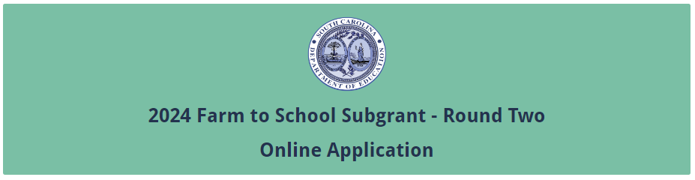
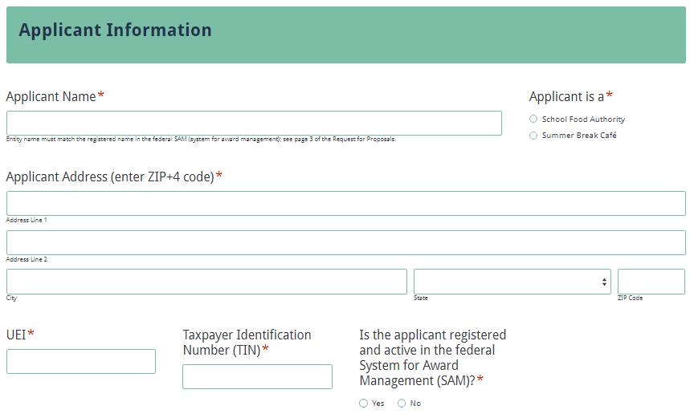
If the SFA/Summer Break Café provider does not have an active SAM registration, the following message will be displayed. The SFA should refer to the information on page 3 or visit SAM.gov for more information on how to update the status of their SAM registration.
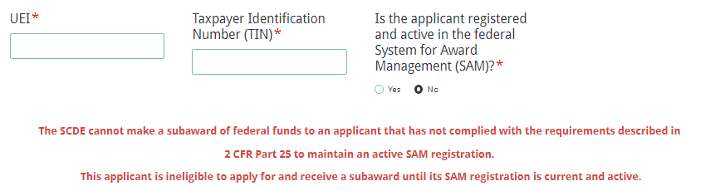
If the SFA/Summer Break Café provider selects “Yes” to indicate that their SAM registration is active, enter the date the current SAM registration expires.
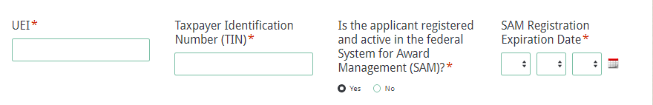
Enter the contact information for the Authorized Official and the Project Director. The names for all contacts entered in the online application must match the names as shown on the Certification Signature Page.
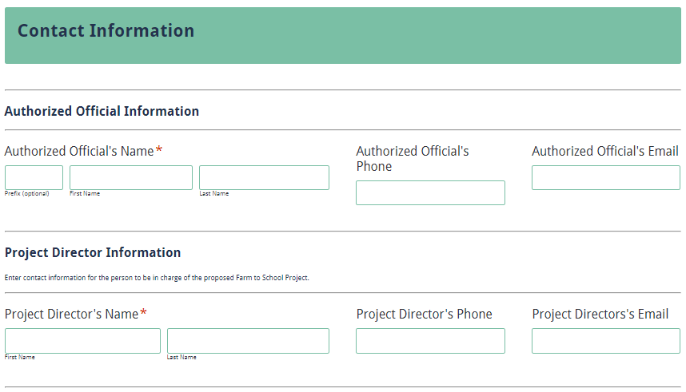
Enter the contact information for the finance official and the school food service director/supervisor. The school food service director/supervisor’s email is a required field. The confirmation of a successful online application submission will be sent only to this email address. Reenter the email address to confirm that it is correct.
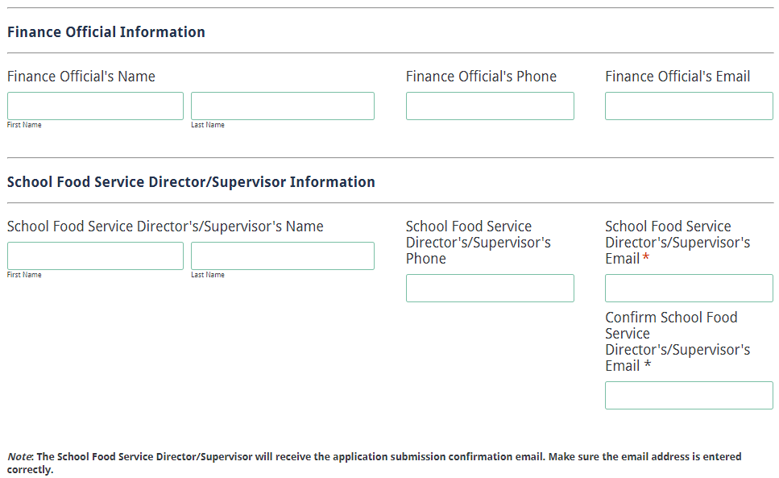

Project Summary

Summarize the applicant’s proposed Farm to School project to include the amount of funds requested and how it will enhance or improve local efforts to implement and/or expand farm to school activities in the school/organization).

Draft and save the project summary to cut and paste into the online application.
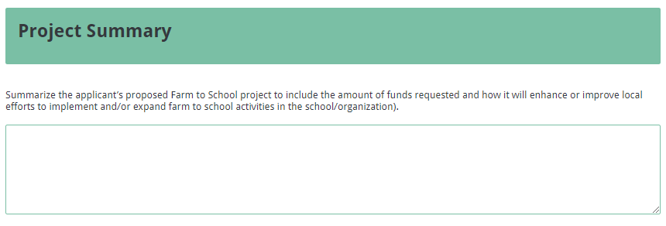

Application Narrative Content

Use the following directions to draft the application narrative and organize it into sections following the sequence presented below. Do not combine sections. Required components must be in their designated sections to be scored. There is no limit to the length of each response. However, be clear and concise when responding to the prompts provided.
When complete, save the narrative sections to cut and paste into the online application where appropriate (see screenshots below).

Needs Statement (maximum of 30 points available)
The applicant will conduct and document a needs assessment to identify the need to build and/or increase capacity to procure and use local food in program meals and/or to provide agricultural education opportunities to students. The information provided should be both factual and directly related to the need to be addressed by the proposed project.

Describe the needs assessment process used to identify and determine the vision for the proposed Farm to School program. Provide the names and titles/positions of all involved in identifying the needs.
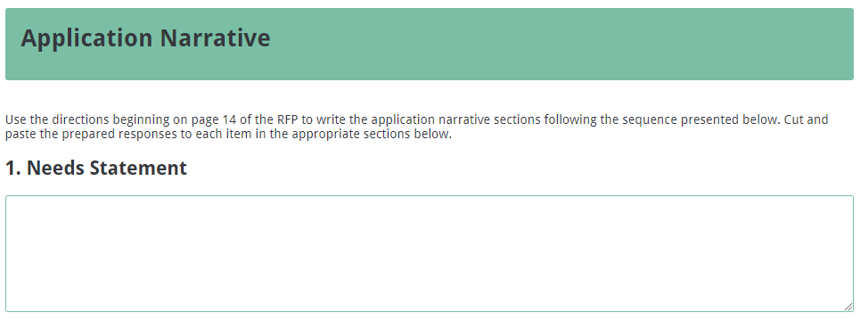

Proposed Farm to School Project (maximum of 50 points available)
  - Describe the proposed Farm to School project including the activities identified and how the activities proposed will support the Farm to School project.
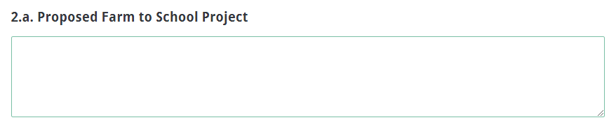
  - Explain how the project will support efforts to
    - Build and increase the capacity to procure and use local food in program meals. Describe how the proposed project will
  - improve the quality of the food prepared and served in ways that support nutritional standards.
  - increase the ability to prepare foods in a healthy manner such as steaming, baking, or grilling.
  - improve food safety service in the nutrition program.
  - increase the efficiency of food service procurement, food storage, and distribution/service.
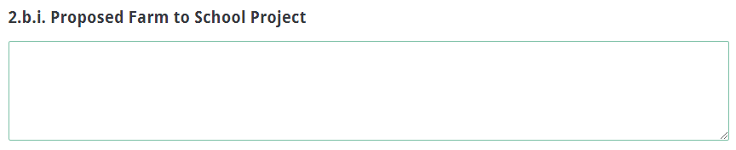
    - Provide agricultural education opportunities for participating children. (Examples include taste testing, farmers visiting school cafeterias, and field trips for students to visit farms.)
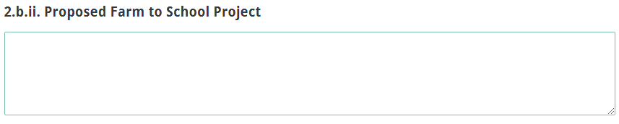

Management and Implementation (maximum of 20 points available)
Outline the plan to manage the project to include the chain of command. Describe the Project Director’s role in managing the project and the responsibilities for each key staff member. Include an organizational chart to show the chain of command as an attachment as directed on page 18.

Use the Timeline of Activities template located on page 32 to thoroughly describe when each program activity begins and ends, how each activity relates to a specific objective, and who is responsible for overseeing the activity. (Include the timeline of activities in the attachments as directed on page 18). Activities must relate to the line item costs in the budget narrative for the proposed project.
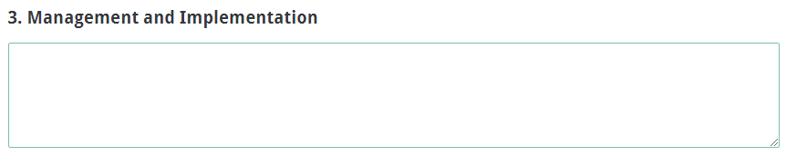

Budget Summary

Although the budget is not scored, it remains a critical component of the entire application. No application with an incomplete budget will be funded.

The application budget consists of two parts: the Budget Summary in the online application form and the Budget Narrative attachment. All proposed expenditures and any in-kind matching funds for the grant funding period must be itemized in the Budget Summary and detailed in the Budget Narrative. Budget items not explained in the application narrative will not be funded.
The Budget Summary is the financial overview of the subgrant and must include all proposed expenditures for the project. Each line item of the Budget Summary must correspond to the line items of the Budget Narrative (discussed in Attachments on page 18). Provide the budget details for July 1, 2024, through September 30, 2025, in the online application Budget Summary section. Indirect costs are allowable and must be reflected in the Budget Summary and the Budget Narrative.

To charge indirect costs to a subgrant, a subgrantee must have an approved indirect cost rate agreement. The approved indirect cost rate must be entered were indicated online (see screenshot below). If the applicant is a school or school district, the restricted indirect cost rate of the school district (in the case of an applicant that is a school, the district in which the school is located) must be used. Any non-federal entity that elects to apply for a rate should contact the SCDE Office of Auditing Services for guidance on applying for a rate.
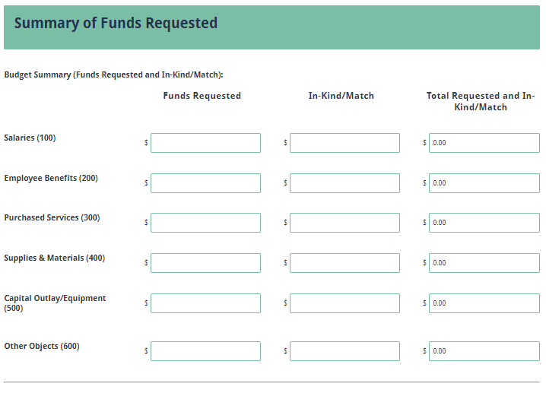
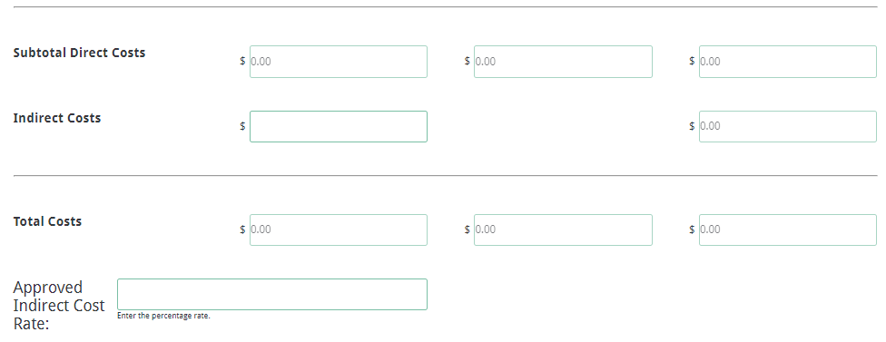
Ensure that the totals in the Budget Summary equal the totals in the Budget Narrative.

The SCDE reserves the right to disqualify, disallow, and negotiate costs associated with any line item proposed in the budget. If any line-item cost is determined to be excessive, given the nature and scope of the entire project or of a particular activity, the SCDE can request the applicant reduce the cost of the line item or ask the applicant to assume a portion of the cost before the budget is approved and funds are awarded.

Funds will be disbursed on a reimbursement basis upon the receipt of expenditure reports with all supporting documentation from the subgrantees. Subgrantees may not obligate funds prior to the receipt of a grant award notice. No expenditures incurred prior to July 1, 2024, will be reimbursed. Applicants should have at their disposal at least three months of sustainable funds to implement the program prior to SCDE reimbursement. Subgrantees are not permitted to pick up their reimbursements from the SCDE office.

Application Attachments

Complete the Certification Signature Page, Organizational Chart, Timeline of Activities, and the Pre-Award Audit Questionnaire as directed below and save each document separately as PDF documents. Complete and save the Budget Narrative as an Excel file. Upload the documents as indicated in the screenshot below.

Certification Signature Page
Print the Certification Signature Page (see page 26) and obtain the appropriate signatures. This form includes the certification of the SCDE’s Assurances and Terms and Conditions for USDA Subawards (pages 27–30), so those documents are not required to be included in the application submission. However, retain the copy included in this RFP for your records and ensure that the signatories have copies of each document.

By signing the Certification Signature Page, the signatories assure that they will comply with all the assurance and terms and conditions for the project. All signatories must understand that they are signing a document that is legally binding in the event a subgrant is awarded. Applications that do not include the signed Certification Signature Page will not be reviewed or considered for funding.

Budget Narrative
The Budget Narrative must provide clear evidence that the budget is appropriate and justified based on the needs assessment. Use an Excel spreadsheet to provide a detailed Budget Narrative that includes estimates for matching funds and in-kind contributions, if applicable. Use the 15-month budget narrative template on page 31 to structure the Budget Narrative line-item categories to parallel the line-item categories of the Budget Summary. Include all formulas used to calculate each line-item expense. This narrative must demonstrate that all expenditures are allowable, reasonable, and allocable; are adequate to support the activities of the project; and directly connect to the goals and objectives in the application/proposal narrative.

Review 2 CFR Part 200 Subpart E Cost Principles, specifically §§ 200.403–200.405, for additional information on the allowability, reasonableness, and allocability of costs for federal grant awards. The General Provisions for Selected Items of Cost are listed in 2 CFR §§ 200.420–200.475. When finalized, save the Budget Narrative as an Excel spreadsheet to be uploaded into the online application where indicated.

Ensure that the totals in the Budget Summary equal the totals in the Budget Narrative.

Organizational Chart
Include an Organizational Chart that reflects the SFA/Summer Break Café’s Farm to School Subgrant personnel hierarchy. Include personnel such as the authorized official, finance director, and school food service director/supervisor, subgrant manager/contact person, and others that will have a role in the subgrant program. Include their names and positions/titles.

Timeline of Activities
Include a Timeline of Activities that includes each benchmark activity (including evaluation and management components), when each project activity begins and ends, how each activity relates to a particular activity, and who is responsible for overseeing the activity. A template for this timeline is included on page 32. The Timeline of Activities may be single-spaced.

Pre-Award Audit Questionnaire
Complete the appropriate Pre-Award Audit Questionnaire (see page 33). The SCDE’s Office of Auditing Services may review this questionnaire as part of the pre-award risk assessment and may conduct a further evaluation of the applicant’s financial system, internal controls, and policies and procedures.
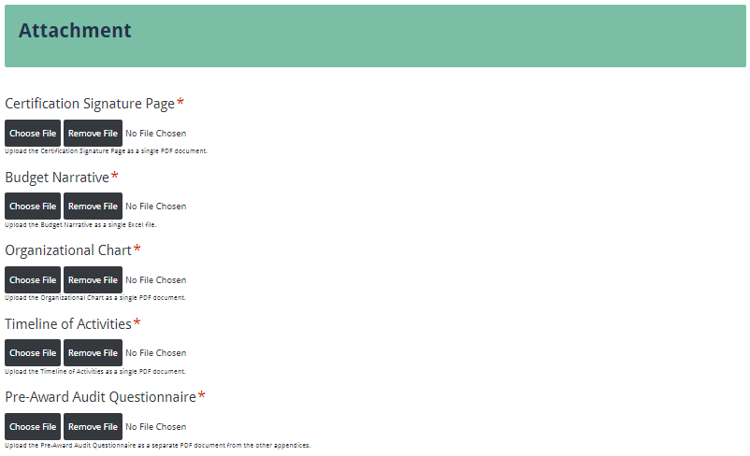

Deadline and Submission Procedures

- Applicants planning to apply are encouraged to submit an email of intent to farm2school@ed.sc.gov by April 18, 2024, to notify the Office of Health and Nutrition of the intention to submit an application. This email is not binding and is not required for an applicant to submit a completed application for this competition.
- Applications must be submitted using the online application form before 5:00 p.m. on May 16, 2024. No applications will be received after this deadline.
- Only applications that adhere to all guidelines and directions set forth in this RFP will be reviewed and considered for funding.
- No hard copy applications will be accepted. Applications delivered by hand, postal mail, email, or fax will not be accepted.
- Applications must originate from the applicant. Applications that are plagiarized from the Internet, other grants, or other resources will not be considered for funding.
- Subgrants are not transferrable.
- Do not attach or submit any additional materials other than what is specifically required. Any additional materials will be disposed of without review.
- Applications will not be returned. Keep a copy of the entire application for your records.

Saving and/or Submitting the Application

Make sure all information submitted is accurate, including formal or official names such as the SFA, and that spelling is correct. Do not use abbreviations or acronyms. All fields marked with an asterisk are required; you will not be able to proceed to the next screen of the application without entering all required information.

If necessary, you may save your progress in the online application and return to the form later. Note that you do not have to save your form in order to submit your form. If you are prepared, you can enter and submit an application without having to save the form.

Click on the “Save and Resume Later” link to save your progress. You will click save and get link and have the option of copying and saving the link to the partially completed form or entering an email address to have the link emailed to you. Be sure to enter the email address correctly as SCDE personnel cannot access the hyperlink or the incomplete application. Use the link to access the application from any computer within thirty days to complete the online submission. Without the link and password or after thirty days, the data previously entered cannot be retrieved, and you will have to begin a new application. A saved application is not a submitted application. You must follow all the steps below to complete the submission process.

Thoroughly review the Data Review and Confirmation Page to verify that the information has been entered correctly in the online application prior to submitting. You will not be able to access the completed application form after it has been submitted. If any of the entries are incorrect, click on the "Previous" button at the bottom of each page to return to the appropriate section(s) and reenter the correct information.
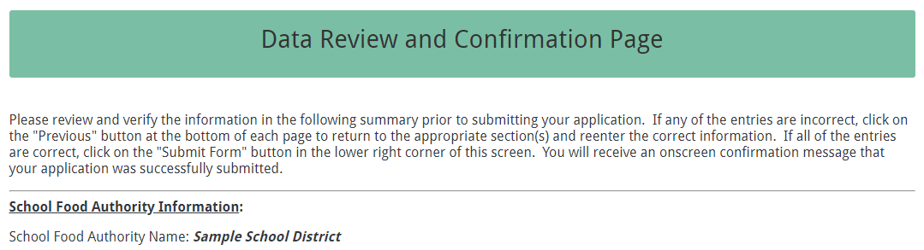
If all entries are correct, click on the “Submit Application” button in the lower right corner of this screen to complete the submission process.
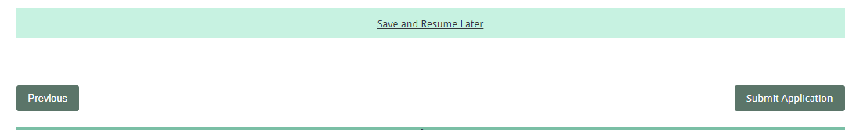
Once the application is submitted, the following message will display on screen.
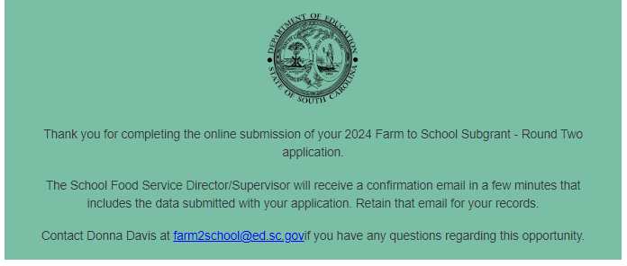
If the SFA director/supervisor does not receive a confirmation email, then the application did not successfully upload. You must resubmit the entire online form, including the attachments, for your application to be considered for funding.
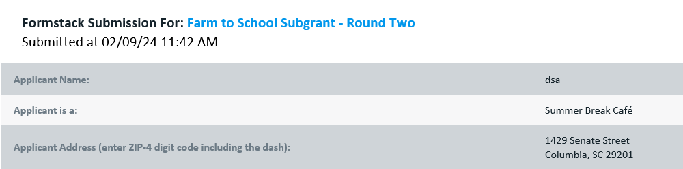
An email confirmation that the subgrant application was successfully submitted does not account for the quality of the uploaded documents or the completeness of the online form. The confirmation email only notifies you that the online application has been submitted. Applicants are responsible for ensuring that the information entered in the online form, including all attachments, is accurate and complete for the application to be reviewed and considered for funding.

Appendix A: Definitions of Terms Used

De-obligation—The downward adjustment of the obligations recorded in a grant award document. It is caused by factors such as (1) termination of part of the project, (2) reduction in material prices, (3) cost savings, or (4) correction of recorded amounts.

Farm to School— Farm to school enriches the connection communities have with fresh, healthy food and local food producers by changing food purchasing and education practices at schools and early care and education sites.

Private/Parochial school—Any organization that is funded and run by a non-governmental entity or entities. (This includes independent schools.) A private school can be run by a for-profit company, a non-profit company, or a church or diocese or some other non-governmental organization.

Residential Child Care Institution (RCCI)—Any public or nonprofit private residential childcare institution, or distinct part of such institution, which operates principally for the care of children. If the RCCI is a private entity, it is licensed to provide residential childcare services under the appropriate licensing code by the state or a subordinate level of government, except for residential summer camps which participate in the Summer Food Service Program for Children, Job Corps centers funded by the Department of Labor, and private foster homes.

School Food Authority (SFA)—Any public, private/parochial, charter, or nonprofit private residential childcare institution, which participate in the National School Lunch Program.

Summer Break Café Sponsor—Any approved sponsor that participates in the Summer Food Service Program for Children.

Appendix B: Selection Criteria and Reviewers’ Scoring Rubric

Selection Criteria

The point values for each section of the application are as follows:

Narrative Sections | Points Available
Needs Statement | 30
Project Narrative | 50
Management and Sustainability | 20
TOTAL | 100

Scoring Rubric

1. Needs Statement: The applicant describes the needs assessment process used to identify and determine the vision for the proposed Farm to School program and provides the names and titles/positions of all involved in identifying the needs.
Acceptable
Fully Meets—22–30 points
Applicant provides a narrative that fully describes all required items.
Adequate/Meets—13–21 points
Applicant provides a narrative that moderately describes all required items.
Not Acceptable
Limited/Approaches—6–12 points
Applicant provides a narrative that is limited or unclear in describing all required items.
Inadequate—0–5 points
Applicant provides a narrative that does not adequately describe all required items.
Reviewer’s Comments

2.a. Proposed Farm to School Project: The applicant describes the proposed Farm to School project including the activities identified and how the activities proposed will support the F2S project.
Acceptable
Fully Meets—15–20 points
Applicant provides a narrative that fully describes all required items.
Adequate/Meets—9–14 points
Applicant provides a narrative that moderately describes all required items.
Not Acceptable
Limited/Approaches—4–8 points
Applicant provides a narrative that is limited or unclear in describing all required items.
Inadequate—0–3 points
Applicant provides a narrative that does not adequately describe all required items.

Reviewer’s Comments

2.b.i. Proposed Farm to School Project: The applicant explains how the project will support efforts to build and increase the capacity to procure and use local food in program meals. Describe how the proposed project will:
- improve the quality of the food prepared and served in ways that support nutritional standards.
- increase the ability to prepare foods in a healthy manner such as steaming, baking, or grilling.
- improve food safety service in the nutrition program.
- increase the efficiency of food service procurement, food storage, and distribution/service.
Acceptable
Fully Meets—15–20 points
Applicant provides a narrative that fully describes all required items.
Adequate/Meets—9–14 points
Applicant provides a narrative that moderately describes all required items.
Not Acceptable
Limited/Approaches—4–8 points
Applicant provides a narrative that is limited or unclear in describing all required items.
Inadequate—0–3 points
Applicant provides a narrative that does not adequately describe all required items.
Reviewer’s Comments

2.b.ii. Proposed Farm to School Project: The applicant provides a description of agricultural education opportunities for participating children. (Examples include taste testing, farmers visiting school cafeterias, and field trips for students to visit farms.)
Acceptable
Fully Meets—7–10 points
Applicant provides a narrative that fully describes all required items.
Adequate/Meets—4–6 points
Applicant provides a narrative that moderately describes all required items.
Not Acceptable
Limited/Approaches—2–3 points
Applicant provides a narrative that is limited or unclear in describing all required items.
Inadequate—0–1 point
Applicant provides a narrative that does not adequately describe all required items.

Reviewer’s Comments

3. Management and Implementation: The applicant provides an outline of the plan to
- manage the project including the chain of command,
- who will manage the project,
- a job description of project director, and
- responsibilities for each key staff member.

The applicant includes the following as attachments:
- an organizational chart to show the chain of command; and
- a Timeline of Activities that thoroughly describes when each program activity begins and ends, how each activity relates to a specific objective, and who is responsible for overseeing the activity.
Acceptable
Fully Meets—15–20 points
Applicant provides a narrative that fully describes all required items.
Adequate/Meets—9–14 points
Applicant provides a narrative that moderately describes all required items.
Not Acceptable
Limited/Approaches—4–8 points
Applicant provides a narrative that is limited or unclear in describing all required items.
Inadequate—0–3 points
Applicant provides a narrative that does not adequately describe all required items.
Reviewer’s Comments

Appendix C: Required SCDE Forms

Certification Signature Page

Certification
I hereby certify that, to the best of my knowledge, the information and data contained in this application are true and correct. The applicant’s governing body has duly authorized this application and documentation, and the applicant will comply with SCDE Assurances and Terms and Conditions if the grant is awarded. The applicant is registered and current (active) on the federal System for Award Management (SAM).

Authorized Official (District Superintendent or CEO of Summer Break Café)
Name:
Position: | Email:
Telephone: | Fax:

Signature of Authorized Official: | Typed name of Authorized Official:
Date Signed:
Signature of Financial Official: | Typed Name of Financial Official:
Date Signed:

Please complete and obtain signatures prior to submission. Include the signed PDF form in the Applicant Attachments as indicated on page 18.

Assurances and Terms and Conditions for USDA Subawards
The applicant certifies to abide by the SCDE Assurances and Terms and Conditions by signing and submitting the Certification Signature Page.

Assurances

I certify that this applicant
- Has the legal authority to apply for federal assistance and the institutional, managerial, and financial capability (including funds sufficient to pay the nonstate share of project costs) to ensure proper planning, management, and completion of the project described in this application.
- Will give the South Carolina Department of Education (SCDE) access to and the right to examine all records, books, papers, or documents related to this award and will establish a proper accounting system in accordance with generally accepted accounting principles (GAAP) or agency directives.
- Has an accounting system with sufficient internal controls, a clear audit trail, and written cost-allocation procedures as necessary. The financial management systems are capable of distinguishing expenditures that are attributable to this grant from those that are not attributable to this grant. This system is able to identify costs by programmatic year and by budget line item and to differentiate among direct, indirect, and administrative costs. In addition, the applicant will maintain adequate supporting documents for the expenditures (federal and nonfederal) and in-kind contributions, if any, that it makes under this grant. Costs are shown in books or records (e.g., disbursements ledger, journal, payroll register) and are supported by a source document such as a receipt, travel voucher, invoice, bill, or in-kind voucher.
- Will also comply with the Office of Management and Budget 2 CFR Part 200 Subpart E-Cost Principles related to the allowability, reasonableness, and allocability of costs consistent with the approved budget and also by maintaining required support for salaries and wages. Required support includes certifications and/or personnel activity records depending upon the amount of time spent on cost objectives.
- Will approve all expenditures, document receipt of goods and services, and record payments on the applicant’s accounting records prior to submission of reimbursement claims to the SCDE for costs related to this grant.
- Will initiate and complete work within the applicable time frame after receipt of approval by the SCDE.
- Will not discriminate against any employee or applicant for employment because of race, color, religion, age, sex, national origin, or disability and comply with Title VI of the Civil Rights Act of 1964, Section 504 of the Rehabilitation Act of 1973, Title IX of the Education Amendments of 1972, the Age Discrimination Act of 1975, and Titles I, II, and III of the Americans with Disabilities Act of 1990 (ADA). The grantee will take affirmative action to ensure that applicants for employment and the employees during the period of their employment are treated without regard to their race, color, religion, age, sex, national origin, or disability.
- Has no policy that prevents, or otherwise denies, participation in constitutionally protected prayer in public schools as set forth in the Guidance on Constitutionally Protected Prayer in Public Education (20 U.S.C. § 7904).
- Will comply with the Family Educational Rights and Privacy Act. (20 U.S.C. §1232g; 34 CFR Part 99).
- Will comply with the Ethics, Government Accountability, and Campaign Reform Act (S.C. Code Ann. § 2-17-10 et seq. and § 8-13-100 et seq. (Supp. 2023)).
- Will comply with the South Carolina Drug Free Workplace Act (S.C. Code Ann. § 44-107-10 et seq. (Supp. 2023) if the amount of this award is $50,000 or more and the federal Drug Free Workplace Act of 1988 (41 USC 702).
- Will provide information to the SCDE, as requested, regarding the reporting requirements of the Federal Funding Accountability and Transparency Act (FFATA), which requires the SCDE to file a FFATA subaward report by the end of the month following the month in which it awards any subgrant equal to or greater than $25,000.
- Will comply with 2 CFR Part 25 and register and receive a unique entity identifier, fulfill the requirement for the System for Award Management, maintain the currency of the registration throughout the full grant term, and allow access by the granting agency to ensure compliance.
- Will comply with 2 CFR Part 200.112 and disclose in writing any potential conflict of interest to the SCDE.
- Will comply with 2 CFR Part 200.113 and disclose in writing to the SCDE all violations of federal criminal law involving fraud, bribery, or gratuity violations potentially affecting the federal award.
- Will comply with conditions under Executive Order 13513 “Federal Leadership on Reducing Text Messaging While Driving” (October 1, 2009) by refraining from text messaging while driving during official grant business. Relatedly, the applicant will refrain from emailing while driving during official grant business.

Terms and Conditions

- Completeness of Proposal. All proposals should be complete and carefully worded and must contain all of the information requested by the South Carolina Department of Education (SCDE). If you do not believe a section applies to your proposal, please indicate that fact.
- Non-awards/Termination. The SCDE reserves the right to reject any and all applications and to refuse to grant monies under this solicitation. If the SCDE rejects an application, the applicant has a right to request a hearing, as provided by the SCDE Hearing Procedures, if it alleges the SCDE’s actions violate a state or federal statute or regulation by (1) disapproving of or failing to approve the application or project, in whole or in part, or (2) failing to provide funds in amounts in accordance with the requirements of statutes and regulations.
After it has been awarded, the SCDE may terminate a grant by giving the grantee written notice of termination. In the event of a termination after award, the SCDE shall reimburse the grantee for allowable expenses incurred up to the notification of termination. In addition, this grant may be terminated by the SCDE if the grantee fails to perform as promised in its proposal.
In the event that this grant is terminated, the grantee shall have a right to a hearing as set forth in the SCDE Hearing Procedures. The grantee must notify the SCDE of its request for a hearing within 30 days of receiving written notice of the termination. If a hearing is requested, the SCDE will conduct the hearing in accordance with the SCDE Hearing Procedures.
- Reduction in Budgets and Negotiations. The SCDE reserves the right to negotiate budgets with applicants. The SCDE may, at its sole discretion, determine that a proposed budget is excessive and may negotiate a lower budget with the applicant. The applicant may at that time negotiate or withdraw its proposal. In addition, the SCDE may desire to fund a project but not at the level proposed. In that case, the SCDE shall notify the applicant of the amount that can be funded, and the applicant and the SCDE shall negotiate a modification to the proposal to accommodate the lower budget. All final decisions are that of the SCDE.
- Amendments to Grants. Amendments are permitted generally for budgets, grant end date, and management upon the mutual agreement of the parties involved and will become effective when specified in writing and signed by both parties. However, amendments to scope of work that significantly alter the original application proposal may trigger partial or full termination.
- Use of Grant Funds. Funds awarded are to be expended only for purposes and activities covered by the approved project plan and approved budget and budget narrative.
- Submission of Expenditure Reports. Claims for reimbursement must be made at least quarterly and consistent with calendar quarters (e.g., an expenditure report claim for costs for January 1 through March 30 must be filed by May 15).
- Obligation of Grant Funds. Grant funds may not be obligated prior to the effective date or subsequent to the end or termination date of the grant period. No obligations are allowed after the end of the grant period. The final request for expenditure report claims must be submitted no later than forty-five (45) days after the end of the grant period unless the scope of work for the grant states a shorter reporting period.
- Deobligation of Funds. After a final expenditure report claim has been submitted to the SCDE, the grantee will go through the official deobligation process with the SCDE.
- Documentation. The grantee must provide for accurate and timely recording of receipts and expenditures. The grantee’s accounting system should distinguish receipts and expenditures attributable to each grant. The grantee must review the memo regarding “Guidelines for Retaining Documentation to Support Expenditure Claims.”
- Travel Costs. Travel costs, if allowed under this solicitation, must not exceed limits noted in the United States General Services Administration (GSA) per diem rates for lodging, except in the case of conference lodging required for program-required training. In the case that conference-related lodging exceeds the GSA per diem rate, the grantee shall follow their entity’s written procedure for obtaining prior approval to exceed a GSA rate for a conference hotel. Meals and incidentals are limited by the state budget proviso, currently not to exceed $35 per day for in-state travel and $50 for out-of-state travel (see page 81 of the State of South Carolina Statewide Disbursement Regulations). Mileage reimbursement must follow the current Office of Comptroller General instructions, which is consistent with the published IRS rates.
- Honoraria. Amounts paid in honoraria, if allowed under this grant, must be consistent with SCDE policies. Applicants should check with the program office before budgeting for honoraria.
- Reports. The grantee shall submit, as required or instructed by the awarding program office, all reports (programmatic, financial, or evaluation) within the specified period or date and in the prescribed format. An expenditure claim report must be filed by August 15 for all expenditures incurred by June 30 in order to comply with the generally accepted accounting principles (GAAP) and the production of the State's Comprehensive Annual Financial Report.
- Copyright. The grantee is free to copyright any books, publications, or other copyrightable materials developed in the course of this grant. However, the SCDE reserves a royalty-free, nonexclusive, and irrevocable license to reproduce, publish, or otherwise use, and to authorize others to use, the copyrighted work developed under this grant.
- Certification Regarding Lobbying, Suspension, and Debarment. By submitting an application, the applicant certifies, to the best of its knowledge and belief, that the
- Applicant and/or any of its principals, subgrantees, or subcontractors
  - Have not paid or will not pay to any person any federally appropriated funds for the purpose of influencing or attempting to influence an officer or employee of any agency, a Member of Congress, an officer or employee of Congress, or any employee of a Member of Congress in connection with making any federal grant and the extension continuation, renewal, amendment, or modification of any federal grant, as stated at 2 CFR Part 418 and 34 CFR Part 82. If any funds other than federally appropriated funds have been paid or will be paid to any person for influencing or attempting to influence an officer or employee of any agency, a Member of Congress, an officer or employee of Congress, or any employee of a Member of Congress in connection with this federal grant, the undersigned shall complete and submit Standard Form LLL, “Disclosure of Lobbying Activities,” in accordance with its instructions.
  - Are not presently debarred, suspended, proposed for debarment, or declared ineligible for the award of contracts by any state or federal agency as stated at 2 CFR Part 417.
  - Have not, within a three-year period preceding this application, been convicted of or had a civil judgment rendered against them for commission of fraud or a criminal offense in connection with obtaining, attempting to obtain, or performing a public (federal, state, or local) contract or subcontract; violated federal or state antitrust statutes relating to the submission of offers; or committed embezzlement, theft, forgery, bribery, falsification or destruction of records, making false statements, tax evasion, or receiving stolen property.
  - Are not presently indicted for, or otherwise criminally or civilly charged by a governmental entity with, commission of any of the offenses enumerated above.
- Applicant has not, within a three-year period preceding this application, had one or more contracts terminated for default by any public (federal, state, or local) entity.
- Audits.
- Entities expending $750,000 or more in federal awards:
Entities that expend $750,000 or more in federal awards during the fiscal year are required to have an audit performed in accordance with the provisions of 2 CFR Part 200.501, et seq. Except for the provisions for biennial audits provided in 2 CFR Part 200.504 (a) and (b), audits must be performed annually as stated at 2 CFR Part 200.504. A grantee that passes through funds to subrecipients has the responsibility of ensuring that federal awards are used for authorized purposes in compliance with federal program laws, federal and state regulations, and grant agreements. The director of the OMB, who will review this amount every two years, has the option of revising the threshold upward.
- Entities expending less than $750,000 in federal awards:
Entities that expend less than $750,000 in a fiscal year in federal awards are exempt from the audit requirements in 2 CFR Part 200.504. However, such entities are not exempt from other federal requirements (including those to maintain records) concerning federal awards provided to the entity. The entity’s records must be available for review or audit by the SCDE and appropriate officials of federal agencies, pass-through entities, and the General Accounting Office (GAO).
- Records. The grantee shall retain federal grant records, including financial records and supporting documentation, for a minimum of six (6) years after the end date of the grant when the final expenditure report claim for reimbursement and all final reports have been submitted, unless informed otherwise or in the case of litigation.
- Electronic Signature Agreement. I agree that my electronic signature is the legally binding equivalent to my handwritten signature.

Budget Narrative Template

For informational purposes only
Go to the SCDE Grant Opportunities webpage to obtain the Excel spreadsheet template.

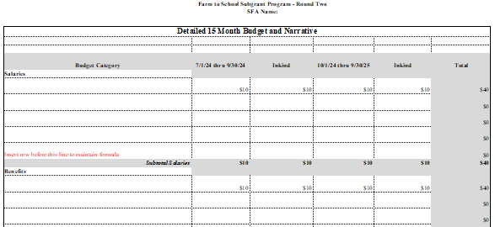

Timeline of Activities Template

Start Date–End Date | Activity to support Farm to School Project | Evidence that Proves Activity has been Completed OR Data to be Collected from Activity | Persons/Agency Responsible

Pre-Award Audit Questionnaire

Download and complete the appropriate Pre-Award Audit Questionnaire for your entity to include your application as directed on page 18. The screenshot below is provided for your information.

