Request for Proposals (RFP)
Application Package

Summer Reading Camp Community Partnership Grant
FY 2023 Competitive Grant

The Summer Reading Community Partnership Grant is a grant program funded by the General Assembly of the state of South Carolina, authorized by the General Appropriations Act, Proviso 1.56, and administered by the South Carolina Department of Education.

Deadline for Receipt of Applications: 5:00 p.m., February 16, 2023

Technical Assistance for Applicants: January 11, 2023

Letter of Intent Deadline: January 18, 2023

For questions about the Summer Reading Camp Community Partnership Grant, contact:
Ablean Hanna, Education Associate
803-734-0780, ahanna@ed.sc.gov

Issued by:
South Carolina Department of Education
Office of Early Learning and Literacy
1429 Senate Street, Suite 604
Columbia, SC 29201
TABLE OF CONTENTS

PART I: General Information 1
A. Introduction and Purpose 1
B. Eligible Applicants 1
C. Competitive Priorities 2
D. Timeline of Granting Process 2
E. Technical Assistance Sessions for Applicants 2
F. Statutory, State-Level, and Oher Requirements 2
G. Authorized Activities 5
H. Unauthorized Activities 5
I. Program Accountability and Monitoring 5
J. Fiscal Operations 8
K. Supplement, Not Supplant 8
L. Review and Selection Process 9
M. Appeals Process 10

PART II: Application Overview, Content, and Instructions 11
A. Application Overview 11
B. Application Narrative Format 11
C. Online Application Submission 12
D. Program Summary 12
E. Proposal Narrative Content 12
F. Application Budget 15
G. Appendices 17
H. Deadline and Submission Procedures 18
I. Screenshots of Online Application Submission Forms 19

Appendix A: Definitions of Terms Used 29

Appendix B: Selection Criteria and Reviewers’ Scoring Rubric 30

Appendix C: Required SCDE Forms 37
Certification Signature Page 37
SCDE Assurances and Terms and Conditions for State Awards 38
General Appropriations Act, Proviso 1.57 Summer Reading Camps 41
Request for Taxpayer Identification Number and Certification 42
Partnership Identification and Funding Request Form 43
Timeline of Activities Template 44

Appendix D: Optional Forms 45
Grant Design Chart 45
Goals, Objectives, and Outcomes Worksheet 46
Action Plan Form 47

Appendix E: Elementary Schools
Ineligible to Apply (Poverty Index below 40 percent) 48

PART I: General Information

Introduction and Purpose

The South Carolina General Assembly has provided funds to the South Carolina Department of Education (SCDE) for summer reading camps through a legislative proviso. Subsection (2) of proviso 1.56 states:

1.56. (SDE: Summer Reading Camps) $700,000 [is] allocated to the Department of Education to provide grants to support community partnerships whereby community organizations shall partner with local school districts to provide enrichment activities as part of after school programs or summer reading camps that utilize volunteers, mentors or tutors to provide instructional support to struggling readers in elementary schools that have a poverty index of forty percent or greater.

Funds are to provide additional resources to support the South Carolina Read to Succeed Act of 2014 by creating effective partnerships between community organizations and school districts.

The purpose of the Summer Reading Camp (SRC) Community Partnership Grant (CPG) is to provide students who are significantly below grade-level reading proficiency with the opportunity to receive quality intensive instructional services and support. Camp staff must ensure that students are provided with a wide selection of texts and genres that are written on multiple reading levels to best serve the individual needs of students. For students to benefit from the summer program, they must attend regularly and be engaged in instructional and hands-on learning experiences. Sites should strategize ways to increase student attendance on a consistent basis including incentives for attendance and establishing frequent parental contact.

Approximately $700,000 is available for new SRC CPGs to expand the SRC experience for students and to increase student achievement through partnerships with community organizations in this funding cycle. The SCDE anticipates awarding approximately 10–15 grants. Award amounts will be determined based on the quality of applications received and total funding requested. Final budgets may be negotiated based on demonstrated needs.

The 2023 grant funding period is March 21, 2023, through August 15, 2023. The grantee may obligate funds upon receipt of the grant award notice. No funds will be disbursed until after March 21, 2023.

Pending the quality of applications and state allocations, the SCDE reserves the right to not award grants for this funding cycle.

Eligible Applicants

Eligible applicants are South Carolina community partnerships made up of community organizations and local school districts that are collaborating to provide SRCs and instructional support to struggling readers in elementary schools with a poverty index of 40 percent or greater. CPG programs should be based on the recommended Effective Summer Reading Camp Partnership Model (see page 3). A list of schools that are not eligible to apply, based on their poverty index, is provided on pages 48–50.

Schools and school districts are encouraged to partner with county or school libraries, institutions of higher education, community organizations, faith-based institutions, businesses, pediatric and family practice medical personnel, and other groups to provide volunteers, mentors, tutors, space, or other support to assist with the provision of the SRC.

The SCDE strongly recommends that an eligible school district be the fiscal agent for the proposed program.

Competitive Priorities

No competitive priority points will be awarded during this funding round.

Timeline of Granting Process

Date | Activity/Action
January 11, 2023 | Pre-application technical assistance session
January 18, 2023 | Email notice of intent due
February 16, 2023 | Deadline for receipt of application (due by 5:00 p.m.)
March 2023 | Notification of awards
March 21, 2023 | Grant funding period begins; programs can begin
August 15, 2023 | Grant funding period ends
August 31, 2023 | Final report(s) due to the SCDE

Technical Assistance Sessions for Applicants

The Office of Early Learning and Literacy (OELL) will offer a technical assistance webinar via Adobe Connect on January 11, 2023, from 10:00 a.m. until 11:30 a.m. to assist eligible applicants in understanding this RFP and how to apply for this grant. No password is required to join the session. Participants should enter their full names when logging in. Participants will be able to log in 30 minutes prior to the start of the session to test their audio settings and download/print handouts. While participation is not mandatory to submit an application, it is highly recommended.

Statutory, State-Level, and Oher Requirements

The following criteria for this program were established by Proviso 1.56 and the 2023 SRC Community Partnerships Report.
  - Community organizations must partner with local school districts to provide enrichment activities as part of after school programs or summer reading camps that use volunteers, mentors, or tutors to provide instructional support to struggling readers in elementary schools.
  - The participant-to-volunteer or -teacher ratio must conform to that of the school district in which the program is located.
  - All mentors and tutors for these after school programs or SRCs must have passed a State Law Enforcement Division (SLED) criminal background check.
  - A reading coach/reading specialist should train volunteers, tutors, and other staff in the role they will play for supporting students’ reading. Tutors should be trained to understand the reading process before they begin tutoring.
  - Programs using funds earmarked for partnerships as part of the Read to Succeed Act should employ reading specialists (reading teachers, reading interventionists, or reading coaches who have documented substantial success in helping students read) in the summer program, depending on the number of students in the program. A reading specialist can provide the direction and coordination for implementation of an effective supplemental reading program including:
    - providing training on best practices to volunteers, tutors, and mentors;
    - administering and interpreting the progress monitoring reading levels; and
    - providing direct instruction to the students reading at the lowest levels.
  - A SRC or afterschool program must operate at least six weeks in duration with a minimum of four days of instruction per week and four hours of instruction per day, or the equivalent of 96 hours of instruction.
  - A SRC or afterschool program must be taught by compensated certified teachers who have at least an add-on literacy endorsement or who have documented and demonstrated substantial success in helping students comprehend grade-level texts.
  - Grantees must ensure that students are provided with a wide selection of texts and genres that are written on multiple reading levels in order to best serve the individual needs of students.
  - For students to benefit from the summer program, they must attend regularly and be engaged in instructional and hands-on learning experiences. Grantees should strategize ways to increase student attendance on a consistent basis including engaging enrichment activities, incentives for attendance, and contact with families.
  - School transportation must be provided.
  - Grantees must use one of the following formative assessment tools as pre- and post- assessments to measure student growth: Development Reading Assessment, Fountas and Pinnell, or Dominie.
  - Grantees must document student attendance.
  - Grantees must complete a final statistical report form.

An Effective Summer Reading Camp Partnership Model
Under this effective partnership model, the school district and the community partners coordinate services provided to its students in reading. This model may include:
- Focused reading instruction,
- Certified teachers,
- Progress monitoring with valid reading assessments,
- Character development and team/skills building, and
- Recreational sports and activities.

The school district will take the primary lead on the instructional part of the SRC, identifying students in need of additional support for reading on grade level, developing the reading program, administering the reading assessment, and providing the reading instruction. The school district will provide the necessary reading instruction hours with certified reading teachers and provide and administer the reading assessment with the appropriate student/teacher ratio.

If the sites are separate, the school district, with permission from the parents, can transport the students from the school to the partnership site. The Summer Feeding Program may be used to provide lunch and breakfast. (For information on becoming a summer food sponsor or site, please visit the SCDE’s Summer Food Program web page.)

Community partners could be comprised of organizations such as the Boys and Girls Clubs, United Way agencies, YWCA, YMCA, faith-based groups, or public libraries. The community partner is responsible for providing enrichment activities for students during the remaining portion of the day. The community partner must coordinate and collaborate with the services that other tutors, volunteers, and community partners are providing during the instructional portion of the SRC. Enrichment activities may include, but are not limited to, arts, sports, life skills, character development, reading enrichment activities, or field trips. Interesting and engaging enrichment opportunities reduce boredom and encourage regular attendance, which increases the likelihood of academic success.

An excellent example of this model was demonstrated by a school district that partnered with the YMCA and a local church to operate its SRC as part of the Read to Succeed Act. The school district designed and operated the morning session, providing focused reading instruction for students identified as struggling readers. The church acted as the host site and as a summer feeding site. The YMCA was responsible for afternoon activities that included sports and recreation, team building, and other activities. The school district provided transportation to and from the church site.

Universal Identifier and System of Award Management—2 CFR Part 25
All grant/subgrant applicants must obtain a unique entity identifier (UEI) by registering in the federal System for Award Management (SAM). The applicant must be registered in SAM prior to submitting their application, maintain their SAM registration throughout the application and award process, and include a valid UEI in the online application.

To register in SAM, visit the Get Started page at SAM.gov for information about registering your entity. If you do not receive confirmation that your SAM registration is complete, please contact SAM.gov. For assistance, see the Federal Service Desk.

Please note that applicant organizations must be registered in the SAM prior to submitting an application, maintain a publicly searchable SAM registration throughout the application and award process, and include a valid UEI in their application. The SCDE will not make a subaward of funds to an applicant until the applicant has complied with the requirements described in 2 CFR 25 to provide a valid UEI and maintain an active SAM registration with current information.
Applicants should also review the Assurances and Terms and Conditions for State Awards (pages 38–40) to ensure that, if awarded a grant, they are capable of full compliance, especially with all the referenced federal regulations and state laws to enter into an agreement with the SCDE for this program. Pursuant to S.C. Code Ann. § 8-13-700 (Supp. 2021), the applicant must disclose any potential conflict of interest to the SCDE in accordance with the SC Ethics Reform Act conflict of interest policy. A signed Certification Signature Page (page 37) is required with the grant application and legally binds the applicant to the agency’s Assurances and Terms and Conditions.

Authorized Activities

Allowable activities include evidence-based academic and enrichment activities to supplement academic content. Activities associated with all strategies and/or models must demonstrate a direct and/or indirect link to improving students’ reading abilities. Examples of enrichment activities include music, arts, sports, science, team building, community service, and other activities that allow for building positive relationships, character development, and developing leadership skills.

Unauthorized Activities

Unallowable activities include the renovation or construction of facilities and the support of political or religious activities. Grantees may not subgrant components of the program to outside vendors. Funds used for any purpose other than those approved in the grant application and purchases that do not directly support the approved work plan will be disallowed.

Program Accountability and Monitoring

The SCDE is responsible for monitoring the SRC CPG implementation to ensure that community organizations partner with elementary schools to provide enrichment activities and intensive instructional services as part of their after-school programs or summer reading camps to students who are significantly below third grade reading proficiency in accordance with the following program accountability requirements:
- Each grantee meets the eligibility requirements for the grant described herein, and the applicant has provided all required assurances that it will comply with all program implementation and reporting requirements established through this RFP.
- Each grantee appropriately uses these funds as described in this application package.
- Each grantee implements activities funded through this application within the timeline in which the funds provided are to be used.

Applicants may be subjected to an evaluation of their financial system, internal controls processes, and policies and procedures by the SCDE’s Office of Auditing Services before a grant award is issued or during the grant term. Visit the Pre-award Audit Resources web page to access the review process and procedures.

Applicants awarded grant funds must satisfy periodic reporting and accountability requirements throughout the term of the grant. These requirements address: (1) program accountability; (2) performance reporting; (3) program budget; (4) monitoring; (5) program evaluation; and (6) technical assistance.

    - Program Accountability
Each grantee is responsible for carrying out its responsibilities in accordance with Proviso 1.56, including all applicable statutes, regulations, programmatic guidance, and its approved grant application and work plan. Grantees are required to submit periodic reports to the SCDE to report on the use of grant funds and the progress of grant activities.

    - Performance Reporting
Performance reporting requirements include both programmatic reporting and fiscal reporting. The grantee is responsible for ensuring that all required performance reports are accurate, complete, and submitted on time.

Programmatic Reporting Requirements
A final performance report must be submitted to the SCDE no later than August 31, 2023. Progress toward achieving grant goals and objectives will be monitored through the final performance report process.

The following is required of all grant recipients and is required to be reported in the final performance report:
- total number of students eligible by grade level,
- total number of students who successfully completed an SRC by grade level,
- attendance for participants (reported by district average),
- total number of students improving reading levels as indicated by student growth,
- total number of grade three students promoted to grade four,
- total number of grade three students retained, and
- ratio of certified teachers to students served.

Fiscal Reporting Requirements
Applicants must submit an initial budget with the application. The grantee is responsible for ensuring that all expenditures are aligned to the approved budget for authorized activities (see section G on page 5) and for retaining accurate and complete documentation and records of all expenditures. The grantee must submit an interim and final fiscal report to the SCDE by the due dates indicated below. The reporting period of the grant is March 21, 2023, through August 15, 2023.

Fiscal Reporting Deadlines
Report | Reporting Period | Report Due Date
Interim | March 21–May 30, 2023 | June 8, 2023
Final | June 1–August 15, 2023 | August 31, 2023

Reports are subject to verification. The SCDE reserves the right to recover any funds used for expenditures that are determined to be unauthorized for the program, including funds not expended according to the approved budget
    - Program Budget
A program budget is due with the application. Program budget expenditures must be aligned to the final approved budget and must be for authorized activities only (see page 5).

    - Monitoring
The SCDE will monitor grantees by reviewing and approving the progress reports and final performance reports. All information in monitoring reports is subject to verification. The SCDE may conduct programmatic and financial monitoring site visits. Grantees must agree to site visits conducted by SCDE representatives.

The SCDE may require additional information from the grantee, verify information with the authorizing agency, or require the submission of additional documentation including, but not limited to, invoices, receipts, and personnel time and effort reports. Prior to a site visit, the grantee may be required to submit additional relevant information that will allow the SCDE to conduct a useful, efficient, and effective visit. The SCDE may require electronic submission of documents instead of a hardcopy submission.

SCDE staff will verify the contents of documentation submitted. Grantees may be asked to revise reports when:
- non-allowable expenses are found;
- reports are confusing or difficult to understand; or
- there are unexplained discrepancies between the proposed use of grant funds, as provided in the annual budget, and actual expenditures found in the submitted documentation.

    - Program Evaluation
Grantees are required to conduct ongoing monitoring and evaluation to ensure program goals are achieved. Progress toward meeting program goals is to be reported through the final performance report. In addition, the SCDE will compile evaluation information.

A final program evaluation report is to be completed before the end of the grant period. The final evaluation report must address program success toward each goal stated in the application. If a grantee fails to conduct the final program evaluation report before the end of the grant period, or if any of the performance requirements in section I.2 are not completed, the SCDE may consider the subgrantee a high risk and elect to discontinue funding or disqualify the subgrantee from future funding opportunities.

    - Technical Assistance to Grantees
Grantees are required to participate in any technical assistance that the SCDE conducts related to the CPG program. Delivery of such technical assistance may include in-person meetings, webinars, and conference calls.

Fiscal Operations

Grantees must use grant funds only for allowable expenditures during the designated grant period.

Ordinarily the SCDE disburses grant funds on a reimbursement basis limited to the state’s fiscal year, ending June 30. The CPG will fund summer camps that run at least six weeks and likely will extend into July or August (after June 30). Therefore, subject to financial risk analysis, the SCDE will disburse funds after March 21, 2023, for the entire grant period and require documentation of allowable expenditures made with that allocation. Documentation of allowable expenditures must be submitted to the SCDE by August 31, 2023. Note: The SCDE will recoup any funds unexpended at the end of the grant period or funds expended on unallowable activities.

The SCDE reserves the right to withdraw or recoup funding pursuant to the grant agreement. The grantee must agree to pay a refund if the SCDE determines that CPG funds were not expended in accordance with allowable activities in the approved grant application, the grant agreement, and assurances.

Matching or in-kind funds are not required for this grant. However, funds invested from other sources are an indicator of the strength of the partnerships and potential long-term sustainability of the program.

Allowable Costs
Grants must be used in accordance with statutory and regulatory requirements. CPG funds are provided solely to support a grantee’s efforts related to activities that occur in preparation for and during the summer months to support struggling readers in elementary schools. Activities associated with all strategies and/or models must demonstrate a direct and/or indirect link to students improving their reading skills. The model must match the one specified in the approved grant application. As such, funds may be used for books, educational grant-related field trips, stipends for tutors and/or teachers, professional development, and materials to provide hands-on learning experiences. Funds may also be used for grant requirements such as background checks.

Unallowable Costs
Grant funds may not be used to provide student stipends, construct facilities, or support political or religious activities. Equipment and supplies totaling more than $5,000 per unit are not allowable. Grantees may not subgrant components of this program to outside vendors. Funds used for any purpose other than those approved in the grant application will be disallowed. Indirect costs are not allowable.

Supplement, Not Supplant

CPG funds must supplement, not supplant, existing services and may not be used to supplant federal, state, or local funds. Programs may not use grant funds to pay for existing levels of services funded from other sources. If current expenditures are being paid from state or local public funds, the applicant may not replace those funds with CPG grant funds. CPG funds may not be used for new construction or purchases that do not directly support the approved work plan. These CPG grant funds may not be used to supplant district funding to provide the mandated SRC to third graders but may be used to expand those programs to include other elementary students.

Review and Selection Process

The SCDE’s OELL will conduct an initial review of all applications for completeness and compliance with application and eligibility guidelines. All required materials including forms and appendices must be submitted for the application to be considered complete and eligible for review. Only applications received by 5:00 p.m., on February 16, 2023, and deemed complete by the program office will be forwarded for review and funding consideration.

Three reviewers from diverse backgrounds without a vested interest in any applicant being funded will evaluate each application based on the quality of the proposed activities and the capability of the applicant to implement the proposed program. The review panel will be comprised of experienced grant readers.

Reviewers will use the scoring rubric included on pages 30–36 to read and rate each application independently. After the three reviewers individually score an application, the three scores will be averaged. An application can earn up to 100 points for an average score.

Applications will be rank ordered by averaged scores. Subject to the SCDE’s final approval and the availability of funds, grant awards will be made starting with the highest ranked applications that earn an average score of 80 points or higher. If funds remain following these awards, the SCDE will consider funding the remaining applications that earned an average score within the adequate/meets range until all funds are allocated. To the extent practical, the SCDE will award grants equitably among geographic regions within the state to include rural and urban communities.

The SCDE may negotiate with the applicant to make changes recommended by the review panel for any approved grants. The SCDE reserves the right to negotiate final budgets and to disqualify costs associated with line items that are unallowable, unreasonable, or inconsistent with the program’s goals or the proposed program’s activities and strategies.

Prior to making awards, the SCDE’s Office of Auditing Services may conduct a pre-award risk assessment of the applicant organization. Based upon the results of this assessment, special conditions may be applied to the award that may include, but are not limited to, requirements for more frequent programmatic or financial reporting, increased monitoring of grant activities, and the provision of additional technical assistance. The SCDE reserves the right to interview applicants recommended for funding, request additional documentation, and make site visits as appropriate to ensure compliance with state requirements.

Grant awards are not final until a SCDE grant award notification (GAN) is fully executed. Notification of funding will be sent in March 2023, to the authorized official listed on the Certification Signature Page. After the notification of awards, copies of the reviewers’ comments and score sheets will be made available upon request.

Appeals Process

An applicant who has submitted a proposal that the SCDE does not fund has 30 calendar days after receiving notification that the proposal is not funded to request a review of the process. Scores may not be appealed; the SCDE will not rescore applications. An unfunded applicant may inquire as to whether the application process was followed. The request for review must be directed to the State Superintendent of Education and must state the reasons for the request. The Superintendent may delegate to a deputy superintendent the authority to conduct a review. The deputy superintendent will issue a decision after the review of the information submitted by the applicant and the program office. This decision will be the final decision of the agency. The applicant may appeal the agency’s decision to the Administrative Law Court under the terms of the Administrative Procedures Act.

PART II: Application Overview, Content, and Instructions

Read all guidelines and criteria carefully before preparing your application. Adhere to font, format, page limit, and organizational requirements. Only applications that include all sections and appendices and fully adhere to these guidelines will be reviewed and considered for funding. Incomplete applications will not be reviewed.

Application Overview

Applicants are encouraged to prepare all of the following elements of the application before beginning the online submission process. Do not wait until the last minute to submit an application. Use the following overview as a checklist to ensure that the application is complete with items labeled accordingly and presented in the order outlined below. Verify that all narrative components and appendices are included prior to uploading attachments.

The SRC CPG online application is organized into the following sections (also see the screenshots on pages 19–28):
- Online Forms
- Primary Applicant Information
- Contact Information
- Authorized Representative Information
- Contact Person Information
- Financial Official Information
- Collaborating Partners
- Program Information
- Program Site Information
- Funding Information
- Budget Summary
- Proposal Attachments
- Program Summary
- Proposal Narrative Content
- Application Budget
- Appendices

Application Narrative Format

Length of Narrative: | Maximum of 15 pages, excluding the Table of Contents, Program Summary, Budget Narrative, and Appendices.
Required Font/Size: | Times New Roman or Arial/11 or 12.
Margins: | 1” on all sides.
Page Numbers: | Number all pages on bottom right corner.
Spacing: | Double-space the narrative; charts and tables may be single-spaced.
Final File Format: | PDF document.
Each section must be clearly identified. Sections may not be combined. Reviewers will not consider information requested in one section that is provided in another section. Incomplete proposals will not be considered.

Online Application Submission

Proposals must be submitted using the online application form. The online submission is organized into two sections—Online Forms and Proposal Attachments.

Provide the primary applicant’s 12-character alphanumeric UEI and Taxpayer Identification Number (TIN) in the application form. Applicants should contact their organization’s finance office if they need assistance with these items.

Use the following instructions to compile and complete all proposal attachments prior to submitting your application. Verify that all components of the narrative and appendices are included prior to uploading attachments. Follow the directions in each section for saving the documents and refer to the screenshot on page 26 for upload locations.

Program Summary

In a one-page summary, concisely describe the community partnership, the proposed number of students to be served by the SRC CPG program, the documented need for the program, the goals and objectives of the proposed program, and the amount of funding requested. The one-page summary is not included in the page limit.

When completed, save the abstract as a single PDF document to be uploaded as an attachment in the online application (see page 26).

Proposal Narrative Content

Use the following directions to write the proposal narrative and organize it into sections following the sequence presented below. Include a table of contents as the first page of the narrative (not included in the page limit). Do not combine sections. Required components must be located in their designated sections in order to be scored.

When complete, save the entire narrative as a single PDF document to be uploaded into the online application where indicated in the proposal attachments section (see page 26).

- Statement of Need (maximum of 10 points available)
The statement of need is a key element of a proposal that makes a clear, concise, and well-supported statement of the need or problem to be addressed. The needs statement reflects the mission of the applicant organization and fits with the purpose of the funding opportunity.

To make a convincing case that students need the proposed SRC CPG, the applicant should conduct a needs assessment to determine the population’s needs that the proposed program will address.

This section should be a clear, factual, and compelling statement of the need or problem, who and how many are affected, what will happen if the need is not addressed or the problem is not resolved. How does the program that you have designed and are proposing meet the need you have identified?

Explain the needs assessment process and its findings to include the
- involvement of the collaborative partner(s) in the needs assessment process;
- needs of the community;
- needs of the school(s);
- needs of the students to be served, including any specific student data pertaining to the needs to be addressed; and
- needs of the students’ families to be served.

- Goals and Objectives (maximum of 30 points available)
Goals and objectives are clear statements of what the applicant proposes to accomplish with the program. All goals and objectives must reflect the purpose of the grant award and address the need or problem identified in the needs statement.

- Goals
A goal is a broad statement that explains the purpose of your program, also known as what the program wishes to accomplish with the end in mind. It sets the fundamental, long-range direction. In short, what is the desired end result? Typically, goals are broad general statements that express the desired change(s).

Present a clear goal or goals that align with the purpose and statutory requirements of the SPC CPG, such as:
- documenting regular participation and improved reading abilities of students,
- promoting consistent attendance of students,
- incorporating both instructional and hands-on learning experiences,
- involving trained tutors and volunteers, and
- administering pre- and post-reading assessments of all participants.

- Objectives
Objectives are statements that define the results the applicant expects to achieve through the proposed program. They break the goal(s) down into smaller parts that provide specific, measurable actions (i.e., methods) by which the goal can be accomplished. As such, objectives should be specific, measurable, achievable, relevant, and time-specific (i.e., SMART). They are meant to be realistic targets for the program, so objectives should indicate a logical progression and clear achievement outcomes at the end of the program.

Objectives should be written in active voice and use action verbs such as plan, write, augment, enhance, conduct, initiate, and produce (rather than more vague terms like learn, understand, feel). Refer to the need or problem identified in the needs statement and the outcome of the proposed activities when developing an objective; figures used should be verifiable. A well-written objective will always answer the following question: Who is going to do what, when, and to what extent?

The Grant Design Chart on page 45 may be used to develop the operational plan for the proposed program. The worksheet on page 46 may be used to develop the goals, objectives, and outcomes. One form should be used for each goal and objective. These worksheets are for planning purposes only; do not include them with the application.

Clearly state the objectives related to the goal(s) for the proposed SRC CPG program. Describe who and how many will be served or affected by the proposed program, what changes will occur within the target population, and the anticipated outcomes for students by the end of the grant period.

- Strategies and Activities (maximum of 30 points available)
Strategies are considered those tasks that are the catalyst to help the target population achieve objectives. For example, in a classroom, strategies are what the teacher does/plans for the students to do so that they learn.

Activities are considered those tasks that the target population does to achieve objectives. For example, in a classroom, activities are what the students do to learn.

Strategies and activities must be based on scientifically based, or evidence-based, interventions; they must be related to methods/design that the applicant will pursue to help the student achieve the goal; and they are those things that the student will do that will advance their abilities. Like objectives, strategies and activities use action verbs such as work, create, and hire.

Both strategies and activities must relate to the line item costs in the Budget Narrative for the proposed program. Any activities that require funding must be described in the strategies and activities section and must be explained in the Budget Narrative or the item(s) will not be funded.

- Strategies
Provide a clear, concise description of the scientifically or evidence-based strategies that will be used to maximize student learning; the rationale for selecting these strategies; and an explanation of how these strategies align with the program’s goals and objectives and how they will help students increase their reading levels.

- Activities
Provide a clear, concise description of the program activities that will be provided for students; the rationale for selecting these activities; and how the activities are expected to improve student academic achievement and achieve other stated objectives.

Include a Timeline of Activities that thoroughly details when each program activity begins and ends, how each activity relates to a specific objective, and who is responsible for overseeing the activity.

Use the chart on page 44 to develop a Timeline of Activities showing target dates for activities. See page 18 for instructions on including the Timeline in the Appendices.

- Management (maximum of 15 points available)
Outline the plan to manage the program including the chain of command, who will manage the program, the program director’s job description, and the responsibilities for each key staff member.

Also
- explain how the proposed SRC CPG program will be implemented efficiently and effectively;
- provide evidence of successful experience or the capacity to succeed in providing educational and enrichment activities to complement and enhance the academic performance, achievement, and positive development of students and their families (such evidence includes the applicant’s experience in managing and coordinating the types of activities they propose and their ability to perform the required services on time and within budget); and
- include a transportation plan that explains how students will travel safely to and from the program activities and home.

- Evaluation (maximum of 15 points available)
Evaluation is tied to the overall goal of the program (i.e., with the end in mind). The evaluation plan should be developed concurrently with the program plan in order to measure success. Evaluation should be ongoing.

Describe the plan to evaluate the program’s outcomes with an analysis of how well the program worked to achieve its goal(s) and objectives.

Application Budget

While the budget is assigned zero (0) points, the budget is a critical component of the entire application. No application with an incomplete budget will be funded.

The application budget consists of two parts: the Budget Summary and the Budget Narrative. All proposed expenditures for the grant funding period must be itemized in the Budget Summary and detailed in the Budget Narrative. Budget items not explained in the Proposal Narrative will not be funded.

All program costs must connect directly to the goals and objectives and activities and strategies in the Proposal Narrative. For budgets, applicants should use a cost-per-student allocation that does not exceed $1,000 per student.

- The Budget Summary provides the financial overview and must include all proposed expenditures for the program. Each line item of the Budget Summary must correspond to the line items of the Budget Narrative (discussed below). Provide the budget line-item expenses for the program in the online application Budget Summary section.
- The Budget Narrative must provide clear evidence that the budget is appropriate and justified based on the needs assessment. Use the Excel budget file located on the SRC CPG SCDE Grant Opportunities web page to provide a detailed Budget Narrative that includes estimates for funds from other resources that will be contributed to the program, if applicable. Structure the Budget Narrative line-item categories to parallel the line-item categories of the Budget Summary. Include all formulas used to calculate each line-item expense. This narrative must demonstrate that all expenditures are allowable, reasonable, and allocable, as well as being adequate to support the activities of the program.

Ensure that the totals in the Budget Narrative equal the totals in the Budget Summary. When finalized, save the Budget Narrative as an Excel file to be uploaded into the online application.

Appropriate personnel and other resources should be carefully allocated for the tasks and activities described in the application. Applicants should ensure that the budget will adequately cover program expenses. It is important for applicants to demonstrate how existing resources, such as computer labs, libraries, and classrooms, will be leveraged to carry out program activities.

Applicants must include in the memorandums of agreement (MOAs) the financial commitment for all contributions from other resources that indicate the amounts and services being provided. All MOAs must be included as appendix items (see page 18). Applicants must also complete a Partnership Identification and Funding Request form (page 43) for each partner institution or organization and include them as appendix items following the instructions on page 18.

The following describes the line items that should be budgeted in each category.

Salaries/Stipends (100)
This category includes pay for salaries for staff members and substitutes and stipends for teachers. The total percentage of time charged to the grant and to non-grant funds cannot exceed 100 percent of the total time worked by any staff member.

Employee Benefits (200)
FICA, workers’ compensation, health insurance, and other employee benefits costs should be included here. These costs will represent a percentage of the total in Salaries/Stipends (100).

Purchased Services (300)
Expenses such as consultant fees, travel/transportation costs, telephone costs, and other purchased services will be included here. This includes amounts paid for personal services rendered by personnel who are not on the payroll and for other specialized services purchased by the organization. While a product may or may not result from the transaction, the primary reason for the purchase is the service provided. Note: Salaries for direct teachers and program staff should be recorded in Salaries/Stipends (100) and not in this section.
For a grantee to pay a vendor, a contract must be in place. At a minimum, the contract should include the scope of services, the duration of the contract, and the method and amount of payment; the contract must be executed by both parties. Consulting and service contracts must be procured in accordance with South Carolina Procurement Law.

For this program, the SCDE requires that grantees ensure that they do not enter into a contract with any vendor that is debarred, suspended, or ineligible for participation in federal programs by
- checking the Excluded Parties List (EPLS) at the federal SAM Web site (Applicants are encouraged to review the user guides for exclusions provided via the “Help” page prior to conducting searches.);
- collecting a certification from the vendor and attaching it to the contract; or
- adding a clause or condition to the contract that indicates the vendor is eligible.

Supplies and Materials (400)
Include the amounts paid for material items of an expendable nature. It is recommended that applicants group items into categories to avoid listing every item; however, make sure that such expenditures are aligned with relevant program characteristics (objectives, number of participants, frequency of activity, etc.).

Capital Outlay/Equipment (500)
Capital outlay and equipment purchases are not allowed.

Other Objects (600)
This category includes expenditures such as postage, liability insurance fees, and copyright fees that do not neatly fit into the other categories.

Indirect Costs (700)
Indirect costs are not allowed.

The SCDE reserves the right to disqualify, disallow, and negotiate costs associated with any line item proposed in the budget. If any line-item cost is determined to be excessive, given the nature and scope of the entire program or of a particular activity, the SCDE can request the applicant reduce the cost of the line item or ask the applicant to assume a portion of the cost before the budget is approved and funds are awarded.

Grantees may not obligate funds nor incur project expenses before receiving a grant award notice.

Appendices

All sections of the appendices must be scanned into a single PDF document to be uploaded into the online application where indicated.

Certification Signature Page
Print the Certification Signature Page (page 37) and obtain the appropriate signatures. This form includes the certification of the SCDE’s Assurances and Terms and Conditions for State Awards and any applicable program-related conditions conveyed in this RFP. Those documents are not required to be included in the applicant’s proposal submission. However, retain the copy included in this RFP for your records and ensure that the signatories and partner organizations have copies of each document.

By signing the Certification Signature Page, the signatories assure that they will comply with all the assurances and terms and conditions for the program. All signatories must understand that they are signing a document that is legally binding in the event a grant is awarded. Applications that do not include the signed Certification Signature Page will not be reviewed or considered for funding.

Request for Taxpayer Identification Number and Certification (W-9)
Applicants that are not school districts must complete the W-9 Request for Taxpayer Identification Number and Certification form (see page 42) for the primary applicant organization. Note: Because of the fiscal requirements, the SCDE strongly recommends that the primary applicant for the proposed SRC CPG program be a school district.

Timeline of Activities
Include a Timeline of Activities that includes each benchmark activity (including evaluation and management components), when each program activity begins and ends, how each activity relates to a particular objective, and who is responsible for overseeing the activity. A template for this timeline is on page 44. The Timeline of Activities may be single-spaced.

Memorandums of Agreement from Collaborative Partners
Include a copy of all MOAs for the proposed SRC CPG. The MOA must articulate the role, scope of services, in-kind contributions, and funding to be provided by each collaborative partner. The authorized officials of each partnering organization must sign an MOA regarding the proposed partnership(s). Applicants and partners are urged to develop one clear, specific MOA when possible.

Partnership Identification and Funding Request Form
Complete a Partnership Identification and Funding Request Form (page 43) for each partner in the program. Include the signature of the partner’s Authorized Official to signify their commitment to the program. If the partner is proposing to use grant funds for the program, list the funds by budget category.

Deadline and Submission Procedures

- Applicants should email a notice of intent to apply by January 18, 2023, to Ablean Hanna in the OELL at ahanna@ed.sc.gov. In the email, include the primary applicant’s name; the contact person’s name, address, phone number, and email address; the names of the schools to be served; and the organizations that comprise the partnership (if applicable). A notice of intent is not required but will help the SCDE prepare for the application submission and review process.
- Applications must be submitted online no later than 5:00 p.m. on February 16, 2023. Applications received after this deadline will not be considered. Because potential technology issues may arise, applicants are encouraged to submit well in advance of the deadline. No exceptions to the deadline will be made regardless of circumstance.
- No hard copy applications will be accepted. Applications delivered by hand, postal mail, email, or fax will not be accepted.
- Only applications that adhere to all guidelines and directions set forth in this RFP will be reviewed and considered for funding. A complete application must include all required documentation and appendices.
- Applications must originate from the applicant. Applications that are plagiarized from the Internet, other grants, or second-party resources will not be considered for funding.
- Grants are not transferrable.
- Do not attach or submit any additional materials other than what is specifically required. Any additional materials will be disposed of without review.
- Applications will not be returned. Keep a copy of the entire application for your records.

Screenshots of Online Application Submission Forms

The following screenshots are for informational purposes only and are provided to assist applicants in compiling all items needed to complete the online submission. Complete the attachments for the online application as directed in the preceding instructions. The SCDE encourages applicants to prepare all items of the application prior to beginning the online submission process.

Make sure all information submitted is accurate, including formal or official names such as the school district, and that spelling is correct. Do not use abbreviations or acronyms. All fields marked with a red asterisk are required; you will not be able to proceed to the next screen of the application without entering all required information.

If necessary, you may save your progress in the online application and return to the form later. Click on the “Save and Resume Later” link to save your progress. You will be given the option of copying and saving the link to the partially completed form or entering an email address to have the link emailed to you. Be sure to enter the email address correctly as SCDE personnel cannot access the hyperlink or the incomplete application. Use the link to access the application from any computer within thirty days to complete the online submission. Without the link or after thirty days, the data previously entered cannot be retrieved, and you will have to begin a new application. A saved application is not a submitted application. You must follow the steps described on pages 27–28 to complete the submission process.

Enter the official name of the primary applicant organization. If a school is the primary applicant, also enter the name of the school district. The names as entered must match the registered name in SAM. Enter the applicant organization’s physical address with the 10-digit ZIP Code (ZIP+4 Code), 12-digit alphanumeric UEI, and TIN. Select the type of applicant organization from the dropdown menu. Provide a descriptive title of the program.
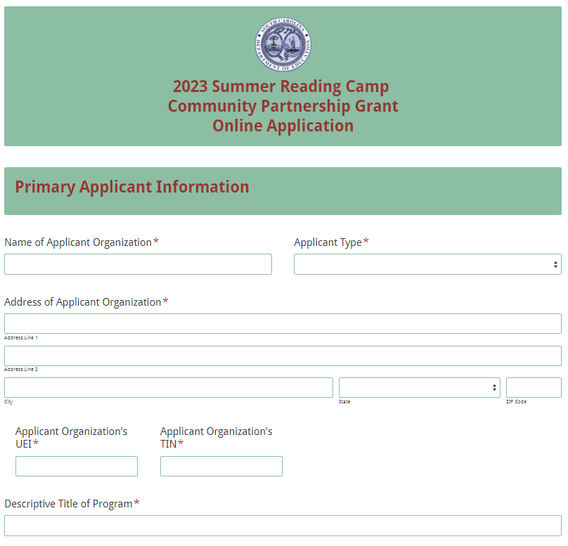
Enter the contact information for the authorized representative. The name entered in the online application must match the name as shown on the Certification Signature Page. Select “Same Address as Applicant Organization” if the authorized representative’s mailing address is the same as the information entered on the first screen. The data will automatically populate these fields. If the address is different, enter the appropriate information.
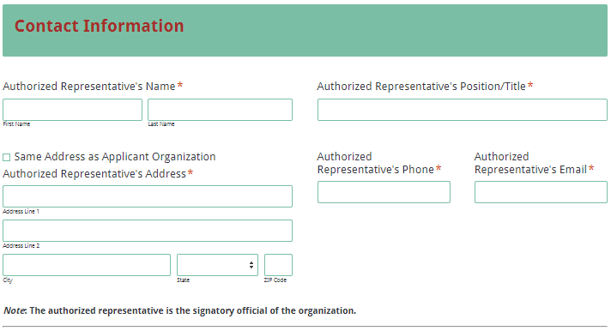
Enter the information for the contact person who will be contacted in all matters relating to the grant application. Select “Same Address as Applicant Organization” if the contact person’s mailing address is the same as the information entered on the first screen. The data will automatically populate these fields. If the address is different, enter the appropriate information. The contact person’s email is a required field. The confirmation of a successful online application submission will be sent only to this email address. Reenter the email address to validate that it is correct.
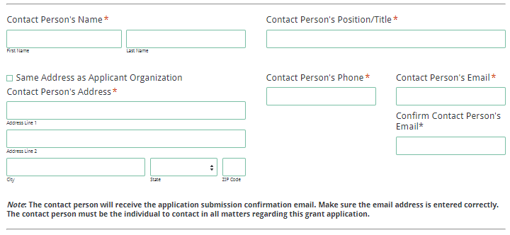
Enter the contact information for the applicant organization’s financial officer.
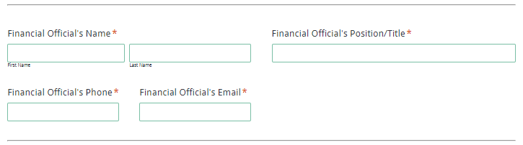
Select the number of collaborating partners.
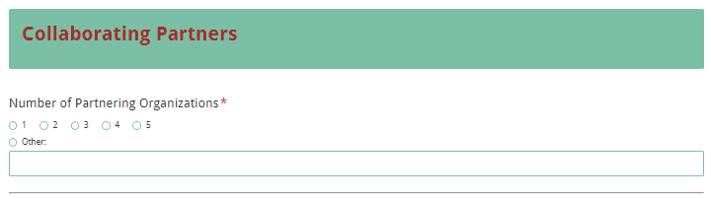
Information fields will be displayed for each organization based on the number selected. Enter the official name of the partner organization(s); do not use abbreviations or acronyms. Select the type of organization from the dropdown box and briefly describe their role and responsibility in the SRC CPG.
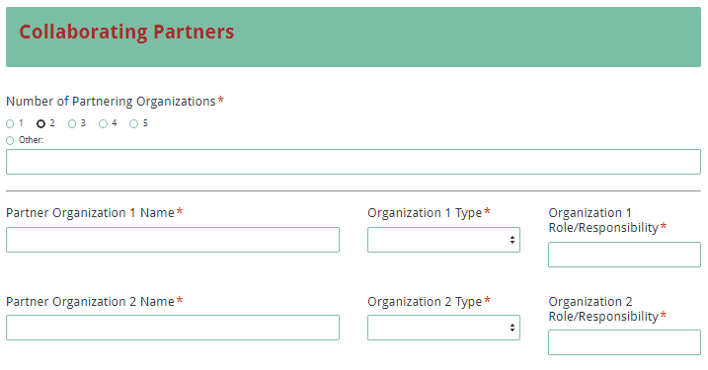
If there are more than five partners, indicate the total number of partners in the “other” field. Then complete the information fields for the five primary collaborating organizations that are investing the greatest amount of resources (staffing, facilities, additional funding, etc.) and provide information for the additional partners (i.e., official name, type of organization, and role and responsibility) in the text box that will be displayed at the bottom of this section.
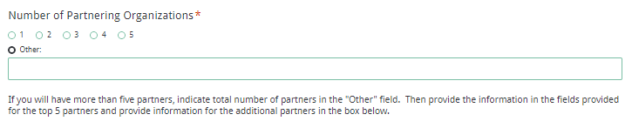
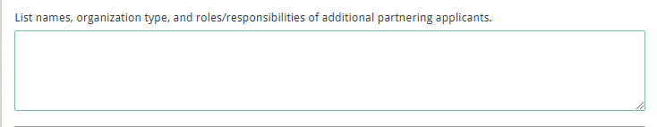
Choose the number of school districts to be served through this program.
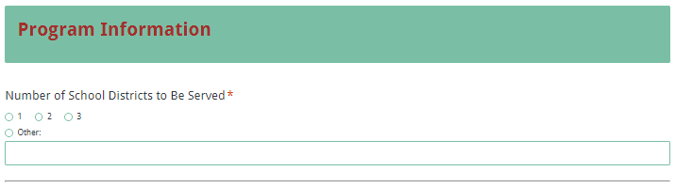
Enter the full formal name for each school district and select the number of schools to be served in each district. Enter the formal name of each school.

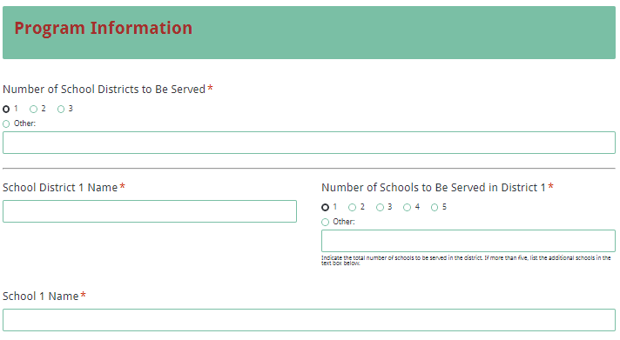
If proposing to serve more than three school districts, use the text box at the end of the section to provide the district name(s) and school name(s) to be served.

Provide details on the overall SRC CPG program, including the number of students to be served and the beginning and ending dates for the summer camps. Indicate the days of the week, total hours per week, total hours per day, and number of weeks the SRC will operate.
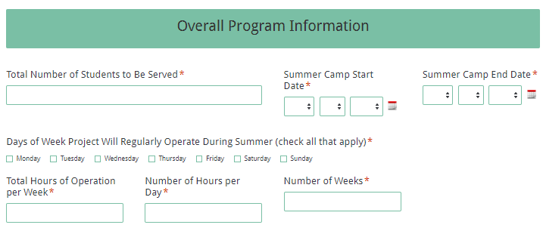
Indicate the activities to be offered throughout the program by checking all applicable boxes. For activities to be offered that are not in this list, select the “Other” option and enter a description.
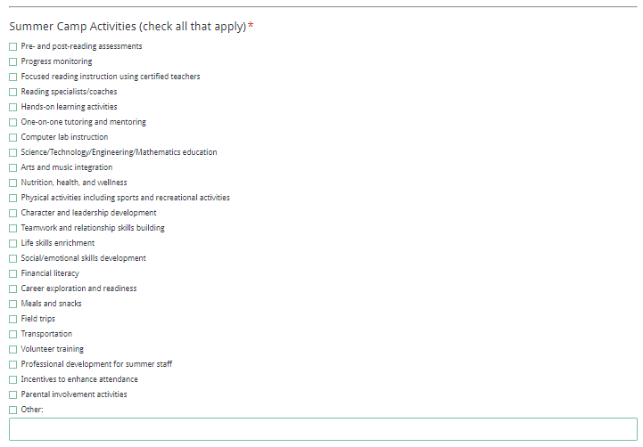
Select the number of proposed sites (up to four) for the program. To propose to serve more than four sites, select Other and enter the total number of sites. Click the next button to proceed.
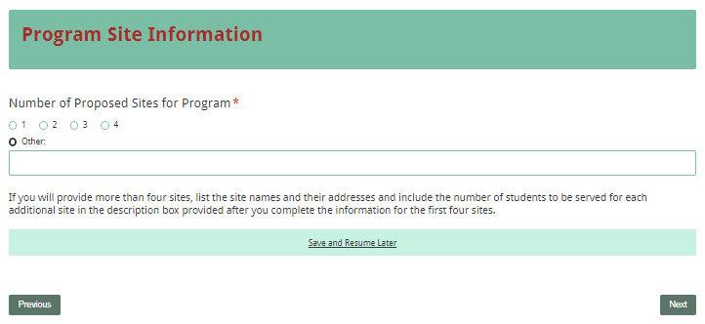
Separate information fields will display for each site based on the number of sites selected. For each site, indicate whether or not an after-school program currently operates there and provide the site address and contact person with phone and email address. Include the number of students to be served, the schools those students attend, and the days and hours of operation for each week. If the site is not at a school, provide the distance in miles from the school that participating students attend.
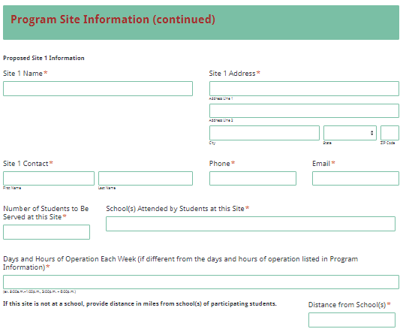
If proposing to serve more than four sites, populate the first four sites as indicated above and use the text box at the end of this section to provide the additional site names and addresses and the number of students to be served at each additional site.
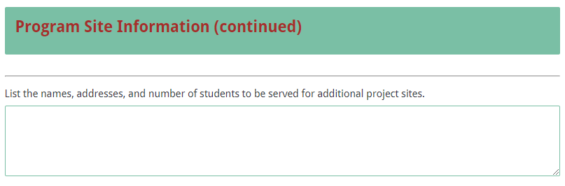
Provide the total grant funds requested and the total program costs. The total program costs can include other sources of in-kind/matching funds to be provided by the program partners.
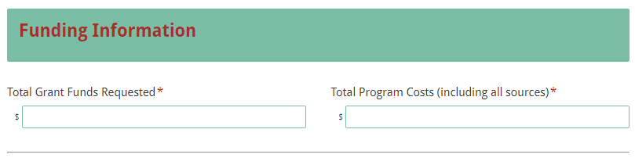
Include an overall budget breakdown by budget category for grant funds requested and other resources. The totals in this section must match the totals in the funding information section.
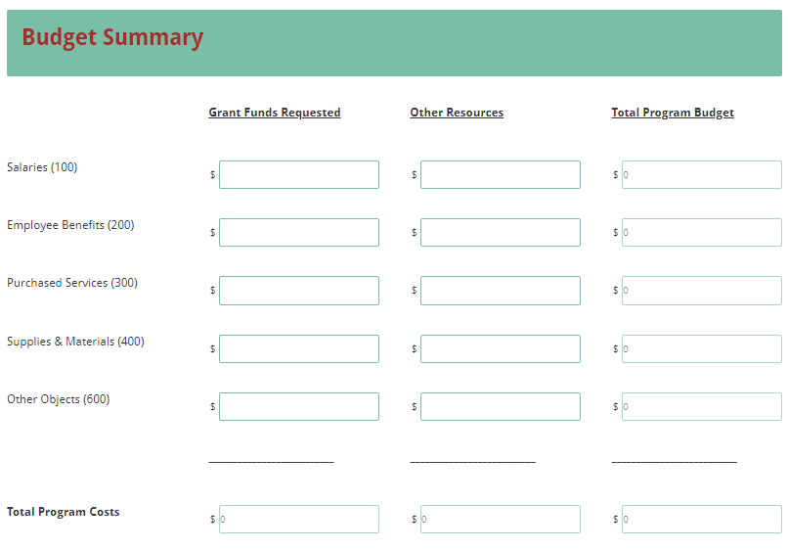
Prepare each proposal attachment (i.e., the Program Summary, the Proposal Narrative, the Budget Narrative, and the Appendices) following the instructions provided earlier. Save each attachment in the proper format, either a PDF or Excel document. Pay close attention to attachments that must be combined into a single document. The online application will only allow one document to be uploaded for each attachment.

Upload the attachments where indicated in the following screenshot. All attachments are required; you will not be able to submit the application without uploading all four documents.
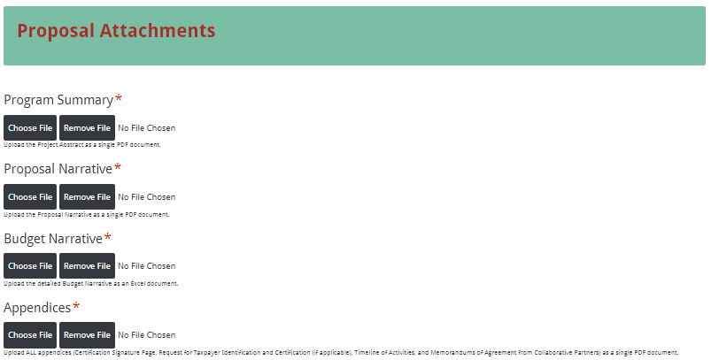
Thoroughly and carefully review the Data Review and Confirmation Page to verify that the information has been entered correctly in the online application prior to submitting. You will not be able to access the completed application form after it has been submitted so it is very important to ensure that all the information in the application has been entered correctly.
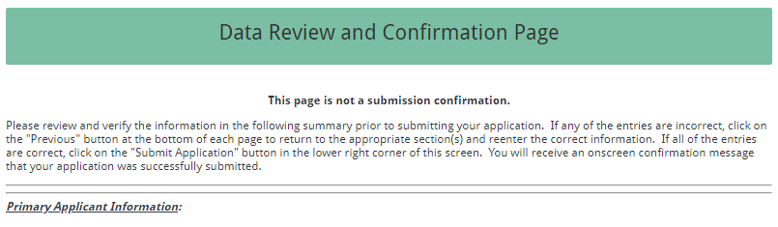
If any entries are incorrect, click the "Previous" button at the bottom left corner of each screen to return to the appropriate section(s) and correct the information. Then click the “Next” button in the lower right corner of each screen to return to the Data Review and Confirmation Page. This page is not a confirmation that the application has been submitted.

Once all entries are correct, click the “Submit Application” button in the lower right corner of this screen to complete the submission process.
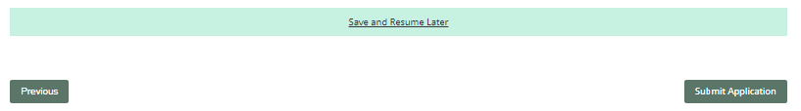
Once the application is submitted, the following message will be displayed on the screen.
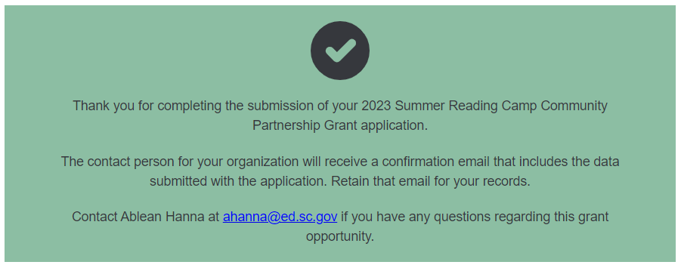
The following confirmation email will be sent to the email address provided for the contact person. If the contact person does not receive the confirmation email, then the application did not successfully transmit. You must go back and resubmit the entire online form, including all attachments, for your application to be considered for funding. Only the most recently submitted application will be reviewed.
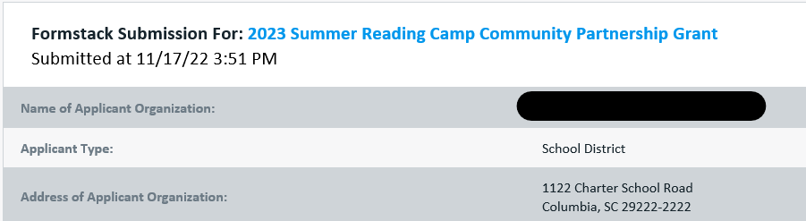
A confirmation email only notifies you that the online grant application has been submitted and received. The email confirmation that the application was successfully submitted does not account for the quality of the uploaded documents or the completeness of the online application form. Applicants are responsible for ensuring that the information entered in the online form, including all attachments, is accurate and complete in order for the application to be reviewed and considered for funding.

Appendix A: Definitions of Terms Used

Collaborative Partner—An organization that provides routine, regular, and ongoing services to the program as outlined in a signed memorandum of agreement (e.g., the regular use of facilities and equipment, mentors/tutors). A collaborative partner plays a critical role in sustaining the program as grant funds decrease.

Memorandum of Agreement (MOA)—A document signed by the authorized representative(s) of each collaborative partner that clearly specifies the role, services, contribution, expertise, and funding for each partner.

Primary Applicant—The organization that serves as the fiscal agent for the proposed program. The primary applicant is responsible for the programmatic and fiduciary management of the grant.

Because of the fiscal requirements, the SCDE strongly recommends that the primary applicant be a school district with a chief business official who is familiar with state requirements.

Reading Proficiency—The ability of students to meet state reading standards in kindergarten through grade twelve, demonstrated by readiness, formative, or summative assessments.

Summer Reading Camp—An educational program offered in the summer by each local school district or consortia of school districts for students who are unable to comprehend grade-level texts and who qualify for mandatory retention.

Third-Grade Reading Proficiency—The ability to read grade-level texts by the end of a student’s third grade year as demonstrated by the results of state-approved assessments administered to third grade students or through other assessments.

Appendix B: Selection Criteria and Reviewers’ Scoring Rubric

Selection Criteria

A total of 100 points is available to applications that meet all of the selection criteria.

The point values for each section of the application are as follows:
Narrative Sections | Points Available
Statement of Need | 10
Goals and Objectives | 30
Strategies and Activities | 30
Management | 15
Evaluation | 15
TOTAL | 100

Each section of the Proposal Narrative will be assigned a score using the following rubric that summarizes the required elements of the Proposal Narrative and includes the point ranges assigned to each section.

The scoring system is used to indicate how well an application meets the funding criteria for the SPC CPG program.

Scoring Criteria
Program Summary: The applicant must, in one page, concisely describe the community partnership, the proposed number of students to be served by the Summer Reading Camp Community Partnership Grant (SRC CPG) program, the documented need for the program, the goals and objectives of the proposed program, and the amount of funding requested.
The applicant provides a one-page summary that concisely describes the  - community partnership,  - proposed number of students to be served by the SRC CPG program,  - documented need for the program,  - goals and objectives of the proposed program, and  - amount of funding requested. | Acceptable | Adequate/Meets—0 points  Applicant provides a narrative that fully addresses all required items.
 | Not Acceptable | Inadequate—0 points  Applicant provides a narrative that does not adequately address all required items.
Reviewer’s Comments
1. Statement of Need: The applicant must provide a clear, factual, and compelling statement of the need or problem, who and how many are affected, what will happen if the need is not addressed or the problem is not resolved, and how the program being proposed meets the needs identified. The applicant also must explain the needs assessment process and its findings, including the involvement of the collaborative partner(s) in the needs assessment process; the needs of the community; the needs of the school(s); the needs of the students to be served, including any specific student data pertaining to the needs to be addressed; and the needs of the students’ families to be served.
The applicant provides a clear, factual, and compelling statement of the need or problem, including all of the following:  - who and how many are affected,  - what will happen if the need is not addressed or the problem is not resolved,  - how the program being proposed meets the needs identified, and  - an explanation of the needs assessment process and its findings, including |  |  | Acceptable | Fully Meets—9–10 points  Applicant provides a narrative that fully addresses all required items.
 |  |  | Acceptable | Adequate/Meets—6–8 points  Applicant provides a narrative that moderately addresses all required items.

- the involvement of the collaborative partner(s) in the needs assessment process;  - the needs of the community;  - the needs of the school(s);  - the needs of the students to be served, including any specific student data pertaining to the needs to be addressed; and  - the needs of the students’ families to be served. |  |  | Not Acceptable | Limited/Approaches—2–5 points  Applicant provides a narrative that is limited or unclear in addressing all required items.
 |  |  | Not Acceptable | Inadequate—0–1 point  Applicant provides a narrative that does not adequately address all required items.
Reviewer’s Comments
2.a. Goals: The applicant must present a clear goal or goals that align with the purpose and statutory requirements of this SPC CPG, such as documenting regular participation and improved reading abilities of students, promoting consistent attendance of students, incorporating both instructional and hands-on learning experiences, involving trained tutors and volunteers, and administering pre- and post-reading assessments of all participants.
The applicant presents a clear goal or goals that is (are) aligned with the purpose and statutory requirements of this SPC CPG such as  - documenting regular participation and improved reading abilities of students;  - promoting consistent attendance of students;  - incorporating both instructional and hands-on learning experiences;  - involving trained tutors and volunteers; and  - administering pre-and post-reading assessments of all participants. | Acceptable | Fully Meets—14–15 points  Applicant provides a narrative that fully address all required items.
 | Acceptable | Adequate/Meets—9–13 points  Applicant provides a narrative that moderately address all required items.
 | Not Acceptable | Limited/Approaches—3–8 points  Applicant provides a narrative that are limited or unclear in addressing all required items.
 | Not Acceptable | Inadequate—0–2 points  Applicant provides a narrative that does not adequately address the required items.
Reviewer’s Comments

2.b. Objectives: The applicant must clearly state objectives related to the goal(s) for the proposed SPC CPG program and describe who and how many will be served or affected by the proposed program, what changes will occur within the target population, and the anticipated outcomes for students by the end of the grant period.
The applicant provides a narrative that clearly states objectives related to the goal(s) for the proposed SPC CPG program and describes:  - who and how many will be served or affected by the proposed program;  - what changes will occur within the target population; and  - the anticipated outcomes for students by the end of the grant period. | Acceptable | Fully Meets—14–15 points  Applicant provides a narrative that fully address all required items.
 | Acceptable | Adequate/Meets—9–13 points  Applicant provides a narrative that moderately address all required items.
 | Not Acceptable | Limited/Approaches—3–8 points  Applicant provides a narrative that are limited or unclear in addressing all required items.
 | Not Acceptable | Inadequate—0–2 points  Applicant provides a narrative that does not adequately address all required items.
Reviewer’s Comments
3.a. Strategies: The applicant must provide a clear, concise description of the scientifically or evidence-based strategies that will be used to maximize student learning; the rationale for selecting these strategies; and an explanation of how these strategies align with the program’s goals and objectives and how they will help students increase their reading levels.
The applicant provides a clear, concise description that includes:  - the scientifically or evidence-based strategies to be used to maximize student learning;  - the rational for selecting these strategies; and  - an explanation of how these strategies align with the program’s goals and objectives and how they will help student increase their reading levels. |  |  | Acceptable | Fully Meets—14–15 points  Applicant provides a narrative that fully addresses all required items.
 |  |  | Acceptable | Adequate/Meets—9–13 points  Applicant provides a narrative that moderately addresses all required items.

 | Not Applicable |  | Limited/Approaches—3–8 points  Applicant provides a narrative that is limited or unclear in addressing all required items.
Inadequate—0–2 points
Applicant provides a narrative that does not adequately address all required items.
Reviewer’s Comments
3.b. Activities: The applicant must provide a clear, concise description of the program activities that will be provided for students; the rationale for selecting these activities; and how the activities are expected to improve student academic achievement and achieve other stated objectives. The applicant must include a Timeline of Activities that thoroughly details when each program activity begins and ends, how each activity relates to a specific objective, and who is responsible for overseeing the activity.
The applicant provides a clear, concise description of  - the program activities that will be provided for students;  - the rationale for selecting these activities;  - how the activities are expected to improve student academic achievement and achieve other stated objectives; and  includes a Timeline of Activities that thoroughly details  - when each program activity begins and ends,  - how each activity relates to a specific objective, and  - who is responsible for overseeing each activity. |  | Acceptable |  | Fully Meets—14–15 points  Applicant provides a narrative that fully addresses all required items.
Adequate/Meets—9–13 points
Applicant provides a narrative that moderately addresses all required items.
 |  | Not Acceptable |  | Limited/Approaches—3–8 points  Applicant provides a narrative that is limited or unclear in addressing all required items.
Inadequate—0–2 points
Applicant provides a narrative that does not adequately address all required items.

Reviewer’s Comments
4. Management: The applicant must outline the plan to manage the program including the chain of command, who will manage the program, the program director’s job description, and the responsibilities for each key staff member. In addition, the applicant must
- explain how the proposed SRC CPG program will be implemented efficiently and effectively;
- provide evidence of successful experience or the capacity to succeed in providing educational and enrichment activities to complement and enhance the academic performance, achievement, and positive development of students and their families (such evidence includes the applicant’s experience in managing and coordinating the types of activities they propose and their ability to perform the required services on time and within budget), and
- include a transportation plan that explains how students will travel safely to and from the program activities and home.
The applicant provides a narrative that clearly  - outlines the plan to manage the program including:  - the chain of command,  - who will manage the program,  - the program director’s job description, and  - the responsibilities for each key staff member;  - explains how the proposed program will be implemented efficiently and effectively;  - provides evidence of successful experience or the capacity to succeed in providing educational and enrichment activities to complement and enhance the academic performance, achievement, and positive development of students and their families (such as the applicant’s experience in managing and coordinating the types of activities they propose and their ability to perform the required services on time and within budget); and  - include a transportation plan that explains how students will travel safely to and from the program activities and home. | Acceptable | Fully Meets—14–15 points  Applicant provides a narrative that fully details a plan to manage the program that includes all required items.
 | Acceptable | Adequate/Meets—9–13 points  Applicant provides a narrative that moderately details a plan to manage the program that includes all required items.
 | Not Acceptable | Limited/Approaches—3–8 points  Applicant provides a narrative that is limited or unclear in detailing a plan to manage the program that includes all required items.
 | Not Acceptable | Inadequate—0–2 points  Applicant provides a narrative that does not adequately detail a plan to manage the program that includes all required items.

Reviewer’s Comments
5. Evaluation: The applicant must describe the plan to evaluate the program’s outcomes with an analysis of how well the program worked to achieve its goal(s) and objectives.
The applicant provides a narrative that describes the plan to evaluate the program’s outcomes with an analysis of how well the program worked to achieve its goal(s) and objectives. | Acceptable | Fully Meets—14–15 points  Applicant provides a narrative that fully describes all required items.
 | Acceptable | Adequate/Meets—9–13 points  Applicant provides a narrative that moderately describes all required items.
 | Not Acceptable | Limited/Approaches—3–8 points  Applicant provides a narrative that is limited or unclear in describing all required items.
 | Not Acceptable | Inadequate—0–2 points  Applicant provides a narrative that does not adequately describe all required items.
Reviewer’s Comments

Appendix C: Required SCDE Forms

Certification Signature Page
(This form must be signed by the individual from each proposed district, school, or organization who holds the title listed below.)

Certification
I hereby certify that, to the best of my knowledge, the information and data contained in this application are true and correct. The applicant’s governing body has duly authorized this application and documentation, and the applicant will comply with the Program Specific Assurances (if applicable) and the SCDE Assurances and Terms and Conditions if the grant is awarded. The applicant is registered and current (active) on the federal System for Award Management (SAM).

Authorized Official or Superintendent Information
Name:
Position: | Email:
Telephone: | Fax:

Signature of Authorized Official: | Typed name of Authorized Official:
Date Signed:
Signature of Financial Official: | Typed Name of Financial Official:
Date Signed:

Please complete, print, and obtain signatures prior to submission. Include the signed, scanned form in the required appendices as indicated on page 28.

SCDE Assurances and Terms and Conditions for State Awards

For informational purposes only
The applicant certifies to abide by the SCDE Assurances and Terms and Conditions by signing and submitting the Certification Signature Page.

I certify that this applicant:
- Has the legal authority to apply for state assistance and the institutional, managerial, and financial capability (including funds sufficient to pay the nonstate share of project costs) to ensure proper planning, management, and completion of the project described in this application.
- Will give the South Carolina Department of Education (SCDE) access to and the right to examine all records, books, papers, or documents related to this award and will establish a proper accounting system in accordance with generally accepted accounting principles (GAAP) or agency directives.
- Has an accounting system that includes sufficient internal controls, a clear audit trail, and written cost-allocation procedures as necessary. The financial management systems are capable of distinguishing expenditures that are attributable to this grant from those that are not attributable to this grant. This system is able to identify costs by programmatic year and by budget line item and to differentiate among direct, indirect, and administrative costs. In addition, the applicant will maintain adequate supporting documents for the expenditures and in-kind contributions, regardless of the type of funds, if any, that it makes under this grant. Costs are shown in books or records (e.g., disbursements ledger, journal, payroll register) and are supported by a source document such as a receipt, travel voucher, invoice, bill, or in-kind voucher.
- Will also comply with GAAP as it relates to budgets, budget amendments, and expenditure claim submissions.
- Will approve all expenditures, document receipt of goods and services, and record payments on the applicant’s accounting records prior to submission of reimbursement claims to the SCDE for costs related to this grant.
- Will initiate and complete work within the applicable time frame after receipt of approval by the SCDE.
- Will not discriminate against any employee or applicant for employment because of race, color, religion, age, sex, national origin, or disability. The applicant will take affirmative action to ensure that applicants for employment and the employees during the period of their employment are treated without regard to their race, color, religion, age, sex, national origin, or disability.
- Will comply with the Ethics, Government Accountability, and Campaign Reform Act (S.C. Code Ann. § 2-17-10 et seq. and § 8-13-100 et seq. (Supp. 2021)).
- Will comply with the Drug Free Workplace Act (S.C. Code Ann. § 44-107-10 et seq. (Supp. 2021)) if the amount of this award is $50,000 or more.

Terms and Conditions

- Completeness of Proposal. All proposals should be complete and carefully worded and must contain all of the information requested by the South Carolina Department of Education (SCDE). If you do not believe a section applies to your proposal, please indicate that fact.
- Non-awards/Termination. The SCDE reserves the right to reject any and all applications and to refuse to grant monies under this solicitation. If the SCDE rejects an application, the applicant has a right to request a review of the process consistent with the appeals process presented in the Request for Proposals (RFP).
After it has been awarded, the SCDE may terminate a grant by giving the grantee written notice of termination. In the event of a termination after award, the SCDE shall reimburse the grantee for expenses incurred up to the notification of termination. In addition, this grant may be terminated by the SCDE if the grantee fails to perform as promised in its proposal.
Upon the termination of a grant, the grantee shall have the right to a review process. The grantee must notify the SCDE of its request within 30 days of receiving written notice of the termination.
- Reduction in Budgets and Negotiations. The SCDE reserves the right to negotiate budgets with potential grantees. The SCDE may, at its sole discretion, determine that a proposed budget is excessive and may negotiate a lower budget with the applicant. The applicant may at that time negotiate or withdraw its proposal. In addition, the SCDE may desire to fund a project but not at the level proposed. In that case, the SCDE shall notify the applicant of the amount that can be funded, and the applicant and the SCDE shall negotiate a modification to the proposal to accommodate the lower budget. All final decisions are that of the SCDE.
- Amendments to Grants. Amendments are permitted upon the mutual agreement of the parties and will become effective when specified in writing and signed by both parties.
- Use of Grant Funds. Funds awarded are to be expended only for purposes and activities covered by the approved project plan, budget, and budget narrative.
- Submission of Expenditure Reports. Claims for reimbursement must be made at least quarterly and consistent with calendar quarters (e.g., an expenditure report claim for costs for January 1 through March 30 must be filed by May 15).
- Obligation of Grant Funds. Grant funds may not be obligated prior to the effective date or subsequent to the end or termination date of the grant period. No obligations are allowed after the end of the grant period. The final request for expenditure report claims must be submitted no later than forty-five (45) days after the end of the grant period unless the scope of work for the grant states a shorter reporting period.
- Deobligation of Funds. After a final expenditure claim has been submitted to the SCDE, the grantee will go through the official deobligation process with the SCDE.
- Documentation. The grantee must provide for accurate and timely recording of receipts and expenditures. The grantee’s accounting system should distinguish receipts and expenditures attributable to each grant. The grantee must review the memo regarding “Guidelines for Retaining Documentation to Support Expenditure Claims.”
- Travel Costs. Travel costs, if allowed under this solicitation, must not exceed limits noted in the United States General Services Administration (GSA) per diem rates for lodging, except in the case of conference lodging required for program-required training. In the case that conference-related lodging exceeds the GSA per diem rate, the grantee shall follow their entity’s written procedure for obtaining prior approval to exceed a GSA rate for a conference hotel. Meals and incidentals are limited by the state budget proviso, currently not to exceed $35 per day for in-state travel and $50 for out-of-state travel (see page 81 of the State of South Carolina Statewide Disbursement Regulations). Mileage reimbursement must follow the current Office of Comptroller General instructions, which is consistent with the published IRS rates.
- Honoraria. Amounts paid in honoraria, if allowed under this grant, must be consistent with SCDE policies. Applicants should check with the program office before budgeting for honoraria.
- Reports. The grantee shall submit, as required or instructed by the awarding program office, all reports (programmatic, financial, or evaluation) within the specified period or date and in the prescribed format. An expenditure claim report must be filed by July 5 for all expenditures incurred by June 30 in order to comply with the generally accepted accounting principles (GAAP) and the production of the State's Comprehensive Annual Financial Report.

- Copyright. The grantee is free to copyright any books, publications, or other copyrightable materials developed in the course of this grant. However, the SCDE reserves a royalty-free, nonexclusive, and irrevocable license to reproduce, publish, or otherwise use, and to authorize others to use, the copyrighted work developed under this grant.
- Certification Regarding Suspension and Debarment. By submitting an application, the applicant certifies, to the best of its knowledge and belief, that the
- Applicant and/or any of its principals, subgrantees, or subcontractors
  - are not presently debarred, suspended, proposed for debarment, or declared ineligible for the award of contracts by any state or federal agency; have not, within a three-year period preceding this application, been convicted of or had a civil judgment rendered against them for commission of fraud or a criminal offense in connection with obtaining, attempting to obtain, or performing a public (federal, state, or local) contract or subcontract; violation of federal or state antitrust statutes relating to the submission of offers; or commission of embezzlement, theft, forgery, bribery, falsification or destruction of records, making false statements, tax evasion, or receiving stolen property; and
  - are not presently indicted for, or otherwise criminally or civilly charged by a governmental entity with, commission of any of the offenses enumerated above.
- Applicant has not, within a three-year period preceding this application, had one or more contracts terminated for default by any public (federal, state, or local) entity.
- Audits. Although this Assurances, Terms, and Conditions document is for a state award, federal audit requirements apply as follows:
- Entities expending $750,000 or more in federal awards:
Entities that expend $750,000 or more in federal awards during the fiscal year are required to have an audit performed in accordance with the provisions of 2 CFR Part 200.501, et seq. Except for the provisions for biennial audits provided in 2 CFR Part 200.504 (a) and (b), audits must be performed annually as stated at 2 CFR Part 200.504. A grantee that passes through funds to subrecipients has the responsibility of ensuring that federal awards are used for authorized purposes in compliance with federal program laws, federal and state regulations, and grant agreements. The director of the OMB, who will review this amount every two years, has the option of revising the threshold upward.
- Entities expending less than $750,000 in federal awards:
Entities that expend less than $750,000 in a fiscal year in federal awards are exempt from the audit requirements in 2 CFR Part 200.504. However, such entities are not exempt from other federal requirements (including those to maintain records) concerning federal awards provided to the entity. The entity’s records must be available for review or audit by the SCDE and appropriate officials of federal agencies, pass-through entities, and the General Accounting Office (GAO).
- Records. The grantee shall retain grant records, including financial records and supporting documentation, for a minimum of six (6) years after the end date of the grant when the final expenditure report claim for reimbursement and all final reports have been submitted, unless informed otherwise or in case of litigation.
- Electronic Signature Agreement. I agree that my electronic signature is the legally binding equivalent to my handwritten signature.

General Appropriations Act, Proviso 1.57 Summer Reading Camps

1.56. (SDE: Summer Reading Camps) For the current fiscal year, funds appropriated for summer reading camps must be allocated as follows: (1) up to twenty percent to the Department of Education to provide bus transportation for students attending the camps; (2) $700,000 allocated to the department to provide grants to support community partnerships whereby community organizations shall partner with local school districts to provide enrichment activities as part of after school programs or summer reading camps that utilize volunteers, mentors or tutors to provide instructional support to struggling readers in elementary schools that have a poverty index of forty percent or greater. All mentors and tutors that are a part of these after school programs or summer reading camps must have passed a SLED criminal background check. Participant to volunteer or teacher ratio must conform to that of the school district in which the program is located; and (3) the remainder on a per pupil allocation to each school district based on the number of students who substantially failed to demonstrate third-grade reading proficiency as indicated on the prior year's state assessment as defined by Section 59-155-120 (10) of the 1976 Code. Summer reading camps must be at least six weeks in duration with a minimum of four days of instruction per week and four hours of instruction per day, or the equivalent minimum hours of instruction in the summer. School transportation shall be provided. The camps must be taught by compensated teachers who have at least an add-on literacy endorsement or who have documented and demonstrated substantial success in helping students comprehend grade-level texts. The Department of Education shall assist districts that cannot find qualified teachers to work in the summer camps. Districts may also choose to contract for the services of qualified instructors or collaborate with one or more districts to provide a summer reading camp. Schools and school districts are encouraged to partner with county or school libraries, institutions of higher learning, community organizations, faith-based institutions, businesses, pediatric and family practice medical personnel, and other groups to provide volunteers, mentors, tutors, space, or other support to assist with the provision of the summer reading camps. In the current school year, any student in third grade who substantially fails to demonstrate third-grade reading proficiency by the end of the school year must be offered the opportunity to attend a summer reading camp at no cost to the parent or guardian. The purpose of the reading camp is to provide students who are significantly below third-grade reading proficiency with the opportunity to receive quality, intensive instructional services and support. A district may also include in the summer reading camps students who are not exhibiting reading proficiency at any grade and may charge fees for these students to attend the summer reading camps based on a sliding scale pursuant to Section 59-19-90, except where a child is found to be reading below grade level in the first, second or third grade. A parent or guardian of a student who does not substantially demonstrate proficiency in comprehending texts appropriate for his grade level must make the final decision regarding the student's participation in the summer reading camp.

Request for Taxpayer Identification Number and Certification
Go to the IRS Web site for an easy-to-complete version of this form.
(To be completed by fiscal agent)
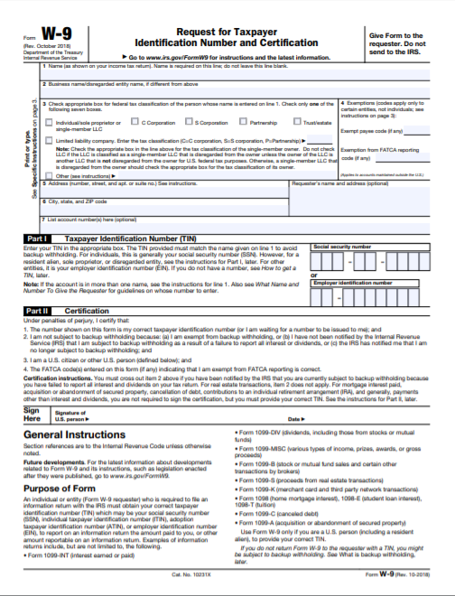

Partnership Identification and Funding Request Form

Name of Applicant:
Name of Program:

Include a Partnership Identification Form for each partner institution/organization.
Name of Partner Institution
Type of Institution/Organization
Primary Contact Information
Name
Title
Complete Address
Telephone |  | Fax
Email

On the form below, list only the funding this partner will receive from the grant.

Direct Cost Requested for Partner | TOTAL
1. Salaries & Wages  (Professional and Clerical) | $
2. Employee Benefits
3. Travel in State
4. Travel Out of State
5. Materials and Supplies
6. Consultants and Contracts
7. Teacher Stipends
8. Equipment (Purchase)
9. Other (Equipment rental, printing, etc.)
Total Funding to Partner From Grant

By signing below, I authorize this institution/organization to participate in this grant program and I certify that the institution/organization is committed to completing the services described in the application and will apply the funds outlined in the budget above to these services.
Signature of Authorized Official |  | Date
Printed Name of Authorized Official

Timeline of Activities Template

Start Date–End Date | Activity to achieve Objective | Related Objective and Goal | Evidence that Proves Activity has been Completed OR Data to be Collected from Activity | Persons/Agency Responsible

Appendix D: Optional Forms

Developing a Plan of Operation for a Project

Grant Design Chart

Goal:
Objectives | Tasks/Activities | Begin/End  Dates | Personnel | Outcomes |  |  | Evaluation | Budget
 |  |  |  | Short | Mid | Long | Evaluation | Budget
A. | A-1:
 | A-2:
B. | B-1:
 | B-2:
C: | C-1:
 | C-2:
D: | D-1:
 | D-2:
 | D-3:

Goals, Objectives, and Outcomes Worksheet

Goal _____:

Objective _____:

Directions
1. Identify a result you expect to achieve through this program.
2. Describe what you will do to achieve this result.
3. What data will you collect to prove that you have achieved this result?
4. Are there target benchmarks for progress toward achieving this result over time?
5. Combine the information from Steps 1-4 into one sentence. (This combined statement is a performance measure)
6. How long will it take to achieve this result?
7. What baseline data will you need to have to measure achievement of this result?

Action Plan Form

Objective:
(Each Objective requires an Action Plan Form)

Strategy | Activity | Result/Measurable Outcome | Timeline | Responsible Agency/Personnel | Budget Needed for Activity

Appendix E: Elementary Schools Ineligible to Apply (Poverty Index below 40 percent)

District | School | Percent in  Poverty
Anderson 1 | Wren Elementary | 36%
Anderson 5 | Midway Elementary | 39%
Beaufort | Coosa Elementary | 38%
Beaufort | Pritchardville Elementary | 39%
Berkeley | Bowen’s Corner Elementary | 35%
Berkeley | Cane Bay Elementary | 35%
Berkeley | Daniel Island School | 10%
Berkeley | Howe Hall AIMS Elementary | 29%
Berkeley | Marrington Elementary School | 18%
Berkeley | Phillip Simmons Elementary | 27%
Charleston | Ashley River Creative Arts Elementary | 30%
Charleston | Belle Hall Elementary | 16%
Charleston | Buist Academy | 21%
Charleston | Carolina Park Elementary | 14%
Charleston | Charles Pinckney Elementary | 14%
Charleston | Drayton Hall Elementary | 38%
Charleston | East Cooper Montessori Charter | 19%
Charleston | Harbor View Elementary | 35%
Charleston | James B. Edwards Elementary | 23%
Charleston | Jennie Moore Elementary | 23%
Charleston | Laurel Hill Primary | 19%
Charleston | Mamie P. Whitesides Elementary | 18%
Charleston | Montessori Community School | 22%
Charleston | Mt Pleasant Academy | 17%
Charleston | Murray-Lasaine Montessori | 36%
Charleston | Orange Grove Charter School | 24%
Charleston | Stiles Point Elementary | 17%
Charleston | Sullivan's Island Elementary | 9%
Charter Institute at Erskine | Belton Preparatory Academy | 39%
Charter Institute at Erskine | Berkeley Preparatory Academy | 37%
Charter Institute at Erskine | Gates School | 25%
Charter Institute at Erskine | The Montessori School of Camden | 35%
Dorchester 2 | Beech Hill Elementary | 29%
Dorchester 2 | Sand Hill Elementary | 38%
Greenville | Augusta Circle Elementary | 13%
Greenville | Bell’s Crossing Elementary | 32%
Greenville | Buena Vista Elementary | 34%
Greenville | Monarch Elementary | 31%
Greenville | Oakview Elementary | 28%
Greenville | Pelham Road Elementary | 34%
Greenville | Rudolph G. Gordon School at Jones Mill | 37%
Greenville | Stone Academy | 34%
Horry | Ocean Bay Elementary | 39%
Horry | Palmetto Academy of Learning and Success | 39%
Lancaster | Harrisburg Elementary | 16%
Lancaster | Indian Land Elementary | 18%
Lancaster | Indian Land Intermediate | 21%
Lancaster | Van Wyck Elementary | 21%
Lexington 1 | Lake Murray Elementary | 29%
Lexington 1 | Meadow Glen Elementary | 24%
Lexington 1 | Midway Elementary | 19%
Lexington 1 | New Providence Elementary | 23%
Lexington 1 | Pleasant Hill Elementary | 27%
Lexington 1 | Rocky Creek Elementary | 33%
Lexington/Richland 5 | Ballentine Elementary | 33%
Lexington/Richland 5 | Chapin Elementary | 30%
Lexington/Richland 5 | Chapin Intermediate | 22%
Lexington/Richland 5 | Irmo Elementary | 32%
Lexington/Richland 5 | Lake Murray Elementary | 18%
Lexington/Richland 5 | Piney Woods Elementary | 35%
Lexington/Richland 5 | River Springs Elementary | 31%
Pickens | Clemson Elementary | 30%
Richland 1 | Brockman Elementary | 21%
Richland 1 | Rosewood Elementary | 34%
Richland 1 | Satchel Ford Elementary | 39%
Richland 2 | Round Top Elementary | 32%
Richland 2 | Muller Road Middle | 38%
SC Public Charter School District | Bridges Preparatory School | 39%
SC Public Charter School District | Cape Romain Environmental Ed. Charter | 34%
SC Public Charter School District | Green Charter School | 27%
SC Public Charter School District | Lakes and Bridges Charter School | 29%
SC Public Charter School District | York Preparatory Academy | 36%
Spartanburg 5 | Reidville Elementary | 37%
Spartanburg 7 | Pine St. Elementary | 32%
York 2 (Clover) | Bethel Elementary | 27%
York 2 (Clover) | Crowders Creek Elementary | 20%
York 2 (Clover) | Griggs Road Elementary | 30%
York 2 (Clover) | Oakridge Elementary | 23%
York 3 (Rock Hill) | Cherry Park School of Language Immersion | 33%
York 4 (Fort Mill) | Doby's Bridge Elementary | 9%
York 4 (Fort Mill) | Fort Mill Elementary | 26%
York 4 (Fort Mill) | Gold Hill Elementary | 18%
York 4 (Fort Mill) | Kings Town Elementary | 15%
York 4 (Fort Mill) | Orchard Park Elementary | 12%
York 4 (Fort Mill) | Pleasant Knoll Elementary | 14%
York 4 (Fort Mill) | River Trail Elementary | 13%
York 4 (Fort Mill) | Springfield Elementary | 28%
York 4 (Fort Mill) | Sugar Creek Elementary | 28%
York 4 (Fort Mill) | Tega Cay Elementary | 14%

