Request for Proposals (RFP)
Application Package

National School Lunch Program Equipment Assistance Subgrant
2022–24 Competitive Subgrant

The Fiscal Year 2022 National School Lunch Program Equipment Assistance Grant is a subgrant program funded by the U.S. Department of Agriculture, authorized by the Consolidated Appropriations Act, 2022, (PL 117-103) and the American Rescue Plan (ARP) Act (PL 117-2) and administered by the South Carolina Department of Education, Assistance Listing Number 10.579 (Child Nutrition Discretionary Grants Limited Availability).

Deadline for Receipt of Applications: 5:00 p.m., January 23, 2023

Technical Assistance for Applicants: December 6 and 8, 2022

For questions about this subgrant, contact:
Diane Gillie, Program Coordinator
803-734-8193, equipmentgrants@ed.sc.gov

Issued by:
South Carolina Department of Education
Office of Health and Nutrition
1429 Senate Street, Suite 701-A
Columbia, SC 29201

TABLE OF CONTENTS

PART I: General Information 1
A. Introduction and Purpose 1
B. Eligible Applicants 2
C. Competitive Priorities 2
D. Timeline of Subgranting Process 2
E. Technical Assistance Sessions for Applicants 2
F. Statutory and Other Requirements 3
G. Authorized Activities 6
H. Unauthorized Activities 6
I. Program Accountability and Monitoring 6
J. Fiscal Operations 9
K. Supplement, Not Supplant 10
L. Review and Selection Process 10
M. Appeals Process 11

PART II: Application Overview, Content, and Instructions 12
A. Application Overview 12
B. Application Narrative Format 12
C. Online Application Submission 13
D. Application Narrative Content 13
1. Needs Statement 13
2. Equipment Acquisition Narrative 13
3. Management and Sustainability 14
E. Application Budget 14
F. Appendices 15
G. Deadline and Submission Procedures 15
H. Screenshots of Online Application Submission Form 16

Appendix A: Definitions of Terms Used 25

Appendix B: Selection Criteria and Reviewers’ Scoring Rubric 26

Appendix C: Required SCDE Forms 33
Certification Signature Page 33
Assurances and Terms and Conditions for U.S. Department of Agriculture Subawards 34
Pre-Award Audit Questionnaire for LEAs and State Agencies 38

PART I: General Information

Introduction and Purpose

The U.S. Department of Agriculture (USDA) has allocated $581,787 from the Fiscal Year (FY) 2022 Consolidated Appropriations Act and $957,461 from the American Rescue Plan (ARP) Act to South Carolina for National School Lunch Program (NSLP) Equipment Assistance subgrants to School Food Authorities (SFA). The South Carolina Department of Education (SCDE) will use a competitive process to award a total of $1,539,248 in equipment assistance subgrants to eligible SFAs that participate in the NSLP.

The purpose of this program is to enable SFAs to serve healthier meals, improve food safety, and to help support the maintenance and/or expansion of the School Breakfast Program (SBP). Any SFA is eligible to receive a subgrant based on the following criteria:
- The age of the food service equipment or lack of appropriate items.
- Ability of food service equipment to increase the efficiency of SFA procurement, food storage, and distribution/service.
- The availability of existing state and local funding for equipment purchases.
- Strategies for adopting lunchroom changes that provide more convenience and appeal to the student.
- Opportunities to realize meaningful impacts on nutrition and quality of meals.

In a competitive subgrant process, the SFA must justify how the requested equipment, with a value of greater than $1,000, will help them serve healthier meals, support scratch cooking, improve food safety, store fresh food, upgrade equipment, and support the maintenance and/or expansion of the SBP.

South Carolina has $1,539,248 available for new subgrants in this funding cycle. The SCDE anticipates awarding approximately 62 subgrants. Award amounts will be determined based on the quality of applications received and total funding requested. No subgrant will be awarded for more than $25,000; the balance for equipment costs exceeding this limit will be the responsibility of the SFA. Final budgets may be negotiated based on demonstrated needs. All subgrant awards are contingent upon total allocations to the SCDE by the USDA.

The subgrant period is April 1, 2022, through September 30, 2024, and is subject to the availability of federal funds and projects meeting all NSLP Equipment Assistance subgrant program requirements.

All funded equipment must be purchased and installed, and funds fully expended by September 30, 2024. The subgrantee may obligate funds upon receipt of the subgrant award notice. However, no funds will be disbursed until after the equipment has been received and installed and all invoices are paid.

Eligible Applicants

Any SFA may apply for a subgrant on behalf of any of its schools/sites that currently participate in the NSLP.

To request funding for more than one school, an SFA must submit a separate application for each school. Schools that received funds for equipment in the previous year are eligible to apply for additional equipment items. However, all schools must meet all reporting requirements and may be subject to a site visit prior to award.

Competitive Priorities

Competitive priorities are not applicable to this subgrant.

Timeline of Subgranting Process

Date | Activity/Action
December 6 and 8, 2022 | Technical assistance sessions
January 23, 2023 | Deadline for receipt of applications
April 2023 | Notification of awards
April 29, 2024 | Deadline for SFAs to obligate funds
September 30, 2024 | Equipment must be installed, and all funds fully expended
November 15, 2024 | Final report due to the SCDE

Technical Assistance Sessions for Applicants

The Office of Health and Nutrition will offer two technical assistance sessions for this funding round to assist all potential applicants with preparing and submitting applications. The first session, Roadmap to a Successful Subgrant, will be held via Adobe Connect on December 6, 2022, from 10:00 a.m. until 11:30 a.m. This session will assist new applicants and previously unfunded applicants with the dos and don’ts for applying for an NSLP Equipment Assistant subgrant.

The second session will provide an overview of the application components and the submission process via Adobe Connect on December 8, 2022, from 10:00 a.m. until 11:30 a.m. This session is highly recommended for all applicants as the application components and submission process has changed this year.

No password is required to join the sessions. Participants should enter their full names when logging into the session. Participants will be able to log in 30 minutes prior to the start of the session to test their equipment’s audio and video settings and to download/print handouts. While participation is not mandatory in order to apply, it is highly recommended.

Statutory and Other Requirements

The school food service director/supervisor should work with other school/site and SFA personnel (i.e., procurement officer, maintenance director, and finance authority) to assess and determine the equipment needs of the school.

In compliance with 2 CFR Part 200.317-326, SFAs are required to follow all federal, state, and local procurement laws when purchasing equipment with subgrant funds to ensure an open and free competitive procurement for the expenditure of federal funds. The vendor, broker, manufacturer, contractor, distributor, etc. of a product cannot have input into the development of product specifications or procurement specifications and/or advance review of the completed procurement documents or the Requests for Proposals/Contracts as such activities compromise open and free competition.

All equipment procured using subgrant funds must be necessary, reasonable, and allocable. The SFA must ensure that equipment can be procured, delivered, and installed within the subgrant period. Wherever practical, SFAs should use the Statewide Term Contracts for equipment that is reasonable and appropriate to better serve quality meals.

Funds must be tracked and reported separately from other child nutrition funds. Warranty and service agreements should be monitored throughout the life of the equipment. SFAs must ensure that vendors are not on the federal suspension or disbarment list by checking the entity exclusion records at the federal System for Award Management (SAM).

Applicants must propose projects that adhere to the following requirements for the NSLP Equipment Assistance subgrant from statute, federal guidance, and the state.

Applicable Federal Regulations
Applicants should review the following federal regulations, accessible at the electronic Code of Federal Regulations (e-CFR) Web site, which are applicable to the NSLP. Applicants are reminded that, if funded, their programs must comply with these regulations.
- 2 CFR Part 25—Universal Identifier and System for Award Management
- 2 CFR Part 170—Reporting Sub-award and Executive Compensation Information
- 2 CFR Part 175—Award Term for Trafficking in Persons
- 2 CFR Part 180—OMB Guidelines to Agencies on Government-wide Debarment and Suspension (Non-Procurement)
- 2 CFR 200—Uniform Administrative Requirements, Cost Principles, and Audit Requirements for Federal Awards
- 2 CFR 400—Uniform Administrative Requirements, Cost Principles, and Audit Requirements for Federal Awards
- 2 CFR Part 415—General Program Administrative Regulations
- 2 CFR Part 416—General Program Administrative Regulations for Grants and Cooperative Agreements to State and Local Governments
- 2 CFR Part 417—Non-Procurement Debarment and Suspension
- 2 CFR Part 418—New Restrictions on Lobbying
- 2 CFR Part 421—Requirements for Drug-Free Workplace (Financial Assistance)
- 7 CFR Part 3—Debt Management
- 7 CFR Part 16—Equal Opportunity for Religious Organizations
- 41 U.S.C. Section 22—Interest of Member of Congress
- Privacy Act. The subgrantee will follow the rules and procedures of disclosure set forth in the Privacy Act of 1974, 5 U.S.C. 552a, and implementing regulations and policies, with respect to systems of records determined to be subject to the Privacy Act.
- Freedom of Information Act (FOIA). Public access to Federal Financial Assistance records will not be limited, except when such records must be kept confidential and would have been excepted from disclosure pursuant to the “Freedom of Information” regulation (5 U.S.C. 552)
- Duncan Hunter National Defense Authorization Act of FY 2009 (P.L. 110-417)
- Sections 745 and 746 of the Consolidated Appropriations Act, 2017 (P.L. 115-31)
- Sections 738 and 739 of the Agriculture, Rural Development, Food and Drug Administration, and Related Agencies Appropriations Act, 2012 (P.L. 112-55)
- Federal Funding Accountability and Transparency Act (FFATA), September 26, 2006
- Civil Rights Compliance—Title VI of the Civil Rights Act of 1964, Title IX of the Education Amendments of 1972, Section 504 of the Rehabilitation Act of 1973, Age of Discrimination Act of 1975, and the American with Disabilities Act of 1990

USDA Nondiscrimination Statement

In accordance with Federal civil rights law and U.S. Department of Agriculture (USDA) civil rights regulations and policies, the USDA, its Agencies, offices, and employees, and institutions participating in or administering USDA programs are prohibited from discriminating based on race, color, national origin, sex, disability, age, or reprisal or retaliation for prior civil rights activity in any program or activity conducted or funded by USDA.

Persons with disabilities who require alternative means of communication for program information (e.g. Braille, large print, audiotape, American Sign Language, etc.), should contact the Agency (State or local) where they applied for benefits. Individuals who are deaf, hard of hearing or have speech disabilities may contact USDA through the Federal Relay Service at (800) 877-8339. Additionally, program information may be made available in languages other than English.

To file a program complaint of discrimination, complete the USDA Program Discrimination Complaint Form, (AD-3027) found online at: http://www.ascr.usda.gov/complaint_filing_cust.html, and at any USDA office, or write a letter addressed to USDA and provide in the letter all of the information requested in the form. To request a copy of the complaint form, call (866) 632-9992. Submit your completed form or letter to USDA by:

- mail: U.S. Department of Agriculture
Office of the Assistant Secretary for Civil Rights
1400 Independence Avenue, SW
Washington, D.C. 20250-9410;

- fax: (202) 690-7442; or

- email: program.intake@usda.gov.
This institution is an equal opportunity provider. USDA IS AN EQUAL OPPORTUNITY PROVIDER AND EMPLOYER.

Additional information on select governmentwide regulations is presented below:

All subgrant applicants must obtain a unique entity identifier (UEI) by registering in the federal System for Award Management (SAM). The applicant must be registered in SAM prior to submitting their application, maintain their SAM registration throughout the application and award process, and include a valid UEI in the online application.

To register in SAM, visit the Get Started page at SAM.gov for information about registering your entity. If you do not receive confirmation that your SAM registration is complete, please contact SAM.gov. For assistance, see the Federal Service Desk.

Please note that applicant organizations must be registered in the SAM before submitting an application, maintain a publicly searchable SAM registration throughout the application and award process, and include a valid UEI in their application. The SCDE will not make a subaward of federal funds to an applicant until the applicant has complied with the requirements described in 2 CFR 25 to provide a valid UEI and maintain an active SAM registration with current information.

Reporting Subaward and Executive Compensation Information—2 CFR Part 170
The Federal Funding Accountability and Transparency Act (FFATA) of 2006 (Public Law 109–282), as amended by Section 6202 of Public Law 110–252, requires primary grantees of federal grants and cooperative agreements to report information on subgrantee obligations and executive compensation. FFATA promotes open government by enhancing the federal government’s accountability for its stewardship of public resources. This is accomplished by making government information, particularly information on federal spending, accessible to the general public.

Primary grantees, like the SCDE, are required to report actions that obligate $25,000 or more in federal grant funds to first-tier subgrantees. This information must be reported in the governmentwide FFATA Subaward Reporting System (FSRS). In order to access FSRS a current SAM registration is required. A primary grantee and first tier subgrantees must also report total compensation for each of its five most-highly compensated executives. Every primary and first tier subgrantee must obtain a UEI prior to being eligible to receive a grant or subgrant award. Additional information will be provided to subgrant recipients upon award.

Applicants also should review the Assurances and Terms and Conditions for USDA Subawards (on pages 34–37), to ensure that, if awarded a subgrant, they are capable of full compliance, especially with all the referenced federal regulations and state laws, in order to enter into an agreement with the SCDE for this program. For example, in compliance with 2 CFR Part 200.112, applicants must disclose in writing any potential conflict of interest to the SCDE in accordance with the USDA’s conflict of interest policy. A signed Certification Signature Page (see page 33) is required with the grant application and legally binds the applicant to the agency’s Assurances and Terms and Conditions.

Authorized Activities

Funds may be used to purchase new equipment, renovate equipment, and/or replace equipment. Installation costs of school food service equipment is also an authorized activity. SFAs are encouraged, as part of their equipment purchases, to take advantage of the training offered by the companies on how to use their specific equipment. The equipment must enable SFAs to serve healthier meals, improve food safety, and to help support the maintenance and/or expansion of the SBP.

Priority will be given to applicants that address the highest need for the proposed equipment to be purchased by describing in their application:
- The age of food service equipment or lack of appropriate items.
- Ability of food service equipment to increase the efficiency of SFA procurement, food storage, and distribution/service.
- The availability of existing state and local funding for equipment purchases,
- Strategies for adopting lunchroom changes that provide more convenience and appeal to the student.
- Opportunities to realize meaningful impacts on nutrition and quality of meals.

Unauthorized Activities

Funds must not be used to purchase non-commercial equipment or to purchase commercial equipment that is not conducive to the existing kitchen/cafeteria infrastructure. Subgrant funds may not be used for administrative costs. Subgrant funds must not be co-mingled with other program funds.

Program Accountability and Monitoring

The SCDE is responsible for monitoring NSLP Equipment Assistance Subgrant implementation in accordance with the following program accountability requirements:
- Each subrecipient receiving funds through this RFP meets the eligibility requirements for the subgrant described herein, and the applicant has provided all required assurances that it will comply with all program implementation and reporting requirements established through this RFP.
- Each subrecipient receiving funds through this RFP appropriately uses these funds as described in this application package.
- Each subrecipient implements activities funded through this application within the timeline in which the funds provided are to be used.

To fulfill its monitoring responsibilities, the SCDE requires subgrantees to submit appropriate fiscal and program documentation following guidance provided by the SCDE program office. In addition, representatives of the state or federal government may conduct site visits to a selected representative sample of subgrantees. The purpose of these visits is to validate information submitted by applicants and to gather additional information from interviews and observations for monitoring and evaluation purposes.

In compliance with 2 CFR Part 200.205, the SCDE will conduct a pre-award risk assessment of potential subgrantees before a grant award is issued. As a part of this process, each applicant must complete the pre-award audit questionnaire included on pages 38–41 to submit with their application as described on page 15. The SCDE’s Office of Auditing Services will evaluate this questionnaire and may conduct a further evaluation of the applicant’s financial system, internal controls, and policies and procedures. Visit the Office of Auditing Services to access the review process and procedures.

Applicants awarded subgrant funds must satisfy periodic reporting and accountability requirements throughout the term of the subgrant. These requirements address: (1) program accountability; (2) performance reporting; (3) annual budget; (4) monitoring; (5) program evaluation; and (6) technical assistance.

    - Program Accountability
Each subgrantee is responsible for carrying out its responsibilities in accordance with USDA’s NSLP Equipment Assistance Grants program requirements; all applicable statutes, regulations, and programmatic guidance; and its approved subgrant application and work plan. Subgrantees are also required to submit quarterly reports to the SCDE to report on the use of subgrant funds and the progress of subgrant activities.

    - Performance Reporting
Performance reporting requirements include those for both programmatic reporting and fiscal reporting. The subgrantee is responsible for ensuring that all required performance reports are accurate, complete, and submitted on time.

Programmatic Reporting Requirements
Quarterly performance reports must be submitted to SCDE to report progress on equipment purchase and installation. Progress toward achieving subgrant goals and objectives will be monitored throughout the year. The quarterly reports must be submitted to the Office of Health and Nutrition as outlined below.

Reporting Period | Report Due Date
April 1–June 30 | August 15
July 1–September 30 | November 10
October 1–December 31 | February 10
January 1–March 31 | May 10

The final performance report is due September 30, 2024. However, subgrantees may submit the final performance report at the time they complete the acquisition and installation of their equipment.

The following is required of all subgrant recipients, and these requirements are to be reported in the quarterly performance reports in the period the activity occurred:
- Progress made in obligating at the SFA level,
- Accomplishments and challenges in expenditures both obligated and actual purchase,
- The impact of the equipment purchased on the school’s food service operations,
- Reasons for any unliquidated funds,
- Potential return of equipment, and
- Each piece of equipment acquired with subgrant funds is listed with and the school site where installed and put into use.

Fiscal Reporting Requirements
Subgrantees must upload their approved budgets into the SCDE’s grants accounting processing system (GAPS) following the receipt of their subgrant award notifications and prior to submitting any reimbursement requests. SFAs must submit the purchase order, invoice, and proof of payment before the SCDE’s Office of Health and Nutrition will release funds for reimbursement of equipment purchases. All expenditure reports must be submitted through the GAPS. GAPS training will be provided to subgrantees during the subgrantee award meeting.

    - Annual Budget
An annual budget of projected expenditures to be funded by the subgrant must be submitted with the application. Approved budgets must be uploaded into GAPS by subgrantees after the receipt of the grant award notification and before submitting any expenditure reports for reimbursement.

    - Monitoring
The SCDE will monitor each subgrantee by reviewing and approving the quarterly performance reports and the annual performance report. All information included in the reports is subject to verification.

The SCDE may conduct programmatic and financial monitoring site visits. Subgrantees must agree to site visits conducted by SCDE or federal program representatives. The purpose of site visits is to validate information provided in fiscal and program reports and to gather more detailed information on implementation efforts and challenges from interviews and observations for monitoring and evaluation purposes.

The SCDE may require additional information from the subgrantee, verify information with the authorizing agency, or require the submission of additional documentation including, but not limited to, invoices, receipts, and personnel time and effort reports. The SCDE may require that the subgrantee to provide documentation that the requested equipment can be competitively procured in the required timeframe and that the infrastructure—e.g., electricity, drainage, voltage, building code compliance, width of doorway—is conducive for the installation and operation of the equipment.

Prior to a site visit, the subgrantee may be required to submit additional relevant information that will allow the SCDE to conduct a useful, efficient, and effective visit. The SCDE may require electronic submission of documents instead of a paper-copy submission.

The SCDE reserves the right to make post-installation site visits to schools/sites to ensure that any equipment acquired with subgrant funds is installed and in working order in the school/site for which it is requested in the application.

SCDE staff will verify the contents of documentation submitted. Subgrantees may be asked to revise reports when
- non-allowable expenses are found;
- reports are confusing or difficult to understand; or
- there are unexplained discrepancies between the proposed use of subgrant funds, as provided in the annual budget, and actual expenditures found in the submitted documentation.

    - Program Evaluation
Subgrantee Project Monitoring and Evaluation
Subgrantees are required to conduct ongoing monitoring and evaluation to ensure procurement and equipment goals are achieved. Progress toward meeting procurement and equipment goals are to be reported through the quarterly performance reporting process.

The final performance report is to be completed by the end of the subgrant period. The final report must reflect project success toward obtaining and installing all equipment as stated in the application. If a subgrantee fails to conduct the final project evaluation report before the end of the subgrant period, or if any of the performance requirements in section I.2 are not completed, the SCDE may consider the subgrantee a high risk and elect to discontinue funding or disqualify the subgrantee from future funding opportunities.

    - Technical Assistance to Subgrantees
Subgrantees are required to participate in any technical assistance that the SCDE may conduct for the NSLP Equipment Assistance subgrant. Delivery of such technical assistance may include in-person meetings, webinars, and conference calls.

Fiscal Operations

Subgrantees must use subgrant funds for allowable expenditures during the subgrant period. NSLP Equipment Assistance subgrant funds are disbursed on a reimbursement basis. The SCDE will de-obligate any unspent funds remaining at the end of the subgrant period for reallocation to other subgrantees.
Allowable Costs
Subgrants must be used in accordance with statutory and regulatory requirements. Subgrant funds must be used to acquire new equipment, renovate equipment, and/or replace equipment. Installation and training costs of school food service equipment is also allowable.

Unallowable Costs
Subgrantees may not use NSLP Equipment Assistance subgrant funds for any costs that provide for any unauthorized activities described in Section H.

Supplement, Not Supplant

All NSLP Equipment Assistance subgrant funds must supplement existing services and may not be used to supplant federal, state, local, or non-federal funds. NSLP Equipment Assistance subgrant funds may not be used for purchases that do not directly support the approved work plan. If current expenditures are being paid from state or local public funds, the applicant may not propose to replace those funds with subgrant funds.

Review and Selection Process

Only those subgrant applications that are received by the deadline and deemed complete will be forwarded for review and funding consideration. All required materials including forms and appendices must be submitted for the application to be considered complete and eligible for review. Program staff will conduct an initial review of applications for completeness and compliance with the RFP instructions. Incomplete applications will not be forwarded to the reviewers or be considered for funding.

Three reviewers from diverse backgrounds without a vested interest in any applicant being funded will evaluate each application based on the quality of the proposed activities and the capability of the applicant to implement the proposed project. The review team will be comprised of experienced grant readers from various professions and entities, including the SCDE.

Reviewers will use the scoring rubric on pages 26–32 to read and score each application independently. After the three reviewers have individually rated each application, the scores will be averaged. An application can earn up to 100 points for an average score.

Applications will be rank ordered by averaged scores. Subject to the SCDE’s final approval and the availability of federal funds, subgrant awards will be made starting with applications that earned an average score of 80 points or higher. If funds remain following these awards, the SCDE will consider funding remaining applications that earned an average score within the adequate/meets range until all funds are expended.

Prior to making awards, if deemed necessary, the SCDE’s Office of Auditing Services will conduct a pre-award risk assessment. Based upon the results of this assessment, special conditions may be applied to the award that may include requirements for increased monitoring of subgrant activities, and the provision of additional technical assistance. The SCDE reserves the right to interview applicants recommended for funding, request additional documentation, and make a site visit as appropriate to ensure compliance with federal requirements.

The SCDE reserves the right to negotiate final budgets and to disqualify costs associated with any line items that are unallowable, unallocable, unreasonable, or inconsistent with the program’s goals or the proposed project’s activities and strategies.

Awards are not final until an SCDE subgrant award notice is fully executed. Notification of funding will be sent in April 2023 to the authorized official listed on the Certification Signature Page. After the notification of awards, copies of the reviewers’ comments and score sheets will be sent to the contact person identified in the online application.

Appeals Process

An applicant who has submitted a proposal that the SCDE does not fund has 30 calendar days after receiving notification that the proposal is not funded to request a review of the process. Scores may not be appealed; the SCDE will not rescore applications. An unfunded applicant may inquire as to whether or not the application process was followed. The request for review must be directed to the State Superintendent of Education and must state the reasons for the request. The SCDE will conduct a hearing in accordance with the provisions of 7 CFR Part 210.

PART II: Application Overview, Content, and Instructions

Read all guidelines and criteria carefully before preparing your application. Adhere to format and organizational requirements. Only applications that include all sections and appendices and fully adhere to these guidelines will be reviewed and considered for funding. Incomplete applications will not be reviewed.

Application Overview

Applicants are encouraged to prepare all of the following elements of the application before beginning the online submission process. Do not wait until the last minute to submit an application. Use the following overview as a checklist to ensure that the application is complete with items labeled accordingly and presented in the order outlined below. Verify that all narrative components and appendices are included prior to uploading attachments.

The 2022–24 NSLP Equipment Assistance online application is organized into the following sections:

- Online Forms
- School Food Authority Information
- Contact Information
  - Authorized Representative Information
  - SFA Finance Director Information
  - School Food Service Director/Supervisor Information
- Equipment Specifications
- Application Narrative
  - Needs Statement
  - Equipment Acquisition Narrative
  - Management and Sustainability
- Summary of Funds Requested
- Proposal Attachment
- Appendices
  - Certification Signature Page
  - Pre-award Audit Questionnaire

Application Narrative Format

Draft the application narrative based on the instructions provided in Section D below and save to cut and paste into the online application where indicated (see screenshots on page 16). There is no limit to the length of each response. However, be clear and concise when responding to the prompts provided.

Each section must be clearly identified. Sections may not be combined. Reviewers will not consider information requested in one section that is provided in another section. Incomplete applications will not be considered.

Online Application Submission

Applications must be submitted using the online application form. The online submission is organized into two sections—Online Forms and Proposal Attachments.

Provide the primary applicant’s twelve-character alphanumeric UEI and Taxpayer Identification Number (TIN) in the application form. Applicants should contact their organization’s finance office if they need assistance with these items. (See page 3 for more information.)

Use the following instructions to compile and complete all proposal attachments prior to submitting your application. Verify that all components of the narrative and appendices are included prior to uploading attachments. Follow the directions in each section for saving the documents and refer to the screenshot on page 23 for proposal attachment upload locations.

Application Narrative Content

Use the following directions to draft the application narrative and organize it into sections following the sequence presented below. Do not combine sections. Required components must be in their designated sections in order to be scored. There is no limit to the length of each response. However, be clear and concise when responding to the prompts provided.

When complete, save the narrative sections to cut and paste into the online application where indicated in the application narrative section.

Needs Statement (maximum of 30 points available)
- For each piece of equipment proposed, indicate whether the SFA is replacing an existing piece of equipment or purchasing a new piece of equipment that the school/site does not currently have in place.
- If replacing equipment, provide a description of the equipment to be replaced. Include the age of the equipment and the reason for it needing to be replaced, such as not meeting food safety (Hazard Analysis Critical Control Point (HACCP)) requirements, energy efficiency standards, and/or is inoperable or not in use due to standard operating procedures.
- If purchasing new equipment that the school/site does not currently own, explain the need for the new equipment. Needs can include, but are not limited to, meeting food safety (HACCP) requirements, meeting energy efficiency standards, improving standard operating procedures, and/or serving healthier meals.
- Describe the needs assessment process used to identify and determine equipment needs. Include who was involved at the school/site and SFA levels in making the decision and ensuring the equipment can be incorporated into the current school/site cafeteria infrastructure. Provide the names and positions of all involved in identifying the need.

Equipment Acquisition Narrative (maximum of 50 points available)
Provide a description of each new equipment proposed. Explain how the new equipment will support efforts to
  - Help the SFA serve healthier meals:
- Include how the equipment improves the quality of the food prepared and served in ways that support the nutritional standards.
- Describe how the equipment will increase the ability to prepare foods in a healthy manner such as steaming, baking, or grilling.
  - Improve food safety service in the school nutrition programs:
- Include how the food service equipment will increase the efficiency of food service procurement, food storage, and distribution/service.
- Describe how the equipment will decrease cross-contamination risks, improve sanitation, and/or maintain proper temperatures.
  - Help the SFA maintain or expand the SBP:
Describe how the equipment will enable preparation and service of additional meals, increase the variety of entrée choices, improve the nutritional quality of meals, and/or add additional points of service.

Management and Sustainability (maximum of 20 points available)
- Provide the chain of command to include who will be responsible for the subgrant at the SFA level and the school/site level. List the name(s), job title(s), and responsibilities of all responsible for acquiring, administering, and managing the equipment.
- Describe how the equipment acquired through this project will be sustained beyond the subgrant period. Identify who will be responsible for monitoring warranty and service agreements throughout the life of the equipment.
- Provide a Timeline of Activities for each piece of equipment to include acquisition, installation, and initial use. The timeline will be entered online and must include the start and end dates, the activity to acquire, install, or initially use the equipment, the evidence to prove that the activity has been completed, and the person responsible for the activity.

Application Budget

Although the budget is not scored, it remains a critical component of the entire application. No application with an incomplete budget will be funded.

Complete the Equipment Specifications section online (see screenshots and directions on pages 19–20) for each piece of equipment requested. List equipment, with a value greater than $1,000, in order of priority based on need. Provide full cost information, including installation, for each piece of requested equipment. All costs provided must be correct and consistent and that the sum of the costs in the Equipment Specifications section equals the total in the Summary of Funds Requested section of the online application.

The overall application budget should be reflected in the Summary of Funds Requested section of the online application (see the screenshot on page 22). This summary is the financial overview of the project. Each line item of this summary indicates the equipment items(s) for which funds are being requested and the total amount of funding (up to $25,000) for that school.

In compliance with 2 CFR Part 180.300, subgrantees must ensure that they do not enter into a contract with any vendor that is debarred, suspended, or ineligible for participation in federal programs by
- checking the exclusions list at the federal SAM Web site (Note: Applicants are encouraged to review the user guides for exclusions provided via the “Help” page prior to conducting searches.);
- collecting a certification from the vendor and attaching it to the contract; or
- adding a clause or condition to the contract that indicates the vendor is eligible.

Appendices

Scan or save the completed Certification Signature Page and the Pre-Award Audit Questionnaire into a single PDF document to be uploaded into the online application where indicated.

Certification Signature Page
Print the Certification Signature Page (see page 33) and obtain the appropriate signatures. This form includes the certification of the SCDE’s Assurances and Terms and Conditions for USDA Subawards (pages 34–37), so those documents are not required to be included in the application submission. However, retain the copy included in this RFP for your records and ensure that the signatories have copies of each document.

By signing the Certification Signature Page, the signatories assure that they will comply with all the assurance and terms and conditions for the project. All signatories must understand that they are signing a document that is legally binding in the event a subgrant is awarded. Applications that do not include the signed Certification Signature Page will not be reviewed or considered for funding.

Pre-Award Audit Questionnaire
Complete the Pre-Award Audit Questionnaire for LEAs and State Agencies (see pages 38–41). The SCDE’s Office of Auditing Services may review this questionnaire as part of the pre-award risk assessment and may conduct a further evaluation of the applicant’s financial system, internal controls, and policies and procedures.

Deadline and Submission Procedures

- Applications must be submitted using the online application form before 5:00 p.m. on January 23, 2023. No applications will be received after this deadline.
- Only applications that adhere to all guidelines and directions set forth in this RFP will be reviewed and considered for funding.
- No hard copy applications will be accepted. Applications delivered by hand, postal mail, email, or fax will not be accepted.
- Applications must originate from the applicant. Applications that are plagiarized from the Internet, other grants, or other resources will not be considered for funding.
- Subgrants are not transferrable.
- Do not attach or submit any additional materials other than what is specifically required. Any additional materials will be disposed of without review.
- Applications will not be returned. Keep a copy of the entire application for your records.

Screenshots of Online Application Submission Form

The following screenshots are for informational purposes only and are provided to assist applicants in compiling all items needed to complete the online submission. Complete the attachments for the online application as directed in the preceding instructions. The SCDE encourages applicants to prepare all parts of the application before beginning the online submission process.

Make sure all information submitted is accurate, including formal or official names such as the SFA, and that spelling is correct. Do not use abbreviations or acronyms. All fields marked with a asterisk are required; you will not be able to proceed to the next screen of the application without entering all required information.

If necessary, you may save your progress in the online application and return to the form later. Note that you do not have to save your form in order to submit your form. If you are prepared, you can enter and submit an application without having to save the form.

Click on the “Save and Resume Later” link to save your progress. You will click save and get link and have the option of copying and saving the link to the partially completed form or entering an email address to have the link emailed to you. Be sure to enter the email address correctly as SCDE personnel cannot access the hyperlink or the incomplete application. Use the link to access the application from any computer within thirty days to complete the online submission. Without the link and password or after thirty days, the data previously entered cannot be retrieved, and you will have to begin a new application. A saved application is not a submitted application. You must follow all the steps described on pages 23–24 to complete the submission process.

To begin the online application form, enter the official name of the SFA. The name as entered must match the registered UEI name. Enter the SFA’s physical address with the 10-digit ZIP code (ZIP+4), UEI, and TIN. Indicate whether the SFA is registered and active with the SAM.
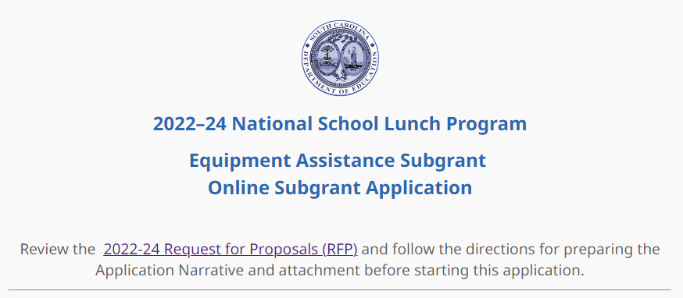
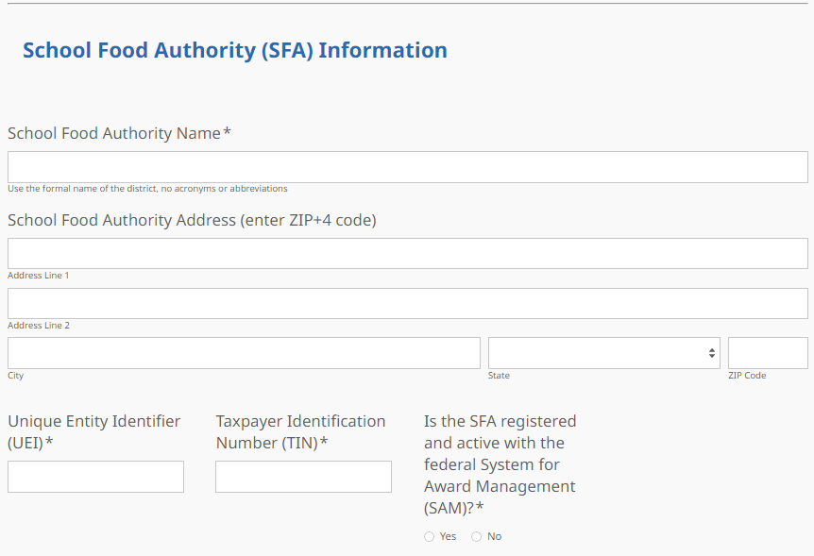
If the SFA does not have an active SAM registration, the following message will be displayed. The SFA should refer to the information on page 5 or visit SAM.gov for more information on how to update the status of their SAM registration.
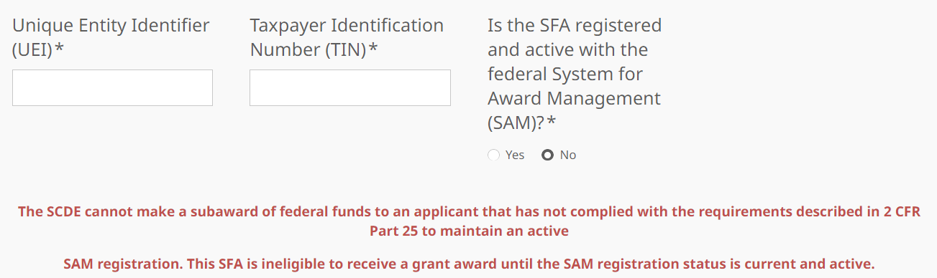
If the SFA selects “Yes” to indicate that their SAM registration is active, enter the date the current SAM registration expires.
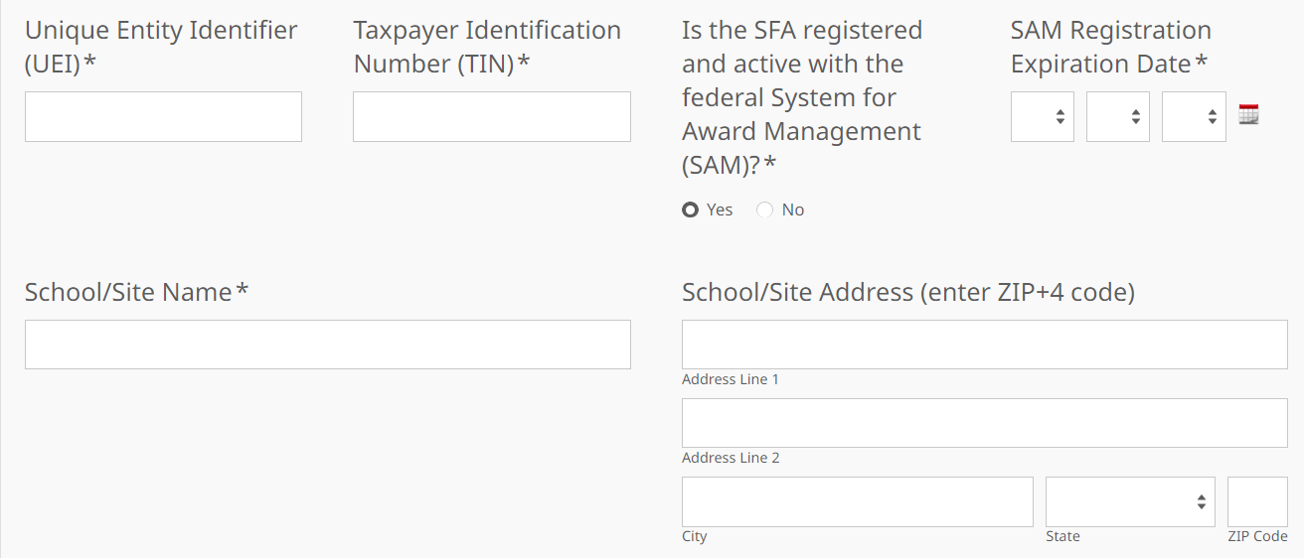
The fields for the school/site’s information will be displayed. Enter the school/site’s name and physical address. If the SFA plans to request funding for more than one school/site, the SFA must complete a separate online application for each additional school/site. Select the number of equipment items the SFA is requesting for the school/site (up to 5 pieces).
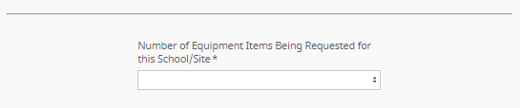
Enter the contact information for the authorized representative (SFA) and the finance director. The names for all contacts entered in the online application must match the names as shown on the Certification Signature Page.
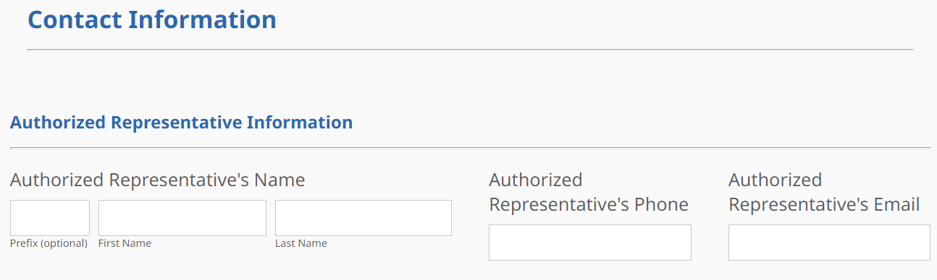
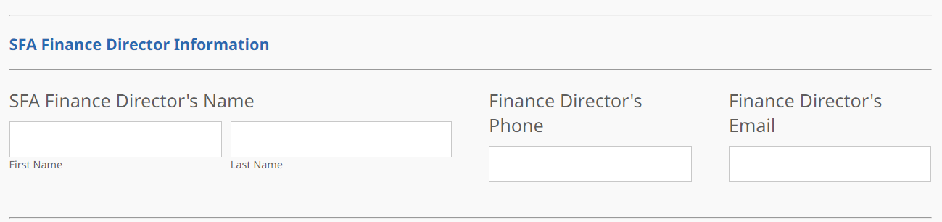
Enter the contact information for the school food service director/supervisor. The school food service director/supervisor’s email is a required field. The confirmation of a successful online application submission will be sent only to this email address. Reenter the email address to confirm that it is correct.
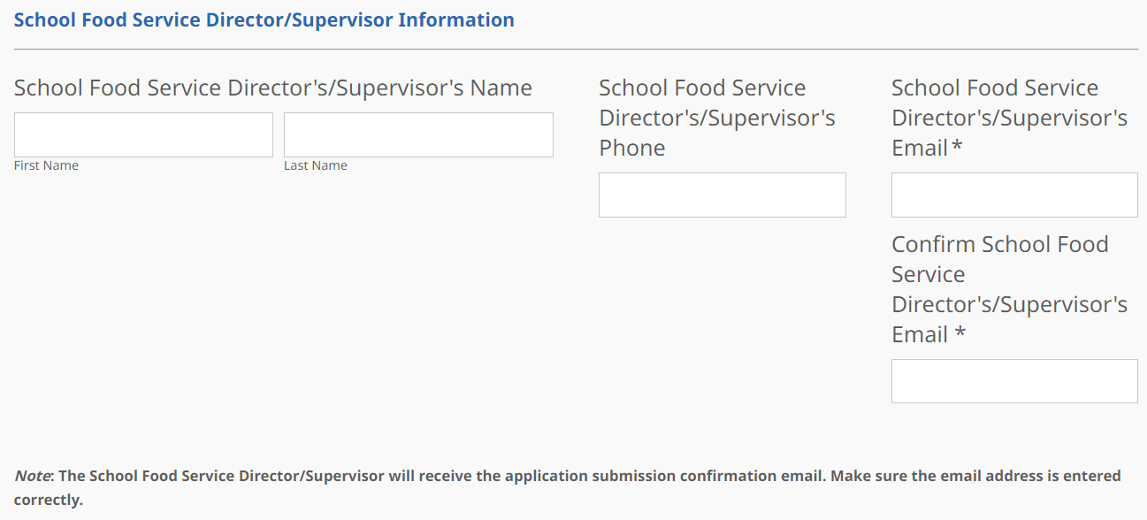
Based on the number of equipment items selected on the first screen, the Equipment Specifications section will display the appropriate number of fields to be completed for each item. Enter a detailed description and estimated cost (including installation) of the equipment item. Indicate if the purchase will be made using the State Contract for Commercial Equipment and if the SFA will accept partial funding for that item.
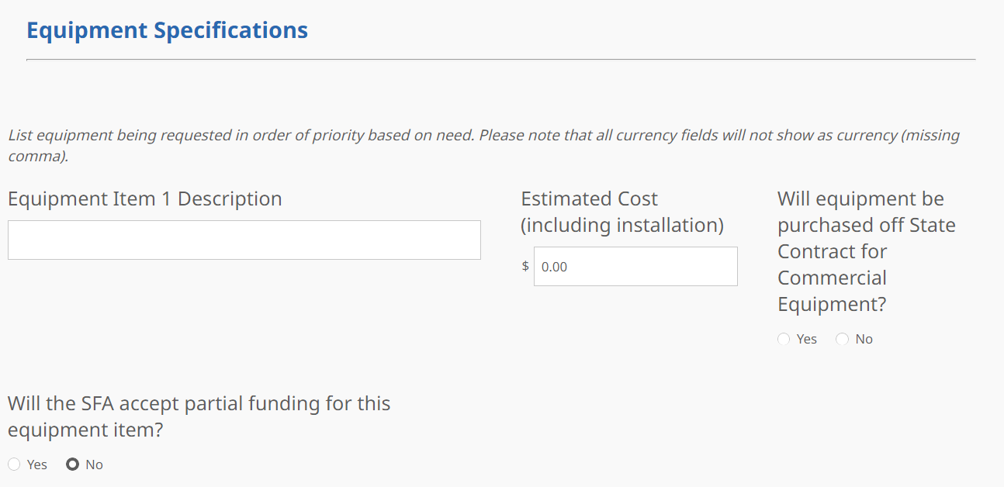
If the SFA will accept partial funding for an item, indicate the minimum amount of funding that will be accepted for the item.
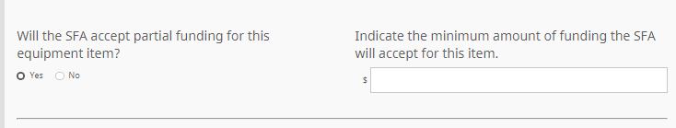
Provide the equipment model number and indicate if the electricity available will be available to suport the equipment.
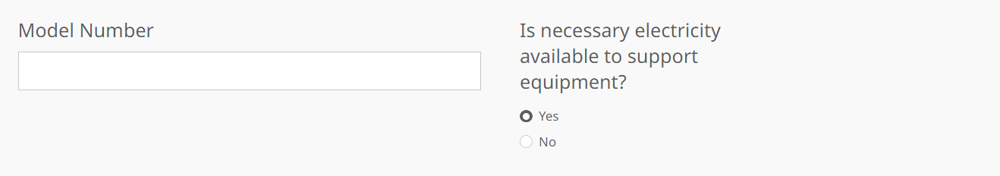
If the electricity available currently does not support the equipment to be purchased, indicate if the SFA has made arrrangements to ensure electrical needs will be met.
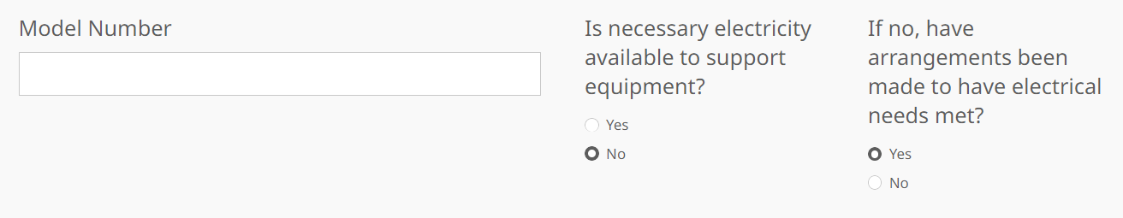
Indicate if the equipment is Energy-star rated, Underwriter Laboratory rated, or National Sanitation Foundation rated. Indicate if this type of equipment is not currently owned by the SFA/site or if it will resplace a current piece of equipment.
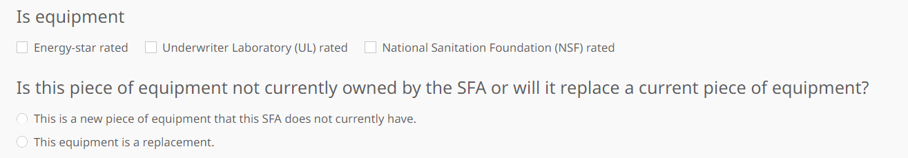
Draft the Application Narrative based on the information provided on pages 12–14 before going online. Save the narrative sections to cut and paste into the online application where indicated in the screenshots below.
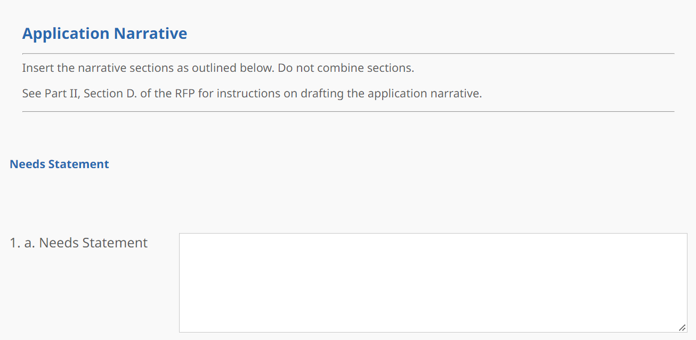
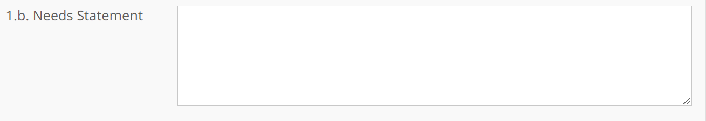
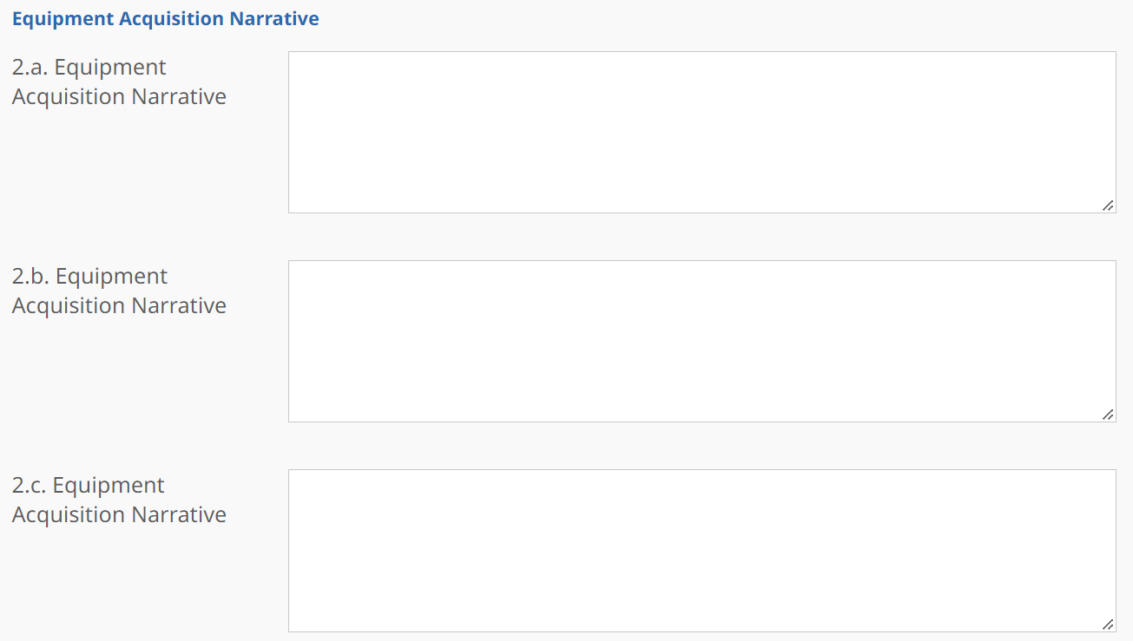
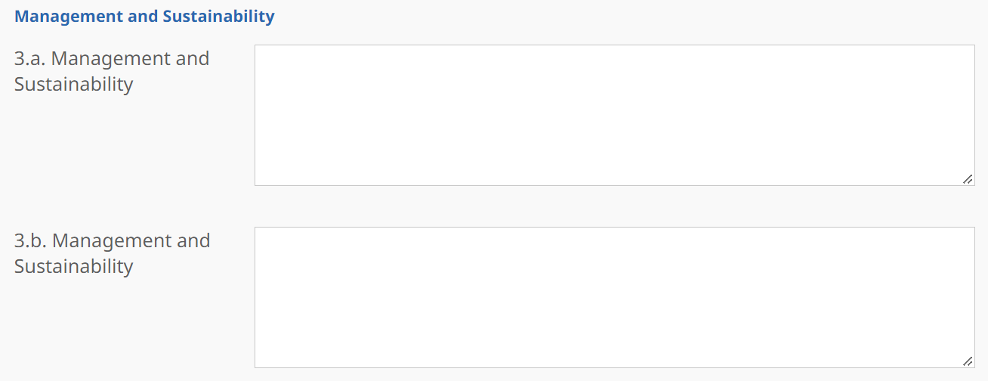
For section 3.c. Management and Sustainability, provide a Timeline of Activities for all of the proposed equipment. Select the number of rows needed for the sites acquisition activities (up to six).

Include in the timeline the acquisition, installation, and initial use for each piece of equipment. Provide the start and end dates, the activity to acquire, install, or initially use the equipment, the evidence to prove that the activity has been completed, and the person responsible for the activity.
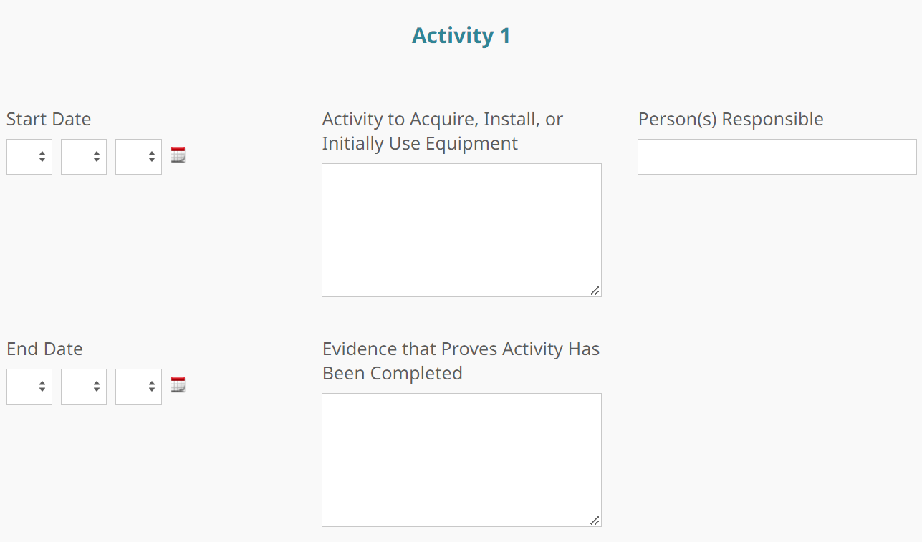
In the Summary of Funds Requested section, click on the box to autofill the equipment descriptions from the previous screen or manually enter the description for each equipment item.

The Total Funds Requested (Per Equipment Item) fields will automatically populate from the estimated costs entered on the previous screen. The Total Funds Requested (All Equipment Items) field will automatically calculate the grand total of the funds being requested.
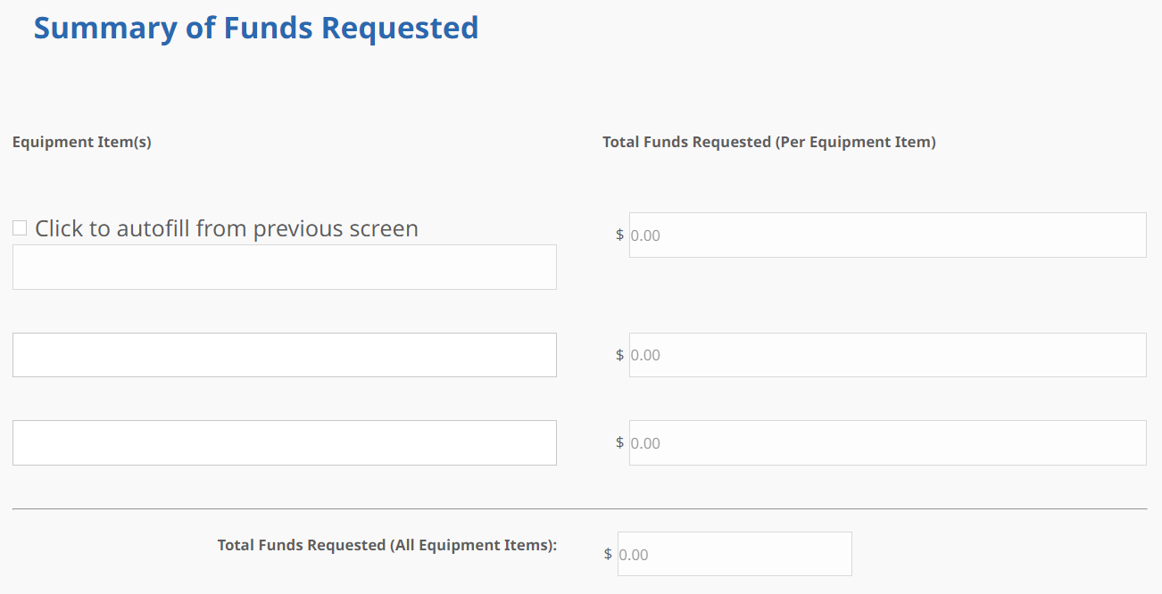
Prepare each of the proposal attachments (i.e., Certification Signature Page and Pre-Award Audit Questionnaire) as directed on page 15. The online application will only allow one document to be uploaded for the attachment. Upload the appendices where indicated in the following screenshot.
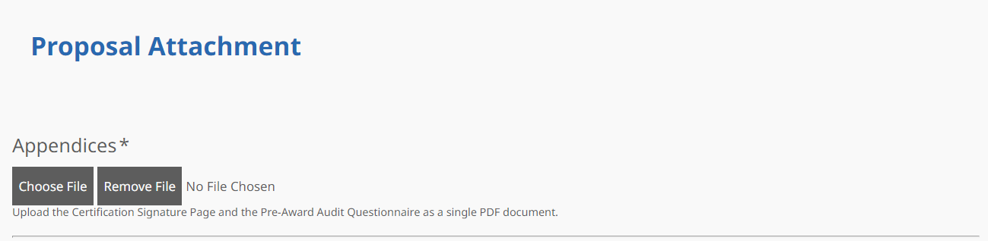
Thoroughly review the Data Review and Confirmation Page to verify that the information has been entered correctly in the online application prior to submitting. You will not be able to access the completed application form after it has been submitted. If any of the entries are incorrect, click on the "Previous" button at the bottom of each page to return to the appropriate section(s) and reenter the correct information.
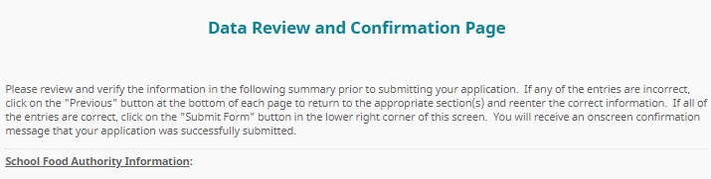
If all entries are correct, click on the “Submit Application” button in the lower right corner of this screen to complete the submission process.
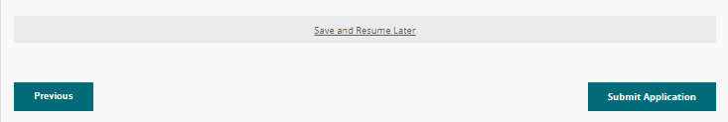
Once the application is submitted, the following message will display on screen.
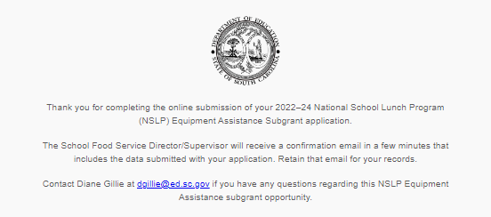
A submission confirmation will be sent to the email address provided for the school food service director/supervisor.
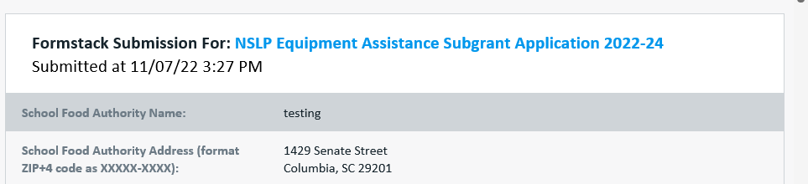
If the SFA director/supervisor does not receive a confirmation email, then the application did not successfully upload. You must resubmit the entire online form, including the attachment, for your application to be considered for funding.

An email confirmation that the subgrant application was successfully submitted does not account for the quality of the uploaded documents or the completeness of the online form. The confirmation email only notifies you that the online application has been submitted. Applicants are responsible for ensuring that the information entered in the online form, including all attachments, is accurate and complete for the application to be reviewed and considered for funding.

Appendix A: Definitions of Terms Used

Charter school—A public school that is independently run and receives greater flexibility over operations in exchange for increased performance accountability. The school is established by a “charter,” which is a performance contract describing key elements of the school. The charter contract describes things like the school’s mission, instructional program, governance, personnel, finance, plans for student enrollment, and how all these are measured.

De-obligation—The downward adjustment of the obligations recorded in a grant award document. It is caused by factors such as (1) termination of part of the project, (2) reduction in material prices, (3) cost savings, or (4) correction of recorded amounts.

Equipment—Articles of nonexpendable, tangible person property having a useful life of more than one year and a per-unit acquisition cost which equals or exceeds the lesser of the capitalization level established by the non-federal entity for financial statement purposes, or $5,000 (see 2 CFR Part 200.33). However, for the FY 2022–24 NSLP Equipment Assistance Subgrants, Congress has specified that the threshold for the purchase of equipment cannot be lower than $1,000.

Private/Parochial school—Any organization that is funded and run by a non-governmental entity or entities. (This includes independent schools.) A private school can be run by a for-profit company, a non-profit company, or a church or diocese or some other non-governmental organization.

Residential Child Care Institution (RCCI)—Any public or nonprofit private residential child care institution, or distinct part of such institution, that operates principally for the care of children. If the RCCI is a private entity, it is licensed to provide residential child care services under the appropriate licensing code by the state or a subordinate level of government, except for residential summer camps which participate in the Summer Food Service Program for Children, Job Corps centers funded by the Department of Labor, and private foster homes.

Appendix B: Selection Criteria and Reviewers’ Scoring Rubric

Selection Criteria

The point values for each section of the application are as follows:

Narrative Sections | Points Available
Needs Statement | 30
Equipment Narrative | 50
Management and Sustainability | 20
TOTAL | 100

Scoring Rubric
1.a. Needs Statement: For each piece of equipment proposed, the applicant must indicate whether the SFA is replacing an existing piece of equipment or purchasing a new piece of equipment that the school/site does not currently have in place.
- If replacing equipment, the applicant must provide a description of the equipment to be replaced, including the age of the equipment and the reason for it needing to be replaced, such as meeting food safety (Hazard Analysis Critical Control Point (HACCP)) requirements, energy efficiency standards, and/or is inoperable or not in use due to standard operating procedures.
- If purchasing equipment that the school/site does not currently own, the applicant must explain the need for the new equipment, including, but are not limited to, meeting food safety (HACCP) requirements, meeting energy efficiency standards, improving standard operating procedures, and/or serving healthier meals.
The applicant indicates whether the SFA is replacing equipment and/or purchasing a piece of equipment that the school/site does not currently have in place and provides a narrative for each piece of equipment that:  - If replacing equipment, the applicant provides a description of the equipment to be replaced. Includes the age of the equipment and the reason for it needing to be replaced, such as meeting food safety (HACCP) requirements, energy efficiency standards, and/or is inoperable or not in use due to standard operating procedures.  - If purchasing equipment that the school/site does not currently own, the applicant provides an explanation of the need for the new equipment. Needs can include, but are not limited to, meeting food safety (HACCP) requirements, energy efficiency standards, improving standard operating procedures, and/or serving healthier meals. | Acceptable | Fully Meets—7–10 points  Applicant provides a narrative that fully describes all required items.
 | Acceptable | Adequate/Meets—4–6 points  Applicant provides a narrative that moderately describes all required items.
 | Not Acceptable | Limited/Approaches—2–3 points  Applicant provides a narrative that is limited or unclear in describing all required items.
 | Not Acceptable | Inadequate—0–1 point  Applicant provides a narrative that does not adequately describe all required items.
Reviewer’s Comments

1.b. Needs Statement: The applicant must describe the needs assessment process used to identify and determine equipment needs, including who was involved at the school/site and SFA levels in making the decision to ensure the equipment can be incorporated into the current school/site cafeteria infrastructure and provides the names and positions of all involved in identifying the need.
Applicant provides a narrative that  - describes the needs assessment process used to identify and determine equipment needs, including who was involved at the school/site and SFA levels in making the decision to ensure the equipment can be incorporated into the current school/site infrastructure  - provides the names and positions of all involved in identifying the need. | Acceptable | Fully Meets—7–10 points  Applicant provides a narrative that fully describes all required items.
 | Acceptable | Adequate/Meets—4–6 points  Applicant provides a narrative that moderately describes all required items.
 | Not Acceptable | Limited/Approaches—2–3 points  Applicant provides a narrative that is limited or unclear in describing all required items.
 | Not Acceptable | Inadequate—0–1 point  Applicant provides a narrative that does not adequately describe the required items.
Reviewer’s Comments
2.a. Equipment Acquisition Narrative: Based on each new piece of equipment, the applicant must provide an explanation of how the equipment will support efforts to help the SFA serve healthier meals, including how the equipment improves the quality of the food prepared and served in ways that support the nutritional standards and will increase the ability to prepare foods in a healthy manner such as steaming, baking, or grilling.
Applicant provides a narrative that, based on each new piece of equipment, explains how the equipment will support efforts to help the SFA serve healthier meals. Including how the equipment  - improves the quality of the food prepared and served in ways that support the nutritional standards; and |  |  | Acceptable | Fully Meets—15–20 points  Applicant provides a narrative that fully describes all required items.
 |  |  | Acceptable | Adequate/Meets—9–14 points  Applicant provides a narrative that moderately describes all required items.

- will increase the ability to prepare foods in a healthy manner such as steaming, baking, or grilling. |  | Not Acceptable |  | Limited/Approaches—4–8 points  Applicant provides a narrative that is limited or unclear in describing all required items.
Inadequate—0–3 points
Applicant provides a narrative that does not adequately describe the required items.
Reviewer’s Comments
2.b. Equipment Narrative: Based on each new piece of equipment, the applicant must provide an explanation of how the equipment will support efforts to improve food safety service in the school nutrition programs, including how the equipment will increase the efficiency of food service procurement, food storage, and distribution/service and decrease cross-contamination risks, improve sanitation, and/or maintain proper temperatures.
Applicant provides a narrative that, based on each new piece of equipment, explains how the equipment will improve food safety. Including how the will  - increase the efficiency of food service procurement, food storage, and distribution/service; and  - decrease cross-contamination risks, improve sanitation, and/or maintain proper temperatures. | Acceptable |  | Fully Meets—15–20 points  Applicant provides a narrative that fully describes all required items.
Adequate/Meets—9–14 points
Applicant provides a narrative that moderately describes all required items.
 | Not Acceptable |  | Limited/Approaches—4–8 points  Applicant provides a narrative that is limited or unclear in describing all required items.
Inadequate—0–3 points
Applicant provides a narrative that does not adequately describe the required items.
Reviewer’s Comments

2.c. Equipment Narrative: Based on each new piece of equipment, the applicant must provide a description of how the equipment will help the SFA maintain or expand the SBP, including how the equipment will enable preparation and service of additional meals, increase the variety of entrée choices, improve the nutritional quality of meals, and/or add additional points of service.
Applicant provides a narrative that, based on each new piece of equipment, describes how the equipment will help the SFA maintain or expand the SBP. Including how the equipment  - will enable preparation and service of additional meals,  - increase the variety of entrée choices, improve the nutritional quality of meals, and/or  - add additional points of service. | Acceptable |  | Fully Meets—7–10 points  Applicant provides a narrative that fully addresses all required items.
Adequate/Meets—4–6 points
Applicant provides a narrative that moderately addresses all required items.
 | Not Acceptable |  | Limited/Approaches—2–3 points  Applicant provides a narrative that is limited or unclear in addressing all required items.
Inadequate—0–1 point
Applicant provides a narrative that does not adequately address the required items.
Reviewer’s Comments
3.a. Management and Sustainability: The applicant must provide the chain of command to include who will be responsible for this subgrant at the SFA level and the school/site level, listing their name(s), job title(s), and responsibilities for acquiring, administering, and managing the equipment.
The applicant provides a narrative that  - describes the chain of command to include who will be responsible for this subgrant at the SFA level and the school/site level; and  - lists their name(s), job title(s), and responsibilities for acquiring, administering, and managing the equipment. |  | Acceptable |  | Fully Meets—4–5 points  Applicant provides a narrative that fully addresses all required items.
Adequate/Meets—2–3 points
Applicant provides a narrative that moderately addresses all required items.

 | Not Acceptable | Limited/Approaches—1 point  Applicant provides a narrative that is limited or unclear in addressing all required items.
 | Not Acceptable | Inadequate—0 points  Applicant provides a narrative that does not adequately address the required items.
Reviewer’s Comments
3.b. Management and Sustainability: The applicant must describe how the equipment acquired through this project will be sustained beyond the subgrant period and identify who will be responsible for monitoring warranty and service agreements throughout the life of the equipment.
Applicant provides a narrative that  - discusses how the equipment acquired through this project will be sustained beyond the subgrant period, and  - Identifies who will be responsible for monitoring warranty and service agreements throughout the life of the equipment. | Acceptable | Fully Meets—4–5 points  Applicant provides a narrative that fully addresses the required item.
 | Acceptable | Adequate/Meets—2–3 points  Applicant provides a narrative that moderately addresses the required item.
 | Not Acceptable | Limited/Approaches—1 point  Applicant provides a narrative that is limited or unclear in addressing the required item.
 | Not Acceptable | Inadequate—0 points  Applicant provides a narrative that does not adequately address the required item.
Reviewer’s Comments

3.c. Management and Sustainability: The applicant must complete the online timeline of activities to include the acquisition, installation, and initial use of the new equipment, including the start and end dates, the activity to acquire, install, or initially use the equipment, the evidence to prove that the activity has been completed, and the person responsible for the activity.
Applicant provides a timeline of activities online that includes the acquisition, installation, an initial use of the new equipment to include the:  - start and end dates,  - activity to acquire, install, or initially use the equipment,  - evidence to prove that the activity has been completed, and the  - person responsible for the activity. | Acceptable | Fully Meets—7–10 points  Applicant provides a narrative that fully addresses all required items.
 | Acceptable | Adequate/Meets—4–6 points  Applicant provides a narrative that moderately describes all required items.
 | Not Acceptable | Limited/Approaches—2–3 points  Applicant provides a narrative that is limited or unclear in describing all required items.
 | Not Acceptable | Inadequate—0–1 point  Applicant provides a narrative that does not adequately describe the required items.
Reviewer’s Comments

Appendix C: Required SCDE Forms

Certification Signature Page
(This form must be signed by the individual from each proposed district, school, or organization who holds the title listed below. Go to the NSLP Equipment Subgrant Opportunity Web page to access the form to include electronic signatures.)

Certification
I hereby certify that, to the best of my knowledge, the information and data contained in this application are true and correct. The applicant’s governing body has duly authorized this application and documentation, and the applicant will comply with the SCDE Assurances and Terms and Conditions for USDA Subawards if the grant is awarded. The applicant is registered and current (active) on the federal System for Award Management (SAM).

Authorized Official or Superintendent Information
School Food Authority (SFA):
Name:
Position: | Email:
Telephone: | Fax:
Authorized Official/Superintendent Signature:
Date Signed:

Provide the appropriate signatures below along with their printed names.

SFA Finance Director: | Printed Name of SFA Finance Director:
Date Signed:
Food Service Director (FSD)/Supervisor: | Printed Name of FSD/Supervisor:
Date Signed:
Facilities Director: | Printed Name of Facilities Director:
Date Signed:

Please complete, print, and obtain signatures prior to submission. Include the signed, scanned form in the required appendices as indicated on page 15.

Assurances and Terms and Conditions for U.S. Department of Agriculture Subawards

For informational purposes only
The applicant certifies to abide by the SCDE Assurances and Terms and Conditions by signing and submitting the Certification Signature Page.

I certify that this applicant
- Has the legal authority to apply for federal assistance and the institutional, managerial, and financial capability (including funds sufficient to pay the nonstate share of project costs) to ensure proper planning, management, and completion of the project described in this application.
- Will give the South Carolina Department of Education (SCDE) access to and the right to examine all records, books, papers, or documents related to this award and will establish a proper accounting system in accordance with generally accepted accounting principles (GAAP) or agency directives.
- Has an accounting system with sufficient internal controls, a clear audit trail, and written cost-allocation procedures as necessary. The financial management systems are capable of distinguishing expenditures that are attributable to this grant from those that are not attributable to this grant. This system is able to identify costs by programmatic year and by budget line item and to differentiate among direct, indirect, and administrative costs. In addition, the applicant will maintain adequate supporting documents for the expenditures (federal and nonfederal) and in-kind contributions, if any, that it makes under this grant. Costs are shown in books or records (e.g., disbursements ledger, journal, payroll register) and are supported by a source document such as a receipt, travel voucher, invoice, bill, or in-kind voucher.
- Will also comply with the Office of Management and Budget 2 CFR Part 200 Subpart E-Cost Principles related to the allowability, reasonableness, and allocability of costs consistent with the approved budget and also by maintaining required support for salaries and wages. Required support includes certifications and/or personnel activity records depending upon the amount of time spent on cost objectives.
- Will approve all expenditures, document receipt of goods and services, and record payments on the applicant’s accounting records prior to submission of reimbursement claims to the SCDE for costs related to this grant.
- Will initiate and complete work within the applicable time frame after receipt of approval by the SCDE.
- Will not discriminate against any employee or applicant for employment because of race, color, religion, age, sex, national origin, or disability and comply with Title VI of the Civil Rights Act of 1964, Section 504 of the Rehabilitation Act of 1973, Title IX of the Education Amendments of 1972, the Age Discrimination Act of 1975, and Titles I, II, and III of the Americans with Disabilities Act of 1990 (ADA). The grantee will take affirmative action to ensure that applicants for employment and the employees during the period of their employment are treated without regard to their race, color, religion, age, sex, national origin, or disability.
- Has no policy that prevents, or otherwise denies, participation in constitutionally protected prayer in public schools as set forth in the Guidance on Constitutionally Protected Prayer in Public Education (20 U.S.C. § 7904).
- Will comply with the Family Educational Rights and Privacy Act. (20 U.S.C. §1232g; 34 CFR Part 99).
- Will comply with the Ethics, Government Accountability, and Campaign Reform Act (S.C. Code Ann. § 2-17-10 et seq. and § 8-13-100 et seq. (Supp. 2021)).
- Will comply with the South Carolina Drug Free Workplace Act (S.C. Code Ann. § 44-107-10 et seq. (Supp. 2021) if the amount of this award is $50,000 or more and the federal Drug Free Workplace Act of 1988 (41 USC 702).
- Will provide information to the SCDE, as requested, regarding the reporting requirements of the Federal Funding Accountability and Transparency Act (FFATA), which requires the SCDE to file a FFATA subaward report by the end of the month following the month in which it awards any subgrant equal to or greater than $25,000.
- Will comply with 2 CFR Part 25 and register and receive a unique entity identifier, fulfill the requirement for the System for Award Management, maintain the currency of the registration throughout the full grant term, and allow access by the granting agency to ensure compliance.
- Will comply with 2 CFR Part 200.112 and disclose in writing any potential conflict of interest to the SCDE.
- Will comply with 2 CFR Part 200.113 and disclose in writing to the SCDE all violations of federal criminal law involving fraud, bribery, or gratuity violations potentially affecting the federal award.
- Will comply with conditions under Executive Order 13513 “Federal Leadership on Reducing Text Messaging While Driving” (October 1, 2009) by refraining from text messaging while driving during official grant business. Relatedly, the applicant will refrain from emailing while driving during official grant business.

Terms and Conditions

- Completeness of Proposal. All proposals should be complete and carefully worded and must contain all of the information requested by the South Carolina Department of Education (SCDE). If you do not believe a section applies to your proposal, please indicate that fact.
- Non-awards/Termination. The SCDE reserves the right to reject any and all applications and to refuse to grant monies under this solicitation. If the SCDE rejects an application, the applicant has a right to request a hearing, as provided by the SCDE Hearing Procedures, if it alleges the SCDE’s actions violate a state or federal statute or regulation by (1) disapproving of or failing to approve the application or project, in whole or in part, or (2) failing to provide funds in amounts in accordance with the requirements of statutes and regulations.
After it has been awarded, the SCDE may terminate a grant by giving the grantee written notice of termination. In the event of a termination after award, the SCDE shall reimburse the grantee for allowable expenses incurred up to the notification of termination. In addition, this grant may be terminated by the SCDE if the grantee fails to perform as promised in its proposal.
In the event that this grant is terminated, the grantee shall have a right to a hearing as set forth in the SCDE Hearing Procedures. The grantee must notify the SCDE of its request for a hearing within 30 days of receiving written notice of the termination. If a hearing is requested, the SCDE will conduct the hearing in accordance with the SCDE Hearing Procedures.
- Reduction in Budgets and Negotiations. The SCDE reserves the right to negotiate budgets with applicants. The SCDE may, at its sole discretion, determine that a proposed budget is excessive and may negotiate a lower budget with the applicant. The applicant may at that time negotiate or withdraw its proposal. In addition, the SCDE may desire to fund a project but not at the level proposed. In that case, the SCDE shall notify the applicant of the amount that can be funded, and the applicant and the SCDE shall negotiate a modification to the proposal to accommodate the lower budget. All final decisions are that of the SCDE.
- Amendments to Grants. Amendments are permitted generally for budgets, grant end date, and management upon the mutual agreement of the parties involved and will become effective when specified in writing and signed by both parties. However, amendments to scope of work that significantly alter the original application proposal may trigger partial or full termination.
- Use of Grant Funds. Funds awarded are to be expended only for purposes and activities covered by the approved project plan and approved budget and budget narrative.
- Submission of Expenditure Reports. Claims for reimbursement must be made at least quarterly and consistent with calendar quarters (e.g., an expenditure report claim for costs for January 1 through March 30 must be filed by May 15).
- Obligation of Grant Funds. Grant funds may not be obligated prior to the effective date or subsequent to the end or termination date of the grant period. No obligations are allowed after the end of the grant period. The final request for expenditure report claims must be submitted no later than forty-five (45) days after the end of the grant period unless the scope of work for the grant states a shorter reporting period.
- Deobligation of Funds. After a final expenditure report claim has been submitted to the SCDE, the grantee will go through the official deobligation process with the SCDE.
- Documentation. The grantee must provide for accurate and timely recording of receipts and expenditures. The grantee’s accounting system should distinguish receipts and expenditures attributable to each grant. The grantee must review the memo regarding “Guidelines for Retaining Documentation to Support Expenditure Claims.”
- Travel Costs. Travel costs, if allowed under this solicitation, must not exceed limits noted in the United States General Services Administration (GSA) per diem rates for lodging, except in the case of conference lodging required for program-required training. In the case that conference-related lodging exceeds the GSA per diem rate, the grantee shall follow their entity’s written procedure for obtaining prior approval to exceed a GSA rate for a conference hotel. Meals and incidentals are limited by the state budget proviso, currently not to exceed $35 per day for in-state travel and $50 for out-of-state travel (see page 81 of the State of South Carolina Statewide Disbursement Regulations). Mileage reimbursement must follow the current Office of Comptroller General instructions, which is consistent with the published IRS rates.
- Honoraria. Amounts paid in honoraria, if allowed under this grant, must be consistent with SCDE policies. Applicants should check with the program office before budgeting for honoraria.
- Reports. The grantee shall submit, as required or instructed by the awarding program office, all reports (programmatic, financial, or evaluation) within the specified period or date and in the prescribed format. An expenditure claim report must be filed by August 15 for all expenditures incurred by June 30 in order to comply with the generally accepted accounting principles (GAAP) and the production of the State's Comprehensive Annual Financial Report.
- Copyright. The grantee is free to copyright any books, publications, or other copyrightable materials developed in the course of this grant. However, the SCDE reserves a royalty-free, nonexclusive, and irrevocable license to reproduce, publish, or otherwise use, and to authorize others to use, the copyrighted work developed under this grant.
- Certification Regarding Lobbying, Suspension, and Debarment. By submitting an application, the applicant certifies, to the best of its knowledge and belief, that the
- Applicant and/or any of its principals, subgrantees, or subcontractors
Have not paid or will not pay to any person any federally appropriated funds for the purpose of influencing or attempting to influence an officer or employee of any agency, a Member of Congress, an officer or employee of Congress, or any employee of a Member of Congress in connection with making any federal grant and the extension continuation, renewal, amendment, or modification of any federal grant as stated at 2 CFR Part 418 and 34 CFR Part 82. If any funds other than federally appropriated funds have been paid or will be paid to any person for influencing or attempting to influence an officer or employee of any agency, a Member of Congress, an officer or employee of Congress, or any employee of a Member of Congress in connection with this federal grant, the undersigned shall complete and submit Standard Form LLL, “Disclosure of Lobbying Activities,” in accordance with its instructions.
  - Are not presently debarred, suspended, proposed for debarment, or declared ineligible for the award of contracts by any state or federal agency as stated at 2 CFR Part 417.
  - Have not, within a three-year period preceding this application, been convicted of or had a civil judgment rendered against them for commission of fraud or a criminal offense in connection with obtaining, attempting to obtain, or performing a public (federal, state, or local) contract or subcontract; violated federal or state antitrust statutes relating to the submission of offers; or committed embezzlement, theft, forgery, bribery, falsification or destruction of records, making false statements, tax evasion, or receiving stolen property.
  - Are not presently indicted for, or otherwise criminally or civilly charged by a governmental entity with, commission of any of the offenses enumerated above.
- Applicant has not, within a three-year period preceding this application, had one or more contracts terminated for default by any public (federal, state, or local) entity.
- Audits.
- Entities expending $750,000 or more in federal awards:
Entities that expend $750,000 or more in federal awards during the fiscal year are required to have an audit performed in accordance with the provisions of 2 CFR Part 200.501, et seq. Except for the provisions for biennial audits provided in 2 CFR Part 200.504 (a) and (b), audits must be performed annually as stated at 2 CFR Part 200.504. A grantee that passes through funds to subrecipients has the responsibility of ensuring that federal awards are used for authorized purposes in compliance with federal program laws, federal and state regulations, and grant agreements. The director of the OMB, who will review this amount every two years, has the option of revising the threshold upward.
- Entities expending less than $750,000 in federal awards:
Entities that expend less than $750,000 in a fiscal year in federal awards are exempt from the audit requirements in 2 CFR Part 200.504. However, such entities are not exempt from other federal requirements (including those to maintain records) concerning federal awards provided to the entity. The entity’s records must be available for review or audit by the SCDE and appropriate officials of federal agencies, pass-through entities, and the General Accounting Office (GAO).
- Records. The grantee shall retain federal grant records, including financial records and supporting documentation, for a minimum of six (6) years after the end date of the grant when the final expenditure report claim for reimbursement and all final reports have been submitted, unless informed otherwise or in the case of litigation.
- Electronic Signature Agreement. I agree that my electronic signature is the legally binding equivalent to my handwritten signature.

Pre-Award Audit Questionnaire for LEAs and State Agencies
Download and complete the Pre-Award Audit Questionnaire for LEAs and State Agencies.
Non-LEAs must complete the Pre-award Audit Questionnaire - Non-LEA-RFP.
