
State of South Carolina

DEPARTMENT OF EDUCATION
Molly M. Spearman
State Superintendent of Education

Request for Proposals (RFP)
Application Package

2022–23 Gifted and Talented Graduate Course Program
Discretionary Grant

Revised 6/6/22: Pages 4, 11, and 17

The Gifted and Talented Graduate Course Program is a discretionary grant program authorized by the General Assembly of the state of South Carolina through Proviso 1A.25 of the General Appropriations Act and administered by the South Carolina Department of Education.

Deadline for Receipt of Applications: 4:30 p.m., June 30, 2022

Technical Assistance for Applicants: 9:30 a.m., June 10, 2022

For questions, contact:
Josie Stratton
803-734-2782
jstratton@ed.sc.gov

Issued by:
South Carolina Department of Education
Office of Assessment and Standards
1429 Senate Street, Suite 602-B
Columbia, SC 29201

TABLE OF CONTENTS

PART I: General Information 1
A. Introduction and Purpose 1
B. Eligible Applicants 2
C. Absolute and/or Competitive Priorities 2
D. Timeline of Grant Process 2
E. Technical Assistance Sessions for Applicants 2
F. Statutory and Other Requirements 3
G. Authorized Activities 4
H. Unauthorized Activities 4
I. Program Accountability and Monitoring 4
J. Fiscal Operations 7
K. Supplement, Not Supplant 7
L. Review and Selection Process 7
M. Appeals Process 9

PART II: Application Overview, Content, and Instructions 10
A. Application Overview 10
B. Application Narrative Format 10
C. Online Application Submission 11
D. Program Narrative Content 11
1 IHE-Level Program Narrative 11
2 Course Quality 13
3 Personnel 14
E. Program Budget 15
F. Required Forms and Attachments 16
G. Deadline and Submission Procedures 16
H. Screenshots of Online Application Submission Forms 17

Appendix A: Definitions of Terms Used 23

Appendix B: Selection Criteria and Reviewers’ Scoring Rubric 24

Appendix C: Required SCDE Forms 34
Certification Signature Page 34
Assurances and Terms and Conditions for State Awards 35

Appendix D: Optional Forms 38
Detailed 12-Month Budget Narrative Template 38
2021 General Appropriations Act, Proviso 1A.25 39

PART I: General Information

Introduction and Purpose

The South Carolina General Assembly has allocated funds to the South Carolina Department of Education (SCDE) through a legislative proviso to provide teacher endorsement activities (graduate courses) for teachers assigned to teach gifted and talented students as required by State Board of Education (SBE) Regulation 43-220(II)(C)(1):

1. Teacher Qualifications
(a) Teachers must hold valid teaching certificates appropriate to the grade level(s) or subject area(s) included in the programming.
(b) Each teacher of a state-funded gifted and talented course or class shall have completed a gifted and talented endorsement program approved by the SCDE. There are three levels of educator credentialing for gifted and talented: beginning endorsement, intermediate endorsement, and certification. The minimal credential level required will be established by the SCDE.
(1) Exception 1: Newly assigned teachers will have one year to meet gifted and talented endorsement requirements.
(2) Exception 2: Teachers who have a master's degree or higher in gifted education from an accredited institution of higher learning may have this requirement waived upon approval of credentials by the SCDE.

Gifted and Talented (GT) Graduate Course Program funding will be provided to institutions of higher education (IHEs) that offer tuition-free graduate courses for teachers who are pursuing either endorsement or certification in GT education. These courses will be designed for the following topics:
- Nature and Needs of Gifted and Talented Students;
- Introduction to Curriculum and Instruction for Gifted and Talented Students;
- Advanced Curriculum for Gifted and Talented Students;
- Student Identification, Current Trends, and Issues in Gifted and Talented Education;
- Social and Emotional Needs of Gifted Learners;
- Special Topic Seminars in Gifted and Talented Education; and
- Other topics applicable to gifted education.

To comply with the SBE regulation, the purpose of the GT Graduate Course Program funds is to provide teachers with access to GT endorsement classes and advanced classes.

The SCDE encourages applicants to use alternative formats to deliver the GT graduate courses, such as online courses, distance education, or a hybrid model, rather than the traditional format (regular class meetings at a physical location for the duration of the course) to reach more educators located in rural areas of the state. Institutions should consider the potential challenges with technology or remote hosting sites and submit a proposal for courses that mitigates as many delivery challenges as possible.

Approximately $200,000 will be allocated for 2022–23 GT graduate courses on a competitive basis. The grant-funding period will be September 1, 2022, through June 30, 2023; therefore, courses may not begin until September 1, 2022, or later and must conclude no later than June 30, 2023. The SCDE is not bound by any estimates in this notice. All funding is contingent upon appropriations from the South Carolina General Assembly.

The SCDE anticipates funding approximately twenty GT graduate courses under this program, depending upon the quality of applications. There is no maximum funding amount applicants may request, but all proposed funding must be appropriate and justified to support the authorized activities of the project. The average per endorsement-level course (i.e., Nature and Needs of Gifted and Talented Learners and Introduction to Curriculum for Gifted and Talented Learners) award made in the previous funding year was $10,342.

Eligible Applicants

An eligible applicant is a public or private South Carolina IHE that currently offers or plans to offer introductory graduate courses in GT education.

Absolute and/or Competitive Priorities

Competitive priority points are not available for this competition.

Timeline of Grant Process

Date | Activity/Action
June 10, 2022 | Technical assistance session for applicants
June 30, 2022 | Deadline for receipt of applications
August 2022 | Notification of awards
September 1, 2022 | Funding period begins
August 2022 | New grantee meeting
June 30, 2023 | Funding period ends; last date for courses to conclude
August 15, 2023 | Final programmatic and financial reports due

Technical Assistance Sessions for Applicants

The SCDE’s Office of Standards and Learning will offer a technical assistance webinar via Adobe Connect on June 10, 2022, from 9:30 a.m. until 11:30 a.m. to assist eligible applicants in understanding the application and how to apply for this grant. No password is required to join the session. Participants will be able to log in prior to the start time to test their audio settings and download/print handouts. While participation is not mandatory in order to submit an application, it is highly recommended.

Statutory and Other Requirements

Grant funds are to provide teacher endorsement activities (graduate courses) for teachers assigned to teach gifted and talented students, as required by SBE Regulation 43-220(II)(C)(1) (see excerpt on page 1). IHEs must have the ability to serve all areas of the state. IHEs are encouraged to thoughtfully and intentionally plan graduate courses to reach both rural areas of the state as well as the population centers.

Each proposed course must meet the following requirements:
- Provide a minimum of three graduate credit hours and a letter grade awarded at the completion of the course. Pass/fail grades are not allowed.
- Endorsement course class-size expectations are 25. For advanced courses (toward certification), a minimum class size of 15 is preferred. Alternative class formats (online, distance education, or hybrid) are preferred. If proposing an alternative format, specifically state the intended class size. The SCDE will review and, if necessary, negotiate class sizes prior to making an award.
- The projected average cost should not exceed $14,000 or $560 per participant for endorsement courses. For alternative formats (online, distance education, and hybrid), the SCDE will negotiate the seat limit and cost based on the proposed course.
- Endorsement-level courses (i.e., Nature and Needs of Gifted and Talented Learners and Introduction to Curriculum for Gifted and Talented Learners) must use a seating priority. Students must be enrolled according to first, second, third, and then fourth priority.
  - First priority (highest level)—teachers who have already completed one of the two endorsement classes and are currently teaching GT students; GT district coordinators who do not have the required credential of GT endorsement.
  - Second priority (middle level A)—teachers who are currently teaching GT students and have not taken an endorsement class or those who have completed one class and are assigned to teach GT students for the upcoming year.
  - Third priority (middle level B)—teachers who have not completed any courses but are assigned to teach GT students for the upcoming semester or school year.
  - Fourth priority (lowest level)—teachers and administrators who have not completed any courses and who are not assigned to teach GT students.
- The professor or master teacher for each funded course must participate in a new grantee meeting with the SCDE (August 2022) to clarify course expectations, enrollment procedures, and reporting requirements. Grantees will be notified about this webinar after awards are made.
- The IHE must advertise and promote the tuition-free course and participant registration. At least 72 hours prior to distributing the advertisement (to the IHE’s database, informational system, public relations releases, or release to the public), the IHE must submit the course advertisements, flyers, and announcements to the SCDE’s Office of Standards and Learning. This step will ensure that all GT district coordinators have advance notification in order to encourage the first and second priority teachers to enroll in the courses. The announcements also will be listed on the SCDE’s GT webpage no earlier than the same date the IHE releases this information through its media sources.

Note: The GT teaching endorsement may only be added to an instructional certificate. A school counselor and media specialist may only receive endorsement credit if she or he possesses an instructional certificate.

Universal Entity Identifier (UEI) and System of Award Management—2 CFR Part 25
All grant applicants must obtain a UEI and maintain a registration in the federal System for Award Management (SAM). On April 4, 2022, the federal government stopped using the DUNS Number to uniquely identify entities. Now, entities doing business with the federal government use the UEI created in SAM.gov. They no longer have to go to a third-party website to obtain their identifier. This transition allows the government to streamline the entity identification and validation process, making it easier and less burdensome for entities to do business with the federal government.

Applicants must be registered in the SAM prior to submitting an application and maintain their SAM registration throughout the application and award process to comply with 2 CFR Part 25. The application must include the UEI in the online subgrant application. Contact your finance office for assistance with your entity’s UEI. Please note that the SCDE will not make an award to an applicant until the applicant has complied with the requirements to provide a valid UEI and maintain an active SAM registration with current information.

Applicants should review the Assurances and Terms and Conditions for State Awards (on pages 35–37) to ensure that, if awarded a grant, they are capable of full compliance, especially with all the referenced regulations and state laws, in order to enter into an agreement with the SCDE for this program. Pursuant to S.C. Code Ann. § 8-13-700 (Supp. 2020), the applicant must disclose any potential conflict of interest to the SCDE in accordance with the SC Ethics Reform Act conflict of interest policy. A signed Certification Signature Page (see page 34) is required with the grant application and legally binds the applicant to the agency’s Assurances and Terms and Conditions for State Awards.

Authorized Activities

Allowable expenses include the cost of hiring a professor and master teacher and the cost of materials and supplies for participants. The projected average cost should not exceed $14,000 or $560 per participant for endorsement courses. For alternative formats (online, distance education, and hybrid), the SCDE will negotiate the seat limit and cost based on the proposed course. For hybrid proposals, the expenses for the professor or master teacher to travel to the site that is not their regular assigned locations are allowable costs. The professor/master teacher salary and fringe should not exceed $4,000.

Unauthorized Activities

The following are not allowable expenses under this program:
- indirect costs;
- administrative charges;
- new construction;
- funds that do not directly support the approved work plan;
- a participant’s travel to and from a course;
- any other fees in addition to the initial graduate school application fees; and
- medical fees, recreational fees, parking, or other fees, or room and board for participants.

Program Accountability and Monitoring

The SCDE is responsible for monitoring GT Graduate Course Program implementation to provide endorsement activities (graduate courses) for South Carolina public school teachers assigned to teach gifted and talented students in accordance with the following program accountability requirements:

- Each grantee receiving funding through this RFP meets the eligibility requirements for the grant described herein, and the applicant has provided all required assurances that it will comply with all program implementation and reporting requirements established through this RFP.
- Each recipient receiving funding through this RFP appropriately uses these funds as described in this application package.
- Each recipient implements activities funded through this application within the timeline in which the funds provided are to be used.

Applicants may be subjected to an evaluation of their financial system, internal controls processes, and policies and procedures by the SCDE’s Office of Auditing Services before a grant award is issued or during the grant term. Visit the Office of Auditing Services Pre-award Audit Resources to access the review process and procedures.

Grantees must satisfy periodic reporting and accountability requirements throughout the term of the grant. These requirements address (1) program accountability, (2) performance reporting, (3) program budget, (4) monitoring, (5) program evaluation, and (6) technical assistance.

    - Program Accountability
Each grantee is responsible for carrying out its responsibilities in accordance with SBE Regulation 43-220(II)(C)(1) (2013; see excerpt on page 1), all applicable statutes, regulations, programmatic guidance; and its approved grant application and work plan. Grantees are also required to submit periodic reports to the SCDE to report on the use of grant funds and the progress of proposed grant activities.

    - Performance Reporting
Performance reporting requirements include those for both programmatic reporting and fiscal reporting. The grantee is responsible for ensuring that all required performance reports are accurate, complete, and submitted on time.

Programmatic Reporting Requirements
The final performance report must be submitted to the SCDE no later than August 15, 2023. Achievement of grant goals and objectives will be determined through the final performance report process.

The following is required of all grant recipients, and these requirements are to be reported in the final report in the period the activity occurred. Within 15 business days (or no later than August 15, 2023), following the conclusion of the GT Graduate Course Program, the grantee will provide the SCDE with a final report that includes, at a minimum, the following for each course provided:
- a roster of students including their district, seating priority, and status (grade, withdrawal, etc.);
- a copy of the completed course evaluations with a compilation of the results; and
- a copy of the course syllabus as used for the course.

Fiscal Reporting Requirements
Grant funds will be disbursed upon receipt of a signed Grant Award Notification (GAN). The grantee is responsible for ensuring that all expenditures are aligned to the approved budget for authorized activities (see Section F) and for retaining accurate and complete documentation and records of all expenditures. The grantee must submit a final fiscal report that covers the full performance period of the grant to the SCDE by August 15, 2022. Reports are subject to verification. The SCDE will recoup any funds that are unexpended at the end of the grant period or funds expended on unallowable activities.

    - IHE-Level Budget Summary and Narrative and Course Budget Narratives
An IHE-Level Budget Summary of total expenditures requested must be included in the online application (see page 19) reflecting the same line-item categories as the individual course budgets. The total costs in the project budget summary must equal the combined budgets of all proposed courses plus the expenses in the general budget, if applicable. Applicants requesting grant funds for general program costs not directly associated with the individual courses must submit an IHE-Level budget narrative detailing those expenditures to be uploaded in the attachments section of the online application (see page 20).

Separate budget narratives must be submitted as attachments for each course in the Proposed Course sections of the online application (see page 20). The individual course budget narratives must itemize and categorize all proposed expenditures per course and must include a per pupil cost.

- Monitoring
The SCDE may conduct programmatic and financial monitoring site visits. Grantees must agree to site visits conducted by the SCDE or state program representatives. The purpose of site visits is to validate information provided in fiscal and program reports and to gather more detailed information on implementation efforts and challenges from interviews and observations for monitoring and evaluation purposes.

The SCDE may require additional information from the grantee, verify information with the authorizing agency, or require the submission of additional documentation including, but not limited to, invoices, and receipts. Prior to a site visit, the grantee may be required to submit additional relevant information that will allow the SCDE to conduct a useful, efficient, and effective visit. The SCDE may require electronic submission of documents instead of a paper copy submission.

SCDE staff will verify the contents of documentation submitted. Grantees may be asked to revise reports when
- non-allowable expenses are found;
- reports are confusing or difficult to understand; or
- there are unexplained discrepancies between the proposed use of grant funds, as provided in the approved budget, and actual expenditures are found in the submitted documentation.

- Program Evaluation
Grantees are required to conduct ongoing monitoring and evaluation to ensure project goals are achieved. Progress toward meeting project goals is to be reported through the final report process.

A final program evaluation report is to be completed before the end of the grant period. The final evaluation report must address project success toward each goal stated in the application. If a grantee fails to conduct the final project evaluation report before the end of the grant period, or if any of the performance requirements in section I.2 are not completed, the SCDE may consider the grantee a high risk and elect to discontinue funding or disqualify the grantee from future funding opportunities.

- Technical Assistance to Grantees
The grantee’s program director and financial official are required to participate in any technical assistance that the SCDE may conduct for the GT Graduate Course Program grant. Delivery of such technical assistance may include in-person meetings, webinars and conference calls.

Fiscal Operations

Grantees must use grant funds only for allowable expenditures (as outlined in the approved application) during the designated grant period.

The SCDE will disburse funds upon receipt of the GAN for the entire grant period and require documentation of allowable expenditures made under that allocation. Documentation of expenditures must be received by August 15, 2023. The SCDE will recoup any funds that are unexpended at the end of the grant period or funds expended on unallowable activities.

Allowable Costs
Grant funds must be used in accordance with the statutory and state requirements stated in section F. Grant funds may be used to support the activities stated in section G.

Unallowable Costs
Grantees may not use GT Graduate Course Program grant funds for any costs that provide for any unauthorized activities described in Section H (see page 4).

Supplement, Not Supplant

GT Graduate Course Program grant funds must supplement and not supplant other federal, state, or local public funds or other resources. Programs may not use grant funds to pay for existing levels of services funded from any other sources. If current expenditures are being paid from state or local public funds, the applicant may not replace those funds with grant funds.

Review and Selection Process

Only those grant applications that are received by the deadline and deemed complete will be forwarded for review and funding consideration. All required materials including forms and appendices must be submitted for the application to be considered complete and eligible for review. The SCDE Office of Standards and Learning will conduct an initial review of applications for completeness and compliance with the RFP instructions. No incomplete applications will be forwarded to the selected reviewers or considered for funding.

Three reviewers from diverse backgrounds without a vested interest in any application being funded will evaluate each application based on the quality of the proposed activities and the capability of the applicant to implement the proposed GT graduate course(s). The review team is comprised of experienced grant readers from various professions and entities including individuals with a background in GT. Any GT program coordinator referenced in an application will be excluded from the review process.

Reviewers will use the scoring rubric included on pages 24–33 to read and score each application independently. Applications will be reviewed and scored using a dual-tier rating system. The first tier will rate the IHE-level program narrative to determine the institution’s capacity to successfully implement and manage a GT Graduate Course Program grant. The second tier will rate each proposed course separately for the quality of the course and the personnel who will be instructing the course. The score assigned to the IHE-level project narrative will be added to the course quality and personnel quality scores to determine the total score for each individual course. A total of 100 points is available for each proposed course. After the reviewers have individually scored each course application, the three scores will be averaged.

Following the review process, course applications will be rank ordered by average scores. Courses that earn an average score of 80 points or higher will receive first consideration for funding. The SCDE may negotiate with the applicant to make changes recommended by the review panel for any approved grants. If funds remain following these awards, the SCDE will consider funding the remaining applications that earned an average score within the adequate/meets range until all funds are allocated.

The SCDE may use additional criteria in making a final determination of grant awards ranking courses based on average scores and other considerations such as budgetary efficiency of each course (cost versus course quality) and addressing the state needs for offering higher-level courses.

The SCDE reserves the right to interview applicants recommended for funding, request additional documentation, and make site visits as appropriate to ensure compliance with state requirements and to assess the risk of making a grant award. The SCDE reserves the right to negotiate final budgets and to disqualify costs associated with any line items that are unallowable, unallocable, unreasonable, or inconsistent with the program’s goals or the proposed project’s activities and strategies.

Before final award decisions are made, applicants who have previously received GT Graduate Course Program funds will be subject to a review of historical data (including financial data for evidence of timely submission of budgets and expenditure reports, accuracy of amendment requests, expenditures and supporting documents, and performance outcomes data) to confirm compliance and performance during the previous funding periods. The SCDE reserves the right to not grant an award if the data reviewed reveals that applicant did not adhere to the grant’s guidelines or meet the program’s goals and objectives.

Grant awards are not final until an SCDE GAN is fully executed. Notification of funding will be sent in August 2022, to the program director listed in the application. After the notification of awards, copies of the reviewers’ comments and score sheets will be sent to the program director upon request.

Appeals Process

An applicant who has submitted a proposal that the SCDE does not fund has 30 calendar days after receiving notification that the proposal is not funded to request a review of the process. Scores may not be appealed. An unfunded applicant may inquire as to whether or not the application process was followed. The request for review must be directed to the State Superintendent of Education and must state the reasons for the request. The Superintendent may delegate to a deputy superintendent the authority to conduct a review. The deputy superintendent will issue a decision after the review of the information submitted by the applicant and the program office. This decision will be the final decision of the agency. The applicant may appeal the agency’s decision to the Administrative Law Court under the terms of the Administrative Procedures Act.

PART II: Application Overview, Content, and Instructions

Read all instructions and criteria carefully before preparing your application. Adhere to font, format, page limit, and organizational requirements. Only complete applications that include all sections and appendices and follow these guidelines will be reviewed and considered for funding. Adhere to the following directions for submitting the 2022–23 Gifted and Talented Graduate Course Program online grant application form.

Application Overview

Applicants are encouraged to prepare all of the following elements of the application before beginning the online submission process. Do not wait until the last minute to submit an application. Use the following overview as a checklist to ensure that the application is complete with items labeled accordingly and presented in the order outlined below. Verify that all narrative components and appendices are included prior to uploading attachments.

The GT Graduate Course Program grant online application is organized into the following sections (also see the screenshots on pages 17–22):

- Online Forms
- Applicant Information
- Program Director Contact Information
- Program Funding Information
- Program Budget Summary
- Course Program Information (per proposed course)
- Supporting Documents
    - Course Narrative
    - Course Syllabus
    - CV/Résumé of Professor and/or Master Teacher
- Course Budget Narrative
- Proposal Attachments
- IHE-Level Program Narrative
- IHE-Level Budget Narrative
- Required Forms and Attachments
  - Certification Signature Page

Application Narrative Format

Length of Program Narratives: | Maximum of four pages for the IHE-level program narrative only. Each course narrative is limited to a maximum of two pages per GT graduate course proposed.
Required Font/Size: | Times New Roman/12 or Arial/12.
Margins: | 1” on all sides.
Page Numbers: | Bottom right-hand corner.
Spacing: | Double-spacing throughout narratives; charts and tables may be single-spaced.
Final File Format: | PDF documents.

Each section must be clearly identified. Applications with missing or incomplete information will not be scored or considered for funding.

Online Application Submission

Applications must be submitted using the online application form. The online submission is organized into two sections—Online Forms and Proposal Attachments.

Provide the applicant’s Universal Entity Identifier (UEI) number and Taxpayer Identification Number (TIN) in the online application form. Applicants should contact their finance office for assistance with these items.

Use the screenshots on pages 17–22 and the following instructions to compile and complete all online sections and proposal attachments prior to submitting your application. Follow the directions in each narrative section for saving and uploading the documents online.

Program Narrative Content

In no more than four pages, applicants must provide an IHE-level program narrative that reflects the IHE’s overall experience with offering gifted education courses and demonstrates its capability to effectively manage a GT Graduate Course Program grant. The IHE-level program must be organized into sections using the headings as outlined in the following instructions. Do not combine sections as this may result in a lower rating by the reviewers. The score awarded for the IHE-level program narrative will be combined with the individual course ratings to determine a total score for each proposed course.

Applicants must provide additional details for each of the proposed GT graduate courses that include a course-level narrative, a course syllabus, a curriculum vita or résumé for the professor/master teacher, and a course budget narrative. These documents must be uploaded under the Course Program Information section of the online application for each respective proposed course.

IHE-Level Program Narrative (maximum of 25 points available)

Provide an IHE-level program narrative that addresses each of the following criteria.

- Describe the overall program to provide one or more GT graduate courses including
- the primary target audience, the number of teachers to be served, and the scope of the program;
- a list of course(s) that will be offered during the program term; and
- the delivery format—traditional (class meetings once a week at a physical location for the duration of the semester), online, distance education, or a hybrid model—for each course.

- Describe the institution’s qualifications in offering GT courses including
- the current level of IHE accreditation and its experience in providing graduate courses in GT education (types of courses provided, number of years the IHE has provided graduate courses in GT education, and delivery methods); and
- the technology infrastructure that is in place to support offering these courses and how technology issues will be resolved if they arise.

- Describe the needs assessment process the IHE conducted within the prior six months to determine the course selections including
- the evidence to support offering courses in each targeted area and the selection of site locations;
- how the results influenced the timing of course offerings and delivery choice models; and
- the estimated need among teachers for the proposed courses, how the courses will serve the teachers’ needs, and how the method for delivering the courses will be the most effective way to address their needs.

- Describe the plan to manage the overall program including
- how duties for managing the grant are delineated,
- how the courses will be publicized to maximize registrations and how seating priorities are communicated,
- the timeline and processes for course registration,
- how the courses will be offered including a timeline to ensure that all courses are completed by June 30, 2023, and
- the process for ensuring that the final report will be submitted by the deadline.

- Describe the institution’s overall process for evaluating the GT courses, how the evaluation results will be used to shape future courses, and how evaluation results will be reported to the SCDE by
- discussing how participants will be evaluated for each required course component and the basis for awarding grades for the courses;
- describing the data collection method, process, and timeline for collection to evaluate courses and/or student achievement;
- explaining how data will be used to determine the success of the courses, how the results will be presented to demonstrate that the program goals and objectives have been met, and how the results will show evidence of relevance and rigor in student assignments; and
- including a copy of the course evaluation instrument to be used for the proposed courses. (Note: The evaluation instrument is subject to approval by the SCDE.)

When completed, save the IHE-level program narrative as a single PDF document and upload where indicated in the Proposal Attachments section of the online application (see page 20).

Course Quality (maximum of 55 points available)

Provide supporting documentation to demonstrate the quality of each proposed GT course to include a brief narrative of the course(s), a course syllabus, and a course budget narrative.

- Course Narrative
Provide a separate, brief narrative (maximum of two-pages) for each course describing
- the goals and specific, measurable, achievable, relevant, and time-specific (SMART) objectives; the instructional approach and materials to be used; how this approach is intended to meet the course objectives; and how the course assessments align with the goals and objectives;
- the primary target audience and how course performance standards will be achieved and measured;
- the type of GT course to be offered as described in the Required Credentials for Professional Staff Members and how it aligns with SBE Regulation 43-220 and South Carolina curriculum goals for GT education;
- how the course incorporates South Carolina College- and Career Ready and National Association of Gifted Children (NAGC) standards and best practices from the South Carolina Gifted and Talented Best Practices Manual; and
- the detailed format of the proposed course, the required course platform or Learning Management System (LMS), the proposed seat limit/class size, and the levels of user support to be provided.

- Course Syllabus
Provide a separate syllabus for each course that
- describes the course components, including the course name/title and number, number of graduate credits awarded, the meeting dates and items to reflect adequate course duration and frequency of instructional activities (i.e., instructional time and the number of times the course will meet);
- identifies the professor and/or master teacher assigned to teach the course;
- explains how students will access the proposed course;
- summarizes the content to be addressed in each of the class meetings and the participant activities and requirements;
- describes how clear expectations for successful completion of the course(s) is conveyed to participants;
- describes the IHE’s academic integrity policy;
- lists the required course materials and the resources to be provided to participants such as texts, articles, and other resources that will be used (Note: texts should be fewer than ten years old and majority of articles should be fewer than five years old);
- includes specific references and resources which present national, international, and South Carolina-specific perspectives;
- explains how the course readings, assignments, and assessments will ensure competency with the specific program standards;
- explains how course materials include practical resources for teachers; and
- explains how the course incorporates theoretical frameworks.

- Course Budget Narrative
Using the template on the SCDE’s Grant Opportunities Web page for Gifted and Talented (see the screenshot on page 38), provide a separate budget narrative for each course that gives a breakdown of the grant funds requested. The course budget narrative should provide clear evidence that the expenditures are adequate, reasonable, appropriate, and justified to support the activities in each proposed course. The budget narrative must parallel the line-item categories of the Program Budget Summary in the online application (see page 19). Include the formulas used to calculate the costs for each line item. Expenditures should be reasonable and adequate to complete the project and must be directly connected to the course goals and objectives.

Use the following guidelines when creating the budget narrative.
- Estimate a maximum of 25 participants for endorsement courses; 15 participants for advanced courses. The projected average cost should not exceed $14,000 or $560 per participant for endorsement courses. Enter the contract course rate in the purchased services section of the course budget narrative. For alternative formats (online, distance education, and hybrid), the SCDE will negotiate the seat limit and cost based on the proposed course.
- Provide a concise justification for any expenses exceeding the projected course average of $14,000 or $560 per person (e.g., the professor leading the course is a full professor versus using an adjunct; therefore, the cost with benefits is 2.25 times the cost of using an adjunct professor with a contracted cost).
- Provide a detailed breakdown (hourly rate, cost per item, cost per student, etc.) for each expense, including all materials and supplies. For example, “Participants will receive two textbooks for this course. One text is titled [insert name of textbook] and is priced at $55 x 25 participants = $1,375. The other is titled [insert name of textbook] and is priced at $15 x 25 participants = $375.”

Personnel (maximum of 20 points available)

Provide a professional vita or résumé (maximum of three pages each) that clearly demonstrates the following for the professor and/or master teacher for each proposed course.
- Educational Credentials—indicates an advanced degree related to gifted education.
- Experience—indicates extensive experience in gifted education with examples that include K–12.
- Leadership and Research and Development—demonstrates activity in gifted education leadership and in gifted research or development.
- Service—demonstrates activity in providing service to the field of gifted education such as leading gifted and talented professional development or coursework; presenting at the district or regional level; presenting at the state and/or national level within the prior five years; and leadership in program coordination, grant work, mentoring, etc.

When completed, combine the course narrative, syllabus, and vita/résumé into a single PDF document for each course. Structure the file names to include the code listed below beginning with the three letter IHE abbreviation, topic of the course, term, year, and delivery format—O for online, D for distance education, H for hybrid, or T for traditional. For example, a course offered by Spartanburg University in hybrid delivery of Social and Emotional Needs of Gifted Learners in Fall 2022 would be named SPU_5HF22. Save each course budget narrative as a separate Excel document following the same file name structure as the course narrative. Upload the documents as separate attachments for each proposed course in the applicable Proposed Course sections of the online application where indicated on page 20.

Course Number | Course Name
1 | Nature and Needs of Gifted and Talented Students
2 | Introduction to Curriculum and Instruction for Gifted and Talented Students
3 | Advanced Curriculum for Gifted and Talented Students
4 | Students Identification, Current Trends, and Issues in Gifted and Talented Education
5 | Social and Emotional Needs of Gifted Learners
6 | Special Topic Seminars in Gifted and Talented Education
7 | Other topics applicable to gifted education

Program Budget

The program budget consists of two parts: the IHE-Level Budget Summary and the IHE-Level Budget Narrative and Course Budget Narratives. The budget includes all grant-related expenditures for the funding period September 1, 2022, through June 30, 2023.

    - IHE-Level Budget Summary
An IHE-Level Budget Summary of total expenditures requested must be entered into the online application (see screenshot on page 19) reflecting the same line-item categories as the IHE-Level Budget Narrative and the individual course budget narratives. Ensure that the totals in the budget summary equal the combined total of all course budget narratives and the IHE-Level Budget Narrative, if applicable.

- The IHE-Level Budget Narrative and Course Budget Narratives reflects general expenses related to the administration of the grant program. Applicants requesting grant funds for general program costs that are not directly associated with the individual courses must submit an IHE-Level budget narrative detailing those expenses. The IHE-Level Budget Narrative is separate from the individual Course Budget Narrative(s). Use the budget template provided on the SCDE’s Grant Opportunities Web page for Gifted and Talented and upload in the attachments section of the online application (see page 20).

Save each Course Budget Narrative as a separate Excel document following the same file name structure as the course narrative. Upload the IHE-Level Budget Narrative in the Proposal Attachments section of the online application (see page 20).

The SCDE reserves the right to negotiate final budgets and to disqualify costs associated with line items that are unallowable, unreasonable, or inconsistent with the proposed program’s activities and strategies.

Required Forms and Attachments

The following document must be uploaded as a separate PDF file in the Proposal Attachments section of the online application where indicated (see page 20).

Certification Signature Page
Print the Certification Signature Page (see page 34) and obtain the appropriate signatures. This form includes certification of the SCDE’s Assurances and Terms and Conditions for State Awards. The assurances and terms and conditions should not be included in the Proposal Attachments section of the online application. However, please retain a copy of these documents for your records and ensure that each signatory has copies of all documents.

By signing the Certification Signature Page, the signatories assure that they will comply with all the assurances and terms and conditions for the program. All signatories must understand that they are signing a document that is legally binding in the event the grant is awarded. Applications that do not include the signed Certification Signature Page will not be reviewed or considered for funding.

Deadline and Submission Procedures

- Applications must be submitted online before 4:30 p.m. on June 30, 2022. Applications received after this deadline will not be considered.
- Only applications that adhere to all of these guidelines and directions in this RFP will be reviewed and considered for funding.
- No hardcopy applications will be accepted. Applications delivered by hand, postal mail, email, or fax will not be accepted.
- Applications must originate from the applicant. Applications that are plagiarized from the Internet, other grants, or resources will not be considered for funding.
- Do not attach or submit any additional materials other than what is specifically required. Any additional materials will be disposed of without review.
- Applications will not be returned. Keep a complete copy of the entire application for your records.

Screenshots of Online Application Submission Forms

The following screenshots are for informational purposes only and are provided to assist applicants in compiling all items needed to complete the online submission. Complete the online application as directed in the preceding instructions. The SCDE encourages applicants to prepare all elements of the application before beginning the online submission process.

Make sure all information submitted is accurate, including formal or official names such as the institution, and that spelling is correct. Do not use abbreviations or acronyms. All fields marked with a red asterisk are required; you will not be able to proceed to the next screen of the application without entering all required information.

Enter the official name of the IHE. The name as entered must match the name as registered with SAM. Enter the department that will be responsible for overseeing the grant. Enter the name, title, email address, and phone number of the IHE’s authorized official. This is the person who is authorized to enter into a legally binding agreement on behalf of the IHE. The authorized official’s name must match the name as entered on the Certification Signature Page. Enter the mailing address using the 10-digit ZIP Code (ZIP+4) and the institution’s UEI and federal taxpayer identification number. Enter a descriptive title of the proposed project.

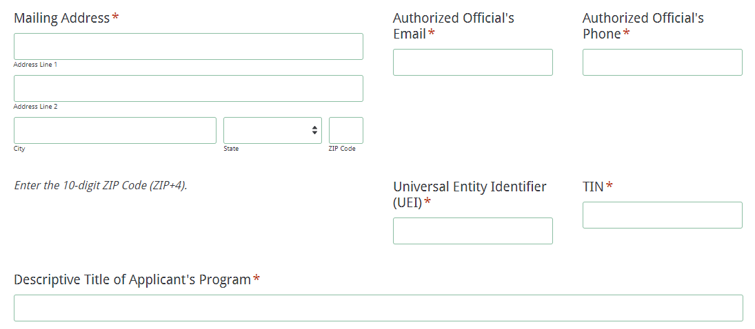
Enter contact information for the program director. The name entered must match the name on the Certification Signature Page. The program director’s email is a required field. The confirmation of a successful online application submission will be sent only to this email address. Reenter the email address to confirm that it is correct.

Enter all amounts in the Program Funding Information and Program Budget Summary sections using whole dollars (no cents). Fill in all fields and enter 0 (zero) for line items that are not applicable to the project. Enter the total cost of the project including any in-kind or matching funds. Enter the total amount of GT funding being requested which includes the combined budgets for all courses and the general project budget. Select the beginning and ending dates of the project.
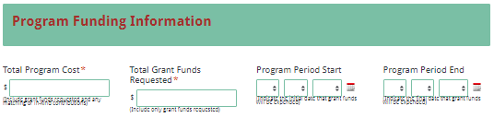
Enter the total line item breakdowns for the GT funds requested in the IHE-Level Budget Summary section. The Total Costs (Funds Requested) field will automatically calculate. This amount should reflect the total grant funds requested for general project costs as well as the combined budgets for proposed courses. This amount must also match the total funds requested under the Funding Information section.
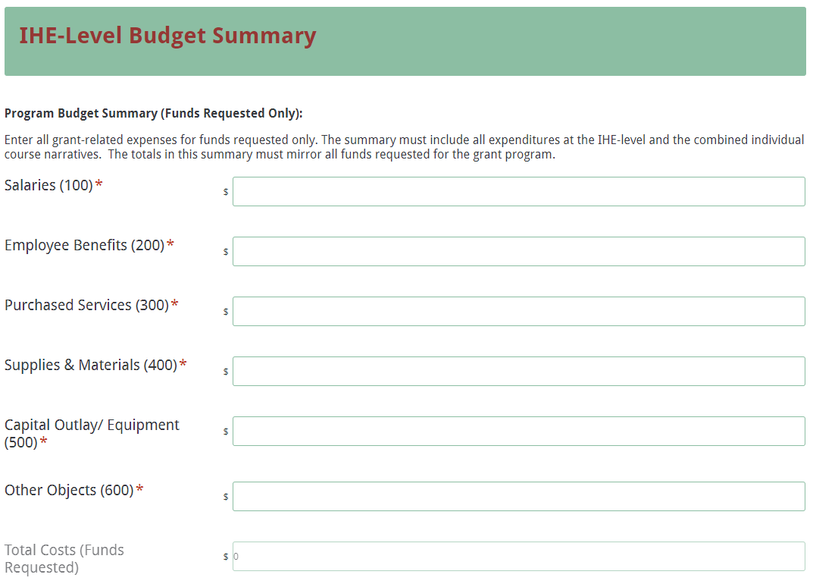
Select the number of proposed courses from the dropdown box (up to ten).

Separate sections will be displayed based on the number of courses selected. Enter the name and number for each course. Enter the total funds requested and the number of participants to be served for each course. The average cost per participant field will automatically calculate.
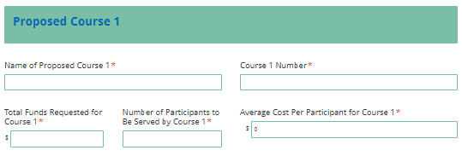
Select the instructional format of how the course will be delivered and the course topic. If the proposed course topic is not listed, select the “Other” category and enter the topic name. If you are proposing to offer one of the special topic seminars, additional fields will be displayed. Select the course topic or enter an additional name in the “Other” category. Provide the geographical area(s) that the course will serve. Enter the name of the professor/master teacher who will teach the course.

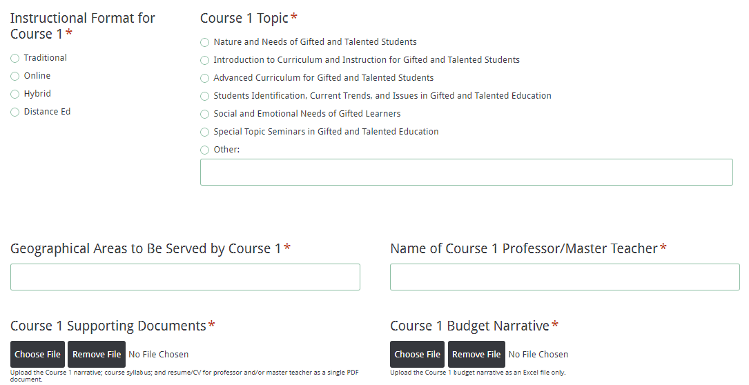
Following the instructions on page 20, upload the supporting documents (i.e., course narrative, syllabus, and professor/master teacher CV/résumé) and budget narrative for each proposed course in the applicable section. The supporting documents must be saved as a PDF file and the course budget narrative must be saved as an Excel file. The online application will only allow one document to be attached in each of the file upload locations. If you attach the wrong document, simply repeat the step by clicking on the “Choose File” button and select the correct document. The most recently uploaded document will overwrite the previous attachment.

Upload the remaining proposal attachments in the appropriate format following the instructions in the RFP; these attachments include the IHE-Level Program Narrative, the IHE-Level Budget Narrative for general program expenses, and the Certification Signature Page (see page 16). All attachments are required; you will not be able to submit the application without attaching all documents.
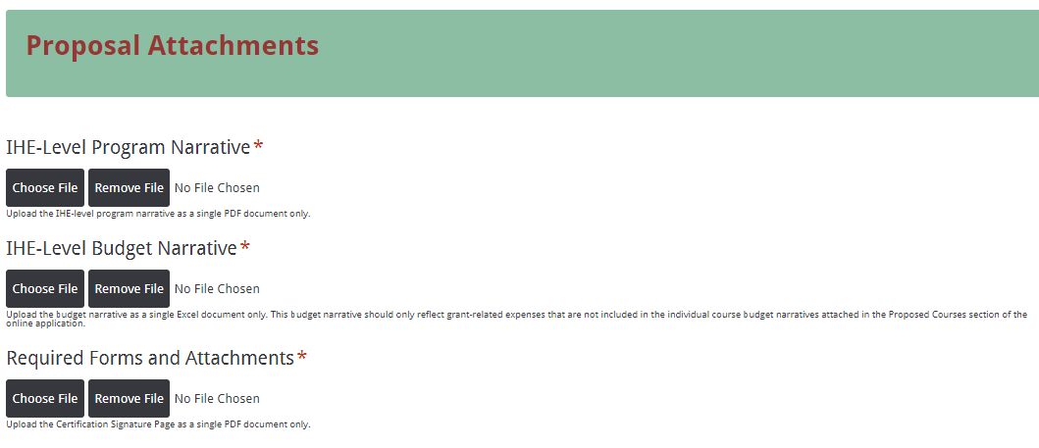
Thoroughly review the summary on the Data Review and Confirmation Page to verify that the information has been entered correctly in the online application prior to submitting. You will not be able to access the completed application form after it has been submitted. If any of the entries are incorrect, click on the "Previous" button at the bottom of each page to return to the appropriate section(s) and reenter the correct information.
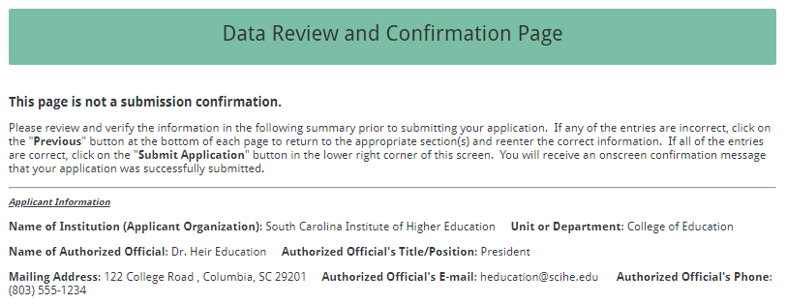
If all of the entries are correct, click on the “Submit Application” button in the lower right corner of this screen to complete the submission process.
Once the application is submitted, the following message will be displayed on the screen, and a submission confirmation will be sent to the email address provided for the program director.

A submission confirmation will be sent to the email address provided for the program director.

If the program director does not receive a confirmation email, then the application did not successfully upload. You must go back and resubmit the entire online form, including all attachments, in order for your application to be considered for funding. Only the most recently submitted application will be reviewed.

An email confirmation that an application was successfully uploaded does not account for the quality of the uploaded documents or the completeness of the online form. The confirmation email only notifies you that your online application has been submitted. Applicants are responsible for ensuring that the information entered in the online form, including all attachments, is accurate and complete in order for the application to be reviewed and considered for funding.

If necessary, you may save your progress in the online application form and return to the form later. When saving the online application form, any attachments and the program director’s email address will not be saved. Those fields must be entered again when submitting the application.

Click on the “Save and Resume Later” link to save your progress. You will be prompted to create a password to securely save your form. You will then be given an option to copy and save the link to your partially completed form or enter an email address to have the link emailed to you. Be sure to enter the email address correctly as SCDE personnel cannot access the link or the incomplete application. Using this link, you can access the application from any computer within thirty days to complete the online submission. Without the link or after thirty days, the data previously entered cannot be retrieved, and you must begin a new application. A saved application is not a submitted application. You must follow all of the steps described on pages 21–22 to complete the submission process.

Appendix A: Definitions of Terms Used

Deobligation—The downward adjustment of the obligations recorded in a grant award document. It is caused by factors such as (1) termination of part of the project, (2) reduction in material prices, (3) cost savings, or (4) correction of recorded amounts.

Endorsement—Completion of the following training fulfills the requirements set forth in SBE Regulation 43-220(II)(C)(1) and provides an endorsement in GT education:
- a professional certificate in the teaching area, and
- six (6) hours in the following endorsement courses: Nature and Needs of Gifted and Talented Students (3 hours) and Introduction to Curriculum and Instruction for Gifted and Talented Students (3 hours).
After successfully completing the two graduate courses, a teacher must submit a change action form and official transcripts to the SCDE’s Office of Educator Services.

Master teacher—An experienced, endorsed GT educator who assists the primary professor in the delivery of instruction and who possesses a minimum of five years of experience in teaching gifted students.

Appendix B: Selection Criteria and Reviewers’ Scoring Rubric

Selection Criteria

Reviewers will use a dual-tier rating system to review applications. The first tier will rate the IHE-level program narrative to determine the institution’s capacity to successfully implement and manage a GT Graduate Course Program grant. The second tier will rate each proposed course separately for the quality of the course and the personnel who will be instructing the course. The score assigned to the IHE-level program narrative will be added to the course quality and personnel quality scores to determine the total score for each individual course. A total of 100 points is available for each proposed course.

The point values for each section of the application are as follows:
Narrative Sections | Points Available
1. IHE-Level Program Narrative | 25
2. Course Quality (per proposed course) | 55
3. Personnel Quality (per proposed course) | 20
TOTAL | 100

Each narrative subsection will be assigned a score using the following rubric, which summarizes the required elements of the application narrative and the point ranges assigned to each subsection.

Scoring Rubric

1.a. IHE-Level Program Narrative: The applicant must describe the overall program to provide one or more GT graduate courses including
- the primary target audience, the number of teachers to be served, and the scope of the program;
- a list of course(s) that will be offered during the program term; and
- the delivery format—traditional (class meetings once a week at a physical location for the duration of the semester), online, distance education, or a hybrid model—for each course.
The applicant provides a program narrative of the overall program to provide one or more GT graduate courses by including:  - the primary target audience, the number of teachers to be served, and the scope of the program;  - a list of course(s) that will be offered during the program term; and  - the delivery format—traditional (class meetings once a week at a physical location for the duration of the semester), online, distance education, or a hybrid model—for each course. | Acceptable | Fully Meets—4 points  Applicant provides a narrative that fully addresses all required items.
 | Acceptable | Adequate/Meets—3 points  Applicant provides a narrative that moderately addresses all required items.
 | Not Acceptable | Limited/Approaches—2 points  Applicant provides a narrative that is limited or unclear in addressing all required items.
 | Not Acceptable | Inadequate—0–1 point  Applicant provides a narrative that does not adequately address all required items.
Reviewer’s Comments

1.b. IHE-Level Program Narrative—IHE’s Qualifications: The applicant must describe the institution’s qualifications in offering GT courses including
- the current level of IHE accreditation and its experience in providing graduate courses in GT education (types of courses provided, number of years the IHE has provided graduate courses in GT education, and delivery methods); and
- the technology infrastructure that is in place to support offering these courses and how technology issues will be resolved if they arise.

The applicant provides a narrative that includes a description of the IHE’s qualifications in offering GT courses including:  - the current level of IHE accreditation and its experience in providing graduate courses in GT education (types of courses provided, number of years the IHE has provided graduate courses in GT education, and delivery methods); and  - the technology infrastructure that is in place to support offering these courses and how technology issues will be resolved if they arise. | Acceptable | Fully Meets—6 points  Applicant provides a narrative that fully addresses all required items.
 | Acceptable | Adequate/Meets—4–5 points  Applicant provides a narrative that moderately addresses all required items.
 | Not Acceptable | Limited/Approaches—2–3 points  Applicant provides a narrative that is limited or unclear in addressing all required items.
 | Not Acceptable | Inadequate—0–1 point  Applicant provides a narrative that does not adequately address all required items.
Reviewer’s Comments

1.c. IHE-Level Project Narrative—Needs Assessment Process: The applicant must describe the needs assessment process the IHE conducted within the prior six months to determine the course selections including
- the evidence to support offering courses in each targeted area and the selection of site locations;
- how the results influenced the timing of course offerings and delivery choice models; and
- the estimated need among teachers in the identified regions for the proposed courses, how the courses will serve the teachers’ needs, and how the method for delivering the courses will be the most effective way to address their needs.
The applicant provides a narrative that describes the needs assessment process the IHE conducted within the prior six months to determine the course selections including  - the evidence to support offering courses in each targeted area and the selection of site locations;  - how the results influenced the timing of course offerings and delivery choice models; and  - the estimated need among teachers in the identified regions for the proposed courses, how the courses will serve the teachers’ needs, and how the method for delivering the courses will be the most effective way to address their needs. | Acceptable | Fully Meets—4 points  Applicant provides a narrative that fully addresses all required items.
 | Acceptable | Adequate/Meets—3 points  Applicant provides a narrative that moderately addresses all required items.
 | Not Acceptable | Limited/Approaches—2 points  Applicant provides a narrative that is limited or unclear in addressing all required items.
 | Not Acceptable | Inadequate—0–1 point  Applicant provides a narrative that does not adequately address all required items.
Reviewer’s Comments

1.d. IHE-Level Project Narrative—Management Plan: The applicant must describe the plan to manage the overall program including
- how duties for managing the grant are delineated,
- how the courses will be publicized to maximize registrations and how seating priorities are communicated,
- the timeline and processes for course registration,
- how the courses will be offered including a timeline to ensure that all courses are completed by June 30, 2023, and
- the process for ensuring that the final report will be submitted by the deadline.

The applicant provides a narrative that describes the plan to manage the overall program including:  - how duties for managing the grant are delineated,  - how the courses will be publicized to maximize registrations and how seating priorities are communicated,  - the timeline and processes for course registration,  - how the courses will be offered including a timeline to ensure that all courses are completed by June 30, 2023, and  - the process for ensuring that the final report will be submitted by the deadline. | Acceptable |  |  |  | Fully Meets—5–6 points  Applicant provides a narrative that fully addresses all required items.
Adequate/Meets—3–4 points
Applicant provides a narrative that moderately addresses all required items.
 | Not Acceptable |  |  |  | Limited/Approaches—1–2 points  Applicant provides a narrative that is limited or unclear in addressing all required items.
Inadequate–0 points
Applicant provides a narrative that does not adequately address all required items.
Reviewer’s Comments
1.e. IHE-Level Project Narrative—Evaluation Process: The applicant must describe the institution’s overall process for evaluating the GT courses, how the evaluation results will be used to shape future courses, and how evaluation results will be reported to the SCDE by
- discussing how participants will be evaluated for each required course component and the basis for awarding grades for the courses;
- describing the data collection method, process, and timeline for collection to evaluate courses and/or student achievement;
- explaining how data will be used to determine the success of the courses, how the results will be presented to demonstrate that the project goals and objectives have been met, and how the results will show evidence of relevance and rigor in student assignments; and
- including a copy of the course evaluation instrument to be used for the proposed courses.
The applicant provides a narrative that describes the institution’s overall process for evaluating the GT courses, how the evaluation results will be used to shape future courses, and how evaluation results will be reported to the SCDE by  - discussing how participants will be evaluated for each required course component and the basis for awarding grades for the courses;  - describing the data collection method, process, and timeline for collection to evaluate courses and/or student achievement;  - explaining how data will be used to determine the success of the courses, how the results will be presented to demonstrate that the project goals and objectives have been met, and how the results will show evidence of relevance and rigor in student assignments; and  - including a copy of the course evaluation instrument to be used for the proposed courses. |  |  |  | Acceptable |  |  |  | Fully Meets—5 points  Applicant provides a narrative that fully addresses all required items.
Adequate/Meets—3–4 points
Applicant provides a narrative that moderately addresses all required items.
 |  |  |  | Not Applicable |  |  |  | Limited/Approaches—1–2 points  Applicant provides a narrative that is limited or unclear in addressing all required items.
Inadequate—0 points
Applicant provides a narrative that does not adequately address all required items.
Reviewer’s Comments
2.a. Course Quality—Course Narrative: The applicant must provide a separate, brief narrative (maximum of two pages) for each course describing
- the goals and SMART objectives, the instruction approach and materials to be used, how this approach is intended to meet the course objectives, and how the course assessments align with the goals and objectives;
- the primary target audience and how course performance standards will be achieved and measured;
- the type of GT course to be offered as described in the Required Credentials for Professional Staff Members and how it aligns with SBE Regulation 43-220 and South Carolina curriculum goals for GT education;
- how the course incorporates South Carolina College- and Career-Ready and NAGC standards and best practices from the South Carolina Gifted and Talented Best Practices Manual; and
- the detailed format of the proposed course, the required course platform or Learning Management System (LMS), the proposed seat limit/class size, and the levels of user support to be provided.
The applicant provides a separate, brief narrative (maximum of two pages) for each course describing  - the goals and SMART objectives, the instruction approach and materials to be used, how this approach is intended to meet the course objectives, and how the course assessments align with the goals and objectives;  - the primary target audience and how course performance standards will be achieved and measured;  - the type of GT course to be offered as described in the Required Credentials for Professional Staff Members and how it aligns with SBE Regulation 43-220 and South Carolina curriculum goals for GT education;  - how the course incorporates South Carolina College- and Career-Ready and NAGC standards and best practices from the South Carolina Gifted and Talented Best Practices Manual; and  - the detailed format of the proposed course, the required course platform or Learning Management System (LMS), the proposed seat limit/class size, and the levels of user support to be provided. |  |  |  |  |  |  |  |  | Acceptable | Fully Meets—20–25 points  Applicant provides a narrative that fully addresses all required items.
 |  |  |  |  |  |  |  |  | Acceptable | Adequate/Meets—13–19 points  Applicant provides a narrative that moderately addresses all required items.
 |  |  |  |  |  |  |  |  | Not Acceptable | Limited/Approaches—6–12 points  Applicant provides a narrative that is limited or unclear in addressing all required items.
 |  |  |  |  |  |  |  |  | Not Acceptable | Inadequate—0–5 points  Applicant provides a narrative that does not adequately address all required items.
Reviewer’s Comments
2.b. Course Quality—Course Syllabus: The applicant must provide a separate syllabus for each course that
- describes the course components, including the course name/title and number, number of graduate credits awarded, the meeting dates and items to reflect adequate course duration and frequency of instructional activities (i.e., instructional time and the number of times the course will meet);
- identifies the professor and/or master teacher assigned to teach the course;
- explains how students will access the proposed course;
- summarize the content to be addressed in each of the class meetings and the participant activities and requirements;
- describes how clear expectations for successful completion of the course(s) is conveyed to participants;
- describes the IHE’s academic integrity policy;
- lists the required course materials and the resources to be provided to participants such as texts, articles, and other resources that will be used (Note: texts should be less than ten years old and majority of articles should be less than five years old);
- includes specific references and resources which present national, international, and South Carolina specific perspectives;
- explains how the course readings, assignments, and assessments will ensure competency with the specific program standards;
- explains how course materials include practical resources for teachers; and
- explains how the course incorporates theoretical frameworks.
The applicant provides a separate syllabus for each course that  - describes the course components, including the course name/title and number, number of graduate credits awarded, the meeting dates and items to reflect adequate course duration and frequency of instructional activities (i.e., instructional time and the number of times the course will meet);  - identifies the professor and/or master teacher assigned to teach the course;  - explains how students will access the proposed course;  - summarizes the content to be addressed in each of the class meetings and the participant activities and requirements;  - describes how clear expectations for successful completion of the course(s) is conveyed to participants;  - describes the IHE’s academic integrity policy;  - lists the required course materials and the resources to be provided to participants such as texts, articles, and other resources that will be used;  - includes specific references and resources which present national, international, and South Carolina specific perspectives;  - explains how the course readings, assignments, and assessments will ensure competency with the specific program standards;  - explains how course materials include practical resources for teachers; and  - explains how the course incorporates theoretical frameworks. |  |  |  |  |  |  |  | Acceptable |  |  | Fully Meets—20–25 points  Applicant provides a course syllabus that fully addresses all required items.
Adequate/Meets—13–19 points
Applicant provides a course syllabus that moderately addresses all required items.
 |  |  |  |  |  |  |  | Not Acceptable |  |  | Limited/Approaches—6–12 points  Applicant provides a course syllabus that is limited or unclear in addressing all required items.
Inadequate—0–5 points
Applicant provides a course syllabus that does not adequately address all required items.
Reviewer’s Comments
2.c. Course Quality—Course Budget Narrative: The applicant must provide a separate budget narrative for each course that
- gives a breakdown of the grant funds requested;
- provides clear evidence that the expenditures are adequate, reasonable, appropriate, and justified to support the activities in each proposed course;
- parallels the line-item categories of the Project Budget Summary in the online application;
- includes the formulas used to calculate the costs for each line item; and
- includes expenditures that are reasonable and adequate to complete the program and directly connected to the course goals and objectives.
The applicant provides a budget narrative for each course that  - gives a breakdown of the grant funds requested;  - provides clear evidence that the expenditures are adequate, reasonable, appropriate, and justified to support the activities in each proposed course;  - parallels the line-item categories of the Project Budget Summary in the online application;  - includes the formulas used to calculate the costs for each line item; and  - includes expenditures that are reasonable and adequate to complete the program and directly connected to the course goals and objectives. |  | Acceptable |  |  |  | Fully Meets—5 points  Applicant provides a budget narrative that fully addresses all required items.
Adequate/Meets—3–4 points
Applicant provides a budget narrative that moderately addresses all required items.
 |  | Not Acceptable |  |  |  | Limited/Approaches—1–2 points  Applicant provides a budget narrative that is limited or unclear in addressing all required items.
Inadequate—0 points
Applicant provides a budget narrative that does not adequately address all required items.
Reviewer’s Comments
3. Personnel: The applicant must provide a professional vita or résumé (maximum of three pages each) that clearly demonstrates the following for the professor and/or master teacher for each proposed course.
- Educational Credentials—indicates an advanced degree related to gifted education.
- Experience—indicates extensive experience in gifted education with examples that include K–12.
- Leadership and Research and Development—demonstrates activity in gifted education leadership and in gifted research or development.
- Service—demonstrates activity in providing service to the field of gifted education such as leading gifted and talented professional development or coursework; presenting at the district or regional level; presenting at the state and/or national level within the prior five years; and leadership in program coordination, grant work, mentoring, etc.
The applicant provides a professional vita or résumé that clearly demonstrates all the following for the professor and/or master teacher for each proposed course.  - Educational Credentials—indicates an advanced degree related to gifted education.  - Experience—indicates extensive experience in gifted education with examples that include K–12.  - Leadership and Research and Development—demonstrates activity in gifted education leadership and in gifted research or development.  - Service—demonstrates activity in providing service to the field of gifted education such as leading gifted and talented professional development or coursework; presenting at the district or regional level; presenting at the state and/or national level within the prior five years; and leadership in program coordination, grant work, mentoring, etc. |  |  | Acceptable |  |  |  | Fully Meets—16–20 points  Applicant provides a professional vita or résumé that fully addresses all required items.
Adequate/Meets—10–15 points
Applicant provides a professional vita or résumé that moderately addresses all required items.
 |  |  | Not Acceptable |  |  |  | Limited/Approaches—5–9 points  Applicant provides a professional vita or résumé that is limited or unclear in addressing all required items.
Inadequate—0–4 points
Applicant provides a professional vita or résumé that does not adequately address all required items.
Reviewer’s Comments

Appendix C: Required SCDE Forms

Certification Signature Page
(This form must be signed by the individual from each proposed district, school, or organization who holds the title listed below.)

Certification
I hereby certify that, to the best of my knowledge, the information and data contained in this application are true and correct. The applicant’s governing body has duly authorized this application and documentation, and the applicant will comply with the Program Specific Assurances (if applicable) and the SCDE Assurances and Terms and Conditions if the grant is awarded. The applicant is registered and current (active) on the federal System for Award Management (SAM).

Authorized Official (duly authorized representative)

Name:
Position: | Email:
Telephone: | Fax:

Signature of Authorized Official: | Signature of Authorized Financial Official:
Date Signed: | Date Signed:
Signature of Program Director:

Date Signed:

Please complete, print, and obtain signatures prior to submission. Include the signed, scanned form in the required appendices as indicated on page 16.

Assurances and Terms and Conditions for State Awards

Assurances

I certify that this applicant
- Has the legal authority to apply for state assistance and the institutional, managerial, and financial capability (including funds sufficient to pay the nonstate share of project costs) to ensure proper planning, management, and completion of the project described in this application.
- Will give the South Carolina Department of Education (SCDE) access to and the right to examine all records, books, papers, or documents related to this award and will establish a proper accounting system in accordance with generally accepted accounting principles (GAAP) or agency directives.
- Has an accounting system that includes sufficient internal controls, a clear audit trail, and written cost-allocation procedures as necessary. The financial management systems are capable of distinguishing expenditures that are attributable to this grant from those that are not attributable to this grant. This system is able to identify costs by programmatic year and by budget line item and to differentiate among direct, indirect, and administrative costs. In addition, the applicant will maintain adequate supporting documents for the expenditures and in-kind contributions, regardless of the type of funds, if any, that it makes under this grant. Costs are shown in books or records (e.g., disbursements ledger, journal, payroll register) and are supported by a source document such as a receipt, travel voucher, invoice, bill, or in-kind voucher.
- Will also comply with GAAP as it relates to budgets, budget amendments, and expenditure claim submissions.
- Will approve all expenditures, document receipt of goods and services, and record payments on the applicant’s accounting records prior to submission of reimbursement claims to the SCDE for costs related to this grant.
- Will initiate and complete work within the applicable time frame after receipt of approval by the SCDE.
- Will not discriminate against any employee or applicant for employment because of race, color, religion, age, sex, national origin, or disability. The applicant will take affirmative action to ensure that applicants for employment and the employees during the period of their employment are treated without regard to their race, color, religion, age, sex, national origin, or disability.
- Will comply with the Ethics, Government Accountability, and Campaign Reform Act (S.C. Code Ann. § 2-17-10 et seq. and § 8-13-100 et seq. (Supp. 2021)).
- Will comply with the Drug Free Workplace Act (S.C. Code Ann. § 44-107-10 et seq. (Supp. 2021)) if the amount of this award is $50,000 or more.

Terms and Conditions

- Completeness of Proposal. All proposals should be complete and carefully worded and must contain all of the information requested by the South Carolina Department of Education (SCDE). If you do not believe a section applies to your proposal, please indicate that fact.
- Non-awards/Termination. The SCDE reserves the right to reject any and all applications and to refuse to grant monies under this solicitation. If the SCDE rejects an application, the applicant has a right to request a review of the process consistent with the appeals process presented in the Request for Proposals (RFP).
After it has been awarded, the SCDE may terminate a grant by giving the grantee written notice of termination. In the event of a termination after award, the SCDE shall reimburse the grantee for expenses incurred up to the notification of termination. In addition, this grant may be terminated by the SCDE if the grantee fails to perform as promised in its proposal.
Upon the termination of a grant, the grantee shall have the right to a review process. The grantee must notify the SCDE of its request within 30 days of receiving written notice of the termination.
- Reduction in Budgets and Negotiations. The SCDE reserves the right to negotiate budgets with potential grantees. The SCDE may, at its sole discretion, determine that a proposed budget is excessive and may negotiate a lower budget with the applicant. The applicant may at that time negotiate or withdraw its proposal. In addition, the SCDE may desire to fund a project but not at the level proposed. In that case, the SCDE shall notify the applicant of the amount that can be funded, and the applicant and the SCDE shall negotiate a modification to the proposal to accommodate the lower budget. All final decisions are that of the SCDE.
- Amendments to Grants. Amendments are permitted upon the mutual agreement of the parties and will become effective when specified in writing and signed by both parties.
- Use of Grant Funds. Funds awarded are to be expended only for purposes and activities covered by the approved project plan, budget, and budget narrative.
- Submission of Expenditure Reports. Claims for reimbursement must be made at least quarterly and consistent with calendar quarters (e.g., an expenditure report claim for costs for January 1 through March 30 must be filed by May 15).
- Obligation of Grant Funds. Grant funds may not be obligated prior to the effective date or subsequent to the end or termination date of the grant period. No obligations are allowed after the end of the grant period. The final request for expenditure report claims must be submitted no later than forty-five (45) days after the end of the grant period unless the scope of work for the grant states a shorter reporting period.
- Deobligation of Funds. After a final expenditure claim has been submitted to the SCDE, the grantee will go through the official deobligation process with the SCDE.
- Documentation. The grantee must provide for accurate and timely recording of receipts and expenditures. The grantee’s accounting system should distinguish receipts and expenditures attributable to each grant. The grantee must review the memo regarding “Guidelines for Retaining Documentation to Support Expenditure Claims.”
- Travel Costs. Travel costs, if allowed under this solicitation, must not exceed limits noted in the United States General Services Administration (GSA) per diem rates for lodging, except in the case of conference lodging required for program-required training. In the case that conference-related lodging exceeds the GSA per diem rate, the grantee shall follow their entity’s written procedure for obtaining prior approval to exceed a GSA rate for a conference hotel. Meals and incidentals are limited by the state budget proviso, currently not to exceed $35 per day for in-state travel and $50 for out-of-state travel (see page 86 of the State of South Carolina Statewide Disbursement Regulations). Mileage reimbursement must follow the current Office of Comptroller General instructions, which is consistent with the published IRS rates.
- Honoraria. Amounts paid in honoraria, if allowed under this grant, must be consistent with SCDE policies. Applicants should check with the program office before budgeting for honoraria.
- Reports. The grantee shall submit, as required or instructed by the awarding program office, all reports (programmatic, financial, or evaluation) within the specified period or date and in the prescribed format. An expenditure claim report must be filed by July 5 for all expenditures incurred by June 30 in order to comply with the generally accepted accounting principles (GAAP) and the production of the State's Comprehensive Annual Financial Report.
- Copyright. The grantee is free to copyright any books, publications, or other copyrightable materials developed in the course of this grant. However, the SCDE reserves a royalty-free, nonexclusive, and irrevocable license to reproduce, publish, or otherwise use, and to authorize others to use, the copyrighted work developed under this grant.
- Certification Regarding Suspension and Debarment. By submitting an application, the applicant certifies, to the best of its knowledge and belief, that the
- Applicant and/or any of its principals, subgrantees, or subcontractors
  - are not presently debarred, suspended, proposed for debarment, or declared ineligible for the award of contracts by any state or federal agency; have not, within a three-year period preceding this application, been convicted of or had a civil judgment rendered against them for commission of fraud or a criminal offense in connection with obtaining, attempting to obtain, or performing a public (federal, state, or local) contract or subcontract; violation of federal or state antitrust statutes relating to the submission of offers; or commission of embezzlement, theft, forgery, bribery, falsification or destruction of records, making false statements, tax evasion, or receiving stolen property; and
  - are not presently indicted for, or otherwise criminally or civilly charged by a governmental entity with, commission of any of the offenses enumerated above.
- Applicant has not, within a three-year period preceding this application, had one or more contracts terminated for default by any public (federal, state, or local) entity.
- Audits. Although this Assurances, Terms, and Conditions document is for a state award, federal audit requirements apply as follows:
- Entities expending $750,000 or more in federal awards:
Entities that expend $750,000 or more in federal awards during the fiscal year are required to have an audit performed in accordance with the provisions of 2 CFR Part 200.501, et seq. Except for the provisions for biennial audits provided in 2 CFR Part 200.504 (a) and (b), audits must be performed annually as stated at 2 CFR Part 200.504. A grantee that passes through funds to subrecipients has the responsibility of ensuring that federal awards are used for authorized purposes in compliance with federal program laws, federal and state regulations, and grant agreements. The director of the OMB, who will review this amount every two years, has the option of revising the threshold upward.
- Entities expending less than $750,000 in federal awards:
Entities that expend less than $750,000 in a fiscal year in federal awards are exempt from the audit requirements in 2 CFR Part 200.504. However, such entities are not exempt from other federal requirements (including those to maintain records) concerning federal awards provided to the entity. The entity’s records must be available for review or audit by the SCDE and appropriate officials of federal agencies, pass-through entities, and the General Accounting Office (GAO).
- Records. The grantee shall retain grant records, including financial records and supporting documentation, for a minimum of six (6) years after the end date of the grant when the final expenditure report claim for reimbursement and all final reports have been submitted, unless informed otherwise or in case of litigation.
- Electronic Signature Agreement. I agree that my electronic signature is the legally binding equivalent to my handwritten signature.

Appendix D: Optional Forms

Detailed 12-Month Budget Narrative Template

For informational purposes only
Go to the SCDE Grant Opportunities webpage for Gifted and Talented to obtain the Excel spreadsheet template.

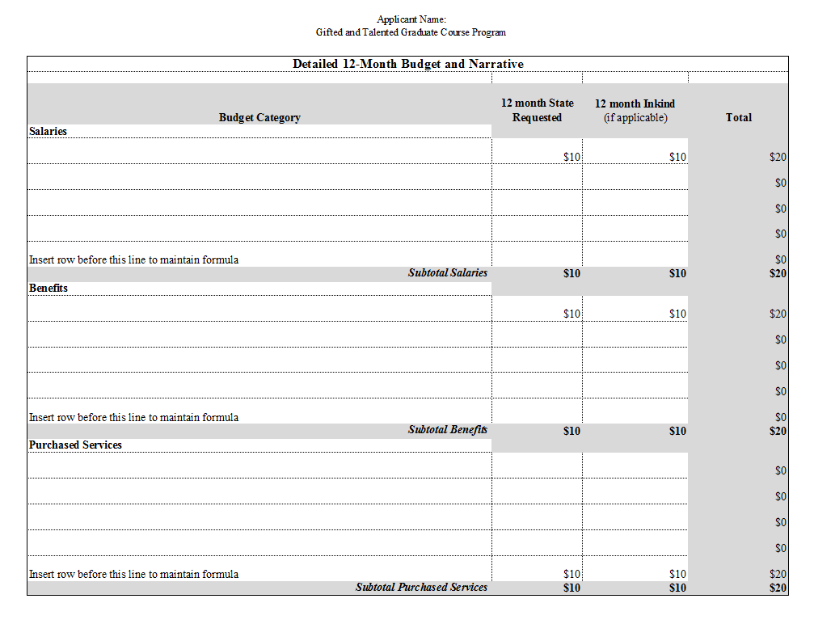

2021 General Appropriations Act, Proviso 1A.25

1A.25. (SDE-EIA: Professional Development) Of the funds appropriated for professional development, up to $500,000 may be expended for gifted and talented teacher endorsement and certification activities. The Department of Education must provide professional development on assessing student mastery of the content standards through classroom, formative and end-of-year assessments. The Department of Education also must post on the agency’s website the South Carolina Professional Development Standards and provide training through telecommunication methods to school leadership on the professional development standards. The department is authorized to carry forward and expend professional development funds for the same purpose.

