Request for Proposals (RFP)
Application Package

Perkins V Reserve
2021–22 Competitive Subgrant

REVISED 6/9/2021 (see pages 14, 17, and 41)

The Perkins V Reserve subgrant is funded by U.S. Department of Education, authorized by the Carl D. Perkins Career and Technical Education Act of 2006, as amended by the Strengthening Career and Technical Education for the 21st Century Act (Perkins V), and administered by the South Carolina Department of Education.

Deadline for Receipt of Applications: July 1, 2021 at 4:30 p.m.

Technical Assistance for Applicants: June 9, 2021

For questions about the subgrant contact:
Maria Swygert, 803-734-8456; nmswyger@ed.sc.gov

Issued by:
South Carolina Department of Education
Office of Career and Technical Education
1429 Senate Street, Suite 912
Columbia, SC 29201

TABLE OF CONTENTS
PART I: General Information 1
A. Introduction and Purpose 1
B. Eligible Applicants 2
C. Competitive Priorities 2
D. Timeline of Subgranting Process 2
E. Technical Assistance Sessions for Applicants 2
F. Statutory and Other Requirements 2
G. Authorized Activities 5
H. Unauthorized Activities 5
I. Program Accountability and Monitoring 5
J. Fiscal Operations 9
K. Supplement, Not Supplant 9
L. Review and Selection Process 9
M. Appeals Process 10

PART II: Application Overview, Content, and Instructions 11
A. Application Overview 11
B. Application Narrative Format 12
C. Online Application Submission 12
D. Project Abstract 12
E. Application Narrative Content 13
1. Statement of Need 13
2. Goal and Objectives 13
3. Activities 13
4. Management and Collaboration 14
F. Application Budget 15
G. Appendices 17
H. Deadline and Submission Procedures 18
I. Screenshots of Online Application Submission Forms 18

Appendix A: Definitions of Terms Used 25

Appendix B: Selection Criteria and Reviewers’ Scoring Rubric 26

Appendix C: Required SCDE Forms 32
Certification Signature Page 32
Assurances and Terms and Conditions for Federal Subawards 33
Budget Narrative Template 37
Pre-Award Audit Questionnaire 38
Instructions for GEPA Statement of Compliance 39
Partner Identification and Funding Request Form 40
Timeline of Activities Template 41
LEAs and IHEs Eligible to apply for a Perkins V Reserve Subgrant 42

PART I: General Information

Introduction and Purpose

The South Carolina Department of Education (SCDE) has allocated funds from its Fiscal Year (FY) 2021 Strengthening Career and Technical Education for the 21st Century Act (Perkins V) allocation from the U.S. Department of Education (USED) for the Perkins V Reserve subgrant. The SCDE’s Office of Career and Technical Education (OCTE) will use a competitive process to award subgrants to eligible local education agencies (LEAs) and institutions of higher education (IHEs).

Perkins V Reserve funding was designed to
- Foster innovation through the identification and promotion of promising and proven career and technical education programs, practices, and strategies, which may include programs, practices, and strategies that prepare individuals for nontraditional fields; or
- Promote the development, implementation, and adoption of programs of study or career pathways aligned with state-identified high-skill, high-wage, or in-demand occupations or industries.

The purpose of the SCDE Perkins V Reserve subgrant is to build upon the South Carolina State Plan for Career Technical Education (CTE) to strengthen and align programs and partnerships as outlined under the Perkins V legislation. Funds will be used to address regional or statewide workforce development needs in high-skill, high-wage, or in-demand occupations in critical or emerging industries. The top industries in South Carolina for current focus are:
- Health Care/Health Sciences,
- Business and Information Technology,
- Manufacturing,
- Transportation, Distribution, and Logistics,
- Construction,
- Hospitality & Tourism, and
- Agriculture.

Up to $1,224,000 will be available for new subgrants in this funding cycle. Subgrants will be awarded to eligible recipients to support special projects focused on collaboration, development, improvement and/or expansion of CTE programs.

The SCDE anticipates awarding at least 16 subgrants of no more than $75,000 each. Award amounts will be determined based on the quality of applications received and total funding requested. Final budgets may be negotiated based on demonstrated needs. All subgrant awards are contingent upon total allocations to the SCDE by the USED.

The subgrant period is July 1, 2021, through September 30, 2022, and is subject to the availability of federal funds and projects meeting all subgrant program requirements. All funds must be fully expended by September 30, 2022. The subgrantee may obligate funds upon receipt of the subgrant award notice. However, no funds will be disbursed until after the budget has been entered and approved in the Grants Accounting Processing System (GAPS). Grant payments are made on a cost-reimbursement basis so applicants should have at least three months of operating funds at their disposal to implement the program to compensate for any delays in receiving reimbursement payments.

Eligible Applicants

Eligible applicants for a Perkins V Reserve subgrant are current Perkins V subgrantees (i.e., LEAs and IHEs that currently offer Perkins-approved CTE programs). See pages 42–43 for a list of eligible applicants.

Competitive Priorities

The SCDE has established a competitive priority for this funding cycle. To receive competitive priority points, the application must identify a collaborative partnership between a current Perkins V LEA subgrantee and a current Perkins V IHE subgrantee to address the needs of all special population students as defined by Section (3)(48) of Perkins V legislation (see the definition in Appendix A). The application narrative must clearly provide evidence that the proposed partnership meets and fulfills the priority. Applicants must clearly meet the partnership criteria to earn 20 additional points. Applicants are not eligible for competitive points unless their application earns an average score of 75 points or higher. Note: Collaboration between the proposed Perkins V Reserve subgrant partners must involve more than the act of simply allocating a set-aside.

Timeline of Subgranting Process

Date | Activity/Action
June 9, 2021 | Pre-application technical assistance session
July 1, 2021 | Deadline for receipt of applications
August 2021 | Notification of awards
July 1, 2021 | Funding period begins; programs can begin
September 30, 2022 | Funding period ends; programs must end
November 15, 2022 | Final reports due to the SCDE

Technical Assistance Sessions for Applicants

The SCDE’s OCTE will offer a pre-application technical assistance session via Adobe Connect on June 9, 2021, from 10:00 a.m. until 11:30 a.m. to assist eligible applicants in understanding this RFP and how to apply for this grant. No password is required to join the session. Participants should enter their full names when logging in. Participants will be able to log in 30 minutes prior to the start time to test their audio settings and download/print handouts. While participation is not mandatory in order to submit an application, it is highly recommended.

Statutory and Other Requirements

Statutory Requirements
The Strengthening Career and Technical Education for the 21st Century Act (Public Law 115-224 (Perkins V)) legislation supports opportunities for every student to explore, choose, and follow career and technical education programs of study (POS) and career pathways to earn credentials of value. Under Perkins V Reserve, the offerings must focus on increasing learner access to high-quality CTE programs of study and is critical to ensuring that programs are prepared to meet the ever-changing needs of learners and employers. Perkins V focuses on improving the academic and technical achievement of CTE students, strengthening the connections between secondary and postsecondary education, and improving accountability.

Perkins CTE sits at the intersection of education, workforce development, and economic development. These connections occur though coordinated planning and the implementation of programmatic requirements as outlined through Perkins V Reserve funding.

As outlined and aligned under the Every Student Succeeds Act (ESSA), Workforce Innovation and Opportunity Act (WIOA), and Perkins V, applicants must provide the following requirements in their program:
- Provide at least one rigorous Program of Study,
- Provide opportunities for special populations (as defined by Perkins V),
- Participate in a Comprehensive Local Needs Assessment, and
- Complete and submit an approved Local Application and Budget.

Applicable Federal Regulations
Applicants should review the following federal regulations, accessible at the electronic Code of Federal Regulations (e-CFR) Web site that are applicable to the Perkins V Reserve subgrant. Applicants are reminded that, if funded, their programs must comply with these regulations.
- 2 CFR Part 25—Universal Identifier and System of Award Management
- 2 CFR Part 170—Reporting Subaward and Executive Compensation Information
- 2 CFR Part 175—Award Term for Trafficking in Persons
- 2 CFR Part 180—OMB Guidelines to Agencies on Governmentwide Debarment and Suspension (Nonprocurement), as adopted at 2 CFR Part 3485
- 2 CFR Part 200— Uniform Administrative Requirements, Cost Principles, and Audit Requirements for Federal Awards as adopted at 2 CFR Part 3474 (Note: 2 CFR Part 200.211(b)(1) requires that a grant recipient’s name match their registered name associated with its unique entity identifier as discussed and defined at 2 CFR Part 25.)
- 34 CFR Part 76—State-Administered Programs
- 34 CFR Part 77—Definitions that Apply to Department Regulations
- 34 CFR Part 81—General Education Provisions Act Enforcement
- 34 CFR Part 82—New Restrictions on Lobbying
- 34 CFR Part 84—Governmentwide Requirements for Drug-Free Workplace (Financial Assistance Grants)
- 34 CFR Part 86—Drug and Alcohol Prevention
- 34 CFR Part 99—Family Educational Rights and Privacy.
- Civil Rights Compliance—Title VI of the Civil Rights Act of 1964, Title IX of the Education Amendments of 1972, Section 504 of the Rehabilitation Act of 1973, Age of Discrimination Act of 1975, and the American with Disabilities Act of 1990

Additional information on select federal governmentwide regulations is presented below:
Universal Entity Identifier and System of Award Management—2 CFR Part 25
All applicants must have a unique entity identifier for federal assistance. Until April 2021, the Dun and Bradstreet (D&B) Data Universal Numbering System (DUNS) number is a universal identifier for federal financial assistance. Visit the D&B DUNS website to request a DUNS number. The applicant must include a valid DUNS number in the online subgrant application.

Also, the applicant must be registered in the federal System for Award Management (SAM) prior to submitting an application and maintain their SAM registration throughout the application and award process to comply with 2 CFR Part 25. To register in SAM, the applicant organization must first be registered for a Login.gov account; see the Login.gov help center for assistance. Visit the SAM update website for more information. Once registered in Login.gov, the organization can register in SAM.gov using the “Create a User Account” under “Getting Started.” Applicants should contact their finance office if they need assistance with this item. Contact the Federal Service Desk for assistance.

Please note that the SCDE will not make a subaward of federal funds to an applicant until the applicant has complied with the requirements described in 2 CFR 25 to provide a valid unique identifier and maintain an active SAM registration with current information.

Reporting Subaward and Executive Compensation Information—2 CFR Part 170
The Federal Funding Accountability and Transparency Act (FFATA) of 2006 (P.L. 109–282), as amended by Section 6202 of P.L. 110–252, requires primary grantees of federal grants and cooperative agreements to report information on subgrantee obligations and executive compensation. FFATA promotes open government by enhancing the federal government’s accountability for its stewardship of public resources. This is accomplished by making government information, particularly information on federal spending, accessible to the general public.

Primary grantees, like the SCDE, are required to report actions that obligate $25,000 or more in federal grant funds to first-tier subgrantees. This information must be reported in the governmentwide FFATA Subaward Reporting System (FSRS). In order to access FSRS a current SAM registration is required. A primary grantee and first-tier subgrantees must also report total compensation for each of its five most-highly compensated executives. Every primary and first-tier subgrantees must obtain a DUNS number prior to being eligible to receive a grant or subgrant award. Additional information will be provided to subgrant recipients upon award.

Applicants should also review the Assurances and Terms and Conditions for Federal Subawards (on pages 33–36) to ensure that, if awarded a subgrant, they are capable of full compliance, especially with all the referenced federal regulations and state laws, in order to enter into an agreement with the SCDE for this program. A signed Certification Signature Page (see page 32) is required with the grant application and legally binds the applicant to the agency’s Assurances and Terms and Conditions.

Authorized Activities

In adherence to the programmatic requirements as outlined in the Perkins V legislation, the Perkins V Reserve subgrant must be used to provide opportunities for every student to explore, choose, and follow career and technical education programs of study and career pathways to earn credentials of value.

Funds may be used to support the following activities and programs:
- collaboration of secondary to postsecondary programs of study and student support;
- administration of end-of-course testing program and/or national certifications exams;
- student recruitment into the industry career cluster;
- programs to educate secondary and post-secondary career counselors, dual enrollment personnel, and academic advisors about the industry;
- professional development and training for secondary and post-secondary faculty, teachers, and staff;
- services to economically disadvantaged youth (as defined by eligibility for free or reduced-price lunch or those students that qualify for Pell funding as defined by the Perkins V legislation);
- administration of business/employer awareness and partnerships that lead to experience-based, career-oriented experiences including internships, apprenticeships, mentoring, cooperative education, and service-learning;
- career awareness programs for the industry career cluster; and
- create increased opportunities for accessing education for students living in rural areas of SC.

Expenditures should be reasonable, necessary, and adequately documented to achieve the subgrant program’s goals and objectives. Administrative costs must not exceed 5 percent of the total funds requested. While computers and software are eligible expenditures, estimates should be reasonable, and all supplies and materials must be clearly tied to the proposed program’s goals and objectives.

Unauthorized Activities

Perkins V Reserve subgrant funds may not be used for activities that do not directly support the approved work plan. Funds may not be used to purchase office furniture, entertainment, alcohol, items associated with non-educational field trips (such as amusement or fun parks), gift cards or other incentives for students or project staff, promotional items, or construction or renovation of a building. Note: these unallowable expenditures are not all-inclusive. Applicants should use prudent judgment to determine expenditures that align with the proposed program’s scope of work and are allowable.

Program Accountability and Monitoring

The SCDE is responsible for monitoring the Perkins V Reserve subgrant implementation in accordance with the following program accountability requirements:
- Each subrecipient receiving funds through this RFP meets the eligibility requirements for the subgrant described herein, and the applicant has provided all required assurances that it will comply with all program implementation and reporting requirements established through this RFP.
- Each subrecipient receiving funds through this RFP appropriately uses these funds as described in this application package.
- Each subrecipient implements activities funded through this application within the timeline in which the funds provided are to be used.

In compliance with 2 CFR Part 200.205, the SCDE will conduct a pre-award risk assessment of potential subgrantees before a subgrant award is issued. As a part of this process, each applicant should complete the pre-award audit questionnaire included on page 38 to submit with their application as described on page 17. The SCDE’s Office of Auditing Services will evaluate this questionnaire and may conduct a further evaluation of the applicant’s financial system, internal controls, and policies and procedures. Visit the Office of Auditing Services to access the review process and procedures.

Applicants awarded subgrant funds must satisfy periodic reporting and accountability requirements throughout the term of the subgrant. These requirements address: (1) program accountability; (2) performance reporting; (3) annual budget; (4) monitoring; (5) program evaluation; and (6) technical assistance.

    - Program Accountability
Each subgrantee is responsible for carrying out its responsibilities in accordance with Strengthening Career and Technical Education for the 21st Century Act (P.L. 115-224); all applicable statutes, regulations, and programmatic guidance; and its approved subgrant application and work plan. Subgrantees are also required to submit periodic reports to the SCDE to report on the use of subgrant funds and the progress of subgrant activities.

    - Performance Reporting
Performance reporting requirements include those for both programmatic reporting and fiscal reporting. The subgrantee is responsible for ensuring that all required performance reports are accurate, complete, and submitted on time.

Programmatic Reporting Requirements
Subgrantees must submit an annual final performance report to the SCDE. Subgrantees are responsible for ensuring that all reports are accurate, complete, and submitted on time. Progress toward achieving subgrant goals and objectives will be monitored through the annual performance report process.

The following is required of all subgrant recipients and is to be reported in the detailed final report. These requirements are to be reported in the annual final performance report submitted by November 15, 2022, to the OCTE. The subgrantee must discuss how the funding:
- increased industry/employer awareness;
- provided direct support of students;
- increased promotion and retention for program participation and completion;
- increased student equity and access to CTE programs;
- increased collaboration of secondary to postsecondary programs of study and student support;
- provided support for the administration of end-of-course testing program and/or national certifications exams;
- increased promotion and retention student recruitment into the industry career cluster;
- provided programs to educate secondary and post-secondary career counselors, dual enrollment personnel, and academic advisors about the industry;
- provided professional development and training for secondary and post-secondary faulty, teachers and staff;
- provided services to economically disadvantaged youth;
- increased promotion of business/employer awareness and partnerships that lead to experience-based, career-oriented experiences including internships, apprenticeships, mentoring, cooperative education, and service-learning; and
- create increased opportunities for accessing education and/or for students living in rural areas of SC.

If a subgrantee fails to submit the annual final performance report by the required deadline, the SCDE may consider the subgrantee a high risk and apply special conditions to subsequent awards, or disqualify the subgrantee from future funding opportunities.

Fiscal Reporting Requirements
All expenditure reports must be submitted through the SCDE’s grants accounting processing system (GAPS). GAPS training will be provided to subgrantees during the subgrantee award meeting. Submission of expenditure reports will be accepted monthly but is required at least quarterly throughout the grant award period. Subgrantees must submit a final fiscal report by November 15, 2022, to the SCDE that covers the duration of the grant award.

The expenditure reporting due dates for the Perkins V Reserve program are:
Quarter | Reporting Period | Report Due Date
1st Quarter | July 1–September 30 | October 31
2nd Quarter | October 1–December 31 | January 31
3rd Quarter | January 1–March 31 | April 30
4th Quarter | April 1–June 30 | July 31

    - Budget
A budget of projected expenditures to be funded by the subgrant must be submitted with the application. Approved budgets must be uploaded into GAPS by subgrantees after the receipt of the grant award notification and prior to submitting any reimbursement requests

    - Monitoring
The SCDE will monitor subgrantees by reviewing and approving the progress reports and annual performance reports. All information in monitoring reports is subject to verification.

The SCDE may conduct programmatic and financial monitoring site visits. Subgrantees must agree to site visits conducted by SCDE or federal program representatives. The purpose of site visits is to validate information provided in fiscal and program reports and to gather more detailed information on implementation efforts and challenges from interviews and observations for monitoring and evaluation purposes.

Following award, subgrantees will be monitored on site or by desk monitoring by the SCDE, conducted by the OCTE. Monitoring will focus on the subgrantee’s progress in meeting the objectives stated in their approved subgrant application and compliance with Perkins V. Monitoring will include a review of documented activities in the areas of identification, policy and procedures, enrollment, fiscal management, and collaboration.

The SCDE may require additional information from the subgrantee, verify information with the authorizing agency, or require the submission of additional documentation including, but not limited to, invoices, receipts, and personnel time and effort reports. Prior to a site visit, the subgrantee may be required to submit additional relevant information that will allow the SCDE to conduct a useful, efficient, and effective visit. The SCDE may require electronic submission of documents instead of a paper-copy submission.

SCDE staff will verify the contents of documentation submitted. Subgrantee may be asked to revise reports when
- non-allowable expenses are found;
- reports are confusing or difficult to understand; or
- there are unexplained discrepancies between the proposed use of subgrant funds, as provided in the annual budget, and actual expenditures found in the submitted documentation.

    - Program Evaluation
Subgrantee Project Monitoring and Evaluation
Subgrantees are required to conduct ongoing monitoring and evaluation to ensure project goals are achieved. While hiring an external monitoring and evaluation contractor is not required, it is also not prohibited. Progress toward meeting project goals is to be reported through the progress review process.

The final performance report is due to the OCTE by November 15, 2022. This report must address project success toward each goal and activity stated in the application. If a subgrantee fails to submit the final project evaluation report by the required deadline, or if any of the performance requirements in section I.2 are not completed, the SCDE may consider the subgrantee a high risk and may elect to apply special conditions to subsequent awards, or disqualify the subgrantee from future funding opportunities.

    - Technical Assistance to Subgrantees
Subgrantees must participate in any technical assistance that the SCDE may conduct on the Perkins V Reserve subgrant. Delivery of such technical assistance may include in-person meetings, webinars, and conference calls.

Fiscal Operations

Subgrantees must use subgrant funds for allowable subgrant expenditures during the subgrant period. Perkins V Reserve funds are disbursed on a reimbursement basis. The SCDE will de-obligate any unspent funds remaining at the end of the subgrant period.

Indirect costs are allowable. Any modification from the approved project application and budget must be approved in advance by the SCDE. Matching or in-kind funds are not required.

Allowable Costs
Subgrant funds must be used in accordance with statutory and regulatory requirements for allowable activities as presented in Section G (see page 5).

Unallowable Costs
Subgrantees may not use Perkins V subgrant funds for any costs that provide for any unauthorized activities described in Section H (see page 5).

Supplement, Not Supplant

Perkins V Reserve subgrant funds must supplement, not supplant, existing services and may not be used to supplant other federal, state, local, or non-federal funds. Projects may not use subgrant funds to pay for existing levels of services funded from any other sources.

Review and Selection Process

Only those applications that are received by the deadline and deemed complete will be forwarded for review and funding consideration. All required materials including forms and appendices must be submitted for the application to be considered complete and eligible for review. Program staff will conduct an initial review of applications for completeness and compliance with the RFP instructions. No incomplete applications will be forwarded to the selected reviewers or considered for funding.

Three reviewers from diverse backgrounds without a vested interest in any applicant being funded will evaluate each application based on the quality of the proposed activities and the capability of the applicant to implement the proposed project. The review team will be comprised of experienced grant readers from various professions and entities.

Reviewers will use the scoring rubric beginning on page 26 to read and score each application independently. After the three reviewers have individually rated each application, the scores will be averaged. An application can earn up to 100 points for an average score. Applications that fail to earn an average score of 75 or higher will not be eligible for funding.

Competitive priority points will be assigned to eligible applications earning an average score of 75 or higher. Priority points will be assigned by an impartial designee, added to the application’s average total score, and awarded only once per application. A maximum of 20 competitive priority points will be awarded for applications that meet the specific competitive priority as defined on page 2.

Applications will be rank ordered by total scores. Subject to the SCDE’s final approval, the availability of federal funds, geographic equity, and the inclusion of priority programming, subgrant awards will be made starting with applications that earned an average score of 90 points or higher.

Prior to making awards, the SCDE’s Office of Auditing Services will conduct a pre-award risk assessment. Based upon the results of this assessment, special conditions may be applied to the award that may include, but are not limited to, requirements for more frequent programmatic or financial reporting, increased monitoring of subgrant activities, and the provision of additional technical assistance. The SCDE reserves the right to interview applicants recommended for funding, request additional documentation, and make a site visit as appropriate to ensure compliance with federal and state requirements.

The SCDE reserves the right to negotiate final budgets and to disqualify costs associated with any line items that are unallowable, unallocable, unreasonable, or inconsistent with the program’s goals or the proposed project’s activities and strategies.

Subgrant awards are not final until a subgrant award notification is fully executed. Notification of funding will be sent in July 2021 to the authorized official listed on the Certification Signature Page. After the notification of awards, reviewers’ comments and score sheets will be sent to the contact person identified in the online application.

Appeals Process

An applicant who has submitted a proposal that the SCDE does not fund has 30 calendar days after receiving notification that the proposal is not funded to request a review of the process. Scores may not be appealed; the SCDE will not rescore applications. An unfunded applicant may inquire as to whether or not the application process was followed. The request for review must be directed to the State Superintendent of Education and must state the reasons for the request. The SCDE will conduct a hearing in accordance with the provisions of 34 CFR Part 76.401.

PART II: Application Overview, Content, and Instructions

Read all guidelines and criteria carefully before preparing your application. Adhere to font, format, page limit, and organizational requirements. Only applications that include all sections and appendices and fully adhere to these guidelines will be reviewed and considered for funding. Incomplete applications will not be reviewed.

Application Overview

Applicants are encouraged to prepare all of the following elements of the application before beginning the online submission process. Do not wait until the last minute to submit an application. Use the following overview as a checklist to ensure that the application is complete with items labeled accordingly and presented in the order outlined below. Verify that all narrative components and appendices are included prior to uploading attachments.

The Perkins V Reserve subgrant online application is organized into the following sections (also see the screenshots starting on page 18):
- Online Forms
- Applicant Information
- Contact Information
  - Authorized Official Information
  - Project Director Information
  - Financial Director Information
- Program Information
- Budget Summary

- Application Attachments
- Project Abstract
- Application Narrative (Including Table of Contents)
  - Statement of Need
  - Goal and Objectives
  - Activities
  - Management and Collaboration
- Budget Narrative
- Appendices
  - Certification Signature Page
  - GEPA Statement
  - Timeline of Activities

Application Narrative Format

Length of Narrative: | Maximum of 6 pages for the application narrative only. This page limit excludes the abstract, budget narrative, and appendices.
Required Font/Size: | Times New Roman or Arial/11 or 12.
Margins: | 1” on all sides.
Page Numbers: | Bottom right-hand corner.
Spacing: | Double-spacing throughout narrative. Charts and tables may be single-spaced.
Final File Format: | PDF document.

Each section must be clearly identified. Sections may not be combined. Reviewers will not consider information requested in one section that is provided in another section. Incomplete proposals will not be considered.

Online Application Submission

Proposals must be submitted using the online application form. The online submission is organized into two sections—Online Forms and Application Attachments.

Provide the primary applicant’s nine-digit DUNS number and Taxpayer Identification Number (TIN) in the application form. Applicants should contact their organization’s finance office if they need assistance with these items.

Use the following instructions to compile and complete all attachments prior to submitting your application. Verify that all components of the narrative and appendices are included prior to uploading attachments. Follow the directions in each section for saving the documents and refer to the screenshot on page 23 for upload locations.

Project Abstract

In one-page, describe the proposed project, including
- name of applicant and contact information,
- name of collaborating partners,
- the documented need for the project and how it aligns with the local needs assessment,
- the goals and objectives for the project,
- the number of students to be served, and
- the amount of funding requested.

When completed, save the abstract as a single PDF document to be uploaded as an attachment in the online application (see page 23).

Application Narrative Content

Use the following directions to write the application narrative and organize it into sections following the sequence presented below. Include a table of contents as the first page of the narrative (not included in the page limit). Do not combine sections. Required components must be located in their designated sections in order to be scored.

When complete, save the entire narrative as a single PDF document to be uploaded into the online application where indicated in the proposal attachments section.

Statement of Need (maximum of 25 points available)

Describe the need for the activities planned including:
- the regional or statewide workforce development needs in high-skill, high-wage, or in-demand occupations in the critical or emerging industries to be addressed;
- any data or relevant information on the focus industries (see page 1) to be addressed; and
- the target population to be served and estimates of future industry employment growth if the project is funded.

Goal and Objectives (maximum of 15 points available)

A goal is a broad statement that explains the purpose of your program, also known as what the program wishes to accomplish with the end in mind. It sets the fundamental, long-range direction. In short, what is the desired end result? Typically, goals are broad general statements that express the desired change(s).

Objectives are statements that define the results the applicant expects to achieve through the proposed program. They break the goal down into smaller parts that provide specific, measurable actions by which the goal can be accomplished. They are meant to be realistic targets for the program, so objectives should indicate a logical progression and clear achievement outcomes at the end of the program. A well-written objective will always answer the following question: Who is going to do what, when, and to what extent?

      - Provide a goal for the project that will build upon the SC State Plan for CTE.
      - Include objectives to meet the projected goal. Objectives should be specific, measureable, achievable, relevant, and time-specific (SMART). The objectives must be based on the identified needs and must be related to the identification, participation, completion, and certification for student workforce preparedness.

Activities (maximum of 40 points available)

All activities must relate to the line item costs in the budget narrative for the proposed project. Any activities that require funding must be described in the activities section and must be explained in the budget narrative or the item(s) will not be funded. If an activity does not “equate to a dollar sign,” it is not a true activity.
The activities for the Perkins V Reserve subgrant must support the goal and objectives of the project.

      - Provide a description that
  - Explains how the proposed program will support the implementation of innovative CTE programs;
  - Discusses how the program will support increased and sustainable student equity and achievement in college and career coursework; and
  - Describes how the program will prepare students for career success and support CTE instructors, administrators, and counselors.

      - Include a timeline of activities (see template on page 41) that indicates, in chronological order, the activities of the project. The timeline should thoroughly describe when each program activity begins and ends, how each activity relates to a specific objective, and who is responsible for overseeing the activity.

Management and Collaboration (maximum of 20 points available)

Project management includes oversight of day-to-day programmatic activities and fiscal administration. Applicants should consider their mechanisms and internal controls for monitoring activities and compliance, gathering data for routine analysis and periodic reports, disbursing and tracking funds, reconciling expenditures, and retaining records.

- Explain all aspects of the management plan to include:
- a description of the organization’s previous grant experience that indicates the capacity to manage the proposed program;
- the plan to manage the proposed program, including the chain of command;
- the key program personnel, their credentials, and their responsibilities and time commitments on the proposed program; and
- each partner in the proposed program, their roles and responsibilities related to the program’s goal and objectives.

- To meet the competitive priority, applicants must identify a collaborative partnership between current secondary and postsecondary subgrantees in order to address the needs of all special population students (see Appendix A).

If applicable, provide evidence that the proposed collaborative partnership meets and fulfills the priority to address the needs of all special population students by
- identifying the secondary/postsecondary subgrantee(s) and the purpose of the collaborative partnership;
- discussing how the partnership will address the CTE needs of the students in the community and region;
- describing the activities in which the secondary and postsecondary subgrantees will take a role (also must be reflected in the timeline of activities); and
- completing the partnership identification and collaboration form and including it in the appendices as directed on page 17.

Application Budget

The budget must provide clear evidence that proposed expenditures are appropriate, justified, reasonable, and adequate to support allowable activities to complete the project (see Authorized Activities on page 5). Even though the budget is assigned zero (0) points, the budget remains a critical component of the entire application and will be reviewed. No application with an incomplete budget will be funded.

The application budget consists of two parts: the Budget Summary and the Budget Narrative. All proposed expenditures for the grant funding period must be itemized in the Budget Summary and detailed in the Budget Narrative. Budget items not explained in the application narrative will not be funded.

- The Budget Summary is the financial overview of the subgrant and must include all proposed expenditures for the project. Each line item of the Budget Summary must correspond to the line items of the Budget Narrative (discussed below). Provide the budget details for the period of July 1, 2021, through September 30, 2022, in the online application Budget Summary section.
- The Budget Narrative must provide clear evidence that the budget is appropriate and justified based on the needs assessment. Use the Budget Narrative Template located on the SCDE Grant Opportunities web page for Perkins V Reserve (see screenshot on page 37) to structure the Budget Narrative line-item categories to parallel the line-item categories of the Budget Summary. This narrative must demonstrate that all expenditures are allowable, reasonable, and allocable; adequate to support the activities of the project; and directly connect to the goals and objectives in the application narrative. When finalized, save the Budget Narrative as a PDF to be uploaded into the online application where indicated in the proposal attachments section.

Review 2 CFR Part 200 Subpart E Cost Principles, specifically §§ 200.403–200.405, for additional information on the allowability, reasonableness, and allocability of costs for federal grant awards. The General Provisions for Selected Items of Cost are listed in 2 CFR §§ 200.420–200.475.

Ensure that the totals in the Budget Summary equal the totals in the Budget Narrative.

The following describes the line items that should be budgeted in each category.

Salaries/Stipends (100)
This category includes pay for salaries for staff members and substitutes and stipends for teachers. The total percentage of time charged to the subgrant and to non-grant funds cannot exceed 100 percent of the total time worked by any staff member.

Employee Benefits (200)
FICA, workers’ compensation, health insurance, and other employee benefits costs should be included here. These costs will represent a percentage of the total in Salaries/Stipends (100).

Purchased Services (300)
Expenses such as consultant fees, travel/transportation costs, telephone costs, and other purchased services will be included here. This includes amounts paid for personal services rendered by personnel who are not on the payroll and for other specialized services purchased by the organization. While a product may or may not result from the transaction, the primary reason for the purchase is the service provided. Note: Salaries for direct teachers and project staff should be recorded in Salaries/Stipends (100) and not in this section.

For a subgrantee to pay a vendor with federal funds, a contract must be in place. At a minimum, the contract should include the scope of services, the duration of the contract, and the method and amount of payment; the contract must be executed by both parties. Consulting/service contracts must be procured in accordance with procurement regulations in 2 CFR Part 200 (see § 200.317 to § 200.326 and Appendix II). LEA applicants should also review South Carolina Procurement Law.

In compliance with 2 CFR Part 180.300, subgrantees must ensure that they do not enter into a contract with any vendor that is debarred, suspended, or ineligible (i.e., excluded) for participation in federal programs by
- checking the Advanced Search-Exclusions at the federal SAM Web site (review the Quick Start Guide for Advanced Search-Exclusions provided via the “Help” page prior to conducting searches.);
- collecting a certification from the vendor and attaching it to the contract; or
- adding a clause or condition to the contract that indicates the vendor is eligible.

Supplies and Materials (400)
Include the amounts paid for material items of an expendable nature. It is recommended that applicants group items into categories to avoid listing every item; however, make sure that such expenditures are aligned with relevant project characteristics (objectives, number of participants, frequency of activity, etc.). Allow for maintenance, repair, and replacement costs over the grant life cycle of the proposed project for any equipment that totals $5,000 and below.

Capital Outlay/Equipment (500)
Equipment and supplies totaling more than $5,000 per unit. Applicants are reminded that equipment purchased with federal funds must be managed in compliance with 2 CFR Part 200 Subpart D § 200.313 (and § 200.439 as applicable). See part I, section F for more information on applicable federal regulations.

Other Objects (600)
This category includes expenditures such as postage, liability insurance fees, and copyright fees that do not neatly fit into the other categories.

Indirect Costs (700)
Indirect costs are not allowed.

The SCDE reserves the right to disqualify, disallow, and negotiate costs associated with any line item proposed in the budget. If any line item cost is determined to be excessive, given the nature and scope of the entire project or of a particular activity, the SCDE can request the applicant reduce the cost of the line item or ask the applicant to assume a portion of the cost before the budget is approved and funds are awarded.

Funds will be disbursed on a reimbursement basis upon the receipt of expenditure reports with all supporting documentation from the subgrantees. Subgrantees may not obligate funds prior to the receipt of a grant award notice. No expenditures incurred prior to March 1, 2021, will be reimbursed. Applicants should have at their disposal at least three months of sustainable funds to implement the program prior to SCDE reimbursement. Subgrantees are not permitted to pick up their reimbursements from the SCDE office.

Appendices

All bulleted items below must be scanned into a single PDF document to be uploaded into the Appendices Section of the online application.

- Certification Signature Page
Print the Certification Signature Page (see page 32) and obtain the appropriate signatures. This form includes the certification of the SCDE’s Assurances and Terms and Conditions for Federal Subawards. Those documents are not required to be included in the applicant’s proposal submission. However, retain the copy included in this RFP for your records and ensure that the signatories and partner organizations have copies of each document.

By signing the Certification Signature Page, the signatories assure that they will comply with all the assurance and terms and conditions. All signatories must understand that they are signing a document that is legally binding in the event a subgrant is awarded. Applications that do not include the signed Certification Signature Page will not be reviewed or considered for funding.

- GEPA Statement
Pursuant to section F of this RFP, Statutory Requirements, all applicants for Perkins V Reserve subgrant funds are required to provide a GEPA Statement. Follow the instructions included on the attached GEPA Notice to All Applicants (see page 39) and create a GEPA Statement for the proposed project.

- Timeline of Activities
Use the Timeline of Activities template on page 41 to create your timeline. Save the timeline as a PDF document and include it in the online attachments where indicated.

- Partnership Identification and Funding Request Form
Complete the Partner Identification and Funding Request Form on page 41 for each partnering organization.

Pre-Award Audit Questionnaire
Complete the Pre-Award Audit Questionnaire for LEA’s and State Agencies (see page 38 for a link to questionnaire). Save the completed questionnaire as a separate PDF document and upload where indicated in the screenshots on page 18. Do not submit the supporting documents with the application. The SCDE’s Office of Auditing Services will review this questionnaire as part of the pre-award risk assessment and may conduct a further evaluation of the applicant’s financial system, internal controls, and policies and procedures.

Deadline and Submission Procedures

- Applications must be submitted online before 4:30 p.m. on July 1, 2021. Applications received after this deadline will not be considered.
- Only applications that adhere to all of these guidelines and directions will be reviewed and considered for funding.
- No hard copy applications will be accepted. Applications delivered by hand, postal mail, email, or fax will not be accepted.
- Applications must originate from the applicant. Applications that are plagiarized from the internet, other grants, or resources will not be considered for funding.
- Do not attach or submit any additional materials other than what is specifically required. Any additional materials will be disposed of without review.
- Applications will not be returned. Keep a copy of the entire application for your records.

Screenshots of Online Application Submission Forms

The following screenshots are for informational purposes only and are provided to assist applicants in compiling all items needed to complete the online submission. Complete the attachments for the online application as directed in the preceding instructions. The SCDE encourages applicants to prepare all parts of the application before beginning the online submission process.

Make sure all information submitted is accurate, including formal or official names such as the school district, and that spelling is correct. Do not use abbreviations or acronyms. All fields marked with a red asterisk are required; you will not be able to proceed to the next screen of the application without entering all required information.

If necessary, you may save your progress in the online application and return to the form later. Applicants are not required to save their online form in order to submit your application. The email addresses of the authorized official and the contact person and any uploaded attachments will not be retained when saving the form.

Click on the “Save and Resume Later” link to save your progress. You will be prompted to create a password to securely save your form. You will have the option of copying and saving the link to the partially completed form or entering an email address to have the link emailed to you. Be sure to enter the email address correctly as SCDE personnel cannot access the hyperlink or the incomplete application. Use the link to access the application from any computer within thirty days to complete the online submission. Without the link and password or after thirty days, the data previously entered cannot be retrieved, and you will have to begin a new application. A saved application is not a submitted application.

To begin the online application form, enter the official name of the Applicant Organization. The name as entered must match the registered DUNS name. Select if the applicant is an LEA or an IHE. Enter the Applicant Organization’s physical address with the 10-digit ZIP code (ZIP+4), DUNS number, and TIN.
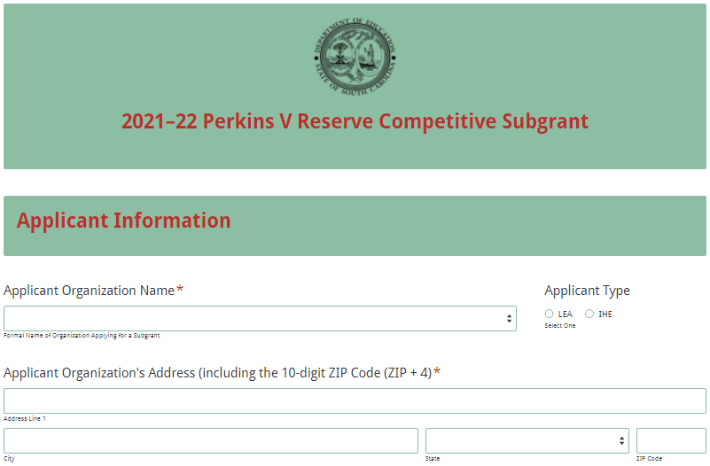
Indicate whether the organization is registered and active with the SAM. If the organization selects “Yes” to indicate that their SAM registration is active, enter the date the current SAM registration expires and if the organization is applying for competitive priority points.
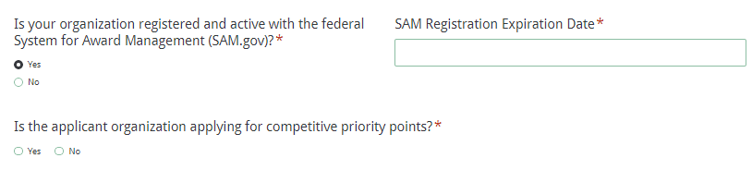
If the applicant organization does not have an active SAM registration, the following message will be displayed. The organization should refer to the information on page 3 or visit SAM.gov for more information on how to update the status of their SAM registration.
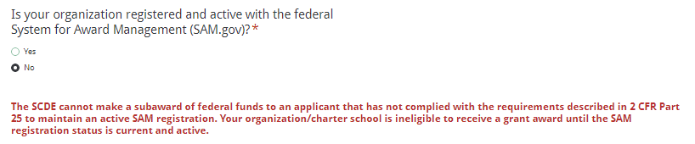
Enter the authorized official’s name, position or title, phone number, and email address. The authorized official’s email is a required field. Reenter the email address to confirm that it is correct.
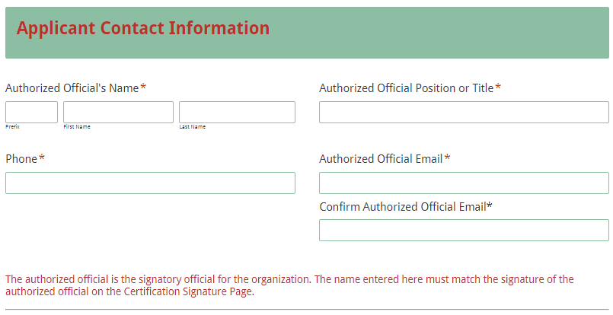
Enter the contact person’s name, position or title, and mailing address. If the contact person’s mailing address is the same as the applicant organization, click on “Same as Applicant Organization’s Address” and the data will automatically populate these fields. If the address is different, enter the appropriate information. The contact person’s email is a required field. The application submission confirmation message will be sent only to this email address. Reenter the email address to confirm that it is correct.
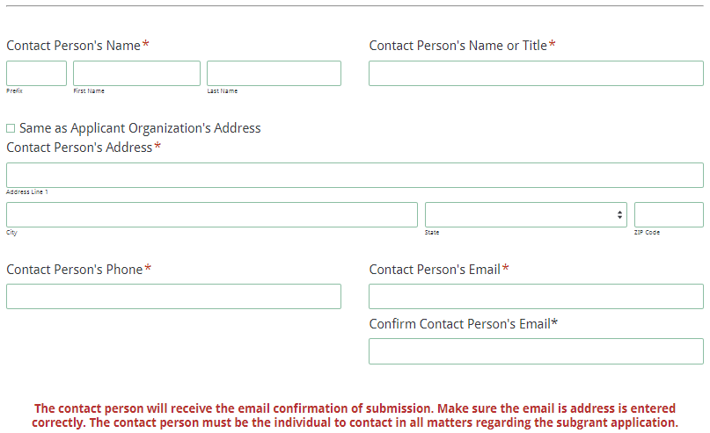
Enter the Project Director’s name, position or title, phone, and email address. If the project director is the same as the contact person, click “Same as Contact Person” to populate the field.
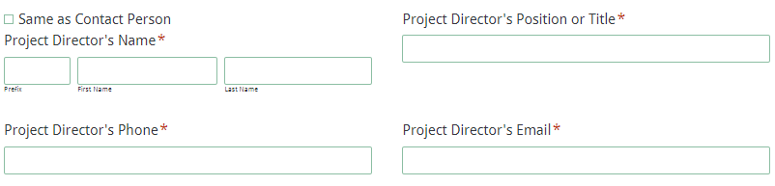
Enter the Financial Official’s name, position or title, phone, and email address.
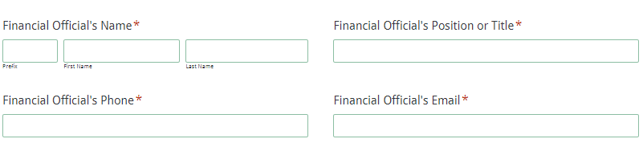
Select the number of partnering organizations for the project.
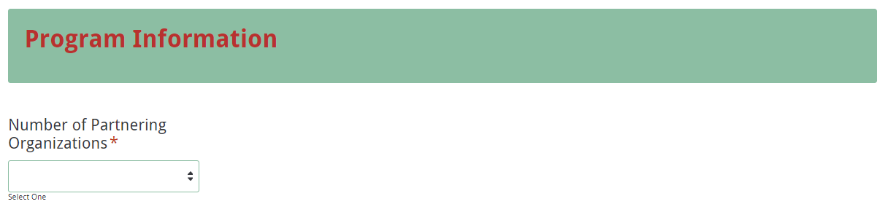
If the applicant is partnering with more than 3 organizations, select “Other” for the number of partnering organizations. A box will appear directing applicants to enter the information requested for the 3 most active partners in the sections provided and then enter the information requested for the rest of the organizations in the box provided.
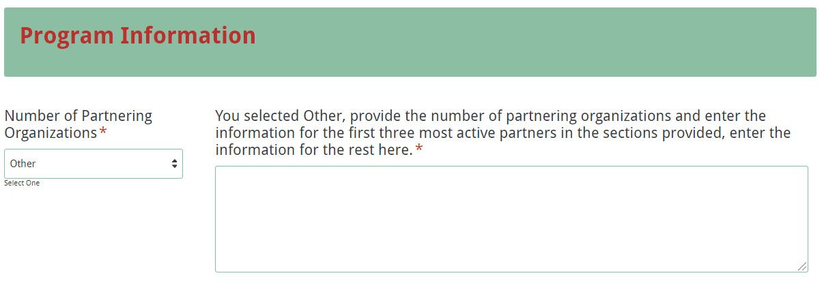
The program information fields will appear for each of the number of organizations selected. If you selected the wrong number of organizations, click the previous button and select the appropriate number. Enter the formal name for the organization and street address.
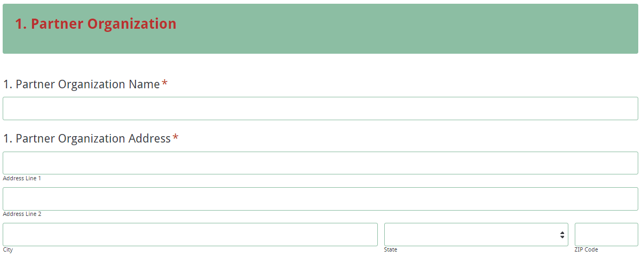
Provide the partner’s contact person, phone number, and email address. Enter the number of students to be served by this partner and select the activities the partner will offer during the project period.
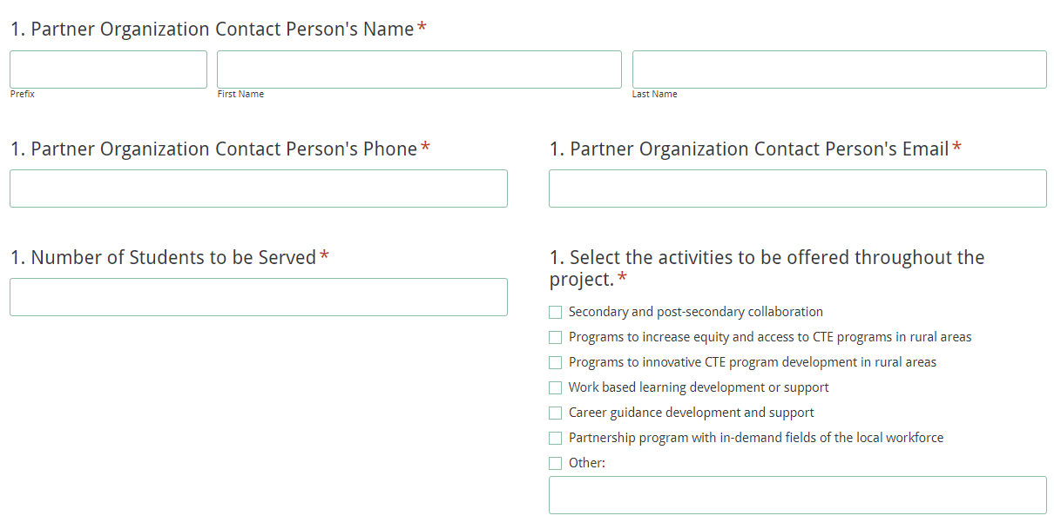
The Budget Summary reflects the detail in the budget narrative and totals must match. Enter the budget summary by object code and function code. Enter a zero (0) in the fields that are not used.
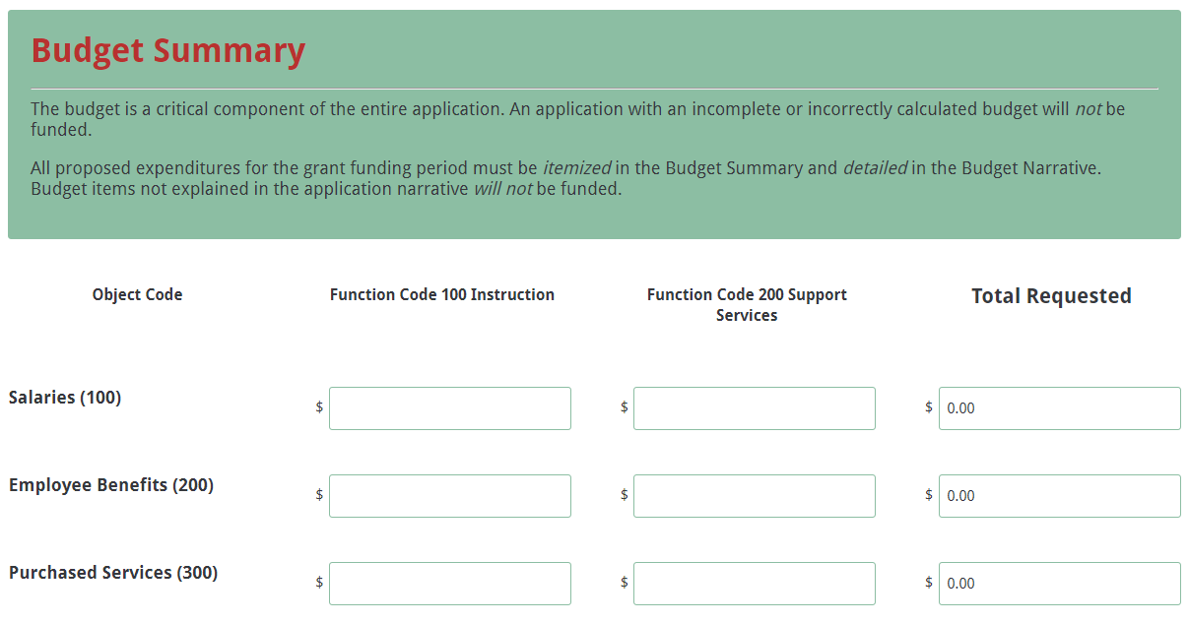
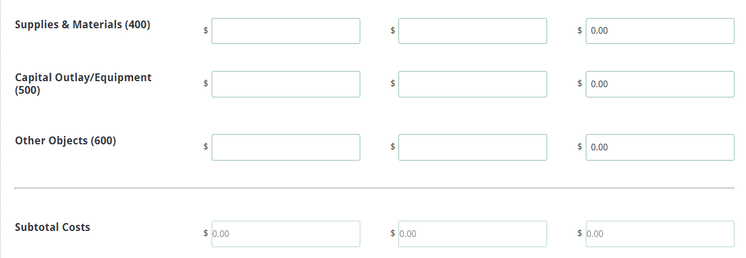
The Total Requested, Subtotal Cost, and Total Cost fields will auto-calculate. Enter the indirect costs per Function Code based on the applicant’s restricted indirect cost rate.
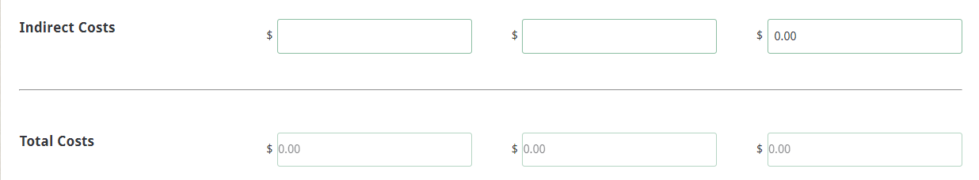
Save the Project Abstract and the Application Narrative as separate PDFs and upload in the Application Attachments section. Follow the directions on page 17 to compile and save the Appendices and Pre-Award Audit Questionnaire. Directions for completing and saving the Budget Narrative start on page 15. Once complete, upload the Budget Narrative where indicated.
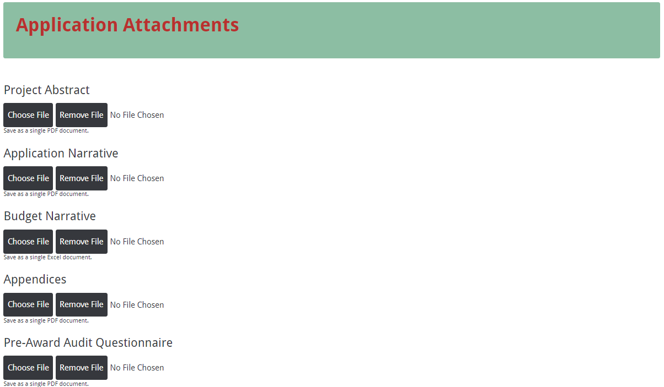
Click the Next button once everything is entered into the online form and the required certification form is attached. You will be directed to the Data Review and Confirmation page. Thoroughly review all information entered and attached before submitting the application.
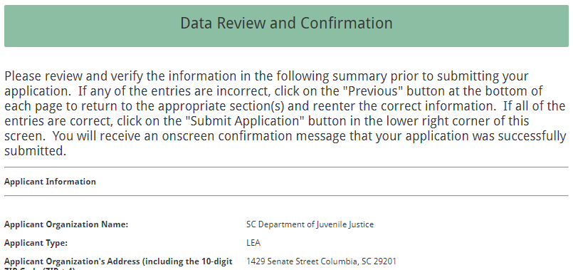
If any of the entries are incorrect, click on the "Previous" button at the bottom of each screen to return to the appropriate section(s) and reenter the correct information.

Note: You will not be able to access the completed application form after it has been submitted. If you need to make changes after the application has been submitted, you must start another application submission and enter the information again.

Once the application has been verified, click on the “Submit Application” button to submit the completed application. Remember, a saved application is not a submitted application.

Once the submission is complete, you will receive the following confirmation message.
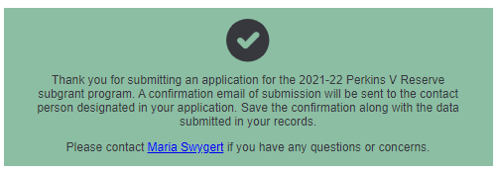
The contact person will receive a confirmation email of the submission that contains the data entered online. Save this email along with these instructions, the Assurances and Terms and Conditions, and the Certification Signature Page for your records.

If the contact person does not receive a confirmation email, then the application did not successfully submit. You must go back and resubmit the entire online form, including all attachments, in order for your application to be considered for funding. Only the last complete application submitted will be reviewed.

An email confirmation that the application was successfully submitted does not account for the quality of the uploaded documents or the completeness of the online form. The confirmation email only notifies you that the online application has been submitted. Applicants are responsible for ensuring that the information entered in the online form, including all attachments, is accurate and complete in order for the application to be reviewed and considered for funding.

Appendix A: Definitions of Terms Used

CTE Program of Study—A CTE program of study is a comprehensive, structured approach for delivering academic and career and technical education to prepare students for postsecondary education and career success. It consists of a coherent sequence of academic and career and technical courses offering students the opportunity to earn an industry-recognized credential or certificate at the secondary or postsecondary level, or an associate or baccalaureate degree related to the focus of the program of study. States receiving Perkins funds are required to develop CTE programs of study and each local recipient of Perkins funds must offer at least one CTE program of study.

Collaborative Partner—An organization that provides routine, regular, and ongoing services to the project as outlined in a signed memorandum of agreement (e.g., the regular use of facilities and equipment, mentors/tutors). For the Perkins V Reserve subgrant it is a partnership between a Perkins V LEA and Perkins V IHE.

Perkins V IHE — Eligible applicants are institutions that meet the definition of “institution of higher education” (IHE) and offer at least one program of study.

Perkins V LEA — Eligible applicants are institutions that meet the definition of secondary “local educational agency” (LEA) and offer at least one program of study.

Primary Applicant—The organization that serves as the fiscal agent in either a joint or consortium application. The primary applicant is responsible for the programmatic and fiduciary management of the grant.

Special populations— The Perkins V legislation mandates to serve special populations and document the achievement of each group to achieve established performance levels. Areas of achievement relate to Career Technical Education program completion, earning twelfth grade diplomas, placement of twelfth graders following program completion, nontraditional program enrollment, and nontraditional career program completion. Special populations as defined by Section (3)(48) Perkins V are:
- Individuals with disabilities
- Individuals from economically disadvantaged families, including low-income youth and adults
- Individuals preparing for nontraditional fields
- Single parents, including single pregnant women
- Out-of-workforce individuals
- Homeless individuals
- Youth who are in, or have aged out of, the foster care system
- Youth with a parent who is a member of the armed forces and is on active duty
- Individuals with other barriers to educational achievement, including individuals with limited English proficiency

Appendix B: Selection Criteria and Reviewers’ Scoring Rubric

Selection Criteria

A total of 100 points is available to applications that meet the maximum score for each selection criteria. While the budget is assigned zero (0) points, the budget remains a critical component of the entire application. An application with an incomplete budget will not be funded.

The point values for each section of the application are as follows:

Narrative Sections | Points Available
- Statement of Need | 25
- Goals and Objectives | 15
- Activities | 40
- Management and Collaboration | 20
SUBTOTAL
Competitive Points (bonus points available) | 20
TOTAL | 120

Scoring Rubric
Program Abstract: In one page, the applicant must concisely describe the proposed project, including the name of applicant and contact information, the name of collaborating partners, the documented need for the project and how it aligns with the local needs assessment, the goals and objectives for the project, the number of students to be served, and the amount of funding requested.
The applicant provides a one-page abstract that describes the proposed project, including  - name of applicant and contact information  - name of collaborating partners  - the documented need for the project and how it aligns with the local needs assessment,  - the goals and objectives for the project,  - the number of students to be served, and  - the amount of funding requested. | Acceptable | Adequate/Meets—0 points  Applicant provides a one-page abstract that provides all required items.
 | Not  Acceptable | Inadequate—0 points  Applicant provides a one-page abstract that did not provide all required items.
Reviewer’s Comments
1. Statement of Need: The applicant must provide a narrative that describes the need for the activities planned including the regional or statewide workforce development needs in high-skill, high-wage, or in-demand occupations in the critical or emerging industries to be addressed; any data or relevant information on the focus industries to be addressed; and the target population to be served and estimates of future industry employment growth if the project is funded.
The applicant provides a narrative that describes the need for the activities planned including:  - the regional or statewide workforce development needs in high-skill, high-wage, or in-demand occupations in the critical or emerging industries to be addressed;  - any data or relevant information on the focus industries to be addressed; and  - the target population to be served and estimates of future industry employment growth if the project is funded. | Acceptable | Fully Meets—18–25 points  Applicant provides a narrative that fully addresses all required items.
 | Acceptable | Adequate/Meets—12–17 points  Applicant provides a narrative that is limited or unclear in addressing all required items.

 | Not Acceptable | Limited/Approaches—6–11 points  Applicant provides a statement that is limited or unclear in describing all required items.
 | Not Acceptable | Inadequate—0–5 points  Applicant provides a narrative that does not adequately address all required items.
Reviewer’s Comments
2. Goals and Objectives: The applicant must provide a goal for the project that will build upon the SC State Plan for CTE and include objectives to meet the projected goal. Objectives should be specific, measureable, achievable, relevant, and time-specific (SMART). The objectives must be based on the identified needs and must be related to the identification, participation, completion, and certification for student workforce preparedness.
The applicant provides a  - goal for the project that will build upon the SC State Plan for CTE; and  - include objectives to meet the projected goal, that are SMART, based on the identified needs, and related to the identification, participation, completion, and certification for student workforce preparedness. | Acceptable | Fully Meets—12–15 points  Applicant provides a narrative that fully addresses all required items.
 | Acceptable | Adequate/Meets—8–11 points  Applicant provides a narrative that is limited or unclear in addressing all required items.
 | Not Acceptable | Limited/Approaches—4–7 points  Applicant provides a statement that is limited or unclear in describing all required items.
 | Not Acceptable | Inadequate—0–3 points  Applicant provides a narrative that does not adequately address all required items.

Reviewer’s Comments
3.a. Activities: The applicant must provide a narrative that explains how the proposed program will support the implementation of innovative CTE programs; discusses how the program will support increased and sustainable student equity and achievement in college and career coursework; and describes how the program will prepare students for career success and support CTE instructors, administrators, and counselors.
The applicant provides a narrative that  - explains how the proposed program will support the implementation of innovative CTE programs;  - discusses how the program will support increased and sustainable student equity and achievement in college and career coursework;  - describes how the program will prepare students for career success and support CTE instructors, administrators, and counselors. | Acceptable | Fully Meets—15–20 points  Applicant provides a narrative that fully addresses all required items.
 | Acceptable | Adequate/Meets—9–14 points  Applicant provides a narrative that is limited or unclear in addressing all required items.
 | Not Acceptable | Limited/Approaches—4–8 points  Applicant provides a statement that is limited or unclear in describing all required items.
 | Not Acceptable | Inadequate—0–3 points  Applicant provides a narrative that does not adequately address all required items.
Reviewer’s Comments

3.b. Activities: The applicant must provide a timeline of activities that indicates, in chronological order, the activities of the project; thoroughly describes when each program activity begins and ends; how each activity relates to a specific objective; and who is responsible for overseeing the activity.
The applicant provides a timeline of activities that  - indicates, in chronological order, the activities of the project;  - thoroughly describe when each program activity begins and ends;  - how each activity relates to a specific objective;  - and who is responsible for overseeing the activity. | Acceptable | Fully Meets—15–20 points  Applicant provides a narrative that fully addresses all required items.
 | Acceptable | Adequate/Meets—9–14 points  Applicant provides a narrative that is limited or unclear in addressing all required items.
 | Not Acceptable | Limited/Approaches—4–8 points  Applicant provides a statement that is limited or unclear in describing all required items.
 | Not Acceptable | Inadequate—0–3 points  Applicant provides a narrative that does not adequately address all required items.
Reviewer’s Comments
4.a. Management and Collaboration: The applicant must provide a narrative that describes previous grant experience that indicates the organization’s capacity to manage the proposed program; explains the plan to manage the proposed program, including the chain of command; and identifies key program personnel, their credentials, and their responsibilities and time commitments on the proposed program.
The applicant provides a narrative that  - describes previous grant experience that indicates the organization’s capacity to manage the proposed program;  - explains the plan to manage the proposed program, including the chain of command;  - and identifies key program personnel, their credentials, and their responsibilities and time commitments on the proposed program. | Acceptable | Fully Meets—15–20 points  Applicant provides a narrative that fully addresses all required items.
 | Acceptable | Adequate/Meets—9–14 points  Applicant provides a narrative that is limited or unclear in addressing all required items.

 | Not Acceptable | Limited/Approaches—4–8 points  Applicant provides a narrative that is limited or unclear in describing all required items.
 | Not Acceptable | Inadequate—0–3 points  Applicant provides a narrative that does not adequately address all required items.
Reviewer’s Comments
4.b. Management and Collaboration: To meet the competitive priority, applicants must identify a collaborative partnership between current secondary and postsecondary subgrantees in order to address the needs of all special population students (defined in Appendix A).

If applicable, the applicant must provide evidence that the proposed collaborative partnership meets and fulfills the priority to address the needs of all special population students by identifying the secondary and postsecondary subgrantees and the purpose of the collaborative partnership; discussing how the partnership will address the CTE needs of the students in the community and region; describing the activities in which the secondary and postsecondary subgrantees will take a role (also must be reflected in the timeline of activities); and completing the partnership identification and collaboration form.
If applicable, the applicant provides a narrative that provides evidence that the proposed collaborative partnership meets and fulfills the priority to address the needs of all special population students by  - identifying the secondary/postsecondary subgrantees and the purpose of the collaborative partnership;  - discussing how the partnership will address the CTE needs of the students in the community and region;  - describing the activities in which the secondary and postsecondary subgrantees will take a role (and are also reflected in the timeline of activities); and  - completing the partnership identification and collaboration form. |  |  | Acceptable | Meets Priority—20 points  Applicant provides a narrative that fully addresses all required items.
 |  |  | Not Acceptable | Not Applicable/Does Not Meet Priority—0 points  Applicant provides a narrative that does not apply for priority points/adequately address all required items.
Reviewer’s Comments

Appendix C: Required SCDE Forms

Certification Signature Page
(This form must be signed by the individual from each proposed district, school, or organization who holds the title listed below.)

Certification
I hereby certify that, to the best of my knowledge, the information and data contained in this application are true and correct. The applicant’s governing body has duly authorized this application and documentation, and the applicant will comply with the Program Specific Assurances (if applicable) and the SCDE Assurances and Terms and Conditions if the grant is awarded. The applicant is registered and current (active) on the federal System for Award Management (SAM).

Authorized Official

Name:
Position: | Email:
Telephone: | Fax:

Signature of Authorized Official: | Typed name of Authorized Official:
Date Signed:
Signature of Financial Official: | Typed Name of Financial Official:
Date Signed:
Signature of Contact Person: | Typed Name of Contact Person:
Date Signed:
Project Director (if different than Contact Person): | Typed Name of Project Director:
Date Signed:

Please complete, print, and obtain signatures prior to submission. Include the signed, scanned form in the required appendices as indicated on page 17.

Assurances and Terms and Conditions for Federal Subawards

Assurances

I certify that this applicant
- Has the legal authority to apply for federal assistance and the institutional, managerial, and financial capability (including funds sufficient to pay the nonstate share of project costs) to ensure proper planning, management, and completion of the project described in this application.
- Will give the South Carolina Department of Education (SCDE) access to and the right to examine all records, books, papers, or documents related to this award and will establish a proper accounting system in accordance with generally accepted accounting principles (GAAP) or agency directives.
- Has an accounting system with sufficient internal controls, a clear audit trail, and written cost-allocation procedures as necessary. The financial management systems are capable of distinguishing expenditures that are attributable to this grant from those that are not attributable to this grant. This system is able to identify costs by programmatic year and by budget line item and to differentiate among direct, indirect, and administrative costs. In addition, the applicant will maintain adequate supporting documents for the expenditures (federal and nonfederal) and in-kind contributions, if any, that it makes under this grant. Costs are shown in books or records (e.g., disbursements ledger, journal, payroll register) and are supported by a source document such as a receipt, travel voucher, invoice, bill, or in-kind voucher.
- Will also comply with the Office of Management and Budget 2 CFR Part 200 Subpart E-Cost Principles related to the allowability, reasonableness, and allocability of costs consistent with the approved budget and also by maintaining required support for salaries and wages. Required support includes certifications and/or personnel activity records depending upon the amount of time spent on cost objectives.
- Will approve all expenditures, document receipt of goods and services, and record payments on the applicant’s accounting records prior to submission of reimbursement claims to the SCDE for costs related to this grant.
- Will initiate and complete work within the applicable time frame after receipt of approval by the SCDE.
- Will not discriminate against any employee or applicant for employment because of race, color, religion, age, sex, national origin, or disability and comply with Title VI of the Civil Rights Act of 1964, Section 504 of the Rehabilitation Act of 1973, Title IX of the Education Amendments of 1972, the Age Discrimination Act of 1975, and Titles I, II, and III of the Americans with Disabilities Act of 1990 (ADA). The grantee will take affirmative action to ensure that applicants for employment and the employees during the period of their employment are treated without regard to their race, color, religion, age, sex, national origin, or disability.
- Has no policy that prevents, or otherwise denies, participation in constitutionally protected prayer in public schools as set forth in the Guidance on Constitutionally Protected Prayer in Public Education (20 U.S.C. § 7904).
- Will comply with the Family Educational Rights and Privacy Act. (20 U.S.C. §1232g; 34 CFR Part 99).
- Will comply with the Ethics, Government Accountability, and Campaign Reform Act (S.C. Code Ann. § 2-17-10 et seq. and § 8-13-100 et seq. (Supp. 2020)).
- Will comply with the South Carolina Drug Free Workplace Act (S.C. Code Ann. § 44-107-10 et seq. (Supp. 2020) if the amount of this award is $50,000 or more and the federal Drug Free Workplace Act of 1988 (41 USC 702).
- Will provide information to the SCDE, as requested, regarding the reporting requirements of the Federal Funding Accountability and Transparency Act (FFATA), which requires the SCDE to file a FFATA subaward report by the end of the month following the month in which it awards any subgrant equal to or greater than $25,000.
- Will comply with 2 CFR Part 25 and register and receive a unique entity identifier, fulfill the requirement for the System for Award Management, maintain the currency of the registration throughout the full grant term, and allow access by the granting agency to ensure compliance.
- Will comply with 2 CFR Part 200.112 and disclose in writing any potential conflict of interest to the SCDE.
- Will comply with 2 CFR Part 200.113 and disclose in writing to the SCDE all violations of federal criminal law involving fraud, bribery, or gratuity violations potentially affecting the federal award.
- Will comply with conditions under Executive Order 13513 “Federal Leadership on Reducing Text Messaging While Driving” (October 1, 2009) by refraining from text messaging while driving during official grant business.

Terms and Conditions

- Completeness of Proposal. All proposals should be complete and carefully worded and must contain all of the information requested by the South Carolina Department of Education (SCDE). If you do not believe a section applies to your proposal, please indicate that fact.
- Non-awards/Termination. The SCDE reserves the right to reject any and all applications and to refuse to grant monies under this solicitation. If the SCDE rejects an application, the applicant has a right to request a hearing, as provided by 2 CFR Part 200.341 and 34 CFR Part 76.401, if it alleges the SCDE’s actions violate a state or federal statute or regulation by (1) disapproving of or failing to approve the application or project, in whole or in part, or (2) failing to provide funds in amounts in accordance with the requirements of statutes and regulations.
After it has been awarded, the SCDE may terminate a grant by giving the grantee written notice of termination. In the event of a termination after award, the SCDE shall reimburse the grantee for allowable expenses incurred up to the notification of termination. In addition, this grant may be terminated by the SCDE if the grantee fails to perform as promised in its proposal. Federal grants will be terminated in accordance with 2 CFR Part 200.339 and 200.340.
In the event that this grant is terminated, the grantee shall have a right to a hearing as set forth in 34 CFR Part 76.783. The grantee must notify the SCDE of its request for a hearing within 30 days of receiving written notice of the termination. If a hearing is requested, the SCDE will conduct the hearing in accordance with the procedures outlined in 34 CFR Part 76.401(d)(2)–(7).
- Reduction in Budgets and Negotiations. The SCDE reserves the right to negotiate budgets with applicants. The SCDE may, at its sole discretion, determine that a proposed budget is excessive and may negotiate a lower budget with the applicant. The applicant may at that time negotiate or withdraw its proposal. In addition, the SCDE may desire to fund a project but not at the level proposed. In that case, the SCDE shall notify the applicant of the amount that can be funded, and the applicant and the SCDE shall negotiate a modification to the proposal to accommodate the lower budget. All final decisions are that of the SCDE.
- Amendments to Grants. Amendments are permitted generally for budgets, grant end date, and management upon the mutual agreement of the parties involved and will become effective when specified in writing and signed by both parties. However, amendments to scope of work that significantly alter the original application proposal may trigger partial or full termination consistent with 2 CFR Part 200.339 and 200.340.
- Use of Grant Funds. Funds awarded are to be expended only for purposes and activities covered by the approved project plan and approved budget and budget narrative.
- Submission of Expenditure Reports. Claims for reimbursement must be made at least quarterly and consistent with calendar quarters (e.g., an expenditure report claim for costs for January 1 through March 30 must be filed by May 15).
- Obligation of Grant Funds. Grant funds may not be obligated prior to the effective date or subsequent to the end or termination date of the grant period. No obligations are allowed after the end of the grant period. The final request for expenditure report claims must be submitted no later than forty-five (45) days after the end of the grant period unless the scope of work for the grant states a shorter reporting period.
- Deobligation of Funds. After a final expenditure report claim has been submitted to the SCDE, the grantee will go through the official deobligation process with the SCDE.
- Documentation. The grantee must provide for accurate and timely recording of receipts and expenditures. The grantee’s accounting system should distinguish receipts and expenditures attributable to each grant. The grantee must review the memo regarding “Guidelines for Retaining Documentation to Support Expenditure Claims.”
- Travel Costs. Travel costs, if allowed under this solicitation, must not exceed limits noted in the United States General Services Administration (GSA) per diem rates for lodging, except in the case of conference lodging required for program-required training. In the case that conference-related lodging exceeds the GSA per diem rate, the grantee shall follow their entity’s written procedure for obtaining prior approval to exceed a GSA rate for a conference hotel. Meals and incidentals are limited by the state budget proviso, currently not to exceed $35 per day for in-state travel and $50 for out-of-state travel (see page 86 of the State of South Carolina Statewide Disbursement Regulations). Mileage reimbursement must follow the current Office of Comptroller General instructions, which is consistent with the published IRS rates.
- Honoraria. Amounts paid in honoraria, if allowed under this grant, must be consistent with SCDE policies. Applicants should check with the program office before budgeting for honoraria.
- Reports. The grantee shall submit, as required or instructed by the awarding program office, all reports (programmatic, financial, or evaluation) within the specified period or date and in the prescribed format. An expenditure claim report must be filed by August 15 for all expenditures incurred by June 30 in order to comply with the generally accepted accounting principles (GAAP) and the production of the State's Comprehensive Annual Financial Report.
- Copyright. The grantee is free to copyright any books, publications, or other copyrightable materials developed in the course of this grant. However, the SCDE reserves a royalty-free, nonexclusive, and irrevocable license to reproduce, publish, or otherwise use, and to authorize others to use, the copyrighted work developed under this grant.
- Certification Regarding Lobbying, Suspension, and Debarment. By submitting an application, the applicant certifies, to the best of its knowledge and belief, that the
- Applicant and/or any of its principals, subgrantees, or subcontractors
  - Have not paid or will not pay to any person any federally appropriated funds for the purpose of influencing or attempting to influence an officer or employee of any agency, a Member of
Congress, an officer or employee of Congress, or any employee of a Member of Congress in connection with making any federal grant and the extension continuation, renewal, amendment, or modification of any federal grant, as defined at 34 CFR Part 82.105 and 82.110. If any funds other than federally appropriated funds have been paid or will be paid to any person for influencing or attempting to influence an officer or employee of any agency, a Member of Congress, an officer or employee of Congress, or any employee of a Member of Congress in connection with this federal grant, the undersigned shall complete and submit Standard Form LLL, “Disclosure of Lobbying Activities,” in accordance with its instructions.
  - Are not presently debarred, suspended, proposed for debarment, or declared ineligible for the award of contracts by any state or federal agency as stated at 2 CFR Part 180 or 2 CFR Part 3485.
  - Have not, within a three-year period preceding this application, been convicted of or had a civil judgment rendered against them for commission of fraud or a criminal offense in connection with obtaining, attempting to obtain, or performing a public (federal, state, or local) contract or subcontract; violated federal or state antitrust statutes relating to the submission of offers; or committed embezzlement, theft, forgery, bribery, falsification or destruction of records, making false statements, tax evasion, or receiving stolen property.
  - Are not presently indicted for, or otherwise criminally or civilly charged by a governmental entity with, commission of any of the offenses enumerated above.
- Applicant has not, within a three-year period preceding this application, had one or more contracts terminated for default by any public (federal, state, or local) entity.
- Audits.
- Entities expending $750,000 or more in federal awards:
Entities that expend $750,000 or more in federal awards during the fiscal year are required to have an audit performed in accordance with the provisions of 2 CFR Part 200.501, et seq. Except for the provisions for biennial audits provided in 2 CFR Part 200.504 (a) and (b), audits must be performed annually as stated at 2 CFR Part 200.504. A grantee that passes through funds to subrecipients has the responsibility of ensuring that federal awards are used for authorized purposes in compliance with federal program laws, federal and state regulations, and grant agreements. The director of the OMB, who will review this amount every two years, has the option of revising the threshold upward.
- Entities expending less than $750,000 in federal awards:
Entities that expend less than $750,000 in a fiscal year in federal awards are exempt from the audit requirements in 2 CFR Part 200.504. However, such entities are not exempt from other federal requirements (including those to maintain records) concerning federal awards provided to the entity. The entity’s records must be available for review or audit by the SCDE and appropriate officials of federal agencies, pass-through entities, and the General Accounting Office (GAO).
- Records. The grantee shall retain federal grant records, including financial records and supporting documentation, for a minimum of six (6) years after the end date of the grant when the final expenditure report claim for reimbursement and all final reports have been submitted, unless informed otherwise or in the case of litigation.
- Electronic Signature Agreement. I agree that my electronic signature is the legally binding equivalent to my handwritten signature.

Budget Narrative Template
Sample Only

Go to the SCDE Grant Opportunities Web page for the Perkins V Reserve Subgrant Program to download and complete the budget narrative. Save the budget as instructed and upload in the attachments section when indicated on page 17.

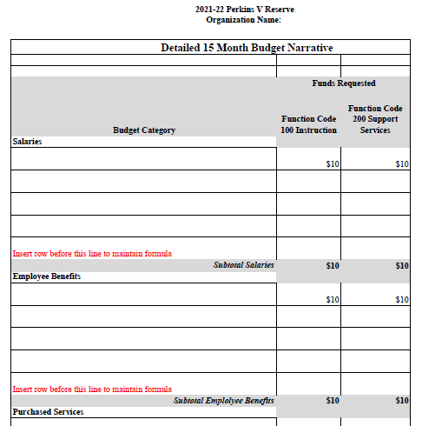

South Carolina Department of Education

Pre-Award Audit Questionnaire
Sample Only

Complete the Pre-Award Audit Questionnaire for LEAs and State Agencies and submit with your application where indicted in the online application attachments.
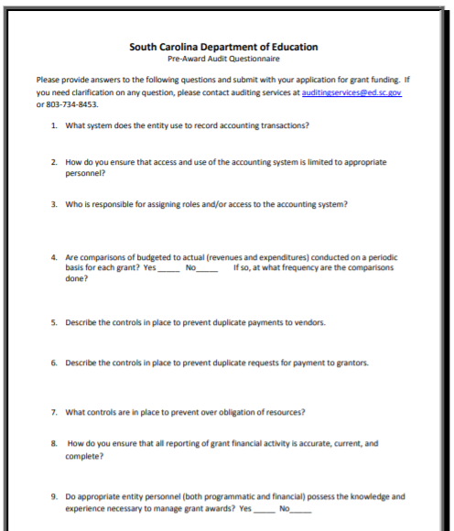

Instructions for GEPA Statement of Compliance
OMB Control No. 1894-0005 (Exp. 06/30/2023)

NOTICE TO ALL APPLICANTS
The purpose of this enclosure is to inform you about the following provision in the Department of Education's General Education Provisions Act (GEPA) that applies to applicants for new grant awards under Department programs. This provision is Section 427 of GEPA, enacted as part of the Improving America's Schools Act of 1994 (Public Law (P.L.) 103-382).
To Whom Does This Provision Apply?
Section 427 of GEPA affects applicants for new grant awards under this program. ALL APPLICANTS FOR NEW AWARDS MUST INCLUDE INFORMATION IN THEIR APPLICATIONS TO ADDRESS THIS NEW PROVISION IN ORDER TO RECEIVE FUNDING UNDER THIS PROGRAM.

What Does This Provision Require?
Section 427 requires each applicant for funds (other than an individual person) to include in its application a description of the steps the applicant proposes to take to ensure equitable access to, and participation in, its federally-assisted program for students, teachers, and other program beneficiaries with special needs. This provision allows applicants discretion in developing the required description. The statute highlights six types of barriers that can impede equitable access or participation: gender, race, national origin, color, disability, or age. Based on local circumstances, you should determine whether these or other barriers may prevent your students, teachers, etc. from such access or participation in the federally-funded project or activity. The description in your application of steps to be taken to overcome these barriers need not be lengthy; you may provide a clear and succinct description of how you plan to address those barriers that are applicable to your circumstances. In addition, the information may be provided in a single narrative, or, if appropriate, may be discussed in connection with related topics in the application.

Section 427 is not intended to duplicate the requirements of civil rights statutes, but rather to ensure that, in designing their projects, applicants for federal funds address equity concerns that may affect the ability of certain potential beneficiaries to fully participate in the project and to achieve to high standards. Consistent with program requirements and its approved application, an applicant may use the federal funds awarded to it to eliminate barriers it identifies.

What are Examples of How an Applicant Might Satisfy the Requirement of This Provision?
The following examples may help illustrate how an applicant may comply with Section 427.
- An applicant that proposes to carry out an adult literacy project serving, among others, adults with limited English proficiency might describe in its application how it intends to distribute a brochure about the proposed project to such potential participants in their native language.
- An applicant that proposes to develop instructional materials for classroom use might describe how it will make the materials available on audio tape or in braille for students who are blind.
- An applicant that proposes to carry out a model science program for secondary students and is concerned that girls may be less likely than boys to enroll in the course, might indicate how it intends to conduct "outreach" efforts to girls to encourage their enrollment.
- An applicant that proposes a project to increase school safety might describe the special efforts it will take to address concern of lesbian, gay, bisexual, and transgender students, and efforts to reach out to and involve the families of LGBT students.
We recognize that many applicants may already be implementing effective steps to ensure equity of access and participation in their grant programs, and we appreciate your cooperation in responding to the requirements of this provision.
Estimated Burden Statement for GEPA Requirements
According to the Paperwork Reduction Act of 1995, no persons are required to respond to a collection of information unless such collection displays a valid OMB control number. Public reporting burden for this collection of information is estimated to average 1.5 hours per response, including time for reviewing instructions, searching existing data sources, gathering and maintaining the data needed, and completing and reviewing the collection of information. The obligation to respond to this collection is required to obtain or retain benefit (Public Law 103-382. Send comments regarding the burden estimate or any other aspect of this collection of information, including suggestions for reducing this burden, to the U.S. Department of Education, 400 Maryland Ave., SW, Washington, DC 20210-4537 or email ICDocketMgr@ed.gov and reference the OMB Control Number 1894-0005.

Partner Identification and Funding Request Form
Complete this form for each collaborating partner and save as a PDF to include in the appendices as directed on page 17.

Name of Applicant:
Name of Project:

Include a Partnership Identification Form for each partner institution/organization.

Name of Partner Institution
Type of Institution/Organization
Primary Contact Name

List only the funding this partner will receive from the subgrant.

Direct Cost Requested for Partner | YEAR 1  Requested | YEAR 1  In-kind | TOTAL
1. Salaries & Wages
2. Employee Benefits
3. Travel in State
4. Travel Out of State
5. Materials and Supplies
6. Consultants and Contracts
7. Teacher Stipends
8. Equipment (Purchase)
9. Other (Equipment rental, printing, etc.)
Total Funding to Partner From Subgrant

By signing below, I authorize this agency to participate in this subgrant program, and I certify that the agency is committed to completing the services described above and will apply the funds outlined in the budget above to these services.

____________________________________________ _______________
Signature of Authorized Official Date

____________________________________________
Printed Name of Authorized Official

Timeline of Activities Template

Start Date–End Date | Activity to achieve Objective | Related Objective and Goal | Evidence that Proves Activity has been Completed OR Data to be Collected from Activity | Persons/Agency Responsible

LEAs and IHEs Eligible to apply for a Perkins V Reserve Subgrant

LEAs and IHEs Eligible to Apply
Abbeville County School District
Aiken County Public School District
Allendale County Schools
Anderson School District One
Anderson School District Two
Anderson School District Three
Anderson School District 4
Anderson School District Five
Anderson County Career Center
Bamberg School District One
Bamberg School District 2
Blackville-Hilda Public Schools (Barnwell 19)
Williston School District 29 (Barnwell 29)
Barnwell School District 45
Barnwell County Career Center
Beaufort County School District
Beaufort Jasper Academy for Career Excellence
Berkeley County School District
Calhoun County Public Schools
Charleston County School District
Cherokee County School District
Chester County School District
Chesterfield County School District
Clarendon School District One
Clarendon School District Two
Clarendon County School District Three
F.E. DuBose Career Center
Colleton County School District
Darlington County School District
Dillon School District Three
Dillon School District Four
Dillon County Career Center
Dorchester School District Two

LEAs and IHEs Eligible to Apply
Dorchester School District Four
Dorchester County Career Center
Edgefield County School District
Fairfield County School District
Florence Public School District One
Florence County School District 2
Florence County School District 3
Florence County School District Four
Florence County School District Five
Georgetown County School District
The School District of Greenville County
Greenwood School District 50
Ware Shoals School District 51 (Greenwood 51)
Greenwood County School District 52
Hampton School District One
Hampton County School District 2
Horry County Schools
Jasper County School District
Kershaw County School District
Lancaster County School District
Laurens County School District 55
Laurens County School District 56
Lee County School District
Lexington County School District One
Lexington School District Two
Lexington County School District Three
Lexington School District Four
School District Five of Lexington and Richland Counties (Lexington/Richland 5)
McCormick County School District
Marion County School District (Marion 10)
Marlboro County School District
School District of Newberry County

LEAs and IHEs Eligible to Apply
School District of Oconee County
Orangeburg County School District
School District of Pickens County
Richland County School District One
Richland School District Two
Saluda County Schools
Spartanburg School District One
Spartanburg School District 2
Spartanburg School District Three
Spartanburg School District Four
Spartanburg School District Five
Spartanburg County School District Six
Spartanburg School District 7
Daniel Morgan Career Center
R D Anderson Career Center
H B Swofford Career Center
Sumter School District
Union County Schools
Williamsburg County School District
York School District 1
Clover School District (York 2)
Rock Hill School District Three (York 3)

LEAs and IHEs Eligible to Apply
Fort Mill School District (York 4)
S.C. Public Charter School District
Charter Institute at Erskine
Aiken Technical College
Central Carolina Technical College
Denmark Technical College
Florence-Darlington Technical College
Greenville Technical College
Horry Georgetown Technical College
Midlands Technical College
Northeastern Technical College
Orangeburg-Calhoun Technical College
Piedmont Technical College
Spartanburg Community College
Technical College of the Low country
Tri-County Technical College
Trident Technical College
Williamsburg Technical College
York Technical College
SC School for the Deaf and the Blind
SC Department of Juvenile Justice
SC Department of Corrections

