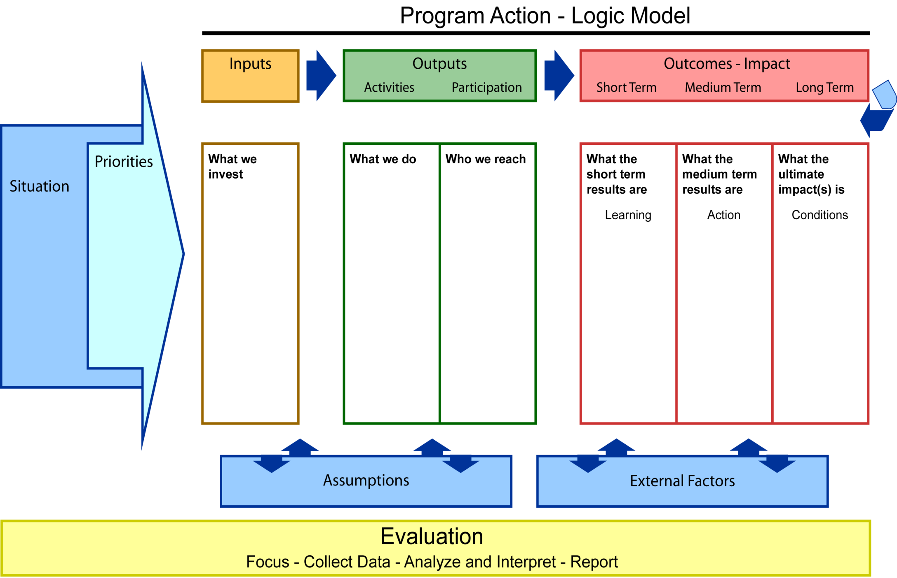
{Populate with details}

{Populate with details}

{Populate with details}

{Populate with details}

{Populate with details}

{Populate with details}

{Populate with details}

{Populate with details}

{Populate with details}

{Populate with details}

{Populate with details}

{Populate with details}

{Populate with details}

{Populate with details}

