Evaluator: Student Growth & Professional Goals
SCLead.org has the option to record Student Growth and Professional Goals data for educators evaluated under Expanded ADEPT. The use of the SLO worksheets in SCLead.org is a district level decision; however, each educator will need an SLO rating provided in the evaluation results. Here are instructions for an evaluator who has permission to view and edit Student Growth & Professional Goals, to review and sign the conference forms for each SLO and or Professional Goals.
Note: Principals will have access to Student Growth & Professional Goals even if he/she is not listed on the educator’s evaluation team.
Educators can enter more than one Student Learning Objective. The educator can also enter the data for a separate Professional Goal, if required. Each goal will have a signature option for preliminary, mid-course, and summative conferences.
Step 1: Click Evaluations on the navigation menu bar.
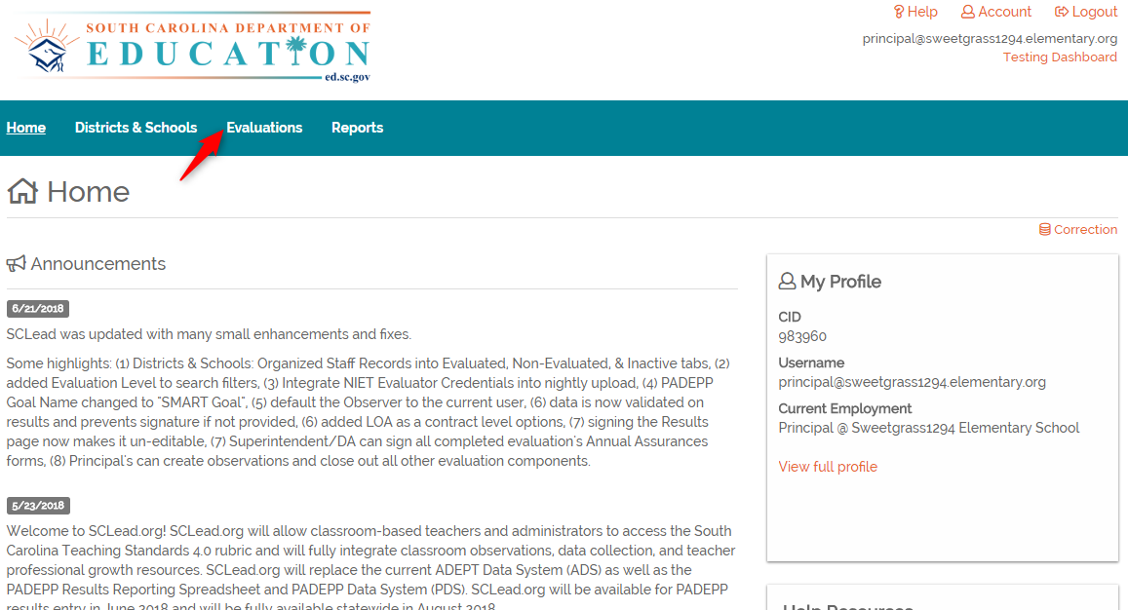
Step 2: Locate the evaluation and click Details.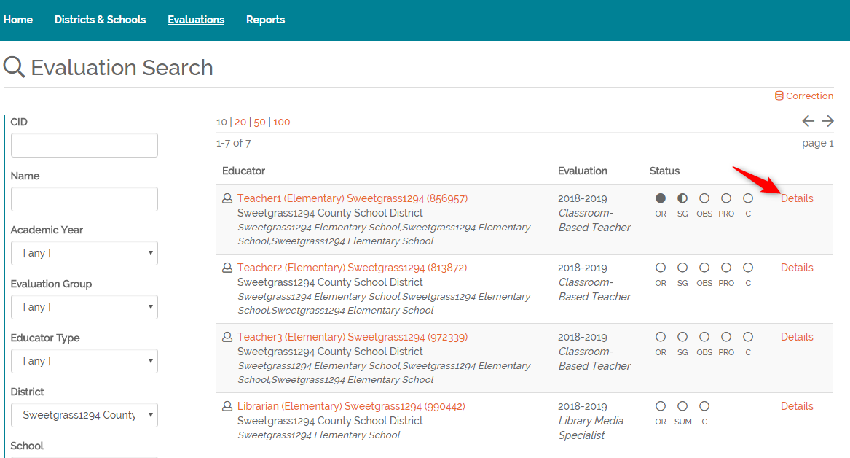
Step 3: Click Student Growth & Professional Goals.
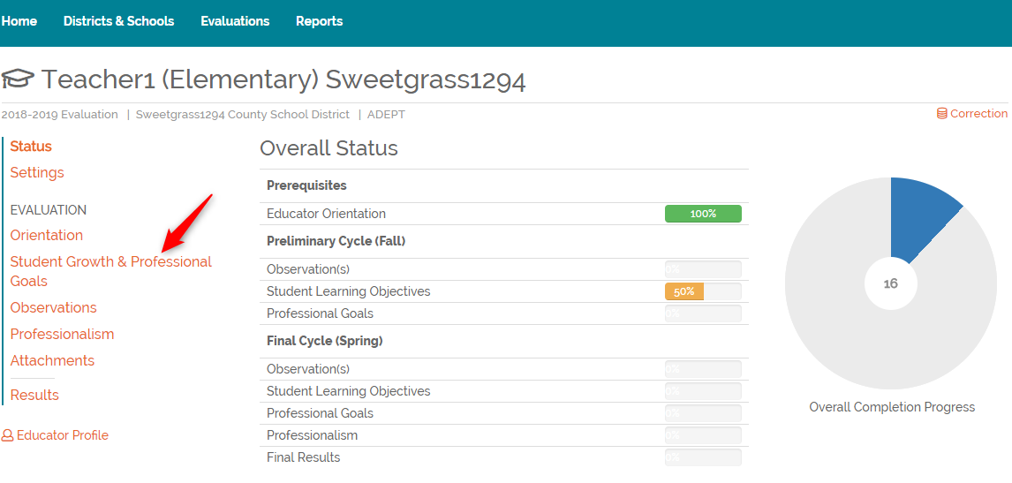

Step 4: Click on the SLO or Professional Goal name you would like to review and sign.
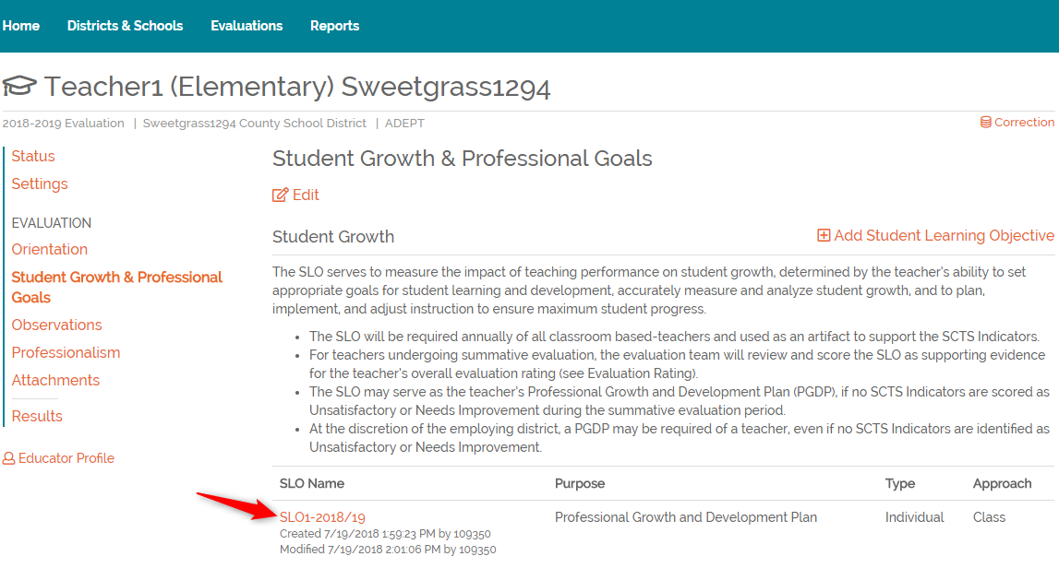
Step 5: At the bottom of the Preliminary Conference Form, click Add my signature.
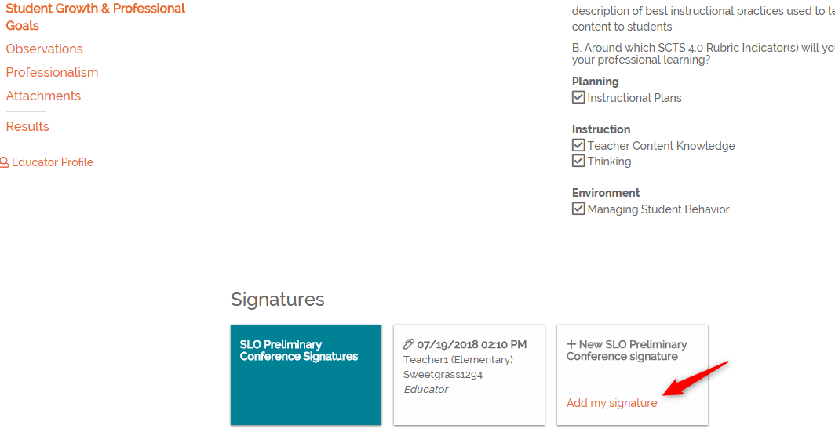

Step 6: Enter your PIN in the PIN entry box. PIN’s are automatically assigned by the system. Click Forgot your PIN? to view your assigned PIN. Once you enter your PIN, click Sign.
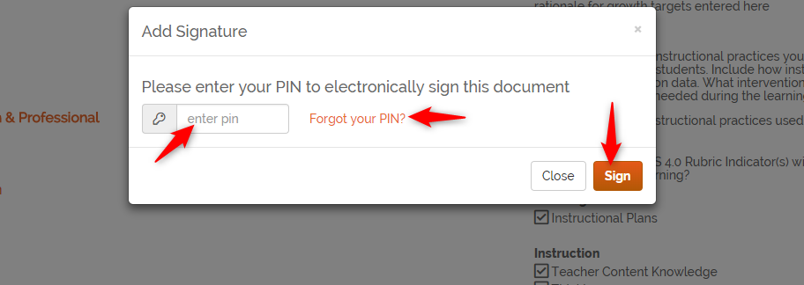
Repeat steps 1-4 to access the Mid-Course Conference form.
Step 7: Click Mid-Course Conference and click Add my signature to sign the Mid-Course Conference.
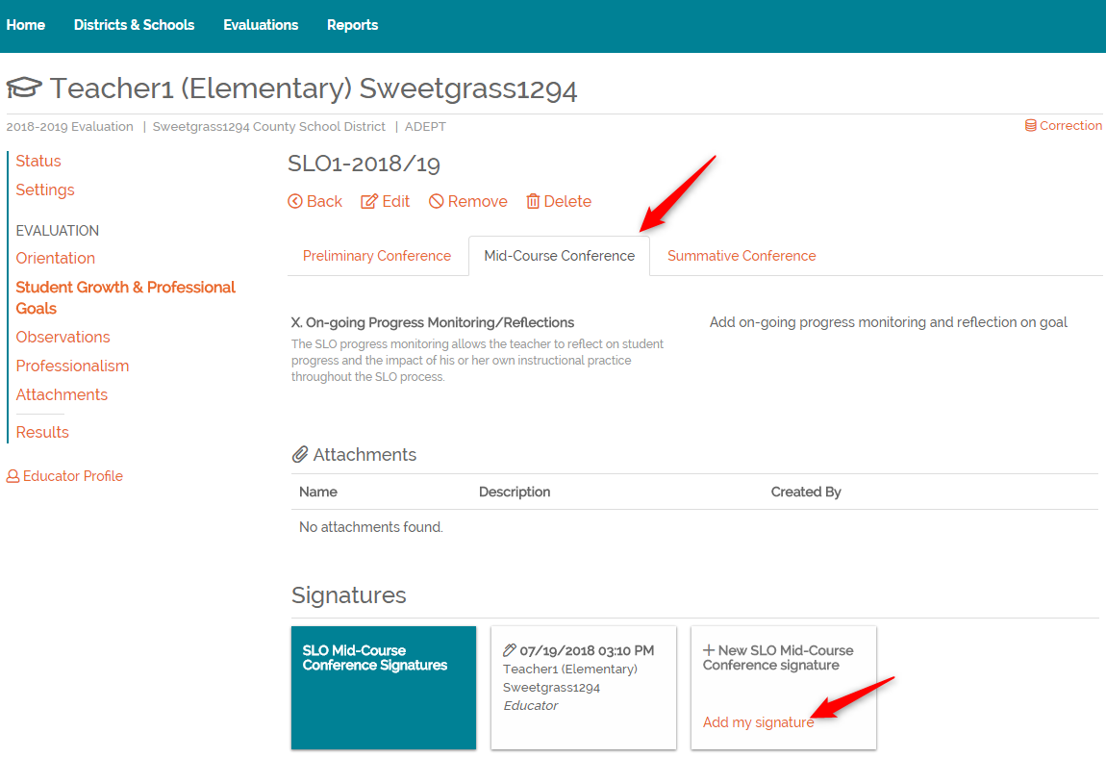
Repeat steps 1-4 to access the Summative Conference form.

Step 8: Click Summative Conference and click Add my signature to sign the Summative Conference.
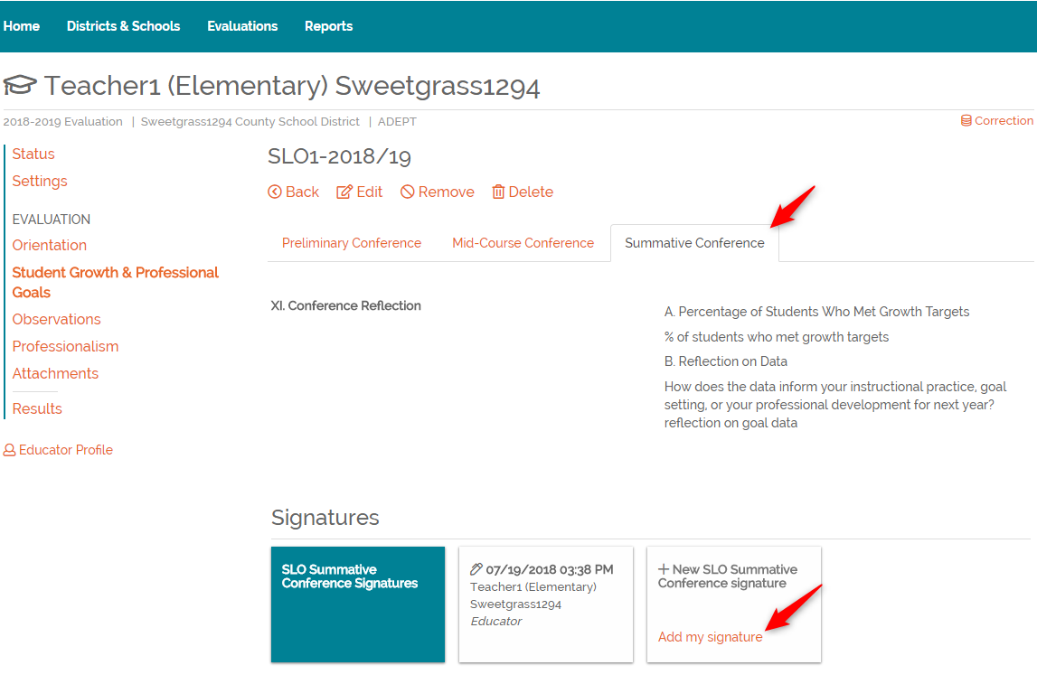
Once the conference forms have been signed for all SLO’s and the Professional Goals, as applicable, the Student Growth & Professional Goals status can be marked as complete. To access this page, repeat steps 1-3.
Reminder: The Student Growth and Professional Goals rating will be entered in the results section of the evaluation.

Contact SCLead.org support if you have problems accessing or completing the Student Growth & Professional Goals forms.
1-877-314-1412 or https://sclead.org/Help/Support.

