State of South Carolina

DEPARTMENT OF EDUCATION

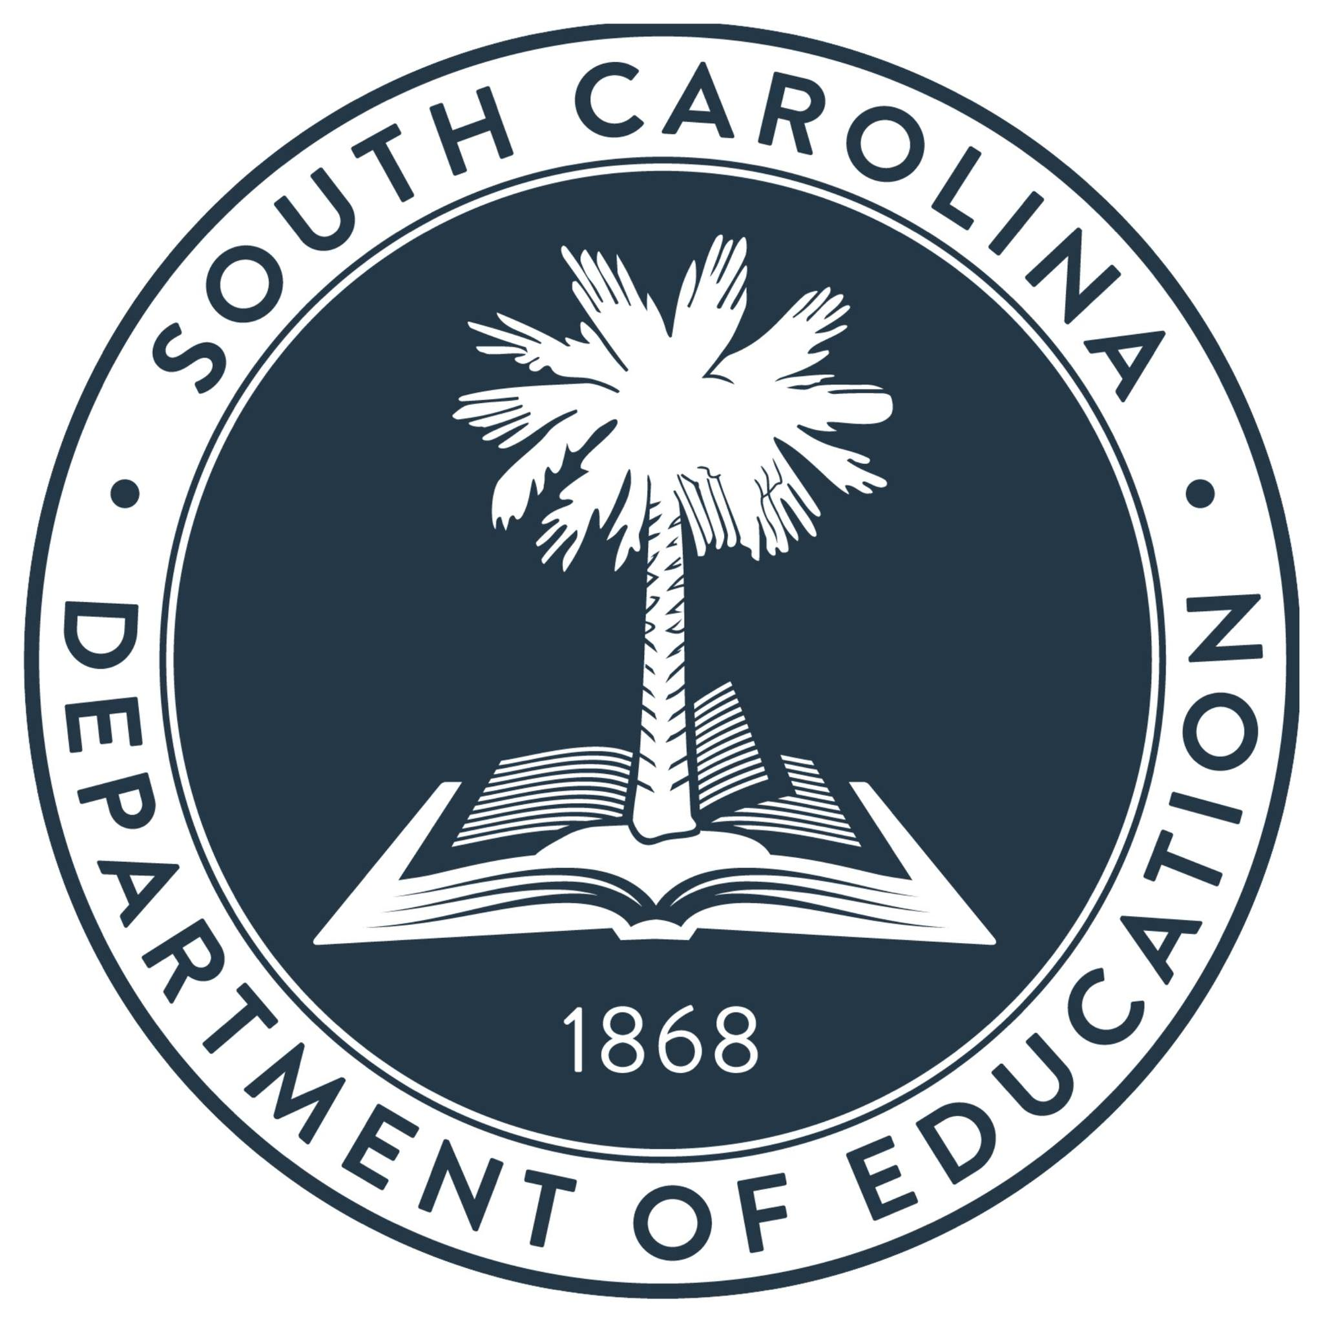

The International Baccalaureate (IB) Examinations 2026

July 29, 2026

The International Baccalaureate (IB) Examinations 2026

International Baccalaureate Results

Founded in 1968, the International Baccalaureate® (IB) is a non-profit educational foundation offering four highly respected programs of international education for students aged 3 to 19. Schools that are authorized to teach IB programs can offer the programs individually or as a continuum.

The IB Diploma Programme (DP) is an academically challenging and balanced program of education with final examinations that prepare students, aged 16 to 19, for success at university and life beyond. Visit www.ibo.org for more information.
The DP curriculum is made up of six subject groups and the DP core, comprised of Theory of Knowledge (TOK); Creativity, Activity, Service (CAS); and the Extended Essay (EE). Through the DP core students reflect on the nature of knowledge, complete independent research, and undertake a project that often involves community service. DP students choose courses from the subject groups listed below. Students may opt to study an additional Science, Individuals and Societies, or Language course instead of a course in the arts.

Subject Group | Description
Studies in Language and Literature | Courses offer a broad range of texts, and students grow to appreciate a language’s complexity, wealth and subtleties in a variety of contexts.
Language Acquisition | The main emphasis of the modern language courses is on the acquisition and use of language in a range of contexts and for different purposes while, at the same time, promoting an understanding of another culture through the study of its language.
Individuals and Societies | Business management, economics, geography, global politics, history, information technology in a global society, philosophy, psychology, social and cultural anthropology, world religions
Sciences | Biology; computer science; chemistry; design technology; physics; sports, exercise and health science
Mathematics | Mathematical studies standard level, mathematics standard level, mathematics higher level, further mathematics higher level
The Arts | Dance, music, film, theater, visual arts

Students will take some subjects at Higher Level and some at Standard Level. Higher Level and Standard Level courses differ in scope but are measured according to the same grade descriptors, with students expected to demonstrate a greater body of knowledge, understanding, and skills at Higher Level. Each student takes at least three (but not more than four) subjects at Higher Level, and the remaining at Standard Level. Standard Level subjects take up 150 teaching hours. Higher Level comprises 240 teaching hours.

The table in Appendix A displays a summary of the students’ examinations for the 2025-26 school year, grouped by school. The data is for South Carolina public school students taking IB subject area exams, TOK, or EE. The grades awarded for each subject exam range from 1 (lowest) to 7 (highest). The grades awarded for TOK and EE range from E (lowest) to A (highest). Subject exam grades of 4, 5, 6, and 7 are considered satisfactory or better. TOK and EE grades of A, B, and C are considered satisfactory or better. Counts for students less than five are not displayed and are masked with dashes.

Students studying for the diploma must complete 6 courses. They can earn up to 7 points for each subject and up to 3 additional points for their combined results on TOK and EE. The diploma is awarded to students who gain at least 24 points, subject to certain minimum levels of performance across the whole program, and satisfactory participation in the Creativity, Action, Service requirement. The highest total that a Diploma Programme student can be awarded is 45 points.

The table in Appendix B displays diploma results by school. “Number of IB Diplomas Attempted” is the number of students in the second year of the two-year IB program who registered as diploma candidates during testing.

NOTE: The tables in this document reflect South Carolina IB results provided by IBO as of July 2026. Score results that were then pending but were resolved after July 2026 are not reflected in this report. Note that there are students taking IB courses who are not participating in the Diploma Programme.

For questions about this report, please contact Stoyan Gamishev at 803-734-0332 or sgamishev@ed.sc.gov.

APPENDIX A

International Baccalaureate 2026
Students and Tests
High School | District | Total Number of Students | Total Number of Tests | Subject Number of Students | Subject Number of Tests | Subject Number of Tests with Scores 4 or Higher | Subject Percentage of Tests with Scores 4 or Higher | TOK, EE and RP  Number of Students | TOK, EE and RP  Number of Tests | TOK, EE and RP  Number of Tests with Scores A, B or C | TOK, EE and RP  Percentage of Tests with Scores A, B or C
A.C. Flora High | Richland 1 | 69 | 531 | 69 | 399 | 299 | 74.9% | 66 | 132 | 91 | 68.9%
Aynor High | Horry | 79 | 163 | 79 | 141 | 76 | 53.9% | 11 | 22 | 12 | 54.5%
Greer High | Greenville | 29 | 35 | 29 | 33 | 26 | 78.8% | -- | -- | -- | --
Hartsville High | Darlington | 44 | 84 | 44 | 76 | 38 | 50.0% | -- | -- | -- | --
Hilton Head High | Beaufort | 107 | 297 | 107 | 243 | 181 | 74.5% | 27 | 54 | 35 | 64.8%
Irmo High | Lexington 5 | 26 | 69 | 26 | 53 | 31 | 58.5% | 12 | 16 | 14 | 87.5%
James Island Charter High | Charleston | 86 | 169 | 85 | 139 | 120 | 86.3% | 23 | 30 | 27 | 90.0%
Latta High | Dillon 3 | 40 | 96 | 40 | 86 | 66 | 76.7% | 5 | 10 | 7 | 70.0%
Lexington High | Lexington 1 | 17 | 95 | 16 | 74 | 71 | 95.9% | 12 | 21 | 19 | 90.5%
Lower Richland High | Richland 1 | 88 | 157 | 87 | 143 | 15 | 10.5% | 11 | 14 | 8 | 57.1%
Rock Hill High | York 3 | 30 | 68 | 30 | 58 | 46 | 79.3% | 5 | 10 | 9 | 90.0%
Socastee High | Horry | 70 | 103 | 70 | 96 | 70 | 72.9% | -- | -- | -- | --
Southside High | Greenville | 46 | 98 | 46 | 84 | 53 | 63.1% | 7 | 14 | 8 | 57.1%
Sumter High | Sumter | 25 | 77 | 25 | 61 | 44 | 72.1% | 8 | 16 | 9 | 56.3%
Travelers Rest High | Greenville | 25 | 64 | 25 | 54 | 51 | 94.4% | 6 | 10 | 8 | 80.0%
Wilson High | Florence 1 | 75 | 250 | 75 | 198 | 140 | 70.7% | 26 | 52 | 48 | 92.3%
Woodmont High | Greenville | 51 | 142 | 51 | 117 | 87 | 74.4% | 13 | 25 | 10 | 40.0%

APPENDIX B

International Baccalaureate 2026
Number of Diplomas Attempted
with Number and Percentage of Diplomas Awarded
High School | District | Number of IB Diplomas Attempted | Number of IB Diplomas Awarded | Percentage of IB Diplomas Awarded
A.C. Flora High | Richland 1 | 66 | 44 | 66.7%
Aynor High | Horry | 11 | 6 | 54.5%
Greer High | Greenville | -- | -- | --
Hartsville High | Darlington | -- | -- | --
Hilton Head High | Beaufort | 27 | 18 | 66.7%
Irmo High | Lexington 5 | -- | -- | --
James Island Charter High | Charleston | 7 | 6 | 85.7%
Latta High | Dillon 3 | 5 | 4 | 80.0%
Lexington High | Lexington 1 | 9 | 7 | 77.8%
Lower Richland High | Richland 1 | -- | -- | --
Rock Hill High | York 3 | 5 | 5 | 100.0%
Socastee High | Horry | -- | -- | --
Southside High | Greenville | 7 | 5 | 71.4%
Sumter High | Sumter | 8 | 6 | 75.0%
Travelers Rest High | Greenville | -- | -- | --
Wilson High | Florence 1 | 26 | 19 | 73.1%
Woodmont High | Greenville | 12 | 6 | 50.0%

