Tuesday, February 18, 2025

E-Rate PIA Valid File Department
Universal Service Administrative Company (USAC)

I certify that this list contains only public schools and/or libraries or, alternatively, this list contains only eligible schools (eligible because they are schools under the statutory definitions of elementary and secondary schools found in the No Child Left Behind Act of 2001, 20 U.S.C. Sections 7801 (18) and (38), that do not operate as for-profit businesses and do not have endowments exceeding $50 million).

The state public school data can be found via the following South Carolina Department of Education website: https://www.ed.sc.gov/data/other/. Additionally, the state public library data can be accessed via the following South Carolina State Library website: https://www.statelibrary.sc.gov/libraries-librarians/library-grants-funding/e-rate.

Sincerely,

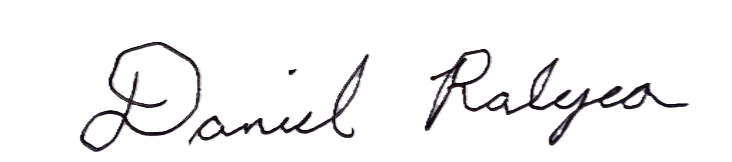

Daniel Ralyea
Chief Information Officer
South Carolina Department of Education

