EDPlan SC Data
  - What SPED and PowerSchool Admin need to know!

Data Elements
There are several pieces of data that must be entered in PowerSchool and published to Ed-Fi for a student to appear in the EDPlan application (see the corresponding mapping document for actual field names and endpoints in PowerSchool, Ed-Fi, and Stadium):
- District Code
- School Code
- SUNS (state ID)
- First Name
- Last Name
- Sex
- DOB
- Race
- Grade

Data Source
For the 2025-2026 school year, PCG loads three Ed-Fi data files (for student, user, and guardian information) compiled by Education Analytics (EA) into EDPlan.
- These files are loaded nightly (after 8:00 p.m.)
- The files are generated from the district-level Ed-Fi environment.

Verifying Data in EDPlan
If a student does not appear in EDPlan within a 24-hour period, check to see make sure the “Student Demographics” json packet within the “Student Enrollments” category published for the student AND that this category appears on the student’s individual publishing page as shown below – if not, republish the student’s data from their individual student publishing page:
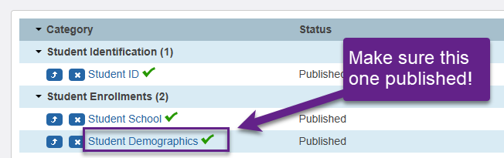
If, after republishing, the “Student Demographics” subcategory does not appear on the page with a green check mark, then put in a support case with PowerSchool.

